Graphing general mayhem
This lesson develops students’ ability to graph lines given in a variety of forms using algebraic skills to rearrange or by finding gradient and intercepts.

Visible learning
This lesson incorporates Path content.

Learning intentions
- To know how to rearrange linear equations.
- To understand and apply the most appropriate form of linear equation to efficiently solve problems.

Success criteria
- I can explain the characteristics of equations in general form.
- I can convert between general form and gradient-intercept form.
- I can graph lines given in any form.
- I can model linear relationships from real-world scenarios.

Syllabus outcomes
- develops understanding and fluency in mathematics through exploring and connecting mathematical concepts, choosing and applying mathematical techniques to solve problems, and communicating their thinking and reasoning coherently and clearly MAO-WM-01
- graphs and interprets linear relationships using the gradient/slope-intercept form
MA5-LIN-C-02
- describes and applies transformations, the midpoint, gradient/slope and distance formulas, and equations of lines to solve problems MA5-LIN-P-01
Mathematics K–10 Syllabus © NSW Education Standards Authority (NESA) for and on behalf of the Crown in right of the State of New South Wales, 2022.

Activity structure
Please use the associated PowerPoint Graphing General Mayhem to display images in this lesson.

Launch
- Display the picture of Kai, Kaitlin and their mother on the board. This graphic can be found on slide 2 of the PowerPoint Graphing general mayhem.
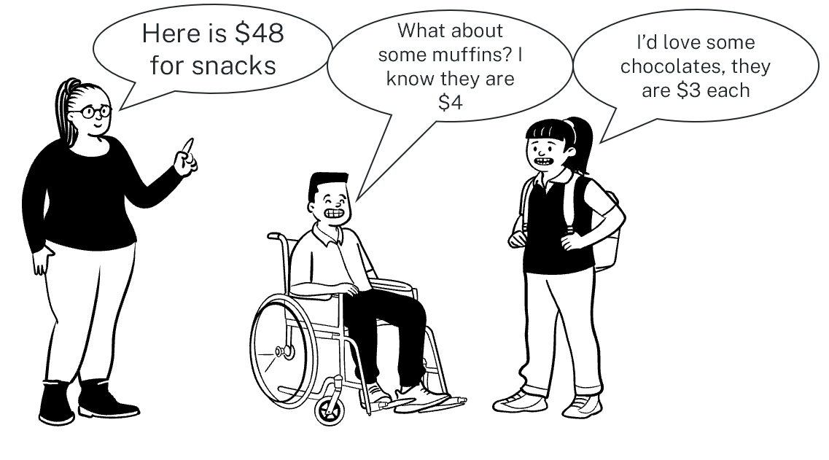
- Use a Think-Pair-Share (bit.ly/thinkpairsharestrategy) to encourage students to discuss, ‘What combinations of muffins and chocolates could Kai and Kaitlin buy?’
Teachers can use advancing questions for students such as:
- How many chocolates can you buy if there were no muffins?
- How many muffins can you buy if there were no chocolates?
- How many different combinations can you find?
- If we plotted these combinations on a cartesian plane, what kind of relationship would they create?
- If the cost of the items changed, what would happen?
- Can you write an equation that represents this scenario?

Explore
- Display slide 3 from the Graphing general mayhem PowerPoint, showing 3 different statements about linear relationships.
- In pairs, allow time for students to Think-Pair-Share (bit.ly/thinkpairsharestrategy) to discuss if the statements are always true, sometimes true or never true.
- Hand out the cards from Appendix A ‘Card sort’ which have numerous equations that are both linear and non-linear. Students are to identify which cards represent linear relationships and non-linear relationships.
This activity is to remind students that for an equation to represent a linear relationship, it should have up to 2 variables to the power of one. These can be written in any form, not just in gradient-intercept form.
- Assign students into visibly random groups of 3 (bit.ly/visiblegroups). Each group will need a copy of Appendix B ‘Goal-free problems’ and a vertical non-permanent surface (bit.ly/VNPSstrategy).
- Students are to write down as much information as possible that can be determined from each equation.
While students are working on these goal-free problems, walk around the classroom and, if necessary, ask students assessing and advancing questions to further student thinking.
- ‘Assessing questions’ draw out students’ thinking about a problem and what methods they have tried so far.
- ‘Advancing questions’ are intended to help move students’ thinking forward toward the lesson goals. We want to draw their attention to something they may not have noticed or considered yet.
Question suggestions are included below.
Table 1 – suggestions for assessing and advancing questions
Assessing questions | Advancing questions
What have you noticed so far? | Are there other ways we can represent linear relationships?
What have you explored so far? | What are the features of linear relationships?
Can you explain your thinking here? | Is there a scenario where you might use an equation like this?
- Using a questioning technique such as Pose-Pause-Pounce-Bounce [PDF 200 KB] (bit.ly/pausepouncebounce), combine the information that students determined. Discuss whether there was certain information that was easier to find from one equation format than another.
- Discuss the name for each form of linear equation in Appendix B.

Summarise
- Issue each student with a copy of Appendix C ‘Frayer Diagram’.
- Display slide 4 of the PowerPoint Graphing general mayhem which has 2 sections of the Frayer diagram completed.
- In pairs, allow students time to Think-Pair-Share what they notice and what they wonder (bit.ly/noticewonderstrategy) about the examples and non- examples provided [PDF 68.8 KB] (bit.ly/nonexamplesstrategy).
- Allow students time to complete the top 2 cells of Appendix C, paying particular attention to presenting the information in their own words.
- Use slides 5 to 8 for the Graphing general mayhem PowerPoint for the explicit teaching of rearranging a linear equation into general form
The explicit teaching technique used in the associated PowerPoint is ‘Your turn.’ The first slide is a worked example which should be displayed for the students and then use the following steps.
- Reveal the question to students and its solution.
- Students read in silence.
- Students individually think and explain to themselves what is happening in each step.
- Students hold a thumbs up to the teacher when they have finished reading and have some sort of understanding.
- Think-Pair-Share. Students explain the solution to their partner.
- In pairs, students then answer the self-explanation questions.
- Finally, randomly select students to share their answers with the whole class.
- Slide 9 from the PowerPoint has an incorrect example. Have students work through the question to find the error and advise Sham how he could prevent this error in the future.
- Use slides 10 to 13 from the PowerPoint for the explicit teaching of rearranging a linear relationship in general form into gradient-intercept form.
- Students will complete ‘Graphing linear relationships’ from Appendix D. They can work through these questions individually.

Apply
Using their knowledge of rearranging equations and graphing, ask students in their pairs to complete Appendix E ‘Game show’. This activity requires students to model correct and incorrect responses for TV shows.

Assessment and differentiation

Suggested opportunities for differentiation
Launch
- Teachers could challenge students to graph the linear relationship, find potential solutions and discuss the features of the graph.
- Working in pairs will provide support to students who are still becoming familiar with real-life scenarios involving linear relationships.
- Provide students with concrete materials to represent the scenario.
Explore
- Appendix A ‘Card sort’ could be supplied to students with the equations already grouped in linear and non-linear equations for students to notice and wonder.
- In Appendix C ‘Graphing linear relationships’, if students struggle with rearranging linear relationships into different forms individually, prompt them to move onto question 3 and explain why this is the case.
- Working in visibly random groups of 3 will provide support to students who are still developing their algebra skills.
- Goal-free problems are open ended and can have many solutions. Use the teacher prompts to encourage students to think deeply about the problem.
Apply
- Challenge students by asking them to create their own scenarios which would result in linear relationships.
- If students have interest in sport, teachers could modify the activity to refer to scoring systems. For example, give students an end score and have them determine the combinations of goals and behinds from Australian Rules football.

Suggested opportunities for assessment
Explore
- The answers students display for the goal-free problems can show their prior knowledge and their application of skills. It is also a place where you could identify misconceptions.
Summarise
- Questions from the ‘Graphing linear relationships’ activity in Appendix D could be used as an exit ticket.

Appendix A

Card sort
$$y=2x+4$$ | $$y=x^{2}$$
$$\frac{x}{6}=y$$ | $$x^{2}+y^{2}=9$$
$$4x+3y-12=0$$ | $$\frac{6}{x}=y$$
$$\frac{x}{9}+\frac{y}{2}=15$$ | $$x^{2}-4y+15=0$$
$$x=7$$ | $$y=4-7^{x}$$

Appendix B

Goal-free problems
For each of the equations, write down everything you can determine from the equation.
- $y=\frac{4}{3}x-2$
- $5x-4y+20=0$
- $7x+3y=42$

Appendix C

Graphing linear relationships
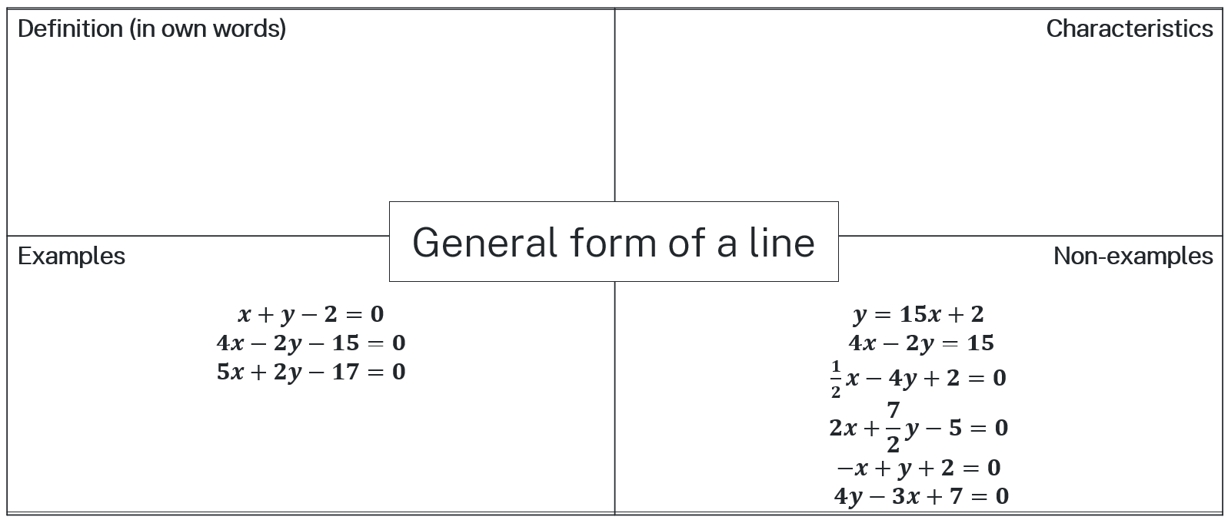

Appendix D

Graphing linear relationships
- Use the equation $3x+4y-48=0$ to:
- Find the $x$- and$y$-intercepts.
- Use the $x$- and $y$-intercepts to graph the equation $3x+4y=48$. Label all important points.
- Use the equation $6x-4y-24=0$ to:
- Find the gradient and the $y$-intercept.
- Use the gradient and $y$-intercept to graph $6x-4y-24=0$.
- Explain and justify which method you prefer to graph linear relationships in general form, using $x$- and $y$-intercepts or using the gradient and y-intercept.
- Use the equation $y=\frac{7}{2}x-4$ to:
- Find the $x$- and $y$-intercepts.
- Use the $x$- and $y$-intercepts to graph the equation $y=\frac{7}{2}x-4$ . Label all important points.
- Use the equation $y=-\frac{2}{3}x+5$ to:
- Find the gradient and the $y$-intercept.
- Use the gradient and $y$-intercept to graph $y=-\frac{2}{3}x+5$.
- Explain and justify which method you prefer to graph linear relationships in general form, using $x$- and $y$-intercepts or using the gradient and $y$-intercept.

Appendix E

Game show
You are watching a new game show. In this show:
- A team is awarded $3 for every correct answer.
- A team loses $2 for every incorrect answer.
- You only caught the end of the show, where the team won $12. How many questions could teams have answered correctly and incorrectly?
- Write a linear relationship to represent this scenario.
- How many combinations of correct and incorrect answers are there?
- Can a team answer 7 questions correctly? Justify your answer mathematically.
- Graph the linear relationship.

Sample solutions

Appendix A – card sort
Linear | Non-linear
$$y=2x+4$$ | $$y=x^{2}$$
$$\frac{x}{6}=y$$ | $$x^{2}+y^{2}=9$$
$$4x+3y-12=0$$ | $$\frac{6}{x}=y$$
$$\frac{x}{9}+\frac{y}{2}=15$$ | $$x^{2}-4y+15=0$$
$$x=7$$ | $$y=4-7^{x}$$

Appendix B – goal-free problems
For each of the equations, write down everything you can determine from the equation.
- $y=\frac{4}{3}x-2$
- gradient is $\frac{4}{3}$
- $y$-intercept is (0, -2)
- $x$-intercept is (1.5, 0)
- graph increases from left to right
- graphs a linear relationship.
- $5x-4y+20=0$
- gradient is $\frac{5}{4}$
- $y$-intercept is (0, 5)
- $x$-intercept is (4, 0)
- graph increases from left to right
- graphs a linear relationship.
- $7x+3y=42$
- gradient is $-\frac{7}{3}$
- $y$-intercept is (0, 14)
- $x$-intercept is (6, 0)
- graph increases from left to right
- graphs a linear relationship.

Appendix D – graphing linear relationships

Let $y=0$,
$$3x+4\left(0\right)-48=0$$
$$3x-48=0$$
$$3x=48$$
$$x=16$$
Therefore, the $x$-intercept is at (16,0).
Let $x=0$,
$$3\left(0\right)+4y-48=0$$
$$4y-48=0$$
$$4y=48$$
$$y=12$$
Therefore, the $y$-intercept is at (0,12).

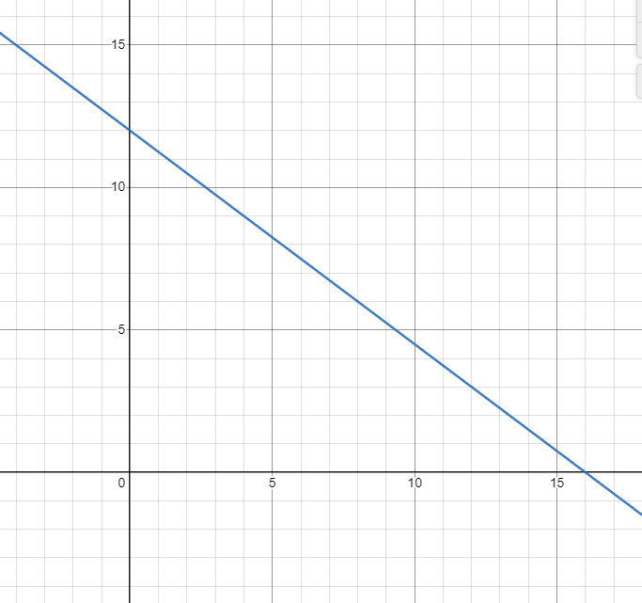

$$6x-4y-24=0$$
$$6x-24=4y$$
$$\frac{6}{4}x-6=y$$
$$y=\frac{3}{2}x-6$$
Therefore, $m=\frac{3}{2}$ and $c=-6$.

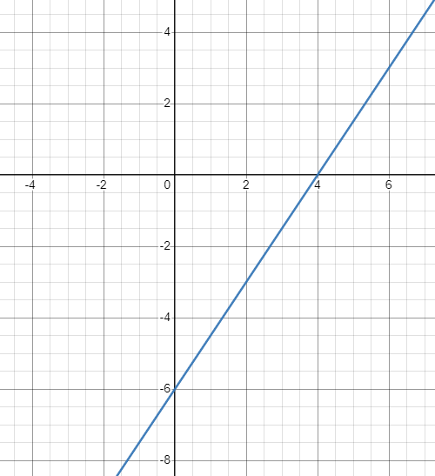
- Answers may vary depending on preferred method for graphing.

Let $y=0$,
$$0=\frac{7}{2}x-4$$
$$4=\frac{7}{2}x$$
$$8=7x$$
$$\frac{8}{7}=x$$
Therefore, the $x$-intercept is at ($\frac{8}{7}$,0).
Let $x=0$,
$$y=\frac{7}{2}(0)-4$$
$$y=-4$$
Therefore, the $y$-intercept is at (0,−4).

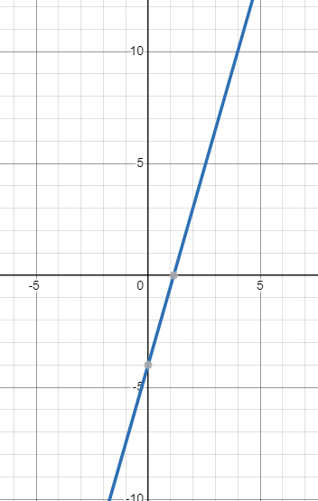

$$m=-\frac{2}{3}$$
$$c=5$$

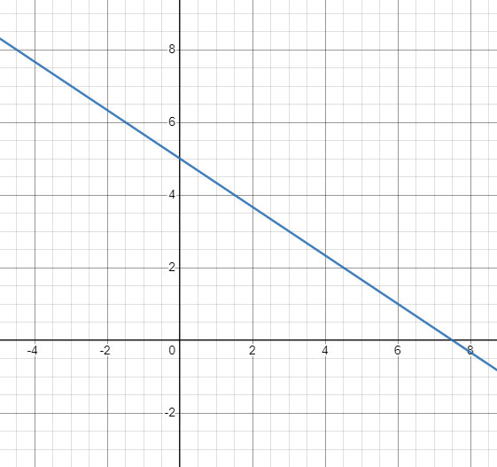
- Answers may vary depending on students’ preference.

Appendix E – game show
- Different combinations are possible, including 4 correct answers.
- Let $x$ = correct answers and $y=$ incorrect answers.
$$3x-2y=12$$
- (4, 0), (6, 3), (8, 6), (10, 9), …
$x$-values go up by 2, $y$-values go up 3.
- $3\left(7\right)-2y=12$
$$-2y=12-21$$
$$-2y=-9$$
$$y=4.5$$
Since $y$ is the number of questions, $y≠4.5$ (y must be a counting number).

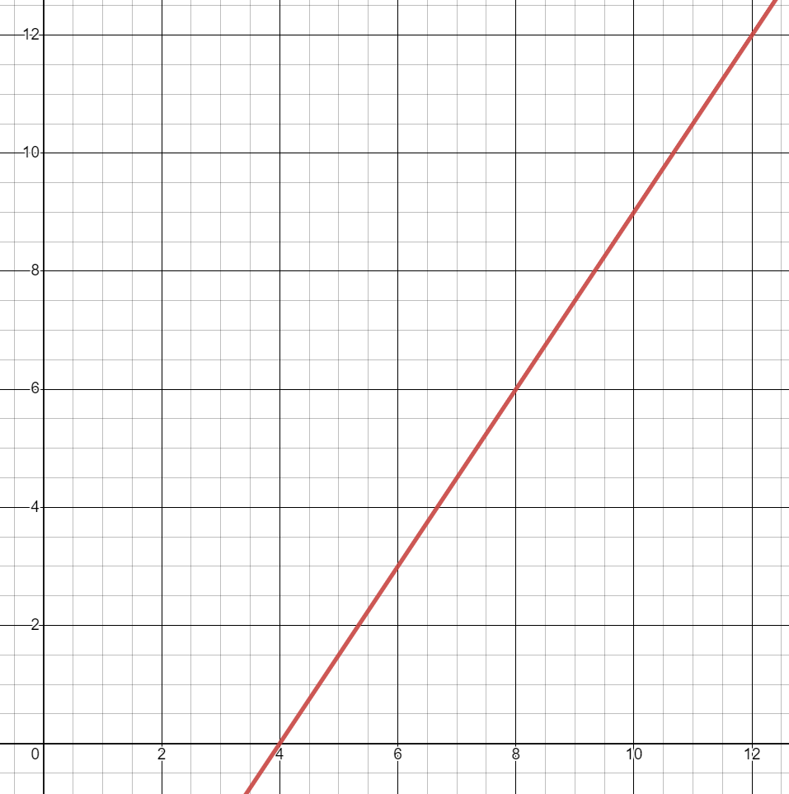
There is an opportunity here to discuss which parts of the graph are appropriate. For example, we can’t have a negative number of questions.

References
This resource contains NSW Curriculum and syllabus content. The NSW Curriculum is developed by the NSW Education Standards Authority. This content is prepared by NESA for and on behalf of the Crown in right of the State of New South Wales. The material is protected by Crown copyright.
Please refer to the NESA Copyright Disclaimer for more information https://educationstandards.nsw.edu.au/wps/portal/nesa/mini-footer/copyright.
NESA holds the only official and up-to-date versions of the NSW Curriculum and syllabus documents. Please visit the NSW Education Standards Authority (NESA) website https://educationstandards.nsw.edu.au/ and the NSW Curriculum website https://curriculum.nsw.edu.au/home.
Mathematics K–10 Syllabus © NSW Education Standards Authority (NESA) for and on behalf of the Crown in right of the State of New South Wales, 2022.

© State of New South Wales (Department of Education), 2023
The copyright material published in this resource is subject to the Copyright Act 1968 (Cth) and is owned by the NSW Department of Education or, where indicated, by a party other than the NSW Department of Education (third-party material).
Copyright material available in this resource and owned by the NSW Department of Education is licensed under a Creative Commons Attribution 4.0 International (CC BY 4.0) license.
This license allows you to share and adapt the material for any purpose, even commercially.
Attribution should be given to © State of New South Wales (Department of Education), 2023.
Material in this resource not available under a Creative Commons license:
- the NSW Department of Education logo, other logos and trademark-protected material
- material owned by a third party that has been reproduced with permission. You will need to obtain permission from the third party to reuse its material.
Links to third-party material and websites
Please note that the provided (reading/viewing material/list/links/texts) are a suggestion only and implies no endorsement, by the New South Wales Department of Education, of any author, publisher, or book title. School principals and teachers are best placed to assess the suitability of resources that would complement the curriculum and reflect the needs and interests of their students.
If you use the links provided in this document to access a third-party's website, you acknowledge that the terms of use, including licence terms set out on the third-party's website apply to the use which may be made of the materials on that third-party website or where permitted by the Copyright Act 1968 (Cth). The department accepts no responsibility for content on third-party websites.

