# **Promoting literacy and numeracy in the preschool**

Participant workbook

Contents

About this workbook 2

Presentation overview 3

Learning intentions and success criteria 3

Alignment to the Australian Professional Standards for Teachers 3

Alignment to the School Excellence Framework 4

Part 1 – presentation notes 5

Activity 1 6

Microlearning module 6

Part 2 – presentation notes 7

Activity 2 8

Research snapshot 8

Part 3 – presentation notes 10

Activity 3 11

Examining literacy or numeracy in your preschool curriculum 11

Where to next? 13

Evaluation 14

References 15

## About this workbook

This workbook is designed to guide your thinking, reflections and plans for future action. In the workbook, you will find **note-taking** **pages** that complement the presentation and **activity templates** to help you engage with the content.

The note-taking pages feature focus questions specific to the content of the presentation. They also provide you with the opportunity to record your key take-aways and ideas.

The activity pages support you to collaborate with colleagues and consider how you can apply the content in your preschool context.

This workbook can be printed double-sided or used digitally. If you have questions about the presentation, please connect with your [Statewide staffroom](https://education.nsw.gov.au/teaching-and-learning/curriculum/statewide-staffrooms) or email [earlylearning@det.nsw.edu.au](mailto:earlylearning@det.nsw.edu.au).

## Presentation overview

This session builds on information and guidance for teachers and educators in the preschool setting to understand the importance of developing early literacy and numeracy skills in young children. You will unpack the Early Years Learning Framework expectation and the pedagogical practices for literacy and numeracy learning in the preschool.

### Learning intentions and success criteria

By the end of the presentation, participants will:

* understand and consider how the Early Years Learning Framework (EYLF) and NSW Syllabus form a continuum of learning
* know and understand the importance of resisting push down pedagogy in preschool curriculum
* examine quality literacy and numeracy practices to support teaching and learning aligned to the EYLF.

To demonstrate learning, participants will:

* discuss and describe the importance of continuity of learning between preschool and school settings
* describe and identify push down pedagogy
* discuss and identify literacy and numeracy practices aligned to the EYLF.

### Alignment to the Australian Professional Standards for Teachers

This presentation aligns with the following standards:

* 2.1.2 Apply knowledge of the content and teaching strategies of the teaching area to develop engaging teaching activities.
* 2.3.2 Design and implement learning and teaching programs using knowledge of curriculum, assessment and reporting requirements.

### Alignment to the School Excellence Framework

This professional learning session aligns with the following elements of the School Excellence Framework:

* Learning culture
* Curriculum

## Part 1 – presentation notes

**Focus question**

* How do I support continuity of learning in my preschool curriculum?

| **Key points** | **Notes** |
| --- | --- |

**Summary**

The 3 key ideas that I would like to apply to my practice:

## Activity 1

### Microlearning module

Together the Early Years Learning Framework (EYLF) and NSW syllabuses form an education continuum, guiding children’s learning from early childhood into school. Continuity of learning occurs when learning builds upon prior learning, through age-appropriate experiences and pedagogy. This is strengthened when early childhood educators and school teachers understand what and how children learn in both settings.

To learn more about the continuum of learning:

1. use the QR code below to access the [Curriculum Reform curriculum links – early childhood educators' course](https://myplsso.education.nsw.gov.au/mylearning/catalogue/details/890e5157-bd3a-ec11-948f-0003ff1545a5) in MyPL
2. complete Module 3 – Understanding the continuum of learning between preschool and Kindergarten.

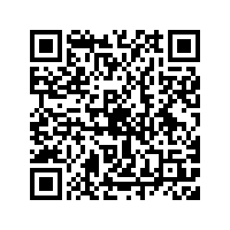

## Part 2 – presentation notes

**Focus question**

* How do I resist a push down pedagogical approach and ensure my curriculum decision making is aligned the EYLF?

| **Key points** | **Notes** |
| --- | --- |

**Summary**

The 3 key ideas that I would like to apply to my practice:

## Activity 2

### Research snapshot

The Early Years Learning Framework (EYLF) is the approved learning framework for all early childhood education and care services, including public preschools. The EYLF draws on conclusive international evidence and forms the foundation for quality teaching and learning. The article ‘The Pushes and Pulls of Pedagogy in the Early Years: Competing Knowledges and the Erosion of Play-based Learning’ (Barblett, Knaus and Barratt-Pugh 2016) explores the idea of play as a pedagogical tool disappearing from programs for four- and five-year-old children in favour of early academics through a pushdown curriculum.

**Task:**

1. **Read the following snapshot from the article from Barblett et al. (2016):**

International research has reported early childhood educator concerns across the world about the impact of policy implementation on their work with young children. One of these reported concerns is the disappearance of play as a pedagogical practice from early childhood programs in the years transitioning to school (Gunnarsdottir 2014; Hirsch-Pasek, Michnick Golinkoff, Berk & Singer 2009; Nicolopoulou 2010). Indeed, many western countries are reporting that the preschool years are becoming more academic or school-like, such as Hirsch-Pasek et al. (2009) in the United States (US); Gunnarsdottir (2014) in Iceland; Gibbons (2013) in New Zealand; and Whitebread et al. (2012) in the United Kingdom. Others have identified the tensions between play-based learning and the move towards published programs and scripted teaching (Thomas, Warren and deVries 2011). The increasing demand for formal assessments to measure and evaluate children’s learning has also been identified as impacting on pedagogical practices (Dulfer, Polesel and Rice, 2012).

1. **Reflect on the prompts below.**

**What questions does this snapshot raise for you?**

|  |
| --- |
|  |

**What are some examples of push down curriculum you have experienced?**

|  |
| --- |
|  |

**How do you use your knowledge of the EYLF to resist a push-down curriculum approach?**

|  |
| --- |
|  |

A strong body of evidence shows that access to quality early childhood education programs makes a significant and long-term difference to children’s development in many areas.

**(CESE 2016: 4)**

## Part 3 – presentation notes

**Focus question**

* What strategies do I use to promote high quality literacy and numeracy teaching and learning?

| **Key points** | **Notes** |
| --- | --- |

**Summary**

The 3 key ideas that I would like to apply to my practice:

## Activity 3

### Examining literacy or numeracy in your preschool curriculum

The EYLF has a specific emphasis on play-based learning and the intentional role played by both educators and children in extending and enriching learning (AGDE [Australian Government Department of Education] 2022). Preschool teachers and educators must work to ensure educational programs and curriculum decision making is informed by these requirements, including when planning for literacy and numeracy.

**Use the table below to document how you promote literacy or numeracy teaching and learning throughout each day.**

|  |  |  |
| --- | --- | --- |
| Preschool planning | Examples of how you support children’s learning | Actions to take |
| Indoor learning environment |  |  |
| Outdoor learning environment |  |  |
| Planned learning experiences |  |  |
| Daily routine and transition times |  |  |

Encouraging children’s positive attitudes and competencies in literacy and numeracy are essential for all children’s successful learning. The foundations for these competencies are built in early childhood.

**(AGDE 2022: 57)**

## Where to next?

Would you like to learn more? The links below provide additional learning and resources.

* Early Learning [Continuity of learning and curriculum links webpage](https://education.nsw.gov.au/teaching-and-learning/curriculum/early-learning/continuity-of-learning-and-curriculum-links#The1)

This webpage contains information for early childhood educators and schoolteachers to understand what and how children learn in both settings.

* Early Learning Resources for teachers – [Projects for learning](https://education.nsw.gov.au/teaching-and-learning/curriculum/early-learning/early-learning-resources)

These resources provide educators with a range of suggestions and play based learning experiences that can be used to support children’s learning, including early literacy and numeracy.

* Early Learning professional learning – [Fostering positive dispositions across literacy and numeracy in early childhood](https://education.nsw.gov.au/teaching-and-learning/curriculum/early-learning/professional-learning/positive-dispositions)

This professional learning session explores how positive dispositions in early childhood supports children’s learning trajectory in literacy and numeracy and identifies the practices in the EYLF that promote and nurture the development of literacy and numeracy.

* Evidence for Learning Guidance report – [Improving mathematics in the early years with children aged 3–7 years](https://evidenceforlearning.org.au/education-evidence/guidance-reports/early-maths)

This Guidance Report supports Australian educators and leaders with the best available international evidence and practical examples for mathematics practice across the early years.

* Evidence for Learning [Tip sheets on oral language development for educators](https://evidenceforlearning.org.au/guidance-for-educators/oral-language-development-in-ece)

These tip sheets provide evidence-informed strategies to create opportunities for oral language development in early childhood education and care settings.

* Australian Education Research Organisation (AERO) [Early childhood practices](https://www.edresearch.edu.au/practice-hub/early-childhood-practices)

Explore a range of practical guidance and resources on evidence-based practices such as learning trajectories and tried and tested practice guides for early literacy and numeracy.

## Evaluation

We value your feedback. Please complete the [Promoting literacy and numeracy in the preschool evaluation](https://forms.office.com/r/yxjg6tH5dc) to help us provide further support.

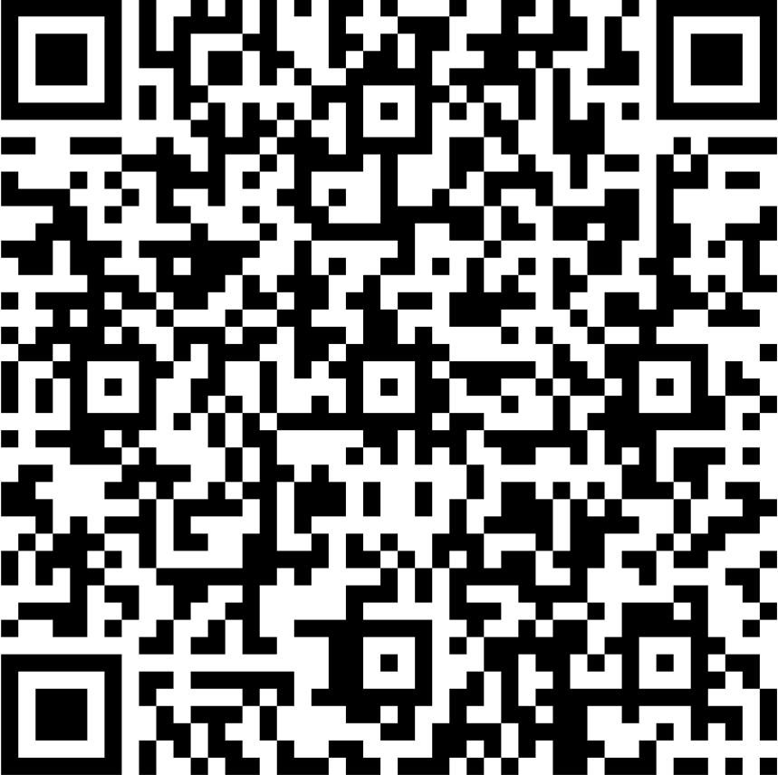

## References

This resource contains NSW Curriculum and syllabus content. The NSW Curriculum is developed by the NSW Education Standards Authority. This content is prepared by NESA for and on behalf of the Crown in right of the State of New South Wales. The material is protected by Crown copyright.

Please refer to the NESA Copyright Disclaimer for more information <https://educationstandards.nsw.edu.au/wps/portal/nesa/mini-footer/copyright>.

NESA holds the only official and up-to-date versions of the NSW Curriculum and syllabus documents. Please visit the NSW Education Standards Authority (NESA) website <https://educationstandards.nsw.edu.au/wps/portal/nesa/home> and the NSW Curriculum website <https://curriculum.nsw.edu.au/>.

AGDE (Australian Government Department of Education) (2022) [*Belonging, Being and Becoming: The Early Years Learning Framework for Australia (V2.0)*]((2022)%20Belonging,%20Being%20and%20Becoming:%20The%20Early%20Years%20Learning%20Framework%20for%20Australia%20(V2.0)) Australian Government Department of Education for the Ministerial Council accessed 15 December 2023.

Barblett L, Knaus M and Barratt-Pugh C (2016) 'The Pushes and Pulls of Pedagogy in the Early Years: Competing Knowledges and the Erosion of Play-based Learning', *Australasian Journal of Early Childhood*, 41(4):36.

CESE (Centre for Education Statistics and Evaluation) (2016) ‘[How schools can improve literacy and numeracy performance and why it (still) matters](https://education.nsw.gov.au/about-us/education-data-and-research/cese/publications/research-reports/how-schools-can-improve-literacy-and-numeracy-performance)’, State of New South Wales (Department of Education), accessed 15 December 2023.

**© State of New South Wales (Department of Education), 2024**

The copyright material published in this resource is subject to the *Copyright Act 1968* (Cth) and is owned by the NSW Department of Education or, where indicated, by a party other than the NSW Department of Education (third-party material).

Copyright material available in this resource and owned by the NSW Department of Education is licensed under a [Creative Commons Attribution 4.0 International (CC BY 4.0) license](https://creativecommons.org/licenses/by/4.0/).

[](https://creativecommons.org/licenses/by/4.0/)

This license allows you to share and adapt the material for any purpose, even commercially.

Attribution should be given to © State of New South Wales (Department of Education), 2024.

Material in this resource not available under a Creative Commons license:

* the NSW Department of Education logo, other logos and trademark-protected material
* material owned by a third party that has been reproduced with permission. You will need to obtain permission from the third party to reuse its material.

**Links to third-party material and websites**

Please note that the provided (reading/viewing material/list/links/texts) are a suggestion only and implies no endorsement, by the New South Wales Department of Education, of any author, publisher, or book title. School principals and teachers are best placed to assess the suitability of resources that would complement the curriculum and reflect the needs and interests of their students.

If you use the links provided in this document to access a third-party's website, you acknowledge that the terms of use, including licence terms set out on the third-party's website apply to the use which may be made of the materials on that third-party website or where permitted by the *Copyright Act 1968* (Cth). The department accepts no responsibility for content on third-party websites.