English Stage 4 (Year 7) – resource booklet
Escape into the world of the novel – part 1
Phase 1, phase 2 and integrated phase 5 resources
This document contains the teacher-facing resources and activities that accompany the Year 7 teaching and learning program, ‘Escape into the world of the novel’.

Contents
About this resource 3
Purpose of resource 4
Target audience 4
When and how to use 4
Texts and resources 5
Phase 1 – engaging with the unit and strengthening the learning community 7
Phase 1, resource 1 – preparing for reading the text 8
Phase 1, activity 1 – reading the news report text 10
Phase 1, activity 2 – identifying the effect of language features in a text 11
Phase 1, activity 3 – benefits of reading 13
Phase 1, adjusted activity 3 – benefits of reading scaffold 14
Phase 1, resource 2 – preparing for Britannica Kids fiction article 16
Phase 1, activity 4 – what makes a good story? 17
Phase 1, resource 3 – fiction cards 20
Phase 1, resource 4 – categorising texts 22
Phase 1, resource 5 – using the Frayer model 27
Phase 1, activity 5 – understanding representation 30
Phase 1, activity 6 – representations of landscapes and landforms in film 32
Phase 1, activity 7 – symbolism and representation 34
Phase 1, resource 6 – sample definition 41
Phase 1, activity 8 – prepositions and prepositional phrases 42
Phase 1, resource 7 – prepositions and prepositional phrases answers 43
Phase 1, resource 8 – interactive writing 44
Core formative task 1 – imaginative orientation 45
Phase 1, resource 9 – sample improved orientation 52
Phase 1, resource 10 – spelling (refining checklist part 1) 53
Phase 1, resource 11 – additional strategies for introducing a novel 55
Phase 1, resource 12 – list of prediction words from Across the Risen Sea 58
Phase 1, activity 9 – parts of speech 60
Phase 1, activity 10 – matching vocabulary to story elements 61
Phase 1, resource 13 – creating predictive sentences 62
Phase 1, resource 14 – genre 64
Phase 1, activity 11 – genre match 66
Phase 1, resource 15 – genre match answers 68
Phase 1, activity 12 – how does genre engage responders? 70
Phase 1, resource 16 – answers for how genre engages responders 72
Phase 1, activity 13 – the Explanation Game 74
Phase 1, activity 14 – response to the novel’s orientation 75
Phase 2 – unpacking and engaging with the conceptual focus 76
Phase 2, resource 1 – adapted conceptual framework 77
Phase 2, resource 2 – villains revealed 79
Phase 2, activity 1 – match and sort 80
Phase 2, resource 3 – story, plot and narrative 83
Phase 2, activity 2 – identifying the structural elements of narrative in a text 85
Phase 2, activity 3 – reordering the rising tension 91
Phase 2, activity 4 – considering the effect of rising tension 93
Phase 2, activity 5 – think, puzzle, explore prompts 94
Phase 2, resource 4 – prompts for physical Likert scale 95
Phase 2, resource 5 – vocabulary building 96
Phase 2, activity 6 – reflective writing prompts 97
Phase 2, activity 7 – reading journal 98
Phase 2, activity 8 – narrative structure diagram 99
Phase 2, resource 6 – blank narrative structure diagram 100
Phase 2, resource 7 – additional narrative structure terminology 101
Phase 2, activity 9 – conscience alley for Across the Risen Sea 103
Phase 2, resource 8 – ways into argument 105
Phase 2, activity 10 – Neoma the ‘anti-hero’? 106
Phase 2, activity 11 – analytical writing using theme-rheme structures 107
Phase 2, activity 12 – conflict and rising tension 110
Phase 2, activity 13 – learning about the protagonist 111
Phase 2, activity 14 – introduction to narrative voice 113
Phase 2, resource 9 – teacher support for narrative voice 115
Phase 2, activity 15 – sentence combining and narrative voice 116
Core formative task 2 – experimenting with point of view and narrative voice (integrated Phase 5) 118
Phase 2, resource 10 – verb choice (refining checklist part 2) 120
References 122

Updating the table of contents
Want to update the table? Have you added content to the document and noticed the page numbers have changed? As you add content to this report, you can update the table of contents to accurately reflect the page numbers within the resource. To update the table:
- Right click on the table and select ‘Update table of contents’ (in the browser version) or ‘Update field’ (in the desktop app). In the browser version, it will automatically update the entire table.
- In the desktop app, you will then need to select ‘Update entire table’. Your table numbers should then update to reflect your changes.

About this resource
This teacher resource booklet is not a standalone resource. It has been designed for use by teachers in connection to Year 7 resources designed by the English curriculum team for the English K–10 Syllabus (NESA 2022). These include the Year 7 scope and sequence, Year 7 ‘Escape into the world of the novel’ program and the Year 7 Term 3 sample assessment task, which includes a student work sample.

Purpose of resource
The content in this resource booklet has been prepared by the English curriculum team, unless otherwise credited. Some of the information is collated from relevant NESA and department documentation. It is important that all users re-read and cross-reference the relevant syllabus, assessment and reporting information hyperlinked throughout. This ensures the content is an accurate reflection of the most up-to-date syllabus content. Links contained within this resource were correct as of 30 October 2023.

Target audience
These samples are intended to support teachers as they develop teaching and learning resources for their students’ needs. The program and associated resources are not intended to be taught exactly as is presented in their current format. There are instructions for the teacher and instructions for the student throughout the resources and activities. Teachers using this resource booklet should edit and refine these to suit their students’ needs, interests, abilities and the texts selected.

When and how to use
This teaching and learning program has been designed for Term 3 of Year 7. It provides opportunities for the teacher to strengthen class rapport, while encouraging students to explore and understand new texts and concepts, and experience new ways of learning. Teacher-facing material has been included as a ‘resource’, while student-facing material has been labelled ‘activity’ in this booklet. The resources and activities can be used as an example and adapted for the teacher’s own design of resources. The booklet also serves as an example of how resources and activities can be designed for the English K–10 Syllabus (NESA 2022). The resources and activities should be used with timeframes that are created by the teacher to meet the faculty and school assessment schedules.

Texts and resources
A succinct overview of the texts required for the teaching and learning program are outlined in the table below. This brief overview provides the name and details of each text, the syllabus requirement being addressed and points of note.
Table 1 – core texts and their alignment to the text requirements
Text | Text requirement | Annotation and overview
(Core text)  MacDibble B (2020) Across the Risen Sea, Allen &Unwin Pty Ltd, St Leonards, NSW. | This novel is a moderately complex text as per the National Literacy Learning Progression (NLLP) (V3) (NLLP) (V3) in that it provides students opportunities to engage with a prose text with moderately complex sentence, language and vocabulary. This includes modality, literary devices, idiomatic language and meaning built around multiple perspectives.  EN4-RVL-01 requires students to read texts that are complex in their ideas and construction. The text helps meet the Text requirements for English 7–10: a work of extended prose by an Australian author which explores intercultural experiences and perspectives from popular and youth cultures. | The novel is a dystopian novel set in a post climate change affected world. Readers engage with the protagonist’s journey to save themselves and the planet. The novel explores human greed, selfishness and sense of community.  A study of this accessible text will allow for the development of reading skills, the appreciation of genre, and the ways in which composers create an interesting fictional world through characterisation and carefully curated narrative elements.
(Satellite text)  Carroll L (1865) Alice’s Adventures in Wonderland, Macmillan’s Children’s Books. | This novella is a complex text as per the NLLP (V3). It uses figurative language, complex vocabulary and contains allegorical ideas that lead to multi-layered meanings. While it can be read as a children’s book, it provides opportunities for close reading and stage-appropriate analysis of characterisation and narrative structure.  EN4-RVL-01 requires students to read texts that are complex in their ideas and construction. The text helps meet the Text requirements for English 7–10: a work of extended prose that is widely regarded as quality literature. | This prose work is widely known and hence ready for consideration in new ways that will engage a young adult reader.  It is a work of Victorian literature that has had a profound influence on popular culture, particularly through its fantasy genre structure and characterisation. The anthropomorphic creatures that the protagonist meets have influenced children’s literature as well as provided material for comedy, psychological analysis and wordplay.

Phase 1 – engaging with the unit and strengthening the learning community
The focus of this phase is for students to explore the unique relationship between themselves as readers and the evocative worlds created by the composers of fiction. Students will engage in structured reading and viewing activities. This will challenge and inspire them to consider themselves as readers and investigate what draws them personally into fictional worlds. Students are engaged conceptually through genre and characterisation in the idea of escape, and their relationship with fiction. Students begin exploring the purpose of fiction and how it attempts to engage the audience. Students practise writing by manipulating texts to deepen their awareness of prose fiction, and to reflect on the writing process.

Phase 1, resource 1 – preparing for reading the text
Teacher note: prepare the article for your student cohort prior to reading. Depending on your students, this topic may be upsetting and should be omitted if required. The article Why millions of girls in Afghanistan can’t go to school (Boudjikanian 2022) can be accessed online, linked to a Google classroom or printed as a hard copy. Suggested activities to help students access the article are below.
Vocabulary activities
To prepare students for this text, the teacher could:
- issue the glossary (following table) prior to reading and students find visual images to represent each term
- use the glossary during the reading process to look up unfamiliar words
- use the glossary for spelling activities
- break students up into small groups, allocate each group a term, students research the term and report back to the class
- support students to take notes while reading, and record key ideas in the ‘Relevance to the article’ section of the table.
Table 2 – article glossary
Term | Definition | Relevance to the article
Afghanistan | A country in central Asia next to India and Iran | The country where the article is set
Taliban | An extreme Muslim group in Afghanistan
hurdles | Difficult problems to be overcome
refugees | People who flee a country often to escape political tensions
Islamist extremist group | A group of people who follow extreme religious beliefs | A categorisation for the Taliban group
waging | To carry on a battle
ousted | Thrown out
pandemic | A disease that is experienced throughout the entire country or world
violation | The act of breaking the law or agreement
plight | A condition, state or situation
Extended reading suggestions
Prior to reading the article, it may be beneficial for students to conduct some wider reading on the topic or view a short documentary. Here are some possible research options.
- Britannica Kids – Afghanistan and National Geographic Kids – Afghanistan – after reading these articles, students should choose information beneath a couple of the subheadings and complete a Digital Learning Selector – Dictogloss for each.
- The Taliban’s takeover of Afghanistan, explained (Brewster 2021) – after reading this article, students should use the Digital Learning Selector – 5 Whys process to think more deeply about the Taliban’s takeover of Afghanistan.
- Afghanistan Anniversary (3:56) – after viewing the clip, students complete a Digital Learning Selector – Think, Pair, Share activity to address a variety of discussion points, including how life has changed for those living in Afghanistan since the Taliban takeover and how life differs for those who have moved to Australia.

Phase 1, activity 1 – reading the news report text
Assisted reading suggestions
The teacher may organise or suggest one of the following ways of reading the text. Alternatively, the class may decide together. Options include:
- Teacher reads aloud and students follow along.
- Students read in small groups, pairs or individually.
- Teacher organises a small group reading and ensure there is at least one strong reader in each group.
- Students to stop at key points to ask key questions and check for understanding. Suggested questions are provided below with the ‘Inferential analysis questions’.
- Students complete a Jigsaw activity and chunk the text into small sections – different groups could be issued different sections to read and summarise.
Student activity – inferential analysis questions
Answer the following questions. You will need to use inferential thinking skills to interpret the additional layers of meaning created by the author’s use of connotation.
- How do the opening sentences of the text immediately orient the reader into the concerns of the piece?
- How do the final sentences conclude the key concerns of the piece?
- What connotations are attached to the word ‘right(s)’ throughout the article?
- How is a perspective about education conveyed through the text? Consider in particular how emotive language is used to communicate the perspective.
- How does the text position the audience to reconsider their own perspectives on ‘right(s)’?

Phase 1, activity 2 – identifying the effect of language features in a text
Teacher note: EAL/D students requiring extra support may need to be provided with a visual glossary.
Glossary
- Contextual vocabulary – precise words used in relation to the background or situation.
- Emotive language – language that creates an emotional response.
- Facts – proven truths about a topic.
- Gaze – the relationship between the human subject of the text and the viewer through looking.
- Headings and subheadings – words that are used at the top of a page or section to provide a title that explains what it is about.
- Hyperlink – text, image, frame or button that when clicked or tapped will open another webpage, website, image, sound, document or application, such as email. Hyperlinks are often used within documents to link to other pages or sections.
- Quotations – exact wording from the text or person can provide strong evidence of techniques or theme.
- Rhetorical question – a question which does not require an (often obvious) answer. It is asked for the sake of emphasis or effect. A rhetorical question is a figure of speech.
- Your group has been assigned a language feature to identify in the text.
- Each group member should identify one example in the text.
- Add your examples to the collaborative document.
- Identify the effect of their use.
Table 3 – LEE table
Language feature | Evidence | Effect
Rhetorical question
Emotive language
Quotations | “Each person can do something, whether it be posting on social media, talking to your class about it, or starting conversations within your family,” said Oates. | This call to action from Oates gives readers a solution as to what they can do personally about the situation.
Facts
Hyperlinks
Contextual vocabulary
Gaze
Heading and subheadings

Phase 1, activity 3 – benefits of reading
- Use the first row of the table to record the main ideas from your viewing of view Top 10 Benefits Of Reading Books (6:10).
- List your Top 5 reasons to read in order of preference.
Table 4 – benefits of reading
Preference | Top benefits of reading books | Justification
Main ideas
1
2
3
4
5

Phase 1, adjusted activity 3 – benefits of reading scaffold
Teacher note: pause the clip Top 10 Benefits Of Reading Books (6:10) after each benefit to check for understanding and use the adjusted activity structure here to support learners.
- Use the table to list your top 5 reasons to read in order of preference.
Table 5 – adjusted scaffold benefits of reading
Five benefits of reading books | Preference (1–5)
Reading expands vocabulary.
Reading improves your imagination.
Reading reduces stress.
Reading improves your knowledge.
Reading improves your writing skills.
- Now select your top 2 reasons and use the scaffold to write a paragraph.
Table 6 – sentence starter template
Sentence stem | Your answer
The top 2 benefits of reading on my list were
I chose
as my first preference because I believe that
I also think my second preference,
is an important reason as
I now understand that reading

Phase 1, resource 2 – preparing for Britannica Kids fiction article
Pre-reading resource: planning the ingredients for a good story
When you are cooking, your meals need particular ingredients, combined in a certain way, to ensure that they are good to eat. Similarly, stories need certain ingredients to guarantee that they will be interesting to the reader and get the writer’s message across to the audience.
Think about this: what do you think are the essential ingredients that are needed to make a story a ‘good’ story?
Remember, your responses should be general enough that they can apply to all good stories. For example, if you write ‘dragons’ as an essential ingredient, this would mean any story without a dragon could not be considered a good story. Instead, if you like reading stories with dragons in them, you might like to think about what the dragon brings to the story. Is it an interesting or exciting character? Does it bring a sense of wonder or fantasy to the story? Does it bring excitement and action to the plot?
Teacher note: students should be provided with access to the Britannica Kids – fiction article after they have completed their initial brainstorm. A differentiated article Britannica Kids article – fiction (Kids), which also has read aloud capability, could also be used.

Phase 1, activity 4 – what makes a good story?
Teacher note: this activity and concept is based on Inferring meaning of unfamiliar words (Griffith University 2023). It is like Phase 1, activity 3 – benefits of reading, the activity can be scaffolded by providing some initial ingredients or sentence stems.
This activity asks you to think about the elements, or ingredients, that go into making a story a ‘good’ story.
- Brainstorm your list of ‘ingredients’ in the first column. In brainstorming your list, you should consider:
- the stories that you have enjoyed personally – what made them so enjoyable?
- popular stories and films that you have heard of – what do these have in common?
- stories that you have disliked – what was missing?
- As you read the text for a second time, tick off all your brainstorm ingredients that are mentioned in the text in the second column.
- Add any new ingredients to the third column.
- In pairs, discuss which expectations were included and what was missed.
Table 7 – ingredients of fiction
Ingredients brainstorm | Identified in text | Additional ingredients
An important skill when reading is to infer the meaning of unfamiliar words through context. The following steps will assist you in making meaning of these words. Use this strategy whenever you encounter unfamiliar words.
- Re-read the Britannica Kids– fiction article
- Identify 2 unfamiliar words and write them in the second and third columns.
- For each word, complete the process activities outlined in the first column.
Table 8 – steps for using contextual clues
Process | Unfamiliar word 1 | Unfamiliar word 2
Identify an unfamiliar word.
Identify its part of speech.
Look at the words and sentences around it. Find its synonym or antonym in the text.
Look at the information after the word to see if there is a clue to its meaning.
Look to see if there is a smaller or more common word in the unknown word.
Try a synonym in the sentence. Does it make sense?
Inferred meaning

Phase 1, resource 3 – fiction cards
Teacher note: cut up the provided cards and place each set in a paper bag. You will probably need 5 sets of cards depending on your class size. You may like to laminate the cards for future use.
For differentiation: for an adapted set of cards, a broad example could be added under the definition. For instance, under ‘Elements of conflict to create drama’ you could add ‘an argument or disagreement’.
This would allow a talking point for Life Skills learners to create extra context, then link to the concrete examples you provide in the resource booklet's tables.
Table 9 – fiction cards
Elements of fiction | Elements of fiction
Elements of conflict to create drama | Use of figurative language
Believable, memorable characters | Sizzling starts
Subplots of events | Dynamic and interesting dialogue
Detailed and descriptive setting | Satisfying endings
Strong voice (allows responder to understand the character’s perspective) | An insightful theme or message
Interesting literary world | Draws an emotional response from the responder

Phase 1, resource 4 – categorising texts
Teacher note: print a set of sample texts and a set of categories for each student pair from the following tables. Each pair should match the text with the correct category. At the completion of this activity, students should discuss their choices and any anomalies groups may identify. Note that the amount of text and the number of cards can be adjusted to suit class context.
Table 10 – sample texts
Sample texts
- WENDY. Of course it's awfully fascinating! Would you teach John and Michael to fly too?
PETER (indifferently). If you like.
WENDY (playing rum-turn on JOHN). John, wake up; there is a boy here who is to teach us to fly.
JOHN. Is there? Then I shall get up. (He raises his head from the floor.) Hullo, I am up!
WENDY. Michael, open your eyes. This boy is to teach us to fly.
- PLAIN MUFFINS
2 cups flour, 3 1/2 teaspoons baking powder, 1/2 teaspoon salt,
2 tablespoons fat, 1 to 2 tablespoons sugar, 1 egg, 1 cup milk
Break the egg into a mixing bowl, beat it. Add the milk to it. Melt the fat, add it to the egg mixture. Measure the dry ingredients thoroughly. Add them (through a sifter) to the other ingredients. Mix quickly and thoroughly and drop into buttered muffin pans. Bake in a hot oven (200 degrees Celsius.) from 25 to 30 minutes.
- Remembrance Day (also known as Poppy Day or Armistice Day) is observed on 11 November each year to recall the end of hostilities of World War I in 1918. Hostilities formally ended "at the 11th hour of the 11th day of the 11th month," in accordance with the Armistice, signed by representatives of Germany and the Entente at about 5:15 a.m. that morning. The war officially ended with the signing of the Treaty of Versailles on 28 June 1919.
- 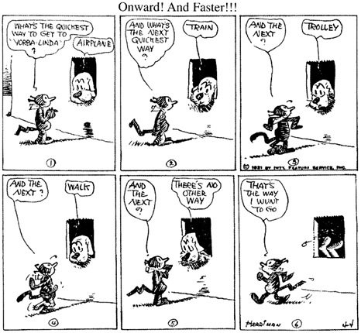
- Bedtime by Lizzie Lawson
"It's bedtime, bedtime, Cissy dear,
It's time to put away,
Your little Noah's ark dear
Until another day,
You know it isn't right at all
To tire yourself with play.”
- The woman was about 180 centimetres tall with a slender build. She was Caucasian with a pale coloured skin tone. The woman had shoulder length, straight blond hair that was pulled back in a ponytail. Her eyes were large and green in colour.
- Nearly all the sports practised nowadays are competitive. You play to win, and the game has little meaning unless you do your utmost to win. On the village green, where you pick up sides and no feeling of local patriotism is involved, it is possible to play simply for the fun and exercise: but as soon as the question of prestige arises, as soon as you feel that you and some larger unit will be disgraced if you lose, the most savage combative instincts are aroused. Anyone who has played even in a school football match knows this. At the international level sport is frankly mimic warfare.
- When Dorothy stood in the doorway and looked around, she could see nothing but the great gray prairie on every side. Not a tree nor a house broke the broad sweep of flat country that reached the edge of the sky in all directions. The sun had baked the plowed land into a gray mass, with little cracks running through it. Even the grass was not green, for the sun had burned the tops of the long blades until they were the same gray color to be seen everywhere. Once the house had been painted, but the sun blistered the paint and the rains washed it away, and now the house was as dull and gray as everything else.
- Across the Risen Sea by Bren MacDibble is a rollicking adventure story that follows the journey of Neoma and her family as they fight for survival in a near-future world where rising sea levels have transformed the land. A story of determination and community, we follow the story of this fierce girl who will do everything to protect those she loves. Recommended for pre-teens or young adults, I give this book a 4 out of 5 rating.
- Who wants to be the most successful school in the region? Who wants to win the debating championship? Who wants to go down in history as the school’s best competitors? If you answered yes, then we are seeking your assistance. As a school, it is important we step up to these opportunities, showcase our abilities and prove to everyone that we are the best! So, who is with me? Sign up at lunch time today.
The next table contains the category cards.
Table 11 – categories
Categories
Narrative story
Poem
Procedural text – recipe
Description
Comic strip
Non-fiction historical text
Play script
Essay
Book review
Speech
References:
- Barrie JM (1860-1937) Peter Pan or The Boy Who Would Not Grow Up (The Play), Project Gutenberg website, accessed 11 October 2023.
- Greer C (1920) School and Home Cooking, Project Gutenberg website, accessed 11 October 2023).
- Project Gutenberg Australia (2019) The First World War and ANZAC, Project Gutenberg website, accessed 11 October 2023.
- Herriman G (4 April 1921) Krazy Kat, Comicstrip library website, accessed 11 October 2023.
- Lawson L (n.d.) Bedtime, Public Domain Poetry website, accessed 11 October 2023.
- De Redder D (2023) Description, NSW Department of Education.
- Orwell G (1945) The Sporting Spirit, Fifty Orwell Essays, Project Gutenberg website, accessed 11 October 2023.
- Baum L Frank (1900) The Wonderful Wizard of Oz, Project Gutenberg website, accessed 11 October 2023.
- De Redder D (2023) Book review, NSW Department of Education.
- De Redder D (2023) Speech, NSW Department of Education.

Phase 1, resource 5 – using the Frayer model
Teacher note: prompt students to ask clarifying questions in relation to the terminology. Students may need some of the language explained or defined. A Frayer model can be used to assist students in developing a deeper understanding of a word. For a version of this template that you can edit, visit the Department’s page, Digital Learning Selector – Frayer diagrams. The Frayer model, as pictured below, has been adapted from Closing the Vocabulary Gap (Quigley 2018:155).
The Frayer model is a graphic organiser that can help us unpack unfamiliar vocabulary we encounter in texts. To use the Frayer model, we complete the following steps:
- Place the target word – the word you would like to understand – in the middle square of the diagram. Look up the definition of the target word in a dictionary. Choose the most appropriate definition and re-write it in your own words.
- Next, look at the ‘characteristics’ section of the diagram. In this section, write down words or phrases that you have come across in the dictionary definition that give us more of an idea of the target word.
- To consolidate your understanding of the word, use it in a sentence.
- To consolidate understanding, look for non-examples to include in the last section of the table.
Figure 1 – Frayer model with definitions

The below diagram is an example of using the Frayer model for the word ‘personification’.
Figure 2 – example Frayer model for the word ‘personification'

- Explore the word ‘escape’ using the Frayer model.
Figure 3 – Frayer model for the word ‘escape’

Phase 1, activity 5 – understanding representation
Use the Frayer model diagram to develop a deeper understanding of the word ‘representation’.
Figure 4 – Frayer model for the word ‘representation’

- View Understanding representation video (2:46) and add additional information to your diagram.
- Examine the representation poster. What else could you add to your Frayer diagram?
Figure 5 – poster representing the concept representation
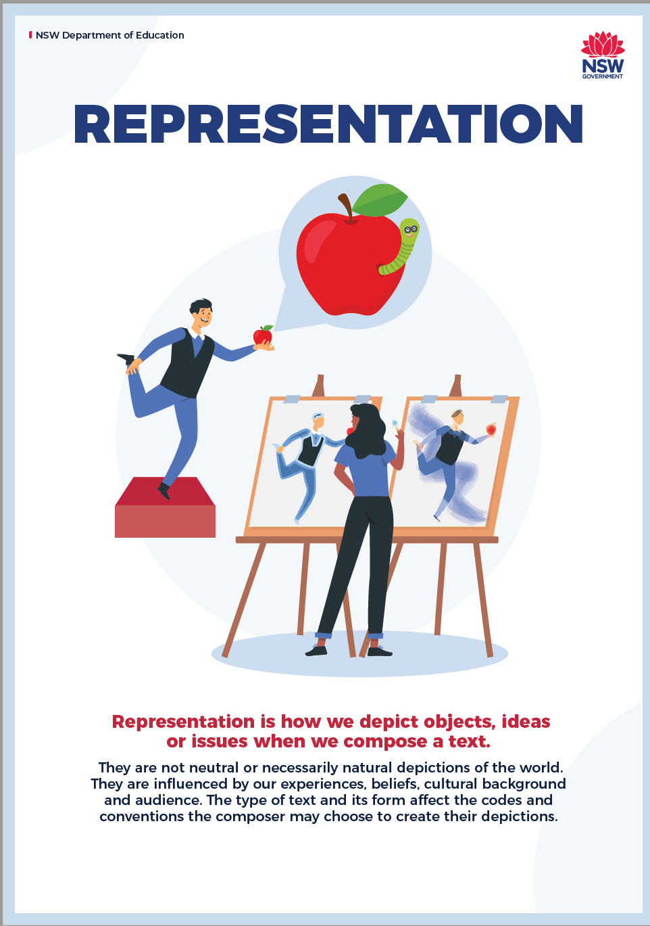

Phase 1, activity 6 – representations of landscapes and landforms in film
Teacher note: select a short clip from one of the suggested films to show the class. It should be selected based on your understanding of locations with which your students would most likely be familiar. Add extra texts or delete the texts listed if they are unfamiliar to students.
Student activity instructions
- Reflect on when you have been to the location in real life or seen the location on the news or other media. Note your observations in the second column.
- View the film clip.
- In the fourth column, note down how the location is represented in the text – use adjectives and 5 senses.
Table 12 – representations of landscapes and landforms in film
Australian location | Real life or own perception of the location | Film | How the location is represented in the text (literary world)
Sydney Harbour |  | Finding Nemo Arrival To Sydney (2:47)
Mount Warning |  | Ferngully (5:13)
Northern Australian rainforest |  | Crocodile Dundee (2:40)
Australian countryside or farm |  | Babe (2:12)
Dampier, Pilbara region of Western Australia |  | Red Dog (2:21)
Sydney and Bellingen |  | Danny Deckchair (2:14)

Phase 1, activity 7 – symbolism and representation
Teacher note: text choices may need to be adapted for EAL/D students who have limited knowledge of popular youth texts in Australian society. This activity should be adapted to suit the background knowledge of student cohorts.
- Examine the images.
- Match the image with the name of the correct world from the resource list.
- Based on this activity, make an inference of the meaning of ‘literary worlds’ and write in it in your workbook.
Resource list:
- "Alice in Wonderland (Illustrator: Hudson, 1922?) Croquet with the Duchess" by Toronto Public Library Special Collections is licensed under CC BY-SA 2.0.
- ‘Hogwarts’ representation, Photo by RAMSHA ASAD on Unsplash.
- ‘Hundred acre woods’ representation, photo by Annie Spratt on Unsplash.
- ‘Middle Earth’, Photo by Jeff Finley on Unsplash.
- ‘Narnia’ representation, Photo by Szymon Fischer on Unsplash.
- ‘North Pole’ representation, Photo by Norman Tsui on Unsplash.
- ‘Panem’ representation, Photo by De'Andre Bush on Unsplash.
- "The Wizard of Oz (1939)" by twm1340 is licensed under CC BY-SA 2.0.
Table 13 – matching images with literary worlds
Image | Literary world
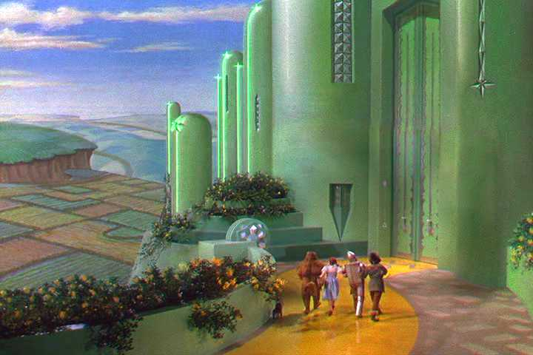.
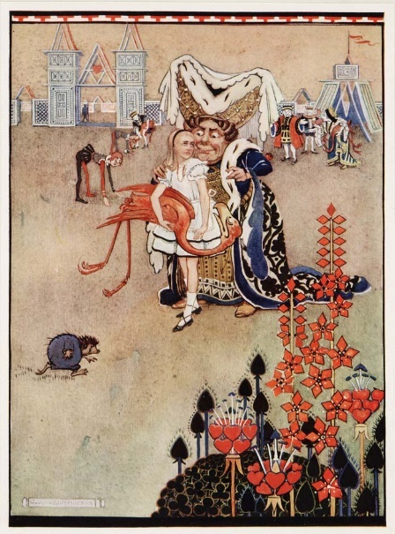
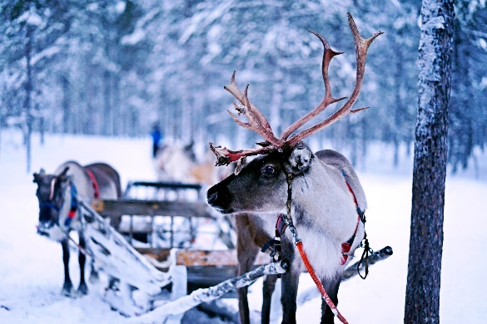
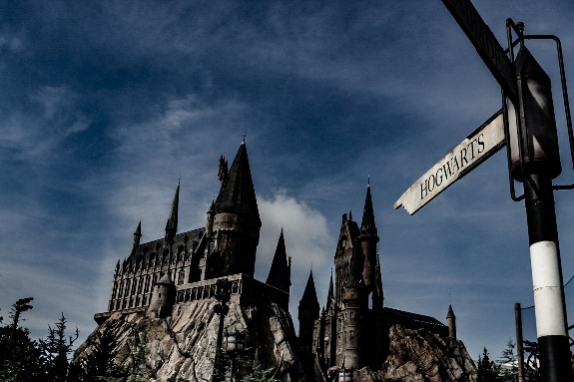
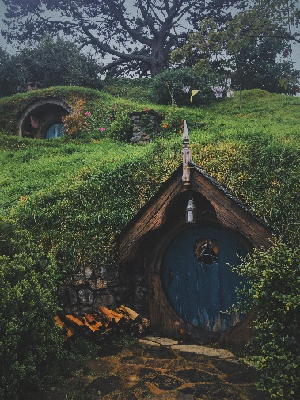
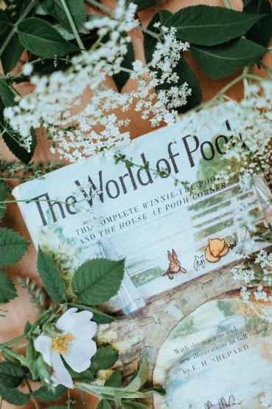
Teacher note: the correct responses for the literary world match activity are below.
Table 14 – inference answers
Image | Literary world
. | ‘The Wizard of Oz (1939)’ by twm1340 is licensed under CC BY-SA 2.0.
 | ‘Narnia’ representation, photo by Szymon Fischer is licensed under the Unsplash License.
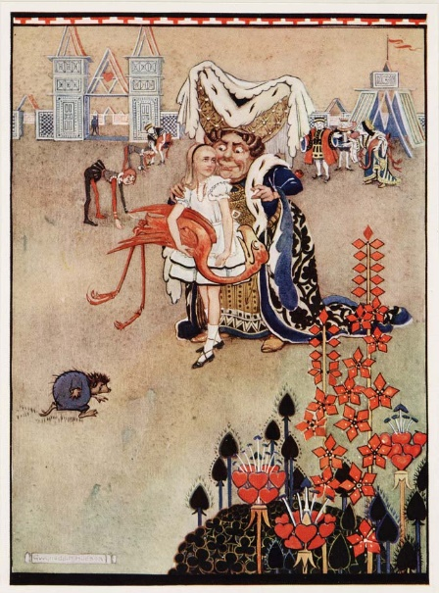 | ‘Alice in Wonderland (Illustrator: Hudson, 1922?) Croquet with the Duchess’ by Toronto Public Library Special Collections is licensed under CC BY-SA 2.0.
 | ‘North Pole’ representation, photo by Norman Tsui is licensed under the Unsplash License.
 | ‘Hogwarts’ representation, photo by RAMSHA ASAD is licensed under the Unsplash License.
 | ‘Middle Earth’, photo by Jeff Finley is licensed under the Unsplash License.
 | ‘Hundred acre woods’ representation, photo by Annie Spratt is licensed under the Unsplash License.
 | ‘Panem’ representation, photo by De'Andre Bush is licensed under the Unsplash License.

Phase 1, resource 6 – sample definition
Sample definition:
Literary world – a made-up place or setting that belongs to a fictional story. It can be based on a real location but can also be completely made up.
Reason – based on the image representing the North Pole, this is a setting based on a real place with real creatures such as reindeer, but they are altered to fit into the magical world of Santa.

Phase 1, activity 8 – prepositions and prepositional phrases
Glossary
- Preposition – a word that begins an adverbial phrase or an adjectival phrase indicating time, place, manner, causality, for example in, on, after, before, by, under, over, of, through.
- Prepositional phrase – units of meaning within a clause that begin with a preposition. They indicate how, when, where or why, for example 'She ran into the garden', 'He is available from nine o'clock'.
- View Meet the preposition | The parts of speech | Grammar | Khan Academy (3:48).
- Identify the prepositions in the following sentences:
- Amanda’s dog is inside its kennel.
- During the carnival, Simon lost his shoe.
- Wendy went to the party with Mike.
- The horse galloped over the road and into the paddock.
- The koala climbed up the tree.
- Yesterday, I ate chips.
- View Prepositional phrases | The parts of speech | Grammar | Khan Academy (5:37).
- Underline the prepositional phrase and bold or circle the prepositions in the following sentences:
- The man on the stage is a fantastic actor.
- Junior hides under the bed.
- After the show, we went to the museum.
- Mum was hiding our presents in the cupboard.
- Mark went skating with his friend.
- Without asking permission, Sam wrote his name on the board.

Phase 1, resource 7 – prepositions and prepositional phrases answers
- Identify the prepositions in the following sentences.
- Amanda’s dog is inside its kennel.
- During the carnival, Simon lost his shoe.
- Wendy went to the party with Mike.
- The horse galloped over the road and into the paddock.
- The koala climbed up the tree.
- Yesterday, I ate chips.
- Underline the prepositional phrase and bold or circle the prepositions in the following sentences:
- The man on the stage is a fantastic actor.
- Junior hides under the bed.
- After the show, we went to the museum.
- Mum was hiding our presents in the cupboard.
- Mark went skating with his friend.
- Without asking permission, Sam wrote his name on the board.

Phase 1, resource 8 – interactive writing
Teacher note: the teacher might like to trial the ‘Interactive writing’ technique (Daffern and Mackenzie 2020) as an introduction to this task. Interactive writing is a co-constructed writing strategy which aims to support student brainstorming and compositional skills. The teacher orchestrates class discussion and shares the pen with students, while guiding the collective text towards the skills and outcomes desired.
A routine for an interactive writing lesson will involve the following steps:
- Teacher curates a class brainstorm of ideas about setting, character and other features of the orientation on a graphic organiser.
- Teacher uses a black marker and students a coloured one to contribute. Teacher thinks aloud and asks guiding questions such as ‘What might the character be doing at this point?’
- Teacher leads the co-construction of the text using class ideas. Students are invited, strategically, to contribute, while the teacher corrects errors and guides the writing so that students practise new skills and demonstrate known ones. Teacher encourages, in particular, use of target vocabulary and syntax from this Phase.
- Teacher continues thinkaloud through entire process to demonstrate text creation and cycles of evaluation and re-drafting.
- Opportunities for reading aloud the developing text are set up by the teacher.
- Teacher guides completion of co-constructed text and supports students to increasingly write words, phrases and clauses independently.
- At a key point, teacher invites students to continue independently or to write their own versions.

Core formative task 1 – imaginative orientation
Teacher note: guide students through each of the activities with explicit focus on the sample reflective activities to build self-monitoring capacity.
This task will give you an opportunity to explore ways to craft an orientation that enables the responder to ‘escape’ into the text.
Writing an imaginative orientation
- Use the ideas from the Eerie encounter game to craft an orientation for your own story. Your orientation should be approximately 100–200 words in length.
- You may like to use the scaffold below to assist your writing.
- Examples have been included for each language or structural device provided.
- Put your own example in the third column and use it in your full piece if you like it (you may need to adjust it slightly to fit).
- Don’t forget to start with an action!
- Type or write your orientation in full on a separate document for peer editing.
Table 15 – writing scaffold
Language checklist | Example | Your text
Action | Whack! The branch slapped me across the face hard… real hard.
Dialogue | “Help me!” I yelled as I raced across the paddock.
Description | Its face (or what I thought was its face) drooped down to brush against the burnt grass as it turned towards me.
Describe what is happening. | I couldn’t believe it! Right there in front of me stood a creature I had never seen before – not on television or even in a book.
Introduce protagonist. | How could I, just a school kid, be in this situation? I should be sitting back at home with a mouthful of chips and Grand Theft Auto blasting on the TV. I can tell you, this is not my idea of fun.
Establish setting. | But here I am… somewhere in the middle of nowhere smack bang in a paddock filled with corn stalks with no idea of how to get home.
Use figurative language (SHAAMPOO)  Simile  Hyperbole  Alliteration  Assonance  Metaphor  Personification  Oxymoron  Onomatopoeia | The night was as black as soot.  It was bigger than a skyscraper.  As always, Alex answered the alarm.  A small call rang out.  A tsunami of emotions hit me.  The branch clawed at my face.  It was a bright night.  “Whoosh!”
- Use the checklist to ensure you have included appropriate features of an engaging orientation.
Table 16 – checklist for an engaging orientation
Technique | Used
I have used an action, dialogue or description in the first sentence.
My opening sentence grabs the responder’s attention.
I have used vivid language (adjectives, adverbs, figurative language).
I have introduced the audience to my protagonist.
I have established some form of setting.
My introduction has between 5–10 sentences.
I have checked for accurate spelling and punctuation.
- Look at the sample writing task and self-reflection. Does yours look similar?
Sample writing task for Core formative task 1 – imaginative orientation
There was a bright light and a spaceship landed on the ground in front of me. My friend Pete said we had to hide but I didn’t want to. He’s a big scaredy pants so he ran off. I just stood there and looked at the ship. It was grey and shaped like a frisbee. I touched it and it was smooth and cold. Then it moved. I stepped back and heard a big noise. A big door opened and three strange creatures walked down the ramp. I thought it was cool but I was a bit nervous of what would happen.
Sample self-reflection for Core formative task 1 – imaginative orientation
- This is a sample of self-reflection. Do you think it has enough detail? Annotate ideas to provide more information.
Table 17 – sample checklist for an engaging orientation
Technique | Used
I have used an action, dialogue or description in the first sentence. | Kind of
My opening sentence grabs the responder’s attention. | Yes – spaceship
I have used vivid language (adjectives, adverbs, figurative language) | Not really
I have introduced the audience to my protagonist. | Kind of
I have established some form of setting. | Not really
My introduction has between 5–10 sentences. | Yes
I have checked for accurate spelling and punctuation. | Yes
- Swap your work with a peer and provide feedback on each other’s work using the peer feedback scaffold. If the technique has been used, identify it and write it in the third column. If it has not been used, make a suggestion in the third column instead.
Table 18 – peer feedback scaffold
Language device or feature | Used | Example or suggestion for improvement
Action, dialogue or description has been used in the first sentence.
Opening sentence grabs the responder’s attention.
Vivid language (adjectives, adverbs, figurative language) has been used.
The protagonist has been introduced.
Setting has been established.
Introduction has between 5–10 sentences.
Accurate spelling and punctuation.
Sample peer feedback for Core formative task 1 – imaginative orientation
- Consider how the sample peer feedback could be used to improve the sample writing task for Core formative task 1 – imaginative orientation. What do you think are the 2 most important suggestions the writer should use?
Table 19 – sample peer feedback scaffold
Technique | Used | Example or suggestion for improvement
Action, dialogue or description has been used in the first sentence. | No | A blinding light flashed in front of me.
Opening sentence grabs the responder’s attention. | No | Start with dialogue – for example: “Whoah! What’s that?” Pete yelled as a blinding light flashed in front of us.
Vivid language (adjectives, adverbs, figurative language) has been used | No | Use show don’t tell and SHAMPOO.
The protagonist has been introduced. | Sort of | “I” – we know his friend is Pete and the protagonist is braver than Pete – could add in some more information.
Setting has been established. | No | Where are you? Describe this in your introduction. For example: I was standing in the middle of the local cricket pitch. You could tell it hadn’t had a lick of water for quite some time as my steps had crunched as I paced across it.
Introduction has between 5–10 sentences. | Yes | No changes needed.
Accurate spelling and punctuation. | Almost | There  Capital letter for person’s name – Pete.  Use dialogue.  Proofread your work carefully.
- Now look at your own feedback. Does it have sufficient detail? If not, give it back to your peer for additional feedback.
- When you have enough feedback, select the 2 most important feedback suggestions and improve your writing.
- Now read the sample improved piece of writing. Is it better? Can you highlight the parts where feedback was used?

Phase 1, resource 9 – sample improved orientation
Sample improved piece of writing for Core formative task 1 – imaginative orientation
“Whoah! What’s that?” Pete yelled as a blinding light flashed in front of us.
I couldn’t believe my eyes as a disc as big as a giant’s frisbee hovered above us. We stood frozen in place as we peered up at this miraculous sight. We were standing smack bang in the middle of the local cricket pitch. You could tell we hadn’t had a lick of rain for quite some time as my steps had crunched as I paced across it. Now, as the giant frisbee drew nearer, I worried the intense heat bouncing off it, would set the whole town on fire.
“Jeez, Max! What are you doing just standing there? We’ve got to get out of here!” yelled Pete as he spun on his heels to escape. Pete’s always been a big wuss – when he was 5, we went to a circus and he ended up crying like a baby because the clown came up to him and shook his hand. So it didn’t really surprise me that he was now just a fleeting shadow in the distance beyond the outer fence of the cricket grounds.
[188 words]
- Go back and make any further changes to your work.

Phase 1, resource 10 – spelling (refining checklist part 1)
Teacher note: a refining checklist has been added to the writing process for every core formative task in this program. Use the following process, which starts with spelling then adds one refining focus for each task, to support students to refine writing.
To support student refining, the teacher could:
- guide students through the examples and understanding indicated in the annotated text in the table
- support student extension by finding other examples in the core text
- support paired and independent student refining practices by asking students to use the sample and its annotated examples to check and improve their own writing in Core formative task 1.
Table 20 – model text and annotations for refining spelling
Model text | Annotations – spelling
“Whoah! What’s that?” Pete yelled as a blinding light flashed in front of us.  I couldn’t believe my eyes as a disc as big as a giant’s frisbee hovered above us. We stood frozen in place as we peered up at this miraculous sight. We were standing smack bang in the middle of the local cricket pitch. You could tell we hadn’t had a lick of rain for quite some time as my steps had crunched as I paced across it. Now, as the giant frisbee drew nearer, I worried the intense heat bouncing off it, would set the whole town on fire.  “Jeez, Max! What are you doing just standing there? We’ve got to get out of here!” yelled Pete as he spun on his heels to escape.  Pete’s always been a big wuss – when he was 5, we went to a circus and he ended up crying like a baby because the clown came up to him and shook his hand. So it didn’t really surprise me that he was now just a fleeting shadow in the distance beyond the outer fence of the cricket grounds. | ‘frisbee’, ‘peered’, ‘heels’ and ‘fleeting’ – Double 'e' is often used to make a long vowel sound. It is a common convention in English spelling, but it is not always consistent.  'quite' – indicating extent or degree (as opposed to its homophone ‘quiet’). This is an opportunity to start a ‘homophone’ spelling list.  ‘bouncing’ and ‘outer’ – The combination of ‘ou’ is a common and tricky one. It is a diphthong and pronunciation is not always consistent with spelling. Compare ‘outer’ to ‘brown’.  ‘off it, would’ – The comma is not needed and is used incorrectly.  'We've' – a contraction of 2 words: 'we' and 'have'. An apostrophe replaces the missing letters.  ‘Surprise’ – commonly misspelt word - often the 'r' is left out, or the 's' is replaced with 'z'. What other commonly misspelt words are included here?

Phase 1, resource 11 – additional strategies for introducing a novel
Teacher note: introducing a text can be done using a range of different approaches. It is not an expectation that students complete all of the suggested activities. The following strategies could be used for any text being studied. The focus is on supporting students to collect information, make and refine predictions about the text and deepen their understanding of context.
General strategies
- Understanding context – revisit prior understanding of the term ‘context’.
- Context – an environment or situation (social, cultural or historical) in which a text is responded to or created. Or wording surrounding an unfamiliar word, which a reader or listener uses to understand its meaning.
- Research the contextual setting of the text and create a presentation or brochure to demonstrate learning. Students could include
- a setting description
- a suburb/venue map
- things to do in the area
- demographics
- the cultural beliefs of members of the local population.
- View or listen to an interview with the author and make predictions about the connection between the interview content and the novel.
- Visit a related location (in-person or virtually) to gain background knowledge.
- Listen to a guest speaker discuss the significance of a location or plot point from the story.
- Visit a museum related to the text and guide students as they examine images, recordings and artifacts.
- Curate a gallery walk – the teacher can select a series of objects, images, excerpts from non-fiction texts or other items and guide students as they examine the materials.
Novel suitcase
Teacher note: the philosophy of this activity is to engage students in the text and inspire a desire to read it. Therefore, the teacher should attempt to be creative in their choices and presentation. The number and type of items can be varied to suit the class context.
A ‘novel suitcase’ is a way of introducing a topic to the class. In the case of a novel, it can hold items that represent setting, characters and events. The aim is to engage students in wanting to find out more about the text being studied as well as to help them make predictions about what the book is about.
The suitcase should contain 5 items (either literal or inferential depending on class context) that represent the text being studied. Each item is removed from the ‘suitcase’ and students reflect on what it could represent about the story. Students can do this in a number of ways:
- think individually and record their ideas
- share with their pair
- share what each represents as a class
- class plenary – what might the book be about?
- write a list of ideas.
Table 21 – suggestions for Across the Risen Sea suitcase items and their possible representations
Item for suitcase | Possible representations
A map | Journeys, adventure
Picture of a rusty old bus | Journeys, family, outdated technology
Picture of a flooded town | Climate change, danger, the power of water
Fishing rod | A pastime but also an activity linked to survival
Electric wires | Energy, technology, danger
Prediction chart
Teacher note: the NSW Centre for Effective Reading provides resources that guide assessment processes and teaching strategies that support all students, especially those with reading difficulties. The ‘making predictions’ template for this activity has been adapted from page 15 of the Comprehension Handbook (a downloadable PDF).
- Complete the table with your initial predictions based on the cover of the book.
- Read the blurb of the book and add to your predictions.
- Read the opening 7 pages of Across the Risen Sea and add to or amend your predictions.
Table 22 – making predictions template
Text feature | What I see | Prediction
Title of the novel
Illustrations on the front cover
Colours used
Font
Blurb content
Blurb layout
Orientation

Phase 1, resource 12 – list of prediction words from Across the Risen Sea
Teacher note: this resource aligns with the student activity in Phase 1, activity 9 – parts of speech. To support specific class and student needs the teacher may stop the playback of listening tasks to allow time to check understanding or take notes. The teacher may review target parts of speech prior to the following activity and provide a glossary for students to use. Extension students could complete a Frayer diagram, using some, all, or Tier 2 words from the list (Phase 1, resource 5 – using the Frayer model).
- The teacher reads an extract from the text (first page of chapter 1 ‘This Off Day’).
- The teacher reads the specific words to the class, allowing enough time for the students to decide which column it belongs to in the table in Phase 1, activity 9 – parts of speech. (It may be necessary to re-read the word in its sentence for students to identify its part of speech.)
- Check the answers at the end of the activity and reinforce why each word belongs in each category.
Table 23 – list of words with answers
Word | Part of speech | Word | Part of speech
Rusty Bus | proper noun | friend | noun
beach | noun | swimming | verb
Margy | proper noun | Neoma | proper noun
grouchy-tired | adjective | gasping | verb
sea | adjective or noun | newborn | adjective
Jaguar | proper noun | sweaty | adjective
scrambles | verb | buzzing | verb
loo | noun | salvagers | noun

Phase 1, activity 9 – parts of speech
Definitions:
- Nouns: refer to a person, place or thing
- Verbs: refer to the actions of the subject of the sentence
- Adjectives: enrich a sentence by describing nouns
- As your teacher reads individual words from the novel, list the words in the correct column.
Table 24 – parts of speech
Nouns | Verbs | Adjectives

Phase 1, activity 10 – matching vocabulary to story elements
- In pairs, use the words you have been given to categorise the elements or ingredients of the story. Some have been done for you – you will need to add in the remaining words.
Table 25 – vocabulary and elements matching
Elements or ingredients of a story | Words from the novel
Setting – the time and place where the story is set | Rusty Bus
Plot – the events that happen in the story | scrambles
Characters – who is in the story | Neoma

Phase 1, resource 13 – creating predictive sentences
The below table can be used to support student understanding (or review) of sentence types that could support a student to write predictive sentences about the novel.
Table 26 – glossary of sentence terminology
Terminology | Meaning | Effect | Example
Appositive | A noun, or noun group, that immediately follows and renames another noun in order to clarify or classify it. | Used to reduce wordiness, add detail, and add syntactic variety to a sentence. | The setting, a drowned world, might mean that the novel is set in the future.
Compound sentence | Two simple sentences joined by a coordinating conjunction such as ‘and…so…or’. | Reduces wordiness and is used to compare things or show a cause-and-effect relationship. | The main characters are teenagers so the story could be about growing up.
Complex sentence | An independent clause joined to a dependent clause with a subordinating conjunction. | Creates sophistication in writing by adding more information. | Although Neoma is young, she is fierce and independent.
Dependent clause | A phrase that doesn’t make sense on its own and starts with a subordinating conjunction. | Adds additional or clarifying information to a sentence. | Neoma is young
Independent clause (simple sentence) | Has a noun and a verb and makes sense. | Provides information. | She is fierce and independent.
Subordinating conjunction | A word or phrase that links a dependent clause to an independent clause. | Indicates that a clause has informative value to add to the sentence's main idea, signalling a cause-and-effect relationship or a shift in time and place. | After  Although  As  When  While  Until  Because  Before  If  Since
Modal verbs | Words that add to or modify the sense of the main verb. | Indicates possibility or the level of certainty. | Might  Could  Should

Phase 1, resource 14 – genre
Teacher note: English textual concepts posters are available for download on the NSW Education English K–12 website. Students will explore genre in greater detail in a later phase.
- Students view the Department of Education resource ‘Understanding genre video (3:00)’.
- In pairs or individually, they create a definition for genre in their workbooks.
- Students examine the poster and annotate any additions to their definition.
Figure 6 – genre poster
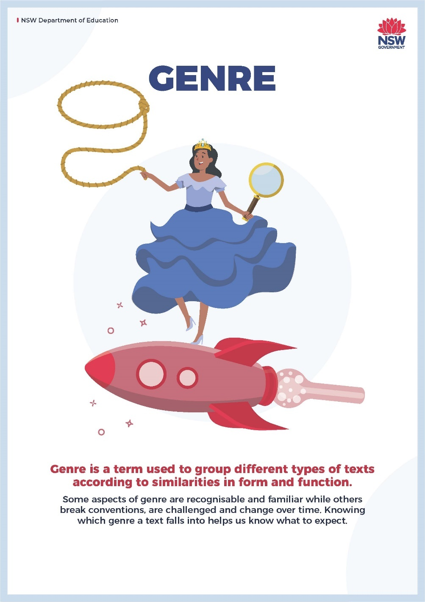

Phase 1, activity 11 – genre match
Teacher note: EAL/D students may have limited understanding of these texts, which are popular in the Western canon. This activity may be a good opportunity to allow for EAL/D students to draw on examples of texts from their first languages to demonstrate their understanding of the concept of genre.
Note also for differentiation, that the teacher can reduce the number of items for the genre match and use different font types in each column.
- Match the genre with the correct description and example text. You may like to do this by colouring the matching components for each genre in one colour.
Table 27 – genre match
Genre | Description | Example text
Adventure | A story where the reader has to solve a puzzle | One of Us Is Next – Karen M. McManus
Science fiction | A story about future technology, time or space travel | Barack Obama – Barack Obama
Thriller or suspense | A story about fantastic events and magical creatures | Harry Potter and the Philosopher’s Stone – JK Rowling
Humorous or comedy | A coming-of-age story where the main character shows growth or maturity | The Hunger Games – Suzanne Collins
Mystery or detective | A story about an exciting journey for the main character | Snow White and the Seven Dwarves – The Brothers Grimm
Love story or romance | Story set in a futuristic world that has obvious shortcomings | The Lightning Thief (Percy Jackson and the Olympians) – Rick Riordan
Legend | A story about someone’s life written by someone else | Bridge to Terabithia – Katherine Paterson
Fable | Horror stories about crime or murder | The Adventures of Sherlock Holmes – Sir Arthur Conan Doyle
Biography | A fictional story where the main characters are non-human | Diary of a Wimpy Kid – Jeff Kinney
Fairytale | A funny story with a happy ending | A Wrinkle in Time – Madeleine L'Engle
Autobiography | A romantic story about love and relationships | The Hare and the Tortoise – Aesop
Bildungsroman | A story about someone’s life written by that person | 50 cent – Jj Vance
Dystopian | A traditional story about heroes from the past | Love from Scratch – Kaitlyn Hill

Phase 1, resource 15 – genre match answers
The correct responses for the genre match activity are below.
Table 28 – genre match answers
Genre | Description | Example text
Adventure | A story about an exciting journey for the main character | Harry Potter and the Philosopher’s Stone – JK Rowling
Science fiction | A story about future technology, time or space travel | A Wrinkle in Time – Madeleine L'Engle
Thriller or suspense | Horror stories about crime or murder | One of Us Is Next – Karen M. McManus
Humorous or comedy | A funny story with a happy ending | Diary of a Wimpy Kid – Jeff Kinney
Mystery or detective | A story where the protagonist has to solve a puzzle | The Adventures of Sherlock Holmes – Sir Arthur Conan Doyle
Love story or romance | A romantic story about love and relationships | Love from Scratch – Kaitlyn Hill
Legend | A traditional story about heroes from the past | The Lightning Thief (Percy Jackson and the Olympians) – Rick Riordan
Fable | A fictional story where the main characters are non-human | The Hare and the Tortoise – Aesop
Biography | A story about someone’s life written by someone else | 50 cent – Jj Vance
Fairytale | A story about fantastic events and magical creatures | Snow White and the Seven Dwarves – The Brothers Grimm
Autobiography | A story about someone’s life written by that person | Barack Obama – Barack Obama
Bildungsroman | A coming-of-age story where the main character shows growth of maturity | Bridge to Terabithia – Katherine Paterson
Dystopian | Story set in a futuristic world that has obvious shortcomings | The Hunger Games – Suzanne Collins

Phase 1, activity 12 – how does genre engage responders?
Teacher note: when showing films or film clips, you must ensure that the classification is appropriate for your students. You may like to use the Text selection notification provided on the Department’s website. If you have not done so already, please review the Controversial issues in schools policy and the procedures for use. Sample permission forms are available on the Leading English 7–12 page of the department’s website.
- As you view each clip, identify its genre. Remember, some clips may have several genres.
- Write down at least 2 conventions you notice in the clip that fit the genre.
- Indicate whether this particular genre invites you into the text with a Yes or No.
- Consider: has your opinion on your favourite genre changed?
- Complete the favourite genre form.
Table 29 – genre and conventions in film
Film clip | Genre | Conventions | Invites me in? Yes or No
The Rescuers - Trailer #1 – 1977 (2:52) (G)
Rio (2:06) (G)
WALL·E Trailer (2008) (2:31) (G)
The Nightmare Before Christmas (1993) (1:25) (G)
The Great Mouse Detective (1986) Trailer (1:15) (G)
The Swan Princess (2:14) (G)

Phase 1, resource 16 – answers for how genre engages responders
Potential answers are below, but these responses are not absolute.
Table 30 – genre and conventions in film answers
Film clip | Genre | Conventions | Invites me in? Yes or No
The Rescuers - Trailer #1 – 1977 (2:52) (G) | Adventure | Journey to find something  Danger, antagonist  Pass test to succeed
Rio (2:06) (G) | Comedy | Humorous jokes  Slapstick comedy
WALL·E Trailer (2008) (2:31) (G) | Science fiction | Out of space  Robots  Astronauts
The Nightmare Before Christmas (1993) (1:25) (G) | Horror | Talking living house  Dark features  Scary music
The Great Mouse Detective (1986) Trailer (1:15) (G) | Crime or detective | Solve a puzzle  Detective  Problems to be dealt with
The Swan Princess (2:14) (G) | Romance | Feelings between 2 people  Loss and finding someone  Soul mates

Phase 1, activity 13 – the Explanation Game
- In your group, ask yourselves: How are we invited to escape into texts through genre?
- Each group member can record their initial observations in the first column.
- Work together to complete the rest of the columns.
- Select your best idea to share with the class.
Table 31 – the Explanation Game
Initial observation – how am I invited into the text? | Explanations or hypotheses – how does it do this? | Reasons or justifications – why does it do this?

Phase 1, activity 14 – response to the novel’s orientation
- After reading the novel’s orientation, complete the table with the relevant information.
Table 32 – initial response to the text
Stimulus question | Response
What genre is the novel?
Where is it set?
What is the context of the story?
What was the most interesting part of the orientation?
- Write a personal reflection responding to the question: how are we invited to escape into texts? Use the following prompts to guide your response:
- In what ways does the novel appeal to you? Why?
- Does the setting and context allow you to feel familiar with the plot? Explain.
- Can you see similarities to things in your own life? Discuss.
- How important is the genre in inviting or engaging you in the text?
- Do you think you can ‘escape’ into this book? Why or why not?

Phase 2 – unpacking and engaging with the conceptual focus
In this phase, students begin to explore the conceptual focus of the program – the ways in which narrative and characterisation invite an escape into the worlds of fiction. They investigate how their experiences of reading fiction are influenced by the choices made by writers in their use of the codes and conventions of imaginative writing. Students will begin their engagement with a core text and respond to a range of model texts to develop an informed personal perspective. They will investigate how an exploration of these worlds can lead to a broadening engagement with others, the world and their understanding of their own personal, emotional and intellectual responses.
Students will consider the way that narrative elements such as rising tension, and aspects of characterisation such as the choice of point of view, create effective narratives. They experiment with these features in their own writing and reflect on the impacts of their own choices as the composers of imaginative texts.
Building from Stage 3, students should understand how narrative conventions engage the reader and apply this understanding when creating texts. They analyse how patterns in narratives set up expectations and experiment with these patterns in their own writing. From early in Stage 4, students will continue to refine their reflective writing and deepen their understanding of the recursive nature of the writing process as they will experiment with elements of narrative.

Phase 2, resource 1 – adapted conceptual framework
Teacher note: the following diagram has been provided to support teacher planning and implementation following an ‘adopt and adapt’ model. This adaptation of the conceptual framework triangle illustrates the way in which this phase of the program has been conceived and planned. Since the key objective of this phase is on student engagement with the conceptual focus, it is important to clarify the key concepts and explain how their interaction leads to ‘conceptual understanding’ (see Stern, Ferraro and Mohnkern 2017).
Figure 7 – adapted conceptual framework diagram of Phase 2 (for teacher reference)
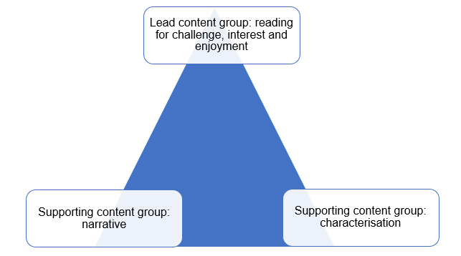
Notes on how to use the diagram above:
- We would normally take our concepts from within EN4-URA-01, EN4-URB-01 and EN4-URC-01. Since this phase is early in the program and the focus is on the ways that reading helps us make connections to the world around us, a content group from EN4-RVL-01 has been chosen as the lead content group as it is central to all teaching and learning in this phase.
- The diagram points us towards the relationships between concepts. They are a way to leverage conceptual thinking and a focus on a specifically subject English approach to a topic. We are interested in the ways in which narrative might encourage us to read for the challenge of broadening understanding of the world. Students consider the ways choices within narratives interact with choices in characterisation, such as the point of view a story is told from. Finally, they investigate how narrative and characterisation codes and conventions can allow texts to serve different personal and social purposes.

Phase 2, resource 2 – villains revealed
Teacher note: examples of film texts from which (age-appropriate) scenes can be shown to demonstrate the villain being revealed either at the end or at the beginning include the following. Note that this is intended as a short stimulus activity and it may not be necessary to view scenes. A curated student-led discussion (students must receive teacher approval before discussing a text) of their viewing experiences may be more appropriate. PG classified content can be shown with parental permission and in alignment with the Controversial issues in schools policy. As per the policy, principals are responsible for approving such texts. Text selection notification and permission samples are provided on the English curriculum Leading English 7–12 webpage.
- Scooby Doo – there is a reveal in most episodes. See for example the ‘Unmasking classic villains compilation (25:20)’ (YouTube)
- Note that Murder, She Wrote, Murder on the Orient Express (1974) and Young Sherlock are all PG rated and certain scenes can only be shown with parental permission and in alignment with the Controversial issues in schools policy.
Discussion prompts for teacher-directed discussion:
- Do you enjoy stories more or less if you know who the villain is from the beginning?
- The narrative usually increases in intensity before the villain is revealed (or a false reveal). What makes for good ‘narrative structure’ in this situation? (The teacher may check understanding of key terminology here. Note the conventions association with ‘rising tension’ is introduced in a later activity.)

Phase 2, activity 1 – match and sort
Teacher note: this activity can be adjusted by providing half the class with the structural elements of narrative and the other half with the definitions. Students move around the classroom to find their ‘match’. When all have been matched correctly, all students complete the table below. This activity has been adapted from Stage 5 reading – text structure and features.
- Match the structural elements of narrative in the column on the left, with the definition or purpose in the column on the right.
Table 33 – match and sort activity student activity
Structural element of narrative | Definition
Title | The historical and geographical location in which the story takes place.
Orientation | The point in a narrative where the conflict or tension is at its highest intensity.
Setting | A struggle between 2 opposing forces. It can be internal; a character may experience struggle with themselves. It can be external; a character may struggle with another character or a situation.
Characters | A short phrase or word that reflects the theme or premise of the text.
Complication | Occurs after the climax or complication, when the point of tension eases.
Conflict | The events leading to a complication or to the climax (in a story, a chapter of extended prose, or a novel).
Rising tension | The people, animals or entities in the text.
Climax | Occurs after the climax or complication, when the point of tension eases.
Falling tension | An event that significantly challenges the character(s). The tension rises to this point, then resolves before further tension. An effective complication must change the course of the story and challenge the protagonist’s ‘desire line’.
Resolution | Introduces characters and setting. May fill in relevant background information or hint at the narrative arc or instigating problem of the story.
Teacher note: the correct answers have been provided below.
Table 34 – match and sort activity teacher answers
Structural element of narrative | Definition
Title | A short phrase or word that reflects the theme or premise of the text.
Orientation | Introduces characters and setting. May fill in relevant background information or hint at the narrative arc or instigating problem of the story.
Setting | The historical and geographical location in which the story takes place.
Characters | The people, animals or entities in the text.
Complication | An event that significantly challenges the character(s). The tension rises to this point, then resolves before further tension. An effective complication must change the course of the story and challenge the protagonist’s ‘desire line’.
Conflict | A struggle between 2 opposing forces. It can be internal; a character may experience struggle with themselves. It can be external; a character may struggle with another character or a situation.
Rising tension | The events leading to a complication or to the climax (in a story, a chapter of extended prose, or a novel).
Climax | The point in a narrative where the conflict or tension is at its highest intensity.
Falling tension | Occurs after the climax or complication, when the point of tension eases.
Resolution | The outcome of a complication that then sets up new rising tension.

Phase 2, resource 3 – story, plot and narrative
Teacher note: although the terms story, plot and narrative are often used interchangeably, there are significant nuances in their meaning which should be taught explicitly to students.
Table 35 – story, plot and narrative definitions
Term | Definition
Story | A more generic term that usually refers to type (a love story) or purpose and effect (humorous or educative). The focus is on ‘what happened’ as opposed to why or how it is structured.
Plot | The arrangement of the set of events in a story. Plot may refer to the sequence of events or significant action and depend on cause and effect.
Narrative | The techniques and conventions by which a story is created. In its simplest form, narrative refers to a set of events occurring in a time sequence, but most narratives also use features such as character and setting to tell the story.
Students are supported to apply their understanding of the terms ‘story’, ‘plot’ and ‘narrative’ by completing the table below to describe each of these terms using a text with which you are familiar. It may be a text that has been used in class or one that students have engaged with outside of class.
An example using ‘Cinderella’ has been provided as a model.
Table 36 – modelled example using ‘Cinderella’
Term | Cinderella
Story | This is a fairy tale about a kind, but mistreated young woman who finds her ‘happily ever after’. It is a story with a moral or message.
Plot | The poor protagonist is helped by magic to meet a prince who falls in love with her. She becomes a princess because her foot fits the shoe she left behind.
Narrative | This ‘rags to riches’ narrative engages readers because it appeals to their sense of justice. The ‘good’ characters are rewarded with a happy ending while the ‘bad’ characters suffer.
This version can be used after students have listened to the story as extra practice.
Table 37 – modelled example for ‘Not in the lesson plan’
Term | ‘Not in the Lesson Plan’
Story | This is an entertaining (funny and dramatic?) story of a teacher’s decision to take his class to the park.
Plot | The school’s decision not to allow recess leads to the teacher’s plan to take his class to the park. The teacher’s desire to play with every student leads to a climactic accident and injury.
Narrative | This ‘accident’ type of anecdotal narrative is engaging because it is set in a school (and park) and involves a subversion when it is the teacher who suffers the accident in the climax.

Phase 2, activity 2 – identifying the structural elements of narrative in a text
Teacher note: the following text is taken from ‘The Moth’ website. The Moth Story Slams are competitions where people tell true, personal stories relating to a specified theme. Exploring this platform for storytelling and running a class or interclass story slam would provide an opportunity for HPGE students to enrich their learning.
Complete the pre-listening activities focused on prediction.
- Predict what the story will be about based on the title ‘Not in the Lesson Plan’.
- Predict the order in which the following plot elements will occur:
- chasing a student
- wrapping a shirt around a head
- students in straight and silent lines.
Teacher note: explicit links between prediction and terminology can be made here. As plot refers to the sequence of events, so cause-and-effect sentences and linking words may be a valuable focus.
Consider using some of the following linking words and phrases to help you to write cause-and-effect sentences to recreate the plot: as a result, because, because of, caused by, consequently, for that reason, that is why, therefore, thus.
- Listen to the podcast ‘Not in the Lesson Plan (7:42)’.
- Work in pairs to summarise the story using keywords. Practise retelling the story using the keywords.
- As a class, reconstruct the story. Use a range of transition words to create the cause-and-effect sentences that reflect the plot.
- The teacher is determined to prove himself because he is concerned about what his colleagues think of him.
- As a result of the school’s strict rules _________________________(fill in the blank)
- The teacher’s first year of teaching had not gone well; __________________, (insert a linking word or phrase) he believed he needed to prove himself to the other teachers.
- Using the plot diagram template, match the details of the story to the structural element of the narrative that they explore.
Teacher note: use a plot diagram template from Phase 2, resource 6 – blank narrative structure diagram for students to match the details of the story with the structural element of narrative that they reflect. This plot diagram template is available as a downloadable PDF or as editable PowerPoint slides can be found on the Planning, programming and assessing English 7–10 webpage with the other resources for this program. The image of a ‘jungle gym’ below can be provided to support students to build a mental picture of the story with which they will engage.
The following image is of a ‘jungle gym’. This term is used in America to describe playground equipment.
Figure 8 – image of a jungle gym
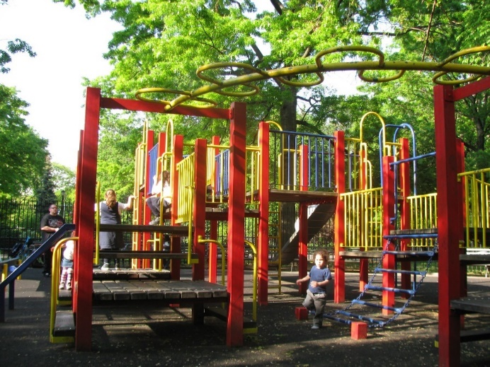
‘Jungle Gym’ by Eden, Janine and Jim is licensed under CC BY 2.0.
Teacher note: the table below provides possible answers for the identifying and matching the structural elements of narrative in a text activity.
Table 38 – identifying and matching the structural elements of narrative in a text: teacher answers
Structural elements of narrative | Details from the story
Orientation | The storyteller is 23 years old, in his second year of teaching. His first year of teaching has not gone well.
Complication | The storyteller is determined to prove himself to his class and all the other teachers.
Conflict | The school where the storyteller works is very strict – there is no recess scheduled in the day. It is ‘a kid’s nightmare’.
Rising tension | The storyteller starts taking his students to the park. The school is more concerned about ‘straight lines’ than anyone getting hurt. The class walk to the park and it is a beautiful day. The storyteller plays with all the groups of students. One student wants to be chased.
Climax | The storyteller runs at full speed into the jungle gym and blood starts pouring down his face.
Falling tension | The storyteller informs the students calmly that they are ‘going to go back early today’ and he manages his head wound. He tells the school that there is good news and bad news; someone got hurt but it wasn’t a student. The students ask their teacher ‘does it hurt?’ as they walk back to school. Medical attention is provided to the teacher and he has 9 staples in his head and is not allowed to work for the rest of the day.
Resolution | The storyteller has learned the lesson that you can’t control everything.
Transcript for ‘Not in the lesson plan’
Not in the Lesson Plan (reproduced with permission from The Moth website)
James Hamilton
[00:00:19] When I was 23, I was going into my second year of teaching, and I was obsessed with being an excellent teacher. Like, I had a chip on my shoulder about it, and I had a chip on my shoulder about it because my first year of teaching had not gone that well. And the general vibe with the veteran teachers was that I couldn't cut it. Like, at some point in the last year, they maybe concluded that I didn't have my stuff together. I don't know if it's because I was so young or because I was so inexperienced or maybe because I clearly didn't own an iron, and all my shirts were very wrinkled…um…
[00:01:08] So, going into year two, every day, walking into my fourth-grade classroom was a chance for me to, like, show a new group of kids and prove to all these other teachers that I had my stuff together. Like, you know, every time we had to walk out on the hall, my lines were the straightest, my lesson plans were the most thorough, and while I didn't buy an iron, I did find a type of shirt that doesn't even get wrinkled.
[00:01:40] Every detail accounted for. And my school was very rigid, like, strict curriculum, long school days, and no recess. So, it's like a kid's nightmare. And the other teachers would complain about this no recess policy, but I took it on myself to find a solution. The solution that I came up with is that on Fridays, I would take my class to the park, and would let them play for a while. And, it was about eight blocks from our school, which meant that technically, it was a field trip, not a recess. So still within the rules. And, if you'd ask any of the kids, they'd say that despite the fact that, like, eight blocks is a very long way for fourth graders to walk, they thought this was the best idea ever. And their now favorite teacher, Mr. Hamilton, came up with it.
[00:02:44] And the school was surprisingly okay with this on two conditions. One, the kids had to walk in and out of the building in straight and silent lines. And two, no one could get hurt and I was like, ‘Weird that you put straight lines before no one getting hurt.’ But also, ‘I don't know if you've noticed, but my lines are very straight.’
[00:03:10] Um…So, one day we go to the park. It's like perfect weather, everyone's in a particularly good mood, and I always make a point of playing with every group of kids. So, I did it all. I did the swings, I did the slide, you know? I did the jungle gym and there was one kid, and all he wanted was for me to chase him. And so, like, he would run into the field, and I'd follow him, and then he'd run around the swings, and I'd follow him. And then he went under the jungle gym, and I followed him. He's a fourth grader, which is the perfect height to run full speed under a jungle gym that is mostly made of sheets of metal and sharp edges. And I am two full feet taller than him, which is not the perfect height to run under a jungle gym at full speed.
[00:04:08] So, when I stood up even a little bit, I just put my head going full speed right into one of these sharp metal edges, and I like, stumbled out and was holding my head. I don't know if you remember being 10 years old, but it's very funny when your teacher gets hurt.
[00:04:29] It's like the funniest thing in the world. So, there was this kid Thomas, who just pointed and laughed, and as he's laughing, we lock eyes just as blood starts going down my face. So, his laugh was kind of like, ‘Hahahaha!—Oh, no, no!’ And I just hold my head and very calmly go, ‘You, know, we're going to go back early today, um…so y’all can just line up right over there.’ While they're lining up, I go behind a car and take off my dress shirt and take off my undershirt and wrap my undershirt around my now very bloody head and button my dress shirt back all the way up, which, by the way, still not wrinkled.
[00:05:31] And I call the school, and I say, ‘Hey, good news and bad news. Bad news, someone got hurt.. ah…. Good news, not a student. Ah, you'll see what I mean when I get back.’ Assuming I get back. Um…and we begin this eight-block trek back to the school, which, again, a long distance for 10 year olds under normal circumstances, particularly long when your teacher has an active head wound.
[00:06:06] And I'm just trying to keep it cool, you know?. I'm just having conversations and saying things like, ‘You know, this is why I tell you to sit up so straight in class. A lot of blood flowing up there, a lot of blood.’ And every couple of blocks, ah, one of the kids just goes quietly, ‘Does it hurt?’ And I go, ‘No, no,’ which it didn't, but internally, I was like, ‘This doesn't hurt, ‘cause that's how shock works, um...’
[00:06:42] And I get all the way back to the school, and they're waiting for me and even in the chaos, I'm like, aware that my like, seemingly brilliant plan has ended with egg on my face. By egg, I mean my own blood. And, they take me to the urgent care, and I get nine pretty painful staples in my head, and then I do what seems reasonable, and I go back to work, and the school is like, ‘No, you can't teach.’ And I'm pretty sure I know why. I'm like, ‘This is because you don't think I know what I'm doing. You think that I'm bad at my job.’ And what they…the reason they gave me was that, ah, ‘You're wearing an urgent care shirt, your hair is caked with blood, and you probably have a concussion.’
[00:07:39] There was lots of things that my 23-year-old self should have learned. Um…I should have learned to not care what other people were thinking. I should have cared, or I should have learned that you're inevitably going to bleed in front of the people that you least want to see you bleed. But those aren't like lessons that you can just teach one day and learn. Those are things you have to learn painfully over and over and over and over again. But the one thing I did learn is that you can't control everything.
[00:08:09] And I learned that, because no matter how good my lesson plans were or how straight my line was, I was just always going to be the teacher who cracked his head open. That was just it. Thank you.

Phase 2, activity 3 – reordering the rising tension
Teacher note: consider cutting up the table in this activity so students can physically reorder the events. Alternatively, divide the class in half and allocate one ‘event’ to each student (events may need to be added or removed depending on the number of students in the class). Students then arrange themselves in a line that reflects the order of events.
- Re-read the first chapter of Across the Risen Sea (‘This off day’).
- Reorder the series of events from the chapter that create the rising tension.
- Using the Think, Pair, Share thinking routine, consider ‘what do the series of events of the chapter have in common?’
- The table below describes the series of events that create the rising tension in ‘This off day’. Put these in the correct order, or in the order that you think they should appear.
Table 39 – reordering the rising tension
Rising tension from ‘This off day’ in Across the Risen Sea
They see a pale pink baby head poke up out of the water pulling itself up on the sea wall.
Old Marta understands their language and they find out the strangers are siblings from the Valley of the Sun.
Jag sees something on the water and tells Neoma to run.
Three tall strangers dressed in black get out of the boat carrying big black bags.
Jag stands on the sea wall to look out for crocs.
The strangers head for Cottage Hill.
An aluminium boat with a bright yellow sun comes sliding out of the mist.
The baby has crab legs instead of a body.
The elders tell them not to cut down the trees.
Best friends Jag and Neoma head to the beach.
They realise it is a crab with a baby doll’s head as a shell.
Teacher note: the table below provides the answers for reordering the rising tension activity.
Table 40 – rising tension in ‘This off day’ from Across the Risen Sea
Rising tension from ‘This off day’ in Across the Risen Sea
Best friends Jag and Neoma head to the beach.
Jag stands on the sea wall to look out for crocs.
Jag sees something in the water and tells Neoma to run.
They see a pale pink baby head poke up out of the water pulling itself up on the sea wall.
The baby has crab legs instead of a body.
They realise it is a crab with a baby doll’s head as a shell.
An aluminium boat with a bright yellow sun comes sliding out of the mist.
Three tall strangers dressed in black get out of the boat carrying big black bags.
The strangers head for Cottage Hill.
The elders tell them not to cut down the trees.
Old Marta understands their language and they find out the strangers are siblings from the Valley of the Sun.

Phase 2, activity 4 – considering the effect of rising tension
The rising tension can serve a greater purpose than merely revealing plot; this structural convention of a narrative is used by writers to draw their readers into the world of a novel.
- From the series of events that create the rising tension of ‘This off day’, select 3 events and explain how these events impact both the protagonist and the reader. An example has been provided for you as a model.
Table 41 – considering the effect of rising tension
Event | Impact on the character | Impact on the reader
Jag sees something in the water. | Jag runs, leaving Neoma behind. | We see that Neoma is disappointed in Jag that he left her as they were ‘meant to be a team’.

Phase 2, activity 5 – think, puzzle, explore prompts
Consider your developing thoughts about how and why we are drawn into the imaginary worlds of novels.
- Use the following prompts for small group discussion about your experiences with novels:
- What is usually your favourite part of the narrative structure of a novel?
- Why do we read novels?
- Why do writers continue to write novels?
- Why do companies still invest in novels rather than just making films?
- Do you enjoy rising tension?
- Use the ‘Think, Puzzle, Explore’ thinking routine to develop your understanding of the novel form. Record your ideas on a Jamboard.
- Think – what do you think you know about the novel as a textual form?
- Puzzle – what questions or puzzles do you have about the novel as a textual form?
- Explore – how might you work together to explore your puzzles about the novel as a textual form?
- The title of this program is ‘Escape into the world of a novel’. Substitute the word ‘escape’ with other ‘ways into’ the world of a novel. For example, ‘dive’, ‘creep’, ‘burrow’.
- Discuss with a peer the connotation of a range of the substituted words. Some questions to guide your discussion include:
- How do these words reflect the possibilities of how readers can interact with a novel?
- How does the structure of a novel affect the way a reader interacts with it? For example, if a novel begins with the climax, do we ‘dive in’? If it begins with the resolution, do we ‘creep in’ as we piece the story together?
- Which word best reflects the way that you interact with a novel?

Phase 2, resource 4 – prompts for physical Likert scale
Students physically position themselves on a line (the scale) indicating whether they strongly agree, agree, have no opinion, disagree or strongly disagree with the following statements:
- The book is always better than the movie.
- There is no point in watching the film if you have read the book (or vice versa).
- Stories are arranged in the same ways in novels and films.
- The rising tension in the story is what keeps us hooked.
- I am bored in the bits between the action.
- I like it when different characters ‘tell’ the story.

Phase 2, resource 5 – vocabulary building
The following notes support the student exploration of etymology and morphology related to the root words ‘nov’ and ‘cine’. The teacher will use this information to support student vocabulary activities in the teaching and learning program.
Words that include the root ‘nov’: novice, novelty, innovation, renovate, supernova
Opportunities for exploring parts of speech in context: teacher explicit instruction of one example:
- Noun – innovation, innovator
- Verb – innovate
- Adjective – innovative
Dual meanings of the word ‘novel’: both a work of extended prose fiction, and ‘new’. Are there connections between these 2 meanings? In what ways are novels ‘new’? (Consider how they were once a new form of entertainment; how do novels invite readers to consider new ideas?)
Tie-in to other languages: an interesting tie-in to French is: new = nouvelle, novel = roman (French, Spanish as ‘Romance languages’ as related to Ancient Rome). The teacher may connect to the German ‘bildungsroman’ as it is coming up in this program.
Extension to ‘cine-‘ and portmanteau: cinema, cinematographer, cinematic, uncinematic, cinemagoers. Podcast is a portmanteau of iPod and broadcast. Students can be challenged to find other portmanteaus in relation to texts and art (for example ‘sitcom’ and ‘dramedy’).

Phase 2, activity 6 – reflective writing prompts
- Use one or 2 of the following prompts to help guide you in writing a reflective response about reading. You may choose to respond to the prompts that are most relevant to your reading experience.
- Identify the part of the novel that you have found most engaging.
- Why is this engaging for you?
- How has the rising tension contributed to making this part engaging for you?
- What have you learned about yourself through your reading?
- What have you learned about the world through reading?
- Do you prefer texts that follow the narrative structure we have explored in class? Or, do you prefer texts that experiment with conventional structures (for example, narratives that begin with the climax or move backwards and forwards in time or explore multiple perspectives).
- Do you prefer texts that surprise you? Or do you enjoy being able to predict the plot?
- What challenges have you experienced in engaging with the novel you have been reading in class?
- Now that you have reflected on yourself as a reader and what you enjoy, how can you use this information to guide you in selecting future reading experiences?

Phase 2, activity 7 – reading journal
- Use the following table to reflect on your reading journey. Your teacher may provide suitable prompts for you to reflect upon.
Table 42 – reading journey prompts
Section of novel | Journal entry
Pre-reading | Prompt: From examination of the cover, blurb and any introductory activities, how do you think this novel will play out?
Chapter 1 | Prompt: What is your reaction to the first chapter?
Orientation | Prompt: What things are you familiar with in this chapter? What things are unfamiliar to you?
[students insert section of novel]
[students insert section of novel]
[students insert section of novel]
[students insert section of novel]

Phase 2, activity 8 – narrative structure diagram
The overarching narrative structure that we have been exploring (orientation, complication, rising tension, climax, resolution) together forms something that is referred to as the ‘narrative arc’. The narrative arc of individual chapters in Across the Risen Sea often follow the same pattern as the novel.
- Use the blank narrative arc diagram below (Phase 2, resource 6 – blank narrative structure diagram) and work with your teacher and class to plot the narrative arc of the chapter ‘This off day’ from Across the Risen Sea.
- Select another chapter from Across the Risen Sea and plot the narrative arc using the blank narrative structure diagram below (Phase 2, resource 6 – blank narrative structure diagram).
- Compare the diagrams for both chapters. What similarities can you see? What is common to both chapters in the falling tension? How does this align with the narrative arc of the novel?
- Discuss why the phrase ‘narrative arc’ has been used to describe this aspect of a novel, story or chapter. Write a definition. For extension: consider other metaphors that could be used to describe the structure.

Phase 2, resource 6 – blank narrative structure diagram
Figure 9 – narrative structure diagram template
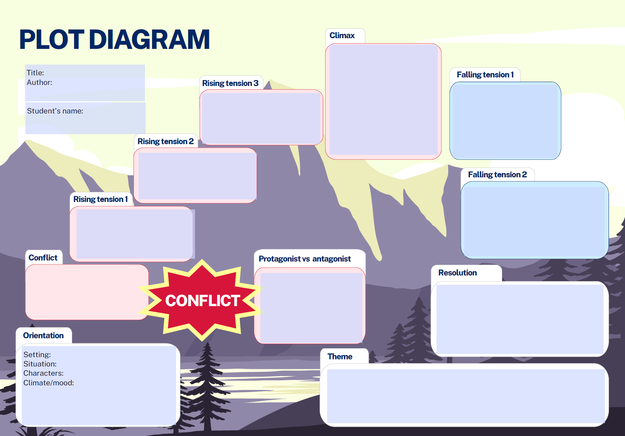

Phase 2, resource 7 – additional narrative structure terminology
The following table provides a definition of key terms and a suggestion for what the definition is based on, as well as where the teacher can seek further support.
Table 43 – additional narrative structure terminology
Terminology | Definition | Further support
Instigating event or problem | This is a plot element that acts as the starting point for conflict, tension or drama. It is often revealed as part of the orientation and may be referred to as the ‘inciting incident’ or ‘initiating event’. Inciting is a useful term as it sets the protagonist onto a new course of action. | Explore the playwright David Mamet’s idea that if all stories are about solving problems, then a story needs a genesis for that problem. This is the ’instigating event’.
Conflict | Conflict in a narrative can be internal (for example a moral choice) or external (with a bully) or both. It can be emotional, intellectual, physical, moral or social. Conflict creates tension and usually sets up the obstacles for the protagonist that drive the narrative structure. | Writers.com suggests that conflict within a story is about a struggle between opposing forces that creates the narrative thread of a story.
Complication  (in addition to the earlier definition) | Complications are obstacles or opportunities that get in the way of, or change, the possibility of the character achieving their goal. | According to Karen Woodward’s blog the complication should reveal what the protagonist is up against, raise the stakes and tempt the character to give up on the goal.
Point of view | ‘The position from which the information and events of a text are intended to be perceived by its audience. Point of view is constructed through the narrator, voice or images of the text and by characters or voices presented within it. Point of view should not be confused with the term ‘perspective’ or with notions of opinion.’ (English K–10 Syllabus glossary, NESA 2022) | For further ideas and activities on the differences between first person, second person, third-person omniscient and third-person limited, see MasterClass support resources.
Examples related to the chapter ‘Everything has changed’
- The ‘instigating problem’ of the chapter – the siblings from the Valley of the Sun digging the pits and building a tall pole.
- The conflicts of the chapter – between Old Marta and the siblings not telling her what they are doing or why.
- The complication – the ‘Teknology’ starting up preventing it from being removed.
Discussion prompts – impacts of each term
- The ‘instigating problem’ sets the course for the story and provides a starting point for the character’s main objective. In this chapter, the construction of the poles and wires creates a problem for the Island as they do not know what it is for and if they are in danger.
- The conflicts provide tension. In this situation, the arrival of the strangers could bring disease as well as questions regarding ownership of the Island and who determines what happens there.
- The complication changes the course of the story and forces the character to make a choice, or to take action that significantly changes the characters or plot. In other words, the choices at this moment must matter; in this case, what do they do with the ‘Teknology’ and its unknown purpose and power OR, do they tear it down?

Phase 2, activity 9 – conscience alley for Across the Risen Sea
Teacher note: the following steps are to take the class through the conscience alley activity. Resources for students follow the instructions.
Teacher activity instructions
- Pre-reading discussion – what is a ‘turning point’ (for a character) in fiction? What typically happens before and after them in examples known to students?
- Reading – as an example from the core text Across the Risen Sea use an extract from the chapter ‘It was me!’ where Neoma must decide if she will own up to pulling out the wires from the ‘Teknology’ or have Old Marta be punished.
- Pre-reading vocabulary – depending on class context students may either discuss and check the meaning of key vocabulary provided by the teacher, or practise using context to guess the meaning of key vocabulary signalled by the teacher.
- Teacher reads the extract from ‘The adults all look at each other ...’ and stops at the end of the line ‘... but no one is quietening down’ (pp 108–109).
- In pairs, students prepare 2 arguments why Neoma should own up and 2 arguments detailing why she should not. Use the table below – conscience alley preparation – to scaffold pair work if required. Then refer to Phase 2, resource 8 – ways into argument, for an extension activity exploring ethos, pathos and logos as approaches (appeals) students can take to their arguments.
- Teacher selects 4 students to form an ‘alley’. Two students will form a line and will express reasons ‘for’ owning up, and 2 students will form a line opposite them and will be expressing reasons ‘against’ owning up.
- Another student, representing Neoma, will walk through the ‘alley’ pausing at each pair who will act as Neoma’s conscience.
- As Neoma pauses, the students on opposing sides of the argument will make their arguments for the action that they believe Neoma should take.
- When Neoma reaches the top of the ‘alley’, the student will evaluate which argument they were most effectively persuaded by, and will reveal the course of action they intend to take.
Student activity instructions
- Your teacher will read an extract from Across the Risen Sea where the protagonist, Neoma. is faced with a decision.
- In the table below, record 2 reasons why Neoma should own up to pulling out the wires from the ‘Teknology’ and 2 reasons why she should not.
Table 44 – conscience alley preparation
Reasons why Neoma should own up | Reasons why Neoma should not own up

Phase 2, resource 8 – ways into argument
Ethos, logos and pathos are variously referred to as ‘rhetorical appeals’ or modes of argument or persuasion. They were coined by Aristotle, hence the retention of the Greek terminology. There are various online sources that will provide discussion and examples for teachers and students. The 3 terms are generally defined, for example by thesaurus.com as:
- Ethos – an appeal meant to convince on the basis of the speaker’s credibility or authority (‘I have been a teacher for 32 years so listen to me when I tell you…’)
- Pathos – an appeal based in emotion (usually through emotive language, intense descriptions or anecdotes)
- Logos – an appeal to logic, with an attempt to convince by way of reason (the use of statistics for example).
Extension activity – stipulate that the pairs create one argument founded in each of the 3 rhetorical appeals.

Phase 2, activity 10 – Neoma the ‘anti-hero’?
- Students use this brainstorm, research and discussion thinking routine modelled on Generate, Sort, Connect, Elaborate to engage with key terminology. One example has been completed for teachers and students as a model.
Generate – all ideas that come to mind when you first think of or see that word.
Sort – prioritise ideas in the box. Most important at the top.
Connect – connect ideas between different words. Explain in a short sentence.
Elaborate – add new ideas by looking up definitions or asking another pair or group.
Table 45 - Generate, Sort, Elaborate, Connect activity table
Character ‘type’ | Generate | Sort | Elaborate | Connect
Hero | - Popular  - Strong  - Leader  - Action | - Leader  - Action  - Popular | - Main fictional character  - Glory in ancient epics  - Admired for courage | - Seems like opposite of anti-hero, but isn’t exactly…
Anti-hero
Villain
Protagonist
Stock character
Well-rounded supporting character

Phase 2, activity 11 – analytical writing using theme-rheme structures
Teacher note: ‘theme’ and ‘rheme’ are ways of classifying the structure of ideas in a sentence. The ‘theme’ is the main idea of the sentence that the writer expresses first. The ‘rheme’ is the remainder of clause or sentence, and may contain new or unfamiliar information. This distinction makes it a useful strategy for encouraging continuity in writing when students get ‘stuck’. Use the following activity as a resource or adapt to use with students.
Theme-rheme teacher demonstration activity (‘I do’)
- Consider this response to the question: What sorts of characters do you prefer in fiction?
I really like characters in novels who find themselves in some sort of danger. Sinking ships, attacking aliens or spreading viruses seem to bring out the best in people. They become caring and resilient, daring and innovative so that the challenges are overcome and the ordinary people come out on top. Everyday characters in awful predicaments are therefore my favourite type.
The following table sets out the relationships between themes and rhemes.
Table 46 – themes and rhemes in example answer
Theme | Rheme
I really like characters in novels who | find themselves in some sort of danger.
Sinking ships … viruses | seem to bring out the best in people.
They become caring … resilient … innovative | so that the challenges are overcome and the ordinary people come out on top.
Everyday characters in awful predicaments | are therefore my favourite type.
Notes on the table above
- Each ‘rheme’ is the basis for the ‘theme’ of the next sentence: ‘danger’ in sentence one is elaborated on by ‘sinking ships’ for example in sentence 2.
- The new theme can be related to the previous rheme in a number of ways. Here the ships and viruses are an elaboration through exemplifying the key word in the rheme. The second example has a similar relationship between ‘best in people’ and ‘caring … innovative’. However, in the final example, ‘ordinary people’ in the rheme is elaborated on in the following theme through the synonym of ‘everyday characters’.
- The teacher could explicitly teach the terminology through examples, then support students to use the principle in their analytical writing for the activity above. If ‘stuck’ the student could work independently or with a partner to create a new theme based on the preceding rheme. At first, keep the range of possibilities limited to examples and synonyms.
Theme-rheme scaffolded and collaborative activity (‘we do’)
Working with a partner prepare for writing an analytical paragraph that explores whether Jag is a well-rounded supporting character.
Teacher note: this activity will apply to wherever your students are in the reading of this novel. If students are at an early stage of the novel, then select information from where they are up to. If they are at a later stage of the novel, select information from that point.
Students who may need an additional step in the writing process may benefit from organising their information under 3 headings:
What do I know about Jag? Possible response: Jag is Neoma’s companion and best friend. They experience many adventures together (p 53) and care about each other’s welfare.
How does this make him a well-rounded supporting character? Possible response: Jag and Neoma’s adventures allow the author to build characterisation and provide opportunities for the reader to get to know the protagonist by her interactions with Jag.
Quotes to support my evidence: ‘I practise every day and my muscles are strong’ (Neoma p 52); ‘each step he takes ... is like his thigh muscles gave up a few floors ago’ (p 54).
- Complete the theme-rheme table below considering your response to the question: Do you think Jag is a well-rounded supporting character? The first 2 examples have been completed for you.
Table 47 – theme-rheme table for Jag
Theme | Rheme
I believe Jag is a well-rounded supporting character as | he is Neoma’s best friend.
Because he is so close to her, he plays a significant role | such as taking the blame for the wires.
- Co-write an analytical paragraph with your partner (between 50 and 120 words) about whether you think Jag is a well-rounded supporting character.
Theme-rheme independent writing activity (‘you do’)
- Use the theme-rheme table below, if you would like, to prepare for writing an analytical paragraph about Marta. Work by yourself, but then show your writing to a partner for feedback. If you do not use the table, choose your own preferred way of brainstorming or note-taking to prepare for writing.
Table 48 – theme-rheme table for Marta
Theme | Rheme
- Write an analytical paragraph (between 50 and 120 words) about whether you think Marta is a well-rounded supporting character.

Phase 2, activity 12 – conflict and rising tension
- Students complete the table after reading a chapter, to identify the connections between inner conflict and the key points of rising tension in a chapter.
Table 49 – inner conflict and rising tension in one chapter
Rising tension | Inner conflict | Discussion ideas
Men from the Valley of the Sun come to the Island with guns to find Gerra and find out who pulled the wires out in ‘It was me!’ | Does Neoma own up to pulling out the wires and risk being taken away?  Does she stay quiet knowing Marta will be punished instead? | Neoma believes she was doing the right thing by pulling down the wires. Did she think of the consequences for; herself, others, the island?
Teacher note: this is a post-reading activity guide for examining point of view. After reading activities are complete and the teacher has checked terminology, use the following discussion and activity ideas to connect to students’ background knowledge and prepare for the analysis that follows.
- Discussion about preferences and personal responses: Which do you prefer and why?
- Experimenting: students change a passage from one point of view to another and comment. This could be done with the core text or, for example, a student chosen fairy tale.
- Extension: the English textual concepts resource suggests that point of view dictates the distance – temporal, spatial and emotional – between the responder and the events and ideas in the text. Students analyse, in pairs, the ‘distance’ between the reader and the events in a prose fiction text of their choice. They report back for class discussion and comparison.

Phase 2, activity 13 – learning about the protagonist
Provocation statement
First-person point of view involves a story told by the protagonist to the audience. The reader learns about events, but also about the protagonist based on how she chooses to tell the story.
- In pairs, brainstorm in a 2-column table what you learn about events, and what you learn from how Neoma tells the story in the chapter ‘Find Jag’. You are given 2 examples to start you off.
Table 50 – what we learn from a first-person protagonist
What we learn about events in the chapter | What we learn about Neoma from how she describes events
The stars can be used to navigate at sea of a nighttime. | Neoma appreciates her environment ‘I say hello to my kite shaped friend the Southern Cross...’ and also that Neoma is a skilful sailor, ‘She’ll prolly dip below the horizon later, but I can find my way north now with her pointing to the empty night sky that is north’.
People take advantage of other people if they can. | Neoma listens to advice from adults and is suspicious of people she doesn’t know or are not form the Ockery Islands. ‘I dunno if Corky has moved the light tonight, so I take a wide trip around that headland.’
- Now work with your partner on the chapter ‘Dog’s Elbow’ to consider what would be different if the story was not told from Neoma’s first-person point of view. Jot down your ideas in your books.
- Prepare for class discussion of the following topic: First-person point of view may bring the reader close to the protagonist but why? Does this help to immerse us in the world of the novel?
- Experiment with point of view by re-writing. Choose a section from one of these 2 chapters and re-write it in third-person point of view. Share with your partner, then discuss what it has changed. You may consider: how it changes our relationship with the character and how it changes what we know about their world.

Phase 2, activity 14 – introduction to narrative voice
Teacher note: language features that can, typically, ‘create’ a narrative voice include: emotive language, idioms, humour, descriptive language, figurative language, sentence length, register and formality, high modality. Narrative voice depends on choice of point of view but is constructed as part of the composer’s characterisation.
- In pairs or small groups, re read ‘Find Jag’, identify any language features used to create character, and record these in your books.
- Share your annotations with 2 other pairs or groups and compare your notes.
- Refine your notes.
The following table includes examples of language features used to create narrative voice in the extract from Across the Risen Sea.
- Practise identifying language features using an extract from the chapter.
- Find new examples of the language features you have already identified and discussed.
- Identify the impact of these language features in creating a narrative voice for Neoma and fill them into the right-hand column.
Table 51 – language features and narrative voice
Language feature | Example | Impact
Self-deprecating humour | ‘ain’t no misbehaving kids in Blackberry’ (p 123) | Neoma makes a joke at her own expense as the wires and poles are still standing on Blackberry. She acknowledges that she did the wrong thing by pulling down the wires even though she thought it would help.

Phase 2, resource 9 – teacher support for narrative voice
The following table contains sample answers for the student activity in Phase 2, activity 14 – introduction to narrative voice.
Table 52 – sample answers for language features and narrative voice
Language feature | Example | Impact
Self-deprecating humour | ‘ain’t no misbehaving kids in Blackberry’  (p 123) | Neoma makes a joke at her own expense as the wires and poles are still standing on Blackberry. She acknowledges that she did the wrong thing by pulling down the wires even though she thought it would help.
Figurative language | ‘A pinprick of light on the shore where there is no village.’  (p 124) | Neoma often describes things using figurative language. She is a deep thinker and has a lyrical voice.
Descriptive language | ‘...people, sitting by a fire, but their foreheads is glinting that gold sun...’ (p 125) | Neoma’s choice of description often reinforces the fact that she is still young. Her voice is confident at times and nervous at other times.
Repetition | ‘My best friend in the world. My perfect numbat friend.’ (p 125) | The repetition of the personal pronoun ‘my’ reinforces a sense of ownership. The noun ’friend’ suggests Neoma’s close relationship with Jag.
Exaggeration | ‘...stingrays with wing tips that fold up either side of your boat wrapping you up!’ (p 123) | Exaggeration amplifies the fears that Neoma is feeling about being at sea by herself.

Phase 2, activity 15 – sentence combining and narrative voice
Teacher note: the following sentences have been taken from the chapter ‘Pirates’! The terms ‘subject’ and ‘predicate’ will need to be explicitly taught.
Every complete sentence in English is made up of 2 parts: the subject and the predicate. The subject is what or whom the sentence is about and the predicate tells the reader something about the subject.
- In each of the simple sentences below, identify the subject (bold) and predicate (italics). The first one has been done for you as a model.
- I wake up at a weird bang and a rattle.
- She looks at me like she din’t expect to see a person.
- I can’t believe she thinks I have a pet croc.
- I pull my hand back.
- ’You can’t salvage this boat, coz it’s mine!’
- Me and my boat are now in pirate hands.
- Saleesi shakes her head at me.
- Pirate Bradshaw stands over me.
- As a class, rewrite these simple sentences to include at least one compound and one complex sentence (refer to Phase 1, resource 13 – creating predictive sentences to help you with this task if you need a refresher on compound and complex sentences).
- Compare the rewritten sentences with the originals from the chapter ‘Pirates’.
- What is the effect of changing the sentence structure from simple sentences to a wider variety of sentence structures?
- In pairs, combine the simple sentences taken from a paragraph in the chapter ‘Pirates’ to improve the sentence variation:
- Uncle Croc thrashes his tail.
- He’s got a mind to eat this old lady.
- She’s too fast for him.
- She makes two giant leaps across the net.
- She’s over the wall.
- She's standing in front of me.
Post-reading and analysis
- Compare your response to another pair’s response and to the original extract found in the chapter ‘Pirates’. Are they identical? If they are not, how do the different sentence choices affect the writing?
- In pairs, discuss the differences between the adapted version and the version where the sentences have been combined. Which one do you like better? Why?
- In a class discussion, explain how the sentence length can be used to create an authentic and engaging narrative voice. You may consider how people speak in varied sentence lengths and structure, sometimes using short, simple sentences for dramatic effect; you may consider how sentence length can create a relationship between the character and the reader. Do the longer sentences create a comfortable connection between Neoma and the reader? Do the sentence structures help to create drama?
- Add your observations and thoughts as well as notes from the class discussion to the table above in Phase 2, activity 14 – introduction to narrative voice to explain the impact of sentence length on creating a narrative voice.
Teacher note: the original extract taken from ‘Pirates’ (p 145) reads:
‘Uncle Croc thrashes his tail like he’s got a mind to eat this old lady but she’s too fast for him. She makes two giant leaps across the net and then she’s over the wall and standing in front of me.’

Core formative task 2 – experimenting with point of view and narrative voice (integrated Phase 5)
Teacher note: in this core formative task, students are guided to experiment with point of view and narrative voice. They rework an initial descriptive piece about a character to investigate the impact of second and third person. This task is completed in a low stakes environment where they can take risks and enjoy sharing and discussing the results. Provide information to students before they write each stage, not as one block. Consider the appropriate options and adjustments necessary for your context and provide time for planning the narrative voice for options 1–3 before students write.
This task will give you an opportunity to experiment with point of view and narrative voice. It will allow you to practise your understanding of the difference purposes and impacts of writing in first, second and third person, as well as the ways that the narrator’s voice in a piece of imaginative writing is a crucial part of the way in which a reader is engaged and immersed into the world of the novel. Engaging in low-stakes creative tasks such as this one allows you to practise your composing skills knowing that you can take risks, then get feedback – if you want it – from the teacher or your peers.
Preparation for writing
- Choose someone you know well and create a brainstorm of key words for appearance, personality and behaviour.
Writing
- Write a one-paragraph portrait of the character (or yourself) focusing on physical appearance and personality. Write in the first person – from the point of view of that character.
- Continue to the next paragraph and describe the character performing an activity in an imaginary world that you are familiar with – the activity that goes wrong in some way. This can be simple like pouring a cup of tea that spills. Focus on how they react, including feelings and thoughts. Keep to the first-person point of view.
Options for experimenting. Complete at least one of the following.
Note that each of the following requires you to develop a specific narrative voice for the person doing the describing. Try to keep as much of the basic information from points 2 and 3 above. What you change, add and how you do it is the focus of the activity.
Option 1 – rewrite this description and scene in the narrative voice of one of their (your) parents. This will be in the third person. The narrator will know different things. They may have judgements, they may conceal things, they may have different emotions connected to the person and the activity. Choose whether you will be distanced (omniscient) or closer to the subject (subjective/limited). Note that in the latter option the description will be as much about the parent as the child.
Option 2 – rewrite the description in the narrative voice of a biographer, 100 years in the future. This will be in the third person again. The narrator will have full access to all information but may also have an agenda. Are they objective or are they wanting to show the character as a hero or a villain?
Option 3 – rewrite the description in the second person. Decide what attitude the narrator has to the character. Best friend, worst enemy or neighbour who is secretly watching their every move?
In your development of a narrative voice for your narrator, you may wish to include:
- imagery – would the narrator use very matter-of-fact descriptions, or would they use evocative, flowery or lyrical imagery?
- emotive language – would the narrator use emotive language or would the narrator be very technical, formal or reserved?
- metaphor, personification or symbolism – would your narrator use figurative language to convey their thoughts, or would they stay literal?
- sentence variation – would shorter or longer sentences suggest the narrative voice you have in mind? Would they use simple sentences, complex sentences or a combination?

Phase 2, resource 10 – verb choice (refining checklist part 2)
Teacher note: this refining checklist is the second part of the process, introduced for Core formative task 1 in Phase 1, resource 10 – spelling (refining checklist part 1). Continue to use the process, which is included as part of each core formative task, to support students to refine their writing. Remind them of the spelling focus of part 1 and indicate that this has been included for them as a reminder in the table below.
The focus of this second editing activity is on crafting through the choice of verbs. Students should be encouraged to compare the verbs used in the model text with less effective choices. Note that we have included the previous focus to suggest the gradual building of skills. This can be deleted if the class context suggests it might cause cognitive overload.
To support student refining, the teacher could:
- guide students through the examples and understanding indicated in the annotated text in the table
- support student extension by finding other examples in the core text
- support paired and independent student refining practices by asking students to use the sample and its annotated examples to check and improve their own writing in Core formative task 2.
Table 53 – model text and annotations for crafting through verb choice
Model text | Annotations – verb choice
“Whoah! What’s that?” Pete yelled as a blinding light flashed in front of us.  I couldn’t believe my eyes as a disc as big as a giant’s frisbee hovered above us. We stood frozen in place as we peered up at this miraculous sight. We were standing smack bang in the middle of the local cricket pitch. You could tell we hadn’t had a lick of rain for quite some time as my steps had crunched as I paced across it. Now, as the giant frisbee drew nearer, I worried the intense heat bouncing off it, would set the whole town on fire.  “Jeez, Max! What are you doing just standing there? We’ve got to get out of here!” yelled Pete as he spun on his heels to escape.  Pete’s always been a big wuss – when he was 5, we went to a circus and he ended up crying like a baby because the clown came up to him and shook his hand. So it didn’t really surprise me that he was now just a fleeting shadow in the distance beyond the outer fence of the cricket grounds. | Continued focus on spelling – for example the contraction in ‘what’s’.  New refining focus: verb choice  ‘yelled’ – conveys emotion and indicates that the speaker is speaking loudly and with intensity (as opposed to ‘said’).  ‘hovered’ – creates vivid imagery and creates suspense or anticipation.  ‘peered’ – suggests curiosity, caution or suspicion. More effective than ‘looked’.  ‘crunched’ – creates tactile imagery, allowing the reader to imagine the protagonist walking across dry grass.  ‘bouncing’ – vividly describes the movement, suggesting playfulness and energy.  ‘spun’ – describes sudden movement that suggests urgency.

References
This resource contains NSW Curriculum and syllabus content. The NSW Curriculum is developed by the NSW Education Standards Authority. This content is prepared by NESA for and on behalf of the Crown in right of the State of New South Wales. The material is protected by Crown copyright.
Please refer to the NESA Copyright Disclaimer for more information https://educationstandards.nsw.edu.au/wps/portal/nesa/mini-footer/copyright.
NESA holds the only official and up-to-date versions of the NSW Curriculum and syllabus documents. Please visit the NSW Education Standards Authority (NESA) website https://educationstandards.nsw.edu.au and the NSW Curriculum website https://curriculum.nsw.edu.au.
English K–10 Syllabus © NSW Education Standards Authority (NESA) for and on behalf of the Crown in right of the State of New South Wales, 2022.
Animation Compendia (23 April 2022) The Rescuers - Trailer #1 - 1977 Theatrical Trailer (35mm 4K) [video], Animation Compendia, YouTube, accessed 8 November 2023.
Barrie JM (1860–1937) Peter Pan or The Boy Who Would Not Grow Up (The Play), Project Gutenberg website, accessed 11 October 2023.
Baum L Frank (1900) The Wonderful Wizard of Oz, Project Gutenberg website, accessed 11 October 2023.
Boas E and Kerin R (2021) Novel ideas: teaching fiction in the middle years, Australian Association for the Teaching of English, Kensington Gardens SA.
Boudjikanian R (22 May 2022) ‘Why millions of girls in Afghanistan can’t go to school’, CBC Kids News, accessed 22 September 2023.
Brandows Animations (10 November 2017) ‘Finding Nemo Arrival To Sydney' [video]’, Brandows Animations, YouTube, accessed 11 October 2023.
Brewster M (18 August 2021) ‘The Taliban’s takeover of Afghanistan, explained’, CBC Kids News, accessed 22 September 2023.
British Secret Agent 007 (31 August 2015) 'Danny Deckchair (2003) – Trailer' [video], British Secret Agent 007, YouTube, accessed 11 October 2023.
Burke KJ (2007) ‘Reflective writing: the 3D format’, Metaphor, 4:65–6.
Carroll L (1865) Alice’s Adventures in Wonderland, Macmillan’s Children’s Books.
Clifford WK (1886) 'The Kite', Very Short Stories and Verses For Children, Project Gutenberg website, accessed 20 September 2023.
Daffern T and Mackenzie N M (2020), 'Theoretical perspectives and strategies for teaching and learning writing', in Daffern T and Mackenzie N M (eds) Teaching Writing, Routledge, New York.
Derewianka B (2020) ‘Supporting meaning-making through text organisation’ in T Daffern and NM Mackenzie (eds) Teaching Writing, Routledge, London and New York.
Durrett M (2017) The Agatha Christie formula, Martha Durrett website, accessed 12 October 2023.
edenpictures (21 May 2013) Jungle Gym [photograph], Eden, Janine and Jim, Flickr website, accessed 12 October 2023.
Goldfields Libraries (27 October 2020) Bren MacDibble - on writing 'Across the Risen Sea’ [video], Goldfields Libraries, YouTube, accessed 11 October 2023.
Greer C (1920) School and Home Cooking, Project Gutenberg website, accessed 11 October 2023.
Griffith University (2023) Inferring meaning of unfamiliar words, PTE Success – The Skills You Need, Future Learn, accessed 14 September 2023.
Hamilton J (2023) ‘Not in the Lesson Plan’ [audio], The Moth website, accessed 12 October 2023.
Harvard Graduate School of Education (2022) Project Zero’s Thinking Routine Toolbox, Project Zero website, accessed 20 June 2023.
Herriman G (4 April 1921) Krazy Kat, Comicstrip library website, accessed 11 October 2023.
Hochman J and Wexler N (2017) The Writing Revolution: a guide to advancing thinking though writing in all subjects and grades, Jossey-Bass, San Francisco.
JoBlo Animated Videos (29 August 2019) Ferngully clips & Trailer (1992) [video], JoBlo Animated Videos, YouTube, accessed 11 October 2023.
JoBlo Animated Videos (1 November 2019) THE SWAN PRINCESS 25th Anniversary Trailer (1994) [video], JoBlo Animated Videos, YouTube, accessed 8 November 2023.
KinoCheck.com (19 June 2020) WALL·E Trailer (2008) [video], KinoCheck, YouTube, accessed 8 November 2023.
Lawson L (n.d.) Bedtime, Public Domain Poetry website, accessed 11 October 2023.
Literary Devices (2023) Literary Devices and Terms, accessed 11 September 2023
MacDibble B (2020) Across the Risen Sea, Allen & Unwin Pty Ltd, St Leonards, NSW.
Moon B (2005) Literary Term: a practical glossary, Chalkface Press, Cottesloe.
Movie Trailer Locker (23 February 2015) The Great Mouse Detective (1986) Trailer [video], Movie Trailer Locker, YouTube, accessed 16 October 2023.
Orwell, G (1945) The Sporting Spirit, Fifty Orwell Essays, Project Gutenberg website, accessed 11 October 2023.
Project Gutenberg Australia (2019) The First World War and ANZAC, Project Gutenberg Australia website, accessed 11 October 2023.
Quigley A (2018) Closing the vocabulary gap, Routledge, GB.
Quigley A (2020) Closing the reading gap, Routledge, GB.Roadshow Films (15 March 2011), Red Dog (2011) Official Trailer, Roadshow Films, YouTube, accessed 11 October 2023.
Rotten Tomatoes Classic Trailers (13 December 2011), Babe Official Trailer #1 - Miriam Margolyes Movie (1995), Rotten Tomatoes Classic Trailers, YouTube, accessed 11 October 2023.
Rotten Tomatoes Classic Trailers (20 April 2018) The Nightmare Before Christmas (1993) Official Trailer #1 - Animated Movie , Rotten Tomatoes Classic Trailers, YouTube, accessed 16 October 2023.
State Library Victoria (9 November 2020) Story Talks with Boori Monty Pryor - Family stories (Part 1), State Library Victoria, YouTube, accessed 11 October 2023.
State of New South Wales (Department of Education) (2023) Understanding representation, English K–12, NSW Department of Education website, accessed 6 October 2023.
State of New South Wales (Department of Education) (2020b) School Excellence Framework, NSW Department of Education website, accessed 11 April 2024.
State of New South Wales (Department of Education) (2023) Stage 5 reading – Text structure and features, NSW Department of Education website, accessed 12 October 2023.
State of New South Wales (Department of Education) (2024a) Our Plan for NSW Public Education, NSW Department of Education website, accessed 10 April 2024.
State of New South Wales (Department of Education) (2024b) Universal Design for Learning, NSW Department of Education website, accessed 11 April 2024.
Stern J, Ferraro K and Mohnkern J (2017) Tools for Teaching Conceptual Understanding, Secondary, Corwin, SAGE, Thousand Oaks CA.
Teach, Learn, Share (2014) Reflective writing: the 3D format, Scootle website, accessed 11 October 2023.
Twentieth Century Studios (22 May 2010), Rio | Trailer | 20th Century FOX [video], 20th Century Studios, YouTube, accessed 8 November 2023.
Wehbe, A (23 August 2022) Afghanistan Anniversary [video], Behind the News, ABC website, accessed 11 October 2023.
WestlineDI (19 April 2016) CROCODILE DUNDEE (1986) Australian Theatrical Trailer, WestlineDI, YouTube, accessed 11 October 2023.
© State of New South Wales (Department of Education), 2023
The copyright material published in this resource is subject to the Copyright Act 1968 (Cth) and is owned by the NSW Department of Education or, where indicated, by a party other than the NSW Department of Education (third-party material).
Copyright material available in this resource and owned by the NSW Department of Education is licensed under a Creative Commons Attribution 4.0 International (CC BY 4.0) license.
This license allows you to share and adapt the material for any purpose, even commercially.
Attribution should be given to © State of New South Wales (Department of Education), 2023.
Material in this resource not available under a Creative Commons license:
- the NSW Department of Education logo, other logos and trademark-protected material
- material owned by a third party that has been reproduced with permission. You will need to obtain permission from the third party to reuse its material.
Links to third-party material and websites
Please note that the provided (reading/viewing material/list/links/texts) are a suggestion only and implies no endorsement, by the New South Wales Department of Education, of any author, publisher, or book title. School principals and teachers are best placed to assess the suitability of resources that would complement the curriculum and reflect the needs and interests of their students.
If you use the links provided in this document to access a third-party's website, you acknowledge that the terms of use, including licence terms set out on the third-party's website apply to the use which may be made of the materials on that third-party website or where permitted by the Copyright Act 1968 (Cth). The department accepts no responsibility for content on third-party websites.

