# **Modern Languages K–6**

Participant workbook

Contents

About this workbook 3

Presentation overview 4

Learning intentions and success criteria 4

Alignment to the Australian Professional Standards for Teachers 4

Alignment to the School Excellence Framework 4

Session 1 – adapting available resources to your language 6

Activity 1.1 – adapting a Microsoft Word resource to your language 7

Activity 1.2 – adapting a PowerPoint resource to your language 7

Where to next? 8

Session 2 – the 5 elements of effective assessment in languages 9

Activity 2.1 – learning intentions and success criteria 9

Activity 2.2 – explicit descriptive feedback 13

Activity 2.3 – peer and self-assessment 17

Activity 2.4 – goal setting 20

Where to next? 24

Evaluation 25

References 26

## About this workbook

This workbook is designed to guide your thinking, reflections and plans for future action. In the workbook, you will find **note-taking** **pages** that complement the presentation and **activity templates** to help you engage with the content.

The note-taking pages feature focus questions specific to the content of the presentation. They also provide you with the opportunity to record your key take-aways and ideas.

The activity pages support you to collaborate with colleagues and consider how you can apply the content in your school context. Your facilitator will guide you through the activities.

This workbook can be printed double-sided or used digitally. If you have questions about the presentation, please connect with the [Primary Languages Statewide staffroom](https://forms.office.com/pages/responsepage.aspx?id=muagBYpBwUecJZOHJhv5kbW-YvDwiqVLh7O9Rfo_l2dUMzNZRlJKN0Y3OFNEMFg2VEZTMkhLTk9UNSQlQCN0PWcu&web=1&wdLOR=cFE37BD2F-2138-4D5E-A04A-23E56C2EE445) or email [primlang@det.nsw.edu.au](mailto:primlang@det.nsw.edu.au).

## Presentation overview

Engage in practical teaching and learning strategies to support the implementation of the Modern Languages K–10 Syllabus in your K–6 context.

### Learning intentions and success criteria

By the end of the presentation, participants will:

* adapt resources in another language to the language they teach
* practise using effective assessment strategies.

To demonstrate learning, participants can:

* adapt Microsoft Word and PowerPoint resources in the language they teach
* apply effective assessment strategies to language lessons.

### Alignment to the Australian Professional Standards for Teachers

This presentation aligns with the following standards:

* 2.1.2 Apply knowledge of the content and teaching strategies of the teaching area to develop engaging teaching activities.
* 2.3.2 Design and implement learning and teaching programs using knowledge of curriculum, assessment and reporting requirements.
* 3.3.2 Select and use relevant teaching strategies to develop knowledge, skills, problem solving and critical and creative thinking.
* 6.2.2 Participate in learning to update knowledge and practice, targeted to professional needs and school and/or system priorities.

### Alignment to the School Excellence Framework

This professional learning session aligns with the following elements of the School Excellence Framework:

* Curriculum
* Assessment
* Effective classroom practice

## Session 1 – adapting available resources to your language

**Focus questions**

* What are the key linguistic challenges in translating content from one language to another?
* How can cultural nuances and context be accurately conveyed when adapting a resource to a different language?

| **Key points** | **Notes** |
| --- | --- |

### Activity 1.1 – adapting a Microsoft Word resource to your language

Choose a resource made in Microsoft Word, such as flash cards or a sentence builder, from an available [unit](https://education.nsw.gov.au/teaching-and-learning/curriculum/languages/planning-programming-and-assessing-languages-k-6#Modern0). Follow the recorded instructions to adapt it to your language.

**Use the Find and Replace tool to adapt a unit to your language**

**If, for example, you wish to convert a Vietnamese unit to Chinese, the ‘Find and Replace’ tool is a useful short-cut. You can find the tool by selecting Replace from the Editing tab or by pressing Ctrl + H.**

**In the Find what box, type ‘Italian’ or ‘Italy’.**

**In the Replace with box, type ‘Vietnam’ or ‘Vietnamese’.**

**Select Replace to change the text or select Replace All to change all instances of this text in your file.** 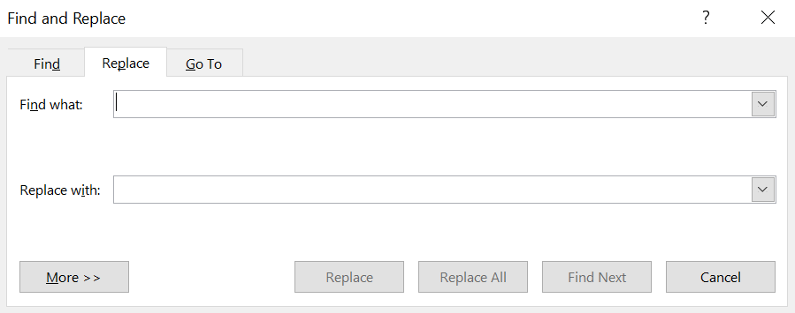

### Activity 1.2 – adapting a PowerPoint resource to your language

Choose a resource made in MS PowerPoint, such as a story book or a learning map, from a [published unit](https://education.nsw.gov.au/teaching-and-learning/curriculum/languages/planning-programming-and-assessing-languages-k-6#Modern0). Follow the recorded instructions to adapt it to your language.

**Summary**

The 3 key ideas that I would like to apply to my practice:

### Where to next?

Would you like to learn more? The links below provide additional learning and resources.

To find more information on using MS Word:

* [LinkedIn Learning: Word Essential Training (Microsoft 365)](https://www.linkedin.com/learning/word-essential-training-microsoft-365-17548621?u=74950778)

To find more information on using MS PowerPoint:

* [LinkedIn Learning: PowerPoint Essential Training (Microsoft 365)](https://www.linkedin.com/learning/powerpoint-essential-training-microsoft-365?u=74950778)

## Session 2 – the 5 elements of effective assessment in languages

### Activity 2.1 – learning intentions and success criteria

**Focus questions**

* In your classroom, do learning intentions relate to syllabus outcomes or content points?
* Are learning intentions and success criteria written in student-friendly language?
* Do students understand the learning intentions and success criteria? How do you know?

| **Key points** | **Notes** |
| --- | --- |

| **Key points** | **Notes** |
| --- | --- |

**Question:** what success criteria would you suggest to your students for the following Stage 1 communicative task?

|  |  |
| --- | --- |
| Element | Information |
| Task | You would like to invite your friend by giving them an invitation that you have created. Ask them if they would come to your party and tell them the details of your party in [Language]. |
| Context | Your party |
| Audience | Your friend |
| Purpose | To invite them to the party |

**Record your response below.**

|  |
| --- |
|  |

If you are familiar with writing learning intentions, you may like to write learning intentions for the some of the Stage 1 weekly lessons required to prepare for the communicative task above. Express the learning intentions in terms of specific knowledge, skills or understanding.

* Knowledge – this is factual information.
* Understanding – this often concerns concepts, reasons or processes.
* Skill (do) – these are proficiencies or abilities acquired through training or experience.

**Record your response below.**

|  |
| --- |
|  |

**Summary**

The 3 key ideas that I would like to apply to my practice:

1.

2.

3.

### Activity 2.2 – explicit descriptive feedback

**Focus questions**

* Do you identify what students have done well, and what needs improvement?
* Does your feedback include how students can improve?
* Are your students expected to act on your feedback?
* Do you give clear, concise feedback related to the learning goals and success criteria?

| **Key points** | **Notes** |
| --- | --- |

| **Key points** | **Notes** |
| --- | --- |

While the class completed a communicative activity (or activities), the teacher has made some observations and recorded them on the [intentional observation checklist [DOCX 72.7KB](https://education.nsw.gov.au/content/dam/main-education/teaching-and-learning/curriculum/key-learning-areas/languages/media/documents/languages-es1-s1-s2-s3-intentional-observation-checklist-for-c-a.docx)] using the traffic light system where:

* green means the student is on track
* orange means the student may need some support
* red means the student is not on track and needs support.

**Question:** what feedback would you give to either Asha, Ken, Aoife or Kim to help them improve?

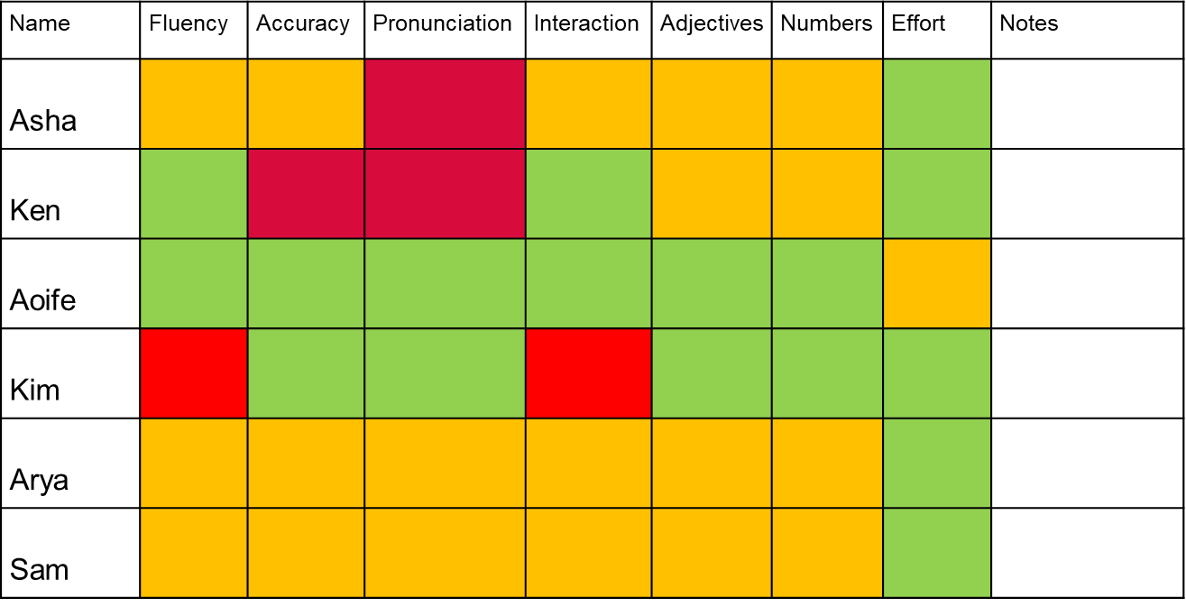

Record your response in the space provided in the table below. Remember to link your feedback to the success criteria created in Activity 2.1.

**Note:** also consider what strategies you might put in place to further support these students.

|  |  |
| --- | --- |
| Student | Feedback |
| Asha |  |
| Ken |  |
| Aoife |  |
| Kim |  |

**Summary**

The 3 key ideas that I would like to apply to my practice:

### Activity 2.3 – peer and self-assessment

**Focus questions**

* What ground rules will you co-construct with your students to support them with peer-assessment?
* How can you prepare students for effective self- assessment?

| **Key points** | **Notes** |
| --- | --- |

| **Key points** | **Notes** |
| --- | --- |

**Question:** based on the learning intentions and success criteria developed in Activity 2.1, what peer and self-assessment strategies would you use with your students completing the activities for Stage 1 – party time unit?

**Record your response below.**

|  |
| --- |
|  |

**Summary**

The 3 key ideas that I would like to apply to my practice:

### Activity 2.4 – goal setting

**Focus questions**

* How often do you set learning goals with your students?
* Are they SMART goals?

| **Key point** | **Notes** |
| --- | --- |

| **Key point** | **Notes** |
| --- | --- |



**Question:** based on the intentional observation checklist above, write a SMART learning goal for at least one of the following students:

* Ken
* Aoife
* Kim
* Arya

**Note:** SMART learning goals are specific, measurable, achievable, realistic and timely.

Model writing SMART goals and display a chart with the success criteria (or develop your own class success criteria) for the activities or communicative task.

|  |  |
| --- | --- |
| SMART goals | |
| S – Specific | Clearly define what the student wants to achieve. |
| M – Measurable | Establish criteria to track the progress. |
| A – Achievable | Set out actions that the student can take to achieve the goal. |
| R – Realistic | Ensure that the goal aligns with student’s overall learning. |
| T – Timely | Sets out a reasonable timeframe for achieving the goal. |

#### Learning goal template

Use the template below to assist you with creating the learning goals.

|  |  |
| --- | --- |
| Learning goal | Notes |
| My learning goal |  |
| The steps I will take |  |
| Target date |  |
| Date target was achieved |  |

### Where to next?

Would you like to learn more? The links below provide additional learning and resources.

Comprehensive support for the K–6 component of [Modern Languages K–10 Syllabus](https://curriculum.nsw.edu.au/learning-areas/languages/modern-languages-k-10-2022):

* [Planning, programming and assessing languages K–6](https://education.nsw.gov.au/teaching-and-learning/curriculum/languages/planning-programming-and-assessing-languages-k-6).
* Primary Languages Statewide Staffroom. Complete the [entry survey](https://forms.office.com/pages/responsepage.aspx?id=muagBYpBwUecJZOHJhv5kbW-YvDwiqVLh7O9Rfo_l2dUMzNZRlJKN0Y3OFNEMFg2VEZTMkhLTk9UNSQlQCN0PWcu&web=1&wdLOR=cFE37BD2F-2138-4D5E-A04A-23E56C2EE445) to join.
* [What works best 2020 update](https://education.nsw.gov.au/about-us/education-data-and-research/cese/publications/research-reports/what-works-best-2020-update).

The 2020 update outlines 8 quality teaching practices that are known to support school improvement and enhance the learning outcomes of our students.

* [Five elements of effective assessment](https://education.nsw.gov.au/teaching-and-learning/learning-remotely/teaching-at-home/assessment/primary-assessment/five-elements-of-effective-assessment-practice).

By embedding strategies throughout the teaching and learning cycle, teachers ensure that assessment practices are linked to learning experienced by students. Effective assessment practices are responsive and result in change to teacher practice, based on student need.

* [Digital Learning Selector – Peer feedback](https://app.education.nsw.gov.au/digital-learning-selector/LearningActivity/Card/549?clearCache=b9c1ac41-8094-74a9-e156-7e90e34d732d)

The Digital learning selector includes templates to embed various peer feedback strategies. The tool supports purposeful, high quality and purposeful ICT integration into teaching practice.

Resources – Modern Languages K–10 Syllabus​:

* Microlearning – [Modern Languages K–10 syllabus – from planning to practice in Years K–6.](https://myplsso.education.nsw.gov.au/mylearning/catalogue/index?menu=Home#/detail?page=1&pageSize=10&openSessionsOnly=false&search=Modern%20Languages%20K%E2%80%9310%20Syllabus%20%E2%80%93%20from%20planning%20to%20practice%20in%20Years%20K%E2%80%936&details=%2Fmylearning%2Fcatalogue%2Fdetails%2F9d359239-0e22-ee11-87dc-0003ffd05031)
* [Modern Languages K–10 syllabus professional learning](https://catalog.learning.nesa.nsw.edu.au/browse/t/cr/courses/modern-languages-k10-professional-learning) (NESA accredited)​
* [Teaching and learning support – Modern Languages K–10 Syllabus](https://curriculum.nsw.edu.au/learning-areas/languages/modern-languages-k-10-2022/teaching-and-learning)​
* [Sample scope and sequences K–6](https://education.nsw.gov.au/teaching-and-learning/curriculum/languages/planning-programming-and-assessing-languages-k-6#Modern0)​
* [Language generic and language specific units](https://education.nsw.gov.au/teaching-and-learning/curriculum/languages/planning-programming-and-assessing-languages-k-6#Modern0)​
* [K–6 mapping tool [XLSX 56.5KB]](https://education.nsw.gov.au/content/dam/main-education/teaching-and-learning/curriculum/languages/media/documents/modern-languages-k-6-mapping-tool.xlsx)​
* [Programming guidelines for primary languages teachers](https://education.nsw.gov.au/teaching-and-learning/curriculum/languages/planning-programming-and-assessing-languages-k-6/programming-guidelines-for-primary-languages-teachers)​
* [Modern Languages K–10 (2022) Syllabus – Information for school leaders](https://education.nsw.gov.au/teaching-and-learning/curriculum/languages/leading-languages-k-12/modern-languages-k-10-syllabus-information)

Resources – assessment​:

* [Strong Start Great Teachers – Actions to take](https://education.nsw.gov.au/teaching-and-learning/professional-learning/teacher-quality-and-accreditation/strong-start-great-teachers/refining-practice/aspects-of-assessment/actions-to-take)​
* [Feedback to students](https://education.nsw.gov.au/teaching-and-learning/professional-learning/teacher-quality-and-accreditation/strong-start-great-teachers/refining-practice/feedback-to-students)​
* [Peer and self-assessment for students](https://education.nsw.gov.au/teaching-and-learning/professional-learning/teacher-quality-and-accreditation/strong-start-great-teachers/refining-practice/peer-and-self-assessment-for-students)​
* [Introducing student self-assessment](https://education.nsw.gov.au/teaching-and-learning/professional-learning/teacher-quality-and-accreditation/strong-start-great-teachers/refining-practice/peer-and-self-assessment-for-students/introducing-student-self-assessment)​
* [Self-assessment – explain how to set goals](https://education.nsw.gov.au/teaching-and-learning/professional-learning/teacher-quality-and-accreditation/strong-start-great-teachers/refining-practice/peer-and-self-assessment-for-students/introducing-student-self-assessment#Explain1)​
* [Growth goal setting – what works best in practice](https://education.nsw.gov.au/about-us/education-data-and-research/cese/publications/practical-guides-for-educators/growth-goal-setting)​

## Evaluation

We value your feedback. Please complete the [Modern Language K–6 syllabus evaluation](https://forms.office.com/r/dMXcUP4Bft) to help us provide further support.

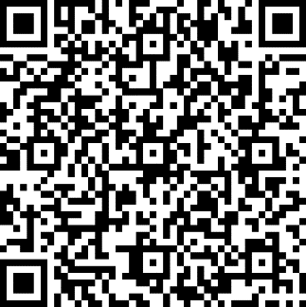

## References

This resource contains NSW Curriculum and syllabus content. The NSW Curriculum is developed by the NSW Education Standards Authority. This content is prepared by NESA for and on behalf of the Crown in right of the State of New South Wales. The material is protected by Crown copyright.

Please refer to the NESA Copyright Disclaimer for more information <https://educationstandards.nsw.edu.au/wps/portal/nesa/mini-footer/copyright>.

NESA holds the only official and up-to-date versions of the NSW Curriculum and syllabus documents. Please visit the NSW Education Standards Authority (NESA) website <https://educationstandards.nsw.edu.au/> and the NSW Curriculum website [https://curriculum.nsw.edu.au](https://curriculum.nsw.edu.au/).

[Modern Languages K–10 Syllabus](https://curriculum.nsw.edu.au/learning-areas/languages/modern-languages-k-10-2022) © NSW Education Standards Authority (NESA) for and on behalf of the Crown in right of the State of New South Wales, 2022.

CESE (Centre for Education Statistics and Evaluation) (2020a) [*What works best: 2020 update*](https://education.nsw.gov.au/about-us/education-data-and-research/cese/publications/research-reports/what-works-best-2020-update), NSW Department of Education, accessed 13 November 2023.

CESE (Centre for Education Statistics and Evaluation) (2020b) [*What works best in practice*](https://education.nsw.gov.au/about-us/education-data-and-research/cese/publications/practical-guides-for-educators-/what-works-best-in-practice), NSW Department of Education, accessed 13 November 2023.

**© State of New South Wales (Department of Education), 2024**

The copyright material published in this resource is subject to the *Copyright Act 1968* (Cth) and is owned by the NSW Department of Education or, where indicated, by a party other than the NSW Department of Education (third-party material).

Copyright material available in this resource and owned by the NSW Department of Education is licensed under a [Creative Commons Attribution 4.0 International (CC BY 4.0) license](https://creativecommons.org/licenses/by/4.0/).

[](https://creativecommons.org/licenses/by/4.0/)

This license allows you to share and adapt the material for any purpose, even commercially.

Attribution should be given to © State of New South Wales (Department of Education), 2024.

Material in this resource not available under a Creative Commons license:

* the NSW Department of Education logo, other logos and trademark-protected material
* material owned by a third party that has been reproduced with permission. You will need to obtain permission from the third party to reuse its material.

**Links to third-party material and websites**

Please note that the provided (reading/viewing material/list/links/texts) are a suggestion only and implies no endorsement, by the New South Wales Department of Education, of any author, publisher, or book title. School principals and teachers are best placed to assess the suitability of resources that would complement the curriculum and reflect the needs and interests of their students.

If you use the links provided in this document to access a third-party's website, you acknowledge that the terms of use, including licence terms set out on the third-party's website apply to the use which may be made of the materials on that third-party website or where permitted by the *Copyright Act 1968* (Cth). The department accepts no responsibility for content on third-party websites.