Italian Stage 1
Introduzioni (Introductions)
Contents
Unit overview 5
Stage 1 outcomes and content to be addressed 6
Learning map 10
Assessment 13
Assessment opportunities 14
Teaching and learning activities 15
Week 1 – greetings 15
Vocabulary 1 – greetings, farewells and feelings 15
Activity 1 – Learning map 17
Activity 2 – sing ‘Ciao, Buongiorno’ 17
Activity 3 – greetings 18
Activity 4 – una passeggiata 19
Activity 5 – formal and informal Italian 19
Activity 6 – una passeggiata 2 – using formal and informal Italian 20
Week 2 – family members 21
Vocabulary 2 – family 21
Activity 1 – family members 22
Activity 2 – la mia famiglia 24
Activity 3 – game – Concentration 24
Activity 4 – labelling family members 25
Week 3 – introducing friends 26
Activity 1 – Come stai? (How are you?) review 26
Activity 2 – this is … Anna 27
Activity 3 – how to introduce siblings and cousins 28
Activity 4 – making sentences 28
Activity 5 – practise introducing siblings and cousins 29
Activity 6 – modelled role-play introducing siblings and cousins 29
Activity 7 – introducing siblings and cousins – modelled, guided and independent writing 30
Week 4 – introducing an adult 31
Activity 1 – this is … my mum 31
Activity 2 – how to introduce parents and grandparents 32
Activity 3 – practise introducing parents and grandparents 33
Activity 4 – modelled role-play introducing parents and grandparents 34
Activity 5 – introducing parents and grandparents – modelled, guided and independent writing 34
Week 5 – assessment criteria and practice task 36
Activity 1 – group role-play practice 36
Activity 2 – assessment task 37
Activity 3 – success criteria 37
Activity 4 – task groups 38
Activity 5 – practice task 39
Week 6 – communicative task – introduce a family member 41
Activity 1 – task set-up 42
Activity 2 – communicative task – introducing someone 42
Activity 3 – peer assessment 44
Week 7 – feedback and goal setting 45
Activity 1 – ‘Beat the Teacher’ 45
Activity 2 – self-assessment 46
Activity 3 – set learning goals 46
Week 8 – language review 48
Activity 1 – student questions 49
Activity 2 – ‘Hangman’ 49
Activity 3 – role-play sequencing activity 49
Activity 4 – reading role-play 50
Activity 5 – greetings labelling activity 50
Student resources 51
Resource 1 – greetings, farewells and feelings flashcards 51
Resource 2 – family member flashcards 55
Resource 3 – family member labelling activity 57
Resource 4 – family sentence builder 59
Resource 5 – visual rubric 60
Resource 6 – peer feedback strategy – Two stars and a wish 61
Resource 7 – greetings labelling activity 62
Support and alignment 66
References 69

Unit overview
Stage: 1
Title: Introduzioni (Introductions)
Description: In this unit, students use culturally appropriate informal and formal language to greet and introduce people to each other, using formulaic phrases to introduce peers and adults.
Duration: This lesson sequence is designed to be completed over approximately 8 weeks.
Student proficiency levels:
It is assumed that most Stage 1 students have been learning Italian since Kindergarten and their proficiency level will still be Beginner. The assessment tasks in this scope and sequence are aimed at Beginner students. Every classroom will be different, and teachers will need to adapt to their context. Many classes may include a combination of Beginner, Intermediate and Advanced students with varying skills and abilities within these proficiency levels. Assessment tasks and opportunities in this unit can be differentiated using the ‘Too hard?’ and ‘Too easy?’ suggestions.

Stage 1 outcomes and content to be addressed
The table below outlines the focus area, outcomes and content points for Stage 1 students.
Focus area and outcome | Content points
Interacting  A student:  - exchanges meaning by selecting culturally appropriate modelled language ML1-INT-01 | Exchanging meaning in oral interactions in the target language  - Exchange greetings, farewells and simple information to describe people or objects  - Answer common questions about themselves and their personal world in a guided conversation  - Interact in classroom routines using familiar language  - Interact by selecting modelled language in games or scenarios using imagination  Reproducing oral language to interact in the target language  - Recognise and reproduce modelled sounds, including pronunciation and intonation patterns to interact  - Reproduce familiar vocabulary and short formulaic phrases to interact  Applying knowledge of the target language culture(s) to interact  - Use familiar verbal and nonverbal communication that is appropriate to cultural practices
Understanding texts  A student:  - recognises and responds to information in simple texts to demonstrate understanding ML1-UND-01 | Understanding and responding to target language texts  - Listen to, read and/or view simple texts, such as stories, songs, charts, rhymes or lists on familiar themes  - Use auditory cues, gestures, visuals and other forms of nonverbal communication to support comprehension  - Associate vocabulary on familiar themes with known actions, people, places, objects and ideas  - Recognise information in simple texts and respond to simple questions in the target language and/or English to show understanding of texts  - Demonstrate understanding when responding to texts using actions, drawing, singing or simple exchanges in the target language and/or English  Applying knowledge of language systems to understand and respond to target language texts  - Recognise and use sounds of modelled vocabulary and phrases to understand and respond to texts  - Recognise sound–symbol correspondences in modelled words and phrases to understand and respond to texts  - Recognise and use knowledge of modelled vocabulary, high-frequency words and formulaic phrases on familiar themes to understand and respond to texts  - Use simple grammar patterns to understand and respond to texts  - Recognise that the target language has features that may be similar to or different from English  - Recognise and reproduce symbols or modelled vocabulary and phrases of the writing system to understand and respond to texts  Developing intercultural understanding through target language texts  - Notice that language is used in ways that reflect cultural practices and reflect on their own language and cultural practices
Creating texts  A student:  - creates simple texts by selecting culturally appropriate modelled language ML1-CRT-01 | Creating spoken, written and multimodal texts in the target language  - Create texts using familiar vocabulary, phrases and visuals to express meaning  - Label or describe objects and images  Applying knowledge of language systems to create texts in the target language  - Use pronunciation patterns to create spoken texts  - Use familiar sound–symbol correspondences to create written texts  - Use familiar vocabulary and formulaic phrases to create texts  - Use simple modelled sentence structures to create texts  - Reproduce modelled features of the target language writing system to create written texts  Reproducing how target language speakers communicate to create texts  - Reproduce language appropriate to cultural practices to create texts
Modern Languages K–10 Syllabus © NSW Education Standards Authority (NESA) for and on behalf of the Crown in right of the State of New South Wales, 2022.

Learning map
The creation of maps for learning is a planning process that incorporates Aboriginal intellectual tradition. Learning maps are a visual pathway of what students will learn.
Share the learning map with your students, briefly explaining the learning that will happen in each lesson. Provide students with a copy of the learning map or display the learning map in the classroom. This learning map can be adapted to Italian by accessing a copy of Learning map – Introductions (Stage 1 Italian).
Figure 1 – Introductions learning map
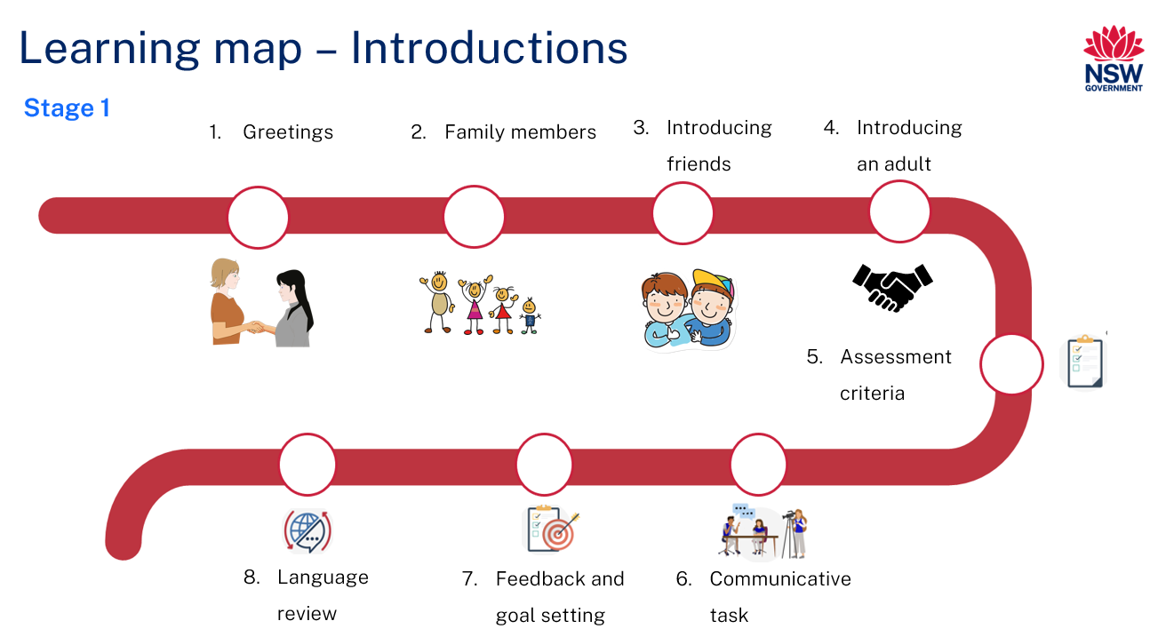
Figure 2 – Introduzioni learning map
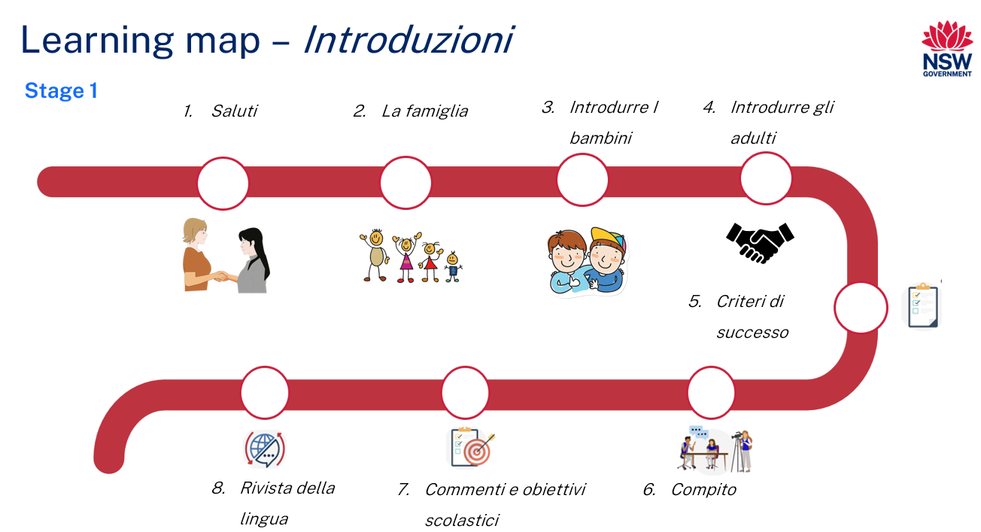

Assessment
Stage 1 communicative task: You are a student who has just moved to Australia from Italy. Introduce a friend to a family member.
Note: Your friend is studying Italian, and your family member can only speak Italian. Use appropriate language for speaking to an adult or another child. Use greetings appropriate for the time of day.
Too hard?
Use greetings and gestures to indicate the person and give their name.
Too easy?
Introduce both an adult and a child family member to a friend.
Context: you have just moved to Australia from Italy
Audience: your friend
Purpose: to introduce a family member to your friend

Assessment opportunities
The table below details assessment opportunities and differentiation ideas.
Assessment opportunities | Too hard? | Too easy?
Week 2 – family members  Pre-assessment of vocabulary knowledge. | Family members  If most of the students know only a few of the words, leave out nonna and nonno (grandparents) and cugino and cugina (cousins). | Family members  If most of the students know all of the words, add madre (mother), padre (father), zia (aunt) and zio (uncle).
Week 3 – making sentences  Use Resource 4 – family sentence builder to make and say sentences about family members in Italian. | Making sentences  Simplify Resource 4 – family sentence builder by including only mamma (mum), papà (dad), fratello (brother) and sorella (sister). | Making sentences  Make Resource 4 – family sentence builder less predictable by changing the order of words in each column.
Week 4 – modelled, guided and independent writing  Students read, discuss and copy a modelled sentence. They then write guided and independent sentences. | Modelled, guided and independent writing  Students have additional modelled and guided sentences before moving to independent writing. | Modelled, guided and independent writing  Less time is spent on modelled and guided writing. Students write additional independent sentences.

Teaching and learning activities

Week 1 – greetings
The table below outlines the learning intention and success criteria of the lesson, and materials that the teacher and students will need to complete the teaching and learning activities.
Learning intention and success criteria | Materials
Students will use appropriate formal and informal greetings depending on the person they’re talking to.  Students can:  - greet an adult using a formal greeting  - greet a friend using an informal greeting. | - Resource 1 – greetings, farewells and feelings flashcards  - Italian exercise books/worksheet  - Writing and drawing materials

Vocabulary 1 – greetings, farewells and feelings
The table below outlines the suggested vocabulary used throughout this learning sequence. It includes the Italian words and phrases and their corresponding English translations.
English | Italian
Good morning/Good day | Buongiorno
Good evening | Buona sera
Good night | Buona Notte
Hi/Bye | Ciao
Goodbye | Arrivederci
How are you? | Come stai?
I’m well | Sto bene
I’m not well | Sto male
I’m okay | Così così

Activity 1 – Learning map
Explain and display the Learning map to give students a more detailed breakdown of lessons during the unit. Point out that the Learning map is a plan that may need to change.

Activity 2 – sing ‘Ciao, Buongiorno’
Note: view the ABC recording of Ciao, Buon Giorno (0:39) if you are not familiar with the song. The song uses the tune of Frère Jacques. Each line is sung twice. The lyrics are:
Ciao, Buongiorno (Hi, hello) × 2
Come Stai? (How are you?) × 2
Molto, molto bene (Very, very well) × 2
Grazie a te (Thank you (to you)) × 2
Stage 1 students should be familiar with the language in this song.
- Ask students to repeat each line after you sing it, then sing the song as a class.
- Students Think-Pair-Share the English meaning of each line in the song.
- Point out that the words to this song are very common and will be used in many Italian conversations.
- Model and drill the pronunciation of the language if required.

Activity 3 – greetings
- Ask students what greetings are and when people use them. Possible answers include being polite when meeting someone for the first time or things people say when they see someone they know.
- Ask students which words in the song can be used as greetings. Answers are ‘ciao’ (hi!/bye!), ‘buongiorno’ (hello!) and possibly ‘Come stai?’ (How are you?).
- Tell students that in Italian, like in English, different greetings are used at different times of the day. Ask students if they can say some of these greetings in English. Examples are good morning, good day, good afternoon, good evening and good night.
- Display images from Resource 1 – greetings, farewells and feelings flashcards. Point out that many greetings are relevant at different times of the day. Model and drill the pronunciation of each greeting.
- Many of the greetings and farewells are multi-syllable words, such as arrivederci, and phrases, such as buona sera. Ask students how many syllables are in each word or phrase.
- Clap out a-rri-ved-er-ci, pointing out that there are 5 syllables in this word, while buon-a ser-a has 4 syllables. Clap out the syllables in the other words and phrases.

Activity 4 – una passeggiata
Note: la passeggiata is an integral part of Italian life where people take a walk or stroll through their town or city, usually in the late afternoon or early evening. It is an opportunity for people to meet and greet friends, relations and members of the community.
Explain the concept of la passeggiata, model and drill the phrases fate una passeggiata (take an evening stroll through the main street) and camminate (walk).
Tell students to stroll around the classroom. When you say fate una passeggiata (take an evening stroll through the main street), students say buona sera (good evening) to their classmates. When you say camminate (walk), students say buongiorno (good day) to their classmates.

Activity 5 – formal and informal Italian
- Ask students if they know what the English words ‘formal’ and ‘informal’ mean.
- Use the example of dress to explain the concepts, by asking why students would wear different clothes to a wedding and to the beach.
- Explain that language can also be formal, for example, students speak more formally to their teachers than they do to their friends.
- In Italian, children use different words when speaking to adults and speaking to other children. Explain that ciao is an informal greeting people use to say ‘hi’ and ‘bye’ to friends, while buongiorno, buona sera and arrivederci are more formal greetings that are used with people students don’t know very well.

Activity 6 – una passeggiata 2 – using formal and informal Italian
- Play another round of una passeggiata. This time students must greet their classmate and then say goodbye in Italian.
- Tell students to stroll around the classroom. When you ring a bell, students find the nearest classmate to greet.
- If you hold up a flashcard of an adult, the students say buongiorno or buona sera, then arrivederci. If you hold up a flash card of child, the students say ciao.
Evaluation: students use different greetings with adults and children to demonstrate their understanding of the concepts of formality and informality.

Week 2 – family members
The table below outlines the learning intention and success criteria of the lesson, and materials that the teacher and students will need to complete the teaching and learning activities.
Learning intention and success criteria | Materials
Students will learn the Italian words for family members.  Students can:  - say and write words for family members in Italian. | - Resource 2 – family member flashcards (to be displayed on the board or wall and sets printed for groups)  - Resource 3 – family member labelling activity

Vocabulary 2 – family
The table below outlines the suggested vocabulary used throughout this learning sequence. It includes the Italian words and phrases and their corresponding English translations.
English | Italian
My family | La mia famiglia
My cousin (male) | Mio cugino
My cousin (female) | Mia cugina
My grandfather | Mio nonno
My grandmother | Mia nonna
My mum | La mia mamma
My dad | Il mio papà
My sister | Mia sorella
My brother | Mio fratello

Activity 1 – family members
- Display images of family members, such as those on Resource 2 – family member flashcards one at a time. Say the words of each family member in English as they are placed on the board.
- Pre-assessment: students look at the family member flashcards. Ask students to identify how many words they know in Italian by answering the following questions, showing thumbs up at their chests:
- Do you know all the words?
- Do you know most of them?
- Do you know some of them?
- Do you know none of them?
- Students Think-Pair-Share and tell their partners the words they know and report back to the class.
- On the other side of the board, put the Italian words for family members one at a time in random order. Model the pronunciation of each family member and have students imitate the pronunciation. Select a student to match each word to an image.
- Model and have students repeat the pronunciation of each word.
- Remove the papà card and display the other family members grouped by gender. Ask students if they notice anything about how the words for family members are written. Prompt students if necessary to look at the last letter of each word. They will notice that the words for female family members end in -a, while the words for male family members end in -o. Tell students that almost all Italian words end in a vowel. Ask students to tell you what the vowel letters in English are.
- Tell students that many words in Italian are masculine and these words usually, but not always, end in -o. Other words are feminine and these words usually end in -a. Papà is an unusual example of a masculine word that ends in -a.
Note: if most students know most of the vocabulary already, include madre (mother), padre (father), zia (aunt), zio (uncle).

Activity 2 – la mia famiglia
- Tell students the word for family in Italian is famiglia. Model and drill the correct pronunciation of the word. Ask students to notice the ‘glia’ sound and model and drill this sound. Ask students how they think this sound might be spelt. Answers will likely include ‘ly’. Tell students that this would make sense in English, but some sound-symbol/letter correspondence in Italian is different to English. In Italian ‘gl’ is always followed by a vowel and always makes a ‘ly’ sound.
- Tell students that there is more than one word for ‘my’ in Italian. When talking about a female member of your family, the word for my is mia. When talking about a male member of your family, the word for my is mio.
- Students talk to 3 classmates and use a combination of Italian and English to talk about different members of their family. For example, mia mamma (my mum) is lovely and is called Maria, mio fratello (my brother) is called John and he is good at football.

Activity 3 – game – Concentration
- Cut the images from the words in Resource 2 – family member flashcards.
- Stick the cards on the board back-to-front so the images and words can’t be seen.
- Choose a student to turn over a picture card and a label card. Ask the class to name the picture and read the label. If the cards match, the student keeps the cards and displays them face up.
- If the cards don’t match, the student turns the cards over and another student has a turn. Keep playing until all the cards are matched up.
- When all the cards are matched up read the labels as a class.
Note: expand the game by including Resource 1 – greetings, farewells and feelings flashcards.

Activity 4 – labelling family members
Students complete Resource 3 – family member labelling activity.
Students write or cut out the Italian word under the image of the relevant family member.
Note: as an extension, students can add the appropriate word for ‘my’ with each family member.

Week 3 – introducing friends
The table below outlines the learning intention and success criteria of the lesson, and materials that the teacher and students will need to complete the teaching and learning activities.
Learning intention and success criteria | Materials
Students will introduce 2 children to each other.  Students can:  - greet and introduce a child using Ecco (Here is – informal). | - Resource 2 – family member flashcards  - Resource 4 – family sentence builder  - Italian exercise books
Note: vocabulary introduced in this lesson includes e tu? (and you), ecco (here is/this is) and piacere (nice to meet you).

Activity 1 – Come stai? (How are you?) review
- Tell students they will be introducing a sibling or cousin to their friend. Explain that the family member does not speak English. Their friend is learning Italian and wants to practise speaking Italian.
- Ask a few students ‘Come stai?’ (How are you?). If students don’t answer straight away, remind them about the Ciao, buongiorno (Hi, hello) song. Students might respond with molto, molto bene (very, very well) or bene (well).
- Ask students if they can think of any other ways to respond to ‘Come stai?’ Use appropriate facial expressions and gestures to encourage the responses ‘così, così’ (I’m okay) and ‘sto male’ (I’m not good).
- Model and drill the different answers to ‘Come stai?’ using appropriate tone of voice, facial expressions and gestures.
- Tell students that it’s usually enough to say ‘bene’ when answering ‘Come stai?’ when introducing or being introduced to someone.
- Tell students that if someone asks how they are in English, students may say something like ‘What about you?’ instead of repeating ‘How are you?’. It is a similar situation in Italian. Instead of repeating ‘Come stai?’, Italian speakers will ask ‘e tu?’ (and you?). Model the phrase ‘Bene, e tu?’ (Well, and you?) and ask students to repeat, focusing on pronunciation and intonation.
- Tell students to ask 3 classmates Come Stai? Students answer classmates’ questions with a different answer each time and follow their answer with ‘e tu?’
Note: point out to students that the Italian words for ‘is’ (é) and ‘and’ (e) sound the same and look very similar. The difference is that the word for ‘is’ has an accent above the letter e.

Activity 2 – this is … Anna
- Choose a student and introduce them to the class by saying, for example, ‘Ecco Roberto’.
- Explain that students can use the word Ecco (Here is….) to introduce a friend or another child. In English, they might also say ‘This is…’
- Students sit in a circle and introduce the person next to them by saying Ecco and the name of the person next to them, for example, Ecco Andrea, Ecco Anna, and so on.

Activity 3 – how to introduce siblings and cousins
- Display the images of the younger family members, brother, sister, male cousin and female cousin from Resource 2 – family member flashcards, one at a time.
- Clarify that in English there is only one word for cousin. Ask students if their home language has separate words for male and female cousins, like Italian, or only one word, like English.
- Introduce one person in English. For example, here is my brother, Marco.
- Students Think-Pair-Share how to say the introduction in Italian, for example Ecco mio fratello, Marco. After the first example has been shared by the class in Italian, point out that there are 4 words in each sentence when introducing one child to another. Ask the class as a whole or individual students to finish these sentences:
- The first word is… Ecco
- The second word is... mio or mia (my)
- The third word is the relationship: fratello (brother), sorella (sister), cugina (female cousin), cugino (male cousin)
- The fourth word is the person’s name.
- After each family member has been introduced, display the written sentence of the introductions.

Activity 4 – making sentences
Display Resource 4 – family sentence builder and demonstrate how it can be used to make a sentence about someone in their family.
In pairs, students take turns at making and saying sentences about family members in Italian.
Example sentences:
- Student 1: Ecco mio fratello. (This is my brother.)
- Student 2: Ecco mia sorella. (This is my sister.)

Activity 5 – practise introducing siblings and cousins
- Students form groups of 5. Each group has a set of images of the 4 younger family members from Resource 2 – family member flashcards.
- Four students have one card each. The student without a card will introduce each of the 4 younger family members.
- Have the sentences from the previous activity displayed in Resource 4 – family sentence builder, but encourage students to introduce some family members without referring to them.
- After the student without a card has introduced the 4 family members, cards are rotated, and a new student introduces the 4 family members.

Activity 6 – modelled role-play introducing siblings and cousins
- Read the example role-play below as a class several times. Point out that piacere means ‘nice to meet you’. Ask students to repeat after you to ensure correct pronunciation. Discuss any questions students have about the language.
- Keep the text displayed for students to access while they are practising the interaction.
- Put students in groups of 3. Students take turns at playing each role.
- Example interaction with you, your friend Joe and your brother Marco:
- You: Ciao Joe, come Stai? (Hi Joe, how are you?)
- Joe: Bene, grazie. E tu? (I'm good thank you. How are you?)
- You: Cosi, cosi. Ecco mio fratello, Marco. (I'm ok. This is my brother, Marco.)
- Joe: Ciao Marco, piacere. (Hi Marco, nice to meet you.)
- Marco: Piacere Joe, ciao. (It's nice to meet you too Joe. Bye.)
- Joe: Ciao. (Bye.)

Activity 7 – introducing siblings and cousins – modelled, guided and independent writing
- Leave only one of the written sentences, for example Ecco mio fratello, Marco (This is my brother, Marco), displayed. Ask students to read it aloud and explain what the sentence means in English. Students then copy in their books.
- Write Ecco ____ sorella, ______ on the board and ask students to write the completed sentence Ecco mia sorella, Siena (This is my sister, Siena) in their books.
- Ask students to follow the pattern and independently write a sentence about a male or female cousin in their books.

Week 4 – introducing an adult
The table below outlines the learning intention and success criteria of the lesson, and materials that the teacher and students will need to complete the teaching and learning activities.
Learning intention and success criteria | Materials
Students will introduce adult family members.  Students can:  - greet and introduce an adult family member using Questo é or Questa é. (This is – formal, masculine and feminine). | - Resource 2 – family member flashcards  - Resource 4 – family sentence builder  - Italian exercise books  - Sample role-play displayed in the classroom
Note: vocabulary introduced in this lesson includes Questo é (This is – when introducing an adult male), Questa é (This is – when introducing an adult female). Students will also learn Signora (Mrs) and Signor (Mr).

Activity 1 – this is … my mum
- Tell students they will be introducing an adult family member to their friend. Explain that the family member does not speak English. Their friend is learning Italian and wants to practise speaking Italian.
- Explain that students can use questo é (this is….) to introduce a male adult and questa é (this is….) to introduce a female adult, as these words are more formal than ecco (here is).
- Model and drill questo é and questa é for pronunciation.
- Ask students to Think-Pair-Share how to say ‘This is my mum’ in Italian. Remind students to use the feminine forms of ‘this’ and ‘my’. After students have shared, write or display the correct Italian sentence: ‘Questa é la mia mamma’.
- Show images of family members from Resource 2 – family member flashcards and ask students to say ‘questo é’ or ‘questa é’ depending on the gender of the family member on the card along with the appropriate word for ‘my’.
Note: when using one of the words for ‘my’ in Italian, for example, mia or mio, the appropriate definite article, or word for ‘the’, is generally used. An exception is when talking about family members, for example, mio fratello is the correct way to say my brother, while il mio fratello is not.
It is acceptable to say both mio papà and il mio papà (my dad) and mia mamma and la mia mamma (my mum), although il mio papà and la mia mamma are more common.

Activity 2 – how to introduce parents and grandparents
- Display the images of the older family members mum, dad, grandmother and grandfather, from Resource 2 – family member flashcards, one at a time.
- Introduce one person in English. For example, this is my grandmother, Paola.
- Students Think-Pair-Share how to say the introduction in Italian, for example ‘Questa é mia nonna, Paola’. After the first example has been shared by the class in Italian, point out that there are 5 words in each sentence when introducing a child to an adult. Ask the class as a whole or individual students to finish these sentences:
- The first word is… Questo or Questa (This)
- The second word is… é (is)
- The third word is... mio or mia (my)
- The fourth word is the relationship: mamma (mum), papà (dad), nonna (grandmother), nonno (grandfather)
- The fifth word is the person’s name.
- After each family member has been introduced, display the written sentence of the introductions.

Activity 3 – practise introducing parents and grandparents
- Students form groups of 5. Each group has a set of images of the 4 older family members: mamma (mum), papà (dad), nonna (grandmother) and nonno (grandfather), from Resource 2 – family member flashcards.
- Four students have one card each. The student without a card will introduce each of the 4 older family members.
- Have the sentences from the previous activity in Resource 4 – family sentence builder displayed but encourage students to introduce some family members without referring to them.
- After the student without a card has introduced the 4 family members, cards are rotated, and a new student introduces the 4 family members.

Activity 4 – modelled role-play introducing parents and grandparents
- Read the example role-play below as a class several times. Practise pronunciation of piacere (it’s nice to meet you) again.
- Keep the text displayed for students to access while they are practising the interaction.
- Put students in groups of 3. Students take turns at playing each role.
- Example interaction with you, your friend Joe and your Mum:
- You: Buonasera Joe, come Stai? (Good evening Joe, how are you?)
- Joe: Bene, grazie. E tu? (I'm good thank you. How are you?)
- You: Bene. Questa é la mia mamma, Anna. (I'm well. This is my mum, Anna.)
- Joe: Buonasera Signora, piacere. (Good evening Mrs, nice to meet you.)
- Mum: Piacere Joe, arrivederci. (It's nice to meet you too Joe. Goodbye.)
- Joe: Arrivederci. (Goodbye.)

Activity 5 – introducing parents and grandparents – modelled, guided and independent writing
- Display one of the written sentences, for example, Questa é mia nonna, Paola (This is my grandmother, Paola). Ask students to read it aloud and explain what the sentence means in English. Students then copy this in their books.
- Write Questo é ____ __ papà, ______ on the board and ask students to write the completed sentence ‘Questo é il mio papà, Andrea’ (This is my dad, Andrea) in their books.
- Ask students to follow the pattern and independently write sentences about their mum and grandfather in their books.

Week 5 – assessment criteria and practice task
The table below outlines the learning intention and success criteria of the lesson, and materials that the teacher and students will need to complete the teaching and learning activities.
Learning intention and success criteria | Materials
Students will develop a clear understanding of the requirements of the task, prepare for and practise the task.  Students can:  - say what they need to do to be successful in the task. | - Resource 5 – visual rubric

Activity 1 – group role-play practice
- Display the example role-plays from Weeks 3 and 4 on the board or in the classroom.
- Divide the class into 3 groups.
- Assign each group a part, for example, Group 1 – person 1, Group 2 – person 2, Group 3 – person 3. Use a different colour for each part to help students know which part they are reading.
- Read each role-play 3 times rotating the groups, so each group has read each part.
- Ask the students to point out words that were ‘tricky’ to say. Practise saying these words with the whole class.

Activity 2 – assessment task
- Explain the communicative task: you have just moved to Australia from Italy. You want to introduce a family member to your friend in your Italian class.
- Students greet their friend and introduce someone from their family using an appropriate greeting and level of formality, depending on whether students are introducing an adult or another child.
- Point out that:
- the context of the task is that students have just moved to Australia from Italy
- the audience of the communication will be their friend from their Italian class
- the communicative purpose or reason is to introduce someone from the students’ family to their friend.

Activity 3 – success criteria
- After looking at the assessment task, students Think-Pair-Share and suggest appropriate success criteria, such as:
I will be successful if I can:
- use greeting words such as Buongiorno, Buonasera, Ciao and Arrivederci
- say how I’m feeling
- introduce a family member by saying, for example, ‘Questa é la mia mamma’ (This is my mum), ‘Ecco mia sorella’ (Here is my sister) correctly
- say words in the right order
- speak loudly and clearly.
- Explain Resource 5 – visual rubric and adjust if necessary.

Activity 4 – task groups
- Students will use the same groups for the practice task and the actual task.
- Organise students into groups of 4 and give them a few minutes to ensure everybody knows the order in which they will perform each role.
- ‘You’ is the student who is completing the assessed communicative task.
Suggested rotations:
- Role-play 1: Student 1 – ‘You’, Student 2 – Peer assessor/Camera operator, Student 3 – Family member, Student 4 – Friend
- Role-play 2: Student 1 – Friend, Student 2 – ‘You’, Student 3 – Peer assessor/Camera operator, Student 4 – Family member
- Role-play 3: Student 1 – Family member, Student 2 – Friend, Student 3 – ‘You’, Student 4 – Peer assessor/Camera operator
- Role-play 4: Student 1 – Peer assessor/Camera operator, Student 2 – Family member, Student 3 – Friend, Student 4 – ‘You’.

Activity 5 – practice task
- Choose students to model the example interactions.
- Display the modelled role-plays from Weeks 3 and 4.
- Display an image of papà, with each student playing a different role. Then display sorella, nonna and cugino, rotating roles each time.
- Give groups a minute or two to adjust the displayed role-play text based on the family member involved. Remind students to use appropriate language based on the gender of the family member and whether they are speaking to an adult or a child.
- Example interaction 1 (introducing an adult family member):
- You: Buonasera Joe, come stai? (Good evening Joe, how are you?)
- Joe: Bene, grazie. E tu? (I'm good thank you. How are you?)
- You: Bene. Questa é la mia mamma, Anna. (I'm well. This is my mum, Anna.)
- Joe: Buonasera Signora, piacere. (Good evening Mrs, nice to meet you.)
- Mum: Piacere Joe, arrivederci. (It’s nice to meet you too Joe. Goodbye.)
- Joe: Arrivederci. (Goodbye.)
- Example interaction 2 (introducing a child family member):
- You: Ciao Joe, come stai? (Hi Joe, how are you?)
- Joe: Bene, grazie. E tu? (I’m good, thank you. How are you?)
- You: Cosi, cosi. Ecco mio fratello, Marco. (I'm ok. This is my brother, Marco.)
- Joe: Ciao Marco, piacere. (Hi Marco, nice to meet you.)
- Marco: Piacere Joe, ciao. (It's nice to meet you too Joe. Bye.)
- Joe: Ciao. (Bye.)

Week 6 – communicative task – introduce a family member
The table below outlines the learning intention and success criteria of the lesson, and materials that the teacher and students will need to complete the teaching and learning activities.
Learning intention and success criteria | Materials
Students will introduce a family member to a friend.  Students can:  - use greeting words such as Buongiorno, Buonasera, Ciao and Arrivederci  - say how they are feeling  - introduce a family member by saying, for example, ‘Questa é la mia mamma’ (This is my mum), ‘Ecco mia sorella’ (Here is my sister) correctly  - say words in the right order  - speak loudly and clearly. | - Resource 6 – peer feedback strategy – Two stars and a wish  - Recording device

Activity 1 – task set-up
Students get into groups of 4. Groups are given a few minutes to ensure everybody knows the order in which they will perform each role. ‘You’ is the student who will be completing the assessed communicative task.
Suggested rotations:
- Role-play 1: Student 1 – ‘You’, Student 2 – Peer assessor/Camera operator, Student 3 – Family member, Student 4 – Friend
- Role-play 2: Student 1 – Friend, Student 2 – ‘You’, Student 3 – Peer assessor/Camera operator, Student 4 – Family member
- Role-play 3: Student 1 – Family member, Student 2 – Friend, Student 3 – ‘You’, Student 4 – Peer assessor/Camera operator
- Role-play 4: Student 1 – Peer assessor/Camera operator, Student 2 – Family member, Student 3 – Friend, Student 4 – ‘You’.
Note: if students are above a Beginner level and/or if time permits, students can have 2 conversations where they introduce an adult and a child member of their family to a friend.

Activity 2 – communicative task – introducing someone
Note: make sure to space students apart when filming. Demonstrate how to film using a recording device. Use microphones, if possible, to maximise sound quality. Highlight the importance of holding the recording device still by using a tripod or resting it on a table.
Students get into groups of 4 and complete the task.
Example interaction 1 (introducing an adult family member):
- You: Buonasera Joe, come stai? (Good evening Joe, how are you?)
- Joe: Bene, grazie. E tu? (I'm good thank you. How are you?)
- You: Bene. Questa é la mia mamma, Anna. (I'm well. This is my mum, Anna.)
- Joe: Buonasera Signora, piacere. (Good evening Mrs, nice to meet you.)
- Mum: Piacere Joe, arrivederci. (It's nice to meet you too Joe. Goodbye.)
- Joe: Arrivederci. (Goodbye.)
Example interaction 2 (introducing a child family member):
- You: Ciao Joe, come stai? (Hi Joe, how are you?)
- Joe: Bene, grazie. E tu? (I'm good thank you. How are you?)
- You: Cosi, cosi. Ecco mio fratello, Marco. (I'm okay. This is my brother, Marco.)
- Joe: Ciao Marco, piacere. (Hi Marco, nice to meet you.)
- Marco: Piacere Joe, ciao. (It's nice to meet you too Joe. Bye.)
- Joe: Ciao. (Bye.)
Note: before recording interactions, check if any students do not have permission to be filmed. Alternatives to video recording include audio recording or the teacher watching the interactions while taking notes and marking the rubric.

Activity 3 – peer assessment
Note: this may be the first-time students have engaged in peer assessment. As a result, you may need to provide further explanation on why this is important and what students should and should not do while giving and receiving peer assessment.
- Students pair up and give each other feedback on their introduction of one or more family members using Resource 6 – peer feedback strategy – Two stars and a wish.
- Explain that it is important students check not only their own work, but also provide feedback to classmates regarding their work. Remind students that they need to be respectful to each other when giving and receiving feedback.
- Co-construct ‘ground rules’ for peer feedback. It may be helpful to provide sentence starters to prompt students. For example, ‘I like the way…’, ‘You did an excellent job of…’, ‘My favourite part was…’, ‘I didn’t understand…’. Emphasise that the peer feedback should be related to visual rubric provided for this task.
- Each student will provide and receive feedback to the student who was ‘you’ when they had the role of peer assessor/camera operator. Peer feedback is provided verbally and may be followed up with a completed peer feedback slip.

Week 7 – feedback and goal setting
Note: if there is insufficient time to mark the videos before Week 8, Weeks 7 and 8 can be swapped.
The table below outlines the learning intention and success criteria of the lesson, and materials that the teacher and students will need to complete the teaching and learning activities.
Learning intention and success criteria | Materials
Students will reflect on feedback to set suitable learning goals.  Students can:  - understand the feedback received  - reflect on the feedback provided to establish new learning. | - Resource 1 – greetings, farewells and feelings flashcards  - Resource 5 – visual rubric – teacher marked rubric (one per student)
Note: prior to this lesson, the teacher views each video and marks each student according to the criteria on the Introduzioni visual rubric.

Activity 1 – ‘Beat the Teacher’
- Display images from Resource 1 – greetings, farewells and feelings flashcards.
- Say a greeting. If the greeting matches the image on the card, the class must all repeat it immediately. If this happens, students get a point.
- If you try to trick the class with a different greeting, no one must repeat the word or phrase. If students repeat the wrong word, then you get a point. If all students stay silent, they get a point.

Activity 2 – self-assessment
Students watch the video of themselves completing the task and mark themselves using the Resource 5 – visual rubric. Students then compare both the teacher completed rubric and the one they completed.

Activity 3 – set learning goals
- To foster student ownership of their learning, facilitate a class discussion to help students reflect on their marked rubric, peer and self-assessment and set their own personalised learning goals for the next phase. During the discussion, provide age-appropriate suggestions for learning goals, such as improving their ability to speak the language, adding more detail or creativity to their instructions, or building confidence in their abilities. Use simplified language to ensure that the students can understand and engage with the discussion effectively.
- Teacher suggested learning goals include:
- I will be confident when saying words in Italian.
- I will try to say Italian words in the correct order.
- I will practise saying tricky sounds in Italian, for example …
- I will not be worried about making a mistake when speaking Italian.
- Present these suggestions and encourage students to raise their hands when they hear a goal that resonates with them. By doing so, students will understand their options and select a learning goal that is most relevant and suitable for their needs.
- Students record their learning goals in their Italian notebooks.
Evaluation: students set appropriate learning goals.

Week 8 – language review
Note: if there is insufficient time to mark the videos before Week 8, Weeks 7 and 8 can be swapped.
The table below outlines the learning intention and success criteria of the lesson, and materials that the teacher and students will need to complete the teaching and learning activities.
Learning intention and success criteria | Materials
Students will reflect on and ask questions about the language taught in this unit.  Students can:  - ask questions about vocabulary, grammar or pronunciation they have used in this unit  - use Italian they have learned to communicate with classmates. | - Resource 2 – family member flashcards  - Resource 4 – family sentence builder  - Resource 7 – greetings labelling activity
Note: over the course of the unit, gaps in student knowledge, misconceptions and misuse of language will have been identified. These observations are addressed using engaging and interactive activities and strategies. The activities below are examples and will need to be supplemented with activities to address your observations.

Activity 1 – student questions
Remind students of the activities and tasks they have completed over the course of the unit. Give students time to Think-Pair-Share any questions they may have about any aspect of the language taught.

Activity 2 – ‘Hangman’
- Display images from Resource 2 – family member flashcards.
- Set up the board for hangman with gaps marked out for the letters in the words, for example, mio cugino (my [male] cousin).
- Display the 21 letters of the Italian alphabet.
- Students are invited to guess a letter in the words. When a letter is guessed, it is crossed out from the displayed alphabet.
- If a letter is guessed correctly it is written in the appropriate gap(s). When letters are incorrectly guessed, a stick figure is slowly drawn with each incorrect guess. The class can have 6 incorrect guesses – one for the head, one for the body, 2 for the arms and 2 for the legs. Additional guesses can be allowed by adding hands and feet.
- The class will win if they can fill all the gaps before the body is drawn.
- A student is selected to lead the next round.

Activity 3 – role-play sequencing activity
- Display the 2 example role-plays in the classroom or on the board.
- Divide the class into groups of 3 and give each group a copy of each example role-play cut into strips.
- Students work together to put the strips into the correct order.
- Students take a photo of their completed work to send to you.

Activity 4 – reading role-play
In different groups, students read the example role-plays, taking turns at playing each character.

Activity 5 – greetings labelling activity
Students complete Resource 7 – greetings labelling activity by selecting the appropriate greeting for the person illustrated. Students can complete this by writing or cutting and pasting the appropriate word. Some students may choose to draw a line to the correct greeting.

Student resources

Resource 1 – greetings, farewells and feelings flashcards
Buongiorno |  | Buona sera |  | Buona notte
 |  |  |  | 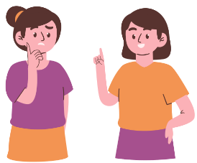
Ciao |  | Arrivederci |  | Come stai?
Sto bene |  | Sto male |  | Così, così
This resource can be adapted by replacing the text to suit your [Language].

Good morning/ Good day |  | Good evening |  | Good night
Hi!/Bye! |  | Goodbye |  | How are you?
I’m well |  | I’m not good |  | I’m okay

Resource 2 – family member flashcards
This resource can be adapted by replacing the text to suit your [Language].
la mamma |  | il papà |  | la sorella |  | il fratello
la nonna |  | il nonno |  | il cugino |  | la cugina
mum |  | dad |  | sister |  | brother
grandmother |  | grandfather |  | cousin (male) |  | cousin (female)

Resource 3 – family member labelling activity
La mia famiglia
_____________________ |  | _____________________ |  | _____________________
_____________________ |  | _____________________ |  | _____________________

papà | fratello | mamma | sorella | nonno | nonna
My family
_____________________ |  | _____________________ |  | _____________________
_____________________ |  | _____________________ |  | _____________________

dad | brother | mum | sister | grandpa | grandma

Resource 4 – family sentence builder
This is | my | family member
Ecco | mia | sorella  cugina
 | mio | fratello  cugino
Questa é | la mia  mia | mamma  nonna
Questo é | il mio  mio | papà  nonno

Resource 5 – visual rubric
I can greet someone.
I can say how I’m feeling.
I can introduce a member of my family.
I can speak loudly and clearly.
I can say words in the right order.

Resource 6 – peer feedback strategy – Two stars and a wish
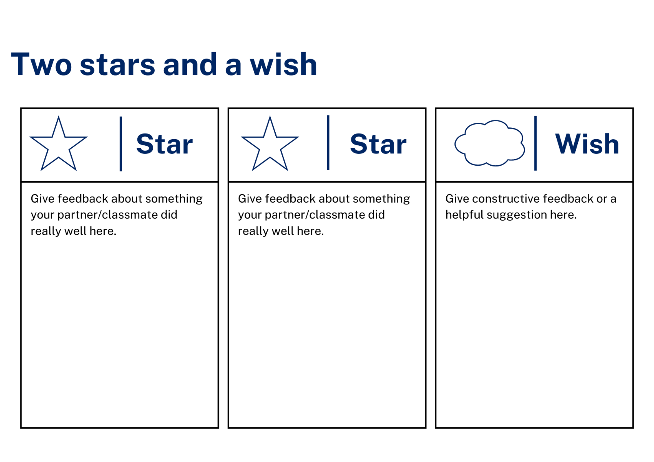

Resource 7 – greetings labelling activity
Name:____________________________________
Saluti
Which word would you use to greet these people? Draw a line to the correct word.
 |  |  |  | Ciao
 |  |  |  | Arrivederci
 |  |  |  | Ciao
 |  |  |  | Buongiorno
 |  |  |  | Buona notte
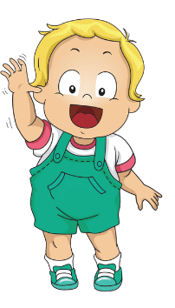 |  |  |  | Buona sera
Name:____________________________________
Greetings
Which word would you use to greet these people? Draw a line to the correct word.
Hi
Goodbye
Bye!
Good morning
Good night
Buona sera

Name:__________________________________________
Saluti
Which word would you use to greet these people? Write the correct word on the line.
_____________________ |  | _____________________ |  | _____________________
_____________________ |  | _____________________ |  | _____________________

Arrivederci | Buono notte | Buongiorno | Ciao | Buona sera | Ciao

Name:__________________________________________
Greetings
Which word would you use to greet these people? Write the correct word on the line.
_____________________ |  | _____________________ |  | _____________________
_____________________ |  | _____________________ |  | _____________________

Goodbye | Good night | Good morning | Hi | Good evening | Bye

Support and alignment
Resource evaluation and support: all curriculum resources are prepared through a rigorous process. Resources are periodically reviewed as part of our ongoing evaluation plan to ensure currency, relevance, and effectiveness. For additional support or advice, contact the Primary Languages team by emailing primlang@det.nsw.edu.au.
Alignment to system priorities and/or needs: School Excellence Policy, School Success Model
Alignment to the School Excellence Framework: this resource supports the School Excellence Framework elements of curriculum (curriculum provision, teaching and learning programs) and effective classroom practice (lesson planning).
Alignment to Australian Professional Teaching Standards: this resource supports teachers to address Australian Professional Teaching Standards 2.2.2, 3.2.2.
Consulted with: Curriculum, Secondary Learners, school-based staff and NESA subject matter experts. Advice from Aboriginal Outcomes and Partnerships, EAL/D, HPGE and Inclusive Education for Modern Languages Stage 3 Italian Mangiare in Ristorante has been considered in preparing this document.
NSW syllabus: Modern Languages K–10 Syllabus
Syllabus outcomes: ML1-INT-01, ML1-UND-01, ML1-CRT-01
Author: Primary Curriculum
Publisher: State of NSW, Department of Education
Resource: unit
Related resources: further resources to support Stage 1 Modern Languages can be found on the Languages K-6 curriculum page.
Professional learning: relevant professional learning is available through Primary Languages Networks on Teams (staff only).
Universal Design for Learning: support the diverse learning needs of students using inclusive teaching and learning strategies. Some students may require more specific adjustments to allow them to participate on the same basis as their peers. For further advice see Inclusive practice resources for primary school.
Differentiation: when using these resources in the classroom, it is important for teachers to consider the needs of all students in their class, including:
- Aboriginal and Torres Strait Islander students. Targeted strategies can be used to achieve outcomes for Aboriginal students in K-12 and increase knowledge and understanding of Aboriginal histories and cultures. Teachers should use students’ Personalised Learning Pathways to support individual student needs and goals.
- EAL/D learners. EAL/D learners may require scaffolding to support them to gain content knowledge, while providing extra time and assistance to master the English language required to engage with texts or complete classroom tasks. View some samples of differentiating through scaffolding.
- Students with additional learning needs. Learning adjustments enable students with disability and additional learning and support needs to access syllabus outcomes and content on the same basis as their peers. Teachers can use a range of adjustments to ensure a personalised approach to student learning.
- High potential and gifted learners. Assessing and identifying high potential and gifted learners will help teachers decide which students may benefit from extension and additional challenge. In addition, the Differentiation Adjustment Tool can be used to support the specific learning needs of high potential and gifted students.
Creation date: 18 October 2023
Rights: © State of New South Wales, Department of Education

References
This resource contains NSW Curriculum and syllabus content. The NSW Curriculum is developed by the NSW Education Standards Authority. This content is prepared by NESA for and on behalf of the Crown in right of the State of New South Wales. The material is protected by Crown copyright.
Please refer to the NESA Copyright Disclaimer for more information https://educationstandards.nsw.edu.au/wps/portal/nesa/mini-footer/copyright.
NESA holds the only official and up-to-date versions of the NSW Curriculum and syllabus documents. Please visit the NSW Education Standards Authority (NESA) website https://educationstandards.nsw.edu.au/ and the NSW Curriculum website https://curriculum.nsw.edu.au.
Modern Languages K–10 Syllabus © NSW Education Standards Authority (NESA) for and on behalf of the Crown in right of the State of New South Wales, 2022.
8 Ways (n.d.) 8 Aboriginal Ways of Learning [website], accessed 13 December 2022.
AITSL (Australian Institute for Teaching and School Leadership) (2017) ‘Feedback Factsheet’, AITSL, accessed 13 December 2022.
Brookhart SM (2011) How to Assess Higher-Order Thinking Skills in Your Classroom, Hawker Brownlow Education, Victoria.
CESE (Centre for Education Statistics and Evaluation) (2020a) What works best: 2020 update, NSW Department of Education, accessed 13 December 2022.
CESE (Centre for Education Statistics and Evaluation) (2020b) What works best in practice, NSW Department of Education, accessed 13 December 2022.
Conti G (2015) ‘16 tips for effective grammar teaching in the foreign language classroom’, The Language Gym, accessed 13 December 2022.
Conti G (2017) From Target Language to Model Language – the mind shift that has transformed my teaching, The Language Gym, accessed 13 December 2022.
Henshaw FG and Hawkins MD (2022) Common Ground: Second Language Acquisition Theory Goes to the Classroom, Focus, Indianapolis, accessed 13 December 2022.
Jones J and Wiliam D (2014) Modern Foreign Languages Inside the Black Box: Assessment for Learning in the Modern Foreign Languages Classroom (Black P, Harrison C, Marshall B and Wiliam D, eds), Learning Sciences International, United States.
NESA (NSW Education Standards Authority) (2020) ‘NSW Curriculum Review – final report’, NESA,, accessed 13 December 2022.
Rosenshine B (2012) ‘Principles of Instruction: Research-Based Strategies That All Teachers Should Know’, American Educator, 36(1):12–19, 39, accessed 13 December 2022.
Smith S (2022) Becoming an Outstanding Languages Teacher, 2nd edn, Routledge, United Kingdom.
Wisniewski B, Zierer K and Hattie J (2020) ‘The Power of Feedback Revisited: A Meta-Analysis of Educational Feedback Research’, Frontiers In Psychology, 10(3087), doi:10.3389/fpsyg.2019.03087, accessed 13 December 2022.
Wiliam D (2013) ‘Assessment: The bridge between teaching and learning’, Voices from the Middle, 21(2):15–20, accessed 13 December 2022.
Wiliam D and Leahy S (2015) Embedding Formative Assessment: Practical Techniques for K–12 Classrooms, Learning Sciences International, United States.

© State of New South Wales (Department of Education), 2023
The copyright material published in this resource is subject to the Copyright Act 1968 (Cth) and is owned by the NSW Department of Education or, where indicated, by a party other than the NSW Department of Education (third-party material).
Copyright material available in this resource and owned by the NSW Department of Education is licensed under a Creative Commons Attribution 4.0 International (CC BY 4.0) license.
This license allows you to share and adapt the material for any purpose, even commercially. Attribution should be given to © State of New South Wales (Department of Education), 2023.
Material in this resource not available under a Creative Commons license:
- the NSW Department of Education logo, other logos and trademark-protected material
- material owned by a third party that has been reproduced with permission. You will need to obtain permission from the third party to reuse its material.
Links to third-party material and websites
Please note that the provided (reading/viewing material/list/links/texts) are a suggestion only and implies no endorsement, by the New South Wales Department of Education, of any author, publisher, or book title. School principals and teachers are best placed to assess the suitability of resources that would complement the curriculum and reflect the needs and interests of their students.
If you use the links provided in this document to access a third-party's website, you acknowledge that the terms of use, including licence terms set out on the third-party's website apply to the use which may be made of the materials on that third-party website or where permitted by the Copyright Act 1968 (Cth). The department accepts no responsibility for content on third-party websites.

