Chinese calendar game

Setting up the game
This game is played in pairs. The aim is to guess which September dates your partner has chosen before they guess your dates.
You each need 2 blank September calendars:
- ‘My dates’
- ‘My opponent’s dates’.
On the ‘My dates’ calendar, circle 15 different dates, as follows:
- one single date
- a row of 2 dates
- a row of 3 dates
- a row of 4 dates
- a row of 5 dates.
Your rows of dates can run horizontally or vertically, but not diagonally. Do not overlap any row of dates. Your partner will do the same. Do not show each other.

An example has been provided in the image below.
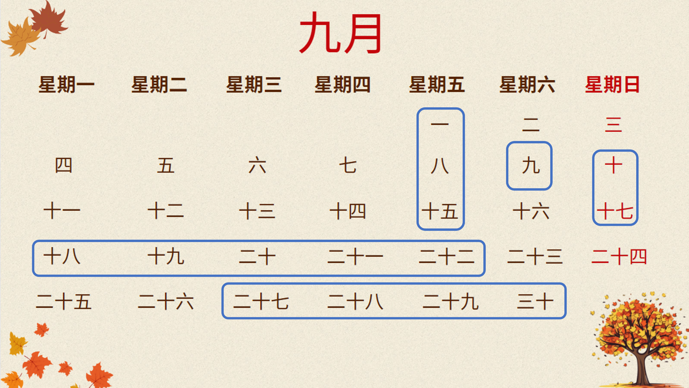
When you’re both ready, take turns to guess each other’s dates.

Playing the game
Whoever’s birthday is closest to 1 September goes first (Student A). You will alternate asking the question to try and find each other’s dates.
Sample conversation:
Student A: 三十日吗？(Is it the 30th?)
Student B: 不，不是三十日。二十日吗？(No, it is not the 30th. Is it the 20th?)
Student A: 是，二十日。(Yes, it’s the 20th) 十七日吗？(Is it the 17th?)
Student B: 是，十七日。(Yes, it’s the 17th)
And so on.
On the ‘My dates’ calendar, record the hits your opponent makes by drawing a cross on any date they identify.
On the ‘My opponent’s dates’ calendar, record the guesses you make by drawing a circle around the dates you ask about and record the hits you make by drawing a cross on the dates you identify.
The winner is the first student to correctly guess their opponent’s 15 dates.

My dates
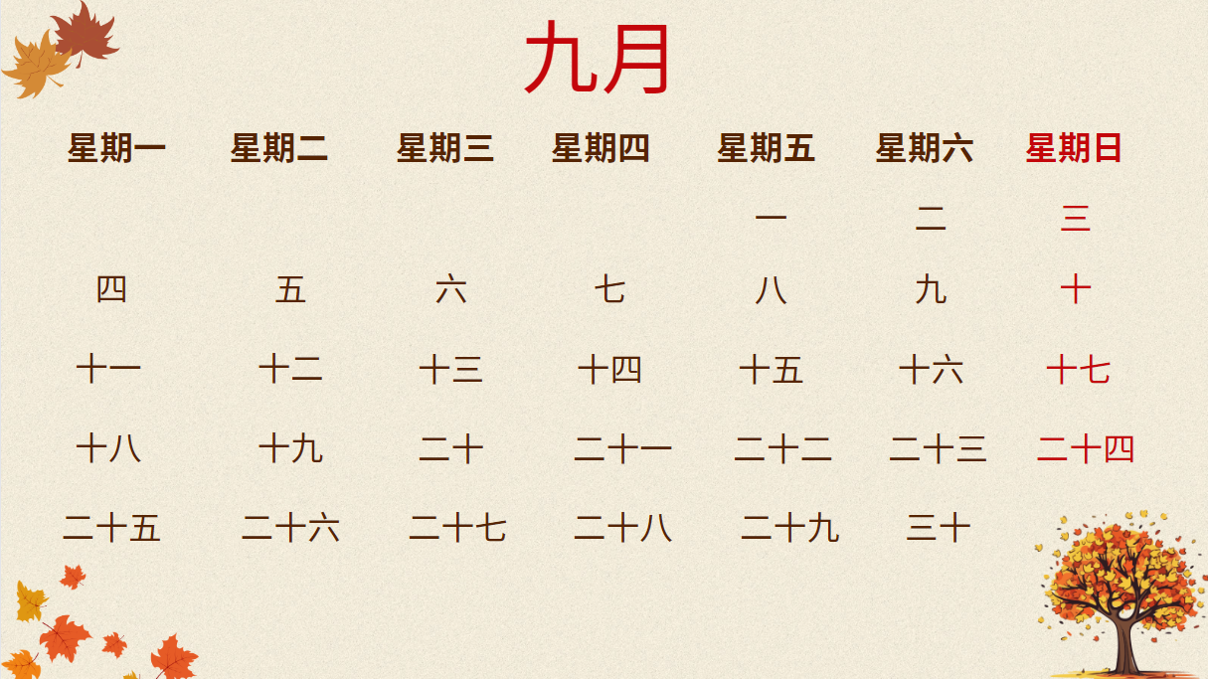

My opponent’s dates
© State of New South Wales (Department of Education), 2023
The copyright material published in this resource is subject to the Copyright Act 1968 (Cth) and is owned by the NSW Department of Education or, where indicated, by a party other than the NSW Department of Education (third-party material).
Copyright material available in this resource and owned by the NSW Department of Education is licensed under a Creative Commons Attribution 4.0 International (CC BY 4.0) license.
This license allows you to share and adapt the material for any purpose, even commercially.
Attribution should be given to © State of New South Wales (Department of Education), 2023.
Material in this resource not available under a Creative Commons license:
- the NSW Department of Education logo, other logos and trademark-protected material
- material owned by a third party that has been reproduced with permission. You will need to obtain permission from the third party to reuse its material.
Links to third-party material and websites
Please note that the provided (reading/viewing material/list/links/texts) are a suggestion only and implies no endorsement, by the New South Wales Department of Education, of any author, publisher, or book title. School principals and teachers are best placed to assess the suitability of resources that would complement the curriculum and reflect the needs and interests of their students.
If you use the links provided in this document to access a third-party's website, you acknowledge that the terms of use, including licence terms set out on the third-party's website apply to the use which may be made of the materials on that third-party website or where permitted by the Copyright Act 1968 (Cth). The department accepts no responsibility for content on third-party websites.

