Comprehension and summarising strategies

Activity 1 – comprehension strategies
The email below is to an Australian student who will be going on exchange to Germany, from their German host sister. Listen as your teacher reads the email aloud. Then read the email again, quietly to yourself.
Email 1
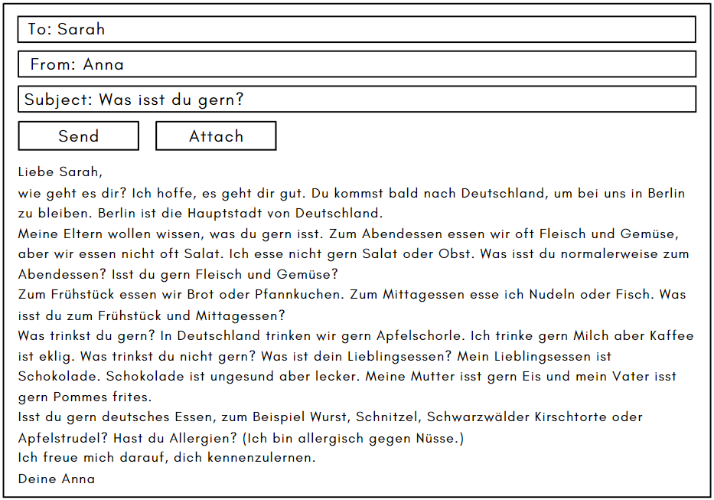
To support you to understand the email, use the following strategies:
- underline words you know
- circle unfamiliar words
- see if you can work out the meaning of unfamiliar words, or use a dictionary to look them up
- code words and phrases, using:
- * for familiar words/structures
- + for new information
- ! for ‘’wow’ (something they find interesting)
- ? for ‘I don’t understand’
- colour-code the text to identify prepositions, nouns, adjectives and verbs.

Questions about email 1
Once you have used the strategies above to assist you to understand email 1, answer the following questions in English about the text:
- When will Sarah be going to Germany?
- Provide one detail about the city where she will be staying.
- Describe Anna’s eating habits for breakfast, lunch and dinner.
- Name the German dishes and drink mentioned in the email.
- Apart from what she eats at meals, describe what Anna likes to eat and drink.
- What information does Anna provide about herself, in relation to food, before signing off the email?
- Why do you think Anna has written this email? Justify your response with reference to the text.

Activity 2 – summarising strategies
You are now going to summarise a text. Summarising a text is not the same as translating it. To summarise, you have to concisely express the relevant details and/or information.
- As a class, discuss how you would summarise email 1, Anna’s email to Sarah.
- Which details and/or information would you include in your summary?
- How would you express these concisely?
Then write the summary in your books or devices.
- Now, summarise email 2 below using the strategies you have learned.

Email 2
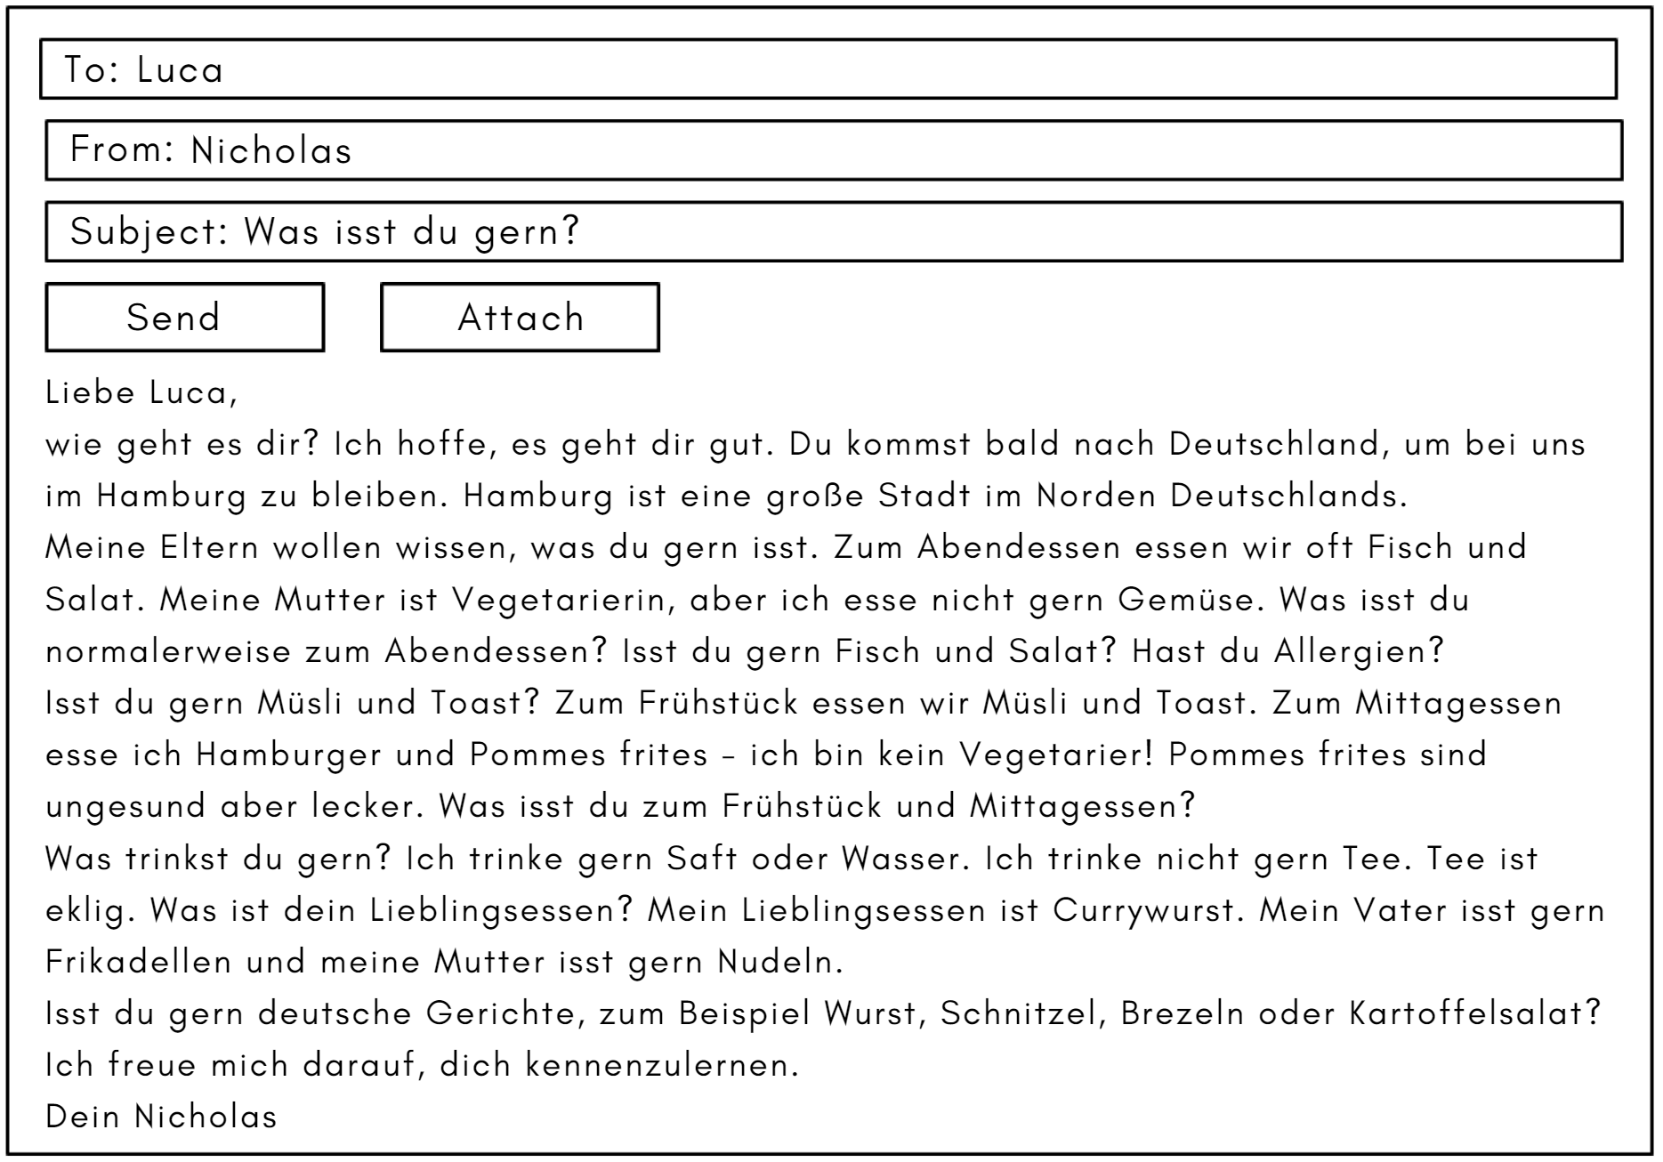

For the teacher
Remove this section before sharing this resource with students.

Activity 1

Accessible version of email 1
Liebe Sarah,
wie geht es dir? Ich hoffe, es geht dir gut. Du kommst bald nach Deutschland, um bei uns in Berlin zu bleiben. Berlin ist die Hauptstadt von Deutschland.
Was isst du gern? Zum Abendessen essen wir oft Fleisch und Gemüse, aber wir essen nicht oft Salat. Ich esse nicht gern Salat oder Obst. Was isst du normalerweise zum Abendessen? Isst du gern Fleisch und Gemüse?
Zum Frühstück essen wir Brot oder Pfannkuchen. Zum Mittagessen esse ich Nudeln oder Fisch. Was isst du zum Frühstück und Mittagessen?
Was trinkst du gern? In Deutschland trinken wir gern Apfelschorle. Ich trinke gern Milch aber Kaffee ist eklig. Was trinkst du nicht gern? Was ist dein Lieblingsessen? Mein Lieblingsessen ist Schokolade. Schokolade ist ungesund aber lecker. Meine Mutter isst gern Eis und mein Vater isst gern Pommes frites.
Isst du gern deutsches Essen, zum Beispiel Wurst, Schnitzel, Schwarzwälder Kirschtorte oder Apfelstrudel? Hast du Allergien? (Ich bin allergisch gegen Nüsse.)
Ich freue mich darauf, dich kennenzulernen.
Deine Anna

Questions about email 1
- When will Sarah be going to Germany?
Soon.
- Provide one detail about the city where she will be staying.
It is the capital of Germany.
- Describe Anna’s eating habits for breakfast, lunch and dinner.
For breakfast she eats bread or pancakes. For lunch she eats pasta or fish. For dinner she often eats meat and vegetables.
- Name the German dishes and drink mentioned in the email.
Wurst, Schnitzel, Schwarzwälder Kirschtorte and Apfelstrudel.
- Apart from what she eats at meals, describe what Anna likes to eat and drink.
Anna’s favourite food is chocolate. She likes milk. She doesn’t like coffee (it is disgusting).
- What information does Anna provide about herself, in relation to food, before signing off the email?
She is allergic to nuts.
- Why do you think Anna has written this email? Justify your response with reference to the text.
Because Sarah is coming to visit soon, Anna is writing to find out her eating and drinking habits and to tell her what she and her family usually eat for meals and what she likes to eat. We know this because Anna describes what she likes to eat and drink and asks Sarah lots of questions to find out her eating and drinking habits, such as ‘What do you normally eat for dinner?’, ‘What do you eat for breakfast and lunch?’ and ‘What is your favourite food?’

Activity 2

Sample summary of email 1
Anna is writing to Sarah to let her know about what kind of food she and her family like to eat as Sarah will be visiting them soon. She tells her details about what she or her family often eat for dinner – meat and vegetables, for lunch – pasta or fish and breakfast – bread or pancakes. She asks Sarah what she eats at mealtimes. She also tells Sarah her family’s likes and dislikes relating to food, for example, her favourite food is chocolate, she likes milk and doesn’t like coffee and her mother likes ice cream. She asks about Sarah’s likes and dislikes for food and whether she likes German dishes, such as schnitzel and black forest cherry cake.

Accessible version of email 2
Liebe Luca,
wie geht es dir? Ich hoffe, es geht dir gut. Du kommst bald nach Deutschland, um bei uns im Hamburg zu bleiben. Hamburg ist eine große Stadt im Norden Deutschlands.
Meine Eltern wollen wissen, was du gern isst. Zum Abendessen essen wir oft Fisch und Salat. Meine Mutter ist Vegetarierin, aber ich esse nicht gern Gemüse. Was isst du normalerweise zum Abendessen? Isst du gern Fisch und Salat? Hast du Allergien?
Isst du gern Müsli und Toast? Zum Frühstück essen wir Müsli und Toast. Zum Mittagessen esse ich Hamburger und Pommes frites - ich bin kein Vegetarier! Pommes frites sind ungesund aber lecker. Was isst du zum Frühstück und Mittagessen?
Was trinkst du gern? Ich trinke gern Saft oder Wasser. Ich trinke nicht gern Tee. Tee ist eklig. Was ist dein Lieblingsessen? Mein Lieblingsessen ist Currywurst. Mein Vater isst gern Frikadellen und meine Mutter isst gern Nudeln.
Isst du gern deutsche Gerichte, zum Beispiel Wurst, Schnitzel, Brezeln oder Kartoffelsalat? Ich freue mich darauf, dich kennenzulernen.
Dein Nicholas

Sample summary of email 2
Nicholas is writing to Luca to let him know about what kind of food he and his family like to eat as Luca will be visiting them soon. He includes details about what his family eats for dinner – fish and salad, lunch – hamburger and fries, and breakfast – muesli and toast. He mentions his mum is vegetarian. He asks Luca what he eats at mealtimes. He also includes his family’s food preferences, for example, his favourite food is curry sausage, he likes milk and juice and doesn’t like tea and his father likes meatballs. He asks about Luca’s likes and dislikes for food and whether he likes German dishes, such as sausages and pretzels.

© State of New South Wales (Department of Education), 2024
The copyright material published in this resource is subject to the Copyright Act 1968 (Cth) and is owned by the NSW Department of Education or, where indicated, by a party other than the NSW Department of Education (third-party material).
Copyright material available in this resource and owned by the NSW Department of Education is licensed under a Creative Commons Attribution 4.0 International (CC BY 4.0) license.
This license allows you to share and adapt the material for any purpose, even commercially.
Attribution should be given to © State of New South Wales (Department of Education), 2024.
Material in this resource not available under a Creative Commons license:
- the NSW Department of Education logo, other logos and trademark-protected material
- material owned by a third party that has been reproduced with permission. You will need to obtain permission from the third party to reuse its material.
Links to third-party material and websites
Please note that the provided (reading/viewing material/list/links/texts) are a suggestion only and implies no endorsement, by the New South Wales Department of Education, of any author, publisher, or book title. School principals and teachers are best placed to assess the suitability of resources that would complement the curriculum and reflect the needs and interests of their students.
If you use the links provided in this document to access a third-party's website, you acknowledge that the terms of use, including licence terms set out on the third-party's website apply to the use which may be made of the materials on that third-party website or where permitted by the Copyright Act 1968 (Cth). The department accepts no responsibility for content on third-party websites.

