Mini task 1 – lunch deals

Activity
Listen to 3 exchange students from Germany introduce themselves. Then, from the menu provided below, choose which lunch deal will match them – 1, 2, 3, 4 or 5.
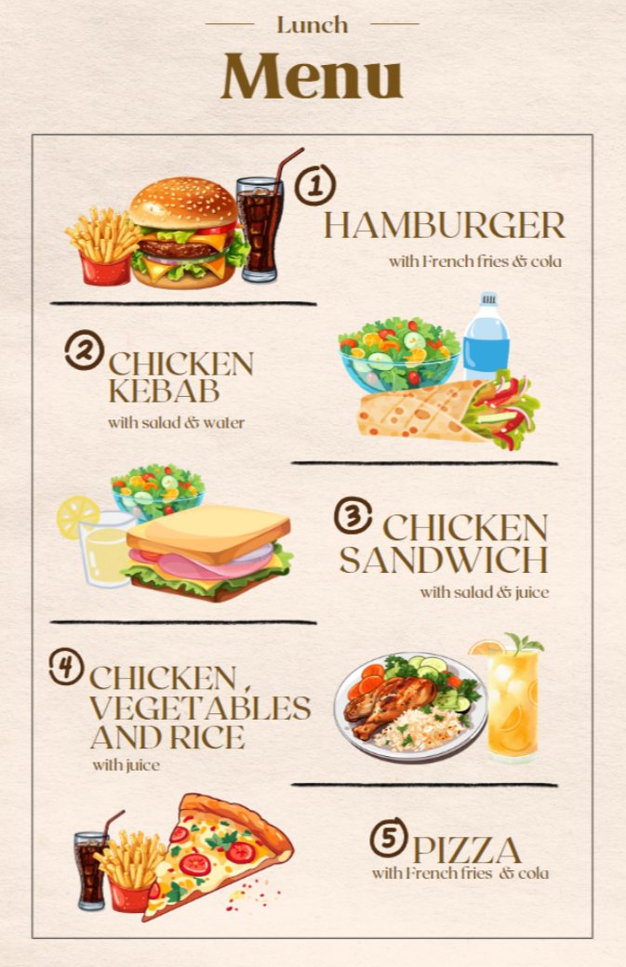
Student | Lunch deal number
Mia
Lasse
Jakob

For the teacher
Remove this section before sharing this resource with students.

Accessible version of lunch menu
Lunch menu
Option 1 – hamburger, French fries and cola
Option 2 – chicken kebab, salad and water
Option 3 – chicken sandwich, salad and juice
Option 4 – chicken, vegetables and rice
Option 5 – pizza, French fries and cola

Sound files
- Link to sound file 1.mp3 (0:12)
- Link to sound file 2.mp3 (0:14)
- Link to sound file 3.mp3 (0:13)

Script
- Hallo! Ich heiße Mia. Ich esse gern Pommes. Ich trinke gern Cola. Ich trinke nicht gern Wasser. Ich esse nicht gern Hamburger.
- Guten Tag. Ich heiße Lasse. Ich esse gern Salat und Obst. Ich esse auch gern Reis. Ich esse nicht gern Brot. Ich trinke gern Saft.
- Moin. Ich heiße Jakob. Ich esse gern Hähnchen. Ich esse nicht gern Reis. Ich trinke gern Wasser. Ich trinke nicht gern Saft.

Correct responses
Student | Lunch deal number
Mia | 1
Lasse | 4
Jakob | 2

© State of New South Wales (Department of Education), 2024
The copyright material published in this resource is subject to the Copyright Act 1968 (Cth) and is owned by the NSW Department of Education or, where indicated, by a party other than the NSW Department of Education (third-party material).
Copyright material available in this resource and owned by the NSW Department of Education is licensed under a Creative Commons Attribution 4.0 International (CC BY 4.0) license.
This licence allows you to share and adapt the material for any purpose, even commercially. Attribution should be given to © State of New South Wales (Department of Education), 2024.
Material in this resource not available under a Creative Commons licence:
- the NSW Department of Education logo, other logos and trademark-protected material
- material owned by a third party that has been reproduced with permission. You will need to obtain permission from the third party to reuse its material.
Links to third-party material and websites
Please note that the provided (reading/viewing material/list/links/texts) are a suggestion only and implies no endorsement, by the New South Wales Department of Education, of any author, publisher, or book title. School principals and teachers are best placed to assess the suitability of resources that would complement the curriculum and reflect the needs and interests of their students.
If you use the links provided in this document to access a third-party's website, you acknowledge that the terms of use, including licence terms set out on the third-party's website apply to the use which may be made of the materials on that third-party website or where permitted by the Copyright Act 1968 (Cth). The department accepts no responsibility for content on third-party websites.

