Pizzaspiel board game
This resource is for the teacher. It provides the content and instructions you need to share with students.

Instructions
Play this game in groups of 3–6 players.
Each group needs:
- a game board
- a set of pizza cards
- a set of ingredients cards
- a die
- player tokens (for example, buttons).
(Consider laminating the gameboard and cards, for durability. Students can play this game when planned lessons finish earlier than expected, or as a brain break activity.)
The aim of the Pizzaspiel game is for students to collect all 6 toppings for their pizza before their opponents.
Each student in the group selects a different pizza card. Students place their ingredients cards in a pile (face-up) in the centre of the table.
The student who rolls the highest number goes first.
When a student lands on a topping, they need to say the topping in German. For example, if they land on chicken, they would say Hähnchen. If it is a topping they need for their pizza, they express their delight by saying Hurra! (Yay!). Then, they find the matching ingredient in the ingredients card pile and place it on the desk in front of them.
If it is a topping they don’t need, they express their regret by saying Schade! (What a shame!). If a student lands on the free space, they can choose any topping they need for your pizza from the ingredients card pile – they just need to say what they need in German. Students continue around the game board until someone collects all 6 toppings for their pizza. They are the winner.
During the game, students only speak in German. Viel Glück!
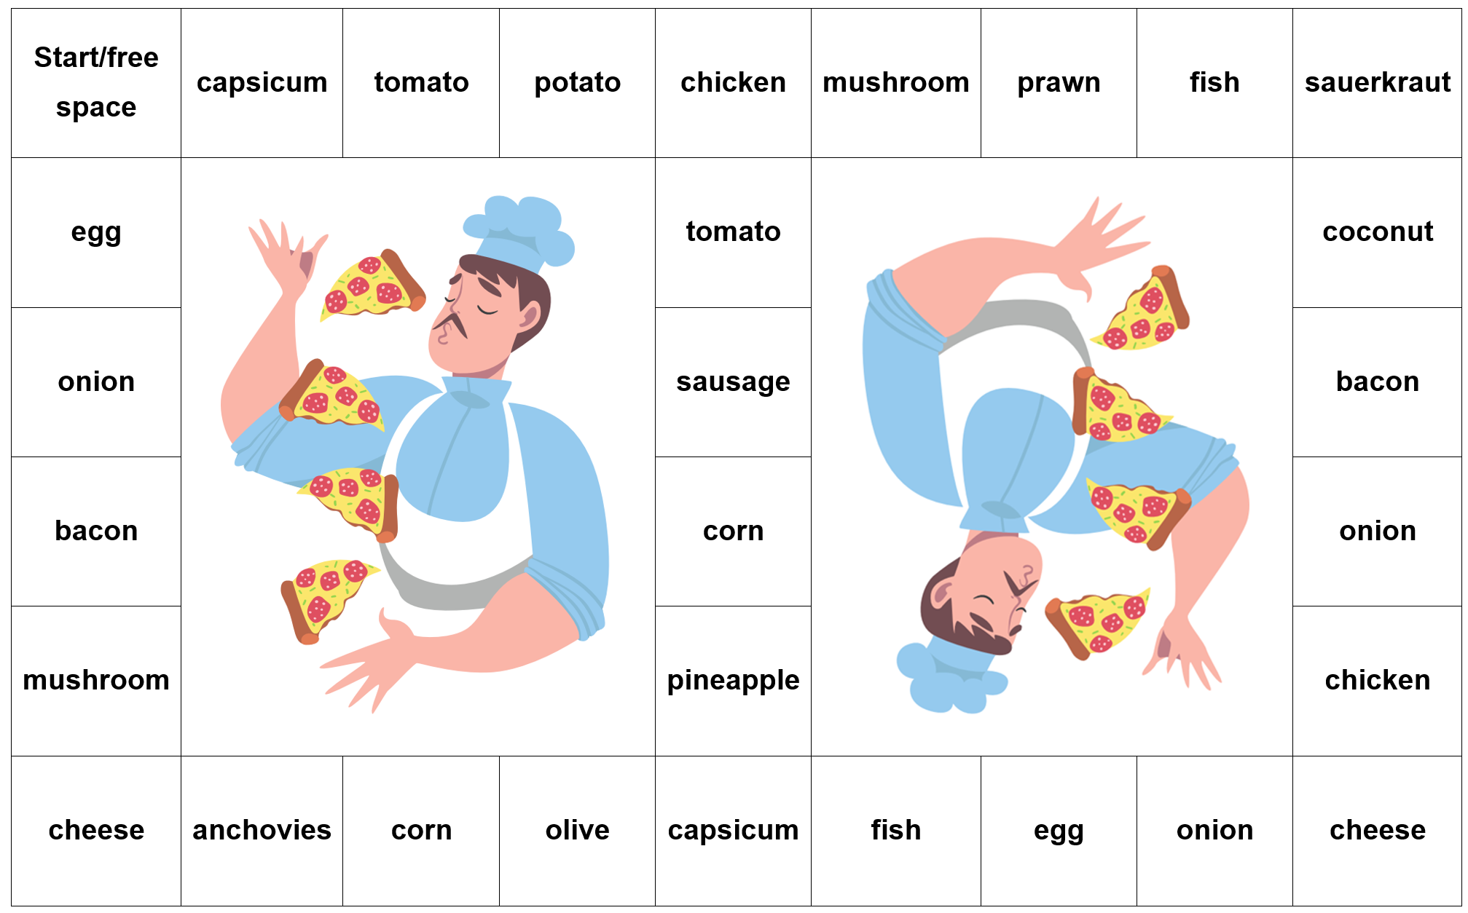

Game cards
Gemüsepizza  Paprika  Zwiebeln  Tomaten  Mais  Kartoffeln  Käse | Fischpizza  Fisch  Garnele  Ananas  Sardellen  Zwiebeln  Käse
Hähnchenpizza  Hähnchen  Ei  Zwiebeln  Ananas  Paprika  Käse | Tropenpizza  Ananas  Kokosnuss  Speck  Paprika  Ei  Käse
Fleischpizza  Speck  Hähnchen  Wurst  Tomaten  Champignon  Käse | Deutsche Pizza  Wurst  Sauerkraut  Zwiebeln  Kartoffeln  Speck  Käse

Ingredients cards
Wurst | Speck | Käse
Sauerkraut | Zwiebeln | Hähnchen
Wurst | Tomaten | Champignon
Oliven | Fisch | Mais
Kokosnuss | Paprika | Garnele
Ananas | Kartoffeln | Ei
Wurst | Speck | Käse
Sauerkraut | Zwiebeln | Hähnchen
Wurst | Tomaten | Champignon
Oliven | Fisch | Mais
Kokosnuss | Paprika | Garnele
Ananas | Kartoffeln | Ei
Wurst | Speck | Käse
Sauerkraut | Zwiebeln | Hähnchen
Wurst | Tomaten | Champignon
Oliven | Fisch | Mais
Kokosnuss | Paprika | Garnele
Ananas | Kartoffeln | Ei
Wurst | Speck | Käse
Sauerkraut | Zwiebeln | Hähnchen
Wurst | Tomaten | Champignon
Oliven | Fisch | Mais
Kokosnuss | Paprika | Garnele
Ananas | Kartoffeln | Ei
Käse | Käse | Käse

© State of New South Wales (Department of Education), 2024
The copyright material published in this resource is subject to the Copyright Act 1968 (Cth) and is owned by the NSW Department of Education or, where indicated, by a party other than the NSW Department of Education (third-party material).
Copyright material available in this resource and owned by the NSW Department of Education is licensed under a Creative Commons Attribution 4.0 International (CC BY 4.0) license.
This licence allows you to share and adapt the material for any purpose, even commercially. Attribution should be given to © State of New South Wales (Department of Education), 2024.
Material in this resource not available under a Creative Commons licence:
- the NSW Department of Education logo, other logos and trademark-protected material
- material owned by a third party that has been reproduced with permission. You will need to obtain permission from the third party to reuse its material.
Links to third-party material and websites
Please note that the provided (reading/viewing material/list/links/texts) are a suggestion only and implies no endorsement, by the New South Wales Department of Education, of any author, publisher, or book title. School principals and teachers are best placed to assess the suitability of resources that would complement the curriculum and reflect the needs and interests of their students.
If you use the links provided in this document to access a third-party's website, you acknowledge that the terms of use, including licence terms set out on the third-party's website apply to the use which may be made of the materials on that third-party website or where permitted by the Copyright Act 1968 (Cth). The department accepts no responsibility for content on third-party websites.

