Teacher resource – Chinese leisure activities flashcards
This resource is for the teacher. It provides the content and instructions you need to share with students.
The activities in this resource will occur at various points in the unit of work.
Use the flashcards in this resource to:
- drill questions and responses about leisure activities
- identify and discuss strategies to memorise Hanzi for leisure activities
- identify and recall Hanzi and correct pronunciation for phrases about leisure activities
- introduce the sentence structure 我的爱好是…… using flashcards, for example: 我的爱好是游泳 and practise this with students
- revise (from prior learning) frequency.

Activity 1 – vocabulary building
Print the cards below (to whatever size suits your purpose) and use them as flashcards to drill vocabulary with students. Students should pay attention to character recognition, tones, pronunciation and meaning.
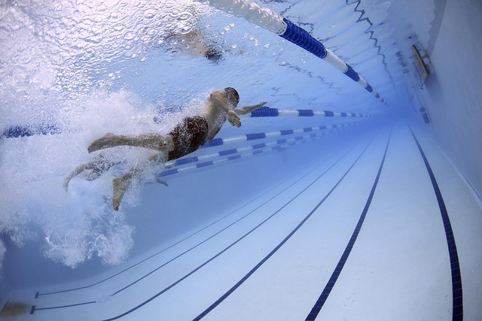  游泳 | 拍照
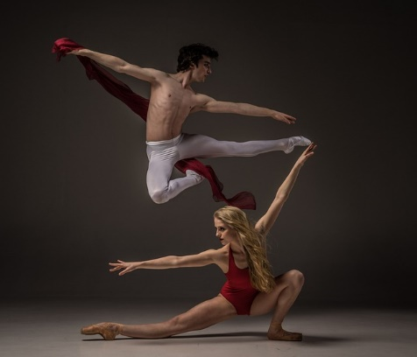  跳舞 | 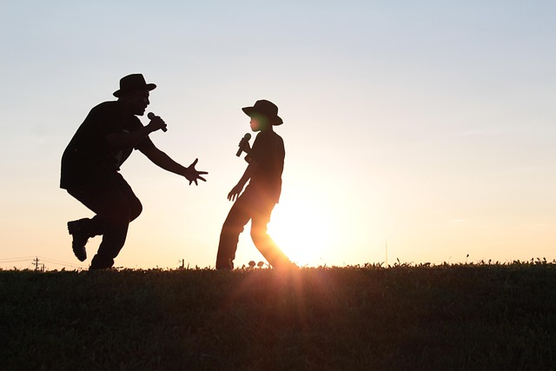  唱歌
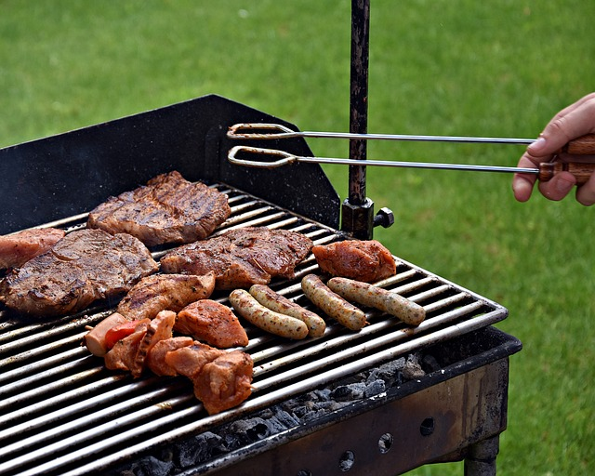  烧烤 | 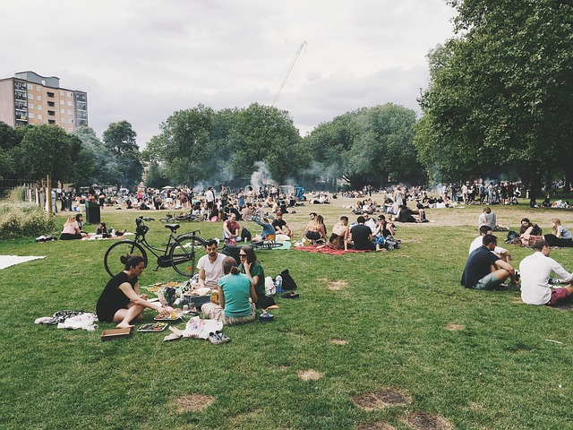  野餐
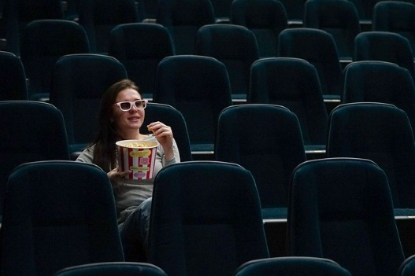  看电影 | 看书
听音乐 | 踢足球
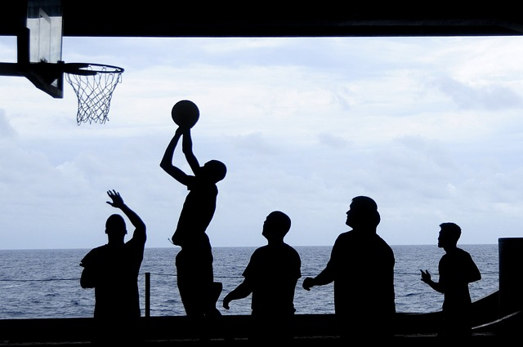  打篮球 | 打武术
玩游戏 | 画画
Images licensed under Pixabay Content License.

Activity 2 – understanding texts
Print and give copies of the table below to students and ask them to cut it up. This activity can be done individually, in pairs or small groups.
Students can use these cards to:
- play a matching memory-style game
- play a vocabulary ‘grab’ game in groups, with the teacher or a student calling out prompts and students racing each other to grab a matching card. The prompts may be just the words, or they may be questions or phrases with the word embedded.
游泳 | 拍照
跳舞 | 唱歌
烧烤 | 野餐
看电影 | 看书
听音乐 | 踢足球
打篮球 | 打武术
玩游戏 | 画画
swim | take a photo
dance | sing a song
have a barbeque | have a picnic
watch a movie | read a book
listen to music | play soccer
play basketball | do martial arts
play games | paint or draw pictures

Activity 3 – interacting
In pairs or small groups, students take turns to randomly select a card, using the card as a prompt to ask questions and elicit responses from their partner(s), drawing on prior learning. For example, Do you like playing basketball? How often do you have a barbeque?
To begin this activity, model an interaction with a volunteer student following the steps below. Repeat the interaction as many times as necessary until students feel confident to work independently.
Student A randomly selects a card from the pile of activity cards (images or text as determined by the teacher) and shows Student B.
Student B must identify the activity in Chinese on the card.
Using prior knowledge (preferences, expressions of frequency or time), Student A asks Student B a question about the activity. For example, Do you like [activity]? How often do you [activity]?
Student B responds appropriately.
Student B then selects a card and repeats the interaction with a different activity and so on.

Activity 4 – creating texts
Working in pairs or small groups, students select 3 cards from the pile. Using the cards as prompts, they create:
- sentences which include a range of conjunctions, sentence starters and tenses
- a role-play to discuss the activities.
© State of New South Wales (Department of Education), 2023
The copyright material published in this resource is subject to the Copyright Act 1968 (Cth) and is owned by the NSW Department of Education or, where indicated, by a party other than the NSW Department of Education (third-party material).
Copyright material available in this resource and owned by the NSW Department of Education is licensed under a Creative Commons Attribution 4.0 International (CC BY 4.0) license.
This license allows you to share and adapt the material for any purpose, even commercially.
Attribution should be given to © State of New South Wales (Department of Education), 2023.
Material in this resource not available under a Creative Commons license:
- the NSW Department of Education logo, other logos and trademark-protected material
- material owned by a third party that has been reproduced with permission. You will need to obtain permission from the third party to reuse its material.
Links to third-party material and websites
Please note that the provided (reading/viewing material/list/links/texts) are a suggestion only and implies no endorsement, by the New South Wales Department of Education, of any author, publisher, or book title. School principals and teachers are best placed to assess the suitability of resources that would complement the curriculum and reflect the needs and interests of their students.
If you use the links provided in this document to access a third-party's website, you acknowledge that the terms of use, including licence terms set out on the third-party's website apply to the use which may be made of the materials on that third-party website or where permitted by the Copyright Act 1968 (Cth). The department accepts no responsibility for content on third-party websites.

