Part 1: Flexible strategies with combinations to 10

About the resource
This resource is the first section of a 4-part resource, supporting additive thinking:
- Part 1: Flexible strategies with combinations to 10
- Part 2: Flexible strategies with 2-digit numbers
- Part 3: Flexible strategies with 3-digit numbers
- Part 4: Flexible strategies with decimals.
Like most things in mathematics, talking about additive thinking is hard to do without referring to other aspects such as patterning, subitising (and visual recognition), counting (with understanding), number sense, measurement and statistics. As such, this resource is best used in conjunction with other guides in order to support a connected network of critical mathematical concepts, skills and understanding.
Flexible additive strategies involve students using what they know (such as known facts, properties, part-part-whole knowledge, and so on.), using landmark numbers (like multiples of 10 and 5) and using partitioning to solve problems. Students understanding about how numbers and operations work is a critical part of developing deep, meaningful mathematical skills, understanding and confidence.
Continued learning of pattern and structures, number knowledge (including place value understanding) and counting (with understanding) is vital in supporting students’ continued development of number sense. Additionally, students should be supported in developing rich, meaningful understanding of how the operations work in order to support their skills in working flexibly with numbers. Students need to be provided with opportunities to compare strategies and contexts, exploring situations when particular strategies are efficient and when they are not as efficient. It should be remembered too, that efficiency is connected to the confidence and knowledge of individuals. Building representational fluency is important in supporting meaning-making about the operations and how numbers work.
Students at this stage of learning require targeted teaching in the form of investigations and meaningful, low-stress practice to enhance and solidify their understanding and use of non count-by-one strategies. Teachers should validate the different strategies students invent and use, using individual thinking to cultivate a culture of communication, thinking and reasoning.

The resource has been developed in partnership with the NSW Mathematics Strategy Professional Learning team, Curriculum Early Years and Primary Learners, and Literacy and Numeracy.

How to use the resource
Teachers can use assessment information to make decisions about when and how they use this resource as they design teaching and learning sequences to meet the learning needs of their students.
The tasks and information in the resource includes explicit teaching, high expectations, effective feedback and assessment and can be embedded in the teaching and learning cycle.
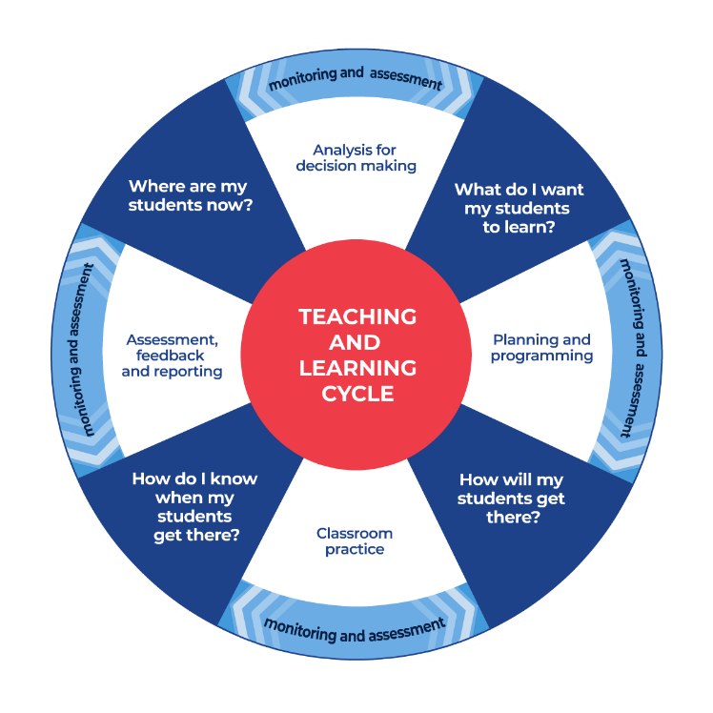
Figure 1: Teaching and learning cycle
- Where are my students now? – Teachers use a range of assessment information to determine what students know and can do, including their interests, learning strengths and needs.
- What do I want my students to learn? - Teachers use the information gathered along with the syllabus and NNLP to determine the next steps for learning. Teachers might also like to look at the ‘what’s some of the maths’ and ‘key generalisations to synthesise the information they have gathered into the next step/s for learning.
- How will my students get there? – Teachers can then use the task overview information (‘What does it promote?’ and ‘What other tasks can I make connections to?’) to find tasks that meet the learning needs of students. Teachers then make decisions about what instructional practices and lesson structures to use in order to best support student learning. Further support with What works best in practice is available.
- How do I know when my students get there? - Teachers can use the section ‘Some observable behaviours you may look for/notice’ that have been articulated for each task as a springboard for what to look for. These ideas can be used to co-construct success criteria and modified to suit the learning needs, abilities and interests of students. Referring back to the syllabus and the NNLP are also helpful in determining student learning progress as well as monitoring student thinking during the task. The information gained will inform ‘where are my students now’ and ‘what do I want them to learn’ as part of the iterative nature of the teaching and learning cycle.

Syllabus
MAO-WM-01 develops understanding and fluency in mathematics through exploring and connecting mathematical concepts, choosing and applying mathematical techniques to solve problems, and communicating their thinking and reasoning coherently and clearly
MAE-RWN-01 demonstrates an understanding of how whole numbers indicate quantity
MAE-RWN-02 reads numerals and represents whole numbers to at least 20
MAE-CSQ-01 reasons about number relations to model addition and subtraction by combining and separating, and comparing collections
MAE-CSQ-02 represents the relations between the parts that form the whole, with numbers up to 10
MA1-RWN-01 applies an understanding of place value and the role of zero to read, write and order two- and three-digit numbers
MA1-RWN-02 reasons about representations of whole numbers to 1000, partitioning numbers to use and record quantity values
MA1-CSQ-01 uses number bonds and the relationship between addition and subtraction to solve problems involving partitioning
NSW Mathematics K-10 Syllabus (2022)

Progression
Number and place value NPV1-NPV3
Counting processes CPr2-CPr6
Additive strategies AdS1-AdS7
Number patterns and algebraic thinking NPA1-NPA2
National Numeracy Learning Progression Version 3

Overview of tasks
Task name | What does it promote? | What other tasks can I make connections to? | What materials will I need? | Possible group size
Blocks on a bowl | Developing confidence with part-part-whole understanding, spatial patterns and structures and determining hidden quantities. | Rekenrek duel 1 Rekenrek duel 2  Pinch a 10  Sam and Holly’s problem | - Container, such as an empty ice-cream container  - 5 blocks | 2 players
Let’s talk 4 - part 1 | Encourages students to recognise that the same problem can be solved in different ways. Let's talk 4 – part 2 encourages students to how some strategies work. | Let’s talk 4 – part 2  Game of totals (1-2) (youcubed) | - Ten-frames | Whole class
If you didn’t know | Encourages students to consider how known facts can be used to solve what isn’t known yet (using foundational number facts and number sense to derive solutions). | Rekenreks 1  Rekenreks 2 | - Various discussion prompts | Whole class
6 piles | Developing confidence with combinations to 5 or 10. | Finger trails (youcubed)  Rekenrek duel 1 Rekenrek duel 2 | - Appendix 1: Dot cards  - Playing cards (0-5) | 2 players
Turn over 3 | Developing confidence with combinations to 10, doubles and near doubles. | Go fish relationships  Doubles fill | - Appendix 2: Turn over 3 game board  - Playing cards (Ace-10) | 2 players
Capture 10 | Developing a strong understanding of using landmark or benchmark numbers (bridging to 10) and ideas of equivalence. | 10 or bust  3 tens in a row  Game of totals (youcubed) | - Appendix 3: Capture 10 game board  - Playing cards (Ace-10) | 2 players

Blocks on a bowl

Key generalisations / what’s (some of) the mathematics?
- Numbers are made up of smaller numbers. For example, 5 can be composed of:
  - 2 and 3
  - 3 and 1 and 1
  - 1 and 2 twos
  - 1 and 4, and so on.
- Any given whole number can be partitioned (decomposed/broken) into smaller parts.
- Mathematicians use what they know about numbers to solve problems.
- Mathematicians refine/extend their thinking after listening to the ideas and strategies of others.

Some observable behaviours you may look for/notice
- Uses part-part-whole number knowledge. For example, uses their knowledge that 5 is 4 and 1 more to determine how many blocks are missing.
- Subitises to determine how many
- Counts all to determine how many
- Counts-up, counts-down, counts-to and counts-from to determine how many
- Counts hidden items using fingers, for example, to keep track of the count.
- Uses addition to solve subtraction.

Materials
- Cup or container, such as an empty ice-cream container
- 5 blocks.

Instructions
- Place a container, such as an empty ice-cream container, between a pair of students.
- Turn the container upside down and place 5 blocks on top. Instruct one student to look away while his or her partner takes away some, or all, of the blocks from the top of the container and hides them under the container.
- Instruct the first student to turn back to see how many blocks are left on top of the container.
- Using this information, the student determines how many blocks were placed under the container.
- The student may then lift the container to confirm the answer.

Variations
- Use more than one cup or container
- Adjust the quantity of blocks.

Teaching point
Providing students with opportunities to solve tasks involving hidden or screened items encourages students to visualise, develop and use mental images. It can also encourage students to use part-part-whole number knowledge and counting-up and counting-down as problem-solving strategies.
Teachers could ask questions such as:
- What possibilities are there?
- Could you use structures like dice patterns or finger patterns to help you work out how many are hiding?
- Is there another way we could have worked that out?

Let’s talk 4

Key generalisations/what’s (some of) the mathematics?
- The same problem can be solved using a range of different strategies.
- Numbers can be used flexibly to solve problems. For example, “I can think of 8 as 6 and 2 so that I can combine it with 8. I can then join 2 and 8 to get to 10 before I combine the final 4 to get to 14”.
- We can use visualisation (our mathematical imaginations) to imagine parts of quantities moving to join with other numbers in order to help us solve problems.
- Different people see and think about numbers and problems in different ways.
- Listening to other people’s thinking helps us become aware of other ways of thinking, building our knowledge of mathematics.
- Mathematicians compare their strategies with the thinking of others.
- Mathematicians use the ideas of others to refine/extend their own ideas.

Some observable behaviours you may look for/notice
- Describes how many are on a ten-frame by noticing what is missing. For example, “I see 3 empty rectangles so there must be 7”
- Uses known facts, patterns and strategies to determine how many in a collection without counting
- Visualises dots moving on a ten-frame to answer the question “how many?”
- Partitions a number to reach a landmark (or benchmark) number like ten
  - (We can also refer to this as “breaking apart to make a ten” or “bridging to ten”)
- Uses renaming to determine how many. For example, “I can partition 6 into 4 and 2, then I can move the 2 to join 8 and that creates 1 ten. Then I have 1 ten and 4 more which I can rename as fourteen”
- Uses part-part-whole knowledge to solve problems
- Describes how equivalence can be used to solve problems. For example, “I don't know 8 and 6 but I know it is the same as 7 and 7 and that’s 14”
- Uses known facts to solve unknown problems
- Uses counting to solve problems
- Refines/extends thinking after listening to the ideas and strategies of others.

Materials
- Ten-frames

Instructions
- There are 2 video parts to this task:
  - Part 1: View ‘Let’s talk 4’ 8 + 6 + 8 using the questioning in the video to guide student thinking.
  - Part 2: View 'Let’s talk 4 part 2' to investigate some ideas explored further.
- Pose, ‘What other quantities can you find that are equivalent in value to 8 + 6 + 8?

If you didn’t know

Key generalisations/what’s (some of) the mathematics?
- We can use number facts we know to help us solve problems.
- Number facts, like 6 + 4 = 10 are a special kind of pattern because whenever you have 6 of something and you combine it with 4 of something, you will have 10 of something. This kind of pattern is sometimes called a combinatorial pattern.
- We can use relationships between numbers to help us solve problems. For example, “If I know that 10 is 1 more than 9, I can use this to help me solve 7 + 9 by re-thinking the problem as 7 combined with 10 and the remove 1.”
- We can think about numbers flexibly to solve problems.
- Different people see and think about numbers and problems in different ways.
  - Mathematicians explain their thinking so it makes sense to others.
- Mathematicians think strategically when they solve problems, looking for what they already know and deciding how to use that knowledge.
- Mathematicians work together to solve problems and explain their strategies using concrete or pictorial representations.

Some observable behaviours you may look for/notice
- Chooses and uses a range of strategies such as:
  - partitions numbers, for example, breaks 8 into 5 and 3 more
  - uses the commutative property
  - adjusts number using knowledge of equivalence. For example, re-thinks 9 + 4 as 10 + 3
  - uses known facts.
- Uses various representations to share thinking:
  - concrete materials
  - gestures
  - drawings
  - language
  - diagrams
  - virtual manipulatives.

Materials
- Discussion prompts such as 8 + 5; 7 + 6; 4 + 5.

Instructions
- Pose the following task to the class: “If you did not know the answer to 8 + 5 (or any fact that you want the students to think about), what are some ways we can think our way out of the problem without needing to count?”
- Explain that mathematicians think strategically when they solve problems, looking for how they can use information they already know.
- Encourage students to consider a range of strategies such as:
  - partitioning numbers, for example, breaks 8 into 5 and 3 more
  - using the commutative property
  - adjusting number using knowledge of equivalence. For example, re-thinks 9 + 4 as 10 + 3
  - using other known facts.
- Provide students with discussion prompts.
- Ask students to work together to work out which strategy they would use to solve each problem and explain their strategies using concrete or pictorial representations.
- Have students share back to the class and analyse the strategies chosen by each group.

Teaching point
Students come to know number facts by working with them frequently and being provided multiple, meaningful opportunities to work with and apply them.

Variations
- Have students create problems that could be solved using a particular strategy.
- Investigate whether a particular strategy is as useful for addition as it is for subtraction. Ask students to discuss why? or why not? and provide evidence to justify claims.
- Have students make fact families using unifix cubes and record each related number fact, describing the similarities and differences between each fact.
- Provide dominoes to students to record fact families.

6 piles

Key generalisations/what’s (some of) the mathematics?
- Numbers are made up of smaller numbers. For example, 5 can be made by joining:
  - 2 and 3
  - 3 and 1 and 1
  - 1 and 2 twos
  - 1 and 4, and so on.
- Knowing that all numbers are composed of smaller numbers (that smaller numbers ‘nest inside’) helps us use flexible strategies to solve problems.
- We can rename numbers in ways that allow us to use number facts we know to solve what we don’t know yet. For example, “I don’t know what 8 and 3 is yet. I do know that 3 is made up of 2 and 1 more and this matters because I also know that 10 is made up of 8 and 2. So, I can use these pieces of information to combine 8 and 2 (to form 10) and then I can combine the remaining 1 which I know is 11”.
- Numbers can be composed in different ways. For example, “I can create 10 by combining 2 fives, I could combine 2 sixes and then remove 2 ones, I could even share 100 into 10 equal groups to end up with 10 in each group.”
- Different people see and think about numbers and problems in different ways.
- Mathematicians use thinking of their peers to refine and revise their ideas.
- Mathematicians can use their knowledge of numbers and operations to strategise to improve their chances of winning a game.

Teaching point
Modifying games as suggested by students and teachers can be a powerful strategy. Teachers should make careful decisions when adjusting games to ensure the task meets the mathematical goal they are hoping to achieve with students. In this game, when it is played by finding only 2 cards that total 5, this promotes number bonds to 5 (an important part-part-whole relationship). In this case, the winner would be the player/team that has the most pairs at the end of the game.
When the game is adapted to have players finding as many cards as possible that total 5, this supports awareness of additive contexts with multiple addends and the idea that part-part-whole number knowledge extends beyond partitioning only into 2 parts. In this version of the game, the winner would be the player/team that has the most cards at the end of the game.
Both ways of playing are important in building robust and flexible number knowledge.

Some observable behaviours you may look for/notice
- Connects quantities with numerals and number names in the range 1-5
- Describes a quantity by talking about some of its smaller parts (part-part-whole) for example, 5 is 4 and 1, 5 and 0 and 2 and 3
- Uses known facts and strategies to determine how many there are in a collection without having to count all by ones
- Uses known facts and strategies to combine quantities to reach a target number.

Materials
- Appendix 1: Dot cards or playing cards Ace-5

Instructions
- Using playing cards 0-5 (if using playing cards A represents one and K represents zero).
- Shuffle the cards and deal out face up into 6 piles of 4 cards.
- Have the teams take turns to locate at least 2 cards that total to 5.
- If students can find 2 or more cards equalling 5 (on the top of the pile), the student collects the cards, revealing new cards.
- The activity continues until a player is unable to find combinations of cards that total 5.
- The winner is the person with the greatest number of cards collected.

Variations
- Adapt the game to compose any quantity up to and including 10
- Use any operation
- Use the ace to represent eleven and adapt to game to find combinations to 20

Turn over 3

Key generalisations/what’s (some of) the mathematics?
- We can use number facts we know to help us solve problems. For example, “one less than” or “one more than” when working with near doubles.
- Number facts, like 6 + 4 = 10 are a special kind of pattern because whenever you have 6 of something and you combine it with 4 of something, you will have 10 of something. This kind of pattern is sometimes called a combinatorial pattern.
- Different people see and think about numbers and problems in different ways.
- Mathematicians explain their thinking, so it makes sense to others.
- Mathematicians can use their knowledge of numbers and operations to strategise and improve their chances of` winning a game.

Some observable behaviours you may look for/notice
- Chooses and uses a range of strategies such as:
  - partitions numbers, for example, breaks 8 into 5 and 3 more
  - uses the commutative property
  - adjusts number using knowledge of equivalence. For example, re-thinks 9 + 4 as 10 + 3
  - uses known facts.

Materials
- Playing cards Ace to 10 (representing 1-10) and the jokers (representing zero)
- Appendix 2: Turn over 3 game board

Instructions
View Turn over 3 for instructions on how to play.
- Using playing cards Ace-10 (representing 1-10) and the jokers (representing zero), shuffle the cards into a pile.
- Place the pile face down between 2 students.
- Students take turns to turn over the top 3 cards.
- Students look for doubles, near doubles and combinations of 10.
- Students keep the cards of any known facts they identify and know, justifying their thinking to their partner who records it on Appendix 2: Turn over 3 game board.
- Any unused cards are placed into a discard pile.
- Students continue taking turns until the cards run out. When that happens, reshuffle all the unused cards, and re-distribute them into 3 piles and continue playing.
- The winner is the student with the highest cumulative total at the end.

Variations
- For subtraction, choose which cards to combine using known facts and then subtract the third card. Students can keep all 3 cards if they are able to identify a known fact and then subtract the third value, explaining their mental computation to their partner.
- Students also look for combinations of 20.
- Play until the whole deck of cards is used.

Capture 10

Key generalisations/what’s (some of) the mathematics?
- 10 can be composed in many different ways.
- We can use “break apart to make a ten” (using partitioning and landmark numbers) to help us solve problems. This can also be called bridging to ten.
- When we compose a quantity, we can use 2 or more ‘chunks’ (or parts, or collections). For example, we can create a collection of 10 by combining:
  - 2 collections, such as 9 and 1
  - 3 collections, such as 4, 3 and 3
  - 6 collections, such as 2 and 2 and 2 and 1 and 1 and 2, and so on.

Some observable behaviours you may look for/notice
- Renames pairs of numbers in equivalent ways. For example, renames 6 and 7 as 10 and 3
- Uses a range of strategies to determine equivalent pairs of numbers such as:
  - knowledge of relationships such as 1 more, 1 less, 2 more, 2 less
  - number bonds to 10
  - counting
  - spatial structures, and so on.
- Uses various representations to share thinking:
  - concrete materials
  - gestures
  - drawings
  - language
  - diagrams
  - virtual manipulatives

Materials
- Appendix 3: Capture 10 game board
- Playing cards (Ace- 10)
- Writing materials

Instructions
Watch Capture 10 to learn how to play.
- Shuffle your cards (using Ace - 10).
- Turn over 2 cards.
- Work out: Can you capture a 10? If you can, record your cards in the appropriate column before you put them at the bottom of the pile. Then, have another turn.
- If you can't capture a 10, put your cards at the bottom of the pile and take 2 more cards.

Teaching point
Teachers could ask questions such as:
- Is there more than one way we can visualise dots moving?
- Is your strategy the same or different as someone else’s?
- I wonder if there is a different decision we could have made that would have made us the winners?

Appendix 1: Dot cards 0-9
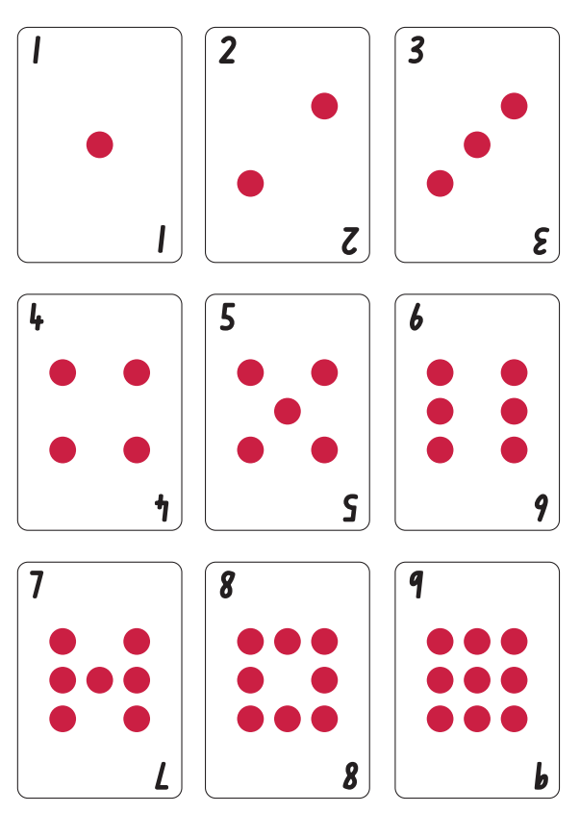

Appendix 2: Turn over 3 gameboard
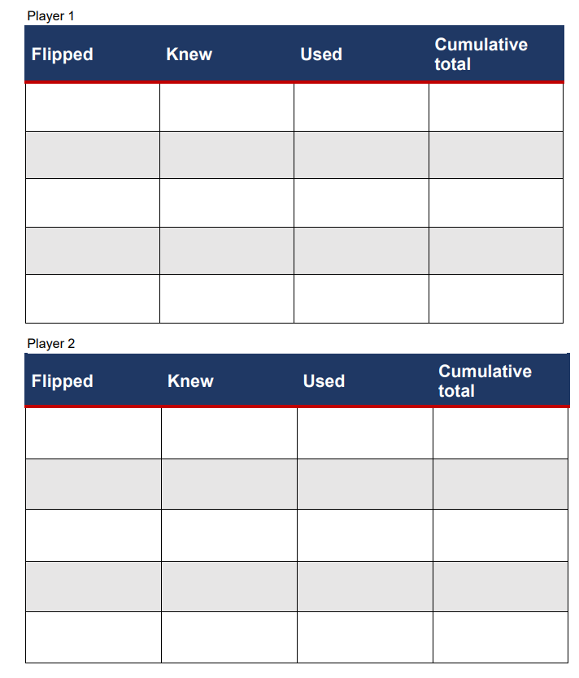

Appendix 3: Capture ten
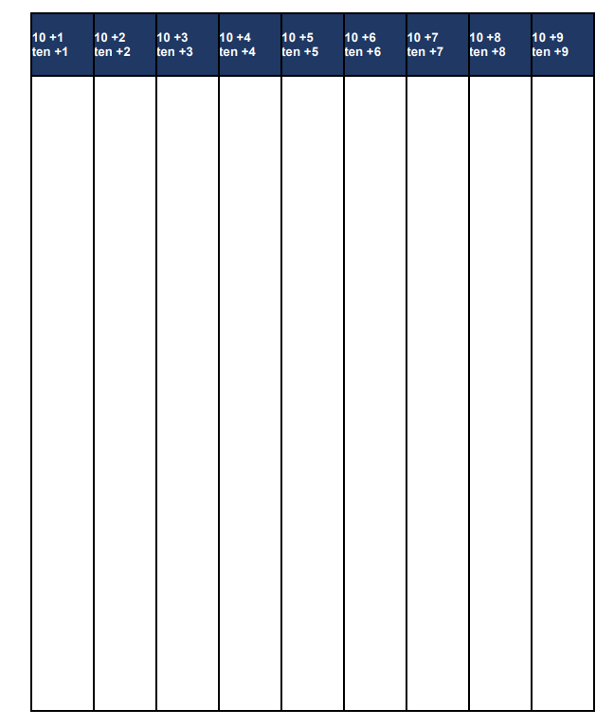

Reference list
Mathematics K–10 Syllabus © NSW Education Standards Authority (NESA) for and on behalf of the Crown in right of the State of New South Wales, 2022.
National Numeracy Learning Progression © Australian Curriculum, Assessment and Reporting Authority (ACARA) 2010 to present, unless otherwise indicated. This material was downloaded from the Australian Curriculum website (National Literacy Learning Progression) (accessed 6 November 2023) and was not modified.
State of New South Wales (Department of Education) (2023) ‘3 tens in a row’, Mathematics K-6 resources, NSW Department of Education website, accessed 16 November 2023.
State of New South Wales (Department of Education) (2023) ‘10 or bust’, Mathematics K-6 resources, NSW Department of Education website, accessed 16 November 2023.
State of New South Wales (Department of Education) (2023) ‘Capture 10’, Mathematics K-6 resources, NSW Department of Education website, accessed 16 November 2023.
State of New South Wales (Department of Education) (2023) ‘Doubles fill’, Mathematics K-6 resources, NSW Department of Education website, accessed 16 November 2023.
State of New South Wales (Department of Education) (2023) ‘Go fish relationships’, Mathematics K-6 resources, NSW Department of Education website, accessed 16 November 2023.
State of New South Wales (Department of Education) (2023) ‘Let’s talk 4 – part 2’, Mathematics K-6 resources, NSW Department of Education website, accessed 16 November 2023.
State of New South Wales (Department of Education) (2023) ‘Pinch a 10’, Mathematics K-6 resources, NSW Department of Education website, accessed 16 November 2023.
State of New South Wales (Department of Education) (2023) ‘Rekenreks 1’, Mathematics K-6 resources, NSW Department of Education website, accessed 16 November 2023.
State of New South Wales (Department of Education) (2023) ‘Rekenreks 2’, Mathematics K-6 resources, NSW Department of Education website, accessed 16 November 2023.
State of New South Wales (Department of Education) (2023) ‘Rekenrek duel 1’, Mathematics K-6 resources, NSW Department of Education website, accessed 16 November 2023.
State of New South Wales (Department of Education) (2023) ‘Rekenrek duel 2’, Mathematics K-6 resources, NSW Department of Education website, accessed 16 November 2023.
State of New South Wales (Department of Education) (2023) ‘Sam and Holly’s problem’, Mathematics K-6 resources, NSW Department of Education website, accessed 16 November 2023.
State of New South Wales (Department of Education) (2023) ‘Turn over 3’, Mathematics K-6 resources, NSW Department of Education website, accessed 16 November 2023.
Stanford University (n.d.) ‘Finger trails’, Tasks, youcubed website, accessed 16 November 2023.
Stanford University (n.d.) ‘Game of totals (1-2)’, Tasks, youcubed website, accessed 16 November 2023.

Copyright
Section 113P Notice
Texts, Artistic Works and Broadcast Notice
Some of this material has been copied and communicated to you in accordance with the statutory licence in section 113P of the Copyright Act. Any further reproduction or communication of this material by you may be the subject of copyright protection under the Act. Do not remove this notice.

Evidence base
Sparrow, L., Booker, G., Swan, P., Bond, D. (2015). Teaching Primary Mathematics. Australia: Pearson Australia.
Brady, K., Faragher, R., Clark, J., Beswick, K., Warren, E., Siemon, D. (2015). Teaching Mathematics: Foundations to Middle Years. Australia: Oxford University Press.
Alignment to system priorities and/or needs: The literacy and numeracy five priorities.
Alignment to School Excellence Framework: Learning domain: Curriculum, Teaching domain: Effective classroom practice and Professional standards
Consulted with: NSW Mathematics Strategy professional learning and Curriculum Early Years Primary Learners-Mathematics teams
Reviewed by: Literacy and Numeracy
Created/last updated: January 2024
Anticipated resource review date: January 2025
Feedback: Complete the online form to provide any feedback.

