Part 4: Flexible strategies with decimals

About the resource
This resource is the second section of a 4-part resource supporting additive thinking.
- Part 1: Flexible strategies with combinations to 10
- Part 2: Flexible strategies with 2-digit numbers
- Part 3: Flexible strategies with 3-digit numbers
- Part 4: Flexible strategies with decimals
Like most things in mathematics, talking about additive thinking is hard to do without referring to other aspects such as patterning, subitising (and visual recognition), counting (with understanding), number sense, measurement and statistics. As such, this resource is best used in conjunction with other guides to support a connected network of critical mathematical concepts, skills and understanding.
Flexible additive strategies involve students using what they know (such as known facts, properties, part-part-whole knowledge), using landmark numbers (like multiples of 10 and 5) and using partitioning to solve problems. Students understanding about how numbers and operations work is a critical part of developing deep, meaningful mathematical skills, understanding and confidence.
Continued learning of pattern and structures, number knowledge (including place value understanding) and counting (with understanding) is vital in supporting students’ continued development of number sense. Additionally, students should be supported in developing rich, meaningful understanding of how the operations work in order to support their skills in working flexibly with numbers. Students need to be provided with opportunities to compare strategies and contexts, exploring situations when particular strategies are efficient and when they are not as efficient. It should be remembered too, that efficiency is connected to the confidence and knowledge of individuals. Building representational fluency is important in supporting meaning-making about the operations and how numbers work.
Students at this stage of learning require targeted teaching in the form of investigations and meaningful, low-stress practice to enhance and solidify their understanding and use flexible strategies in increasingly complex contexts. Teachers should validate the different strategies students invent and use, using individual thinking to cultivate a culture of communication, thinking and reasoning.

How to use the resource
Teachers can use assessment information to make decisions about when and how they use this resource as they design teaching and learning sequences to meet the learning needs of their students.
The tasks and information in the resource includes explicit teaching, high expectations, effective feedback and assessment and can be embedded in the teaching and learning cycle.
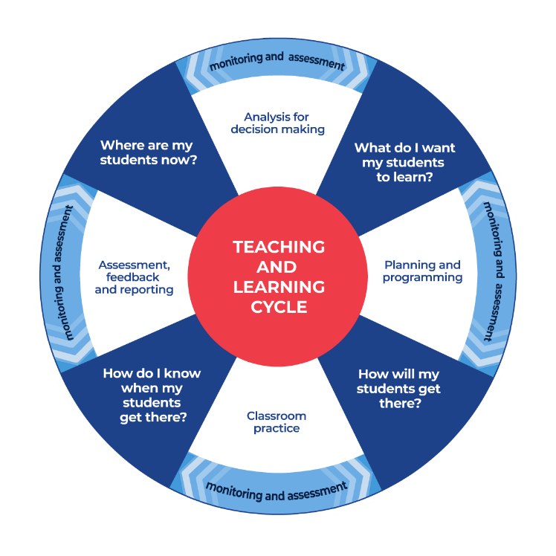
Figure 1: Teaching and learning cycle
- Where are my students now? Teachers use a range of assessment information to determine what students know and can do, including their interests, learning strengths and needs.
- What do I want my students to learn? Teachers use the information gathered along with the syllabus and NNLP to determine the next steps for learning. Teachers might also like to look at the ‘what’s some of the maths’ and ‘key generalisations to synthesise the information they have gathered into the next step/s for learning.
- How will my students get there? Teachers can then use the task overview information (‘What does it promote?’ and ‘What other tasks can I make connections to?’) to find tasks that meet the learning needs of students. Teachers then make decisions about what instructional practices and lesson structures to use to best support student learning. Further support with What works best in practice is available.
- How do I know when my students get there? Teachers can use the section ‘Some observable behaviours you may look for/notice’ that have been articulated for each task as a springboard for what to look for. These ideas can be used to co-construct success criteria and modified to suit the learning needs, abilities and interests of students. Referring back to the syllabus and the NNLP are also helpful in determining student learning progress as well as monitoring student thinking during the task. The information gained will inform ‘where are my students now’ and ‘what do I want them to learn’ as part of the iterative nature of the teaching and learning cycle.

Syllabus
MAO-WM-01 develops understanding and fluency in mathematics through exploring and connecting mathematical concepts, choosing and applying mathematical techniques to solve problems, and communicating their thinking and reasoning coherently and clearly
MA3-RN-02 compares and orders decimals up to 3 decimal places
MA3-AR-01 selects and applies appropriate strategies to solve addition and subtraction problems
MA3-RQF-02 determines $\frac{1}{2}$, $\frac{1}{4}$, $\frac{1}{5}$ and $\frac{1}{10}$ of measures and quantities
NSW Mathematics K-10 Syllabus (2022)

Progression
Number and place value NPV5-NPV8
Additive strategies AdS6-AdS9
Number patterns and algebraic thinking NPA3-NPA5, NPA7
National Numeracy Learning Progression Version 3

Additional background information
Decimal fractions are fractions that have a special feature, their denominators are always powers of 10. It is strongly recommended that teachers and students read decimal numbers such as 34.72 as ‘thirty-four and seventy-two-hundredths’ to support comprehension. Voicing decimals as ‘thirty-four point seventy-two’ can build substantial misunderstanding, emphasising whole number thinking in a fractional context and making it hard to distinguish between whole and decimal numbers.
Having said that, many place value characteristics that apply to whole numbers also apply to decimal fractions. For example:
- the maximum number in any place is 9
- to calculate with numbers, we often temporarily break this rule. For example, I may rename 4.5 to be ‘3 and 15 tenths’ so I can subtract nine-tenths
- zero acts a place holder as well as representing nothing
- the order we write digits makes a difference to the value of the digit. For example, 2.8 does not have the same value as 8.2
- the position of a digit tells us how much it is worth (in other words, its value)
- ‘ten of these is the same as one of those’ applies to decimal numbers too
- each positional shift in place value is a multiplicative process. For example, transforming 0.2 into 0.02 requires 0.2 to be divided by 10.
Understanding place value means that, in part, a student appreciates the constant multiplicative relationship between places which can be extended infinitely to the left and right of the decimal point. Students need experiences reasoning with decimal fractions through direct comparison, indirect comparison, naming and re-naming the whole, partitioning and modelling ideas and understanding. In the same way as we teachers should invest time in developing strong number sense in the early years, we need students to be able to read, understand and interpret decimal fractions with the same robustness.
Whilst money has often been used to introduce decimals, it is not an ideal model. Firstly, we read $2.45 as ‘two dollars, forty-five’ not ‘two dollars and 45-hundredths’, thus not distinguishing between the whole and fractional numbers. Money is also problematic as there are no visual clues from the coins that 45 cents is a fraction of a dollar. In fact, if you look at the coins for 45 cents, they look larger than a dollar. It is also no longer possible to make a dollar out of 100 individual cent pieces. Measurement offers a stronger context. Length is regarded as a more natural introduction to decimals as students can see and prove that 100 centimetres is the same as 1 metre. Likewise, we can see that 0.5 m is more than 0.45 m.

A note about concrete materials and fraction models
Decimal numbers should be introduced using materials that can easily show a unit that can be broken into 10 parts. Linear arithmetic blocks (LAB) provide a concrete way of representing decimals through length and are particularly useful for ones, tenths, hundredths and thousandths. The LAB components can be constructed from, for example, plastic pipe, foam tubing, dowel, with decimals represented by either stacking the pieces on rods or laying them in a line. Apart from helping students to comprehend the magnitude of decimal numbers, the LAB can be used to demonstrate addition and subtraction as well as multiplication and division by small whole numbers and powers of 10.
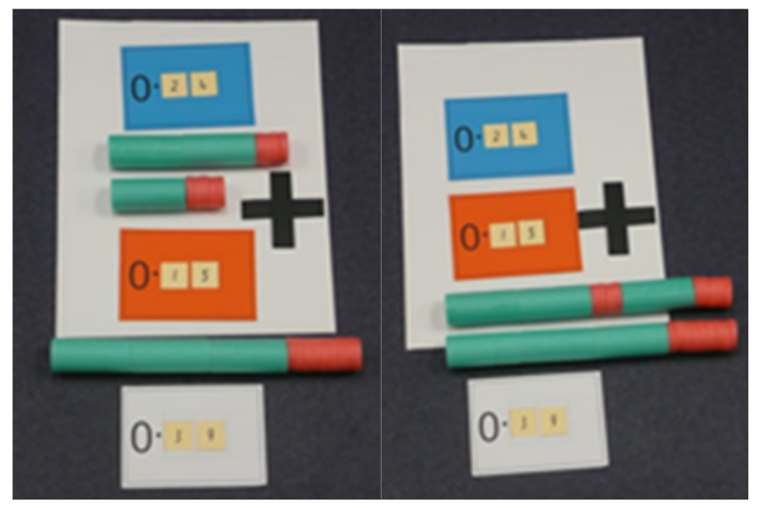
Figure 2: Examples of linear arithmetic blocks (LAB)
There are 3 primary forms of representations in fractions: linear, area and discrete.
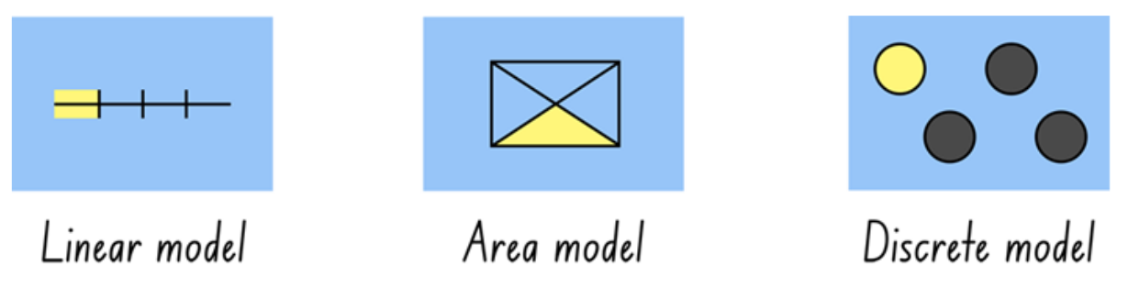
Figure 3: 3 primary forms of representation
In linear models, comparisons between fractional parts can be made using length. To use the area model, students need to have developed an understanding of how to compare area. They need to know what ‘area’ is, identify the area of the part and of the whole as well as being able to calculate the area in order to prove their thinking. Models where the partitioning has already taken place (such as the image shown below), limit the thinking required of students (since they only have to count to determine the answer) and lead to shallow understanding.
Q: ‘How many rectangles are shaded?’
A: ‘3-tenths.’
Instead, teachers should offer students a similar model, and ask them to work out ‘If this rectangle represents the whole, where would 3-tenths be? How do you know?’
or,
Q: ‘what fraction of the length of this rectangle is shaded?’
This could also be followed by questions where the whole is re-formed. For example:
Q: ‘Where would 3-tenths be if this is 5-tenths of the whole?’
Q: ‘Where would 3-tenths be if this is 1 and a half?’
Teachers need to support students in understanding that addition and subtraction always involves combining like groups. For example:
- 3 apples plus 4 apples makes 7 apples in total.
- 3 apples plus 4 pears makes 3 apples and 4 pears in total. This could be renamed to say there are 7 pieces of fruit in total.
- 3-tenths plus 4-tenths makes 7-tenths in total.
- 3-tenths plus 4-hundredths makes 3-tenths and 4-hundredths in total. This could be renamed to say there are 34-hundredths in total.
Teachers should also be aware of a number of common misunderstandings surrounding fractions. Students often make generalisations that:
- The longer the fraction, the larger it is. For example, 0.32 is bigger than 0.4 as 0.32 is ‘longer’ than 0.4. These students tend to apply ‘whole number thinking’ to fractional numbers.
- The shorter a fraction is, the larger it is. These students tend to pick the shorter decimal to be the larger number, often as a result of not considering the amount that they have (the numerator) in relationship to the amount needed to make the whole (the denominator). For example, a student applying this misconception may argue 0.03 is larger than 0.035 because it has less digits.
Misconceptions in student thinking are difficult to identify as they often produce the correct answer. It is important, therefore, to examine and analyse why students respond to questions as they do, whether they have determined a correct or incorrect response.
The resource has been developed in partnership with the NSW Mathematics Strategy Professional Learning team, Curriculum Early Years and Primary Learners, and Literacy and Numeracy.

Overview of tasks
Task name | What does it promote? | What other tasks can I make connections to? | What materials will I need? | Possible group size
Decimals on a number line | Positioning decimal numbers on the number line supports students in understanding the magnitude of numbers, the relationship between numbers and enhances proportional reasoning. | Spiralling decimals (nrich) | - Unmarked one-metre strip of paper  - Markers | Whole class
Making tenths and hundredths | Building conceptual understanding and number sense through paper folding and modelling of fractional quantities. | Colour in fractions  Decimats | - Square sheets of paper | Whole class
Get your balance: tenths and hundredths | Building conceptual understanding and number sense through equivalence and mass. | Reaction time | - Balance scale and weights (1 kg, 100 g and  10 g)  - Dot stickers or sticky notes  - Writing materials | Whole class and/or small group
I'll race you to zero: decimal place value | Encourages students to develop their use of flexible additive strategies in a fractional context. | Magic matrix (nrich) | - Appendix 1: 12 chart  - Appendix 2: 12 chart with labels  - Counters  - Six-sided dice  - Six-sided dice labelled | Small group
More than or less than? | Encourage students to estimate and reason using benchmarks and prove their thinking using representations. | Target practice | - Writing materials | Whole class
Roll 5 dice: decimal version | Encourages students to develop their use of flexible additive strategies in a fractional context. | Target practice | - 5 dice  (2 different colours)  - Writing materials | Whole class
What can you say? | Encourages students to talk and record what they know about decimal numbers, showcasing their number knowledge. |  | - Writing materials | Whole class
How does knowing...? | Encourages students to develop their use of flexible additive strategies in a fractional context. | Decimats: Helping students make sense of decimal place value | - Writing materials  - Concrete materials | Whole class
Red or black: decimals | Encourages students to develop their use of flexible additive strategies in a fractional context. | Which one would you do in your head? | - Playing cards  - Writing materials | Small group
Subtraction face off: thousandths, hundredths and tenths | Encourages students to develop their use of flexible additive strategies in a fractional context. | Let’s investigate 1 | - Playing cards  - Appendix 3: Explanation spinner | Small group and/or two players
Number sentence battle | Encourages students to develop their use of flexible additive strategies in a fractional context. |  | - Nine-sided dice  - Game board | Small group
Which would you work out in your head? Place value system | Encourages students to develop their use of flexible additive strategies in a fractional context and analyse the efficiency of strategies. | Which one would you do in your head? | - Writing materials  - Sticky notes | Whole class and/or small group

Decimals on a number line

Key generalisations/what’s (some of) the mathematics?
- We can visualise fractional quantities to solve problems.
- We can use benchmarks to determine the place of a decimal on a number line. For example, “If I know 0.5 is here (gesturing half- way mark on a number line) then I know 0.25 would be about here as it is half-way between 0 and one-half. So now that I know a quarter is here, 0.3 is a little more than a quarter so I'd place that here”
- We can compare, order and understand the size of fractions by using language and renaming. For example, 0.8 can be read as 8-tenths and renamed as 80-hundredths. This helps me compare it to 75-hundredths to know that 0.8 is larger than 0.75.
- Mathematicians compare similarities and differences.
- Mathematicians use comparisons to analyse choices.
- Mathematicians use a range of representations to communicate their ideas.
- Mathematicians explain their thinking so it makes sense to others.
- Different people see and think about numbers and problems in different ways.

Some observable behaviours you may look for/notice
- Compares decimal fractions using language. For example, 80-hundredths is closer to 75-hundredths than 99-hundredths.
- Compares decimal fraction by renaming
- Compares decimal fractions by comparing digits in place value places
- Shares thinking when locating numbers on a number line
- Makes connections between the symbols for decimal fractions, the language and various representations (both physical and mental) of that quantity
- Recognises the relationship between tenths and hundredths. For example, 7-tenths and 5-hundredths is equivalent in value to 75-hundredths.

Materials
- Unmarked one-metre strip of paper
- Markers

Instructions
- Take an unmarked one-metre strip of paper.
- Attach it to a board or wall.
- Tell students that the strip of paper is about one metre long.
- Ask students to turn and talk, sharing their thinking about where they think 0.5 m would be located on the strip of paper. Invite students to record their thinking on the paper strip.
- Discuss together how you might prove whether our estimates were valid or need some revising by showing how to mentally estimate half-way and using paper folding to help.
- Next, repeat the process by asking students to consider where 0.25 m might be located.
- Continue the lesson by asking a student to mark where 0.75 m would be.
- Draw attention to the idea 0.5 (the shorter decimal) is bigger than 0.25 and smaller than 0.75, dispelling any misconception that the shorter the decimal, the bigger it is.
- Continue by locating 0.2 m and 0.3 m.
Teacher note: Having the student locate 0.2m and 0.3m on either side of 0.25m is important to reinforce this awareness.

Variation
- Have students match fractional notation, word cards and images to the number line. For example, ‘1/10’, ‘one-tenth’ and so on.
Teacher note: For the purpose of this activity, teachers should not record 0.5 m as 0.50 m.

Making tenths and hundredths

Key generalisations / what’s (some of) the mathematics?
- We can flexibly rename decimal fractions. For example, we can rename as one and 53-hundedths as 15-tenths and 3-hundredths. We can also rename it as one and 4-tenths and 13-hundredths.
- Partitioning a whole into ten equal parts creates tenths. So, when you tenth 1-whole, you get 10-tenths.
- Partitioning a tenth in ten equal parts creates hundredths. So, when you tenth 1-tenth, you get 10-hundredths (You could also extend this further to tenth 1-hundredth to get 10-thousandths)
- Paper folding can help us understand and represent fractions
- Mathematicians explain their thinking so it makes sense to others.

Some observable behaviours you may look for/notice:
- Communicates through explaining and/or representing that tenthing 1-whole creates 10-tenths, and tenthing 1-tenth will create hundredths
- Compares the size of fractions
- Partitions paper into equal-sized parts reasonably accurately
- Describes fractions using the words tenths and hundredths
- Connects decimal numbers to the symbol, word and amount in order to make meaning
- Renames decimal fractions. For example, explains that 7-tenths and 5-hundredths is equivalent in value to 75-hundredths. It can also be renamed as 6-tenths and 15-hundredths.

Materials
- Square sheets of paper

Instructions
- Provide students with a square sheet of paper and ask them to consider how we could fold the paper in order to ‘tenth it’, dividing (partitioning) it into tenths.
- Provide students with additional squares as they try to figure out the best way to partition the paper in order to show tenths.
- Discuss the different ways tenths can be made and what other fractions we can find in the different models. For example, the one on the left shows only tenths but the one on the right shows tenths as well as fifths that have been halved and halves that have been fifthed.
Figure 4: Partitioning to see tenths
- Teachers could now ask students to do things such as:
- Identify a part of their whole, for example, 3-tenths, 8-tenths or 1 and 2-tenths.
- Have students record the fractions in a range of ways. See Figure 5.
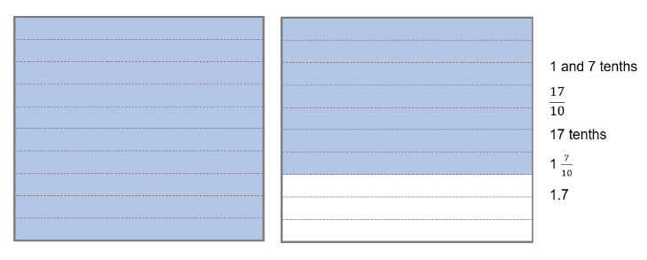
Figure 5: Fractions in a range of ways
- Ask students to make an additional tenth, partitioning the paper only vertically or horizontally (as in the image on the left, above).
- Ask them to predict what might happen if we divide our tenths into 10 smaller parts.
- Brainstorm and share ideas.
- Have students test out their ideas, eventually supporting them to make tenths, turn their paper 90 degrees and divide into tenths again, in order to make hundredths.
- Discuss the process students undertook, explicitly drawing out the relationship between tenths to hundredths by dividing by ten.
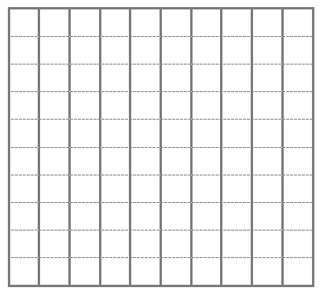
Figure 6: tenths to hundredths

Variations
- Ask students to identify a part of their whole, for example, 33-hundredths, 8-tenths or 1 and 27-hundredths. Have students record the fractions in a range of ways. For example:
  - Order the various fractions on a number line, comparing their models and counting forwards and backwards, naming and renaming
  - Make connections to metric units of measurement
  - Make connections to percentages.

Teacher note: Take note of students who apply whole number thinking to fractions (for example, students who say ‘one point fifty-three’) and help correct their use of language to accurately describe the size of the units (that is, one and fifty-three hundredths). Students should have prior experience in paper folding to represent fractions such as halves, quarters, eights, fifths, thirds and sixths, and so on.

Get your balance: tenths and hundredths

Key generalisations / what’s (some of) the mathematics?
- The balance scale can be used to explore and represent equivalence. We can record equivalence using this symbol: =
- Describes how equivalence can be used to solve problems. When we describe something as balanced it means it is equivalent.
- Smaller numbers can be found hiding inside of fractional numbers too. For example, inside of 3 and 3-tenths of a kilogram (3.3 kg) we can find 1 and 8-tenths and 1 and 5-tenths more.
- Mathematicians use thinking of their peers to refine and revise their ideas.
- Mathematicians use a range of representations to communicate their ideas.

Some observable behaviours you may look for/notice
- Communicates through explaining and/or representing that tenthing 1-whole creates 10-tenths, and tenthing 1-tenth will create hundredths
- Provides reasons why quantities are or are not equivalent, using the arms of the balance scale as evidence
- Describes what is meant by the term equivalence
- Talks about or represents part-part-whole understanding

Materials
- Balance scale and weights (1 kg, 100 g and 10 g)
- Dot stickers or sticky notes
- Writing materials

Instructions
- Provide students with a balance scale and weights which include 1 kg, 100 g and 10 g.
- Show and discuss how if one kilogram is the ‘whole’, we need 10 hundred grams to have an equivalent value to the ‘whole’. As such, this means that 100 g = tenths (in this task) and 10 g must then be equivalent to hundredths.
- Provide students with dot stickers or post-it notes so they can label their weights as ‘whole’, ‘1-tenth’ or ‘1-hundredth’.
- Have students work out, and record, different ways of creating the ‘whole’ that is balanced on one side of the balance scale. For example, ask a group of students to find different ways to partition 3.1 kg.
- Ask questions such as:
  - What does it mean when the balance arm is level?
  - What would happen if we removed one-tenth from each side?
  - What would happen if I removed one-tenth from the left side?
  - What would happen if I added 3-tenths to the right side? What might the scale look like? (Have students draw and label what it might look like).

Variation
- Provide an unbalanced scale. Ask questions such as:
  - Why is the scale not equal?
  - What do we need to do to make the scale balanced?
  - Ask what might be on the other side, supporting students in justifying their thinking.
  - Use Cuisenaire rods or MABs rather than weights

I’ll race you to zero: decimal place value

Key generalisations/what’s (some of) the mathematics?
- When adding and subtracting with decimal numbers we can use mental strategies. For example:
  - applying known facts and part-part-whole number knowledge
  - using landmark numbers (sometimes called benchmark numbers. These may be whole numbers (like 1), or 1-half, or even multiples of ten, tenths or hundredths in a fractional context)
  - using the relationship between numbers
  - trusting and using patterns
  - renaming numbers
  - using properties and inverse operations.
- Mathematicians explain their thinking so it makes sense to others.
- Listening to other people’s thinking helps us become aware of other ways of thinking, building our knowledge of mathematics.
- Mathematicians use thinking of their peers to refine and revise their ideas.
- Mathematicians can use their knowledge of numbers and operations to strategise to improve their chances of winning a game.

Some observable behaviours you may look for/notice:
- Uses a range of strategies to solve problems. For example:
  - uses known facts
  - renames numbers
  - uses properties (such as commutative and associative)
  - uses knowledge of counting
  - uses landmark or benchmark numbers
  - in a fractional context, these may be whole numbers, like 1, or 1-half, or even multiples of ten, tenths or hundredths
- partitions numbers into smaller parts
- uses inverse operations.
- Explains how addition and subtraction problems involving decimal numbers can be solved using some similar mental strategies as those used with whole numbers

Materials
- Appendix 1: 12 chart
- Appendix 2: 12 chart with labels
- counters
- six-sided dice
- six-sided dice labelled one-tenth, two-tenths, three-tenths, four-tenths, five-tenths, six-tenths.

Instructions
- Provide pairs of students with Appendix 1: 12 chart, 2 counters and 2 dice, one 1-6 and one specially made ‘one-tenth’, ‘two-tenths’,’ three-tenths’, ‘four-tenths’, ‘five-tenths’, ‘six-tenths’ dice.
- Students place their counters at 12. The person whose birthday is closest to 29 February goes first.
- Students take turns to roll both dice and decide which to use, subtracting the amount from their current position. For example, a student rolled ‘6-tenths’ and ‘4’, they can choose to subtract ‘6-tenths’ or ‘4’.
- Students explain where they need to move their counter to their partner, justifying their thinking. If their partner agrees, they move the counter to the corresponding position.
- Students take turns until someone has been able to land exactly on zero.
- Students miss a turn if they cannot move.

Variations
- Students make a number roll by cutting their 12 chart into strips and joining them into one number strip. Students can roll it up when out of use.
- Using a 1 and 2-tenths chart.

More than or less than?

Key generalisations/what’s (some of) the mathematics?
- We can compare, order and understand the size of fractions by using language and renaming. For example, 0.8 can be read as 8-tenths and renamed as 80-hundredths. This helps me compare it to 75-hundredths to know that 0.8 is larger than 0.75.
- We can apply our place value understanding to rename numbers to solve problems.
- We can use estimation to help us when solving problems.
- Mathematicians can represent their thinking in a number of ways. For example, through symbols, words, diagrams or concrete materials.
- Different people see and think about numbers and problems in different ways.

Some observable behaviours you may look for/notice
- Explains thinking using a variety of representations
- Provides reasonable estimates by using benchmark numbers
- Uses a range of strategies to solve problems. For example:
- uses known facts
- renames numbers
- uses properties (such as commutative and associative)
- uses knowledge of counting
- uses landmark or benchmark numbers
  - in a fractional context, these may be whole numbers, like 1, or 1-half, or even multiples of ten, tenths or hundredths
- partitions numbers into smaller parts
- uses inverse operations.
- Compares the size of decimal fractions. For example, 0.75 is known to be of greater magnitude than 0.5 because of the positional value of the digits.

Materials
- Writing materials

Instructions
- Provide students with recording materials. Ask students a question such as:‘Is 3.9 + 6.8 less than 10 or more than 10?’.
- Encourage students to estimate and reason using benchmarks rather than calculating. For example, 3.9 is almost 4 and 6.8 is almost 7 so 3.9 + 6.8 must be more than 10.
- Ask students to share their thinking using their recording materials.
- Ask if there is a way to prove their thinking is accurate using diagrams or concrete materials. Allow students to draw or model their thinking before sharing back with the class.
- Discuss the reasoning students share to answer the question.

Variation
- Many questions can be asked following a similar format such as:
  - Is 8.3 – 1.25 less than 7 or more than 7?
  - Is 9.9 – 4.5 less than 5 or more than 5?
  - Is 0.1 more than 0 or less than 0?
  - Is 1 – 0.1 more than 0 or less than 0?
  - Is 23.51 – 12.9 less than 10 or more than 10?

Roll 5 dice: decimal version

Key generalisations/what’s (some of) the mathematics?
- When adding and subtracting with decimal numbers we can use similar flexible strategies used with whole numbers. For example:
- applying known facts and part-part-whole number knowledge
- using landmark numbers (sometimes called benchmark numbers. These may be whole numbers (like 1), or 1-half, or even multiples of ten, tenths or hundredths in a fractional context)
- using the relationship between numbers
- trusting and using patterns
- renaming numbers
- using inverse operations and properties.
- Mathematicians compare similarities and differences.
- Mathematicians use comparisons to analyse choices.
- Mathematicians use a range of representations to communicate their ideas.
- Mathematicians explain through symbols, words and representations why some strategies are more efficient than others.
- Mathematicians use thinking of their peers to refine and revise their ideas.

Some observable behaviours you may look for/notice
- Uses a range of strategies to solve problems. For example:
- uses known facts
- renames numbers
- uses properties (such as commutative and associative)
- uses knowledge of counting
- uses landmark or benchmark numbers
  - in a fractional context, these may be whole numbers, like 1, or 1-half, or even multiples of ten, tenths or hundredths
- partitions numbers into smaller parts
- uses inverse operations
- Explains how addition and subtraction problems involving decimal numbers can be solved using some similar mental strategies as those used with whole numbers
- Selects and uses a range of efficient strategies to solve problems

Materials
- 5 dice (2 different colours)
- Writing materials

Instructions
- Select a target number between 0.05 and 3.6 and write it on the board.
- Choose 5 dice using only 2 different colours. Chose one colour to represent tenths and the other colour to represents hundredths.
- Roll all 5 dice.
- Students work out how they would add the numbers together in the most efficient way.
- Students to share different strategies, recording thinking using visual and concrete materials.
- Work out ‘how many more’ or ‘how many less’ than the sum is needed to hit the target.
- Roll again

What can you say?

Key generalisations/what’s (some of) the mathematics?
- We can flexibly rename decimal fractions. For example, we can rename as one and 53-hundedths as 15-tenths and 3-hundredths or as one and 4-tenths and 13-hundredths.
- Smaller numbers can be found hiding inside of fractional numbers too.
- Different people see and think about numbers in different ways.
- Mathematicians use thinking of their peers to refine and revise their ideas.

Some observable behaviours you may look for/notice
- Talks about part-part-whole understanding of fractional numbers
- Describes a number relationship to other numbers. For example, 2.83 is less than 2.9 and larger than 2.8
- Renames numbers
- Describes the value of a digit is determined by its place
- Connects decimal numbers to the symbol, word and amount in order to make meaning

Materials
- Writing materials

Instructions
- Write, for example, ‘two and eighty-three hundredths’ in words so that students can see it.
- Ask students to write the corresponding number on their whiteboards or paper.
- Ask students to talk to a thinking partner and record everything they know about the number.
- Invite students to share their thinking, discussing their ideas and questions. Encourage students make suggestions such as:
- There is a 3 in the hundredths place
- The nearest whole number is 3
- It is between 2 and 3
- It is bigger than 2.5
- It is smaller than 2.9
- You need 7 more hundredths to make 2.9
- You can rename it as ‘1 and 183-hundredths'.

How does knowing…?

Key generalisations/what’s (some of) the mathematics?
- When adding and subtracting with decimal numbers we use similar flexible strategies used with whole numbers. For example:
- applying known facts and part-part-whole number knowledge
- using landmark numbers (sometimes called benchmark numbers. These may be whole numbers (like 1), or 1-half, or even multiples of ten, tenths or hundredths in a fractional context)
- using the relationship between numbers
- trusting and using patterns
- renaming numbers
- using inverse operations and properties.
- Different people see and think about numbers and problems in different ways.

Some observable behaviours you may look for/notice
- Uses a range of strategies to solve problems. For example:
- uses known facts
- renames numbers
- uses properties (such as commutative and associative)
- uses knowledge of counting
- uses landmark or benchmark numbers
  - in a fractional context, these may be whole numbers, like 1, or 1-half, or even multiples of ten, tenths or hundredths
- partitions numbers into smaller parts
- uses inverse operations
- Explains how addition and subtraction problems involving decimal numbers can be solved using some similar mental strategies as those used with whole numbers.

Materials
- Concrete materials (Refer concrete materials in page 1 ‘About the resource’

Instructions
- Pose the following question for discussion and provide a range of concrete materials.
- I know that 6 + 4 = 10. How does knowing that help me work out the problems such as…?
- 1.6 + 0.4 For example:
If 6 + 4 = 10, then 6-tenths + 4-tenths = 10-tenths and I know 10-tenths is 1 whole, or 1. So, 1.6 + 0.4 gives me 1 + 6-tenths + 4-tenths which is 1 + 10-tenths which is 1 + 1 which is 2.

- 0.6 + 1.4
- 0.4 + 0.7
- 2.6 + 0.4
- 0.06 + 0.24
- 2.6 + 1.4
- 1.5 + 0.6
- 3.56 + 2.14
- 6 + 34
- 5.0 – 0.4
- 9.0 – 1.6
- 1.20 – 0.04
- 0.1 – 0.04
- 1.0 – 0.6

Teacher note: These questions are not intended to be provided as a worksheet or as an independent activity. Use them as a point of discussion, selecting only a few questions based upon the learning needs of their students. Through the richness of conversation these questions are hoping to draw out connections.

Red or black: decimals
Key generalisations/what’s (some of) the mathematics?
- When adding and subtracting with decimal numbers we can use mental strategies. For example:
- applying known facts and part-part-whole number knowledge
- using landmark numbers (sometimes called benchmark numbers. These may be whole numbers (like 1), or 1-half, or even multiples of ten, tenths or hundredths in a fractional context)
- using the relationship between numbers
- trusting and using patterns
- renaming numbers
- using inverse operations and properties.
- Mathematicians explain their thinking so it makes sense to others.
- Different people see and think about numbers and problems in different ways.
Some observable behaviours you may look for/notice
- Uses a range of strategies to solve problems. For example:
- uses known facts
- renames numbers
- uses properties (such as commutative and associative)
- uses knowledge of counting
- uses landmark or benchmark numbers
  - in a fractional context, these may be whole numbers, like 1, or 1-half, or even multiples of ten, tenths or hundredths
- partitions numbers into smaller parts
- uses inverse operations
- Explains how addition and subtraction problems involving decimal numbers can be solved using some similar mental strategies as those used with whole numbers.

Materials
- Playing cards
- Writing materials

Instructions
- Organise students into groups of 4.
- Provide each group with a pack of playing cards, mini white boards and markers.
- Each player begins with a score of 2.1 points.
- Shuffle the cards and place them face down in a pile.
- Each player in the group takes turns to draw a card from the pile. Before drawing, they must say whether the card will be red or black.
- If the player guesses the colour correctly, the number on the card is added to their score.
- If the player guesses incorrectly, the number on the card is subtracted.
- Clubs and hearts are worth tenths.
- Diamonds and spades are worth thousandths.
If the player guesses incorrectly but has not enough points to take away the number on the card, they miss a turn. All cards have a score of their face value. Picture cards score as follows: Jack = 11, Queen = 12, King = 13, Ace = 1
- The winner is the first player to score 7.25.

Variations
- Remove picture cards and play with cards Ace-10 only
- Students invent extra rules for playing. For example, include the ‘joker’ and if drawn, the player reverses the score of an opponent
- Change the winning score. For example, for a shorter game change the winning score to 5.55
- Highest score after 5 turns wins.
Teacher note: Have the students record their thinking. Use different ways of recording as the focus of later targeted teaching.

Subtraction face-off: thousandths, hundredths and tenths
Key generalisations/what’s (some of) the mathematics?
- When adding and subtracting with decimal numbers we can use mental strategies. For example:
- applying known facts and part-part-whole number knowledge
- using landmark numbers (sometimes called benchmark numbers. These may be whole numbers (like 1), or 1-half, or even multiples of ten, tenths or hundredths in a fractional context)
- using the relationship between numbers
- trusting and using patterns
- renaming numbers
- using inverse operations and properties.
- Mathematicians explain their thinking so it makes sense to others.
- Different people see and think about numbers and problems in different ways.
- Mathematicians can use their knowledge of numbers and operations to strategise to improve their chances of winning a game.
Some observable behaviours you may look for/notice
- Uses a range of strategies to solve problems. For example:
- uses known facts
- renames numbers
- uses properties (such as commutative and associative)
- uses knowledge of counting
- uses landmark or benchmark numbers
  - in a fractional context, these may be whole numbers, like 1, or 1-half, or even multiples of ten, tenths or hundredths
- partitions numbers into smaller parts
- uses inverse operations.
- Compares the size of decimal fractions. For example 0.8 is known to be of greater magnitude than 0.75 because of the positional value of the digits
- Explains how addition and subtraction problems involving decimal numbers can be solved using some similar mental strategies as those used with whole numbers.

Materials
- Playing cards (Ace-9)
- Appendix 3: Explanation spinner

Instructions
- Provide pairs of students with a set of playing cards and Appendix 3: Explanation spinner.
- Students use Ace to 9 to represent 1 – 9.
- Have students shuffle the cards and deal them out evenly between the 2 players.
- Students place their cards into a face down pile. At the same time, students take the 5 top cards from the pile to form a number in the thousandths and a number in the hundredths. For example, I flip over 5, 5, 6, 1, and 9. I make 0.561 and 0.59.
- Students can arrange the cards in any way they like to make the smallest difference.
- The student with the smallest difference collects all 10 cards.
- Students continue playing until someone has lost all of their cards.
- Have students use the explanation spinner and share the strategies used to work out differences based on what the spinner lands on.

Number sentence battle
Key generalisations/what’s (some of) the mathematics?
- When adding and subtracting with decimal numbers we can use mental strategies. For example:
- applying known facts and part-part-whole number knowledge
- using landmark numbers (sometimes called benchmark numbers. These may be whole numbers (like 1), or 1-half, or even multiples of ten, tenths or hundredths in a fractional context)
- using the relationship between numbers
- trusting and using patterns
- renaming numbers
- using inverse operations and properties.
- Different people see and think about numbers and problems in different ways.
- Mathematicians can use their knowledge of numbers and operations to strategise to improve their chances of winning a game.
Some observable behaviours you may look for/notice
- Uses a range of strategies to solve problems. For example:
- uses known facts
- renames numbers
- uses properties (such as commutative and associative)
- uses knowledge of counting
- uses landmark or benchmark numbers
  - in a fractional context, these may be whole numbers, like 1, or 1-half, or even multiples of ten, tenths or hundredths
- partitions numbers into smaller parts
- uses inverse operations
- Explains how addition and subtraction problems involving decimal numbers can be solved using some similar mental strategies as those used with whole numbers
- Understands the positional place value of decimals
- Compares the size of decimal fractions. For example, 0.75 is known to be of greater magnitude than 0.5 because of the positional value of the digits.

Materials
- Nine-sided dice
- Game board.

Instructions
- Provide students with a game board, see Figure 7, and a nine-sided dice.
- 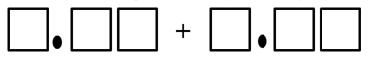or
Figure 7: Example game board
- Students take turns to roll the dice and build a number sentence that will result in:
- the largest total
- the largest difference
- the smallest total
- the smallest difference
- closest to a target number such as 9.01

Which would you work out in your head? Place value system
Key generalisations/what’s (some of) the mathematics?
- There are a range of mental, written and digital strategies we can use to solve problems.
- When adding and subtracting with decimal numbers we can use mental strategies. For example:
- applying known facts and part-part-whole number knowledge
- using landmark numbers (sometimes called benchmark numbers. These may be whole numbers (like 1), or 1-half, or even multiples of ten, tenths or hundredths in a fractional context)
- using the relationship between numbers
- trusting and using patterns
- renaming numbers
- using inverse operations and properties.
- Mathematicians compare similarities and differences.
- Mathematicians use comparisons to analyse choices.
- Different people see and think about numbers and problems in different ways.
- Mathematicians explain their thinking so it makes sense to others.
Some observable behaviours you may look for/notice
- Uses a range of strategies to solve problems. For example:
- uses known facts
- renames numbers
- uses properties (such as commutative and associative)
- uses knowledge of counting
- uses landmark or benchmark numbers
  - in a fractional context, these may be whole numbers, like 1, or 1-half, or even multiples of ten, tenths or hundredths
- partitions numbers into smaller parts
- uses inverse operations
- Selects and uses a range of efficient strategies to solve problems
- Explains how addition and subtraction problems involving decimal numbers can be solved using some similar mental strategies as those used with whole numbers.

Materials
- Writing materials
- Sticky notes

Instructions
- Display:

  - 4.7 + ___ = 13.4
  - 0.980 - 0.5
  - 7.5 + 0.15 + 6.5
  - 1.001 – 0.75
  - 235 – 44
  - 98 + ___ = 266
  - 0.635 - ___ = 0.23
  - 2 – 0.09
  - 7.8 – 1.2 – 1.6

- Allow students time to think before asking them to respond. Students record which questions they would do in their head. Have students record these on sticky notes or on a digital response application.
- As a class compare the similarities and differences in class preferences. Looking at the responses, ask questions such as:
- Which question/s do you think most people might prefer to model to help them solve?
  - Why do you think that?
  - What do these questions have in common?
- Which question/s do you think most people would work out in their heads?
  - Why do you think that?
  - What do these questions have in common?
- Which strategies are we not considering as often as others?
  - What do we need to learn in order to use those strategies as comfortably as the others?

Variation
- Change the questions examined by students.
Teacher note: Pose questions such as these enable students to see how different people work with problems in different contexts.

Appendix 1: 12 Chart
 |  |  |  |  |  |  |  |  | 0
0.1 | 0.2 | 0.3 | 0.4 | 0.5 | 0.6 | 0.7 | 0.8 | 0.9 | 1
1.1 | 1.2 | 1.3 | 1.4 | 1.5 | 1.6 | 1.7 | 1.8 | 1.9 | 2
2.1 | 2.2 | 2.3 | 2.4 | 2.5 | 2.6 | 2.7 | 2.8 | 2.9 | 3
3.1 | 3.2 | 3.3 | 3.4 | 3.5 | 3.6 | 3.7 | 3.8 | 3.9 | 4
4.1 | 4.2 | 4.3 | 4.4 | 4.5 | 4.6 | 4.7 | 4.8 | 4.9 | 5
5.1 | 5.2 | 5.3 | 5.4 | 5.5 | 5.6 | 5.7 | 5.8 | 5.9 | 6
6.1 | 6.2 | 6.3 | 6.4 | 6.5 | 6.6 | 6.7 | 6.8 | 6.9 | 7
7.1 | 7.2 | 7.3 | 7.4 | 7.5 | 7.6 | 7.7 | 7.8 | 7.9 | 8
8.1 | 8.2 | 8.3 | 8.4 | 8.5 | 8.6 | 8.7 | 8.8 | 8.9 | 9
9.1 | 9.2 | 9.3 | 9.4 | 9.5 | 9.6 | 9.7 | 9.8 | 9.9 | 10
10.1 | 10.2 | 10.3 | 10.4 | 10.5 | 10.6 | 10.7 | 10.8 | 10.9 | 11
11.1 | 11.2 | 11.3 | 11.4 | 11.5 | 11.6 | 11.7 | 11.8 | 11.9 | 12

Appendix 2: 12 Chart with labels
0
zero
0.1 | 0.2 | 0.3 | 0.4 | 0.5 | 0.6 | 0.7 | 0.8 | 0.9 | 1
zero point 1 | zero point 2 | zero point 3 | zero point 4 | zero point 5 | zero point 6 | zero point 7 | zero point 8 | zero point 9 | one
one-tenth | two-tenths | three-tenths | four-tenths | five-tenths | six-tenths | seven-tenths | eight-tenths | nine-tenths
1.1 | 1.2 | 1.3 | 1.4 | 1.5 | 1.6 | 1.7 | 1.8 | 1.9 | 2
1 point 1 | 1 point 2 | 1 point 3 | 1 point 4 | 1 point 5 | 1 point 6 | 1 point 7 | 1 point 8 | 1 point 9 | two
one and one-tenth | one and two-tenths | one and three-tenths | one and four- tenths | one and five- tenths | one and six- tenths | one and seven-tenths | one and eight-tenths | one and nine-tenths
2.1 | 2.2 | 2.3 | 2.4 | 2.5 | 2.6 | 2.7 | 2.8 | 2.9 | 3
2 point 1 | 2 point 2 | 2 point 3 | 2 point 4 | 2 point 5 | 2 point 6 | 2 point 7 | 2 point 8 | 2 point 9 | three
two and one-tenth | two and two-tenths | two and three-tenths | two and four-tenths | two and five-tenths | two and six-tenths | two and seven-tenths | two and eight-tenths | two and nine-tenths
3.1 | 3.2 | 3.3 | 3.4 | 3.5 | 3.6 | 3.7 | 3.8 | 3.9 | 4
3 point 1 | 3 point 2 | 3 point 3 | 3 point 4 | 3 point 5 | 3 point 6 | 3 point 7 | 3 point 8 | 3 point 9 | four
three and one-tenth | three and two-tenths | three and three-tenths | three and four-tenths | three and five-tenths | three and six-tenths | three and seven-tenths | three and eight-tenths | three and nine-tenths
4.1 | 4.2 | 4.3 | 4.4 | 4.5 | 4.6 | 4.7 | 4.8 | 4.9 | 5
4 point 1 | 4 point 2 | 4 point 3 | 4 point 4 | 4 point 5 | 4 point 6 | 4 point 7 | 4 point 8 | 4 point 9 | five
four and one-tenth | four and two-tenths | four and three-tenths | four and four-tenths | four and five-tenths | four and six-tenths | four and seven-tenths | four and eight-tenths | four and nine-tenths
5.1 | 5.2 | 5.3 | 5.4 | 5.5 | 5.6 | 5.7 | 5.8 | 5.9 | 6
5 point 1 | 5 point 2 | 5 point 3 | 5 point 4 | 5 point 5 | 5 point 6 | 5 point 7 | 5 point 8 | 5 point 9 | six
five and one-tenth | five and two-tenths | five and three-tenths | five and four-tenths | five and five-tenths | five and six-tenths | five and seven-tenths | five and eight-tenths | five and nine-tenths
6.1 | 6.2 | 6.3 | 6.4 | 6.5 | 6.6 | 6.7 | 6.8 | 6.9 | 7
6 point 1 | 6 point 2 | 6 point 3 | 6 point 4 | 6 point 5 | 6 point 6 | 6 point 7 | 6 point 8 | 6 point 9 | seven
six and one-tenth | six and two-tenths | six and three-tenths | six and four-tenths | six and five-tenths | six and six-tenths | six and seven-tenths | six and eight-tenths | six and nine-tenths
7.1 | 7.2 | 7.3 | 7.4 | 7.5 | 7.6 | 7.7 | 7.8 | 7.9 | 8
7 point 1 | 7 point 2 | 7 point 3 | 7 point 4 | 7 point 5 | 7 point 6 | 7 point 7 | 7 point 8 | 7 point 9 | eight
seven and one-tenth | seven and two-tenths | seven and three-tenths | seven and four-tenths | seven and five-tenths | seven and six-tenths | seven and seven-tenths | seven and eight-tenths | seven and nine-tenths
8.1 | 8.2 | 8.3 | 8.4 | 8.5 | 8.6 | 8.7 | 8.8 | 8.9 | 9
8 point 1 | 8 point 2 | 8 point 3 | 8 point 4 | 8 point 5 | 8 point 6 | 8 point 7 | 8 point 8 | 8 point 9 | nine
eight and one-tenth | eight and two-tenths | eight and three-tenths | eight and four-tenths | eight and five-tenths | eight and six-tenths | eight and seven-tenths | eight and eight-tenths | eight and nine-tenths
9.1 | 9.2 | 9.3 | 9.4 | 9.5 | 9.6 | 9.7 | 9.8 | 9.9 | 10
9 point 1 | 9 point 2 | 9 point 3 | 9 point 4 | 9 point 5 | 9 point 6 | 9 point 7 | 9 point 8 | 9 point 9 | ten
nine and one-tenth | nine and two-tenths | nine and three-tenths | nine and four-tenths | nine and five-tenths | nine and six-tenths | nine and seven-tenths | nine and eight-tenths | nine and nine-tenths
10.1 | 10.2 | 10.3 | 10.4 | 10.5 | 10.6 | 10.7 | 10.8 | 10.9 | 11
10 point 1 | 10 point 2 | 10 point 3 | 10 point 4 | 10 point 5 | 10 point 6 | 10 point 7 | 10 point 8 | 10 point 9 | eleven
ten and one-tenth | ten and two-tenths | ten and three-tenths | ten and four-tenths | ten and five-tenths | ten and six-tenths | ten and seven-tenths | ten and eight-tenths | ten and nine-tenths
11.1 | 11.2 | 11.3 | 11.4 | 11.5 | 11.6 | 11.7 | 11.8 | 11.9 | 12
11 point 1 | 11 point 2 | 11 point 3 | 11 point 4 | 11 point 5 | 11 point 6 | 11 point 7 | 11 point 8 | 11 point 9 | twelve
eleven and one-tenth | eleven and two-tenths | eleven and three-tenths | eleven and four-tenths | eleven and five-tenths | eleven and six-tenths | eleven and seven-tenths | eleven and eight-tenths | eleven and nine-tenths

Appendix 3: Explanation spinner
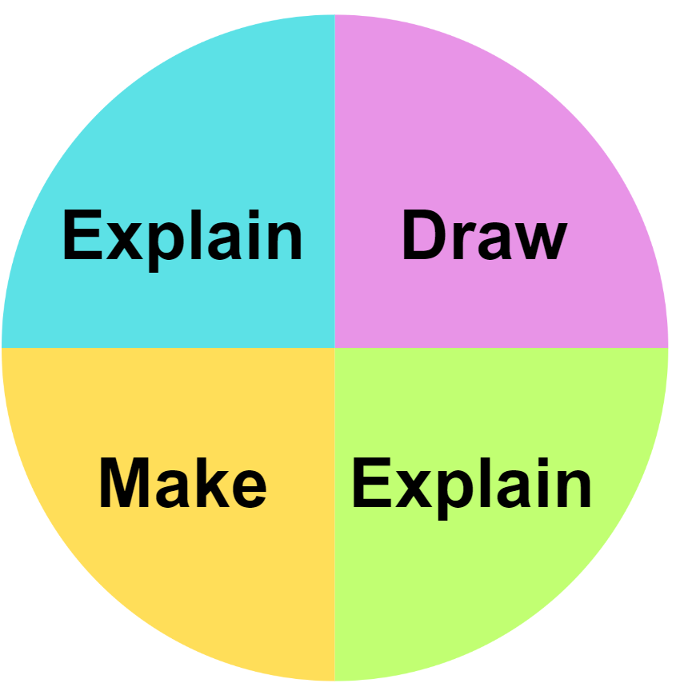

Reference list
This resource contains images and content obtained from Canva, and their use outside of this resource is subject to Canva’s Content License Agreement.
Mathematics K–10 Syllabus © NSW Education Standards Authority (NESA) for and on behalf of the Crown in right of the State of New South Wales, 2022.
National Numeracy Learning Progression © Australian Curriculum, Assessment and Reporting Authority (ACARA) 2010 to present, unless otherwise indicated. This material was downloaded from the Australian Curriculum website (National Literacy Learning Progression) (accessed 6 November 2023) and was not modified.
Roche A (2010) ‘Decimats: Helping students make sense of decimal place value’, Australian Primary Mathematics Classroom, 15(2):4-10.
State of New South Wales (Department of Education) (2023) ‘Colour in fractions’, Mathematics K-6 resources, NSW Department of Education website, accessed 15 November 2023.
State of New South Wales (Department of Education) (2023) ‘Decimats’, Mathematics K-6 resources, NSW Department of Education website, accessed 15 November 2023.
State of New South Wales (Department of Education) (2023) ‘Let’s investigate 1-Number talk’, Mathematics K-6 resources, NSW Department of Education website, accessed 15 November 2023.
State of New South Wales (Department of Education) (2023) ‘Reaction time test’, Mathematics K-6 resources, NSW Department of Education website, accessed 15 November 2023.
State of New South Wales (Department of Education) (2023) ‘Which would you do in your head?’, Mathematics K-6 resources, NSW Department of Education website, accessed 15 November 2023.
University of Cambridge (Faculty of Mathematics) (1997–2023) ‘Magic matrix’, NRICH website, accessed 15 November 2023.
University of Cambridge (Faculty of Mathematics) (1997–2023) ‘Spiralling Decimals’, NRICH website, accessed 15 November 2023.

Copyright
Section 113P Notice
Texts, Artistic Works and Broadcast Notice
Some of this material has been copied and communicated to you in accordance with the statutory licence in section 113P of the Copyright Act. Any further reproduction or communication of this material by you may be the subject of copyright protection under the Act. Do not remove this notice.

Evidence base
Sparrow, L., Booker, G., Swan, P., Bond, D. (2015). Teaching Primary Mathematics. Australia: Pearson Australia.
Brady, K., Faragher, R., Clark, J., Beswick, K., Warren, E., Siemon, D. (2015). Teaching Mathematics: Foundations to Middle Years. Australia: Oxford University Press.
Alignment to system priorities and/or needs: The literacy and numeracy five priorities.
Alignment to School Excellence Framework: Learning domain: Curriculum, Teaching domain: Effective classroom practice and Professional standards
Consulted with: NSW Mathematics Strategy professional learning and Curriculum Early Years Primary Learners-Mathematics teams
Reviewed by: Literacy and Numeracy
Created/last updated: January 2024
Anticipated resource review date: January 2025
Feedback: Complete the online form to provide any feedback.

