Part 1: Strategies for sharing and forming equal groups

About the resource
This resource is the first section of a 4-part resource supporting multiplicative thinking.
- Part 1: Strategies for sharing and forming equal groups
- Part 2: Flexible strategies with single-digit numbers
- Part 3: Flexible strategies with multi-digit numbers
- Part 4: Flexible strategies with rational numbers
Like most concepts in mathematics, talking about multiplicative thinking is difficult without referring to other aspects of mathematics such as patterning, subitising (and visual recognition), counting (with understanding), number sense, measurement and statistics. This resource is best used in conjunction with other guides to support a connected network of critical mathematical concepts, skills and understanding. Student understanding about how numbers and operations work is a critical part of developing deep, meaningful mathematical skills, understanding and confidence.
Continued learning of pattern and structures, number knowledge (including place value understanding) and counting (with understanding) is vital in supporting continued development of number sense. Students should also be supported in developing rich, meaningful understanding of how the operations work to support their skills in working flexibly with numbers. Provide students with opportunities to compare strategies and contexts, explore situations when particular strategies are efficient and when they are not as efficient. Remember, efficiency is connected to the confidence and knowledge of individuals. Building representational fluency is important in supporting meaning-making about the operations and how numbers work.
Students at this stage of learning need targeted teaching that includes problem solving, exploring how strategies work, deepening conceptual understanding and meaningful, low-stress practice. This enhances and solidifies understanding and confidence in choosing and using various flexible strategies in increasingly complex contexts. Validate the different strategies students invent and use, using individual thinking to cultivate a culture of communication, thinking and reasoning.

Syllabus
MAO-WM-01 develops understanding and fluency in mathematics through exploring and connecting mathematical concepts, choosing and applying mathematical techniques to solve problems, and communicating their thinking and reasoning coherently and clearly
MAE-RWN-01 demonstrates an understanding of how whole numbers indicate quantity
MAE-RWN-02 reads numerals and represents whole numbers to at least 20
MAE-FG-01 recognises, describes and continues repeating patterns
MAE-FG-02 forms equal groups by sharing and counting collections of objects
MA1-RWN-01 applies an understanding of place value and the role of zero to read, write and order two- and three-digit numbers
MA1-RWN-02 reasons about representations of whole numbers to 1000, partitioning numbers to use and record quantity values
MA1-FG-01 uses number bonds and the relationship between addition and subtraction to solve problems involving partitioning
MA1-2DS-01 recognises, describes and represents shapes including quadrilaterals and other common polygons
MA1-2DS-02 measures and compares areas using uniform informal units in rows and columns
MA2-RN-01 applies an understanding of place value and the role of zero to represent numbers to at least tens of thousands
MA2-MR-01 represents and uses the structure of multiplicative relations to 10 × 10 to solve problems
NSW Mathematics K-10 Syllabus (2022)

Progression
Number and place value NPV1-NPV4
Counting processes CPr1-CPr7
Additive strategies AdS1-AdS2
Multiplicative strategies MuS1-MuS6
Number patterns and algebraic thinking NPA1-NPA4
National Numeracy Learning Progression Version 3
The resource has been developed in partnership with the NSW Mathematics Strategy Professional Learning team, Curriculum Early Years and Primary Learners, and Literacy and Numeracy.

How to use the resource
Use assessment information to make decisions about when and how they use this resource as they design teaching and learning sequences to meet the learning needs of their students.
The tasks and information in the resource includes explicit teaching, high expectations, effective feedback and assessment and can be embedded in the teaching and learning cycle.
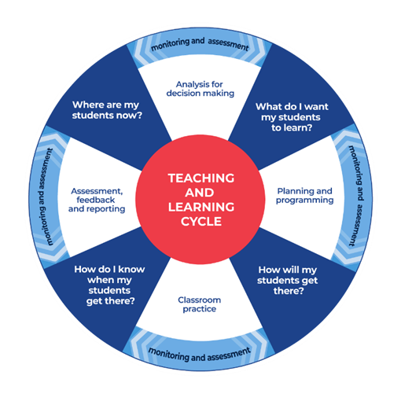
Where are my students now? Use a range of assessment information to determine what students know and can do, including their interests, learning strengths and needs.
What do I want my students to learn? Use the information gathered along with the syllabus and National Numeracy Learning Progression to determine the next steps for learning. You might also like to look at the ‘what’s some of the maths’ and ‘key generalisations’ to synthesise the information that they’ve gathered into the next step/s for learning.
How will my students get there? Use the task overview information (‘What does it promote?’ and ‘What other tasks can I make connections to?’) to find tasks that meet the learning needs of students. Make decisions about what instructional practices and lesson structures to use in order to best support student learning. Further support with What works best in practice is available.
How do I know when my students get there? Use the section ‘Some observable behaviours you may look for/notice’ that have been articulated for each task as a springboard for what to look for. These ideas can be used to co-construct success criteria and modified to suit the learning needs, abilities and interests of students. Referring back to the syllabus and the National Numeracy Learning Progression are also helpful in determining student learning progress as well as monitoring student thinking during the task. The information gained will inform ‘where are my students now’ and ‘what do I want them to learn’ as part of the iterative nature of the teaching and learning cycle.

The nature of the learner
Students tend to progress through several broad phases of learning as multiplicative thinking develops. Typically, they need a deep understanding of the principles of counting, including the cardinal and order-irrelevance principles before multiplicative thinking can develop. Students need to be able to: count collections of items; know the last number word tells us how many; know the order in which you count a collection of objects does not change the total; and know collections can be rearranged and partitioned without changing the total.
This understanding is number sense and form a crucial foundation for multiplicative thinking.
When students ‘trust the count’, they can take advantage of equal groups, using more efficient counting strategies. Students using multiplication and division grouping strategies can ‘double counting’ - this means they can keep track of multiple sequences at the same time as keeping track of the number of groups, without relying on material or markers to represent the groups.
Note: using counting and dealing strategies to solve problems are additive strategies, limited by a student’s fluency with the counting sequences and the size of a collection to be shared.
Students at this stage of learning are working towards developing an increasingly sophisticated idea of composite units, learning to coordinate the number of groups (multiplier), the number in each group (multiplicand) and the total (product). They are learning to represent and describe multiplicative situations, moving from over relying on items to visualising composite units.
As students continue in their learning, they need to be supported in focusing on the multidimensionality of multiplicative situations, understanding how:
- to move flexibly between multiplication and division, using the inverse operations to help them solve problems
- to fluently coordinate the number of groups (multiplier), the number in each group (multiplicand) and the total (product), realising that missing information determines whether the situation requires multiplication or division to be used to find a solution
- to apply part-part-whole reasoning to composite units
- to use known facts to work out the unknown
- multiplication and division can be used in a wide range of situations, some of which are not easy to ‘see’ as multiplicative
- to use manipulatives, vocabulary and diagrams to communicate mathematically
- to apply the commutative, associative and distributive properties to solve problems, knowing how and when these properties are useful and when they are not.
Moving from additive to multiplicative thinking is an important stage in learning and should be carefully navigated. Remember thinking strategically to solve problems (considering the context, the numbers and the operations) takes time. Equating mathematical competence with speed sends potentially negative messages to students about what skills are most valued within mathematics. Valuing and expecting quick recall can also impair learning.

Teaching considerations
Number sense forms the foundation of all mathematical work. Having a ‘feel’ for numbers and understanding how to work flexibly and creatively with both of single units and composite units is critical to all mental strategies for multiplication and division, laying the foundations for later mathematical concepts. Building strong number sense requires an understanding of numerical relationships, the use of strong mental imagery and the active making of connections between representations, situations, concepts, experiences and language.
Figure 1: Adapted from Siemon, D., Beswick, K., Brady, K., Clark, J., Faragher, R., & Warren, E. (2015). Teaching mathematics. South Melbourne, Vic.: Oxford University Press.
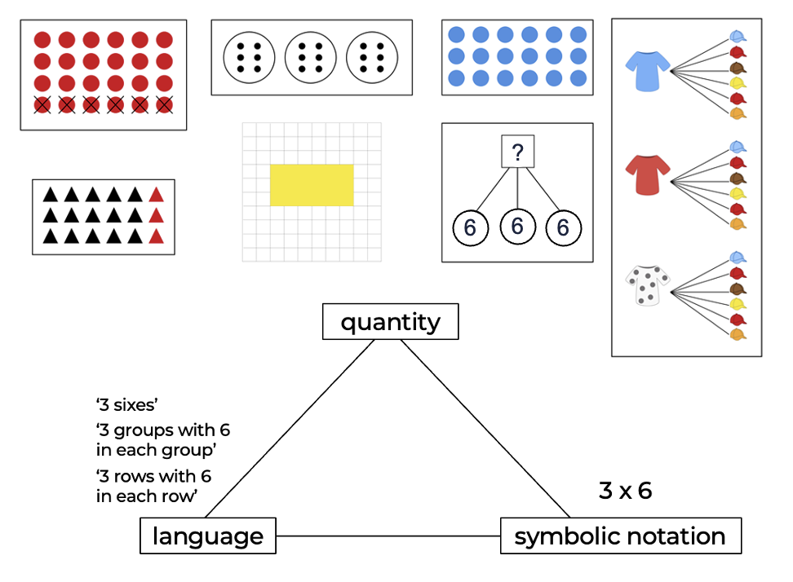
Blending these layers of conceptual, verbal, visual, symbolic and procedural meaning together requires frequent, meaningful opportunities to make observations, conjecture, test ideas, play, investigate, debate, conclude, discuss, question, practice and explore.
Multiplicative situations and multiplicative thinking are broad terms that encompass multiplication and division. Multiplicative situations occur when we stop working in single units and start working with collections of equal size. These can be tens, tenths, halves, fours, thirds, and so on. The progress from additive thinking to multiplicative thinking marks a significant shift in abstraction, complexity and efficiency. Experiences in understanding and flexibly using strategies to solve subtraction and addition problems can strongly influence understanding of multiplicative situations and processes. Through learning about counting, numbers, place value and addition and subtraction, support students to understand that:
- numbers and operations are flexible entities that can be transformed and adapted to suit the knowledge and understanding of the person solving the problem
- mental imagery, manipulatives and visuals are necessary to build meaning and should be used when introducing new concepts and strategies to help make sense of how particular strategies and concepts work and again to deepen understanding
- learning mathematics involves a focus on making meaning and building comprehension
- place value is built around patterns that make our number system efficient
- numbers can be represented in various different ways
- numbers can be partitioned and adjusted in almost endless ways
- numbers can be renamed in various ways
- 10 of one thing can be exchanged to make 1 of another, for example, 10 ones can be exchanged to have 1 ten
- some ways of solving problems are more efficient than others
- context plays an important role in determining efficiency
- the knowledge and skills of the ‘mathematician’ determines which strategies are most effective
- choosing from various strategies requires strategic thinking which is why speed of responding is not a reliable indicator of mathematical success, skills or understanding when it is the only measure being used
- fluency involves flexibility, efficiency and accuracy.
In the early years, multiplicative situations are usually introduced in informal ways, often appearing as counting problems involving repeated subtraction and repeated addition. This early understanding involves processes like skip and rhythmic counting, sharing, making groups, recognising groups that are equal. Just as counting strategies are limited by student’s knowledge of the sequence of number words, so too are their early multiplication and division strategies limited by their knowledge of the sequence of multiples. When a student’s knowledge of a sequence of multiples is exhausted, they will switch back to counting by ones.
Whilst multiplicative situations can be dealt with using repeated addition or repeated subtraction (as well as by employing rhythmic and skip counting), students must learn to working multiplicatively as it is critical to later mathematical development and understanding. Working multiplicatively will help understanding of ratio, rate, fractions, proportional reasoning and algebraic relationships.
Working and thinking multiplicatively involves moving from working with one-dimensional situations to multi-dimensional ones. Students who think multiplicatively can simultaneously coordinate and make sense of, the number of groups, the number in each group and the total (called the product).
The representations and models used support students in this transition. Whilst repeated addition can be shown on an empty number line, arrays are a more powerful display of the multidimensionality of multiplicative situations, making commutative, associative and distributive principles visual.
Figure 2: Representing multiplicative situations visually
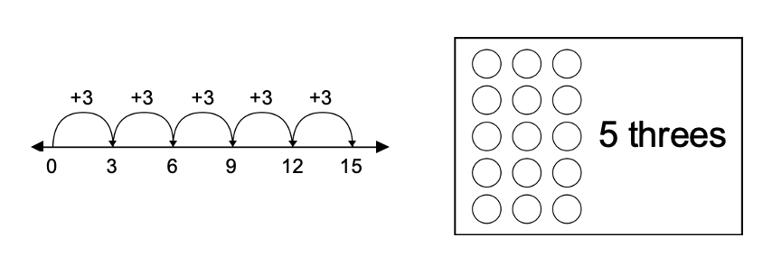
Experience with a broad range of representations, making connections between them and evaluating their effectiveness in aiding meaning, supports understanding of complex concepts like multiplicative thinking.
Multiplicative thinking is critical to developing a robust understanding of place value, fractions, rate, ratio, percentages, and other mathematical ideas. Moving from coordinating composite units to using multiplication and division as operations requires the development of understanding such as:
- place value is primarily a multiplicative process - dividing and multiplying by groups of 10 appears to ‘shift’ digits and decrease or increase their value
- there are similarities and differences between all 4 major operations we learn about in primary school.
Table 1: Similarities and differences between major operations
 | Working with single units | Working with composite units
Combining collections to create a new total | Addition  Often expressed as  addend + addend = sum | Multiplication  Often expressed as  multiplier (factor) x multiplicand (factor) = product
Starting with the total | Subtraction  Often expressed as  minuend – subtrahend = difference | Division  Often expressed as  dividend (product) ÷ divisor (factor) = quotient (factor)  Note: As division can be symbolised in various ways, change symbols used to support understanding of the nuances of language used for different symbols.
- solving multiplication and division problems requires the same level of flexibility and strategic thinking we use to solve problems using addition and subtraction
- understanding and using principles of multiplication and division are critical to developing numeracy. Some core principles are:
  - multiplication and division are related inverse operations (I can use multiplication facts I know to solve division problems and vice versa)
  - the multiplier and/or multiplicand can be adjusted to make landmark (or benchmark) numbers, for example, I can adjust $3 × 29$ (3 twenty-nines) to make 3 thirties and then can remove 1 three.
Figure 3: Using landmark numbers
3 x 30 = 90 (I know as 3 3 tens is 9 tens which we call ninety)
Now I need to remove 3 ones
99-3 = 87
So, 3 x s9 = 87
  - numbers can be multiplied in any order (the commutative property), for example, 7 fives = 5 sevens = 35 - whilst the number of groups and the number in each group (context) is different, the product is the same (this does not work with division)
  - The multiplier and/or multiplicand can be partitioned (the distributive property), for example, I can work out 3 sevens ($3 × 7$) because I know 3 fives are 15 and 3 twos are 6; 15 and 6 is 21 in total

Figure 4: partitioning the multiplier
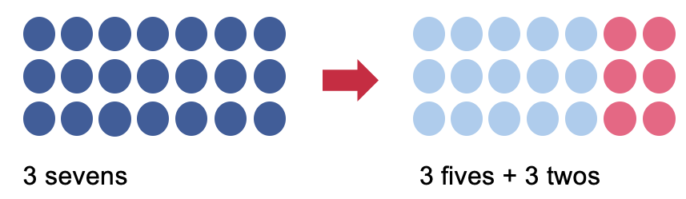
  - The distributive property works with division by partitioning the dividend, for example, $98 ÷ 7 = 70 ÷ 7 + 28 ÷ 7$
Figure 5: partitioning the dividend
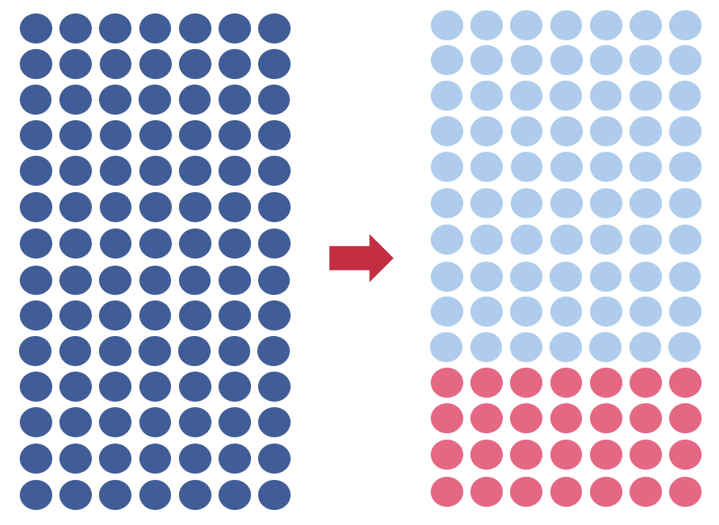
$98 ÷ 7$ $70 ÷ 7 + 28 ÷ 7$
  - you can multiply and divide in parts by factorising, for example, I can work out $14 × 8 = 2 × 7 ×8$, I know $7 × 8 = 56$, then, double 56 = 112.
  - the factorising strategy can also be used for division by factorising the divisor, for example, $42 ÷ 6 = 42 ÷ 2 ÷ 3$. I know half of 42 is 21, then $21 ÷ 3 = 7$.
  - the multiplier and multiplicand can be proportionally adjusted (the associative property) meaning the factors can be doubled and halved; trebled and ‘thirded’, for example, $4×12 = 2×24 = 1×48 = 48$.
Figure 6: using the associative property
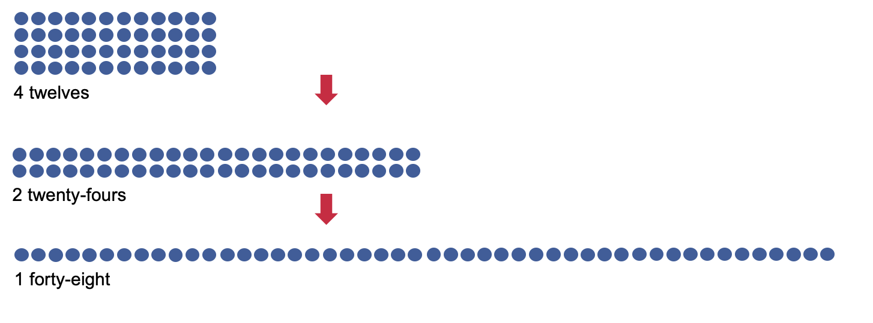
  - numbers in division problems can also be transformed, however, you must multiply or divide both numbers by the same amount, for example, $60 ÷ 12 = 10 ÷ 2$ when dividing both numbers by 6.
  - becoming familiar with how and why numbers are transformed differently with different operations helps students use various strategies with greater fluency.
Table 2: Ways numbers are transformed
 | Working with single units | Working with composite units
Combining collections to create a new total | $$116+45$$  $$120+41=161$$  (add 4 to one number and subtract 4 from the other) | $$116×4$$  $$232×2$$  $$468×1=468$$  (double one number and halve the other)
Starting with the total | $$116-45$$  $$111-40=71$$  (subtract 5 from both numbers) | $$116÷4$$  $$58÷2$$  $$29 ÷1=29$$  (halve both numbers each time)
  - division problems do not always result in a whole number solution
  - remainders can be written as fractions, decimals, rounded up, discarded or noted as ‘r’ based on the problem.
  - when multiplying or dividing by one, the answer is the number you started with
  - when multiplying by zero, the answer is zero - this is because you have a situation where you have 0 eights (that is, your group or unit size is 8 but you have none of them), or you have a unit size of zero, for example, 8 zeros.
- knowing foundational number facts allows you to use other strategies
- problems involving division and multiplication can be solved in many different ways.
- we often use a combination of strategies when solving problems
- the context of the problems combined with the skills and knowledge of the mathematician determines how useful and efficient one strategy is over another.

Different situations
There are different types of division situations, wanting to know how many are in each group (size of unit) or how many groups there are (number of units). These 2 types of division questions are:
- partitive division (sharing)
- measurement division (sometimes called quotitive).
Partitive (or sharing) division refers to dividing a whole into several equal parts. In this situation, the missing information is how many there are in each group, for example, ‘12 pencils are shared equally among 4 containers. How many pencils are in each container?’ This type of problem is often expressed as ‘$12 ÷ 4 = ?’$
Figure 7: Partitive division
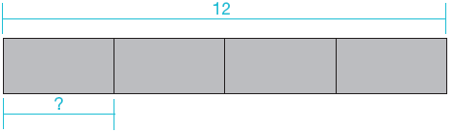
Measurement (or quotitive) division you need to work out how many units are required to form the product. In this situation, the product and the size of the unit are known, but not how many we have, for example, ‘There are 12 pencils I want to share into containers. Each container holds 4 pencils. How many containers do I need? This type of problem is often expressed as ‘$12 ÷ ? = 4$’
Figure 8: Quotitive division

Different multiplicative situations
As there are many different meanings of multiplicative situations (equal groups, comparison, scale, rate, Cartesian products and area), learning in multiplication and division needs to be rich and varied, drawing from various contexts and situations. Situations can appear to be very different, so students need to be aware of various situations and their connection to multiplication and division. Examples of some different multiplicative situations are provided in the Tables 3 to 6 below:
Table 3: Multiplication situation examples
Multiplicative situation | Partitive (sharing) division | Measurement (quotitive) division | Multiplication
Equal groups | 10 apples are shared equally amongst 5 students? How many apples does each student receive? 10 ÷ 5 =?  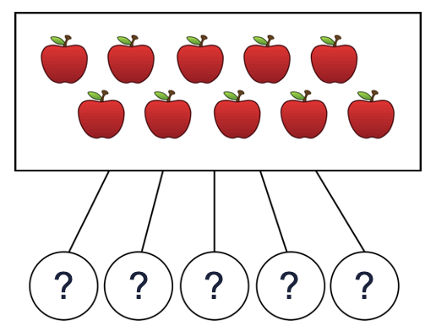 | 10 apples are shared so each student receives 2 apples each. How many students are there?  $$10 ÷ ? = 2$$  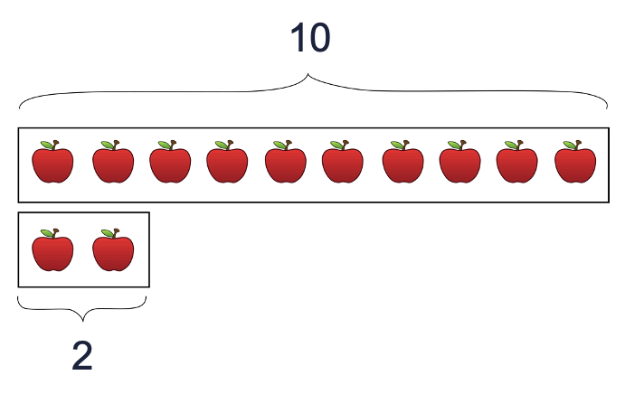 | 5 students have 2 apples each. How many apples in total? $5 × 2 = ?$  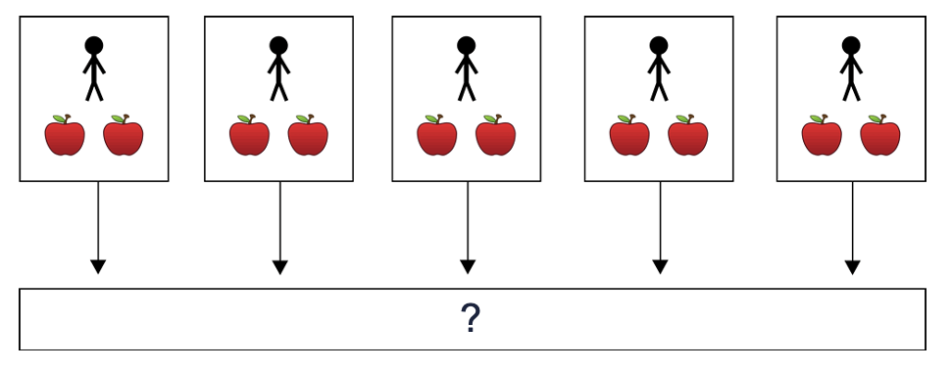
Comparisons | Katherine has five times as many pencils as Linda. Katherine has 10 pencils. How many pencils does Linda have? $10 ÷ 5 = ?$  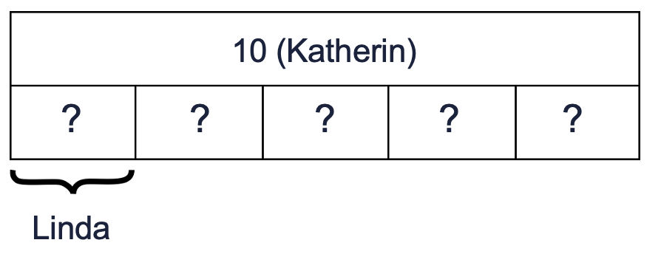 | Katherine has 10 pencils and Linda has 5. How many times more pencils does Katherine have than Linda? $10 ÷ ? = 5$  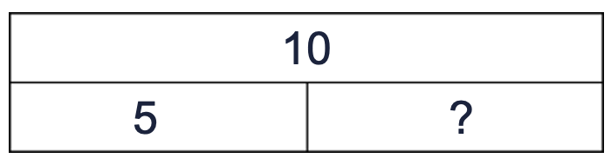 | Katherine has five times as many pencils as Linda. Linda has 2 pencils. How many pencils does Katherine have? $5 × 2 = ?$  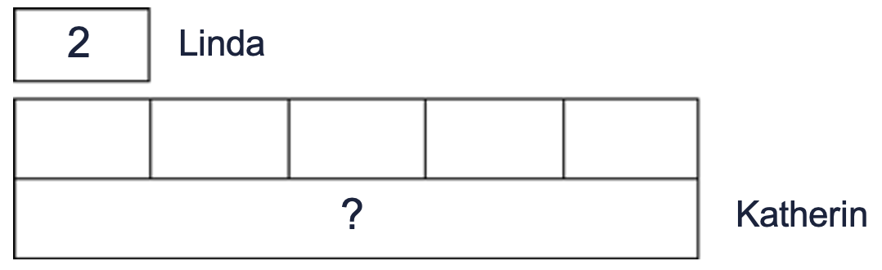
Table 4: Multiplication situation examples
Multiplicative situation | Partitive (sharing) division  Measurement (quotitive) division | Multiplication
Combinations (Cartesian product) | Willow can make 10 t-shirt and short outfit combinations. She has 5 t-shirts. How many pairs of shorts does she have? $10÷5= ?$  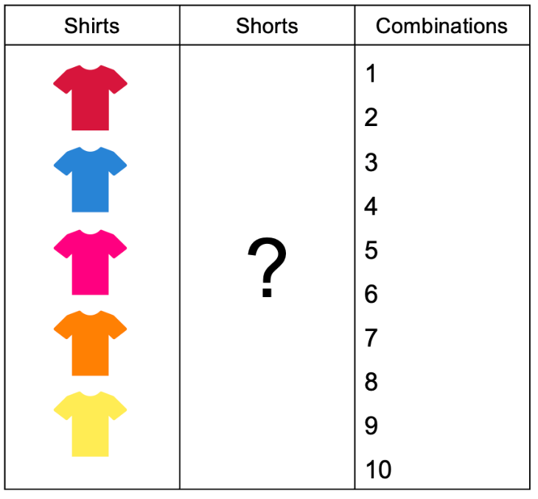 | Willow has 5 t-shirts and 2 pairs of shorts. How many different combinations of shirts and shorts can she make? $5×2= ?$  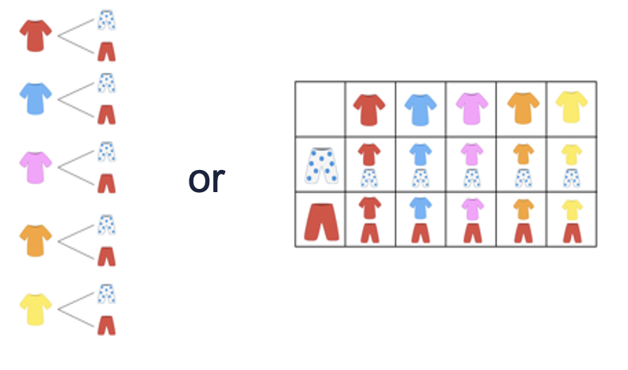
Arrays and area | A rectangle has an area of 24cm². If one side is 6cm, how long are the other sides?  A rectangle has an area of 24cm². If one side is 4cm, how long are the other sides? 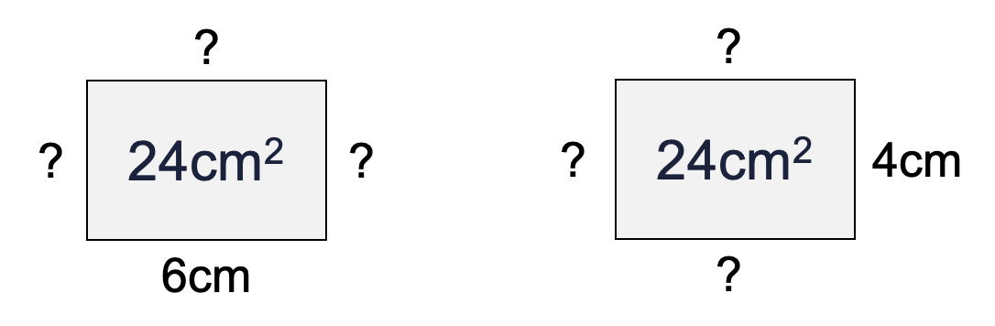 | A rectangle has two sides that are 6cm long and 2 sides are 4cm long. What is the area?  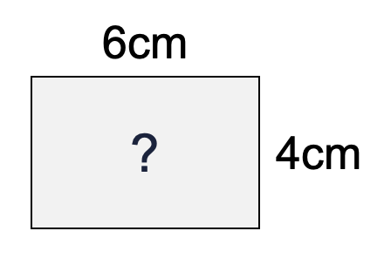
Table 5: Multiplication situation examples
Multiplicative situation | Partitive (sharing) division | Measurement (quotitive) division | Multiplication
Rate | Rachelle can make 5 sandwiches in 10 minutes. How long does it take her to make 1 sandwich? $10÷5 = ?$  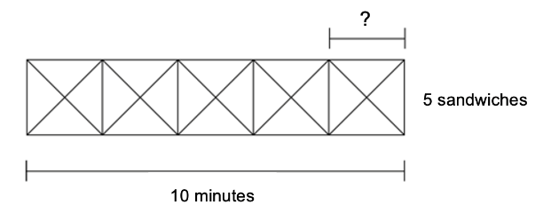 | How many sandwiches can Rachelle make in 10 minutes in if each sandwich takes 2 minutes make? $10÷ ? = 2$ | Rachelle can make 1 sandwich in 2 minutes. How long will it take her to make 5 sandwiches? $5×2= ?$  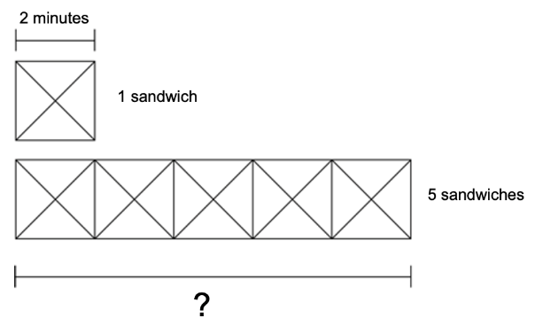
Table 6: Multiplication situation examples
Multiplicative situation | Partitive (sharing) division  Measurement (quotitive) division | Multiplication
Proportion | At soccer practice, Lloyd scored 2 goals in 5 attempts. Tiffany scored 5 goals in 10 attempts. Who would you choose to take the free kick?  Compare: Lloyd scores at a ratio of $2:5$ and Tiffany scores at a ratio of $5:10$  Lloyd $4:10$ and Tiffany $5:10$  I would choose Tiffany as she has the higher ratio of goals scored. OR  Compare: Lloyd $\frac{2}{5}≡\frac{?}{10}$ and Tiffany $\frac{5}{10}$  Lloyd scored $\frac{2}{5}$ of his attempts and Tiffany scored $\frac{5}{10}$ of her attempts  Lloyd $\frac{4}{10}$ and Tiffany $\frac{5}{10}$  I would choose Tiffany as she scored more goals. 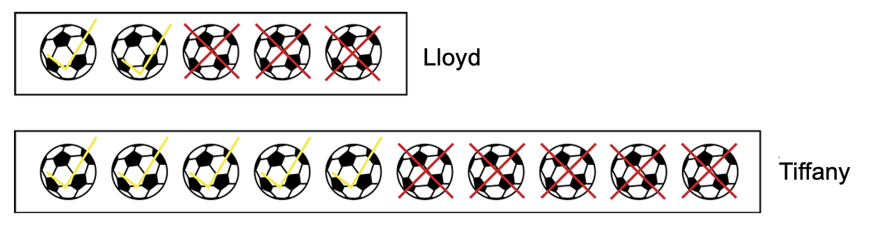 | Aidan and Shona made a deal. For every $5 Aidan saved, Shona gave him $2 extra. Aidan has saved $21 in total. How much money did Shona give him?  Aidan:Shona$→$Total =?  $\$5:\$2→$Total =?  $\$10:\$4→$Total =?  $\$15:\$6→$Total =?  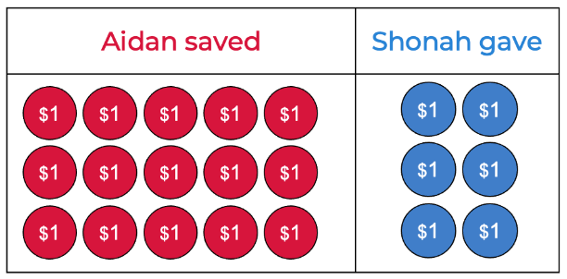
Note: Present these problems with missing multipliers, multiplicand, divisors, and dividend also. Choosing different problems highlights the way different strategies change in efficiency depending on the problem you are trying to solve.

A note about facts and ‘times tables’
Fluency in applying multiplication facts is a key strategy for solving multiplicative problems. Support development of deep conceptual understanding of foundational facts and how to apply them to other situations will lead to greater mathematical confidence. Investigating, exploring, using, adjusting, generalising, solving, questioning, playing, estimating and connecting leads to remembering as well as understanding. Understanding supports future mathematical learning and create robust and stable concept images that are more likely to persist once facts are forgotten.
Enhance the presentation of multiplication and division facts as lists by using multiplication grids that connect the number you have, the size of the unit, and the product. Reciting ‘times tables’ to find a solution can be inefficient. Understanding the relationships between facts as well as mathematical properties dramatically reduces the reliance on memory.
- Learning about the tens should take place through the development of conceptual place value. The tens can then be used as a base for learning the fives by multiplying by 10 and the halving the result. Five facts are often well known because of the repetitive nature of the counting sequence.
- The nine facts can be worked out by using knowledge of tens by multiplying by 10 and then subtracting one groups.
- Learning about two facts takes place as students learn to use doubles to solve subtraction and addition problems. From the twos, students can double twice to work out the fours and double thrice to work out the eights.
- The sixes can be derived by adding one more group to known (or derived) five facts
- The twos also provide a basis for working out the three facts by doubling and adding one more group.
Making links back to the twos, fives and tens provides a strong foundation for developing number sense and strong conceptual foundations. Many facts overlap and leaves 4 facts remaining (for example, square number, ones facts/can be commuted to make ones facts). Students should develop an understanding through the awareness of multiplication.
Whilst these ideas provide a starting point, there are other ways to use the known facts to determine solutions. Starting points and connections between facts are a guide, not an exhaustive ‘how to’ list.
The knowledge is acquired as well as having access to number facts is vital. Knowing and understanding multiplication and division principles and developing deep number sense promotes robust knowledge, is more stable, increases the probability of being able to recall and apply facts and knowledge when needed.
Research by Siemon, Beswick, Brady, Clark, Faragher, & Warren (2015) suggests a more efficient representation of multiplication and division facts is to use a multiplication and division grid. This grid can allow students to see the number of groups, the number in each group and the product, far more powerfully representing the multidimensionality of multiplicative than a list of equations (number sentences).

Figure 9: Multiplication and division grid from Siemon, D., Beswick, K., Brady, K., Clark, J., Faragher, R., & Warren, E, (2015) Teaching mathematics. South Melbourne, Vic.: Oxford University Press
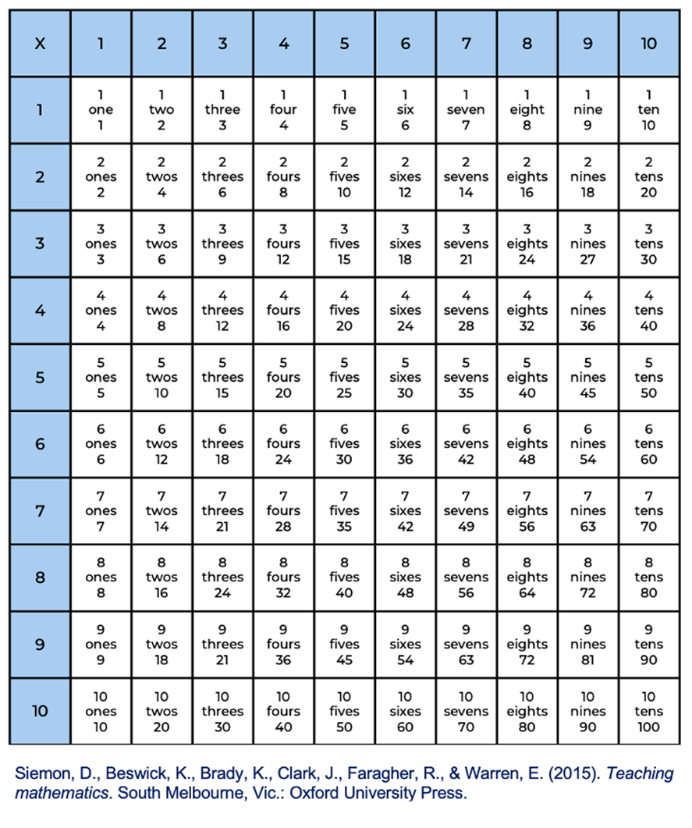
In the example (Figure 10), students see 7 x 6 is 42. They see the number of groups (the highlighted rows – there are 7 of them), the number in each group (the highlighted amount in each row – in this case, 6) and the total (the product – 42 – which could count by ones to verify).
Figure 10: Highlighted multiplication and division grid to show 7 sixes from Siemon, D., Beswick, K., Brady, K., Clark, J., Faragher, R., & Warren, E, (2015) Teaching mathematics. South Melbourne, Vic.: Oxford University Press
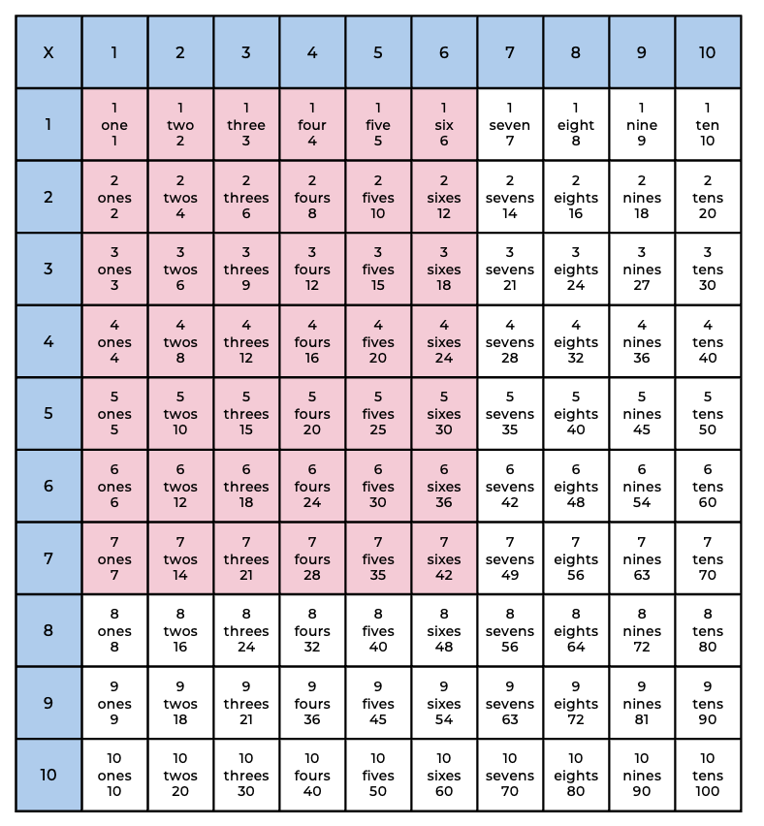

Literacy (language and symbols) for multiplication and division
Mathematical language is not necessary to carry out mathematical processes, vocabulary is fundamental to making and conveying meaning from mathematical texts. Students need the language to describe the various strategies, situations, and properties of multiplicative situations. Comprehending the language of mathematics is important to develop deep understanding.
Mathematics presents unique challenges - including the highly decontextualised way texts are often presented. Students need to make sense of and use mathematical vocabulary to understand multiplication and division. Examples include multiply, times, product, groups of, repeated addition, multiple, factor, division, sharing, divided by, equal groups, repeated subtraction, divisor, dividend, remainder, quotient, multiplier, associative, distributive, commutative, factorise and multiplicand.
‘Non-mathematical’ vocabulary and text choices are also significant in developing numeracy and enabling students to communicate mathematically and can sometimes hinder understanding, for example:
- prepositions
- words that change meaning in different contexts (‘product’ versus ‘product’, ‘take-away versus ‘take-away’)
- lexical density
- the use of abstract diagrams
Multiplicative situations are represented in various ways, for example, using diagrams, concrete materials, visualisations, language, enactments. However, some representations are more powerful than others, often depending upon the context and the knowledge of the ‘reader’ and the ‘author’. The purpose of all representations (concrete, diagrams, photographs or gestures) is to enhance and extend meaning. Teachers and students should analyse and evaluate the effectiveness of representations by providing and responding to effective feedback.
Expose students to various symbols for the operations of division and multiplication. In school ‘$×$’ is typically used to represent multiplication, however, make students aware that mathematicians tend to use ‘.’ or no symbol at all, for example, $4×3$ is represented as 4.3 in some countries and by ab (where a = 4 and b = 3). Statements such as ‘3 hundreds and 4 tens are 340’ imply this way of representing multiplication - what we mean is ‘$3×100 + 4×10 = 340$’.
Often, division is represented as fraction and the obelus symbol (÷) is rarely used outside of school, for example, $12÷3$, is written as $\frac{12}{3}$. Making the connection between division and fractions explicit is vital. In schools, division is also often represented as 3/12, meaning the same as 12 ÷ 3.
Multiplication and division should begin with concrete representations and conceptual understanding before introducing symbols. Design learning activities that allow students to explore, investigate, visualise, reason, and generalise to support understanding. Formal definitions of mathematical operations (for example properties and symbols) can be difficult to make sense of for all learners. Start with investigating and exploring to build a basis of understanding upon which labels and definitions can be co-constructed, added and refined.
Teach operations and procedures in meaningful ways to support learners. Understanding is a requirement of becoming numerate. Understanding and knowing how to apply the various principles are vital in supporting students as flexible, efficient, and critical users of operations and procedures. Concrete materials, language development, meaningful repetition, opportunities to explore and discuss, as well as visual representations all facilitate meaning-making.

Overview of tasks
Task name | What does it promote? | What other tasks can I make connections to? | What materials will I need? | Possible group size
Let’s share to be fair | Supports students to understand an equal share is when each group has the same amount. | Sharing by dealing  Sharing collections  Bunches of balloons | 20 pegs, 20 beads, 5 plates, device to watch video. | Whole class
Sharing collections | Encourages students to explore the different ways we can share the same collection into equal groups. | Sharing by dealing  Let’s share to be fair  Bunches of balloons | 24 objects (pegs or blocks), device to watch video, something to write on/with. | Whole class
Composite unit cards | Encourages students to develop an understanding of multiplication through composite units. | Array bingo  Exploring arrays | Composite unit cards resource, something to write on/with. | Small group/ whole class
Exploring arrays | Using arrays assists students to view rows of items as a countable unit. Exploring array representations in this task may help students move beyond rhythmic and skip counting. | Composite unit cards | Exploring arrays resource, numeral sheet, cover board | Small group
The counting game (by multiples of 5) | Encourages students in using repeated addition and subtraction, moving towards developing efficiency and fluency with multiplicative strategies. |  | Counters, device to watch video, something to write on/with. | Pairs
Bucket count: multiples | Encourages students to see and use composite units as an efficient way to count collections |  | Composite unit cards resource, objects to bundle (pencils, unifix), container. | Small group
How many rectangles? | Encourages students to explore arrays as rectangles and investigate how they may look different but be equivalent in area. |  | 24 square tiles (or square sticky notes), grid paper, device to watch video, something to write on/with. | Whole class
Handfuls – thinking multiplicatively | Encourages students to explore the ‘for each’ idea when solving problems. |  | Collection of items (mini figurines, bears, toy cars, trains or animal figurines), device to watch video, something to write on/with. | Pairs, small group
Sharing by dealing | Supports students using a dealing strategy to consider the magnitude of each ‘share’. Encourages meaning making by connecting sharing to arrays. | Let’s share to be fair  Sharing collections | Counters or materials that can be shared, something to write on/with. | Small group
Array bingo | Encourages students to make connections between visual representation of arrays and the language used to describe them. | Composite unit cards | Set of array cards per pair, a device to watch video. | Pairs
Problem creating | Encourages students to share their thinking and ways of representing when solving written problems. |  | Think board resource, materials (counters, markers or toothpicks). | Pairs
How many arrays? | Encourages students to recognise arranging the same quantity in different arrays doesn’t change the product. |  | Large pile of counters, camera or tool to visually record student arrays. | Pairs
Rolling arrays | Encourages students to use a repeated row structure as a means of measuring area and determining the product. |  | Tiles or counters,  1 – 10-sided dice, something to write on/with. | Pairs
Subitise this | Encourages students to visualise multiplicative situations to aid comprehension and support more efficient strategies. | Imagining dots | Composite unit cards, collection of counters, something to write on/with. | Pairs
Bunches of balloons | Encourages students to explore the different ways we can share the same collection into equal groups. | Sharing by dealing  Let’s share to be fair  Sharing collections | 29 balloons (made of playdough, rocks, paper clips or leaves), device to watch video, something to write on/with. | Whole class/ small group
Imagining dots | Encourages students to visualise and use their mathematical imagination to think multiplicatively. | Subitise this | Dot talk stimulus, device to watch video, something to write on/with. | Whole class
How many bales? | Encourages students to explore what we know to help solve what they don’t know yet. | Handfuls – thinking multiplicatively  For each game | Counters, device to watch videos, something to write on/with. | Whole class/ small group
For each game | Encourages students to use their imagination to explore each idea. | Handfuls – thinking multiplicatively  How many bales? | For each spinner, mini figurines, tokens, device to watch video. | Pairs

Strategies for sharing and forming groups tasks

Let’s share to be fair
Key generalisations/ what’s (some of) the mathematics?
- A collection of objects can be shared by giving them out one at a time.
- An equal share is when groups have the same amount.
- Mathematicians use objects to help them solve mathematical problems and represent their thinking using pictures, numbers and words.
Some observable behaviours you may look for/notice
- shares equally by dealing one by one
- forms equal groups in different ways
- uses various representations to share thinking:
  - concrete materials
  - gestures
  - language
  - virtual manipulatives.
Materials
- 20 pegs and 20 beads (or similar items)
- 5 plates
- A device to watch videos
Instructions
There are 2 parts to this task.
Part 1: Watch the ‘Let’s share to be fair’ – part 1 video and pose the following questions:
- Can you help me share 20 green grapes? Use your 20 beads to help work out how many grapes we will each get?
Part 2: Watch the ‘Let’s share to be fair’ - part 2 video.
- Students place the strawberries (pegs) and grapes (beads) together in one bowl. Students spread out their 5 plates and share them out again. Remind students now we only have 10 strawberries and 20 grapes to share.
- Pose the following questions:
  - How many will we each get now?
  - Is it an equal or fair share? How do you know?

Sharing collections
Key generalisations/ what’s (some of) the mathematics?
- Some collection of objects can be shared equally in different ways, for example, 12 can be shared equally into 4 threes, 3 fours, 2 sixes and 6 twos.
- Some collections of objects can’t be shared equally in some ways, for example, 12 can’t be shared equally into fives because if we made 2 fives, we would have 2 left over, but we don’t have enough to make 3 fives.
- Mathematicians use objects to help them solve mathematical problems and represent their thinking using pictures, numbers and words.
Some observable behaviours you may look for/notice
- shares systematically using groups or multiples. For example, by twos, threes or fours
- shares equally by dealing one by one
- arrives at correct solution by trial and error rather than systematic sharing
- forms equal groups 4 different ways (2 groups of 6, 3 groups of 4, 4 groups of 3 and 6 groups of 2)
- uses various representations to share thinking:
  - concrete materials
  - gestures
  - drawings
  - language
  - diagrams
  - virtual manipulatives
Materials
- 24 objects (pegs or blocks)
- A device to watch videos
- Something to write on/with
Instructions
There are 2 parts to this task:
Part 1: Watch the Sharing collections - part 1 video.
- Ask students in relation to 3 fours and 4 threes.
  - What is the same?
  - What is different?
Part 2: Watch the Sharing collections - part 2 video.
- Pose the following questions to students:
  - How many different ways can we share 24 objects equally?
  - How do we know if we have found all the ways to share 24 objects equally?
  - Is there a way we can keep track to check we have found all the ways?

Exploring arrays
Key generalisations/ what’s (some of) the mathematics?
- Mathematicians can use their imagination and visualise how many dots are missing to help them solve problems.
- We can use the structure of an array to solve how many. We can think about how many in each row and then how many rows we have, for example: “There are 4 rows with 5 dots in each row. We can think of this as 4 fives.”
- We can create/ name groups of units as a composite unit, for example, when we see 5 dots, we can group them together to create a unit of 1 five.

Some observable behaviours you may look for/notice
- recognises and uses five as a composite unit
- uses doubles and doubling strategies
- visualises and skip counts the number of dots covered and may use fingers to keep track of groups/ rows
- visualises and counts by ones the number of dots covered.
Materials
- 10 x 4 array resource (refer to appendix 2)
- Exploring arrays resource variations (refer to appendix 2)
- A4 cardboard piece
Instructions
- Using A4 cardboard, cover a section of the array so only the first row is visible, for example:
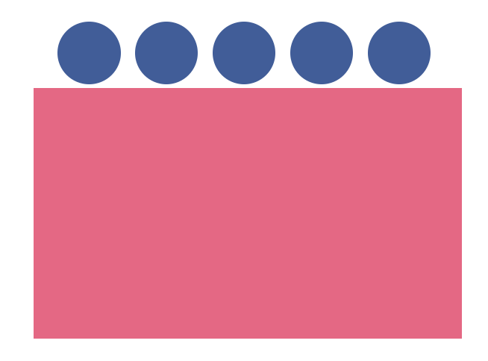
- Ask questions such as `many dots altogether?’
- Briefly show the next two rows of dots and cover again.
- Encourage students to visualise how many dots are missing. Prompt with questions such as;
  - Using your mathematical imagination, how many dots are in the second row?
  - How many in the third row?
  - If we double 2 fives and add one more 5, will that help us work out how many dots in total?
  - Can you visualise any known structures?
- Students work in pairs and repeat the activity. Encourage students to share their thinking and compare strategies used.
- Reveal the full array to check if they were correct. Students determine how many rows and how many in each row and record the equation, for example, 4 fives is equivalent to 20 (where 4 is the multiplier and five is the multiplicand) or 4 x 5 = 20.

Composite unit cards
Key generalisations/ what’s (some of) the mathematics?
- We can create/ name groups of units as a composite unit, for example, when we see 5 dots, we can group them together to create a unit of 1 five.
- Mathematicians use what they know to help them solve what they don’t know yet.
- The same problem can be solved using many strategies, for example, we can use doubling, skip counting and known facts.
- Different people see and think about numbers and problems in different ways.
- Mathematicians check thinking by using an alternative way to solve the problem.
- Mathematicians use various representations to communicate ideas, including recording findings using words, symbols and diagrams.
Some observable behaviours you may look for/notice
- recognises and uses numbers other than one as composite units
- uses a range of strategies to solve problems:
  - uses known facts to solve unknown problems
  - uses doubles and doubling strategies
  - visualises and skip counts the number of dots covered and may use fingers to keep track of groups/ rows
  - visualises and counts by ones the number of dots covered
- uses various representations to share thinking:
  - concrete materials
  - gestures
  - drawings
  - language
  - diagrams
  - virtual manipulatives
- explains their chosen strategies
- refines/ extends thinking after listening to the ideas and strategies of others.
Materials
- Composite unit cards resource (refer to appendix 1)
- Something to write on/with
Instructions
- Show a collection of composite unit cards arranged so one card is visible. Turn the remaining cards face down.
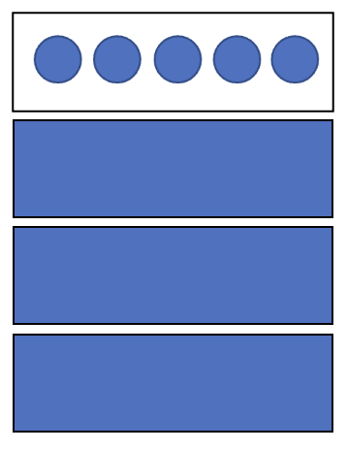
- Explain the first card sets the pattern and shows (in this case) we will be working with ‘fives’, for example, “we can see 5 dots so the unit we are working with is fives.”
- Ask how many fives they can see, including those that are turned over (elicit 4 fives).
- Ask students to think about how they could work out how many dots (visible and concealed) there are in total.
- Encourage students to think of as many ways as possible to work out a solution
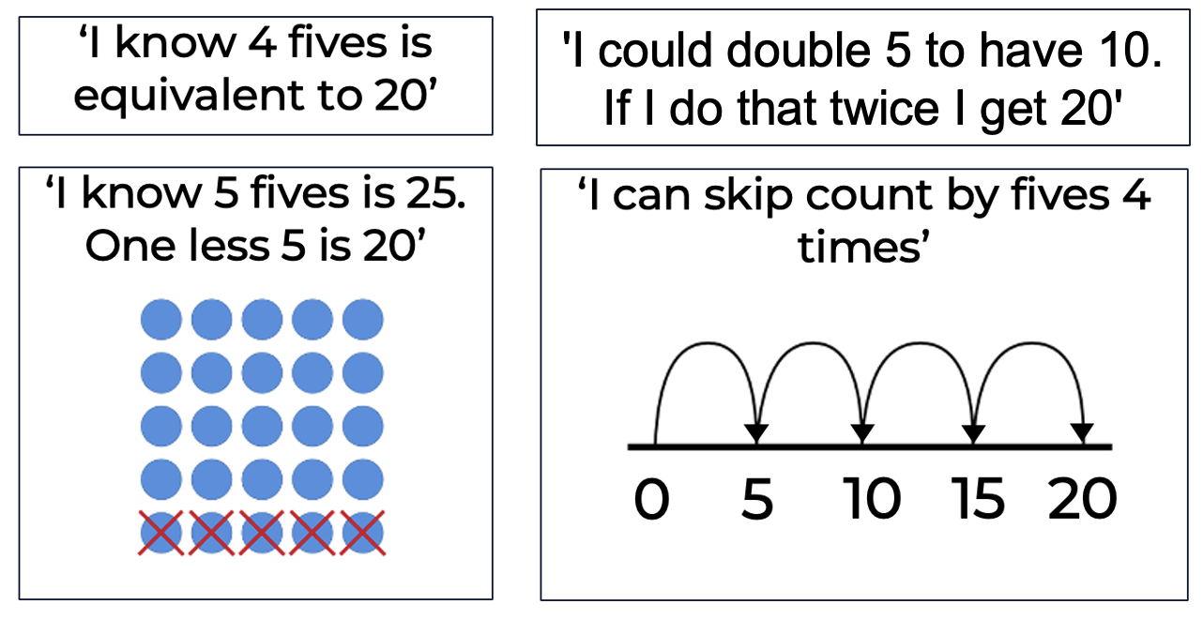

Teaching point: Use think-alouds and various representations to add on to the ideas offered by the students. Students may not yet be able to recall facts or know about and use various strategies efficiently. Thinking aloud allows you to share the flexibility with which students could approach multiplication and division problems.
Ask questions such as:
- How many dots would there be if we had 1 more ‘five’?
- We know 4 fives is the same as 20 in total, so does that mean 5 fives must be 25 because it is 1 five more?
- What does the 4 tell us? Why is it important?
- What does the ‘five’ tell us? Why is that important?
- How many dots would there be if we had 2 more 'fives'?
- How many dots would there be if we had 1 less 'five'?
- What if we had 4 fives? Use a Think board (refer to Appendix 3) to create a context for 4 fives.
Variations
- Use different sized units.
- Start by showing more cards where the unit is visible
- Start by showing all the composite unit cards, determining the total and then remove some, asking students to determine the new product. How many units were removed? How many dots were removed?
- Screen the cards and flash to students as a subitising activity.

The counting game (by multiples of 5)
Key generalisations/ what’s (some of) the mathematics?
- We can find patterns in counting sequences, for example, when we count in twos, each time we say the next number word, the quantity increases by two. This sort of pattern is called a growing pattern. If we were to count backwards, we would have a shrinking pattern.
- Mathematicians strategise by using their knowledge of numbers and patterns to improve their chances of winning a game.
- We can count in composite units. Counting in composite units helps us be more efficient. We say less number words.
Some observable behaviours you may look for/notice
- recognises and uses numbers other than one as composite units
- uses skip counting and may use fingers to keep track of groups
- uses rhythmic counting
- explains their chosen strategies
- refines/ extends thinking after listening to the ideas and strategies of others.
Materials
- Counters
- A device to watch video
- Something to write on/with

Instructions
Watch The counting game: multiples video to learn how to play.
How to play
- In pairs, students select a target number, for example, 85 and a unit value for example, fives.
- The goal is to be the student who says the target number.
- Students can count on by saying the next 1, 2 or 3 number words in the fives sequence, for example, for a target number 85
Student A: 5, 10, 15
Student B: 20, 25, 30
Student A: 35, 40
Student B: 45, 50, 55
Student A: 60, 65
Student B: 70
Student A: 75, 80, 85
- The winning student collects a counter when they say the target number.
- A new target number is chosen and students play again. The student who collects the most counters after an agreed number of rounds is the winner.
- Ask students to explore if there is a way to play the game so they never lose.
Variations
- Start from a given number and count back, the winner is the student who says zero.
- Count within a range, for example, starting at 81 and countdown to 50.
- Vary the amount of number words.

Bucket count: multiples
Key generalisations/ what’s (some of) the mathematics?
- We can find patterns in counting sequences, for example, when we count in twos, each time we say the next number word, the quantity increases by two. This sort of pattern is called a growing pattern. If we were to count backwards, we would have a shrinking pattern.
- We can count in composite units which helps us be more efficient when we count collections as we say less number words.
- Mathematicians use what they observe and notice to help them solve problems.
Some observable behaviours you may look for/notice
- recognises and uses numbers other than one as composite units
- uses skip counting and may use fingers to keep track of groups
- uses rhythmic counting
- identify and describe patterns when skip counting.
Materials
- Composite unit cards resource (refer to Appendix 1)
- Objects to bundle such as pencils or unifix cubes
- Container
Instructions
- Using composite unit cards or small units already grouped (such as packets of pencils or unifix cubes) establish a starting quantity and the size of the units, for example, counting by 2s and starting from 4 twos (8).
- Ask students to count aloud as each composite unit (‘two’) is added to the container.
- Record the number words spoken and ask students to consider what mathematical observations they notice and wonder, for example, ‘I noticed all the numbers end in 0, 2, 4, 6, or 8 when counting by twos. I wonder if this is the same if we started counting from a different number?’
Variations
- Start with a nominated amount inside the bucket and count backwards by composite units as each is removed.
- If using composite unit cards, take them out of the bucket at the end and build into an array to check the total count, for example, if you counted by fives 9 times, we should have an array showing 9 fives. Check by counting the number of rows (9) and the number in each row (5).

How many rectangles
Key generalisations/ what’s (some of) the mathematics?
- Arrays help us see the different ways we can arrange collections, for example, a collection of 12 can be arranged in an array as 2 sixes, 6 twos, 3 fours and 4 threes.
- A rectangle can look different but be equivalent in area.
- Mathematicians see and think about numbers and problems in different ways.
Some observable behaviours you may look for/notice
- recognises and uses numbers other than one as composite units
- uses a range of strategies to solve problems:
  - uses known facts to solve unknown problems
  - uses doubles and doubling strategies, for example double and one more
  - uses skip counting and may use fingers to keep track of rows
- uses various representations to share thinking:
  - concrete materials
  - gestures
  - drawings
  - language
  - diagrams
  - virtual manipulatives
- explains how and why area remains constant when units are rearranged, representing the same total in multiple arrangements
- recognises and uses arrays to model the commutative property of multiplication.
Materials
- 24 square tiles (or square sticky notes)
- Grid paper
- A device to watch videos
- Something to write on/with
Instructions
There are 3 parts to this task.
Part 1: Watch the How many rectangles? - part 1 video and pose the following questions:
- What is the same about these two rectangles?
- What is different about these two rectangles?
- What are you wondering?
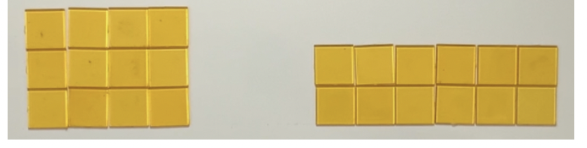
- Can you make another rectangle that uses 12 squares?
Part 2: Watch the How many rectangles? - part 2 video and pose the following questions:
- How many different rectangles can you make?
- How will you know when you have found them all?
Part 3: Watch the How many rectangles? - part 3 video and pose the following question:
- Are there multiple ways to make rectangles with 24 squares?
- What about 18 squares?

Handfuls - thinking multiplicatively
Key generalisations/ what’s (some of) the mathematics?
- We can think about the 'for each' idea when dealing with quantities within quantities.
- We can use number facts we know to help us to estimate and solve problems we don’t know yet.
- Mathematicians think strategically when they solve problems, looking for what they already know and deciding how to use that knowledge.
- We can use our mathematical imagination and spatial structures such as dice patterns and ten-frames to support quantifying collections efficiently and seeing quantities within quantities.
Some observable behaviours you may look for/notice
- recognises and uses numbers other than one as composite units
- uses a range of strategies to solve problems:
  - uses known facts to solve unknown problems
  - uses doubles and doubling strategies
  - visualises and uses spatial structures
  - uses skip or rhythmic counting
- makes reasonable estimates
- uses various representations to share thinking:
  - concrete materials
  - gestures
  - drawings
  - language
  - diagrams
  - virtual manipulatives
- explains their chosen arrangements
- refines/ extends thinking after listening to the ideas and strategies of others.
Materials
- Collection of the same items such as bears, connecting brick mini figurines or an alternative like toy cars, trains, or animal figurines
- A device to watch video
- Something to write on/with
Instructions
Watch the Handfuls – Thinking multiplicatively video to learn how to play.
How to play
- Students take a handful of their item.
- While holding the objects in their hand, imagine how many they have and use this to determine if for each figurine there are 2 eyes, 2 legs, 4 paws, 4 wheels and so on, how many are there in total?
- Students record their estimate.
- Students then organise their collection so someone else can determine how many by looking and thinking.

Sharing by dealing
Key generalisations/ what’s (some of) the mathematics?
- Some collections of objects can be shared equally. For example, 15 can be shared equally into 3 fives.
- We can share by dealing and use composite units to be more efficient.
- Mathematicians use tools such as counters/ concrete materials to represent their thinking.
- We can use tools such as number lines to helps us keep track of our thinking. For example, we can record how many there are in each group and how many there are still left to be shared.
- Mathematicians can use colour strategically to help them represent their thinking.
- We can represent the same thinking in many of different ways. For example, we can use materials such as counters to create equal groups and also record this on a number line.
- Mathematicians make connections between representations to support meaning making.
Some observable behaviours you may look for/notice
- shares systematically using groups or multiples. For example, by twos, threes or fours.
- shares equally by dealing one by one
- arrives at correct solution by trial and error rather than systematic sharing
- forms equal groups in 4 different ways (2 groups of 6, 3 groups of 4, 4 groups of 3 and 6 groups of 2)
- uses various representations to share thinking:
  - concrete materials
  - gestures
  - drawings
  - language
  - diagrams
  - virtual manipulatives
Materials
- Counters or a group of the same item that can be shared
- Something to write on/with

Instructions
- Provide students with a problem where they share 15 items (biscuits, for example) between 3 people and model the situation using manipulatives.
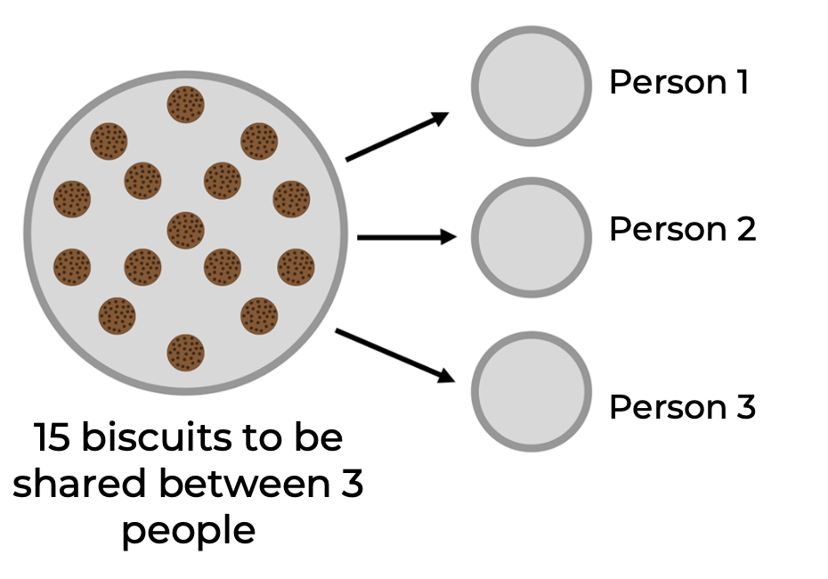
- Model how to share one item from the total to each person, recording how many there are in total and in each group (each person). “Each person has one biscuit. There are 12 left to be shared.
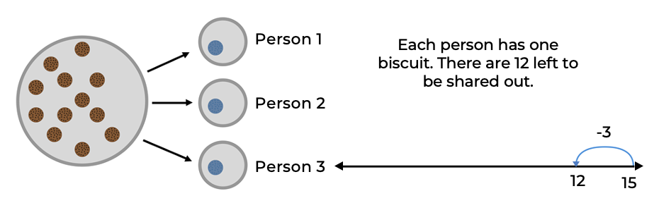
- Record how many there are in each group and how many there are still left to be shared, explaining your thinking out aloud, for example, ‘There are 3 groups and so far, there is 1 in each group. That means there are now 3 less than 15 which is 12.’
- Continue demonstrating how to share and reason using think alouds, for example, ‘I know I can share out another group of 3 since 12 is more than 3. 2 threes equal 6 which is also less than 12 so I could share out 2 threes this time. I am going to try that.’
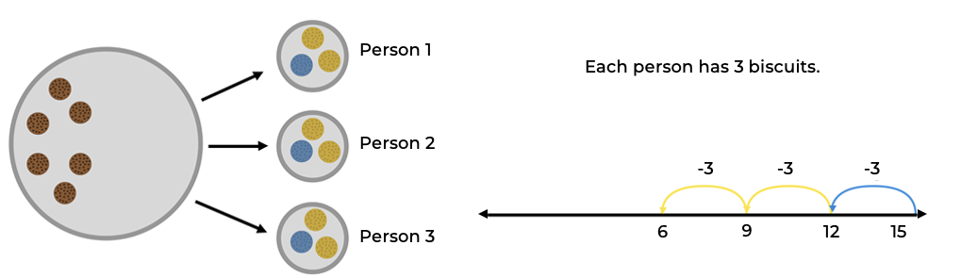
- Now I have 3 threes. I had 12 to share out and I removed 2 threes, leaving me with 6 to go. 6 is the same as 2 threes so that means I will end up with 5 threes once I’ve shared everything out. Here is this thinking on a number line, and I can share the 2 threes out to check.
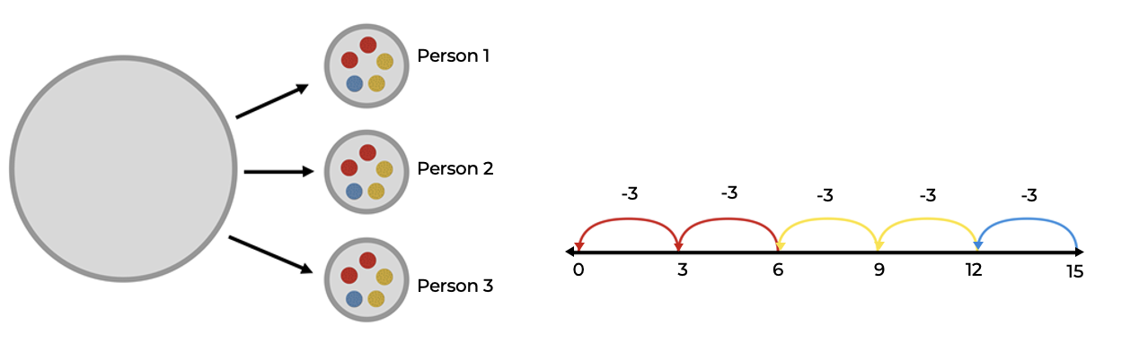

- ‘So, I had 15 to start with and shared them into 3 fives. As I shared out each collection of three, it was like subtracting from my starting collection. I could rearrange my collections now into an array to show 5 rows of 3. The 5 rows will represent each person who got some of the biscuits. The amount in each row will be 3 which shows how many biscuits each person got.’
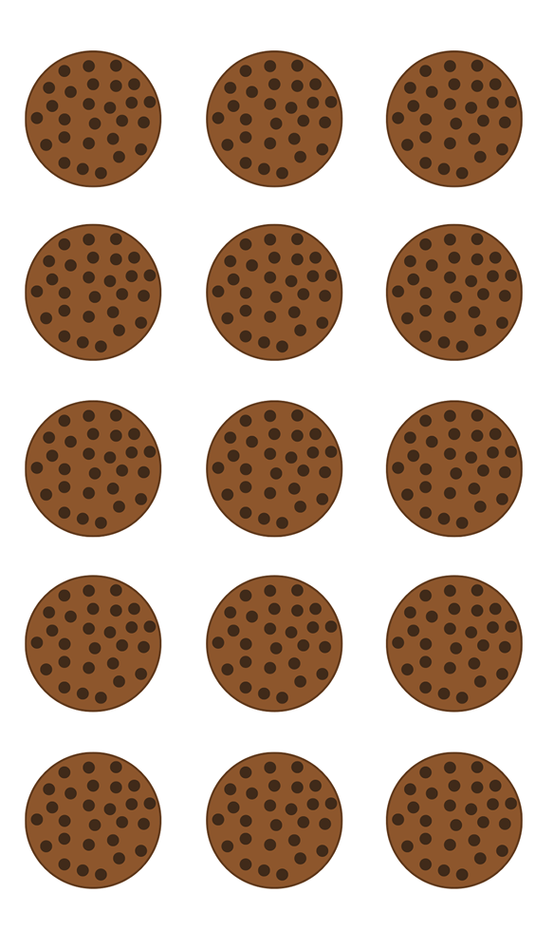
Teaching point: Support students using a dealing strategy to consider the magnitude of each ‘share’, whether it needs to be by 1s or whether they could consider sharing in a larger unit, adjusting as they revaluate how many are left to share.
Variations
- Use sharing mats.
- Repeat for other questions.
- Use multiplication to check solutions.

Array bingo
Key generalisations/ what’s (some of) the mathematics?
- Games provide us with an opportunity to practise our mathematical skills and understanding. We can use what we know about arrays to match cards, for example, turning over 3 tens means we need to match an array that has 3 rows with ten in each row.
- We can use the commutative property to think strategically and flexibly about array structures, for example, when we rotate 3 twos and name it 2 threes.
- We can use our knowledge of spatial patterns to quantify the number of rows.
Some observable behaviours you may look for/notice
- recognises and uses numbers other than one as composite units
- recognises and uses arrays to model the commutative property of multiplication.
- uses a range of strategies to solve problems:
  - uses known facts to solve unknown problems
  - uses doubles and doubling strategies
  - visualises and uses spatial structures
  - uses skip or rhythmic counting
- uses various representations to share thinking:
  - language
  - diagrams
- explains their chosen strategies
Materials
- A set of array cards (includes array structures and descriptor cards) per pair (refer to Appendix 2)
- A device to watch video
Instructions
Watch the Array bingo video.
How to play:
- Each student creates a gameboard using 6 array cards. Set aside the remaining array cards.
- Place the descriptor cards in a pile, face down.
- Turn over a descriptor card. If a student has the matching array card on their gameboard, they may turn the array card over.
- If both students have the matching array card, they can both turn over their cards.
- If neither student has the matching array card, turn over the next descriptor card in the pile.
- Use the commutative property to rotate the arrays, to make a match, for example, take an array structured as 3 twos and rotate it to show 2 threes.
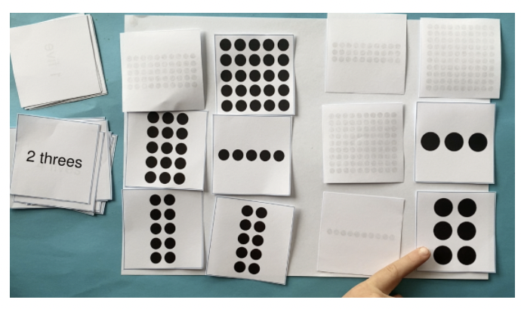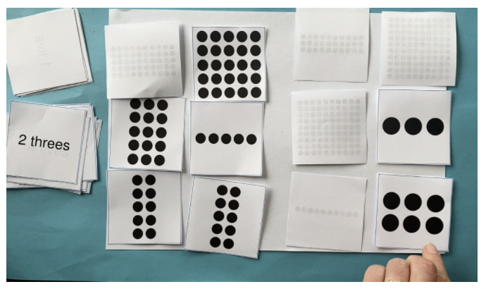
- The winner is the first student to turn over all their cards and say ‘bingo!’
Variation
- Swap how the piles of cards are used in the game. Make a gameboard from the descriptor cards and turn over the array cards.
Possible discussion questions
- What arrays did you rotate to make a match?
- Did rotating the arrays change the total number of dots? Why/why not?
- What strategies did you use to determine how many dots there are in the arrays?
- Were there any arrays where you knew how many dots there were? Which ones and why?

Problem creating
Key generalisations/ what’s (some of) the mathematics?
- When creating and solving problems we can represent our thinking using words, pictures, manipulatives and numbers.
- Listening to other people’s thinking helps us become aware of other strategies, building our knowledge of mathematics.
- Mathematicians compare their strategies with the thinking of others.
Some observable behaviours you may look for/notice
- uses a range of strategies to solve problems:
  - uses known facts to solve unknown problems
  - uses doubles and doubling strategies
  - counts items using rhythmic or skip counting
  - visualises and skip counts the number of dots and may use fingers to keep track of groups/ rows
  - visualises and counts by ones the number of dots
- uses various representations to share thinking:
  - manipulatives
  - gestures
  - drawings
  - language
  - diagrams
  - virtual manipulatives
- explains their chosen strategies
- refines/ extends thinking after listening to the ideas and strategies of others.
Materials
- Think board resource (refer to Appendix 3)
- Objects such as counters, toothpicks or markers
- Something to write on/with
Instructions
- Use the following problems or students create simple multiplicative problems, for example:
  - Ruby can fit 3 cars into each box. How many cars does she need to fill 5 boxes?
  - There are 4 students. Each has 3 sandwiches for lunch. How many sandwiches are there altogether?
  - One car has four wheels, how many wheels do 6 cars have?
  - If each student has half a muffin, how many muffins are needed for 3 students?
  - The number of elbows in the room is 46. How many people are here?
  - The 10 members of the cricket team each hit 5 practice balls. How many balls did they hit each?
  - How many cakes were eaten if 6 people ate 2 each?
  - How many collector cards were there altogether if Sam and Joss had 9 each?
  - Five students each have 6 pencils. How many altogether?
- Students work in pairs to discuss and represent their multiplicative situation using Think boards.
Teaching points: Use Think boards to support students in representing their understanding of and strategies used to solve the same problem in various ways. Support students to make connections between the varying representations and mathematical concepts.
Support students to solve problems with manipulatives and record their thinking using diagrams and mathematical language. Explicitly draw out how to solve different situations (partition and quotient division, for example) using the same operation (see teaching considerations above).

How many arrays?
Key generalisations/ what’s (some of) the mathematics?
- We can arrange the same quantity into different arrays and the product remains the same/ unchanged, for example:
  - 20 can be arranged into an array of 2 tens, 5 fours, 10 twos and 4 fives.
- Collections of objects can look different but have the same quantity.
- When we describe an array, we attend to how many rows and how many in each row.
- Some collections of objects cannot be shared equally in some ways, for example, 20 cannot be shared equally into threes because if we made 6 threes, we would have 2 left over.
Some observable behaviours you may look for/notice
- recognises and uses numbers other than one as composite units
- uses a range of strategies to solve problems:
  - uses known facts to solve unknown problems
  - uses doubles and doubling strategies, for example double and one more
  - uses skip counting and may use fingers to keep track of rows
- uses various representations to share thinking:
  - concrete materials
  - gestures
  - drawings
  - language
  - diagrams
  - virtual manipulatives
- explains how and why the product remains constant when units are rearranged, representing the same total in multiple arrangements
- explains the idea of a remainder as what is ‘left over’ or as an incomplete row or multiple, when collections cannot be shared equally
- recognises and uses arrays to model the commutative property of multiplication.
Materials
- Counters
- Camera or tool to record student arrays visually
Instructions
- Provide pairs with a large pile of counters and explain they are going to investigate how many different arrays they can make that have a total of 20 (for example).
- Investigate how to make rows of 1, discussing how the array could be described and how we could work out the total number of counters.
- Continue investigating arrays for 20, taking photos and documenting the arrays made. Each time students construct an array they should use a new collection of 20 counters.
- Have students describe each array they can construct as well as the situations when an array could not be made using the photos of student arrays with the whole class.
Teaching points: Support students in recognising the rearrangement of objects does not change the product. Pay careful attention to how students deal with remainders.

Rolling arrays
Key generalisations/ what’s (some of) the mathematics?
- We can use the structure of an array to solve how many. We can think about how many in each row and then how many rows we have. There are 6 rows with 4 dots in each row. We can think of this as 6 fours.
- We can use various strategies to solve the same problem such as:
  - visualising
  - estimating
  - counting in multiples
  - using known facts.
- We can use estimation.
- Mathematicians use what they know to help them solve what they don’t know yet, for example, I don’t know 6 fours, but I know 6 twos is 12 and double 12 is 24.

Some observable behaviours you may look for/notice
- recognises and uses numbers other than one as composite units
- determine and distinguish between the number of rows/columns and the number in each row/column when describing and forming arrays
- uses a range of strategies to solve problems:
  - uses known facts to solve unknown problems
  - uses doubles and doubling strategies
  - visualises and skip counts the number of dots and may use fingers to keep track of groups/ rows
  - visualises and counts by ones the number of dots
- uses various representations to share thinking:
  - concrete materials
  - gestures
  - drawings
  - language
  - diagrams
  - virtual manipulatives
- explains their chosen strategies
- refines/ extends thinking after listening to the ideas and strategies of others.
Materials
- Counters
- 1 - 10-sided dice
- Something to write on/with
Instructions
- Students roll the 1-10 dice and collect the corresponding number of counters to form a row.
- Students then roll the dice a second time to indicate the number of rows.
- Encourage students to work out the product before completing the array, estimating, counting in multiples or applying known facts, for example, ‘I rolled 6 and 4, I would organise my thinking like this:
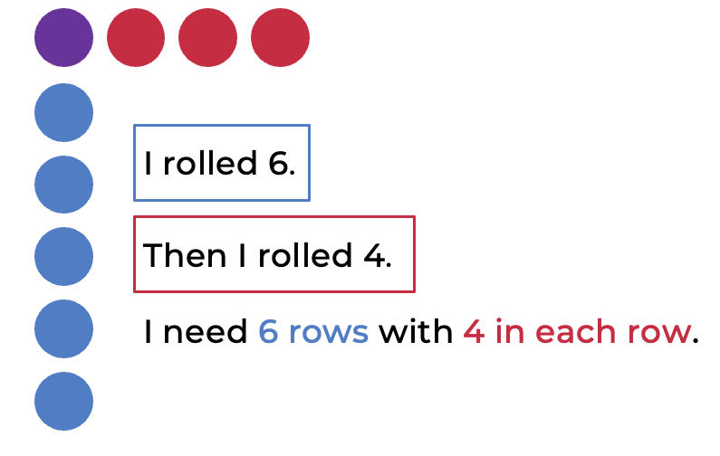
‘I don’t know 6 fours, but I know 3 fours is 12 and double 12 is 24 so I think the product is 24.’
- Discuss the intentionality of the overlap of colour with the counter attending to the first counter representing one of four in the row and one of 6 rows.
Variation
- Have students make different equal rows from the one handful of counters and record the combinations.
Teaching point: Observe the strategies students use to find the total number of tiles needed. Visualising a collection in a particular arrangement and picturing the number of hidden dots should be regular practices to enable strong mental images students can later use.

Subitise this
Key generalisations/ what’s (some of) the mathematics?
- We can use the structure of an array to solve how many. We can think about how many in each row and then how many rows we have.
- We can use our knowledge of spatial patterns to quantify the number of rows and the number in each row.
- Mathematicians share their thinking so it makes sense to others.
- Mathematicians compare their strategies with the thinking of others.
Some observable behaviours you may look for/notice
- recognises and uses numbers other than one as composite units
- uses spatial structures such as dice and domino patterns, five and ten frames to determine and distinguish between the number of rows/columns and the number in each row/column when describing arrays
- uses a range of strategies to solve problems:
  - uses known facts to solve unknown problems
  - uses doubles and doubling strategies
  - visualises and skip counts the number of dots and may use fingers to keep track of groups/ rows
  - visualises and counts by ones the number of dots
- explains their chosen strategies
- refines/ extends thinking after listening to the ideas and strategies of others.
Materials
- Composite unit cards resource (refer to Appendix 1)
- Collection of counters
- Something to write on/with
Instructions
- Create an array using composite unit cards hidden from view.
- Say ‘I am going to quickly show you an array. You need to note how many rows and how many in each row’.
- Show the array for 3 seconds.
- Ask students to describe what they think they saw to a thinking partner.
- Show the array for 3 seconds again and ask students to individually make the arrangement they saw using counters.
- Students share their thinking in pairs, describing the situation rather than focusing on how many, for example, ‘I saw twos and there were 4 of them.’ Or ‘I saw 4 rows and there were two in each row.’
- Check by comparing their arrangement to the composite unit card and give students the opportunity to revise their thinking.
- Students determine the total and share strategies to discuss the most efficient way possible.
Variations
- Students draw what they saw.
- Use alternative stimulus material such as playing cards for example 3 sixes, ten-frames or images of groups
Teaching point: At this level of learning, we are not looking for students to be able to subitise the product but be able to describe the situation, focusing on salient information including the number of rows and the size of each unit. Visualising multiplicative situations is an important tool to aid comprehension and support more efficient strategies.

Bunches of balloons
From reSolve
Key generalisations/ what’s (some of) the mathematics?
- Mathematicians can use trial and error to solve problems.
- Not all numbers can be shared equally into groups, for example, 29 cannot be shared equally into bunches, groups or rows. Even if you try many ways there is always ‘left overs’.
- Arrays help us see the different ways we can arrange collections and how many are left over each time.
Some observable behaviours you may look for/notice
- recognises and uses numbers other than one as composite units
- uses a range of strategies to solve problems:
  - uses known facts to solve unknown problems
  - uses doubles and doubling strategies, for example double and one more
  - uses skip counting and may use fingers to keep track
- uses various representations to share thinking:
  - concrete materials
  - gestures
  - drawings
  - language
  - diagrams
  - virtual manipulatives
- explains how and why the total remains the same/ unchanged when units are rearranged, representing the same total in multiple arrangements
- explains the idea of a remainder as what is ‘left over’ or as an incomplete row or multiple, when collections cannot be shared equally.
Materials
- 29 balloon shapes (made from playdough, rocks, paper clips, leaves, for example)
- A device to watch videos
- Something to write on/with

Instructions
There are 2 parts to this task:
Part 1: Watch the Bunches of balloons – part 1 video.
- Using 29 balloons, students explore putting a different number of balloons into equal groups and see if they can do this without any leftovers.
Part 2: Watch the Bunches of balloons – part 2 video.
- Students record their findings using an array to clearly show any leftovers.
- Ask “How many equal groupings can we find if we have 30 balloons?”

Imagining dots
Key generalisations/ what’s (some of) the mathematics?
- Mathematicians can use their imaginations to help them draw representations.
- Listening to other people’s thinking helps us become aware of other strategies, building our knowledge of mathematics.
Some observable behaviours you may look for/notice
- recognises and uses numbers other than one as composite units
- uses spatial structures such as dice and domino patterns to determine and distinguish between the number of rows/columns and the number in each row/column when describing arrays
- uses a range of strategies to solve problems:
  - uses known facts to solve unknown problems
  - uses doubles and doubling strategies
  - visualises and skip counts the number of dots and may use fingers to keep track of groups/rows
  - visualises and counts by ones the number of dots
- explains their chosen strategies
- refines/ extends thinking after listening to the ideas and strategies of others.
Materials
- Dot talk stimulus (refer to Appendix 4)
- A device to watch videos
- Something to write on/with
Instructions
There are 2 parts to this task
Part 1: Watch the Imagining dots - part 1 video.
- Encourage students to imagine how they see the dots arranged.
Part 2: Watch the Imagining dots - part 2 video.
- After watching, students use their imagination to draw a picture of how they saw the dots.
- Students may like to draw pictures to show some of the different ways they saw the dots.

How many bales?
From Dianne Siemon, RMIT University.
Key generalisations/ what’s (some of) the mathematics?
- We can think about 'for each' ideas by using knowledge such as skip counting, counting by ones, known facts, and imagining structures like ten frames.
- Mathematicians can use many different ways to solve the same problem.
- We can use what we know to help us solve what we don’t know yet, for example, we can use known counting sequences and familiar spatial structures and patterns to solve problems.
Some observable behaviours you may look for/notice
- recognises and uses numbers other than one as composite units
- uses a range of strategies to solve problems:
  - uses known facts to solve unknown problems
  - uses doubles and doubling strategies
  - visualises and uses spatial structures
  - uses skip or rhythmic counting
- uses various representations to share thinking:
  - concrete materials
  - gestures
  - drawings
  - language
  - diagrams
  - virtual manipulatives
- explains their strategies
- solves a problem in multiple ways
- refines/ extends thinking after listening to the ideas and strategies of others.
Materials
- Counters
- A device to watch videos
- Something to write on/with
Instructions
There are 2 parts to this task.
Part 1: Watch the How many bales? - part 1 video. Allow time to solve the problem.
Part 2: Watch the How many bales? - part 2 video.
- In pairs explore different ways to solve: If there were 5 sheep, how many bales of wool?
- Encourage students to use the 3 different strategies from the video to solve this new problem. ‘If each of the 5 sheep made 4 bales of wool, how many bales would there be in total?’

For each game
From Ann Gervasoni
Key generalisations/ what’s (some of) the mathematics?
- Mathematicians can use their imaginations to help them solve problems. Being able to imagine quantities helps us work with numbers with greater flexibility and confidence.
- By using different equipment like the figurines and bears, we can enhance our understanding of working with multiplicative situations.
- We can think about 'for each' ideas by using knowledge such as skip counting, counting by ones, known facts, and imagining structures like ten frames.
Some observable behaviours you may look for/notice
- recognises and uses numbers other than one as composite units
- uses a range of strategies to solve problems:
  - uses known facts to solve unknown problems
  - uses doubles and doubling strategies
  - visualises and uses spatial structures
  - uses skip or rhythmic counting
- explains their strategies
- refines/ extends thinking after listening to the ideas and strategies of others.
Materials
- For each spinner (refer to Appendix 5)
- Mini figurines
- Objects for tokens
- A device to watch video
Instructions
Watch For each game video to learn how to play.
- Students spin the spinner to determine how many legs they need in total.
- Students imagine and then collect the number of figurines they need to make that many legs.
- The student with the most figurines each round wins a token.
- The first student to win 5 tokens wins the game.

Appendix 1: Composite unit cards resource

Fives

Twos

Threes

Tens

Appendix 2: Exploring arrays resource

10 x 4 array

10 x 3

4 x 5

3 x 5

Appendix 3: Think board
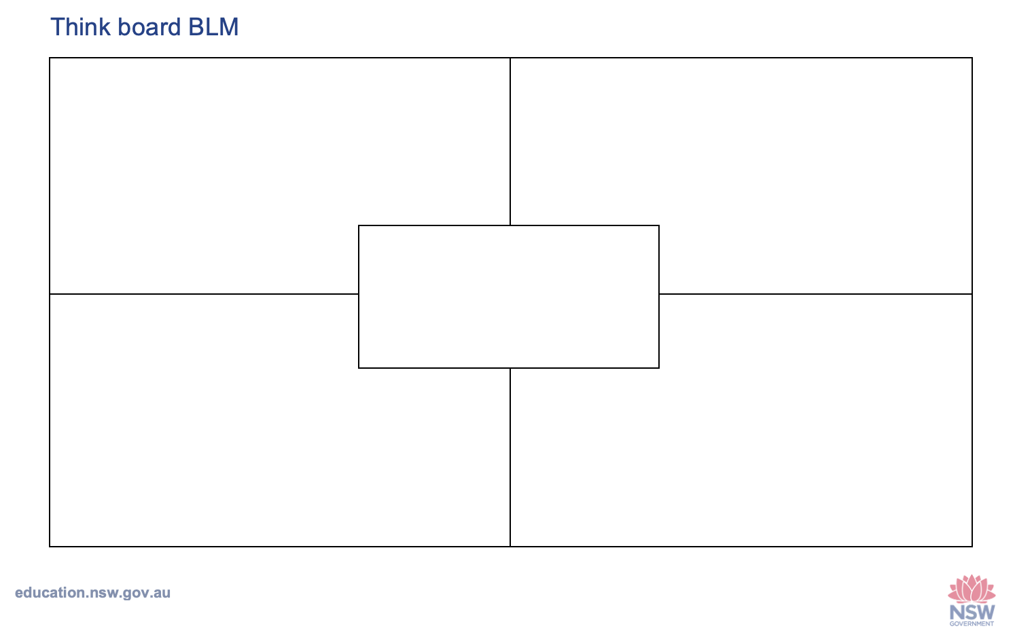

Appendix 4: Imagining dots

Dot talk stimulus
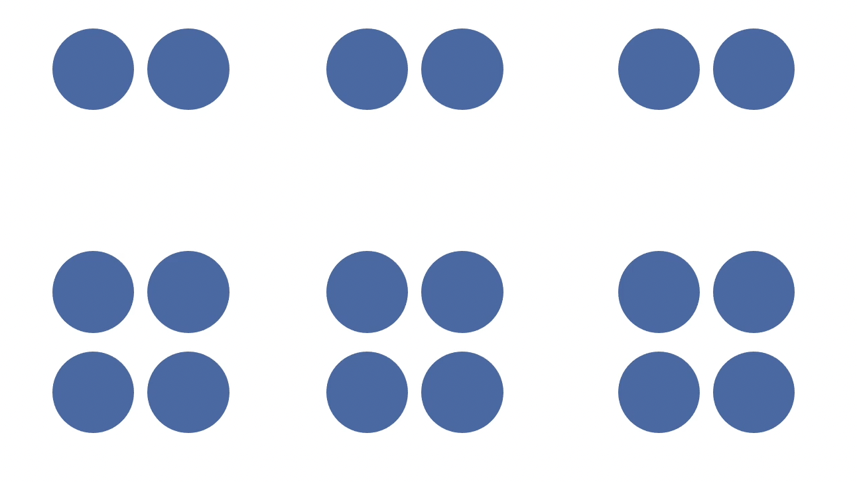

Appendix 5: For each spinner
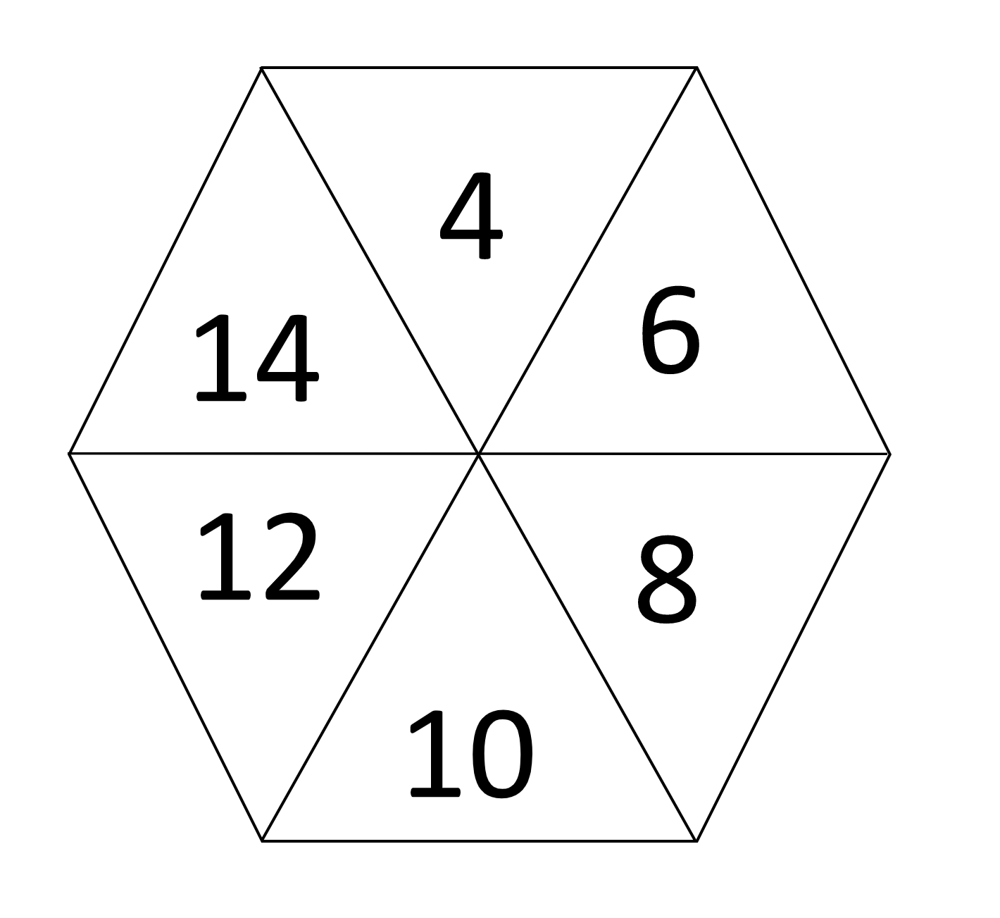

Copyright
Section 113P Notice
Texts, Artistic Works and Broadcast Notice
Some of this material has been copied and communicated to you in accordance with the statutory licence in section 113P of the Copyright Act. Any further reproduction or communication of this material by you may be the subject of copyright protection under the Act. Do not remove this notice.

Evidence base
Sparrow, L., Booker, G., Swan, P., Bond, D. (2015). Teaching Primary Mathematics. Australia: Pearson Australia.
Brady, K., Faragher, R., Clark, J., Beswick, K., Warren, E., Siemon, D. (2015). Teaching Mathematics: Foundations to Middle Years. Australia: Oxford University Press.
Alignment to system priorities and/or needs: The literacy and numeracy five priorities.
Alignment to School Excellence Framework: Learning domain: Curriculum, Teaching domain: Effective classroom practice and Professional standards
Consulted with: NSW Mathematics Strategy professional learning and Curriculum Early Years Primary Learners-Mathematics teams
Reviewed by: Literacy and Numeracy
Created/last updated: January 2024
Anticipated resource review date: January 2025
Feedback: Complete the online form to provide any feedback.

