Part 2: Flexible strategies with single-digit numbers

About the resource
This resource is the second section of a 4-part resource supporting multiplicative thinking.
- Part 1: Strategies for sharing and forming equal groups
- Part 2: Flexible strategies with single-digit numbers
- Part 3: Flexible strategies with multi-digit numbers
- Part 4: Flexible strategies with rational numbers
Like most concepts in mathematics, talking about multiplicative thinking is difficult without referring to other aspects of mathematics such as patterning, subitising (and visual recognition), counting (with understanding), number sense, measurement and statistics. This resource is best used in conjunction with other guides to support a connected network of critical mathematical concepts, skills and understanding. Student understanding about how numbers and operations work is a critical part of developing deep, meaningful mathematical skills, understanding and confidence.
Continued learning of pattern and structures, number knowledge (including place value understanding) and counting (with understanding) is vital in supporting continued development of number sense. Students should also be supported in developing rich, meaningful understanding of how the operations work to support their skills in working flexibly with numbers. Provide students with opportunities to compare strategies and contexts, explore situations when particular strategies are efficient and when they are not as efficient. Remember, efficiency is connected to the confidence and knowledge of individuals. Building representational fluency is important in supporting meaning-making about the operations and how numbers work.
Students at this stage of learning need targeted teaching that includes problem solving, exploring how strategies work, deepening conceptual understanding and meaningful, low-stress practice. This enhances and solidifies understanding and confidence in choosing and using various flexible strategies in increasingly complex contexts. Validate the different strategies students invent and use, using individual thinking to cultivate a culture of communication, thinking and reasoning.
The resource has been developed in partnership with the NSW Mathematics Strategy Professional Learning team, Curriculum Early Years and Primary Learners, and Literacy and Numeracy.

How to use the resource
Use assessment information to make decisions about when and how you use this resource as you design teaching and learning sequences to meet the learning needs of your students.
The tasks and information in the resource includes explicit teaching, high expectations, effective feedback and assessment and can be embedded in the teaching and learning cycle.
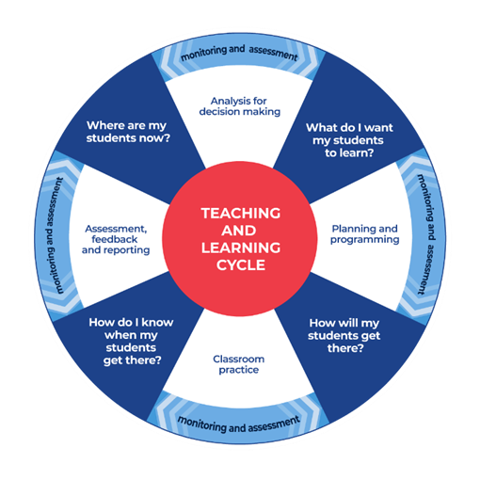
Figure 1: Teaching and learning cycle
Where are my students now? Use a range of assessment information to determine what students know and can do, including their interests, learning strengths and needs.
What do I want my students to learn? Use the information gathered along with the syllabus and National Numeracy Learning Progression to determine the next steps for learning. You might also like to look at the ‘what’s some of the maths’ and ‘key generalisations’ to synthesise the information you have gathered into the next step/s for learning.
How will my students get there? Use the task overview information (‘What does it promote?’ and ‘What other tasks can I make connections to?’) to find tasks that meet the learning needs of students. Make decisions about what instructional practices and lesson structures to use to best support student learning. Further support with What works best in practice is available.
How do I know when my students get there? Use the section ‘Some observable behaviours you may look for/notice’ for each task as a springboard for what to look for. These ideas can be used to co-construct success criteria and modified to suit the learning needs, abilities and interests of students. Referring to the syllabus and the National Numeracy Learning Progression are also helpful in determining student learning progress as well as monitoring student thinking during the task. The information gained will inform ‘where are my students now’ and ‘what do I want them to learn’ as part of the iterative nature of the teaching and learning cycle.

Syllabus
MAO-WM-01 develops understanding and fluency in mathematics through exploring and connecting mathematical concepts, choosing and applying mathematical techniques to solve problems, and communicating their thinking and reasoning coherently and clearly
MAE-RWN-01 demonstrates an understanding of how whole numbers indicate quantity
MAE-RWN-02 reads numerals and represents whole numbers to at least 20
MAE-FG-02 forms equal groups by sharing and counting collections of objects
MA1-RWN-01 applies an understanding of place value and the role of zero to read, write and order two- and three-digit numbers
MA1-RWN-02 reasons about representations of whole numbers to 1000, partitioning numbers to use and record quantity values
MA1-FG-01 uses the structure of equal groups to solve multiplication problems, and shares or groups to solve division problems
MA1-GM-03 creates and recognises halves, quarters and eighths as part measures of a whole length
MA2-MR-01 represents and uses the structure of multiplicative relations to 10 × 10 to solve problems
MA2-PF-01 represents and compares halves, quarters, thirds and fifths as lengths on a number line and their related fractions formed by halving (eighths, sixths and tenths)
NSW Mathematics K-10 Syllabus (2022)

Progression
Number and place value NPV2-NPV5
Counting processes CPr1-CPr7
Multiplicative thinking MuS1-MuS6
Interpreting fractions InF1-InF2
Understanding units of measure UuM1-UuM2
National Numeracy Learning Progression Version 3

Overview of tasks
Task name | What does it promote? | What materials will I need? | Possible group size
Sharing cupcakes | Encourages students to experience and understand the different contexts for division. This sharing problem includes a situation where the total and the number of groups is known but not the number in each group (the size of the composite unit is unknown). | Sharing cupcakes | Small group  Whole class
Understanding division situations | Encourages students to experience, represent and understand a context for division. This sharing problem includes a situation where the total and the number in each group is known but the number of groups is unknown. | Manipulatives, something to write on/with. | Whole class Small group
How many leaps? | Supports students to apply their knowledge of the flexibility of numbers to composite units by noticing the relationship between the composite unit and the number of groups for a given amount. | Counters, connecting blocks, cubes, something to write on/with. | Whole class
Subitising arrays | Encourages students to recognise composite units can be ungrouped and regrouped using the distributive property, place value and adjusting the numbers. | Subitising arrays resource, counters, something to write on/with. | Whole class
Understanding the commutative property | Supports students understanding of the commutative property and recognise the order in which we multiply numbers is irrelevant; the product is the same regardless of the order. | Array image, Understanding the commutative property Is 6 fives exactly the same as 5 sixes manipulatives such as counters and connecting blocks cubes. | Whole class/ Small group
Investigating related facts | Encourages students to understand the commutative and associative properties and how and when to use these properties. | Something to write on/with. | Whole class
Is 6 fives exactly the same as 5 sixes? | Encourages students to use the commutative property to solve problems, recognising whilst the product is the same, the number of groups and number in each group can be different. | A range of manipulatives, arrays resource | Small group/ Whole class
Would you rather? | Encourages students to consider the context of situations and the relationship between the number of groups and the number in each group. | Something to write on/with. | Pairs
Create an array | Encourages students to understand rows of items as countable units in arrays. This visual representation of equal groupings may assist students to move beyond rhythmic and skip counting. | 10 x 10 array, 2 blank sheets of paper. | Pairs
Partitioning arrays | Encourages students to ungroup and regroup composite units to develop an understanding of foundational facts and properties of mathematics. It promotes flexible thinking and reasoning. Part-part-whole understanding with composite units is the foundation of the distributive property. | Double sided counters, something to write on/with. | Whole class/ small groups
Partially covered arrays | Encourages students to use their understanding of array structures to explore efficient strategies when solving concealed array problems. | Blue and green mat image, partially covered array resource. | Whole class  Pairs
Multiplication toss | Supports fluency and development of multiplication facts through exploring and investigating. Students are encouraged to use the associative and distributive properties. | Multiplication toss game board, different coloured pencils or markers, multiplication toss spinners, paper clip for spinner, device to watch the video. | Pairs
Relating tens and fives | Encourages students to see the relationship between tens and fives and how arrays can be partitioned. | 4 tens array resource, 3 tens array resource, something to write on/with. | Pairs  Whole class
2s, 5s and 10s bingo | Supports fluency with 2s, 5s and 10s facts. These facts form the basis for deriving other number facts. | Blank bingo grid, number fact cards, something to write on/with. | Whole class
Doubles fill | Encourages students to develop fluency with doubles facts. | 0 - 9 spinner or 0-9 dice, doubles spinner, doubles fill game board, pencils, 2 paperclips. | Pairs
Multiples madness: fives | Supports fluency with 5s facts. This fact forms the basis for deriving other number facts. | 2 markers/ pencils, 5 counters each, multiples madness gameboard, spinner and paperclip or 0-9 dice. | Pairs
Factors fun | Encourages students to use their knowledge of related facts and consider using the inverse operation in order to solve problems. | 3 pencils, a gameboard, a paper clip, 4-6 pink counters (or another colour) and 4-6 blue counters (or another colour), device to watch the video. | Pairs
Introducing multiplication and division grids | Encourages students to explore similarities and differences between the hundred chart and multiplication and division grid to support understanding of this representation. | 10 x 10 multiplication and division grid, hundred chart. | Whole class  Pairs
Understanding the distributive property | Encourages students to use known facts to derive unknown facts. | Distribute property resource. | Small group
Multiplicative versus additive strategies | Supports students to explain why multiplication and division are useful operations. This task encourages students to shift from seeing multiplication as repeated addition to seeing the benefit of multiplicative thinking. | Calculator, something to write on/with. | Small group
Array bingo - partially covered arrays | Encourages students to make connections between visual and symbolic representations of arrays. | A set of game cards, device to watch the video. | Pairs
Go fish - collecting and solving doubles | Encourages students to use different strategies to solve double facts. | Playing cards A - 10, device to watch the video. | Pairs/ small group
How many unique characters | Encourages students to explore the ‘for each’ idea to solve problems. | Something to write on/with. | Pairs
reSolve fruit shop | Encourages students to explore and recognise some numbers can be represented as an array in many ways. | Device to watch the videos, something to write on/with. | Small group/ whole class
Squares bingo | Supports students to develop confidence and fluency with square number facts | 4 x 4 grid or draw your own grid with blank paper, playing cards (Kings, Jacks and Jokers removed), 2 different coloured markers, device to watch the video. | Pairs
Number talk: Dot card talk 5 | Encourages students to explore different ways of seeing a collection, emphasising thinking multiplicatively. | Device to watch the video, something to write on/with. | Whole class
Imagining dots - number talk | Encourages students to explore different ways of seeing a collection, emphasising thinking multiplicatively. | Device to watch the videos, something to write on/with. | Whole class
Double or halve? | Encourages students to develop confidence and fluency with doubling and halving. | 2 different coloured markers or coloured pencils, blank hundreds chart, 6-sided dice or a 1-6 spinner, device to watch the video, something to write on/with. | Pairs
youcubed® number visuals | Encourages students to explore different ways of seeing a collection, emphasising thinking multiplicatively. | Collection of objects, device to watch the video, something to write on/with | Small group/ whole class
Remainders game | Encourages students to understand some collections can’t be shared equally in some ways. When a collection can’t be shared equally, we are left with remainders. | 24 objects per student, dice, 6 squares of paper, device to watch video, something to write on/with. | Pairs
Tangrams - investigating fractions | Supports students to create and find the fractional value of rectangles made from tangram pieces. | tangram pieces (from How to make a tangram), device to watch the videos, something to write on/with. | Whole class  Small group
Paper halving | Supports students to build understanding of halves using paper folding and visualising. | Sheets of a4 paper, scissors, coloured markers/ pencils, device to watch the videos
Which one doesn’t belong? | Supports students to use reasoning to explore common features and differences between representations of quantities. | Which one doesn’t belong resource, device to watch the video.

Tasks

Sharing cupcakes
Key generalisations/ what’s (some of) the mathematics?
- An equal share is when groups have the same amount.
- Some collections of objects can be shared equally without creating remainders or fractions.
- The same collection can sometimes be shared equally collections in different ways.
- The more groups you share into the smaller the share becomes.
- Mathematicians use representations such as drawings, diagrams, gestures, and objects to help them solve problems.
- Mathematicians use representations such as drawings, diagrams, gestures, and objects to share their thinking.
Some observable behaviours you may look for/notice:
- shares equally by dealing one by one
- shares systematically using groups or multiples, for example, by twos, threes or fours
- forms equal groups in different ways
- explains the idea of a remainder as what is ‘left over’ when collections cannot be shared equally
- uses various representations to share thinking:
  - concrete materials
  - gestures
  - language
  - virtual manipulatives.
Materials
- sharing cupcakes (refer to Appendix 1)
Instructions
- Provide small groups of students with 12 cupcake images cut out individually. Demonstrate how to model and record sharing 12 cupcakes with:
  - 12 people
  - 6 people
  - 4 people
  - 3 people
  - 2 people
  - 1 person
  - scenarios where remainders occur, for example sharing with 5 people or 8 people.
- Students discuss what they notice with a thinking partner before sharing back with the class. Record student thinking, eliciting ideas such as:
  - 12 can be shared in many ways
  - the more people there are, the smaller the share each person receives
  - 12 can be shared equally into 12 groups, 6 groups, 4 groups, 3 groups, 2 groups and 1 group, for example, when you share a collection of 12 cupcakes with 4 people, they get 3 each and when there is only one person, they receive all 12 cupcakes.
  - sometimes 12 cannot be shared equally without having a remainder or creating fractions, for example, sharing 12 cupcakes between 8 people results in each person getting one whole cupcake and 4 being left over (these can then be halved and re-shared or left as remainders)
- There are different ways you can solve this problem or gather evidence to prove your thinking, for example,
  - you can use two-to-one (or another composite unit) when dealing
  - you can visualise the cupcakes in an array
  - you can use a known fact
  - you can work out how many cupcakes people get in a sharing situation using one-to-one dealing
Variations
Set up similar scenarios and ask students to estimate how many each person may get. As items begin to be shared out, continue to refine estimations, talking out aloud to model the thinking process, for example, ‘I have 24 cupcakes and 4 people. I estimate each person will get more than two cupcakes so I will start by sharing 2 cupcakes per person. I shared out some of the cupcakes but there are still a lot of them there. I would change my estimation now to say I think each person will get about 4 cupcakes each. Since there are plenty of cupcakes remaining, I might share by twos again.’
Teaching point: The language students choose to describe division should be selected carefully and describe the action of division to support comprehension, for example, ‘12 cupcakes were shared between 6 people. Each person got 2 cupcakes. When students are confident using the appropriate language to describe division situations, link student verbal and written explanations to the symbolic notation.

Understanding division situations
Key generalisations/ what’s (some of) the mathematics?
- There are different types of division situations, for example, wanting to know how many are in each group (size of unit) or how many groups there are (number of units).
- Mathematicians understand the link and connection between subtraction and division.
- Mathematicians can count in composite units helps us solve problems.
- An equal share is when groups have the same amount.
- We can use multiplication facts we know to solve division problems we may not know yet (inverse operation).
- Some collections of objects can be shared equally without creating remainders or fractions.
- The same collection can sometimes be shared equally collections in different ways.
- The more groups you share into the smaller the share becomes.
- Mathematicians use representations such as drawings, diagrams, gestures, and objects to share their thinking.
Some observable behaviours you may look for/notice:
- recognises and uses numbers other than one as composite units
- uses skip counting and may use fingers to keep track of groups
- uses rhythmic counting
- explains chosen strategies
- refines/ extends thinking after listening to the ideas and strategies of others
- uses various representations to share thinking:
  - concrete materials
  - drawings
  - diagrams
  - gestures
  - language
  - virtual manipulatives.
Materials
- A range of manipulatives
- Something to write on/with
Instructions
- Explain there are different kinds of division problems - some where we know the number of groups and others where we know the size of the group.
- Provide a problem context, where we know the size of the group, such as ‘The school organised oranges for the sports carnival. The oranges come in bags of 5. Our class was delivered a total of 30 oranges. How many bags of oranges did our class receive?’
- Model how to use skip counting and/or repeated subtraction, to keep track of the number of groups being counted. Using ‘think alouds’, connect thinking to concrete materials and the appropriate language to describe the process, for example,
‘The important information here is I know we have 30 oranges in total and they are in bags of five. I should write this information down.
I could work this problem out by counting backwards by fives, keeping track of how many fives, I visualise myself counting.
So, I have 30 and if I subtract 5 that leaves 25 (demonstrate how to keep track of the count of groups using fingers), then 20 (show the second group you’ve subtracted), 15 (show the third group that has been subtracted), 10 (show the fourth group that has been subtracted), 5 (show the fifth group that has been subtracted) and 0.
Now there are no oranges left (show the sixth group that has been subtracted). I counted by five 6 times so that means we have 6 bags or 6 fives.’

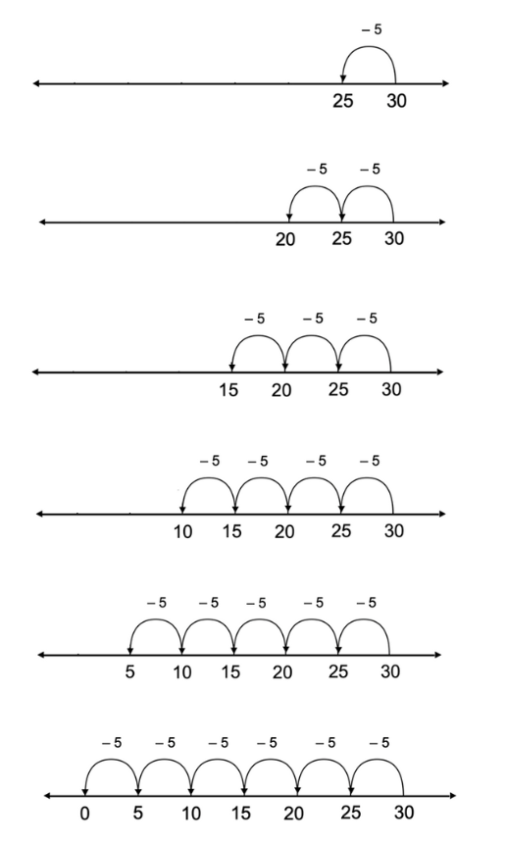
Figure 2: Number lines
- Discuss how to check the thinking shared by using a different strategy, for example, using manipulatives and/or the inverse operations.
- Discuss ways to record our thinking to solve the problem, making explicit connections between thinking and representations.
Variations
- Pose similar problems, where we know the size of the group, encouraging students to consider if they know any number facts that might be useful in helping them solve the problem before they use skip counting.
- Encourage students to model the problem using manipulatives before considering ways they could represent the problem using diagrams and pictures.
- Have students estimate and refine their estimations as they work through problems.

How many leaps?
Key generalisations/ what’s (some of) the mathematics?
- Mathematicians notice patterns and relationships when counting, for example, when counting in multiples such as 3 and 6.
- We can use multiplication facts we know to solve division problems we may not know yet (inverse operation).
- Mathematicians use what they know to help them solve what they don’t know yet.
- Mathematicians check thinking by using an alternative way to solve the problem.
- Mathematicians use representations such as drawings, diagrams, gestures and objects to share their thinking.
Some observable behaviours you may look for/notice:
- recognises and uses numbers other than one as composite units
- uses a range of strategies to solve problems:
  - uses known facts to solve unknown problems
  - uses inverse operations
  - uses known multiples in calculating related multiples
  - uses doubles and doubling strategies, for example double and one more
  - uses skip counting and may use fingers to keep track
- uses various representations to share thinking:
  - concrete materials
  - gestures
  - drawings
  - language
  - diagrams
  - virtual manipulatives.
Materials
- Counters
- Connecting blocks / cubes
- Something to write on/with
Instructions
- Pose the problem ‘Amy, Caitlin and James are trying to get back to zero at the end of the giant number line. At the moment, they are all on number 12. Amy takes big leaps when she moves. She can leap 6 numbers at a time. Caitlin can leap 3 numbers at a time and James can leap 2 numbers at a time. How many leaps will each person have to make to get to zero?’
- Ask students to consider how they could model this problem to help them make sense of it, solve it, and explain their thinking, bringing out the idea of acting it out or making a smaller number line using manipulatives.
- Place people (or counters) along a large number line and ask students to think about what information they already know that may be useful in helping them solve the problem:
- ‘I know 2 sixes is the same as 12 in total so I know Amy will need 2 leaps.’
- ‘I know Caitlin and James will need more leaps than Amy because they go a shorter distance each time.’
- ‘I know 3 is half of 6. That means Caitlin leaps half the distance Amy leaps. I can prove that by folding a number line or by using connecting blocks cubes.’
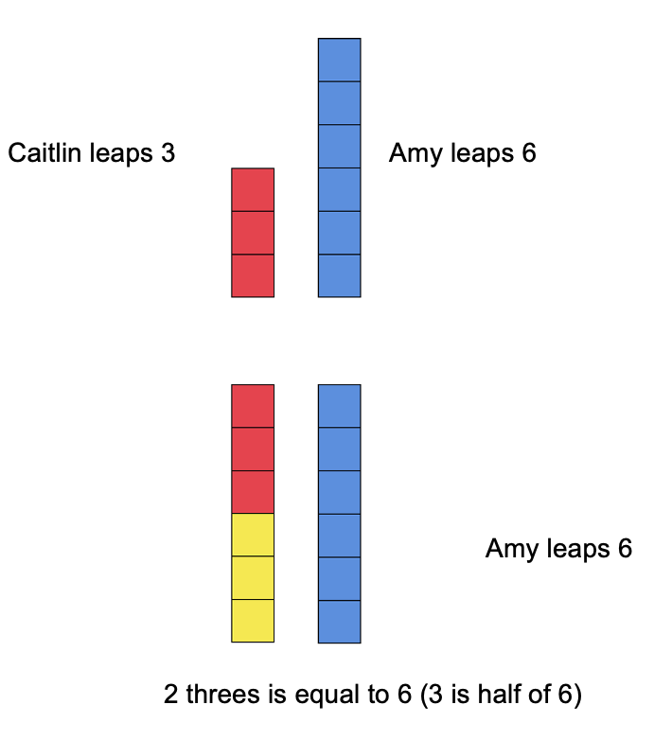
Figure 3: Solving problems with blocks
- Use a moment such as landing on 6, to ‘notice’ mathematically, drawing out the idea that sometimes you land on the same number.
Teaching point: Strategic teacher ‘noticing’ should be used regularly to help students generalise and test ideas. In this variation, it provides an opportunity to re-examine patterns in the number words we say when counting in particular multiples, helping students build an understanding that some units are related (such as threes and sixes - sixes are double threes, and threes are double sixes).
- Provide students with manipulatives to apply the knowledge, testing out if it was useful in helping them solve the problem and to find a solution.
- Have students record the steps made by each person on an empty number line.
- Use multiplication as the inverse operation to check thinking.
- When students are ready, make connections between their number lines and representations with symbolic notation.
Variations
- Use Think boards
- Have students create their own ‘How many steps?’ problems.

Subitising arrays
Key generalisations/ what’s (some of) the mathematics?
- We can use our knowledge of spatial patterns to quantify the number of rows and the number in each row.
- We can use our knowledge of the structure of arrays to help us solve multiplicative problems. We can think about how many in each row and then how many rows we have, for example, “There are 4 rows with 5 dots in each row. We can think of this as 4 fives.
- We can use our understanding of part-part-whole relationships to solve multiplicative problems.
- We can think about numbers flexibly to solve problems.
- Different people see and think about numbers and problems in different ways.
- Mathematicians check thinking by using an alternative way to solve the problem.
- Mathematicians use representations such as drawings, diagrams, gestures, and objects to share their thinking.
Some observable behaviours you may look for/notice:
- recognises and uses numbers other than one as composite units
- determine and distinguish between the number of rows/columns and the number in each row/column when describing arrays
- uses a range of strategies to solve problems:
  - uses known facts to solve unknown problems
  - uses doubles and doubling strategies
  - visualises and skip counts the number of dots and may use fingers to keep track of groups/ rows
  - visualises and counts by ones the number of dots
- explains their chosen strategies
- refines/ extends thinking after listening to the ideas and strategies of others.
Materials
- Counters
- Subitising arrays (refer to Appendix 2)
- Something to write on/with
Instructions
- Create an array, hidden from view. Briefly show the array to students for about 3 seconds.
- Ask students to recreate the array they saw using counters.
- Students to turn and talk to share and justify their thinking, for example, ‘I saw 3 fives which is 15 in total’ or ‘I saw 15. There were 5 threes’.
- Encourage students to check their representation with the original array and share their thinking using gesturing.
- Repeat the task several times using different arrays.

Variations
- Have students draw the array they saw.
- Show an array in two colours to promote the relationship between facts, for example, in this case (see below) I see 15 made up of 2 fives and 1 five more, or I may see 3 fives and know that is 15.
Figure 4: Array
- This could also be shown as 3 fours and 3 ones as below
Figure 5: Array
- Have students write a statement about what they saw, explaining the situation using words
- Show students region model cards rather than arrays (see examples below).
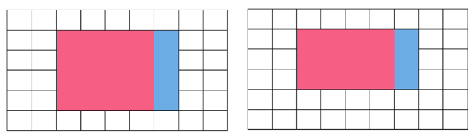

Figure 6: Region model
Teaching point: Make explicit connections between the ways in which we can use part-part-whole partitioning in additive and multiplicative situations.

Understanding the commutative property
Key generalisations/ what’s (some of) the mathematics?
- We can use the commutative property to think strategically and flexibly about array structures, for example, when we rotate 3 twos and rename it 2 threes.
- We can use our mathematical imagination to rotate an array. The product remains the same/ unchanged but the way we name the array changes, for example,
  - 12 can be arranged into an array that represents 3 fours and 4 threes.
- Collections of objects can look different but have the same quantity.
- Mathematicians use representations such as drawings, diagrams, gestures, and objects to help them solve problems.
Some observable behaviours you may look for/notice:
- recognises and uses numbers other than one as composite units
- explains how and why quantities remain the same when units are rearranged, representing the same total in multiple arrangements
- recognises and uses arrays to model the commutative property of multiplication
- uses materials and models to represent equivalence and the commutative property of multiplication
- refines/ extends thinking after listening to the ideas and strategies of others
- uses various representations to share thinking:
  - concrete materials
  - drawings
  - diagrams
  - gestures
  - language
  - virtual manipulatives.
Materials
- Understanding the commutative property array (refer to Appendix 3)
- Manipulatives such as, counters and connecting blocks cubes
Teaching point: Understanding the commutative property is a significant component of learning how the operations of multiplication and division work. It plays an important role in choosing efficient strategies for solving multiplicative problems. The order in which we multiply numbers is irrelevant; the product is the same regardless of the order. Support students in investigating how the commutative property relates to the order-irrelevance principle of counting, for example, 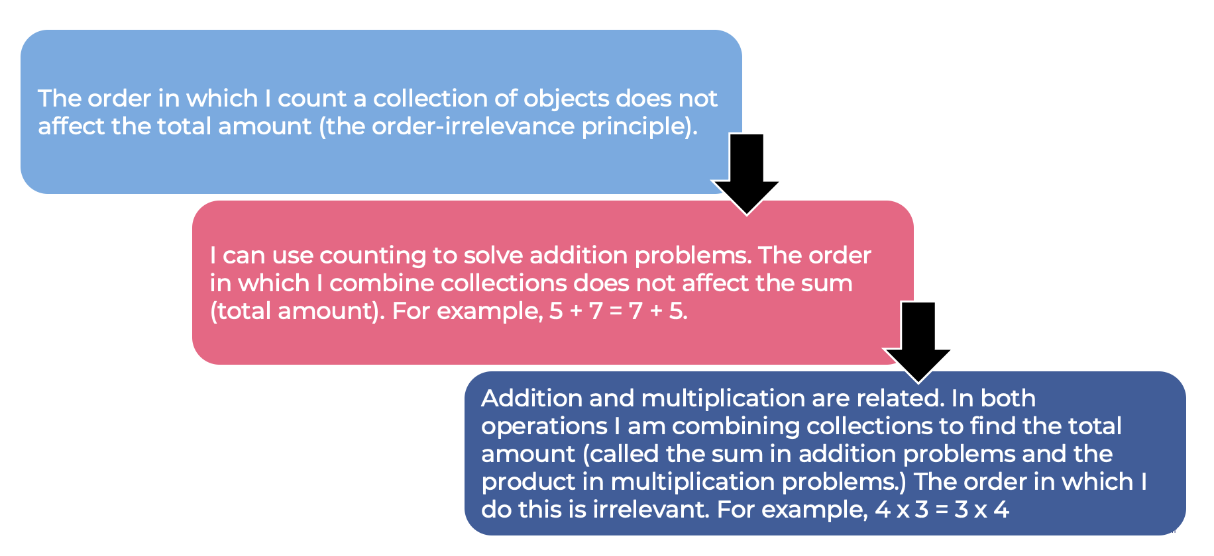

Instructions
- Show the following image of an array.
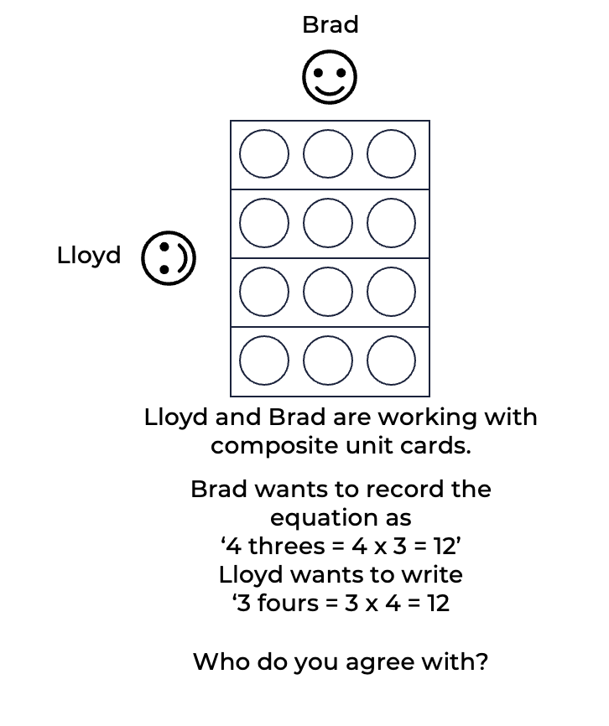
Figure 7: Array problem
- Provide time for students to explore, discuss and debate questions such as:
- What is the same about the equation Brad and Lloyd want to record?
- What is different?
- Why might it be useful to know 3 x 4 is equivalent to 4 x 3?
- How many ways can we prove 3 fours is equivalent to 4 threes? Display different representations and models (example below).
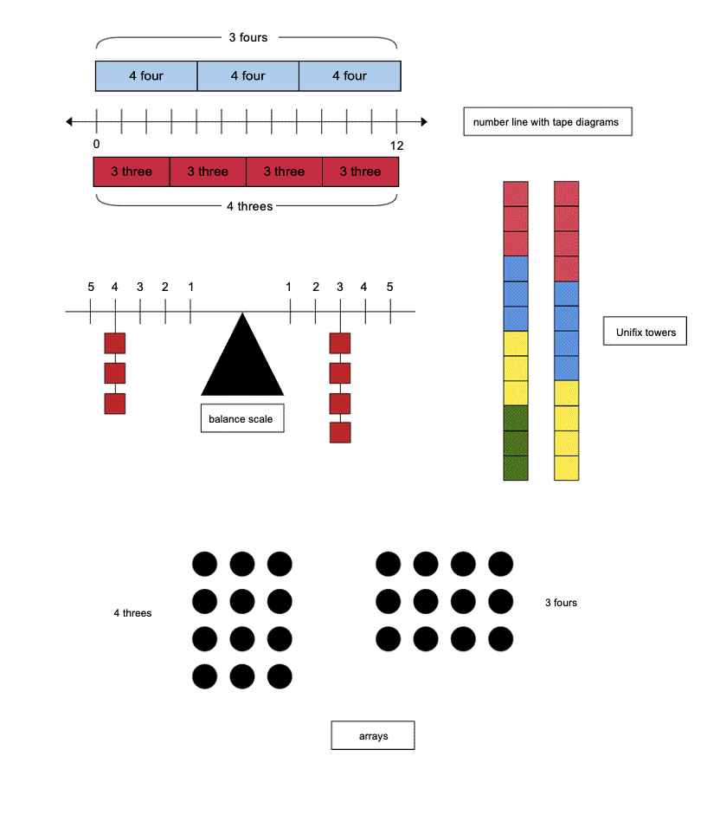
Figure 8: Representing 3 fours

Variations
- Relate commutativity in multiplication to commutativity in addition
- Use array patterns using images of cars or smiley faces to enable students to ‘see’ the physical ‘turning-around’ often associated with the commutative property (example below)
Figure 9: Icon array
- Investigate situations where the commutative property does and doesn’t work.
Teaching point: Support students in making connections between their knowledge of the commutative property in addition and subtraction to aid comprehension in multiplication and division. Knowing when and why you can commute in additive situations is important in building understanding in multiplicative ones.

Investigating related facts: Multiplication and division
Key generalisations/ what’s (some of) the mathematics?
- When solving problems, we can use what we know about:
  - known facts
  - landmark numbers
  - the relationship between numbers
  - properties
  - renaming of numbers.
- We can think about numbers flexibly to solve problems.
- Different people see and think about numbers and problems in different ways.
- We can use multiplication facts we know to solve division problems we may not know yet (inverse operation).
- Mathematicians explain their thinking so it makes sense to others.
- Mathematicians use what they know to help them solve what they don’t know straight away or yet.
- Mathematicians use representations such as drawings, diagrams, gestures, and objects to share their thinking
Some observable behaviours you may look for/notice:
- Uses a range of strategies to solve problems, for example,
  - uses known facts
  - renames numbers
  - uses properties (such as commutative and associative)
  - uses knowledge of counting
  - uses landmark or benchmark numbers (multiples of five and ten)
  - uses inverse operations.
- Explains why they used a particular strategy
- refines/ extends thinking after listening to the ideas and strategies of others
- uses various representations to share thinking:
  - concrete materials
  - drawings
  - diagrams
  - gestures
  - language
  - virtual manipulatives.
Materials
- Something to write on/with
Instructions
- Ask students to share a number fact they know without having to work out the answer, for example, ‘I know 5 tens is the same as fifty in total. I know that because we name 5 bundles of ten ice cream sticks ‘5 tens’ which we rename as ‘fifty’. We write the numeral as ‘50’.’
- Elicit other examples, asking students to explain how they know that fact, drawing upon their visualisation.
- Explain we can think efficiently about problems by using facts we already know to work out problems we don’t know the answer to straight away or yet. We call these ‘related facts, for example, see Figure 10.
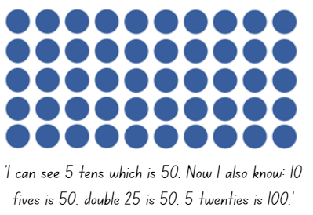
Figure 10: Array problem
Teaching point: Students need to have spent time investigating the commutative and associative properties of addition and subtraction, having genuinely explored the situations in which these mathematical properties work and can be applied, and situations when they cannot. Support students’ ability to explain why these properties work in some situations and not others. It is important students have varied, meaningful opportunities to notice, generalise, test, refine, explore and apply these properties in a range of problem contexts.
- Students investigate a range of related facts based on a number fact they already know.
- Students record their work using an iPad or other tablet device, taking and annotating photos of their work to share with the class.
Teaching point: It is important to support students in using what they already know to work out things they do not know. This strategy of making connections from the known to the unknown requires reasoning and problem-solving skills which students will need support in developing.

Is 6 fives exactly the same as 5 sixes?
Key generalisations/ what’s (some of) the mathematics?
- Arrays can look different but be equivalent in total. The product can remain the same but the number of groups and the number in each group is different.
- We can use the commutative property to think strategically and flexibly about array structures, for example, when we rotate 5 sixes, we rename it 6 fives.
- We can use our mathematical imagination to rotate an array. The product remains the same/ unchanged but the way we name the array changes, for example,
- 30 can be arranged into an array that represents 5 sixes and 6 fives.
- When we describe an array, we attend to how many rows and how many in each row.
- Mathematicians explain their thinking so it makes sense to others.
- Mathematicians use representations such as drawings, diagrams, gestures, and objects to share their thinking.
Some observable behaviours you may look for/notice:
- recognises and uses numbers other than one as composite units
- explains how and why quantities remain the same when units are rearranged, representing the same total in multiple arrangements
- recognises and uses arrays to model the commutative property of multiplication
- uses materials and models to represent equivalence and the commutative property of multiplication
- refines/ extends thinking after listening to the ideas and strategies of others
- uses various representations to share thinking:
  - concrete materials
  - drawings
  - diagrams
  - gestures
  - language
  - virtual manipulatives.
Materials
- A range of manipulatives
- Is 6 fives exactly the same as 5 sixes (refer to Appendix 4)
Instructions
- Show students arrays representing 6 fives and 5 sixes.
- Ask students to decide whether 6 fives is exactly the same as 5 sixes.
- Students choose one position (yes or no), and brainstorm justifications for their thinking with like-minded peers.
- Students share their thinking with the class. Allow them to change their mind and change their thinking if they feel persuaded to do so.
- Provide students some more information (context) for the problem, for example,
- A: ‘Simon had chocolate buttons. He gave some to his friends so each person had 5 chocolate buttons each.’
- B: ‘Simon had chocolate buttons. He gave some to his friends so each person had 6 chocolate buttons each.’
- Ask if they still believe 6 fives is exactly the same as 5 sixes.
- Provide materials to model each problem (A and B), enabling them to realise whilst the product is the same, the number of groups and number in each group are different.
Teaching point: Students need to understand they can use the commutative property to solve problems. However, they need to be able to explain whilst the product is the same, the number of groups and number in each group is different.

Would you rather?
Key generalisations/ what’s (some of) the mathematics?
- Mathematicians consider the context to help make sense of problems and justify their thinking.
- We can use the commutative property to think strategically and flexibly about array structures, for example, when we rotate 8 twos or 2 eights.
- We can use our mathematical imagination to visualise arrays.
- When we describe an array, we attend to how many rows and how many in each row. The product remains the same/ unchanged the number of groups and the number in each group changes.
- Mathematicians explain their thinking so it makes sense to others.
- Mathematicians use representations such as drawings, numerals, diagrams, gestures, and objects to share their thinking.
Some observable behaviours you may look for/notice:
- recognises and uses numbers other than one as composite units
- explains how and why quantities remain the same when units are rearranged, representing the same total in multiple arrangements
- recognises and uses arrays to model the commutative property of multiplication
- uses materials and models to represent equivalence and the commutative property of multiplication
- refines/ extends thinking after listening to the ideas and strategies of others
- uses various representations to share thinking:
  - concrete materials
  - drawings
  - diagrams
  - gestures
  - language
virtual manipulatives.
Materials
- Something to write on/with
Instructions
- Provide a problem such as ‘8 twos or 2 eights’
- Have students visualise the array in one orientation only and describe it to their partner who draws and labels it.
- The second student visualises the second array that could have been drawn, explaining it to the first student who now has the job of drawing and labelling the array.
- Ask students to consider situations where the number of groups and the number in each group favours one array over another, creating contexts to justify their thinking, for example, Figure 11.
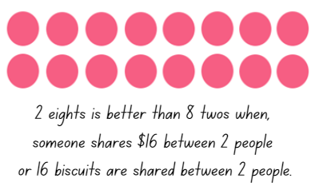
Figure 11: Array problem
Figure 12: Array problem
- Ask questions such as:
  - What is different?
  - What is the same?
  - How can you record each scenario using an equation?

Create an array
Key generalisations/ what’s (some of) the mathematics
We can use various strategies to solve the same problem such as:
  - visualising
  - estimating
  - counting in multiples
  - using known facts
- We can use our knowledge of spatial patterns to quantify the number of rows and the number in each row.
- We can use our knowledge of the structure of arrays to help us solve multiplicative problems.
- We can think about how many in each row and then how many rows we have, for example, “There are 7 rows with 5 dots in each row. We can think of this as 7 fives.
- We can think about numbers flexibly to solve problems.
- Different people see and think about numbers and problems in different ways.
- Mathematicians check thinking by using an alternative way to solve the problem.
- Mathematicians use representations such as drawings, diagrams, gestures, and objects to share their thinking
Some observable behaviours you may look for/notice:
- recognises and uses numbers other than one as composite units
- determine and distinguish between the number of rows/columns and the number in each row/column when describing and forming arrays
- uses a range of strategies to solve problems:
  - uses known facts to solve unknown problems
  - uses doubles and doubling strategies
  - visualises and skip counts the number of dots and may use fingers to keep track of groups/ rows
  - visualises and counts by ones the number of dots
- uses various representations to share thinking:
  - concrete materials
  - gestures
  - drawings
  - language
  - diagrams
  - virtual manipulatives
- explains their chosen strategies
- refines/ extends thinking after listening to the ideas and strategies of others.
Materials
- Create an array (refer to Appendix 5)
- 2 sheets of blank paper
Instructions
- Demonstrate how an array with 10 tens can be covered with 2 pieces of paper to form other arrays, for example, cover the top 3 rows with paper and the first 5 columns with another piece of paper to show an array of 7 fives (7 rows with 5 in each row).
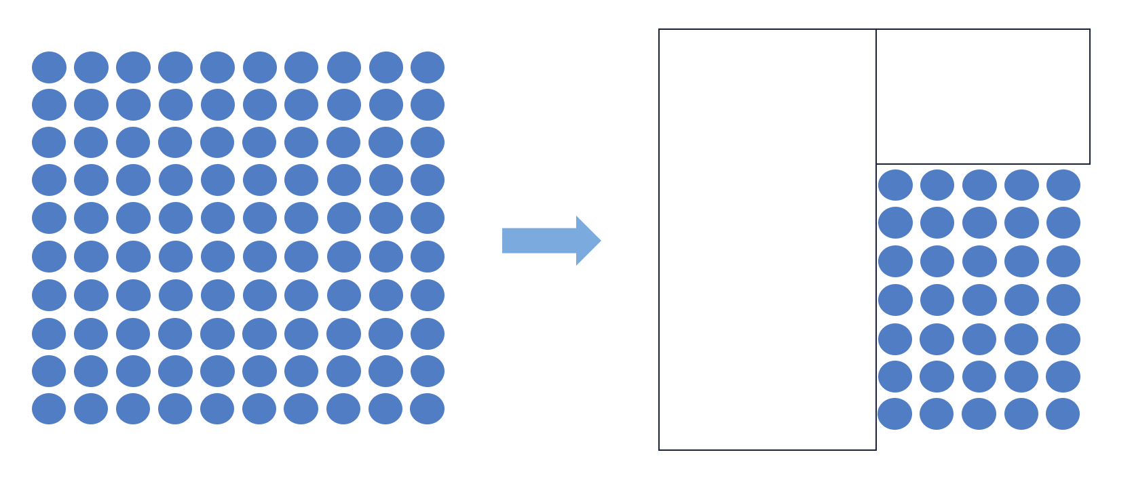
Figure 13: Covered array
- Students to use their array sheets and paper to make nominated arrays. Have students determine the product. Students can verify their answer by sharing their multiplicative thinking strategies. Attend to the reasoning shared by students.

Variations
- Students form arrays with a nominated number of dots, say 24. Record the arrays the students have constructed, for example, 6 fours, 4 sixes, 3 eights and 8 threes.
- Students represent their array using words and symbols, for example, if a student made 6 fours, they could record it in a table.
Table 1: Words and symbols
Words | Symbols
6 fours equals twenty-four | $$6×4=24$$
4 sixes equals twenty-four | $$4×6=24$$
3 eights equals twenty-four | $$3×8=24$$
8 threes equals twenty-four | $$8×3=24$$
- Students form arrays of their own choice and describe it to other class members.
- Students create word problems to match the array they have constructed, for example, ‘4 bears live in each cave and there are 6 caves. How many bears altogether?’ Other students may then use their array paper to solve the problem.
- After students have formed an array, ask them to quarter turn their array and re-name the array, recognising the commutative property
- Students link multiplication and division facts using the arrays, for example, 12 shared into 4 rows makes 3 in each, 12 ÷ 4 = 3.
Teaching point: To support comprehension of symbols, support students in brainstorming the words, symbols and meaning of a particular operation using graphic organisers such as word maps or Frayer charts. These should be regularly revised and refined as new knowledge and understanding develops. Co-constructed working definitions support the development of common understanding.

Partitioning arrays
Key generalisations/ what’s (some of) the mathematics?
- We can use our understanding of part-part-whole relationships to solve multiplicative problems.
- We can think about numbers flexibly to solve problems.
- Different people see and think about numbers and problems in different ways.
- Arrays can look different but be equivalent in total. The product can remain the same but the number of groups and the number in each group is different.
- We can use our mathematical imagination to rotate an array. The product remains the same/ unchanged but the way we name the array changes, for example,
  - 30 can be arranged into an array that represents 5 sixes and 6 fives.
- When we describe an array, we attend to how many rows and how many in each row.
- Mathematicians explain their thinking so it makes sense to others.
- Mathematicians use representations such as drawings, diagrams, gestures, and objects to share their thinking
Some observable behaviours you may look for/notice:
- determine and distinguish between the number of rows/columns and the number in each row/column when describing and forming arrays
- explains how and why quantities remain the same when units are rearranged, representing the same total in multiple arrangements
- uses a range of strategies to solve problems:
uses the commutative property
uses the distributive property
uses known facts to solve unknown problems
uses doubles and doubling strategies
visualises and skip counts the number of dots and may use fingers to keep track of groups/ rows
visualises and counts by ones the number of dots
- uses various representations to share thinking:
  - concrete materials
  - gestures
  - drawings
  - language
  - diagrams
  - virtual manipulatives
- explains their chosen strategies
- refines/ extends thinking after listening to the ideas and strategies of others.
Materials
- Double sided counters
- Something to write on/with
Instructions
- Students explore arrays to examine the various ways composite units can be partitioned, for example, provide manipulatives and ask them to make an array that shows 6 sevens.
- Record ‘6 sevens’ and ask, ‘How can we describe this array using words and symbols?’
- Have students discuss their thinking with a partner before sharing with the group.
- Record student descriptions and symbolic notation, linking multiplication and division.
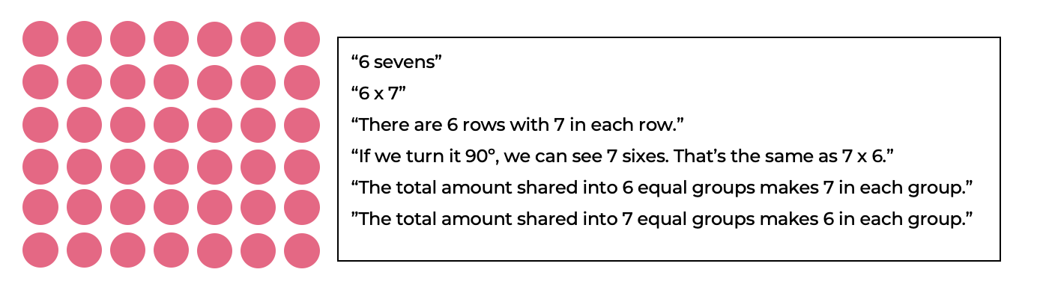

- Ask students to consider the ways in which 6 sevens could be partitioned, for example, I could partition the 6 sevens to make 5 sevens and 1 seven.
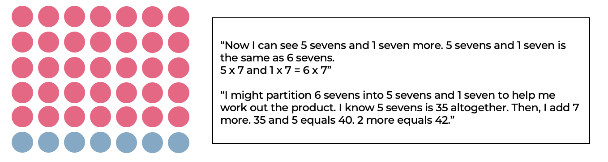
Figure 14: Partitioning an array
- Students to share their ideas, modelling each partition by changing the colours of their counters and slightly separating their arrays.
- Students partition their array in as many ways as possible, recording each variation using diagrams and equations.
- Students share their thinking with the class.
- Students consider which way of partitioning their array is most useful in helping them solve the problem.
Variations
- Investigate how many ways a particular array could be partitioned
- Ask questions such as:
- What happens if we increase the 7 to 8?
- What happens if we decrease the 6 to 5?
- What happens if we increase the 6 to 7?
- How is 6 sevens related to 5 sevens?
- Could you work out 6 x 8 from knowing 6 x 7?
Teaching points: Leverage the opportunity to explicitly investigate how students can use known facts to help them solve problems they don’t know yet. This supports students in understanding the relationship between number facts as well as understanding the difference between additive and multiplicative situations.
Repeat this task using a range of arrays. Students create arrays using manipulatives, for example, they could cut array images to show how they have partitioned the composite units or visualise their arrays and describe how they might partition it.

Partially covered arrays
Key generalisations/ what’s (some of) the mathematics?
- We can use various strategies to solve the same problem such as:
  - visualising
  - estimating
  - counting in multiples
  - using known facts
- Mathematicians use what they know to help them solve what they don’t know yet.
- We can use what we know about the structure of an array to imagine dots hiding in partially covered arrays.
- Different people see and think about numbers and problems in different ways.
- Listening to other people’s thinking helps us become aware of other strategies, building our knowledge of mathematics.
- Mathematics compare similarities and differences between strategies and contexts to help choose which strategies to use and when.
- Mathematicians use the ideas of other to refine/ extend their own ideas.
Some observable behaviours you may look for/notice:
- recognises and uses numbers other than one as composite units
- determine and distinguish between the number of rows/columns and the number in each row/column when describing and forming arrays
- uses a range of strategies to solve problems:
  - uses known facts to solve unknown problems
  - uses doubles and doubling strategies
  - visualises and skip counts the number of dots and may use fingers to keep track of groups/ rows
  - visualises and counts by ones the number of dots
- uses various representations to share thinking:
  - concrete materials
  - gestures
  - drawings
  - language
  - diagrams
  - virtual manipulatives
- explains their chosen strategies
- refines/ extends thinking after listening to the ideas and strategies of others.
Materials
- Partially covered array resource (refer to Appendix 6)

Instructions
- Share the blue and green mat image and ask students to consider the range of strategies they could use to solve the problem. ‘I made a patchwork mat with some blue squares and some green squares all the same size. How many squares did I use altogether?’
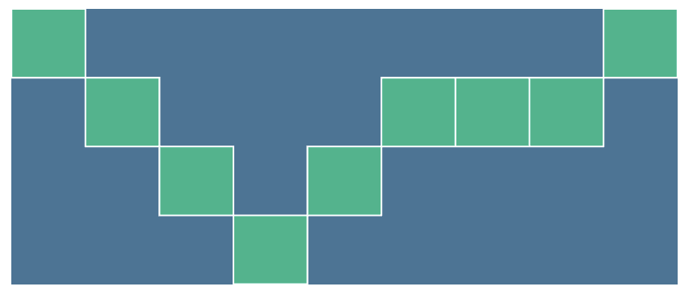
Figure 15: Mat image
- Students discuss their ideas with a thinking partner before sharing back with the class. Represent student thinking of the different strategies explored, for example, count by ones, count by fours, recall a known fact.
- Students explore and compare each of the strategies shared, recording the solution and their thinking with their partner. Students discuss and reflect on the efficiency of each strategy.
- Support students to see the efficiency of each strategy, for example, ‘to count by ones means I need to say 36 number words and I may easily get lost in the count. I say 9 number words when counting by fours, but I need to know the number sequence when I count by fours.’
Variations
- Students design other partially covered arrays for others to solve
- Introduce other partially covered array problems (see partially covered array resource).

Multiplication toss
From Dianne Siemon, RMIT University
Key generalisations/ what’s (some of) the mathematics?
- Numbers can be partitioned (distributive property) to help us think flexibly about problems, for example, “We can rename 3 sixes as 2 sixes and 1 six”.
- Mathematicians think strategically when they solve problems, looking for what they already know and deciding how to use that knowledge.
- Different people see and think about numbers and problems in different ways.
- Games provide us with an opportunity to practise our mathematical skills and understanding.
- Mathematicians strategise by using their knowledge of numbers and operations to improve their chances of winning a game.
- We can use multiplication facts we know to solve division problems we may not know yet (inverse operation).
Some observable behaviours you may look for/notice:
- recognises and uses numbers other than one as composite units
- explains their chosen strategies
- refines/ extends thinking after listening to the ideas and strategies of others.
- uses a range of strategies to solve problems:
  - uses known facts to solve unknown problems
  - uses doubles and doubling strategies
  - visualises and skip counts the number of dots and may use fingers to keep track of groups/ rows
- partitions numbers to think about problems flexibly
- explains how and why quantities remain the same when units are rearranged, representing the same total/ product in multiple arrangements.
Materials
- Multiplication toss game board (refer to Appendix 7)
- Different coloured pencils or markers
- Multiplication toss spinners (refer to Appendix 7)
- Paper clip for spinner
- Device to watch the video
Instructions
- Watch the Multiplication toss video to learn how to play.
- Students take turns to spin each of the spinners. If a student spins a 3 and 6 for example, they can enclose either a block of 3 rows of 6 (3 sixes) or 6 rows of 3 (6 threes).
- The game continues with no overlapping areas.
- The winner is the student with the largest area blocked out after 10 spins.
- Eventually the space available on the grid paper gets really small. Encourage students to use partitioning to help them, for example, if a student rolls 3 and 6 and it won’t fit as 3 sixes or as 6 threes, students can rename 3 sixes as:
  - 2 sixes and 1 six
  - 5 threes as 1 three
  - 2 threes, 3 threes and 1 three
- Multiplication toss follow up 1 video and Multiplication toss follow up 2 video explore the partitioning strategy in the context of this game.

Relating tens and fives
Key generalisations/ what’s (some of) the mathematics?
- We can use various strategies to solve the same problem such as:
  - visualising
  - using landmark numbers (sometimes called benchmark numbers, multiples of 10)
  - renaming numbers
  - using known facts
- We can use our understanding of part-part-whole relationships to solve multiplicative problems.
- We can think about numbers flexibly to solve problems.
- Different people see and think about numbers and problems in different ways.
- Arrays can look different but be equivalent in total. The product can remain the same but the number of groups and the number in each group is different.
- We can use our mathematical imagination to rotate an array. The product remains the same/ unchanged but the way we name the array changes, for example,
  - 30 can be arranged into an array that represents 5 sixes and 6 fives.
- When we describe an array, we attend to how many rows and how many in each row.
- Mathematicians explain their thinking so it makes sense to others.
- Mathematicians use representations such as drawings, diagrams, gestures, and objects to share their thinking
Some observable behaviours you may look for/notice
- partitions numbers to think about problems flexibly
- uses various representations to share thinking:
  - concrete materials
  - gestures
  - drawings
  - language
  - diagrams
  - virtual manipulatives
- explains how and why quantities remain the same when units are rearranged, representing the same total in multiple arrangements
- refines/ extends thinking after listening to the ideas and strategies of others.
- uses known multiples in calculating related multiples.
Materials
- 4 tens array resource (refer to Appendix 8)
- 3 tens array resource (refer to Appendix 8)
- Something to write on/with
Teaching point: Check what students know about regrouping and renaming numbers, linking ‘tens’ facts with student knowledge of ‘-ty’ words and place value.
Instructions
- Show students an array representing 4 tens (example below). Explain this array shows 4 tens which we can rename as 40.
Figure 16: Array 4 tens
- Students consider what else they can see within this array, discussing and recording their ideas with a thinking partner.
- Record the students’ ideas. If not identified by the students, use ‘think aloud’ to share the idea that 4 fives could also be seen if we partition the array and place the pink dots below the blue ones.
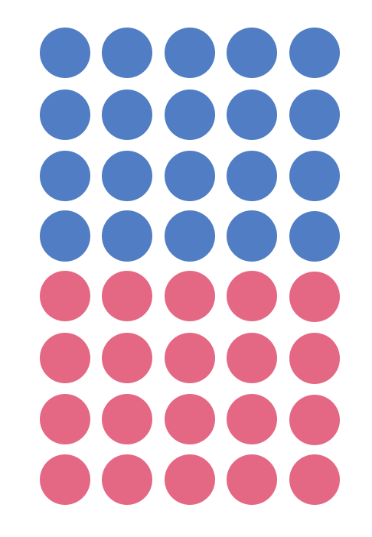
Figure 17: Array 8 fives
- Discuss differences and similarities between the two different arrays eliciting ideas such as:
  - The number of dots in total did not change therefore the product is the same
  - The product is forty
  - We had 4 tens (4 x 10)
  - Now we have 8 fives (8 x 5)
  - 4 tens has the same product (total) as 8 fives (4 x 10 = 8 x 5)
  - The number of groups changed (the first array has 4 groups and the second array as 8)
  - The number in each group changed (the first array shows ‘tens’ and the second array shows ‘fives’).
  - They are equivalent in value.
- Show students an array of 3 tens and 6 fives (examples below). Discuss the similarities and differences. Ensure the previous example of 4 tens and 8 fives is visible to students.
Figure 18: Array 3 tens
Figure 19: Array 6 fives
- Students look at the different examples, recording any patterns that may be emerging, talking first with a thinking partner before discussing as a group.
Teaching point: Encourage students to notice ‘fives’ can be solved by doubling and halving, for example, 14 fives (14 x 5) can be solved by halving 14 to make 7 and doubling 5 to make 10, changing the problem to be 7 tens (7 x 10). Record the number sentence as 14 x 5 = 7 x 10.

2s, 5s and 10s bingo
Key generalisations/ what’s (some of) the mathematics?
- Meaningful practice of foundational facts: the 2s, 5s, and 10s lay the groundwork for solving derived-fact strategies, for example, knowing 2s, 5s and 10s support us to derive other facts such as 3s, 4s, 6s, and 9s.
- We can use various strategies to solve the same problem such as:
- visualising
- estimating
- counting in multiples
- using known facts
- Mathematicians use what they know to help them solve what they don’t know yet.
- We can think about numbers flexibly to solve problems.
Some observable behaviours you may look for/notice
- partitions numbers to think about problems flexibly
- uses various representations to share thinking:
  - concrete materials
  - gestures
  - drawings
  - language
  - diagrams
  - virtual manipulatives
- explains how and why quantities remain the same when units are rearranged, representing the same total in multiple arrangements
- recognises and uses numbers other than one as composite units
- uses a range of strategies to solve problems:
  - uses known facts to solve unknown problems
  - uses inverse operations
  - uses known multiples in calculating related multiples
  - uses doubles and doubling strategies, for example double and one more
  - uses skip counting and may use fingers to keep track
Materials
- Blank bingo grid resource (refer to Appendix 9)
- Number fact cards resource (refer to Appendix 9)
- Something to write with.
Instructions
- Provide students with a blank bingo grid. As a class, brainstorm the products from 0 twos to 10 twos (0 x 2 to 10 x 2), repeating again for fives and tens. From the list, students choose numbers to fill out their bingo grid.
- Shuffles the number fact cards and one at a time, then read the card to the students, for example, ‘2 eights’.
- If a student has that product on their bingo board, they can cross it off.
- Play until a student has crossed off all their numbers.
Variations
- Instead of calling out the number fact, display an array image.
- Students write number facts on their bingo boards (for example, 2 fives) and the teacher calls out the product, for example, 10.
- Provide students with two bingo boards from a game (one winning board and one that did not) and investigate why one board won and the other was unsuccessful.
Teaching point: Fluency with these facts is important as they form the basis for deriving other facts, as needed. From 2s, we can work out 4s, 8s, and 3s. From 5s, we can work out 4s and 6s and 7s and 10s. From 10s, we can work out 9s.

Doubles fill
Key generalisations/ what’s (some of) the mathematics?
- Mathematicians use what they know to solve what they do not know yet.
- Meaningful practice of foundational doubles facts which support problem solving.
- We can use various strategies to solve the same problem such as:
  - visualising
  - estimating
  - counting in multiples
  - using known facts
- We can think about numbers flexibly to solve problems.
Some observable behaviours you may look for/notice
- recognises and uses numbers other than one as composite units
- uses a range of strategies to solve problems:
  - uses known facts to solve unknown problems
  - uses doubles and doubling strategies
  - visualises and skip counts the number of dots and may use fingers to keep track of groups/ rows
Materials
- 0-9 spinner or 0-9 dice (refer to Appendix 10)
- Doubles spinner (refer to Appendix 10)
- Doubles fill game board (refer to Appendix 10)
- 2 paperclips
- Device to watch the video
- Something to write with/on
Instructions
Watch the Doubles fill video to learn how to play.
- Students take turns to spin the 0-9 spinner (or roll dice) and spin the doubles fill spinner.
- If a student spins a 6 and spins ‘double’, they double 6 which is equivalent to 12, explaining their thinking to their partner who records the equation.
- The student then colours in a corresponding array.
- Students then swap roles.
- If there is no space on the grid, students miss a turn.
- Play continues until no one can add another array.
- Students then calculate the number of squares they covered
- The student with the largest area is the winner.
Variations
- Use manipulatives to work out double facts.
- Make up ‘codes’ to show the order in which they made the arrays (see Doubles fill video).
- Students can rotate and rename the array to use the commutative property, for example, change 5 twos into 2 fives and colour the corresponding array.
- Change the spinner to include repeated doubling.
Teaching point: Support students in becoming precise and accurate with the language and representations they use to communicate mathematically.

Multiples madness: fives
Key generalisations/ what’s (some of) the mathematics?
- We can use various strategies to solve the same problem such as:
  - visualising
  - estimating
  - counting in multiples
  - using known facts
- Mathematicians use what they know to help them solve what they don’t know yet.
- We can think about numbers flexibly to solve problems.
- Mathematicians strategise by using their knowledge of numbers and operations to improve their chances of winning a game.
- Mathematicians share strategies and explain thinking to others.
- Mathematicians listen to other people’s thinking to become aware of other strategies and build knowledge of mathematics.
- Games provide us with an opportunity to practice our mathematical skills and understanding.
Some observable behaviours you may look for/notice:
- refines/ extends thinking after listening to the ideas and strategies of others
- uses a range of strategies to solve problems:
  - uses known facts to solve unknown problems
  - uses doubles and doubling strategies
  - visualises and skip counts the number of dots and may use fingers to keep track of groups/ rows
- partitions numbers to think about problems flexibly.
Materials
- 2 markers/pencils
- 5 counters each
- Multiples madness gameboard (refer to Appendix 11)
- 0-9 spinner and paperclip or 0-9 dice (refer to Appendix 10)
- Device to watch the video
Instructions
Watch the Multiple madness: fives video to learn how to play.
- Students take turns to roll the dice or spin the spinner and multiply the number selected (for example, 6) by the number rolled and work out the product, explaining their thinking to their partner.
- Their partner records their thinking. If they agree, the first player places one of their counters on the number on the game board, claiming that place.
- If the number is taken, players miss a turn.
- A player wins by getting three counters in a row (in any orientation).
- Since players only have 3 counters, they will need to choose which counter to move once all 3 have been placed on the game board.
Variations
- Play with 4 counters to win.
- Play with a multiplication grid to check your partners answer, giving players an opportunity to have a second attempt if they answer incorrectly initially.

Factors fun
Key generalisations/ what’s (some of) the mathematics?
- Mathematicians use what they know to help them solve what they don’t know yet.
- We can think about numbers flexibly to solve problems.
- Mathematicians strategise by using their knowledge of numbers and operations to improve their chances of winning a game.
- Mathematicians share strategies and explain thinking to others.
- Mathematicians listen to other people’s thinking to become aware of other strategies and build knowledge of mathematics.
- Games provide us with an opportunity to practice our mathematical skills and understanding.
Some observable behaviours you may look for/notice
- refines/ extends thinking after listening to the ideas and strategies of others
- uses a range of strategies to solve problems:
  - uses known facts to solve unknown problems
  - uses doubles and doubling strategies
  - visualises and skip counts the number of dots and may use fingers to keep track of groups/ rows
  - partitions numbers to think about problems flexibly
- explains their chosen strategies.
Materials
- 3 pencils
- A factor fun gameboard (refer to Appendix 12)
- A paper clip
- 4-6 pink counters (or another colour) and 4-6 blue counters (or another colour)
- Device to watch the video
Instructions
Watch the Factors fun video to learn how to play.
- Students take turns to spin the spinner and divide the number by the chosen divisor (for example, 5).
- Students then work out the solution and explain their thinking to their partner.
- The partner records their thinking and if they agree, the student can place one of their counters on the number on the game board, claiming that place.
- If the number is taken, students miss a turn.
- If no new counters can be added to the game board, students must move an existing counter to a new place.
- Students win by getting 4counters in a row (in any orientation, including a square).
- If preferred, students can use 5 or 6 counters, looking for 4 in a row.

Introducing multiplication and division grids
Key generalisations/ what’s (some of) the mathematics?
- Mathematicians use representations such as multiplication grids and hundred charts to help them solve problems.
- We can use our mathematical noticings to identify and explore patterns and relationships between numbers.
- Mathematicians compare the similarities and differences noticed to help comprehend mathematical tools.
- Listening to other people’s thinking helps us become aware of other viewpoints, building our knowledge of mathematics.
Some observable behaviours you may look for/notice:
- refines/ extends thinking after listening to the ideas and strategies of others
- explains their chosen strategies
- identify and describe patterns when using grids and charts
- uses various representations to share thinking:
  - concrete materials
  - gestures
  - drawings
  - language
  - diagrams
  - virtual manipulatives
Materials
- 10 x 10 multiplication and division grid (refer to Appendix 13)
- Hundreds chart (refer to Appendix 13)
Instructions
- Students examine the similarities and differences between the multiplication and division grid and the hundreds chart. Support students to understand what the grid shows as well as the differences and similarities between the two, drawing out ideas such as:
  - The hundreds chart goes up/ down by ones as you move along the rows and up/ down by 10s as you travel along the columns
  - The multiplication and division grid goes up/ down by the same amount as you travel along each row and column, however, they are different for each row and column. Sometimes you increase/ decrease by for example, 2s, 5s or 8s
  - Not all the numbers from 1-100 are present on a 10 x 10 grid
  - Both start at 0 and end at 100
  - Some numbers are missing from the 10 x 10 grid and some are there numerous times
  - Interesting patterns can be found on both the hundreds chart and the 10 x 10 grid which students should be encouraged to explore, describe and explain
  - There is a diagonal line of symmetry that can be seen.
  - The answers to multiplication facts and division facts can be found using the grid.
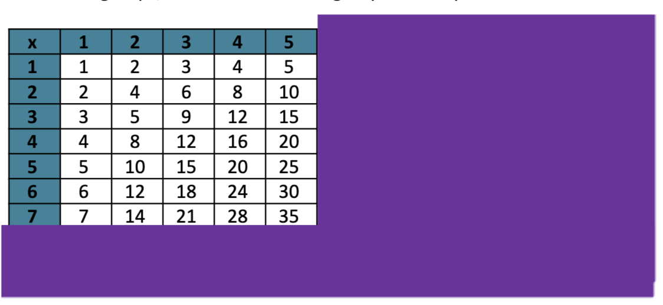
Figure 20: Multiplication grid
Teaching point: Just as the hundreds chart provides an idea of the size of each number, so does the multiplication and division grid. It provides information about working with composite numbers, for example, if looking at just this section (see below), I can see the number of groups (7), the number in each group (5) and the product (35).

Understanding the distributive property
Key generalisations/ what’s (some of) the mathematics?
- The same quantity can be partitioned and renamed in different ways. 6 sevens can be renamed 5 sevens and 1 seven, 2 sevens and 2 sevens and 2 sevens and 1 seven and so on.
- We can use the distributive property to think strategically and flexibly about array structures, for example, we can think about 6 sevens as 6 fives and 6 twos or 5 sevens and 1 seven.
- We can use our mathematical imagination to partition and rename arrays. The product remains the same/ unchanged but the way we name the array changes.
- Mathematicians use what they know to help them solve what they don’t know yet.
- Listening to other people’s thinking helps us become aware of other viewpoints, building our knowledge of mathematics.
- Different people see and think about numbers and problems in different ways.
- Mathematicians use representations such as drawings, diagrams, gestures, and objects to share their thinking.

Some observable behaviours you may look for/notice:
- refines/ extends thinking after listening to the ideas and strategies of others
- partitions numbers to think about problems flexibly
- explains how and why quantities remain the same when units are rearranged, representing the same total in multiple arrangements
- recognises and uses numbers other than one as composite units
- uses a range of strategies to solve problems:
  - uses known facts to solve unknown problems
  - uses inverse operations
  - uses known multiples in calculating related multiples
  - uses doubles and doubling strategies, for example double and one more
  - uses skip counting and may use fingers to keep track
- uses various representations to share thinking:
  - concrete materials
  - gestures
  - drawings
  - language
  - diagrams
  - virtual manipulatives
Materials
- Distribute property resource (refer to Appendix 16)
Teaching point: The distributive property relies of student understanding of part-part-whole knowledge of composite units. It helps students use known facts to derive unknown facts and can be applied to division as well as multiplication. Understanding and using the distributive property plays a very important role in later mathematics learning.
Instructions
- Show the following image to students and ask “How do these representations help us see that there are lots of ways we could work out 6 sevens?”
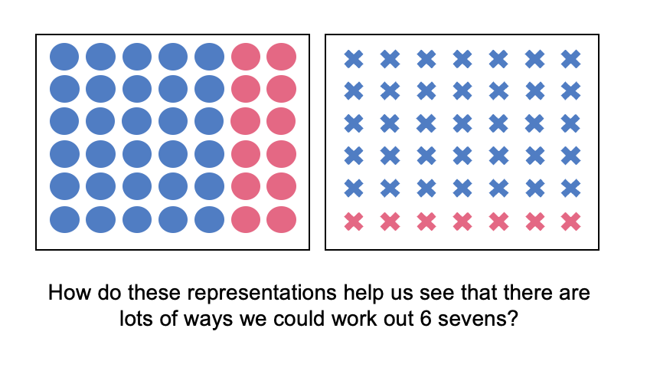
Figure 21: Array 6 sevens
- Provide time for students to explore, discuss and debate questions such as:
  - What equations could you write to match the images?
  - What is the same about the equations?
  - What is different about the equations?
  - Why is it useful to know 6 sevens = 5 sevens + 1 seven = 6 fives + 6 twos?

Multiplicative versus additive strategies
Key generalisations/ what’s (some of) the mathematics?
- Mathematicians understand and use the relationship between addition and multiplication, subtraction and division to solve problems.
- The same problem can be solved in many ways.
- Mathematicians compare similarities and differences between strategies and contexts to help choose which strategies to use and when.
- Mathematicians use representations such as drawings, diagrams, gestures, and objects to share their thinking
Some observable behaviours you may look for/notice:
- refines/ extends thinking after listening to the ideas and strategies of others
- partitions numbers to think about problems flexibly
- solves a problem in multiple ways
- uses materials and models to represent the commutative property and inverse relationship between addition and multiplication, subtraction and division to solve problems
- recognises and uses numbers other than one as composite units
- uses various representations to share thinking:
  - concrete materials
  - gestures
  - drawings
  - language
  - diagrams
  - virtual manipulatives.
Materials
- Calculator
- Something to write on/with.
Teaching point: Multiplicative strategies and situations involve the use of multiplication and division. Students need to be supported to understand why multiplication and division are useful operations, shifting from seeing multiplication as repeated addition (and therefore using counting and addition strategies to solve problems) to seeing the benefit of multiplicative thinking.
Instructions
- Pose a problem such as: ‘The delivery person had 56 boxes of bottled water in her van. She delivered 8 boxes to each shop. How many shops did she deliver water to?’
- Ask half of the students to use additive strategies to solve the problem and the remaining students to use multiplicative strategies. Students have the option to use calculators.
- Students consider if they were using repeated subtraction, what they would have to work out mentally or enter into the calculator. Support students in representing the problem symbolically by asking questions and eliciting information such as:
  - What information do we have? We know the product is 56, We know the amount each person receives is 8 boxes
  - What information is missing? We don’t know how many ‘shops’ the delivery person visited
  - We could write the problem as ‘50 shared into ____ leaves us with 8 in each group’, as well as ‘56 ÷ ___ = 8’
  - If we used an additive strategy such as repeated subtraction, what would we repeatedly subtract and what information would we be looking for? (The number of times 8 was subtracted)
  - If we used a multiplicative strategy, what might we do in our heads, or, what might we type into the calculator?
- Students solve the problem.
- Compare and discuss how many steps were needed to determine a solution. Attend to how repeated subtraction and repeated addition becomes tedious (even with a calculator) as the numbers students are working with become larger, or the counting sequence is not as familiar to students.
Variations
- Pose different problems using larger numbers such as ‘how many weeks are in 994 days?’ or ‘How many months have you been alive?’
- Compare the number of steps involved in using particular mental strategies compared with repeated addition or subtraction.
Teaching point: This task illustrates why fluency with addition and subtraction strategies are often critical to effectively solving problems with multiplication and division.

Array bingo - partially covered arrays
Key generalisations/ what’s (some of) the mathematics?
- Games provide us with an opportunity to practice our mathematical skills and understanding.
- Mathematicians make connections between different representations, for example, we can make connections between an array that represents 5 rows with 5 In each row (a diagram) and the product 25 (a number).
- We can use what we know about the structure of an array to imagine dots hiding in partially covered arrays.
- We can use what we know about multiplicative properties to help us solve problems, for example, we can use the commutative property to rotate an array of 5 twos and make it 2 fives.
Some observable behaviours you may look for/notice:
- recognises and uses numbers other than one as composite units
- recognises and uses arrays to model the commutative property of multiplication.
- explains their chosen strategies
- explains how and why quantities remain the same when units are rearranged, representing the same total in multiple arrangements
Materials
- A set of game cards (with pictures of different partially covered arrays and their matching product) (refer to Appendix 14)
- Device to watch the video

Instructions
Watch the Partially covered arrays bingo video to learn how to play.
- Each student creates a gameboard using 6 array cards.
- Students set aside the remaining array cards and place descriptor cards face down in a pile.
- Students take turns to turn over a descriptor card. If a student has the matching array card on their gameboard, they may turn the array card over.
- If both students have the matching array card, they can both turn over their matching cards.
- If neither student has the matching array card, turn over the next descriptor card in the pile.
- The winner is the first student to turn over all their cards and say ‘bingo!’
Possible discussion questions
- What strategies did you use to determine how many dots there are in the partially covered arrays?
- Were there any arrays which were known facts for you? Which ones?
- What strategies did you use for the arrays that weren’t known facts for you?
Variations
- Swap how the piles of cards are used in the game.
- Make a gameboard from the descriptor cards and turn over the array cards.
- Extend the number range by adding in the expansion pack and/or replacing the product cards with 2 x 9-sided dice

Go fish - collecting and solving doubles
Key generalisations/ what’s (some of) the mathematics?
- Games provide us with an opportunity to practice our mathematical skills and understanding.
- Mathematicians use what they know to help them solve what they don’t know yet.
- When solving problems, we can use what we know about:
  - known facts
  - landmark numbers
  - the relationship between numbers
  - properties
  - renaming of numbers.
Some observable behaviours you may look for/notice:
- refines/ extends thinking after listening to the ideas and strategies of others
- uses a range of strategies to solve problems:
  - uses known facts to solve unknown problems
  - uses doubles and doubling strategies
  - visualises and skip counts the number of dots and may use fingers to keep track of groups/ rows
- explains their chosen strategies
- partitions numbers to think about problems flexibly.
Materials
- Playing cards 1-10
- Device to watch the video
Instructions
- Watch the Go fish - collecting and solving doubles video to learn how to play.
- Each student gets 7 cards. The rest of the cards are placed in a pile in the middle as the draw pile.
- Students try to make matches, that is, pairs of cards that are the same. If students make a match, they place that pair of cards in front of them.
- Once students can't make any more matches using their own cards, they can take turns to ask their opponents for a card.
- If their opponents have a card of that number, they must give it to the asking student.
- If they don't, they say 'go fish' and the student gets a card from the central pile of cards.
- For the student to keep the match they must solve the doubles fact, for example, if a student collected a double 9, they must solve and say ‘double 9 is 18’ to their opponent.
- If at any point a student has no cards left, they can pick up another 7 cards from the draw pile.
- Play continues until all no cards are left in the draw pile and/or all matches have been made.
- The student with the most matches at the end is the winner.
Possible discussion questions
- How many pairs did you collect?
- Is this more than, less than or the same as your opponent?
- What’s the difference between how many pairs you collected and how many pairs your opponent collected?
- What strategies did you use to solve the doubles?
- If you played the game again tomorrow, what’s an adaptation we could make?

How many unique characters
Key generalisations/ what’s (some of) the mathematics?
- We can think about the ‘for each’ idea (Cartesian product) when dealing with quantities within quantities, for example, for each mini figurine head there are 3 body options, so we can work out how many combinations.
- Mathematicians use representations such as drawings, diagrams, gestures, and objects to help them solve problems
- We can think about numbers flexibly to solve problems.
- Different people see and think about numbers and problems in different ways.
Some observable behaviours you may look for/notice:
- recognises and uses numbers other than one as composite units
- uses a range of strategies to solve problems:
  - uses known facts to solve unknown problems
  - uses doubles and doubling strategies
  - visualises and uses spatial structures
  - uses skip or rhythmic counting
- explains their strategies
- refines/ extends thinking after listening to the ideas and strategies of others.

Materials
- Device to watch the videos
- Something to write on/with
Instructions
There are 2 parts to this task
- Part 1 - Watch How many unique characters - part 1 video and ask the students:
  - How many unique characters can we make for $25?
- Part 2 - Watch How many unique characters - part 2 video and ask the students:
  - Now, how many unique characters can we make for $25?

reSolve fruit shop
adapted from reSolve: Maths by Inquiry
Key generalisations/ what’s (some of) the mathematics?
- Arrays can be used to determine how many are in a collection, using strategies such as skip counting, repeated addition and partitioning the array into smaller parts
- Some numbers can be represented as an array in different ways, for example, 12 can be represented as 2 sixes, 3 fours, 4 threes and 6 twos
- Some numbers cannot be represented as an array with two or more in each row and column.
- Mathematicians use representations such as drawings, diagrams, gestures, and objects to share their thinking
- Different people see and think about numbers and problems in different ways.
- Collections of objects can look different but have the same quantity.
Some observable behaviours you may look for/notice:
- recognises and uses numbers other than one as composite units
- uses a range of strategies to solve problems:
  - uses known facts to solve unknown problems
  - uses doubles and doubling strategies
  - visualises and uses spatial structures
  - uses skip or rhythmic counting
- partitions numbers to think about problems flexibly
- uses various representations to share thinking:
  - concrete materials
  - gestures
  - drawings
  - language
  - diagrams
  - virtual manipulatives
- uses materials and models to represent equivalence
- explains how and why quantities remain the same when units are rearranged, representing the same total in multiple arrangements
- explains their strategies.

Materials
- Counters
- Device to watch the videos
- Something to write on/with
Instructions
There are 2 parts to this task
- Part 1 - Watch the reSolve fruit shop 1 video and ask students the following questions:
  - How are the mangoes and apples similar and different?
  - What else is can you add about something similar or different?
  - How are the 2 boxes of oranges similar and different?
  - How else could you use what you know about the mangoes to help you work out the number of blueberry punnets?
  - Can you use the number of apples to help you work out the number of peaches? Can you draw some diagrams for us, to share your amazing thinking?
  - Can you make any other connections using any of the fruit?
- Part 2 - Watch the reSolve fruit shop 2 video and pose the following problems:
  - There are 4 bags of lemons. The owner of the fruit shop wants to take the lemons out of the bags and arrange them in a box like the oranges, apples, peaches, apricots and mangos. She wants more than one lemon in each row and column.
  - How could the owner arrange all the lemons in an array? Can you find more than one way?
  - Draw representations of the arrays so the owner can make some decisions about which one she likes.

Squares bingo
From Bay-WIlliams and Kling, 2019
Key generalisations/ what’s (some of) the mathematics?
- Games can help us practice using what we know to help us solve what we don’t know yet, including with multiplication and division number facts, for example,
  - if we don’t know the product of 9 nines, we can use what we know about 9 tens. We can imagine an array of 9 tens which we rename as 90 and take 1 nine away which is equal to 81.
  - Mathematicians strategise by using their knowledge of numbers and operations to improve their chances of winning a game.
Some observable behaviours you may look for/notice:
- recognises and uses numbers other than one as composite units
- uses a range of strategies to solve problems:
  - uses known facts to solve unknown problems
  - uses doubles and doubling strategies
  - visualises and uses spatial structures
  - uses skip or rhythmic counting
- partitions numbers to think about problems flexibly
- refines/ extends thinking after listening to the ideas and strategies of others
- explains their strategies.
Materials
- 4 x 4 grid or draw your own grid with blank paper
- Playing cards (Kings, Jacks and Jokers removed)
- 2 different coloured markers
- Device to watch the video.
Instructions
Watch the Squares bingo video to learn how to play and make the game board
- Students place the square products randomly inside the 4 x4 grid, making sure each square product is used at least once and there are no empty spaces.
- Player 1 flips one card and determines its square product on the bingo board.
- Player 2 has their turn, flips over their card and selects their square product on the board.
- If a player selects a card and the square product has already been taken, they miss a turn.
- Encourage students to think strategically and block the other player from completing their row.
- The player who gets 4 in a row (horizontally, diagonally or vertically) is the winner. If there are 2 of the same square products on your bingo card you are only allowed to cover up one for each card you flip.

Number talk: Dot card talk 5
Key generalisations/ what’s (some of) the mathematics?
- Mathematicians listen to and add onto the thinking and ideas of others
- We can use what we know about familiar structures and our mathematical imagination to quantify collections.
- Different people see and think about numbers and problems in different ways.
- Mathematicians use what they know to help them solve what they don’t know yet.
- We can think about numbers flexibly to solve problems.
- Mathematicians use representations such as drawings, diagrams, gestures, and objects to share their thinking
Some observable behaviours you may look for/notice:
- recognises and uses numbers other than one as composite units
- uses spatial structures such as dice and domino patterns
- uses a range of strategies to solve problems:
  - uses known facts to solve unknown problems
  - uses doubles and doubling strategies
  - visualises and skip counts the number of dots and may use fingers to keep track
- explains their chosen strategies
- refines/ extends thinking after listening to the ideas and strategies of others
- uses various representations to share thinking:
  - concrete materials
  - gestures
  - drawings
  - language
  - diagrams
  - virtual manipulatives.
Materials
- Device to watch the video
- Something to write on/with
Instructions
- Watch the Dot card talk 5 video, pausing to allow individual thinking time.
- Some possible reflection and discussion prompts include:
- Tom, Mish and Pen all saw the 32 dots differently. How was your way of seeing the dots similar or different to theirs?
- Create your own dot card number talk.
- What are 3 different ways you can see the dots?
- Use colour to show your thinking.

Imagining dots - number talk
Key generalisations/ what’s (some of) the mathematics?
- We can use various strategies to solve the same problem such as:
  - visualising
  - estimating
  - counting in multiples
  - using known facts
- We can think about multiplicative situations with the same flexibility we use for whole numbers.
- Mathematicians listen to and add onto the thinking and ideas of others
- We can use what we know about familiar structures and our mathematical imagination to quantify collections.
- Different people see and think about numbers and problems in different ways.
- Mathematicians use what they know to help them solve what they don’t know yet.
- We can think about numbers flexibly to solve problems.
- Mathematicians use representations such as drawings, diagrams, gestures, and objects to share their thinking.
- We can use our understanding of part-part-whole relationships to solve multiplicative problems.
Some observable behaviours you may look for/notice:
- recognises and uses numbers other than one as composite units
- uses spatial structures such as dice and domino patterns
- uses a range of strategies to solve problems:
  - uses known facts to solve unknown problems
  - uses doubles and doubling strategies
  - visualises and skip counts the number of dots and may use fingers to keep track
- explains their chosen strategies
- refines/ extends thinking after listening to the ideas and strategies of others
- uses various representations to share thinking:
  - concrete materials
  - gestures
  - drawings
  - language
  - diagrams
  - virtual manipulatives.
Materials
- Device to watch the videos
- Something to write on/with
Instructions
There are 2 parts to this task
- Part 1 - Watch the Imagining dots - part 1 video, pausing to provide thinking time. Pose the following questions:
  - How could you use the ways of thinking in the video to solve 7 x 9? We can also call this 7 nines.
  - How many ways can you think of to solve 7 x 9?
- Part 2 - Watch the Imagining dots - part 2 video then pose the following questions:
  - Michael and Penny both saw the arrays differently. How was your way of seeing the dots similar or different to their way of thinking?
  - Can you use the area model to represent the different ways to break apart your array?

Double or halve?
Key generalisations/ what’s (some of) the mathematics?
- We can use what we know about doubling and halving to make strategic decisions to reach a target number.
- Mathematicians use what they know to solve what they do not know yet.
- We can use various strategies to solve the same problem such as:
  - visualising
  - estimating
  - using known facts.
- We can think about numbers flexibly to solve problems.
- Games provide us with a meaningful opportunity to practise our mathematical skills and understanding.
- Mathematicians strategise by using their knowledge of numbers and operations to improve their chances of winning a game.
Some observable behaviours you may look for/notice:
- uses a range of strategies to solve problems:
  - uses inverse operations
  - uses known multiples in calculating related multiples
  - uses known facts to solve unknown problems
  - uses doubles and doubling and halving strategies
- explains their chosen strategies
- refines/ extends thinking after listening to the ideas and strategies of others
- uses various representations to share thinking:
  - concrete materials
  - gestures
  - drawings
  - language
  - diagrams
  - virtual manipulatives.
Materials
- 2 different coloured markers or coloured pencils​
- Blank hundreds chart (see Appendix 15)
- 6-sided dice or a 1-6 spinner (see Appendix 15)
- Device to watch the video
- Something to write on/with
Instructions
- Watch the Double or halve? video to learn how to play.
- Players choose a target number between 10 and 99.
- Write the target number on the blank hundreds chart.
- The first player rolls the dice and chooses whether to double or halve the number.
- Record the roll on the game board, by shading the amount of squares.
- Then records their running total to the side of their hundreds chart game board.
- Players take turns to roll the dice and if they can't go, they miss a turn.
- The winner is the player who reaches the target number exactly.
Some possible discussion questions
- If you played the game again are there any moves you would change?
- Would you choose to halve a number you doubled? Why or why not?
- Play a game where you can double, halve or keep your roll. Do you think this might make it easier to reach the target number?
- What if you could only halve the number each time?

Youcubed® number visuals
adapted from youcubed®
Key generalisations/ what’s (some of) the mathematics?
- Larger numbers can be made up of smaller groups of numbers.
- Mathematicians can use colour to help capture their thinking/ represent their thinking.
- We can use our knowledge of spatial structures to notice patterns and rename chunks.
- We can count in composite units. Counting composite units helps us be more efficient as we say less number words.
- We can find patterns in counting sequences, for example, when we count in fours, each time we say the next number word, the quantity increases by four. This sort of pattern is called a growing pattern.
- We can think about numbers flexibly to solve problems.
- Different people see and think about numbers and problems in different ways.
- Mathematicians use what they observe and notice to help them solve problems.
Some observable behaviours you may look for/notice:
- recognises and uses numbers other than one as composite units
- uses spatial structures such as dice and domino patterns
- recognises and describes patterns in counting sequences
- partitions numbers to think about problems flexibly
- uses a range of strategies to solve problems:
  - uses known facts to solve unknown problems
  - uses doubles and doubling strategies
  - visualises and skip counts the number of dots and may use fingers to keep track
- explains their chosen strategies
- refines/ extends thinking after listening to the ideas and strategies of others.
Materials
- Collection of objects
- Device to watch the video.
- Something to write on/with
Instructions
- Watch the youcubed® number visuals video using the questions to guide student thinking.
- Students explore the number visuals and record different ways they see each number visual made up of other numbers.

Remainders game
Key generalisations/ what’s (some of) the mathematics?
- Some collections of objects can be shared equally without creating remainders or fractions, for example, 24 can be shared equally into 6 fours, 4 sixes, 3 eights, 8 threes, 12 twos and 2 twelves.
- We can use manipulatives to notice patterns when considering multiples and remainders.
- Games provide us with a meaningful opportunity to practise our mathematical skills and understanding.
- Mathematicians explain their thinking so it makes sense to others.
- Mathematicians listen carefully to make sense of and record others thinking.
Some observable behaviours you may look for/notice
- recognises and uses numbers other than one as composite units
- uses a range of strategies to solve problems:
  - uses known facts to solve unknown problems
  - uses doubles and doubling strategies, for example double and one more
  - uses skip counting and may use fingers to keep track of rows
- uses various representations to share thinking:
  - concrete materials
  - gestures
  - drawings
  - language
  - diagrams
  - virtual manipulatives
- shares systematically using groups or multiples (for example, by twos, threes or fours).
- explains their chosen strategies
- refines/ extends thinking after listening to the ideas and strategies of others.

Materials
- 24 objects per student
- A dice
- 6 squares of paper
- Device to watch the video.
- Something to write on/with
Instructions
- Watch the Remainders game video to learn how to play.
  - Students start with a collection of 24 objects
  - Students take turns to roll the dice to determine how many groups their collection needs to be shared into.
  - One student works out the solution to their division problem and explains their thinking to their partner who represents their thinking.
  - If the product cannot be evenly divided, players keep the remainders and the collection of counters they were working with is reduced.
  - The student who reduces their collection to only 2 counters is declared the winner.
Variation
- Change the quantity of the starting collection.

Tangrams - investigating fractions
Key generalisations/ what’s (some of) the mathematics?
- We can use our understanding of part-part-whole relationships to solve multiplicative problems.
- Parts of a whole can look different but be equivalent in value.
- We can use partitioning (dividing) strategies to create fractional quantities
- Mathematicians use what they know to help them solve what they don’t know yet.
- We can think about shapes flexibly to solve problems, for example, an object or a shape can often be partitioned in different ways
Some observable behaviours you may look for/notice
- equally partitions areas of shapes to think about problems flexibly
- uses materials and models to represent equivalence
- divides a whole (shape) into smaller fractional parts in various ways
- uses understandings of known 2D shapes to develop fractional knowledge
- refines/ extends thinking after listening to the ideas and strategies of others
- uses various representations to share thinking:
  - concrete materials
  - drawings
  - language
  - diagrams
  - virtual manipulatives
Materials
- Tangram pieces (from How to make a tangram video)
- Device to watch the videos.
- Something to write on/with
Instructions
There are 3 parts to this task
- Part 1 - Watch the Tangrams - investigating fractions - part 1 video, then ask:
  - What other rectangles can you make of exactly the same dimensions?
- Part 2 - Watch the Tangrams - investigating fractions - part 2 video, then ask:
  - If the rectangle is the whole, what’s the value of the square, the small triangle, the medium triangle and the parallelogram?
- Part 3 - Watch the Tangrams - investigating fractions - part 3 video, then ask:
  - How can we prove the medium triangle, the parallelogram and the square are all equal in area?

Paper halving
Key generalisations/ what’s (some of) the mathematics?
- We create halves when we partition (share) a whole into two equal parts.
- We can use our understanding of part-part-whole relationships to solve multiplicative problems.
- Halves can look different but be equivalent in value.
- We can use partitioning (dividing) strategies to create fractional quantities
- Mathematicians use what they know to help them solve what they don’t know yet.
- We can think about shapes flexibly to solve problems, for example, an object or a shape can often be halved in different ways
- Different people see and think about numbers and problems in different ways.
Some observable behaviours you may look for/notice
- uses halves to create wholes
- equally partitions areas of shapes to think about problems flexibly
- refines/ extends thinking after listening to the ideas and strategies of others
- uses various representations to share thinking:
  - concrete materials
  - drawings
  - language
  - diagrams
  - virtual manipulatives
Materials
- Sheets of A4 paper
- Scissors
- Coloured markers/pencils
- Device to watch the videos.

Instructions
There are 2 parts to this task
- Part 1 - Watch the Paper halving - part 1 video.
  - Students record using words or drawings what they notice about the images.
    - How many different ways can you halve a piece of A4 paper?
    - How will you know if they are halves?
    - How can you prove if your piece of paper has been halved or not?
- Part 2 - Watch the Paper halving - part 2 video, then ask:
  - How many ways can you fourth (quarter) a piece of paper?
  - How many ways can you eighth a piece of paper?
  - How will you know if you have quarters or eighths?

Which one doesn’t belong?
Key generalisations/ what’s (some of) the mathematics?
- We create halves when we partition (share) a whole into two equal parts.
- We create quarters when we partition (share) a whole into four equal parts.
- We can use our understanding of part-part-whole relationships to solve multiplicative problems.
- Quantities can look different but be equivalent in value.
- We can use partitioning (dividing) strategies to create fractional quantities
- Mathematicians use what they know to help them solve what they don’t know yet.
- We can think about shapes flexibly to solve problems, for example, an object or a shape can often be halved in different ways.
- Different people see and think about problems in different ways.
Some observable behaviours you may look for/notice
- equally partitions areas of shapes to think about problems flexibly
- uses understandings of known 2D shapes to develop fractional knowledge
- explains how quantities can look different but be equivalent in value
- refines/ extends thinking after listening to the ideas and strategies of others
- uses various representations to share thinking:
  - concrete materials
  - drawings
  - language
  - diagrams
  - virtual manipulatives
Materials
- Which one doesn’t belong resource (refer to Appendix 17)
- Device to watch the video
Instructions
- Watch the Which one doesn’t belong? video then ask:
  - Which one doesn’t belong?
  - What's your initial thinking?
  - Can you make a case for why each domino doesn’t belong?
- Show students following image and ask ‘Can you make a case for why each one doesn’t belong?
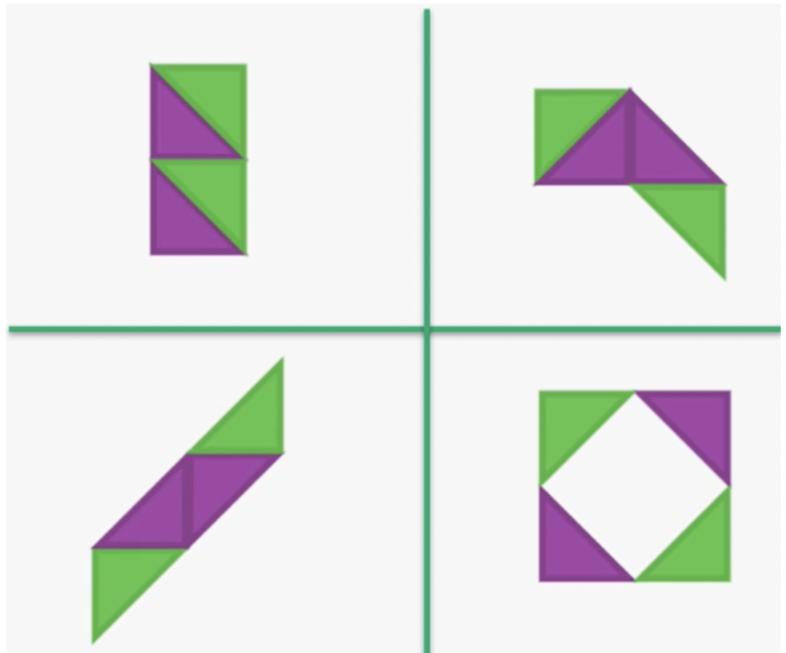
Figure 22: Which one does not belong?

Appendix 1: Sharing cupcakes

Appendix 2: Subitising arrays

Array images
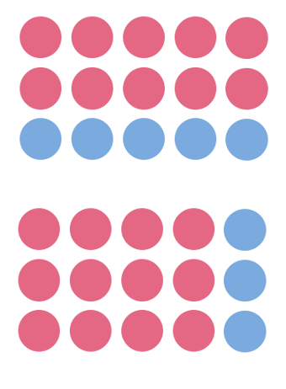

Region model examples
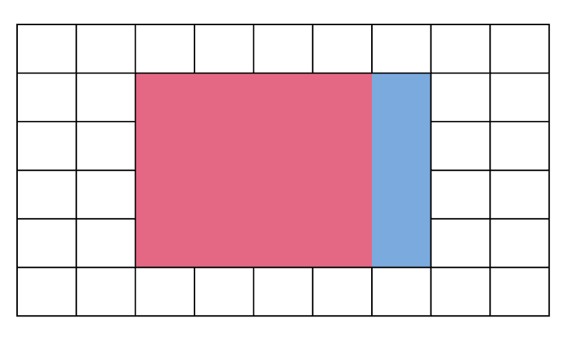
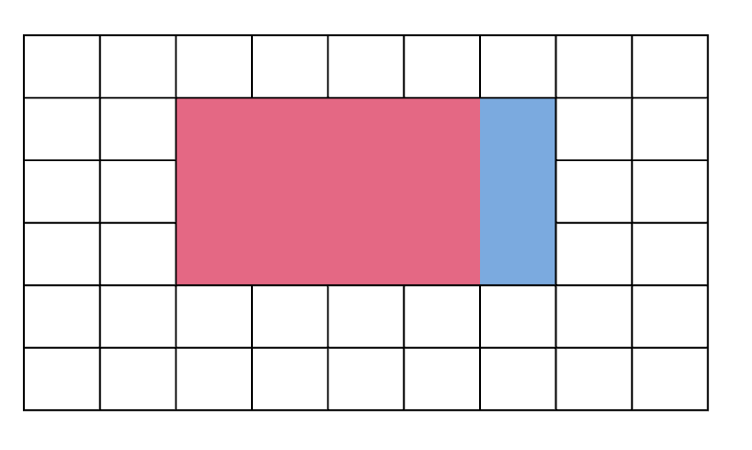

Appendix 3: Understanding the commutative property

Appendix 4: Is 6 fives exactly the same as 5 sixes?

6 fives array

5 sixes array

Appendix 5: Create an array
10 x 10 array

Appendix 6: Partially covered arrays

The blue and green mat
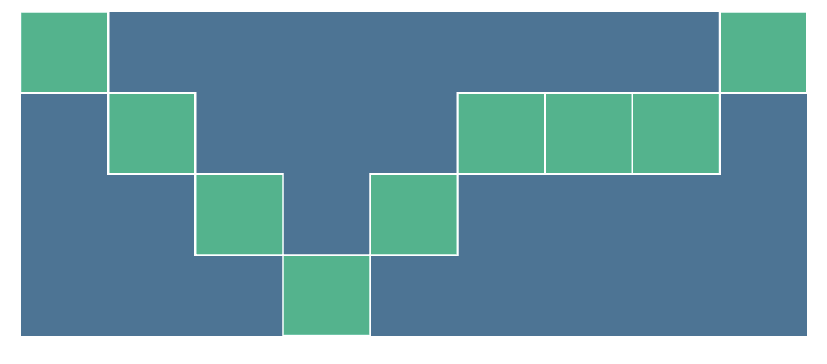

The block of chocolate
My brother ate some of my block of chocolate.
How many squares were in my block of
chocolate before he ate some?
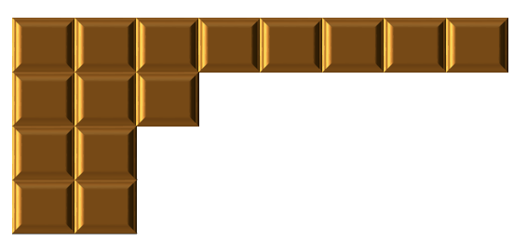

The wrapping paper
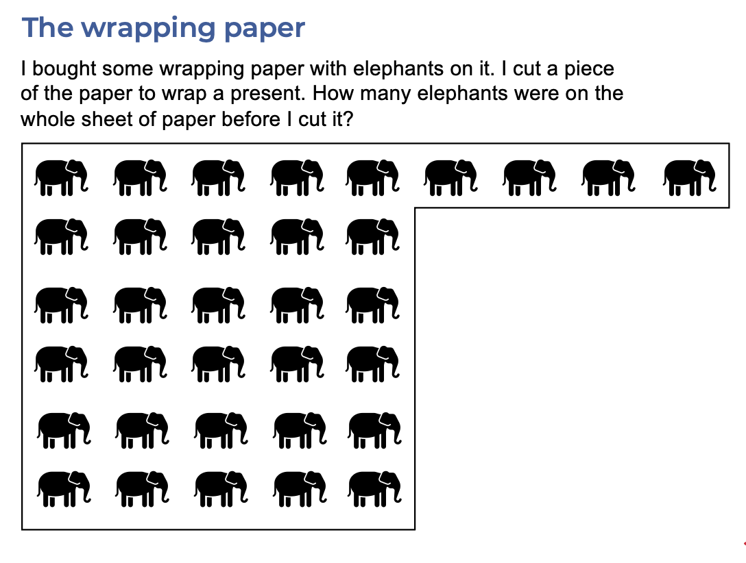

Donuts
This tray had several rows of donuts but some donuts have been eaten. How many
donuts were there when the tray was full?
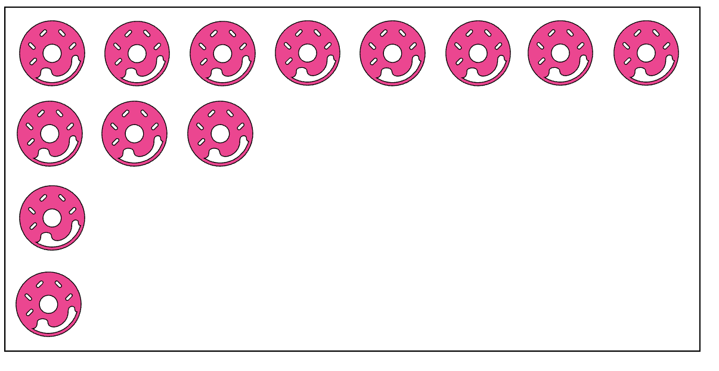

Tiles
This is the bathroom floor with a bathmat on it.
How many tiles are on the whole floor?
How many tiles are covered by the bathmat?
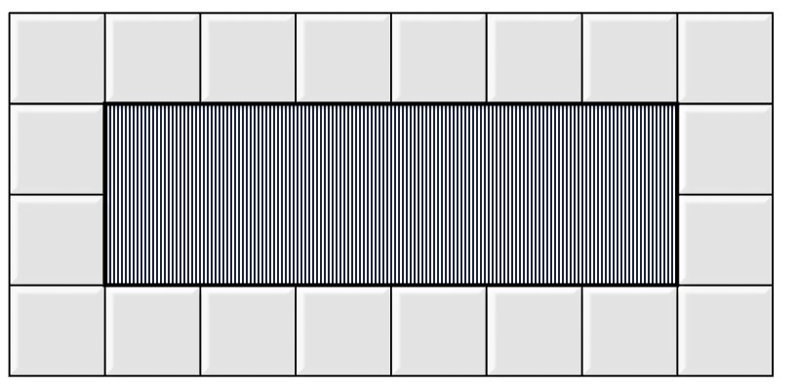

The box of cakes
My dad bought a box of cakes for my party. The cakes were
arranged in rows in the box. Here is the box of cakes after we
all ate some. How many cakes did dad buy?
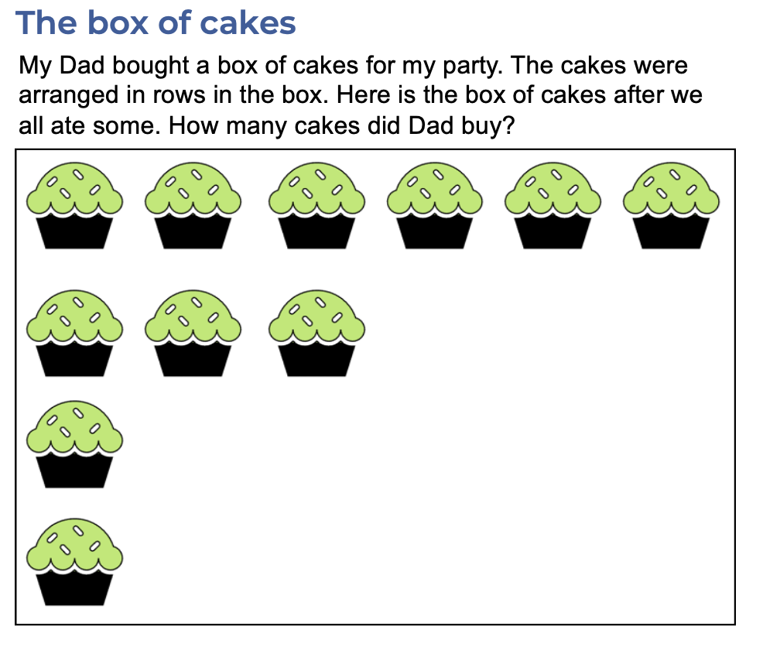
Appendix 7: Multiplication toss

Multiplication toss spinners
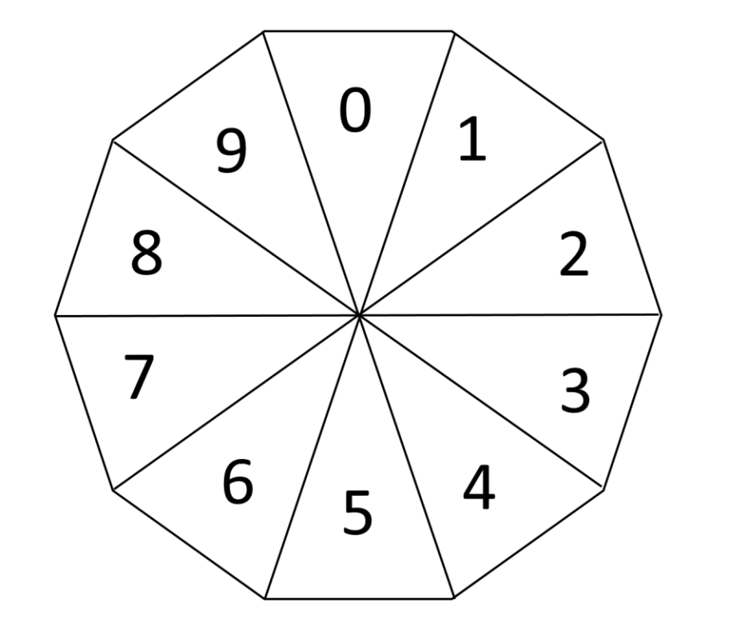

Appendix 8: Relating tens and fives

4 tens and 8 fives

3 tens and 6 fives

Appendix 9: 2s, 5s and 10s bingo

Bingo grid
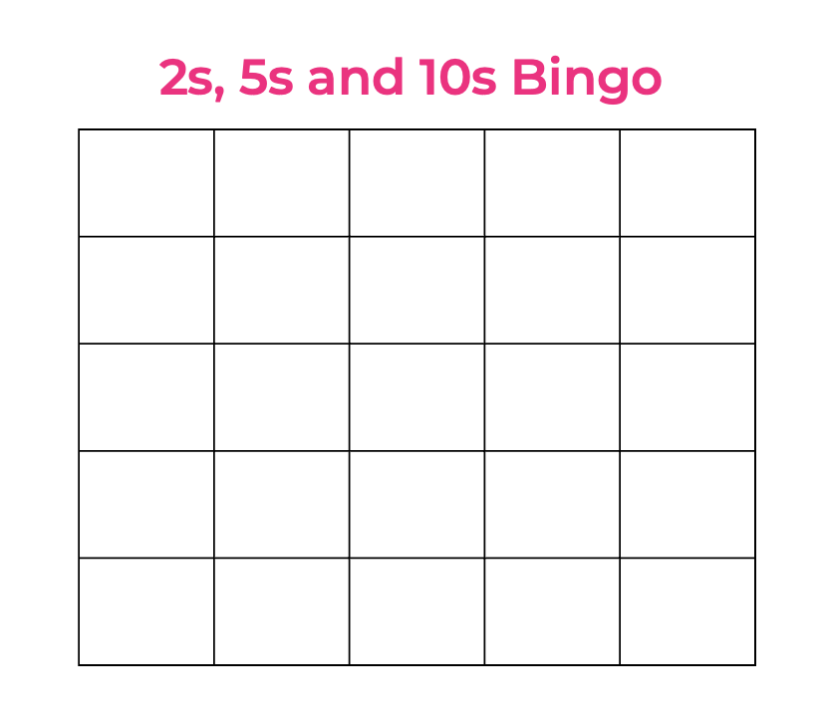

Number fact cards
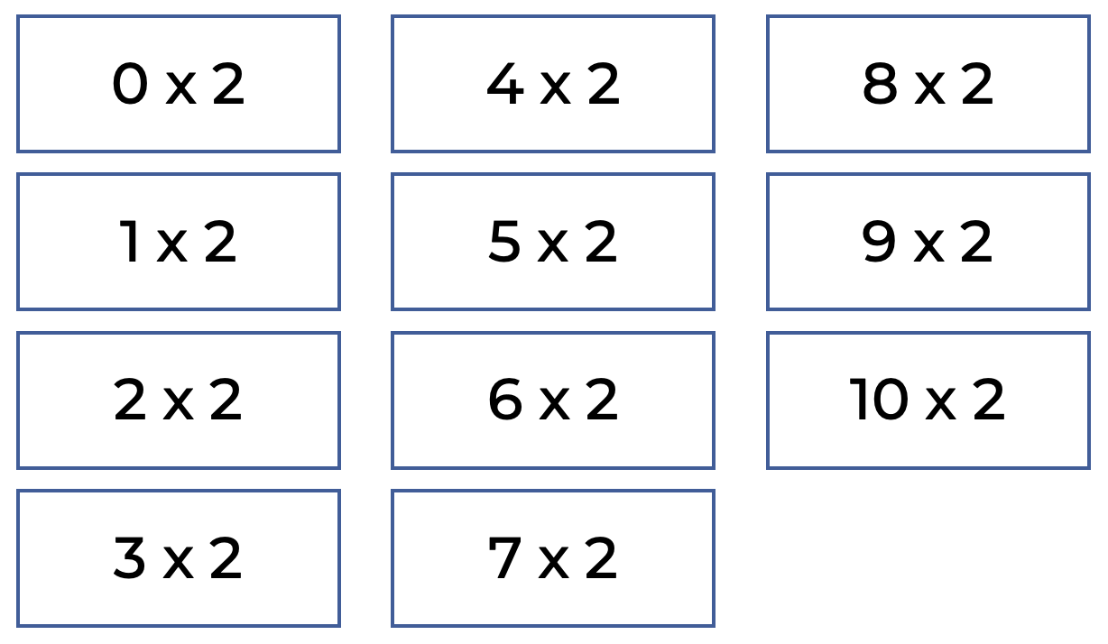
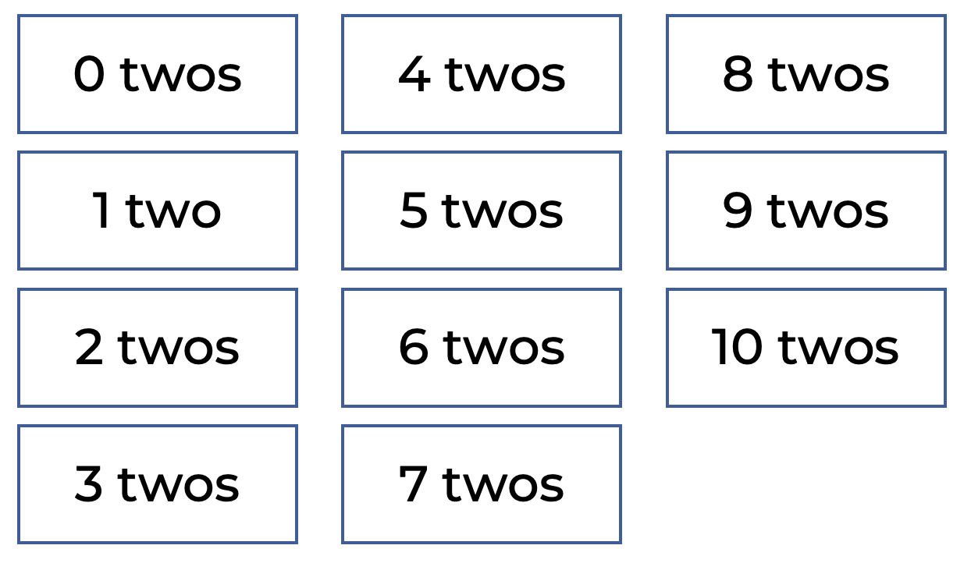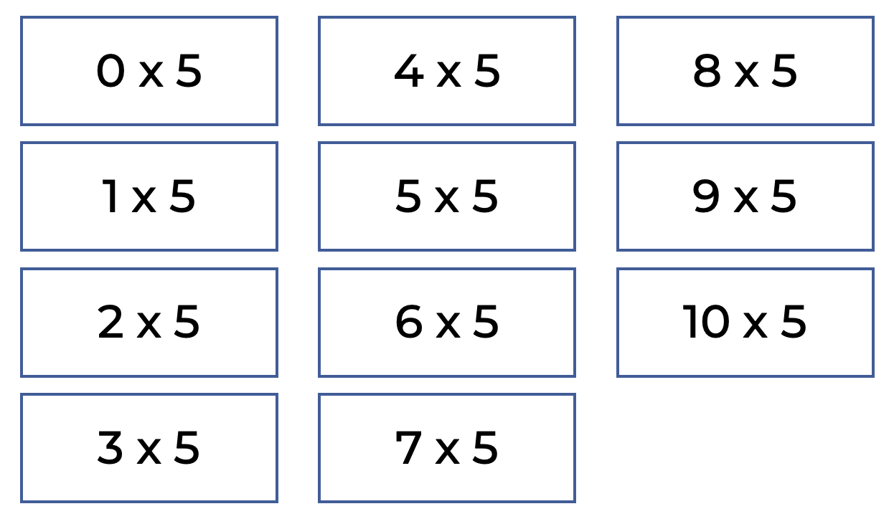
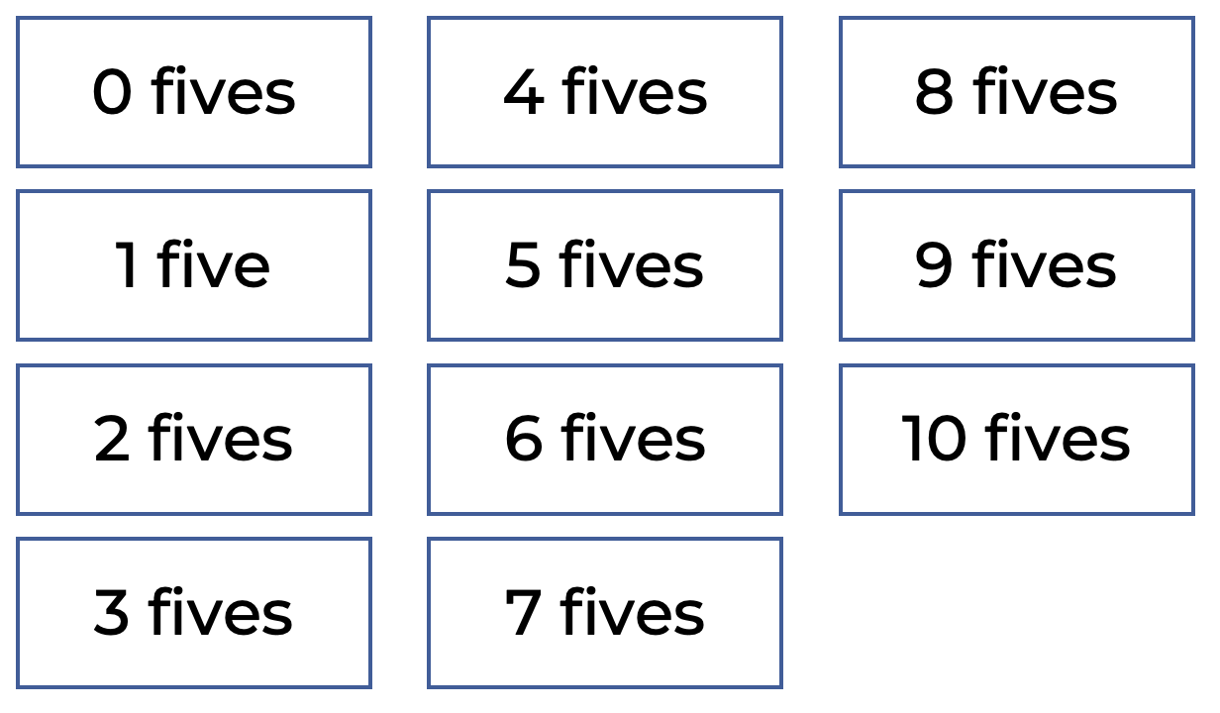
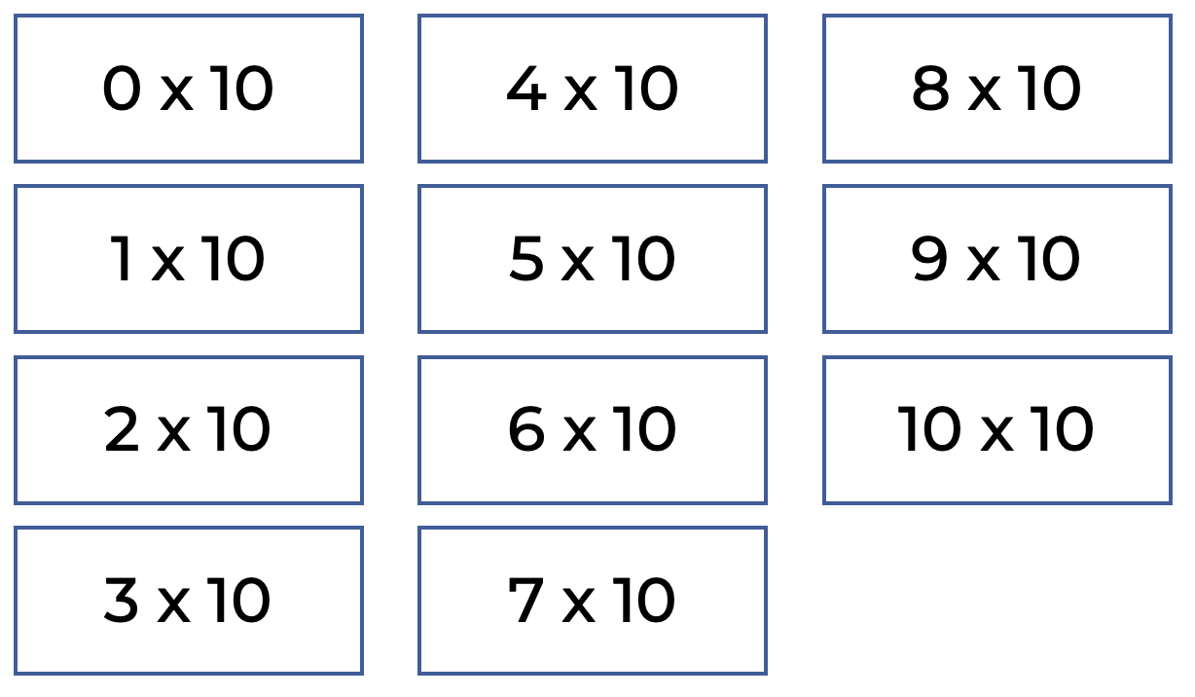
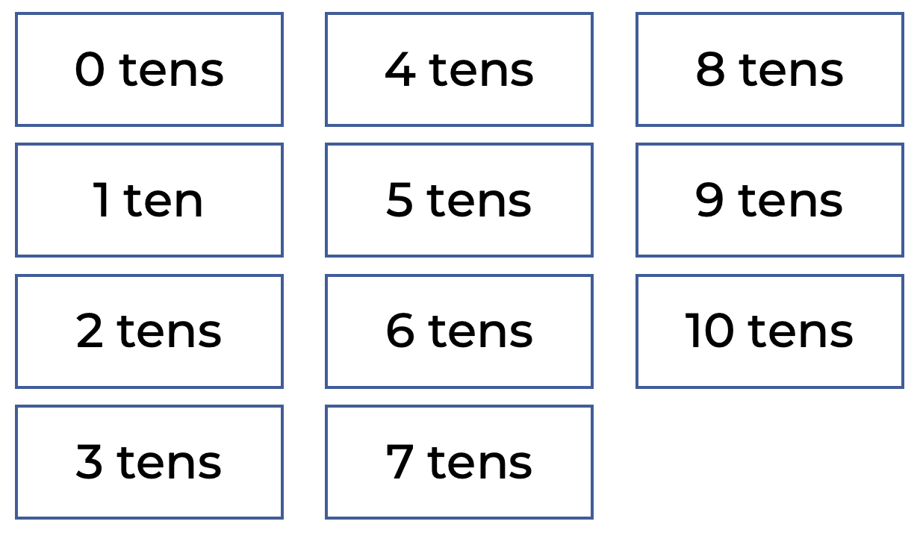

Appendix 10: Doubles fill
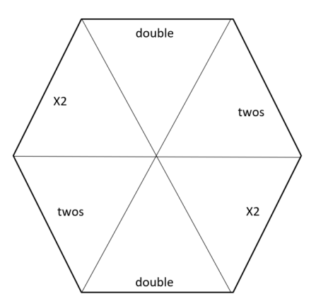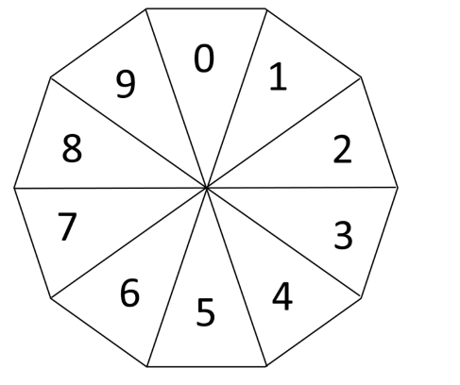

Doubles fill gameboard
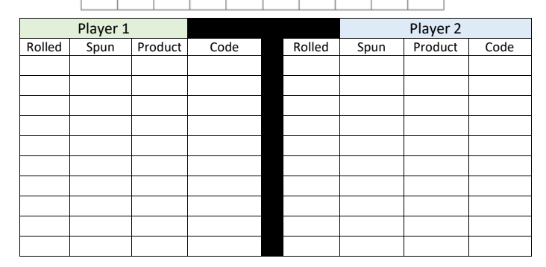

Appendix 11: Multiples madness
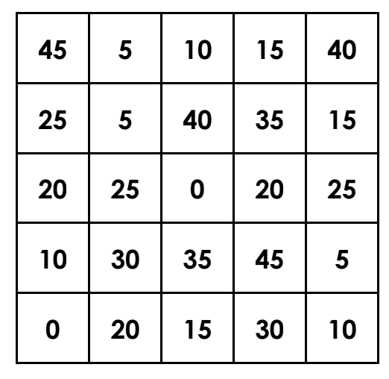
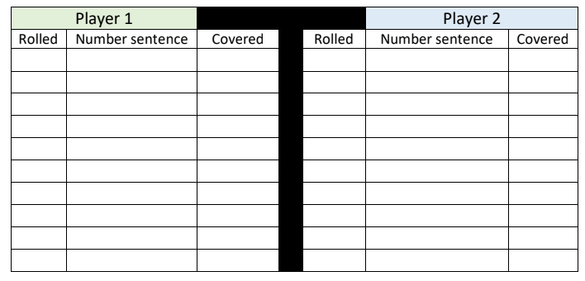

Appendix 12: Factors fun gameboard
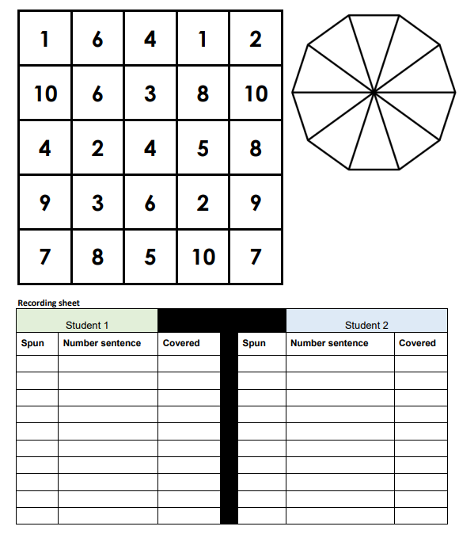

Appendix 13: Introducing multiplication and division grids

Multiplication and division grid
X | 1 | 2 | 3 | 4 | 5 | 6 | 7 | 8 | 9 | 10
1 | 1  one  1 | 1  two  2 | 1  three  3 | 1  four  4 | 1  five  5 | 1  six  6 | 1  seven  7 | 1  eight  8 | 1  nine  9 | 1  ten  10
2 | 2  ones  2 | 2  twos  4 | 2  threes  6 | 2  fours  8 | 2  fives  10 | 2  sixes  12 | 2  sevens  14 | 2  eights  16 | 2  nines  18 | 2  tens  20
3 | 3  ones  3 | 3  twos  6 | 3  threes  9 | 3  fours  12 | 3  fives  15 | 3  sixes  18 | 3  sevens  21 | 3  eights  24 | 3  nines  27 | 3  tens  30
4 | 4  ones  4 | 4  twos  8 | 4  threes  12 | 4  fours  16 | 4  fives  20 | 4  sixes  24 | 4  sevens  28 | 4  eights  32 | 4  nines  36 | 4  tens  40
5 | 5  ones  5 | 5  twos  10 | 5  threes  15 | 5  fours  20 | 5  fives  25 | 5  sixes  30 | 5  sevens  35 | 5  eights  40 | 5  nines  45 | 5  tens  50
6 | 6  ones  6 | 6  twos  12 | 6  threes  18 | 6  fours  24 | 6  fives  30 | 6  sixes  36 | 6  sevens  42 | 6  eights  48 | 6  nines  54 | 6  tens  60
7 | 7  ones  7 | 7  twos  14 | 7  threes  21 | 7  fours  28 | 7  fives  35 | 7  sixes  42 | 7  sevens  49 | 7  eights  56 | 7  nines  63 | 7  tens  70
8 | 8  ones  8 | 8  twos  16 | 8  threes  24 | 8  fours  32 | 8  fives  40 | 8  sixes  48 | 8  sevens  56 | 8  eights  64 | 8  nines  72 | 8  tens  80
9 | 9  ones  9 | 9  twos  18 | 9  threes  21 | 9  fours  36 | 9  fives  45 | 9  sixes  54 | 9  sevens  63 | 9  eights  72 | 9  nines  91 | 9  tens  90
10 | 10  ones  10 | 10  twos  20 | 10  threes  30 | 10  fours  40 | 10  fives  50 | 10  sixes  60 | 10  sevens  70 | 10  eights  80 | 10  nines  90 | 10  tens  100

Siemon, D., Beswick, K., Brady, K., Clark, J., Faragher, R., & Warren, E. (2015). Teaching mathematics. South Melbourne, Vic.: Oxford University Press.

X | 1 | 2 | 3 | 4 | 5 | 6 | 7 | 8 | 9 | 10
1 | 1 | 2 | 3 | 4 | 5 | 6 | 7 | 8 | 9 | 10
2 | 2 | 4 | 6 | 8 | 10 | 12 | 14 | 16 | 18 | 20
3 | 3 | 6 | 9 | 12 | 15 | 18 | 21 | 24 | 27 | 30
4 | 4 | 8 | 12 | 16 | 20 | 24 | 28 | 32 | 36 | 40
5 | 5 | 10 | 15 | 20 | 25 | 30 | 35 | 40 | 45 | 50
6 | 6 | 12 | 18 | 24 | 30 | 36 | 42 | 48 | 54 | 60
7 | 7 | 14 | 21 | 28 | 35 | 42 | 49 | 56 | 63 | 70
8 | 8 | 16 | 24 | 32 | 40 | 48 | 56 | 64 | 72 | 80
9 | 9 | 18 | 21 | 36 | 45 | 54 | 63 | 72 | 91 | 90
10 | 10 | 20 | 30 | 40 | 50 | 60 | 70 | 80 | 90 | 100

Hundreds chart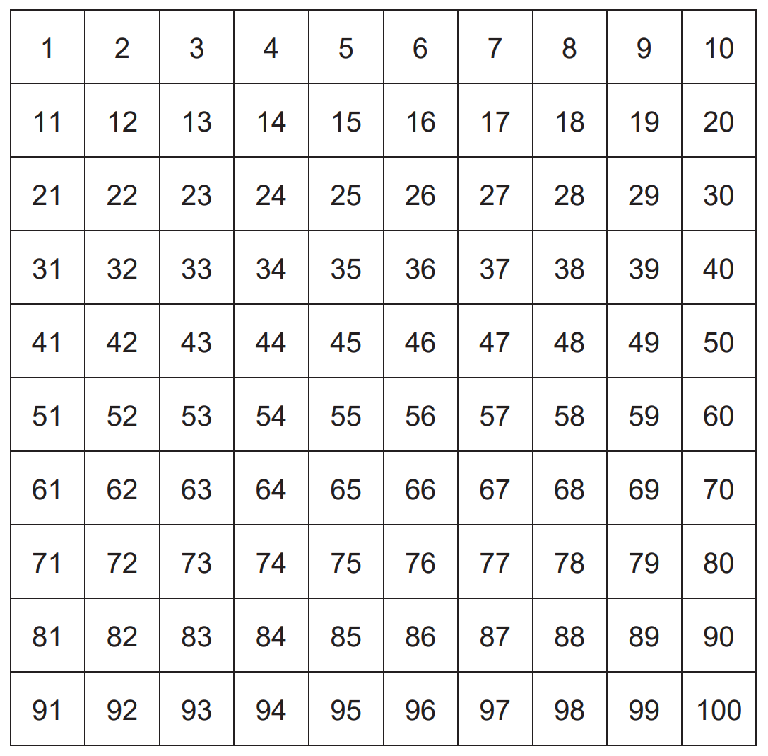

Appendix 14: Partially covered array cards
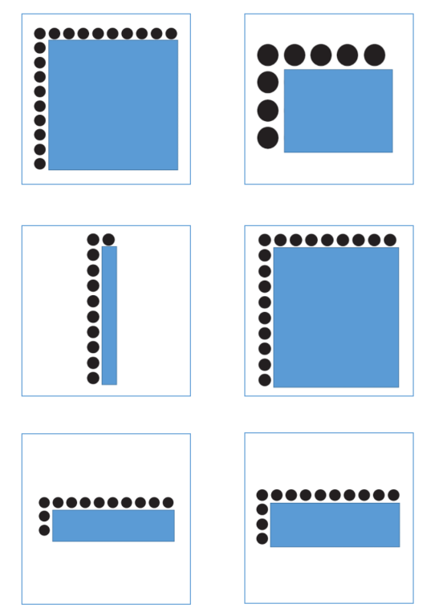 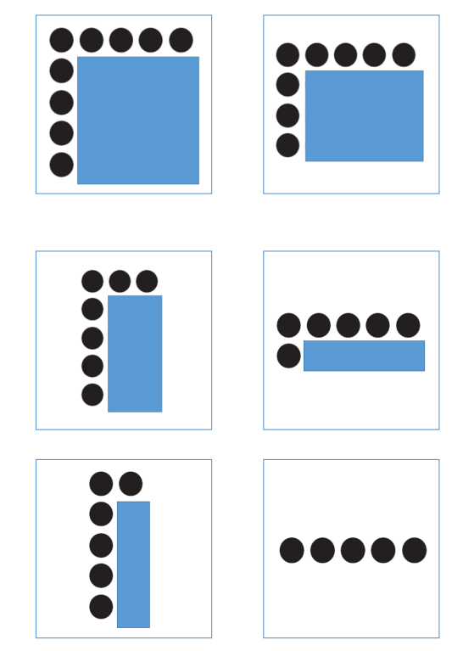 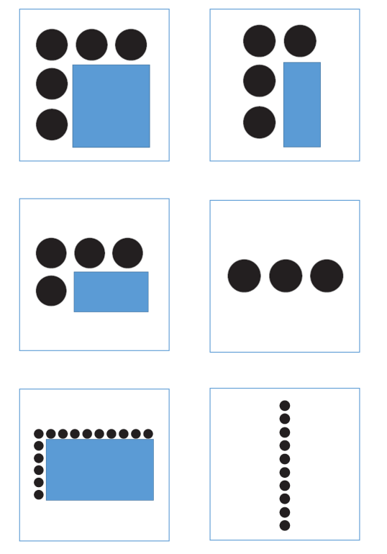 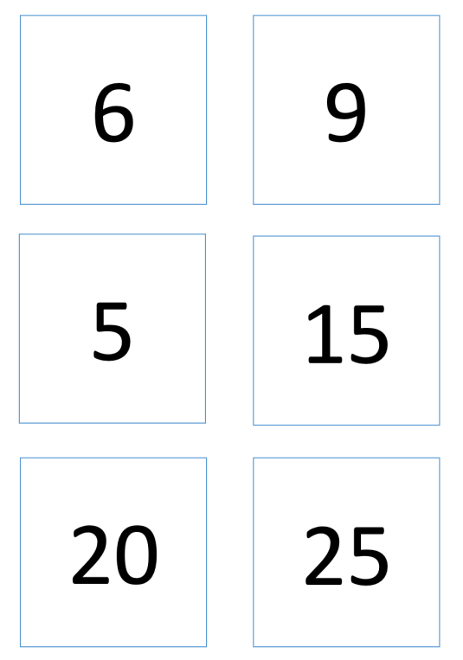 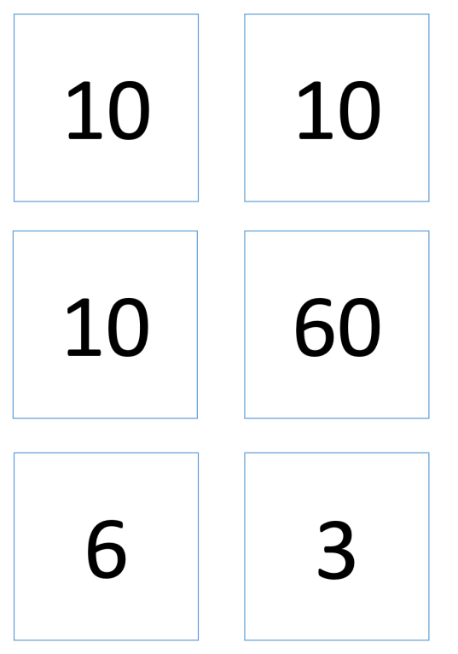 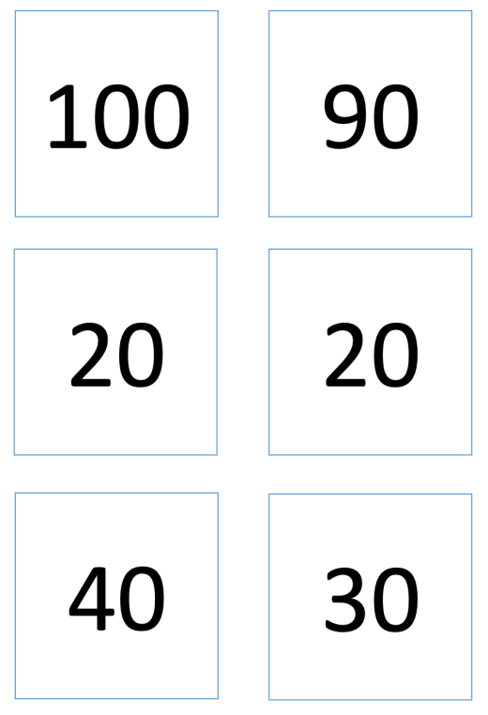

Appendix 15: Double or halve

100s chart
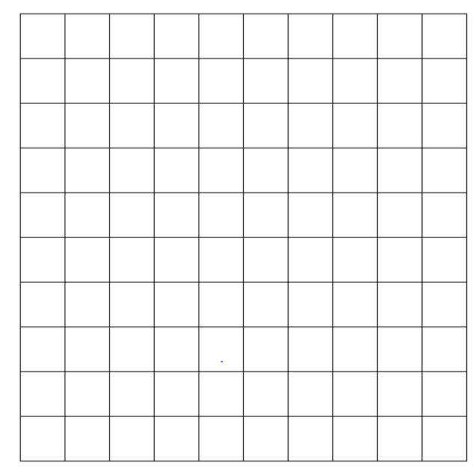

Spinner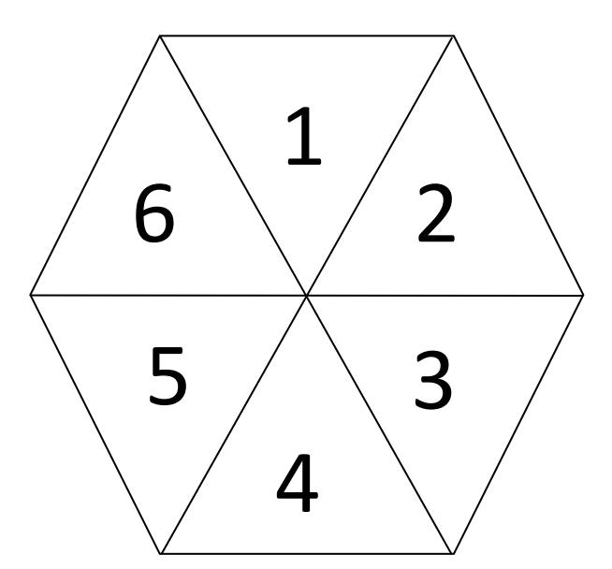

Appendix 16: Understanding the distributive property resource
How do these representations help us see there are lots of ways we could work out 6 sevens?

Appendix 17: Which one doesn’t belong?

Copyright
Section 113P Notice
Texts, Artistic Works and Broadcast Notice
Some of this material has been copied and communicated to you in accordance with the statutory licence in section 113P of the Copyright Act. Any further reproduction or communication of this material by you may be the subject of copyright protection under the Act. Do not remove this notice.

Evidence base
Sparrow, L., Booker, G., Swan, P., Bond, D. (2015). Teaching Primary Mathematics. Australia: Pearson Australia.
Brady, K., Faragher, R., Clark, J., Beswick, K., Warren, E., Siemon, D. (2015). Teaching Mathematics: Foundations to Middle Years. Australia: Oxford University Press.
Alignment to system priorities and/or needs: The literacy and numeracy five priorities.
Alignment to School Excellence Framework: Learning domain: Curriculum, Teaching domain: Effective classroom practice and Professional standards
Consulted with: NSW Mathematics Strategy professional learning and Curriculum Early Years Primary Learners-Mathematics teams
Reviewed by: Literacy and Numeracy
Created/last updated: January 2024
Anticipated resource review date: January 2025
Feedback: Complete the online form to provide any feedback.

