Part 2: building relationships- part-part-whole

About the resource
This resource the second section of a 6-part resource supporting number knowledge. Use this resource is conjunction with other guides to support a connected network of critical mathematical concepts, skills and understanding.
The resource has been developed in partnership with the NSW Mathematics Strategy Professional Learning team, Curriculum Early Years and Primary Learners, and Literacy and Numeracy.
We use numbers to describe the world around us.
Understanding how numbers work is a critical part of developing deep, meaningful mathematical skills, understanding and confidence. This includes the use of flexible additive strategies which are a direct by-product of a student’s number sense.
Like most things in mathematics, talking about number is hard to do without referring to other aspects such as patterns, subitising, counting, fractions, the operations, measurement, and statistics. As such, this resource is best used in conjunction with other guides to support a connected network of critical mathematical concepts, skills and understanding.
- Part 1: Connecting number names, numerals and quantities
- Part 2: Building relationships - part-part-whole
- Part 3: Building relationships - more than, less than, equivalent in value to
- Part 4: Benchmarks of 5 and 10
- Part 5: Comparing, ordering, sequencing and estimating
- Part 6: Building place value (including renaming)

Syllabus
MAO-WM-01 develops understanding and fluency in mathematics through exploring and connecting mathematical concepts, choosing and applying mathematical techniques to solve problems, and communicating their thinking and reasoning coherently and clearly
MAE-RWN-01 demonstrates an understanding of how whole numbers indicate quantity
MAE-RWN-02 reads numerals and represents whole numbers to at least 20
MAE-CSQ-01 reasons about number relations to model addition and subtraction by combining and separating, and comparing collections
MAE-CSQ-02 represents the relations between the parts that form the whole, with numbers up to 10
MA1-RWN-01 applies an understanding of place value and the role of zero to read, write and order two- and three-digit numbers
MA1-RWN-02 reasons about representations of whole numbers to 1000, partitioning numbers to use and record quantity values
MA1-CSQ-01 uses number bonds and the relationship between addition and subtraction to solve problems involving partitioning
NSW Mathematics K-10 Syllabus (2022)

Progression
Number and place value NPV1-NPV4
Counting processes CPr1-CPr5
Additive strategies AdS1-AdS3
Number patterns and algebraic thinking NPA1-NPA2
National Numeracy Learning Progression (NNLP) Version 3

How to use the resource
Teachers can use assessment information to make decisions about when and how they use this resource as they design teaching and learning sequences to meet the learning needs of their students.
The tasks and information in the resource includes explicit teaching, high expectations, effective feedback and assessment and can be embedded in the teaching and learning cycle.
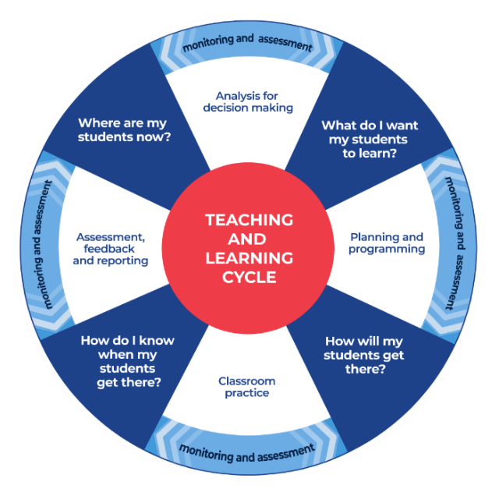
Figure 1: Teaching and learning cycle
- Where are my students now? Teacher uses a range of assessment information to determine what students know and can do, including their interests, learning strengths and needs.
- What do I want my students to learn? Teachers use the information gathered along with the syllabus and NNLP to determine the next steps for learning. Teachers might also like to look at the ‘what’s some of the maths’ and ‘key generalisations’ to synthesise the information they have gathered into the next step/s for learning.
- How will my students get there? Teachers can then use the task overview information (‘What does it promote?’ and ‘What other tasks can I make connections to?’) to find tasks that meet the learning needs of students. Teachers then make decisions about what instructional practices and lesson structures to use to best support student learning. Further support with What works best in practice is available.
- How do I know when my students get there? Teachers can use the section ‘Some observable behaviours you may look for/notice’ that have been articulated for each task as a springboard for what to look for. These ideas can be used to co-construct success criteria and modified to suit the learning needs, abilities and interests of students. Referring back to the syllabus and the NNLP are also helpful in determining student learning progress as well as monitoring student thinking during the task. The information gained will inform ‘where are my students now’ and ‘what do I want them to learn’ as part of the iterative nature of the teaching and learning cycle.

Overview of tasks
Task name | What does it promote? | What other tasks can I make connections to? | What materials will I need? | Possible group size
Introducing Rekenreks | Mathematical representations help us attend to important mathematical structures. By attending to the structure of fives and tens in a Rekenreks, we can help build important part-part-whole relationships. | How to make a Rekenreks | - Rekenreks | Small group
6 is... | The same quantity can be partitioned in different ways and we can use colour to help us show the parts we see inside a quantity | Ducks away | - Building blocks  - Coloured markers | Small group
Building towers | Composing and decomposing quantities builds flexible additive strategies such as bridging to ten, number bonds, doubles and near doubles. |  | - Building blocks  - Dice  - Appendix 1: Numeral cards  - Writing materials | Small group
Dotty 6 | Using games with dice patterns can help build familiarity with spatial patterns. This game also explores the parts that can be combined to form six. |  | - Paper  - Appendix 1: Numeral cards  - Writing materials | 2 teams of two
Number Busting 26 | Exploring different ways to decompose (partition_ collections can support part-part-whole number knowledge. | Number Busting 7  Snap it (youcubed) | - 26 items  - Writing materials | Whole class
Rekenreks Duel 1 and 2 | The structure of Rekenreks supports us to see relationships to fives and tens. | Partitioning (resolve) | - Rekenreks  - Appendix 2: Numeral cards  - Writing materials | 2 players or two teams of two or small group
Power dot pro | This task provides an opportunity for students to apply their part-part-whole knowledge when combining multiple addends. |  | - Tiny Polka Dot Cards or single dominoes | Small group

Introducing Rekenreks

Key generalisations / what’s (some of) the mathematics?
- Bigger numbers are made up of smaller numbers.
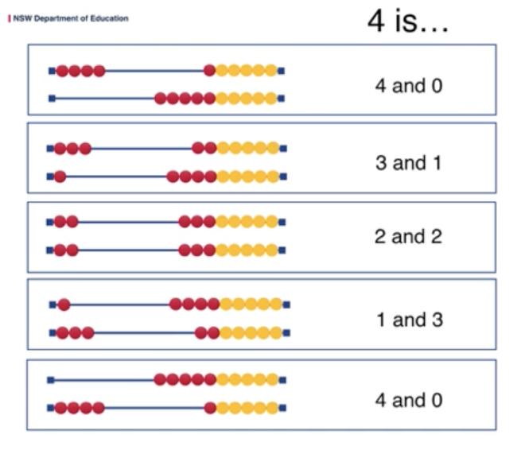
Figure 2: Image of examples of ‘4 is’
- We can think about 4 as ‘5 with one left behind’.
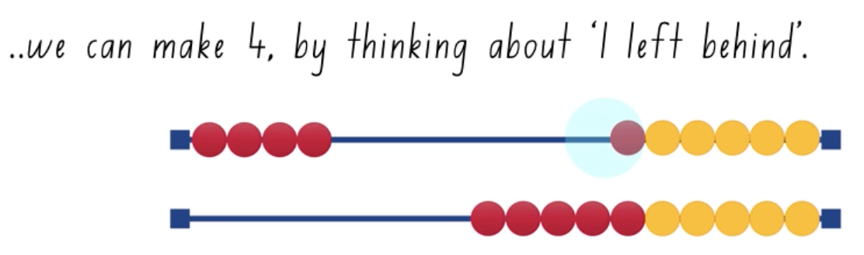
Figure 3: Image of written examples of ‘4 is’
- Different people see and think about numbers and problems in different ways. Listening to other people’s thinking helps us become aware of other ways of thinking, building our flexibility in mathematics
- Mathematicians use what they know about numbers to solve problems
- Mathematicians know there can be more than one way to solve the same problem
Teaching point: When talking about part-part-whole that entails 2 critical relationships: the parts a quantity can be decomposed into or composed of (for example, 8 can be partitioned into 5 and 2 and 1) and; all numbers can be related to other wholes (for example, 8 is 2 less than 10, it is 3 more than 5 and it is 12 less than 20).

Some observable behaviours you may look for/notice
- Notices the mathematical features of Rekenreks. For example, explains the two colours each represent a collection or group of 5; there are 2 fives in each row; there are 2 tens in total, 1 ten on top row and 1 ten on the bottom row; there are 20 beads in total
- Connects quantities with numerals and number names in the range of 1–20
- Describes their thinking using phrases such as double, near double, 1 more 1 less, 2 more, 2 less, leaving 1 behind, leaving 2 behind, and so on.
- Uses known facts to determine how many. For example, knows 5 and 2 more is 7
- Uses knowledge of relationships between quantities to determine how many. For example, knows 8 is 2 less than 10
- Describes teen numbers as 1 ten and some more
- Uses counting to determine how many
- Considers how many more or less to get to the nearest five or ten
- Explains a collection can be organised in different ways but still represent the same quantity (for example, 4 is 4 and 0, 3 and 1, 2 and 2, 1 and 3, 0 and 4)
- Listens to the thinking of others, using their ideas to refine and extend thinking

Materials
- Rekenreks

Instructions
- View Introducing Rekenreks with students
- After watching the video, have students think about this problem:
Mum gave us some baby carrots for a snack. There were 8 in total. Some carrots were on my brother's plate and some carrots were on my plate.
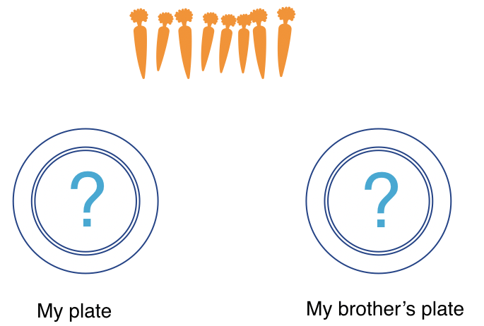
Figure 4: My plate and my brother's plate
- Reflect and discuss:
  - How many carrots might have been on my plate?
  - How many carrots might have been on my brother’s plate
  - Find as many solutions as you can.
  - You can use your Rekenreks to help you solve the problem.
  - Then, record your thinking.

6 is...

Key generalisations / what’s (some of) the mathematics?
- Numbers can be broken up into smaller parts (part-part-whole)
- Smaller numbers can be found hiding inside of bigger numbers (hierarchical inclusion)
- Tools such as connecting blocks can help us to explore and see the smaller numbers inside of bigger numbers with greater efficacy than other tools
- Different representations of quantities can help us to see different ways of partitioning (breaking apart) a quantity
- Describes a quantity by talking about some of its smaller parts (part-part-whole). For example, ‘six is three, two and one’
- The intentional use of colour can help us and others to understand our thinking with greater clarity
- Mathematicians can see the same collection in different ways
- Mathematicians use what they know about mathematical regularities like standard dice patterns to answer the question: ‘how many?
- Mathematicians use pictorial representations to show their thinking and support conclusions

Some observable behaviours you may look for/notice
- Trusts collections can be organised in different ways but still represent the same quantity (for example, 6 is 4 and 2, 3 and 3, 2 and 2, 2) (conservation)
- Considers different ways of describing combinations of a total (for example, 6 is 3 and 3, 6 is double 3 or 6 is 2 threes)
- Represents quantities using different structures, proving quantities can be made up of different parts but still equal the same whole (equivalence)
- Identifies a quantity is made up of smaller parts
- Creates a system to find all the different ways of making a collection (for example, all the ways to make 6 using 1, 2, and 3 colours)
- Represents mathematical problems using diagrams to prove their thinking (for example, all the different ways to solve the problem)

Materials
- Building blocks
- Coloured markers

Instructions
- View 6 is…
- Have students consider what are all the different ways we can make 6? Investigate by using blocks or by drawing the blocks using coloured pencils.
- How many ways can you make 6…?
  - with just one colour pencil?
  - with 2 different colours?
  - with 3 different colours?

Building towers

Key generalisations / what’s (some of) the mathematics?
- Numbers are made up of smaller numbers (part-part whole). For example, 8 is
  - 5 and 3
  - 2 threes and 2 more
  - 2 more than 8
  - 2 fours, and so on.
- We can use knowledge of part-part whole relationships to determine ‘how many more’. For example, because we know inside of 7 is 5 and 2, we also know 7 is 2 more than 5
- Materials such as blocks, Rekenreks, bead strings, ten-frames, dice, dominos and even our hands can help us to explore some of the smaller numbers can be found inside of bigger numbers
- Mathematicians use mathematical reasoning to analyse games as they are playing them, using this information to strategise and hopefully improve their chances of winning a game.
Teaching point: Providing students with opportunities and experiences in composing and decomposing numbers can assist in the development of flexible additive strategies. When students know the parts of numbers and see how they relate to other numbers, they are able to use this understanding to additive problems, using derived facts, bridging to ten, and so on.
For example, a student can use what they know about double 3 to determine 3 and 4 is double 3 and then 1 more (as 4 is one more than 3), totalling 7.

Some observable behaviours you may look for/notice
- Uses known facts and strategies to determine how many there are in a collection. For example, “I had 2 and then I rolled a 5. I know 7 is 2 more than 5”
- Uses counting to determine how many
- Identifies a quantity is made up of smaller parts
- Explains how many more are needed to reach the target number/win the game
- Provides information about how they arrived at an answer. For example, explains “I have 11 here as I had 5 and then I rolled 6. I counted on from 5, 6, 7, 8, 9, 10, 11. That’s 6 number words I said so 5 and 6 combines to be total to 11”
- Describes who has more/less blocks and who is closest to the target number
- Draws diagrams and/or orders towers using language like smallest to largest to describe their order

Materials
- Building blocks
- Dice
- Appendix 1: Numeral cards
- Writing materials

Instructions
View building towers to learn how to play.
- Players choose 4 numbers to build as towers, for example, 5, 7, 11 and 3.
- Take turns to roll a die and use the number of bricks to build up their towers.
- Towers can be built up in any way you choose.
- Take turns to build up your towers until one player gets the exact roll to complete the last tower.
- You can also play this in reverse.
- Talk about how many you have, how many more you need, what strategies you used, and so on.
- Reflect and discuss:
  - If you were to play the game again tomorrow, what is one thing you would do differently? Why?
  - Draw a picture that shows the towers you built in order of shortest to tallest.

Variations
- Build the towers and play in reverse. Taking away blocks each time until there are no blocks left.
- Change the number of towers you build.
- Change the number of blocks needed for each tower.

Dotty 6

Key generalisations / what’s (some of) the mathematics?
- Knowing numbers nest inside other numbers (having part-part-whole number knowledge) is helpful when solving problems
- There are many ways of combining quantities to total. For example, 6 is:
  - 5 and 1
  - 4 and 2
  - 3 and 2 and 1
  - 4 and 1 and 1, and so on.
- Arranging quantities in spatial structures like dice patterns can be useful in keeping a track of our total without having to recount everything
- Mathematicians use mathematical reasoning to analyse games as they are playing them, using this information to strategise and hopefully improve their chances of winning a game

Some observable behaviours you may look for/notice:
- Instantly recognises quantities represented by dice patterns
- Connects quantities with numerals and number names in the range 1-6
- Determines the total of a collection by “looking and thinking”, using what is known about spatial patterns and familiar number facts (bonds)
- Identifies a quantity as a result of recognising and combining smaller parts (for example 6 is 4 and 2)
- Describes spatial patterns as a way of keeping track of a total. For example, explains “I can see we have 6 as I can see 1 four dice pattern in orange and two more dots on top in red to look like a 6 dice pattern”
- Explains why they can or cannot place their amount in a particular space (for example, “I cannot put my four in this space as there is already 1 four there. 2 fours would be larger than 6 so the space would have too many dots.”)
- Analyses the game board and makes strategic decisions about where to place quantities to increase their chance of winning.

Materials
- Paper (to make your game board and your number cards)
- 3 sets of Appendix 1: Numeral cards
- Writing materials

Instructions
View Dotty 6 to learn how to play.
- Teams take turns to roll the dice and put the corresponding number of dots into a box.
- Teams can put their dots anywhere, but they cannot have more than 6 dots in any box.
- Teams must put all their dots in 1 box.
- A team wins if they finish the row, column or diagonal of complete boxes (6 dots in each).
- If a team cannot go, they miss a turn.
Teaching point: You may like to show students a video of the game being played without audio. Can they work out the rules?

Variations
- Change the total. So instead of Dotty 6, make it Dotty 12 or Dotty 21.
- Change the number cards you use. So instead of numbers 1 - 6, you could make cards from 1 - 10, or only use odd numbers, and so on.
- Change the grid from 3 x 3 to 4 x 4

Number busting 26

Key generalisations / what’s (some of) the mathematics?
- Bundling and unbundling objects can help us see the way we can regroup and rename equivalent collections. For example, it helps as see 10 ones is 1 ten, and 1 ten is 10 ones
- You can work out how many there are in a collection (you can quantify a collection) in different ways
- In our number system, every time we collect 10 of something, we regroup and rename it. This is a kind of pattern. For example, 10 ones is renamed as 1 ten; 10 hundreds is renamed as 1 hundred
- Mathematicians can see the same collection in different ways
Teaching point: An excellent resource to help students to see the concept of place value is the students’ own fingers – not to count by ones, but to show groups of tens and ones. Most students instantly recognise the fingers of two hands as a powerful representation of ten. This representation has the advantage that the ten can be viewed as 1 ten, as 10 ones, or as pairs of numbers that combine to total ten. For example, 7 and 3 (NSW Department of Education, 2007). You can learn more about how to use hands to build place value understanding in Hands Up: engaging students as a resource for teaching article.
Bundling and unbundling paddle pop sticks or straws has the same advantages and also allows for the physical exchange of 10 ones into 1 ten, and likewise, 1 ten into 10 ones.

Some observable behaviours you may look for/notice
- Partitions collections in a variety of ways using knowledge of number bonds to 10 and 20, doubling, halving, place value
- Describes a collection in terms of its place value parts, using renaming to describe collections of tens and ones. For example, describes 26 as 2 tens and 6 more: 1 ten and 16 ones
- Visualises a quantity and describes its structure
- Records various ways of partitioning a quantity using the language of place value, diagrams, concrete materials
- Intentionally uses colour to demonstrate how a collection was combined or separated
- Compares their thinking to the thinking of others, noticing similarities and differences
- Refines/extends thinking after listening to others

Materials
- 26 items (for example, pasta pieces, counters or pencils)
- Writing materials

Instructions
View ‘Number Busting’ to learn how to number bust.
- Get 26 items (for example, pasta pieces, counters or pencils).
- Have students organise and describe their collection.
- Guide students to reorganise and describe their collection as many times as they can in 5 minutes.
- Have students draw and record all of their ways of thinking about their collection.
- Play number busting again.

Rekenreks duel 1 and 2

Key generalisations / what’s (some of) the mathematics?
- Tools such as Rekenreks can help us see important relationships such as the way smaller numbers nest inside bigger numbers. We also sometimes talk about this as part-part-whole. For example, 7 is:
  - 5 and 2
  - 3 and 4
  - double 3 and 1 more.
- Rekenreks can also help us see relationships with other wholes. For example, 7 is:
  - 3 less than 10
  - 13 less than 20
  - one less than 8
  - 2 more than 5.
- You can use part-part-whole knowledge to determine ‘how many more’ for example, inside of 10 is 8 and 2, so I know if I have 8, I need 2 more to make 10
- You can use part-part-whole knowledge to determine ‘how many less’ for example, inside of 12 is 10 and 2, so I know if I have 12, I need 2 less to make 10
- Knowing the smaller numbers nest inside bigger numbers helps me solve problems efficiently and flexibly
- Mathematicians use what they know about numbers to solve problems in multiple ways
Teaching point: Asking students to move the beads in one or two moves is an important rule as it encourages students to use part-part-whole knowledge and their understanding of important relationships to make their move.
In the following excerpt from a classroom conversation, the student’s knowledge that 5 is composed of 4 and 1, enables them to use the ‘left behind’ strategy when making their move.
Teacher: “Can you move 4 beads in one move?
Student: [moves the beads]
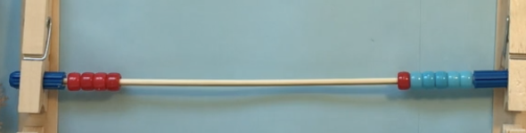
Figure 5: beads on the Rekenreks
Teacher: “Please share your thinking with me. How did you know it was 4 beads?”
Student: “I know that inside of 5 you can find 4 and 1. So I know I can move 4 beads by leaving one behind in that chunk of colour. Each coloured chunk has 5.”
This ‘left behind’ strategy could also be extended into larger quantities for example, moving 18 beads by leaving 2 behind. This strategy connects to part-part-whole by drawing on a student’s understanding of how a number relates to other whole numbers.

Some observable behaviours you may look for/notice
- Connects quantities with numerals and number names in the range of 1–20
- Uses the mathematical features of a Rekenreks to help make a move. For example, because each chunk of colour is a collection of 5, moves 4 beads by leaving 1 bead behind
- Uses known facts to make a move. For example, knows 5 and 2 more is 7
- Uses knowledge of relationships between quantities to make a move. For example, knows 8 is 2 less than 10
- Uses knowledge of teen numbers as 1 ten and some more
- Uses counting to make a move
- Describes a quantity by talking about some of its smaller parts up to 20 (part-part-whole). For example, ‘Eighteen is five and thirteen’.
- Describes their thinking using phrases such as double, near double, 1 more 1 less, 2 more, 2 less, leaving 1 behind, leaving 2 behind, and so on.
- Listens to the thinking of others, using their ideas to refine and extend thinking
- Considers how many more or less to get to the nearest five or ten

Materials
- Rekenreks (class set)
- Appendix 2: Numeral cards
- Writing materials

Instructions
View Rekenrek dual to learn how to play

Power dot pro

Key generalisations / what’s (some of) the mathematics?
- Numbers can be represented in many different ways. You can use things like pictures, words, symbols and concrete materials to represent them
- There are many ways of combining quantities to make a total. For example, to have a total of 9, you could:
  - combine 6 and 3
  - combines 8 and 1
  - combine 3 and 4 and 2
  - combine 2 fours and 1 more, and so on.
- Different representations of quantities can help us to see different relationships between numbers
- Using familiar spatial structures like ten-frames, dice patterns, domino patterns, finger patterns, and so on., can help us use more efficient strategies to determine ‘how many’?
- Different people see and think about numbers and problems in different ways
- Listening to other people’s thinking helps us enrich our understanding and strategies

Teaching point: Here are some questions and prompts you might like to ask as students play:
“How did you know how many dots there were (after one card is flipped)?”
“How did you see the dots?”
“Which colour of cards/structures are the easiest to add/combine for your brain? Why?”
“What’s the highest total you think you could get in this round? Why?”
Games like Power dot pro can be the inspiration for whole-class challenges and discussions. For example, select any 6 cards from the deck. Pose the question: If we combined the quantities represented on these 6 cards, what:
- is the smallest possible total?
- the largest possible total?
- do you predict the total might be?
Then, reveal one card and ask: Now we know we have one quantity, what do you predict the total might be now? Would you revise your thinking? Why/Why not?
You could then use this task as the stimulus for a number talk, asking students to share their ideas about the different strategies they could use to determine the total (sum) of the 6 cards.

Some observable behaviours you may look for/notice
- Connects quantities with numerals and number names in the rage of 0-5
- Instantly recognises collections up to three or four without needing to count
- Instantly recognises quantities represented by familiar patterns (dice patterns, ten-frames, five-frames, dominoes, fingers, and so on.)
- Uses known facts, patterns and strategies to determine how many there are in a collection without having to count all by ones
- Describes what knowledge was used to determine the total, such as known facts, doubles, near doubles, relationships like 1 more or 2 more, counting, and so on.
- Identifies who has won the game by finding the largest total and uses descriptive language to describe who has the most. For example, “I have two more than Michelle and one more than Sarah, so I have the most”
- Makes predictions about who will win a round by analysing the quantities dealt. For example, “I turned over a 4 and a 3. You will need to 8, 9 or 10 to win!”

Materials
Dan Finkel and the Math for Love team have generously allowed us to share the Tiny Polka Dot starter kit with our department schools.
The Tiny Polka Dot Cards are available for printing. Download, print and cut out the cards to start playing. Alternatively, use single dominoes.

Instructions
- View Power dot pro to learn how to play
- Power dot pro is best for 2-3 or 2 teams of 2 or 3 players.
- Divide the deck evenly among the players/teams.
- Before each game, decide how many cards will be flipped over in each turn (for example, we will each flip over 2 cards) then all players turn over that many cards from their deck.
- Whoever has the largest sum/total wins the round and puts all the cards on the bottom of their pile.
- In case of ties, each player turns over another card and adds it to their previous total.
- The game is over when someone runs out of cards.
Example play
Round 1: Players decide 2 cards will be flipped over. Then each player turns over 2 cards from their deck. Player 1 turns up a 4 and a 3, for a total of 7, and Player 2 turns up a 9 and a 0, for a total of 9. Player 2 wins all four cards and puts them on the bottom of their deck.
Round 2: Players decide 3 cards will be flipped over. Player 1 turns up a 5, 6, and 8, for a total of 19. Player 2 turns up a 1, 10, and 8, for a total of 19. Since players are tied, they each turn another card over. Player 1 turns up a 3, and Player 2 turns up a 1, making their totals 22 to 20. Player 1 takes all the cards, and play continues.

Variations
- Adjust the number range by taking cards out.
- Use single dominoes instead of tiny polka dot cards.

Appendix 1: Numeral cards 0-6
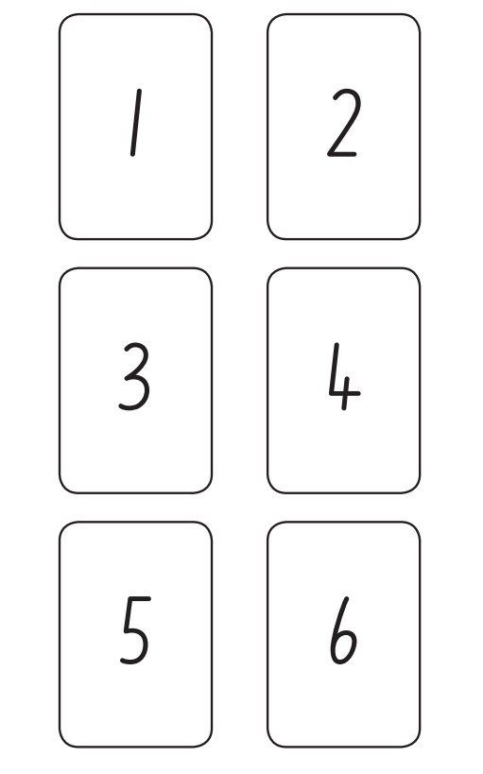

Appendix 2: Numeral cards 0-20

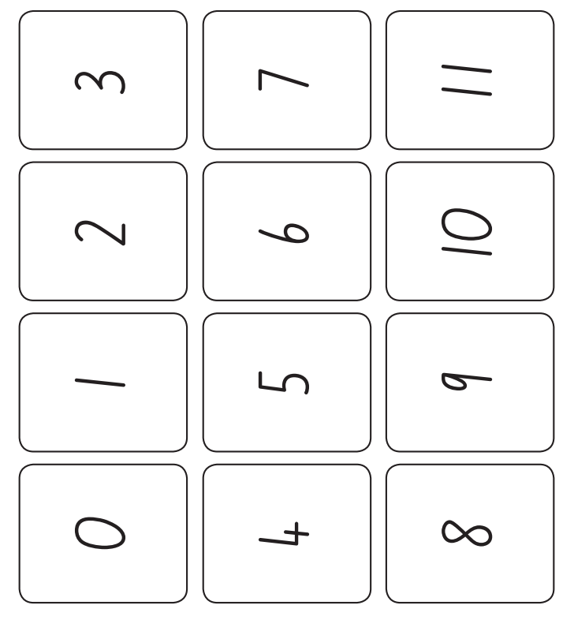
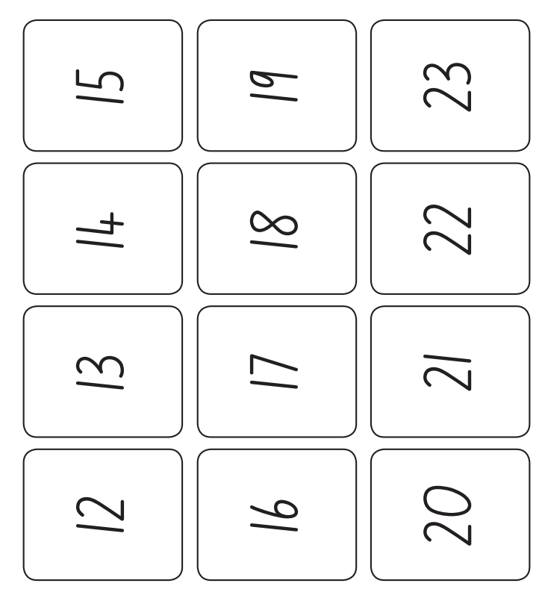

Reference list
Mathematics K–10 Syllabus © NSW Education Standards Authority (NESA) for and on behalf of the Crown in right of the State of New South Wales, 2022.
National Numeracy Learning Progression © Australian Curriculum, Assessment and Reporting Authority (ACARA) 2010 to present, unless otherwise indicated. This material was downloaded from the Australian Curriculum website (National Literacy Learning Progression) (accessed 6 November 2023) and was not modified.
Australian Government Department of Education (2020) ‘Partitioning’, Teaching resources, reSolve: Maths by Inquiry website, accessed 17 November 2023.
Finkel D (2020) ‘Tiny Polka Dot starter deck’, math for love website, accessed 17 November 2023.
Stanford University (n.d.) ‘Snap it’, Tasks, youcubed website, accessed 16 November 2023.
State of New South Wales (Department of Education) (2023) ‘6 is…’, Mathematics K-6 resources, NSW Department of Education website, accessed 16 November 2023.
State of New South Wales (Department of Education) (2023) ‘Building towers’, Mathematics K-6 resources, NSW Department of Education website, accessed 16 November 2023.
State of New South Wales (Department of Education) (2023) ‘Dotty 6’, Mathematics K-6 resources, NSW Department of Education website, accessed 16 November 2023.
State of New South Wales (Department of Education) (2023) ‘Ducks away’, Mathematics K-6 resources, NSW Department of Education website, accessed 16 November 2023.
State of New South Wales (Department of Education) (2023) ‘How to make a Rekenreks’, Mathematics K-6 resources, NSW Department of Education website, accessed 16 November 2023.
State of New South Wales (Department of Education) (2023) ‘Introducing Rekenreks’, Mathematics K-6 resources, NSW Department of Education website, accessed 16 November 2023.
State of New South Wales (Department of Education) (2023) ‘Number Busting 7’, Mathematics K-6 resources, NSW Department of Education website, accessed 16 November 2023.
State of New South Wales (Department of Education) (2023) ‘Number Busting’, Mathematics K-6 resources, NSW Department of Education website, accessed 16 November 2023.
State of New South Wales (Department of Education) (2023) ‘Rekenrek dual’, Mathematics K-6 resources, NSW Department of Education website, accessed 16 November 2023.

Copyright
Section 113P Notice
Texts, Artistic Works and Broadcast Notice
Some of this material has been copied and communicated to you in accordance with the statutory licence in section 113P of the Copyright Act. Any further reproduction or communication of this material by you may be the subject of copyright protection under the Act. Do not remove this notice.

Evidence base
Sparrow, L., Booker, G., Swan, P., Bond, D. (2015). Teaching Primary Mathematics. Australia: Pearson Australia.
Brady, K., Faragher, R., Clark, J., Beswick, K., Warren, E., Siemon, D. (2015). Teaching Mathematics: Foundations to Middle Years. Australia: Oxford University Press.
Alignment to system priorities and/or needs: The literacy and numeracy five priorities.
Alignment to School Excellence Framework: Learning domain: Curriculum, Teaching domain: Effective classroom practice and Professional standards
Consulted with: NSW Mathematics Strategy professional learning and Curriculum Early Years Primary Learners-Mathematics teams
Reviewed by: Literacy and Numeracy
Created/last updated: January 2024
Anticipated resource review date: January 2025
Feedback: Complete the online form to provide any feedback.

