Part 3: building relationships- more than, less than, equivalent in value to

About the resource
This resource the third section of a 6-part resource supporting number knowledge. Use this resource is conjunction with other guides to support a connected network of critical mathematical concepts, skills and understanding.
The resource has been developed in partnership with the NSW Mathematics Strategy Professional Learning team, Curriculum Early Years and Primary Learners, and Literacy and numeracy.
We use numbers to describe the world around us.
Understanding how numbers work is a critical part of developing deep, meaningful mathematical skills, understanding and confidence. This includes the use of flexible additive strategies which are a direct by-product of a student’s number sense.
Like most things in mathematics, talking about number is hard to do without referring to other aspects such as patterns, subitising, counting, fractions, the operations, measurement, statistics. As such, this resource is best used in conjunction with other guides in order to support a connected network of critical mathematical concepts, skills and understanding.
- Part 1: Connecting number names, numerals and quantities
- Part 2: Building important relationships - part-part-whole
- Part 3: Building relationships - more than, less than, equivalent in value to
- Part 4: Benchmarks of 5 and 10
- Part 5: Comparing, ordering, sequencing and estimating
- Part 6: Building place value (including renaming)

Syllabus
MAO-WM-01 develops understanding and fluency in mathematics through exploring and connecting mathematical concepts, choosing and applying mathematical techniques to solve problems, and communicating their thinking and reasoning coherently and clearly
MAE-RWN-01 demonstrates an understanding of how whole numbers indicate quantity
MAE-RWN-02 reads numerals and represents whole numbers to at least 20
MA1-RWN-01 applies an understanding of place value and the role of zero to read, write and order two- and three-digit numbers
NSW Mathematics K-10 Syllabus (2022)

Progression
Number and place value NPV1-NPV3
Counting processes CPr1-CPr4
Additive strategies AdS1-AdS2
National Numeracy Learning Progression (NNLP) Version 3

How to use the resource
Teachers can use assessment information to make decisions about when and how they use this resource as they design teaching and learning sequences to meet the learning needs of their students.
The tasks and information in the resource includes explicit teaching, high expectations, effective feedback and assessment and can be embedded in the teaching and learning cycle.
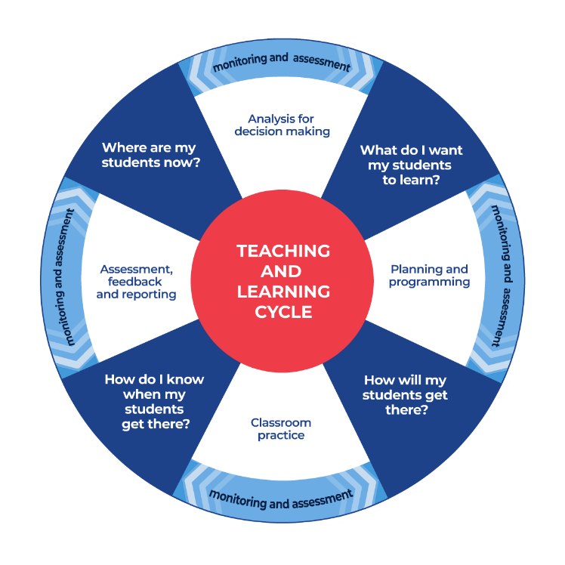
Figure 1: Teaching and learning cycle
- Where are my students now? – Teacher uses a range of assessment information to determine what students know and can do, including their interests, learning strengths and needs.
- What do I want my students to learn? - Teachers use the information gathered along with the syllabus and NNLP to determine the next steps for learning. Teachers might also like to look at the ‘what’s some of the maths’ and ‘key generalisations’ to synthesise the information they have gathered into the next step/s for learning.
- How will my students get there? – Teachers can then use the task overview information (‘What does it promote?’ and ‘What other tasks can I make connections to?’) to find tasks that meet the learning needs of students. Teachers then make decisions about what instructional practices and lesson structures to use to best support student learning. Further support with What works best in practice is available.
- How do I know when my students get there? - Teachers can use the section ‘Some observable behaviours you may look for/notice’ that have been articulated for each task as a springboard for what to look for. These ideas can be used to co-construct success criteria and modified to suit the learning needs, abilities and interests of students. Referring back to the syllabus and the NNLP are also helpful in determining student learning progress as well as monitoring student thinking during the task. The information gained will inform ‘where are my students now’ and ‘what do I want them to learn’ as part of the iterative nature of the teaching and learning cycle.

Overview of tasks
Task name | What does it promote? | What other tasks can I make connections to? | What materials will I need? | Possible group size
Balancing Numbers 1 | Equal arm balances support students in seeing relationships of equivalence and non-equivalence.  When we explore equivalence on an equal arm balance, we begin to notice while things may look different, they can also have an attribute that is the same. | Counting sounds  Balancing Numbers 2  Balancing Numbers 3 | - Equal arm balances  - Different colour blocks the same size | Small group and/or whole class
Number busting (7 is...) | Ten-frames are useful structures that help us to investigate and explore numbers and notice their relationships to five and ten. | Ducks away  Handfuls | - Building blocks  - Ten-frames  - Counters  - Building blocks | Small group and/or whole class
Go fish relationships | Knowing the numbers before and after a given number is an important skill that support skills in counting and the development of flexible mental computation strategies. | consecutive numbers (youcubed) | - Playing cards (A-10) | 2 players
Subitising 6 – one less than | Making the connection between the backward number word sequence, number before and the act of subtraction by imagining taking one away. | Game of totals (youcubed) | - Appendix 1: Dot cards | Small group and/or whole class
Subitising – more, less, the same | Quantities can be compared by subitising, direct comparison, or organising collections. We can compare collections by using the language of comparison as we explain our thinking to others. | Balancing Numbers 1 | - Appendix 2: Mini twenty frames | Small group and/or whole class

Balancing numbers 1

Key generalisations / what’s (some of) the mathematics?
- When we describe something as 'equivalent' it means the collections or objects we are comparing have an attribute that is the same. For example, two collections can be described as equivalent because their mass is the same.
- Collections can look different and still be equivalent in mass.
- Counting with understanding involves saying number words in a particular order, knowing the last number word we say tells us how many there are in a collection, and saying one number word for each item counted.
- Mathematicians can represent ideas in different ways.
- Mathematicians can create drawings that are life-like or create diagrams what include the most important mathematical information.
Teaching point: When students are comparing two sides of a balance arm scale, they are physically exploring the relationship of equivalence.

Some observable behaviours you may look for/notice
- Uses one-to-one correspondence
- Explains the last number said in a count describes the total in the collection
- Adjusts estimates when provided with additional information
- Represents situations with objects, drawings and diagrams, describing their representation to another person
- Describes equivalence as ‘is equivalent to’ or ‘has the same mass as’, for example
- Compares the mass of the two collections or objects using a balance scale
- Uses comparative language such as 'heavier than', 'lighter than', ‘lightest’, 'heaviest', 'the same mass as', 'the same as', and so on.

Materials
- Equal arm balances
- Blocks of the same size but in different colours

Instructions
There are 3 parts to this task. View each video in Balancing Numbers 1 using the questioning to guide student thinking.
Part 1: Ask students: “What do you notice? What do you wonder?”
Part 2: Ask students:
- “How many more bears are needed to make the scales balance? (In other words, how many bears are equivalent in mass to the Hulk?)”
- “What's an estimate that is way too high?” “way too low?” “What's reasonable estimate?”
Part 3: Students create a drawing to represent your thinking around our problem: "How many bears are equivalent in mass to The Hulk?"

Variation
Teachers could modify this task to explore equivalence in quantity by using different coloured blocks (for example, 13 red blocks on the left compared to 10 blue and 3 yellow blocks on the right).

Number busting (7 is...)

Key generalisations / what’s (some of) the mathematics?
- Ten-frames are useful structures to investigate and explore numbers and notice relationships to other numbers.
- Ten-frames have a particular structure that help us understand important mathematical relationships to 5 and 10.
- The different ways we arrange our collections help us to notice different parts a number is composed of. For example, I can arrange a collection in a way that helps me see the six and one inside of 7, or I can arrange it so I can see the four and three inside of 7.
- When we draw representations, it helps us notice their features and allows us to make meaning from them.
- Different people see and think about numbers and problems in different ways.
- Mathematicians communicate their thinking in ways that others can understand.
Teaching point: The different ways we arrange quantities on structures such as ten-frames can help students to notice different parts it is composed of as well as noticing relationships to other wholes. Figure 2 depicts an arrangement of the quantity of 7, which helps us to see 7 is made up of 5 and 2, or 4 and 3 or as 3 less than 10. In Figure 3, we can also see how the intentional use of colour can help us to see 7 as 2 and 2 and 2 and 1 or as 3 twos and 1. Students need to be provided with multiple opportunities to explore and investigate different representations and arrangements of numbers, using a range of structures and tools such as ten-frames, bead strings, Rekenreks, dominoes, dice, fingers, five-frames and connecting blocks.
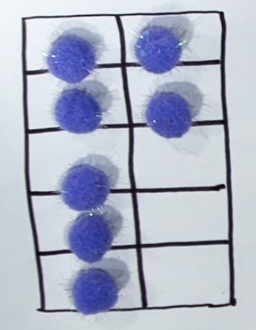
Figure 2: ten-frame showing 7 as 5 and 2
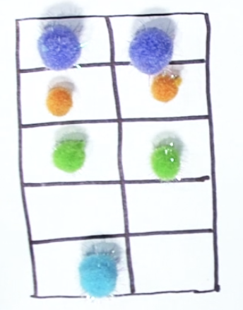
Figure 3: ten-frame showing 7 as 3 and 3 and 1

Some observable behaviours you may look for/notice
- Describes structural features of mathematical representations
- Draws pretty accurate diagrams of mathematical tools
- Instantly recognises quantities represented by familiar patterns (dice patterns, ten-frames, five-frames, dominoes, fingers, and so on.)
- Organises the same collection in different ways on a ten-frame to notice different ways to partition and describe a collection
- Describes how many are on a ten-frame by noticing what is missing. For example, “I see 3 empty rectangles so there must be 7”
- Describes equivalence as being ‘the same as’, ‘equivalent to’, ‘equivalent in value to’
- Draws diagrams to capture ideas
- Uses descriptive language to describe the relationship between quantities. For example, uses phrases such as less than, more than, 1 more than, 1 less than, 2 more than, 2 less than, between, smaller than, larger than, and so on.
- Intentionally uses colour or other coding system to clearly communicate thinking
- Compares their thinking to the thinking of others, noticing what is the same and different.

Materials
- Building blocks
- Ten-frames
- Counters

Instructions
Part 1 View Number Busting (go fish7 is...)
- Have students choose a number such as 7.
- Get the amount of items for that number, for example, pasta pieces, counters or pencils.
- Organise your items.
- Describe your collection.
- What other ways can the items be organised?
  - Describe the other ways.
  - You may like to use a mathematical structure such as a ten-frame to help you.
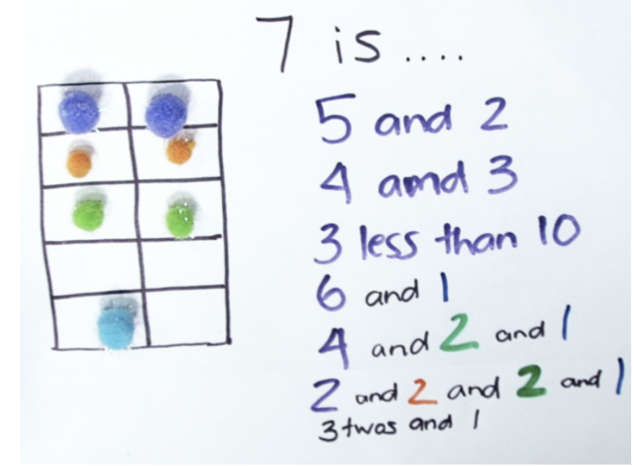
Figure 4: ten-frame showing 7 and the recordings

Part 2: View the video Number Busting.
Ask students:
- Can you try the same activity using different equipment, for example, building blocks?
- Draw and record 3 different ways you thought about your collection.
Reflection:
- Were you surprised by all the different ways to make your number?
- What did your structure help you notice? (for example, ten frame, dice pattern)
- What did you find interesting in this activity?
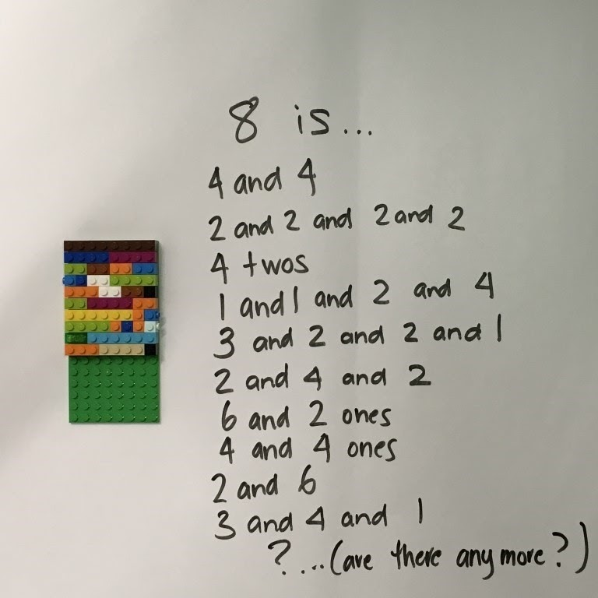
Figure 5: Lego showing different combinations to 8

Go fish relationships

Key generalisations / what’s (some of) the mathematics?
- knowing how numbers relate to other numbers helps us to solve problems
- knowing 1 more than, 2 more than, 1 less than and 2 less than helps us with things like:
  - counting forwards and backwards
  - identifying the number before and after
  - using landmark numbers (fives and tens) to solve problems.

Some observable behaviours you may look for/notice
- Compares and contrasts quantities in the range 1 to 10, describing quantities in various ways including 1 more than, 1 less than, 2 more than, two less than, smaller than, bigger than, close to, and so on.
- Justifies a match by explaining how their pair matches using phrases like more, less, before, after, plus or minus, and so on.
- Explains why two quantities can’t be a match. For example, “I have a five and a five. They are equivalent and so they can’t be a match.”
- Analyses what their partner is asking to determine if they have a card that is one or two more or less than to match their selection of cards
- Strategically considers what to ask for based on the difference between quantities for example, ‘I have a 7 and a 10, if I ask for a card that sits in the middle of them, I can increase my chance of getting a match’

Materials
- Playing cards (Ace-10)

Instructions
You can view Go fish relationships to learn how to play.
- Each player gets 7 cards. The rest of the cards are placed. in a pile in the middle.
- Players try to make pairs that are 1 more, 1 less, 2 more, or 2 less than the other number.
- Once they cannot make any more pairs, they can take turns to ask their opponent.
- If their opponent has a card of that number, they must give it to the asking player.
- If they do not, they say 'Go Fish' and the player gets a card from the central pile of cards.
- Play continues until one player has no more cards left in their hand. They are the winner!

Variation:
Play continues until there are no cards left. The player with the most pairs is the winner.

Subitising 6 – one less than

Key generalisations / What’s (some of) the mathematics?
- When subitising, we can determine how many there are without having to count
- Visualising helps us build our mathematical imaginations
- We can learn different things about numbers by exploring how different people use subitising and other knowledge they have to work out how many there are in a collection
- We can learn to use numbers flexibly
- Subitising can help us determine important relationships like one less than
- We can describe 1 less than as the number before. It also means we are taking one away from a collection
- Mathematicians listen to other people’s thinking, using this information to refine and extend their own ideas.
Teaching point: Frequent meaningful practice with different spatial patterns and structures, including standard and non-standard structures, helps build strong mental images and the capacity to visualise quantities. Strong mental images and visualisation supports students to use increasingly flexible problem-solving strategies.

Some observable behaviours you may look for/notice
- Instantly recognises collections up to three
- Conceptually subitises a collection up to 5 (for example, recognises a collection of up to five items by perceptually subitising smaller parts such as 4 and 1 and then using what they know about combining 4 and 1 more)
- Determines how many by recognising quantities represented by patterns and structures such as dominoes, ten-frames, dice, fingers, Rekenreks, and so on.
- Determines the number before by ‘looking and thinking’, using what is known about spatial patterns to determine 1 less than a quantity
- Visualises spatial patterns to imagine how the quantity changes when we take one away
- Explains a collection can be made up of smaller parts for example 5 is 4 and 1
- Describes 1 less than as the number before a given number
- Explains 1 less than is the same as counting back 1 and by taking one away from a collection
- Identifies and names numerals in the range of 1–8
- Connects quantities with number names
- Refines/extends thinking after listening to the ideas and strategies of others

Materials
- Appendix 1: Dot cards

Instructions
- Have students view Subitising 6 - one less than, ready to follow on, looking and thinking about ‘how many’ they see without having to count.

Subitising – more, less, the same

Key generalisations / what’s (some of) the mathematics?
- We can learn to think about and use numbers flexibly.
- When subitising, we can determine how many there are without having to count.
- We can learn different things about numbers by exploring how different people use subitising and other knowledge they have to work out how many there are in a collection.
- We can use direct comparison to determine which has more, less or if two collections are the same.
- We can use subitising to determine which has more, less or if two collections are the same.
- We can use counting to determine which has more, less or if two collections are the same.
- Mathematicians listen to other people’s thinking, using this information to refine and extend their own ideas.
Teaching point: Any comparison can be expressed in more than one way. For example, 8 is more than 6 can also be explained as:
6 is less than 8
8 is bigger than 6
6 is smaller than 8
6 is fewer than 8
6 is less than 8, and so on.
It is important to support students in developing rich and varied mathematical vocabularies, connecting words to meaningful experiences and a broad range of representations, and using dialogic practices like revoicing.

Some observable behaviours you may look for/notice
- Instantly recognises collections up to three
- Conceptually subitises a collection up to 5 (for example, recognises a collection of up to five items by perceptually subitising smaller parts such as 4 and 1 and then using what they know about combining 4 and 1 more)
- Determines how many by recognising quantities represented by patterns and structures such as dominoes, ten-frames, dice, fingers, Rekenreks, and so on.
- Explains a collection can be made up of smaller parts for example 5 is 4 and 1
- Describes 1 less than as the number before a given number
- Explains 1 less than is the same as counting back 1 and by taking one away from a collection
- Identifies and names numerals in the range of 1–8
- Organises two different collections using familiar patterns and structures to prove they are more, less or the same
- Uses counting to determine how many
- Explains the strategies they used to determine how many
- Recognises we can use different strategies to determine which quantity has more, less or the same

Materials
- Appendix 2: Mini twenty frames
- Dot cards with different arrangements blocks, teddies or other counters

Instructions
Have students view ‘Subitising - more, less, the same’ and ready to work out what quantities are more, less or the same.

Appendix 1: Dot cards 0-9

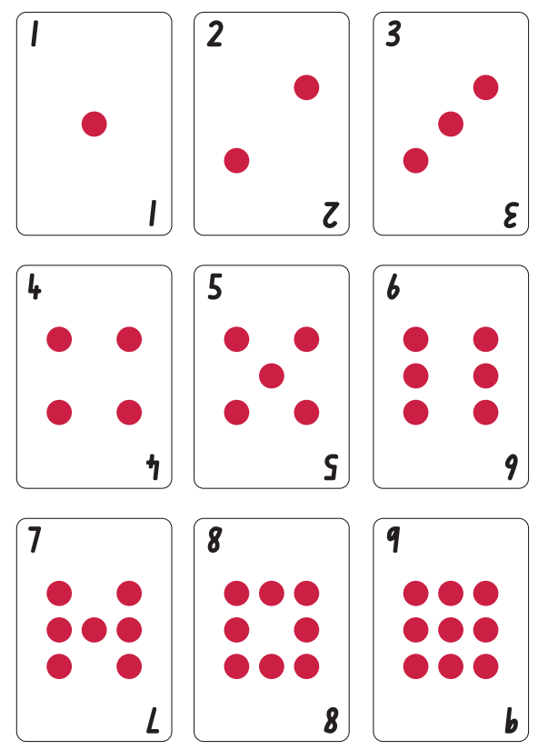
Appendix 2: Mini twenty frames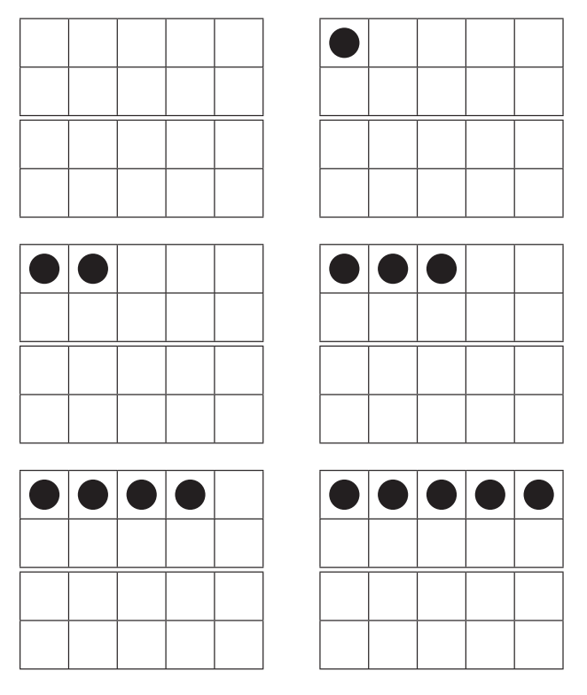

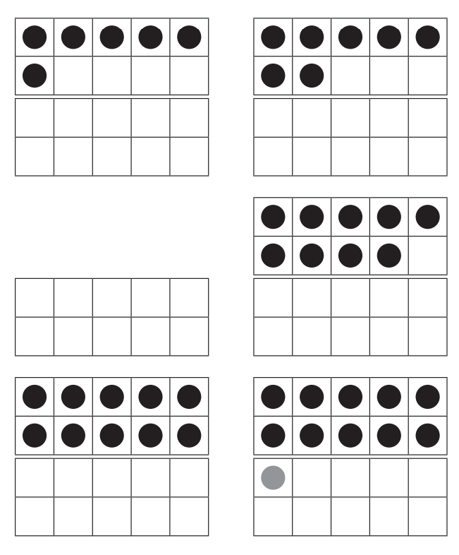

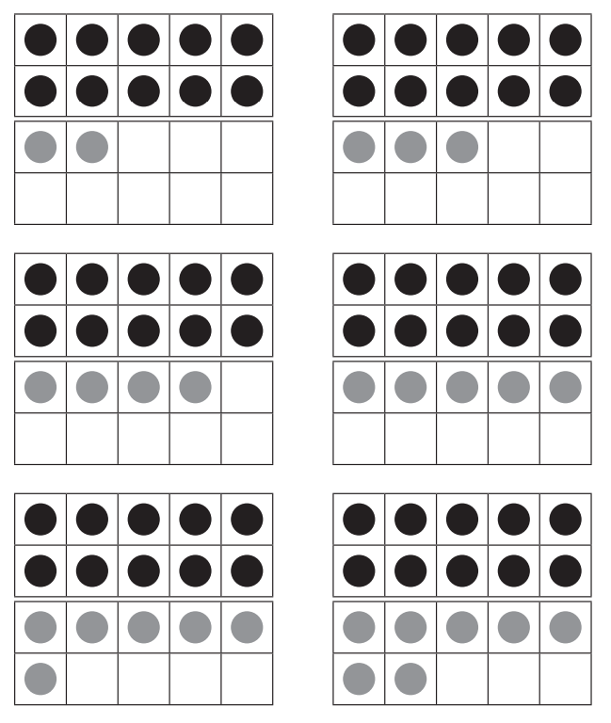
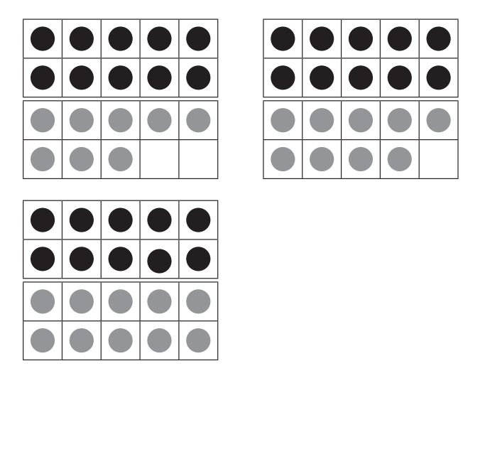

Reference list
This resource contains images and content obtained from Canva, and their use outside of this resource is subject to Canva’s Content License Agreement.
Mathematics K–10 Syllabus © NSW Education Standards Authority (NESA) for and on behalf of the Crown in right of the State of New South Wales, 2022.
National Numeracy Learning Progression © Australian Curriculum, Assessment and Reporting Authority (ACARA) 2010 to present, unless otherwise indicated. This material was downloaded from the Australian Curriculum website (National Literacy Learning Progression) (accessed 6 November 2023) and was not modified.
Stanford University (n.d.) ‘consecutive numbers’, Tasks, youcubed website, accessed 17 November 2023.
Stanford University (n.d.) ‘Game of totals’, Tasks, youcubed website, accessed 17 November 2023.
State of New South Wales (Department of Education) (2023) ‘Balancing Numbers 1’, Mathematics K-6 resources, NSW Department of Education website, accessed 16 November 2023.
State of New South Wales (Department of Education) (2023) ‘Balancing Numbers 2’, Mathematics K-6 resources, NSW Department of Education website, accessed 16 November 2023.
State of New South Wales (Department of Education) (2023) ‘Balancing Numbers 3’, Mathematics K-6 resources, NSW Department of Education website, accessed 16 November 2023.
State of New South Wales (Department of Education) (2023) ‘Counting sounds’, Mathematics K-6 resources, NSW Department of Education website, accessed 16 November 2023.
State of New South Wales (Department of Education) (2023) ‘Ducks away’, Mathematics K-6 resources, NSW Department of Education website, accessed 16 November 2023.
State of New South Wales (Department of Education) (2023) ‘Go fish relationships’, Mathematics K-6 resources, NSW Department of Education website, accessed 16 November 2023.
State of New South Wales (Department of Education) (2023) ‘Handfuls’, Mathematics K-6 resources, NSW Department of Education website, accessed 16 November 2023.
State of New South Wales (Department of Education) (2023) ‘Number Busting (7 is...)’, Mathematics K-6 resources, NSW Department of Education website, accessed 16 November 2023.
State of New South Wales (Department of Education) (2023) ‘Subitising - more, less, the same’, Mathematics K-6 resources, NSW Department of Education website, accessed 16 November 2023.
State of New South Wales (Department of Education) (2023) ‘Subitising 6 - one less than’, Mathematics K-6 resources, NSW Department of Education website, accessed 16 November 2023.

Copyright
Section 113P Notice
Texts, Artistic Works and Broadcast Notice
Some of this material has been copied and communicated to you in accordance with the statutory licence in section 113P of the Copyright Act. Any further reproduction or communication of this material by you may be the subject of copyright protection under the Act. Do not remove this notice.

Evidence base
Sparrow, L., Booker, G., Swan, P., Bond, D. (2015). Teaching Primary Mathematics. Australia: Pearson Australia.
Brady, K., Faragher, R., Clark, J., Beswick, K., Warren, E., Siemon, D. (2015). Teaching Mathematics: Foundations to Middle Years. Australia: Oxford University Press.
Alignment to system priorities and/or needs: The literacy and numeracy five priorities.
Alignment to School Excellence Framework: Learning domain: Curriculum, Teaching domain: Effective classroom practice and Professional standards
Consulted with: NSW Mathematics Strategy professional learning and Curriculum Early Years Primary Learners-Mathematics teams
Reviewed by: Literacy and Numeracy
Created/last updated: January 2024
Anticipated resource review date: January 2025
Feedback: Complete the online form to provide any feedback.

