Part 4: benchmarks of 5 and 10

About the resource
This resource the fourth section of a 6-part resource supporting number knowledge. Use this resource is conjunction with other guides to support a connected network of critical mathematical concepts, skills and understanding.
The resource has been developed in partnership with the NSW Mathematics Strategy Professional Learning team, Curriculum Early Years and Primary Learners, and Literacy and numeracy.
We use numbers to describe the world around us.
Understanding how numbers work is a critical part of developing deep, meaningful mathematical skills, understanding and confidence. This includes the use of flexible additive strategies which are a direct by-product of a student’s number sense.
Like most things in mathematics, talking about number is hard to do without referring to other aspects such as patterns, subitising, counting, fractions, the operations, measurement, statistics. As such, this resource is best used in conjunction with other guides to support a connected network of critical mathematical concepts, skills and understanding.
- Part 1: Connecting number names, numerals and quantities
- Part 2: Building important relationships - part-part-whole
- Part 3: Building important relationships - more than, less than, equivalent in value to
- Part 4: Benchmarks of 5 and 10
- Part 5: Comparing, ordering, sequencing and estimating
- Part 6: Building place value (including renaming)

Syllabus
MAO-WM-01 develops understanding and fluency in mathematics through exploring and connecting mathematical concepts, choosing and applying mathematical techniques to solve problems, and communicating their thinking and reasoning coherently and clearly
MAE-RWN-01 demonstrates an understanding of how whole numbers indicate quantity
MAE-RWN-02 reads numerals and represents whole numbers to at least 20
MAE-CSQ-01 reasons about number relations to model addition and subtraction by combining and separating, and comparing collections
MAE-CSQ-02 represents the relations between the parts that form the whole, with numbers up to 10
NSW Mathematics K-10 Syllabus (2022)

Progression
Number and place value NPV1-NPV2
Counting processes CPr1-CP3
Additive strategies AdS1-AdS2
National Numeracy Learning Progression Version 3

How to use the resource
Teachers can use assessment information to make decisions about when and how they use this resource as they design teaching and learning sequences to meet the learning needs of their students.
The tasks and information in the resource includes explicit teaching, high expectations, effective feedback and assessment and can be embedded in the teaching and learning cycle.
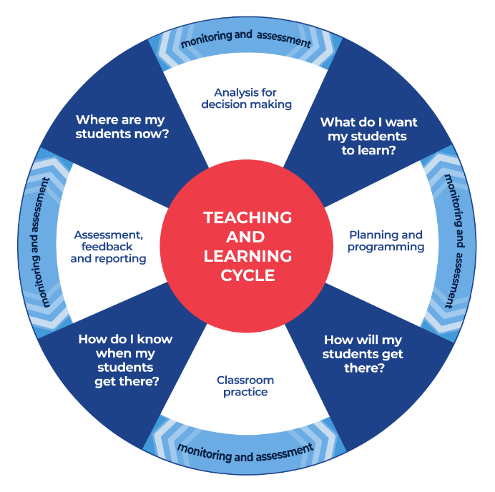
Figure 1: Teaching and learning cycle
- Where are my students now? – Teacher uses a range of assessment information to determine what students know and can do, including their interests, learning strengths and needs.
- What do I want my students to learn? - Teachers use the information gathered along with the syllabus and NNLP to determine the next steps for learning. Teachers might also like to look at the ‘what’s some of the maths’ and ‘key generalisations’ to synthesise the information that they’ve gathered into the next step/s for learning.
- How will my students get there? – Teachers can then use the task overview information (‘What does it promote?’ and ‘What other tasks can I make connections to?’) to find tasks that meet the learning needs of students. Teachers then make decisions about what instructional practices and lesson structures to use in order to best support student learning. Further support with What works best in practice is available.
- How do I know when my students get there? - Teachers can use the section ‘Some observable behaviours you may look for/notice’ that have been articulated for each task as a springboard for what to look for. These ideas can be used to co-construct success criteria and modified to suit the learning needs, abilities and interests of students. Referring back to the syllabus and the NNLP are also helpful in determining student learning progress as well as monitoring student thinking during the task. The information gained will inform ‘where are my students now’ and ‘what do I want them to learn’ as part of the iterative nature of the teaching and learning cycle.

Overview of tasks
Task name | What does it promote? | What other tasks can I make connections to? | What materials will I need? | Possible group size
10 or bust | This task promotes the understanding of the parts that can be composed to make 10. | Rekenreks duel 1 Rekenreks duel 2  Pinch a ten | - Game board (ten frame, fingers, number track)  - Counters  - Dice or Appendix 1: Numeral cards | Whole class and/or small group
Let’s talk | This task encourages students to compare a variety of strategies that can be used to solve a problem, building awareness of a range of additive strategies. | 3 tens in a line  Game of totals (youcubed) | - Blank ten-frames  - Collection of objects | Whole class
Making ten | Number bonds for ten. | Rekenreks 2 | - Double sided counters  - Blank ten-frames | Small group
Six piles | Developing a strong understanding of combinations to five. | Finger trails (youcubed)  Rekenreks duel 1 Rekenreks duel 2 | - Appendix 2: Dot cards 0-5 | 2 players

10 or bust

Key generalisations / what’s (some of) the mathematics?
- 10 can be composed in many different ways.
- When we compose a quantity, we can use 2 or more ‘chunks’ (or parts, or collections). For example, we can create a collection of 10 by combining:
  - 2 collections, such as 9 and 1
  - 3 collections, such as 4 and 5 and 1
  - 4 collections, such as 3 and 3 and 2 and 2, and so on.
- When recording equations (number sentences), we call the collections we are combining ’addends’. For example, in 6 + 4 = 10, 6 and 4 are both addends and 10 is the sum.
- Any given whole number can be partitioned (decomposed/broken) into smaller parts.
- Mathematicians use mathematical reasoning to analyse games as they are playing them, using this information to strategise and hopefully improve their chances of winning the game.
Teaching point: It is important for students to understand, and use their knowledge, that any given whole number can be partitioned (broken) into smaller parts. This flexibility in thinking about numbers, and using that flexibility, is an important foundation for flexible strategies.

Some observable behaviours you may look for/notice
- Instantly recognises dice patterns without needing to count
- Uses a range of representations such as number lines and ten-frame to explain who is closest to 10
- Describes strategies used to combine quantities. For example, “I had 4 and I rolled another 4. I know that 4 and 4 is 8. I could also say double 4 is 8”
- Describes 10 in terms of its parts (part-part-whole knowledge). For example, explains “I have 3 and I rolled 6 so I now have 9. I need to roll a 1 to reach the target of 10 because 10 is 1 and 9”
- Uses counting to determine how many
- Makes strategic decisions to decide if a roll should be used or discarded to finish the game closest to 10. For example, “I have 4. Now I rolled 6. If I use it, I will already have 10 and then I will bust on my next roll, so I won’t include this turn”
- Partitions quantities by considering what quantities might be rolled and the implications that has for the game.

Materials
- game board, such as, a number track, a ten-frame, a drawing of 10 fingers
- drawing of a known number combination to 10
- counters
- a dice or Appendix 1: Numeral cards

Instructions
View 10 or bust to learn how to play.
- Teams have 3 turns each to roll the die and place the matching number of counters on your game board.
- Teams can choose to miss one turn, but it cannot be your last roll.
- If you go over 10, you have ‘busted’ and are out of the game.
- The team closest to 10 after 3 rolls each is the winner.
- Teams can play best out of 3, playing by making up to 10 as well as backwards to 0.
- Reflect:
  - How could we change the game to make it more/less challenging?
  - Did you work out a way to play this game so that you didn’t lose?
  - What was your strategy?
  - Did it work?

Variations
- Adapt this task to focus on combinations to 5.
- Adapt the game to focus on combinations to 20. How does what we know about combinations to 10 help us with solving the combinations to 20?

Let’s talk

Key generalisations / what’s (some of) the mathematics?
- The same problem can be solved using a range of different strategies.
- Numbers can be used flexibly to solve problems. For example, “I can think of 7 as 5 and 2 so that I can combine it with 8. I can then join 2 and 8 to get to 10 before I combine the final 5 to get to 15”.
- We can use visualisation (our mathematical imaginations) to imagine parts of quantities moving to join with other numbers in to help us solve problems.
- Different people see and think about numbers and problems in different ways.
- Listening to other people’s thinking helps us become aware of other ways of thinking, building our knowledge of mathematics.
- Mathematicians compare their strategies with the thinking of others.
- Mathematicians use the ideas of others to refine/extend their own ideas.
Teaching point: There are 2 parts to this activity. View each video in Let’s Talk using the questioning to guide student thinking.

Some observable behaviours you may look for/notice:
- Describes how many are on a ten-frame by noticing what is missing. For example, “I see 3 empty rectangles so there must be 7”
- Uses known facts, patterns and strategies to determine how many in a collection without counting
- Visualises dots moving on a ten-frame to work flexibly with collections to answer the question ‘how many?’
- Partitions quantities to reach landmark numbers
- Uses renaming to determine how many. For example, “I can partition 6 into 4 and 2, then I can move the 2 to join 8 to create 1 ten. Then I have 1 ten and 4 more which I can just rename 14”
- Uses part-part whole knowledge to solve problems
- Describes how equivalence can be used to solve problems (for example, I don't know 8 and 6 but I know it is the same as 7 and 7)
- Uses known facts to solve unknown problems
- Uses counting to solve problems
- Refines/extends thinking after listening to the ideas and strategies of others.

Materials
- Ten-frames
- Collection of objects

Instructions
There are 2 parts to this activity. View each video in Let’s Talk using the questioning to guide student thinking.

Making ten

Key generalisations / what’s (some of) the mathematics?
- Ten-frames have a particular structure that help us understand important mathematical relationships to 5 and 10
- Using structures like ten-frames can help us to see the parts the sit inside quantities for example, I can see 6 and 4 inside of ten
- We can use a ten-frame to represent the same quantity, like ten, in many different ways. This helps us draw out important relationships such as
  - 10 is one more than 9
  - 6 is 4 less than 10
  - 10 is 7 and 3
- A ten-frame can help us to see different properties such as the commutative property for example,
  - 10 is two fives (double five)
  - 5 is 5 less than 10
  - 5 and 5 more makes ten
Teaching point: Memorising basic facts is not the same as working with them so often that a student comes to know number combinations. Facts that are learnt by rote are more easily forgotten. Teachers need to strive towards providing rich and varied experiences for students so that they internalise number combinations with conceptual understanding.

Some observable behaviours you may look for/notice
- Instantly recognises parts of 10 represented in ten-frames. For example, 10 is 6 yellow counters and 4 red counters
- Finds combinations of 10 using knowledge of spatial patterns and familiar number facts (bonds)
- Describes counters on a ten-frame by recognising smaller parts (for example, “10 is 3 red counters and 7 yellow counters”
- Uses five as a reference when noticing parts. “For example, I see a row of 5 red counters and 2 more red counters in the bottom row. I know that 7 is 5 and 2 more”
- Draws pretty accurate diagrams using mathematical representations to record combinations of 10
- Compares their thinking to the thinking of others to determine if they have found all the ways to make ten

Materials
- Double sided counters (for example, red and yellow)
- Blank ten frames (or have students draw their own)

Instructions
- Make 10, using the same-coloured side of the counters and discuss that there are, for example, 10 red counters and no yellow counters.
- Reinforce through discussion how we know that when we see a full ten frame, the total number of counters is always 10.
- Investigate a few times in order to “prove” this fact.
- Turn over one counter and discuss how many counters there are in total, how many red and how many yellow.
- Continue this a few times, discussing and recording the total number of counters, the number of red counters and the number of yellow counters.
- It is important to model how we can see things in the ten frame such as when a number is bigger or smaller than 5, when it is odd, when it is even, and so on.
- Provide individual ten frames for students and allow them to make their own combinations to 10. Have the students discuss in pairs the patterns they have made on their ten-frame - how many counters in total, how many red and how many yellow.
  - Students could record their combinations by copying their patterns onto a paper ten frame.
  - Ask students to share back the various combinations they made, recording their thinking on the whiteboard. Teachers should use this information to have a discussion about the pairs of numbers that combined together to make ten (such as 10 and 0, 8 and 2, 6 and 4, and so on.) and the pairs of numbers that do not combine together to make ten (such as 4 and 1, 2 and 6, and so on.)

Variations
- Adapt this activity to focus on combinations to five.
- Play ‘shake and drop’ and explore combinations to ten without the ten-frame.

Six piles

Key generalisations / what’s (some of) the mathematics?
- Numbers are made up of smaller numbers. For example, 5 can be composed of:
  - 2 and 3
  - 3 and 1 and 1
  - 1 and 2 twos
  - 1 and 4, and so on.
- Knowing that all numbers are composed of smaller numbers (that smaller numbers ‘nest inside’) helps us use flexible strategies to solve problems because we can rename numbers in ways that allow us to use number facts, we know solve what we don’t know yet. For example, “I don’t know what 8 and 3 is yet. I do know that 3 is made up of 2 and 1 more and this matters because I also know that 10 is made up of 8 and 2. So, I can use these pieces of information to combine 8 and 2 (to form 10) and then I can combine the remaining which I know is 11”.
- Numbers can be composed using more than just addition. For example, I can create 10 by combining 2 fives, I could combine 2 sixes and then remove 2 ones, I could even share 100 into 10 equal groups to end up with 10 in each group.
- Different people see and think about numbers and problems in different ways.
- Mathematicians use thinking of their peers to refine and revise their ideas.
- Mathematicians can use their knowledge of numbers and operations to strategise to improve their chances of winning a game.
Teaching point: Modifying games as suggested by students and teachers can be a really powerful strategy. Teachers should make careful decisions when adjusting games to ensure the task meets the mathematical goal they are hoping to achieve with students. In this game, when it is played by finding only 2 cards that total 5, this promotes number bonds to five (an important part-part-whole relationship). In this case, the winner would be the player/team that has the most pairs at the end of the game.
When the game is adapted to have players finding as many cards as possible that total 5, this supports awareness of additive contexts with multiple addends and the idea that part-part-whole number knowledge extends beyond partitioning only into 2 parts. In this version of the game, the winner would be the player/team that has the most cards at the end of the game.
Both of these ways of playing are important in building robust and flexible number knowledge.

Some observable behaviours you may look for/notice
- Connects quantities with numerals and number names in the range 1-5
- Describes a quantity by talking about some of its smaller parts (part-part-whole) for example, 5 is 4 and 1, 5 and 0 and 2 and 3
- Uses known facts and strategies to determine how many there are in a collection without having to count all by ones
- Uses known facts and strategies to combine quantities to reach a target number.

Materials
- Appendix 2: Dot cards 0-5 (or playing cards Ace - 5)

Instructions
- Using playing cards 0-5 (if using playing cards include A to represent one and K to represent zero)
- Shuffle the cards and deal out face up into 6 piles of 4 cards.
- Have the teams take turns to locate at least 2 cards that total to 5
- If students can find 2 or more cards equalling 5 (on the top of the pile), the student collects the cards, revealing new cards.
- The activity continues until a player is unable to find combinations of cards that total 5.
- The winner is the person with the greatest number of cards collected.

Variations
- Adapt the game to compose any quantity up to and including 10
- Use any operation
- Use the ace to represent eleven and adapt to game to find combinations to 20

Appendix 1: Numeral cards 0-6
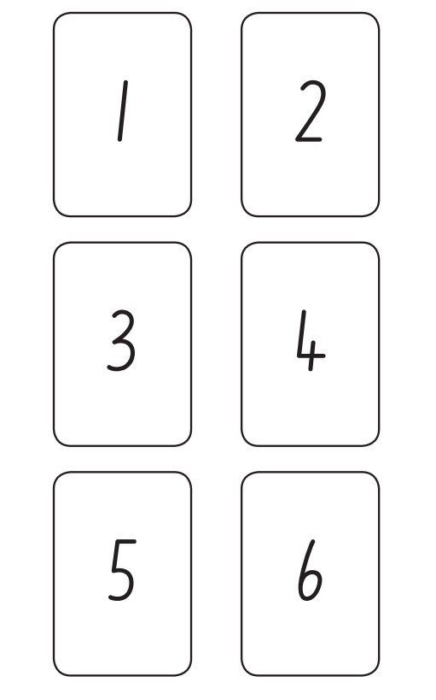

Appendix 2: Dot cards 0-9

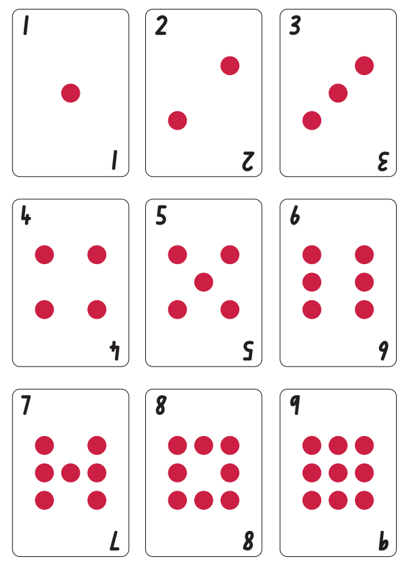

Reference list
Mathematics K–10 Syllabus © NSW Education Standards Authority (NESA) for and on behalf of the Crown in right of the State of New South Wales, 2022.
National Numeracy Learning Progression © Australian Curriculum, Assessment and Reporting Authority (ACARA) 2010 to present, unless otherwise indicated. This material was downloaded from the Australian Curriculum website (National Literacy Learning Progression) (accessed 6 November 2023) and was not modified.
Stanford University (n.d.) ‘Game of totals’, Tasks, youcubed website, accessed 17 November 2023.
Stanford University (n.d.) ‘Finger trails’, Tasks, youcubed website, accessed 17 November 2023.
State of New South Wales (Department of Education) (2023) ‘3 tens in a line’, Mathematics K-6 resources, NSW Department of Education website, accessed 16 November 2023.
State of New South Wales (Department of Education) (2023) ‘10 or bust’, Mathematics K-6 resources, NSW Department of Education website, accessed 16 November 2023.
State of New South Wales (Department of Education) (2023) ‘Let’s Talk’, Mathematics K-6 resources, NSW Department of Education website, accessed 16 November 2023.
State of New South Wales (Department of Education) (2023) ‘Pinch a ten’, Mathematics K-6 resources, NSW Department of Education website, accessed 16 November 2023.
State of New South Wales (Department of Education) (2023) ‘Rekenreks 2’, Mathematics K-6 resources, NSW Department of Education website, accessed 16 November 2023.
State of New South Wales (Department of Education) (2023) ‘Rekenreks duel 1’, Mathematics K-6 resources, NSW Department of Education website, accessed 16 November 2023.
State of New South Wales (Department of Education) (2023) ‘Rekenreks duel 2’, Mathematics K-6 resources, NSW Department of Education website, accessed 16 November 2023.

Copyright
Section 113P Notice
Texts, Artistic Works and Broadcast Notice
Some of this material has been copied and communicated to you in accordance with the statutory licence in section 113P of the Copyright Act. Any further reproduction or communication of this material by you may be the subject of copyright protection under the Act. Do not remove this notice.

Evidence base
Sparrow, L., Booker, G., Swan, P., Bond, D. (2015). Teaching Primary Mathematics. Australia: Pearson Australia.
Brady, K., Faragher, R., Clark, J., Beswick, K., Warren, E., Siemon, D. (2015). Teaching Mathematics: Foundations to Middle Years. Australia: Oxford University Press.
Alignment to system priorities and/or needs: The literacy and numeracy five priorities.
Alignment to School Excellence Framework: Learning domain: Curriculum, Teaching domain: Effective classroom practice and Professional standards
Consulted with: NSW Mathematics Strategy professional learning and Curriculum Early Years Primary Learners-Mathematics teams
Reviewed by: Literacy and Numeracy
Created/last updated: January 2024
Anticipated resource review date: January 2025
Feedback: Complete the online form to provide any feedback.

