Part 3: Ratios

Contents

About the resource 3
The nature of the learner 4
Syllabus 6
Progression 6
Overview of tasks 6
Tasks 8
Task 1: Ratios in the class 9
Task 2: Incorrect ratios 11
Task 3: Recipe alterations 13
Task 4: Comparing lengths 15
Task 5: Ratios with cordial 17
Task 6: Map scale 19
Resources 21
Appendix 1: Ratio cards 21
Appendix 2: Pancake recipe 22
Appendix 3: Comparing lengths 23
Appendix 4: Recreational bushland map 24
Information for teachers 25
References 25
Bibliography 25
Alignment and support 26

About the resource
This resource is the third section of a four-part resource supporting proportional thinking.
- Part 1: Early proportional thinking
- Part 2: Percentages, fractions and decimals
- Part 3: Ratios
- Part 4: Rates
Proportional reasoning refers to the relationship between two or more variables, and a capacity to identify and describe what is being compared with what (Siemon et al. 2021). It is a complex form of reasoning that builds upon a number of interconnected ideas over a long period of time (Siemon et al. 2021). It takes many varied physical experiences to develop an understanding of proportionality and then more time to gain the ability to deal with the concept abstractly (Cordel & Mason, 2000:9). All teachers can support the foundations for proportional thinking by providing targeted teaching that deepens students’ conceptual understanding. This includes problem solving and meaningful practice to explore how and why strategies work.
Proportional thinking requires skills in thinking multiplicatively and involves measures, rates and/or ratios expressed in terms of natural numbers, rational numbers, and/or integers. For example,
$\frac{2}{3}$ × $24 as 2‑thirds of $24, or 3.5 × 68 as 3 and a half times 68, (Siemon et al., 2021). Like most concepts in mathematics, talking about proportional thinking is difficult without referring to other aspects of mathematics that recognise and work with relationships between quantities, such as multiplication and division, decimals, fractions and percentages.
Student understanding of number sense is a critical part of developing deep, meaningful mathematical skills, understanding and confidence. Students apply their number sense to a variety of proportional situations, including practical and financial problems, and develop the numeracy knowledge required for a range of important life skills. Proportional reasoning underpins an understanding of ratios and rates as well as the development of concepts and skills in other aspects of mathematics, such as trigonometry, similarity and gradient.

The nature of the learner
Students tend to progress through several broad phases of conceptual understanding as proportional thinking develops. Multiplicative understanding forms a crucial foundation for proportional thinking and students need to be able to:
- use multiplication and division in a wide range of situations,
- communicate mathematically using manipulatives, vocabulary and diagrams,
- apply the commutative, associative and distributive properties to solve problems, knowing how and when these properties are useful and when they are not, and
- apply part-part-whole reasoning to composite units.
See teaching considerations for multiplicative thinking.
Multiplicative thinking and proportional reasoning are complex. Students should be supported to acquire an understanding of:
- the ‘for each’ idea, or how the Cartesian product develops an understanding of rates and ratios,
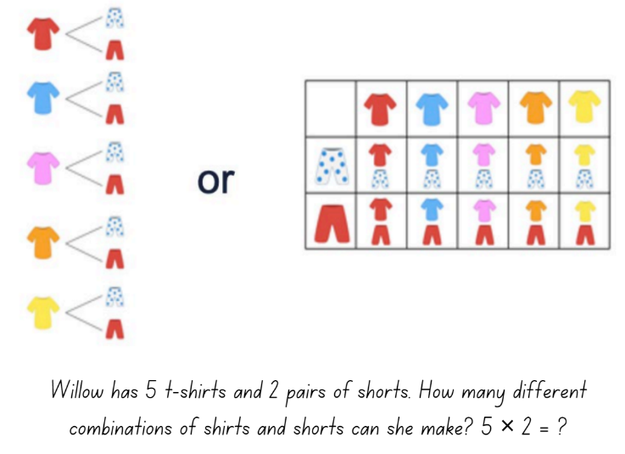
Figure 1 – Cartesian model using clothing items
- the ‘times as many’ or ‘times as large’ idea for comparing quantities multiplicatively as can be seen developing through place value, for example, 0.2 is 10 times as large as 0.02, or 100 times 0.005 is 0.5,
- the conceptual relationship between fractions, decimals and percentages,
- the link between fractions and ratios builds an understanding when simplifying ratios, for example, 2:8 could be simplified to 1:4 because I know that 2 eighths is the same as 1 over 4,
- factorisation to simplify quantities in rates and ratios, connecting this to simplifying fractions,
- fractions as ratios used to make ‘part-part’ comparisons, 2:3 represented as $\frac{2}{3}$ compared to fractions which are used to make ‘part-whole’ comparisons, $\frac{2}{5}$.
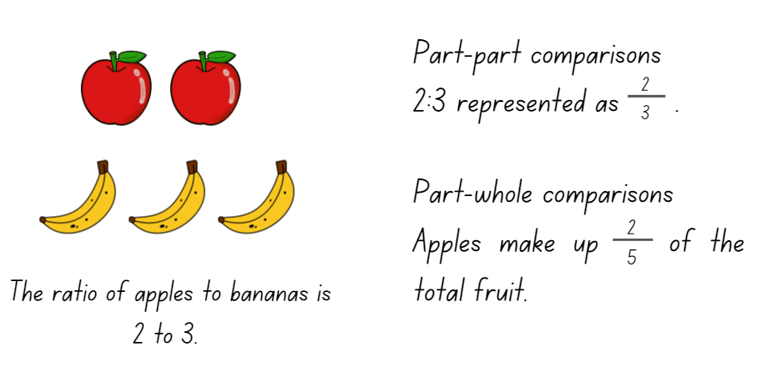
Figure 2 – Ratio of 2 to 3 using squares and triangles
The resource has been developed in partnership with the NSW Mathematics Strategy Professional Learning team and Literacy and Numeracy.

Syllabus
MAO-WM-01 develops understanding and fluency in mathematics through exploring and connecting mathematical concepts, choosing and applying mathematical techniques to solve problems, and communicating their thinking and reasoning coherently and clearly
MA4-RAT-C-01 solves problems involving ratios and rates, and analyses distance–time graphs
NSW Mathematics K-10 Syllabus (2022)

Progression
Number patterns and algebraic thinking NPA6 – NPA7
Multiplicative strategies MuS9 – MuS10
Interpreting fractions InF9
Proportional thinking PrT3 – PrT7
Understanding geometric properties UGP6 – UGP7
National Numeracy Learning Progression Version 3

Copyright
Section 113P Notice
Texts, Artistic Works and Broadcast Notice
Some of this material has been copied and communicated to you in accordance with the statutory licence in section 113P of the Copyright Act. Any further reproduction or communication of this material by you may be the subject of copyright protection under the Act. Do not remove this notice.

Overview of tasks
Task name | What does it promote? | What materials will I need? | IfSR link
Task 1: Ratios in the class | Initial understanding of ratios and the importance of thinking multiplicatively rather than additively. | - Writing materials | PT – 3A.1  PT – 3A.2
Task 2: Incorrect ratios | Identifying errors in ratios and ways to correct them. | - Appendix 1: Ratio cards | PT – 3A.3
Task 3: Recipe alterations | Using ratios to increase or decrease quantities to maintain a given proportion. | - Appendix 2: Pancake recipe  - Writing materials | PT – 3A.3
Task 4: Comparing lengths | Determining equivalence between ratios of length by expressing them in their simplest form. | - Appendix 3: Comparing lengths  - Writing materials | PT – 3A.3  PT – 3A.5
Task 5: Ratios with cordial | Expressing ratios in their simplest form using a real-life context, including the use of questioning to develop students’ understanding. | - 4 jugs (larger than a litre)  - Measuring cup  - Cordial concentrate  - Water | PT – 3A.4
Task 6: Map scale | Calculating ratio and scale factors to interpret a scale on a map and determine real distances. | - Appendix 4: Recreational bushland map  - Writing materials | PT – 3A.5  PT – 3A.6

Tasks
For additional information on key generalisations and observable behaviours see reSolve, What you need to know: FRACTIONS (n.d.) and reSolve What you need to know: PROPORTIONAL REASONING (n.d.).
Key generalisations | Observable features
What is some of the mathematics:  - Mathematicians use what they know to help them solve what they do not know yet.  - The same problem can be solved using many strategies.  - A range of representations can communicate ideas.  - Deriving the unknown from the known teaches problem solving strategies as well as requiring logical thinking skills, critical to the development of numeracy.  - Fractions are used in ratios to represent a part-to-part comparison. | Some observable behaviours:  - Refines and extends thinking after listening to the ideas and strategies of others.  - Explains chosen strategies using technical vocabulary.  - Uses various representations to share thinking, for example, drawings, language, diagrams and virtual manipulatives.  - Uses a range of strategies to solve problems, for example, known facts to solve unknown problems, halve and double numbers and inverse operation.

Task 1: Ratios in the class
Core learning: Initial understanding of ratios and the importance of thinking multiplicatively rather than additively.

Materials
- Writing materials

Instructions
- Scenario 1: Invite 5 students to the front of the classroom. Ensure 2 of them are wearing a particular item and 3 are not, for example, 2 students wearing a jumper and 3 are not. Discuss the group of 5 students and draw out the following information:
- The number of students wearing jumpers compared to those not wearing jumpers is called a part-to-part ratio. That means for every 2 students with a jumper there are 3 without a jumper. This can be written as 2:3 or as a fraction $\frac{2}{3}$ and read as 2 to 3.
- The number of students wearing jumpers compared to the number of students in the whole group, is called a part-to-whole ratio. This can be written as 2:5 or as a fraction $\frac{2}{5}$ and read as 2 to 5.
Figure 3 – Students with and without jumpers
Images licensed under the Canva Content License Agreement.
Teaching point: A part-to-part ratio can be written as a fraction. Students need to be aware that when the ratio is written as a fraction it does not always represent a part-to-whole relationship.
- Scenario 2: Following on from scenario one, add 2 students wearing a jumper to the group of 5. Ask, how many additional students without a jumper should be added to the group to keep the ratio the same as in scenario 1, 2:3. Possible discussion points:
- If 3 is given as a response, students are demonstrating multiplicative thinking as they are maintaining equivalent proportions.
- If students use additive thinking they have answered that they added 2 students without a jumper to one part because 2 students with a jumper were added to the other part, demonstrate that this would not keep the ratio the same as 2:3.
- Scenario 3: Using all the students in the class, create a ratio to simplify. For example, there are 20 students in a class and 8 are wearing a jumper and 12 are not. For every 8 students with a jumper, there are 12 students without a jumper, or 8 to 12. Discuss this ratio using the following prompts:
- Does the ratio stay the same when halving the numbers? This means for every 4 students with a jumper there are 6 without a jumper, therefore the ratio is equivalent.
- Is halving a multiplicative or additive process? It is multiplicative as halving refers to dividing by 2.
- Does the ratio stay the same when halved again? Yes, for every 2 students with a jumper there are 3 without a jumper, therefore the ratio is equivalent.
- Does the ratio stay the same when halved again? Yes, this would give an answer of 1 student wearing a jumper to 1.5 not wearing a jumper.
Teaching point: To simplify ratios divide each part by the highest common factor, for example, 8:12 = 2:3 by dividing both parts by 4. Ratios are usually whole numbers with an exception occurring when using a scale factor. Decimal numbers can be used and are commonly seen when using ratios for reducing or enlarging an image using scale factor.

Task 2: Incorrect ratios
Core learning: Identifying errors in ratios and ways to correct them.

Materials
- Appendix 1: Ratio cards

Instructions
Teaching point: Students need an understanding of ratios for this task. A ratio refers to the multiplicative relationship between 2 quantities, for example the number apples to the number of bananas in a fruit bowl. The order of the ratio is important, and it can be written as a part-to-part fraction, rather than part-to-whole. Ratios can be simplified by dividing by the highest common factor.
- Students work in groups and are given ratio cards from Appendix 1: Ratio cards. They identify what is wrong with the ratio and how to correct the error.
- Model how to identify and make corrections to the ratios. While students are working, support the discussion using the following information.
- Card 1: The ratio of 3 dogs to 7 litres of water is 3:7
Discuss the fact that a ratio compares quantities which use the same units. The number of dogs is being counted where the amount of water is in litres. Lead a discussion on what can be compared in a ratio. If given 2 different quantities a rate can be used. Rates are looked at in section 4 in more detail. To correct the error on the card, it could say 3 dogs to 7 dogs is 3:7 or 3 litres to 7 litres is 3:7.
- Card 2: The ratio of 50 to 40 is $\frac{4}{5}$
Discuss how the order of a ratio is important. What is mentioned first stays first. Students may discuss the fact that ratios can be displayed as a fraction, but the denominator and the numerator are expressing a part-to-part relationship rather than a part-to-whole. Most commonly ratios are displayed as part-to-part where a fraction is part to whole. To correct this card, the 4 and 5 or 40 and 50 need to be switched. Such as 50 to 40 is $\frac{5}{4}$ or 40 to 50 is $\frac{4}{5}$.

- Card 3: The ratio of $4 to 50 cents is 4:50, simplified to 2:25
Discussion is similar to card 1 around needing the same units. On this card the units are both to do with money, however, dollars and cents are different units. To write this as a ratio, students need to convert one of the amounts to be the same unit as the other. To correct the card, convert $4 into 400 cents. This is written as 400:50 or simplified to 8:1. This can also be written in dollars as 4:0.5, and to simplify, it is doubled to remove the decimal and get 8:1.
- Card 4: The ratio of 25 cm to 12 cm is 25cm:12 cm
Discussion is around the need to not write the units in the ratio as ratios compare the same unit. To correct this card, the answer should be 25:12 without the centimetres being written.
- Card 5: The ratio of 4 m to 1 m and 63 cm is 4:1.63
Discuss the need to not use decimals in ratios if it is possible. A ratio should be simplified to be written in whole numbers only. To remove the decimal point, multiply by 10 or a power of 10. See the task, Ratios in the class, for more information on decimals and ratios. To correct the card, multiply both side by 100 to get 400:163.
- Card 6: 12:40:20 is simplified to 6:20:10
Discuss the word simplifying and what is required. When simplifying ratios, divide all parts by the highest common factor. In this example, the ratio was only divided by a common factor, not the highest common factor. To correct the card, halve the answer again to get 3:10:5 or, if starting from the original ratio, divide all parts by 4 to get 3:10:5.

Task 3: Recipe alterations
Core learning: Using ratios to increase or decrease quantities to maintain a given proportion.

Materials
- Appendix 2: Pancake recipe
- Writing materials

Instructions
- Using Appendix 2: Pancake recipe, model the different ways to solve each scenario.
- Scenario 1: Bob is having a party with 10 friends and wants to make pancakes for everyone, how much of each ingredient would he need?
- Scale Factor: $\frac{10 \left(new amount\right)}{4 \left(current amount\right)} = 2.5$. Multiply each ingredient by 2.5 to find the required amount.
- Unitary method: The 4 serves indicate the number of parts given. First, find the amount for one part/serve by dividing the ingredients by 4. Then multiply the answer by 10 as Bob requires 10 serves.
- Equation using equivalent ratios: $\frac{1C flour}{4} = \frac{x C flour}{10}$ Solve for $x$ by multiplying both sides of the equation by 10.
- Number facts: 10 is double 4 plus half of 4 which is 2. For each ingredient double the quantity and then add an extra half of the original amount.
Teaching point: It is important to explicitly teach how an equation with ratios is formed using fractions. The first fraction needs to come from the same recipe. The second fraction is from an equivalent recipe or amount. Both numerators are the same type. Both denominators are the same type.
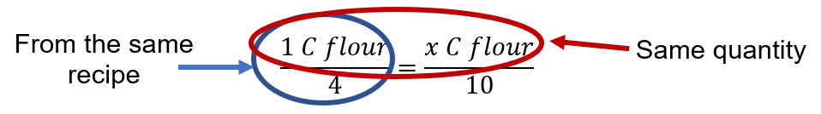

- Scenario 2: Bob realises he has a 250 g block of butter, how many serves of pancakes can he make?
- Scale factor: $\frac{250 \left(new amount\right)}{50 \left(current amount\right)} = 5$ Bob can make 5 times the amount of serves, which is then 5 x 4 = 20 serves of pancakes.
- Unitary method: When Bob has 50 grams of butter, he can make 4 serves. To calculate how many serves per gram of butter he divides 4 by 50, 4 $÷$ 50 = 0.08. He then multiples 0.08 by 250, as he has 250 grams of butter, to work out how many serves he can make.
- Equation using equivalent ratios: $\frac{4 serves}{50g butter}=\frac{x serves}{250g butter}$ Solve for $x$ by multiplying both sides of the equation by 250.
- Number facts: 50 x 5 = 250 which means the serves need to be multiplied by 5 to get 20 serves.
- Scenario 3: Bob realised he has 3 eggs, how much of each ingredient is needed so he can use all his eggs?
- Scale factor: $\frac{3 \left(new\right)}{1 \left(original\right)}=3$ Multiply each ingredient amount by 3.
- Unitary method: Bob has 3 eggs and the original recipe only required 1 egg. To calculate the number of serves for 1 egg, he divides 4 serves by 1 egg, this equals 4 serves per part. Bob has 3 eggs which is the same as 3 parts which means all ingredients will be multiplied by 3.
- Equation using equivalent ratios: $\frac{1C flour}{1 egg}=\frac{xC flour}{3 eggs}$ Solve for $x$by multiplying both sides of the equation by 3 to calculate the total amount of flour. Repeat for all the ingredients keeping the eggs consistent and changing the numerators in the equation.
- Number facts: 1 x 3 = 3 which means each ingredient needs to be multiplied by 3 to get the required amount.
Variations
- Decrease an amount of an ingredient in a recipe and calculate the required amounts of the other ingredients.
Further resources
- Tray Bake (nrich)
- Lamington drive (Universal Resource Hub)

Task 4: Comparing lengths
Core learning: Determining equivalence between ratios of length by expressing them in their simplest form.

Materials
- Appendix 3: Comparing lengths
- Writing materials

Instructions
- Using Appendix 3: Comparing lengths, work through the following scenarios. Focus on explaining the following concepts for each question.
- Question 1: Simplify a ratio by dividing by the highest common factor. In this case the highest common factor is 14. Students may struggle to recognise the highest common factor but can see 2 is a common factor. When they divide by 2, they may then see 7 is now a common factor.
- Question 2: To find the number of buses that fit the length of the jumbo jet and submarine, divide each of them by the length of the bus. The jumbo jet divided by the length of the bus is equal to 5, and the submarine divided by length of the bus is equal to 11. Make explicit the connection between these answers and the simplified ratio from question 1.
- Question 3: Form an equation using equivalent ratios. In this case, $\frac{10}{13}$ $=\frac{x}{26}$. Solve by multiplying $\frac{10}{13}$ by 26 to isolate the variable $x$. This calculates the speed of the submarine on the surface in knots. Students may recognise this can also be solved using equivalent fractions. To find the unknown, multiply the 10 by 2 as the denominator, 13, was multiplied by 2 to get 26. Use task, Recipe alterations, for more details on forming the equation.
- Question 4: Use the simplified ratio to create a scale drawing of each item. The ratio will represent the centimetre length of each item. To fill the width of the paper for their scale drawing, the students can multiply their ratio by a scale factor.
Teaching point: A scale factor is a number used to enlarge or reduce an image. If the scale factor is greater than one, it enlarges the image. If it is between zero and one, it reduces the image. All sides, parts or measurements are multiplied by the same scale factor to keep the image in proportion.
Variations
- Add in the heights of buildings, local landmarks or well-known features such as the Sydney Tower (height of 320 m).
- Compare the lengths/heights of the big things around Australia, for example, The Big Banana, The Big Pineapple, The Big Merino, or heights of local buildings and objects.
Further resources
- Problems involving ratios (Universal Resource Hub)
- Solving problems involving ratios (Universal Resource Hub)
- Proportional reasoning to solve ratio problems (Universal Resource Hub)

Task 5: Ratios with cordial
Core learning: Expressing ratios in their simplest form using a real-life context, including the use of questioning to develop students’ understanding.

Materials
- 4 jugs (larger than a litre)
- Measuring cup
- Cordial concentrate
- Water

Instructions
- Make 4 jugs of cordial to support answering the following questions. While making each jug of cordial explain how the contents of each jug is made up. The jugs are made up as:
- Jug 1: 10 mL of cordial concentrate and 490 mL of water
- Jug 2: 50 mL of cordial concentrate and 450 mL of water
- Jug 3: 100 mL of cordial concentrate and 400 mL of water
- Jug 4: 150 mL of cordial concentrate and 350 mL of water
- Lead a discussion. The table below outlines stimulus prompts to generate conversation about the topic, along with anticipated responses from students.

Prompts | Possible student responses
- What parts makes up the ratio?  - What happens to the colour of the drink as more cordial concentrate is added?  - What happens to the taste of the cordial as the ratio changes?  - How could you simplify the ratios based on the amount of cordial concentrate to water?  - Discuss the order of cordial concentrate and water and the ratio? What would happen if the ratio of cordial concentrate to water was reversed?  - If you were to combine 2 of the jugs, does the ratio change? How could you find the new ratio?  - What is the ideal cordial concentrate to water ratio?  - Is it possible to make the ideal cordial ratio from combining some of our jugs?  - The ideal cordial concentrate to water ratio is 1:4. 20-litres of cordial is needed for an event; how much cordial concentrate is needed?  - In the 20-litre container, keeping the ratio as 1:4 for cordial concentrate to water, how much water is required? Discuss the multiple ways to calculate the answer and check? | - Cordial concentrate and water. Students may be more specific and say 10 mL cordial concentrate and 490 mL water.  - The colour gets more intense.  - The more cordial concentrate added, the stronger the flavour.  - Divide by the highest common factor or divide by a common factor to reduce the numbers to make it easier and repeat the process.  - Ratios are written in the order stated, for example, cordial concentrate to water would be 10:490 or water to cordial concentrate would be 490:10. If the order is reversed without adjusting the order of the ratio, then the taste would be very different.  - Yes, the ratio would change. The cordial concentrate would be added together and then the water would be added together to get the new amounts. This can then be simplified.  - The ideal ratio of cordial concentrate to water is 1:4.  - Yes, when jugs 2 and 4 are combined, the ratio of cordial concentrate to water is 200:800. This, when simplified, is a ratio of 1:4.  - The ideal cordial concentrate to water ratio is 1 part cordial concentrate and 4 parts water. This means there is a total of 5 parts. 20 L divided by 5 parts is 4 L per part, or 1 part of cordial concentrate is multiplied by 4. Therefore 4 L of cordial concentrate is needed.  - The question above calculated how much cordial was needed, as the container holds 20 L, the container minus the cordial will equal the amount of water 20 – 4 = 16. Another way is using the parts. 1-part equals 4 L (calculated above) and there are 4 parts of water therefore the amount of water is 4 x 4 = 16 L.

Teaching point: The discussion and experimentation with cordial connects ratios to real world problems and facilitates deeper understanding. Ensure students understand the importance of order in ratios and that equivalent/simplified ratios can be completed by multiplying or dividing by the same number.
Variations
- Students use different sized jugs to calculate the required quantity of cordial concentrate and water when given the ratio.
- Give a simplified ratio and make up a 250 mL cup of cordial.
- Students compare different ratios of red to white paint to create their preferred colour pink. Similar questions to those listed about can still be asked.
Further resources
- Mixing lemonade (nrich)
- Mixing Paints (nrich)
- Paint numbers (reSolve) (Universal Resources Hub)

Task 6: Map scale
Core learning: Calculating ratio and scale factors to interpret a scale on a map and determine real distances.

Materials
- Appendix 4: Recreational bushland map
- Writing materials

Instructions
- Using Appendix 4: Recreational bushland map, students answer a range of questions involving scale and measurement.
- The distance from Montezuma Falls to Rosebery golf course is 6 kilometres. Measure the distance from Montezuma Falls to Rosebery Golf course on the map to create a scale. The scale can be simplified using the following prompts:
- ? cm = 6 km
- ? cm = 600 000 cm
- 1 cm = ? cm
- 1 : ?
- Ask students to draw a line between routes on Appendix 4: Recreational bushland map, then use the scale to determine the corresponding real distance. The scale should simplify to 1:100 000. For example:
Prompts | Possible student responses
- If the distance on the map from Renison Bell to Rosebery is 8 cm, what is the real distance?  - If the distance on the map from Mount Dundas to Renison Bell going through Montezuma Falls is 6 cm + 5 cm, or 11 cm, what is the real distance? | - The real distance is 800 000 cm or 8 kilometres.  - The real distance is 1100 000 cm or 11 kilometres.
Teacher note: When photocopying Appendix 4: Recreational bushland map check the length of the line between Montezuma Falls to Rosebery golf course is 6 cm or adjust based on printing.
Variations
- Use a map of the school or local area to create a scale and measure the distances.
- Using house plans as a base, find the scale and calculate the length of walls, windows or rooms.
- Students create a scale drawing of their bedroom or a room in their house. Objects and furniture are drawn to scale.
Further resources
- Order on the court (Universal Resource Hub)

Resources

Appendix 1: Ratio cards
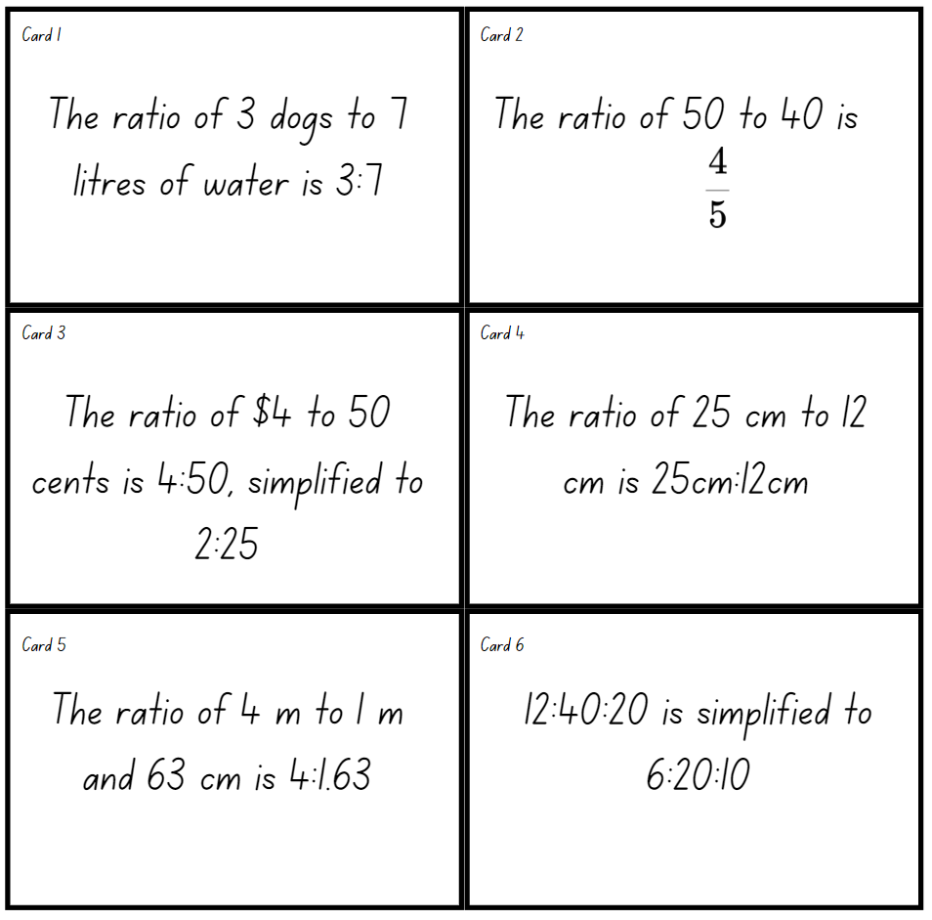
Images licensed under the Canva Content License Agreement.

Appendix 2: Pancake recipe
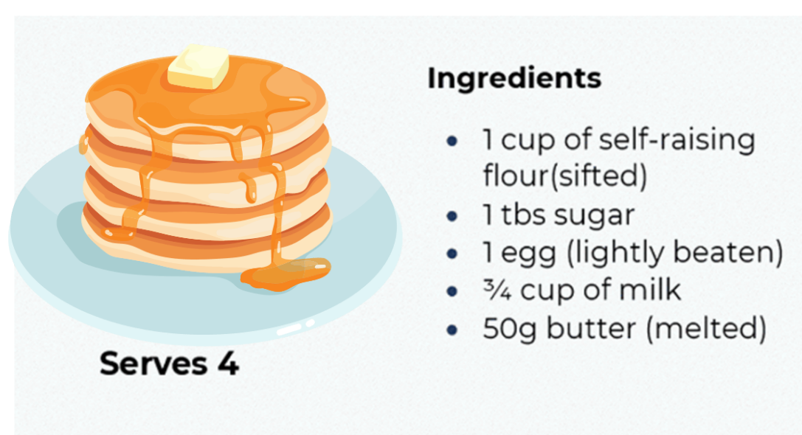

Appendix 3: Comparing lengths
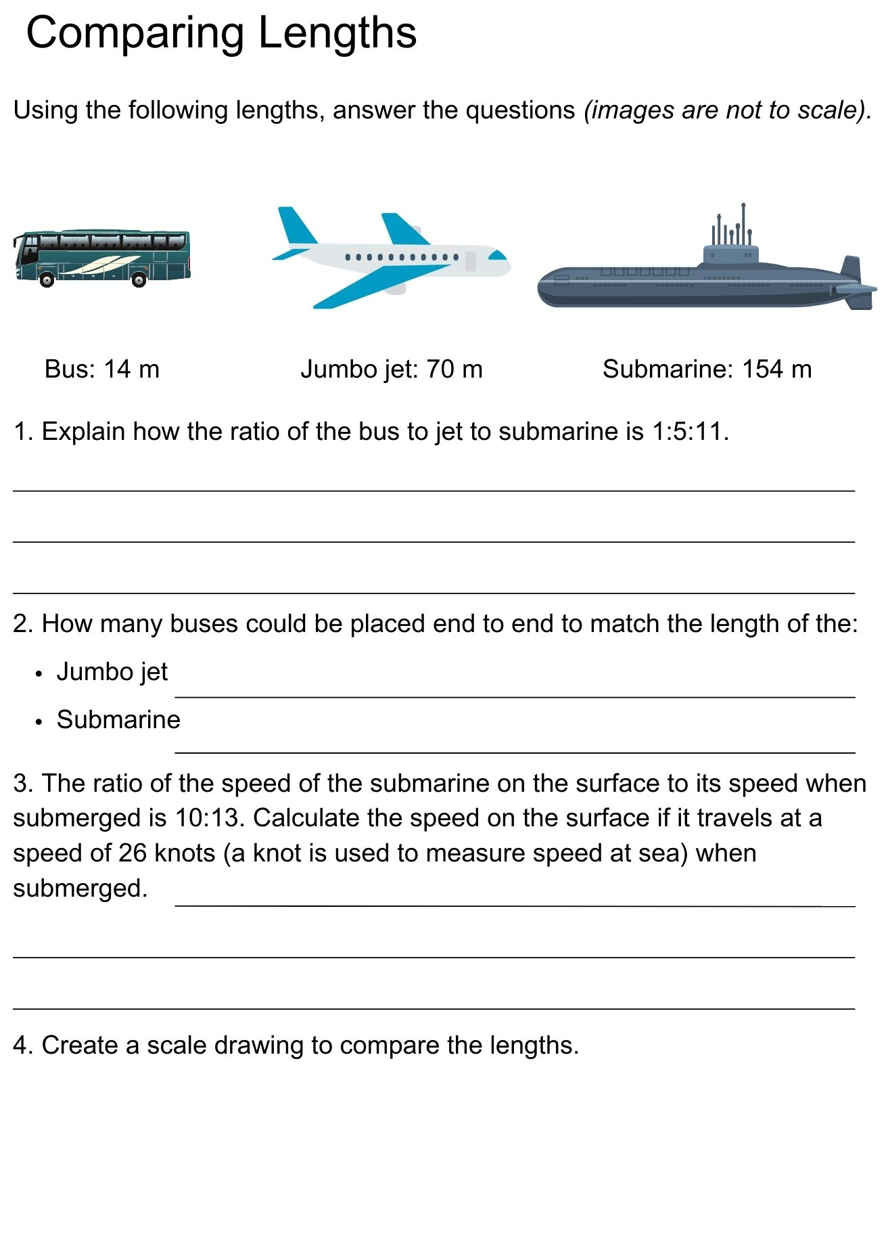
Images licensed under the Canva Content License Agreement.

Appendix 4: Recreational bushland map
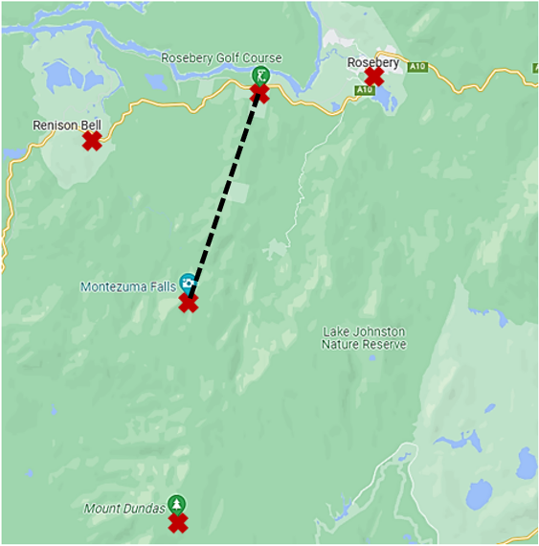
Image sourced from Google Maps.

Information for teachers

References
Australian Government Department of Education (n.d.) ‘What you need to know: FRACTIONS’, Teaching resources, reSolve: Maths by Inquiry website, accessed 27 June 2023.
Australian Government Department of Education (n.d.) ‘What you need to know: PROPORTIONAL REASONING’, Teaching resources, reSolve: Maths by Inquiry website, accessed 27 June 2023.
Cordel B, and Mason R (2000) Proportional reasoning (Algebraic thinking series), Fresno, CA: Aims Education Foundation.
Siemon D, Warren E, Beswick K, Faragher R, Miller J, Horne M, Jazby D & Breed M (2021) Teaching Mathematics Foundations to Middle Years, 3rd edn, Oxford University Press, Victoria.
University of Cambridge (Faculty of Mathematics) (2023) Mixing Lemonade, NRICH website, accessed 25 May 2023.
University of Cambridge (Faculty of Mathematics) (2023) Mixing Paints, NRICH website, accessed 25 May 2023.
University of Cambridge (Faculty of Mathematics) (2023) Tray Bake, NRICH website, accessed 25 May 2023.

Bibliography
Booker G, Bond D, Seah R (2020) Teaching Primary Mathematics, 6th ed, Pearson Education, Australia.
Brady K, Faragher R, Clark J, Beswick K, Warren E, Siemon D (2015). Teaching Mathematics: Foundations to Middle Years. Australia: Oxford University Press.
Goos M, Stillman G & Vale C (2007) Teaching secondary school mathematics: research and practice for the 21st century. Allen & Unwin.
Gould P (2013) ‘Australia’s next top fraction model’, Australian Primary Mathematics Classroom, 18(3):5–12, accessed 27 February 2023.
Ontario Ministry of Education (2012) Paying Attention to Proportional Reasoning, K-12 Queen's Printer for Ontario, accessed 27 June 2023.
Hurst C & Hurrell D (2014). Developing the big ideas of number. International Journal of Educational Studies in Mathematics, 1 (2), 1-18.
Lamon S (1999). Teaching Fractions and Ratios for Understanding – Essential content knowledge and instructional strategies for teachers. Mahwah, NJ: Lawrence Erlbaum and Assoc.
Meyers C, Dawe L, Barnsley G, Grimison L (2003) Mathscape 8. Macmillian Education Australia.
Sparrow L, Booker G, Swan P, Bond D (2015). Teaching Primary Mathematics. Australia: Pearson Australia.
State of Victoria (Department of Education and Training) (2021) ‘Common Misunderstandings - Level 5 Proportional Reasoning’, Numeracy and maths, Department of Education and Training website, accessed 27 June 2023.
The Australian Association of Mathematics Teachers (AAMT) Inc. (n.d.) Top Drawer Teachers: Resources for teachers of mathematics, accessed 5 July 2023.
Tout D & Motteram G (2006). Foundation numeracy in context. Camberwell: ACER Press.

Alignment and support
Alignment to system priorities and/or needs: The literacy and numeracy five priorities.
Alignment to School Excellence Framework: Learning domain: Curriculum, Teaching domain: Effective classroom practice and Professional standards
Consulted with: NSW Mathematics Strategy professional learning and Curriculum Early Years Primary Learners-Mathematics teams
Reviewed by: Literacy and Numeracy
Created/last updated: February 2024
Anticipated resource review date: January 2025
Feedback: Complete the online form to provide any feedback.

