Part 4: Rates

Contents

About the resource 3
The nature of the learner 4
Syllabus 6
Progression 6
Overview of tasks 7
Tasks 8
Task 1: Why can’t we just add? 9
Task 2: Making rates simple 11
Task 3: Which one is cheaper? 13
Task 4: Is it too crowded? 16
Task 5: How quickly can I type? 18
Task 6: Comparing speed of moving objects 20
Resources 22
Appendix 1: Water bottles 22
Appendix 2: Washing powder 23
Appendix 3: Chickens 24
Appendix 4: Typing table 25
Information for teachers 26
References 26
Bibliography 26
Alignment and support 27

About the resource
This resource is the final section of a four-part resource supporting proportional thinking.
- Part 1: Early proportional thinking
- Part 2: Percentages, fractions and decimals
- Part 3: Ratios
- Part 4: Rates
Proportional reasoning refers to the relationship between two or more variables, and a capacity to identify and describe what is being compared with what (Siemon et al. 2021). It is a complex form of reasoning that builds upon a number of interconnected ideas over a long period of time (Siemon et al. 2021). It takes many varied physical experiences to develop an understanding of proportionality and then more time to gain the ability to deal with the concept abstractly (Cordel & Mason, 2000:9). All teachers can support the foundations for proportional thinking by providing targeted teaching that deepens students’ conceptual understanding. This includes problem solving and meaningful practice to explore how and why strategies work.
Proportional thinking requires skills in thinking multiplicatively and involves measures, rates and/or ratios expressed in terms of natural numbers, rational numbers, and/or integers. For example, $\frac{2}{3}$ × $24 as 2‑thirds of $24, or 3.5 × 68 as 3 and a half times 68, (Siemon et al., 2021). Like most concepts in mathematics, talking about proportional thinking is difficult without referring to other aspects of mathematics that recognise and work with relationships between quantities, such as multiplication and division, decimals, fractions and percentages.
Student understanding of number sense is a critical part of developing deep, meaningful mathematical skills, understanding and confidence. Students apply their number sense to a variety of proportional situations, including practical and financial problems, and develop the numeracy knowledge required for a range of important life skills. Proportional reasoning underpins an understanding of ratios and rates as well as the development of concepts and skills in other aspects of mathematics, such as trigonometry, similarity and gradient.

The nature of the learner
Students tend to progress through several broad phases of conceptual understanding as proportional thinking develops. Multiplicative understanding forms a crucial foundation for proportional thinking and students need to be able to:
- use multiplication and division in a wide range of situations,
- communicate mathematically using manipulatives, vocabulary and diagrams,
- apply the commutative, associative and distributive properties to solve problems, knowing how and when these properties are useful and when they are not, and
- apply part-part-whole reasoning to composite units.
See teaching considerations for multiplicative thinking.
Multiplicative thinking and proportional reasoning are complex. Students should be supported to acquire an understanding of:
- the ‘for each’ idea, or how the Cartesian product develops an understanding of rates and ratios,
Figure 1 – Cartesian model using clothing items
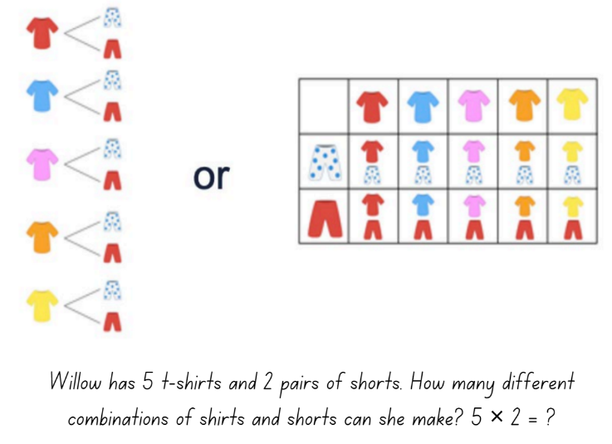
- the ‘times as many’ or ‘times as large’ idea for comparing quantities multiplicatively as can be seen developing through place value, for example, 0.2 is 10 times as large as 0.02, or 100 times 0.005 is 0.5,
- the conceptual relationship between fractions, decimals and percentages,
- the link between fractions and ratios builds an understanding when simplifying ratios, for example, 2:8 could be simplified to 1:4 because I know 2 eighths is the same as 1 over 4,
- factorisation to simplify quantities in rates and ratios, connecting this to simplifying fractions,
- fractions as ratios used to make ‘part-part’ comparisons, 2:3 represented as $\frac{2}{3}$ compared to fractions which are used to make ‘part-whole’ comparisons, $\frac{2}{5}$.
Figure 2 – Ratio of 2 to 3 using squares and triangles
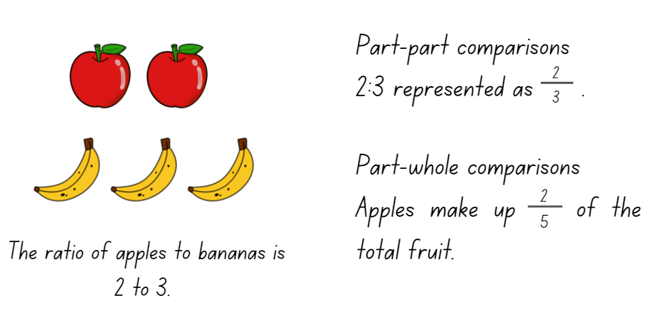
The resource has been developed in partnership with the NSW Mathematics Strategy Professional Learning team and Literacy and Numeracy.

Syllabus
MAO-WM-01 develops understanding and fluency in mathematics through exploring and connecting mathematical concepts, choosing and applying mathematical techniques to solve problems, and communicating their thinking and reasoning coherently and clearly
MA4-RAT-C-01 solves problems involving ratios and rates, and analyses distance–time graphs
NSW Mathematics K-10 Syllabus (2022)

Progression
Multiplicative thinking MuS6 – MuS9
Proportional thinking PrT3 – PrT6
Understanding money UnM7, UnM9
Understanding units of measurement UuM8
Measuring time MeT5
National Numeracy Learning Progression Version 3

Copyright
Section 113P Notice
Texts, Artistic Works and Broadcast Notice
Some of this material has been copied and communicated to you in accordance with the statutory licence in section 113P of the Copyright Act. Any further reproduction or communication of this material by you may be the subject of copyright protection under the Act. Do not remove this notice.

Overview of tasks
Task name | What does it promote? | What materials will I need? | IfSR link
Task 1: Why can’t we just add? | Evaluating additive and multiplicative strategies to identify the most efficient method to solve problems involving rates. | - Writing materials  - 36 counters (optional)  - 12 paper cups (optional) | PT – 4A.1  PT – 4A.2  PT – 4A.7
Task 2: Making rates simple | Comparing 2 different units by expressing the relationship between them as a rate in its simplest form. | - Writing materials  - 36 counters (optional)  - 12 paper cups (optional) | PT – 4A.1  PT – 4A.2  PT – 4A.3
Task 3: Which one is cheaper? | Different quantities can be compared by determining a common unit of measure. | - Appendix 1: Water bottles  - Appendix 2: Washing powder  - Writing materials | PT – 4A.4
Task 4: Is it too crowded? | Rates coordinate pairs of numbers and can be expressed in 2 ways to compare the relationships between the same 2 quantities. | - Appendix 3: Chickens  - Writing materials | PT – 4A.5
Task 5: How quickly can I type? | Making rate comparisons by calculating the multiplicative relationship between the number pairs. | - Appendix 4: Table  - Writing materials  - Stopwatch or timer | PT – 4A.6
Task 6: Comparing speed of moving objects | Calculate and compare rates. | - Writing materials | PT – 4A.8

Tasks
For additional information on key generalisations and observable behaviours see reSolve, What you need to know: FRACTIONS (n.d.) and reSolve What you need to know: PROPORTIONAL REASONING (n.d.).
Key generalisations | Observable features
What is some of the mathematics:  - Mathematicians check their thinking by using an alternative way to solve the problem.  - Mathematicians use tables, diagrams to represent and communicate their thinking.  - Multiplication and division can be used to calculate unknown values in rates problems.  - Knowledge of factors assists with calculating problems involving division.  - Understanding of decimal place value helps to compare units of measurement. | Some observable behaviours:  - Explains why additive thinking is the least efficient strategy when increasing both quantities, given a simple rate.  - Uses a range of multiplicative strategies, such as doubling, to increase quantities.  - Uses a range of strategies to simplify rates, such as inverse operations and partitioning numbers.  - Finds common factors and the highest common factor in numbers.

Task 1: Why can’t we just add?
Core learning: Evaluating additive and multiplicative strategies to identify the most efficient method to solve problems involving rates.

Materials
- Writing materials
- 36 counters (optional)
- 12 paper cups (optional)

Instructions
- Pose the following scenario: For every cup of coffee, I use 3 cubes of sugar. Explain this relationship between coffee and sugar can be written as a rate: 3 cubes of sugar per 1 cup of coffee or 3 cubes/1 coffee.
Teacher note: A rate involves a multiplicative comparison and uses the word per and the
symbol /.
- Ask how many sugar cubes we need if we double the number of coffees? Provide time for students to turn and talk about how they would solve the change in scenario. Choose students to explain their working and reasoning.
- Ask did you just add one more coffee and 3 more cubes, or did you multiply both sides by 2. (See Figure 3.)
Figure 3 – Multiplying sugar cubes and coffee
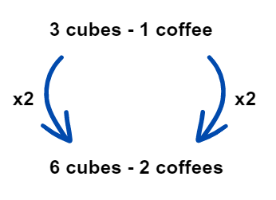
Images licensed under the Canva Content License Agreement.
- Explain the number of coffees is now three times as many, that is, triple the amount. Provide time for students to turn and talk about how they would solve the change in scenario. Choose students to explain their working and reasoning. Ask:
- Did you keep adding one more coffee and 3 more cubes?
- Did you double first and then add one more?
- Did you multiply both sides by 3?
- Did you find the solution using another method? How?
- Which method is most efficient? Why?
- Support students to develop their multiplicative thinking by repeating the activity for 6, 9 and 12 coffees. Discuss all possible ways and have students determine multiplication is the most efficient strategy.
- Change the scenario where the number of coffees is a prime number, such as 7 or 23 coffees. Ask students to explain how they would work out the total number of sugar cubes needed. Use the following prompts:
Prompts | Possible student responses
- Can you solve this using addition?  - How many different ways could you use part additive and part multiplicative strategies to solve this problem?  - How could you solve this using multiplicative strategies? | - Yes, I kept adding on because I could not double or triple to get the total.  - I used part multiplicative and part additive because I doubled the number of coffees first, then I tripled that result and finally added one more.  - I multiplied both sides by the prime number itself.
Teaching point: The strategy used to increase quantities in rates is important. Adding on both sides to change quantities is not efficient, especially when they are changing in the same proportion. Students need to acknowledge that multiplying both sides by the largest multiple is the quickest way to increase quantities when working with rates.
Variations
- Repeat the activity using other examples of rates to justify multiplicative thinking as the most efficient strategy. Possible alternatives are typing speed per minute, heart rate, number of steps for every 100 m.

Task 2: Making rates simple
Core learning: Comparing 2 different units by expressing the relationship between them as a rate in its simplest form.

Materials
- Writing materials
- 30 counters (optional)
- 15 paper cups (optional)

Instructions
- Revise a rate is the ratio between 2 related quantities in different units, for example, distance travelled per hour, or cost of items per kg. They are expressed in their simplest form when written as a quantity per one unit of something else, for example, $4.00 per kilogram = $4/kg.
- Pose the following scenario. Ben works in a café and uses 30 sugar cubes to make 15 coffees in one hour. How many cubes does he use for one coffee?
- In small groups, ask students to solve this problem and record their working and strategy used.
- Choose groups to share their strategy with the class. For example:
- I saw 3 is a factor of 30 and 15, so I divided by 3 to get 10 cubes per 5 coffees. Then I say 5 is a factor of 10 and 5 so I divided both by 5 to get 2 cubes per 1 coffee (see Figure4).
- I found the highest common factor of both 30 and 15, which is 15, and divided both sides by that factor.
Figure 4 – Student working
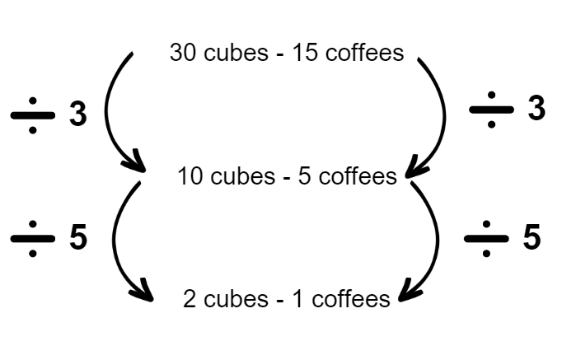
Images licensed under the Canva Content License Agreement.
- Ask which strategy is the most efficient and to explain reasoning.
- Provide more problems to solve with groups.
- Provide problems where students need to simplify a rate to determine new quantities and use a simplified rate to calculate a new quantity. For example:
- Ben works in a café and uses 120 sugar cubes to make 60 coffees in one morning. How many cubes does he need to make 100 coffees?
- Ben works in a café and uses 2 sugar cubes per coffee. How many coffees will he make if he uses 150 sugar cubes in one morning?
Teaching point: Students should use their knowledge of the inverse relationship between multiplication and division when working with rates. Students need knowledge of factors to operate flexibly and build their understanding of multiplicative thinking when working with rates.
Variations
- Use different examples of rates such as wages earned per shift or time taken to fill a jug with water.
- Students find examples of rates at a grocery store. Possible findings: Cost of items per 100g, per 100mL, per L. Discuss if rates measured in per 100 units of quantity are in their simplest form. Ask them to explain why they are not expressed as per one gram or per one mL?

Task 3: Which one is cheaper?
Core learning: Different quantities can be compared by determining a common unit of measure.

Materials
- Appendix 1: Water bottles
- Appendix 2: Washing powder
- Writing materials

Instructions
- Explain goods come in different packaging sizes and sometimes the cheaper product might cost more per unit. Tell students that in this activity, they are to focus on the best value for money and not the different brands or their personal preferences.
- Display Appendix 1: Water bottles and pose the problem, which one is cheaper if you had to buy 12L of water for a camping trip?
- Discuss how to compare the costs when the quantities are different. Ask:
- What do you notice about the units used to measure the amount of water in each bottle?
- Do you think we should make them all the same units, for example, all in mL or all in L? Explain your thinking.
- Students work in small groups to convert the unit of measurement to the same unit and amount. Encourage them to look at increasing or decreasing amounts. Provide writing materials to record thinking, for example, drawing simple diagrams, double number lines or the bar model.
Figure 5 – Student working to convert units
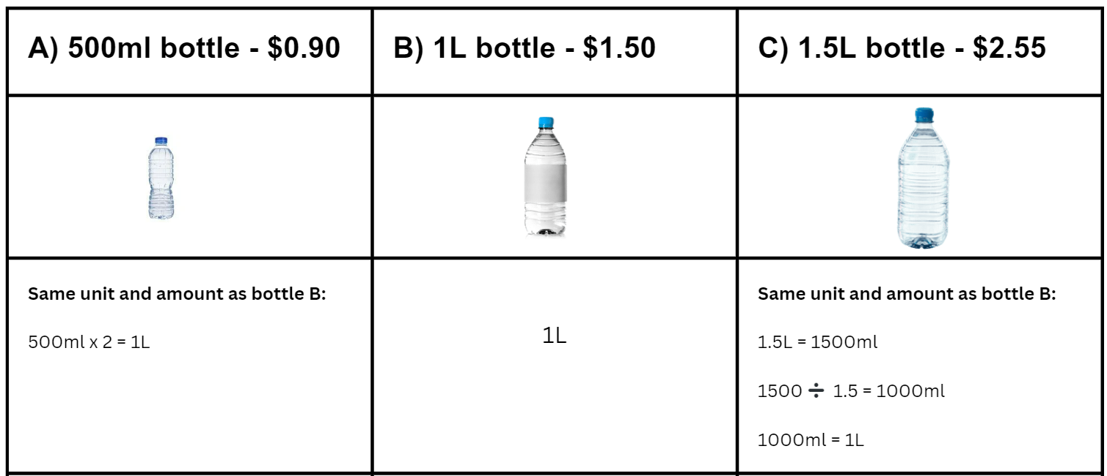Images licensed under the Canva Content License Agreement.
- Have students share how they converted the amount of water in their bottles and discuss in groups if their chosen strategy will make it more or less challenging to calculate the cost. Allow for groups to make changes if they determine there is a more efficient strategy.
- Ask students to look at the cost of each bottle and determine the total cost for 12L. Students reflect on their calculations and which bottle is the best buy and continue to record their working.
Figure 6 – Student working to compare cost
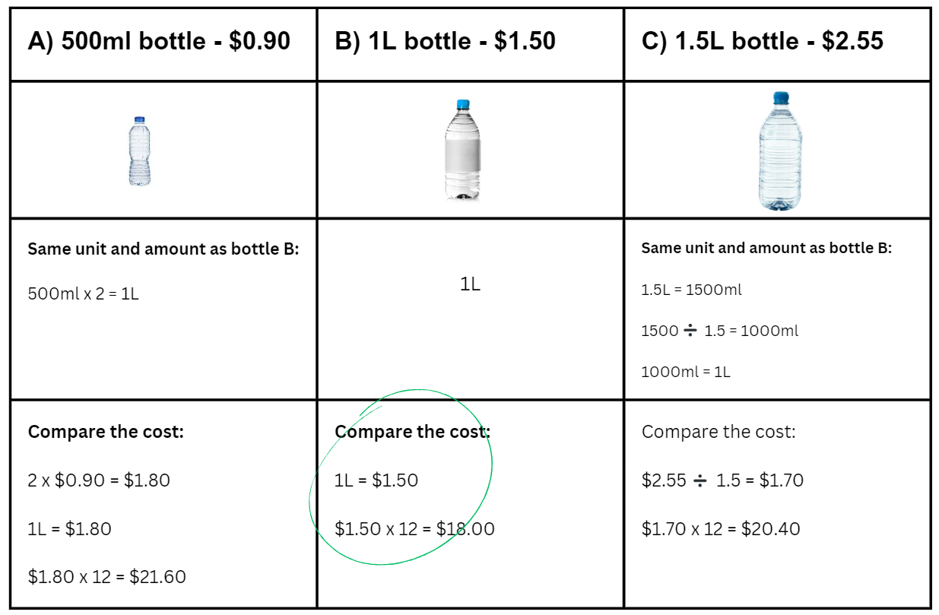
Images licensed under the Canva Content License Agreement.
- Students discuss which is the best buy and how they know. For example, finding a common unit of comparison by converting to find the price per 100 mL, finding the price per 500 mL by halving the price of the 1 L and thirding the price of 1.5 L, or finding the cost of 1.5 L by multiplying 500 mL by 3 and 1 L by 1 and a half.
- Provide opportunities for students to complete similar activities, Appendix 2: Washing powder.
Teaching point: When comparing prices of different sized items, it is much easier to determine a common measure that exists in all the items you are comparing and then find the cost for that unit of measure.
Variations
- Compare the cost of items that include 100 mL or 1 mL as a common measure to compare costs for all 3 sizes.
Further resources
- Comparing rates (Universal Resource Hub)

Task 4: Is it too crowded?
Core learning: Rates coordinate pairs of numbers and can be expressed in 2 ways to compare the relationships between the same 2 quantities.

Materials
- Appendix 3: Chickens
- Writing materials

Instructions
- Display Appendix 3: Chickens with the information below each rectangle covered. Use the questions below to prompt discussion around the image.
Prompts | Possible student responses
- Which rectangle do you think has the most chickens?  - What does crowded mean?  - Which rectangle do you think looks crowded?  - How do you think we can work out which one is more crowded? | - Rectangle A has the most because the area is bigger, so you can fit more chickens in there.  - Crowded means there are too many things too close together in a space.  - There appears to be more space in Rectangle B, so I think rectangle A is more crowded.  - We need to compare the number of chickens per area or the area per chicken.
- Reveal the covered information on Appendix 3: Chickens and demonstrate how to find the solution to, which pen is more crowded?
- To enable students to visualise the difference between the 2 rate relationships, model both unit relationships, chickens per area or the area per chicken. Have students consider if there will be a different result if they use one unit relationship in comparison to the other.

 | Rectangle A | Rectangle B
Number of chickens per $cm^{2}$ | 180 $cm^{2}$ has 50 chickens  For 1$cm^{2}$, there are 50$÷$180 = 0.28 chickens.  This is more than a quarter but less than half. | 100 $cm^{2}$ has 25 chickens  For 1$cm^{2}$, there are 25$÷$100 = 0.25 chickens.  This is exactly a quarter of a chicken or 0.25 chickens per 1 cm squared.
Area $cm^{2}$ per chicken | 50 chickens for 180 $cm^{2}$  For 1 chicken, there is 180$÷$50 = 3.6 $cm^{2}$ of space. | 25 chickens for 100 $cm^{2}$  For 1 chicken, there is 100$÷$ 25 = 4.0 $cm^{2}$of space or 4 cm squared per chicken.
- From the calculation of the number of chickens per $cm^{2}$, Rectangle A states that for every 1$cm^{2}$ of space, a little more than a quarter of a chicken can fit in that space, whereas in Rectangle B only a quarter of a chicken can fit in the same space, which is less. This indicates that when we are comparing number of chickens per $cm^{2}$, Rectangle A is more crowded.
- From the calculation of the area $cm^{2}$ per chicken, Rectangle B has more space for one chicken than Rectangle A. This indicates that Rectangle A is more crowded as it has less space for each chicken.
- Ask students to consider if the order is important in rates and if the order changes the outcome. For example, in which scenarios would it be important to focus on the number of chickens per area and in which scenarios would it be important to focus on the area per chicken?
Teacher note: Rates can be expressed in 2 ways, and describe the same relationship. They are still comparing the same quantities.
Variations
- Model using students in a particular area in the classroom/space around school.
- Compare population density of different countries.
- Comparing by Finding Rates (NZ Maths)

Task 5: How quickly can I type?
Core learning: Making rate comparisons by calculating the multiplicative relationship between the number pairs.

Materials
- Appendix 4: Typing table
- Writing materials
- Stopwatch or timer

Instructions
- Scenario: 2 students were told to write and type the same piece of text as fast as they could in a time span of one minute. Their writing and typing rates were recorded in Appendix 4: Typing table.
- Display Appendix 4: Typing table and ask students to share what they notice and wonder.
- Explain that rates can be compared using additive reasoning and/or multiplicative reasoning. For this example:
- Additive reasoning – Student B is faster at typing than writing as they can type an extra 30 words per minute compared to Student A who can type an extra 20 words per minute.
- Multiplicative reasoning – Student A has doubled the number of words from writing to typing per minute and Student B has less than doubled their writing to typing rate.
- Have students conduct their own experiment with rates of writing and typing. Both students need to time and write a sample text and then record the number of words written in one minute. Round the number to the nearest whole or nearest half to assist with calculations.
- Students then time and type the same sample text and then record the number of words typed in one minute. Round the number to the nearest whole or nearest half to assist with calculations.
- Record results in a table.
- Students compare the results and reason about their findings, using both additive and multiplicative strategies then share their reasoning with the class.
Teaching point: Students need to be able to reason growth/reduction or increase/decrease not only additively, but multiplicatively in a range of contexts. By doing this, students have developed proportional thinking.
Variations
- Students use different scenarios to examine rate relationships, for example, conduct an experiment on the flow rate of water using 2 different taps to fill a glass or jug in 10 seconds, compare 2 babies with different starting weights and determine the rate of growth after 12 months or compare the improvement rates of 2 students who received different marks in a test, and in the follow up test they both received higher marks.
Further resources
- Ratios and Rates (nzmaths)

Task 6: Comparing speed of moving objects
Core learning: Calculate and compare rates of speed.

Materials
- Writing materials

Instructions
This activity is an adaption of Ratios and Rates from nzmaths, (n.d).
Teacher note: A common rate is speed. Speed is a measure of the distance an object travels over a period of time. Speed is not always constant when an object is moving, so we generally calculate the average speed of a moving object.
- Students brainstorm common rates they encounter in their own lives, for example heartbeats per minute, dollars per hour or seconds per 50m freestyle.
- Ask students to suggest a rate of speed they travel on their bicycles, for example, 30km/hour.
- Record this in full alongside the abbreviation: 30 kilometres per hour and 30 km/h and ask for a student to explain what this rate means, such as in every hour I ride 30 kilometres or I ride 30km every one hour.
- Draw a table and add the relevant information.
Figure 7 – Recording table
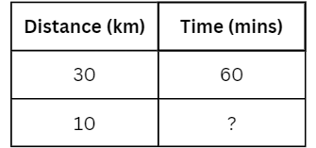
Images licensed under the Canva Content License Agreement.
- Student work in pairs to calculate how long it will take to ride 10 km. Choose students to explain their answers, for example 30 is half of 60 so 10 must be half of 20, or 10 is one third of 30 so 20 is one third of 60.
- Provide other examples to explore, each time highlighting different relationships.
- How long to ride 60 km?
- How long to ride 40 km?
- How long to ride 15 km?
- How far in 30 minutes?
- How far in 45 minutes?
- How far in 10 minutes?
- Choose students to share their responses and strategies used to solve the problems and identify any challenges encountered.
- Explain we can use the distance travelled and the duration of the activity to compare the rate of speed of different drivers. Consider the following, Olivia took 30 minutes to drive 42 km and Aliah took 40 minutes to drive 72 km.
- Discuss how to use information to determine who was driving at the fastest average speed. If not discussed, prompt students that finding how many kilometres travelled per 10 minutes provides a common unit of measure to compare different rates of speed.
- Figure 8 shows a bar model example to compare speed with a common benchmark.
Figure 8 – Bar model comparing speed
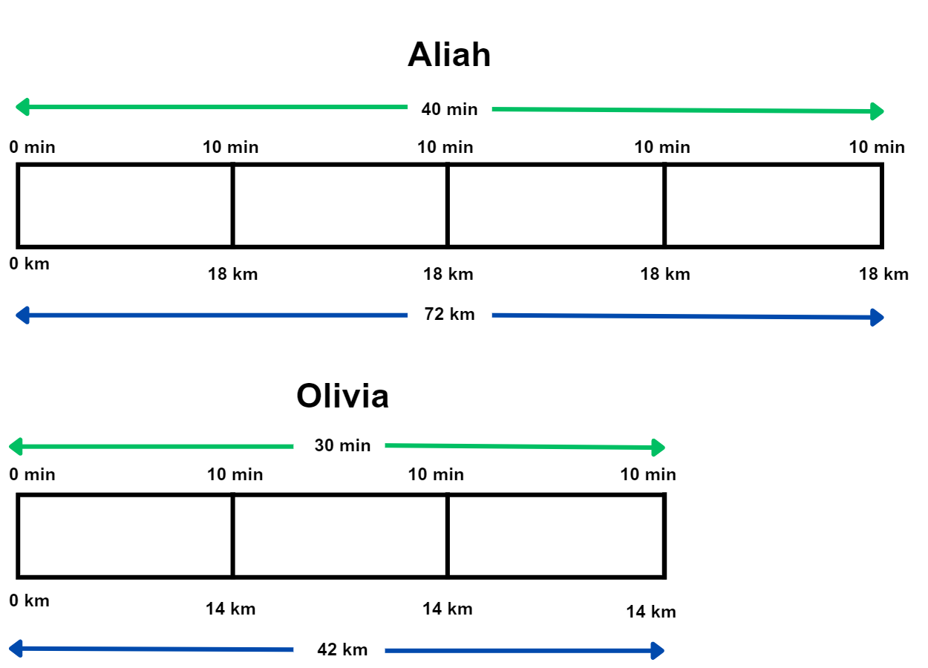
Images licensed under the Canva Content License Agreement.
Variations
- Use other types of travel like walking, running, or swimming to discuss and compare speed.
Further resources
- Ratios and Rates (nzmaths)
- Modelling motion (reSolve)
- Running laps (NRICH)

Resources

Appendix 1: Water bottles
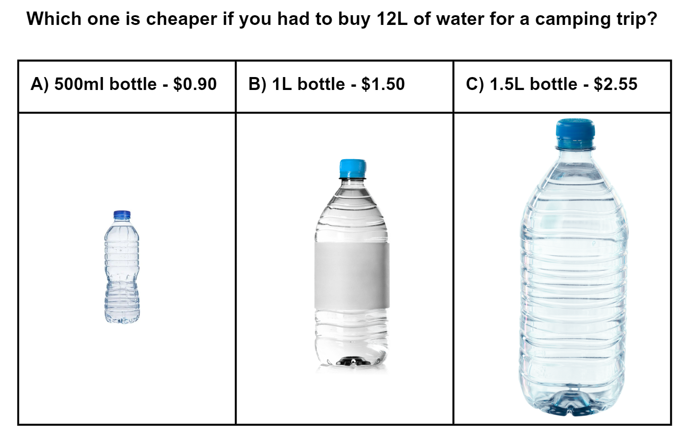
Images licensed under the Canva Content License Agreement.

Appendix 2: Washing powder
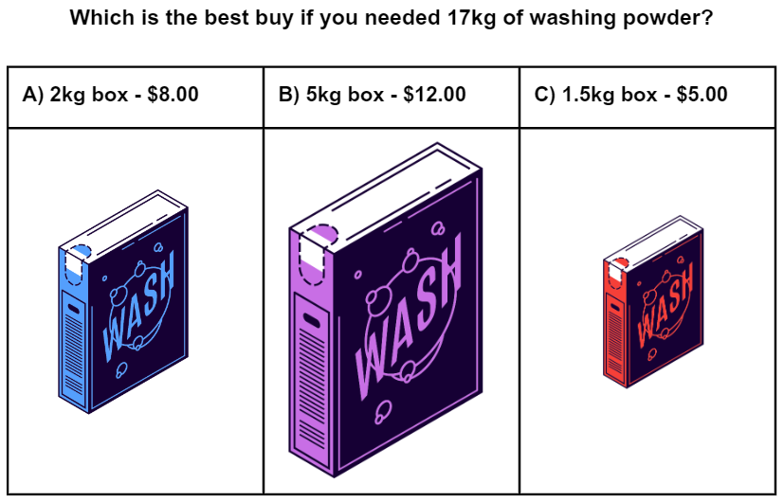
Images licensed under the Canva Content License Agreement.

Appendix 3: Chickens
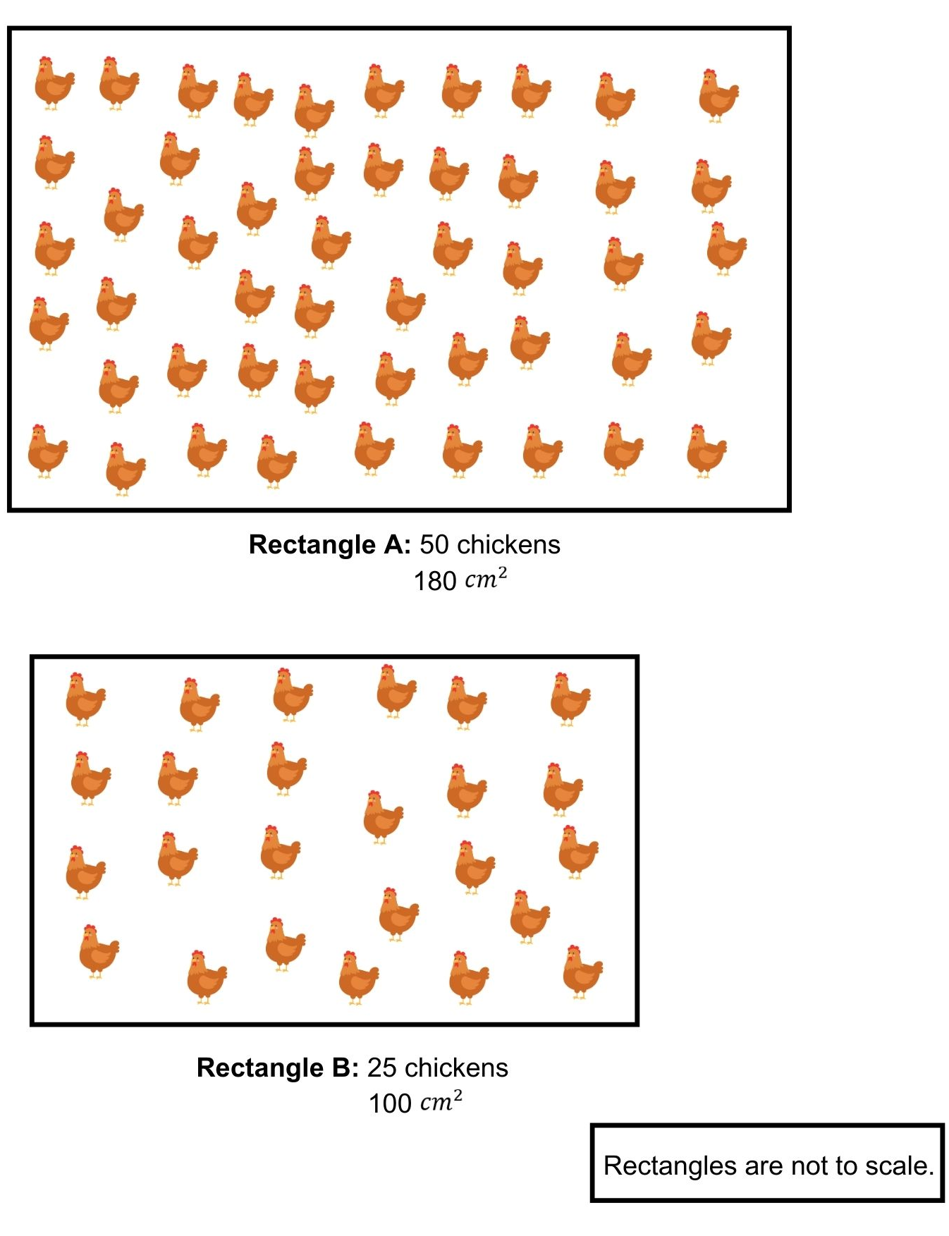
Images licensed under the Canva Content License Agreement.

Appendix 4: Typing table
 | Student A | Student B
Writing rate | 20 words/min | 40 words/min
Typing rate | 40 words/min | 70 words/min

Information for teachers

References
Australian Government Department of Education (n.d.) ‘Modelling motion’, Teaching resources, reSolve: Maths by Inquiry website, accessed 27 June 2023.
Australian Government Department of Education (n.d.) ‘What you need to know: FRACTIONS’, Teaching resources, reSolve: Maths by Inquiry website, accessed 27 June 2023.
Australian Government Department of Education (n.d.) ‘What you need to know: PROPORTIONAL REASONING’, Teaching resources, reSolve: Maths by Inquiry website, accessed 27 June 2023.
Cordel B, and Mason R (2000) Proportional reasoning (Algebraic thinking series), Fresno, CA: Aims Education Foundation.
New Zealand Ministry of Education (n.d.) ‘Comparing by Finding Rates’, Resource, nzmaths website, accessed 1 July 2023.
New Zealand Ministry of Education (n.d.) ‘Ratios and Rates’, Resource, nzmaths website, accessed 1 July 2023.
Siemon D, Warren E, Beswick K, Faragher R, Miller J, Horne M, Jazby D & Breed M (2021) Teaching Mathematics Foundations to Middle Years, 3rd edn, Oxford University Press, Victoria.
University of Cambridge (Faculty of Mathematics) (2023) Laps, NRICH website, accessed 5 July 2023.

Bibliography
Bayazit I (2013) Quality of the tasks in the new Turkish elementary mathematics textbooks: the case of proportional reasoning. International Journal of Science and Mathematics Education 11, 651–682.
Booker G, Bond D, Seah R (2020) Teaching Primary Mathematics, 6th ed, Pearson Education, Australia.
Brady K, Faragher R, Clark J, Beswick K, Warren E, Siemon D (2015). Teaching Mathematics: Foundations to Middle Years. Australia: Oxford University Press.
Goos M, Stillman G & Vale C (2007) Teaching secondary school mathematics: research and practice for the 21st century. Allen & Unwin.
Gould P (2013) ‘Australia’s next top fraction model’, Australian Primary Mathematics Classroom, 18(3):5–12, accessed 27 February 2023.
Hurst C & Hurrell D (2014). Developing the big ideas of number. International Journal of Educational Studies in Mathematics, 1 (2), 1-18. http://doi.org/10.17278/ijesim.2014.02.001
Lamon S (1999). Teaching Fractions and Ratios for Understanding – Essential content knowledge and instructional strategies for teachers. Mahwah, NJ: Lawrence Erlbaum and Assoc
Lappan G, Fey J, Fitzgerald W, Friel S and Difanis-Phillips E (2009). Connected Mathematics: Comparing and Scaling. East Lansing, MI: Pearson Education, Inc
Ontario Ministry of Education (2012) Paying Attention to Proportional Reasoning, K-12 Queen's Printer for Ontario, accessed 27 June 2023.
Sparrow L, Booker G, Swan P, Bond D (2015). Teaching Primary Mathematics. Australia: Pearson Australia.
State of Victoria (Department of Education and Training) (2021) ‘Common Misunderstandings - Level 5 Proportional Reasoning’, Numeracy and maths, Department of Education and Training website, accessed 27 June 2023.
The Australian Association of Mathematics Teachers (AAMT) Inc. (n.d.) Top Drawer Teachers: Resources for teachers of mathematics, accessed 5 July 2023.

Alignment and support
Alignment to system priorities and/or needs: The literacy and numeracy five priorities.
Alignment to School Excellence Framework: Learning domain: Curriculum, Teaching domain: Effective classroom practice and Professional standards
Consulted with: NSW Mathematics Strategy professional learning and Curriculum Early Years Primary Learners-Mathematics teams
Reviewed by: Literacy and Numeracy
Created/last updated: February 2024
Anticipated resource review date: January 2025
Feedback: Complete the online form to provide any feedback.

