Multiplicative thinking: developing flexible strategies

Stage 3

Learning intention
Students will strengthen efficiency, flexibility and confidence in using a variety of mental strategies to solve problems of a multiplicative nature. They will use informal recordings to represent their strategies and communicate effectively with others. Students will also deepen their understanding of the operations themselves and the inverse relationship between multiplication and division.

Syllabus outcomes
The following teaching and learning strategies will assist in covering elements of the following outcomes:
- MAO-WM-01 develops understanding and fluency in mathematics through exploring and connecting mathematical concepts, choosing and applying mathematical techniques to solve problems, and communicating their thinking and reasoning coherently and clearlyMA3-2WM: selects and applies appropriate problem-solving strategies, including the use of digital technologies, in undertaking investigations
- MA3-RN-01 applies an understanding of place value and the role of zero to represent the properties of numbers
- MA3-MR-01 selects and applies appropriate strategies to solve multiplication and division problems
NSW Mathematics K-10 Syllabus (2022)

National Numeracy Learning Progression guide

What are multiplicative strategies?
Multiplicative strategies describe how students become increasingly able to use more efficient and flexible strategies for multiplication and division computation. As students develop an understanding of coordinating units multiplicatively, they can use the value of one unit applied to each of the units of the other, the multiplier, and that this process can be equally relevant to problems of division.
Students may demonstrate these behaviours as they develop increasing confidence with choosing and using flexible strategies to solve multiplicative problems.
- Multiplicative strategies MuS5 –MuS7
- Understanding money UnM7
- Understanding unit of measurement UuM5-UuM6
National Numeracy Learning Progression version 3

Overview of teaching strategies

What works best
Explicit teaching practices involve teachers clearly explaining to students why they are learning something, how it connects to what they already know, what they are expected to do, how to do it and what it looks like when they have succeeded. Students are given opportunities and time to check their understanding, ask questions and receive clear, effective feedback.
This resource reflects the latest evidence base and can be used by teachers as they plan for explicit teaching.
Teachers can use assessment information to make decisions about when and how they use this resource as they design teaching and learning sequences to meet the learning needs of their students.
Further support with What works best is available.

Differentiation
When using these resources in the classroom, it is important for teachers to consider the needs of all students, including Aboriginal and EAL/D learners.
EAL/D learners will require explicit English language support and scaffolding, informed by the Enhanced EAL/D enhanced teaching and learning cycle and the student’s phase on the EAL/D Learning Progression. Teachers can access information about supporting EAL/D learners and literacy and numeracy support specific to EAL/D learners.
Learning adjustments enable students with disability and additional learning and support needs to access syllabus outcomes and content on the same basis as their peers. Teachers can use a range of adjustments to ensure a personalised approach to student learning.
Assessing and identifying high potential and gifted learners will help teachers decide which students may benefit from extension and additional challenge. Effective strategies and contributors to achievement for high potential and gifted learners helps teachers to identify and target areas for growth and improvement. A differentiation adjustment tool can be found on the High potential and gifted education website.

Using tasks across learning areas
This resource may be used across learning areas where it supports teaching and learning aligned with syllabus outcomes.
Literacy and numeracy are embedded throughout all K-10 syllabus documents as capabilities. As the English and mathematics learning areas have a particular role in developing literacy and numeracy, NSW English K-10 and Mathematics K-10 syllabus outcomes aligned to literacy and numeracy skills have been identified.

Considerations

Language and vocabulary
As students are provided opportunities to experience concepts, teachers can also build understanding of mathematical vocabulary and communicating skills. Teachers can help build students confidence and capabilities by making complex mathematical ideas visible to students through drawings, diagrams, enactment, gestures and modelling. Making intentional connections between various representations and experiences with mathematical language helps build an understanding of important vocabulary whilst also building conceptual understanding.

Talk moves
Classroom talk is a powerful tool for both teaching and learning. Rich, dialogic talk supports students in making sense of complex ideas and builds classroom communities centred around meaning-making. 'Talk moves' are some of the tools a teacher can use to support rich, meaningful classroom discussion.
Some of the talk moves include:

- wait time
- turn and talk
- revoicing
- reasoning
- adding on
- repeating
- revise your thinking.

The Literacy and numeracy website provides additional information and resources to support talk moves.

Number talks
Number talks are a powerful teaching routine centred on short, intentional classroom conversation about a purposefully crafted problem that is solved using a broad range of mental strategies. Their general goal is to build fluency and sense-making through meaningful communication, problem solving and reasoning. They provide regular opportunities to develop number sense and mathematical reasoning through exploring, using and building confidence in additive and multiplicative strategies.
Suggested structure for an open-sharing number talk:
- A teacher determines the next learning goal for students and finds/designs a problem connected to that learning need.
- The teacher (and colleagues) considers and discuss possible responses from students and plan formative assessment strategies, questioning and how to use a broad range of tools to represent the possible ideas student may raise (for example, enactment, diagrams, models)
- The carefully designed problem is posed to all students within the class.
- Allow thinking time for students to consider the different strategies they would use to solve the problem.
- Readiness to share is indicated by individual students raising a thumb unobtrusively against their chests (and raising one or more fingers if they think of other solutions).
- Provide students with opportunities to turn and talk, sharing their ideas with other students sitting nearby.
- The teacher listens to students as they talk, moving about the class inviting students to share their thinking more broadly, intentionally selecting and sequencing conversation that will best support the purpose of the number talk.
- Thinking is collected and discussed. The teacher may seek a variety of answers without comment, then discus them as a class. Or the teacher may invite one student at a time to explain their thinking.
- The teacher supports students to make connections between ideas and to other learning experiences.
- The teacher concludes the open-sharing number talk by connecting back to the purpose of the task, making explicit the mathematical goal of the conversation.
The Literacy and numeracy website provides additional information and resources to support number talks.

Two versus two
For most games, we recommend small groups of 4 students, working in pair of 2 (2 versus 2). This gives students the opportunity to discuss mathematical ideas, strategies and understanding with their team mates as well as their opponents.

Think board
Think boards can be used to make connections between different mathematical concepts or for students to visually represent their understandings and strategies in a range of ways.
Figure 1: Think board

Tools and resources to support learning
These tools and resources can be used throughout the tasks:
- white boards and markers
- counters
- dice (with various faces)
- dominos
- multi-attribute blocks (MAB)
- region representation of multiplication and division facts
- array dot images (up to 10 tens)
- blank 10 x 10 grid

Key understandings
Student understanding of these key concepts is essential. If there are misconceptions in these areas, additive thinking can be more challenging, and these areas may need to be readdressed.
Professor Di Siemon’s research is pivotal to supporting students to develop understanding of multiplicative thinking. A snapshot of this research has been used in this section from the following text: Siemon D, Beswick K, Brady K, Clark J, Faragher R, Warren E (2015) Teaching Mathematics: Foundations to Middle Years, Second Edition, Oxford University Press, Melbourne.

Repeated addition
It is possible to use repeated addition and subtraction to solve multiplicative problems, however these strategies are additive processes being applied to a multiplicative context. Retaining a dominant view of multiplication and division as repeated addition and subtraction is likely to make it significantly more difficult for students to make, understand and work with ratio, rate, fractions, proportional reasoning and algebraic relationships (need to reference the research base). The progress from additive to multiplicative thinking marks a significant shift in abstraction, complexity and efficiency.

What might this look like?
- Students may frequently use ‘groups of’ and ‘how many groups in’ as the only strategies for multiplication and division.
- Automatic recall is not the end goal of multiplicative thinking but rather the access to meaningful, efficient strategies for facts up to 10 x 10 that can be applied to a broad range of contexts and problems.

Multiplicative thinking
Professor Dianne Siemon describes multiplicative thinking as:
- “a capacity to work flexibly and efficiently with an extended range of numbers (i.e., larger whole numbers, decimals, common fractions, ratio and per cent),
- an ability to recognise and solve a range of problems involving multiplication or division including direct and indirect proportion, and
- the means to communicate this effectively in a variety of ways (for example, words, diagrams, symbolic expressions, and written algorithms).”
Reference: Siemon D, Beswick K, Brady K, Clark J, Faragher R, Warren E (2015) Teaching Mathematics: Foundations to Middle Years, second edition, p:376, Oxford University Press, Melbourne.

Tasks
The following tasks can be used to consolidate mental strategies, build fluency (including and exploring efficiency with mathematical strategies) and deepen their awareness of the flexible ways we can use numbers as we work mathematically.

Focus: Division strategies

Background information
The two ideas of division
There are different types of division situations. Sometimes we are interested in how many are in each group and other times we want to know how many groups there are. These 2 types of division questions are described as partitive division (sharing) and measurement division (sometimes called quotitive).
Partitive (or sharing) division refers to dividing a whole into several equal parts. In this situation, the missing information is how many there are in each group.
Measurement (or quotitive) division requires us to work out how many units are needed to form the product. In this situation, we know the product and the size of the unit, but we don’t know how many of them we have.
Reference: Developing Efficient Numeracy Strategies 2 (DRAFT) © State of New South Wales, Department of Education

Inverse operations
By considering division as the inverse operation of multiplication, the strategy ‘think multiplication’ and the question ‘what do I have to multiply by?’ arise. This supports a factor-factor-product approach to multiplication and division.
Reference: Siemon D, Beswick K, Brady K, Clark J, Faragher R, Warren E (2015). Teaching Mathematics: Foundations to Middle Years, second edition, Oxford University Press, Melbourne.

Factors fun
Teacher note: This is a two-player game where students to explore division, work out a solution and explain their thinking.
Watch the Factors fun video to learn how to play.

You will need:
- 3 pencils
- writing materials
- Appendix 1: Game board
- a paper clip
- 4-6 pink counters (or another colour) and 4-6 blue counters (or another colour).

How to play
- Provide students with Appendix 1: Game board, spinner, counters, and pencils.
- Students take it in turn to spin the spinner and divide the number by the chosen divisor.
- Players work out the solution and explain their thinking to their partner.
  - The partner records their thinking and if they agree, the player can place one of their counters on the number on the game board, claiming that place.
  - If the number is taken, students miss a turn.
  - If there are no new counters that can be added to the game board, players must move an existing counter to a new place.
- Players win by getting 4 counters in a row in any orientation, including a square.
- If preferred, students can use 5 or 6 counters, looking for 4 in a row.

Remainders game
Teacher note: This can be played in small groups of 3-4 player and reinforces division with remainders.
Watch remainders game to learn how to play.

You will need
- writing materials
- 24 counters each
- a dice
- 6 squares of paper.

How to play
- Start with a collection of 24 things each
- Players take it in turns to roll the dice to determine how many groups their collection needs to be shared into
  - The player works out the solution to their division problem and explain their thinking to their partner who records their move
  - If the product cannot be evenly divided, players keep the remainders, and the collection of counters they were working with is reduced
- The player who reduces their collection to only 2 counters is declared the winner

Variation
- Problem-solving consideration could be to have students interpret the remainder in the context of a word problem.

The tiler
Teacher note: This activity aims to engage students in a multiplicative reasoning task with multiplicative thinking.

You will need
- Appendix 2: The tiler problem solving task

Steps
- Provide students with Appendix 2: The tiler problem solving task.
Task: A tiler was asked to pave a small courtyard. He drew up plans of the different tiling designs he could use and calculated the cost of the tiles. Would it be cheaper to tile the courtyard with all smile tiles or with all large tiles?
The cost to buy the exact number of tiles needed:
- Small tiles: $360
- Large tiles: $640
This task explores arrays through the context of a tiling a courtyard. Students are given the total cost of tiling a courtyard and use this to calculate the price for individual tiles. They then explore the cost of different tiling designs to determine if one is cheaper than another.

Solutions
- The total cost of the small tiles is $360
    - There are 36 small tiles used
    - This means that each tile costs $360 ÷ 36 = $10 each
    - To pave the whole area in small tiles would take 10 x 10 = 100 tiles
    - 100 small tiles x $10 = $1000
- The total cost of the large tiles is $640
    - There are 16 large tiles used
    - This means that each tile costs $640 ÷ 16 = $40 each
    - To pave the whole area in large tiles would take 5 x 5 = 25 tiles
    - 25 large tiles x $40 = $1000
- To pave the courtyard using the tiler’s design would cost $360 + $640 = $1000

Discuss
- How did you work out the total number of small tiles and large tiles in the tilers’ design?
- How did you work out the number of tiles needed to tile the whole area in just the small tiles?
- How did you work out the number of tiles needed to tile the whole area in just the large tiles?

Variation
- Students may be asked to design a different courtyard that uses the same number of tiles.
Reference: Adapted from The tiler from reSolve.

Focus: Multiplication strategies
Teacher note: This is a two-player game where students practice and consolidate their learning of multiplication and division. This game is played like ‘Memory’ or ‘Concentration’.
Watch the Math cards video from youcubed to see one way of playing with the number cards.

You will need
- Youcubed number cards

How to play
- Students play this game is like ‘Memory’ or ‘Concentration’.
- Using the youcubed cards, students aim to match cards with the same value shown through different representations.
- Students lay all the cards down on a table then take turns to pick them up, looking for a match.
- For example, 9 fours can be shown with an area model, a set of objects such as dominoes, and the number sentence (equation) as well as the product, 36. When players match the cards, they should explain how they know that the different cards are equivalent in value.

Variation
- Students can create additional cards to add to the collection, ensuring they show different representations such as a number sentence and an array.
Reference: Adapted from Math Cards from youcubed, Stanford University.

Prime climb hundreds chart
Teacher note: This is a task to develop student knowledge of factors and multiples as well as vocabulary associated with multiplication and division.

You will need
- Appendix 3: Prime climb chart
- Appendix 4: Blank prime climb

Steps
- Display Appendix 3: Prime climb chart and have students spend time to discuss what do they notice and what do they wonder?
- Suggested lesson structure. Show numbers 1-20 first and for students to notice, wonder and make conjectures about what the numbers and colours mean, look for patterns and create generalisations.
- The next optional step is to extend to the chart to 60 and ask: Do their initial conjectures hold? What changes would they make?
- After that discussion, hand out Appendix 4: Blank prime climb and challenge students to colour in the next row. How far can they go?
Reference: Finkel D (2023) ‘Prime Climb Color Chart’, Math for Love website, accessed 14 November 2023.

Examples of what students may notice

Colour and structure
- Some circles have only one colour
- Except for the whole red circles, each other colour appears as a whole circle only once.
- Colour is used to demonstrate relationships between numbers
- Every second number has orange in it (and similar statements about other colours)
- All even numbers are yellow/orange
- Friendly numbers (5s and 10s) have blue in them
- Completely green numbers are multiples of 3 (and similar statements about other colours).
- The rings are broken into fractions that vary between a whole and 1/6
- All the small white numbers that appear ‘randomly’ on the bottom of the circles are all odd numbers.
- Numbers with orange in them (multiples of 2) are in a vertical pattern, as are numbers with blue in them (multiples of 5). But numbers with green in them (multiples of 3) are in a diagonal pattern (right to left) when viewed from top to bottom
- The greatest number of coloured sectors around a number is six
- The greatest number of different colours included in the sectors surrounding any number is three

Prime numbers
- The circles with full colours are prime numbers.
- Prime numbers have their own specific colour up to the value of 7
- Other than 2, all prime numbers between 1 and 100 are odd numbers
- The ‘3’s column has the most prime numbers between 1 and 100.

Composite numbers
- Numbers that aren’t prime are a mix of colours. For example, 15 is 5×3 where 5 is blue and 3 is green, so 15 is half blue and half green
- All multiples of 6 must have orange (2) and green (3) in them
- Any number ending in 4, 6, 8 or 0 isn’t a prime number
- Some non-prime numbers are made up of factors which are just (only) prime numbers

Multiplication-oriented
- We can use the colours around each number and multiply their ‘representing numbers’ together to make the number in the middle
- The circle fragments symbolise how many times multiplication has occurred. For example, the number 8 has three yellow circle fragments, indicating 2 × 2 × 2

Divisor and factor-oriented
- There are only 2 numbers on this chart are represented by a circle split into sixths - 64 and 96
- No more than six factors are required to make numbers up to 100
- Odd numbers more commonly have factors that are prime numbers
- The circles are divided into sections depending on how many divisors they have

Examples of what students might wonder

Colour and structure
- Why 1 is the only number that is grey?
- Why are different numbers cut into different ‘fractions’? Is there an underlying reason for this?

Patterns
- Is there are pattern between the numbers and the number of parts in its coloured circle that can be used to work it out for any number?
- Can you use this number chart and extend it to find every single prime number without manual and tedious calculations?

Extending the chart
- If this went to 1000, what number would have the greatest number of different colours?
- I wonder what the next 100 numbers would look like prime factorised in this way? I would imagine that the amount of red visible would decrease.
- What would this look like if extended to 200?

Other
- What maths learning this could be used for?
- What would this look like if we created an image like this based on addition?
- If this chart would be as easily translated if squares or triangles or some other shape was used in place of circles?
- What does this diagram represent? Who was it made for?
- Why did someone choose this representation?

Here is a problem
Teacher note: This strategy highlights the distributive property or partitioning of composite units for students to be able to use what they know to solve what they don’t know just yet. As students explain to the class how they used each set of helper problems, the teacher is modelling on the appropriate model such as with an open array.

11 x 13
- Which of these number facts that you already know could you use to help solve the problem?
- How does that number fact help you?
1 x 11 | 12 x 12 | 10 x 11 | 10 x 13
2 x 10 | 13 x 13 | 11 x 11 | 11 x 12
13 x 2 | 11 x 2 | 10 x 10 | 1 x 13
4 x 13 | 9 x 13 | 1 x 3 | 14 x 11
Reference: Adapted from Number Strings by Kara Imm.

Array bingo
Teacher note: Students play bingo with arrays to help see how numbers can be represented.
- Teacher models how to create an array using the number 12 – how can we show this number in an array? The number 12 can be shown:
  - twelve rows of one (12 ones)
  - one row of twelve (1 twelve)
  - two rows of six, (2 sixes)
  - six rows of two, (6 twos)
  - three rows of four (3 fours) and
  - four rows of three (4 threes).
- The teacher shows how to add one of the arrays for number 12 onto a 3 x 3 grid. The grid size can be modified to be smaller or larger, depending on student need.
- Students each complete arrays using any numbers within an appropriate range, such as between 1 and 32, in an array table, Figure 2.
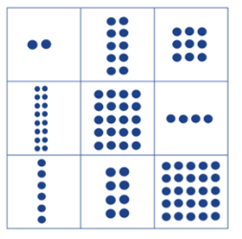
Figure 2: Array grid

- The teacher calls out a number and students find the array on their array grid. A teacher might mix up the numbers and call out 12 as “twelve”, “2 sixes” or “4 threes”.
- First student to have found all numbers on the array grid, wins.

Variation
- Sets of number cards from Math cards (youcubed), Mathematics K-6 resources, NSW Department of Education website.
Reference: Developing Efficient Numeracy Strategies 1© State of New South Wales, Department of Education.

Multiplication toss
Teacher note: This activity, played in pairs, can help students develop multiplicative automaticity
Watch multiplication toss to learn how to play.

You will need
- grid paper
- writing materials
- different coloured pencils
- Nine-sided dice or Two spinners
- paper clip for spinner

How to play
- Players take turns to roll or spin.
- If a 3 and 6 are spun, players can enclose wither a block out of 3 rows of 6 (3 sixes) or 6 rows of 3 (6 threes).
- The game continues with no overlapping areas.
- The winner is the player with the largest area blocked after 10 spins.
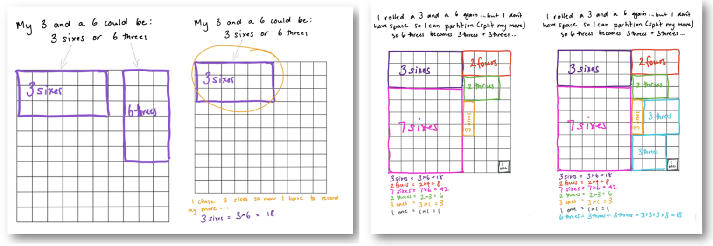
Figure 3: Student example

- Eventually, the space on the grid paper gets really small.
- Students then have to think:
- What if my 3 sixes won’t fit as 3 sixes or as 6 threes?
- Players can partition to help them! So, for example, they can rename 3 sizes as 2 sixes and 1 six (if that helps them to fit the block into the game board).

Discuss
- What would you do differently next time to increase your chances of filling in 100 squares?
Reference: Siemon D, Beswick K, Brady K, Clark J, Faragher R, Warren E (2015). Teaching Mathematics: Foundations to Middle Years, second edition, Oxford University Press, Melbourne.

Always, sometimes or never? Number
Teacher note: Students reason with situations, instances and concepts that are always, sometime or never true. This prompt allows students to generate generalisations, a key mathematical action.
- Students determine whether a given statement is always, sometimes or never true (explore these terms prior to the activity). Ask students to find examples and non-examples of their choice to communicate their reasoning.
- Encourage students who choose ‘sometimes’ to rewrite the statements so they are always or never true. Students prove their thinking with an equation (number sentence).
Some example statements that allow students to explore key multiplicative concepts through investigation:
  - What happens when you multiply 2 numbers? (The order changes the product.)
  - Can multiplication be ‘undone’ by division?
  - How can we use addition to solve multiplication?
  - How does knowing doubles facts help when multiplying by 2? Does this knowledge help with other numbers?
  - What do you notice when a whole number is multiplied by 5?
  - What happens when an even number is multiplied by an even number?
Reference: Adapted from Always, Sometimes or Never? Number by nrich, University of Cambridge.

Multiplication squares
Teacher note: This game is suitable for both Stages 2 and 3. Students use their knowledge of factors and products to find the missing element in a grid.
      - In the 2 x 2 multiplication, the boxes at the end of each row and the foot of each column give the result of multiplying the 2 numbers in that row or column.
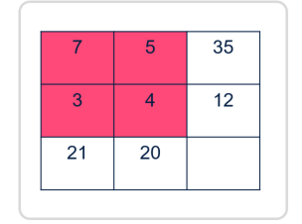
Figure 4: 2 x 2 multiplication results
Variation
- Give students a blank template and asked to design their own multiplication square.
- Can you design a multiplication square that has more than one possible solution?
- The 3 x 3 multiplication square below works in the same way. The boxes at the end of each row and the foot of each column give the result of multiplying the three numbers in that row or column. The numbers 1–9 may be used once and once only.
- Can you work out the arrangement of the digits in the square so that the given products are correct?
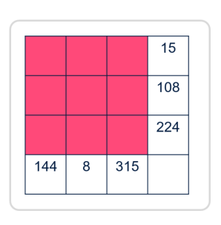
Figure 5: Variation
Reference: Adapted from Multiplication Squares by nrich, University of Cambridge.

Appendix 1: Factors fun game board
1 | 6 | 4 | 1 | 2
10 | 6 | 3 | 6 | 10
4 | 2 | 4 | 5 | 8
9 | 3 | 6 | 2 | 9
7 | 8 | 5 | 10 | 7

Recording sheet
Student 1 |  |  |  |  | Student 2
Spun | Number sentence | Covered |  | Spun | Number sentence | Covered

Appendix 2: The tiler problem solving task
A tiler was asked to pave a small courtyard. He drew up plans of the different tiling designs he could use and calculated the cost of the tiles.
Would it be cheaper to tile the courtyard with all smile tiles or with all large tiles?
The cost to buy the exact number of tiles needed:
- Small tiles: $360
- Large tiles: $640
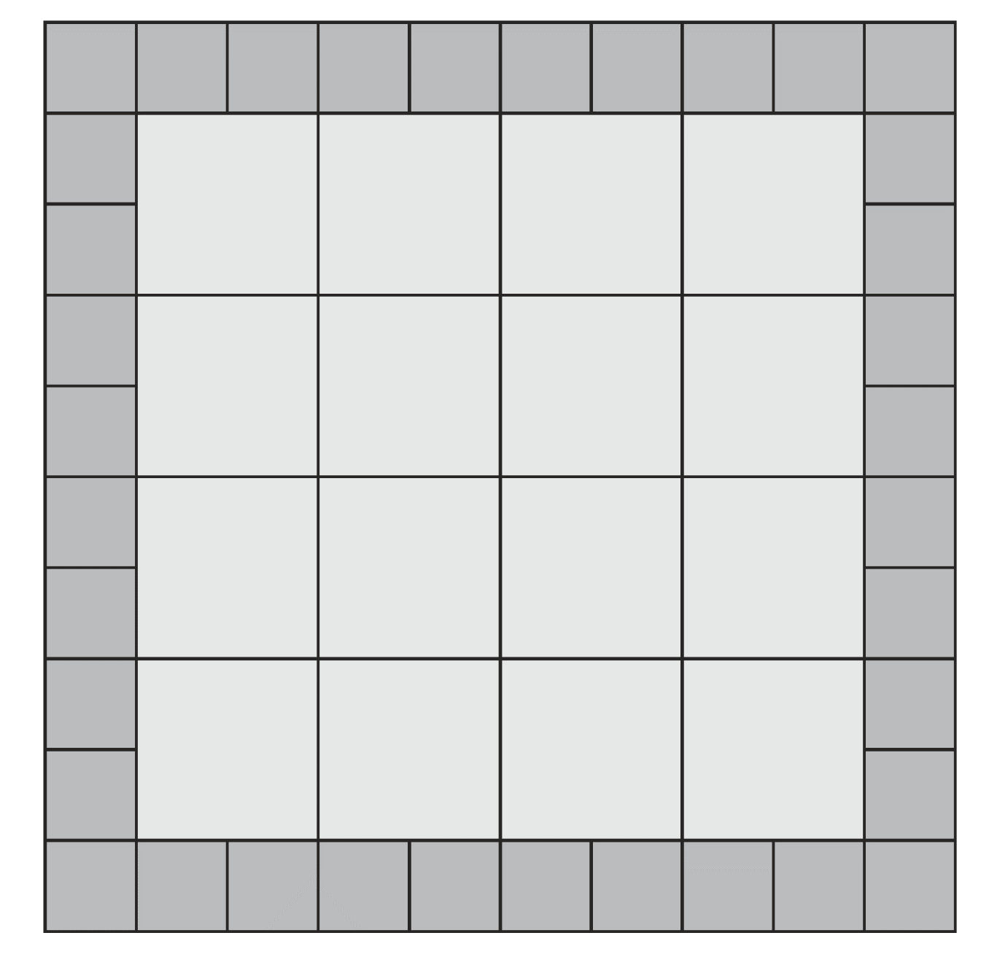

The tiler problem solving task: Courtyard design 2
A tiler was asked to pave a small courtyard. He drew up plans of the different tiling designs he could use and calculated the cost of the tiles.
Would it be cheaper to tile the courtyard with all smile tiles or with all large tiles?
The cost to buy the exact number of tiles needed:
- small tiles: $450
- large tiles: $360

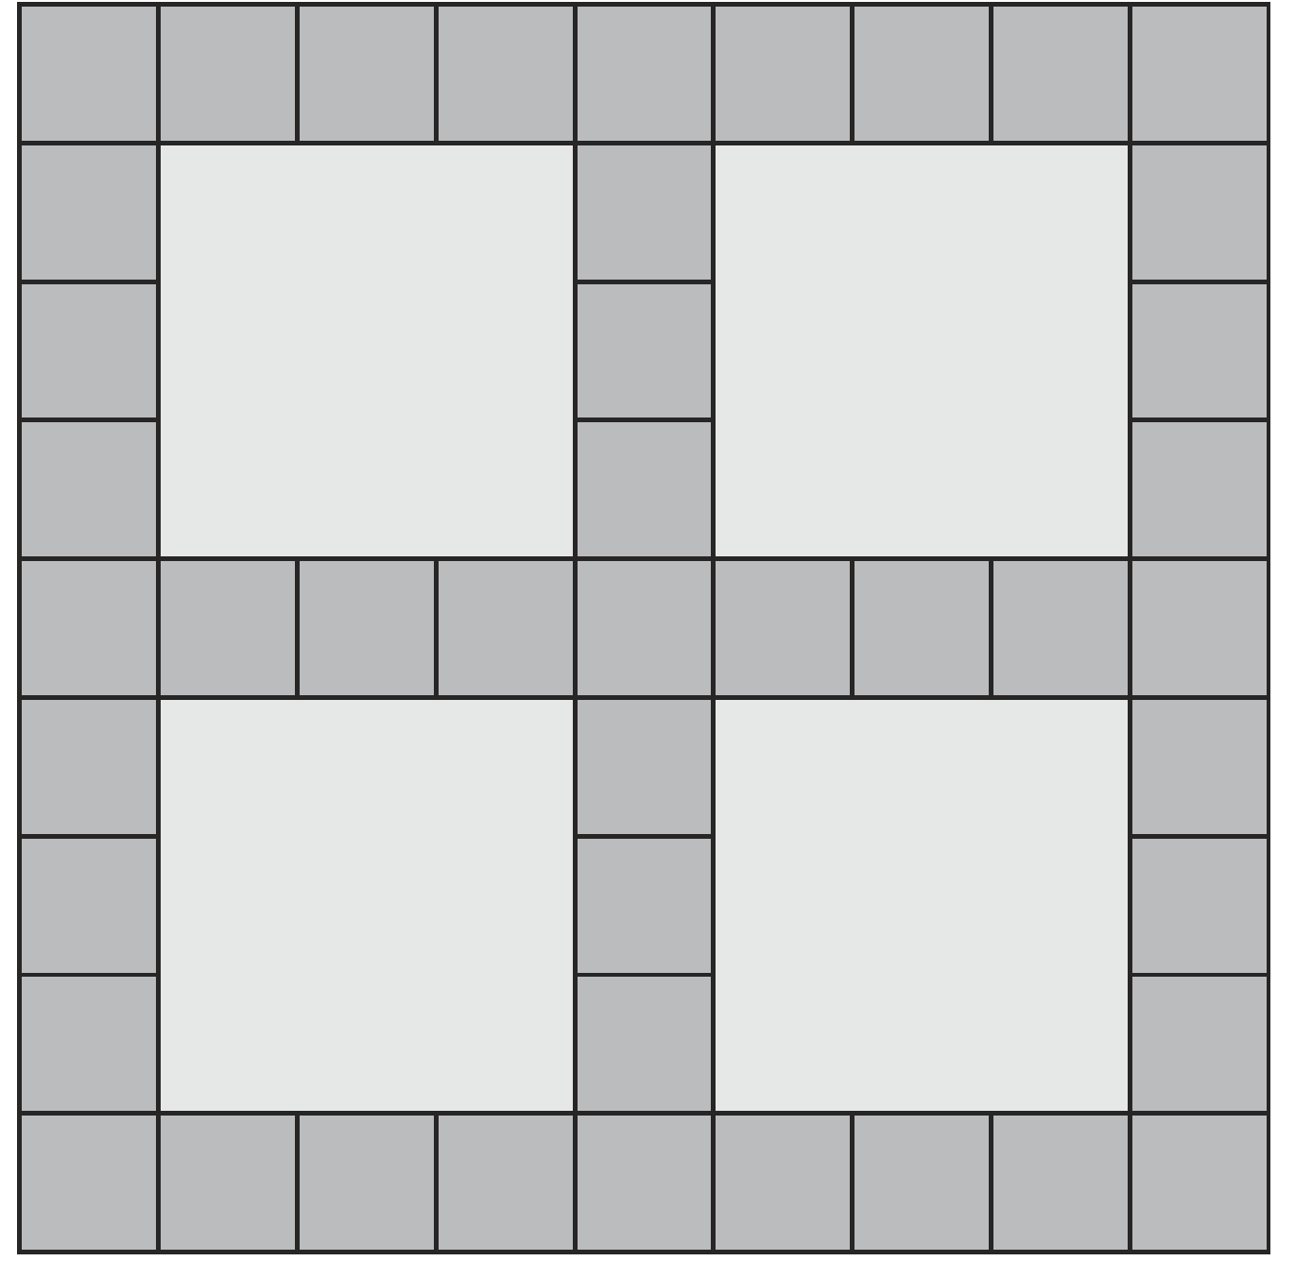

Appendix 3: Prime climb chart
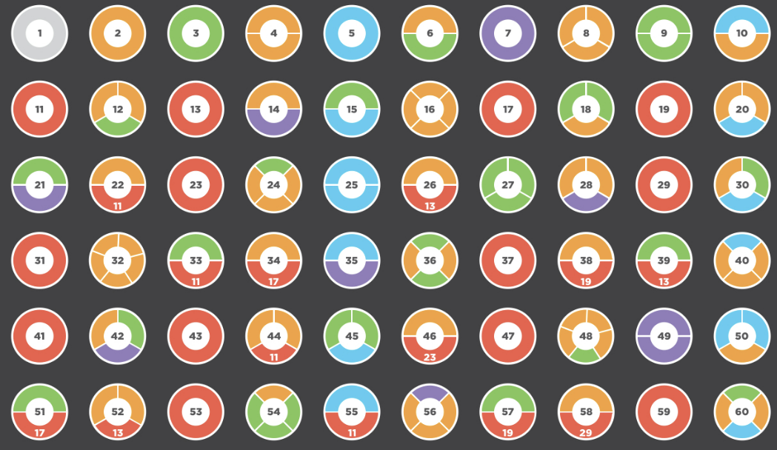
Finkel D (2023) ‘Prime Climb Color Chart’, Math for Love website.

Appendix 4: Blank prime climb
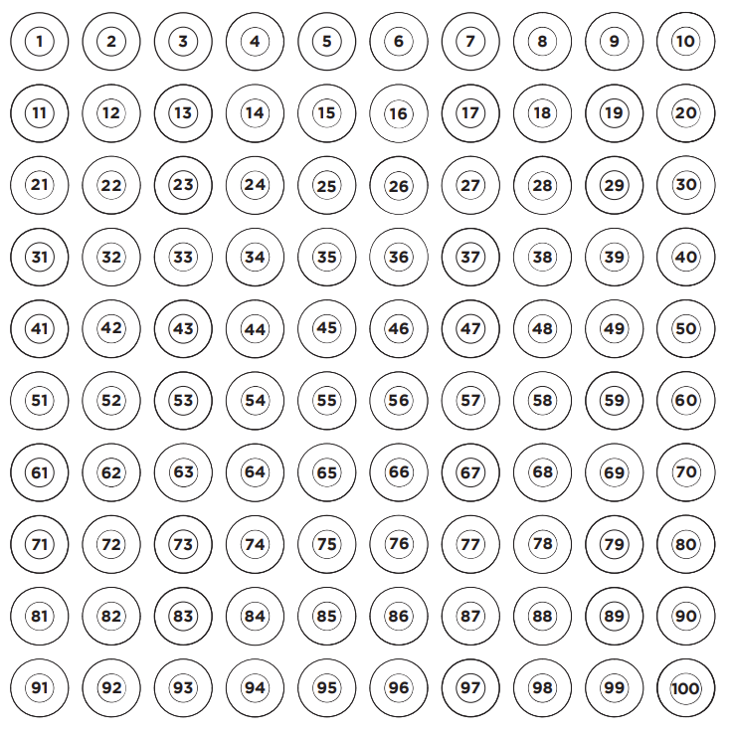
Finkel D (2023) ‘Prime Climb Color Chart’, Math for Love website.

Reference list
This resource contains images and content obtained from Canva, and their use outside of this resource is subject to Canva’s Content License Agreement.
Mathematics K–10 Syllabus © NSW Education Standards Authority (NESA) for and on behalf of the Crown in right of the State of New South Wales, 2022.
National Numeracy Learning Progression © Australian Curriculum, Assessment and Reporting Authority (ACARA) 2010 to present, unless otherwise indicated. This material was downloaded from the Australian Curriculum website (National Literacy Learning Progression) (accessed 6 November 2023) and was not modified.
Australian Government Department of Education (2020) ‘The tiler’, Teaching resources, reSolve: Maths by Inquiry website, accessed 14 November 2023.
Finkel D (2023) ‘Prime Climb Color Chart’, Math for Love website, accessed 14 November 2023.
Imm K (n.d) ‘What is a number string?’, Number strings website, accessed 14 November 2023.
Siemon D, Beswick K, Brady K, Clark J, Faragher R, Warren E (2015) Teaching Mathematics: Foundations to Middle Years, second edition, Oxford University Press, Melbourne.
Stanford University (n.d.) ‘Math Cards (3-6)’, Videos, youcubed website, accessed 14 November 2023.
State of New South Wales (Department of Education) (2023) ‘Factors fun’, Mathematics K-6 resources, NSW Department of Education website, accessed 14 November 2023.
State of New South Wales (Department of Education) (2023) ‘Remainders game’, Mathematics K-6 resources, NSW Department of Education website, accessed 14 November 2023.
State of New South Wales (Department of Education) (2023) ‘Multiplication toss’, Mathematics K-6 resources, NSW Department of Education website, accessed 14 November 2023.
State of New South Wales (Department of Education) (n.d) ‘Array bingo’, Developing Efficient Numeracy Strategies website, accessed 15 November 2023.
University of Cambridge (Faculty of Mathematics) (1997–2023) Always, Sometimes or Never? Number, NRICH website, accessed 15 November 2023.
University of Cambridge (Faculty of Mathematics) (1997–2023) ‘Multiplication Squares’, NRICH website, accessed 15 November 2023.

Copyright
Section 113P Notice
Texts, Artistic Works and Broadcast Notice
Some of this material has been copied and communicated to you in accordance with the statutory licence in section 113P of the Copyright Act. Any further reproduction or communication of this material by you may be the subject of copyright protection under the Act. Do not remove this notice.

Evidence base
Sparrow, L., Booker, G., Swan, P., Bond, D. (2015). Teaching Primary Mathematics. Australia: Pearson Australia.
Brady, K., Faragher, R., Clark, J., Beswick, K., Warren, E., Siemon, D. (2015). Teaching Mathematics: Foundations to Middle Years. Australia: Oxford University Press.
Alignment to system priorities and/or needs: The literacy and numeracy five priorities.
Alignment to School Excellence Framework: Learning domain: Curriculum, Teaching domain: Effective classroom practice and Professional standards
Consulted with: NSW Mathematics Strategy professional learning and Curriculum Early Years Primary Learners-Mathematics teams
Reviewed by: Literacy and Numeracy
Created/last updated: January 2024
Anticipated resource review date: January 2025
Feedback: Complete the online form to provide any feedback.

