Flexible strategies with integers

Stage 4

Overview

Learning intention
Students learn to work with and apply their knowledge of directed number (positive and negative numbers) in a variety of contexts. They learn to solve a range of word and number problems involving all four operations, positive and negative numbers, and by selecting effective strategies and incorporating reasoning when offering solutions.

Syllabus outcomes
The following teaching and learning strategies will assist in covering elements of the following outcomes:
- MAO-WM-01 develops understanding and fluency in mathematics through exploring and connecting mathematical concepts, choosing and applying mathematical techniques to solve problems, and communicating their thinking and reasoning coherently and clearly
- MA3-RN-01 applies an understanding of place value and the role of zero to represent the properties of numbers
- MA4-INT-C-01 compares, orders and calculates with integers to solve problems
NSW Mathematics K-10 Syllabus (2022)
- MA4-1WM communicates and connects mathematical ideas using appropriate terminology, diagrams and symbols
- MA4-2WM applies appropriate mathematical techniques to solve problems
- MA4-3WM recognises and explains mathematical relationships using reasoning
- MA4-4NA compares, orders and calculates with integers, applying a range of strategies to aid computation.
NSW Mathematics K-10 Syllabus (2012)

Syllabus background information
Students should have some understanding of integers, as the concept is introduced in Stage 3 Representing numbers B. However, operations with integers are introduced in Stage 4.
Complex recording formats for integers, such as raised signs, can be confusing. On printed materials, the en-dash ( – ) should be used to indicate a negative number and the operation of subtraction. The hyphen ( - ) should not be used in either context. The following formats are recommended:
−2 − 3 = −5 −7 + (−4) = −7 − 4 = −11 −2 − −3 = −2 +3 = 1
Brahmagupta (c598–c665), an Indian mathematician and astronomer, is noted for the introduction of zero and negative numbers in arithmetic.

Purpose/Relevance of Substrand
The positive integers (1, 2, 3, …) and 0 allow us to answer many questions involving 'How many?', 'How much?', 'How far?', and others, and so carry out a wide range of daily activities. The negative integers (…, –3, –2, –1) are used to represent 'downwards', 'below', 'to the left', and others, and appear in relation to everyday situations such as the weather (for example, a temperature of –5° is 5° below zero), altitude (for example, a location given as –20 m is 20 m below sea level), and sport (for example a golfer at –6 in a tournament is 6 under par). The Computation with Integers substrand includes the use of mental strategies, written strategies and others, to obtain answers – which are very often integers themselves – to questions or problems through addition, subtraction, multiplication and division.
Mathematics syllabus K-10 © NSW Education Standards Authority (NESA) for and on behalf of the Crown in right of the State of New South Wales, 2012.

National Numeracy Learning Progression guide
- Number and place value NPV9
- Counting processes CPr8
- Additive strategies AdS7-AdS8
National Numeracy Learning Progression Version 3

Copyright
Section 113P Notice
Texts, Artistic Works and Broadcast Notice
Some of this material has been copied and communicated to you in accordance with the statutory licence in section 113P of the Copyright Act. Any further reproduction or communication of this material by you may be the subject of copyright protection under the Act. Do not remove this notice. Overview of teaching strategies

What works best
Explicit teaching practices involve teachers clearly explaining to students why they are learning something, how it connects to what they already know, what they are expected to do, how to do it and what it looks like when they have succeeded. Students are given opportunities and time to check their understanding, ask questions and receive clear, effective feedback.
This resource reflects the latest evidence base and can be used by teachers as they plan for explicit teaching.
Teachers can use assessment information to make decisions about when and how they use this resource as they design teaching and learning sequences to meet the learning needs of their students.
Further support is available on the What works best web page.

Differentiation
When using these resources in the classroom, it is important for teachers to consider the needs of all students, including Aboriginal and Torres Strait Islander students and EAL/D learners.
EAL/D learners will require explicit English language support and scaffolding, informed by the Enhanced EAL/D enhanced teaching and learning cycle and the student’s phase on the EAL/D Learning Progression. Teachers can access information about supporting EAL/D learners and literacy and numeracy support specific to EAL/D learners.
Learning adjustments enable students with disability and additional learning and support needs to access syllabus outcomes and content on the same basis as their peers. Teachers can use a range of adjustments to ensure a personalised approach to student learning.
Assessing and identifying high potential and gifted learners will help teachers decide which students may benefit from extension and additional challenge. Effective strategies and contributors to achievement for high potential and gifted learners helps teachers to identify and target areas for growth and improvement. A differentiation adjustment tool can be found on the High potential and gifted education website.

Using tasks across learning areas
This resource may be used across learning areas where it supports teaching and learning aligned with syllabus outcomes. Literacy and numeracy are embedded throughout all K-10 syllabus documents as capabilities. As the English and mathematics learning areas have a particular role in developing literacy and numeracy, NSW English and Mathematics syllabus outcomes aligned to literacy and numeracy skills have been identified.

Considerations

Language and vocabulary
As students are provided opportunities to experience concepts, teachers can also build understanding of mathematical vocabulary and communicating skills. Teachers can help build students’ confidence and capabilities by making complex mathematical ideas visible to students through drawings, diagrams, enactment, gestures and modelling. Making intentional connections between various representations and experiences with mathematical language helps build an understanding of important vocabulary whilst also building conceptual understanding.

Talk moves
Classroom talk is a powerful tool for both teaching and learning. Rich, dialogic talk supports students in making sense of complex ideas and builds classroom communities centred around meaning-making. 'Talk moves' are some of the tools a teacher can use to support rich, meaningful classroom discussion.
Some of the talk moves include:
- wait time
- turn and talk
- revoicing
- reasoning
- adding on
- repeating
- revise your thinking.
Additional resources to support talk moves are available on the Literacy and numeracy website and Universal Resources Hub.

Number talks
Number talks are a powerful teaching routine centred on short, intentional classroom conversation about a purposefully crafted problem that is solved using a broad range of mental strategies. Their general goal is to build fluency and sense-making through meaningful communication, problem solving and reasoning. They provide regular opportunities to develop number sense and mathematical reasoning through exploring, using and building confidence in additive and multiplicative strategies.
Suggested structure for an open-sharing number talk:
- A teacher determines the next learning goal for students and finds/designs a problem connected to that learning need.
- The teacher (and their colleagues) consider and discuss possible responses from students and plan formative assessment strategies, questioning and how to use a broad range of tools to represent the possible ideas student may raise (for example enactment, diagrams, models and others.)
- The carefully designed problem is posed to all students within the class.
- Thinking time is allowed for students to consider the different strategies they would use to solve the problem.
- Readiness to share is indicated by individual students raising a thumb unobtrusively against their chests (and raising one or more fingers if they think of other solutions).
- Students are provided opportunities to turn and talk, sharing their ideas with other students sitting nearby.
- The teacher listens to students as they talk, moving about the class inviting particular students to share their thinking more broadly, intentionally selecting and sequencing conversation that will best support the purpose of the number talk.
- Thinking is collected and discussed. The teacher may seek a variety of answers without comment, then discus them as a class. Or the teacher may invite one student at a time to explain their thinking.
- The teacher supports students to make connections between ideas and to other learning experiences.
- The teacher concludes the open-sharing number talk by connecting back to the purpose of the task, making explicit the mathematical goal of the conversation.

Two versus two
For most games, we recommend small groups of 4 students, working in pairs of 2 (2 versus 2). This gives students the opportunity to discuss mathematical ideas, strategies and understanding with their team mates as well as their opponents. When engaging in investigations, groups of 3 or 4 might be a positive group dynamic.

Think board
Think boards can be used to make connections between different mathematical concepts or for students to visually represent their understandings and strategies in a range of ways.
- Question? - what are you being asked to find/evaluate?
- Get the info – write down all the relevant numerical information form the question, maybe draw a diagram.
- Do the maths – complete any calculations that may support finding the solution to the problem.
- Write the answer – check whether you have answered the actual question asked.
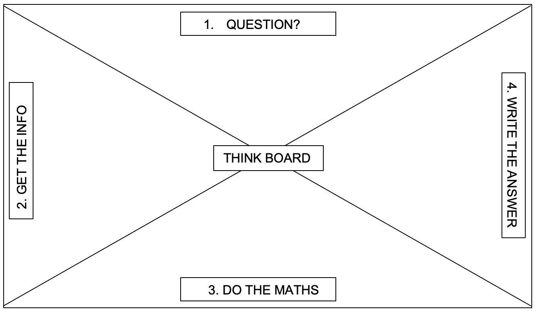
Figure 1: Think board

Tools and resources to support learning
These tools and resources can be used throughout the tasks:
- dice
- playing cards, A-9
- counters
- white boards
- (+) and (–) symbol cards, positive and negative number cards
- Number lines and cartesian planes

Resource sequence

Negative numbers around us
Teacher note: This is an activity to contextualise negative numbers and can be completed as a small group, individual or partner activity.
- Discuss what exists below a zero on a vertical number line. Why do you think we need negative numbers? How do they help us?
- Teachers and students brainstorm and identify situations where they might encounter numbers below zero (negative numbers). Students can be encouraged to collect or identify examples from internet sources, books, media and others.
Some links to other key learning areas where students encounter negative numbers might be:
- Science – temperatures, melting and boiling points
- Science and geography – temperatures (weather), altitude
- PDHPE – sport scores (for example, golf)
- History – timelines (for example, BCE and CE)
- Commerce – finances (credits and debits)
Students could construct or use a table similar to that shown in Appendix 1 – ‘Negative numbers around us’ to illustrate where negative numbers are found in their world.
Table 1: Negative numbers example
Situation | Value | Subject (weather, sports, finance and others)
Coldest temperature ever recorded in Australia, 29 June 1994 at Charlotte Pass | –23 degrees Celsius | Weather and climate
There is an opportunity to consolidate language in this activity. The idea that negative numbers can be named ‘negative 5’, whereas a temperature of 5 degrees below zero will be named ‘minus 5’ and a golf score of 5 below par will be named ‘5 under’.

Language of loss and gain board game
Teacher note: Exploring the language can contextualise negative and positive integers. This can be used in a game of ‘snakes and ladders’ where students follow directions to move along the board game. This can be played in pairs or small groups.
You will need
- Appendix 2 – ‘Language of loss and gain’
- Appendix 3 – ‘Language of loss and gain game board’
- dice
How to play
      - Brainstorm examples of ways to indicate a negative or positive move in a direction along a horizontal number line. For example, a loss in income means a move to the left or minus. A ‘bonus’ is an example of a move to the right or an addition. Teachers might offer suggestions to start conversations such as the sea, money, on the sporting field. Have students categorise suggestions onto a poster that has been organised into two columns:
Table 2: Negative and positive words
negative | positive
loss | gain
down by | up by
decrease of | increase of
drop | rise
depreciation | appreciation
below sea level | above sea level
debit | credit
loss | profit
backwards | forwards
2. Students write their suggestions onto cards and place into a pile, face down. Cards can also be used from Appendix 2 – Language of loss and gain.
3. Using Appendix 3 – Loss and gain gameboard, students roll a dice and collect one of their cards to determine the amount of spaces they will move, as well as if it is forwards or backwards.
4. First to the end of the game board wins.

Variation
- Students can aim to get to a target number, for example, 50. Students roll their dice to determine how many and select a card to determine whether it is being added or subtracted.
- Students can roll one dice or two and have different target numbers.
- Students could also design their own board game with obstacles and bonuses.

Zero pairs counter modelling (visuals or models)
Teacher note: Students can be supported to develop an understanding of addition and subtraction of positive and negative numbers with the use of coloured counters to model examples.
You will need
- 2 sets of coloured counters used to model the thinking.
- Orange counters may represent positive numbers
- Blue counters may represent negative numbers
- One of each (an orange and blue pair) represents zero.
Students can then use the counters to represent various quantities:
For example:
3 blue counters represents $-$3, 3 orange counters represents +3, total 0
6 blue counters represents $-$6, 3 orange counters represents +3, total $-$3
9 blue counters represents $-$9, 6 orange counters represents +3, total $-$3 and others
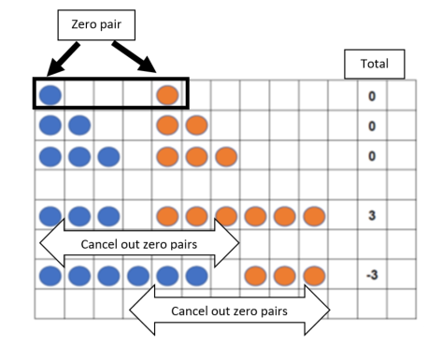
Figure 2: Zero pairs

Close to zero
Teacher note: This is a game that students play in pairs to further reinforce direction of negative and positive integers.
You will need
- Game board (see Appendix 4)
- 2 different coloured counters
- Dice
- An operation dice labelled +, +, +, $-$, $-$, $-$ OR the same operations on cards that can be drawn and flipped from a pile.
How to play
- Place counters at the start of the game board and students take turns to roll the dice.
- The number rolled on the dice determines the direction to move on the game board. If you cannot move in the direction rolled, you miss a turn.
Table 3: Game rules
Number | Direction
1 or 2 | down
3 or 4 | right
5 or 6 | left
- The operation dice or cards determine whether you are adding or subtracting the number on the board.
- Record problem solving and reasoning as playing.
- If the other player is on the space you need to move to, you must add the amount you are currently on to your score.
- The game ends when one player reaches the space named ‘End’. The player with the score closest to 0 at the end wins the game.

Variation
Students discuss what would be the best combination of numbers to have in order to win, then share their reasoning.
Reference: Adapted from Close to zero from nzmaths.co.nz.

Up, down, flying around
Teacher note: This is a game that can be played in pairs. This reinforces using a number line vertically. A video showing how to play this game can be found at nrich.maths.org.
You will need
- Appendix 5a - Up, down, flying around game board
- Appendix 5b – Up, down, flying around operation and number cards. Print out two sets and shuffle together.
How to play
Discuss that students can move their balloon in two ways:
- Puff of air: Students can move balloons by using a puff of air; puffs of air are positive numbers. Students can release a puff of hot air to make the hot air balloon go down.
- Sandbags: Students can move balloons by using sandbags; sandbags are negative numbers; if you add sandbags to the balloon, it will sink. If you remove a sandbag, it will rise.
- The object of the game is to either get to positive 20, or for your opponent to get to negative 20.
- Starting at zero, each player takes a turn to turn over a ‘move’ card and a number card. For example, a player might turn over ‘add’ and –9. The player would then need to add sandbags to their balloon and move it nine spaces in a negative direction.
- Reinforce that a negative number is a sandbag and a positive number is a puff of air. So if they were to subtract –7, this means they would take away 7 sandbags so the balloon would move in a positive direction.
Reference: Adapted from Up, down, flying around from nrich, University of Cambridge.

Integer quick draw
Teacher note: A card game for two players to apply additive thinking with negative and positive integers.
You will need
- 2 packs of playing cards with picture cards removed
- Appendix 6 – Integer quick draw game board with spinner
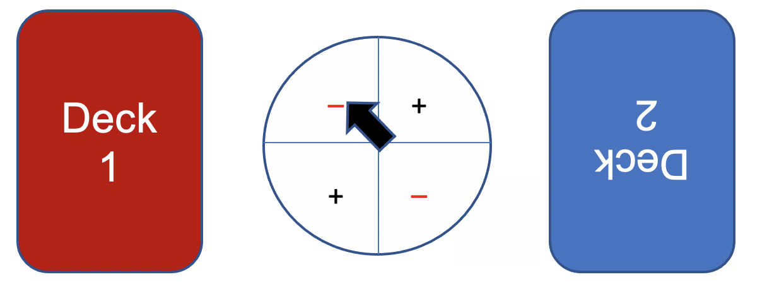
Figure 3: Game layout
How to play
- Place each shuffled deck of cards face down on the game board.
- Player one will draw from deck one, player two will draw from deck two.
- Player one spins the spinner, and each player turns the top card on their deck.
- The first person to correctly answer the equation wins the cards. Red cards represent negative integers and black cards represent positive integers. The equation must be created by reading the cards left to right. The person with the most cards at the end of the game, wins.
This game will expose students to double negatives, so considerations will need to be made for student preparedness prior to this activity. See Zero Pairs for further support.
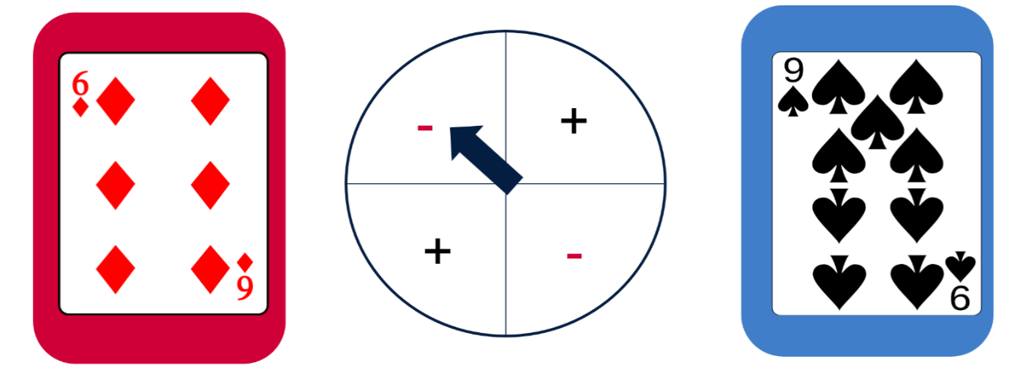
Figure 4: Sample game

Variations
- Student can choose to swap the order of the cards to get closer to a target number.
- The picture cards can be given specific values, for example king = 25.
- Students could have number lines in front of them to scaffold and to check answers.
Reference: Adapted from Integer quick draw from nzmaths.

Tug of integers
Teacher note: A game for 2 players. Students compete to get to either end of the number line by adding and subtracting positive and negative integers.
You will need
- 2 dice
- One counter
How to play
- Students draw a number line with numbers $-$15 to 15 (for example). Encourage students to create both vertical and horizontal number lines.
- A counter is placed on zero.
- One student is nominated as ‘minus’ and can only subtract, and their goal is to reach $-$15.
- The other player is ‘plus’ and can only add and their target is 15.
- Students take turns to roll 2 dice, add or subtract the total and move the counter according to the sum of the dice. The first to their target wins.
Reference: Adapted from Tug of integers from nrich, University of Cambridge.

Connect 3
Teacher note: A game for 2 players using 2 dice and coloured counters (different colour for each player). Students roll two dice by adding and subtracting positive and negative integers to get three in a row.
You will need
- 2 dice
- Counter per player
- Appendix 7 - Connect 3 number grid
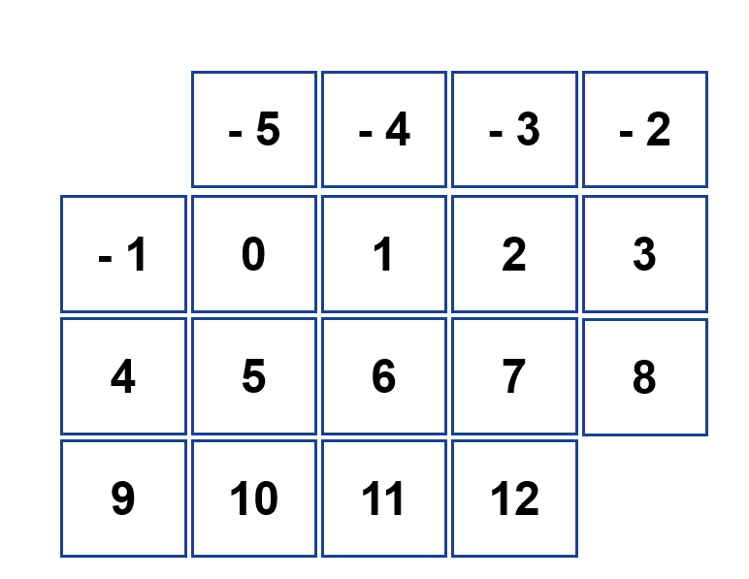
Figure 5: Connect 3 game grid
How to play
- Students take turns to roll 2 dice.
- They can choose to add or subtract the numbers on the dice. Whatever the result, they place a counter on the answer.
- The object is to connect 3 squares horizontally, vertically or diagonally to win.

Variation
- Students can be challenged to always have a negative number in their connect 3, to be asked to identify patterns – which number/s are the easiest to get, what is the best strategy to win and others.
- Students could also connect four in a line.
Reference: Adapted from Connect 3 from nrich, University of Cambridge.

Finding zero with opposites
Teacher note: Students develop an understanding of the connection between positive and their opposite negative integers and that the difference to zero is the same. This can be played in small groups as a concentration game.
- Brainstorm some examples of negative and positive integer opposites, for example, $-$3 + 3 = 0.
- Show on a number line that the difference between $-$3 to 0 and 0 to 3 is the same. Using money can help illustrate this: I borrow $5 from a friend on Monday, then gave them $5 on a Tuesday. Do I owe them anything further to have repaid?
- Ask students to show on a number line the space between $-$3 and 3 and how much sits between them (6).
- Give students an opportunity to find zero by using cards with positive and negative numbers (refer to Appendix 8a). This could be played as a game of concentration or memory, where students must match the positive and the negative number as a pair. The player with the most pairs wins.

Variation
To further extend the concentration game, add in the difference between the two integers (refer to Appendix 8b). For example, $-$3, 3 and 6 spaces. The students would need to match all three to collect the trio.

Appendix 1: Negative numbers around us
Situation | Value | Subject (weather, sports, finance and others)
Coldest temperature ever recorded in Australia, 29 June 1994 at Charlotte Pass | –23°C | Weather and climate

Appendix 2: Language of loss and gain
negative | positive
loss | gain
down by | up by
decrease of | increase of
drop | rise
depreciation | appreciation
below sea level | above sea level
debit | credit
loss | profit
backwards | forwards
ebb | flow
decline | incline
back | forth
down | up

Appendix 3: Loss and gain board game

 |  | Draw a card | END
Draw a card |  | Draw a card
Draw a card |  | Draw a card
 | Draw a card
 |  |  | Draw a card
 |  | Draw a card
Draw a card | Draw a card
 |  | Draw a card
START |  | Draw a card

Appendix 4: Close to zero game board
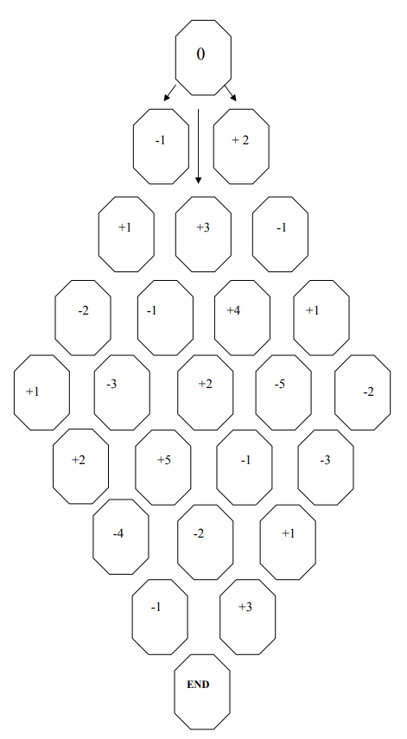

Appendix 5a: Up, down, flying around game board
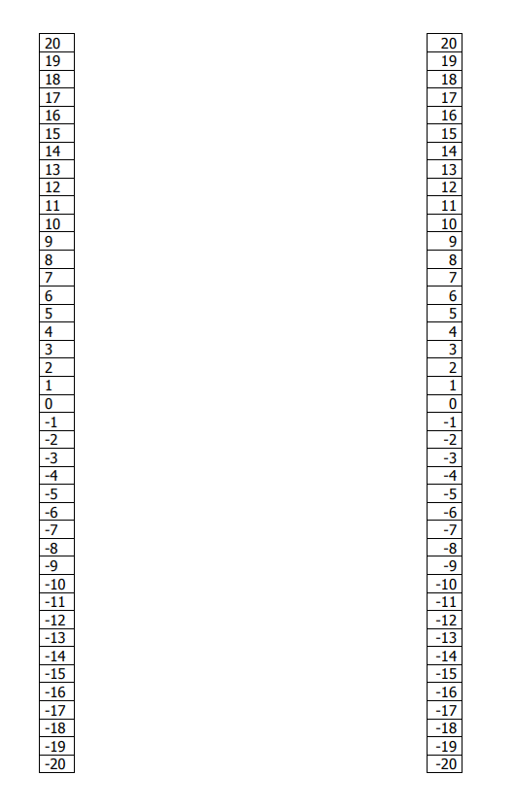

Appendix 5b: Up, down, flying around: operation and number cards
Print out these cards, shuffle them together then place them face down.
add | add | add
add | subtract | subtract
add | subtract | subtract
add | add | add
add | subtract | subtract
add | subtract | subtract

Print out these cards, shuffle them together then place them face down.
0 | $-$1 | +1
$-$2 | +2 | $-$3
+3 | $-$4 | +4
$-$5 | +5 | $-$6
+6 | $-$7 | +7
$-$8 | +8 | $-$9
+9 | $-$10 | +10

Appendix 6: Integer quick draw game board
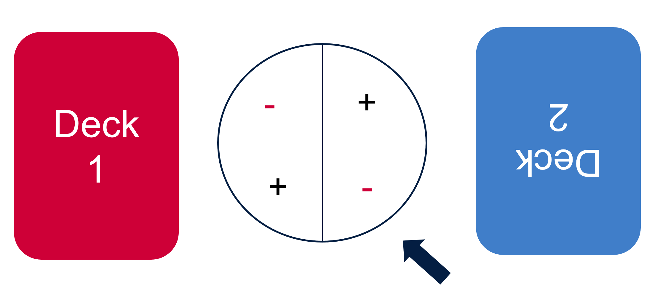

Appendix 7: Connect 3 grid
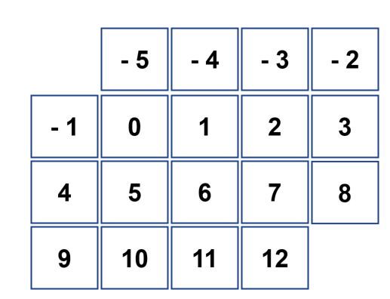

Appendix 8a: Finding zero with number opposites
1 | 4 | 7 | 10
-1 | -4 | -7 | -10
2 | 5 | 8 | 11
-2 | -5 | -8 | -11
3 | 6 | 9 | 12
-3 | -6 | -9 | -12

Appendix 8b: Finding zero with number opposites (align 3)
1 | 4 | 7 | 10
-1 | -4 | -7 | -10
2 | 5 | 8 | 11
-2 | -5 | -8 | -11
3 | 6 | 9 | 12
-3 | -6 | -9 | -12
2 | 4 | 6 | 8
10 | 12 | 14 | 18
20 | 22 | 24

Reference list
Mathematics K–10 Syllabus © NSW Education Standards Authority (NESA) for and on behalf of the Crown in right of the State of New South Wales, 2022.
Mathematics K-10 Syllabus © NSW Education Standards Authority (NESA) for and on behalf of the Crown in right of the State of New South Wales, 2012.
National Numeracy Learning Progression © Australian Curriculum, Assessment and Reporting Authority (ACARA) 2010 to present, unless otherwise indicated. This material was downloaded from the Australian Curriculum website (National Literacy Learning Progression) (accessed 6 November 2023) and was not modified.
New Zealand Ministry of Education (n.d.) Close to zero, NZ Maths website, accessed 21 November 2023.
New Zealand Ministry of Education (n.d.) Integer quick draw, NZ Maths website, accessed 21 November 2023.
University of Cambridge (Faculty of Mathematics) (1997–2023) Connect 3, NRICH website, accessed 21 November 2023
University of Cambridge (Faculty of Mathematics) (1997–2023) Tug Harder!, NRICH website, accessed 21 November 2023.
University of Cambridge (Faculty of Mathematics) (1997–2023) Up, Down, Flying around, NRICH website, accessed 21 November 2023.

Evidence base
Sparrow, L., Booker, G., Swan, P., Bond, D. (2015). Teaching Primary Mathematics. Australia: Pearson Australia.
Brady, K., Faragher, R., Clark, J., Beswick, K., Warren, E., Siemon, D. (2015). Teaching Mathematics: Foundations to Middle Years. Australia: Oxford University Press.
Alignment to system priorities and/or needs: The literacy and numeracy five priorities.
Alignment to School Excellence Framework: Learning domain: Curriculum, Teaching domain: Effective classroom practice and Professional standards
Consulted with: NSW Mathematics Strategy professional learning and Curriculum Early Years Primary Learners-Mathematics teams
Reviewed by: Literacy and Numeracy
Created/last updated: January 2024
Anticipated resource review date: January 2025
Feedback: Complete the online form to provide any feedback.

