Mathematics 3–6 Multi-age – Year A – Unit 9

Contents

Unit description and duration 6

Syllabus outcomes 6

Stage 2 6

Stage 3 7

Working mathematically 7

Student prior learning 8

Lesson overview and resources 9

Lesson 1 18

Daily number sense – What’s the nearest? – 10 minutes 18

Core lesson 1 – describing features of shapes and objects – 15 minutes 20

Core lesson 2 – naming and comparing 3D objects – 30 minutes 22

Consolidation and meaningful practice – 10 minutes 25

Lesson 2 27

Daily number sense – ascending and descending order – 10 minutes 27

Core lesson – making three-dimensional objects – 40 minutes 29

Consolidation and meaningful practice – 10 minutes 35

Lesson 3 38

Daily number sense – what zeros matter – 10 minutes 38

Core lesson – exploring nets of prisms and pyramids – 40 minutes 40

Consolidation and meaningful practice – 10 minutes 45

Lesson 4 47

Daily number sense – 10 minutes 47

Core lesson: 40 minutes 47

Stage 2 task – deconstructing everyday packages 47

Stage 3 task – making 3D objects by matching nets 50

Discuss and connect the mathematics – 15 minutes 53

Lesson 5 56

Daily number sense – How many ways? – 15 minutes 56

Core lesson – litres and millilitres – 40 minutes 58

Discuss and connect the mathematics – 15 minutes 63

Lesson 6 65

Daily number sense – hundredths and thousandths – 10 minutes 65

Core lesson – investigating formal units to measure capacity – 50 minutes 68

Discuss and connect the mathematics – 10 minutes 73

Lesson 7 76

Daily number sense – measuring using decimal notation – 15 minutes 76

Core lesson – 40 minutes 78

Stage 2 task – ordering and comparing capacities 78

Stage 3 task – displacement 81

Consolidation and meaningful practice – 10 minutes 84

Lesson 8 87

Daily number sense – 10 minutes 87

Core lesson – 45 minutes 87

Stage 2 task – planning a class party 87

Stage 3 task – drinks for a disco 90

Discuss and connect the mathematics – 15 minutes 93

Resource 1 – 2D features 96

Resource 2 – guess what? 97

Resource 3 – sketch and label 98

Resource 4 – prisms 99

Resource 5 – decimal cards 1 100

Resource 6 – decimal cards 2 101

Resource 7 – nets or not 102

Resource 8 – nets of cubes 103

Resource 9 – cut cube net 104

Resource 10 – match my net 105

Resource 11 – deconstructed net 106

Resource 12 – estimate and measure 107

Resource 13 – capacity sort 1 108

Resource 14 – capacity sort 2 110

Resource 15 – drinks problem 112

Resource 16 – equivalent capacity 113

Resource 17 – Which unit? 114

Resource 18 – capacity conversions 115

Resource 19 – equivalent capacities 116

Resource 20 – capacity problems 117

Resource 21 – recording table 118

Resource 22 – capacity cards 119

Resource 23 – capacity decimals bingo 120

Resource 24 – bingo clues 122

Syllabus outcomes and content 123

Stage 2 123

Stage 3 129

References 134

# Unit description and duration

This unit develops the big idea that what needs to be measured determines the unit of measurement.

In this 2-week unit students are provided opportunities to:

* compare and describe features of three-dimensional objects by making and exploring models, sketches and diagrams
* construct and deconstruct nets of three-dimensional objects
* use formal units (litres and millilitres) to measure capacity and use scaled instruments to measure and compare capacities.

This multi-age unit is informed by the lessons in Stage 2 Year A Unit 9 and Stage 3 Year A Unit 9. Please refer to these units for additional lesson guidance.

## Syllabus outcomes

* **MAO-WM-01** develops understanding and fluency in mathematics through exploring and connecting mathematical concepts, choosing and applying mathematical techniques to solve problems, and communicating their thinking and reasoning coherently and clearly

### Stage 2

* **MA2-RN-01** applies an understanding of place value and the role of zero to represent numbers to at least tens of thousands
* **MA2-RN-02** represents and compares decimals up to 2 decimal places using place value
* **MA2-2DS-01** compares two-dimensional shapes and describes their features
* **MA2-3DS-01** makes and sketches models and nets of three-dimensional objects including prisms and pyramids
* **MA2-3DS-02** estimates, measures and compares capacities (internal volumes) using litres, millilitres and volumes using cubic centimetres

### Stage 3

* **MA3-RN-01** applies an understanding of place value and the role of zero to represent the properties of numbers
* **MA3-RN-02** compares and orders decimals up to 3 decimal places
* **MA3-3DS-01** visualises, sketches and constructs three-dimensional objects, including prisms and pyramids, making connections to two-dimensional representations
* **MA3-3DS-02** selects and uses the appropriate unit to estimate, measure and calculate volumes and capacities

## Working mathematically

In the Mathematics K–10 Syllabus, there is one overarching Working mathematically outcome (**MAO-WM-01**). The Working mathematically processes should be embedded within the concepts being taught. The Working mathematically processes present in the Mathematics K–10 Syllabus are:

* communicating
* understanding and fluency
* reasoning
* problem solving.

[Mathematics K–10 Syllabus](https://curriculum.nsw.edu.au/learning-areas/mathematics/mathematics-k-10-2022/overview) © NSW Education Standards Authority (NESA) for and on behalf of the Crown in right of the State of New South Wales, 2022.

## Student prior learning

Before engaging in these teaching and learning activities, students would benefit from prior experience with:

* naming, comparing and describing features of two-dimensional shapes
* exploring faces, vertices and edges of three-dimensional objects
* using uniform informal units and formal units (litres and millilitres) to measure capacity of different sized containers.

In NSW classrooms there is a diverse range of students, including Aboriginal and Torres Strait Islander students, students learning English as an additional language or dialect, high potential and gifted students and students with disability. Some students may identify with more than one of these groups or possibly all of them. Refer to [Curriculum planning for every student – advice](https://education.nsw.gov.au/teaching-and-learning/curriculum/planning-programming-and-assessing-k-12/advice-on-curriculum-planning-for-every-student-k-12) for further information.

# Lesson overview and resources

To cover the content of the syllabus across Stage 2 and Stage 3, some core lessons in the unit contain both a Stage 2 and a Stage 3 task. Teachers are encouraged to adapt and contextualise the units to meet the needs of their students.

The table below outlines the sequence and approximate timing of lessons, learning intentions and resources.

|  |  |  |
| --- | --- | --- |
| Lesson | Content | Duration and resources |
| **Lesson 1**  **Daily number sense**  **Stage 2:**   * **Representing numbers using place value B**: Order numbers in the thousands   **Stage 3:**   * **Represents numbers A**: Recognise, represent and order numbers in the millions | **Lesson core concept**: objects can be described effectively by focusing on features.  **Stage 2:**   * **Two-dimensional spatial structure A**: Compare and describe features of two-dimensional shapes * **Three-dimensional spatial structure A**: Use models of three-dimensional objects to compare and describe key features * **Three-dimensional spatial structure B**: Connect three-dimensional objects and two-dimensional representations   **Stage 3:**   * **Three-dimensional spatial structure A**: Compare, describe and name prisms and pyramids | **Lesson duration**: 65 minutes   * Resource 1 – 2D features * Resource 2 – guess what? * 9-sided dice * A3 size triangle, square, circle, trapezium and rectangle * Three-dimensional geometrical models * Writing materials |
| **Lesson 2**  **Daily number sense**  **Stage 2:**   * **Representing numbers using place value B**: Order numbers in the thousands   **Stage 3:**   * **Represents numbers A**: Compare, order and represent decimals | **Lesson core concept**: objects can be modelled or constructed using different materials.  **Stage 2:**   * **Three-dimensional spatial structure B**: Connect three-dimensional objects and two-dimensional representations * **Three-dimensional spatial structure A**: Make models of three-dimensional objects to compare and describe their key features   **Stage 3:**   * **Three-dimensional spatial structure A**: Compare, describe and name prisms and pyramids * **Three-dimensional spatial structure A**: Connect three-dimensional objects with two-dimensional representations by constructing prisms and pyramids * **Three-dimensional spatial structure B**: Construct prisms and pyramids | **Lesson duration**: 60 minutes   * Resource 3 – sketch and label * Resource 4 – prisms * 6 feely bags * 9-sided dice * A few everyday butter knives * Plasticine * Rulers * Sticky putty * Straws * Three-dimensional models * Writing materials |
| **Lesson 3**  **Daily number sense**  **Stage 2:**   * **Representing numbers using place value B**: Make connections between fractions and decimal notation * **Representing numbers using place value B:** Extend the application of the place value system from whole numbers to tenths and hundredths   **Stage 3:**   * **Represents numbers A**: Compare, order and represent decimals | **Lesson core concept**: mathematicians examine diagrams to name and explore the features of an object.  **Stage 2:**   * **Three-dimensional spatial structure A**: Make models of three-dimensional objects to compare and describe key features * **Two-dimensional spatial structure A**: Use features of two-dimensional shapes to describe three-dimensional objects   **Stage 3:**   * **Three-dimensional spatial structure A**: Connect three-dimensional objects with two-dimensional representations | **Lesson duration**: 60 minutes   * Resource 5 – decimal cards 1 * Resource 6 – decimal cards 2 * Resource 7 – nets or not * Resource 8 – nets of cubes * Website: [Exploring Nets of Geometric Solids](https://www.geogebra.org/m/n6EjQDw8) * A4 card * Scissors * Three-dimensional geometrical models |
| **Lesson 4**  **Daily number sense**   * teacher-identified task based on student needs | **Lesson core concept**: mathematicians construct and deconstruct objects to explore their features.  **Stage 2:**   * **Three-dimensional spatial structure A**: Make models of three-dimensional objects to compare and describe key features * **Three-dimensional spatial structure B**: Connect features of three-dimensional objects to two-dimensional shapes   **Stage 3:**   * **Three-dimensional spatial structure A**: Connect three-dimensional objects with two-dimensional representations | **Lesson duration**: 65 minutes   * Resource 9 – cut cube net * Resource 10 – match my net * Resource 11 – deconstructed net * Website: [Cut nets](https://nrich.maths.org/2315) * A3 paper * Glue * Range of cardboard packaging * Scissors * Sticky tape * Three-dimensional geometrical models * Writing materials |
| **Lesson 5**  **Daily number sense**  **Stage 2:**   * **Representing numbers using place value A**: Apply place value to partition and regroup numbers up to 4-digits   **Stage 3:**   * **Represent numbers A**: Apply place value to partition, regroup and rename numbers to one billion | **Lesson core concept**: the capacity of the object determines the most appropriate unit of measure.  **Stage 2:**   * **Three-dimensional spatial structure A**: Measure and order containers using litres   **Stage 3:**   * **Three-dimensional spatial structure A**: Choose appropriate units of measurement for capacity * **Three-dimensional spatial structure A**: Connect decimal representations to the metric system | **Lesson duration**: 70 minutes   * Resource 12 – estimate and measure * Resource 13 – capacity sort 1 * Resource 14 – capacity sort 2 * Resource 15 – drinks problem * Resource 16 – equivalent capacity * MAB materials * Measuring jugs and cups * One litre containers * Teaspoons * Variety of containers smaller and larger than one litre * Water * Writing materials |
| **Lesson 6**  **Daily number sense**  **Stage 2:**   * **Representing numbers using place value B**: Extend the application of the place value system from whole numbers to tenths and hundredths   **Stage 3:**   * **Represents numbers A**: Recognise that the place value system can be extended beyond hundredths | **Lesson core concept**: standard units are an efficient way to communicate capacity.  **Stage 2:**   * **Three-dimensional spatial structure A**: Measure and order containers using litres * **Three-dimensional spatial structure B**: Use scaled instruments to measure and compare capacities (internal volumes)   **Stage 3:**   * **Three-dimensional spatial structure A**: Connect decimal representations to the metric system * **Represents numbers A**: Recognise that the place value system can be extended beyond hundredths | **Lesson duration**: 70 minutes   * Resource 17 – Which unit? * Resource 18 – capacity conversions * Resource 19 – equivalent capacities * Resource 20 – capacity problems * 0–9 spinners * 3 different sized everyday cups * Containers with a capacity of 1 L plus * One litre containers * Scaled measuring cup * Scaled measuring jug * Teaspoon * Transparent one litre container * Water * Writing materials |
| **Lesson 7**  **Daily number sense**  **Stage 2:**   * **Representing numbers using place value B**: Make connections between fractions and decimal notation   **Stage 3:**   * **Represents numbers A**: Recognise that the place value system can be extended beyond hundredths | **Lesson core concept**: mathematicians explore capacity in different ways.  **Stage 2:**   * **Three-dimensional spatial structure A**: Measure and order containers using litres * **Three-dimensional spatial structure B**: Use scaled instruments to measure and compare capacities (internal volumes)   **Stage 3:**   * **Three-dimensional spatial structure A**: Use displacement to investigate volumes of irregular solids | **Lesson duration**: 65 minutes   * *Mr Archimedes’ Bath* by Pamela Allen * Containers of various sizes and shapes * Measuring jugs * Popsicle sticks * Rulers (that include millimetres and centimetres) * Scaled measuring jug * Solid irregular objects (3 per group) * Water * Whiteboard markers * Writing materials |
| **Lesson 8**  **Daily number sense**   * teacher-identified task based on student needs | **Lesson core concept**: everyday objects have an internal volume.  **Stage 2:**   * **Three-dimensional spatial structure A**: Measure and order containers using litres * **Representing numbers using place value A**: Read, represent and order numbers to thousands   **Stage 3:**   * **Three-dimensional spatial structure A:** Connect decimal representations to the metric system * **Represents numbers A**: Compare, order and represent decimals | **Lesson duration**: 70 minutes   * Resource 21 – recording table * Resource 22 – capacity cards * Resource 23 – capacity decimals bingo * Resource 24 – bingo clues * Counters * Different sized bowls with a capacity of more than one litre * Different sized bowls with a capacity of one litre * Home scavenger hunt containers * Scaled measuring jug * Writing materials |

# Lesson 1

**Core concept**: objects can be described effectively by focusing on features.

## Daily number sense – What’s the nearest? – 10 minutes

Daily number sense activities for Lessons 1 to 3 ‘activate’ prior number knowledge and support the learning of new content in the unit. These activities can also assist teachers to identify the starting points for learning by revealing the extent of students’ existing knowledge.

The table below contains suggested learning intentions and success criteria. These are best co-constructed with students.

|  |  |
| --- | --- |
| Daily number sense learning intentions | Daily number sense success criteria |
| Students working towards Stage 2 outcomes are learning to:   * order numbers in the thousands.   Students working towards Stage 3 outcomes are learning to:   * recognise, represent and order numbers in the millions. | Students working towards Stage 2 outcomes can:   * identify the closest thousand to a 4-digit number * arrange 4-digit numbers in ascending or descending order.   Students working towards Stage 3 outcomes can:   * round numbers to a specified place value * arrange numbers in the millions in ascending and descending order using place value. |

1. In small groups, students roll four 9-sided dice to make a 4-digit number. Students then read the number aloud and record it on a sticky note, identifying the nearest thousand. For example, 8524 is closest to 9000 and 8203 is closest to 8000.

**Multi-age**: students working towards Stage 3 outcomes roll seven 9-sided dice to make a 7-digit number, read the number aloud, and then record and identify the nearest million. For example, 5 461 883 is closest to 5 million and 6 921 241 is closest to 7 million.

1. Students repeat the process 5 times.
2. Students order their collection of numbers in ascending or descending order and explain their reasoning.
3. Repeat the process.
4. At the end of this activity, display the number 9537 and discuss how the closest thousand is 10 000.

**Multi-age**: for students working towards Stage 3 outcomes, display the number 9 836 724 and discuss how the closest million is 10 000 000.

This table details opportunities for assessment.

|  |  |
| --- | --- |
| Assessment opportunities | Links |
| What to look for:   * Can Stage 2 students identify the closest thousand to a 4-digit number? **[MAO-WM-01, MA2-RN-01]** * Can Stage 2 students arrange 4-digit numbers in ascending or descending order? **[MAO-WM-01, MA2-RN-01]** * Can Stage 3 students round numbers to a specified place value? **[MAO-WM-01, MA3-RN-01]** * Can Stage 3 students arrange numbers in the millions in ascending and descending order using place value? **[MAO-WM-01, MA3-RN-01]** | Links to [National Numeracy Learning Progressions](https://www.australiancurriculum.edu.au/resources/national-literacy-and-numeracy-learning-progressions/version-3-of-national-literacy-and-numeracy-learning-progressions/) (NNLP):   * Stage 2 – NPV6, NPV7. * Stage 3 – NPV6, NPV7.   Links to suggested [Interview for Student Reasoning](https://education.nsw.gov.au/teaching-and-learning/curriculum/literacy-and-numeracy/assessment-resources/ifsr) (IfSR) tasks:   * **Stage 2 – IfSR-NP**: 4C.8. |

## Core lesson 1 – describing features of shapes and objects – 15 minutes

The table below contains suggested learning intentions and success criteria. These are best co-constructed with students.

|  |  |
| --- | --- |
| Core concept learning intentions | Core concept success criteria |
| Students working towards Stage 2 outcomes are learning to:   * compare and describe features of two-dimensional shapes * use models of three-dimensional objects to compare and describe key features * connect three-dimensional objects and two-dimensional representations.   Students working towards Stage 3 outcomes are learning to:   * compare, describe and name prisms and pyramids. | Students working towards Stage 2 outcomes can:   * describe and compare two-dimensional shapes, including triangles, rectangles, circles, squares and trapeziums * identify the differences between prisms, pyramids and cylinders * identify features of prisms, pyramids and cylinders.   Students working towards Stage 3 outcomes can:   * compare properties of prisms and pyramids * name prisms and pyramids according to the shape of their base. |

**Note**: this part of the lesson revises Stage 1 content, particularly to revise syllabus vocabulary.

1. Display a large triangle, square, circle, trapezium and rectangle in the classroom. Provide small groups of students with Resource 1 – 2D features. Ask students to match feature cards with shapes and justify their mathematical thinking.
2. Identify whether any shapes have been matched to more than one feature card. Discuss why, supporting correct use of vocabulary and identifying any misconceptions.
3. Display a set of three-dimensional geometrical models. Ask students if they can see any two-dimensional shapes on the models. Support students to see that the faces are two-dimensional shapes.
4. Discuss the features of the three-dimensional models, revising vocabulary.

**Face**: a flat surface of a three-dimensional object with only straight edges.

**Edge**: the line segment formed where 2 faces of a 3D object meet.

**Vertex**: the point where 3 or more faces of a 3D object meet.

**Curved surface**: not classified as a face. Flat surfaces with curved boundaries are not faces. For example, cylinders, cones and spheres.

## Core lesson 2 – naming and comparing 3D objects – 30 minutes

This activity is an adaptation of '[Guess What?](https://nrich.maths.org/14777)' from NRICH by the University of Cambridge.

1. Explain that students need to guess an object a partner has chosen by following these instructions:

* In pairs, each player chooses a random card from Resource 2 – guess what?
* Students take turns asking their partner yes or no questions about properties of their three-dimensional object. Each answer should be used to get closer to guessing the object. For example, asking if it has 12 edges or 9 sides.

**Note**: the teaching advice for Stage 2 states that formal names for particular prisms and pyramids are not introduced at this stage. Prisms and pyramids are to be treated as classes for the grouping of all prisms and all pyramids. Names for particular prisms and pyramids are introduced in Stage 3.

1. Ask students:

* What questions helped you to correctly guess your partner’s object?
* Why are they good questions?

1. Students repeat the process with a new object.
2. Display a variety of three-dimensional geometrical models, such as cubes, cylinders, cones, pyramids and prisms.
3. Each student writes a definition for a three-dimensional model on a sticky note. Students place these next to each model.

**Multi-age**: students working towards Stage 2 outcomes only need to name three-dimensional models such as a prism, pyramid, cube, sphere, cylinder or cone.

1. As a class, discuss the student-generated definitions. For example, a square pyramid has a square base with 4 triangular faces that meet at an apex. It has 8 edges and 5 vertices. Ask students:

* What is similar and different about the models?
* What are the essential features needed to define each model? Support students to discuss bases of pyramids and prisms.
* Do any definitions describe more than one model? For example, all the pyramids have an apex, all the prisms have 2 bases.

**Note**: the Stage 3 teaching advice states the apex where the triangular faces meet on a pyramid is called a common vertex. This means that a square pyramid is described as having 5 vertices.

1. Write a class definition for each model and display.

**Note**: prisms have 2 bases that are the same shape and size. The bases of a prism may be squares, rectangles, triangles or other polygons. The base of a prism is the shape of the uniform cross-section, not necessarily the face on which it is resting. Pyramids differ from prisms as they have only one base and all the other faces are triangular.

This table details opportunities for differentiation.

|  |  |
| --- | --- |
| Too hard? | Too easy? |
| Stage 2 students cannot identify features of three-dimensional objects.   * Model counting sides, faces and vertices of some three-dimensional objects.   Stage 3 students cannot compare, describe and/or name prisms and pyramids.   * Students match descriptions with three-dimensional geometrical models. | Stage 2 students can identify features of three-dimensional objects.   * Students sketch three-dimensional geometrical models.   Stage 3 students can compare, describe and name prisms and pyramids.   * Students create descriptions for hexagonal pyramids and pentagonal prisms. |

## Consolidation and meaningful practice – 10 minutes

1. Take students on a three-dimensional object scavenger hunt around the school grounds.
2. Give students a sticky note and pencil. They each find one object and write a clue for that object, based on features. For example:

* My object has 12 edges and 6 faces.
* My object has one curved surface and 2 flat surfaces.

1. Collect the sticky notes. Read aloud the clues and have students guess the everyday objects. For example, electric box, rainwater tank. Ask students:

* What similarities did you notice with all the objects?
* What differences did you notice?
* Are there other 3D objects that are similar or different to these?

This table details opportunities for assessment.

|  |  |
| --- | --- |
| Assessment opportunities | Links |
| What to look for:   * Can Stage 2 students compare two-dimensional shapes, including triangles, rectangles, rhombuses, squares, trapeziums? **[MAO-WM-01, MA2-2DS-01]** * Can Stage 2 students identify the differences between prisms, pyramids and cylinders? **[MAO-WM-01, MA2-3DS-01]** * Can Stage 2 students identify features of prisms, pyramids and cylinders from geometrical models and real-life objects? **[MAO-WM-01, MA2-3DS-01]** * Can Stage 3 students compare properties of prisms and pyramids? **[MAO-WM-01, MA3-3DS-01]** * Can Stage 3 students name prisms and pyramids according to the shape of their base? **[MAO-WM-01, MA3-3DS-01]** | Links to [National Numeracy Learning Progressions](https://www.australiancurriculum.edu.au/resources/national-literacy-and-numeracy-learning-progressions/version-3-of-national-literacy-and-numeracy-learning-progressions/) (NNLP):   * Stage 2 – UGP2, UGP3, UGP4, UGP5 * Stage 3 – UGP3, UGP5. |

# Lesson 2

**Core concept**: objects can be modelled or constructed using different materials.

## Daily number sense – ascending and descending order – 10 minutes

The table below contains suggested learning intentions and success criteria. These are best co-constructed with students.

|  |  |
| --- | --- |
| Daily number sense learning intentions | Daily number sense success criteria |
| Students working towards Stage 2 outcomes are learning to:   * order numbers in the thousands.   Students working towards Stage 3 outcomes are learning to:   * compare, order and represent decimals. | Students working towards Stage 2 outcomes can:   * arrange 4-digit numbers in ascending and descending order.   Students working towards Stage 3 outcomes can:   * compare and order decimal numbers of up to 3 decimal places. |

1. Small groups of students roll a 9-sided dice 4 times to create a 4-digit number. Students read the number aloud and record the number on a sticky note.

**Multi-age**: small groups of students working towards Stage 3 outcomes roll a 9-sided dice 4 times to create a number to 3 decimal places. For example, the numbers 3, 7, 2 and 4 are rolled to create 3.724.

1. Roll the dice again and repeat the process. Arrange the 2 numbers made so far in ascending order.
2. Repeat 3 or 4 more times, arranging the numbers in ascending order.
3. Students read the list of numbers aloud starting from the smallest.
4. Repeat the process with new numbers, this time using descending order to arrange the numbers.
5. As a class, discuss how to order one set of pre-prepared numbers that include internal zeros.

This table details opportunities for assessment.

|  |  |
| --- | --- |
| Assessment opportunities | Links |
| What to look for:   * Can Stage 2 students arrange 4-digit numbers in ascending order? **[MAO-WM-01, MA2-RN-01]** * Can Stage 2 students arrange 4-digit numbers in descending order? **[MAO-WM-01, MA2-RN-01]** * Can Stage 3 students compare and order decimal numbers of up to 3 decimal places? **[MAO-WM-01, MA3-RN-02]** | Links to [National Numeracy Learning Progressions](https://www.australiancurriculum.edu.au/resources/national-literacy-and-numeracy-learning-progressions/version-3-of-national-literacy-and-numeracy-learning-progressions/) (NNLP):   * Stage 2 – NPV6 * Stage 3 – NPV8.   Links to suggested [Interview for Student Reasoning](https://education.nsw.gov.au/teaching-and-learning/curriculum/literacy-and-numeracy/assessment-resources/ifsr) (IfSR) tasks:   * **Stage 3 – IfSR-PT**: 1A.5, 1A.7 * **Stage 3 – IfSR-AT**: 4B.1 * **Stage 3 – IfSR-NP**: 4D.6. |

## Core lesson – making three-dimensional objects – 40 minutes

The table below contains suggested learning intentions and success criteria. These are best co-constructed with students.

|  |  |
| --- | --- |
| Core concept learning intentions | Core concept success criteria |
| Students working towards Stage 2 outcomes are learning to:   * connect three-dimensional objects and two-dimensional representations * make models of three-dimensional objects to compare and describe their key features.   Students working towards Stage 3 outcomes are learning to:   * compare, describe and name prisms and pyramids * connect three-dimensional objects with two-dimensional representations by constructing prisms and pyramids * construct prisms and pyramids. | Students working towards Stage 2 outcomes can:   * create sketches of three-dimensional objects from different views, including top, front and side views * identify features of prisms and pyramids and cylinders from geometrical models * construct models of prisms, pyramids and cylinders using physical manipulatives and identify their features.   Students working towards Stage 3 outcomes can:   * name and compare prisms and pyramids according to the shape of their base * visualise and sketch three-dimensional objects from different views, including top, front and side views * create skeletal models of prisms and pyramids. |

**Note**: pre-prepare 6 feely bags containing a square pyramid, cube, cylinder, triangular prism, cone and triangular pyramid.

1. Revise three-dimensional geometrical model definitions from Lesson 1.
2. Model feeling and visualising an unknown three-dimensional object inside a feely bag. Complete the first row of Resource 3 – sketch and label (see Figure 1).

Figure 1 – sketch and label table

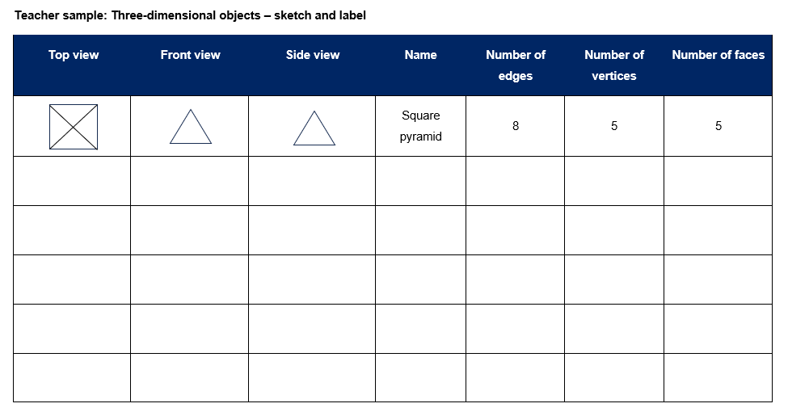

**Note**: the teaching advice for Stage 2 states that formal names for particular prisms and pyramids are not introduced in Stage 2. Prisms and pyramids are to be treated as classes for the grouping of all prisms and all pyramids. Names for particular prisms and pyramids are introduced in Stage 3.

1. In small groups, students repeat the process with one of the pre-prepared feely bags.
2. Students [turn and talk](https://education.nsw.gov.au/teaching-and-learning/curriculum/literacy-and-numeracy/teaching-and-learning-resources/numeracy/talk-moves) to compare drawings and properties.
3. Rotate the feely bags and repeat the process until Resource 3 – sketch and label is completed.
4. Share results with the class.
5. Discuss which 2 models had the most similar features and which 2 models were the most different.
6. Display Resource 4 – prisms and discuss features.

**Multi-age**: students working towards Stage 2 outcomes will be using plasticine to create three-dimensional models and exploring faces with parallel cuts.

1. In small groups, students working towards Stage 2 outcomes construct models of prisms with plasticine. Students place each model on A4 paper and record the number of faces, vertices and edges for each prism. Students discuss the features with their group.
2. Students make parallel cuts to their models to explore how the faces remain the same size and shape all the way through the object. Explain that these are congruent shapes (see Figure 2).

Figure 2 – cutting prisms

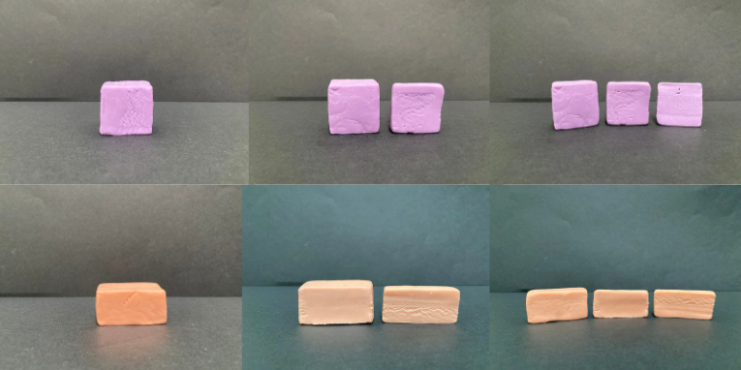

**Congruent**: an exact match between every part of one figure with the corresponding part of another figure, regardless of orientation. For example, congruent figures can be exactly superimposed on each other.

1. Ask students what they notice. For example, if the prism has a triangle as a face and a section is cut off, the face is still a triangle.
2. Repeat the activity for cylinders as in Figure 3. Students cut layers off from one end. Discuss how the flat surface is always a circle.

Figure 3 – cutting a pyramid and a cylinder

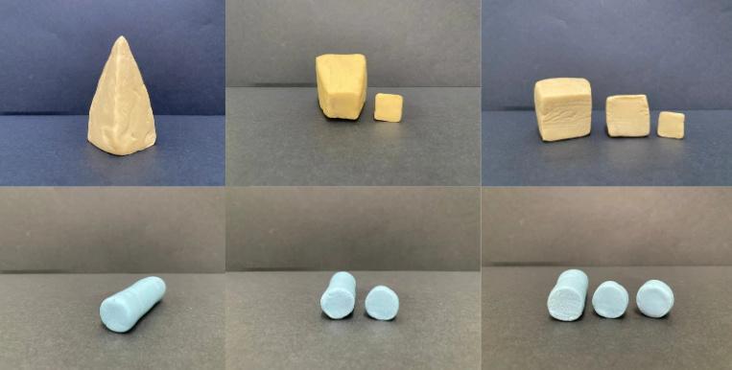

1. Repeat the activity for pyramids as in Figure 3. Students cut layers off from the top. Support students to notice the shape of the face remains the same but increases in size as each layer is cut from the top of the pyramid.

**Note**: when using plasticine, the sides of objects might not be completely straight due to the nature of the material. Explain to students that a model isn’t always an exact replica. Show students some three-dimensional geometrical models to reinforce correct recognition.

**Multi-age**: students working towards Stage 3 outcomes are making skeletal models of three-dimensional objects.

1. In small groups, students working towards Stage 3 outcomes name and make three-dimensional skeletons as in Figure 4. Can students name and make skeletons using:

* 12 straws and 8 pieces of sticky putty to join them? Answer: cube.
* 6 straws and 4 pieces of sticky putty? Answer: triangular pyramid (tetrahedron).
* 8 straws and 5 pieces of sticky putty? Answer: square pyramid.
* 9 straws and 6 pieces of sticky putty? Answer: triangular prism.

Figure 4 – examples of skeletal models

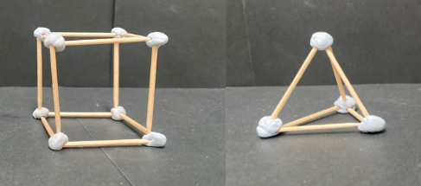

1. Students [turn and talk](https://education.nsw.gov.au/teaching-and-learning/curriculum/literacy-and-numeracy/teaching-and-learning-resources/numeracy/talk-moves) to another group to prove how they know their models are correct.
2. Group the models using the property of the base(s). Discuss how the pyramids have one base and the prisms have 2.

**Note**: the Stage 3 teaching advice states that another name for a triangular pyramid is a tetrahedron. If a triangular pyramid has all its triangular faces identical, it is called a regular tetrahedron.

This table details opportunities for differentiation.

|  |  |
| --- | --- |
| Too hard? | Too easy? |
| Stage 2 students cannot make and/or cut three-dimensional objects.   * Model how to make and cut a prism. Students copy each step.   Stage 3 students cannot draw top, front and side views and/or create skeletal models of prisms and pyramids.   * Support students to draw prisms and pyramids from different views. | Stage 2 students can make and/or cut three-dimensional objects.   * Students record the prisms, pyramids and cylinders showing what happens with each cut.   Stage 3 students can draw top, front and side views and create skeletal models of prisms and pyramids.   * Students draw top, front and side views of their skeletal models. |

## Consolidation and meaningful practice – 10 minutes

1. Revise properties of three-dimensional objects by giving descriptions. Students draw answers on individual whiteboards and justify their thinking to a partner. Ask students:

* I have triangular faces and a square base. I have 5 vertices. What am I? Answer: pyramid (Stage 2) or square pyramid (Stage 3).
* I have 5 faces, only 2 of them are triangles. What am I? Answer: prism (Stage 2) or triangular prism (Stage 3).
* I have a curved boundary and 3 surfaces. What am I? Answer: cylinder.

This table details opportunities for assessment.

|  |  |
| --- | --- |
| Assessment opportunities | Links |
| What to look for:   * Can Stage 2 students create sketches of three-dimensional objects from different views, including top, front and side views? **[MAO-WM-01, MA2-3DS-01]** * Can Stage 2 students identify features of prisms, pyramids and cylinders? **[MAO-WM-01, MA2-3DS-01]** * Can Stage 2 students construct models of prisms, pyramids and cylinders using physical or virtual manipulatives, identifying their features? **[MAO-WM-01, MA2-3DS-01]** * Can Stage 3 students name and compare prisms and pyramids according to the shape of their base? **[MAO-WM-01, MA3-3DS-01]** * Can Stage 3 students visualise and sketch three-dimensional objects from different views, including top, front and side views? **[MAO-WM-01, MA3-3DS-01]** * Can Stage 3 students create skeletal models of prisms and pyramids. compare, describe and name prisms and pyramids? **[MAO-WM-01, MA3-3DS-01]** | Links to [National Numeracy Learning Progressions](https://www.australiancurriculum.edu.au/resources/national-literacy-and-numeracy-learning-progressions/version-3-of-national-literacy-and-numeracy-learning-progressions/) (NNLP):   * Stage 2 – UGP3, UGP5 * Stage 3 – UGP3, UGP5. |

# Lesson 3

**Core concept**: mathematicians examine diagrams to name and explore the features of an object.

## Daily number sense – what zeros matter – 10 minutes

The table below contains suggested learning intentions and success criteria. These are best co-constructed with students.

|  |  |
| --- | --- |
| Daily number sense learning intentions | Daily number sense success criteria |
| Students working towards Stage 2 outcomes are learning to:   * make connections between fractions and decimal notation * extend the application of the place value system from whole numbers to tenths and hundredths.   Students working towards Stage 3 outcomes are learning to:   * compare, order and represent decimals. | Students working towards Stage 2 outcomes can:   * compare and order decimals of up to 2 decimal places * distinguish between the role of zero in various positions.   Students working towards Stage 3 outcomes can:   * compare and order decimal numbers of up to 3 decimal places * use place value to interpret zero digits in decimals. |

**Note**: the Stage 3 teaching advice states that the role of zero as a place holder assists in understanding how to say and write decimals. Zero is written in the ones place in a decimal to reduce the risk of misreading the decimal as a whole number. The number 0.2 has the same value as 0.20 and the number 2 has the same value as 2.0. In measurement, zeros at the end of a decimal have a different meaning as they are used to record precision. A measurement recorded as 0.2 seconds is measured in tenths of a second. A measurement recorded as 0.20 seconds is measured in hundredths of a second.

1. Revise the role of zero as a place holder to support saying and writing decimals with students. Revise that students must write a zero in the ones place if the decimal is smaller than one.

**Multi-age**: students working towards Stage 2 outcomes cut up and use Resource 5 – decimal cards 1 and students working towards Stage 3 outcomes use Resource 6 – decimal cards 2.

1. Students take turns to select a card, read the decimal aloud and sort the cards from smallest to largest, justifying decisions. Students decide which zeros matter. For example, the zeros in 0.025 are important, but the zero in 1.590 does not affect the place value if removed.

**Note**: when reading aloud, students use daily convention and ignore the end zeros. For example, 0.500 is interpreted as 0.5 and read as 5 tenths.

1. Move around the groups, checking for misconceptions about the role of zero in decimals.
2. Once groups have ordered the cards, students compare their card order to one other group.
3. Ask the class:

* Were there any groups that had any cards in a different position? Why do you think that is?
* Did your group face any challenges while deciding on the order of cards?

This table details opportunities for assessment.

|  |  |
| --- | --- |
| Assessment opportunities | Links |
| What to look for:   * Can Stage 2 students compare and order decimals of up to 2 decimal places? **[MAO-WM-01, MA2-RN-02]** * Can Stage 2 students distinguish between the role of zero in various positions? **[MAO-WM-01, MA2-RN-02]** * Can Stage 3 students compare and order decimal numbers of up to 3 decimal places? **[MAO-WM-01, MA3-RN-02]** * Can Stage 3 students interpret zero digits using place value? **[MAO-WM-01, MA3-RN-02]** | Links to [National Numeracy Learning Progressions](https://www.australiancurriculum.edu.au/resources/national-literacy-and-numeracy-learning-progressions/version-3-of-national-literacy-and-numeracy-learning-progressions/) (NNLP):   * Stage 2 – NPV4, NPV5, NPV6, NPV7. * Stage 3 – NPV8.   Links to suggested [Interview for Student Reasoning](https://education.nsw.gov.au/teaching-and-learning/curriculum/literacy-and-numeracy/assessment-resources/ifsr) (IfSR) tasks:   * **Stage 2 – IfSR-NP**: 4D.1, 4D.7. * **Stage 3 – IfSR-PT**: 1A.5, 1A.7 * **Stage 3 – IfSR-AT**: 4B.1 * **Stage 3 – IfSR-NP**: 4D.6. |

## Core lesson – exploring nets of prisms and pyramids – 40 minutes

The table below contains suggested learning intentions and success criteria. These are best co-constructed with students.

|  |  |
| --- | --- |
| Core concept learning intentions | Core concept success criteria |
| Students working towards Stage 2 outcomes are learning to:   * make models of three-dimensional objects to compare and describe key features * use features of two-dimensional shapes to describe three-dimensional objects.   Students working towards Stage 3 outcomes are learning to:   * connect three-dimensional objects with two-dimensional representations. | Students working towards Stage 2 outcomes can:   * use nets to construct prisms (including cubes) * investigate the variety of nets that can be used to create a particular prism * use understanding of two-dimensional shapes to compare and describe three-dimensional objects.   Students working towards Stage 3 outcomes are learning to:   * examine a diagram to determine whether it is or is not the net of a closed three-dimensional object * visualise and name prisms and pyramids, given representations of their nets * visualise and sketch nets for three-dimensional objects. |

**Note:** the Stage 2 teaching advice states that not all three-dimensional objects have nets. As spheres, cylinders and cones are not polyhedrons, their lack of edges means they do not have a net (Friedman 2018). There are 11 distinct nets of a cube and 2 nets of a regular tetrahedron.

1. Display Resource 7 – nets or not. Ask students which net or nets could be folded to make a pyramid (Stage 2) or a square pyramid (Stage 3) or a prism (Stage 2) or a rectangular prism (Stage 3). Discuss answers (see Figure 5).

Figure 5 – net answers

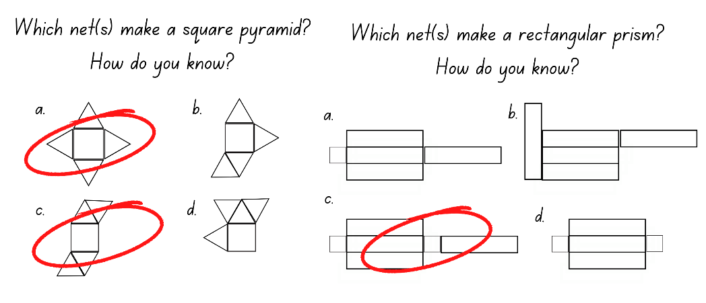

1. Draw a cube net as in Figure 6. Revise that it contains 6 congruent squares. Ask students if they could make a net for a cube using 6 squares in any other arrangement.

Figure 6 – example of a cube net

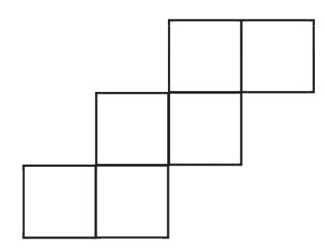

1. In small groups, students working towards Stage 2 outcomes investigate net possibilities by drawing, cutting and folding card.
2. Show students working towards Stage 3 outcomes a triangular pyramid. Model drawing and constructing the net using card. Revise properties, for example, faces, edges and vertices.
3. Provide small groups of students working towards Stage 3 outcomes with three-dimensional geometrical models and card.
4. Students working towards Stage 3 outcomes draw the net of one solid and justify how it is correct to the group. If there is disagreement, a student may choose to adapt or redraw their net. Students then cut out their nets and make the geometrical model. Students may need to redraw their nets at this point.
5. Compare and discuss results with students working towards Stage 2 outcomes. Support students to see which solutions are the same and which are different. Display Resource 8 – nets of cubes. Ask students:

* Were there any nets that were the same as yours?
* Were there any nets that were different?
* If you flip or turn a net, is it the same or different? How do you know?
* Do all the nets make the cube? Why not? How can you explain this using mathematical language? See Figure 7.

Figure 7 – correct and incorrect

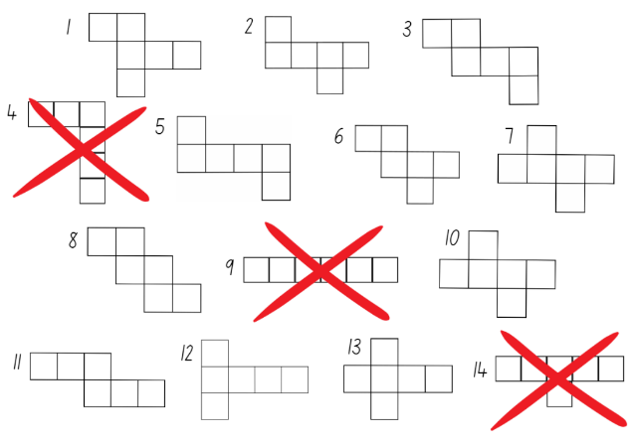

1. Display the nets created by students working towards Stage 3 outcomes. Ask students:

* What did you notice?
* Is there only one way to make a net for each three-dimensional solid. Why or why not?
* What adjustments did you need to make for your net to be successful?

This table details opportunities for differentiation.

|  |  |
| --- | --- |
| Too hard? | Too easy? |
| Stage 2 students cannot create three-dimensional objects from nets.   * Support students to draw, cut and fold nets.   Stage 3 students cannot visualise and/or sketch nets for given three-dimensional objects.   * Use step-by-step instructions to support students to sketch nets of one three-dimensional object. | Stage 2 students can create three-dimensional objects from nets.   * Students explore nets for a pyramid or another prism.   Stage 3 students can visualise and sketch nets for given three-dimensional objects.   * Students make nets for everyday objects in the classroom. |

## Consolidation and meaningful practice – 10 minutes

**Note**: this activity is taken from [GeoGebra](https://www.geogebra.org/m/n6EjQDw8) and may be completed as a class or in small groups depending on access to devices.

1. As a class or in small groups complete the activities at [Exploring Nets of Geometric Solids](https://www.geogebra.org/m/n6EjQDw8) to revise nets of three-dimensional geometrical models.

This table details opportunities for assessment.

|  |  |
| --- | --- |
| Assessment opportunities | Links |
| What to look for:   * Can Stage 2 students use nets to construct prisms (including cubes)? **[MAO-WM-01, MA2-3DS-01]** * Can Stage 2 students investigate the variety of nets that can be used to create a particular prism? **[MAO-WM-01, MA2-3DS-01]** * Can Stage 2 students use understanding of two-dimensional shapes to compare and describe three-dimensional objects? **[MAO-WM-01, MA2-2DS-01, MA2-3DS-01]** * Can Stage 3 students examine a diagram to determine whether it is or is not the net of a closed three-dimensional object? **[MAO-WM-01, MA3-3DS-01]** * Can Stage 3 students visualise and name prisms and pyramids, given representations of their nets? **[MAO-WM-01, MA3-3DS-01]** * Can Stage 3 students visualise and sketch nets for given three-dimensional objects? **[MAO-WM-01, MA3-3DS-01]** | Links to [National Numeracy Learning Progressions](https://www.australiancurriculum.edu.au/resources/national-literacy-and-numeracy-learning-progressions/version-3-of-national-literacy-and-numeracy-learning-progressions/) (NNLP):   * Stage 2 – UGP3, UGP4, UGP5 * Stage 3 – UGP3, UGP5. |

# Lesson 4

**Core concept**: mathematicians construct and deconstruct objects to explore their features.

## Daily number sense – 10 minutes

1. From a class need surfaced through formative assessment data, identify a short, focused activity that targets students’ knowledge, understanding and skills. Example activities may be drawn from the following resources:

* [Mathematics K–6 resources](https://education.nsw.gov.au/teaching-and-learning/curriculum/mathematics/mathematics-curriculum-resources-k-12/mathematics-k-6-resources.main-education--category---catalogue---key-learning-area---mathematics---thinking-mathematically.nameAsc.1.grid)
* [Universal Resources Hub](https://resources.education.nsw.gov.au/home).

## Core lesson: 40 minutes

### Stage 2 task – deconstructing everyday packages

The table below contains suggested learning intentions and success criteria. These are best co-constructed with students.

|  |  |
| --- | --- |
| Core concept learning intentions | Core concept success criteria |
| Students working towards Stage 2 outcomes are learning to:   * make models of three-dimensional objects to compare and describe key features * connect features of three-dimensional objects to two-dimensional shapes. | Students working towards Stage 2 outcomes can:   * deconstruct everyday packages that are prisms (including cubes) and cylinders to create nets * identify, describe and compare features of three-dimensional objects. |

1. Display a range of everyday packaging that shows examples of prisms, cubes and cylinders. For example, cereal boxes, tissue boxes, chocolate, chips containers (see Figure 8). Explain that mathematicians call these three-dimensional objects.

Figure 8 – everyday packaging

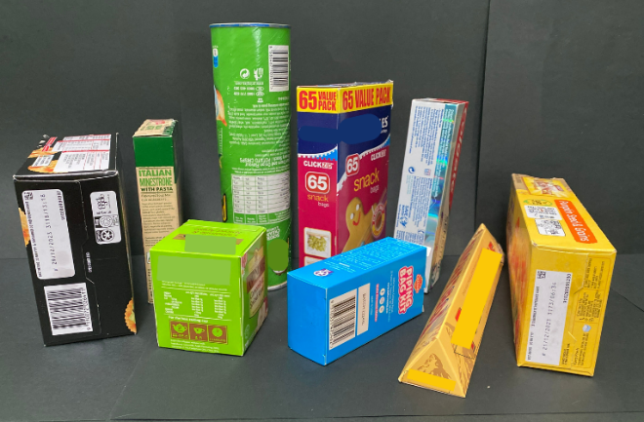

1. Students explore and describe faces, edges and vertices for each three-dimensional object.
2. Model how to cut a package along the edges to open it out. Explain that this is called a net (see Figure 9).

Figure 9 – unfolding packages

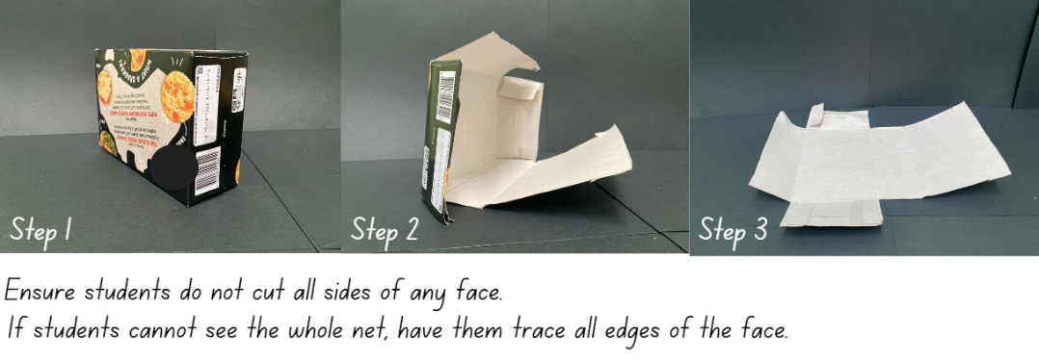

1. Provide small groups of students with a variety of everyday packages. Groups cut as per teacher modelling and flatten their packages into nets.

**Note**: tabs on everyday packaging must be secured with sticky tape to create an accurate representation of the net.

1. Groups draw around the nets. Compare the shapes and sides of the nets.
2. Students fold the nets back into the original packaging format and place the packaging beside the corresponding net drawing.
3. Go on a [gallery walk](https://app.education.nsw.gov.au/digital-learning-selector/LearningActivity/Card/555) to observe the nets and drawings. Ask students:

* What do you notice?
* If you translate (slide), reflect (flip) or rotate (turn) an unfolded package drawing is it still the same? How do you know?
* What is similar or different?

This table details opportunities for differentiation.

|  |  |
| --- | --- |
| Too hard? | Too easy? |
| Stage 2 students cannot deconstruct everyday packages or make net drawings.   * Support students to deconstruct everyday packages. Point to each side of the opened package and state the name of the two-dimensional shape. For example, square or rectangle. | Stage 2 students can deconstruct everyday packages and make net drawings.   * Provide students with other prisms, for example, a prism that has a hexagon for each end face. Discuss the similarities with other prisms. |

### Stage 3 task – making 3D objects by matching nets

The table below contains suggested learning intentions and success criteria. These are best co-constructed with students.

|  |  |
| --- | --- |
| Core concept learning intention | Core concept success criteria |
| Students working towards Stage 3 outcome are learning to:   * connect three-dimensional objects with two-dimensional representations. | Students working towards Stage 3 outcomes can:   * examine a diagram to determine whether it is or is not the net of a closed three-dimensional object * visualise and name prisms and pyramids, given representations of their nets * visualise and sketch nets for three-dimensional objects. |

This activity is an adaptation of [Cut Nets](https://nrich.maths.org/2315) from NRICH by the University of Cambridge.

1. Display a range of three-dimensional geometrical models. For example, cube, triangular prism, rectangular prism, square pyramid.
2. Draw a Venn diagram to model how to describe and record the similarities and differences between 2 models. For example, rectangular prism and square pyramid (see Figure 10).

Figure 10 – Venn diagram ideas

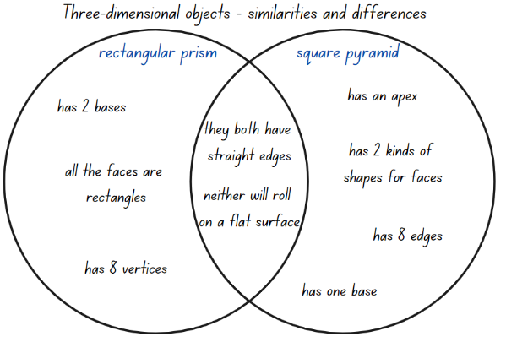

1. In small groups, students draw a Venn diagram to repeat the process with a rectangular prism and a triangular pyramid.
2. Discuss responses as a class.
3. Display Resource 9 – cut cube net. Explain that the net of a cube has been cut into 2. These can be joined together and then folded into a cube.
4. Ask students how this net could be put back together. Make the net and discuss student answers. Support students to discuss multiple solutions.
5. Give small groups of students 2 copies of Resource 10 – match my net. Explain that each net has been cut into 2 pieces, like the net of the cube.
6. Students use one set of nets to join together and make geometrical models. Then they display these next to the other set of nets (see Figure 11).

Figure 11 – matching nets

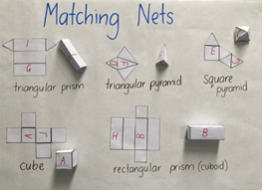

1. Discuss results with class. Ask students to explain the strategies used to put the cut nets together.

**Note:** please refer to [Cut Nets](https://nrich.maths.org/2315) at NRICH for further information on how to develop student responses.

This table details opportunities for differentiation.

|  |  |
| --- | --- |
| Too hard? | Too easy? |
| Stage 3 students cannot visualise and/or make nets of three-dimensional objects.   * Allow students to trace unfolded nets. | Stage 3 students can visualise and make nets of three-dimensional objects.   * Students create nets of other three-dimensional objects. Students cut nets in 2 and swap with a student to solve. |

## Discuss and connect the mathematics – 15 minutes

1. Display Resource 11 – deconstructed net to students working towards Stage 2 outcomes.
2. Students draw the three-dimensional object the net will make on individual whiteboards.
3. Students working towards Stage 3 outcomes draw half the net of a three-dimensional object on individual whiteboards.
4. Students swap their half net with a partner to solve.
5. Look at the constructed object drawings of students working towards Stage 2 outcomes and ask:

* What three-dimensional object did you draw from this net: prism, pyramid or cylinder? How do you know?
* Could this net represent another three-dimensional object? How do you know?

1. Choose some students working towards Stage 3 outcomes to share solutions with the class.

This table details opportunities for assessment.

|  |  |
| --- | --- |
| Assessment opportunities | Links |
| What to look for:   * Can Stage 2 students deconstruct everyday packages that are prisms and cylinders to create nets? **[MAO-WM-01, MA2-3DS-01]** * Can Stage 2 students identify, describe and compare features of three-dimensional objects? **[MAO-WM-01, MA2-2DS-01, MA2-3DS-01]** * Can Stage 3 students examine a diagram to determine whether it is or is not the net of a closed three-dimensional object? **[MAO-WM-01, MA3-3DS-01]** * Can Stage 3 students visualise and name prisms and pyramids, given representations of their nets? **[MAO-WM-01, MA3-3DS-01]** * Can Stage 3 students visualise and sketch nets for given three-dimensional objects? **[MAO-WM-01, MA3-3DS-01]** | Links to [National Numeracy Learning Progressions](https://www.australiancurriculum.edu.au/resources/national-literacy-and-numeracy-learning-progressions/version-3-of-national-literacy-and-numeracy-learning-progressions/) (NNLP):   * Stage 2 – UGP3, UGP4, UGP5 * Stage 3 – UGP3, UGP5. |

# Lesson 5

**Core concept**: the capacity of the object determines the most appropriate unit of measure.

## Daily number sense – How many ways? – 15 minutes

Daily number sense activities for Lessons 5 to 7 ‘loop’ back to concepts and procedures covered in previous units to assist students to build an increasingly connected network of ideas. These concepts may differ from the core concepts being covered by the unit.

The table below contains suggested learning intentions and success criteria. These are best co-constructed with students.

|  |  |
| --- | --- |
| Daily number sense learning intentions | Daily number sense success criteria |
| Students working towards Stage 2 outcomes are learning to:   * apply place value to partition and regroup numbers up to 4-digits.   Students working towards Stage 3 outcomes are learning to:   * apply place value to partition, regroup and rename numbers to 1 billion. | Students working towards Stage 2 outcomes can:   * partition and record 4-digit numbers in non-standard forms.   Students working towards Stage 3 outcomes can:   * partition numbers to 1 billion in non-standard forms. |

1. Display the number 4627. Ask students to describe this number using standard partitioning. This is 4000 + 600 + 20 + 7 or 4 thousands, 6 hundreds, 2 tens and 7 ones. Record these on the board.
2. Ask students how it could be described if they could not use tens. The number could now be described as 4000 + 600 + 27 or 4 thousands, 6 hundreds and 27 ones. Record this on the board.
3. Ask students to [turn and talk](https://education.nsw.gov.au/teaching-and-learning/curriculum/literacy-and-numeracy/teaching-and-learning-resources/numeracy/talk-moves) to work out how they could describe 4627 without using thousands.
4. In small groups, students choose a 4-digit number and explore describing it in as many ways as possible.

**Multi-age**: students working towards Stage 3 outcomes may enjoy the challenge of exploring non-standard partitioning with 5- or 6-digit numbers and beyond.

1. Move between groups, supporting understanding of place value.
2. Some students may need to model a number using MAB materials to support thinking. Others may need to work with non-standard place value forms for 2- and 3-digit numbers first.
3. Some students may enjoy the challenge of logically working out how many ways are possible using different combinations of tens and ones, hundreds and tens and so on. For example, 4 thousands, 5 hundreds, 12 tens and 7 ones and then 4 thousands, 4 hundreds, 22 tens and 7 ones and so on.

This table details opportunities for assessment.

|  |  |
| --- | --- |
| Assessment opportunities | Links |
| What to look for:   * Can Stage 2 students partition and record 4-digit numbers in non-standard forms? **[MAO-WM-01, MA2-RN-01]** * Can Stage 3 students partition numbers to 1 billion in non-standard forms? **[MAO-WM-01, MA3-RN-01]** | Links to [National Numeracy Learning Progressions](https://www.australiancurriculum.edu.au/resources/national-literacy-and-numeracy-learning-progressions/version-3-of-national-literacy-and-numeracy-learning-progressions/) (NNLP):   * Stage 2 – NPV5, NPV6 * Stage 3 – NPV6.   Links to suggested [Interview for Student Reasoning](https://education.nsw.gov.au/teaching-and-learning/curriculum/literacy-and-numeracy/assessment-resources/ifsr) (IfSR) tasks:   * **Stage 2 – IfSR-NP**: 4B.3. |

## Core lesson – litres and millilitres – 40 minutes

The table below contains suggested learning intentions and success criteria. These are best co-constructed with students.

|  |  |
| --- | --- |
| Core concept learning intentions | Core concept success criteria |
| Students working towards Stage 2 outcomes are learning to:   * measure and order containers using litres.   Students working towards Stage 3 outcomes are learning to:   * choose appropriate units of measurement for capacity * connect decimal representations to the metric system. | Students working towards Stage 2 outcomes can:   * use the litre as a unit to measure capacities * record capacities using the abbreviation for litres (L) * estimate the capacity of a container in litres and check by measuring.   Students working towards Stage 3 outcomes can:   * select and use appropriate units to measure the capacities of a variety of containers * recognise the equivalence of whole-number and decimal representations of measurements of capacities. |

This activity is an adaptation of ‘How many litres’ from [*Teaching measurement: Stage 2 and Stage 3* [PDF 686KB]](https://education.nsw.gov.au/content/dam/main-education/teaching-and-learning/curriculum/key-learning-areas/mathematics/media/documents/mathematics-s2-s3-teaching-measurement.pdf) by the State of NSW (Department of Education).

1. Revise the difference between volume and capacity. Volume is the space taken up by a three-dimensional object. Capacity is the internal volume, which is how much a three-dimensional object can hold. For example, Linda is going on a road trip around Australia in her caravan. She needs to know the volume of the caravan, so that she knows how much space the caravan takes up when parking it in her garage. Linda also needs to know the capacity (internal volume) of the caravan, so she knows how much she can fit inside when packing.

**Capacity (internal volume)**: refers to the amount a container can hold and is measured in units such as millilitres (mL), litres (L) and kilolitres (kL).

**Note**: capacity is only used in relation to containers and generally refers to the measurement of liquid. The capacity of a container will be slightly less than its volume as capacity is based on the inside dimensions, while volume is determined by the outside dimensions. It is recommended that the terms ‘capacity’ and ‘internal volume’ be used interchangeably.

1. Ask students for other examples of the difference between volume and capacity.
2. Review the use of formal units of measurement in length, such as metres and centimetres. Ask students what the formal unit of measurement is for internal volume or capacity.
3. Discuss the terms millilitres and litres and explain why they are important. Formal units allow measures to be communicated easily and with more accuracy. Ask students to give examples of times they have heard the term litres or millilitres. For example, litres of petrol or milk or millilitres of cough syrup or tomato sauce. Explain to students the abbreviation for millilitres is mL and the abbreviation for litres is L.

**Multi-age**: students working towards Stage 2 outcomes will have previously measured capacity using informal units of measurement and concrete materials, such as water, sand, beads and blocks. This may be the first time students have been introduced to the formal measurements for capacity of litres and millilitres. In this lesson, students working towards Stage 2 outcomes are focusing on using the litre as a unit to measure capacities only. They will be exploring the need for a unit smaller than a litre (millilitre) in Lesson 6.

1. Show students working towards Stage 2 outcomes everyday one litre containers. Show students working towards Stage 3 outcomes a measuring instrument and a container.
2. For students working towards Stage 2 outcomes, model estimating, measuring and recording the capacity (internal volume) of a bucket using an everyday container. Prompt students to consider whether to refine their estimate after adding the first 2 litres of water. Model the process and record the capacity of the bucket using the abbreviation for litres (L) with Resource 12 – estimate and measure.
3. For students working towards Stage 3 outcomes, model choosing a measuring instrument to estimate, measure and record the capacity of a container with Resource 12 – estimate and measure.
4. Give small groups of students working towards Stage 2 outcomes one everyday litre container and 4 larger containers. For example, buckets, ice cream containers, tote trays or bins.
5. Give students working towards Stage 3 outcomes containers with different capacities and a selection of formal and informal measuring instruments. For example, measuring cup, jug or teaspoon.
6. Ask students working towards Stage 2 outcomes to use water to estimate and record with Resource 12 – estimate and measure the capacity of each container to the nearest litre. Students use the abbreviation for litres (L). Students [turn and talk](https://education.nsw.gov.au/teaching-and-learning/curriculum/literacy-and-numeracy/teaching-and-learning-resources/numeracy/talk-moves) to their group, explaining how they reached their estimate.
7. Ask students working towards Stage 3 outcomes to select a measuring instrument and use Resource 12 – estimate and measure to record estimates and measures for each container to the nearest millilitre, using water. Students use the abbreviation for millilitres (mL).
8. Remind students to refine their estimates after measuring the capacity of the first container if required.
9. Ask students:

* What did you notice with the capacities of your containers?
* What was the capacity of each container?
* Did you change any estimates when you started to fill containers? Why?

**Multi-age**: students working towards Stage 2 outcomes order Resource 13 – capacity sort 1 in small groups. Students working towards Stage 3 outcomes order Resource 14 – capacity sort 2 in small groups.

1. Discuss the orders with the class.

This table details opportunities for differentiation.

|  |  |
| --- | --- |
| Too hard? | Too easy? |
| Stage 2 students cannot estimate, use and record capacity (internal volume) using litres.   * Support students using scaled instruments when measuring and recording capacity.   Stage 3 students cannot select and/or use appropriate units of measurement for capacity.   * Give students one instrument of measurement, for example, a measuring cup. Support students to measure using the given object with water. | Stage 2 students can estimate, use and record capacity (internal volume) using litres.   * Students estimate, use and record capacities using millilitres and litres. For example, one litre and 500 millilitres.   Stage 3 students can select and use appropriate units of measurement for capacity.   * Students describe measurements using benchmarks. |

## Discuss and connect the mathematics – 15 minutes

1. Display Resource 15 – drinks problem and ask pairs of students working towards Stage 3 outcomes to work out how many litres and millilitres were purchased and record their solution using words, drawings and formal measurements. For example, 1050 mL is equivalent to 1.050 L.
2. Give pairs of students working towards Stage 3 outcomes Resource 16 – equivalent capacity. Students draw lines matching the equivalent amounts. For example, 500 mL is the same as half a litre or 0.5 L.
3. Show students working towards Stage 2 outcomes a collection of labelled containers with the capacity of less than one litre, such as 500 millilitres, 250 millilitres. Students estimate how many times each container will have to be filled to make one litre. They check and record by filling with water. Ask students:

* What did you notice?
* Could you find any patterns? For example, it takes 2 500 millilitre containers to fill one litre, so 500 millilitres must be half of one.

This table details opportunities for assessment.

|  |  |
| --- | --- |
| Assessment opportunities | Links |
| What to look for:   * **Can Stage 2 students use the litre as a unit to measure capacities (internal volumes) to the nearest litre? [MAO-WM-01, MA2-3DS-02]** * Can Stage 2 students record capacities (internal volumes) using the abbreviations for litres (L)? **[MAO-WM-01, MA2-3DS-02]** * Can Stage 2 students estimate the capacity (internal volume) of a container in litres and check by measuring? **[MAO-WM-01, MA2-3DS-02]** * Can Stage 3 students select and use appropriate units to measure the capacities of a variety of containers? **[MAO-WM-01,** **MA3-3DS-02]** * Do Stage 3 students recognise the equivalence of whole-number and decimal representations of measurements of capacities? **[MAO-WM-01,** **MA3-3DS-02]** | Links to [National Numeracy Learning Progressions](https://www.australiancurriculum.edu.au/resources/national-literacy-and-numeracy-learning-progressions/version-3-of-national-literacy-and-numeracy-learning-progressions/) (NNLP):   * Stage 2 – UuM6 * Stage 3 – UuM6. |

# Lesson 6

**Core concept**: standard units are an efficient way to communicate capacity.

## Daily number sense – hundredths and thousandths – 10 minutes

The table below contains suggested learning intentions and success criteria. These are best co-constructed with students.

|  |  |
| --- | --- |
| Daily number sense learning intentions | Daily number sense success criteria |
| Students working towards Stage 2 outcomes are learning to:   * extend the application of the place value system from whole numbers to tenths and hundredths.   Students working towards Stage 3 outcomes are learning to:   * recognise that the place value system can be extended beyond hundredths. | Students working towards Stage 2 outcomes can:   * express decimals as both tenths and hundredths.   Students working towards Stage 3 outcomes can:   * indicate the place value of digits in decimal numbers of up to 3 decimal places * use place value to partition decimals. |

1. Model spinning a 0–9 spinner 4 times to record as a whole number and tenths, hundredths and thousandths. Read aloud to show place value understanding in standard form. For example, 5.429 is 5 ones, 4 tenths, 2 hundredths and 9 thousandths. However, it is read as 5 and 429 thousandths (see Figure 12).

Figure 12 – teacher example

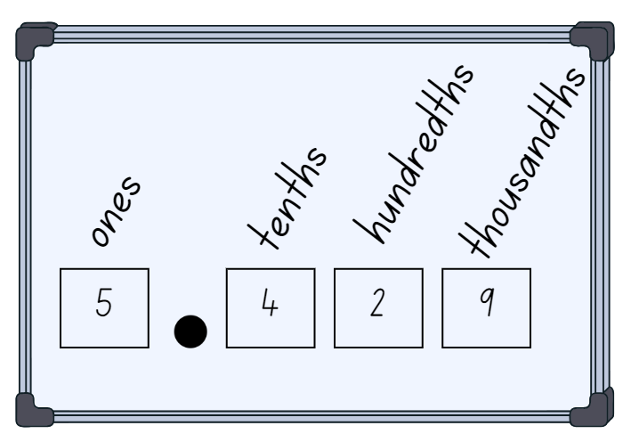

1. Give students a 0–9 spinner. Students spin the spinner 4 times and record the ones, tenths, hundredths and thousandths place on their individual whiteboards (see Figure 12).

**Multi-age**: students working towards Stage 2 outcomes spin the spinner 3 times and record on individual whiteboards the ones, tenths and hundredths place (see Figure 13).

Figure 13 – student working towards Stage 2 outcomes

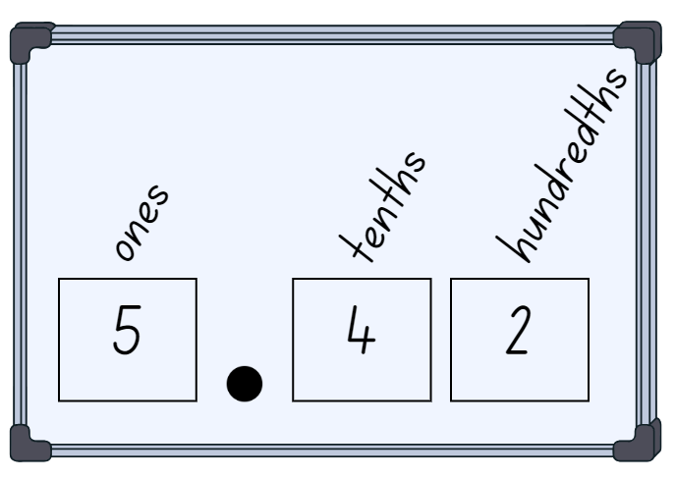

1. Once recorded, students identify and name the place value parts. For example, 6 ones, 3 tenths, one hundredth and 8 thousandths. Students circle the decimal parts and say that these will be named as thousandths. They then read the number as six and three hundred and eighteen thousandths.
2. Students repeat the process for a given time.
3. As a class, spin another number. Challenge students to consider non-standard place value partitioning. For example:

* If you cannot have a whole number, how many thousandths would you have? For example, 7.264 could be recorded in a non-standard place value form as 7264 thousandths.
* If you cannot have tenths, how could you say this number? 7 wholes, 26 hundredths and 4 thousandths.

This table details opportunities for assessment.

|  |  |
| --- | --- |
| Assessment opportunities | Links |
| What to look for:   * Can Stage 2 students express decimals as both tenths and hundredths? **[MAO-WM-01, MA2-RN-02]** * Can Stage 3 students indicate the place value of digits in decimal numbers of up to 3 decimal places? **[MAO-WM-01, MA3-RN-02]** * Can Stage 3 students use place value to partition decimals? **[MAO-WM-01, MA3-RN-02]** | Links to [National Numeracy Learning Progressions](https://www.australiancurriculum.edu.au/resources/national-literacy-and-numeracy-learning-progressions/version-3-of-national-literacy-and-numeracy-learning-progressions/) (NNLP):   * Stage 2 – NPV7 * Stage 3 – NPV7, NPV8.   Links to suggested [Interview for Student Reasoning](https://education.nsw.gov.au/teaching-and-learning/curriculum/literacy-and-numeracy/assessment-resources/ifsr) (IfSR) tasks:   * **Stage 2 – IfSR-NP**: 4D.3 * **Stage 3 – IfSR-PT**: 1A.5 * **Stage 3 – IfSR-NP**: 4D.2, 4D.6. |

## Core lesson – investigating formal units to measure capacity – 50 minutes

The table below contains suggested learning intentions and success criteria. These are best co-constructed with students.

|  |  |
| --- | --- |
| Core concept learning intentions | Core concept success criteria |
| Students working towards Stage 2 outcomes are learning to:   * measure and order containers using litres * use scaled instruments to measure and compare capacities (internal volumes).   Students working towards Stage 3 outcomes are learning to:   * connect decimal representations to the metric system * recognise that the place value system can be extended beyond hundredths. | Students working towards Stage 2 outcomes can:   * recognise the need for formal units to measure capacity accurately * recognise the need for a formal unit smaller than the litre to measure capacity * estimate the internal volume of a container to common benchmark values and check by measuring.   Students working towards Stage 3 outcomes can:   * recognise the equivalence of whole-number and decimal representations of measurements of capacities * interpret and record decimal notation for capacities to 3 decimal places * indicate the place value of digits in decimal numbers of up to 3 decimal places. |

1. Show students a transparent everyday one litre container that is partly filled with water. For example, a 1 L water bottle. Ask students to estimate how much water is in it.
2. Use 3 different sized everyday cups to pour water into the container. Mark the water level on the container after each pour.
3. Prompt students to notice the marks after each pour are not equally spaced.

**Multi-age**: students working towards Stage 2 outcomes will have used cups to measure internal volume (capacity) in Stage 1. This activity should prompt students to recognise the need for a standard formal unit smaller than the litre to measure internal volume (capacity).

1. Ask students:

* Why are the marks for each cup not equally spaced?
* Have you used cups to measure anything before?
* Is a cup an efficient unit of measurement? Why or why not?

1. Show students a scaled measuring cup and explain that it will always contain 250 millilitres. Explain that this is a common measuring instrument. To extend student understanding of small units of measurement, show one standard teaspoon of water and explain that it is 5 millilitres of liquid.
2. Display Resource 17 – Which unit? Ask students to explain their choice of measuring units to measure the capacity of each object.
3. Give students working towards Stage 2 outcomes a range of one litre containers. Students estimate and record how many scaled measuring cups it will take to fill the containers. Students check by filling containers with water and keeping tally marks to record how many cups are needed for each. Allow students to refine their estimates after adding one cup of liquid.
4. Display Resource 18 – capacity conversions for students working towards Stage 3 outcomes. Discuss how to convert between millilitres and litres. Ask students to do simple mental conversions such as 2 L = 2000 mL and 7000 mL = 7 L.

**Note:** it is important that students working towards Stage 3 outcomes understand the place value needed to convert between whole number (litres), and decimal representations (millilitres). For example, 1 mL = 0.001 L.

1. Revise place value to 3 decimal places with students working towards Stage 3 outcomes and discuss what place the 7 represents in 0.750. Repeat for digits 0, 5, and 0. Ask students:

* What is the place value of 7 in each of these numbers? 1.670, 0.700, 4.257 and 7.001.

1. Model to students working towards Stage 3 outcomes how to complete Resource 19 – equivalent capacities using decimal notation (see Figure 14). For example, 750 mL is the same as 0.750 L. Pour 5 cups into a container with a capacity of more than 1 L. At 4 cups, draw students’ attention to 4 cups is the same as one litre or 1000 mL. Add the last cup and record the capacity as 1 L and 250 mL or 1250 mL. Ask students how this could be represented with decimal notation.

Figure 14 – teacher decimals recordings

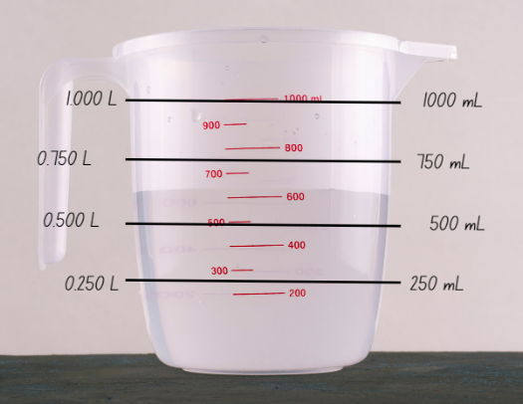

1. Model converting 1250 mL or 1 L and 250 mL to 1.250 L. Explain how the one here represents 1000 mL or one whole litre and the 250 after the decimal place represents 250 mL.

**Note**: some students working towards Stage 3 outcomes may benefit from the use of a number slider to convert between millilitres and litres.

1. In small groups, students working towards Stage 3 outcomes solve Resource 20 – capacity problems. Discuss answers with students, asking what strategies were most useful to help convert millilitres into litres.
2. Discuss with students working towards Stage 2 outcomes how many cups were needed to fill each of the containers. Students should realise that each container takes 4 cups. Ask students how they could record this mathematically. For example, 4 lots of 250 mL, 1000 mL or 1 L. A useful benchmark for estimating internal volume is that one measuring cup holds a quarter of a litre (250 mL).

**Multi-age**: students working towards Stage 2 outcomes are recognising the need for litres and millilitres to accurately measure capacity. Students are not expected to record measurements using decimal representations.

This table details opportunities for differentiation.

|  |  |
| --- | --- |
| Too hard? | Too easy? |
| Stage 2 students cannot recognise the need for formal units to measure internal volume (capacity).   * Show students 2 transparent containers. Fill one using a scaled measuring cup and the other using an everyday cup. Look at the differences and discuss which cup is more useful for communicating measurement.   Stage 3 students cannot recognise, interpret and/or record decimal notation to 3 decimal places for capacities.   * Students experience further hands-on opportunities to explore equivalent capacities. | Stage 2 students can recognise the need for formal units to measure internal volume (capacity).   * Students solve problems to calculate how many millilitres containers might hold. For example, if Sarah had one litre of water and used it to fill 4 containers, ask how much each container might hold.   Stage 3 students can recognise, interpret and record decimal notation to 3 decimal places for capacities.   * Students take one measurement and write it in standard and non-standard place value forms. |

## Discuss and connect the mathematics – 10 minutes

1. Discuss benchmark equivalence with students. For example, one litre is the same as 1000 mL or 4 cups. Model using a measuring jug to show how 4 cups is the same as 1000 mL or one litre. Support students to make connections between cups and the benchmarks of a quarter of a litre, half a litre, 3 quarters of a litre and one whole litre. Discuss how many millilitres would be in each cup and one litre (see Figure 15).

Figure 15 – measuring benchmark equivalence

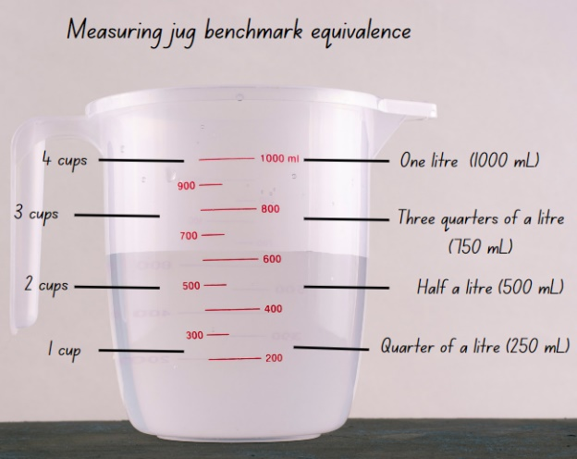

1. Create an anchor chart of internal volume (capacity) that includes the definition for internal volume (capacity) and formal units of measurement.

This table details opportunities for assessment.

|  |  |
| --- | --- |
| Assessment opportunities | Links |
| What to look for:   * Can Stage 2 students recognise the need for formal units and a formal unit smaller than the litre to measure capacity? **[MAO-WM-01, MA2-3DS-02]** * Can Stage 2 students estimate the capacity of a container to common benchmark values and check by measuring? **[MAO-WM-01, MA2-3DS-02]** * Can Stage 3 students recognise the equivalence of whole-number and decimal representations of measurements of capacities? **[MAO-WM-01, MA3-3DS-02]** * Can Stage 3 students interpret and record decimal notation for capacities to 3 decimal places? **[MAO-WM-01, MA3-3DS-02]** * Can Stage 3 students indicate the place value of digits in decimal numbers of up to 3 decimal places? **[MAO-WM-01, MA3-RN-02]** | Links to [National Numeracy Learning Progressions](https://www.australiancurriculum.edu.au/resources/national-literacy-and-numeracy-learning-progressions/version-3-of-national-literacy-and-numeracy-learning-progressions/) (NNLP):   * Stage 2 – UuM6 * Stage 3 – NPV7, NPV8.   Links to suggested [Interview for Student Reasoning](https://education.nsw.gov.au/teaching-and-learning/curriculum/literacy-and-numeracy/assessment-resources/ifsr) (IfSR) tasks:   * **Stage 3 – IfSR-PT**: 1A * **Stage 3 – IfSR-NP**: 4D.2, 4D.6. |

# Lesson 7

**Core concept**: mathematicians explore capacity in different ways.

## Daily number sense – measuring using decimal notation – 15 minutes

The table below contains suggested learning intentions and success criteria. These are best co-constructed with students.

|  |  |
| --- | --- |
| Daily number sense learning intentions | Daily number sense success criteria |
| Students working towards Stage 2 outcomes are learning to:   * make connections between fractions and decimal notation.   Students working towards Stage 3 outcomes are learning to:   * recognise that the place value system can be extended beyond hundredths. | Students working towards Stage 2 outcomes can:   * record equivalent measurements using decimals.   Students working towards Stage 3 outcomes can:   * express thousandths as decimals * interpret decimal notation for thousandths. |

1. Show students the millimetre and centimetre measurements on a ruler. Revise with students that there are 10 mm in one centimetre, 100 cm in one metre and 1000 millimetres in one metre. Explain that 1 mm is equal to 0.001 m, 10 mm and 1 cm are equal to 0.01 m and 100 mm and 10 centimetres are equal to 0.1 m.

**Note**: some students may benefit from the use of a number slider to convert between millimetres, centimetres and metres.

1. Give students writing materials and a ruler. Students working towards Stage 2 outcomes measure items around the room and record the centimetre measurement. Students working towards Stage 3 outcomes measure items around the room and record the millimetre measurement. Then they record the equivalent measurement in metres (see Figure 16).

Figure 16 – possible student recording

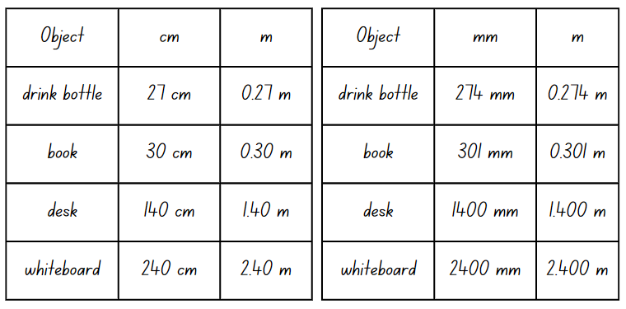

1. Once recording tables have been completed, students [turn and talk](https://education.nsw.gov.au/teaching-and-learning/curriculum/literacy-and-numeracy/teaching-and-learning-resources/numeracy/talk-moves). They discuss the items and their recorded measurements.
2. Ask students:

* What were the smallest and largest decimal notations you recorded? What were the items?
* Did anyone measure the same item as someone else and record a different measurement? If so, why do you think this may have happened?

1. Revise with students that because there are 100 centimetres in one metre, students should read 0.27 as 27 hundredths of a metre. Because there are 1000 millimetres in one metre, student should read 0.301 as 301 thousandths of a metre.

This table details opportunities for assessment.

|  |  |
| --- | --- |
| Assessment opportunities | Links |
| What to look for:   * Can Stage 2 students record equivalent measurements using decimals? **[MAO-WM-01, MA2-RN-02]** * Can Stage 3 students express thousandths as decimals? **[MAO-WM-01, MA3-RN-02]** * Can Stage 3 students interpret decimal notation for thousandths? **[MAO-WM-01, MA3-RN-02]** | Links to [National Numeracy Learning Progressions](https://www.australiancurriculum.edu.au/resources/national-literacy-and-numeracy-learning-progressions/version-3-of-national-literacy-and-numeracy-learning-progressions/) (NNLP):   * Stage 2 – NPV6, NPV8 * Stage 3 – NPV7, NPV8. |

## Core lesson – 40 minutes

### Stage 2 task – ordering and comparing capacities

The table below contains suggested learning intentions and success criteria. These are best co-constructed with students.

|  |  |
| --- | --- |
| Core concept learning intentions | Core concept success criteria |
| Students working towards Stage 2 outcomes are learning to:   * measure and order containers using litres * use scaled instruments to measure and compare capacities (internal volumes). | Students working towards Stage 2 outcomes can:   * relate the litre to familiar everyday containers * record capacities using the abbreviation for litres (L) * estimate the capacity of a container in litres and check by measuring * relate benchmark values to familiar everyday containers. |

This activity is an adaptation of ‘Choose Me’ from [*Teaching measurement: Stage 2 and Stage 3* [PDF 686KB]](https://education.nsw.gov.au/content/dam/main-education/teaching-and-learning/curriculum/key-learning-areas/mathematics/media/documents/mathematics-s2-s3-teaching-measurement.pdf)by the State of New South Wales (Department of Education).

1. Display a large group of containers of various sizes and shapes. For example, drink bottles, take-away food or margarine containers. Ask the class:

* Which one looks like it holds the most?
* Which one looks like it holds the least?
* What do you notice?

1. Students choose a container which they estimate has the capacity of one litre.
2. Students measure and record the capacity (internal volume) of their chosen container by using a litre unit as a measure.
3. Students use labels more than one litre, exactly one litre or less than one litre or to the nearest benchmark value. For example, half a litre, a quarter of a litre and three-quarters of a litre.
4. Discuss results with class. Ask students:

* How accurate were your estimates?
* What did you notice?

1. In small groups, students sort further containers into groups of more than one litre, exactly one litre and less than one litre.
2. Ask students if there are any other ways these containers can be grouped.
3. Students group containers in different ways. For example, one litre, half a litre (500 mL), quarter of a litre (250 mL) or three-quarters of a litre (750 mL).
4. Ask students to explain the reasoning behind new groupings.
5. Compare between groups. Ask the class:

* Which container holds the most? How do you know?
* Which container holds the least? How do you know?
* Are there any containers that do not fit into these categories?
* What did you notice?

1. Tell students they are going to go on a scavenger hunt at home. They will collect a range of containers that hold 100 millilitres, 250 millilitres (one quarter of a litre), 500 millilitres (half a litre), 1000 millilitres (1 L) or 2000 millilitres (2 L) to bring to school the next day.

This table details opportunities for differentiation.

|  |  |
| --- | --- |
| Too hard? | Too easy? |
| Stage 2 students cannot measure, order and compare containers using litres.   * Support students to measure, order and compare containers using litres. | Stage 2 students can measure, order and compare using litres.   * Students think of other benchmark measurements, such as a fifth or a tenth (200 millilitres and 100 millilitres). Students add these to their descriptions of measurements. |

### Stage 3 task – displacement

The table below contains a suggested learning intention and success criteria. These are best co-constructed with students.

|  |  |
| --- | --- |
| Core concept learning intention | Core concept success criteria |
| Students working towards Stage 3 outcomes are learning to:   * use displacement to investigate volumes of irregular solids. | Students working towards Stage 3 outcomes can:   * recognise that an object’s volume takes up space by observing the change in water level when an object is placed in a container of water * compare the volumes of 2 or more objects by marking the change in water level when each is submerged in a container. |

This activity is an adaptation of 'Calibrations' from [*Teaching measurement: Stage 2 and Stage 3* [PDF 686KB]](https://education.nsw.gov.au/content/dam/main-education/teaching-and-learning/curriculum/key-learning-areas/mathematics/media/documents/mathematics-s2-s3-teaching-measurement.pdf) by the State of New South Wales (Department of Education).

1. Revise litres and millilitres to measure and record capacities.
2. Read *Mr Archimedes’ Bath*. After reading, ask students to explain what they think the term displacement means.
3. Explain that displacement is the change in water level when an object is submerged.
4. Using a 1 L measuring jug, model and discuss how submerging an irregular object can be used to measure displacement in volume (see Figure 17).

Figure 17 – displaced object

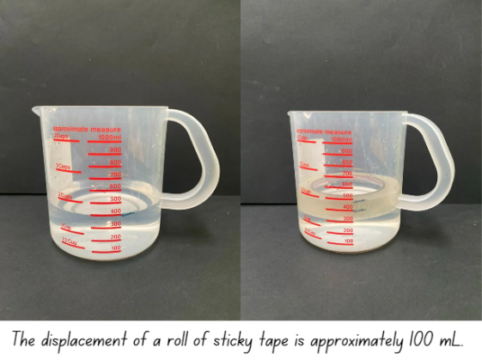

**Note**: objects will need to be fully submerged to measure displacement. A popsicle stick can be used to submerge the object.

1. Give small groups of students a measuring jug, whiteboard marker, popsicle stick and 3 solid irregular objects. For example, glue stick or a hundreds block.
2. Students submerge each object one at a time, marking, comparing and recording the changes in water level.
3. Students order the objects from smallest to largest volume, based on displacement tests.
4. Groups share findings with the class. For example, the glue stick has a smaller volume compared to the hundreds block, as the water level rose higher when the hundreds block was submerged.

This table details opportunities for differentiation.

|  |  |
| --- | --- |
| Too hard? | Too easy? |
| Stage 3 students cannot recognise and/or compare the volume of objects using displacement.   * Model marking the level of water in a container before and after displacement. | Stage 3 students can recognise and compare the volume of objects using displacement.   * Students write displacement problems. For example, 2 glue sticks displaced 50 mL of water so how much water did each glue stick displace? Students swap and solve problems. |

## Consolidation and meaningful practice – 10 minutes

1. Tell students working towards Stage 2 outcomes that they have 3 containers that have the capacity of 2, 4 and 6 litres. They can only use these containers to fill a small shell pool. Ask how the containers can be used to measure exactly 10 litres of water and how many ways students can solve the problem.
2. Explore and discuss answers with students working towards Stage 2 outcomes. Possible solutions:

* 2 + 2 L + 2 L + 2 L + 2 L = 10 L
* 4 L + 6 L = 10 L
* 2 L + 4 L + 4 L = 10 L
* 6 L + 2 L + 2 L = 10 L

1. Display these problems to students working towards Stage 3 outcomes to solve:

* If Xiang submerges 5 glue sticks in a bucket and it displaces 500 mL of water, how much water does each glue stick displace?
* If 20 dice displace 100 mL of water, how much water does each displace?

This table details opportunities for assessment.

|  |  |
| --- | --- |
| Assessment opportunities | Links |
| What to look for:   * Can Stage 2 students relate the litre to familiar everyday containers? **[MAO-WM-01, MA2-3DS-02]** * Can Stage 2 students record capacities (internal volumes) using the abbreviation for litres (L)? **[MAO-WM-01, MA2-3DS-02]** * Can Stage 2 students estimate the capacity (internal volume) of a container in litres and check by measuring? **[MAO-WM-01, MA2-3DS-02]** * Can Stage 2 students relate benchmark values to familiar everyday containers? **[MAO-WM-01, MA2-3DS-02]** * Can Stage 3 students recognise that an object’s volume takes up space by observing the change in water level when an object is placed in a container of water? **[MAO-WM-01, MA3-3DS-02]** * Can Stage 3 students compare the volumes of 2 or more objects by marking the change in water level when each is submerged in a container? **[MAO-WM-01, MA3-3DS-02]** | Links to [National Numeracy Learning Progressions](https://www.australiancurriculum.edu.au/resources/national-literacy-and-numeracy-learning-progressions/version-3-of-national-literacy-and-numeracy-learning-progressions/) (NNLP):   * Stage 2 – UuM4, UuM6. * Stage 3 – N/A. |

# Lesson 8

**Core concept**: everyday objects have an internal volume.

## Daily number sense – 10 minutes

1. From a class need surfaced through formative assessment data, identify a short, focused activity that targets students’ knowledge, understanding and skills. Example activities may be drawn from the following resources:

* [Mathematics K–6 resources](https://education.nsw.gov.au/teaching-and-learning/curriculum/mathematics/mathematics-curriculum-resources-k-12/mathematics-k-6-resources.main-education--category---catalogue---key-learning-area---mathematics---thinking-mathematically.nameAsc.1.grid)
* [Universal Resources Hub](https://resources.education.nsw.gov.au/home).

## Core lesson – 45 minutes

### Stage 2 task – planning a class party

The table below contains suggested learning intentions and success criteria. These are best co-constructed with students.

|  |  |
| --- | --- |
| Core concept learning intentions | Core concept success criteria |
| Students working towards Stage 2 outcomes are learning to:   * measure and order containers using litres * read, represent and order numbers in the thousands. | Students working towards Stage 2 outcomes can:   * recognise that one litre containers can be a variety of shapes * record capacities using the abbreviation for litres (L) * estimate the internal volume of a container in litres and check by measuring * read and arrange numbers of up to at least 4 digits in ascending and descending order. |

This activity is an adaptation of '[Morning tea volumes](https://nzmaths.co.nz/resource/morning-tea-volumes)' from NZ Maths by the New Zealand Ministry of Education.

1. Students share the containers they have brought from home. See Lesson 7. Ask students:

* Which one looks like it holds the most?
* Which one looks like it holds the least?
* What do you notice?

1. Group the containers by capacity. Ask students which capacities were most and least common.
2. Display a variety of bowls. At least 2 should have a capacity of one litre and some should have more. Ask students which of the containers from home they think are about the same size.
3. Explain that the class needs to cater for a party with jelly and soft drinks. Ask students:

* Which bowl do you think will hold the most jelly?
* Which bowl do you think will hold the least?
* Which bowls will hold a similar amount?

1. Give groups of students 3 different bowls and a scaled measuring jug.
2. Students use Resource 21 – recording table to estimate and record the capacities of their bowls to the nearest half a litre. For example, 2 and a half litres.
3. Students compare the results of their estimates and measurements with another group.
4. Using information from Resource 21 – recording table, students solve the following problems:

* If one packet of jelly crystals makes one litre of jelly, how many packets would be needed for each bowl?
* How many packets would be needed for all the bowls?

**Note:** if bowls have capacities between one and 2 litres, students can work to the nearest packet of jelly or use fractions of packets.

1. In small groups, students use Resource 22 – capacity cards to order capacities using understanding of place value. For example, 750 mL is smaller than one litre.
2. Move between groups checking for understanding.
3. Some students may enjoy the challenge of writing more cards and placing them correctly in the place value sequence.

This table details opportunities for differentiation.

|  |  |
| --- | --- |
| Too hard? | Too easy? |
| Stage 2 students cannot measure and/or order containers using litres.   * Support students to measure, order and compare containers using litres. | Stage 2 students can measure and order containers using litres.   * Students measure containers to the millilitre and record using decimal notation. |

### Stage 3 task – drinks for a disco

The table below contains suggested learning intentions and success criteria. These are best co-constructed with students.

|  |  |
| --- | --- |
| Core concept learning intentions | Core concept success criteria |
| Students working towards Stage 3 outcomes are learning to:   * connect decimal representations to the metric system * compare, order and represent decimals. | Students working towards Stage 3 outcomes can:   * recognise the equivalence of whole-number and decimal representations of measurements of capacities * interpret and record decimal notation for capacities to 3 decimal places * compare and order decimal numbers of up to 3 decimal places. |

1. Give pairs of students counters and a bingo card from Resource 23 – capacity decimals bingo.
2. Read Resource 24 – bingo clues one-by-one to students.
3. Students put a counter on the capacity that matches the clue. Students can only put one counter down at a time even if a clue matches more than one capacity. Students who can cover all their squares call out bingo.
4. After playing, discuss the clues and how they could relate to more than one capacity. Revise that the mathematical term for this is equivalence.
5. Explain that students will be organising the drinks for a Year 5 disco. There are 55 students in Year 5. Each student will have one 250 mL popper and one 600 mL water bottle. Ask students to solve and record the following problems:

* How many litres of drink will be at the disco? Answer in decimal form.
* If 5 students do not come to the disco, how many litres are left over?
* If 10 students did not drink their popper, how many litres of juice are left over?

1. Discuss answers with class, asking what strategies they used to calculate the total amount of litres needed.
2. Model comparing and ordering 0.250 L, 2.25 L, 2.205 L from smallest to largest capacity.
3. Write the following capacities on the board for students to order from smallest to largest capacity:

* 3.300 L, 0.350 L, 2.35 L
* 2.000 L, 0.250 L, 0.750 L
* 0.7 L, 0.705 L, 0.75 L

1. Discuss orders with students, asking them to justify their thinking.

This table details opportunities for differentiation.

|  |  |
| --- | --- |
| Too hard? | Too easy? |
| Stage 3 students cannot record and/or order capacity measurements to 3 decimal places.   * Use place value houses or a numeral card to help students develop place value understanding of whole-number and decimal representations. | Stage 3 students can record and order capacity measurements to 3 decimal places.   * Students create sets of capacity measurements to 3 decimal places. They swap with other students to order and discuss. |

## Discuss and connect the mathematics – 15 minutes

1. Remind students working towards Stage 2 outcomes that there is usually soft drink at a party too. Tell students that one glass holds 250 mL. Ask:

* How many one litre bottles of soft drink will I need for everyone in our class to have one glass of soft drink?
* If I bought 2 litre bottles of soft drink, how many will I need?
* How can I make sure that every glass has the same amount of soft drink?

1. Some students working towards Stage 2 outcomes may enjoy the challenge of working out how many bottles would be needed if only 600 mL bottles were available at the shops, or if 1.25 L bottles were purchased.
2. Show these problems to the students working towards Stage 3 outcomes to solve:

* If everyone gets 100 mL of ice cream during a class party, how many tubs of 2 L ice cream will the class need to buy?
* How much ice cream will be left over?

1. Discuss answers with class, asking:

* How could you buy the ice cream so there is no waste?
* What size tubs of ice cream could you buy? How do you know?

1. Ask students working towards Stage 3 outcomes if they can think of other foods that are measured in litres and millimetres.

This table details opportunities for assessment.

|  |  |
| --- | --- |
| Assessment opportunities | Links |
| What to look for:   * Do Stage 2 students recognise that one-litre containers can be a variety of shapes? **[MAO-WM-01, MA2-3DS-02]** * Can Stage 2 students record capacities using the abbreviation for litres (L)? **[MAO-WM-01, MA2-3DS-02]** * Can Stage 2 students estimate the internal volume of a container in litres and check by measuring? **[MAO-WM-01, MA2-3DS-02]** * Can Stage 2 students read and arrange numbers of up to at least 4 digits in ascending and descending order? **[MAO-WM-01, MA2-RN-01]** * Can Stage 3 students recognise the equivalence of whole-number and decimal representations of measurements of capacities? **[MAO-WM-01, MA3-3DS-02]** * Can Stage 3 students interpret and record decimal notation for capacities to 3 decimal places? **[MAO-WM-01, MA3-3DS-02]** * Can Stage 3 students compare and order decimal numbers of up to 3 decimal places? **[MAO-WM-01, MA3-RN-02]** | Links to [National Numeracy Learning Progressions](https://www.australiancurriculum.edu.au/resources/national-literacy-and-numeracy-learning-progressions/version-3-of-national-literacy-and-numeracy-learning-progressions/) (NNLP):   * Stage 2 – UuM6, NPV5, NPV6 * Stage 3 – NPV8, NPV9.   Links to suggested [Interview for Student Reasoning](https://education.nsw.gov.au/teaching-and-learning/curriculum/literacy-and-numeracy/assessment-resources/ifsr) (IfSR) tasks:   * **Stage 2 – IfSR-NP**: 4B.2, 4C.5 * **Stage 3 – IfSR-PT**: 1A.5, 1A.7 * **Stage 3 – IfSR-NP**: 4D.2, 4D.6. |

# Resource 1 – 2D features

|  |  |
| --- | --- |
| I have straight sides | I have curved sides |
| I have 4 sides | I have 3 sides |
| I have 4 vertices | I have 3 vertices |
| All my sides are equal | 2 of my sides are equal |

# Resource 2 – guess what?

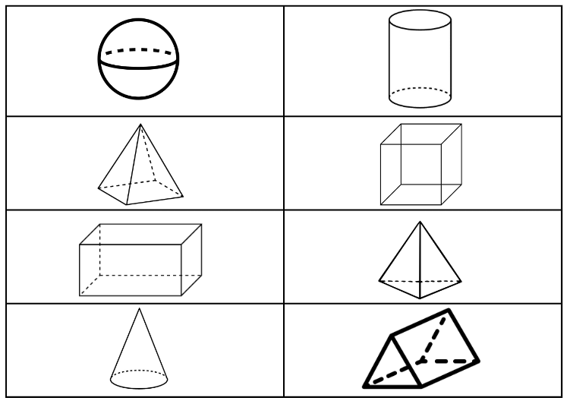

# Resource 3 – sketch and label

|  |  |  |  |  |  |  |
| --- | --- | --- | --- | --- | --- | --- |
| Top view | Front view | Side view | Name | Number of edges | Number of vertices | Number of faces |
|  |  |  |  |  |  |  |
|  |  |  |  |  |  |  |
|  |  |  |  |  |  |  |
|  |  |  |  |  |  |  |
|  |  |  |  |  |  |  |
|  |  |  |  |  |  |  |

# Resource 4 – prisms

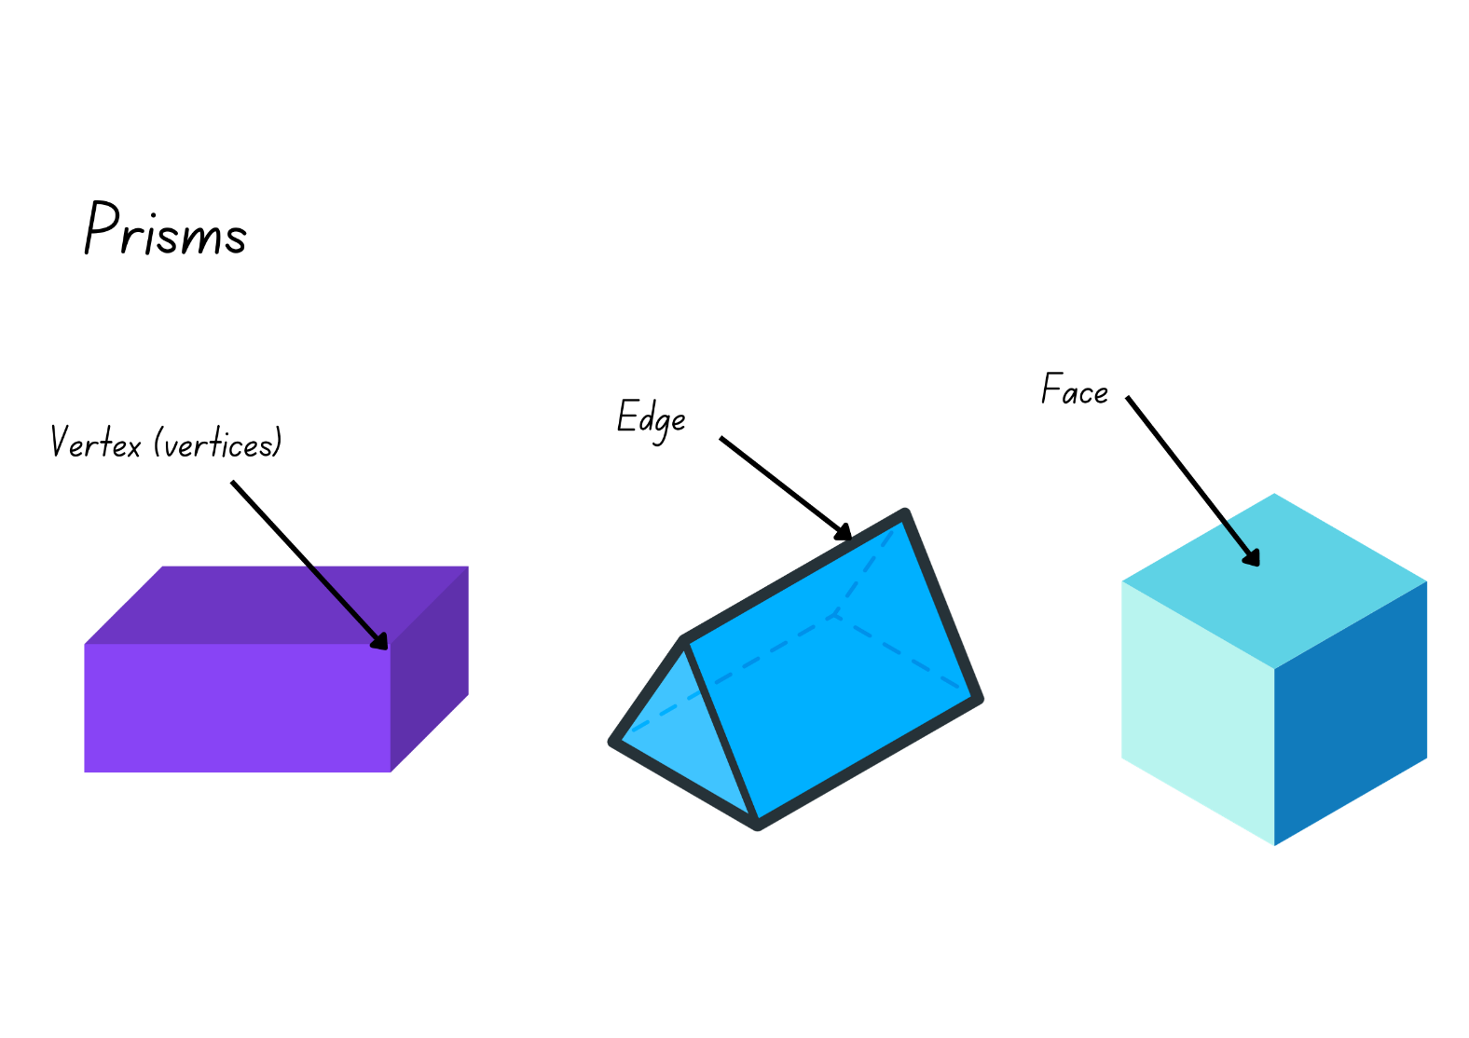

# Resource 5 – decimal cards 1

|  |  |  |  |  |
| --- | --- | --- | --- | --- |
| 0.50 | 0.90 | 0.02 | 0.09 | 0.30 |
| 0.05 | 0.70 | 0.00 | 0.06 | 0.04 |
| 0.07 | 0.20 | 1.00 | 0.01 | 0.60 |
| 0.10 | 0.40 | 0.80 | 0.03 | 0.08 |

# Resource 6 – decimal cards 2

|  |  |  |  |  |
| --- | --- | --- | --- | --- |
| 0.150 | 0.390 | 0.602 | 0.209 | 0.375 |
| 0.005 | 0.750 | 0.500 | 0.025 | 0.904 |
| 0.050 | 0.250 | 0.505 | 0.001 | 0.650 |
| 0.710 | 0.470 | 0.800 | 0.010 | 0.075 |

# Resource 7 – nets or not

Two questions for students. 
Question 1. Which net(s) make a square pyramid? How do you know?
Four nets displayed. Two are not a net and 2 are square pyramid nets. 

Question 2. Which net(s) make a rectangular prism? How do you know? Four nets are displayed. 3 are not a net and 1 is a rectangular pyramid net.

# Resource 8 – nets of cubes

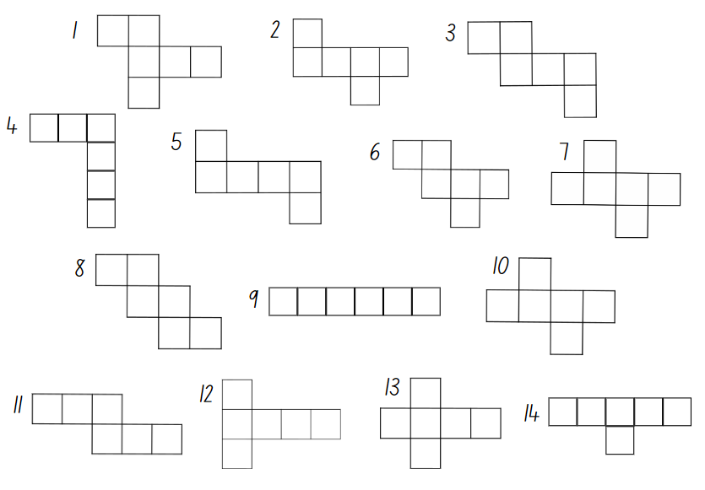

# Resource 9 – cut cube net

A cut cube net. 
Above it are 2 questions: How could this net be put together? How do you know?

# Resource 10 – match my net

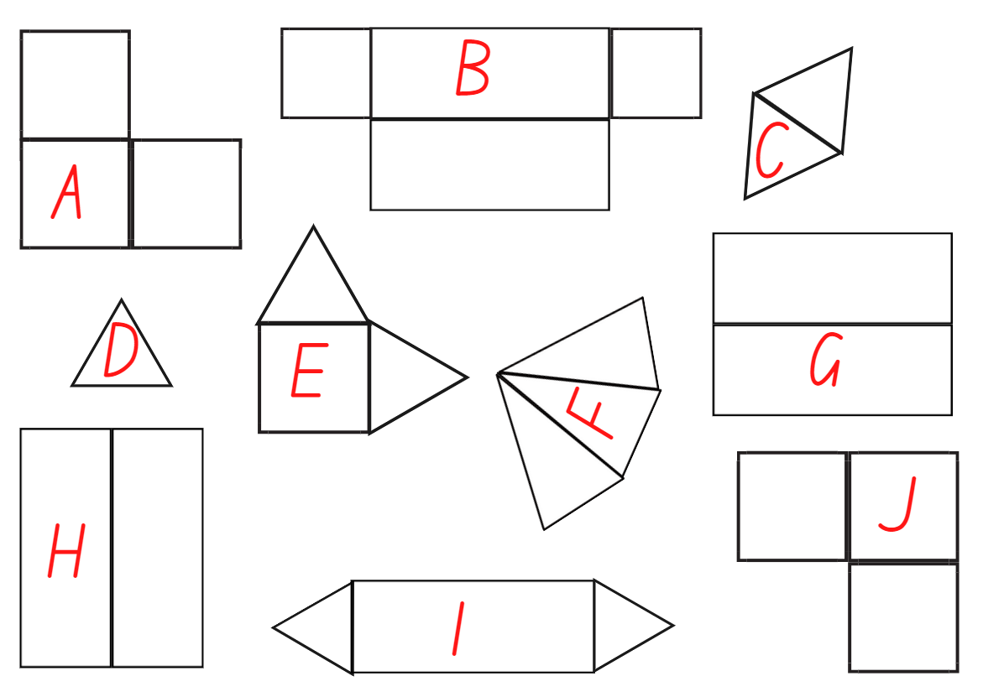

# Resource 11 – deconstructed net

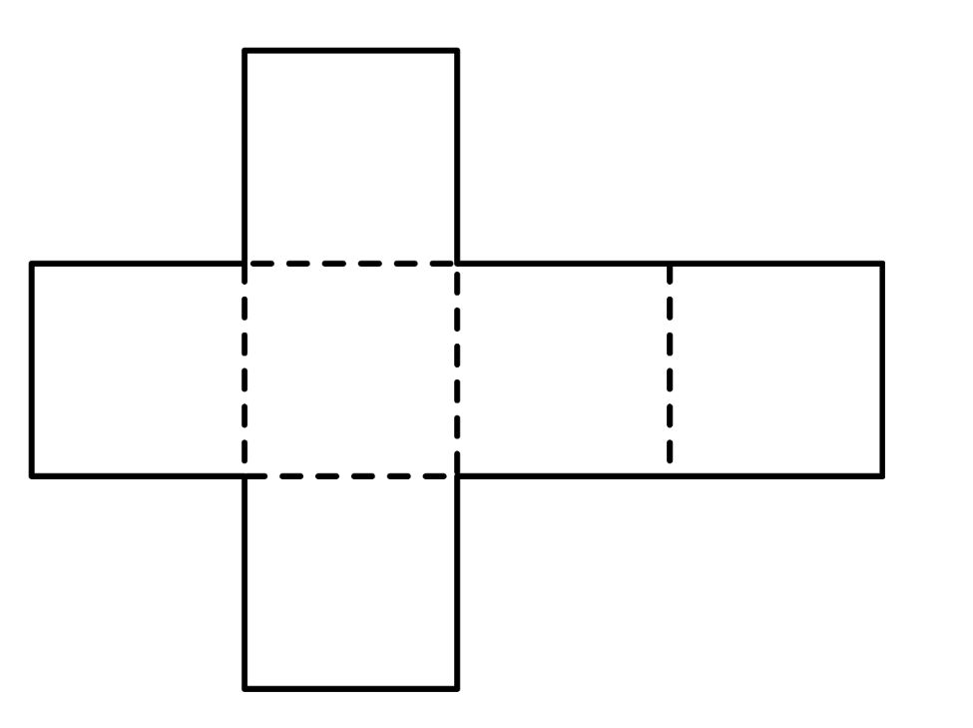

# Resource 12 – estimate and measure

|  |  |  |  |
| --- | --- | --- | --- |
| Container | Estimate | Revised estimate | Measure |
| **1** |  |  |  |
| **2** |  |  |  |
| **3** |  |  |  |

# Resource 13 – capacity sort 1

|  |  |  |  |  |  |  |  |  |
| --- | --- | --- | --- | --- | --- | --- | --- | --- |
| **11 litres** |  | **13 litres** |  | **3 litres** |  | **4 litres** |  | **8 L** |
|  |  |  |  |  |  |  |  |  |
| **6 litres** |  | **7 L** |  | **5 L** |  | **14 L** |  | **10 litres** |
|  |  |  |  |  |  |  |  |  |
| **12 L** |  | **2 litres** |  | **15 L** |  | **9 L** |  | **16 L** |

|  |  |  |  |  |  |  |  |  |
| --- | --- | --- | --- | --- | --- | --- | --- | --- |
| **17 litres** |  | 1 litre milk carton. |  | **30 litres** |  | **60 L** |  | **18 L** |
|  |  |  |  |  |  |  |  |  |
| **1 litre** |  | **19 litres** |  | 2 litres of orange juice. |  | **70 litres** |  | **50 litres** |
|  |  |  |  |  |  |  |  |  |
| **20 L** |  | **40 L** |  | **100 L** |  | **18 L** |  | 3 litres of washing detergent. |

# Resource 14 – capacity sort 2

|  |  |  |  |  |  |  |  |  |
| --- | --- | --- | --- | --- | --- | --- | --- | --- |
| **100 mL** |  | **500 mL** |  | **1500 mL** |  | **10 mL** |  | **0.100 L** |
|  |  |  |  |  |  |  |  |  |
| **1000 mL** |  | **250 mL** |  | **1 L** |  | **2000 mL** |  | **1.000 L** |
|  |  |  |  |  |  |  |  |  |
| **700 mL** |  | **3 quarters of a litre** |  | **1.5 litres** |  | **Half a litre** |  | **0.750 L** |

|  |  |  |  |  |  |  |  |  |
| --- | --- | --- | --- | --- | --- | --- | --- | --- |
| **18 mL** |  | **3 litres** |  | **3 cups** |  | **750 mL** |  | **0.5 L** |
|  |  |  |  |  |  |  |  |  |
| **4 cups** |  | **1 cup** |  | **150 mL** |  | **2 cups** |  | **0.250 L** |
|  |  |  |  |  |  |  |  |  |
| **300 mL** |  | **700 mL** |  | **40 mL** |  | **1300 mL** |  | **1.3 L** |

# Resource 15 – drinks problem

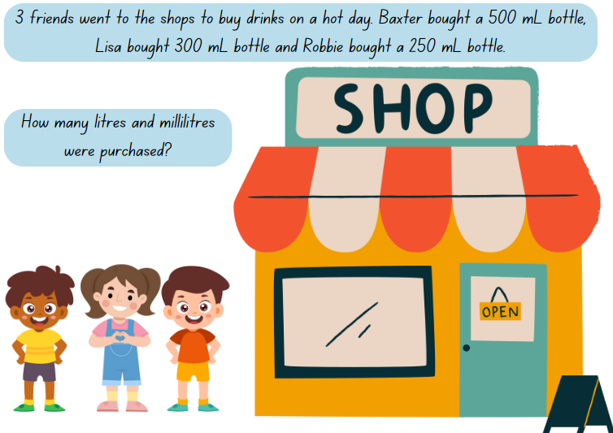

# Resource 16 – equivalent capacity

**What is my equivalent measurement?**

|  |  |  |
| --- | --- | --- |
| **Half a litre** |  | **0.75 L** |
|  |  |  |
| **750 mL** |  | **Three quarters of a litre** |
|  |  |  |
| **Quarter of a litre** |  | **250 mL** |
|  |  |  |
| **0.25 mL** |  | **0.5 L** |
|  |  |  |
| **One litre** |  | **2 cups** |
|  |  |  |
| **500 mL** |  | **1000 mL** |

# Resource 17 – Which unit?

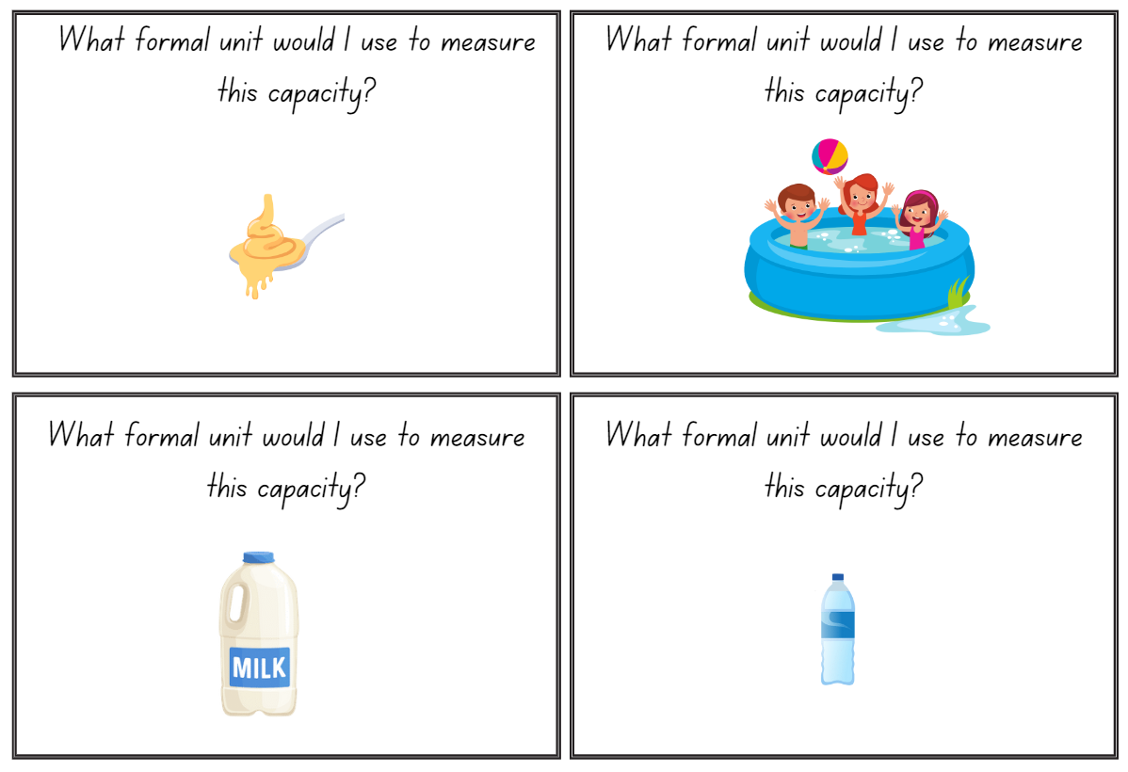

# Resource 18 – capacity conversions

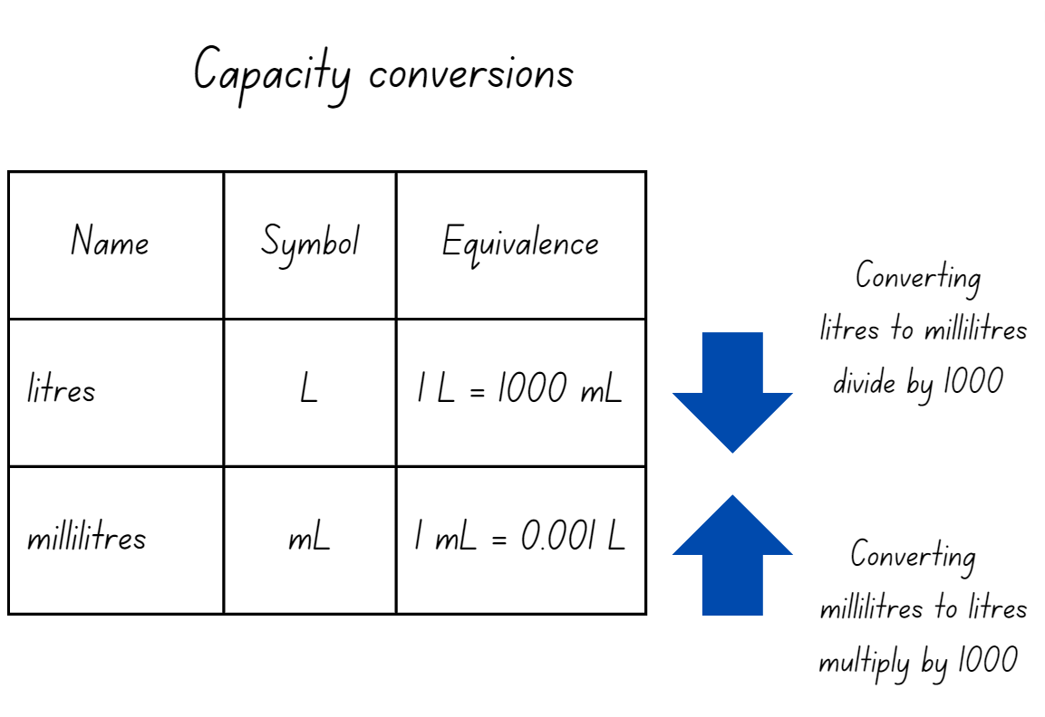

# Resource 19 – equivalent capacities

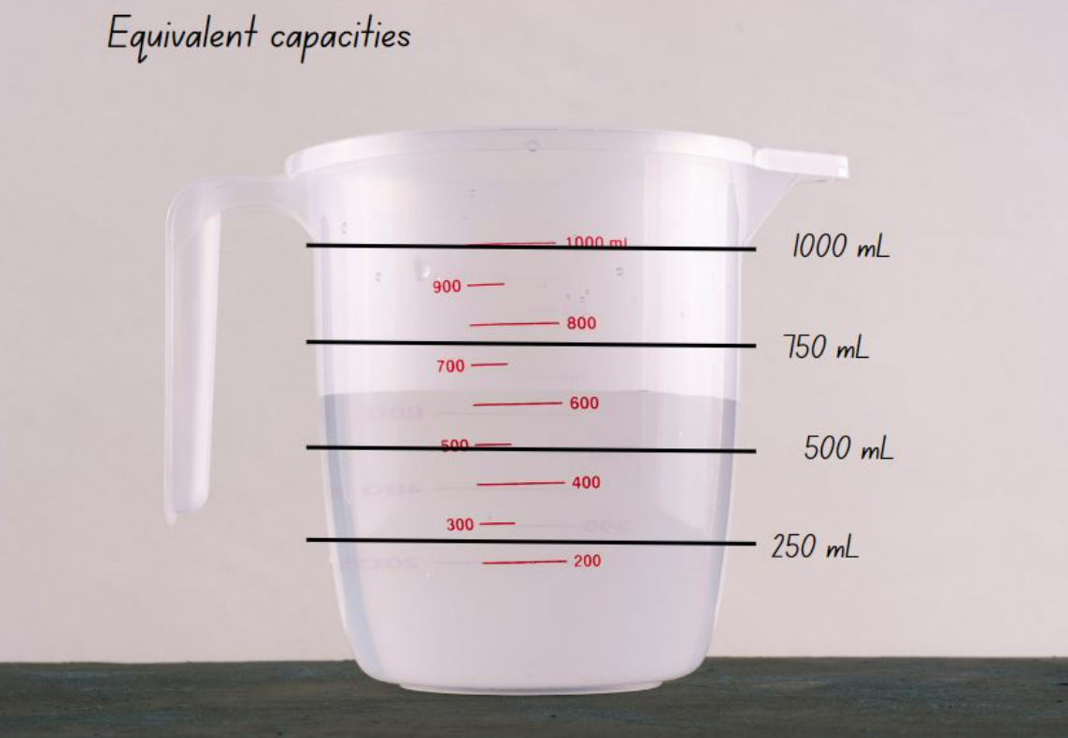

# Resource 20 – capacity problems

|  |
| --- |
| Linda is organising drinks for her friends. She needs one litre of soft drink 750 mL of orange  juice and 300 mL of milk. How many litres of drink does Linda need to organise?  Answer using decimal notation. |
| Sarah goes to the shop and buys 6 bottles of 1.25 L soft drink. How many litres of soft drink  did she buy?  Answer using decimal notation. |
| Amy has a tap that is leaking 300 mL an hour. How much water has leaked after 6 hours?  Answer using decimal notation. |

# Resource 21 – recording table

|  |  |  |
| --- | --- | --- |
| Bowl | Estimated internal volume (capacity) | Measured internal volume (capacity) |
| 1 |  |  |
| 2 |  |  |
| 3 |  |  |

# Resource 22 – capacity cards

|  |  |
| --- | --- |
| 750 millilitres | 1500 mL |
| 2500 mL | 250 mL |
| 1000 mL | 500 millilitres |
| 4000 mL | 2.5 L |

# Resource 23 – capacity decimals bingo

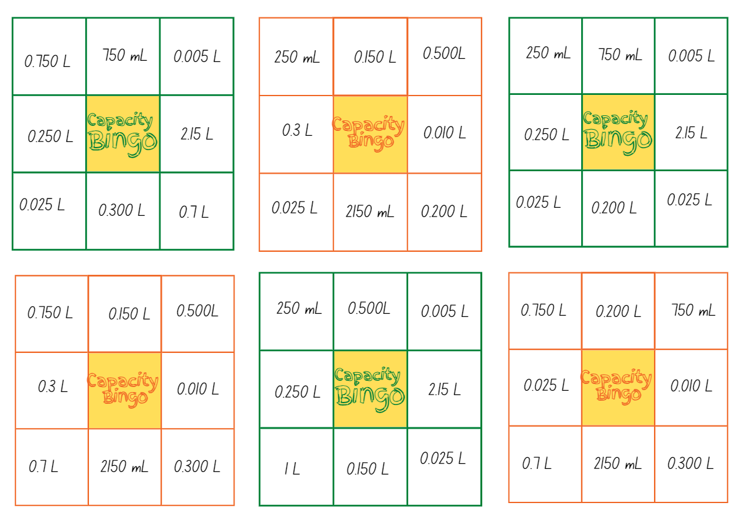

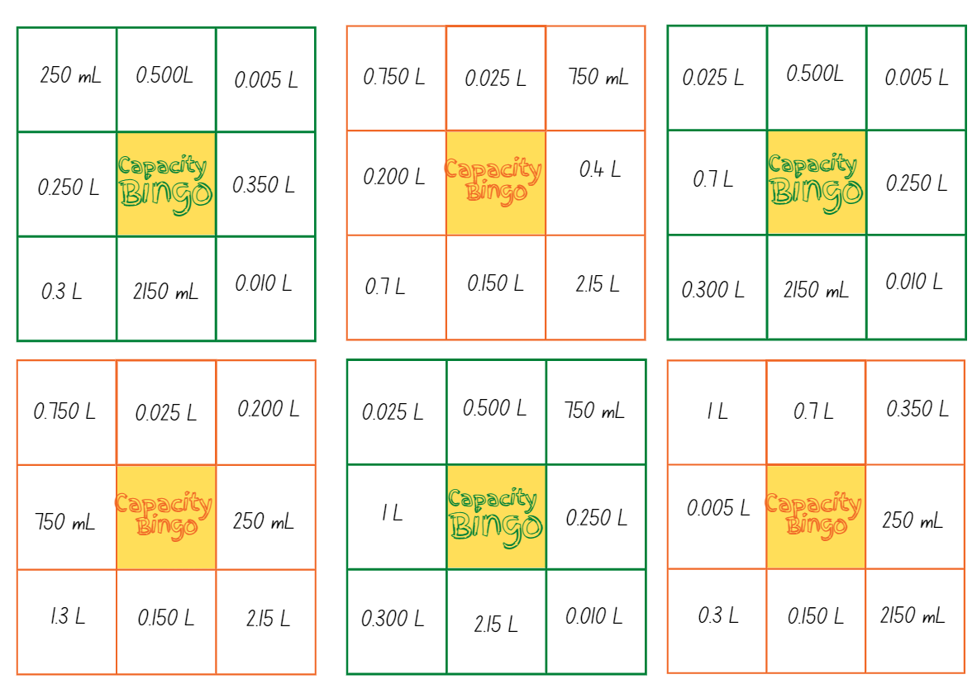

# Resource 24 – bingo clues

|  |  |  |
| --- | --- | --- |
| I am used to show 750 mL | I am used to show half a litre | I am used to show 100 mL |
| I am used to show 300 mL | I am used to show 25 mL | I am used to show 2 cups |
| I am used to show 2 L and 150 mL | I am used to show 10 mL | I am used to show 250 mL |
| I am used to show 5 mL | I am used to show 150 mL | I am used to show 700 mL |
| I am used to show 200 mL | I am used to show 1 L and 300 mL | I am used to show 4 cups |
| I am used to show 350 mL | I am used to show 3 cups | I am used to show 400 mL |

# Syllabus outcomes and content

## Stage 2

The table below outlines the [syllabus outcomes](https://curriculum.nsw.edu.au/learning-areas/mathematics/mathematics-k-10-2022/overview) and range of relevant syllabus content covered in this unit. Content is linked to [National Numeracy Learning Progression](https://www.australiancurriculum.edu.au/resources/national-literacy-and-numeracy-learning-progressions/version-3-of-national-literacy-and-numeracy-learning-progressions/) version (3).

|  |  |  |  |  |  |  |  |  |
| --- | --- | --- | --- | --- | --- | --- | --- | --- |
| Outcomes and content | 1 | 2 | 3 | 4 | 5 | 6 | 7 | 8 |
| **Representing numbers using place value A**: Whole numbers: Read, represent and order numbers to thousands  **[MAO-WM-01, MA2-RN-01]** |  |  |  |  |  |  |  |  |
| * Read and order numbers of up to at least 4 digits |  |  |  |  |  |  |  | x |
| **Representing numbers using place value A**: Whole numbers: Apply place value to partition and regroup numbers up to 4 digits  **[MAO-WM-01, MA2-RN-01]** |  |  |  |  |  |  |  |  |
| * Partition numbers of up to 4 digits in non-standard forms (Reasons about quantity) |  |  |  |  | x |  |  |  |
| **Representing numbers using place value B**: Whole numbers: Order numbers in the thousands  **[MAO-WM-01, MA2-RN-01]** |  |  |  |  |  |  |  |  |
| * Arrange numbers in the thousands in ascending and descending order | x | x |  |  |  |  |  | x |
| * Identify the nearest thousand, 10 thousand or 100 thousand to numbers | x |  |  |  |  |  |  |  |
| **Representing numbers using place value B**: Decimals: Extend the application of the place value system from whole numbers to tenths and hundredths  **[MAO-WM-01, MA2-RN-02]** |  |  |  |  |  |  |  |  |
| * Express decimals as both tenths and hundredths |  |  |  |  |  | x |  |  |
| * Distinguish between the role of zero in various positions |  |  | x |  |  |  |  |  |
| **Representing numbers using place value B**: Decimals: Make connections between fractions and decimal notation  **[MAO-WM-01, MA2-RN-02]** |  |  |  |  |  |  |  |  |
| * Record equivalent measurements using decimals |  |  |  |  |  |  | x |  |
| * Compare and order decimals of up to 2 decimal places |  |  | x |  |  |  |  |  |
| **Two-dimensional spatial structure A**: 2D shapes: Compare and describe features of two-dimensional shapes  **[MAO-WM-01, MA2-2DS-01]** |  |  |  |  |  |  |  |  |
| * Describe and compare two-dimensional shapes, including parallelograms, rectangles, rhombuses, squares, trapeziums and kites | x |  | x |  |  |  |  |  |
| **Three-dimensional spatial structure A**: 3D objects: Make models of three-dimensional objects to compare and describe key features  **[MAO-WM-01, MA2-3DS-01]** |  |  |  |  |  |  |  |  |
| * Identify the differences between prisms (including cubes), pyramids and cylinders | x |  |  |  |  |  |  |  |
| * Construct models of prisms, pyramids and cylinders using physical or virtual manipulatives, identifying their features |  | x |  |  |  |  |  |  |
| * Deconstruct everyday packages that are prisms (including cubes) to create nets |  |  | x | x |  |  |  |  |
| * Investigate the variety of nets that can be used to create a particular prism |  |  | x |  |  |  |  |  |
| **Three-dimensional spatial structure A**: Volume: Measure and order containers using litres  **[MAO-WM-01, MA2-3DS-02]** |  |  |  |  |  |  |  |  |
| * Recognise the need for formal units to measure capacity (internal volume) accurately |  |  |  |  |  | x |  |  |
| * Use the litre as a unit to measure capacities (internal volumes) to the nearest litre |  |  |  |  | x |  |  |  |
| * Relate the litre to familiar everyday containers |  |  |  |  |  |  | x |  |
| * Recognise that one-litre containers can be a variety of shapes (Reasons about spatial structure) |  |  |  |  |  |  |  | x |
| * Record capacities (internal volumes) using the abbreviation for litres (L) |  |  |  |  | x |  | x | x |
| * Estimate the capacity (internal volume) of a container in litres and check by measuring |  |  |  |  | x |  | x | x |
| **Three-dimensional spatial structure B**: 3D objects: Connect three-dimensional objects and two-dimensional representation  **[MAO-WM-01, MA2-3DS-01]** |  |  |  |  |  |  |  |  |
| * Identify features of prisms and pyramids (faces, vertices and edges) and cylinders (curved/flat surfaces and boundaries) from images | x | x |  | x |  |  |  |  |
| * Create sketches of three-dimensional objects from different views, including top, front and side views (Reasons about spatial relations) |  | x |  |  |  |  |  |  |
| **Three-dimensional spatial structure B**: Volume: Use scaled instruments to measure and compare capacities (internal volumes)  **[MAO-WM-01, MA2-3DS-02]** |  |  |  |  |  |  |  |  |
| * Recognise the need for a formal unit smaller than the litre to measure capacity (internal volume) |  |  |  |  |  | x |  |  |
| * Relate benchmark values to familiar everyday containers |  |  |  |  |  |  | x |  |
| * Estimate the capacity (internal volume) of a container to common benchmark values, such as 250 mL, and check by measuring |  |  |  |  |  | x |  |  |

[Mathematics K–10 Syllabus](https://curriculum.nsw.edu.au/learning-areas/mathematics/mathematics-k-10-2022/overview) © NSW Education Standards Authority (NESA) for and on behalf of the Crown in right of the State of New South Wales, 2022.

## Stage 3

The table below outlines the [syllabus outcomes](https://curriculum.nsw.edu.au/learning-areas/mathematics/mathematics-k-10-2022/overview) and range of relevant syllabus content covered in this unit. Content is linked to [National Numeracy Learning Progression](https://www.australiancurriculum.edu.au/resources/national-literacy-and-numeracy-learning-progressions/version-3-of-national-literacy-and-numeracy-learning-progressions/) version (3).

|  |  |  |  |  |  |  |  |  |
| --- | --- | --- | --- | --- | --- | --- | --- | --- |
| Outcomes and content | 1 | 2 | 3 | 4 | 5 | 6 | 7 | 8 |
| **Represents numbers A**: Whole numbers: Recognise, represent and order numbers in the millions  **[MAO-WM-01, MA3-RN-01]** |  |  |  |  |  |  |  |  |
| * Arrange numbers in the millions in ascending and descending order using place value | x |  |  |  |  |  |  |  |
| * Round numbers to a specified place value | x |  |  |  |  |  |  |  |
| **Represents numbers A**: Whole numbers: Apply place value to partition, regroup and rename numbers to 1 billion  **[MAO-WM-01, MA3-RN-01]** |  |  |  |  |  |  |  |  |
| * Partition numbers to 1 billion in non-standard forms |  |  |  |  | x |  |  |  |
| **Represents numbers A**: Decimals and percentages: Recognise that the place value system can be extended beyond hundredths  **[MAO-WM-01, MA3-RN-02]** |  |  |  |  |  |  |  |  |
| * Express thousandths as decimals |  |  |  |  |  |  | x |  |
| * Interpret decimal notation for thousandths |  |  |  |  |  |  | x |  |
| * Indicate the place value of digits in decimal numbers of up to 3 decimal places |  |  |  |  |  | x |  |  |
| * Use place value to partition decimals |  |  |  |  |  | x |  |  |
| **Represents numbers A**: Decimals and percentages: Compare, order and represent decimals  **[MAO-WM-01, MA3-RN-02]** |  |  |  |  |  |  |  |  |
| * Compare and order decimal numbers of up to 3 decimal places |  | x | x |  |  |  |  | x |
| * Interpret zero digit(s) at the end of a decimal |  |  | x |  |  |  |  |  |
| **Three-dimensional spatial structure A**: 3D objects: Compare, describe and name prisms and pyramids  **[MAO-WM-01,** **MA3-3DS-01]** |  |  |  |  |  |  |  |  |
| * Compare properties of prisms and pyramids | x | x |  |  |  |  |  |  |
| * Name prisms and pyramids according to the shape of their base | x | x |  |  |  |  |  |  |
| **Three-dimensional spatial structure A**: 3D objects: Connect three-dimensional objects with two-dimensional representations  **[MAO-WM-01,** **MA3-3DS-01]** |  |  |  |  |  |  |  |  |
| * Visualise and sketch three-dimensional objects from different views, including top, front and side views (Reasons about spatial orientation) |  | x |  |  |  |  |  |  |
| * Examine a diagram to determine whether it is or is not the net of a closed three-dimensional object |  |  | x | x |  |  |  |  |
| * Visualise and sketch nets for given three-dimensional objects |  |  | x | x |  |  |  |  |
| * Visualise and name prisms and pyramids, given representations of their nets (Reasons about spatial visualisation) |  |  | x | x |  |  |  |  |
| **Three-dimensional spatial structure A**: Volume: Choose appropriate units of measurement for capacity  **[MAO-WM-01,** **MA3-3DS-02]** |  |  |  |  |  |  |  |  |
| * Select and use appropriate units to measure the capacities of a variety of containers |  |  |  |  | x |  |  |  |
| **Three-dimensional spatial structure A**: Volume: Use displacement to investigate volumes of irregular solids  **[MAO-WM-01,** **MA3-3DS-02]** |  |  |  |  |  |  |  |  |
| * Recognise that an object’s volume takes up space by observing the change in water level when an object is placed in a container of water |  |  |  |  |  |  | x |  |
| * Compare the volumes of 2 or more objects by marking the change in water level when each is submerged in a container |  |  |  |  |  |  | x |  |
| **Three-dimensional spatial structure A**: Volume: Connect decimal representations to the metric system  **[MAO-WM-01,** **MA3-3DS-02]** |  |  |  |  |  |  |  |  |
| * Recognise the equivalence of whole-number and decimal representations of measurements of capacities |  |  |  |  | x | x |  | x |
| * Interpret decimal notation for capacities |  |  |  |  |  | x |  | x |
| * Record measurements to 3 decimal places |  |  |  |  |  | x |  | x |
| **Three-dimensional spatial structure B**: 3D objects: Construct prisms and pyramids  **[MAO-WM-01,** **MA3-3DS-01]** |  |  |  |  |  |  |  |  |
| * Create skeletal models of prisms and pyramids |  | x |  |  |  |  |  |  |

[Mathematics K–10 Syllabus](https://curriculum.nsw.edu.au/learning-areas/mathematics/mathematics-k-10-2022/overview) © NSW Education Standards Authority (NESA) for and on behalf of the Crown in right of the State of New South Wales, 2022.

# References

This resource contains NSW Curriculum and syllabus content. The NSW Curriculum is developed by the NSW Education Standards Authority. This content is prepared by NESA for and on behalf of the Crown in right of the State of New South Wales. The material is protected by Crown copyright.

Please refer to the NESA Copyright Disclaimer for more information <https://educationstandards.nsw.edu.au/wps/portal/nesa/mini-footer/copyright>.

NESA holds the only official and up-to-date versions of the NSW Curriculum and syllabus documents. Please visit the NSW Education Standards Authority (NESA) website <https://educationstandards.nsw.edu.au/wps/portal/nesa/home> and the NSW Curriculum website <https://curriculum.nsw.edu.au/>.

[Mathematics K–10 Syllabus](https://curriculum.nsw.edu.au/learning-areas/mathematics/mathematics-k-10-2022/overview) © NSW Education Standards Authority (NESA) for and on behalf of the Crown in right of the State of New South Wales, 2022.

[National Numeracy Learning Progression](https://www.australiancurriculum.edu.au/resources/national-literacy-and-numeracy-learning-progressions/version-3-of-national-literacy-and-numeracy-learning-progressions/) © Australian Curriculum, Assessment and Reporting Authority (ACARA) 2010 to present, unless otherwise indicated. This material was downloaded from the [Australian Curriculum](http://www.australiancurriculum.edu.au/) website (National Numeracy Learning Progression) (accessed 19 December 2023) and was not modified.

Allen P (2020) *Mr Archimedes’ Bath*, HarperCollins Children's Books, Australia.

Friedman M (2018) *A history of folding in mathematics: A mathematization of the margins*, Birkhäuser, Basel.

GeoGebra (2023) [*Exploring Nets of Geometric Solids*](https://www.geogebra.org/m/n6EjQDw8), GeoGebra website, accessed 19 December 2023.

New Zealand Ministry of Education (n.d.) ‘[Morning tea volumes](https://nzmaths.co.nz/resource/morning-tea-volumes)’, *Resource Finder*, NZ Maths website, accessed 19 December 2023.

State of New South Wales (Department of Education) (2017) [Teaching measurement: Stage 2 and Stage 3 [PDF 686KB]](https://education.nsw.gov.au/content/dam/main-education/teaching-and-learning/curriculum/key-learning-areas/mathematics/media/documents/mathematics-s2-s3-teaching-measurement.pdf), NSW Department of Education Learning and Teaching Directorate, accessed 19 December 2023.

University of Cambridge (Faculty of Mathematics) (n.d.) [*Cut Nets?*](https://nrich.maths.org/2315),NRICH website, accessed 19 December 2023.

University of Cambridge (Faculty of Mathematics) (n.d.) [*Guess What?*](https://nrich.maths.org/14777), NRICH website, accessed 19 December 2023.

**© State of New South Wales (Department of Education), 2023**

The copyright material published in this resource is subject to the *Copyright Act 1968* (Cth) and is owned by the NSW Department of Education or, where indicated, by a party other than the NSW Department of Education (third-party material).

Copyright material available in this resource and owned by the NSW Department of Education is licensed under a [Creative Commons Attribution 4.0 International (CC BY 4.0) license](https://creativecommons.org/licenses/by/4.0/).

[](https://creativecommons.org/licenses/by/4.0/)

This license allows you to share and adapt the material for any purpose, even commercially.

Attribution should be given to © State of New South Wales (Department of Education), 2023.

Material in this resource not available under a Creative Commons license:

* the NSW Department of Education logo, other logos and trademark-protected material
* material owned by a third party that has been reproduced with permission. You will need to obtain permission from the third party to reuse its material.

**Links to third-party material and websites**

Please note that the provided (reading/viewing material/list/links/texts) are a suggestion only and implies no endorsement, by the New South Wales Department of Education, of any author, publisher, or book title. School principals and teachers are best placed to assess the suitability of resources that would complement the curriculum and reflect the needs and interests of their students.

If you use the links provided in this document to access a third-party's website, you acknowledge that the terms of use, including licence terms set out on the third-party's website apply to the use which may be made of the materials on that third-party website or where permitted by the *Copyright Act 1968* (Cth). The department accepts no responsibility for content on third-party websites.