Mathematics 3–6 Multi-age – Year A – Unit 10

Contents
Unit description and duration 7
Syllabus outcomes 7
Stage 2 8
Stage 3 8
Working mathematically 9
Student prior learning 9
Lesson overview and resources 11
Lesson 1 17
Daily number sense – identifying common fractions – 10 minutes 17
Core lesson part 1 – taking turns – 10 minutes 20
Core lesson part 2 – identifying and measuring angles – 40 minutes 22
Discuss and connect the mathematics – 10 minutes 26
Lesson 2 28
Daily number sense – rolling fractions – 10 minutes 28
Core lesson – measuring angles – 50 minutes 31
Stage 2 task – angles represent an amount of turn 31
Stage 3 task – angles represent an amount of turn 34
Discuss and connect the mathematics – 10 minutes 38
Lesson 3 40
Daily number sense – who is winning? – 10 minutes 40
Core lesson part 1 – angles and corners – 20 minutes 43
Core lesson part 2 – measuring angles – 20 minutes 45
Discuss and connect the mathematics – 10 minutes 49
Lesson 4 51
Daily number sense – 10 minutes 51
Core lesson part 1 – angles in art – 20 minutes 51
Core lesson part 2 – mountain bike geometry – 30 minutes 53
Discuss and connect the mathematics – 10 minutes 55
Lesson 5 57
Daily number sense – the same as – 10 minutes 57
Core lesson part 1 – time talk – 10 minutes 61
Core lesson part 2 – 40 minutes 64
Stage 2 task – using the clock 64
Stage 3 task – 24-hour time 67
Discuss and connect the mathematics – 10 minutes 70
Lesson 6 72
Daily number sense – closest to zero – 10 minutes 72
Core lesson – 40 minutes 74
Stage 2 task – the clock 74
Stage 3 task – 24-hour time 76
Discuss and connect the mathematics – 10 minutes 79
Lesson 7 81
Daily number sense – true or false to 1000 – 10 minutes 81
Core lesson – 40 minutes 83
Stage 2 task – problem solving with time 83
Stage 3 task – timetables 87
Discuss and connect the mathematics – 10 minutes 89
Lesson 8 92
Daily number sense – 10 minutes 92
Core lesson – 50 minutes 92
Stage 2 task – time to win 92
Stage 3 task – ISS mission control 96
Discuss and connect the mathematics – 10 minutes 99
Resource 1 – showing a turn 102
Resource 2 – exploring angles 1 103
Resource 3 – angle categories 104
Resource 4 – angles are everywhere 105
Resource 5 – angle identifiers 106
Resource 6 – angle instructions 1 107
Resource 7 – exploring angles 2 108
Resource 8 – angle wedges 109
Resource 9 – measuring angles 110
Resource 10 – a numberless protractor 111
Resource 11 – angle investigation 1 112
Resource 12 – fraction line 113
Resource 13 – who is winning 114
Resource 14 – using a protractor 115
Resource 15 – measuring angles 116
Resource 16 – angles in art 117
Resource 17 – BMX bike geometry 118
Resource 18 – mountain bike geometry 119
Resource 19 – angles in engineering 120
Resource 20 – number sentence board 121
Resource 21 – analog clock template 122
Resource 22 – converting times 123
Resource 23 – clock fractions 124
Resource 24 – reading the time 125
Resource 25 – timeline 126
Resource 26 – time problems 127
Resource 27 – number sentences 128
Resource 28 – think board template 129
Resource 29 – problems with time 130
Resource 30 – train timetable 131
Resource 31 – television tonight 132
Resource 32 – clocks 133
Resource 33 – time to win 134
Resource 34 – ISS mission briefing 1 135
Resource 35 – ISS mission briefing 2 136
Resource 36 – ISS mission briefing 3 137
Syllabus outcomes and content 138
Stage 2 138
Stage 3 142
References 146

Unit description and duration
This unit introduces the big idea that angles are the primary structural component of many shapes.
In this 2-week unit students are provided opportunities to:
- identify angles as measures of turn
- identify and name the parts of an angle
- estimate and describe the size of angles using known angles as benchmarks
- read and represent analog time using minutes and hours and solve problems involving quarter hours and half hours
- estimate, measure and compare angles using degrees (Stage 3)
- compare 12- and 24-hour time systems and convert between them (Stage 3).
This multi-age unit is informed by the lessons in Stage 2 Year A Unit 10 and Stage 3 Year A Unit 10. Please refer to these units for additional lesson guidance.

Syllabus outcomes
- MAO-WM-01 develops understanding and fluency in mathematics through exploring and connecting mathematical concepts, choosing and applying mathematical techniques to solve problems, and communicating their thinking and reasoning coherently and clearly

Stage 2
- MA2-AR-01 selects and uses mental and written strategies for addition and subtraction involving 2- and 3-digit numbers
- MA2-PF-01 represents and compares halves, quarters, thirds and fifths as lengths on a number line and their related fractions formed by halving (eighths, sixths and tenths)
- MA2-GM-03 identifies angles and classifies them by comparing to a right angle
- MA2-NSM-02 represents and interprets analog and digital time in hours, minutes and seconds

Stage 3
- MA3-AR-01 selects and applies appropriate strategies to solve addition and subtraction problems
- MA3-RQF-01 compares and orders fractions with denominators of 2, 3, 4, 5, 6, 8 and 10
- MA3-RQF-02 determines $\frac{1}{2}$, $\frac{1}{4}$, $\frac{1}{5}$ and $\frac{1}{10}$ of measures and quantities
- MA3-GM-03 measures and constructs angles, and identifies the relationships between angles on a straight line and angles at a point
- MA3-NSM-02 measures and compares duration, using 12- and 24-hour time and am and pm notation

Working mathematically
In the Mathematics K–10 Syllabus, there is one overarching Working mathematically outcome (MAO-WM-01). The Working mathematically processes should be embedded within the concepts being taught. The Working mathematically processes present in the Mathematics K–10 Syllabus are:
- communicating
- understanding and fluency
- reasoning
- problem solving.
Mathematics K–10 Syllabus © NSW Education Standards Authority (NESA) for and on behalf of the Crown in right of the State of New South Wales, 2022.

Student prior learning
Before engaging in these teaching and learning activities, students would benefit from prior experience with:
- full turns, half turns and quarter turns of objects and their person
- halves and quarters of lengths
- analog clocks, including half hour and o’clock
- describing angles in comparison to quarter-turns as acute, right, obtuse, straight, reflex or a revolution
- recognising and describe angles as less than, equal to, about the same as or greater than a right angle
- representing and interpret digital time displays.
In NSW classrooms there is a diverse range of students, including Aboriginal and Torres Strait Islander students, students learning English as an additional language or dialect, high potential and gifted students and students with disability. Some students may identify with more than one of these groups or possibly all of them. Refer to Curriculum planning for every student – advice for further information.

Lesson overview and resources
To cover the content of the syllabus across Stage 2 and Stage 3, some core lessons in the unit contain both a Stage 2 and a Stage 3 task. Teachers are encouraged to adapt and contextualise the units to meet the needs of their students.
The table below outlines the sequence and approximate timing of lessons, learning intentions and resources.
Lesson | Content | Duration and resources
Lesson 1  Daily number sense  Stage 2:  - Partitioned fractions A: Create fractional parts of a length using techniques other than repeated halving  Stage 3:  - Representing quantity fractions A: Compare and order common unit fractions | Lesson core concept: lines and angles can be found in every aspect of our daily lives  Stage 2:  - Geometric measure A: Angles: Identify angles as measures of turn  Stage 3:  - Geometric measure A: Angles: Estimate, measure and compare angles using degrees | Lesson duration: 70 minutes  - Resource 1 – showing a turn  - Resource 2 – exploring angles 1  - Resource 3 – angle categories  - Resource 4 – angles are everywhere  - Resource 5 – angle identifiers  - Resource 6 – angle instructions 1  - Fraction strips  - Writing materials
Lesson 2  Daily number sense  Stage 2:  - Partitioned fractions A: Create fractional parts of a length using techniques other than repeated halving  Stage 3:  - Representing quantity fractions A: Compare and order common unit fractions. | Lesson core concept: angles are a measure of turn, or ‘opening’ between fixed arms  Stage 2:  - Geometric measure A: Angles: Identify angles as measures of turn  Stage 3:  - Geometric measure A: Angles: Estimate, measure and compare angles using degrees | Lesson duration: 70 minutes  - Resource 7– exploring angles 2  - Resource 8 – angle wedges  - Resource 9 – measuring angles  - Resource 10 – a numberless protractor  - Resource 11 – angle investigation 1  - 10-sided dice  - Writing materials
Lesson 3  Daily number sense  Stage 2:  - Partitioned fractions A: Create fractional parts of a length using techniques other than repeated halving  Stage 3:  - Representing quantity fractions A: Compare and order common unit fractions. | Lesson core concept: angles in an environment can be estimated, compared and ordered  Stage 2:  - Geometric measure A: Angles: Identify angles as measures of turn  Stage 3:  - Geometric measure A: Angles: Estimate, measure and compare angles using degrees | Lesson duration: 60 minutes  - Resource 4 – angles are everywhere  - Resource 7 – exploring angles 2  - Resource 12 – fraction line  - Resource 13 – who is winning?  - Resource 14 – using a protractor  - Resource 15 – measuring angles  - 2D shape pattern blocks  - Fraction strips  - Pipe cleaners  - Protractors  - Writing materials
Lesson 4  Daily number sense  - teacher-identified task based on student needs | Lesson core concept: angles can be measured to solve problems in our world  Stage 2:  - Geometric measure A: Angles: Identify angles as measures of turn  Stage 3:  - Geometric measure A: Angles: Estimate, measure and compare angles using degrees | Lesson duration: 70 minutes  - Resource 14 – using a protractor  - Resource 16 – angles in art  - Resource 17 – BMX bike geometry  - Resource 18 – mountain bike geometry  - Resource 19 – angles in engineering  - Protractors  - Writing materials
Lesson 5  Daily number sense  Stage 2:  - Additive Relations A: Use the principle of equality  Stage 3:  - Additive Relations A: Apply efficient mental and written strategies to solve addition and subtraction problems | Lesson core concept: 12- and 24-hour time systems are both used to measure the length of time and sequence events  Stage 2:  - Non-spatial measure A: Time: Represent and read analog time  Stage 3:  - Non-spatial measure A: Time: Compare 12- and 24-hour time systems and convert between them | Lesson duration: 70 minutes  - Resource 20 – number sentence board  - Resource 21 – analog clock template  - Resource 22 – converting times  - Playing cards  - Scissors  - Split pins  - Writing materials
Lesson 6  Daily number sense  Stage 2:  - Additive Relations A: Use the principle of equality  Stage 3:  - Additive Relations A: Apply efficient mental and written strategies to solve addition and subtraction problems | Lesson core concept: clocks are complex measuring tools with the 2 hands on an analog clock indicating separate but related quantities  Stage 2:  - Non-spatial measure A: Time: Represent and read analog time  Stage 3:  - Non-spatial measure A: Time: Compare 12- and 24-hour time systems and convert between them | Lesson duration: 60 minutes  - Resource 23 – clock fractions  - Resource 24 – reading the time  - Resource 25 – timeline  - Resource 26 – time problems  - 6-sided dice  - Writing materials
Lesson 7  Daily number sense  Stage 2:  - Additive Relations A: Use the principle of equality  Stage 3:  - Additive Relations A: Apply efficient mental and written strategies to solve addition and subtraction problems | Lesson core concept: analog clocks and timetables are an efficient way to communicate, organise lengths of time and solve time problems  Stage 2:  - Non-spatial measure A: Time: Represent and read analog time  Stage 3:  - Non-spatial measure A: Time: Compare 12- and 24-hour time systems and convert between them | Lesson duration: 60 minutes  - Resource 27 – number sentences  - Resource 28 – think board template  - Resource 29 – problems with time  - Resource 30 – train timetable  - Resource 31 – television tonight  - Writing materials
Lesson 8  Daily number sense  - teacher-identified task based on student needs | Lesson core concept: quantities of time are often partitioned into 5-minute intervals and common fractions, such as halves and quarters  Stage 2:  - Non-spatial measure A: Time: Represent and read analog time  Stage 3:  - Representing quantity fractions A: Solve problems involving addition and subtraction of fractions with the same denominator  - Non-spatial measure A: Time: Compare 12- and 24-hour time systems and convert between them | Lesson duration: 70 minutes  - Resource 32 – clocks  - Resource 33 – time to win  - Resource 34 – ISS mission briefing 1  - Resource 35 – ISS mission briefing 2  - Resource 36 – ISS mission briefing 3  - Reusable plastic sleeves  - Writing materials

Lesson 1
Core concept: lines and angles can be found in every aspect of our daily lives.

Daily number sense – identifying common fractions – 10 minutes
Daily number sense activities for Lessons 1 to 3 ‘activate’ prior number knowledge and support the learning of new content in the unit. These activities can also assist teachers to identify the starting points for learning by revealing the extent of students’ existing knowledge.
The table below contains a suggested learning intention and success criteria. These are best co-constructed with students.
Daily number sense learning intention | Daily number sense success criteria
All students are learning to:  - make, compare and order common fractions on a number line. | Students working towards Stage 2 outcomes can:  - make thirds of a length by comparing to the half  - explain their reasoning using a number line or fraction strip.  Students working towards Stage 3 outcomes can:  - compare and order fractions with denominators of 2, 3, 4, 5, and 8 by placing them on a number line.
This activity is an adaptation of the ‘Thirding strategy’ from Teaching Mathematics: Foundations to Middle Years by Siemon et al.
- Display a number line from zero to one with $\frac{1}{2}$ marked (see Figure 1). Provide students with a fraction strip and writing materials.
Figure 1 – number line
- Revise a half and that 2 halves make a whole.
- As a class, students take turns to add any other known common fractions to the number line. For example, $\frac{1}{4}$,$\frac{1}{8}$.
- Select students to share and explain the placement of their fraction choices.
- As a class, discuss strategies to make thirds and where $\frac{1}{3}$ would be placed on the number line. Ask:
- Do you think $\frac{1}{3}$ is more or less than $\frac{1}{2}$? How do you know?
- Use the fraction strip to make folds and explain the thirding strategy to students:
- Estimate half on the fraction strip.
- Estimate a $\frac{1}{3}$ as something less than half, leaving room for 2 more equal parts.
- Halve the remaining part, making 3 equal parts in total.
- Select students to share and explain their strategies and as a class label the number line with thirds.
Multi-age: Stage 3 students add fractions with denominators of 2, 3, 4, 5 and 8 to their number line and fraction strips.
This table details opportunities for assessment.
Assessment opportunities | Links
What to look for:  - Can Stage 2 students make thirds of a length by comparing to the half? [MAO-WM-01, MA2-PF-01]  - Can Stage 2 students explain their reasoning using a fraction strip or number line to find thirds? [MAO-WM-01, MA2-PF-01]  - Can Stage 3 students compare and order fractions with denominators of 2, 3, 4, 5, and 8 by placing them on a number line? [MAO-WM-01, MA3-RQF-01] | Links to National Numeracy Learning Progressions (NNLP):  - Stage 2 – InF4  - Stage 3 – InF6.

Core lesson part 1 – taking turns – 10 minutes
The table below contains suggested learning intentions and success criteria. These are best co-constructed with students.
Core concept learning intentions | Core concept success criteria
Students working towards Stage 2 outcomes are learning to:  - identify and name the parts of an angle  - identify angles in practical situations.  Students working towards Stage 3 outcomes are learning to:  - recognise angles as a measure of turn. | Students working towards Stage 2 outcomes can:  - identify angles as measures of turn between 2 arms  - name the arms and vertex of an angle  - identify angles in practical situations.  Students working towards Stage 3 outcomes can:  - identify the arms and vertex of an angle where both arms are invisible, such as rotations  - estimate and describe the size of angles using known angles as benchmarks.
- Ask for volunteers to stand up and give them instructions to move by making either a half turn (facing the other direction), full turn (turning around and facing the same direction) or a quarter turn (half of a half turn).
- After the demonstration ask the class to stand up, all facing the same direction. Give directions to move by making either a half turn, full turn or quarter turn. The direction of turn can also be introduced, for example, make a half turn to the right.
- After several turns, ask:
- Which turn was the biggest?
- Which turn was the smallest?
- Is there another way you could show a turn by using your body?
Multi-age: the following instruction and questions are intended for Stage 3 students, but Stage 2 students could participate as well.
- Give Stage 3 students the following instructions:
- Make a half turn to the right.
- Make a quarter turn to the left, then another quarter turn to the left.
- Make a 3-quarter turn to the right (recognising that this will be challenging to show with their arms!).
- Make half of a quarter turn to the left.
- Ask Stage 3 students:
- What instruction will bring you all back to facing the front again?
- How could you describe the half of a quarter turn? (It is an acute angle, half a right angle, an eighth turn or a 45-degree angle).
- Explain that measuring an angle is measuring an amount of turn. Explain that angles can be found in every part of students’ lives.
Angle: formed by 2 straight lines meeting at a common endpoint, called the vertex. An angle describes the amount of turn between the 2 arms (lines).

Core lesson part 2 – identifying and measuring angles – 40 minutes
- Display Resource 1 – showing a turn and ask students:
- Which turn is the biggest?
- How do you know?
- Using Resource 1 – showing a turn explain that an angle is made when 2 straight arms join at a vertex. The size of an angle describes how much turn there is between 2 straight arms describes how much turn there is between 2 straight arms.
Note: students may have misconceptions that one angle is greater in size than another based on the length of arms of the angles. Explain that it is the amount of turn that is measured, not the length of the arms.
- Provide pairs of Stage 2 students with Resource 2 – exploring angles 1. With their partner, Stage 2 students identify the angle in each image, labelling the arms, vertex and the amount of turn.
- While Stage 2 students are working on Resource 2 – exploring angles 1, display Resource 3 – angle categories for Stage 3 students. Revise the angles and their names that students learnt about previously.
- Stage 2 students discuss how they identified the angles in Resource 2 – exploring angles 1.
- Display Resource 4 – angles are everywhere. Explain that angles can be found wherever there are 2 straight lines that join at a vertex. Provide an example from one of the images. Highlight that:
- it is the amount of turn that is measured in an angle, not the length of the arms.
- the arms can be different lengths in an angle.
- a pair of arms can have an angle on both sides of the vertex.
- an angle can be presented in a different orientation, but the amount of turn remains the same.
- Provide pairs of students with Resource 4 – angles are everywhere. Students identify and label as many angles as they can find in each of the images by placing a small circle to show the vertex and a line to show the amount of turn between the 2 arms.
- While Stage 2 students are working, remind Stage 3 students that not all angles have arms that can be seen, sometimes they are invisible. For example, in this activity the amount of turn in the angles were only visible when students held up their arms to show how much they had turned.
- Explain that students can make a simple mathematical tool to help identify which category an angle belongs to. Provide students with a circle from Resource 5 – angle identifiers and say that they will be making an angle identifier.
- Support students to see that when:
- folded in half it creates a straight angle.
- folded in half again (quarters) it creates a right angle.
- folded in half again (eighths) it creates an acute angle.
- unfolded the creases can be used to make the arms of different sized angles.
- Students shade and label segments of their angle identifier to represent each of the different sized angles. Students can add other information to it over the next few lessons.
- Demonstrate how the angle identifier can be used to test or compare the size of angles. For example, when it is folded up the students can place it on the corner of a shape to compare its size to the angle they are testing.
- Explain that another way the angle identifier can be used is by unfolding it and laying the object on top. This allows students to compare the size of the objects’ corner against the angles shaded on the angle identifier.
- Revise that describing an angle is describing the amount of turn between 2 straight arms. The arms are joined at a vertex.
- Display Resource 6 – angle instructions 1 and discuss the task.
- Stage 3 students turn and talk with a partner to describe the first instruction they think Ethan’s friend would need. For example, walk forward 20 steps, then turn to the left using an acute angle. Mark this step with a straight line on the map.
- Provide pairs of Stage 3 students with Resource 6 – angle instructions 1. Students work out each instruction needed to guide Ethan’s friend to his jacket in the park.
Note: tracing paper or baking paper can be overlaid on the map for students to trace their pathway. By removing the image underneath, students can then focus on identifying the angles in the lines they have drawn.
This table details opportunities for differentiation.
Too hard? | Too easy?
Stage 2 students cannot name the arms, vertex and amount of turn in an angle.  - Support students to identify the angles, arms and vertex in each image in Resource 2 – exploring angles 1.  - Help students to identify the amount of turn in each angle. Support students to use their arms to indicate how much turn is represented in each angle.  Stage 3 students cannot identify the arms and vertex of an angle where both arms are invisible, such as for rotations.  - Place a small block or minifigure on the map to represent Ethan’s friend in the park. At each turn, students draw lines to show the amount of turn needed.  - Support students to use their angle identifier to determine the name type of angle at each turn. | Stage 2 students can name the arms, vertex and amount of turn in an angle.  - Students compare the amount of turn in each angle, numbering them in order from smallest to largest.  - Challenge students to identify examples of angles in the school. They record these and compare the amount of turn in each.  Stage 3 students can identify the arms and vertex of an angle where both arms are invisible, such as for rotations.  - Students create their own maze for another student to solve using angle instructions.  - In pairs, students identify invisible angles in the classroom or throughout the school.

Discuss and connect the mathematics – 10 minutes
- Regroup as a class and ask Stage 2 students:
- Did you find any angles in unexpected places?
- What did you notice during this activity?
- Is there anything that you are still wondering about?
- Ask Stage 3 students:
- Was there something that you found challenging about writing the instructions for Ethan’s friend?
- How did you use your angle identifier to help you?
- Is there anything that you are still wondering?
This table details opportunities for assessment.
Assessment opportunities | Links
What to look for:  - Can Stage 2 students identify angles as measures of turn between 2 arms? [MAO-WM-01, MA2-GM-03]  - Can Stage 2 students name the arms and vertex of an angle? [MAO-WM-01, MA2-GM-03]  - Can Stage 3 students identify the arms and vertex of an angle where both arms are invisible, such as for rotations?  [MAO-WM-01, MA3-GM-03]  - Can Stage 3 students estimate and describe the size of angles using known angles as benchmarks? [MAO-WM-01, MA3-GM-03] | Links to National Numeracy Learning Progressions (NNLP):  - Stage 2 – UuM4, UuM5  - Stage 3 – UuM7, UuM8.

Lesson 2
Core concept: angles are a measure of turn, or ‘opening’ between fixed arms.

Daily number sense – rolling fractions – 10 minutes
The table below contains a suggested learning intention and success criteria. These are best co-constructed with students.
Daily number sense learning intention | Daily number sense success criteria
Students are learning to:  - create fractional parts of a length using techniques other than repeated halving. | Students working towards Stage 2 outcomes can:  - make thirds of a length  - make fifths of a length  - explain their reasoning using a fraction strip or number line.  Students working towards Stage 3 outcomes can:  - compare and order fractions with denominators of 2, 3, 4, 5, and 8 by placing them on a number line.
This activity is an adaptation of the ‘Fifthing strategy’ from Teaching Mathematics: Foundations to Middle Years by Siemon et al.
- Provide students with a fraction strip and writing materials. Revise the strategies for identifying thirds in Lesson 1.
- Students fold the fraction strip to show thirds, using the halfway point as a reference.
- Ask students to consider how they could show fifths on their fraction strip. Ask:
- Would a fifth be larger or smaller than a third? How do you know?
- Would a fifth be larger or smaller than a quarter? How do you know?
- How can you use quarters on your fraction strip to find fifths?
- Explain the fifthing strategy to students:
- Estimate half, then estimate one quarter.
- Estimate one fifth as something slightly less than one quarter.
- As 4 more equal parts are needed, halve and halve again the remaining part.
- Fold to create 5 equal parts in total.
- Revise the meaning of the denominator, numerator and fraction line.
- Provide all students with individual whiteboards and writing materials.
- Students draw a blank number line from zero to one.
Numerator: the top number is the numerator, which identifies the number of parts. The little line separating them is called the fraction bar; it is also sometimes referred to as the vinculum.
Denominator: the bottom number is called the denominator and it is the total number of equal parts the whole is broken into. Students then place the fraction on the number line in the correct location.
- Students take turns to roll the die and use the number rolled as the denominator with the numerator always being one. For example, if students roll a 5 the fractions will be $\frac{1}{5}$.
Multi-age: provide Stage 2 students with a 6-sided die and Stage 3 students with a 10-sided die. Students in Stage 2 roll the die again if they roll a 6, as they are only working with denominators up to 5.
- As a group, students take turns collaboratively to mark out fractions on a shared number line.
- Select students to share and explain the placement of the fractions.
This table details opportunities for assessment.
Assessment opportunities | Links
What to look for:  - Can Stage 2 students make parts of a length? [MA2-PF-01]  - Can Stage 2 students explain their reasoning using a fraction strip or number line? [MAO-WM-01, MA2-PF-0]  - Can Stage 3 students compare and order fractions with denominators of 2, 3, 4, 5, 6, 8 and 10 by placing them on a number line? [MAO-WM-01, MA3-RQF-01] | Links to National Numeracy Learning Progressions (NNLP):  - Stage 2 – InF4  - Stage 3 – InF6.

Core lesson – measuring angles – 50 minutes

Stage 2 task – angles represent an amount of turn
The table below contains suggested learning intentions and success criteria. These are best co-constructed with students.
Core concept learning intentions | Core concept success criteria
Students working towards Stage 2 outcomes are learning to:  - identify angles as measures of turn between 2 arms. | Students working towards Stage 2 outcomes can:  - recognise an angle as the amount of turn between 2 arms  - informally measure and compare angles.
This activity is an adaptation of ‘A unit angle’ from Primary and Middle Years Mathematics: Teaching Developmentally by Van De Walle et al.
- Display Resource 7 – exploring angles 2. Revise that all angles have 2 straight arms (lines) which have a joining point called a vertex (corner).
- As students identify the features of the angles, for example the arms and vertex, record these on the images. Ask:
- What do you see?
- How are these angles the same?
- How are these angles different?
- Are there any angles that have the same amount of turn?
- How could we be certain that 2 angles have the same amount of turn?
- Explain that students need a way of comparing and measuring the amount of turn between angles.
- Demonstrate that one way to compare 2 angles is by placing one on top of the other. For example, by placing an open pair of scissors on top of an open stapler to compare the amount of turning.
- Provide each student with an angle wedge from Resource 8 – angle wedges to use as an informal way of measuring angles.
- Explain that these wedges can be used as a unit of angular measure by counting the number of wedges that will fit in a given angle.
- Use an angle wedge to measure and record the number of wedges needed to cover the turn of the angles from the open scissors and stapler.
- Provide pairs with Resource 9 – measuring angles. Students use their wedges to count how many are needed to fill or cover the spread of an angle (see Figure 2).
Figure 2 – measuring angles with an angle wedge
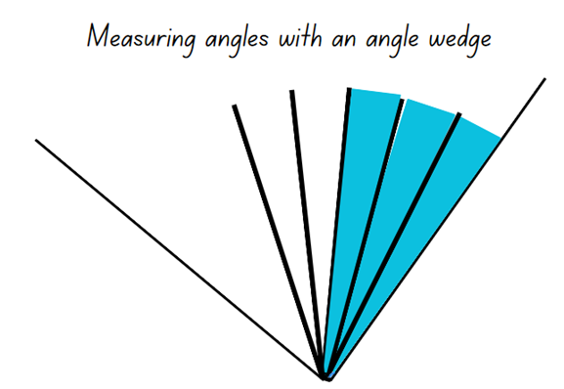
- Students record how many wedges were needed to measure the space between the 2 arms in their workbooks.
- Pairs then discuss and label the amount of turn for the angles, ordering these from the smallest amount of turning to the largest.
This table details opportunities for differentiation.
Too hard? | Too easy?
Stage 2 students cannot recognise or informally measure and compare angles.  - Assist students to identify angles made with strips of card, rulers or pencils.  - Support students to make an angle using strips of card for their partner to measure using the wedge. Students count how many are needed to cover the space in between the 2 arms. | Stage 2 students can recognise or informally measure and compare angles.  - In pairs, students challenge their partner to find an angle in the classroom that measures, for example, less than 12 wedges or more than 7 wedges.  - In pairs, students use a digital device to photograph 3 objects in the classroom that show angles that have a $\frac{1}{4}$ turn, $\frac{1}{2}$ turn and a $\frac{3}{4}$ turn.

Stage 3 task – angles represent an amount of turn
The table below contains suggested learning intentions and success criteria. These are best co-constructed with students.
Core concept learning intentions | Core concept success criteria
Students working towards Stage 3 outcomes are learning to:  - estimate, measure and compare angles using degrees. | Students working towards Stage 3 outcomes can:  - estimate and describe the size of angles using known angles as benchmarks  - explain how a protractor is formed and used to measure an angle  - record angle measurements using the symbol for degrees (°).
This activity is an adaptation of Empty protractor by Francome.
Note: Resource 10 – a numberless protractor can be reproduced on overhead transparent sheets and cut out. This can support students to measure and construct angles accurately. These can also be retained for future use. Paper can be used for copying but will limit students’ ability to view the angles while measuring.
- Display Resource 10 – a numberless protractor and ask students what they notice.
The table below outlines stimulus prompts to generate conversation about the topic, along with anticipated responses from students.
Prompts | Anticipated student responses
- What do you notice about the image? | - It is a circle.  - It looks like a ruler that is round.  - It shows a revolution angle of 360°.  - The lines or arms can be used to make angles of different sizes, including acute, right, obtuse, straight and reflex angles.
- What does each individual line represent? | - Each line is one degree. There are 360° altogether.
- How many lines do you think there are altogether? | - There are 2 straight angles of 180° joined together.  - There are 4 right angles of 90° joined together.
- What is a mathematical tool like this called? | - It is called a protractor or numberless protractor.
- What can this mathematical tool be used for? | - It can be used to measure the amount of turn in angles.  - It can be used to construct angles.
- Explain that:
- protractors are mathematical tools used to measure and construct angles
- some protractors are half a revolution, or circle, and some are a full revolution
- some protractors have numbers on them to help count the number of degrees in an angle
- although the lines look similar to the millimetre lines on a ruler, these lines represent degrees
- degrees are a unit for measuring an angle
- degrees measure the amount of opening, or turn, in an angle between 2 arms.
Degree: a unit for measuring an angle. Angles are measured as a proportion of a full turn which is equivalent to 360 degrees, so that one degree is equal to $\frac{1}{360}$ of a full turn. Degrees are written as °.
- Show Resource 11 – angle investigation 1 and explain that students will use a numberless protractor to estimate, measure and record the size of the angles in the shapes.
- Demonstrate how to align the numberless protractor, by:
- finding an angle to measure
- placing the protractor on the angle (make sure to place the centre point of the protractor on the vertex of the angle)
- rotating the protractor so that the bottom line aligns with the bottom arm of the angle
- reading the protractor carefully and accurately, counting the angle lines from one arm to the other
- using the larger markings to count by multiples of 5° or 10° at a time.
- Students work with a partner to estimate, describe and record at least one angle measurement of shapes on Resource 11 – angle investigation 1. Remind students to use an arrow or other marking to show which angle they are referring to in each shape.
This table details opportunities for differentiation.
Too hard? | Too easy?
Stage 3 students cannot estimate, describe and record angle measurements using the symbol for degrees (°).  - Choose one angle to start with and assist students to name it and estimate its size, using a right angle as a benchmark.  - Support students as they work through the steps of measuring and recording the size of each angle. | Stage 3 students can estimate, describe and record angle measurements using the symbol for degrees (°).  - Students create some irregular 2D shapes of their own for a partner to measure the internal and external angles. They estimate, describe and record the angles in the shapes. Both internal and external angles can be measured.

Discuss and connect the mathematics – 10 minutes
- Regroup as a class.
- Ask Stage 2 students to identify examples of angles they found in the classroom. Discuss:
- What parts of the angles did you use for your estimate?
- What strategies did you use for your estimate?
- How accurate were your estimates?
- Which strategies were most helpful in estimating?
- Ask Stage 3 students:
- What were some things you noticed when you were measuring the angles with the numberless protractors?
- Was there something that you found challenging about using the numberless protractors?
- Were there some strategies that you found helpful to use when measuring the angles?
This table details opportunities for assessment.
Assessment opportunities | Links
What to look for:  - Can Stage 2 students recognise an angle as the amount of turning between 2 arms? [MAO-WM-01, MA2-GM-03]  - Can Stage 2 students informally measure and compare angles? [MAO-WM-01, MA2-GM-03]  - Can Stage 3 students estimate and describe the size of angles using known angles as benchmarks? [MAO-WM-01, MA3-GM-03]  - Can Stage 3 students record angle measurements using the symbol for degrees (°)? [MAO-WM-01, MA3-GM-03] | Links to National Numeracy Learning Progressions (NNLP):  - Stage 2 – UuM4, UuM5  - Stage 3 – UuM7, UuM8

Lesson 3
Core concept: angles in an environment can be estimated, compared and ordered.

Daily number sense – who is winning? – 10 minutes
The table below contains a suggested learning intention and success criteria. These are best co-constructed with students.
Daily number sense learning intention | Daily number sense success criteria
Students are learning to:  - create fractional parts of length using techniques other than repeated halving  - compare and order common fractions. | Students can:  - make thirds of a length  - create fifths of a length  - explain their reasoning of how to find fractions of a length.  Students working towards Stage 3 outcomes can:  - compare and order fractions with denominators of 2, 3, 4, 5, and 8 by placing them on a number line.
This activity is an adaptation of ‘Who is winning?’ from Primary and Middle Years Mathematics: Teaching Developmentally by Van De Walle et al.
- Provide pairs of students with multiple fraction strips and writing materials. Revise how to identify thirds and fifths of a length from Lesson 1 and Lesson 2.
- Show students Resource 12 – fraction line and ask in what situation one whole equal is to 60 of something.
Note: provide time for students to make the connection between one hour and 60 minutes, or prompt them if needed.
- Explain that on Resource 12 – fraction line students need to place the fractions in the correct place on the number line and then record the equivalent minutes above the line (see Figure 3).
Figure 3 – fractions and minutes
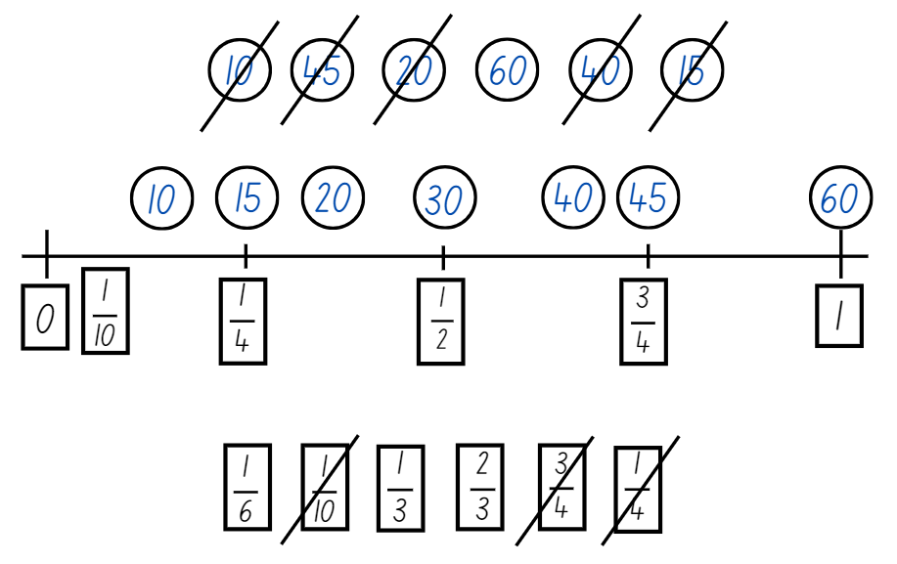
- Display Resource 13 – who is winning? and explain that the 6 students are in a race. The fractions show much of the distance they have already run.
- Provide pairs of students with a fraction strip for each runner and a paper strip to represent a number line.
- With their partner, students use a fraction strip to mark and represent the fraction distance for each runner. Students then use their reasoning strategies to compare the fractional representations for each runner and then use the number line to locate each person’s position in the race and determine who is winning the race.
- Discuss students' strategies used to identify and represent the position of each fraction.
This table details opportunities for assessment.
Assessment opportunities | Links
What to look for:  - Can Stage 2 students make parts of a length? [MA2-PF-01]  - Can Stage 2 students explain their reasoning of how to find fractions of a length? [MAO-WM-01, MA2-PF-01]  - Can Stage 3 students compare and order unit fractions with denominators of 2, 3, 4, 5, 6, 8 and 10 by placing them on a number line? [MAO-WM-01, MA3-RQF-01] | Links to National Numeracy Learning Progressions (NNLP):  - Stage 2 – InF4  - Stage 3 – InF6.

Core lesson part 1 – angles and corners – 20 minutes
The table below contains suggested learning intentions and success criteria. These are best co-constructed with students.
Core concept learning intentions | Core concept success criteria
Students are learning to:  - estimate and compare the amount of turn between angles  - use the term right angle to describe a quarter-turn  - recognise that the length of the arms does not affect the size of the angle. | Students can:  - estimate, compare and order angles  - identify right angles  - explain that the length of the arms does not affect the size of the angle.
This activity is an adaptation of ‘Square corners’ from Teaching about angles: Stage 2 by the State of New South Wales (Department of Education).
- Display Resource 4 – angles are everywhere and ask students to identify angles where the 2 arms are different lengths.
- Ask students to look for angles that are the same size but orientated differently. For example, angles the same size that are left facing or right facing.
- Use a bent drinking straw to show that an angle has 2 lines and a point. Insert a pipe cleaner into the straw, so that when an angle is made the straw holds its shape.
- Transpose the pipe cleaner over angles in Resource 7 – exploring angles 2 to demonstrate an example of an angle tester.
- Tell students that this is an angle tester that shows the amount of turn in different angles, similar to the angle wedge from Lesson 2.
- Explain that different angles can be given names to identify them.
- Introduce the term right angle and ask students to identify the respective angle in Resource 7 – exploring angles 2 as ‘right angle’.
- Demonstrate how to bend the straw into a right angle by folding it over one vertex of a square pattern block (see Figure 4).
Figure 4 – angle tester
- Display 2D shape pattern blocks, as in Figure 5.
Figure 5 – 2D shapes and angles
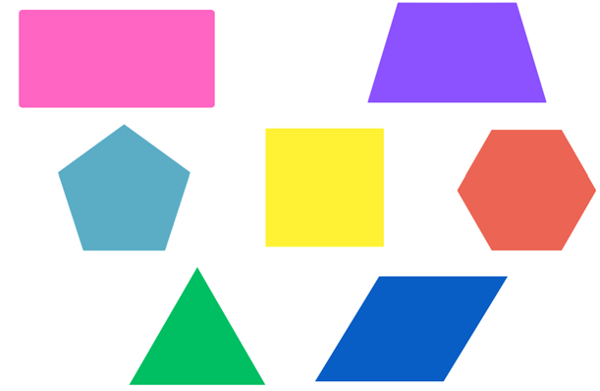
- Discuss and identify which pattern blocks have right angles.
- Provide students with straws and pipe cleaners to make their own angle tester. Have students work in pairs to:
- search for right angles in the classroom
- make a sketch, marking the right angle(s) in colour, ensuring both lines meet at the vertex
- use their angle tester to check that the drawn angle is the correct size.

Core lesson part 2 – measuring angles – 20 minutes
The table below contains suggested learning intentions and success criteria. These are best co-constructed with students.
Core concept learning intentions | Core concept success criteria
Students working towards Stage 2 outcomes are learning to:  - estimate and compare the amount of turn between angles  - use the term ‘right angle’ to describe a quarter-turn  - recognise that the length of the arms does not affect the size of the angle.  Students working towards Stage 3 outcomes are learning to:  - estimate, measure and compare angles. | Students working towards Stage 2 outcomes can:  - estimate, compare and order angles  - identify right angles  - explain that the length of the arms does not affect the size of the angle.  Students working towards Stage 3 outcomes can:  - explain how a protractor is formed and used to measure an angle  - record angle measurements using the symbol for degrees (°).
- Revise the different categories of angles, using the interactive angle display to model. Ask:
- What are the 2 mathematical tools used for measuring angles so far?
- How are these similar?
- How are these different?
- What are perpendicular lines?
- Introduce protractors as another mathematical tool that can be used to measure the amount of turn in angles. Ensure that each student has a protractor to handle and measure with.
- Explain that this is a numbered protractor and that, similar to the numbers on a ruler, the markings are there to help count the number of angles. Ask:
- How is a numbered protractor different to the other mathematical tools we have used in Lesson 2?
- Display Resource 14 – using a protractor and use it to discuss how to measure angles accurately.
- Using the interactive angle display and a protractor, demonstrate how to position a protractor to measure an angle accurately.
- Display Resource 15 – measuring angles. Explain that students will be using protractors to measure and record the size of angles that they find.
Multi-age: Stage 2 students use straws and pipe cleaners to compare and trace onto individual whiteboards. Students in Stage 2 then estimate the size of the angles in relation to a right angle. Allow students to use interactive angle display as an interactive guide to acute, right or obtuse angles.
This table details opportunities for differentiation.
Too hard? | Too easy?
Stage 2 students cannot estimate and compare the amount of turning between angles.  - Use Resource 4 – angles are everywhere to show examples of angles with the same size in different orientations.  - Identify examples of right angles in Resource 4 – angles are everywhere. Students check them using their angle tester.  Stage 2 students cannot recognise that the length of the arms does not affect the size of the angle.  - Use Resource 4 – angles are everywhere to compare examples of angles that have short arms but large amounts of turn, or long arms and small amounts of turn.  - Support students to find other examples in the images.  Stage 3 students cannot estimate, describe and record angle measurements using the symbol for degrees (°).  - Support students to identify the angle they are going to measure. It can be shaded in to make it clearer to see.  - Assist students with positioning the protractor, particularly with steps 3 and 4 in Resource 14 – using a protractor. Help them to start counting from zero, holding the protractor steady to ensure accuracy. | Stage 2 students can estimate and compare the amount of turning between angles.  - Provide students with a copy of Resource 16 – angles in art. Students identify and shade right angles in green.  - After finding the rights angles, students identify and shade angles smaller than a right angle in yellow and angles larger than a right angle in blue.  Stage 3 students can estimate, describe and record angle measurements using the symbol for degrees (°).  - Students find the total of the angles for each set of joining lines.  - Students make a short video for other students to view, explaining how to use a protractor to measure angles.

Discuss and connect the mathematics – 10 minutes
- Regroup as a class and summarise the lesson together drawing out key mathematical ideas. Ask:
- What were some of the benefits of using numbered protractors for measuring angles?
- Was there something that you found challenging about using the numbered protractors?
- Were there some strategies that you found helpful to use when measuring the angles?
- Did you notice anything about some of the angles you measured?
- Is there anything that you are still wondering?
This table details opportunities for assessment.
Assessment opportunities | Links
What to look for:  - Can Stage 2 students estimate, compare and order angles? [MAO-WM-01, MA2-GM-03]  - Can Stage 2 students identify right angles?  [MAO-WM-01, MA2-GM-03]  - Can Stage 2 students explain that the length of the arms does not affect the size of the angle? [MAO-WM-01, MA2-GM-03]  - Can Stage 3 students estimate and describe the size of angles using known angles as benchmarks? [MAO-WM-01, MA3-GM-03]  - Can Stage 3 students record angle measurements using the symbol for degrees (°)? [MAO-WM-01, MA3-GM-03] | Links to National Numeracy Learning Progressions (NNLP):  - Stage 2 – UuM6  - Stage 3 – UuM7, UuM8.

Lesson 4
Core concept: angles can be measured to solve problems in our world.

Daily number sense – 10 minutes
- From a class need surfaced through formative assessment data, identify a short, focused activity that targets students’ knowledge, understanding and skills. Example activities may be drawn from the following resources:
- Mathematics K–6 resources
- Universal Resources Hub.

Core lesson part 1 – angles in art – 20 minutes
The table below contains suggested learning intentions and success criteria. These are best co-constructed with students.
Core concept learning intentions | Core concept success criteria
Students working towards Stage 2 outcomes are learning to:  - estimate and compare the amount of turn between angles  - use the term right angle to describe a quarter-turn  - recognise that the length of the arms does not affect the size of the angle.  Students working towards Stage 3 outcomes are learning to:  - estimate, measure and compare angles using degrees. | Students working towards Stage 2 outcomes can:  - estimate, compare and order angles  - identify right angles  - explain that the length of the arms does not affect the size of the angle.  Students working towards Stage 3 outcomes can:  - identify the arms and vertex of an angle where both arms are invisible, such as rotations  - estimate, describe and record the size of angles using known angles as benchmarks (reasons about mental rotation) and degrees (°).
Multi-age: Stage 2 students work with a partner to identify and label angles using Resource 16 – angles in art. They use their angle wedges from Lesson 3 and other benchmarks to support them.
- Display Resource 14 – using a protractor for Stage 3 students and revise how to measure angles accurately using a protractor.
- Show Resource 16 – angles in art and ask students to identify examples of acute, right, obtuse, straight and reflex angles.
- Provide pairs of students with Resource 16 – angles in art, protractors and writing materials. Students work with their partner to find, measure and label examples of each type of angle.

Core lesson part 2 – mountain bike geometry – 30 minutes
Multi-age: Stage 2 students work with a partner to identify and label angles using Resource 17 – BMX bike geometry. They use their angle wedges from Lesson 3 and other benchmarks to support them.
- Explain that understanding angles and geometry is useful for solving many types of problems in the world.
- Introduce the following problem: Rueben wants to buy a new downhill mountain bike. He has been saving for months and wants to get the best bike possible for his money. Rueben has been researching mountain bikes online and has found that bikes with certain geometric properties help riders to go faster in downhill races. The mountain bike store has 6 bikes with similar features for a similar price, so he wants to find the bike with the best geometry for racing.
- Display Resource 18 – mountain bike geometry and explain that there are 2 geometrical properties of downhill mountain bikes that he is looking for:
- An Effective Seat Angle (ESA) as close to 70° as possible. This helps the rider maximise speed by putting more power into their pedalling.
- A Head Angle (HA) of the smallest angle possible. This is important for racing downhill, as it puts the rider’s weight further back on the bike and means there is less risk of crashing over the handlebars.
- Explain to students that they will be working with partner to measure the ESA and HA of each bike, then make a recommendation about which bike Rueben should buy. When making a recommendation, students will also need to consider the best value for their money. Ask students to share their reasoning for their recommendation.
- Remind students that sometimes angles are invisible, that is, their arms aren’t always visible. Point out that the first bike on Resource 18 – mountain bike geometry has the ESA and HA already marked, but they will need to draw these on the other bikes.
- Using the example on the first bike on Resource 18 – mountain bike geometry, model how to draw a line along the bike’s seat post and the ground to show the ESA angle, then along the bike’s headtube and the ground to show the HA.
- Provide pairs of students with Resource 18 – mountain bike geometry. Using their protractors and writing materials, students measure, record and compare the bikes’ geometric properties to make their recommendation.
This table details opportunities for differentiation.
Too hard? | Too easy?
Stage 2 students cannot estimate and compare the amount of turning between angles, including right angles.  - Identify examples of right angles in Resource 17 – BMX bike geometry. Students check them using their angle tester.  - Use Resource 17 – BMX bike geometry to compare examples of angles that have short arms but large amounts of turn, or long arms and small amounts of turn.  Stage 3 students cannot identify the arms and vertex of an angle where both arms are invisible, such as for rotations.  - Model how to identify the ESA and HA in the next bike on Resource 18 – mountain bike geometry.  - Support students to identify and highlight the arms for the ESA and HA in the following bike.  Stage 3 students cannot describe and measure visible and invisible angle using known benchmarks and the symbol for degrees (°).  - Support students to identify and highlight the arms for the ESA and HA on Resource 18 – mountain bike geometry.  - Support students to align their protractor accurately, then count the number of degrees in the angle starting from 0°. | Stage 2 students can estimate and compare the amount of turning between angles, including right angles.  - Students look for right angles in the playground and check the size using the straw angle tester.  - Using an analog clock, students investigate times that create a right angle using the 2 hands on the clock face.  Stage 3 students can identify the arms and vertex of an angle where both arms are invisible, such as for rotations.  - Students use a digital device to find a profile image of a downhill mountain bike.  - Students measure the geometry of this bike and compare it with the bikes on Resource 18 – mountain bike geometry.  Stage 3 students can describe and measure visible and invisible angle using known benchmarks and the symbol for degrees (°).  - Students use a digital device to find an image of a downhill mountain bike. They measure its geometry and compare it with the bikes on Resource 18 – mountain bike geometry.  - Provide students with Resource 19 – angles in engineering to find, categorise, measure and record the size of the angles in one of the structures.

Discuss and connect the mathematics – 10 minutes
Multiage: Stage 2 students work with a different partner to compare and discuss the types of angles they found in Resource 18 – mountain bike geometry. They number the angles on each bike in order from smallest to largest.
- Ask Stage 3 students to share their bike recommendations for Rueben with the class, as well as their reasoning for that choice.
- There are likely to be several different recommendations. This is an opportunity for students to justify their reasoning. Ask:
- After listening to the other groups, do you want to reconsider your recommendation? Why?
- Have you learnt something new about how angles can help solve problems in the world?
- Where else might angles be important in design and construction?
This table details opportunities for assessment.
Assessment opportunities | Links
What to look for:  - Can Stage 2 students estimate and compare the amount of turning between angles, including right angles?  [MAO-WM-01, MA2-GM-03]  - Can Stage 2 students explain that the length of the arms does not affect the size of the angle? [MAO-WM-01, MA2-GM-03]  - Can Stage 3 students identify the arms and vertex of an angle where both arms are invisible, such as for rotations?  [MAO-WM-01, MA3-GM-03]  - Can Stage 3 students estimate and describe the size of angles using known angles as benchmarks? [MAO-WM-01, MA3-GM-03] | Links to National Numeracy Learning Progressions (NNLP):  - Stage 2 – UuM4, UuM5  - Stage 3 – UuM7, UuM8.

Lesson 5
Core concept: 12- and 24-hour time systems are both used to measure the length of time and sequence events.

Daily number sense – the same as – 10 minutes
Daily number sense activities for Lessons 5 to 7 ‘loop’ back to concepts and procedures covered in previous units to assist students to build an increasingly connected network of ideas. These concepts may differ from the core concepts being covered by the unit.
The table below contains a suggested learning intention and success criteria. These are best co-constructed with students.
Daily number sense learning intention | Daily number sense success criteria
Students are learning to:  - use the principle of equality when solving number sentences. | Students can:  - use the equals sign to record equal number sentences  - add and subtract numbers using mental or written strategies.

This activity is an adaptation of ‘Let’s play...Number sentences’ by James Russo.
Note: there are a variety of mathematical games where decks of cards are a fundamental resource. To reduce the cognitive load for students, it is encouraged to use a set of playing cards that only includes numerical cards. This allows students to focus on the mathematics instead of focussing on the picture cards and their abstract value in the game.
Note: prior to the lesson, remove all the picture cards. It is optional to use the picture cards if appropriate to increase the level of challenge.
- Demonstrate how to play the game by playing against a student or the whole class.
- Deal 4 cards face up on Resource 20 – number sentence board and place the remainder of the cards in a centre pile (see Figure 6).
Figure 6 – number sentence board
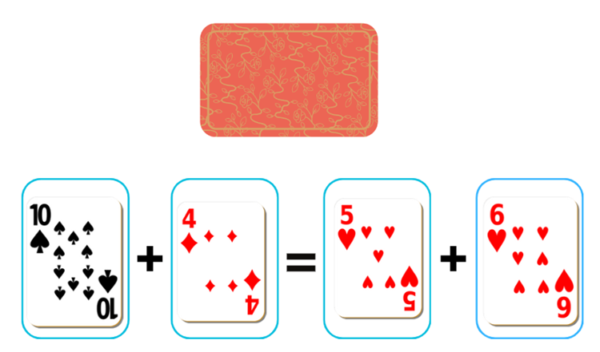
- Player 1 picks a card from the centre pile and decides which of the 4 slots to place the card. For example, Player 1 picks a 7 and places it in one of the slots, then reads out the number sentence stating whether it is true or not. For example, 10 plus 4 is not the same as 7 plus 6 (see Figure 7).
Figure 7 – gameplay
- Player 2 then picks a card and places it in one of the slots. For example, player 2 picks a 7 and reads out the number sentence stating if it is true or not (see Figure 8).
Figure 8 – gameplay 2
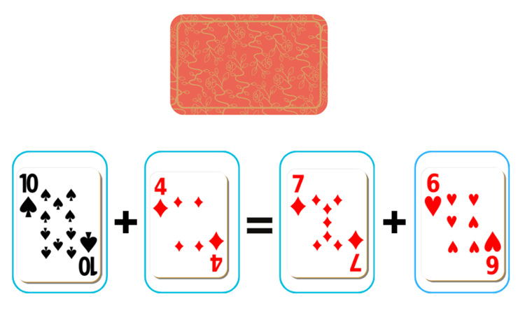
- Play continues until a player selects a card that makes a true statement. For example, Player 1 picks a 3, places it in a slot and reads 10 plus 3 is the same as 7 plus 6 (Figure 9).
Figure 9 – gameplay 3
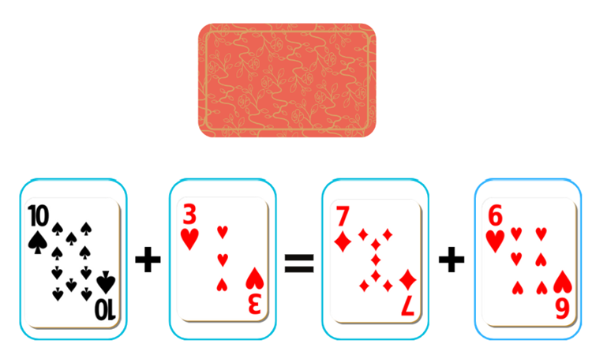
- Players records the number sentences on their whiteboard and that is the end of a round. The cards on the game board are placed at the bottom of the pile, 4 new cards are dealt and play starts again.
This table details opportunities for assessment.
Assessment opportunities | Links
What to look for:  - Can Stage 2 students use the equals sign to record equal number sentences? [MAO-WM-01, MA2-AR-01]  - Can Stage 3 students add and subtract numbers using mental or written strategies? [MAO-WM-01, MA3-AR-01] | Links to National Numeracy Learning Progressions (NNLP):  - Stage 2 – NPA3  - Stage 3 – AdS7, AdS8.  Links to suggested Interview for Student Reasoning (IfSR) tasks:  - Stage 2 – IfSR-AT: 2A.1  - Stage 3 – IfSR-AT: 3A.5.

Core lesson part 1 – time talk – 10 minutes
The table below contains suggested learning intentions and success criteria. These are best co-constructed with students.
Core concept learning intentions | Core concept success criteria
Students working towards Stage 2 outcomes are learning to:  - represent and read analog time using quarter hours and half hours.  Students working towards Stage 3 outcomes are learning to:  - compare 12- and 24-hour time systems and convert between them. | Students working towards Stage 2 outcomes can:  - identify 30 minutes as a half-hour and 60 minutes as an hour  - connect the quarter-hour to 15 minutes  - read time as past the hour and to the hour.  Students working towards Stage 3 outcomes can:  - recognise that 24-hour time is used to avoid confusion between am and pm  - read time using appropriate 24-hour time language.
- As a class, brainstorm words used to describe time. For example, 5 o’clock, a quarter past, half past, a quarter to, six thirty, hours, minutes and seconds.
- Explain that, although they cannot see or touch time, students can measure its length to organise things in the world.
- Display Figure 10 and ask:
- What do you notice about the clock face?
- What numbers are there? Why do the numbers stop at 12?
- How are the numbers arranged? Why do you think that is?
- What clocks do you have at home?
- What is the biggest clock you have ever seen?
- What are times during your day? For example, when do you get up and what time do you go to school?
- What is the time shown on the screen?
- Is it day or night?
- Is this time closer to midday or midnight? What information do we need to answer this?
- Can the time be displayed in a different way to know if it is day or night?
Figure 10 – time talk 1
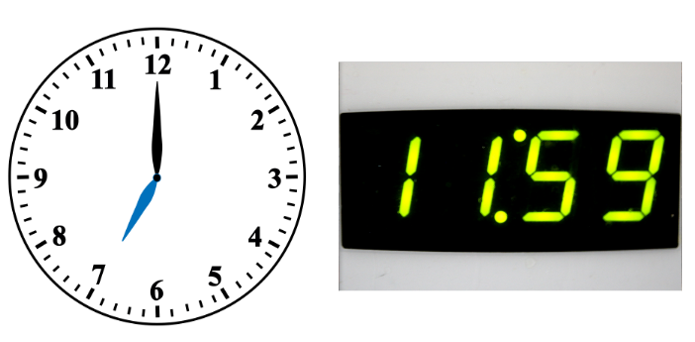

Core lesson part 2 – 40 minutes

Stage 2 task – using the clock
- Provide students with Resource 21 – analog clock template or a paper plate to construct an analog clock. Model the following process for students and support them to construct their clock:
- Fold the circle in half and half again.
- Colour each quarter a different colour. This helps reinforce the concept of quarters and halves.
- Identify that each quarter hour makes a right-angle corner in the centre of the clock face.
- Draw numbers onto the clock-face. Begin by placing the 12, 3, 6, and 9 on the $\frac{1}{4}$ ‘lines’. Discuss their position.
- Explain that, once students reach half past the hour, they should read the time towards the next hour. For example, 20 minutes to 4 o’clock.
- Show how to add the remaining numbers evenly around the clock face.
- Use a split pin to attach the hour hand to the clock. Alternatively, students can hold a pencil to their clock’s face to show hours.
- Revise that the hour hand (the short hand) indicates the hour time and that the minute hand moves on the clock every minute. Discuss what happens to the minute hand as the hour hand moves around the clock face. Ask:
- Why does the minute hand point to the 12 with all the o’clock times?
- If one of the hands was missing do you think you could still tell the time? Why not?
- Ensure students recognise that the minute hand indicates how many minutes have passed since the o’clock time and with hour times zero minutes have passed.
- As a class, model some of these times on the analog clocks previously made.
- Display half past 10 on a clock. State an example of something that happens at 10 o’clock. For example, that this is the time recess begins. Model that the clock shows half past time and ask students to model this on their analog clocks made in Part A. Ask:
- How can you describe the position of the hour and minute hands?
- Why does the minute hand point to the 6?
- Ensure students see the relationship between $\frac{1}{2}$ of the circle and the position of the minute hand pointing to the 6. Ask:
- What is the hour hand pointing to?
- Ensure students understand that the minute hand moves around the clock making one full rotation in 60 minutes and the hour hand moves around the clock making a full rotation in 12 hours.
- Ask the students to show half past 3 on their clocks. As a class, discuss the placement of the hands.
- Discuss times of the day when common events happen including on the hour, half hour and quarter to quart past. Record these on a mind map (see Figure 11).
Figure 11 – mind map showing hour, half hour and quarter hour
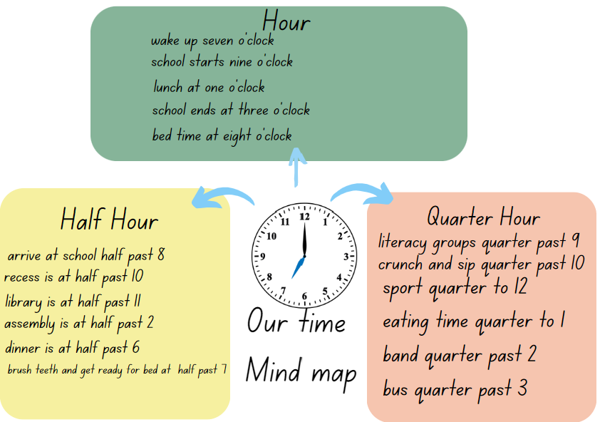
- Discuss the events that occur on the quarter-hour. Show the quarter-past times identified in discussion on the clock and ask students to show the time on their own clocks.
- Ask students to record some of their favourite or important times of the day and show these times on their clocks. Students could do this with a partner first, before sharing one favourite time with the whole class.
This table details opportunities for differentiation.
Too hard? | Too easy?
Students cannot identify 30 minutes as half an hour, 60 minutes as an hour or 15 minutes as quarter of an hour.  - Support students to identify and label a quarter hour and half hour on their clock. Read as quarter past and half past.  - Help students to identify and label a quarter to the hour and the whole clock face as one hour. | Students can identify 30 minutes as half an hour, 60 minutes as an hour or 15 minutes as quarter of an hour.  - With a partner, students represent a time on their clock. Their partner tries to think of a different way to describe the time. For example, half past 7 is 30 minutes after 7 o’clock.  - Show the NRICH resource ‘Clocks’ and explain that these clocks have been reflected in a mirror. Students use what they know about analog clocks to find the times shown.

Stage 3 task – 24-hour time
Note: 24-hour time is written without the colon. For example, 3:45 pm is written as 15:45 and read as ‘fifteen forty-five hours’.
- Introduce 24-hour time as a way of clearly communicating a particular time in the day or night. Explain that it is used to avoid confusion between am and pm. It is often used by emergency services, airlines, military forces and public transport services, as they need to be clear in communicating when things will be happening.
- Write the times 1:45 pm and 13:45 on the board. Display Figure 12 and use the timeline and analog clock to explain that:
- On a 24-hour clock, time is measured from midnight (00:00 hrs). This is shown on the timeline and the analog clock.
- The first 2 digits are the number of hours past midnight.
- The second 2 digits are the number of minutes past the hour.
- Numbers around the clock face below shows how hours on an analogue clock face are converted into 24-hour time.
- The 24-hour times that are after midday are shown on the outside of the clock model above.
- We use pm to indicate after midday in 12-hour time.
- The 24-hour times that are before midday are shown on the inside of the clock model above.
- We use am to indicate before midday in 12-hour time.
- The 24-hour times that are after midday are shown on the outside of the clock model above.
- The notation pm is used to indicate after midday in 12-hour time.
Figure 12 – 12- and 24-hour time
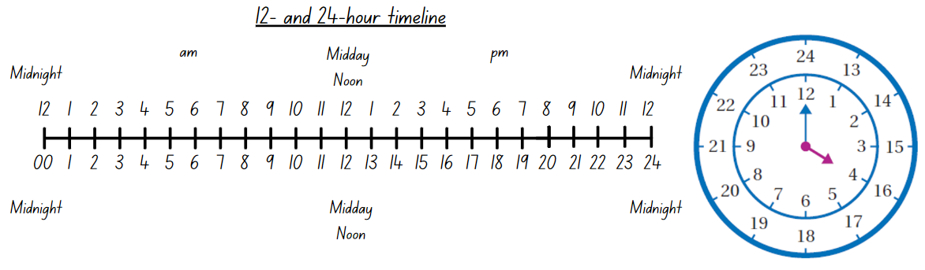
- List some examples of times in the school day on the board, for example, lunch is at 1:10 pm. Students turn and talk with a partner to convert the time to a 24-hour time.
- Provide students with a copy of Resource 22 – converting times. With a partner, students use the timeline and analog clock to convert the times from one format to another.
This table details opportunities for differentiation.
Too hard? | Too easy?
Students cannot recognise the difference between am and pm or read time using appropriate 24-hour time language.  - Draw students’ attention to the timeline on Resource 22 – converting times. Use this to write the first time, before comparing it to the equivalent hour above or below the timeline. The analog clock can also be used to convert between hours.  - Support students to see that the numbers representing the minutes remains the same. | Students can recognise the difference between am and pm or read time using appropriate 24-hour time language.  - Ask students to use the times they wrote on Resource 22 – converting times to see if they can find the time between each of them.  - Challenge students to complete 5 on the clock. Using what they know about 24-hour time, students find how many times a 5 appears on a digital clock showing 24-hour time, over a whole day.

Discuss and connect the mathematics – 10 minutes
- Regroup as a class and summarise the lesson drawing out key mathematical ideas. Ask:
- Where does the minute hand point at 9:45? (Stage 2)
- What happens to the minute and hour hands as time passes? (Stage 2)
- What do the 6 and 12 represent on the clock? (Stage 2)
- What did you find challenging about converting between 12-hour and 24-hour time? (Stage 3)
- What strategies or resources did you and your partner use to help? (Stage 3)
- Did you notice any patterns that helped you? (Stage 3)
- Is there anything that you are still wondering?
This table details opportunities for assessment.
Assessment opportunities | Links
What to look for:  - Can Stage 2 students identify 30 minutes as being a half-hour and 60 minutes as an hour? [MAO-WM-01, MA2-NSM-02]  - Can Stage 2 students understand that the quarter-hour is connected to 15 minutes? [MAO-WM-01, MA2-NSM-02]  - Can Stage 2 students read time as past the hour and to the hour? [MAO-WM-01, MA2-NSM-02]  - Can Stage 3 students recognise that 24-hour time is used to avoid confusion between am and pm? [MAO-WM-01, MA3-NSM-02]  - Can Stage 3 students read time using appropriate 24-hour time language? [MAO-WM-01, MA3-NSM-02] | Links to National Numeracy Learning Progressions (NNLP):  - Stage 2 – MeT3  - Stage 3 – MeT5.

Lesson 6
Core concept: clocks are complex measuring tools with the 2 hands on an analog clock indicating separate but related quantities.

Daily number sense – closest to zero – 10 minutes
The table below contains a suggested learning intention and success criteria. These are best co-constructed with students.
Daily number sense learning intention | Daily number sense success criteria
Students are learning to:  - apply mental and written strategies when solving number sentences when using the principle of equality. | Students can:  - use the equals sign to mean ‘the same as’  - use knowledge of place value to add numbers up to 3-digits.
This activity is an adaptation of ‘Dicey operations in Line’ from NRICH by the University of Cambridge (Faculty of Mathematics).
- Provide pairs of students with three 6-sided dice and an individual whiteboard.
- Students roll the dice 2 times to make two 3-digit numbers and record in a number sentence.
- Students can decide on the combination of their 3-digit numbers from the numbers rolled. For example, if 6, 4 and 3 are rolled, students can choose to record 643, 346 or 463.
- Students record the number sentence 643 + 346 =.
- In pairs, students then calculate 2 other 3-digit numbers that could be written on the other side of the equal sign that would balance the number sentence. For example, 643 + 346 = 531 + 457.
- Students play multiple rounds.
- As a class, discuss:
- What strategies were most useful when selecting the 2 additional numbers?
- How did you check that each number sentence was ‘the same as’?
- How could you convince someone that your number sentence shows equality?
This table details opportunities for assessment.
Assessment opportunities | Links
What to look for:  - Can Stage 2 students use the equal sign to show that 2 number sentences are ‘the same as’?  [MAO-WM-01, MA2-AR-01, MA2, AR,02]  - Can Stage 3 use knowledge of place value to add numbers up to 3-digits? [MAO-WM-01, MA3-AR-01] | Links to National Numeracy Learning Progressions (NNLP):  - Stage 2 – NPA3  - Stage 3 – AdS7, AdS8.  Links to suggested Interview for Student Reasoning (IfSR) tasks:  - Stage 2 – IfSR-AT: 2A.1  - Stage 3 – IfSR-AT: 3A.5.

Core lesson – 40 minutes

Stage 2 task – the clock
The table below contains suggested learning intentions and success criteria. These are best co-constructed with students.
Core concept learning intentions | Core concept success criteria
Students are learning to:  - read times on analog clocks to the minute.  - recognise that the numerals on an analog clock often represent 2 different values. | Students can:  - use the 5-minute intervals to read time on an analog clock  - read analog clocks to the minute  - read time as past the hour and to the hour.
- Provide students with Resource 23 – clock fractions to cut out.
Note: these can be pre-cut for students to save time.
- Explain that as the minute hand moves around the clock face, it shows the fraction of an hour.
- Show students how the $\frac{1}{2}$ piece can be laid over the analog clock to show where the minute hand has moved. Explain that this shows the fraction of time that has passed and how many minutes this is equivalent to.
- Discuss the value of each fraction, the number of minutes they represent and how much time is left in the hour. Point out that the smaller fractions allow time to be recorded very accurately, while the 5-minute intervals assist counting by fives.
- With a partner, students experiment with making combinations of minutes that total one hour. They record these as both a diagram and as a number sentence.
- Ask:
- What did you notice while you were making combinations of an hour?
- What was the simplest combination you made?
- Which combination had the most fractions?
- Were there any patterns that you saw?
- Is there anything else that you are wondering?
- Explain that some times can be said in different ways, for example, one fifty-five is also the same as 5 minutes to 2.
- Students turn and talk with a partner about other times that can be expressed in more than one way.
- Ask students to share their thinking. Record and discuss some of the examples shared.
- Show Resource 24 – reading the time and explain that students will work with a partner to match sometimes that are written in different ways. They will also be reading times written in words, then writing them on an analog clock by drawing the hands.
This table details opportunities for differentiation.
Too hard? | Too easy?
Students cannot read analog clocks accurately, recognising that the numerals on an analog clock often represent 2 different values.  - Use an analog clock to demonstrate how the minute hand moves ‘past’ a given hour.  - Model times that have the minutes hand moving towards the hour and discuss ways they can be read.  - Model how to count by multiples of 5, then use the minute marks to count by ones to find the time indicated by the minute hand. | Students can read analog clocks accurately, recognising that the numerals on an analog clock often represent 2 different values.  - Working with a partner, students use their combined time fractions to work out as many combinations as possible that total 90 minutes.  - Students work with a partner to solve Wonky Watches from NRICH, recording their thinking.

Stage 3 task – 24-hour time
The table below contains suggested learning intentions and success criteria. These are best co-constructed with students.
Core concept learning intentions | Core concept success criteria
Students are learning to:  - compare 12-hour and 24-hour time systems and convert between them. | Students can:  - read time using appropriate 24-hour time language  - convert between 24-hour time and 12-hour time using am or pm notation.
- Display Figure 13 and revise students' knowledge of 12-hour and 24-hour time systems.
Figure 13 – 12- and 24-hour time
- Show Figure 14 and ask:
- What is the time shown on the watch?
- Is it day or night?
- Is this time closer to midday or midnight? What information do we need to answer this?
- Can the time be displayed in a different way to know if it’s day or night?
- Where is 24-hour times used?
Figure 14 – digital watch
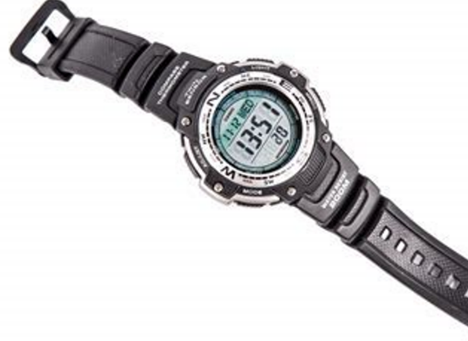
‘Digital Wristwatch’ by George Hodan is in the Public Domain.
- Show the activity Time tools to the class. Demonstrate how equivalent times can be represented on the 3 clocks.
- With a partner, students explore Time tools on a digital device. They record each of the times they create, both as a 12-hour and 24-hour time.
- After 10 minutes, ask students to stop playing the game. Provide them with a copy of Resource 25 – timeline. Students use the timeline to show where each of the times belong, both in 12-hour and 24-hour notation.
- Show Resource 26 – time problems and discuss how to solve the first problem.
- Provide students with a copy of Resource 26 – time problems for them to work on solving the other problems.
This table details opportunities for differentiation.
Too hard? | Too easy?
Students cannot read or convert between 12-hour time and 24-hour time using am or pm notation.  - Support students to use a copy of Figure 11 to convert between 24-hour time and 12-hour times on the Time tools interactive display.  - Assist students to find the corresponding point for each time on their copy of Resource 25 – timeline. | Students can read or convert between 12-hour time and 24-hour time using am or pm notation.  - Students think of the times they do things in their day and add these to their timelines as both 24-hour time and 12-hour time.  - Using the timeline, students calculate how much time they spend on specific tasks each day.

Discuss and connect the mathematics – 10 minutes
- Regroup as a class and summarise the lesson drawing out key mathematical ideas. Ask:
- What strategies help you read the time on analog clocks? (Stage 2)
- If it is 7:45, what time would it be in half an hour? (Stage 2)
- If it is 9:15, what time would it be in 2 hours and 45 minutes? How do you know? (Stage 2)
- What strategies did you and your partner use to convert between 12-hour and 24-hour time? (Stage 3)
- Did you find any new strategies to help you? (Stage 3)
- Which format of time is less confusing for communication, 12-hour or 24-hour? Why? (Stage 3)
- Is there anything that you are still wondering about 24-hour time? (Stage 3)
This table details opportunities for assessment.
Assessment opportunities | Links
What to look for:  - Can Stage 2 students use the 5-minute intervals to read time on an analog clock? [MAO-WM-01, MA2-NSM-02]  - Can Stage 2 students read analog clocks to the minute?  [MAO-WM-01, MA2-NSM-02]  - Can Stage 2 students read time as past the hour and to the hour? [MAO-WM-01, MA2-NSM-02]  - Can Stage 3 read time using appropriate 24-hour time language? [MAO-WM-01, MA3-NSM-02]  - Can Stage 3 students convert between 24-hour time and 12-hour time using am or pm notation? [MAO-WM-01, MA3-NSM-02] | Links to National Numeracy Learning Progressions (NNLP):  - Stage 2 – MeT3  - Stage 3 – MeT5.

Lesson 7
Core concept: analog clocks and timetables are an efficient way to communicate, organise lengths of time and solve time problems.

Daily number sense – true or false to 1000 – 10 minutes
The table below contains a suggested learning intention and success criteria. These are best co-constructed with students.
Daily number sense learning intention | Daily number sense success criteria
Students are learning to:  - use efficient mental and written strategies to add and subtract when using the principle of equality. | Students can:  - recognise and explain when a number sentence has the same value on both sides of the equals sign.
This activity is an adaptation of ‘True or False’ from NRICH by the University of Cambridge (Faculty of Mathematics).
- Display the number sentence 27 + 13 = 11 + 29. Ask students to turn and talk about if the number sentence is true or false.
- Select students to explain how they know that the number sentence is true or false.
- Emphasise to students that the equals sign means ‘the same as’ or ‘balance’ and not just the ‘total’ or the ‘answer’.
Equals sign: is used to indicate equivalence, for example, 5 + 1 = 2 + 4. Equals signs also show that 2 or more amounts have the same value.
- Display Resource 27 – number sentences and ask students the following questions for each number sentence:
- Is the number sentence true?
- Is the number sentence false?
- How do you know you are correct?
- Could you decide without doing any calculating? What strategy did you use?
This table details opportunities for assessment.
Assessment opportunities | Links
What to look for:  - Can students use efficient mental and written strategies to add and subtract when using the principle of equality?  [MAO-WM-01, MA2-AR-01, MA3-AR-01] | Links to National Numeracy Learning Progressions (NNLP):  - Stage 2 – NPA3  - Stage 3 – AdS7, AdS8.  Links to suggested Interview for Student Reasoning (IfSR) tasks:  - Stage 2 – IfSR-AT: 2A.1  - Stage 3 – IfSR-AT: 3A.5.

Core lesson – 40 minutes

Stage 2 task – problem solving with time
The table below contains suggested learning intentions and success criteria. These are best co-constructed with students.
Core concept learning intentions | Core concept success criteria
Students working towards Stage 2 outcomes are learning to:  - represent and read analog time in hours and minutes. | Students working towards Stage 2 outcomes can:  - identify 30 minutes as half-hour and 60 minutes as an hour  - connect the quarter-hour to 15 minutes  - apply appropriate strategies to find solutions to time problems.
This activity is an adaptation of ‘Clock wise (time)’ from NZ Maths by the New Zealand Ministry of Education.
- Display Figure 15 and Resource 28: – think board template and explain that think boards are a useful way to record and show representations of steps and strategies being used to find solutions to problems.
Figure 15 – Rebecca’s walk
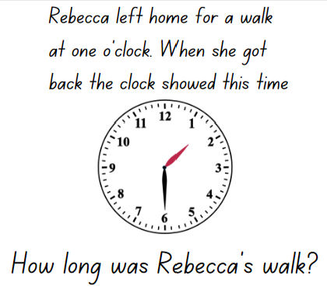
- In pairs, students work through the problem using the template, co-constructing a think board displaying how fractions, angles and diagrams can be used to solve time problems (see Figure 16).
Figure 16 – example of solutions
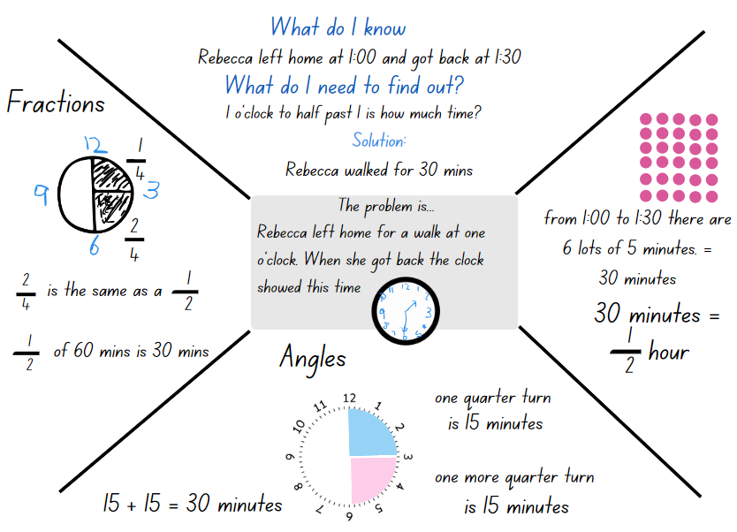
- Provide students with multiple copies of Resource 28 – think board template and a copy of Resource 29 – problems with time. Students solve the problems with time, constructing a think board for each.
- Once students are finished, ask:
- Did you use the same steps each time to solve each problem? Explain.
- How did the think board help you plan and solve each problem?
- Display the interactive game Stop the Clock from NRICH.
- Split the class into 2 teams.
- Explain that, to start the game, the clock is set to 6 o’clock.
- Each team has the option to move the hands of the clock on by ½ hour or by one hour. For example, Team A chooses $\frac{1}{2}$ hour, so the clock hands move to show 6:30. Team B now chooses to move one hour so the hands move to show 7:30.
- Play continues until a team successfully moves the hands exactly onto 12 o’clock.
This table details opportunities for differentiation.
Too hard? | Too easy?
Students cannot solve time problems and identify 30 minutes as being a half-hour and 60 minutes as an hour.  - Support students to use their analog clock and count aloud as the hand moves around the whole clock face, counting the 60-minute markers. Cover half the clock face and, repeat counting only the 30-minute markers as the hand moves around half the clock face.  - With a partner, students use their analog clock to solve the first problem from Resource 29 – problems with time. Ask students to explain their thinking and help them to record their ideas on Resource 28 – think board template. | Students can solve time problems and identify 30 minutes as being a half-hour and 60 minutes as an hour.  - Challenge students to write time problems for a partner to solve.  - Students work with a partner to read time and order clocks using What Is the Time? from NRICH.

Stage 3 task – timetables
The table below contains suggested learning intentions and success criteria. These are best co-constructed with students.
Core concept learning intentions | Core concept success criteria
Students are learning to:  - compare 12-hour and 24-hour time systems and convert between them. | Students can:  - convert between 24-hour time and 12-hour time using am or pm notation  - read, interpret and use timetables from real-life situations, involving 12-hour and 24-hour time.
- Revise students’ knowledge of 12-hour and 24-hour time system.
- Ask students where they have seen timetables used as a way of organising and communicating time.
- Display Resource 30 – train timetable and ask students what they notice about the features of the timetable.
- Read the 2 problems that Sam has. Explain that students will work with a partner to answer the 2 questions.
- Explain that a blank number line can be used to find the difference between 2 amounts or times, using jumps.
- Model how to use small jumps of time to find the difference between the 2 times. For example, jumping by 2 minute or 5-minute intervals each jump, then by one-minute intervals until reaching the second time on the number line (see Figure 17).
Figure 17 – time number line
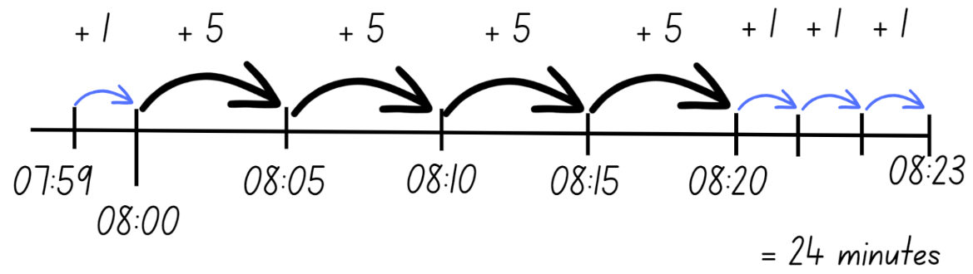
- Students work with their partner, using a number line in the second question to show how long his train journey would take.
- Discuss students’ responses and compare how they have used a number line to find a solution.
- Display Resource 31 – television tonight and explain that time systems help to understand television schedules.
- Ask students what they notice about this timetable, which is a television guide for 2 channels.
- Discuss the first question as a class, using an empty number line to mark the 2 times.
- Ask students to confirm which time should be written for each, recognising that the first time is when ‘Journey to space’ ends.
- With a partner, students find solutions to the problems, using jumps of time on the number lines to support their thinking.
This table details opportunities for differentiation.
Too hard? | Too easy?
Students cannot read, interpret and use timetables from real-life situations, involving 12-hour and 24-hour time.  - Support students to identify the beginning and ending time for each problem, then label these times on the number line.  - Assist students to find the difference between the 2 times, using jumps of time to find the total. | Students can read, interpret and use timetables from real-life situations, involving 12-hour and 24-hour time.  - Challenge students to find the times of each television program, then list them from shortest to longest.  - Explain that there is enough memory on the digital recorder to record 3 hours of programming that night. Students decide which combination of shows they would record to get as close to 3 hours as possible.

Discuss and connect the mathematics – 10 minutes
- Regroup as a class and ask:
- Which problem was the most challenging? Why? (Stage 2)
- Is it better to choose half an hour, one hour or a combination of both? How do you know? (Stage 2)
- What strategy was the most useful to help you decide which option to pick at each step? (Stage 2)
- Was there one option that you would have liked to change after seeing the result? (Stage 2)
- How was this game challenging? (Stage 2)
- Which timetable did you find easier to understand? Why? (Stage 3)
- What could be the consequences of not reading either timetable correctly? (Stage 3)
- Were there any strategies or patterns you found that help you and your partner? (Stage 3)
- Is there anything else you noticed? (Stage 3)
This table details opportunities for assessment.
Assessment opportunities | Links
What to look for:  - Can Stage 2 students identify 30 minutes as being a half-hour and 60 minutes as an hour? [MAO-WM-01, MA2-NSM-02]  - Can Stage 2 students connect the quarter-hour to 15 minutes? [MAO-WM-01, MA2-NSM-02]  - Can Stage 2 students apply appropriate strategies to find solutions to time problems? [MAO-WM-01, MA2-NSM-02]  - Can Stage 3 students convert between 24-hour time and 12-hour time using am or pm notation? [MAO-WM-01, MA3-NSM-02]  - Can Stage 3 students read, interpret and use timetables from real-life situations, involving 12- and 24-hour time?  [MAO-WM-01, MA3-NSM-02] | Links to National Numeracy Learning Progressions (NNLP):  - Stage 2 – MeT3  - Stage 3 – MeT5.

Lesson 8
Core concept: quantities of time are often partitioned into 5-minute intervals and common fractions, such as halves and quarters.

Daily number sense – 10 minutes
- From a class need surfaced through formative assessment data, identify a short, focused activity that targets students’ knowledge, understanding and skills. Example activities may be drawn from the following resources:
- Mathematics K–6 resources
- Universal Resources Hub.

Core lesson – 50 minutes

Stage 2 task – time to win
The table below contains suggested learning intentions and success criteria. These are best co-constructed with students.
Core concept learning intentions | Core concept success criteria
Students are learning to:  - represent and read analog time. | Students can:  - recognise that the quarter-hour and 5-minute intervals are used as benchmarks to read time on an analog clock  - read analog clock as past the hour to half-past and then towards the hour.
The activity is an adaptation of ‘Time to Win’ from The Mathematical Isles of What If? by Jacob Merrill.
- Revise students’ knowledge of reading analog time. Ask:
- What do the 2 hands represent?
- What do the number represent?
- How many minutes are in an hour?
- What would the time be if the hour hand is on the 3 and the minute hand is on the 12?
- How many minutes are in a quarter of an hour?
- Revise quarter past and quarter to as being 15 minutes past the hour and 15 minutes to the hour.
- Display Resource 32 – clocks and demonstrate how to play ‘The landing spot’ by playing against a student or the whole class. The rules are:
- The game starts at a designated time, for example, 9 o’clock. The players choose a time as a target, for example, 11 o’clock.
- To win the game, a player must be the person to land on the target time on one of their turns.
- Players take it in turns to add time to the clock, choosing between either 15 or 30 minutes. The new time is then written on the next clock face.
- As the game progresses, players must think carefully about which choice time can help them be the one to land on the target time.
- Play the game as a class to familiarise students with the rules, as in Figure 17.
Figure 18 – landing spot example
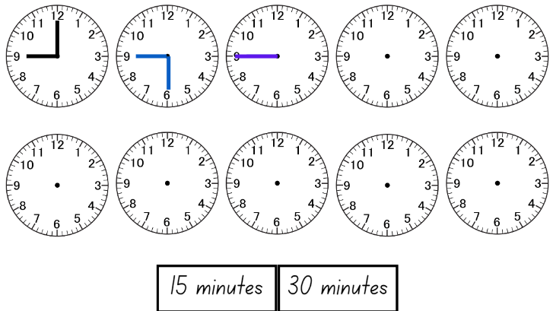
- Provide pairs of students with a copy of Resource 32 – clocks in a reusable sleeve and whiteboard markers.
- Once students have made it up to 11 o’clock, regroup and demonstrate how to extend the game to play ‘Time to Win’:
- Provide pair of students with Resource 33 – Time to Win in a reusable sleeve. Explain that this game is similar, but now players can add any of the 5 possibilities on their turn and draw the correct time on the clock. The game starts at a designated ‘quarter to...’ time, for example, a quarter to 9 o’clock. The players choose a time as a target, for example, a quarter to one o’clock.
- The first player to make it to the ‘quarter to...’ target time is the winner.
- Students play multiple rounds taking it in turns to go first.
This table details opportunities for differentiation.
Too hard? | Too easy?
Students cannot add time intervals and represent the time on an analog clock.  - Provide students with mini clocks to manipulate when adding the times before recoding.  - Allow students to only add hours and half hours starting at 9 o’clock and ending at 3 o’clock. The first student to reach 3 o’clock wins. | Students can add time intervals and represent the time on an analog clock.  - Challenge students to subtract time and aim to be the first player to read and record ‘quarter past...’.  - Students come up with another time possibility to add. For example, 25 minutes.
- Students use Resource 32 – clocks in a reusable sleeve. Tell students that the 2 hands on the clock make a right angle and the minute hand is on the 3. Ask students what the time might be.
- Students draw the possible times on Resource 32 – clocks.
- Select students to share and justify their answers, recording students’ responses.
- Continue with different times, hands on the clock and angles.

Stage 3 task – ISS mission control
The table below contains suggested learning intentions and success criteria. These are best co-constructed with students.
Core concept learning intentions | Core concept success criteria
Students are learning to:  - solve problems involving addition and subtraction of fractions with the same denominator  - compare 12- and 24-hour time systems and convert between them. | Students can:  - solve word problems that involve fractions with the same denominator  - use diagrams, objects and mental strategies to subtract a unit fraction from any whole number including one  - read, interpret and use timetables from real-life situations, involving 12- and 24-hour time.
This activity is an adaptation of ‘Time: Mission Control to ISS’ from reSolve: Maths by Inquiry by the Australian Government Department of Education.
- Display Figure 19 and ask what students already know about the International Space Station (ISS). Use the information provided to build their background knowledge.
Figure 19 – International Space Station
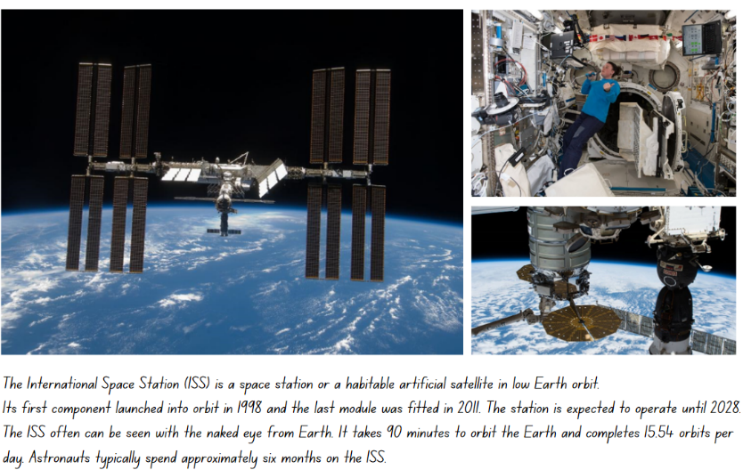
- Explain that students will use what they know about time and fractions to design a daily schedule for 3 astronauts on the ISS.
- Introduce fractions as another way of measuring and compare the lengths of times. Present Figure 20 and explain that a day can be represented as lengths on a bar model using fractions of time. For example, 24 hours can be partitioned using halves, quarters and eighths.
Figure 20 – 24-hour bar model
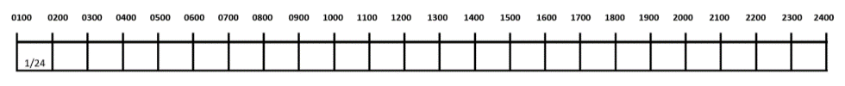
- Ask students to think of other fractions that 24 hours can be partitioned with, for example $\frac{1}{6}$ , $\frac{1}{12}$ or $\frac{1}{24}$. Remind students that they need to have the total number of fraction parts to represent a complete, or one, day.
- Use Resource 34 – ISS mission briefing 1 to show students that there are many parts of a space mission that need to be planned each day, both from mission control on the ground and the astronauts in space.
- Show Resource 35 – ISS mission briefing 2 and tell students that they will be working in mission control, in groups of 2 or 3 to design the daily schedule for the 3 astronauts. Explain that there are a range of tasks the astronauts must complete each day. Some of these can be done at different times, while some tasks need to be done by the 3 astronauts simultaneously.
- Provide students with a copy of Resource 36 – ISS mission briefing 3 and draw attention to the 3 fraction bars representing the 24 hours of a day. There is one for each of the astronauts to map their activities.
- Before working on the task, tell students that there is not one correct solution, but students should focus on meeting the criteria on Resource 36 – ISS mission briefing 3.
- Explain that once they have decided on their daily schedule for the astronauts, students need to calculate the length of time spent on different tasks each day as a fraction.
- Students begin working on the task with their partner or small group, using their copy of Resource 36 – ISS mission briefing 3 to record their thinking.
This table details opportunities for differentiation.
Too hard? | Too easy?
Students cannot solve word problems that involve fractions with the same denominator or interpret and use timetables involving 12- and 24-hour time.  - Support students to focus on developing a daily schedule for just one astronaut.  - Assist students to identify and count the fraction parts of the day, recording each activity as a total of the whole day. | Students can solve word problems that involve fractions with the same denominator or interpret and use timetables involving 12- and 24-hour time.  - Tell students that there has been a collision with some space junk and one of the panels needs to be repaired. This will take at least 6 hours and must be a priority. Students must quickly provide the astronauts with an updated schedule that allows all 3 of them to focus on the repairs, by prioritising critical tasks in their schedule for that day.

Discuss and connect the mathematics – 10 minutes
- Stage 3 students swap their ISS daily schedule with another group, checking to see if the criteria was met in each daily schedule.
- Regroup as a class and ask:
- What do ‘quarter past’ and ‘quarter to’ mean? (Stage 2)
- Did going first make a different in time to win? Why or why not? (Stage 2)
- What challenges did you face during the task? How did you overcome these? (Stage 2)
- Were the fractions of time on each task in the daily schedules the same for both groups? Why do you think this was? (Stage 3)
- How were the daily schedules different? (Stage 3)
- Is there a schedule that you think would be more helpful for the crew? Why or why not? (Stage 3)
- What is something you noticed about solving problems with time during this lesson? (Stage 3)
This table details opportunities for assessment.
Assessment opportunities | Links
What to look for:  - Can Stage 2 students recognise that the quarter-hour and five-minute intervals are used as benchmarks to read time on an analog clock? [MAO-WM-01, MA2-NSM-02]  - Can Stage 2 students Can students read analog clock as past the hour to half-past and then towards the hour?  [MAO-WM-01, MA2-NSM-02]  - Can Stage 3 students solve word problems that involve fractions with the same denominator? [MAO-WM-01, MA3-RQF-02]  - Can Stage 3 students use diagrams, objects and mental strategies to subtract a unit fraction from any whole number including 1? [MAO-WM-01, MA3-RQF-02]  - Can Stage 3 students read, interpret and use timetables from real-life situations, involving 12- and 24-hour time?  [MAO-WM-01, MA3-NSM-02] | Links to National Numeracy Learning Progressions (NNLP):  - Stage 2 – MeT3  - Stage 3 – InF7, InF8, MeT5.

Resource 1 – showing a turn
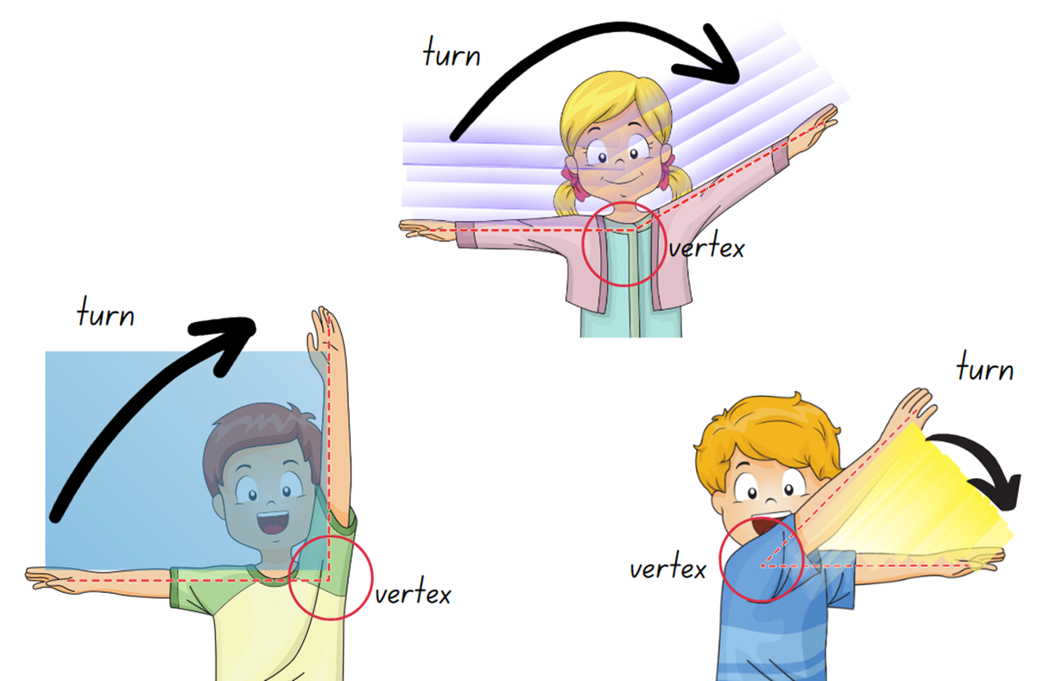

Resource 2 – exploring angles 1
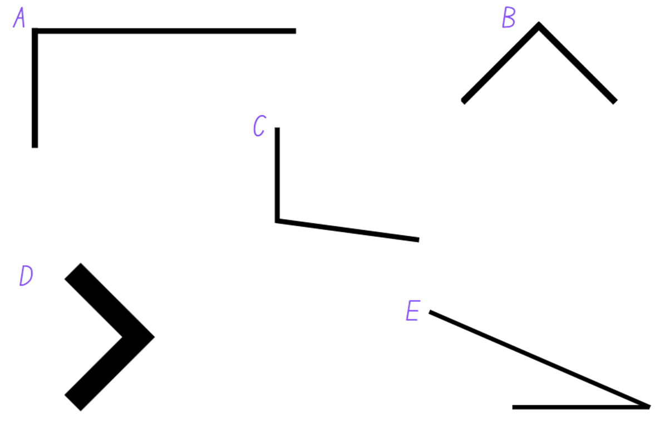

Resource 3 – angle categories
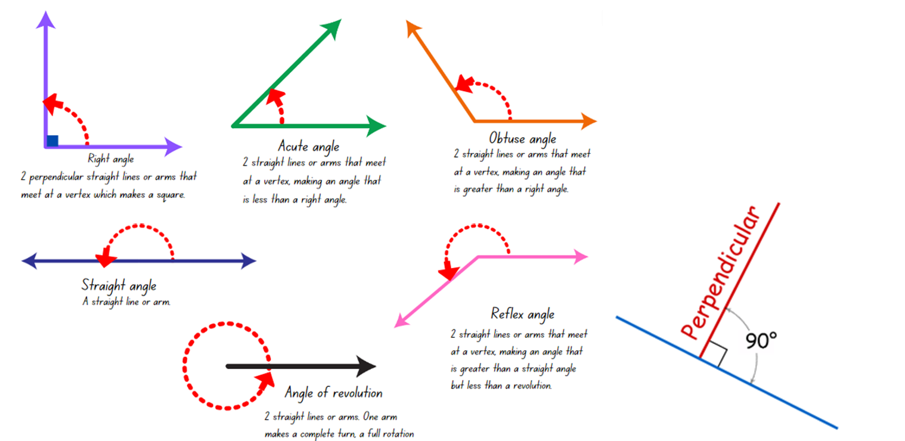

Resource 4 – angles are everywhere

Resource 5 – angle identifiers
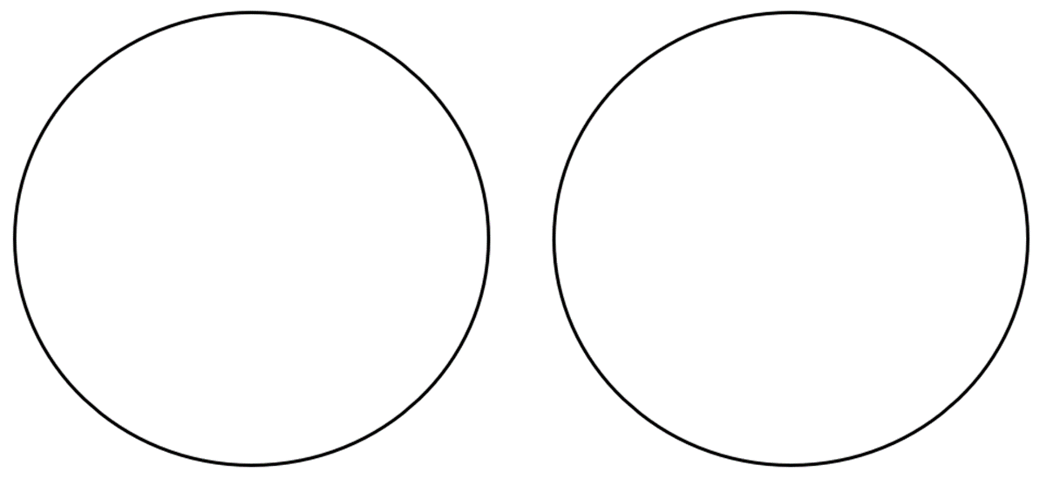

Resource 6 – angle instructions 1
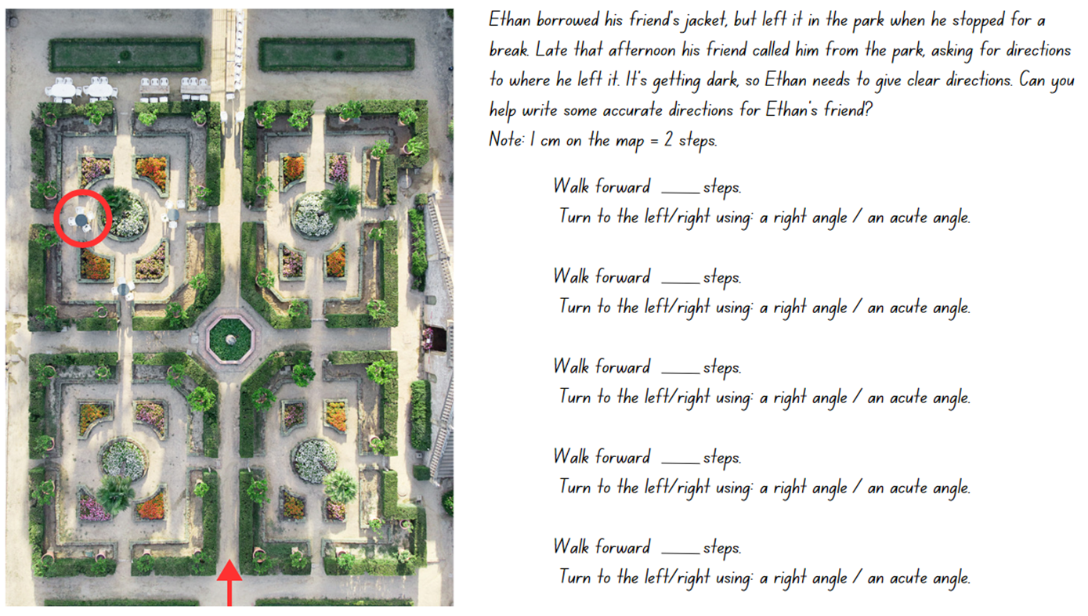

Resource 7 – exploring angles 2
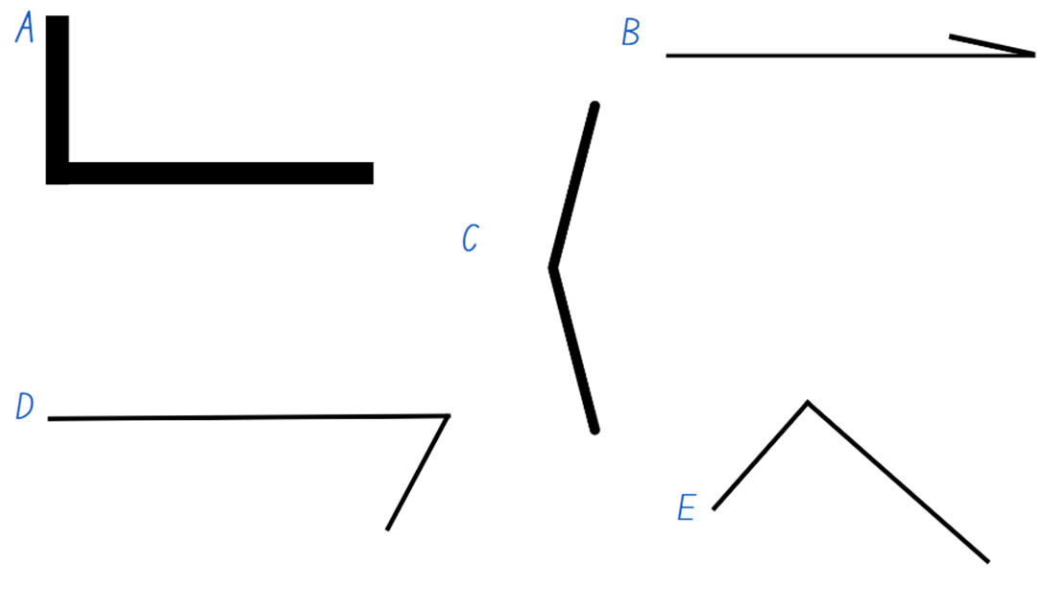

Resource 8 – angle wedges
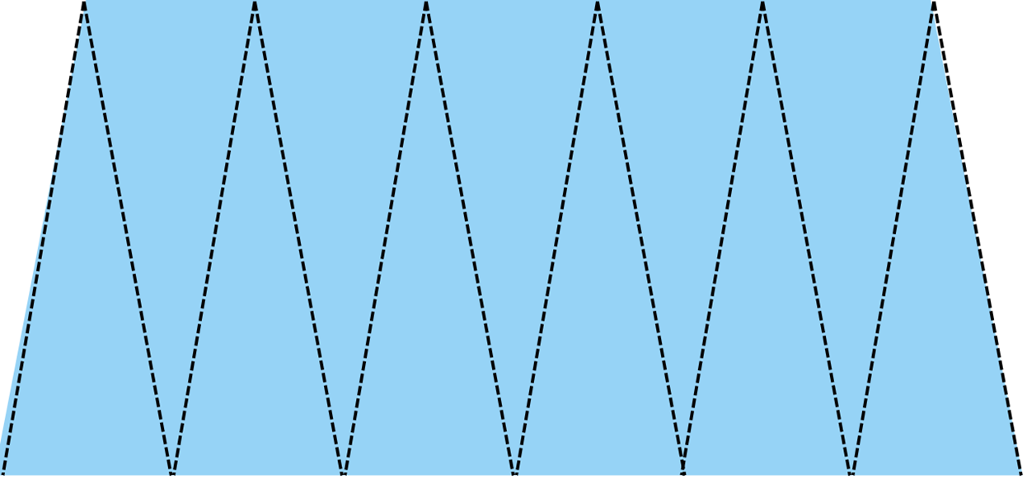

Resource 9 – measuring angles
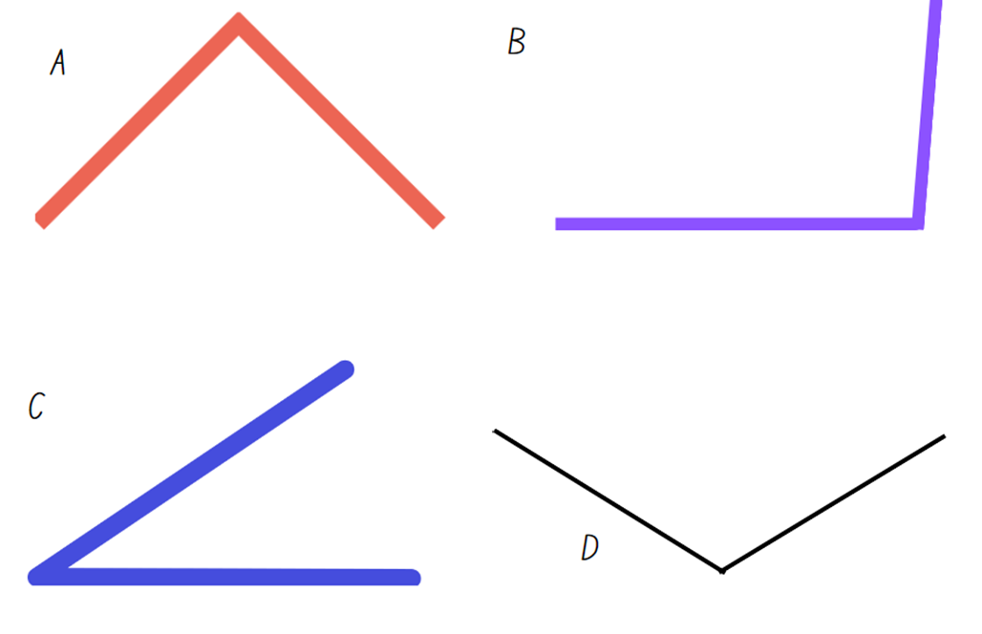

Resource 10 – a numberless protractor
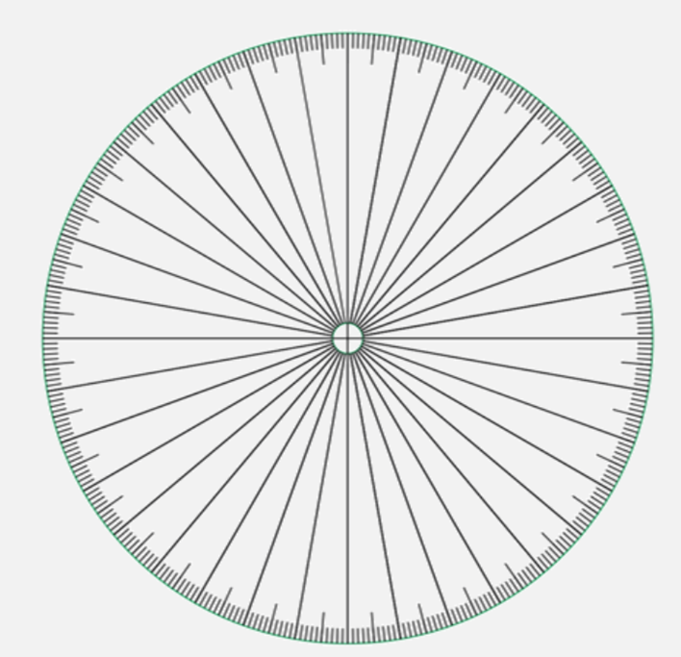
Source: ‘Empty protractor’ by Francome (2016).

Resource 11 – angle investigation 1
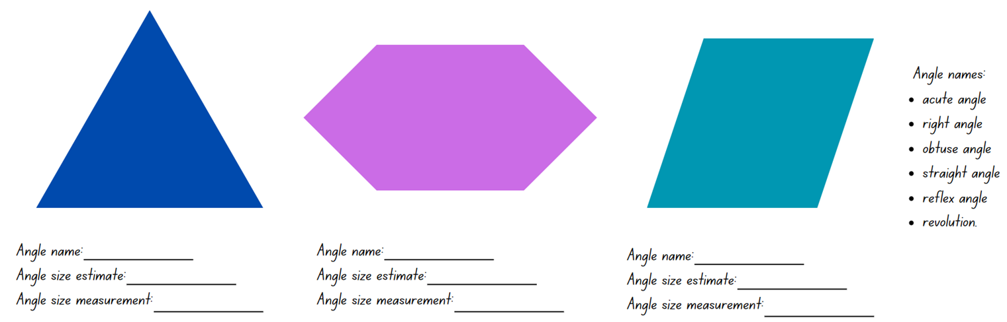

Resource 12 – fraction line
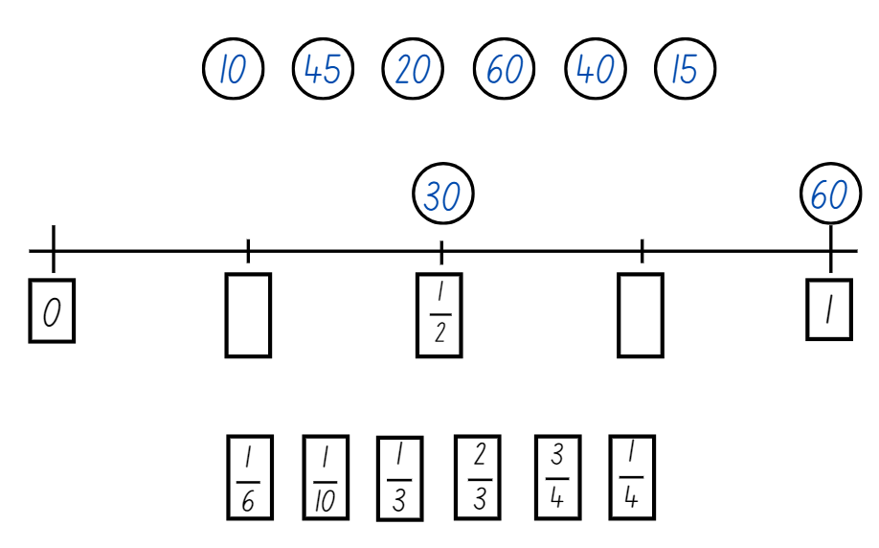

Resource 13 – who is winning
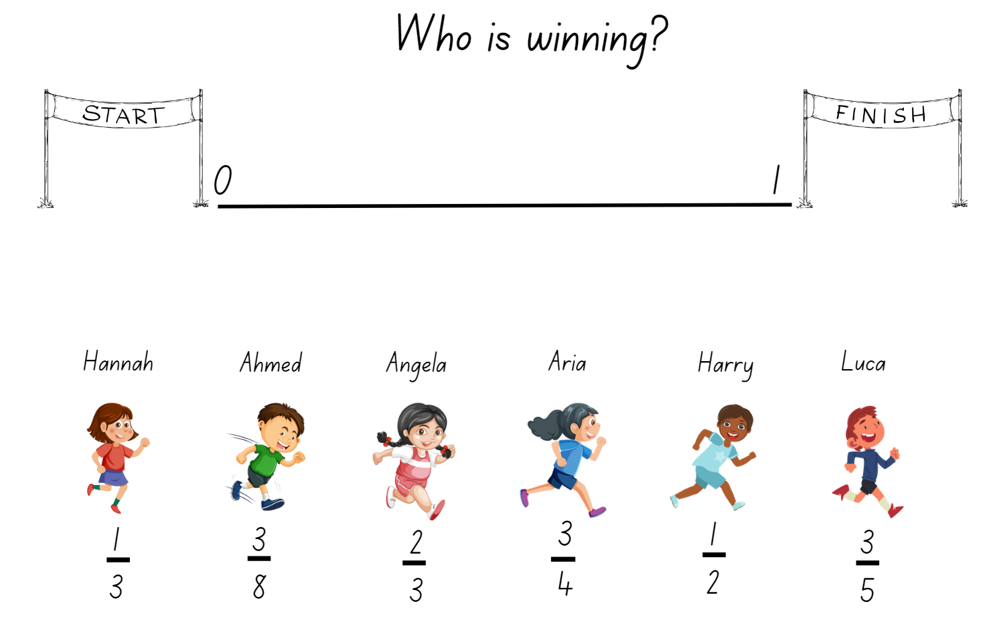

Resource 14 – using a protractor
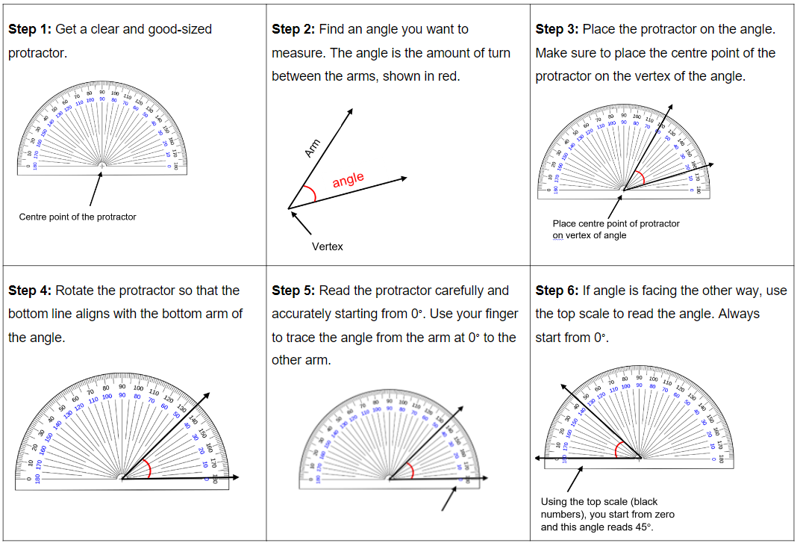

Resource 15 – measuring angles

Resource 16 – angles in art

Resource 17 – BMX bike geometry
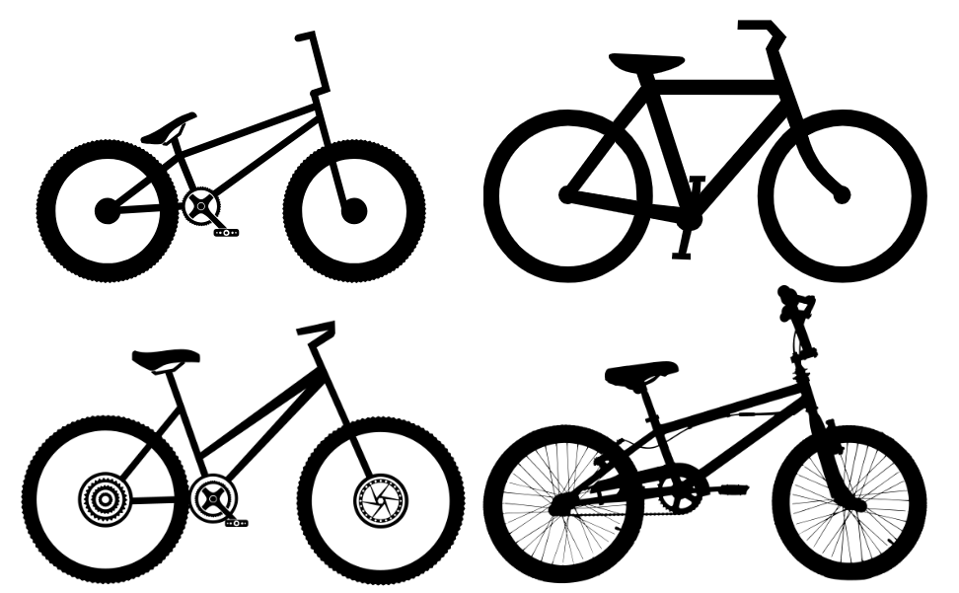

Resource 18 – mountain bike geometry
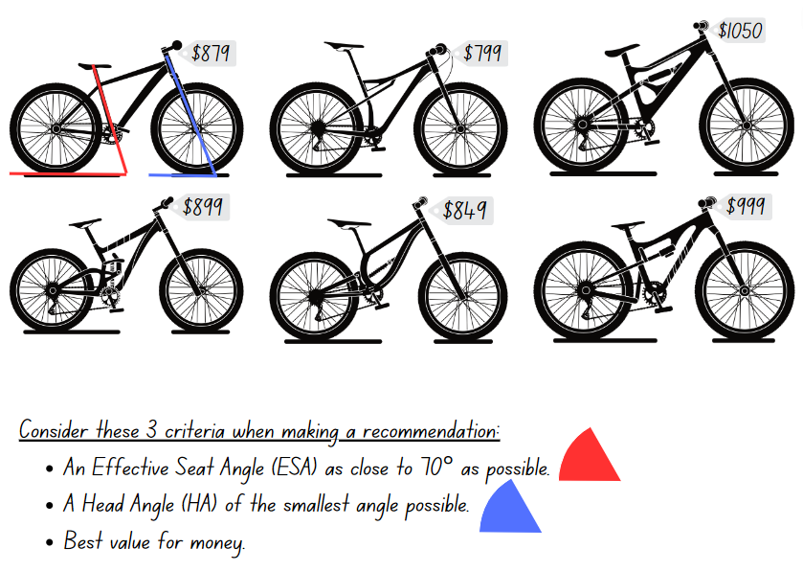

Resource 19 – angles in engineering

Resource 20 – number sentence board
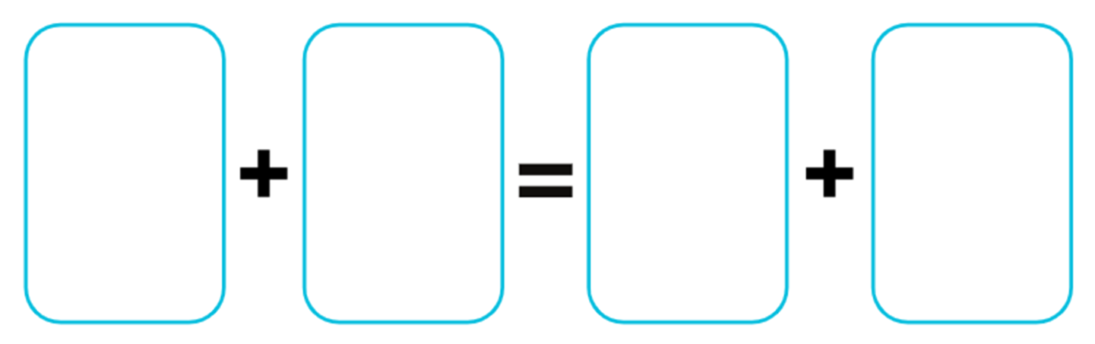

Resource 21 – analog clock template
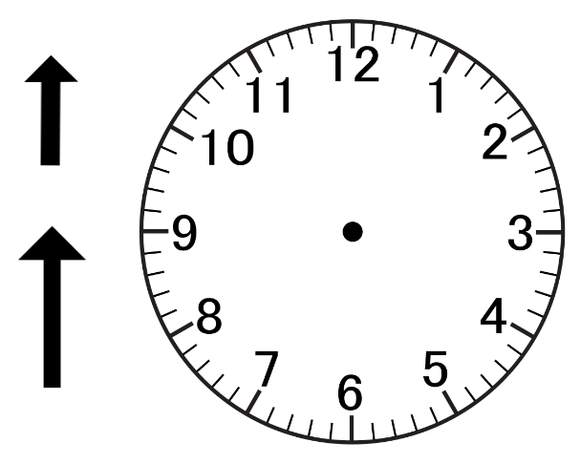

Resource 22 – converting times
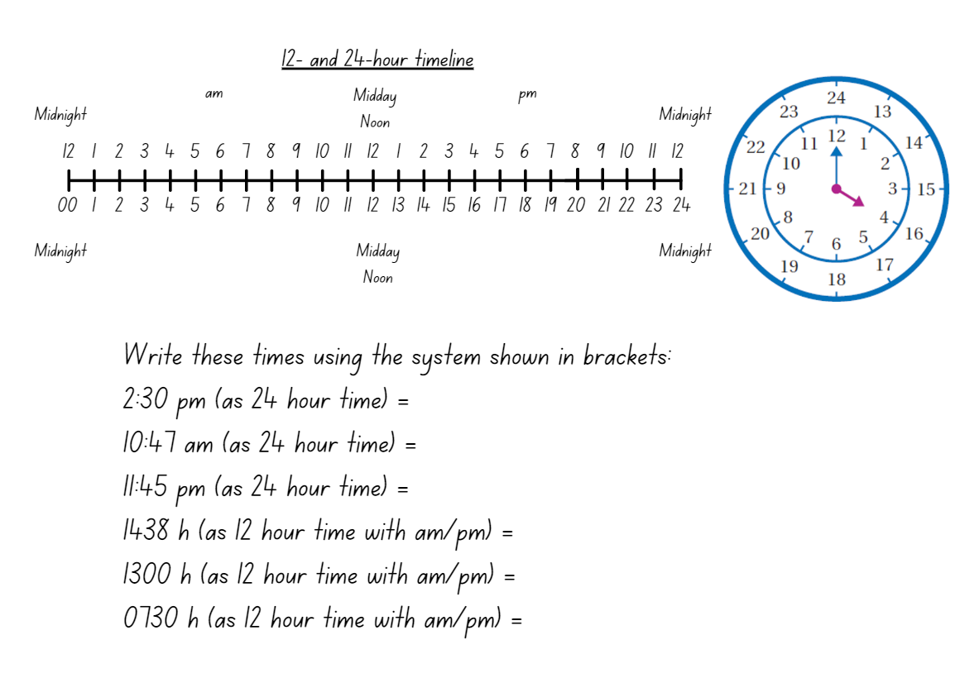

Resource 23 – clock fractions
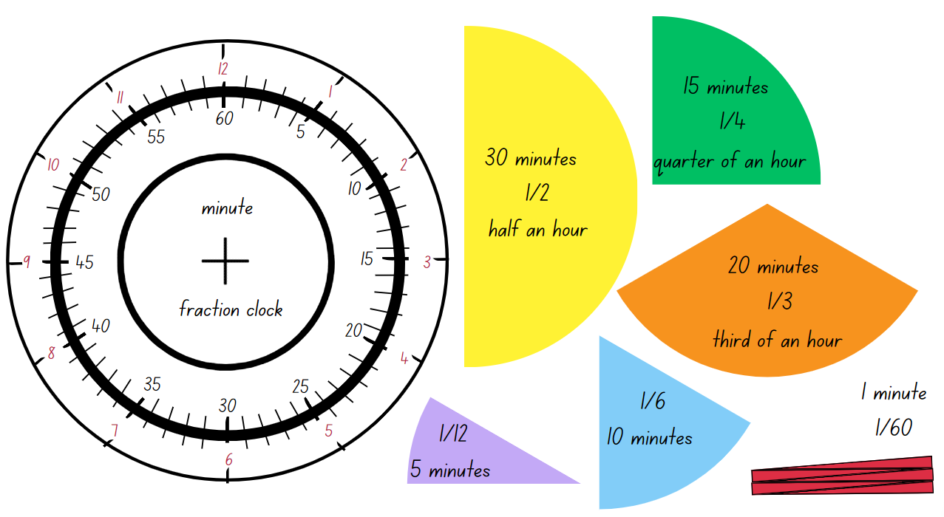

Resource 24 – reading the time
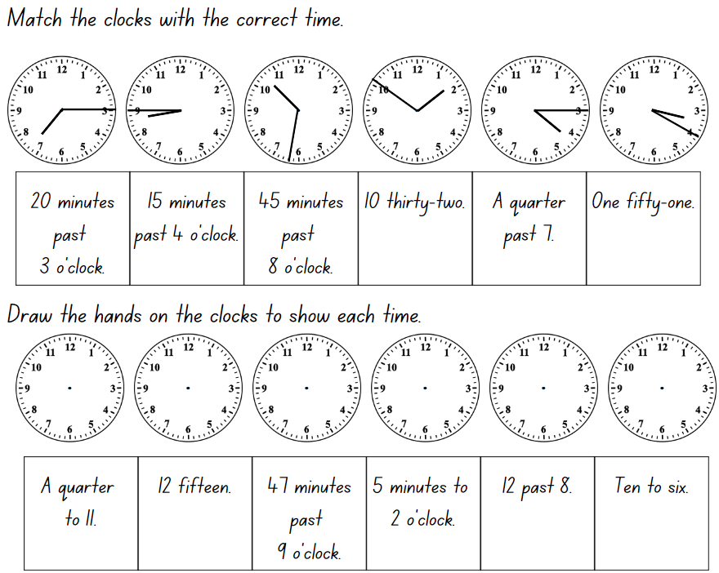

Resource 25 – timeline
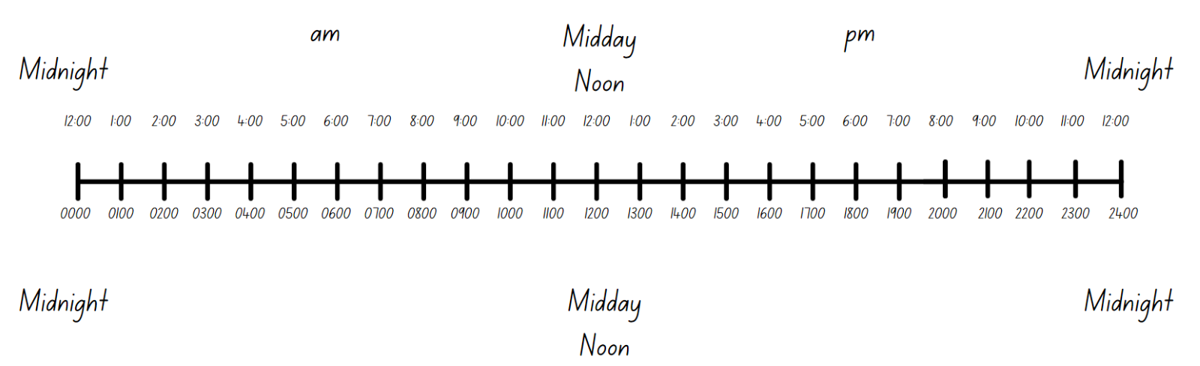

Resource 26 – time problems
Worded problem | Answer
Max had to set an alarm on his mobile phone for an appointment. He wanted to set the alarm for 4:30 pm. He had to set the time in 24-hour time. What time did he enter into his phone?
Adam works as a military officer. His boss told him to meet him at 1500 hours. Express this time as 12-hour time using correct notation.
John was looking at the train timetable and it said that the next train arrives at 1425. What is this in 12-hour time?
Adam’s flight departs at 1945, and he has to be at the airport 2 hours before to allow for check in time. What time does he need to be at the airport in 12-hour time?

Resource 27 – number sentences
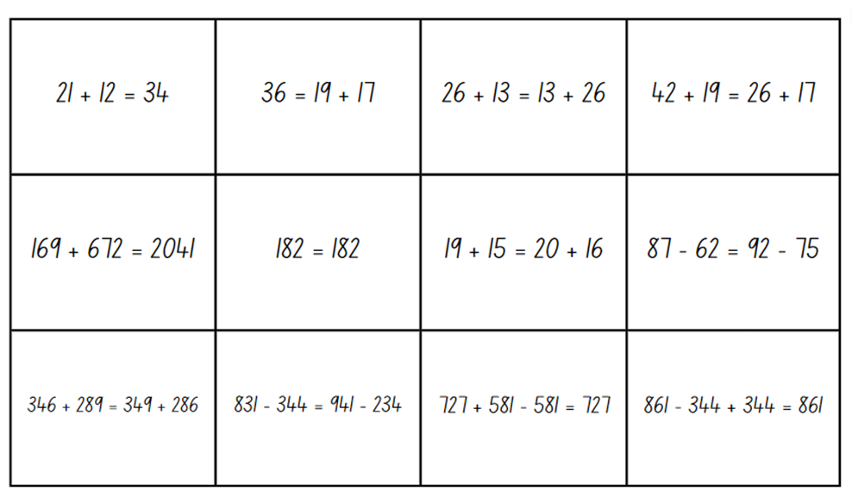

Resource 28 – think board template
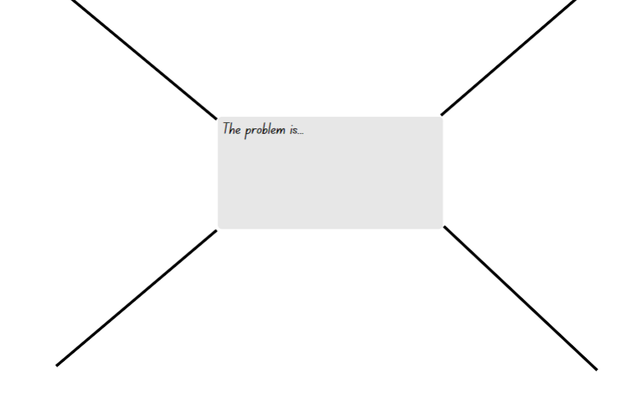

Resource 29 – problems with time
Mark had a piano lesson at quarter past four but he arrived at five o'clock. How late was Mark?
If it takes a quarter of an hour to walk to school from home, how long will it take to walk to school and back home again?
The bus timetable shows that there is a bus every 10 minutes. How many buses will there be in one hour?
A soccer game started at half past nine and the first half is 45 minutes. What time will it be when the first half is over?
Rose was baking biscuits. The recipe said to bake the biscuits for a quarter of an hour. If Rose put them in the oven at 11:45 what time does she need to take them out?
How many quarters of an hour are there in 3 hours?
The movie started at 6 o’clock and finished at half past seven. How long was the movie?

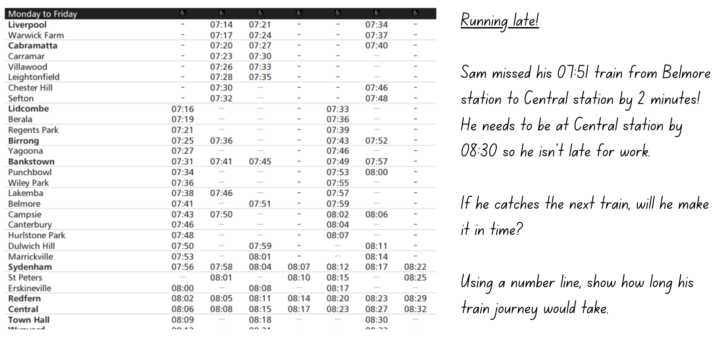
Resource 30 – train timetable

Resource 31 – television tonight
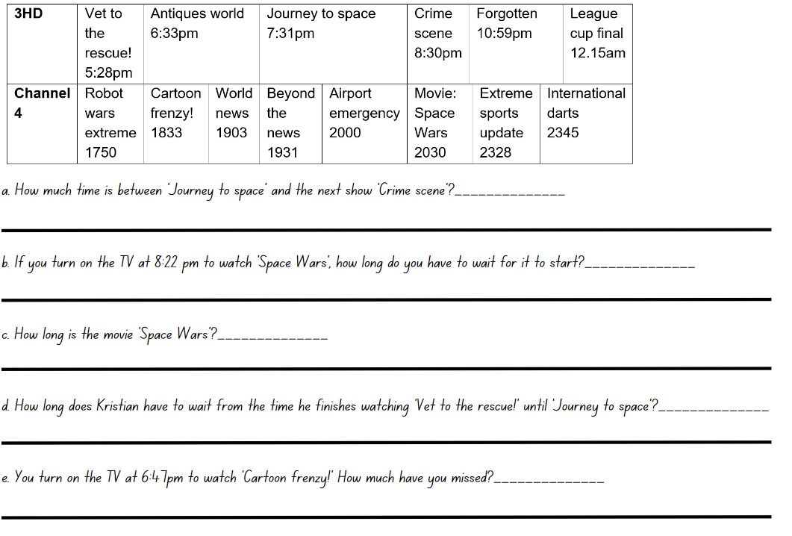

Resource 32 – clocks
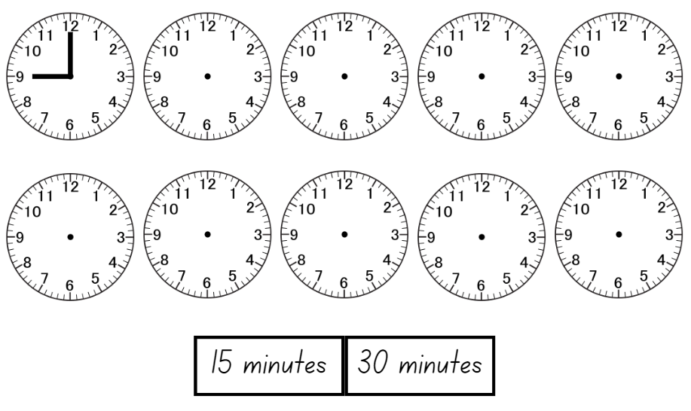

Resource 33 – time to win
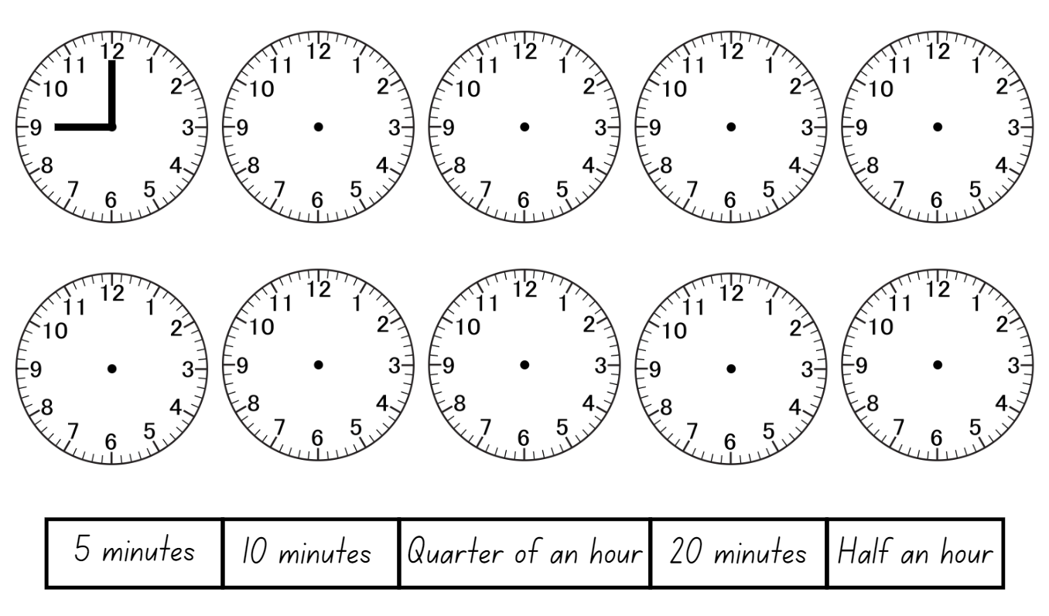

Resource 34 – ISS mission briefing 1
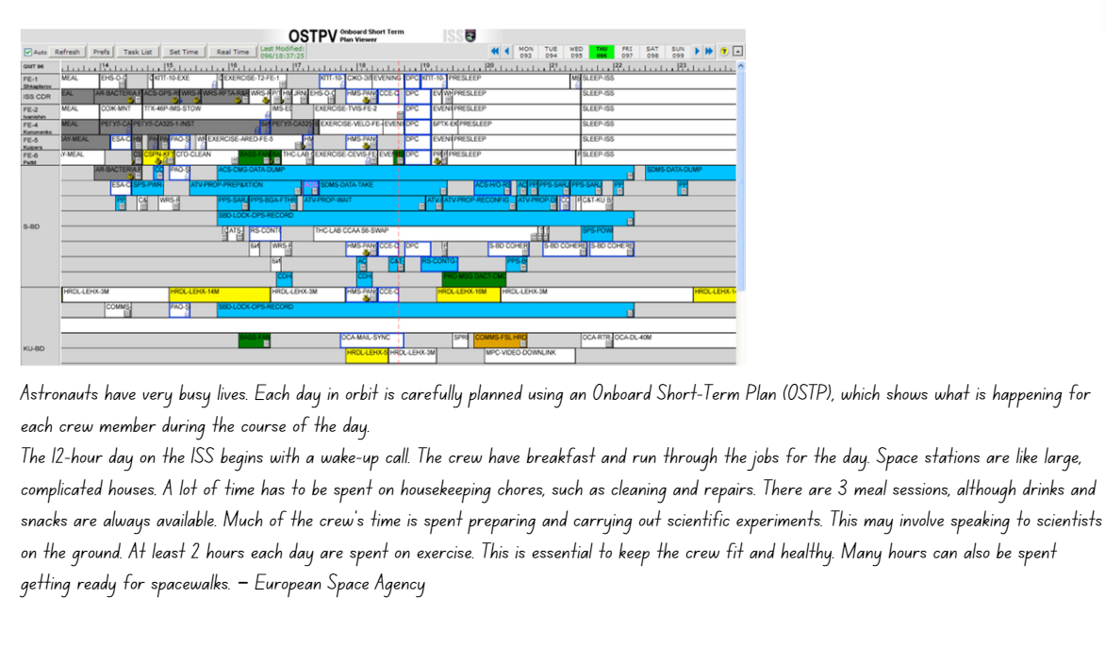

Resource 35 – ISS mission briefing 2
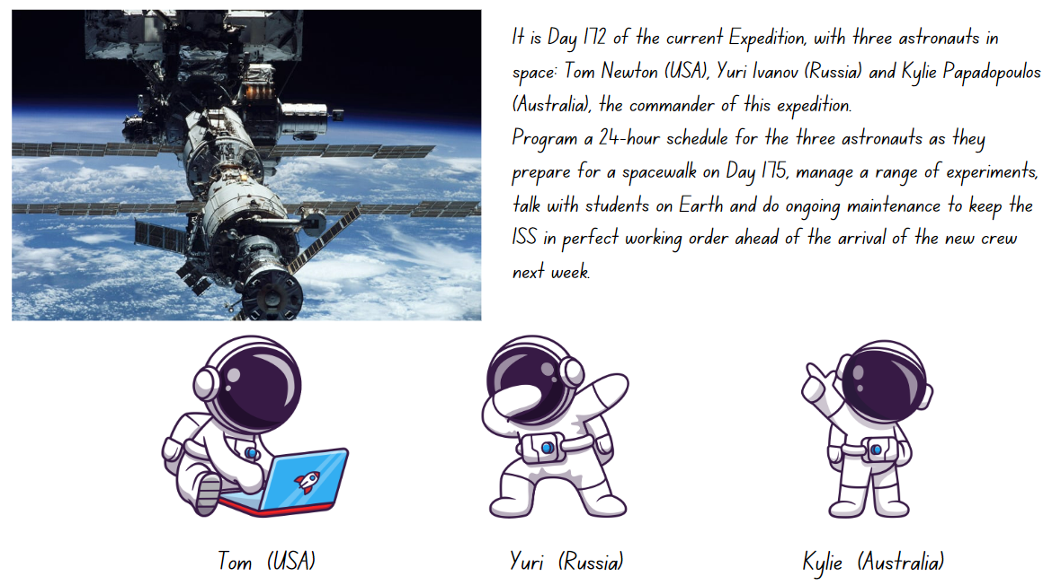

Resource 36 – ISS mission briefing 3
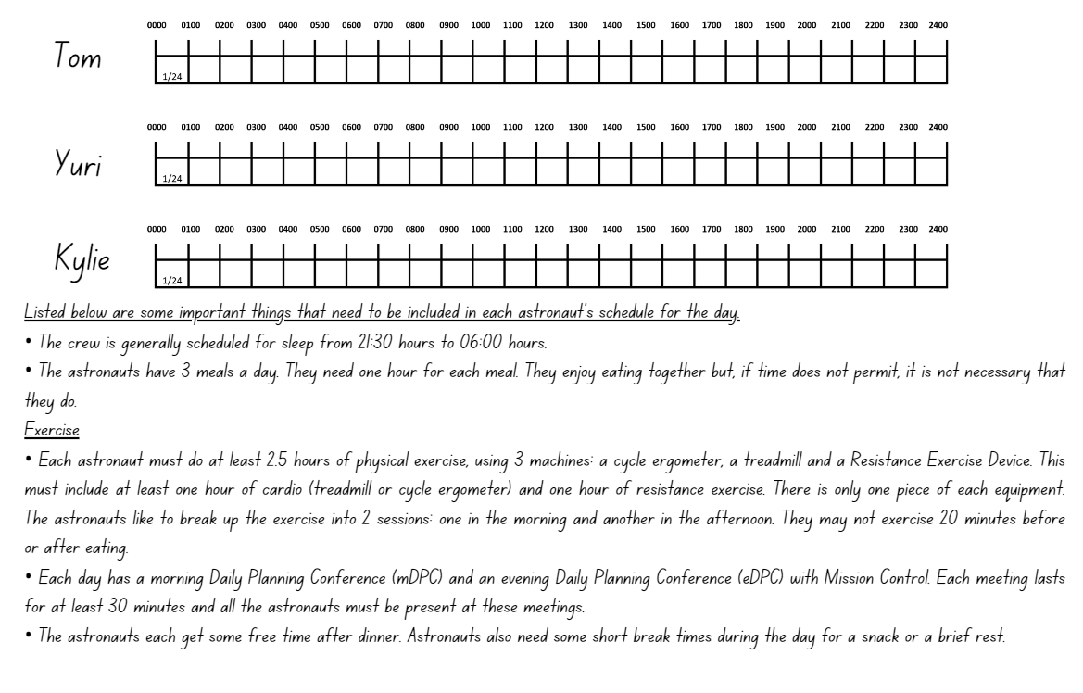

Syllabus outcomes and content

Stage 2
The table below outlines the syllabus outcomes and range of relevant syllabus content covered in this unit. Content is linked to National Numeracy Learning Progression version (3).
Outcomes and content | 1 | 2 | 3 | 4 | 5 | 6 | 7 | 8
Additive relations A: Use the principle of equality
[MAO-WM-01, MA2-AR-01, MA2-AR-02]
- Recognise equal differences and record them in number sentences |  |  |  |  | x | x | x
- Use the equals sign to mean ‘the same as’, rather than to perform an operation |  |  |  |  | x | x | x
- Apply the associative property of addition to forming multiples of 10 |  |  |  |  | x | x
Partitioned fractions A: Create fractional parts of a length using techniques other than repeated halving
[MAO-WM-01, MA2-PF-01]
- Make thirds of a length | x | x
- Create fifths of a length | x | x
Partitioned fractions A: Model and represent unit fractions, and their multiples, to a complete whole on a number line
[MAO-WM-01, MA2-PF-01]
- Model fractions with fraction strips and diagrams for halves, quarters, eighths, thirds | x | x | x
- Describe fraction families formed by dividing the whole into the same total number of equal parts as having the same denominator | x | x
Geometric measure A: Angles: Identify angles as measures of turn
[MAO-WM-01, MA2-GM-03]
- Identify angles with 2 arms in practical situations | x | x
- Identify the arms and vertex of an angle | x |  | x
- Recognise an angle as the amount of turning between 2 arms |  |  | x | x
- Compare angles and explain that the length of the arms does not affect the size of the angle |  |  | x | x
- Use the term right angle to describe a quarter-turn in a range of orientations | x |  | x
Non-spatial measure A: Time: Represent and read analog time
[MAO-WM-01, MA2-NSM-02]
- Use minutes to describe the duration of events |  |  |  |  |  |  | x
- Identify 30 minutes as being a half-hour and 60 minutes as an hour |  |  |  |  | x |  | x
- Connect the quarter-hour to 15 minutes |  |  |  |  | x |  | x
- Recognise that the position of the numerals on an analog timepiece often represents 2 different values |  |  |  |  |  | x
- Recognise that 5-minute intervals (corresponding to the hour markers) are used as benchmarks to read time on an analog clock |  |  |  |  |  | x |  | x
- Read time as past the hour to half-past and then towards the hour |  |  |  |  | x | x |  | x
- Read analog clocks to the minute |  |  |  |  | x | x
Mathematics K–10 Syllabus © NSW Education Standards Authority (NESA) for and on behalf of the Crown in right of the State of New South Wales, 2022.

Stage 3
The table below outlines the syllabus outcomes and range of relevant syllabus content covered in this unit. Content is linked to National Numeracy Learning Progression version (3).
Outcomes and content | 1 | 2 | 3 | 4 | 5 | 6 | 7 | 8
Additive relations A: Selects and applies appropriate strategies to solve addition and subtraction problems
[MAO-WM-01, MA3-AR-01]
- Apply known strategies such as levelling, addition for subtraction, using constant difference, and bridging (Reasons about relations) |  |  |  |  | x | x | x
- Use place value to add or subtract 3 or more numbers with different numbers of digits |  |  |  |  | x | x | x
- Identify efficient and inefficient multidigit subtraction strategies |  |  |  |  | x | x | x
Representing quantity fractions A: Compare and order common unit fractions
[MAO-WM-01, MA3-RQF-01, MA3-RQF-02]
- Compare unit fractions as numbers to the benchmark value $\frac{1}{2}$ | x | x | x
- Compare and order unit fractions with denominators of 2, 3, 4, 5, 6, 8 and 10 by placing them on a number line | x | x | x
Representing quantity fractions A: Solve problems involving addition and subtraction of fractions with the same denominator
[MAO-WM-01, MA3-RQF-01, MA3-RQF-02]
- Represent the sum of fractions with the same denominator, recreating the whole, where the result may exceed one | x | x | x
- Find the difference between fractions with the same denominator and interpret the answer | x | x | x
- Solve word problems that involve fractions with the same denominator |  |  |  |  |  |  |  | x
- Use diagrams, objects and mental strategies to subtract a unit fraction from any whole number including 1 (the complement principle) |  |  |  |  |  |  |  | x
Geometric measure A: Angles: Estimate, measure and compare angles using degrees
[MAO-WM-01, MA3-GM-03]
- Identify the arms and vertex of an angle where both arms are invisible, such as for rotations | x | x | x | x
- Explain how a protractor is formed and used to measure an angle |  | x | x
- Estimate and describe the size of angles using known angles as benchmark (Reasons about mental rotation) | x |  | x | x
- Record angle measurements using the symbol for degrees (°) |  |  | x | x
- Measure angles of up to 360° using a protractor |  |  | x | x
Geometric measure A: Angles: Use a protractor to measure and identify types of angles
[MAO-WM-01, MA3-GM-03]
- Identify and describe angle size in degrees for the classifications acute, obtuse and reflex |  | x | x
Non-spatial measure A: Time: Compare 12- and 24-hour time systems and convert between them
[MAO-WM-01, MA3-NSM-02]
- Recognise that 24-hour time is used to avoid confusion between am and pm |  |  |  |  | x
- Read time using appropriate 24-hour time language |  |  |  |  | x | x
- Convert between 24-hour time and 12-hour time using am or pm notation |  |  |  |  | x | x | x
- Read, interpret and use timetables from real-life situations, involving 12- and 24-hour time |  |  |  |  |  |  | x | x
Mathematics K–10 Syllabus © NSW Education Standards Authority (NESA) for and on behalf of the Crown in right of the State of New South Wales, 2022.

References
This resource contains NSW Curriculum and syllabus content. The NSW Curriculum is developed by the NSW Education Standards Authority. This content is prepared by NESA for and on behalf of the Crown in right of the State of New South Wales. The material is protected by Crown copyright.
Please refer to the NESA Copyright Disclaimer for more information https://educationstandards.nsw.edu.au/wps/portal/nesa/mini-footer/copyright.
NESA holds the only official and up-to-date versions of the NSW Curriculum and syllabus documents. Please visit the NSW Education Standards Authority (NESA) website https://educationstandards.nsw.edu.au/ and the NSW Curriculum website https://curriculum.nsw.edu.au/home.
Mathematics K–10 Syllabus © NSW Education Standards Authority (NESA) for and on behalf of the Crown in right of the State of New South Wales, 2022.
National Numeracy Learning Progression © Australian Curriculum, Assessment and Reporting Authority (ACARA) 2010 to present, unless otherwise indicated. This material was downloaded from the Australian Curriculum website (National Numeracy Learning Progression) (accessed 17 October 2023) and was not modified.
Australian Government Department of Education (2020) ‘Time: Mission Control to ISS’, Teaching resources, reSolve: Maths by Inquiry website, accessed 12 October 2023.
Francome T (2016) Empty protractor [PDF 539 KB], Association of Teachers of Mathematics, accessed 12 October 2023.
Merrill J (2022) Time to Win, The Mathematical Isles of What If...? website, accessed 12 October 2023.
New Zealand Ministry of Education (n.d.) ‘Clock wise (time)’, Resource Finder, NZ Maths website, accessed 12 October 2023.
Russo J (2021) ‘Let’s Play… Number Sentences’, Prime Number, 36(2):4–5, accessed 12 October 2023.
Siemon D, Warren E, Beswick K, Faragher R, Miller J, Horne M, Jazby D, Breed M, Clark J and Brady K (2021) Teaching Mathematics: Foundations to Middle Years, 3rd edn, Oxford University Press Australia and New Zealand.
University of Cambridge (Faculty of Mathematics) (n.d.) Dicey Operations in Line, NRICH website, accessed 12 October 2023.
University of Cambridge (Faculty of Mathematics) (n.d.) Stop the Clock, NRICH website, accessed 12 October 2023.
University of Cambridge (Faculty of Mathematics) (n.d.) True or False?, NRICH website, accessed 12 October 2023.
University of Cambridge (Faculty of Mathematics) (n.d.) What Is the Time?, NRICH website, accessed 12 October 2023.
University of Cambridge (Faculty of Mathematics) (n.d.) Wonky Watches, NRICH website, accessed 12 October 2023.
Van de Walle J, Karp K, Bay-Williams JM, Brass A, Bentley B, Ferguson S, Goff W, Livy S, Marshman M, Martin D, Pearn C, Prodromou T, Symons D and Wilkie K (2019) Primary and Middle Years Mathematics: Teaching Developmentally, 1st Australian edn, Pearson Education Australia, Melbourne.

© State of New South Wales (Department of Education), 2024
The copyright material published in this resource is subject to the Copyright Act 1968 (Cth) and is owned by the NSW Department of Education or, where indicated, by a party other than the NSW Department of Education (third-party material).
Copyright material available in this resource and owned by the NSW Department of Education is licensed under a Creative Commons Attribution 4.0 International (CC BY 4.0) license.
This license allows you to share and adapt the material for any purpose, even commercially.
Attribution should be given to © State of New South Wales (Department of Education), 2024.
Material in this resource not available under a Creative Commons license:
- the NSW Department of Education logo, other logos and trademark-protected material
- material owned by a third party that has been reproduced with permission. You will need to obtain permission from the third party to reuse its material.
Links to third-party material and websites
Please note that the provided (reading/viewing material/list/links/texts) are a suggestion only and implies no endorsement, by the New South Wales Department of Education, of any author, publisher, or book title. School principals and teachers are best placed to assess the suitability of resources that would complement the curriculum and reflect the needs and interests of their students.
If you use the links provided in this document to access a third-party's website, you acknowledge that the terms of use, including licence terms set out on the third-party's website apply to the use which may be made of the materials on that third-party website or where permitted by the Copyright Act 1968 (Cth). The department accepts no responsibility for content on third-party websites.

