Mathematics Stage 2 – Year B – Unit 24

Fractions represent multiple ideas and can be represented in different ways

Contents

Unit description and duration 5

Syllabus outcomes 5

Working mathematically 6

Student prior learning 6

Lesson overview and resources 8

Lesson 1 13

Daily number sense – equivalent to half – 15 minutes 13

Core lesson 1 – missing lengths – 20 minutes 16

Core lesson 2 – recreating the whole – 20 minutes 17

Consolidation and meaningful practice – 10 minutes 18

Lesson 2 20

Daily number sense – equivalent fractions – 10 minutes 20

Core lesson – fractions on a number line – 40 minutes 22

Discuss and connect the mathematics – 10 minutes 26

Lesson 3 27

Daily number sense – fractions towers – 15 minutes 27

Core lesson – fraction towers – 40 minutes 28

Discuss and connect the mathematics – 10 minutes 31

Lesson 4 32

Daily number sense – 10 minutes 32

Core lesson 1 – worm wonderings – 10 minutes 32

Core lesson 2 – snail racing – 30 minutes 33

Discuss and connect the mathematics – 10 minutes 35

Lesson 5 38

Daily number sense – make 500 000 (part 1) – 15 minutes 38

Core lesson – making and exceeding the whole – 30 minutes 40

Consolidation and meaningful practice – 15 minutes 44

Lesson 6 46

Daily number sense – make 500 000 (part 2) – 15 minutes 46

Core lesson – fractional quantities greater than one – 40 minutes 47

Discuss and connect the mathematics – 5 minutes 50

Lesson 7 52

Daily number sense – jumbled number words – 15 minutes 52

Core lesson – number lines extend beyond one – 35 minutes 53

Discuss and connect the mathematics – 10 minutes 55

Lesson 8 57

Daily number sense – 10 minutes 57

Core lesson – blank number lines – 45 minutes 57

Discuss and connect the mathematics – 5 minutes 60

Resource 1 – fraction wall 62

Resource 2 – missing lengths 63

Resource 3 – frog racing 64

Resource 4 – tower fractions 65

Resource 5 – tower number lines 66

Resource 6 – student work sample 67

Resource 7 – snail racing 68

Resource 8 – Which one doesn’t belong? 69

Resource 9 – place value houses 70

Resource 10 – ‘Rob the nest’ score sheet 71

Resource 11 – beanbag scoresheet 72

Resource 12 – ribbon lengths 73

Resource 13 – What’s the number? 74

Resource 14 – number lines 0–2 (a) 75

Resource 15 – number lines 0–2 (b) 76

Resource 16 – thirds on a number line 77

Resource 17 – blank number lines 78

Resource 18 – roll a whole 79

Syllabus outcomes and content 80

References 83

# Unit description and duration

This unit develops the big idea that fractions represent multiple ideas and can be represented in different ways.

In this 2-week unit students are provided opportunities to:

* partition, label and compare lengths and wholes using fractions
* find complementary fractions to make a whole length
* explore equivalence and multiplicative relationships of fractions.

## Syllabus outcomes

* **MAO-WM-01** develops understanding and fluency in mathematics through exploring and connecting mathematical concepts, choosing and applying mathematical techniques to solve problems, and communicating their thinking and reasoning coherently and clearly
* **MA2-RN-01** applies an understanding of place value and the role of zero to represent numbers to at least tens of thousands
* **MA2-MR-01** represents and uses the structure of multiplicative relations to 10 × 10 to solve problems
* **MA2-PF-01** represents and compares halves, quarters, thirds and fifths as lengths on a number line and their related fractions formed by halving (eighths, sixths and tenths)

## Working mathematically

In the Mathematics K–10 Syllabus, there is one overarching Working mathematically outcome (**MAO-WM-01**). The Working mathematically processes should be embedded within the concepts being taught. The Working mathematically processes present in the Mathematics K–10 Syllabus are:

* communicating
* understanding and fluency
* reasoning
* problem solving.

[Mathematics K–10 Syllabus](https://curriculum.nsw.edu.au/learning-areas/mathematics/mathematics-k-10-2022/overview) © NSW Education Standards Authority (NESA) for and on behalf of the Crown in right of the State of New South Wales, 2022.

## Student prior learning

Before engaging in these teaching and learning activities, students would benefit from prior experience with:

* creating fractional and complementary parts of a length
* modelling, labelling and describing fractions through fraction strips and fraction walls
* recreating the whole from a fractional part.

In NSW classrooms there is a diverse range of students, including Aboriginal and/or Torres Strait Islander students, students learning English as an additional language or dialect, high potential and gifted students and students with disability. Some students may identify with more than one of these groups or possibly all of them. Refer to [Curriculum planning for every student – advice](https://education.nsw.gov.au/teaching-and-learning/curriculum/planning-programming-and-assessing-k-12/advice-on-curriculum-planning-for-every-student-k-12) for further information.

# Lesson overview and resources

The table below outlines the sequence and approximate timing of lessons, learning intentions and resources.

|  |  |  |
| --- | --- | --- |
| Lesson | Content | Duration and resources |
| **Lesson 1**  **Daily number sense learning intention:**   * model equivalent fractions as lengths | **Lesson core concept**: recreating a whole from a fractional part.  **Core concept learning intentions**:   * model and represent unit fractions to complete a whole * model equivalent fractions as lengths | **Lesson duration**: 65 minutes   * Resource 1 – fraction wall * Resource 2 – missing lengths * Paper strips (4 cm in length) * Writing materials |
| **Lesson 2**  **Daily number sense learning intention:**   * model equivalent fractions as lengths | **Lesson core concept**: number lines are models used to represent fractions.  **Core concept learning intentions**:   * model and represent unit fractions, and their multiples, to a complete whole on a number line * model equivalent fractions as lengths | **Lesson duration**: 60 minutes   * Resource 1 – fraction wall * Resource 3 – frog racing * Website: [Amplify Polypad – Fraction Bars](https://polypad.amplify.com/p#fraction-bars) * Digital device (one per student) * Small strips of paper * Writing materials |
| **Lesson 3**  **Daily number sense learning intention:**   * model and represent unit fractions, and their multiples, to a complete whole on a number line | **Lesson core concept**: equivalent fractions have related denominators.  **Core concept learning intention**:   * model equivalent fractions as lengths | **Lesson duration**: 65 minutes   * Resource 4 – tower fractions * Resource 5 – tower number lines * Resource 6 – student work sample * Coloured markers * Interlocking cubes * Writing materials |
| **Lesson 4**  **Daily number sense learning intention:**   * teacher-identified task based on student needs | **Lesson core concept**: equal wholes are needed to compare partitioned fractions.  **Core concept learning intentions**:   * create fractional parts of a length using techniques other than repeated halving * model equivalent fractions as lengths | **Lesson duration**: 60 minutes   * Resource 7 – snail racing * Resource 8 – Which one doesn’t belong? * Strips of paper (4 per student) * Writing materials |
| **Lesson 5**  **Daily number sense learning intention:**   * apply place value to partition, regroup and rename numbers up to 6 digits | **Lesson core concept**: making and exceeding the whole.  **Core concept learning intentions**:   * represent fractional quantities greater than one whole | **Lesson duration**: 60 minutes   * Resource 9 – place value houses * Resource 10 – ‘Rob the nest’ score sheet * Resource 11 – beanbag scoresheet * 9-sided dice (one per student) * Coloured beanbags * Hoops * Writing materials |
| **Lesson 6**  **Daily number sense learning intention:**   * apply place value to partition, regroup and rename numbers up to 6 digits | **Lesson core concept**: understanding fractional quantities greater than one.  **Core concept learning intention**:   * represent fractional quantities equal to and greater than one | **Lesson duration**: 60 minutes   * Resource 9 – place value houses * Resource 12 – ribbon lengths * 9-sided dice (one per student) * A4 paper * Scissors * Writing materials |
| **Lesson 7**  **Daily number sense learning intention:**   * apply place value to partition, regroup and rename numbers up to 6 digits | **Lesson core concept**: number lines extend beyond one.  **Core concept learning intentions**:   * model and represent unit fractions, and their multiples to a complete whole on a number line * represent fraction quantities equal to and greater than one | **Lesson duration**: 60 minutes   * Resource 13 – What’s the number? * Resource 14 – number lines 0–2 (a) (A3 copy) * Resource 15 – number lines 0–2 (b) * Resource 16 – thirds on a number line * 6-sided dice (one per student) * Transparent counters * 12-sided dice * Writing materials |
| **Lesson 8**  **Daily number sense learning intention:**   * teacher-identified task based on student needs | **Lesson core concept**: fractional quantities can be greater than one.  **Core concept learning intention**:   * represent fractional quantities equal to and greater than one | **Lesson duration**: 60 minutes   * Resource 14 – number lines 0–2 (a) (on A3 paper) * Resource 17 – blank number lines * Resource 18 – roll a whole * Transparent counters * 6-sided dice * MAB mini cubes * Writing materials |

# Lesson 1

**Core concept**: recreating the whole from a fractional part.

## Daily number sense – equivalent to half – 15 minutes

Daily number sense activities for Lessons 1 to 3 ‘activate’ prior number knowledge and support the learning of new content in the unit. These activities can also assist teachers to identify the starting points for learning by revealing the extent of students’ existing knowledge.

The table below contains a suggested learning intention and success criteria. These are best co-constructed with students.

|  |  |
| --- | --- |
| Daily number sense learning intention | Daily number sense success criteria |
| Students are learning to:   * model equivalent fractions as lengths. | Students can:   * identify equivalent fractions equal to one-half. |

1. Revise that when a whole length is divided into 2 equal parts, each of those parts is named one-half.
2. Ask students to recall the name of the parts when a whole length is partitioned into 3, 4 and 8 equal parts.
3. Write $\frac{1}{2}$ on the board. Revise that when writing half with fraction notation, the 2 shows how much the whole is (2 parts) and the 1 shows how many equal parts of the whole are selected (1 part) (see Figure 1).

Figure 1 – fraction notation

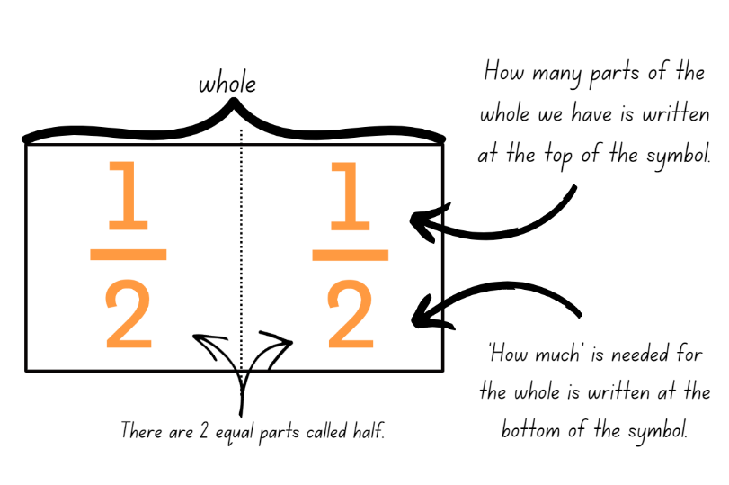

**Note:** use language that will assist students to develop early fraction ideas. For example, rather than saying ‘1 over 2’, ‘1 of 2’ or ‘1 on 2’ (describing the symbol only) say ‘one half of the whole strip’. The teaching advice states that the terms numerator and denominator are used in Stage 3.

1. Discuss the relationship between the numerals in the fraction representing one-half. Guide students to understand that, if the fraction is equal to half, the number of parts we have (numerator) is always half the number representing how much is needed for the whole (denominator).
2. Explain that this set of fractions which represent the same value, such as all fractions equal to one-half, are called equivalent fractions.
3. Provide students with individual whiteboards. Display Resource 1 – fraction wall.
4. Ask students to find fractions equivalent to one-half and record the fractional notation on their whiteboards.
5. Ask students to think of examples which are equivalent to one-half that are not shown on the fraction wall. Students record their ideas using fraction notation, concrete materials, diagrams or number lines.
6. Students share and explain their reasoning.
7. Explain that these fractions have a multiplicative relationship to each other as the number of parts we have is always exactly half of the number of parts that make the whole. For example, a student may reason that $\frac{10}{20}$ is equivalent to one-half because if 20 parts are divided into 2 equal groups, each group will have 10 parts.

This table details opportunities for assessment.

|  |  |
| --- | --- |
| Assessment opportunities | Links |
| What to look for:   * Can **students identify equivalent fractions to one-half?  [MAO-WM-01, MA2-PF-01]** | Links to [National Numeracy Learning Progressions](https://www.australiancurriculum.edu.au/resources/national-literacy-and-numeracy-learning-progressions/version-3-of-national-literacy-and-numeracy-learning-progressions/) (NNLP):   * InF5. |

## Core lesson 1 – missing lengths – 20 minutes

The table below contains suggested learning intentions and success criteria. These are best co-constructed with students.

|  |  |
| --- | --- |
| Core concept learning intentions | Core concept success criteria |
| Students are learning to:   * model and represent unit fractions to complete a whole * model equivalent fractions as lengths. | Students can:   * recreate the whole from a fractional part * determine the complementary fractional part needed to complete one whole (halves, quarters, eighths, thirds) * recognise the need to have equal wholes to compare partitioned fractions. |

1. Display Resource 2 – missing lengths and ask:

* How could you find the missing fractional part for each length of skipping rope?
* Which skipping rope would be the longest and which would be the shortest? How do you know?
* Ezekial stated that the red rope must be the longest because a half is bigger than a third or a quarter. Is he correct? Why or why not?

1. Provide students with Resource 2 – missing lengths. Students determine the length of each skipping rope.
2. Explain that the size of the fractional parts is dependent on the length of the whole.
3. Invite students to share their strategies and their work samples to determine which skipping rope is the longest and which is the shortest.

## Core lesson 2 – recreating the whole – 20 minutes

1. Provide students with a small strip of paper approximately 3 cm in length and writing materials. Use the same strip with each fraction question.
2. Pose the following and ask students to represent their thinking by drawing labelled diagrams:

* If the strip is one-half, how long is the whole?
* If your strip is one-third of the whole, how long is the whole?
* If your strip is one-sixth of the whole, label two-sixths, three-sixths, four-sixths, five-sixths and six-sixths of the whole.
* If your strip is enough to make 3 wholes, draw how long one whole would be?

1. Encourage students to come up with 2 questions of their own for a friend to solve.

This table details opportunities for differentiation.

|  |  |
| --- | --- |
| Too hard? | Too easy? |
| Students cannot recreate the whole from a fractional part or determine the complementary fractional part needed to complete one whole (halves, quarters, eighths, thirds).   * Provide students with a strip of paper the length of a third of the green rope, a quarter or the blue rope and half of the red rope. Show students how to use the strips to iterate the length and mark the fractional parts needed to make the whole length of each rope. | Students can recreate the whole from a fractional part or determine the complementary fractional part needed to complete one whole (halves, quarters, eighths, thirds).   * Students solve problems that extend beyond the whole. For example: * If your strip is enough to make 1 $\frac{1}{2}$, how long is one strip? * If your strip is one-third of a whole what is five-thirds? |

## Consolidation and meaningful practice – 10 minutes

1. Pose the following problem: Mikayla got $\frac{1}{4}$ of a chocolate bar. Elayna got $\frac{1}{3}$ of a chocolate bar. Mikayla says her piece is bigger. How is this possible?
2. Students use writing materials to justify their thinking with a labelled diagram.

**Note:** encourage students to use appropriate fractional language to reason and solve this problem. Key terminology related to this activity could include whole, equal wholes, dependent on the whole, fractional part, thirds, quarters. Justification of this solution would include: one quarter can be bigger than one third because the size of the part depends on the size of the whole or Mikayla could be right because her chocolate might be a different size to Elayna’s and only fractional parts of the same sized whole can be compared.

1. Engage students in a discussion about how the size of the whole determines the size of the fractional parts.

This table details opportunities for assessment.

|  |  |
| --- | --- |
| Assessment opportunities | Links |
| What to look for:   * **Can students recreate the whole from a fractional part?  [MAO-WM-01, MA2-PF-01]** * Can students determine the complementary fractional part needed to complete one whole (halves, quarters, eighths, thirds)?  **[MAO-WM-01, MA2-PF-01]** * Can students recognise the need to have equal wholes to compare partitioned fractions? **[MAO-WM-01, MA2-PF-01]** | Links to [National Numeracy Learning Progressions](https://www.australiancurriculum.edu.au/resources/national-literacy-and-numeracy-learning-progressions/version-3-of-national-literacy-and-numeracy-learning-progressions/) (NNLP):   * InF5. |

# Lesson 2

**Core concept**: number lines are models used to represent fractions.

## Daily number sense – equivalent fractions – 10 minutes

The table below contains a suggested learning intention and success criteria. These are best co-constructed with students.

|  |  |
| --- | --- |
| Daily number sense learning intention | Daily number sense success criteria |
| Students are learning to:   * model equivalent fractions as lengths. | Students can:   * identify equivalent fractions with related denominators as lengths. |

1. Provide students with individual whiteboards. Display Resource 1 – fraction wall.
2. Ask students to identify and record any fractions equivalent to $\frac{1}{2}$, $\frac{1}{3}$, $\frac{1}{4}$, and $\frac{1}{5}$ on an individual whiteboard (see Figure 2).

Figure 2 – equivalent fractions

Equivalent fractions
1/3 = 2/6. 1/4 = 2/8. 1/2 = 2/4 = 3/6 = 4/8 = 5/10 and 1/5 = 2/10.


1. Ask students what they notice about these groups of fractions. Highlight the multiplicative relationship between the equivalent fractions. For example, a student may reason that $\frac{1}{5}$ is equivalent to $\frac{2}{10}$ because if 10 parts are divided into 5 equal groups, each group will have 2 parts.
2. Provide students with strips of paper to fold, model and label the fractions they identify as equivalent.
3. Have students use the fraction wall to identify any other equivalent fractions and record these.

This table details opportunities for assessment.

|  |  |
| --- | --- |
| Assessment opportunities | Links |
| What to look for:   * **Can students identify equivalent fractions with related denominators as lengths? [MAO-WM-01, MA2-PF-01]** | Links to [National Numeracy Learning Progressions](https://www.australiancurriculum.edu.au/resources/national-literacy-and-numeracy-learning-progressions/version-3-of-national-literacy-and-numeracy-learning-progressions/) (NNLP):   * InF5. |

## Core lesson – fractions on a number line – 40 minutes

The table below contains suggested learning intentions and success criteria. These are best co-constructed with students.

|  |  |
| --- | --- |
| Core concept learning intentions | Core concept success criteria |
| Students are learning to:   * model and represent unit fractions, and their multiples, to a complete whole on a number line * model equivalent fractions as lengths. | Students can:   * model fractions with fraction strips and number lines for halves, quarters, eighths, thirds * represent the equivalence of fractions with related denominators as lengths, using concrete materials, diagrams and number lines. |

1. Explain that fractions can be represented as parts of a length and as points on a number line (see Figure 3).

Figure 3 – fractions of a line and fraction on a line

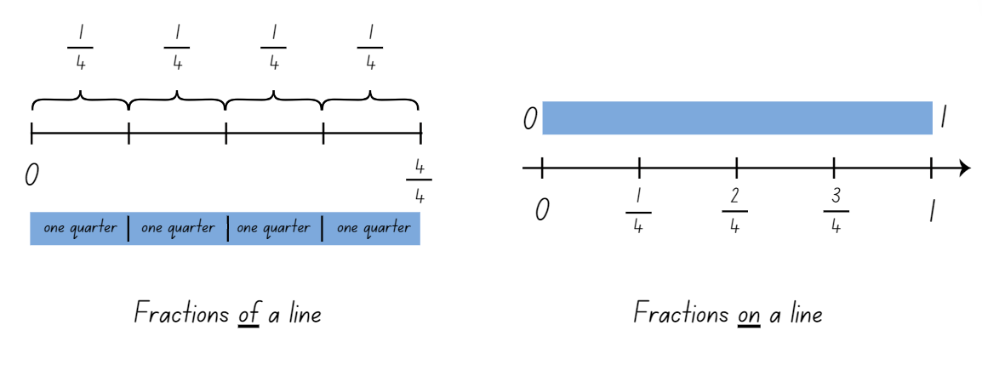

**Note:** fractions can be represented as a part of a length, on a bar model where each segment is labelled as one fractional part of the whole. For example, one-quarter, one-quarter, one-quarter and one-quarter. Fractions can also be represented as numbers on a number line. The distinction between the 2 is that fractions of a length indicate a ‘part’ of a line or length and fractions as a number that sit at a ‘point’ on a number line (Gojak and Miles 2018).

1. Use [Amplify Polypad – Fraction Bars](https://polypad.amplify.com/p#fraction-bars) to demonstrate creating a fraction wall showing a whole, halves and quarters. Use the **pencil** tool to draw and label a number line underneath the wall (see Figure 4).

Figure 4 – fraction bars and number line

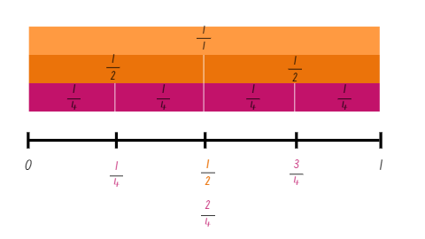

Image created using the free virtual manipulatives at [Polypad by Amplify](https://polypad.amplify.com/p).

1. Highlight that $\frac{1}{2}$ and $\frac{2}{4}$ both fall at the same point on the number line and identify that this means they are equivalent fractions.
2. Remind students that when fractions are placed on a number line, they represent a number that sits at a point on the number line between 2 whole numbers.
3. Draw attention to the way that the symbolic notation for quarter is different on the bar model as part of a length ($\frac{1}{4} , \frac{1}{4}, \frac{1}{4}, \frac{1}{4} )$ compared to the number line ($\frac{1}{4} , \frac{2}{4} , \frac{3}{4} )$.
4. Provide students with digital devices and ask them to create a fraction wall and number line with a whole, thirds and eighths.
5. Ask students to consider the following questions:

* Are there any equivalent fractions in your fraction wall or on the number line? Why do you think this is?
* Which fraction is larger $\frac{1}{3}$ or $\frac{3}{8}$?
* Is there ever an occasion where $\frac{3}{8}$ is smaller than $\frac{1}{3}$? Why or why not? (Yes, if the whole length divided into thirds is longer than the whole length divided into eighths).

1. Students create another fraction wall and number line using [Amplify Polypad – Fraction Bars](https://polypad.amplify.com/p#fraction-bars). For example, fifths and tenths or quarters and thirds. Encourage students to identify and record any equivalent fractions.

This table details opportunities for differentiation.

|  |  |
| --- | --- |
| Too hard? | Too easy? |
| Students cannot model fractions with fraction strips and number lines or represent the equivalence of fractions with related denominators.   * Students draw a separate number line under each fraction strip instead of placing all the fractions on the same number line. * Provide students with paper strips to enable them to fold and partition the whole lengths into fractional parts prior to drawing the connecting number line. | Students can model fractions with fraction strips and diagrams and represent the equivalence of fractions with related denominators.   * Students create a series of number lines showing the whole, halves, thirds, quarters, fifths, sixths, eighths and tenths. * Students fold additional strips to extend their fraction wall with fractions using denominators of their own choosing. For example, twelfths and twentieths. |

## Discuss and connect the mathematics – 10 minutes

1. Display Resource 3 – frog racing. Provide students with writing materials and ask them to represent their solutions using diagrams, fraction symbols, number lines and words.
2. Regroup and discuss strategies used to solve the problem.
3. In pairs, students create a similar word problem about the frog race for their partner to solve.
4. Select several student problems to share with the class. Students solve the tasks, sharing their thinking and reasoning.

This table details opportunities for assessment.

|  |  |
| --- | --- |
| Assessment opportunities | Links |
| What to look for:   * Can students model fractions with fraction strips and number lines for halves, quarters, eighths, thirds? **[MAO-WM-01, MA2-PF-01]** * **Can students represent the equivalence of fractions with related denominators as lengths, using concrete materials, diagrams and number lines? [MAO-WM-01, MA2-PF-01]** | Links to [National Numeracy Learning Progressions](https://www.australiancurriculum.edu.au/resources/national-literacy-and-numeracy-learning-progressions/version-3-of-national-literacy-and-numeracy-learning-progressions/) (NNLP):   * InF2, InF3, InF4, InF5. |

# Lesson 3

**Core concept**: equivalent fractions have related denominators.

## Daily number sense – fractions towers – 15 minutes

The table below contains a suggested learning intention and success criteria. These are best co-constructed with students.

|  |  |
| --- | --- |
| Daily number sense learning intention | Daily number sense success criteria |
| Students are learning to:   * model and represent unit fractions, and their multiples, to a complete whole on a number line. | Students can:   * identify and record complementary fractions to complete one whole. |

1. Display Resource 4 – tower fractions and ask students to record the fractions they can see in each tower.
2. Explain that there are no complementary fractions in Tower A, however there are complementary fractions in Towers B–E. Ask students to consider why this is the case.
3. Select a student to record the fraction notation for Tower B as $\frac{1}{6}$ and $\frac{5}{6}$. State that these fractions are complementary as they represent 2 fractional parts needed to complete one whole.
4. For Tower D, present the following statements:

* one student represented the fractions as $\frac{1}{6}, \frac{1}{6}. \frac{1}{6},\frac{1}{6}, \frac{1}{6},$ and $\frac{1}{6}$
* a second student represented the fractions as $\frac{3}{6}$ and $\frac{3}{6}$; and
* a third student represented the fractions as $\frac{1}{2}$ and $\frac{1}{2}$.

1. Ask students to provide reasoning as to which statement is correct and why.
2. Students share the fraction notation they used to record the remaining towers and discuss complementary fractions and equivalence.

This table details opportunities for assessment.

|  |  |
| --- | --- |
| Assessment opportunities | Links |
| What to look for:   * Can students identify and record complementary fractions to complete one whole? **[MAO-WM-01, MA2-PF-01]** | Links to [National Numeracy Learning Progressions](https://www.australiancurriculum.edu.au/resources/national-literacy-and-numeracy-learning-progressions/version-3-of-national-literacy-and-numeracy-learning-progressions/) (NNLP):   * n/a. |

## Core lesson – fraction towers – 40 minutes

The table below contains suggested learning intentions and success criteria. These are best co-constructed with students.

|  |  |
| --- | --- |
| Core concept learning intentions | Core concept success criteria |
| Students are learning to:   * model equivalent fractions as lengths. | Students can:   * represent the equivalence of fractions with related denominators as lengths. |

1. In small groups, students create 4 towers using interlocking cubes of different colours. Towers must be 4, 5, 8 and 10 cubes high.
2. Provide students with writing materials and coloured markers. Students draw number lines and coloured tape diagrams to show the fractional parts of each tower (see Figure 5).

Figure 5 – student example

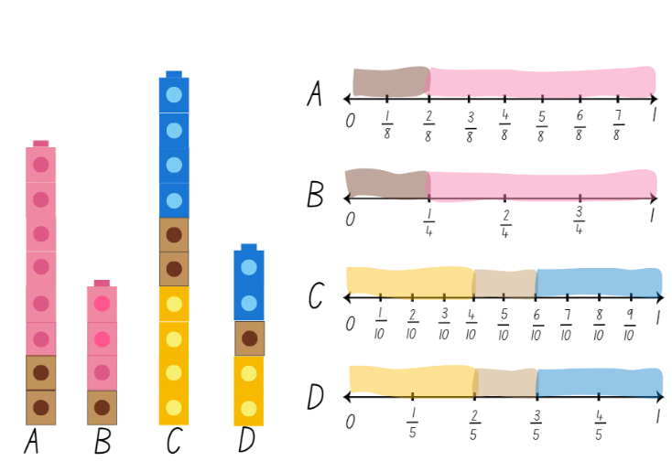

1. Display Resource 5 – tower number lines. Ask students if there are any equivalent fractions.
2. Highlight that in Towers A and B $\frac{2}{8}$ is equivalent to $\frac{1}{4}$ and $\frac{6}{8}$ is equivalent to $\frac{3}{4}$. Explain that the fractions $\frac{2}{8}$ and $\frac{1}{4}$ are equivalent fractions because their fractional parts are in equal proportion to the whole.
3. Ask students if it is possible for a tower of 13 blocks to be built with fractional parts equivalent to Towers A and B. Remind students that both Towers A and B have proportional parts equal to $\frac{1}{4}$ and $\frac{3}{4}.$
4. Using interlocking cubes, students test whether 13 blocks can be used to represent $\frac{1}{4}$ and $\frac{3}{4}.$
5. Regroup as a class and discuss whether it was possible. Ask students to suggest the number of blocks required to make a tower representing $\frac{1}{4}$ and $\frac{3}{4}.$

This table details opportunities for differentiation.

|  |  |
| --- | --- |
| Too hard? | Too easy? |
| Students cannot represent the equivalence of fractions with related denominators as lengths.   * Students create towers with 2 and 4 blocks, then 3 and 6 blocks and look for relationships between them. | Students can represent the equivalence of fractions with related denominators as lengths.   * Challenge students to make towers with a different number of blocks. For example, sixths and twelfths. Students identify equivalent fractions. |

## Discuss and connect the mathematics – 10 minutes

1. Display Resource 6 – student work sample. Discuss how Towers A and B and Towers C and D are connected because the number of parts in the whole tower (denominator) are multiplicatively related. Fractions with related denominators are factors/multiples of each other and belong to related fraction families.
2. Look at how the colour portions in Tower A are twice as big as those in Tower B, but they can both be described using quarters.
3. Ask students if they can identify another name for $\frac{2}{8}$. Provide the answer $\frac{1}{4}$ if not given. Remind students that these are equivalent fractions. Ask students for other names for $\frac{2}{4},\frac{4}{8},\frac{6}{8}$ and $\frac{3}{4}$.
4. Select students to rename the equivalent fractions in Towers C and D ( $\frac{2}{10}$ = $\frac{1}{5}$, $\frac{4}{10}$ = $\frac{2}{5}$, $\frac{6}{10}$ = $\frac{3}{5}$, $\frac{8}{10}$ = $\frac{4}{5}$ and $\frac{10}{10}$ = $\frac{5}{5}$ = 1).

This table details opportunities for assessment.

|  |  |
| --- | --- |
| Assessment opportunities | Links |
| What to look for:   * Can students represent the equivalence of fractions with related denominators as lengths? **[MAO-WM-01, MA2-PF-01]** | Links to [National Numeracy Learning Progressions](https://www.australiancurriculum.edu.au/resources/national-literacy-and-numeracy-learning-progressions/version-3-of-national-literacy-and-numeracy-learning-progressions/) (NNLP):   * InF5. |

# Lesson 4

**Core concept**: equal wholes are needed to compare partitioned fractions.

## Daily number sense – 10 minutes

1. From a class need surfaced through formative assessment data, identify a short, focused activity that targets students’ knowledge, understanding and skills. Example activities may be drawn from the following resources:

* [Mathematics K–6 resources](https://education.nsw.gov.au/teaching-and-learning/curriculum/mathematics/mathematics-curriculum-resources-k-12/mathematics-k-6-resources)
* [Universal Resources Hub](https://resources.education.nsw.gov.au/home).

## Core lesson 1 – worm wonderings – 10 minutes

The table below contains suggested learning intentions and success criteria. These are best co-constructed with students.

|  |  |
| --- | --- |
| Core concept learning intentions | Core concept success criteria |
| Students are learning to:   * create fractional parts of a length using techniques other than repeated halving * model equivalent fractions as lengths. | Students can:   * create thirds and fifths of a length * recognise the need to have equal wholes to compare partitioned fractions * represent fractions with the same-size whole to make valid comparisons. |

1. Read the following scenario to students: A cockatoo and a lorikeet each find a worm. The cockatoo ate $\frac{3}{4}$ of its worm and the lorikeet ate $\frac{2}{3}$ of its worm. Which bird had the biggest feed?
2. Provide students with writing materials and ask them to communicate their thinking with labelled diagrams, fraction notation and words.
3. Explain that when comparing partitioned fractions, the size of the fractional part depends on the size of the whole length. In this scenario, the answer depends on the size of the worms. If the worms were the same sized wholes, then the cockatoo would have eaten more. If, however, the whole worms were different lengths to start with, then either bird could have eaten more.
4. Students draw and label 2 worms of the same length, and 2 worms of different lengths to represent this diagrammatically.

## Core lesson 2 – snail racing – 30 minutes

1. Display Resource 7 – snail racing. Explain that 4 snails made it into the final at the Snail Trail Olympics. The length of the race is the same for each snail. Students determine which snail is the closest to the finish line using the following clues:

* The snail with the blue shell has travelled $\frac{3}{4}$ of the total distance.
* The snail with the orange shell has travelled $\frac{6}{8}$ of the whole track.
* The snail with the purple shell has travelled of $\frac{4}{6}$ of the total distance.
* The snail with the green shell has travelled $\frac{8}{10}$ of the whole track.

1. Provide students with 4 equal sized length strips of paper (to represent each snail’s lane) and have students use repeated halving or other techniques to create the fractional parts of the lengths.
2. Demonstrate looping the paper to create thirds and fifths (see Figure 6). These strips can then be folded in halves to create sixths and tenths.

Figure 6 – looping to create thirds and fifths

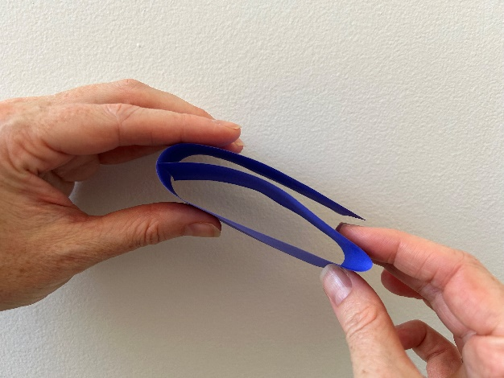

1. Students use their strips of paper and writing materials to solve the problem and represent their thinking.

This table details opportunities for differentiation.

|  |  |
| --- | --- |
| Too hard? | Too easy? |
| Students cannot recognise the need to have equal wholes to compare partitioned fractions.   * Fold paper strips of 2 different lengths into half. Show that the different sized lengths created different sized halves. * Model drawing 2 lines of the same length and 2 lines of different lengths to illustrate how the length of the whole determines the lengths of the partitions.   Students cannot create thirds and fifths of a length or represent fractions with the same-size whole to make valid comparisons.   * Loop the strips of paper with the students modelling how to ensure each part is equal in size. * Provide pre-folded fraction strips. Students identify the distances each snail travelled and mark the position on each strip. | Students can recognise the need to have equal wholes to compare partitioned fractions.   * Students create a poster to explain why equal wholes are needed to compare partitioned fractions, using real-life context examples.   Students can create thirds and fifths of a length and represent fractions with the same-size whole to make valid comparisons.   * Students create and solve their own clues regarding the distance travelled for each snail. * Students explore a snail trail that is not a straight line. For example, a zigzag, wavy line. Students label the distance travelled using fractions. |

## Discuss and connect the mathematics – 10 minutes

1. Regroup and discuss students’ findings. Ask:

* Which snail is the closest to the finish line?
* Which snail is the furthest from the finish line?
* Did any snails travel the same distance in the race?
* Did you find any equivalent fractions?

1. Pose this additional problem: If a fifth snail entered the race, and it was the closest to the finish line, what fraction of the total distance could it have travelled? ( $\frac{5}{6},\frac{7}{8}$ or $\frac{9}{10}$).
2. Display Resource 8 – Which one doesn’t belong? and ask students to think pair share to solve the task (C does not belong as all the others are equivalent fractions).

This table details opportunities for assessment.

|  |  |
| --- | --- |
| Assessment opportunities | Links |
| What to look for:   * **Can students create thirds and fifths of a length?  [MAO-WM-01, MA2-PF-01]** * **Can students recognise the need to have equal wholes to compare partitioned fractions? [MAO-WM-01, MA2-PF-01]** * Can students represent fractions with the same-size whole to make valid comparisons? **[MAO-WM-01, MA2-PF-01]** | Links to [National Numeracy Learning Progressions](https://www.australiancurriculum.edu.au/resources/national-literacy-and-numeracy-learning-progressions/version-3-of-national-literacy-and-numeracy-learning-progressions/) (NNLP):   * InF4, InF5. |

# Lesson 5

**Core concept**: making and exceeding the whole.

## Daily number sense – make 500 000 (part 1) – 15 minutes

Daily number sense activities for Lessons 5 to 7 ‘loop’ back to concepts and procedures covered in previous units to assist students to build an increasingly connected network of ideas. These concepts may differ from the core concepts being covered by the unit.

The table below contains a suggested learning intention and success criteria. These are best co-constructed with students.

|  |  |
| --- | --- |
| Daily number sense learning intention | Daily number sense success criteria |
| Students are learning to:   * apply place value to partition, regroup and rename numbers up to 6 digits. | Students can:   * name thousands using the place value of grouping ones, tens and hundreds of thousands * use place value to expand the number notation. |

1. Explain that students will get 6 dice rolls with a 9-sided die to make the closest possible number to 500 000, without going over.
2. Provide each student with Resource 9 – place value houses and a 9-sided die. After each roll, students need to decide where to place that digit. Once a digit is placed, it cannot be moved.
3. After 5 throws, students decide which number they would most like to be the last dice roll.
4. After 6 throws, each student reads out their number to the person next to them. For example, four hundred and ninety-two thousand, five hundred and eighty-one. Students then use expanded notation to record their number, emphasising the thousands, tens and ones. For example, 400 000 + 90 000 + 2000 + 500 + 80 + 1.
5. As a class, determine who has made the number closest to 500 000.
6. Repeat the process in small groups.
7. Ask students to consider whether changing the rules of the game to allow going over 500 000 could help them to get closer to the target number. For example, 512 367 is closer than 481 975.

This table details opportunities for assessment.

|  |  |
| --- | --- |
| Assessment opportunities | Links |
| What to look for:   * Can students name thousands using the place value grouping of ones, tens and hundreds of thousands?  **[MAO-WM-01, MA2-RN-01]** | Links to [National Numeracy Learning Progressions](https://www.australiancurriculum.edu.au/resources/national-literacy-and-numeracy-learning-progressions/version-3-of-national-literacy-and-numeracy-learning-progressions/) (NNLP):   * NPV7. |

## Core lesson – making and exceeding the whole – 30 minutes

The table below contains suggested learning intentions and success criteria. These are best co-constructed with students.

|  |  |
| --- | --- |
| Core concept learning intentions | Core concept success criteria |
| Students are learning to:   * represent fractional quantities equal to and greater than one whole. | Students can:   * rename 2 halves, 3 thirds, 4 quarters, 5 fifths, 6 sixths, 8 eighths and 10 tenths as wholes * represent totals of halves, thirds, quarters and fifths that extend beyond one. |

**Note:** this lesson needs to be delivered in a large space.

1. Explain that students are going to play a game called ‘Islands’:
2. Students slowly move around an open space.
3. Teacher calls out ‘fifths make the whole’.
4. Students calculate the number of fifths required to make a whole, quickly form groups of 5 and sit down.
5. After all possible groups are formed, discuss as a class how many wholes were created and how many students or fifths are left over. For example, 5 wholes and 2 fifths.
6. Repeat steps using quarters, thirds, eighths, tenths, sixths and halves.
7. Explain to the class they will now play a modified version of ‘Rob the nest’ that involves fractions.
8. Familiarise yourself and students with the game, explaining the rules as follows:
9. Divide the class into 4 equal teams and line up behind a team hoop.
10. Taking turns, one member from each team collects one coloured beanbag from the communal ‘nest’ and places it in their team’s hoop.
11. Repeat this process until the communal nest is empty.
12. One at a time, players can now collect one beanbag of their choice from an opponent’s hoop, remembering that teams cannot guard or defend their own hoop.
13. After 5 minutes, blow a whistle to signify the end of the round.
14. After the initial round, explain that the beanbags are worth different points. Teams apply these fraction values to their beanbags to work out a total:

* green = 1
* red = $\frac{1}{2}$
* blue = $\frac{1}{4}$
* yellow = $\frac{1}{8}$.

1. Students use Resource 10 – ‘Rob the nest’ score sheet to record their scores (see Figure 7).

Figure 7 – ‘Rob the nest’ scoring example

Rob the nest score sheet
Colour in a fractional part for each coloured beanbag that your team collected. Use the bar models to help you calculate your total score.
14 green rectangles, 8 red rectangles, 2 yellow rectangles and 5 blue rectangles representing beanbags.
5 green, 1.5 red, 1.5 blue and 5/8 yellow rectangles shaded.

1. Ask:

* Did your team collect enough beanbags to represent one or more wholes?
* What strategies did you use when creating wholes?
* What is your team total for wholes, halves, quarters and eighths? How could you combine them? This is the team total.
* How could you name leftover beanbags as a fraction?

1. Play another round of ‘Rob the nest’. Students may want to be more strategic with their bean bag choices using the known value of beanbag colours as in Step 12. The aim of this round is to create as many wholes as possible, using any beanbag configuration. Points in this round will only be counted for complete wholes.

This table details opportunities for differentiation.

|  |  |
| --- | --- |
| Too hard? | Too easy? |
| Students cannot rename 2 halves, 3 thirds, 4 quarters, 5 fifths, 6 sixths, 8 eighths and 10 tenths as wholes and/or represent totals of halves, thirds, quarters and fifths that extend beyond one.   * Model task for students. * Students work with 2 colours of beanbags only, representing halves and quarters. | Students can rename 2 halves, 3 thirds, 4 quarters, 5 fifths, 6 sixths, 8 eighths and 10 tenths as wholes and/or represent totals of halves, thirds, quarters and fifths that extend beyond one.   * Students assign other fraction values to the 4 colours. * Students use their understanding of equivalence and complementary fractions to work out the total value. |

## Consolidation and meaningful practice – 15 minutes

1. Return to the classroom and display Resource 11 – beanbag scoresheet.
2. Explain that Class 4 Gold recorded the number of beanbags each team collected into a table, but they are unsure which team won.
3. Model calculating Team 2’s scores, using a think aloud:

* Let's calculate Team 2’s score. Four yellows is equal to 4 wholes. Three blues is equal to three-quarters. Two reds is equal to two-halves which is a whole. Ten greens is equal to ten-eighths. Ten-eighths is going to be more than a whole because eight-eighths is equal to a whole. So, the green beanbags are a whole and two-eighths. Team 2 have scored 6 wholes, with three-quarters and two-eighths left over.

1. Ask students to think about how quarters and eighths are related, and if we can add three-quarters and two-eighths to the team score. Model comparing the length of two-eighths and one-quarter and demonstrating how three-quarters and two-eighths can be combined to make a whole.
2. Provide students with writing materials and in groups, ask students to determine the total for Team 4. Encourage students to use bar models or number lines to support their calculations.
3. Regroup and ask:

* What strategies did your team use to find the total score for Team 4?
* How did your group represent fractional quantities greater than one whole?
* How did you know when you had made a whole?
* How did your knowledge of equivalent fractions help you when calculating team scores?
* Which complementary fractions did you find when calculating Team 4’s score?

This table details opportunities for assessment.

|  |  |
| --- | --- |
| Assessment opportunities | Links |
| What to look for:   * **Can students rename 2 halves, 3 thirds, 4 quarters, 5 fifths, 6 sixths, 8 eighths and 10 tenths as wholes? [MAO-WM-01, MA2-PF-01]** * Can students represent totals of halves, thirds, quarters and fifths that extend beyond one? **[MAO-WM-01, MA2-PF-01]** | Links to [National Numeracy Learning Progressions](https://www.australiancurriculum.edu.au/resources/national-literacy-and-numeracy-learning-progressions/version-3-of-national-literacy-and-numeracy-learning-progressions/) (NNLP):   * InF5. |

# Lesson 6

**Core concept**: understanding fractional quantities greater than one.

## Daily number sense – make 500 000 (part 2) – 15 minutes

The table below contains a suggested learning intention and success criteria. These are best co-constructed with students.

|  |  |
| --- | --- |
| Daily number sense learning intention | Daily number sense success criteria |
| Students are learning to:   * apply place value to partition, regroup and rename numbers up to 6 digits. | Students can:   * name thousands using the place value grouping of ones, tens and hundreds of thousands |

1. Repeat the game ‘Make 500 000’ from Lesson 5 using Resource 9 – place value houses. This time, after the last dice roll, students can swap 2 of their digits with each other. For example, if students have recorded 549 662, they could swap the 5 and the 4 to make 459 662 as this would be closer to 500 000.
2. Repeat the game, but this time, the digit swap must be after the fifth dice roll and no change can be made again after the last dice roll.

This table details opportunities for assessment.

|  |  |
| --- | --- |
| Assessment opportunities | Links |
| What to look for:   * Can students name thousands using the place value grouping of ones, tens and hundreds of thousands?  **[MAO-WM-01, MA2-RN-01]** | Links to [National Numeracy Learning Progressions](https://www.australiancurriculum.edu.au/resources/national-literacy-and-numeracy-learning-progressions/version-3-of-national-literacy-and-numeracy-learning-progressions/) (NNLP):   * NPV7. |

## Core lesson – fractional quantities greater than one – 40 minutes

The table below contains suggested learning intentions and success criteria. These are best co-constructed with students.

|  |  |
| --- | --- |
| Core concept learning intention | Core concept success criteria |
| Students are learning to:   * represent fractional quantities equal to and greater than one. | Students can:   * rename 2 halves, 3 thirds, 4 quarters, 5 fifths, 8 eighths and 10 tenths as one whole * regroup fractional parts beyond one. |

**Note:** when a collection of unit fractions such as five-quarters exceeds the whole, the reorganisation of the unit parts to form the whole relies upon a clear sense of the whole. Having a unit of measure can make the whole easier to describe. Making and exceeding the whole is an important precursor to using quantity fractions in Stage 3.

1. Draw a ribbon on the board and explain that in the ribbon factory, ribbons are always made to be the same length. This drawing represents a whole length of ribbon.
2. Explain that fractional parts beyond one can be regrouped when representing quantities greater than one whole.
3. Pose the following scenario: Marijke needs a piece of ribbon four-thirds the length of the original ribbon.
4. Model splitting the initial ribbon into 3 equal parts (thirds) and labelling the ribbon $\frac{3}{3}$. Remind students that one whole can be renamed as three-thirds.
5. Draw a second ribbon the same size as the first and add an additional third to the rectangle to represent four-thirds. Label this ribbon, $\frac{4}{3}$ (see Figure 8).

Figure 8 – ribbons

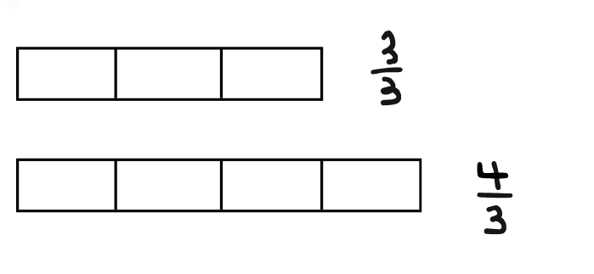

1. Provide students with a copy of Resource 12 – ribbon lengths and ask students to draw 3 ribbons underneath each whole length, that are:

* Four-thirds the size of the original ribbon
* Five-quarters the size of the original ribbon
* Three-halves the size of the original ribbon.

1. Provide pairs of students with A4 paper and explain that this time they will decide the size of the whole.
2. Have students cut a paper strip and write ‘one whole’. Students create additional paper strips that are:

* Five-quarters the size of their strip
* Five-thirds the size of their strip
* Seven-fifths the size of their strip.

1. Students glue their original and 3 additional strips onto a piece of A3 paper and label each strip.

This table details opportunities for differentiation.

|  |  |
| --- | --- |
| Too hard? | Too easy? |
| Students cannot rename 2 halves, 3 thirds, 4 quarters, 5 fifths, 8 eighths and 10 tenths as one whole or regroup fractional parts beyond one.   * Students work with one fraction family. For example, halves. Students create ribbon lengths 3 halves and 4 halves the length of the original ribbon. * Students work with quarters and create ribbon lengths five-quarters, six-quarters, seven-quarters and eight-quarters the length of the original ribbon. | Students can rename 2 halves, 3 thirds, 4 quarters, 5 fifths, 8 eighths and 10 tenths as one whole and regroup fractional parts beyond one.   * Create additional paper strips of alternate fractions that exceed the whole. * Students determine the complementary fractional part required to make 2 whole strips for each. |

## Discuss and connect the mathematics – 5 minutes

1. Draw a new ribbon on the board. Explain that this whole could be renamed 2 halves, 3 thirds, 4 quarters, 5 fifths, 8 eighths or 10 tenths depending on the number of equal partitions.
2. Partition the length into quarters and select a student to draw a second ribbon that represents 6 quarters. The second ribbon will have a length greater than one whole.
3. Ask students how they could use their knowledge of fractions to determine the number of quarters required to make 2 wholes or 8 quarters.
4. Ask: Which would be longer, a ribbon length four-fifths of the original ribbon or a ribbon length five-quarters of the original ribbon?

This table details opportunities for assessment.

|  |  |
| --- | --- |
| Assessment opportunities | Links |
| What to look for:   * **Can students rename 2 halves, 3 thirds, 4 quarters, 5 fifths, 8 eighths and 10 tenths as one whole? [MAO-WM-01, MA2-PF-01]** * Can students regroup fractional parts beyond one?  **[MAO-WM-01, MA2-PF-01]** | Links to [National Numeracy Learning Progressions](https://www.australiancurriculum.edu.au/resources/national-literacy-and-numeracy-learning-progressions/version-3-of-national-literacy-and-numeracy-learning-progressions/) (NNLP):   * InF5. |

# Lesson 7

**Core concept**: number lines extend beyond one.

## Daily number sense – jumbled number words – 15 minutes

The table below contains a suggested learning intention and success criteria. These are best co-constructed with students.

|  |  |
| --- | --- |
| Daily number sense learning intention | Daily number sense success criteria |
| Students are learning to:   * apply place value to partition, regroup and rename numbers up to 6 digits. | Students can:   * use place value to expand the number notation. |

1. Write these on the board: six, ninety, thousand, hundred, three, and, one, and, four. Students use all words from the list to make one number. They can add one hyphen to join 2 numbers together, for example, ninety-three. Students write their solution using words and expanded notation. If they find one solution, ask if that is the only solution possible. Example solutions are:

* six hundred and ninety-three thousand, four hundred and one = 600 000 + 90 000 + 3000 + 400 + 1
* four hundred and ninety-six thousand, one hundred and four = 400 000 + 90 000 + 6000 + 100 + 4
* one hundred and four thousand, six hundred and ninety-three = 100 000 + 4000 + 600 + 90 + 3.

1. Students repeat the process, choosing one option from Resource 13 – What’s the number?. Some of these include zero as a challenge.

This table details opportunities for assessment.

|  |  |
| --- | --- |
| Assessment opportunities | Links |
| What to look for:   * **Can students use place value to expand the number notation? [MAO-WM-01, MA2-RN-01]** | Links to [National Numeracy Learning Progressions](https://www.australiancurriculum.edu.au/resources/national-literacy-and-numeracy-learning-progressions/version-3-of-national-literacy-and-numeracy-learning-progressions/) (NNLP):   * NPV6. |

## Core lesson – number lines extend beyond one – 35 minutes

The table below contains suggested learning intentions and success criteria. These are best co-constructed with students.

|  |  |
| --- | --- |
| Core concept learning intentions | Core concept success criteria |
| Students are learning to:   * model and represent unit fractions, and their multiples, to a complete whole on a number line * represent fraction quantities equal to and greater than one. | Students can:   * determine the fractional part needed to complete 2 wholes * represent totals of halves, thirds, quarters and fifths that extend beyond one. |

**Note:** Resource 14 – number lines 0–2 (a) and Resource 15 – number lines 0–2 (b) will be reused in Lesson 8.

1. Discuss how five-thirds can be shown in different ways. Students [turn and talk](https://education.nsw.gov.au/teaching-and-learning/curriculum/literacy-and-numeracy/teaching-and-learning-resources/numeracy/talk-moves), recording ideas on individual whiteboards. Share representations with the class. Representations could include:

* paper strips
* labelled drawings
* a number line.

1. Display Resource 14 – number lines 0–2 (a). Highlight that the numbers in pink represent whole numbers on the number line.
2. Place a transparent counter at zero on the number line divided into thirds and roll a 6-sided die. Move the counter forward that many thirds on the number line.
3. Ask students to identify and record the fraction on the board. For example, if a 4 is rolled, students identify it as four-thirds and record $\frac{4}{3}$.
4. Students [turn and talk](https://education.nsw.gov.au/teaching-and-learning/curriculum/literacy-and-numeracy/teaching-and-learning-resources/numeracy/talk-moves) to determine how many more thirds would be needed to make 2 wholes. For example, to make 2 wholes from $\frac{4}{3}$ we need an additional $\frac{2}{3}$.
5. Provide pairs with an enlarged A3 copy of Resource 14 – number lines 0–2 (a), a 6-sided die, transparent counter and writing materials.
6. Students take turns rolling the dice and moving the counter that many places along the number line. Students record the fractions that together make 2 wholes, and then swap roles.
7. Students begin with the number line partitioned into thirds before moving onto subsequent number lines.

This table details opportunities for differentiation.

|  |  |
| --- | --- |
| Too hard? | Too easy? |
| Students cannot represent totals of halves, thirds and quarters that extend beyond one.   * Students draw coloured rectangular strips above the number line to represent the 2 fractional parts. | Students can represent totals of halves, thirds and quarters that extend beyond one.   * Provide students with Resource 15 – number lines 0–2 (b) and a 12-sided dice. |

## Discuss and connect the mathematics – 10 minutes

1. Display Resource 16 – thirds on a number line and ask:

* What is the same on both number lines?
* What is different about the number lines?

1. Explain that $\frac{4}{3}$ represents one whole and one more third. As such, we can either write this as $\frac{4}{3}$ or $1\frac{1}{3}$.
2. Ask students to recreate a number line of their choice from Resource 14 – number lines 0–2 (a) or Resource 15 – number lines 0–2 (b) and rename the fractions as a whole and the number of additional parts. For example, $\frac{8}{6}$ can be renamed as $1\frac{2}{6}$.

This table details opportunities for assessment.

|  |  |
| --- | --- |
| Assessment opportunities | Links |
| What to look for:   * Can students determine the complementary fractional part needed to complete 2 wholes? **[MAO-WM-01, MA2-PF-01]** * **Can students represent totals of halves, thirds, quarters and fifths that extend beyond one? [MAO-WM-01, MA2-PF-01]** | Links to [National Numeracy Learning Progressions](https://www.australiancurriculum.edu.au/resources/national-literacy-and-numeracy-learning-progressions/version-3-of-national-literacy-and-numeracy-learning-progressions/) (NNLP):   * InF5. |

# Lesson 8

**Core concept**: fractional quantities can be greater than one.

## Daily number sense – 10 minutes

1. From a class need surfaced through formative assessment data, identify a short, focused activity that targets students’ knowledge, understanding and skills. Example activities may be drawn from the following resources:

* [Mathematics K–6 resources](https://education.nsw.gov.au/teaching-and-learning/curriculum/mathematics/mathematics-curriculum-resources-k-12/mathematics-k-6-resources)
* [Universal Resources Hub](https://resources.education.nsw.gov.au/home).

## Core lesson – blank number lines – 45 minutes

The table below contains suggested learning intentions and success criteria. These are best co-constructed with students.

|  |  |
| --- | --- |
| Core concept learning intention | Core concept success criteria |
| Students are learning to:   * represent fractional quantities equal to and greater than one. | Students can:   * represent totals of halves, thirds, quarters and fifths that extend beyond one * determine the relative location of one-quarter and one-half when a number line extends beyond one. |

1. Display Resource 17 – blank number lines and ask students to determine which fractions are represented by the equidistant points.
2. Draw students’ attention to the fact that there are 2 different sized lengths, as indicated by the position of the 1 on each line which represents one whole.
3. Provide students with Resource 17 – blank number lines and have them record the missing fractions on the number lines.
4. Regroup and display student work samples. Ask students:

* What do you notice about the quarters labelled on the work sample?
* What is the same and what is different? Why?
* Can you identify and record where the position of one-half would be on each number line?

1. Provide small groups of students with Resource 18 – roll a whole, transparent counters, MAB and a 6-sided die. Give each student Resource 14 – number lines 0–2 (a).

**Note:** Resource 14 – number lines 0–2 (a) should be printed on A3 paper to enable easy placement of markers on all the lines.

1. Explain the rules, modelling as necessary:
2. The aim of the game is to reach exactly 2 on one of the number lines.
3. MAB mini cubes are placed at zero on each number line as a marker.
4. Each player places a different coloured transparent counter at START on the gameboard.
5. The first player rolls a dice and moves the counter on the gameboard.
6. This player reads the instruction, moves the MAB mini cube on the appropriate number line and states their new location.
7. Continue the game, taking turns and moving along each number line on Resource 14 – number lines 0–2 (a).
8. The first player to hit exactly 2 on one of the number lines wins.
9. If the player goes over 2 with an instruction, they cannot use that turn.
10. If students reach the end of the gameboard with no-one hitting 2, loop back to the start box and the game continues until a 2 is hit.

This table details opportunities for differentiation.

|  |  |
| --- | --- |
| Too hard? | Too easy? |
| Students cannot determine the relative location of one-quarter and one-half when a number line extends beyond one.   * Provide students with completed number lines 0–1 and 0–2 and have them use this as a model to identify the position of the fractions on the blank number line.   Students cannot represent totals of halves, thirds, quarters and fifths that extend beyond one.   * Students play the game exploring fifths using a 6-sided die and interconnecting cubes. The student rolls the dice to decide the number of cubes to add. When a student has a whole, or 5 joined interconnecting cubes, they begin to make another whole. The student with the most wholes after 3 minutes of play wins. | Students can determine the relative location of one-quarter and one-half when a number line extends beyond one.   * Have students determine the position of thirds and fifths on blank number lines 0–1 and 0–2.   Students can represent totals of thirds and quarters that extend beyond one.   * Provide students with Resource 15 – number lines 0–2 (b) and have them play using knowledge of equivalent fractions of thirds/sixths and quarters/eighths. |

## Discuss and connect the mathematics – 5 minutes

1. Regroup as a class and ask:

* Strategically, which square was the best to land on and why?
* If an instruction square could be added to the game board, what instruction would you choose?

This table details opportunities for assessment.

|  |  |
| --- | --- |
| Assessment opportunities | Links |
| What to look for:   * Can students represent totals of halves, thirds, quarters and fifths that extend beyond one? **[MAO-WM-01, MA2-PF-01]** * Can students determine the relative location of one-quarter and one-half when a number line extends beyond one?  **[MAO-WM-01, MA2-PF-01]** | Links to [National Numeracy Learning Progressions](https://www.australiancurriculum.edu.au/resources/national-literacy-and-numeracy-learning-progressions/version-3-of-national-literacy-and-numeracy-learning-progressions/) (NNLP):   * InF5, InF6. |

# Resource 1 – fraction wall

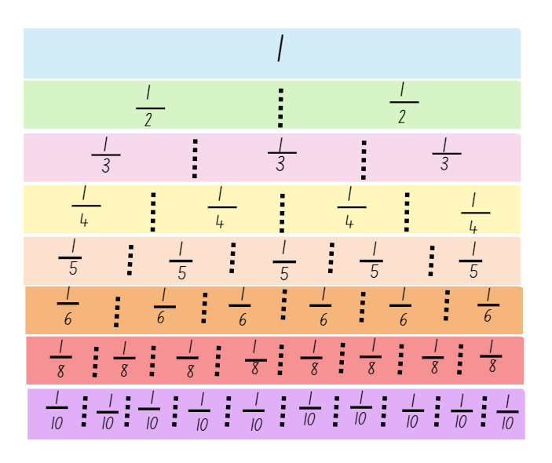

# Resource 2 – missing lengths

Missing lengths.
3 skipping ropes with part of them covered. Green rope has 1/3 on it, blue rope has 1/4 on it and the red rope has 1/2.

# Resource 3 – frog racing

Frog racing
Text - Amara and Harry are racing their pet frogs. The whole length of the track is the same distance, however each frog makes a different number of equal jumps. 
Amara’s frog makes 6 equal jumps from start to finish. 
Harry’s frog makes 8 equal jumps from start to finish. 
Amara’s frog is five-sixths away from finishing. 
Harry’s frog is seven-eighths away from the finish line. 
Who is closer to the finish line?

# Resource 4 – tower fractions

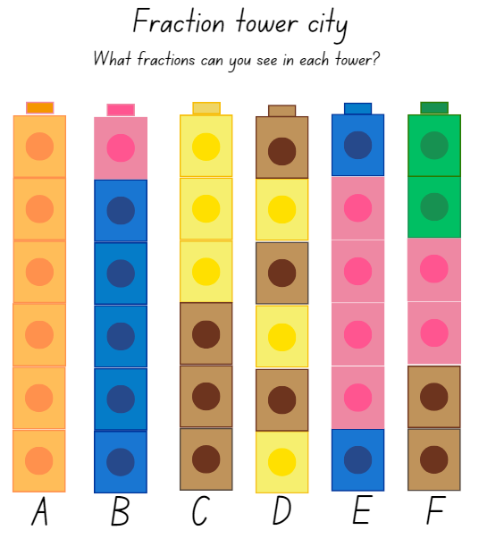

# Resource 5 – tower number lines

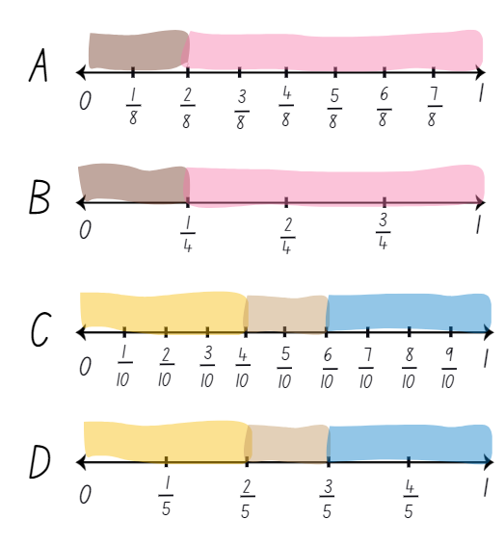

# Resource 6 – student work sample

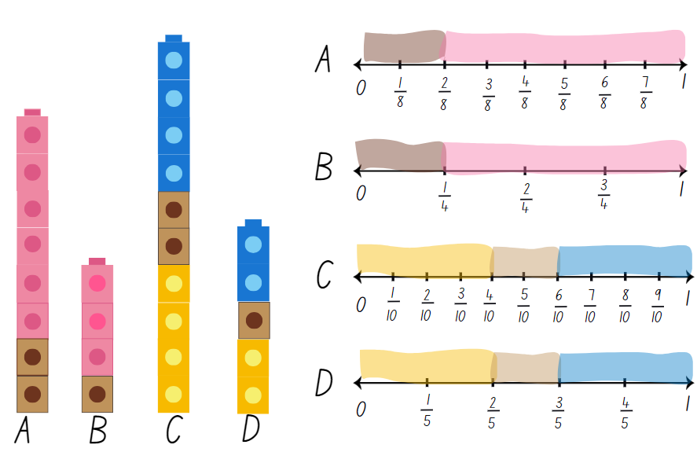

# Resource 7 – snail racing

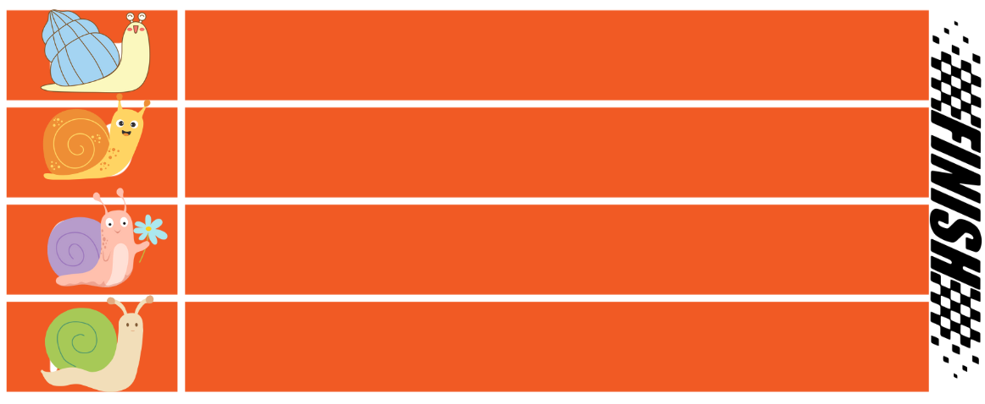

# Resource 8 – Which one doesn’t belong?

4 different fractions of length.
A is 2/3
B is 6/9
C is 3/5
D is 4/6

# Resource 9 – place value houses

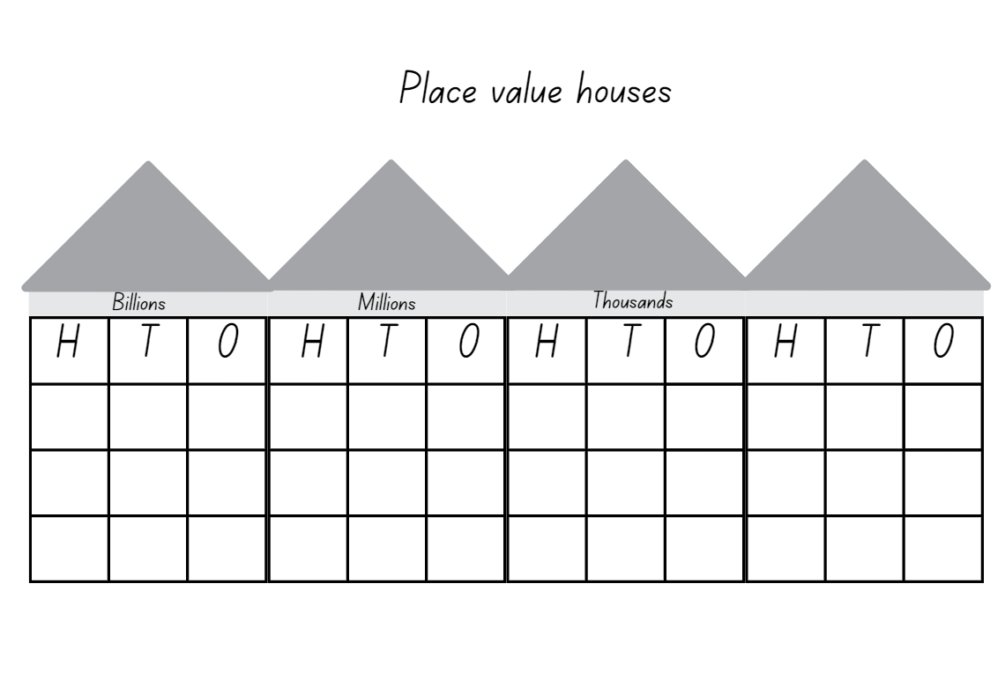

# Resource 10 – ‘Rob the nest’ score sheet

Rob the nest score sheet
Colour in a fractional part for each coloured beanbag that your team collected. Use the bar models to help you calculate your total score.
14 green rectangles, 8 red rectangles, 2 yellow rectangles and 5 blue rectangles representing beanbags.

# Resource 11 – beanbag scoresheet

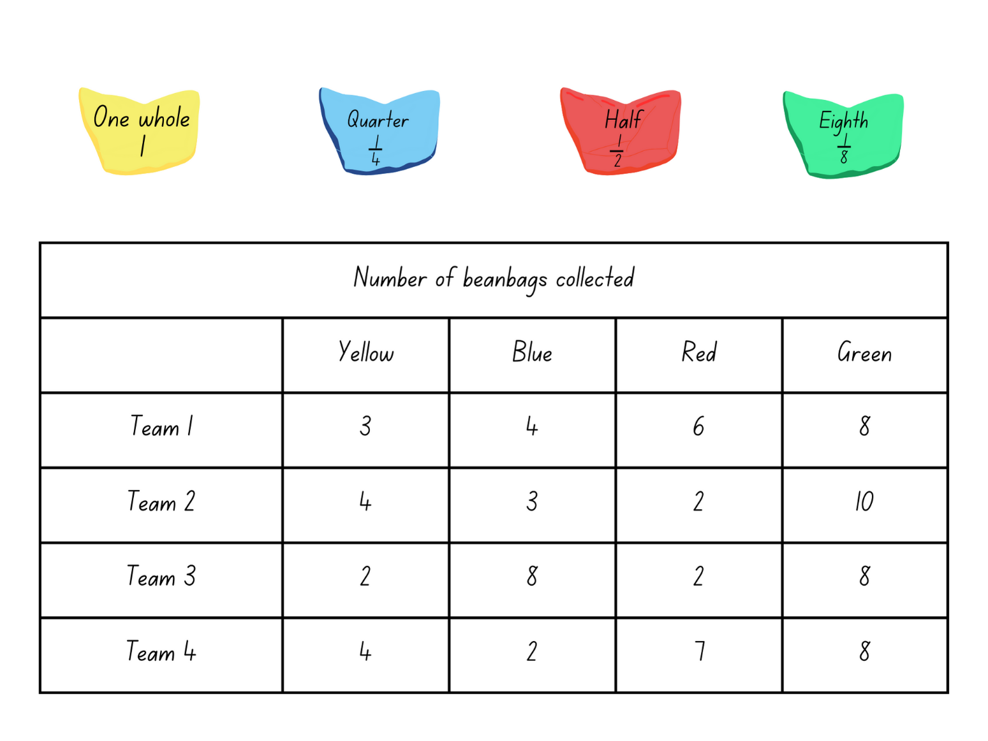

# Resource 12 – ribbon lengths

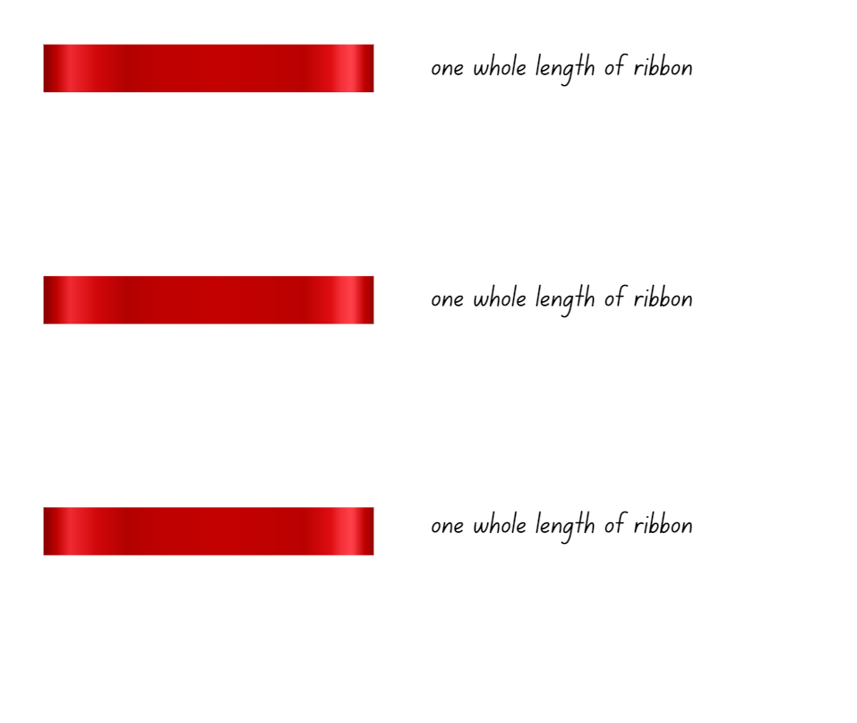

# Resource 13 – What’s the number?

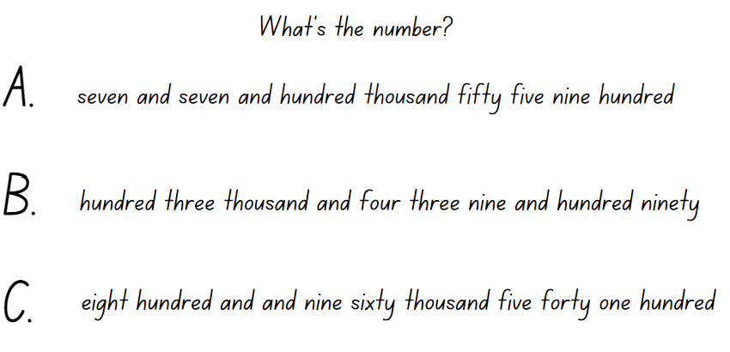

# Resource 14 – number lines 0–2 (a)

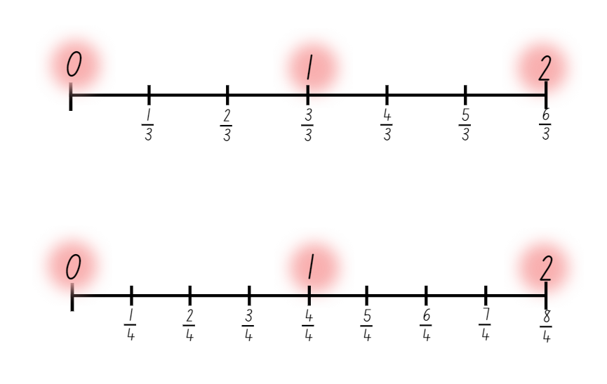

# Resource 15 – number lines 0–2 (b)

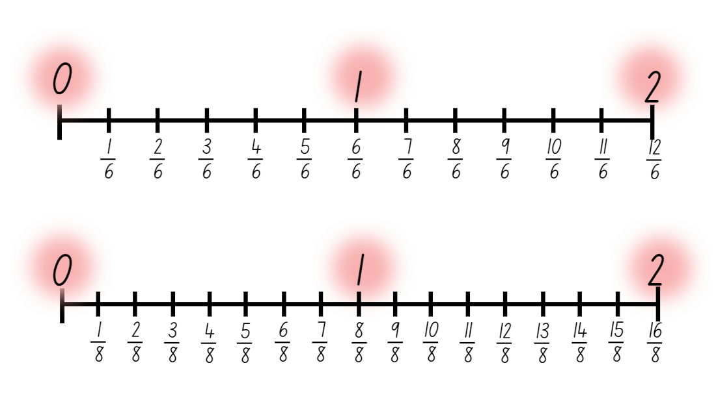

# Resource 16 – thirds on a number line

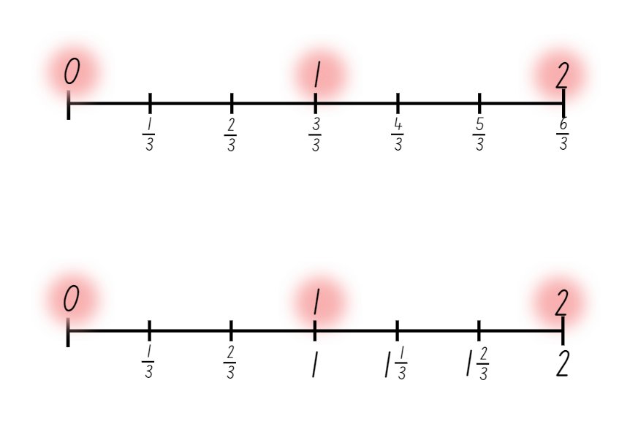

# Resource 17 – blank number lines

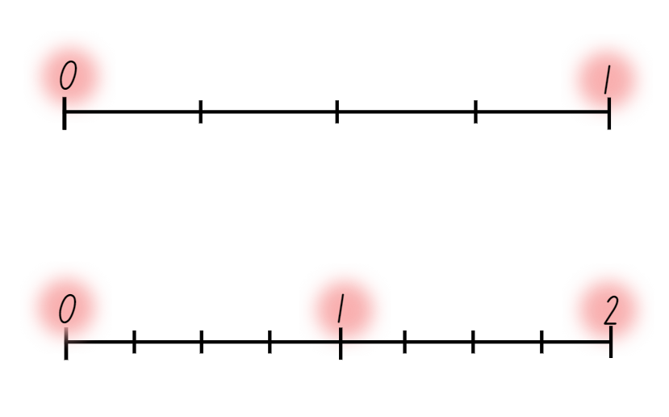

# Resource 18 – roll a whole

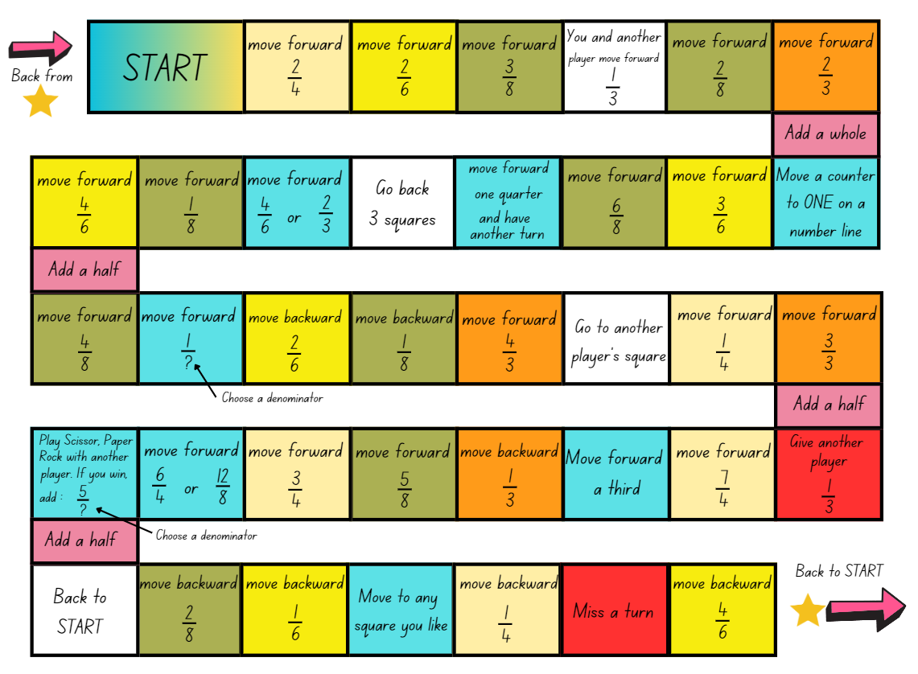

# Syllabus outcomes and content

The table below outlines the [syllabus outcomes](https://curriculum.nsw.edu.au/learning-areas/mathematics/mathematics-k-10-2022/overview) and range of relevant syllabus content covered in this unit. Content is linked to [National Numeracy Learning Progression](https://www.australiancurriculum.edu.au/resources/national-literacy-and-numeracy-learning-progressions/version-3-of-national-literacy-and-numeracy-learning-progressions/) (version 3).

|  |  |  |  |  |  |  |  |  |
| --- | --- | --- | --- | --- | --- | --- | --- | --- |
| Outcomes and content | 1 | 2 | 3 | 4 | 5 | 6 | 7 | 8 |
| **Representing numbers using place value B**: Whole numbers: Apply place value to partition, regroup and rename numbers up to 6 digits  **[MAO-WM-01, MA2-RN-01]** |  |  |  |  |  |  |  |  |
| * Name thousands using the place value grouping of ones, tens and hundreds of thousands |  |  |  |  | x | x |  |  |
| * Use place value to expand the number notation |  |  |  |  | x |  | x |  |
| **Partitioned fractions A**: Create fractional parts of a length using techniques other than repeated halving  **[MAO-WM-01, MA2-PF-01]** |  |  |  |  |  |  |  |  |
| * Make thirds of a length |  |  |  | x |  |  |  |  |
| * Create fifths of a length |  |  |  | x |  |  |  |  |
| **Partitioned fractions A**: Model and represent unit fractions, and their multiples, to a complete whole on a number line  **[MAO-WM-01, MA2-PF-01]** |  |  |  |  |  |  |  |  |
| * Model fractions with fraction strips and diagrams for halves, quarters, eighths, thirds |  | x |  |  |  |  |  |  |
| * Determine the complementary fractional part needed to complete one whole (halves, quarters, eighths, thirds) (Reasons about relations) | x |  | x |  |  |  | x |  |
| * Recreate the whole unit from a fractional part ( $\frac{1}{2}.\frac{1}{4},\frac{1}{3}$ and $\frac{1}{8}$) (Reversible reasoning) | x |  |  |  |  |  |  |  |
| **Partitioned fractions B**: Model equivalent fractions as lengths  **[MAO-WM-01, MA2-PF-01]** |  |  |  |  |  |  |  |  |
| * **Represent the equivalence of fractions with related denominators as lengths, using concrete materials, diagrams and number lines** |  | x | x |  |  |  |  |  |
| * **Recognise the need to have equal wholes to compare partitioned fractions (Reasoning about relations)** | x |  |  | x |  |  |  |  |
| * Represent fractions with the same-size whole to make valid comparisons (denominators of 2, 4 and 8; 3 and 6; 5 and 10) |  | x |  | x |  |  |  |  |
| **Partitioned fractions B**: Represent fractional quantities equal to and greater than one  **[MAO-WM-01, MA2-PF-01]** |  |  |  |  |  |  |  |  |
| * **Rename 2 halves, 3 thirds, 4 quarters, 5 fifths, 6 sixths, 8 eighths and 10 tenths as one whole** |  |  |  |  | x | x |  |  |
| * **Regroup fractional parts beyond one** |  |  |  |  |  | x |  |  |
| * Represent totals of halves, thirds, quarters and fifths that extend beyond one |  |  |  |  | x |  | x | x |
| * Determine the relative location of one-quarter and one-half when a number line extends beyond one |  |  |  |  |  |  |  | x |

[Mathematics K–10 Syllabus](https://curriculum.nsw.edu.au/learning-areas/mathematics/mathematics-k-10-2022/overview) © NSW Education Standards Authority (NESA) for and on behalf of the Crown in right of the State of New South Wales, 2022.

# References

This resource contains NSW Curriculum and syllabus content. The NSW Curriculum is developed by the NSW Education Standards Authority. This content is prepared by NESA for and on behalf of the Crown in right of the State of New South Wales. The material is protected by Crown copyright.

Please refer to the NESA Copyright Disclaimer for more information <https://educationstandards.nsw.edu.au/wps/portal/nesa/mini-footer/copyright>.

NESA holds the only official and up-to-date versions of the NSW Curriculum and syllabus documents. Please visit the NSW Education Standards Authority (NESA) website <https://educationstandards.nsw.edu.au/wps/portal/nesa/home> and the NSW Curriculum website <https://curriculum.nsw.edu.au/>.

[Mathematics K–10 Syllabus](https://curriculum.nsw.edu.au/learning-areas/mathematics/mathematics-k-10-2022/overview) © NSW Education Standards Authority (NESA) for and on behalf of the Crown in right of the State of New South Wales, 2022.

[National Numeracy Learning Progression](https://www.australiancurriculum.edu.au/resources/national-literacy-and-numeracy-learning-progressions/version-3-of-national-literacy-and-numeracy-learning-progressions/) © Australian Curriculum, Assessment and Reporting Authority (ACARA) 2010 to present, unless otherwise indicated. This material was downloaded from the [Australian Curriculum](http://www.australiancurriculum.edu.au/) website (National Numeracy Learning Progression) (accessed 30 January 2024 and was not modified.

Amplify Education (2024) [*Amplify Polypad – Fraction Bars*](https://polypad.amplify.com/p#fraction-bars), Amplify Polypad website, accessed 21 February 2024

Gojak LM and Miles RH (2018) Your Mathematics Standards Companion, Grades 3–5, Corwin Mathematics and National Council of Teachers of Mathematics, United States of America.

**© State of New South Wales (Department of Education), 2024**

The copyright material published in this resource is subject to the *Copyright Act 1968* (Cth) and is owned by the NSW Department of Education or, where indicated, by a party other than the NSW Department of Education (third-party material).

Copyright material available in this resource and owned by the NSW Department of Education is licensed under a [Creative Commons Attribution 4.0 International (CC BY 4.0) license.](https://creativecommons.org/licenses/by/4.0/)

**[](https://creativecommons.org/licenses/by/4.0/)**

This license allows you to share and adapt the material for any purpose, even commercially.

Attribution should be given to © State of New South Wales (Department of Education), 2024.

Material in this resource not available under a Creative Commons license:

* the NSW Department of Education logo, other logos and trademark-protected material
* material owned by a third party that has been reproduced with permission. You will need to obtain permission from the third party to reuse its material.

**Links to third-party material and websites**

Please note that the provided (reading/viewing material/list/links/texts) are a suggestion only and implies no endorsement, by the New South Wales Department of Education, of any author, publisher, or book title. School principals and teachers are best placed to assess the suitability of resources that would complement the curriculum and reflect the needs and interests of their students.

If you use the links provided in this document to access a third-party's website, you acknowledge that the terms of use, including licence terms set out on the third-party's website apply to the use which may be made of the materials on that third-party website or where permitted by the *Copyright Act 1968* (Cth). The department accepts no responsibility for content on third-party websites.