Mathematics Stage 2 Year B – Unit 28
Visual representations help understand aspects of the world (chance and position)
Contents
Unit description and duration 5
Syllabus outcomes 5
Working mathematically 6
Student prior learning 6
Lesson overview and resources 10
Lesson 1 16
Daily number sense – equivalent fractions – 10 minutes 16
Core lesson – developing directional language – 40 minutes 19
Discuss and connect the mathematics – 10 minutes 24
Lesson 2 26
Daily number sense – equivalent fractions – 10 minutes 26
Core lesson – navigating using landmarks – 40 minutes 28
Discuss and connect the mathematics – 10 minutes 31
Lesson 3 33
Daily number sense – colour in fractions – 15 minutes 33
Core lesson – return journeys – 30 minutes 35
Consolidation and meaningful practice – 20 minutes 39
Lesson 4 42
Daily number sense – 10 minutes 42
Core lesson – creating a street map – 40 minutes 42
Discuss and connect the mathematics – 10 minutes 47
Lesson 5 49
Daily number sense – buying balloons – 10 minutes 49
Core lesson – the language of chance – 40 minutes 51
Discuss and connect the mathematics – 15 minutes 57
Lesson 6 59
Daily number sense – candy stall – 10 minutes 59
Core lesson – exploring randomness – 45 minutes 60
Discuss and connect the mathematics – 10 minutes 65
Lesson 7 68
Daily number sense – money problem – 10 minutes 68
Core lesson – predicting outcomes – 40 minutes 70
Discuss and connect the mathematics – 10 minutes 73
Lesson 8 75
Daily number sense – 10 minutes 75
Core lesson – events that are affected by other events – 30 minutes 75
Consolidation and meaningful practice – 20 minutes 80
Resource 1 – position representations 83
Resource 2 – pointer arrows 84
Resource 3 – student maze 85
Resource 4 – street map 86
Resource 5 – colour in fractions 87
Resource 6 – spinners 88
Resource 7 – community map 89
Resource 8 – directions template 90
Resource 9 – animal map 91
Resource 10 – blank street map 92
Resource 11 – chance representations 93
Resource 12 – likelihood scale 94
Resource 13 – likelihood cards 95
Resource 14 – likelihood scale challenge 96
Resource 15 – candy stall 97
Resource 16 – student statements 98
Resource 17 – goat mountain climb 99
Resource 18 – random generator 100
Resource 19 – spinner 101
Resource 20 – bag of marbles 102
Syllabus outcomes and content 103
References 109

Unit description and duration
This unit develops the big idea that visual representation helps us to understand aspects of our world (chance and position).
In this 2-week unit students are provided opportunities to:
- use directional language to interpret and locate positions on a grid map while describing routes between points
- predict and describe possible outcomes from chance experiments
- use visualisation, language and multiple representations of position and chance concepts.

Syllabus outcomes
- MAO-WM-01 develops understanding and fluency in mathematics through exploring and connecting mathematical concepts, choosing and applying mathematical techniques to solve problems, and communicating their thinking and reasoning coherently and clearly
- MA2-AR-01 selects and uses mental and written strategies for addition and subtraction involving 2- and 3-digit numbers
- MA2-PF-01 represents and compares halves, quarters, thirds and fifths as lengths on a number line and their related fractions formed by halving (eighths, sixths and tenths)
- MA2-2DS-02 performs transformations by combining and splitting two-dimensional shapes
- MA2-GM-01 uses grid maps and directional language to locate positions and follow routes
- MA2-CHAN-01 records and compares the results of chance experiments

Working mathematically
In the Mathematics K–10 Syllabus, there is one overarching Working mathematically outcome (MAO-WM-01). The Working mathematically processes should be embedded within the concepts being taught. The Working mathematically processes are:
- communicating
- understanding and fluency
- reasoning
- problem solving.
Mathematics K–10 Syllabus © NSW Education Standards Authority (NESA) for and on behalf of the Crown in right of the State of New South Wales, 2022.

Student prior learning
Before engaging in these teaching and learning activities, students would benefit from prior experience with:
- describing and following directions to position objects in models and drawings
- interpreting simple maps by identifying objects in different locations
- identifying and describing the chance of possible outcomes for familiar activities and events.
In NSW classrooms there is a diverse range of students, including Aboriginal and/or Torres Strait Islander students, students learning English as an additional language or dialect, high potential and gifted students and students with disability. Some students may identify with more than one of these groups or possibly all of them. Refer to Curriculum planning for every student – advice for further information.

Teachers can support student learning and reasoning in this unit by connecting language, representations and visualisation for both position and chance (see Figure 1 and Figure 2). This model of support is adapted from content provided by Adjunct Professor Marj Horne in Big ideas to start strong across K–6 – Module 3: We measure to learn about, navigate and describe the world around us (NSW DoE 2023).
Figure 1 – pedagogical support – position
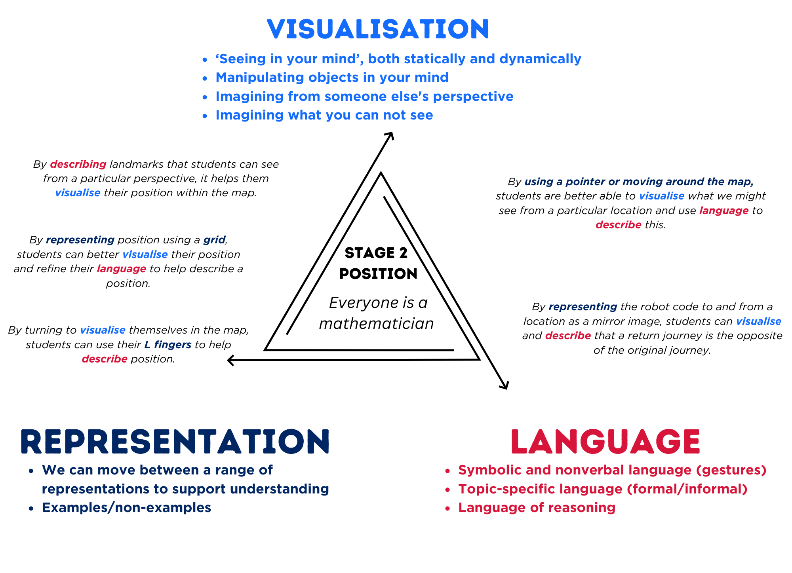
Figure 2 – pedagogical support – chance
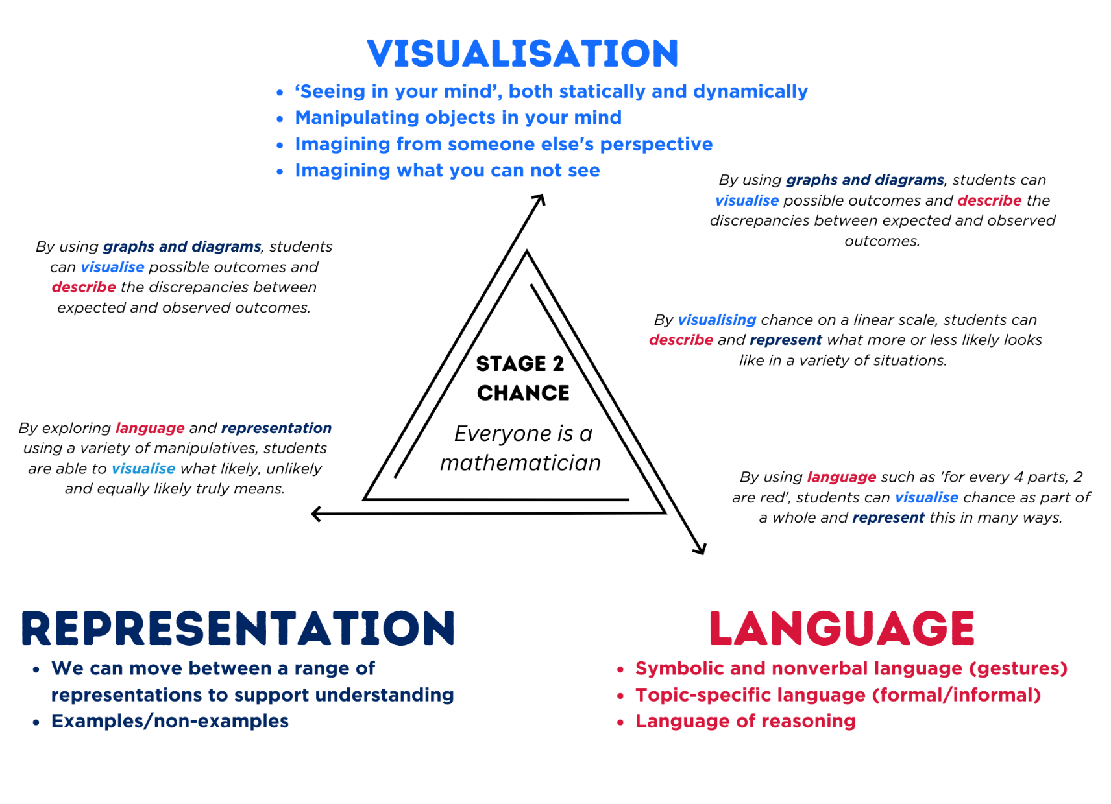

Lesson overview and resources
The table below outlines the sequence and approximate timing of lessons, learning intentions and resources.
Lesson | Content | Duration and resources
Lesson 1  Daily number sense learning intention:  - model equivalent fractions as lengths | Lesson core concept: directional language helps navigation by explaining directions, routes and landmarks.  Core concept learning intentions:  - interpret movement on a map  - use directional language and describe routes with grid maps  - identify angles as a measure of turn | Lesson duration: 60 minutes  - Resource 1 – position representations  - Resource 2 – pointer arrows  - Resource 3 – student maze  - 4 identical strips of card or paper per student  - Envelopes  - Masking tape or chalk  - Scissors  - Writing materials
Lesson 2  Daily number sense learning intention:  - model equivalent fractions as lengths | Lesson core concept: tools assist when navigating maps, resources and landmarks within a local environment.  Core concept learning intentions:  - interpret movement on a map  - use directional language and describe routes with grid maps | Lesson duration: 60 minutes  - Resource 1 – position representations  - Resource 2 – pointer arrows  - Resource 4 – street map  - 2 identical strips of card or paper per student  - Envelopes  - Highlighters  - Scissors  - Writing materials
Lesson 3  Daily number sense learning intention:  - model equivalent fractions as lengths | Lesson core concept: return journeys can be represented and described using maps.  Core concept learning intentions:  - interpret movement on a map  - use directional language and describe routes with grid maps | Lesson duration: 65 minutes  - Resource 1 – position representations  - Resource 2 – pointer arrows  - Resource 5 – colour in fractions  - Resource 6 – spinners  - Resource 7 – community map  - Resource 8 – directions template  - Dice  - Fraction pieces from Lesson 1 and Lesson 2  - If available, programmable robots such as Ozobot, Bee-Bots, Blue-Bots or Cubettos  - Writing materials
Lesson 4  Daily number sense learning intention:  - teacher-identified task based on student needs | Lesson core concept: plan and design maps using real world applications.  Core concept learning intentions:  - interpret movement on a map  - create and interpret grid maps | Lesson duration: 60 minutes  - Resource 1 – position representations  - Resource 7 – community map  - Resource 9 – animal map  - Resource 10 – blank street map  - Counters  - Digital device  - Writing materials
Lesson 5  Daily number sense learning intention:  - apply addition and subtraction to familiar contexts, including money and budgeting | Lesson core concept: the outcomes of chance experiments can be described and recorded.  Core concept learning intentions:  - identify possible outcomes from chance experiments  - describe the likelihood of outcomes of chance events | Lesson duration: 65 minutes  - Resource 11 – chance representations  - Resource 12 – likelihood scale  - Resource 13 – likelihood cards  - Resource 14 – likelihood scale challenge  - Individual whiteboards  - Writing materials
Lesson 6  Daily number sense learning intention:  - apply addition and subtraction to familiar contexts, including money and budgeting | Lesson core concept: data displays can be used to record and compare outcomes of chance events.  Core concept learning intentions:  - identify possible outcomes from chance experiments  - identify when events are affected by previous events  - organise and display data using tables and graphs  - interpret and compare data  - records and compares the results of chance experiments | Lesson duration: 65 minutes  - Resource 15 – candy stall  - Resource 16 – student statements  - Counters  - Dice  - Grid paper  - Individual whiteboards  - Writing materials
Lesson 7  Daily number sense learning intention:  - apply addition and subtraction to familiar contexts, including money and budgeting | Lesson core concept: the outcome of chance experiments can be predicted and recorded.  Core concept learning intentions:  - identify possible outcomes from chance experiments  - describe the likelihood of outcomes of chance events. | Lesson duration: 60 minutes  - Resource 17 – goat mountain climb  - Resource 18 – random generator  - Resource 19 – spinner  - Counters  - Dice  - Plastic coins  - Writing materials
Lesson 8  Daily number sense learning intention:  - teacher-identified task based on student needs | Lesson core concept: events affected by other events impact the outcomes.  Core concept learning intentions:  - describe the likelihood of outcomes of chance events  - identify when events are affected by previous events | Lesson duration: 60 minutes  - Resource 20 – bag of marbles  - Coloured cubes  - Counters  - Individual whiteboards  - Marbles  - Writing materials

Lesson 1
Core concept: directional language helps navigation by explaining directions, routes and landmarks.

Daily number sense – equivalent fractions – 10 minutes
Daily number sense activities for Lessons 1 to 3 ‘activate’ prior number knowledge and support the learning of new content in the unit. These activities can also assist teachers to identify the starting points for learning by revealing the extent of students’ existing knowledge.
The table below contains a suggested learning intention and success criteria. These are best co-constructed with students.
Daily number sense learning intention | Daily number sense success criteria
Students are learning to:  - model equivalent fractions as lengths. | Students can:  - represent the equivalence of fractions with related denominators as lengths, using concrete materials and diagrams.
- Prior to the lesson prepare 4 identical strips of card or paper per student.
- Ask students to label one of the strips as one whole.
- Discuss the need to have equal wholes to compare partitioned fractions.
- Ask students to fold one of the strips into halves and to label each half using fraction notation $\frac{1}{2}$. If needed, revise the meaning of the notation.
- Ask students to fold one of the strips into quarters using repeated halving. Ask students to label the parts using fraction notation $\frac{1}{4}$.
- Ask students to fold the remaining strip into eighths using repeated halving. Ask students to label using fraction notation $\frac{1}{8}$.
- Explain that equivalent fractions are fractions that are different representations of the same value.
- Ask students to identify equivalent fractions with their fraction strips stacked vertically like a fraction wall.
- Students cut the strips into their fractional parts. Ask students to match and name equivalent fractions.
- Ask students to sketch the equivalent fractions they find using a bar model, such as Figure 3
Figure 3 – Equivalent fractions 1
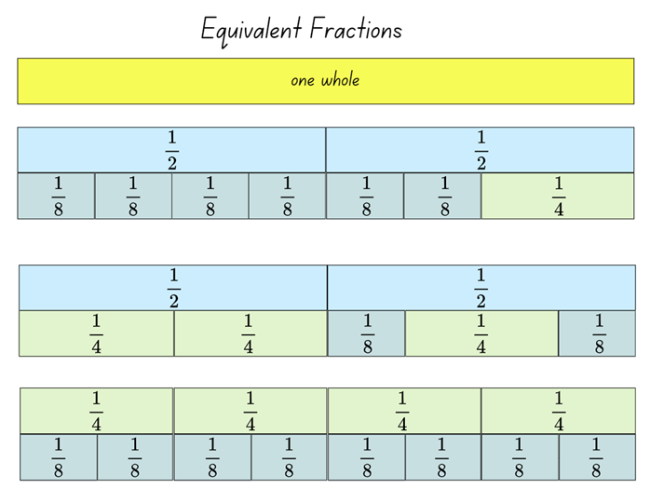
- Ask students to collect and keep their fraction pieces in an envelope. They will be used again in the next lesson.
This table details opportunities for assessment.
Assessment opportunities | Links
What to look for:  - Can students represent the equivalence of fractions with related denominators as lengths, using concrete materials and diagrams? [MAO-WM-01, MA2-PF-01] | Links to National Numeracy Learning Progressions (NNLP):  - InF5.

Core lesson – developing directional language – 40 minutes
The table below contains suggested learning intentions and success criteria. These are best co-constructed with students.
Core concept learning intentions | Core concept success criteria
Students are learning to:  - interpret movement on a map  - use directional language and describe routes with grid maps  - identify angles as a measure of turn. | Students can:  - orient a map to determine directions to travel  - describe a route taken on a map using landmarks and directional language  - use the term right angle to describe a quarter-turn in a range of orientations.

This lesson is an adaptation of Amazing Mazes from NZ Maths by New Zealand Ministry of Education.
Note: the purpose of this lesson is to establish an understanding of left and right (directional language) in a variety of spatial orientations. For each lesson on position in this unit, students can enhance their understanding of position by using multiple representations or tools, such as those featured in Figure 4. These representations and tools can be co-constructed with students on an anchor chart or provided as a resource, see Resource 1 – position representations.
Figure 4 – position representations
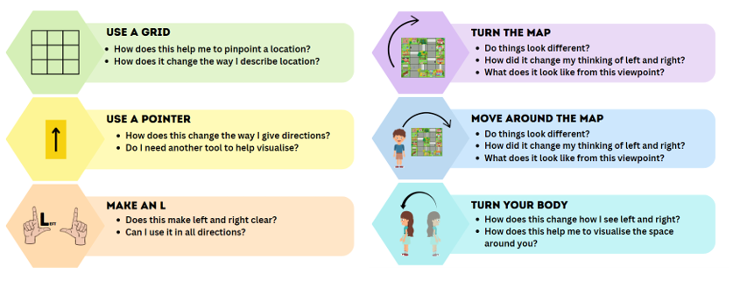
- Prior to the lesson, prepare a large masking tape or chalk maze including grid squares (see Figure 5). Prepare a large arrow, such as Resource 2 – pointer arrows.
Figure 5 – making tape maze
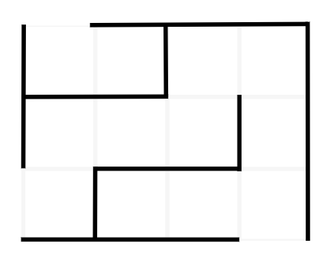
- Explain that students can visually represent left and right by making L shapes with their fingers to help identify various orientations (see Figure 4 above). Explore left and right from different orientations in the classroom, for example, facing different walls.
- Introduce or revise quarter-turn, half-turn and three-quarter turns in each direction. Make an explicit link between a right angle and a quarter-turn.
- Ask students to determine left or right using landmarks from different orientations around the classroom. For example, if a student is facing the front, the door is to their left and the window is to their right. If a student is facing the back, the door is to their right and the window is now to their left.
- Introduce the masking tape maze prepared before the lesson (see Figure 5) above.
- Ask a student to navigate through the maze using directions from the class, using a large arrow from Resource 2 – pointer arrows to mark direction. For example, a direction might be ‘walk forward as far as you can and make a quarter-turn right’ or ‘walk forward 2 squares and make a quarter-turn right’.
- Ask students to think about how left and right changes based on the way they are facing.
- Brainstorm or model how different representations can be used to help navigate using the different representations on Figure 4.
- Repeat navigating the maze from a different starting point or end position.
- Display Resource 3 – student maze and repeat a similar activity in pairs using a paper copy of a maze and an arrow maker.
- As a class, discuss the link between representations and visualisations. Ask students:
- How can we represent the direction in which we are moving or facing? (Anticipated responses include using a pointer with an arrow to indicate direction or turning the map)
- How can this help us to visualise?
- How can this help provide clear instructions?
- Provide students with a copy of Resource 3 – student maze.
- In pairs, students take turns to give each other directions to move through the maze from start to finish (see Figure 6).
Figure 6 – student maze example
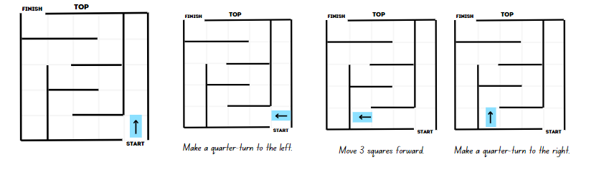
- Repeat the activity from different starting points and different starting arrow orientations.
This table details opportunities for differentiation.
Too hard? | Too easy?
Students cannot use directional language and describe routes with grid maps.  - Students move through the masking tape or chalk maze with teacher support.  - Offer students a shortened end point on the maze. Navigate to that point using the pink support arrow on Resource 2 – pointer arrows. | Students can use directional language and describe routes with grid maps.  - Students turn their student maze so the orientation changes and repeat the maze activity. For example, students enter from the left or right of the map.  - Students create their own maze and route using grid paper. Students provide directions for others to navigate the maze.

Discuss and connect the mathematics – 10 minutes
- Regroup as a class and ask students:
- What representations helped to visualise your position?
- Did you use more than one representation at a time, such as hand visuals and pointer?
- What did you notice about your partner’s instructions?
- Would these instructions be useful in the real world?
- How might instructions change in a real-life situation?
- Discuss that, in a real-life situation, students would not have grid to explain how far forward they are moving. In a real-world situation, they would use landmarks.
- Position everyday objects as landmarks on the masking tape maze and repeat the class activity.
- Discuss how using landmarks assisted in navigating the route and how it changed the type of instructions given.
This table details opportunities for assessment.
Assessment opportunities | Links
What to look for:  - Can students orient a map to determine directions to travel? [MAO-WM-01, MA2-GM-01]  - Can students describe a route taken on a map using landmarks and directional language? [MAO-WM-01, MA2-GM-01]  - Can students use the term right angle to describe a quarter-turn in a range of orientations? [MAO-WM-01, MA2-2DS-01]  - Can students select and apply tools and representations to solve position problems? [MAO-WM-01, MA2-GM1-01] | Links to National Numeracy Learning Progressions (NNLP):  - PoL3, PoL4.

Lesson 2
Core concept: tools assist when navigating maps, resources and landmarks within a local environment.

Daily number sense – equivalent fractions – 10 minutes
The table below contains a suggested learning intention and success criteria. These are best co-constructed with students.
Daily number sense learning intention | Daily number sense success criteria
Students are learning to:  - model equivalent fractions as lengths. | Students can:  - represent the equivalence of fractions with related denominators as lengths, using concrete materials and diagrams.
- Prior to the lesson, prepare 2 identical strips of construction paper per student. The strips should be the same size as those used in Lesson 1. Retrieve student envelopes from Lesson 1.
- Distribute the strips and the envelopes.
- Compare the strips to those used in Lesson 1. Discuss the need to have equal wholes to compare partitioned fractions.
- Ask students to fold one of the strips into thirds. Ask students to label the strips using notation $\frac{1}{3}$. Share student strategies for folding in thirds. Ask students how they know their pieces are thirds.
- Ask students to fold the remaining strip into sixths by folding into thirds, then halving. Ask students to label using notation $\frac{1}{6}$. Share student strategies for folding in sixths. Ask students how they know their pieces are sixths.
- Students cut the strips an explore the ways to use $\frac{1}{3}$ and $\frac{1}{6}$ to make equivalent fractions. Students record equivalent fractions using a bar model, such as Figure 7
Figure 7 – Equivalent fractions 2
- 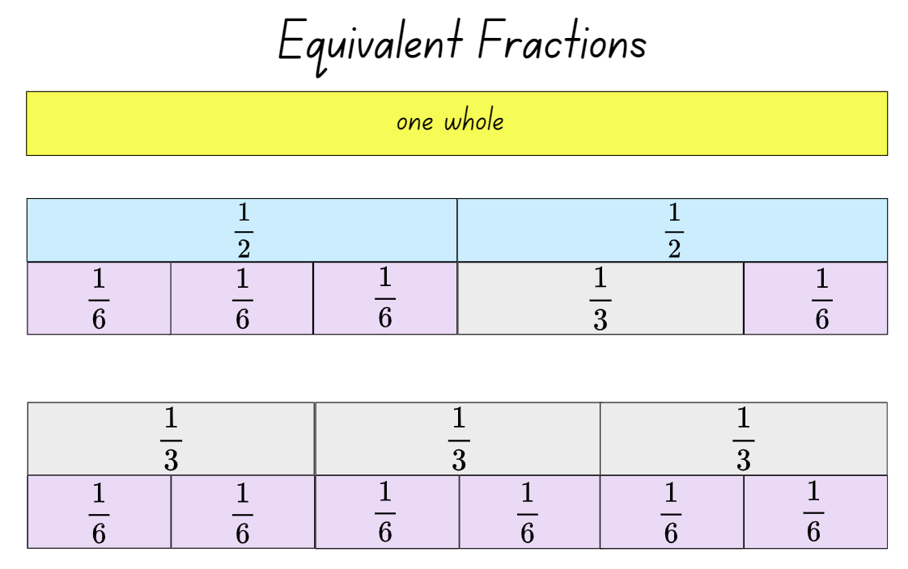
- Ask students to collect and keep their fractions in an envelope. Place all pieces into the envelope and keep for Lesson 3.
This table details opportunities for assessment.
Assessment opportunities | Links
What to look for:  - Can students represent the equivalence of fractions with related denominators as lengths, using concrete materials and diagrams? [MAO-WM-01, MA2-PF-01] | Links to National Numeracy Learning Progressions (NNLP):  - InF5.

Core lesson – navigating using landmarks – 40 minutes
The table below contains suggested learning intentions and success criteria. These are best co-constructed with students.
Core concept learning intentions | Core concept success criteria
Students are learning to:  - interpret movement on a map  - use directional language and describe routes with grid maps. | Students can:  - orient a map to determine directions to travel  - describe a route taken on a map using landmarks and directional language  - use natural resources and landmarks to identify north, south, east and west  - relate compass directions to amounts of turn.
Note: the purpose of the lesson is to develop an understanding of how landmarks can be used to help orientate readers within a map and navigate.
- Tell students that Aboriginal peoples have used stars as navigational aids for thousands of years, with stars representing important landmarks on the ground (Aboriginal Astronomy 2022).
- Display Navigation & Star Maps and explain that the yellow lines show roads, while the red lines show an Aboriginal star map. Ask students what they notice about the alignment.
- Discuss how there is significant overlap between major roads and star maps. Explain that a possible explanation for this is that the first European explorers were led by Aboriginal guides. Over years these paths of exploration have become roads and then highways. Although people use landmarks to navigate journeys, roads and highways determine most routes today. The focus of the lesson is to navigate a street map, using the roads and highways shown.
- Explain that landmarks help us to visualise the environment around us. Brainstorm what landmarks are in the context of Resource 4 – street map.
- Explain that a landmark means to mark the land or identify an object that helps us to find a location. On a street map, a landmark gives useful information when navigating.
- Brainstorm what landmarks are in the context of Resource 4 – street map. For example, school, park, church and so on.
Note: consider downloading a street map of your local area ensuring it has obvious landmarks and sufficient turns.
- Provide students a highlighter and Resource 4 – street map. Split the class into group A and group B.
- Explain that group A students will be independently writing a set of directions from starting point A to destination A. Similarly, group B students will be working from starting point B to destination B.
- Ask students to consider the following while writing their set of directions:
- What visual representation can be used to help you visualise the route?
- Is this the most effective route?
- How can we best describe the route?
Note: emphasise that students may use any of the representations explored on Resource 1 – position representations to support their understanding.
- Once written directions are ready, pair students from group A with those from group B. Students take turns directing each other through the map using their set of instructions.
This table details opportunities for differentiation.
Too hard? | Too easy?
Students cannot interpret movement on a map.  - Students use a more detailed pointer that includes left and right, see Resource 2 – pointer arrows.  - Students describe a short, designated route to follow. For example, 2 or 3 turns to follow. | Students can interpret movement on a map.  - Provide students a selection of pitstops to include in their route.  - Students create their own street map using grid paper. In pairs, student A chooses the starting point and a destination on the map and Student B needs to give directions for Student A to follow. Swap roles and repeat activity.

Discuss and connect the mathematics – 10 minutes
- Ask students to Think-Pair-Share and discuss:
- What was easy or difficult? Explain why.
- What representations did you use to help you visualise the route?
- Did you use more than one representation at a time?
- What did you notice about your partner’s instructions?
- What representations were most useful in helping you create and follow a route?
This table details opportunities for assessment.
Assessment opportunities | Links
What to look for:  - Can students orient a map to determine the direction of travel? [MAO-WM-01, MA2-GM-01]  - Can students describe a route taken using landmarks and directional language? [MAO-WM-01, MA2-GM-01]  - Can students select and apply tools and representations to solve position problems? [MAO-WM-01, MA2-GM1-01] | Links to National Numeracy Learning Progressions (NNLP):  - PoL3, PoL4, PoL5.

Lesson 3
Core concept: return journeys can be represented and described using maps.

Daily number sense – colour in fractions – 15 minutes
The table below contains a suggested learning intention and success criteria. These are best co-constructed with students.
Daily number sense learning intention | Daily number sense success criteria
Students are learning to:  - model equivalent fractions as lengths. | Students can:  - represent the equivalence of fractions with related denominators as length, using concrete materials and diagrams.
This activity is an adaption of ‘Colour in fractions’ from Engaging Maths: 25 favourite lessons by Clarke and Roche. An example of this game being played can be viewed at Colour in fractions on the NSW Department of Education website.
- Display Resource 5 – colour in fractions. View and discuss the fraction wall part of the resource.
- Note that the fractional parts each combine to a whole of the same size.
- Provide the fraction pieces from Lesson 1 and Lesson 2.
- Ask students to replicate the fraction wall using the fraction pieces.
- Display Resource 6 – spinners. Explain how to use the spinners to colour pieces from the fraction wall.
- Provide students one die labelled 1, 2, 2, 3, 3, 4 in one colour and another die labelled $\frac{1}{2}$, $\frac{1}{3}$, $\frac{1}{4}$, $\frac{1}{6}$, $\frac{1}{8}$ in another colour or use Resource 6 – spinners. Also provide each student with Resource 5 – colour in fractions and writing materials.
- Players take turns to throw both dice or spin their spinners. Students make a fraction using the first die or spinner as the numerator. Students then colour the equivalent of the fraction shown. For example, if a player spins 2 quarters they can colour in:
- $\frac{2}{4}$ of one line
- $\frac{4}{8}$of one line
- $\frac{1}{4}$ of one line and $\frac{2}{8}$ of another
- any other combination that is the same as $\frac{2}{4}$.
- For each roll or spin, students should use a different colour pencil or marker. If a player is unable to use their turn, they ‘pass’.
- Players take it in turns to roll or spin and make fractions, marking them on their fraction wall. If the fraction rolled or its equivalence cannot be shaded, that player misses a turn. This becomes more frequent later in the game.
- The first player to colour in their whole wall is the winner. They should encourage the other player to keep filling their fraction wall or make the greatest number of wholes. If after 14 turns neither player has coloured in their whole wall, the player with the greatest number wins.
This table details opportunities for assessment.
Assessment opportunities | Links
What to look for:  - Can students represent the equivalence of fractions with related denominators as length, using concrete materials and diagrams. [MAO-WM-01, MA2-PF-01] | Links to National Numeracy Learning Progressions (NNLP):  - InF5.

Core lesson – return journeys – 30 minutes
The table below contains suggested learning intentions and success criteria. These are best co-constructed with students.
Core concept learning intentions | Core concept success criteria
Students are learning to:  - interpret movement on a map  - use directional language and describe routes with grid maps. | Students can:  - orient a map to determine directions to travel  - describe a return journey between 2 locations on a grid map.
Note: the purpose of this lesson is to develop an understanding that there is a relationship (reversal and flip) between an initial and return journey when represented on a map.
- Discuss students’ journeys to and from school or other locations such as to and from the school to the local park.
- Display the digital Community Mat option from Bee-Bot Online Emulator (see Figure 8) or printed Resource 7 – community map to use programmable robots, such as Ozobots, Bee-Bots, Blue-Bots or Cubettos, if available.
Figure 8 – Community Mat
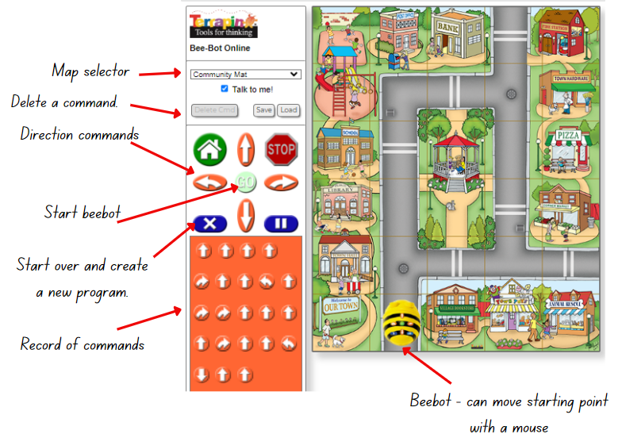
‘Community Mat’ from Bee-Bot Online Emulator © Terrapin (2023).
- Read and discuss the landmarks on the map.
- Students Think-Pair-Share, to brainstorm directional language to describe the Bee-Bot’s route from its starting position to the exit beside the fire station via the library (see Figure 9).
Figure 9 – direction example
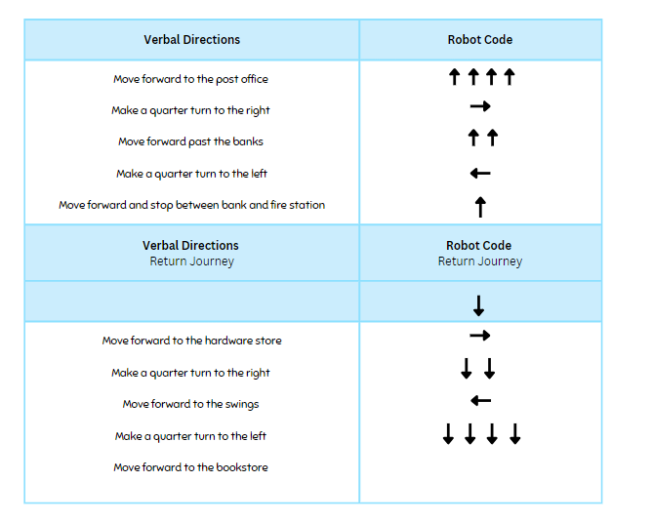
- Ask students:
- What landmarks did you find useful to help describe the journey?
- What representations did you use to help to visualise the journey?
- How were these representations helpful?
- Display Resource 8 – directions template. As a class, record verbal directions from the starting position to the grid square between the bank and the fire station.
- Model how to use the robot’s functions including how to do a half-turn to position for the return journey.
Note: on the Bee-Bot Online Emulator, the Bee-Bot’s starting position can be changed by clicking and dragging the Bee-Bot to the required location. You may then need to turn the Bee-Bot using the arrows and play button so that it faces the correct direction of travel.
- As a class, record the code for the robot using arrows in the second column (see Figure 9).
- As a class, record the directions for the return journey and then the code for the robot’s return journey.
- Ask students:
- What do you notice between the journeys?
- What is the same?
- What is different?
- What is interesting?
Note: students may notice that the code arrows form a mirror image. Use this as a discussion point in relation to the reversal of instructions and directions in a return journey.

Consolidation and meaningful practice – 20 minutes
- Give each student Resource 8 – directions template.
- In pairs, students discuss and agree on a starting point and destination.
- Each student plans and records the outbound or return journey (Student A outbound journey, Student B return journey on the same route) using directional language and landmarks.
- Student A reads out their directions to Student B who plans the outbound route using arrows on the template. Students test the route using the Bee-Bot website and adjust as necessary.
- Student B read out their directions to Student A, who plans the return journey using arrows on the template. Students test the route using the from Bee-Bot website and adjust as necessary.
- Students turn and talk:
- What made it easier and harder to navigate?
- What do you notice between the journeys?
- What is the same? What is different?
- What is interesting?
This table details opportunities for differentiation.
Too hard? | Too easy?
Students cannot give directions for a return journey.  - Provide printed Resource 7 – community map and Resource 2 – pointer arrows to allow students to use concrete materials to navigate the journey.  - Give directions to a location on the map that only involves one turn. Ask student to verbalise and test instructions for the return journey. | Students can give directions for a return journey.  - Provide students with pitstops that they must pass on their route to make the journey more complex.  - Give students a series of arrow instructions. Ask students to identify possible routes that match those instructions.
This table details opportunities for assessment.
Assessment opportunities | Links
What to look for:  - Can students orient a map to determine directions?  [MAO-WM-01, MA2-GM-01]  - Can students describe a return journey between 2 locations? [MAO-WM-01, MA2-GM-01]  - Can students select and apply tools and representations to solve position problems? [MAO-WM-01, MA2-GM-01] | Links to National Numeracy Learning Progressions (NNLP):  - PoL3, PoL4.

Lesson 4
Core concept: plan and design maps using real world applications.

Daily number sense – 10 minutes
- From a class need surfaced through formative assessment data, identify a short, focused activity that targets students’ knowledge, understanding and skills. Example activities may be drawn from the following resources:
- Mathematics K–6 resources
- Universal Resources Hub.

Core lesson – creating a street map – 40 minutes
The table below contains suggested learning intentions and success criteria. These are best co-constructed with students.
Core concept learning intentions | Core concept success criteria
Students are learning to:  - interpret movement on a map  - create and interpret grid maps. | Students can:  - describe a route taken on a map using landmarks and directional language  - create simple maps from an aerial view with landmarks  - use a given grid map and compass directions: north, south, east, west (N, S, E, W) to plan, describe and show a route from one location to another.
The purpose of this lesson is to consolidate understanding of the use of landmarks and directional language to give and interpret directions on a street map.
- Review all representations students can use to give a set of directions, using either the class anchor chart from Lessons 1–3 or from Resource 1 – position representations.
- Discuss the language that can be used to describe location, for example, left and right, quarter-turns and landmarks.
- Ask students another way of showing direction. For example, instead of left and right, they can use east and west.
- Introduce students to the 4 compass point directions: north, south, east, west.
- Display Resource 9 – animal map and orient students to the compass points listed on the map.
- Demonstrate the relationship between directional language and physical movements on the map by modelling with think-aloud. For example, move north one square and east one square; where are you now?
Note: grid references are explicitly taught in Stage 2 Unit 8.
- Provide each student with a copy Resource 9 – animal map. Read directions for students to follow. After each direction, select students to identify what animal they have landed on.
- Move north one square? (Answer: dolphin)
- Move west 2 squares and then north 2 squares? (Answer: octopus)
- Move east 2 squares and then north 5 squares? (Answer: fish)
- Move 3 squares north and east one square? (Answer: turtle)
- Move north 4 squares, west 3 squares and then north one square? (Answer: crab)
- Move east one square, north 4 squares, west 2 squares, south 3 squares, west 2 squares and south one square? (Answer: whale)
- Ask students to turn and talk and explore their thinking and reasoning:
- What makes it easy to identify N, S, E, W?
- What if you were to turn the map?
- How will this change your directions?
- How does this change the language that you use to give directions?
Note: when reorienting the map, the landmarks’ positions do not change. However, reorienting may affect how students describe directions, for example, they may use left or right instead of forward when moving north.
- Display Resource 10 – blank street map.
- Ask pairs or small groups of students to produce a set of directions from a start to end point. Students have 3-5 minutes to draw their own landmarks on the blank squares; roads have been shaded and named already.
- Provide students with their workbooks or a digital device to record their directions. Use 5 counters each to mark journey points on the roads (see Figure 10).
Figure 10 – example of counters on map
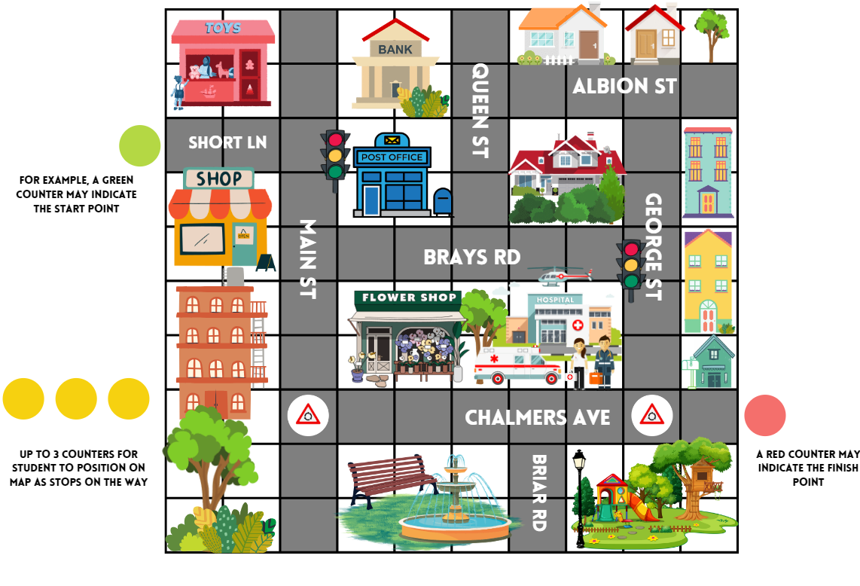
- Students can take turns to give and interpret directions based on different routes.
This table details opportunities for differentiation.
Too hard? | Too easy?
Students cannot create and interpret grid maps.  - Students can reduce the amount of counter stops on their route.  - Students use Resource 7 – community map from Lesson 3 to create their route. | Students can create and interpret grid maps.  - Students give directions for a return journey.  - Students access digital street maps and describe a journey to share with the class.

Discuss and connect the mathematics – 10 minutes
- Regroup as a class and draw out key skills and representations that they used by referring to the class anchor chart or Resource 1 – position representations. Ask:
- What representations did you use to help to visualise your journey?
- How were these representations helpful?
- What language was most useful for describing a route? Why? For example, left/right, using landmarks to describe a route and using compass points.
- Are there times when certain language is more effective?
This table details opportunities for assessment.
Assessment opportunities | Links
What to look for:  - Can students describe a route taken on a map using landmarks and directional language? [MAO-WM-01, MA2-GM-01]  - Can students use compass directions to plan, describe and show a route from one direction to another?  [MAO-WM-01, MA2-GM-01]  - Can students select and apply tools and representations to solve position problems? [MAO-WM-01, MA2-GM-01] | Links to National Numeracy Learning Progressions (NNLP):  - PoL4, PoL5.

Lesson 5
Core concept: the outcomes of chance experiments can be described and recorded.

Daily number sense – buying balloons – 10 minutes
The table below contains a suggested learning intention and success criteria. These are best co-constructed with students.
Daily number sense learning intention | Daily number sense success criteria
Students are learning to:  - apply addition and subtraction to familiar contexts, including money and budgeting. | Students can:  - interpret problems involving money as requiring either addition or subtraction.
This lesson is an adaption of Buying a Balloon from NRICH by University of Cambridge.
- Display the following scenario: A father bought balloons for his 4 children at the community fair. He paid for the balloons using 2 notes and 4 coins.
- In pairs, students record their solutions on whiteboards to the following questions. Ask:
- How much might the balloons have cost?
- What is the largest amount the father could have paid?
- What is the smallest amount the father could have paid?
- Imagine that he used 2 different notes and 2 different coins?
- How much might the balloons cost now?
- Can you find all the possible prices?
- How do you know you have found them all?
- Which of your answers seems a reasonable amount to pay for a balloon?
- As a class share student results and reasoning for each question.
This table details opportunities for assessment.
Assessment opportunities | Links
What to look for:  - Can students interpret problems involving money as requiring either addition or subtraction? [MAO-WM-01, MA2-AR-01] | Links to National Numeracy Learning Progressions (NNLP):  - UnM6, UnM7.

Core lesson – the language of chance – 40 minutes
The table below contains suggested learning intentions and success criteria. These are best co-constructed with students.
Core concept learning intentions | Core concept success criteria
Students are learning to:  - identify possible outcomes from chance experiments  - describe the likelihood of outcomes of chance events. | Students can:  - use the term outcome to describe any possible result of a chance experiment  - use the terms equally likely, likely and unlikely to describe the chance of everyday events occurring.
For each lesson on chance in this unit, students can enhance their understanding by using various representations or tools, featured in Figure 11. These representations and tools can be collaboratively constructed with students or provided as a resource for them see Resource 11 – chance representations.
Figure 11 – chance representations
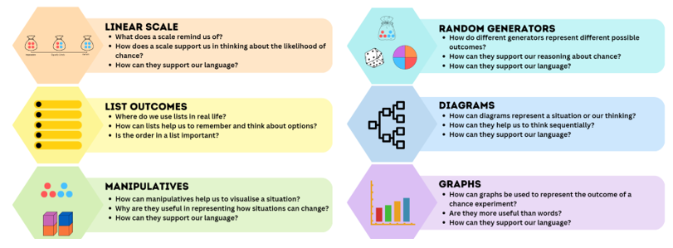
Note: the purpose of this lesson is to examine the everyday language of chance and to develop an understanding of what that could look like.
- Ask students to consider this question: is possible the opposite of impossible? Why or why not?
Note: certain is the opposite of impossible. Anything that is not impossible, is possible. Possible therefore includes a scale of things that are more and less likely, equally likely and certain. Impossible means an outcome can never occur. Certain means that it will occur.
- Display Resource 12 – likelihood scale.
- Explain that the word ‘outcome’ means any possible result of a situation. Discuss situations with different possible outcomes, such as weather, sport, card games or board games.
- Explain that in mathematics outcome has a specific meaning. Share the syllabus definition.
Outcome: a possible result from an experiment or trial.
- Discuss outcomes of random generators such as rolling dice, spinning a spinner, dealing cards from a deck, taking coloured counters from a bag.
- Ask students the questions in the prompt table below about the cards represented in the top scale of Resource 12 – likelihood scale.
- Model how to represent different outcomes on the likelihood scale (see Figure 12).
Prompts | Anticipated student responses
- Why do cards in the centre of the line represent an equally likely chance of drawing a red card? What are the possible outcomes and why are they equally likely? | - There are 2 red and 2 black cards, so it is equally likely that I draw a red card.  - Half of the cards are red.  - There is a 2 in 4 chance that I draw a red card which is the same as a one in 2 chance.
- How would you change the cards to show what an impossible outcome would look like if you wanted to draw a red card? | - The cards would all need to be black.
- What does impossible mean? | - That there is zero chance that I can draw a red card because none of them are red.  - I can never draw a red card.
- How would you change the cards to show what a certain outcome would look like if you wanted to draw a red card? | - The cards would all need to be red.
- What does certain mean? | - I will always draw a red card.  - There is no chance I can draw any card but red because they are all red.
- How can I make it unlikely to draw a red card? Where would that sit on our scale? | - Unlikely sits between equally likely and impossible. There would need to be fewer red cards than black.  - There would need to be 3 black cards and only one red.
- How can I make it more likely to draw a red card? Where would that sit on our scale? | - More likely sits between equally likely and certain.  - There would need to be 3 red cards and only one black.
Figure 12 – teacher likelihood scale
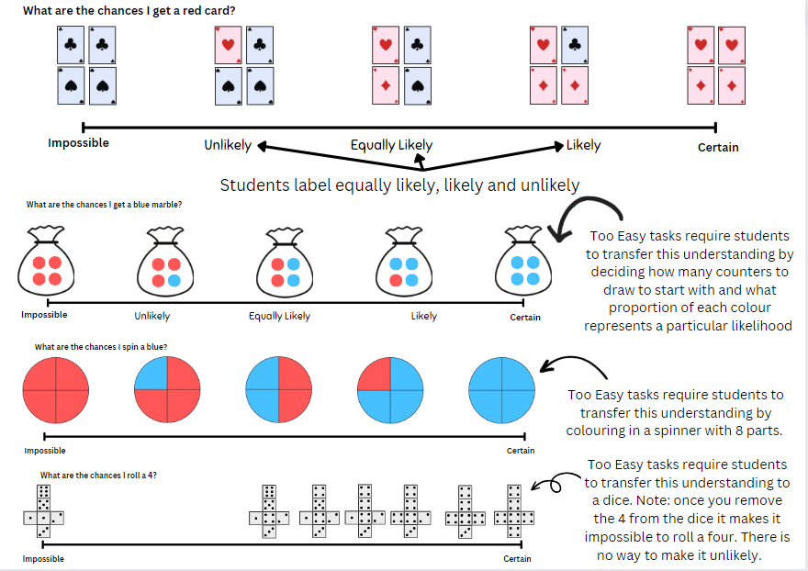
- Provide students Resource 12 – likelihood scale. In pairs, students complete the 3 scales and label equally likely, likely and unlikely on each scale.
- Students complete a gallery walk to observe and consider other students’ thinking.
This table details opportunities for differentiation.
Too hard? | Too easy?
Students cannot describe the likelihood of outcomes of chance events using the terms equally likely, likely and unlikely.  - Student use Resource 13 – likelihood cards to sort and place on the scale rather than drawing.  - Students consolidate their understanding using the spinner example only on Resource 12 – likelihood scale. | Students can describe the likelihood of outcomes of chance events using the terms equally likely, likely and unlikely.  - Give students Resource 14 – likelihood scale challenge. Students scale likely and unlikely in more detail.  - Using Resource 14 – likelihood scale challenge, students complete the activity with dice.

Discuss and connect the mathematics – 15 minutes
- Review whether possible is the opposite of impossible.
- Ask students to Think-Pair-Share where they would put possible on their likelihood scale. Prompt students to explain their reasoning.
- Students complete I Used to Think... Now I Think... for the terms outcome, certain, impossible, likely, unlikely and equally likely.
- Students discuss their ideas. Co-construct definitions and an anchor chart for these terms.
This table details opportunities for assessment.
Assessment opportunities | Links
What to look for:  - Can students understand and use the term outcome to describe possible results of a chance experiment? [MAO-WM-01, MA2-CHAN-01]  - Can students describe the likelihood of outcomes of chance events using the terms equally likely, likely and unlikely? [MAO-WM-01, MA2-CHAN-01] | Links to National Numeracy Learning Progressions (NNLP):  - UnC3.

Lesson 6
Core concept: data displays can be used to record and compare outcomes of chance events.

Daily number sense – candy stall – 10 minutes
The table below contains a suggested learning intention and success criteria. These are best co-constructed with students.
Daily number sense learning intention | Daily number sense success criteria
Students are learning to:  - apply addition and subtraction to familiar contexts, including money and budgeting. | Students can:  - use estimation to check the validity of solutions to addition and subtraction problems, including those involving money.
This lesson is an adaptation of The Puzzling Sweet Shop from NRICH by University of Cambridge.
- Display Resource 15 – candy stall. In pairs, students solve the following problems using estimation to check the validity of their solutions:
- Rosie went to the candy stall at the community fair with $10 to spend. What could Rosie buy if she wanted to spend all her money?
- James, Katie and Henry went into the shop too. They each had $20 to spend and they all spent all their money.
- James spent his money on just one kind of sweet, but he does not like chews. Which sweets did he buy?
- Katie bought the same number of sweets as James, but she had 3 different kinds. Which sweets did she buy?
- Henry chose 8 sweets. What could he have bought?
- How did estimation help you solve the problems?
- Ask students to record their results on an individual whiteboard.
- Select students to share their responses and communicate their reasoning.
This table details opportunities for assessment.
Assessment opportunities | Links
What to look for:  - use estimation to check the validity of solutions to addition and subtraction problems, including those involving money? [MAO-WM-01, MA2-AR-01] | Links to National Numeracy Learning Progressions (NNLP):  - UnM6, UnM7.

Core lesson – exploring randomness – 45 minutes
The table below contains suggested learning intentions and success criteria. These are best co-constructed with students.
Core concept learning intentions | Core concept success criteria
Students are learning to:  - identify possible outcomes from chance experiments  - identify when events are affected by previous events  - organise and display data using tables and graphs  - interpret and compare data  - record and compare the results of chance experiments. | Students can:  - predict the number of times each outcome might occur in a chance experiment involving a set number of trials  - conduct experiments and compare the predicted and actual results where the outcomes are equally likely  - identify and discuss events where the chance of one event occurring will not be affected by the occurrence of the other  - construct column graphs (with scale intervals of one)  - describe and interpret information presented in column graphs.
Note: the purpose of this lesson is to address the misconception that luck influences specific outcomes. Randomness plays a role, especially in smaller sample sizes. Rolling a die illustrates this randomness, where each number has an equal chance of occurring. The actual outcomes are still unpredictable.
- Revise to the language and anchor chart from Lesson 5.
- Explain that students are going to play a game where the aim is to roll a 6.
- Address that, to make it fair, every student with have the same equipment and follow the same rules.
- Students predict and record in their workbooks how many times they think they will roll a 6 in 12 rolls.
- Give each student a 6-sided die.
- Explain that students will receive a counter for every 6 they roll and the person with the most counters after 12 turns will win.
- Students roll their dice at the same time. Students who rolled a 6 are given a counter.
- Repeat 11 more times. The student with the most counters wins.
Note: as the students play, take note of student statements that imply a belief that outcomes of separate rolls of a die are somehow linked.
- Repeat the game, if desired.
- After the game, display Resource 16 – student statements. Ask:
- What do statements like this tell us about how we think about chance? (The idea that luck is involved, the idea that one outcome is dependent on another, the idea that one number is easier to roll than others)
- What possible outcomes can we get from rolling a die?
- How many times did you actually get a 6?
- Was that what you predicted?
- Are you more or less likely to roll a 6 than any other number, for example, a 4? Why or why not?
- Does the outcome of one roll of the dice ever affect the outcome of another roll?
- Is the activity fair or unfair? Why or why not?
Note: students may perceive that it is unfair because they are focused on getting a 6. They may not realise that getting another number other than 6 is 5 times more likely. In the next activity, students explore the idea that every outcome of rolling a die is equally likely.
- Explain that students will now record the number they get on each roll (see Figure 13).
Figure 13 – student work sample
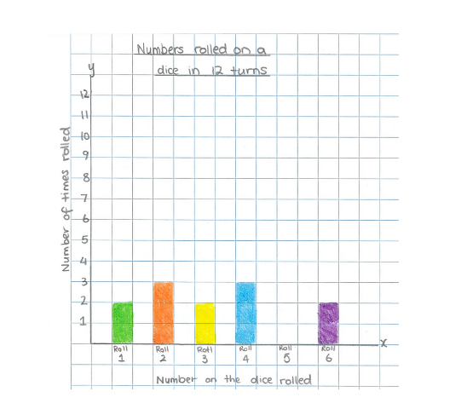
- Give each student a piece of grid paper, with numbers 1–6 along the x-axis, see Figure 13 (above).
- Each student rolls their die 10 times, marking one square of the graph to represent each outcome.
- As a class, each student shares their data, adding it on to the class total.
- Co-construct a column graph of the whole class’s outcomes.
Note: by combining whole class data, you would expect to see less variation in the frequency of each outcome. Therefore, the columns should be approximately equal. This may contrast with students’ individual graphs where randomness is more evident. Draw attention to the idea that by rolling more times, it brings the actual results closer to the predicted result.
This table details opportunities for differentiation.
Too hard? | Too easy?
Students cannot list possible outcomes in simple chance experiments.  - Students list all outcomes when rolling a die. They learn that if there is one wanted outcome out of 6 possibilities, the chance is 1 in 6. Students can explore this for each dice number to understand that all outcomes are equally likely.  - Students work with a partner or with teacher guidance to roll and collect data. | Students can list possible outcomes in simple chance experiments.  - Students predict the expected numerical chance of rolling a 6 involving a set number of trials, for example, in 240, 400 and 600 rolls, and reason as to how the actual result may vary.  - Using a spinner with 4 equal colour options, students consider what the predicted and actual graphs might look like over 10 spins compared to 400 spins. Students consider whether they can generalise their thinking across a range of situations.

Discuss and connect the mathematics – 10 minutes
- The table below outlines stimulus prompts to generate discussion, along with anticipated responses from students.
Prompts | Anticipated student responses
- What do the columns in the graph tell us? | - The number of times each number was rolled on the dice.  - It shows the difference between the number of times each number was rolled.
- If you were to draw a graph that represented the predicted chance over 12 rolls, what would it look like? | - There would be 2 rolls for each number.
- How is your graph similar or different to these predicted results? What does this mean? | - Not all my columns are 2 rolls high.  - Some columns have nothing in them at all.  - Just because an outcome is expected doesn’t mean that it will happen.  - I could roll a 6, 10 out of 12 times or zero out of 12 times.
- How is our class graph similar or different to the predicted results? What does this mean? | - The columns look more similar because they are more equal in height.  - There are more than 2 rolls in each column  - The more times you roll, the closer you get to the expected result.
This table details opportunities for assessment.
Assessment opportunities | Links
What to look for:  - Can students identify and discuss events where the chance of one event occurring will not be affected by the occurrence of the other? [MAO-WM-01, MA2-CHAN-01]  - Can students conduct experiments and compare the predicted and actual results where the outcomes are equally likely?  [MAO-WM-01, MA2-CHAN-01]  - Can students construct, describe and interpret information presented column graphs? [MAO-WM-01, MA2-DATA-01,  MA2-DATA-02] | Links to National Numeracy Learning Progressions (NNLP):  - UnC2, UnC2, CPr8, IRD3.

Lesson 7
Core concept: the outcome of chance experiments can be predicted and recorded.

Daily number sense – money problem – 10 minutes
Daily number sense activities for Lessons 5 to 7 ‘loop’ back to concepts and procedures covered in previous units to assist students to build an increasingly connected network of ideas. These concepts may differ from the core concepts being covered by the unit.
The table below contains a suggested learning intention and success criteria. These are best co-constructed with students.
Daily number sense learning intention | Daily number sense success criteria
Students are learning to:  - apply addition and subtraction to familiar contexts, including money and budgeting. | Students can:  - reflect on a chosen strategy for solving a problem, considering whether it can be improved.
This lesson is an adaptation of Monetary Difference from NRICH by University of Cambridge.
- Display the following scenario: Alex, Bertie and Chris have sums of money totalling $150. Alex has the most money and Chris has the least amount of money in the group.
- Using this information, what amounts could Alex, Bertie and Chris have had each? List at least 3 variations.
- Ask:
- What strategies did you use to solve the problem?
- Did you have any challenges? How did you overcome them?
Note: increase the difficulty of the task by adding this information. Alex and Bertie have $55 between them, and Alex and Chris have $65 between them. Students record possible solutions on their whiteboard.
- Students share their responses and reflect on the most efficient strategy used to solve the problem.
This table details opportunities for assessment.
Assessment opportunities | Links
What to look for:  - Can students reflect on a chosen strategy for solving a problem, considering whether it can be improved?  [MAO-WM-01, MA2-AR-01] | Links to National Numeracy Learning Progressions (NNLP):  - n/a.

Core lesson – predicting outcomes – 40 minutes
The table below contains suggested learning intentions and success criteria. These are best co-constructed with students.
Core concept learning intentions | Core concept success criteria
Students are learning to:  - identify possible outcomes from chance experiments  - describe the likelihood of outcomes of chance events. | Students can:  - predict the number of times each outcome might occur in a chance experiment involving a set number of trials  - record all possible outcome in a chance experiment where the outcomes are equally likely  - use the terms equally likely, likely and unlikely to describe the chance of everyday events occurring.
Note: the purpose of this lesson is to develop an understanding that chance language represents a proportional relationship of a desired outcome occurring in relation to all possible outcomes. Students must also understand that a 1 in 2 chance of an outcome occurring is more likely than a 1 in 3 chance. Like fractions, students may misconceive the bigger number to indicate more likely. For example, students may think $\frac{1}{3}$is bigger than $\frac{1}{2}$.
- Give students Resource 17 – goat mountain climb and display Resource 18 – random generator for goat mountain. Draw students’ attention to the outcome of each generator that will allow the goat to move forward.
- Explain to students that the aim of the game is to get their goat to the top of the mountain within 12 trials, using a given random generator.
- Ask students to turn and talk about which generator would they choose and why.
- Prompt students using the following questions:
The table below outlines stimulus prompts to generate conversation about the topic, along with anticipated responses from students.
Prompts | Anticipated student responses
- What do you need to know to answer this question? | - What to land on to move the goat.  - All the possible outcomes.  - The chance of landing on the one that I want.
- How can you describe the chance of landing on the one you want to move the goat? | - All the possibilities and say the chance of getting to the chosen one.  - It is one in how ever many chances.  - Describe it as a fraction.  Note: redirect the use of this language and encourage students to describe it as 1 in 4 not one-quarter.
Note: the more outcomes there are on the random generator, the more difficult it is to climb the mountain. For example, there is a 1 in 2 chance of flipping a head, however a 1 in 6 chance of rolling a 3 on a die.
- Use think-alouds to model how to list the possible outcomes when tossing a coin. Describe the likelihood of landing on heads.
- Explain that students will be given one of the random generators where one specified outcome will allow them to move up goat mountain.
- Split students into small groups and give them the physical manipulatives of one random generator. For example, one group will have a coin, others will have Resource 19 – spinner with 3 colours, one a bag of 4 different coloured balls or counters or one 6-sided dice.
- In their groups, students record possible outcomes in their workbooks and predict how many times their specified outcome will occur in 12 turns.
- As a class, ask:
- How far up the ladder do you think you will get? Can you explain why you think this?
- Based on your prediction, do you think you can win the game? Why or why not?
Note: for the group using the coin, students should predict that theoretically a head should appear 6 times and therefore they have a chance of winning the game. Some students may also point out that, just because this is theoretically possible, does not mean it will actually happen. This is a great opportunity to revisit the idea of randomness.
- Using their random generator, students play the game ‘Goat Mountain’. Students can only use the random generator 12 times and can only move up the mountain when the specific outcome occurs.
- As a class, ask groups if they were successful and if the result of the game was what they predicted.
- Students swap their generator with another group and repeat the game.
This table details opportunities for differentiation.
Too hard? | Too easy?
Students cannot identify possible outcomes from chance experiments.  - Support students to list the possible outcomes with each random generator and to describe the chance of achieving the desired outcome.  - Give the students the coin random generator or the spinner to play the game with. | Students can identify possible outcomes from chance experiments.  - Ask students how they could change the rules of the game to make each generator as likely to win as the coin.  - Ask students how they could change each random generator to make them as equally likely to win as the coin.

Discuss and connect the mathematics – 10 minutes
- As a class, discuss:
- Which groups reached the top of the mountain? Why did these groups reach the top and not the others?
- Convince a friend which generator is best to use if you want to win the game.
- How can listing all possible outcomes help you to answer this question?
- Which random generator is unlikely to move you up the mountain? Why?
- Did what you predicted actually happen? Can you explain why or why not?
This table details opportunities for assessment.
Assessment opportunities | Links
What to look for:  - Can students predict the number of times each outcome might occur in a chance experiment involving a set number of trials? [MAO-WM-01, MA2-CHAN-01]  - Can students use the terms equally likely, likely and unlikely to describe the chance of everyday events occurring?  [MAO-WM-01, MA2-CHAN-01] | Links to National Numeracy Learning Progressions (NNLP):  - UnC2, UnC3, CPr8.

Lesson 8
Core concept: events affected by other events impact the outcomes.

Daily number sense – 10 minutes
- From a class need surfaced through formative assessment data, identify a short, focused activity that targets students’ knowledge, understanding and skills. Example activities may be drawn from the following resources:
- Mathematics K–6 resources
- Universal Resources Hub.

Core lesson – events that are affected by other events – 30 minutes
The table below contains suggested learning intentions and success criteria. These are best co-constructed with students.
Core concept learning intentions | Core concept success criteria
Students are learning to:  - describe the likelihood of outcomes of chance events  - identify when events are affected by previous events. | Students can:  - compare the likelihood of obtaining particular outcomes in a simple chance experiment by predicting, conducting the experiment and comparing the results with the prediction  - compare events where the chance of one event occurring is affected by the occurrence of the other.
Note: the purpose of this lesson is to examine chance situations where one outcome is dependent on another.
- Display Resource 20 – bag of marbles. Students turn and talk:
- What are the possible outcomes when drawing a marble from this bag?
- What is the chance of getting a blue marble?
- What is the chance of getting a red marble?
- Is there a way to arrange the marbles to help our thinking?
Note: there is an opportunity to discuss the fact that it is twice as likely to select a red marble then select a green or blue marble, and that selecting a green or blue marble is equally likely (see Figure 14).
Figure 14 – organised bag
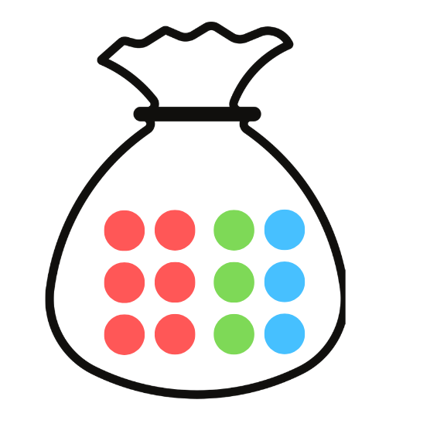
- Discuss class responses and model the language for example, for every 12 marbles, 3 of them are blue therefore I have a 3 in 12 chance of drawing a blue marble.
Optional: display a sentence stem to support student responses. For example, For every ___ marbles, ___ of them are ____, therefore I have a ___ in ___ chance of drawing a ___ marble.
- Ask students:
- What might change if the previous marble is not returned to the bag?
- If you draw a red marble first, what is the chance of drawing a blue marble on the second draw?
- Model this with students by using counters, coloured cubes or marbles in a bag. Show students the remaining choices after the first selection is not returned.
- Provide small groups of students with Resource 20 – bag of marbles and a whiteboard to consider the probability of selecting a particular colour on the first draw. Students then consider how probabilities change for the second draw, when a green marble is not returned to the bag.
Note: this activity helps discussions about how probability is linked to the ratio of desired outcomes to total outcomes. For instance, with 3 blue marbles to draw out of 12 marbles, the probability is 3 in 12 or 1 in 4. Encourage phrases like ‘for every 12 marbles, there are 3 chances of blue.’ Note that possibilities reduce to 11 after a marble is removed, making the second draw likelihood of blue higher (increased chance), see Figure 15.

Figure 15 – misconceptions
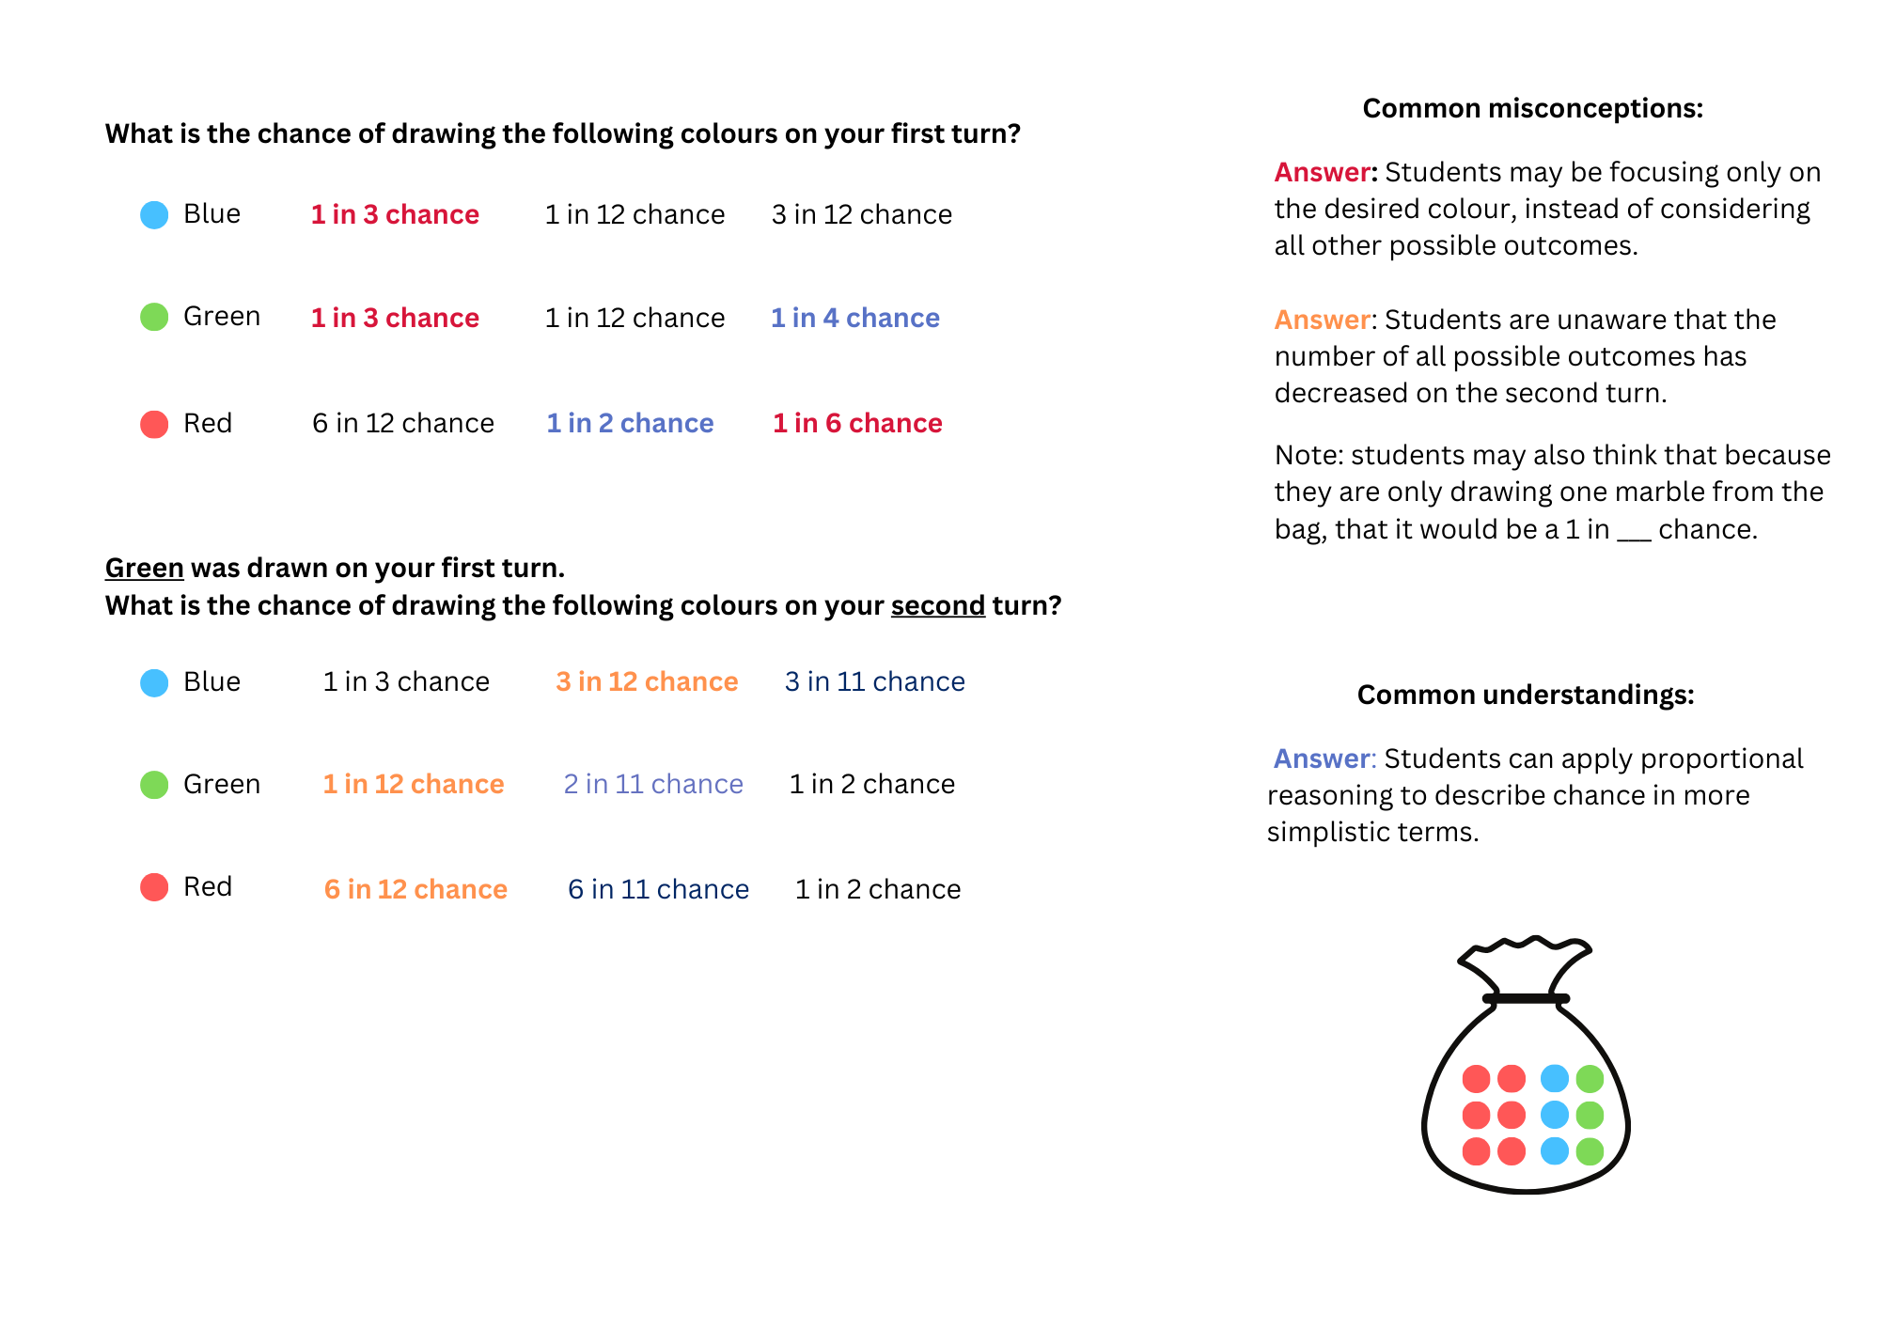
- As a class, ask students:
- How did the language used to help you identify the chance of an outcome occurring?
- How did the way in which you represent the problem help you to identify the chance of an outcome occurring?
This table details opportunities for differentiation.
Too hard? | Too easy?
Students cannot compare events where the chance of one event occurring is affected by the occurrence of the other.  - Give students manipulatives such as coloured cubes or counters to support their thinking.  - Students work with just 2 colours in the bag. | Students can compare events where the chance of one event occurring is affected by the occurrence of the other.  - Students create a tree diagram for the first and second draw where different colours are chosen on the first draw.  - Students represent the probabilities that could occur on a third draw.

Consolidation and meaningful practice – 20 minutes
This activity is an adaptation of Bipin's Choice from NRICH by University of Cambridge.
- Display the problem: Bipin is playing in a game show. The host tells Bipin that there are 10 balls hidden in a box; 5 are red, 3 are yellow and 2 are blue. Bipin pulls out his first ball. It is red and he wins a large sum of money. Now his choices are:
- He can stop playing and take his prize.
- He can pull out another ball. If it is red he doubles his money, if it is yellow he leaves with nothing, if it is blue he can pick one last ball.
- Ask students:
- How might we represent this problem?
- What language can we use to help us describe the probability of pulling out a red ball on the first draw?
- What language can we use to help us describe the probability of pulling out a red, blue or yellow ball on the second draw?
- Convince a friend of what Bipin should do and why.
Note: some students may only describe the chance within this activity.
This table details opportunities for assessment.
Assessment opportunities | Links
What to look for:  - Can students compare the likelihood of obtaining particular outcomes in a simple chance experiment by predicting, conducting the experiment and comparing the results with the prediction? [MAO-WM-01, MA2-CHAN-01]  - Can students compare events where the chance of one event occurring is affected by the occurrence of the other?  [MAO-WM-01, MA2-CHAN-01] | Links to National Numeracy Learning Progressions (NNLP):  - UnC3.

Resource 1 – position representations
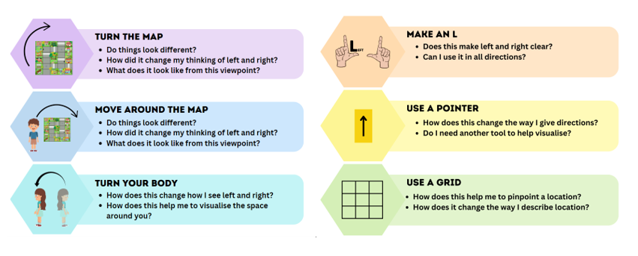

Resource 2 – pointer arrows

Resource 3 – student maze
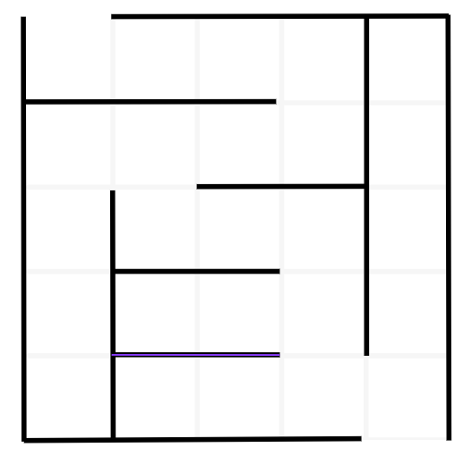

Resource 4 – street map
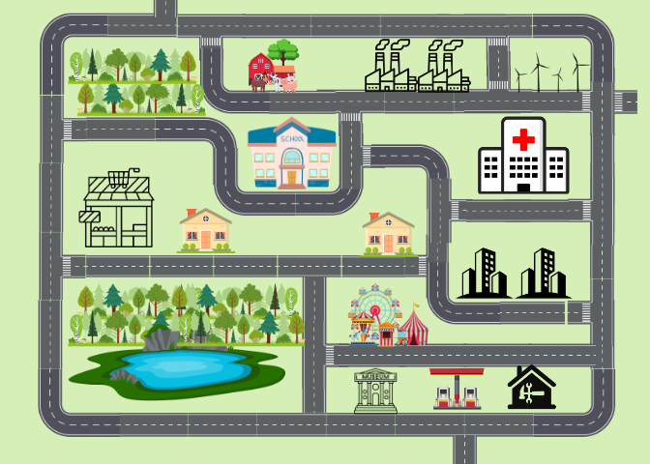

Resource 5 – colour in fractions
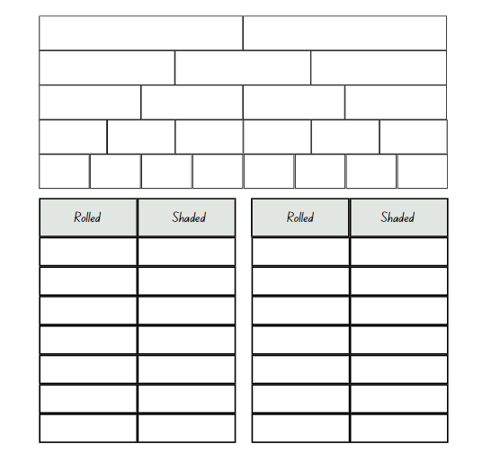

Resource 6 – spinners
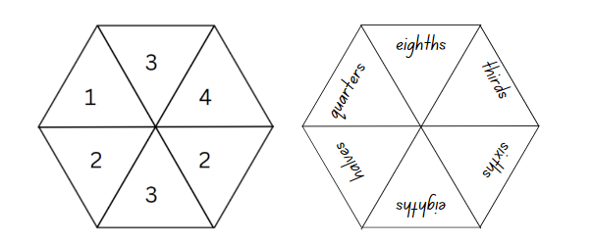

Resource 7 – community map
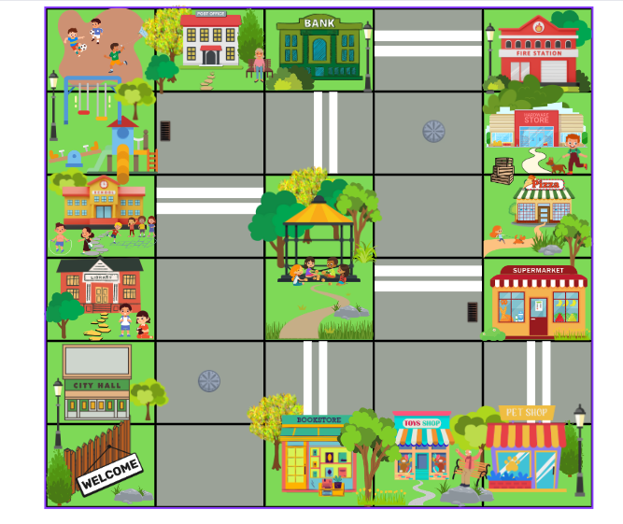

Resource 8 – directions template
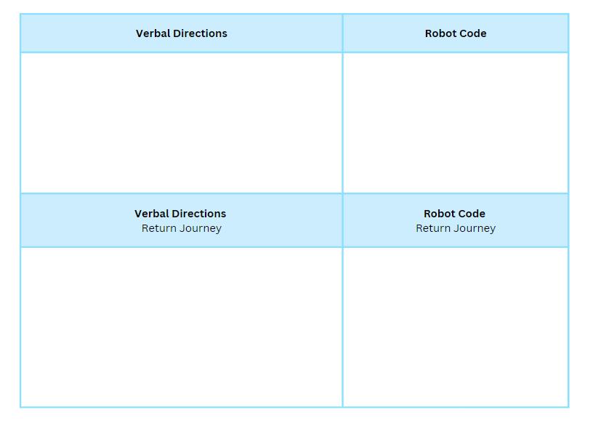

Resource 9 – animal map
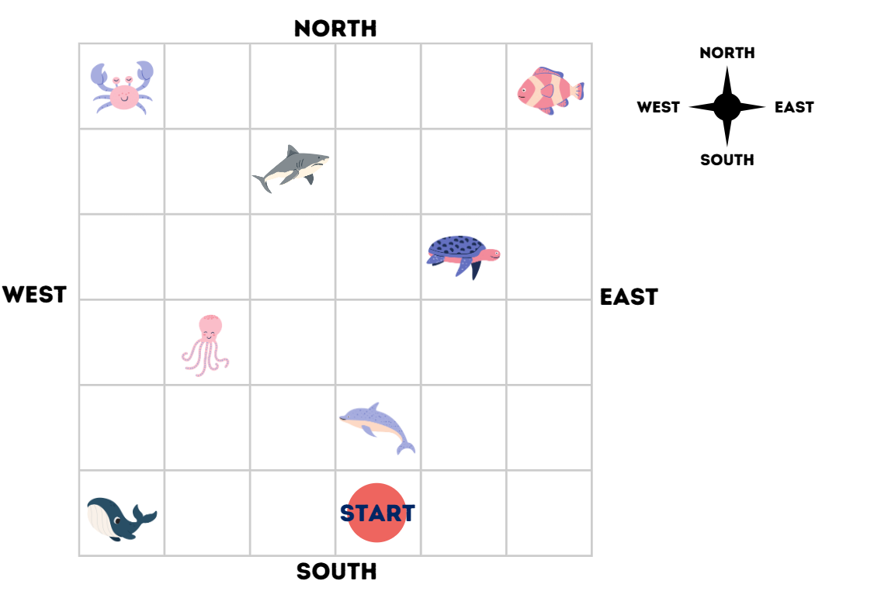

Resource 10 – blank street map
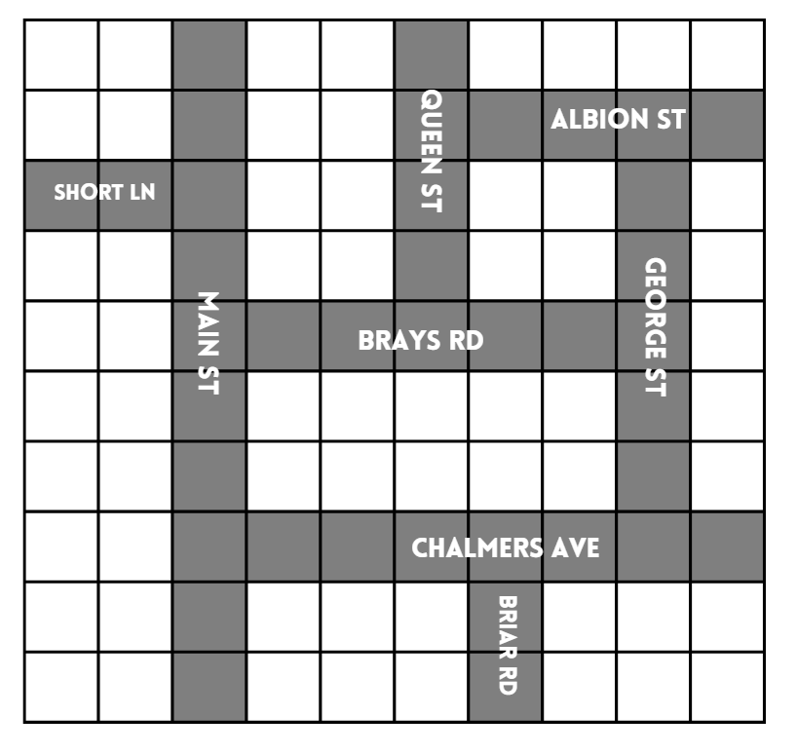

Resource 11 – chance representations
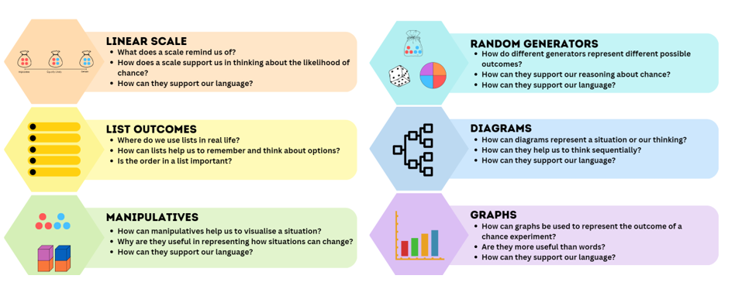

Resource 12 – likelihood scale
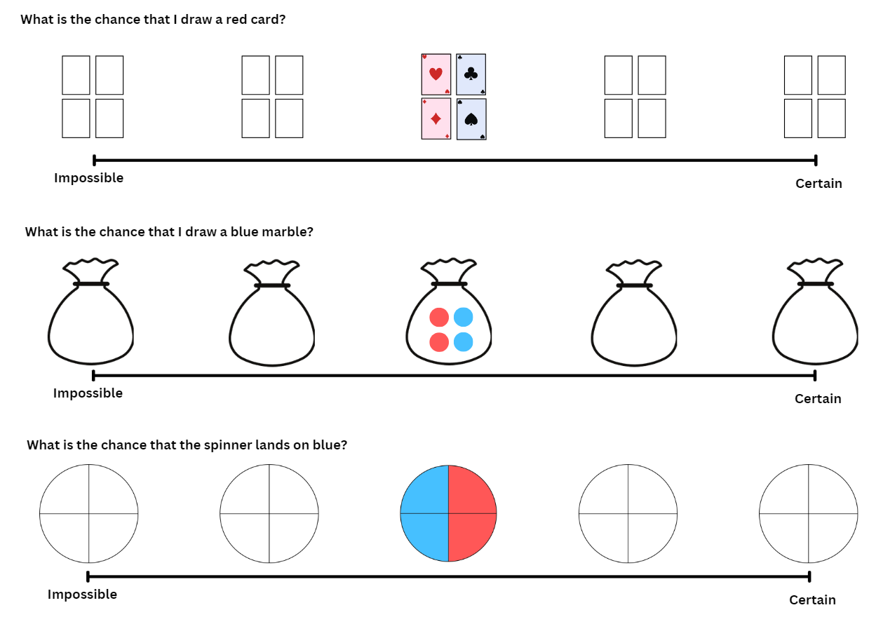

Resource 13 – likelihood cards
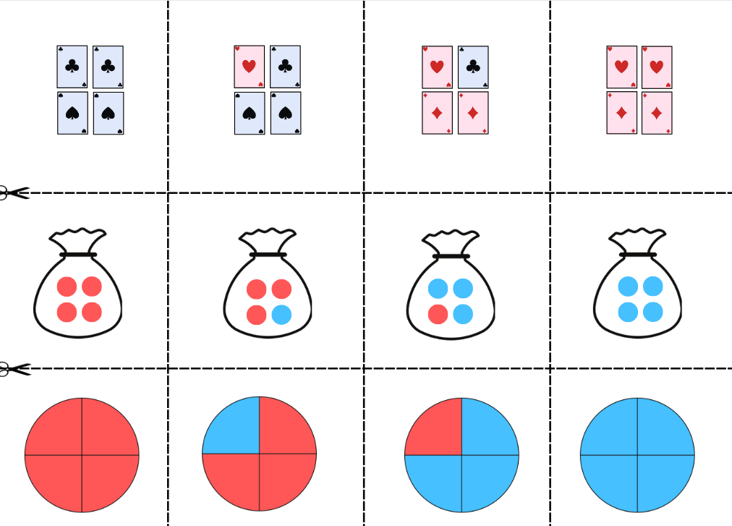

Resource 14 – likelihood scale challenge
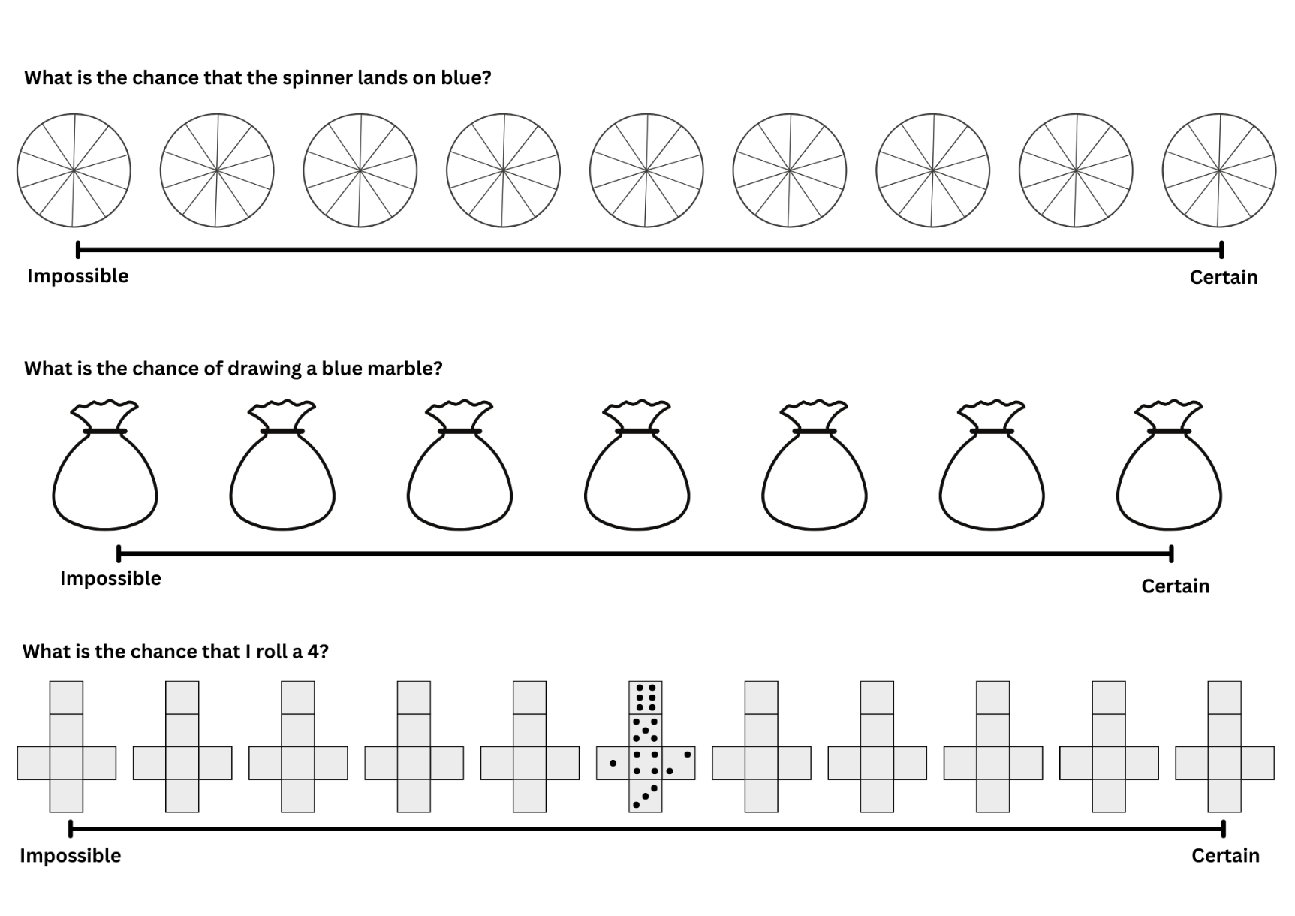

Resource 15 – candy stall
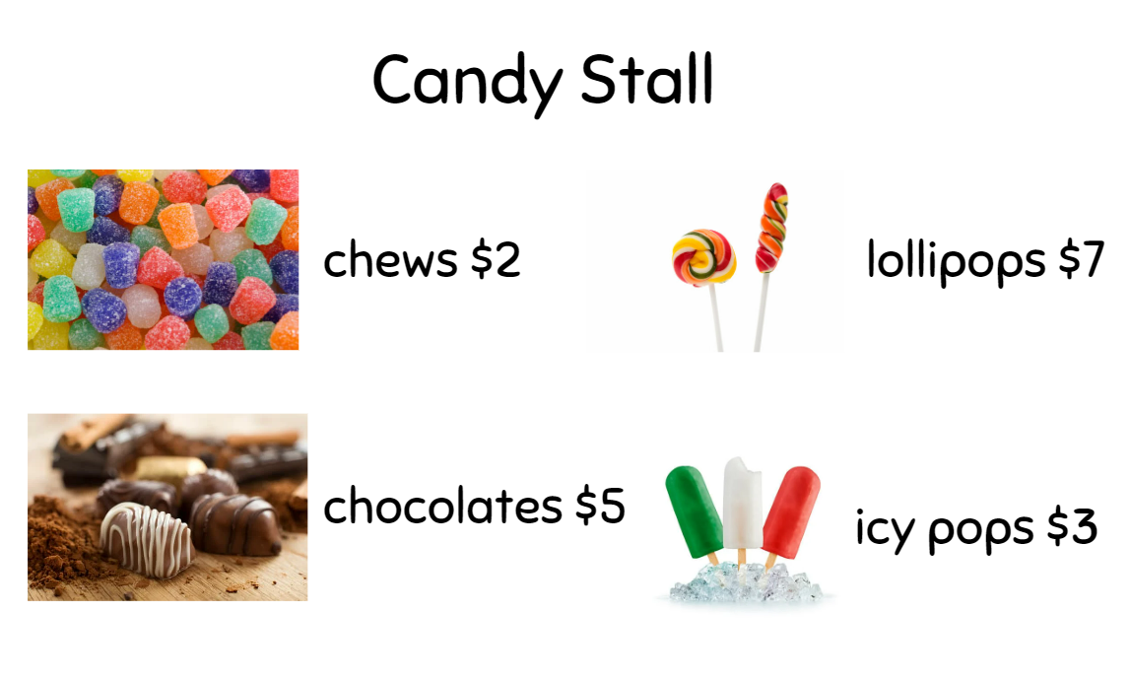

Resource 16 – student statements
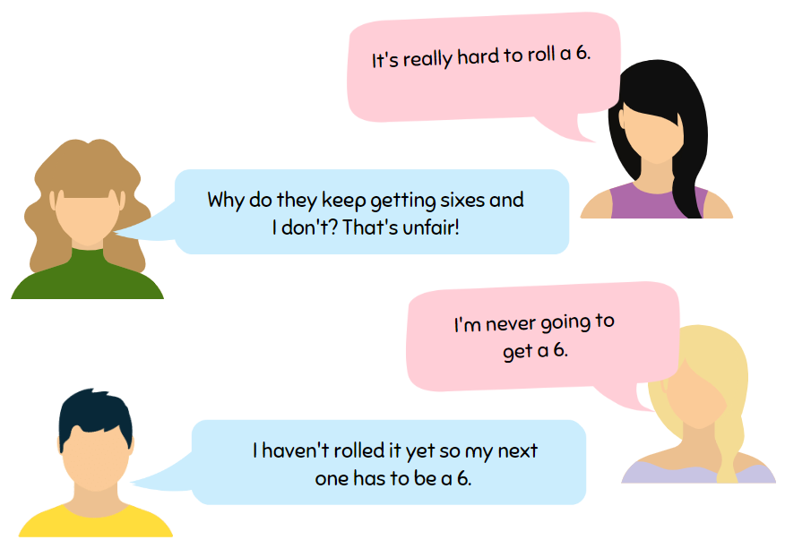

Resource 17 – goat mountain climb
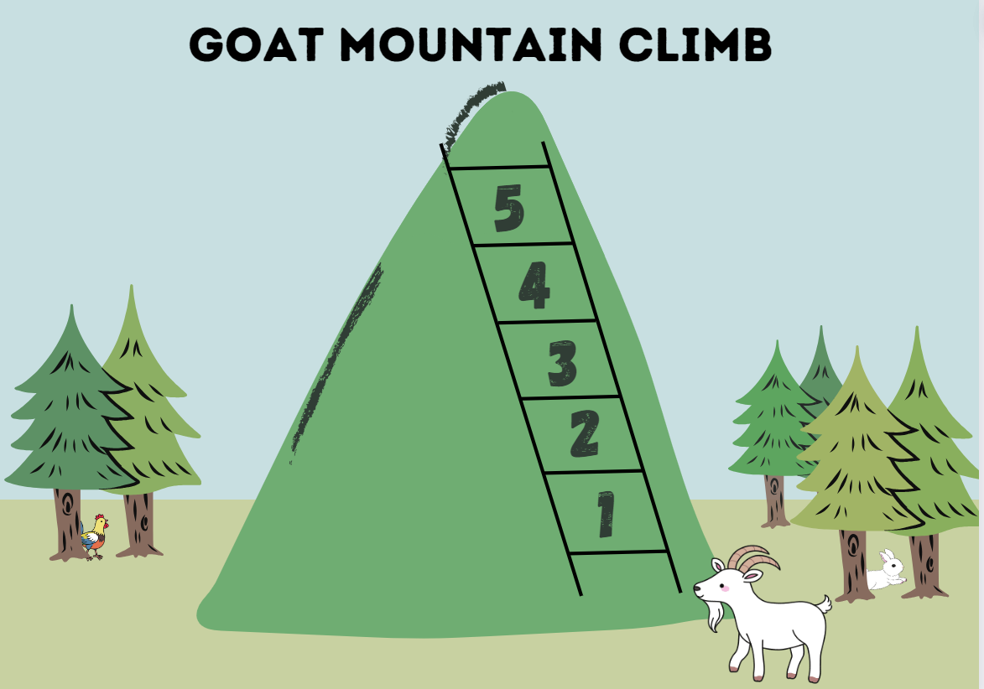

Resource 18 – random generator
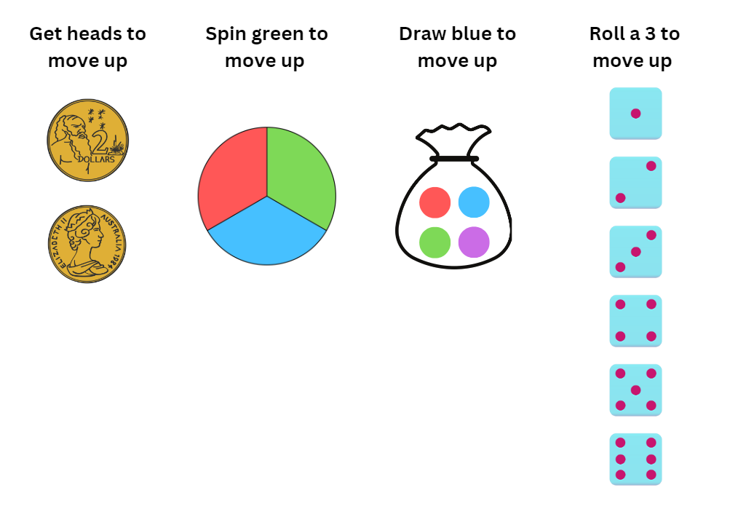

Resource 19 – spinner
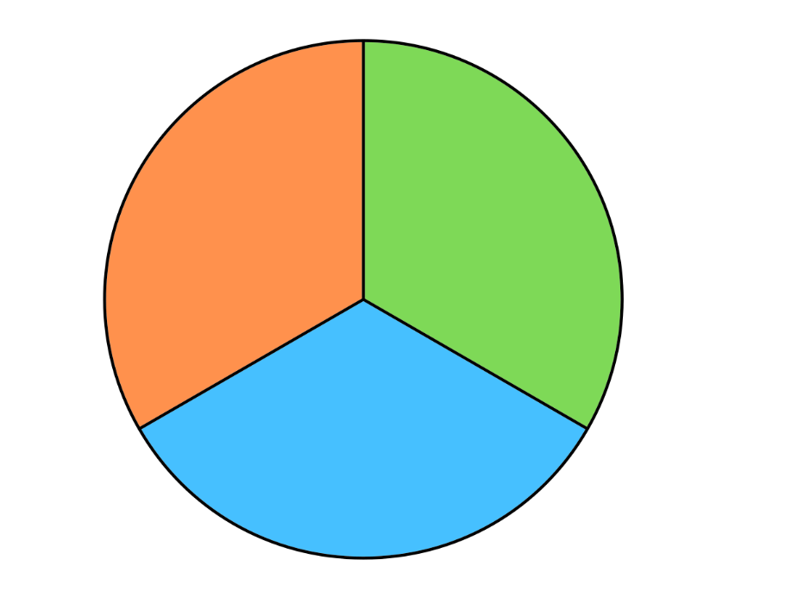

Resource 20 – bag of marbles
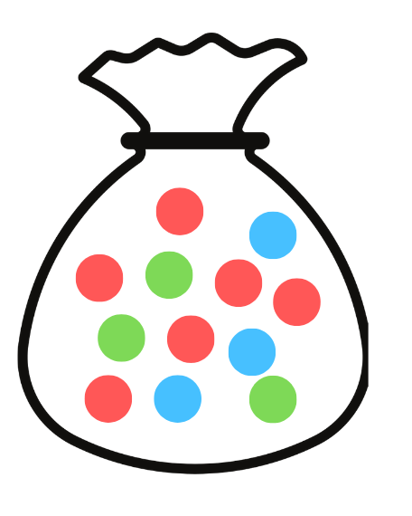

Syllabus outcomes and content
The table below outlines the syllabus outcomes and range of relevant syllabus content covered in this unit. Content is linked to National Numeracy Learning Progression (version 3).
Outcomes and content | 1 | 2 | 3 | 4 | 5 | 6 | 7 | 8
Additive relations B: Apply addition and subtraction to familiar contexts, including money and budgeting
MAO-WM-01, MA2-AR-01
- Use estimation to check the validity of solutions to addition and subtraction problems, including those involving money |  |  |  |  |  | x
- Reflect on a chosen strategy for solving a problem, considering whether it can be improved |  |  |  |  |  |  | x
- Interpret problems involving money as requiring either addition or subtraction |  |  |  |  | x
Partitioned fractions A: Create fractional parts of a length using techniques other than repeated halving
MAO-WM-01, MA2-PF-01
- Make thirds of a length | x | x | x
- Make fifths of a length | x | x | x
Partitioned fractions B: Model equivalent fraction as lengths
MAO-WM-01, MA2-PF-01
- Represent the equivalence of fractions with related denominators as lengths, using concrete materials, diagrams and number lines | x | x | x
- Recognise the need to have equal wholes to compare partitioned fractions (Reasoning about relations) | x | x | x
- Represent fractions with the same-size whole to make valid comparisons (denominators of 2, 4 and 8; 3 and 6; 5 and 10) | x | x | x
Geometric measure A: Position: Interpret movement on a map
MAO-WM-01, MA2-GM-01
- Orient a map to determine directions to travel | x | x | x
- Use given directions to follow routes on land and Aboriginal maps without a grid reference system (Reasons about spatial structure) |  | x
- Describe a route taken on a map using landmarks and directional language | x | x |  | x
Geometric measure A: Position: Locate positions on grid maps
MAO-WM-01, MA2-GM-01
- Use the term right angle to describe a quarter-turn in a range of orientation (Reasons about spatial orientation) | x
Geometric measure B: Position: Create and interpret grid maps
MAO-WM-01, MA2-GM-01
- Create simple maps and plans from an aerial view, labelling grid references |  |  |  | x
Geometric measure B: Position: Use directional language and describe routes with grid maps
MAO-WM-01, MA2-GM-01
- Use a given grid map and compass directions (N, S, E, W) to plan, describe and show a route from one location to another |  |  |  | x
- Use natural resources or landmarks to identify north, south, east, west | x | x
- Relate compass directions to amounts of turn | x | x | x
- Describe a return journey between 2 locations on a grid map (Reasons about spatial orientation) |  |  | x
Two-dimensional spatial structure A: 2D shapes: Transform shapes by reflecting, translating and rotating
MAO-WM-01, MA2-2DS-02
- Apply and describe amounts of rotation including half-turns, quarter-turns and three-quarter-turns when creating designs | x
Data A: Organise and display data using tables and graphs
MAO-WM-01, MA2-DATA-01
- Construct column graphs (with scale intervals of 1) and dot plots using relevant software where appropriate |  |  |  |  |  | x
Data A: Interpret and compare data
MAO-WM-01, MA2-DATA-02
- describe and interpret information presented in tally tables and column graphs. |  |  |  |  |  | x
Chance A: Identify possible outcomes from chance experiments
MAO-WM-01, MA2-CHAN-01
- Use the term outcome to describe any possible result of a chance experiment |  |  |  |  | x
- Record all possible outcomes in a chance experiment where the outcomes are equally likely |  |  |  |  |  |  | x
- Predict the number of times each outcome might occur in a chance experiment involving a set number of trials (Probabilistic reasoning) |  |  |  |  |  | x | x
- Conduct experiments and compare the predicted and actual results where the outcomes are equally likely |  |  |  |  |  | x
Chance B: Describe the likelihood of outcomes of chance events
MAO-WM-01, MA2-CHAN-01
- Use the terms equally likely, likely and unlikely to describe the chance of everyday events occurring |  |  |  |  | x |  | x
- Compare the likelihood of obtaining particular outcomes in a simple chance experiment by predicting, conducting the experiment and comparing the results with the prediction |  |  |  |  |  |  |  | x
Chance B: Identify when events are affected by previous events
MAO-WM-01, MA2-CHAN-01
- Identify and discuss events where the chance of one event occurring will not be affected by the occurrence of the other |  |  |  |  |  | x
- Compare events where the chance of one event occurring is affected by the occurrence of the other (Reasons about relations) |  |  |  |  |  |  |  | x
Mathematics K–10 Syllabus © NSW Education Standards Authority (NESA) for and on behalf of the Crown in right of the State of New South Wales, 2022.

References
This resource contains NSW Curriculum and syllabus content. The NSW Curriculum is developed by the NSW Education Standards Authority. This content is prepared by NESA for and on behalf of the Crown in right of the State of New South Wales. The material is protected by Crown copyright.
Please refer to the NESA Copyright Disclaimer for more information https://educationstandards.nsw.edu.au/wps/portal/nesa/mini-footer/copyright.
NESA holds the only official and up-to-date versions of the NSW Curriculum and syllabus documents. Please visit the NSW Education Standards Authority (NESA) website https://educationstandards.nsw.edu.au/wps/portal/nesa/home and the NSW Curriculum website https://curriculum.nsw.edu.au/.
Mathematics K–10 Syllabus © NSW Education Standards Authority (NESA) for and on behalf of the Crown in right of the State of New South Wales, 2022.
National Numeracy Learning Progression © Australian Curriculum, Assessment and Reporting Authority (ACARA) 2010 to present, unless otherwise indicated. This material was downloaded from the Australian Curriculum website (National Numeracy Learning Progression) (accessed 16 August 2023) and was not modified.
Aboriginal Astronomy (2022) Navigation & Star Maps, Australian Indigenous Astronomy website, accessed 16 August 2023.
Clarke D and Roche A (2014) Engaging Maths: 25 favourite lessons, 2nd edn, published by the authors.
New Zealand Ministry of Education (n.d) Amazing Mazes, NZ Maths website, accessed 16 August 2023.
President and Fellows of Harvard College | Harvard Graduate School of Education (2022) I Used to Think... Now I Think..., Project Zero website accessed 16 August 2023.
State of New South Wales (Department of Education) (2023) Big ideas to start strong across K–6, Department of Education website, accessed 15 August 2023.
State of New South Wales Government (Department of Education) (2023) Colour in fractions, Department of Education website, accessed 4 August 2023.
Terrapin (2023) Bee-Bot Online Emulator, Bee-Bot website, accessed 16 August 2023.
University of Cambridge (n.d) Bipin’s Choice, NRICH website, accessed 16 August 2023.
University of Cambridge (n.d) Buying a Balloon, NRICH website, accessed 16 August 2023.
University of Cambridge (n.d) Monetary Difference, NRICH website, accessed 16 August 2023.
University of Cambridge (n.d) The Puzzling Sweet Shop, NRICH website, accessed 16 August 2023.
Further reading
Evolve Communities (12 May 2021) ‘What are Songlines? [video]’, Evolve Communities, YouTube, accessed 27 July 2023.
Nicholls C (20 December 2017) ‘Songlines: Tracking the Seven Sisters is a must-visit exhibition for all Australians’, The Conversation website, accessed 10 August 2023.
Siemon D, Warren E, Beswick K, Faragher R, Miller J, Horne M, Jazby D, Breed M, Clark J, Brady K (2020) Teaching Mathematics: Foundation to middle years, 3rd edn Oxford University Press, Australia
University of Melbourne (2023) ‘Stellar navigation and mathematics’, Aboriginal and Torres Strait Islander School Curricula: Resources Indigenous Knowledge Institute website, accessed 26 July 2023.
Van de Walle J, Karp K, Bay-Williams JM, Brass A, Bentley B, Ferguson S, Goff W, Livy S, Marshman M, Martin D, Pearn C, Prodromou T, Symons D and Wilkie K (2019) Primary and Middle Years Mathematics: Teaching Developmentally, 1st Australian edn, Pearson Education Australia, Melbourne.
Yubulyawan Dreaming Project (2015) ‘Gujingga Songline (featuring Yidumduma Bill Harney)’ [video], Paul Taylor, YouTube, accessed 26 July 2023.

© State of New South Wales (Department of Education), 2023
The copyright material published in this resource is subject to the Copyright Act 1968 (Cth) and is owned by the NSW Department of Education or, where indicated, by a party other than the NSW Department of Education (third-party material).
Copyright material available in this resource and owned by the NSW Department of Education is licensed under a Creative Commons Attribution 4.0 International (CC BY 4.0) license.
This licence allows you to share and adapt the material for any purpose, even commercially.
Attribution should be given to © State of New South Wales (Department of Education), 2023.
Material in this resource not available under a Creative Commons licence:
- the NSW Department of Education logo, other logos and trademark-protected material
- material owned by a third party that has been reproduced with permission. You will need to obtain permission from the third party to reuse its material.
Links to third-party material and websites
Please note that the provided (reading/viewing material/list/links/texts) are a suggestion only and implies no endorsement, by the New South Wales Department of Education, of any author, publisher, or book title. School principals and teachers are best placed to assess the suitability of resources that would complement the curriculum and reflect the needs and interests of their students.
If you use the links provided in this document to access a third-party's website, you acknowledge that the terms of use, including licence terms set out on the third-party's website apply to the use which may be made of the materials on that third-party website or where permitted by the Copyright Act 1968 (Cth). The department accepts no responsibility for content on third-party websites.

