Mathematics Stage 2 Year B – Unit 29

Contents

Unit description and duration 4

Syllabus outcomes 4

Working mathematically 5

Student prior learning 5

Lesson overview and resources 7

Lesson 1 13

Daily number sense – round the 4 dice – 10 minutes 13

Core lesson – creating models of three-dimensional objects – 50 minutes 15

Consolidation and meaningful practice – 10 minutes 18

Lesson 2 20

Daily number sense – to the nearest thousand – 15 minutes 20

Core lesson – sketching time – 40 minutes 21

Discuss and connect the mathematics – 15 minutes 24

Lesson 3 25

Daily number sense – 4-digit targets – 15 minutes 25

Core lesson – drawing views of objects – 45 minutes 27

Discuss and connect the mathematics – 10 minutes 30

Lesson 4 33

Daily number sense – 10 minutes 33

Core lesson – using top, front and side views to draw objects – 40 minutes 33

Discuss and connect the mathematics – 15 minutes 35

Lesson 5 37

Daily number sense – counting by tens – 10 minutes 37

Core lesson – how many litres in this container? – 40 minutes 39

Discuss and connect the mathematics – 10 minutes 42

Lesson 6 44

Daily number sense – multiples madness – 15 minutes 44

Core lesson – what’s my capacity? – 40 minutes 46

Consolidation and meaningful practice – 10 minutes 48

Lesson 7 50

Daily number sense – multiplying by multiples – 15 minutes 50

Core lesson – estimating known capacities – 40 minutes 52

Consolidation and meaningful practice – 5 minutes 55

Lesson 8 57

Daily number sense – 10 minutes 57

Core lesson – making our own measuring cup – 35 minutes 57

Discuss and connect the mathematics – 10 minutes 59

Consolidation and meaningful practice – 10 minutes 59

Resource 1 – dice combinations 61

Resource 2 – two-dimensional shapes 62

Resource 3 – three-dimensional objects 63

Resource 4 – 20 numbers 64

Resource 5 – pentominoes 65

Resource 6 – pentomino views 66

Resource 7 – recording table A 67

Resource 8 – multiples madness gameboard 68

Resource 9 – multiplying multiples 69

Resource 10 – recording table B 70

Resource 11 – capacity quiz 71

Resource 12 – measurement cards 73

Syllabus outcomes and content 75

References 80

# Unit description and duration

This unit develops the big idea that what needs to be measured determines the unit of measurement.

In this 2-week unit students are provided opportunities to:

* compare and describe features of three-dimensional objects by making and exploring models, sketches and diagrams
* construct and draw models from given top, front and side views, using squared and isometric paper
* use formal units (litres and millilitres) to measure capacity and use scaled instruments to measure and compare capacities.

## Syllabus outcomes

* **MAO-WM-01** develops understanding and fluency in mathematics through exploring and connecting mathematical concepts, choosing and applying mathematical techniques to solve problems, and communicating their thinking and reasoning coherently and clearly
* **MA2-RN-01 applies an understanding of place value and the role of zero to represent numbers to at least tens of thousands**
* **MA2-MR-01** represents and uses the structure of multiplicative relations to 10 × 10 to solve problems
* **MA2-2DS-01** compares two-dimensional shapes and describes their features
* **MA2-3DS-01** makes and sketches models and nets of three-dimensional objects including prisms and pyramids
* **MA2-3DS-02** estimates, measures and compares capacities (internal volumes) using litres, millilitres and volumes using cubic centimetres

## Working mathematically

In the Mathematics K–10 Syllabus, there is one overarching Working mathematically outcome (**MAO-WM-01**). The Working mathematically processes should be embedded within the concepts being taught. The Working mathematically processes present in the Mathematics K–10 Syllabus are:

* communicating
* understanding and fluency
* reasoning
* problem solving.

[Mathematics K–10 Syllabus](https://curriculum.nsw.edu.au/learning-areas/mathematics/mathematics-k-10-2022/overview) © NSW Education Standards Authority (NESA) for and on behalf of the Crown in right of the State of New South Wales, 2022.

## Student prior learning

Before engaging in these teaching and learning activities, students would benefit from prior experience with:

* comparing and describing features of three-dimensional objects by exploring concrete materials, models and sketches
* constructing and deconstructing nets of three-dimensional objects
* using formal units (litres and millilitres) to measure capacity and use scaled instruments to measure and compare capacities.

In NSW classrooms there is a diverse range of students, including Aboriginal and Torres Strait Islander students, students learning English as an additional language or dialect, high potential and gifted students and students with disability. Some students may identify with more than one of these groups or possibly all of them. Refer to [Curriculum planning for every student – advice](https://education.nsw.gov.au/teaching-and-learning/curriculum/planning-programming-and-assessing-k-12/advice-on-curriculum-planning-for-every-student-k-12) for further information.

# Lesson overview and resources

The table below outlines the sequence and approximate timing of lessons, learning intentions and resources.

|  |  |  |
| --- | --- | --- |
| Lesson | Content | Duration and resources |
| **Lesson 1**  **Daily number sense learning intention**:   * order numbers in the thousands | **Lesson core concept**: objects can be described effectively by focusing on features.  **Core concept learning intentions**:   * make models of three-dimensional objects to compare and describe key features * connect three-dimensional objects and two-dimensional representations | **Lesson duration**: 70 minutes   * Resource 1 – dice combinations * Resource 2 – two-dimensional shapes * A4 card * Individual whiteboards * Scissors * Sticky putty * Toothpicks * Writing materials |
| **Lesson 2**  **Daily number sense learning intention**:   * order numbers in the thousands | **Lesson core concept**: objects can be drawn by focussing on their features.  **Core concept learning intentions**:   * make models of three-dimensional objects to compare and describe key features * connect three-dimensional objects and two-dimensional representations | **Lesson duration**: 70 minutes   * Resource 3 – three-dimensional shapes * 0–9 dice * Individual whiteboards * Writing materials |
| **Lesson 3**  **Daily number sense learning intention**:   * order numbers in the thousands | **Lesson core concept**: mathematicians draw objects from different perspectives.  **Core concept learning intentions**:   * make models of three-dimensional objects to compare and describe key features * connect three-dimensional objects and two-dimensional representations | **Lesson duration**: 70 minutes   * Resource 4 – 20 numbers * Resource 5 – pentominoes * Resource 6 – pentomino views * Coloured interlocking blocks * Grid paper * Individual whiteboards * Isometric paper * Writing materials |
| **Lesson 4**  **Daily number sense learning intention**:   * teacher-identified task based on student needs | **Lesson core concept**: drawings are interpreted to construct objects.  **Core concept learning intention**:   * connect three-dimensional objects and two-dimensional representations | **Lesson duration**: 65 minutes   * An opaque bag * Coloured interlocking blocks * Grid paper * Isometric paper * Pentomino sets from Lesson 3 * Writing materials |
| **Lesson 5**  **Daily number sense learning intention**:   * operate with multiples of 10 | **Lesson core concept**: metric units of measurement relate to our base-10 place value system.  **Core concept learning intentions**:   * measure and order containers using litres * use scaled instruments to measure and compare capacities | **Lesson duration**: 60 minutes   * Resource 7 – recording table A * 6-sided dice (one per pair) * Large containers (4 per group) * Large paper for anchor chart * Scaled measuring cups and jugs * Writing materials |
| **Lesson 6**  **Daily number sense learning intention**:   * operate with multiples of 10 | **Lesson core concept**: standard units are an efficient way to communicate capacity.  **Core concept learning intentions**:   * measure and order containers using litres * use scaled instruments to measure and compare capacities | **Lesson duration**: 65 minutes   * Resource 8 – multiples madness gameboard * 2 containers of less than 1 L * 250 mL measuring cups * 9-sided dice (one per pair) * Class anchor chart * Clear containers (more than 1 L) * Coloured counters * Scaled 1 L measuring jugs * Writing materials |
| **Lesson 7**  **Daily number sense learning intention**:   * operate with multiples of 10 | **Lesson core concept**: estimation is guided by using known benchmarks of capacity (internal volume).  **Core concept learning intentions**:   * use scaled instruments to measure and compare capacities * read represent and order numbers to thousands | **Lesson duration**: 60 minutes   * Resource 9 – multiplying multiples * Resource 10 – recording table B * 10-sided dice (one per pair) * Containers brought by students * Scaled measuring cups and jugs * Small everyday containers * Writing materials |
| **Lesson 8**  **Daily number sense learning intention**:   * teacher-identified task based on student needs | **Lesson core concept**: mathematicians estimate, measure and compare capacities.  **Core concept learning intentions**:   * use scaled instruments to measure and compare internal volumes * order numbers in the thousands | **Lesson duration**: 65 minutes   * Resource 11 – capacity quiz * Resource 12 – measurement cards * Permanent markers or elastic bands * Transparent plastic cups * Writing materials |

# Lesson 1

**Core concept**: objects can be described effectively by focusing on features.

## Daily number sense – round the 4 dice – 10 minutes

Daily number sense activities for Lessons 1 to 3 ‘activate’ prior number knowledge and support the learning of new content in the unit. These activities can also assist teachers to identify the starting points for learning by revealing the extent of students’ existing knowledge.

The table below contains a suggested learning intention and success criteria. These are best co-constructed with students.

|  |  |
| --- | --- |
| Daily number sense learning intention | Daily number sense success criteria |
| Students are learning to:   * order numbers in the thousands. | Students can:   * identify the nearest thousand to a given number. |

This activity is an adaptation of ‘[Round the Four Dice](https://nrich.maths.org/10426)’ from [NRICH](https://nrich.maths.org/) by the University of Cambridge (Faculty of Mathematics).

1. Tell students you had four 6-sided dice and rolled the numbers 1, 2, 3 and 4.
2. Display Resource 1 – dice combinations. Show students some of the possible 4-digit number combinations.
3. Ask students to choose and record 4 numbers from Resource 1 – dice combinations on individual whiteboards. Students round each number to the nearest multiple of 1000. Ask:

* How did you work out whether to round up or round down to the nearest multiple of 1000?
* Did you round up to the nearest thousand or round down to the nearest thousand more often? Why?
* Did any of the four 4-digit numbers you chose round to the same multiple of 1000?

1. In pairs, students repeat the process, using a new set of four-digit numbers chosen from Resource 1 – dice combinations.

This table details opportunities for assessment.

|  |  |
| --- | --- |
| Assessment opportunities | Links |
| What to look for:   * Can students identify the nearest thousand to a given number? **[MAO-WM-01, MA2-RN-01]** | Links to [National Numeracy Learning Progressions](https://www.australiancurriculum.edu.au/resources/national-literacy-and-numeracy-learning-progressions/version-3-of-national-literacy-and-numeracy-learning-progressions/) (NNLP):   * NPV7.   Links to suggested [Interview for Student Reasoning](https://education.nsw.gov.au/teaching-and-learning/curriculum/literacy-and-numeracy/assessment-resources/ifsr) (IfSR) tasks:   * **IfSR-NP**: 4C.8. |

## Core lesson – creating models of three-dimensional objects – 50 minutes

**Note**: in Lesson 7, students will be learning to measure and order containers accurately using litres and millilitres. To provide a wide range of containers, students can be asked to bring containers from home. This can also be communicated to parents or carers, for example:

This week, students in (class) will be learning to measure and order containers using litres. To provide a wide range of containers, it would be helpful if students are able bring any containers from home that are able to hold water. Containers that hold different amounts would be appreciated, for example 100 millilitres, 250 millilitres (one quarter of a litre), 500 millilitres (half a litre), 1000 millilitres (1 L) or 2000 millilitres (2 L). These containers can be stored in the classroom until they are used on (day).

Thank you for your support, (Teacher).

The table below contains suggested learning intentions and success criteria. These are best co-constructed with students.

|  |  |
| --- | --- |
| Core concept learning intentions | Core concept success criteria |
| Students are learning to:   * make models of three-dimensional objects to compare and describe key features * connect three-dimensional objects and two-dimensional representations. | Students can:   * identify the differences between prisms (including cubes), pyramids and cylinders * identify features of prisms, pyramids and cylinders from images. |

This activity has been adapted from Open-ended Maths Activities by Sullivan.

**Note**: the Stage 2 teaching advice states that formal names for particular prisms and pyramids are not introduced until Stage 3.

This lesson revises student prior knowledge of three-dimensional objects and their key features. For example, faces, edges, vertices, curved and flat surfaces and boundaries.

1. Revise with students that faces or surfaces of three-dimensional objects are two-dimensional shapes.
2. In small groups, students cut the shapes from Resource 2 – two-dimensional shapes. Teachers can have the shapes pre-cut prior to the lesson.
3. Ask students what three-dimensional objects these two-dimensional shapes could belong to. Ask:

* Is there more than one possibility?
* What other three-dimensional objects could have the same face or surface?

1. Record and discuss student responses.
2. Model building a three-dimensional object with toothpicks and sticky putty, using one of the straight-sided two-dimensional shapes (see Figure 1). Support students to think about the features of three-dimensional objects. For example, edges, vertices, faces.

Figure 1 – building three-dimensional objects

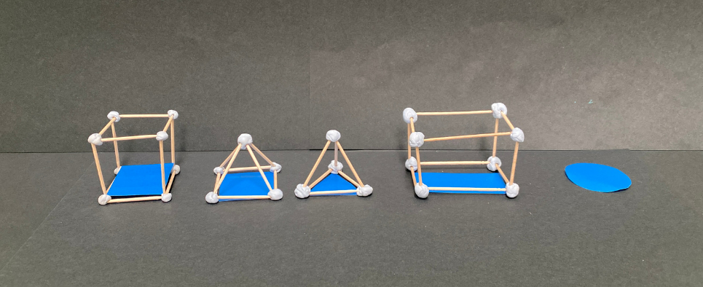

1. In groups, students build the three-dimensional objects. They draw and label the features of each object.
2. Ask students to group the objects into prisms and pyramids. Ask:

* Is there another way to group these objects?
* Why is the cylinder impossible to make with toothpicks and sticky putty?

**Note**: keep the three-dimensional models to use again in Lesson 2.

This table details opportunities for differentiation.

|  |  |
| --- | --- |
| Too hard? | Too easy? |
| Students cannot make models of three-dimensional objects.   * Support students to make models of three-dimensional objects with sticky putty and toothpicks. * Students label the features of a three-dimensional model or a given drawing of a three-dimensional object. | Students can make models of three-dimensional objects.   * Students draw three-dimensional objects showing the invisible edges. * Students write a definition that describes the three-dimensional objects. |

## Consolidation and meaningful practice – 10 minutes

1. Tell students that you went on a walk around the school. The goal was to spot everyday objects, write down the object and its three-dimensional name. You wrote down prism, pyramid and cylinder but forgot to write what the objects were.
2. Ask students what everyday objects these three-dimensional objects could be. For example, a water tank, lockers, and classroom roof.
3. Create class definitions of prisms, pyramids and cylinders to be displayed.

This table details opportunities for assessment.

|  |  |
| --- | --- |
| Assessment opportunities | Links |
| What to look for:   * Can students identify the differences between prisms (including cubes), pyramids and cylinders? **[MAO-WM-01, MA2-3DS-01]** * Can students identify features of prisms, pyramids and cylinders from models and images? **[MAO-WM-01, MA2-3DS-01]** | Links to [National Numeracy Learning Progressions](https://www.australiancurriculum.edu.au/resources/national-literacy-and-numeracy-learning-progressions/version-3-of-national-literacy-and-numeracy-learning-progressions/) (NNLP):   * UGP3, UGP5. |

# Lesson 2

**Core concept**: objects can be drawn by focussing on their features.

## Daily number sense – to the nearest thousand – 15 minutes

The table below contains a suggested learning intention and success criteria. These are best co-constructed with students.

|  |  |
| --- | --- |
| Daily number sense learning intention | Daily number sense success criteria |
| Students are learning to:   * order numbers in the thousands. | Students can:   * recognise and describe how rearranging digits changes the size of a number * identify the nearest thousand to given numbers. |

1. Students write the target numbers 20 000, 40 000, 60 000 and 80 000 on individual whiteboards.
2. Students roll five 0–9 dice and arrange them to make a 5-digit number as near as possible to one of the target numbers. Students say their chosen number aloud and record it next to the desired target number in any order. Repeat the process 7 times.
3. Ask students:

* Who got nearest to a target number? How do you know?
* Is there a 5-digit number you noticed that if the arrangement of numbers was changed, it would create a number closer to one of the target numbers? Explain your reasoning.
* Can you select one of your rolled numbers and rearrange it to be the smallest number possible?

This table details opportunities for assessment.

|  |  |
| --- | --- |
| Assessment opportunities | Links |
| What to look for:   * Can students recognise and describe how rearranging digits changes the size of a number? **[MAO-WM-01, MA2-RN-01]** * Can students identify the nearest thousand to given numbers? **[MAO-WM-01, MA2-RN-01]** | Links to [National Numeracy Learning Progressions](https://www.australiancurriculum.edu.au/resources/national-literacy-and-numeracy-learning-progressions/version-3-of-national-literacy-and-numeracy-learning-progressions/) (NNLP):   * NPV7.   Links to suggested [Interview for Student Reasoning](https://education.nsw.gov.au/teaching-and-learning/curriculum/literacy-and-numeracy/assessment-resources/ifsr) (IfSR) tasks:   * **IfSR-NP**: 4C.8. |

## Core lesson – sketching time – 40 minutes

The table below contains suggested learning intentions and success criteria. These are best co-constructed with students.

|  |  |
| --- | --- |
| Core concept learning intentions | Core concept success criteria |
| Students are learning to:   * make models of three-dimensional objects to compare and describe key features * connect three-dimensional objects and two-dimensional representations. | Students can:   * identify the differences between prisms, pyramids and cylinders * create sketches of rectangular prisms and pyramids, showing depth. |

1. Display class definitions of prisms, pyramids and cylinders. Revise faces, vertices, edges, curved and flat surfaces and boundaries.
2. Give pairs of students Resource 3 – three-dimensional objects. Students finger-trace around the shapes to help them understand angles and perspective for the next part of the lesson.
3. Model how to sketch a cube.

**Note**: support students to understand that two-dimensional shapes that are components of three-dimensional objects are drawn using perspective. For example, a square on the side of a drawn cube may appear to be a rhombus.

1. Discuss how the square faces on the top, bottom and sides of the cube are drawn as rhombuses to achieve depth and perspective.
2. Students use models from Lesson 1 to sketch prisms, pyramids and cylinders showing depth (see Figure 2).

Figure 2 – drawing three-dimensional objects

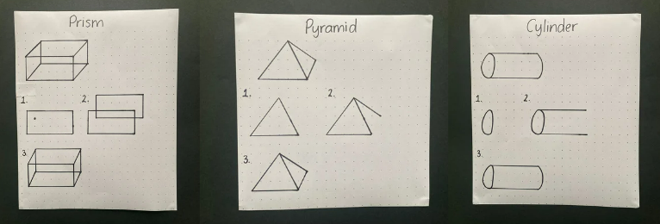

1. Students count the number of faces, vertices and edges they have altogether in their sketches and record this on their paper.

This table details opportunities for differentiation.

|  |  |
| --- | --- |
| Too hard? | Too easy? |
| Students cannot sketch prisms and pyramids, showing depth.   * Students follow guided, step-by-step instructions to draw one three-dimensional object. * Students trace over sketches of three-dimensional objects. | Students can sketch prisms and pyramids, showing depth.   * Students identify a light source and use this to add shadows to their sketches. * Students use a vanishing point to draw objects, so that they appear to stretch indefinitely. |

## Discuss and connect the mathematics – 15 minutes

1. In pairs, students go on a [gallery walk](https://app.education.nsw.gov.au/digital-learning-selector/LearningActivity/Card/555) and discuss these questions:

* What did you notice about the sketches of prisms, pyramids and cylinders?
* What is similar and what is different?
* Are there any features of your sketches that need revising?

This table details opportunities for assessment.

|  |  |
| --- | --- |
| Assessment opportunities | Links |
| What to look for:   * Can students identify the differences between prisms (including cubes), pyramids and cylinders? **[MAO-WM-01, MA2-3DS-01]** * Can students create sketches of rectangular prisms and pyramids, showing depth? **[MAO-WM-01, MA2-3DS-01]** * Can students use two-dimensional shapes to describe three-dimensional objects? **[MAO-WM-01, MA2-2DS-01, MA2-3DS-01]** | Links to [National Numeracy Learning Progressions](https://www.australiancurriculum.edu.au/resources/national-literacy-and-numeracy-learning-progressions/version-3-of-national-literacy-and-numeracy-learning-progressions/) (NNLP):   * UGP3, UGP5. |

# Lesson 3

**Core concept**: mathematicians draw objects from different perspectives.

## Daily number sense – 4-digit targets – 15 minutes

The table below contains a suggested learning intention and success criteria. These are best co-constructed with students.

|  |  |
| --- | --- |
| Daily number sense learning intention | Daily number sense success criteria |
| Students are learning to:   * order numbers in the thousands. | Students can:   * recognise and describe how rearranging digits changes the size of a number * identify the nearest thousand to given numbers. |

This activity is an adaptation of ‘[Four-digit Targets](https://nrich.maths.org/6342)’ from [NRICH](https://nrich.maths.org/) by the University of Cambridge (Faculty of Mathematics).

1. Display Resource 4 – 20 numbers. Tell students they need to arrange the digits to make five 4-digit numbers as close to the target numbers as possible. Explain to students that they can use each digit only once.
2. Encourage small groups of students to work strategically and systematically to get numbers nearest to the target numbers. Remind students they can adjust their answers as they progress with the problem (see Figure 3).

Figure 3 – possible student response

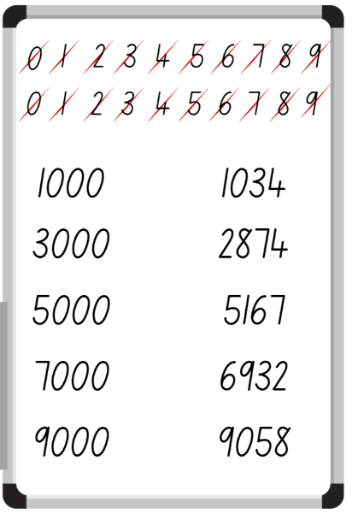

1. Ask students:

* Who recorded the 4-digit number nearest to each target number? How do you know?
* Does your 4-digit number round up or down to the target number?
* What were the challenges in this task?

**Note**:based on students needs, this task can be modified for 5-digit or 6-digit numbers.

This table details opportunities for assessment.

|  |  |
| --- | --- |
| Assessment opportunities | Links |
| What to look for:   * Can students recognise and describe how rearranging digits changes the size of a number? **[MAO-WM-01, MA2-RN-01]** * Can students identify the nearest thousand to given numbers? **[MAO-WM-01, MA2-RN-01]** | Links to [National Numeracy Learning Progressions](https://www.australiancurriculum.edu.au/resources/national-literacy-and-numeracy-learning-progressions/version-3-of-national-literacy-and-numeracy-learning-progressions/) (NNLP):   * NPV7.   Links to suggested [Interview for Student Reasoning](https://education.nsw.gov.au/teaching-and-learning/curriculum/literacy-and-numeracy/assessment-resources/ifsr) (IfSR) tasks:   * **IfSR-NP**: 4C.8. |

## Core lesson – drawing views of objects – 45 minutes

The table below contains suggested learning intentions and success criteria. These are best co-constructed with students.

|  |  |
| --- | --- |
| Core concept learning intentions | Core concept success criteria |
| Students are learning to:   * make models of three-dimensional objects to compare and describe key features * connect three-dimensional objects and two-dimensional representations. | Students can:   * create sketches of three-dimensional objects from different views, including top, front and side views * draw different views on isometric grids of an object constructed from connecting cubes * use features to identify the differences between prisms (including cubes), pyramids and cylinders. |

1. Display Resource 5 – pentominoes. Small groups of students make sets of pentominoes with coloured interlocking blocks.

**Note**: if time allows, students could investigate to find the 12 pentominoes that can be made with 5 blocks. Then, they justify why there are only 12 solutions.

1. As a class, look at the single 5-block tower pentomino and identify the two-dimensional shapes that can be seen on each whole side (squares at the top and bottom bases, rectangles at the sides). Count the sides, vertices and edges and consider their orientation to identify this three-dimensional model as a rectangular prism.
2. Discuss whether a pyramid or cylinder could be made with these blocks. Students turn and talk. Using features of prisms, pyramids and cylinders, discuss why it is impossible to make a pyramid or cylinder.
3. Model drawing the top, front and side views of the tower pentomino on grid paper. Record using Resource 6 – pentomino views.
4. Give students a copy of Resource 6 – pentomino views. Students reform groups and repeat the drawing and recording process for another pentomino. Repeat this process for 10 minutes.
5. Students compare their drawings with others in the group and discuss any differences.
6. Model how to draw the single 5-block tower pentomino using isometric paper. Discuss which faces of each block can be seen. Students may find this easier to visualise and record if the pentomino is made with 5 different coloured blocks (see Figure 4).

Figure 4 – recording pentominoes on isometric paper

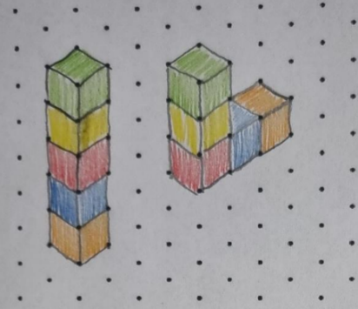

1. Ask students if there are any other ways to draw this pentomino. There are several (see Figure 5).

Figure 5 – different ways to draw the tower pentomino

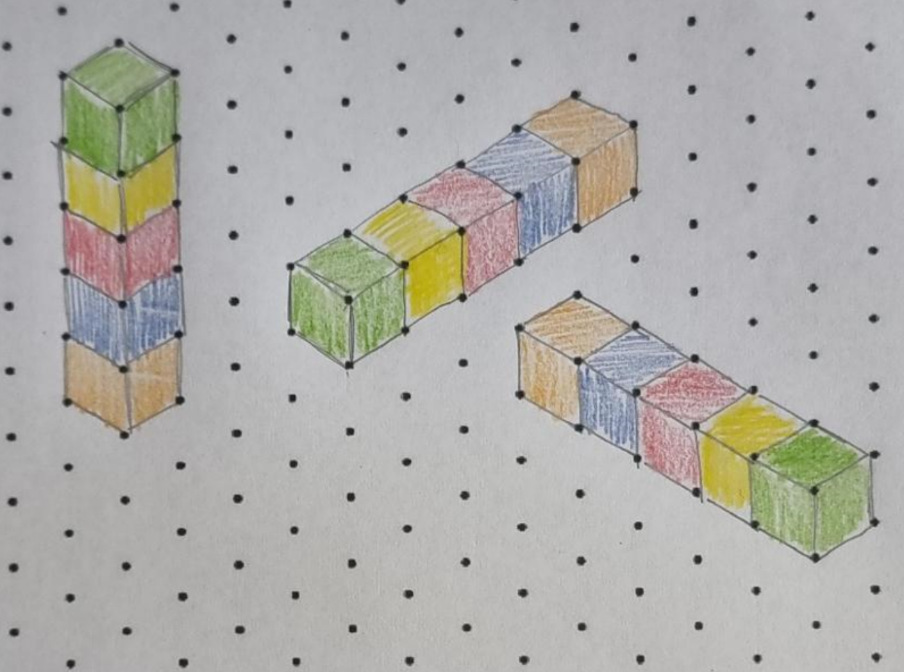

1. Model the pentomino that can be described as an upper-case L. Draw attention to partial faces that students can see (see Figure 5).
2. Students draw the pentomino on isometric paper and then try to draw it from different orientations.
3. Some students may enjoy the challenge of drawing views of more complex pentominoes on isometric paper. All students compare their drawings and discuss what is the same and what is different (see Figure 6).

Figure 6 – views of the U-shaped pentomino

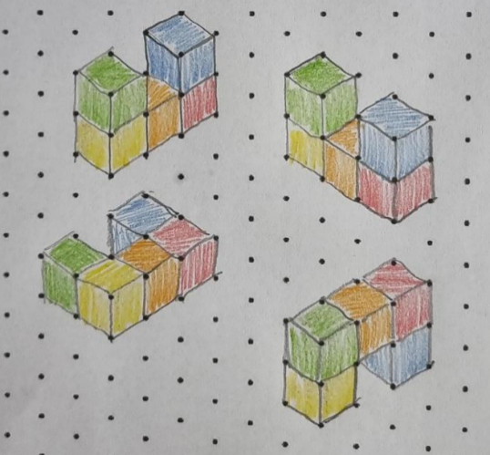

1. Move around the room, supporting students to orientate their pentominoes correctly as three-dimensional models and draw them on isometric paper.

**Note**: keep the sets of pentominoes to use again in Lesson 4.

## Discuss and connect the mathematics – 10 minutes

1. Show students a coloured block. Discuss the edges, faces and vertices to identify this as a cube.
2. Using individual whiteboards, students draw the top, front and side views and discuss.
3. Repeat the process with a cube made from 8 coloured blocks. Discuss what is the same and different to the first cube.

This table details opportunities for differentiation.

|  |  |
| --- | --- |
| Too hard? | Too easy? |
| Students cannot draw top, front and side views and/or represent a pentomino on isometric paper.   * Model observing and drawing the top, front and side views step-by-step with student copying. * Students follow guided, step-by-step instructions to draw the tower pentomino. | Students can draw top, front and side views of 6 or more pentominoes and represent them on isometric paper.   * Students draw all top, front and side views of pentominoes. Then they discuss which are most similar and most different. * Students shine a light on one side of a pentomino and draw it with its shadow. Repeat for other pentominoes. |

This table details opportunities for assessment.

|  |  |
| --- | --- |
| Assessment opportunities | Links |
| What to look for:   * Can students create sketches of three-dimensional objects from different views, including top, front and side views? **[MAO-WM-01, MA2-3DS-01]** * Can students draw different views on isometric grids of an object constructed from connecting cubes? **[MAO-WM-01, MA2-3DS-01]** * Can students use features to identify differences between prisms, pyramids and cylinders? **[MAO-WM-01, MA2-3DS-01]** | Links to [National Numeracy Learning Progressions](https://www.australiancurriculum.edu.au/resources/national-literacy-and-numeracy-learning-progressions/version-3-of-national-literacy-and-numeracy-learning-progressions/) (NNLP):   * UGP3. |

# Lesson 4

**Core concept**: drawings are interpreted to construct objects.

## Daily number sense – 10 minutes

1. From a class need surfaced through formative assessment data, identify a short, focused activity that targets students’ knowledge, understanding and skills. Example activities may be drawn from the following resources:

* [Mathematics K–6 resources](https://education.nsw.gov.au/teaching-and-learning/curriculum/mathematics/mathematics-curriculum-resources-k-12/mathematics-k-6-resources.main-education--category---catalogue---key-learning-area---mathematics---thinking-mathematically.nameAsc.1.grid)
* [Universal Resources Hub](https://resources.education.nsw.gov.au/home).

## Core lesson – using top, front and side views to draw objects – 40 minutes

The table below contains a suggested learning intention and success criteria. These are best co-constructed with students.

|  |  |
| --- | --- |
| Core concept learning intention | Core concept success criteria |
| Students are learning to:   * connect three-dimensional objects and two-dimensional representations. | Students can:   * create sketches of three-dimensional objects from different views, including top, front and side views * draw different views on isometric grids of an object constructed from connecting cubes * interpret top, front and side views to make models of three-dimensional objects using connecting cubes. |

**Note**: you will need the sets of pentominoes from Lesson 3.

1. Place one pentomino into an opaque bag. Have a few students place their hand in the bag for a few seconds and describe the pentomino. Other students use the description to visualise the pentomino. Students draw the top, front and side views on individual whiteboards and compare answers.
2. Repeat the process with another pentomino.
3. Place sets of pentominoes around the room. Students each choose one pentomino. They draw the top, front and side views on grid paper.
4. Students swap their top, front and side views drawings with another student. They both attempt to make the original pentomino model with coloured cubes using the drawings provided.
5. When finished, each student gets to see the original pentomino and identify whether it is the same as their model. If it is not the same, discuss whether it is still a correct solution using the views provided.
6. Students then draw their pentomino using isometric grid paper.

This table details opportunities for differentiation.

|  |  |
| --- | --- |
| Too hard? | Too easy? |
| Students cannot draw top, front or side views and/or recreate original models on squared and isometric paper.   * Model drawing the top, front and side views of 2 pentominoes with students following steps. * Students complete this activity with the simpler pentominoes. | Students can draw top, front and side views and use them to recreate original models.   * Students take a model made by joining 2 pentominoes together. They sketch one view using isometric paper. * Using the same model, students sketch another view. * Students place their hands in an opaque bag that contains 2 pentominoes joined together. After 30 seconds, they draw the top, front and side views. They have one more feel inside the bag and decide whether they can make their drawings more accurate. |

## Discuss and connect the mathematics – 15 minutes

1. Show students one of the top, front and side view drawings of a pentomino. Discuss whether only one model can be drawn using these top, front and side views or if there are multiple solutions and why.
2. Students sketch a possible model solution on isometric paper. Compare solutions.

This table details opportunities for assessment.

|  |  |
| --- | --- |
| Assessment opportunities | Links |
| What to look for:   * Can students create sketches of three-dimensional objects from different views, including top, front and side views?  **[MAO-WM-01, MA2-3DS-01]** * Can students draw different views on isometric grids of an object constructed from connecting cubes? **[MAO-WM-01, MA2-3DS-01]** * Can students interpret top, front and side views to make models of three-dimensional objects using connecting cubes? **[MAO-WM-01, MA2-3DS-01]** | Links to [National Numeracy Learning Progressions](https://www.australiancurriculum.edu.au/resources/national-literacy-and-numeracy-learning-progressions/version-3-of-national-literacy-and-numeracy-learning-progressions/) (NNLP):   * UGP3. |

# Lesson 5

**Core concept**: metric units of measurement relate to our base-10 place value system.

## Daily number sense – counting by tens – 10 minutes

Daily number sense activities for Lessons 5 to 7 ‘loop’ back to concepts and procedures covered in previous units to assist students to build an increasingly connected network of ideas. These concepts may differ from the core concepts being covered by the unit.

The table below contains a suggested learning intention and success criteria. These are best co-constructed with students.

|  |  |
| --- | --- |
| Daily number sense learning intention | Daily number sense success criteria |
| Students are learning to:   * operate with multiples of 10. | Students can:   * multiply a one-digit number by a multiple of 10. |

This activity is an adaptation of ‘[Counting game (by multiples of 10)](https://education.nsw.gov.au/teaching-and-learning/curriculum/mathematics/mathematics-curriculum-resources-k-12/mathematics-k-6-resources/counting-game-by-multiples-of-10)’ from [K–6 Mathematics resources](https://education.nsw.gov.au/teaching-and-learning/curriculum/mathematics/mathematics-curriculum-resources-k-12/mathematics-k-6-resources) by the State of New South Wales (Department of Education).

1. In pairs, students roll a 6-sided die 5 times. Each time, the number rolled is multiplied by 10. The totals are then added together to determine a target number.
2. Ask students how they know that the target number is a multiple of 10.
3. Explain that the object of the game is to be the person who gets to the target number first.
4. Starting at zero, players take turns to roll the die and count on in tens. For example, player A rolls a 5 and counts by 10 five times; 10, 20, 30, 40, 50. Player B rolls a 2 and counts 60, 70. This continues until an exact throw is rolled to land on the target number.
5. Pairs record their dice throw and counting on each turn (see Figure 7).

Figure 7 – counting game example with target number 180

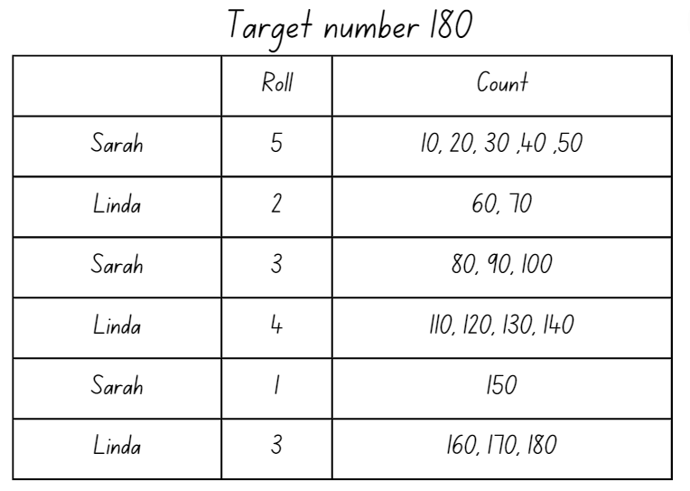

1. Players repeat the process.

This table details opportunities for assessment.

|  |  |
| --- | --- |
| Assessment opportunities | Links |
| What to look for:   * Can students multiply a one-digit number by a multiple of 10? **[MAO-WM-01, MA2-MR-01]** | Links to [National Numeracy Learning Progressions](https://www.australiancurriculum.edu.au/resources/national-literacy-and-numeracy-learning-progressions/version-3-of-national-literacy-and-numeracy-learning-progressions/) (NNLP):   * MuS7. |

## Core lesson – how many litres in this container? – 40 minutes

The table below contains suggested learning intentions and success criteria. These are best co-constructed with students.

|  |  |
| --- | --- |
| Core concept learning intentions | Core concept success criteria |
| Students are learning to:   * measure and order containers using litres * use scaled instruments to measure and compare capacities. | Students can:   * record capacities using the abbreviation for litres (L) * estimate the capacity of a container in litres and check by measuring * use scaled instruments to relate 1000 mL to one litre. |

**Capacity (internal volume)**: refers to the amount a container can hold and is measured in units such as millilitres (mL) and litres (L).

**Note**: capacity is only used in relation to containers and generally refers to liquid. The capacity of a container will be slightly less than its volume as capacity is based on the inside dimensions, while volume is determined by the outside dimensions. It is recommended that the terms ‘capacity’ and ‘internal volume’ be used interchangeably.

1. Revise the difference between volume and capacity.

**Volume** is the space taken up by a three-dimensional object.

**Capacity** is the internal volume, which is how much a three-dimensional object can hold.

1. Ask students to share real life examples of using volume and capacity. For example, the volume of a fish tank is measured to be sure it will fit on a shelf. The capacity of the tank determines how much water we need to fill it.
2. Revise the term ‘litres’ and that it is represented by the abbreviation L. Ask students to explain why formal units such as litres are useful. For example, formal units allow measures to be communicated with greater ease and accuracy.
3. Show students an everyday container with a capacity of one litre and say that one litre is the same as 1000 millilitres. Explain that they are called metric units of measurement and relate to our base-10 place value system.
4. Ask students to give everyday examples of using litres. For example, petrol or milk.
5. Create an anchor chart for capacity. Return to this as necessary over Lessons 6 to 8.
6. Revise scaled instruments, for example a measuring cup and/or jug. Show students a measuring jug labelled as in Figure 8. Discuss the measurements and benchmarks.

Figure 8 – measuring jug

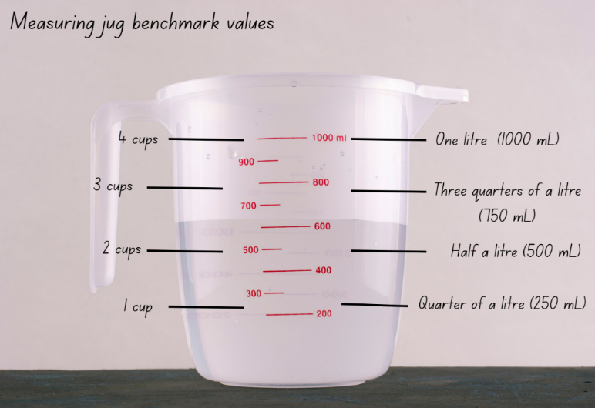

1. Display a range of containers larger than one litre.
2. Explain that students will be estimating and measuring the internal volume of each container to the nearest litre.
3. Model estimating, measuring and recording the internal volume of a large container, using a litre as the measuring unit. Record the capacity using the abbreviation for litres (L) and adjust the estimate after adding the first 2 litres of water to the container.
4. Give groups of students a one litre unit of measure and 4 large containers. For example, buckets, ice cream containers, bins and tote trays.
5. Students estimate, measure and record the internal volume of each container to the nearest litre in Resource 7 – recording table A.
6. Move around the room, prompting students to adjust estimates and checking for correct recording.
7. After measuring and recording the internal volumes, students order their containers from smallest to largest capacity.

This table details opportunities for differentiation.

|  |  |
| --- | --- |
| Too hard? | Too easy? |
| Students cannot estimate, measure and record capacities using litres.   * Give students one container to estimate, measure and record the capacity. * Support students to use scaled instruments when estimating, measuring and recording capacities. | Students can estimate, measure and record capacities using litres.   * Students estimate, measure and record capacities using millilitres and litres in words. For example, one litre and 500 millilitres. * Students record capacities using decimal representations of the metric system. For example, 1.5 L. |

## Discuss and connect the mathematics – 10 minutes

1. Display the problem: Sarah and her 11 friends won the soccer grand final. To celebrate, Sarah’s mum bought bottles of soft drink for everyone. If everyone has one cup measuring 250 millilitres (mL), how many litres of soft drink did Sarah’s mum need to buy?
2. Discuss solutions. Prompt students to think about the combination of using millilitres and litres as a unit of measurement.
3. Remind students find a range of containers from home that hold 100 millilitres, 250 millilitres, 500 millilitres, one litre or 2 litres to bring to school.

**Note**: students will discuss containers brought from home in Lesson 7.

This table details opportunities for assessment.

|  |  |
| --- | --- |
| Assessment opportunities | Links |
| What to look for:   * Can students record internal volumes using the abbreviation for litres (L)? **[MAO-WM-01, MA2-3DS-02]** * Can students estimate the internal volume of a container in litres and check by measuring? **[MAO-WM-01, MA2-3DS-02]** * Can students use scaled instruments to relate 1000 mL to one litre? **[MAO-WM-01, MA2-3DS-02]** | Links to [National Numeracy Learning Progressions](https://www.australiancurriculum.edu.au/resources/national-literacy-and-numeracy-learning-progressions/version-3-of-national-literacy-and-numeracy-learning-progressions/) (NNLP):   * UuM6. |

# Lesson 6

**Core concept**: standard units are an efficient way to communicate capacity.

## Daily number sense – multiples madness – 15 minutes

The table below contains a suggested learning intention and success criteria. These are best co-constructed with students.

|  |  |
| --- | --- |
| Daily number sense learning intention | Daily number sense success criteria |
| Students are learning to:   * operate with multiples of 10. | Students can:   * multiply a one-digit number by 10. |

This activity is an adaptation of ‘[Multiples madness (fives)](https://education.nsw.gov.au/teaching-and-learning/curriculum/mathematics/mathematics-curriculum-resources-k-12/mathematics-k-6-resources/multiples-madness)’ at [Mathematics K–6 resources](https://education.nsw.gov.au/teaching-and-learning/curriculum/mathematics/mathematics-curriculum-resources-k-12/mathematics-k-6-resources) by the State of New South Wales (Department of Education).

1. Distribute Resource 8 – multiples madness gameboard and a 9-sided die to pairs of students.
2. Player A has 3 counters of one colour and Player B has 3 of a different colour.
3. Players take turns to roll the die and multiply the number by 10. If that multiple of 10 is available on the gameboard the player can place their coloured counter over the multiple. If the number is taken, that player misses a turn.
4. A player wins by getting 3 counters in a row in any orientation.
5. As players only have 3 counters, they will need to strategically choose which counter to move again once all 3 have been placed on the game board.
6. Support students to reflect on the activity by asking:

* Did you prefer going first or second? Why?
* What strategy did you use? How successful was it and why?
* How might the game change if you multiplied by 20?
* Would it be easier if you had more counters? Why?

This table details opportunities for assessment.

|  |  |
| --- | --- |
| Assessment opportunities | Links |
| What to look for:   * Can students multiply a one-digit number by 10? **[MAO-WM-01, MA2-MR-01]** | Links to [National Numeracy Learning Progressions](https://www.australiancurriculum.edu.au/resources/national-literacy-and-numeracy-learning-progressions/version-3-of-national-literacy-and-numeracy-learning-progressions/) (NNLP):   * MuS7. |

## Core lesson – what’s my capacity? – 40 minutes

The table below contains suggested learning intentions and success criteria. These are best co-constructed with students.

|  |  |
| --- | --- |
| Core concept learning intentions | Core concept success criteria |
| Students are learning to:   * measure and order containers using litres * use scaled instruments to measure and compare capacities. | Students can:   * recognise the need for formal units to measure capacity accurately * recognise the need for a formal unit smaller than the litre to measure capacity * use a scaled instrument to relate 1000 millilitres to one litre. |

1. Display a selection of clear containers, with a capacity of at least one litre in different sizes and shapes.
2. Model how to use a measuring jug to measure one litre and pour it into one of the containers. Mark the water level on the container.
3. Give small groups of students a selection of clear containers that have a capacity of at least one litre or larger.
4. Students estimate the one litre water level of each container. Mark the estimated levels with pen or rubber bands.
5. Students then use a measuring jug to measure one litre, pour it into a container and mark the water level.
6. Students discuss the marks on their containers. Ask:

* What do you notice?
* How accurate were your estimates?
* Are the marks on your containers at the same level? Why or why not?

**Note**: students may have misconceptions about the litres being the same in different sized containers. If so, model pouring the litres from each container back into the measuring jug.

1. Ask students if the containers can be used to measure capacity accurately. Prompt students to justify their reasoning.
2. Add new knowledge and understandings to the anchor chart.
3. Give small groups of students 2 containers similar in size and shape that have a capacity of less than one litre.
4. Ask students to prove which container has the largest capacity.
5. Students use one litre measuring jugs to find out which container has the largest capacity.
6. Ask students if there was a problem. Support them to recognise the need for formal units smaller than a litre.
7. Show students a measuring cup. Revise that it holds 250 millilitres. Ask students to give examples of where they have seen millilitres used. For example, when pouring medicine or on a bottle of juice.
8. Add examples to the anchor chart.
9. Give students a 250 mL measuring cup and allow them to remeasure the capacities of the 2 containers.

This table details opportunities for differentiation.

|  |  |
| --- | --- |
| Too hard? | Too easy? |
| Students cannot recognise the need for formal units smaller than one litre.   * Show students examples of everyday containers measured in millilitres. Discuss how litres would be inappropriate for these. * Support students to use a 250 mL measuring cup to measure the capacities of the 2 containers. | Students can recognise the need for formal units smaller than one litre.   * Students compare and measure containers using litres and millilitres * Students record capacities using decimal notation. For example, 1.5 L. |

## Consolidation and meaningful practice – 10 minutes

1. Display the following problems:

* Baxter has a car that takes 60 litres of petrol. The tank is one third full. How many litres does Baxter need to fill his tank?
* A toilet flush uses 12 litres of water. Amy goes to the toilet 5 times a day. How many litres of water does she use in a week?
* The average shower uses 8 litres of water a minute. If everyone in this class has a 10-minute shower tonight, how many litres of water will they use?

1. Discuss strategies used to find the answer.

This table details opportunities for assessment.

|  |  |
| --- | --- |
| Assessment opportunities | Links |
| What to look for:   * Can students recognise the need for formal units to measure capacity accurately? **[MAO-WM-01, MA2-3DS-02]** * Can students recognise the need for a formal unit smaller than the litre to measure capacity? **[MAO-WM-01, MA2-3DS-02]** * Can students use a scaled instrument to relate 1000 millilitres to one litre? **[MAO-WM-01, MA2-3DS-02]** | Links to [National Numeracy Learning Progressions](https://www.australiancurriculum.edu.au/resources/national-literacy-and-numeracy-learning-progressions/version-3-of-national-literacy-and-numeracy-learning-progressions/) (NNLP):   * UuM6. |

# Lesson 7

**Core concept**: estimation is guided by using known benchmarks of capacity (internal volume).

## Daily number sense – multiplying by multiples – 15 minutes

The table below contains a suggested learning intention and success criteria. These are best co-constructed with students.

|  |  |
| --- | --- |
| Daily number sense learning intention | Daily number sense success criteria |
| Students are learning to:   * operate with multiples of 10. | Students can:   * use multiplication facts with multiples of 10 to multiply a one-digit number by a multiple of 10. |

1. Provide pairs of students with a 10-sided die and 2 copies of Resource 9 – multiplying multiples.
2. Players take turns to roll the die twice each turn. The first number becomes the multiplier, while the second number is turned into a multiple of 10 and that becomes the multiplicand. The player multiplies the numbers and records their thinking in Resource 9 – multiplying multiples. Students can choose which row each time, the objective being to place their rolls in ascending order according to the product (see Figure 9).

Figure 9 – example of gameboard recording

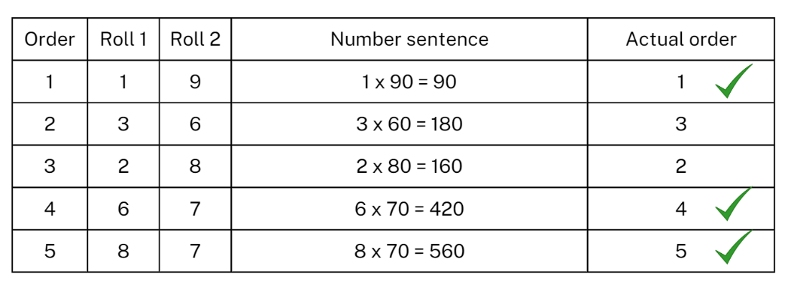

1. After each turn, students will need to use prediction to decide on row placement.
2. After each player has completed 5 turns, use the actual order column to record which turns were placed in the correct row. Players score a point for each correct placement. For example, the player in Figure 11 scores 3 points.
3. Repeat the process.
4. Reflect on the game, asking questions such as:

* How did you decide where to place each answer?
* Did you change your strategy after the first round? Why or why not?
* What modifications could you suggest for the game?

This table details opportunities for assessment.

|  |  |
| --- | --- |
| Assessment opportunities | Links |
| What to look for:   * Can students use multiplication facts with multiples of 10 to multiply a one-digit number by a multiple of 10? **[MAO-WM-01, MA2-MR-0]** | Links to [National Numeracy Learning Progressions](https://www.australiancurriculum.edu.au/resources/national-literacy-and-numeracy-learning-progressions/version-3-of-national-literacy-and-numeracy-learning-progressions/) (NNLP):   * MuS7. |

## Core lesson – estimating known capacities – 40 minutes

The table below contains suggested learning intentions and success criteria. These are best co-constructed with students.

|  |  |
| --- | --- |
| Core concept learning intentions | Core concept success criteria |
| Students are learning to:   * use scaled instruments to measure and compare capacities * read, represent and order numbers to thousands. | Students can:   * use a scaled instrument to relate 1000 millilitres to one litre * record capacity using the abbreviations for millilitres (mL) and litres (L) * estimate the capacity of a container to common benchmark values, such as 250 mL, and check by measuring * read and order numbers of up to at least 4 digits. |

1. Students discuss the containers they brought from home.
2. Sort containers into groups that hold approximately 100 mL, 250 mL, 500 mL, 1 L or 2 L.
3. Compare the heights and capacities of these containers. For example, a tall skinny container compared to a short, wide container. Ask students:

* What do you notice?
* Are there any containers that do not fit in these groups?
* Could you sort these containers in another way?

1. Discuss benchmark values of 250 mL, 500 mL, 1000 mL or 1 L. Make connections between these benchmark values, the capacities of containers and a one litre scaled measuring jug.
2. Model estimating, measuring and recording the capacity of a container using benchmark values. For example:

* I estimate this container is about 500 mL because I can see it looks the same as the 500 mL measuring jug.
* I estimate this container is 250 mL because it looks like it has the about the same capacity as the 250 mL drink bottle.

1. Give groups of students a measuring cup and/or jug and a collection of small containers. For example, cups, butter containers, drink bottles.
2. Students use Resource 10 – recording table B to record estimates for the capacity of each container using benchmark values.
3. Students measure and record capacities, then check their estimates. Students may adjust estimates after measuring the first container.
4. Each group arranges their results in order from smallest capacity to the largest capacity.
5. Ask students:

* What did you notice?
* How accurate were your estimates?
* What benchmark values were your containers closest to?
* Did benchmark values help you to estimate? How?

This table details opportunities for differentiation.

|  |  |
| --- | --- |
| Too hard? | Too easy? |
| Students cannot estimate and/or measure capacities using benchmark values.   * Support students to practice estimating and measuring using a 250 mL measuring cup. * Support students to measure and record capacities. | Students can estimate and/or measure capacities using benchmark values.   * Students make comparisons between containers. For example, 250 mL is the same as one can, one cup or one juice box. * Students convert estimates from litres to millilitres and millilitres to litres. |

## Consolidation and meaningful practice – 5 minutes

1. Display the following problems:

* Tessa estimated that 3 L would fill a container. She only had a 250 mL measuring cup and after she had poured 10 of them into the container, it was full. How far off was her estimate?
* Next, she looked at a container that had the same width as the first one but was twice as high. What should her estimate be?

1. Discuss students’ answers.

This table details opportunities for assessment.

|  |  |
| --- | --- |
| Assessment opportunities | Links |
| What to look for:   * Can students use a scaled instrument to relate 1000 millilitres to one litre? **[MAO-WM-01, MA2-3DS-02]** * Can students record capacity using the abbreviation for millilitres (mL) and litres (L)? **[MAO-WM-01, MA2-3DS-02]** * Can students estimate the capacity of a container to common benchmark values, such as 250 mL, and check by measuring? **[MAO-WM-01, MA2-3DS-02]** * Can students read and order numbers of up to at least 4 digits? **[MAO-WM-01, MA2-RN-01]** | Links to [National Numeracy Learning Progressions](https://www.australiancurriculum.edu.au/resources/national-literacy-and-numeracy-learning-progressions/version-3-of-national-literacy-and-numeracy-learning-progressions/) (NNLP):   * UuM6, NPV5, NPV6.   Links to suggested [Interview for Student Reasoning](https://education.nsw.gov.au/teaching-and-learning/curriculum/literacy-and-numeracy/assessment-resources/ifsr) (IfSR) tasks:   * **IfSR-NP**: 4B.2, 4C.5. |

# Lesson 8

**Core concept**: mathematicians estimate, measure and compare capacities.

## Daily number sense – 10 minutes

1. From a class need surfaced through formative assessment data, identify a short, focused activity that targets students’ knowledge, understanding and skills. Example activities may be drawn from the following resources:

* [Mathematics K–6 resources](https://education.nsw.gov.au/teaching-and-learning/curriculum/mathematics/mathematics-curriculum-resources-k-12/mathematics-k-6-resources.main-education--category---catalogue---key-learning-area---mathematics---thinking-mathematically.nameAsc.1.grid)
* [Universal Resources Hub](https://resources.education.nsw.gov.au/home).

## Core lesson – making our own measuring cup – 35 minutes

The table below contains suggested learning intentions and success criteria. These are best co-constructed with students.

|  |  |
| --- | --- |
| Core concept learning intentions | Core concept success criteria |
| Students are learning to:   * use scaled instruments to measure and compare internal volumes * order numbers in the thousands. | Students can:   * record internal volume using the abbreviation for millilitres (mL) and litres (L) * compare and order the internal volumes of 2 or more containers measured in millilitres * estimate the internal volume of a container to common benchmark values, such as 250 mL, and check by measuring * read and order numbers of up to at least 4 digits. |

1. Explain to students that they will be making a scaled measuring instrument with a plastic cup.
2. Model how to use a measuring cup to pour 100 mL into a plastic cup. Mark the waterline on the plastic cup as 100 mL, using a marker or an elastic band.
3. In pairs, students repeat the process with their own plastic cup until they have scaled it to the top.
4. Students choose different containers to one they measured previously. They record an approximate estimate of the capacity for each, as holding either 100 mL, 200 mL or 500 mL. Students record their estimates.
5. Students use their plastic cup to measure and record the capacity of each container.
6. Discuss with the class:

* Were your estimate accurate? Why or why not?
* How effective was measuring the capacity of a container using the plastic cup? How do you know? (It was more accurate than a 1 L container, as we could measure to the nearest 100 mL or even the nearest 50 mL).

This table details opportunities for differentiation.

|  |  |
| --- | --- |
| Too hard? | Too easy? |
| Students cannot use scaled instruments to measure and compare capacity.   * Support students to measure the capacities accurately using the cups they marked. * Model comparing and ordering capacities of 2 containers. Students measure a third container and order it correctly with the first 2 containers. | Students can use scaled instruments to measure and compare capacity.   * With their partner, students find the total capacity of all the containers they measured. They use decimal notation to record this. * Students create capacity word problems to share with the class, or find the different between the total capacities of other groups. |

## Discuss and connect the mathematics – 10 minutes

1. Students discuss and answer questions in Resource 11 – capacity quiz.

## Consolidation and meaningful practice – 10 minutes

1. Explain to students they will be comparing and ordering different capacity measurements from smallest to largest. See Resource 12 – measurement cards.
2. Give each student one card from Resource 12 – measurement cards.
3. Students order themselves from the smallest to the largest capacity.

This table details opportunities for assessment.

|  |  |
| --- | --- |
| Assessment opportunities | Links |
| What to look for:   * Can students record internal volume using the abbreviation for millilitres (mL) and litres (L)? **[MAO-WM-01, MA2-3DS-02]** * Can students compare and order the internal volumes of 2 or more containers measured in millilitres? **[MAO-WM-01, MA2-3DS-02]** * Can students estimate the internal volume of a container to common benchmark values, such as 250 mL, and check by measuring? **[MAO-WM-01, MA2-3DS-02]** * Can students read and order numbers of up to at least 4 digits? **[MA0-WM-01, MA2-RN-01]** | Links to [National Numeracy Learning Progressions](https://www.australiancurriculum.edu.au/resources/national-literacy-and-numeracy-learning-progressions/version-3-of-national-literacy-and-numeracy-learning-progressions/) (NNLP):   * UuM6, NPV5, NPV6.   Links to suggested [Interview for Student Reasoning](https://education.nsw.gov.au/teaching-and-learning/curriculum/literacy-and-numeracy/assessment-resources/ifsr) (IfSR) tasks:   * **IfSR-NP**: 4B.2, 4C.5. |

# Resource 1 – dice combinations



|  |  |  |
| --- | --- | --- |
| 1243 | 1324 | 1342 |
| 2341 | 2413 | 2431 |
| 3142 | 3214 | 3241 |
| 4231 | 4312 | 4321 |

# Resource 2 – two-dimensional shapes



# Resource 3 – three-dimensional objects

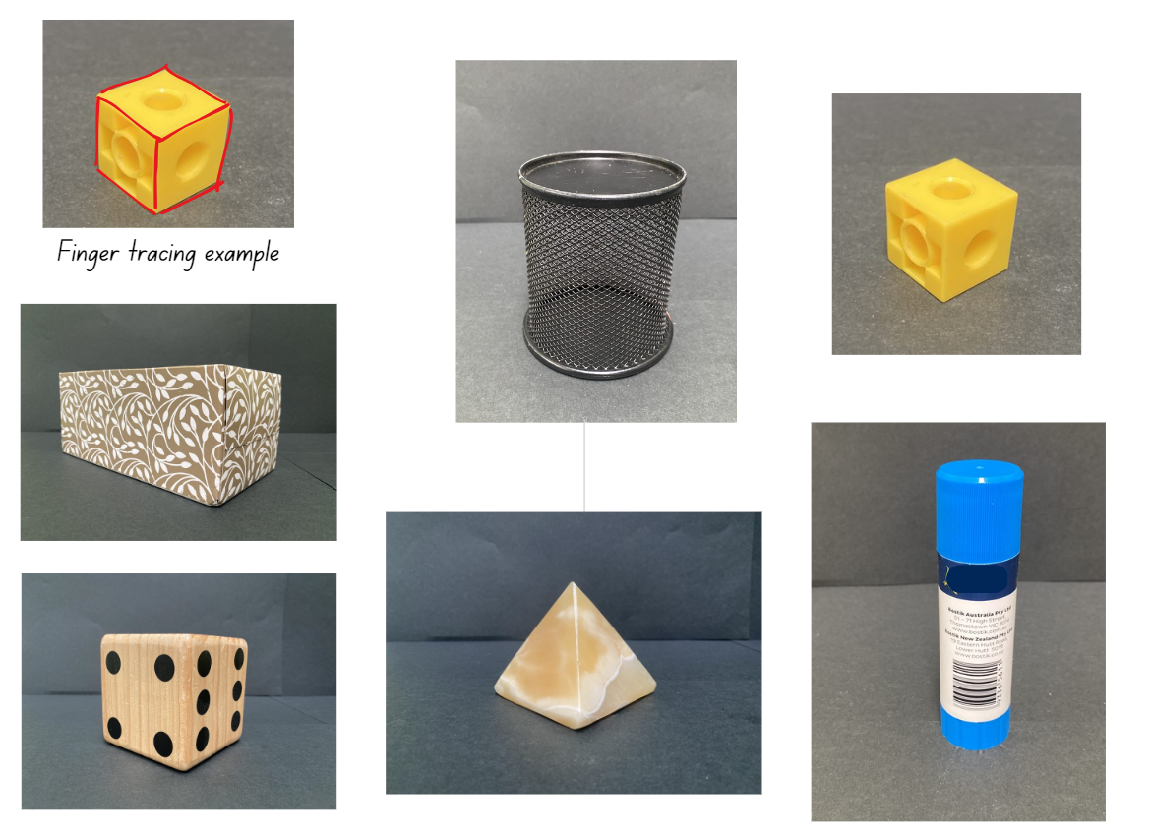

# Resource 4 – 20 numbers

|  |  |  |  |  |  |  |  |  |  |
| --- | --- | --- | --- | --- | --- | --- | --- | --- | --- |
| 0 | 1 | 2 | 3 | 4 | 5 | 6 | 7 | 8 | 9 |
| 0 | 1 | 2 | 3 | 4 | 5 | 6 | 7 | 8 | 9 |

Target Numbers

|  |  |  |  |  |
| --- | --- | --- | --- | --- |
| Number closest to 1000 | Number closest to 3000 | Number closest to 5000 | Number closest to 7000 | Number closest to 9000 |

# Resource 5 – pentominoes

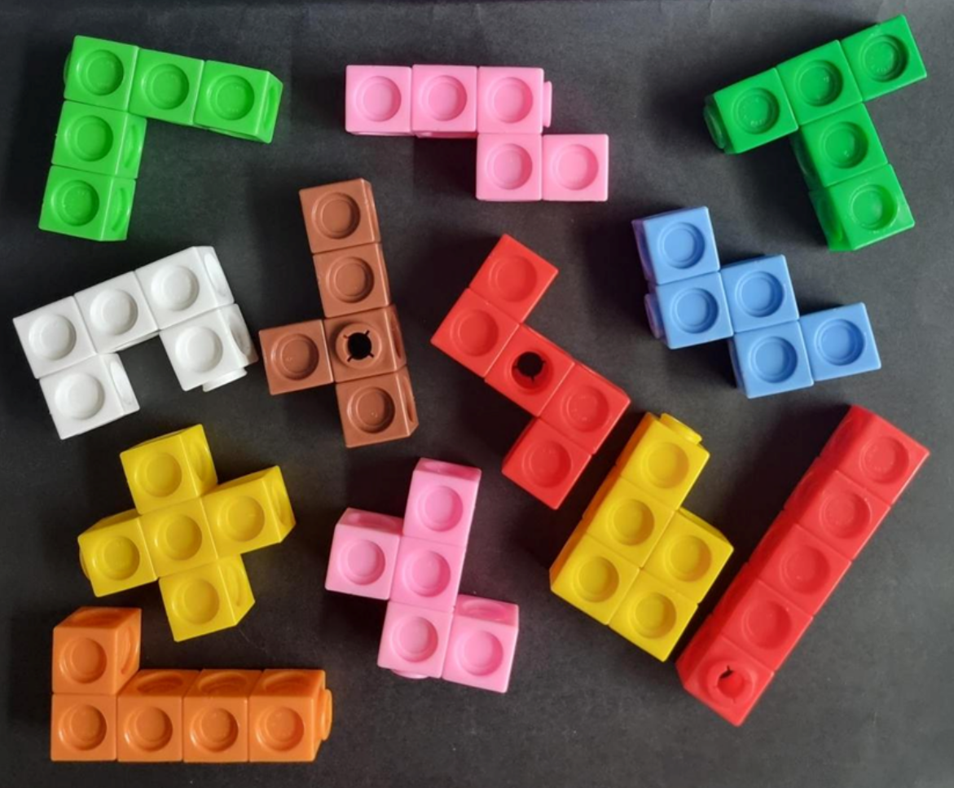

# Resource 6 – pentomino views

|  |  |  |  |
| --- | --- | --- | --- |
| Pentomino | Top view | Front view | Side view |
|  |  |  |  |
|  |  |  |  |
|  |  |  |  |
|  |  |  |  |
|  |  |  |  |
|  |  |  |  |

# Resource 7 – recording table A

|  |  |  |  |
| --- | --- | --- | --- |
| Container | Estimate | Revised estimate | Measure (litres, L) |
| 1 |  |  |  |
| 2 |  |  |  |
| 3 |  |  |  |

# Resource 8 – multiples madness gameboard

|  |  |  |  |  |
| --- | --- | --- | --- | --- |
| 0 | 10 | 40 | 80 | 60 |
| 30 | 70 | 20 | 50 | 30 |
| 50 | 20 | 0 | 40 | 60 |
| 90 | 10 | 70 | 80 | 50 |
| 40 | 60 | 30 | 90 | 20 |

# Resource 9 – multiplying multiples

|  |  |  |  |  |
| --- | --- | --- | --- | --- |
| Order | Roll 1 | Roll 2 | Number sentence | Actual order |
| 1 |  |  |  |  |
| 2 |  |  |  |  |
| 3 |  |  |  |  |
| 4 |  |  |  |  |
| 5 |  |  |  |  |

# Resource 10 – recording table B

|  |  |  |  |
| --- | --- | --- | --- |
| Container | Estimate | Revised estimate | Measure (millilitres, mL)  Litres (L) |
| 1 |  |  |  |
| 2 |  |  |  |
| 3 |  |  |  |

# Resource 11 – capacity quiz

A sports drink, paint tin, bathtub and tablespoon with 4 options for their capacity to choose from.
The sports drinks has the options:
a. 5 litres (L)
b. one litre (L)
c. 7 litres (L)
d. 3.5 litres (L).
The paint can has the options:
a. 200 litres (L)
b. 10 litres (L)
c. 500 millilitres (mL)
d. 20 millilitres (mL).
The bath tub has the options:
a. 1000 millilitres (mL)
b. 150 litres (L)
c. 10000 litres (L)
d. 5 litres (L).
The tablespoon has the options:
a. 15 millilitres (mL)
b. 750 millilitres (mL)
c. 1 litre (L) 
d. 50 millilitres (mL).

A variety of everyday objects with different capacities to estimate and measure capacities.
The first card has the images of a jug, an ice cream container and a cup of coffee. The question asks: Which has the capacity closest to one litre? How do you know?
The second card has a garbage truck, a water fountain and a garbage bin. The question asks: Which has the largest capacity? How do you know?
The third card has a bathtub, a carton of milk and a swimming pool. The question asks: Which has the smallest capacity? How do you know?
The fourth card has a cup of iced water, a bottle of skin lotion and a cup of coffee. The question asks: Which has the capacity closest to 250 millilitres? How do you know?

# Resource 12 – measurement cards

|  |  |  |  |  |  |  |
| --- | --- | --- | --- | --- | --- | --- |
| **100 mL** |  | **500 mL** |  | **1500 mL** |  | **10 mL** |
|  |  |  |  |  |  |  |
| **1000 mL** |  | **250 mL** |  | **1 L** |  | **2000 mL** |
|  |  |  |  |  |  |  |
| **700 mL** |  | $\frac{3}{4}$**litre** |  | **1.5 litres** |  | $\frac{1}{2}$**litre** |

|  |  |  |  |  |  |  |
| --- | --- | --- | --- | --- | --- | --- |
| **18 mL** |  | **3 litres** |  | **3 cups** |  | **750 mL** |
|  |  |  |  |  |  |  |
| **4 cups** |  | **1 cup** |  | **150 mL** |  | **2 cups** |
|  |  |  |  |  |  |  |
| **300 mL** |  | **700 mL** |  | **40 mL** |  | **1300 mL** |

# Syllabus outcomes and content

The table below outlines the [syllabus outcomes](https://curriculum.nsw.edu.au/learning-areas/mathematics/mathematics-k-10-2022/overview) and range of relevant syllabus content covered in this unit. Content is linked to [National Numeracy Learning Progression](https://www.australiancurriculum.edu.au/resources/national-literacy-and-numeracy-learning-progressions/version-3-of-national-literacy-and-numeracy-learning-progressions/) version (3).

|  |  |  |  |  |  |  |  |  |
| --- | --- | --- | --- | --- | --- | --- | --- | --- |
| Outcomes and content | 1 | 2 | 3 | 4 | 5 | 6 | 7 | 8 |
| **Representing numbers using place value A**: Whole numbers: Read, represent and order numbers to thousands  **MAO-WM-01, MA2-RN-01** |  |  |  |  |  |  |  |  |
| * Count forwards and backwards by tens and hundreds on and off the decade |  |  |  |  | x |  |  |  |
| * Read and order numbers of up to at least 4 digits | x | x | x |  |  |  | x | x |
| **Representing numbers using place value B**: Whole numbers: Order numbers in the thousands  **MAO-WM-01, MA2-RN-01** |  |  |  |  |  |  |  |  |
| * Arrange numbers in the thousands in ascending and descending order |  |  |  |  |  |  | x | x |
| * Recognise and describe how rearranging digits changes the size of a number (Reasons about relations) |  | x | x |  |  |  |  |  |
| * Identify the nearest thousand, 10 thousand or 100 thousand to numbers | x | x | x |  |  |  |  |  |
| **Multiplicative relations B**: Operate with multiples of 10  **MAO-WM-01, MA2-MR-01** |  |  |  |  |  |  |  |  |
| * Use multiplication facts with multiples of 10 to multiply a one-digit number by a multiple of 10 |  |  |  |  | x | x | x |  |
| **Two-dimensional spatial structure A**: 2D shapes: Compare and describe features of two-dimensional shapes  **MAO-WM-01, MA2-2DS-01** |  |  |  |  |  |  |  |  |
| * Describe and compare two-dimensional shapes, including parallelograms, rectangles, rhombuses, squares, trapeziums and kites | x |  |  |  |  |  |  |  |
| **Three-dimensional spatial structure A**: 3D objects: Make models of three-dimensional objects to compare and describe key features  **MAO-WM-01, MA2-3DS-01** |  |  |  |  |  |  |  |  |
| * Identify the differences between prisms (including cubes), pyramids and cylinders | x | x | x |  |  |  |  |  |
| * Construct models of prisms, pyramids and cylinders using physical or virtual manipulatives, identifying their features | x | x |  |  |  |  |  |  |
| **Three-dimensional spatial structure A**: Volume: Measure and order containers using litres  **MAO-WM-01, MA2-3DS-02** |  |  |  |  |  |  |  |  |
| * Recognise the need for formal units to measure capacity (internal volume) accurately |  |  |  |  | x | x | x | x |
| * Use the litre as a unit to measure capacities (internal volumes) to the nearest litre |  |  |  |  | x | x |  |  |
| * Relate the litre to familiar everyday containers |  |  |  |  | x | x |  | x |
| * Recognise that one-litre containers can be a variety of shapes (Reasons about spatial structure) |  |  |  |  |  | x |  | x |
| * Record capacities (internal volumes) using the abbreviation for litres (L) |  |  |  |  | x | x |  | x |
| * Estimate the capacity (internal volume) of a container in litres and check by measuring |  |  |  |  |  | x | x | x |
| **Three-dimensional spatial structure B**: 3D objects: Connect three-dimensional objects and two-dimensional representations  **MAO-WM-01, MA2-3DS-01** |  |  |  |  |  |  |  |  |
| * Identify features of prisms and pyramids (faces, vertices and edges) and cylinders (curved/flat surfaces and boundaries) from images | x | x |  |  |  |  |  |  |
| * Create sketches of rectangular prisms and pyramids, showing depth |  | x | x | x |  |  |  |  |
| * Create sketches of three-dimensional objects from different views, including top, front and side views (Reasons about spatial relations) |  |  | x | x |  |  |  |  |
| * Draw different views on isometric grids of an object constructed from connecting cubes |  | x | x | x |  |  |  |  |
| * Interpret given drawings to make models of three-dimensional objects using connecting cubes (Reasons about spatial visualisation) |  |  |  | x |  |  |  |  |
| **Three-dimensional spatial structure B**: Volume: Use scaled instruments to measure and compare capacities (internal volumes)  **MAO-WM-01, MA2-3DS-02** |  |  |  |  |  |  |  |  |
| * Recognise the need for a formal unit smaller than the litre to measure capacity (internal volume) |  |  |  |  | x | x | x | x |
| * Use a scaled instrument to relate 1000 millilitres to one litre |  |  |  |  | x | x | x |  |
| * Relate benchmark values to familiar everyday containers |  |  |  |  | x |  | x | x |
| * Calibrate a container by marking 100 mL increments to measure capacity (internal volume) to the nearest 100 mL |  |  |  |  |  |  |  | x |
| * Record capacity (internal volume) using the abbreviation for millilitres (mL) and litres (L) |  |  |  |  |  |  | x | x |
| * Compare and order the capacities (internal volumes) of 2 or more containers measured in millilitres |  |  |  |  |  |  | x | x |
| * Estimate the capacity (internal volume) of a container to common benchmark values, such as 250 mL, and check by measuring |  |  |  |  |  |  | x | x |

[Mathematics K–10 Syllabus](https://curriculum.nsw.edu.au/learning-areas/mathematics/mathematics-k-10-2022/overview) © NSW Education Standards Authority (NESA) for and on behalf of the Crown in right of the State of New South Wales, 2022.

# References

This resource contains NSW Curriculum and syllabus content. The NSW Curriculum is developed by the NSW Education Standards Authority. This content is prepared by NESA for and on behalf of the Crown in right of the State of New South Wales. The material is protected by Crown copyright.

Please refer to the NESA Copyright Disclaimer for more information <https://educationstandards.nsw.edu.au/wps/portal/nesa/mini-footer/copyright>.

NESA holds the only official and up-to-date versions of the NSW Curriculum and syllabus documents. Please visit the NSW Education Standards Authority (NESA) website <https://educationstandards.nsw.edu.au/> and the NSW Curriculum website <https://curriculum.nsw.edu.au>.

[Mathematics K–10 Syllabus](https://curriculum.nsw.edu.au/learning-areas/mathematics/mathematics-k-10-2022/overview) © NSW Education Standards Authority (NESA) for and on behalf of the Crown in right of the State of New South Wales, 2022.

[National Numeracy Learning Progression](https://www.australiancurriculum.edu.au/resources/national-literacy-and-numeracy-learning-progressions/version-3-of-national-literacy-and-numeracy-learning-progressions/) © Australian Curriculum, Assessment and Reporting Authority (ACARA) 2010 to present, unless otherwise indicated. This material was downloaded from the [Australian Curriculum](http://www.australiancurriculum.edu.au/) website (National Numeracy Learning Progression) (accessed 1 December 2023) and was not modified.

State of New South Wales (Department of Education) (2023) ‘[[Counting game (by multiples of 10)](https://education.nsw.gov.au/teaching-and-learning/curriculum/mathematics/mathematics-curriculum-resources-k-12/mathematics-k-6-resources/counting-game-by-multiples-of-10)](https://education.nsw.gov.au/teaching-and-learning/curriculum/mathematics/mathematics-curriculum-resources-k-12/mathematics-k-6-resources/counting-game-by-multiples-of-10)’, *K–6 Mathematics Resources*, NSW Department of Education website, accessed 23 August 2023.

State of New South Wales (Department of Education) (2023) ‘[Multiples madness (fives)](https://education.nsw.gov.au/teaching-and-learning/curriculum/mathematics/mathematics-curriculum-resources-k-12/mathematics-k-6-resources/multiples-madness)’, *K–6 Mathematics Resources*, NSW Department of Education website, accessed 23 August 2023.

Sullivan P and Lilburn P (2017) *Open-ended Maths Activities: Using ‘Good’ Questions to Enhance Learning in Mathematics*, Revised edn, Oxford University Press ANZ, Great Britain.

University of Cambridge (n.d.) [*Four-digit Targets*](https://nrich.maths.org/6342), NRICH website, accessed 23 August 2023.

University of Cambridge (n.d.) [Round the Four Dice](https://nrich.maths.org/10426), NRICH website, accessed 23 August 2023.

**© State of New South Wales (Department of Education), 2023**

The copyright material published in this resource is subject to the Copyright Act 1968 (Cth) and is owned by the NSW Department of Education or, where indicated, by a party other than the NSW Department of Education (third-party material).

Copyright material available in this resource and owned by the NSW Department of Education is licensed under a [Creative Commons Attribution 4.0 International (CC BY 4.0) license](https://creativecommons.org/licenses/by/4.0/).

[](https://creativecommons.org/licenses/by/4.0/)

This license allows you to share and adapt the material for any purpose, even commercially.

Attribution should be given to © State of New South Wales (Department of Education), 2023.

Material in this resource not available under a Creative Commons license:

* the NSW Department of Education logo, other logos and trademark-protected material
* material owned by a third party that has been reproduced with permission. You will need to obtain permission from the third party to reuse its material.

**Links to third-party material and websites**

Please note that the provided (reading/viewing material/list/links/texts) are a suggestion only and implies no endorsement, by the New South Wales Department of Education, of any author, publisher, or book title. School principals and teachers are best placed to assess the suitability of resources that would complement the curriculum and reflect the needs and interests of their students.

If you use the links provided in this document to access a third-party's website, you acknowledge that the terms of use, including licence terms set out on the third-party's website apply to the use which may be made of the materials on that third-party website or where permitted by the Copyright Act 1968 (Cth). The department accepts no responsibility for content on third-party websites.