Mathematics Stage 3 – Unit 7

Contents
Unit description and duration 5
Syllabus outcomes 5
Working mathematically 6
Student prior learning 6
Lesson overview and resources 8
Lesson 1 13
Daily number sense – unknown factors – 10 minutes 13
Core lesson – prime and composite numbers – 30 minutes 15
Discuss and connect the mathematics – 20 minutes 20
Lesson 2 23
Daily number sense – factorising – 15 minutes 23
Core lesson – multiplying numbers – 40 minutes 26
Discuss and connect the mathematics – 10 minutes 29
Consolidation and meaningful practice – 15 minutes 29
Lesson 3 32
Daily number sense – number talk – 10 minutes 32
Core lesson – multiple strategies for multiplication– 40 minutes 35
Discuss and connect the mathematics – 15 minutes 38
Lesson 4 40
Daily number sense – 10 minutes 40
Core lesson – area model – 40 minutes 40
Discuss and connect the mathematics – 10 minutes 45
Lesson 5 47
Daily number sense – place value mystery – 15 minutes 47
Core lesson – linking the area model to the algorithm – 40 minutes 49
Consolidation and meaningful practice – 15 minutes 54
Lesson 6 56
Daily number sense – larger numbers – 10 minutes 56
Core lesson – connecting multiplication and division – 40 minutes 58
Discuss and connect the mathematics – 10 minutes 63
Lesson 7 65
Daily number sense – ordering numbers game – 10 minutes 65
Core lesson 1 – class remainders – 15 minutes 66
Core lesson 2 – chipping away – 25 minutes 68
Discuss and connect the mathematics – 15 minutes 71
Lesson 8 73
Daily number sense – 15 minutes 73
Core lesson – using multiple strategies – 40 minutes 73
Discuss and connect the mathematics – 10 minutes 76
Resource 1 – What is inside? 78
Resource 2 – fact families 79
Resource 3 – prime climb 80
Resource 4 – the product is 12 81
Resource 5 – looking at 12 82
Resource 6 – two boxes 83
Resource 7 – two hundreds 84
Resource 8 – question prompts 85
Resource 9 – applying facts 86
Resource 10 – factorising gameboard 87
Resource 11 – blank gameboard 88
Resource 12 – find the total 89
Resource 13 – student strategies 90
Resource 14 – student strategies 2 91
Resource 15 – area model 92
Resource 16 – What am I? 93
Resource 17 – two estimations 94
Resource 18 – matching algorithms 95
Resource 19 – division template 97
Resource 20 – number cards 98
Resource 21 – array with remainders 102
Resource 22 – What’s the problem? 103
Resource 23 – problems to solve 104
Syllabus outcomes and content 105
References 111

Unit description and duration
This unit develops the big idea that multiplicative thinking involves flexible use of multiplication and division concepts, strategies and representations. Additional lessons on this big idea can be found in Term 3 Unit 13 and Term 4 Unit 19.
In this 2-week unit students are provided opportunities to:
- determine products and factors
- use partitioning and place value to multiply 2-, 3- and 4-digit numbers by one-digit numbers
- represent and solve division problems with whole number remainders.

Syllabus outcomes
- MAO-WM-01 develops understanding and fluency in mathematics through exploring and connecting mathematical concepts, choosing and applying mathematical techniques to solve problems, and communicating their thinking and reasoning coherently and clearly
- MA3-RN-01 applies an understanding of place value and the role of zero to represent the properties of numbers
- MA3-MR-01 selects and applies appropriate strategies to solve multiplication and division problems
- MA3-MR-02 constructs and completes number sentences involving multiplicative relations, applying the order of operations to calculations

Working mathematically
In the Mathematics K–10 Syllabus, there is one overarching Working mathematically outcome (MAO-WM-01). The Working mathematically processes should be embedded within the concepts being taught. The Working mathematically processes are:
- communicating
- understanding and fluency
- reasoning
- problem solving.
Mathematics K–10 Syllabus © NSW Education Standards Authority (NESA) for and on behalf of the Crown in right of the State of New South Wales, 2022.

Student prior learning
Before engaging in these teaching and learning activities, students would benefit from prior experience with:
- generating and describing patterns
- using arrays to establish multiplication facts from multiples of 2 and 4, 5 and 10
- representing and solving problems involving multiplication fact families.
In NSW classrooms there is a diverse range of students, including Aboriginal and Torres Strait Islander students, students learning English as an additional language or dialect, high potential and gifted students and students with disability. Some students may identify with more than one of these groups or possibly all of them. Refer to Curriculum planning for every student – advice for further information.

Lesson overview and resources
The table below outlines the sequence and approximate timing of lessons, learning intentions and resources.
Lesson | Content | Duration and resources
Lesson 1  Daily number sense learning intention:  - determine products and factors | Lesson core concept: prime numbers are building blocks.  Core concept learning intention:  - use factors to determine whether a number is prime, composite or neither (0 or 1) | Lesson duration: 60 minutes  - Resource 1 – What is inside?  - Resource 2 – fact families  - Resource 3 – prime climb  - Cubes  - Envelopes  - Grid paper  - Poster paper  - Writing materials
Lesson 2  Daily number sense learning intention:  - select and apply appropriate strategies to solve multiplication problems | Lesson core concept: known number facts and strategies support multiplicative understanding.  Core concept learning intentions:  - use partitioning and place value to multiply 2-, 3- and 4-digit numbers by one-digit numbers | Lesson duration: 80 minutes  - Resource 4 – the product is 12  - Resource 5 – looking at 12  - Resource 6 – two boxes  - Resource 7 – two hundreds  - Resource 8 – question prompts  - Resource 9 – applying facts  - Resource 10 – factorising gameboard  - Resource 11 – blank gameboard  - Individual whiteboards  - Whiteboard markers  - Poster made in Lesson 1  - Writing materials
Lesson 3  Daily number sense learning intentions:  - select and apply appropriate strategies to solve multiplication and division problems  - apply the order of operations | Lesson core concept: flexible methods of computation in multiplication and division involve composing and decomposing numbers.  Core concept learning intention:  - select and apply appropriate strategies to solve multiplication and division problems | Lesson duration: 65 minutes  - Resource 12 – find the total  - Resource 13 – student strategies  - Resource 14 – student strategies 2  - Anchor chart  - Individual whiteboards  - Writing materials
Lesson 4  Daily number sense learning intention:  - teacher-identified task based on student needs | Lesson core concept: the area model can support multiplicative thinking.  Core concept learning intention:  - use the area model to partition numbers in multiplication problems | Lesson duration: 60 minutes  - Resource 15 – area model  - Grid paper  - MAB materials  - Writing materials
Lesson 5  Daily number sense learning intention:  - recognise and represent numbers in the millions | Lesson core concept: mathematicians use algorithms with understanding to solve multiplicative problems.  Core concept learning intentions:  - select and apply appropriate strategies to solve multiplication and division problems  - construct and complete equations involving multiplicative relations | Lesson duration: 70 minutes  - Resource 16 – What am I?  - Resource 17 – two estimations  - Resource 18 – matching algorithms  - Coloured whiteboard markets  - Dice  - Individual whiteboards
Lesson 6  Daily number sense learning intention:  - recognise, represent and round numbers in the millions | Lesson core concept: multiplication and division are inverse operations.  Core concept learning intention:  - select and apply appropriate strategies to solve multiplication and division problems. | Lesson duration: 60 minutes  - Resource 19 – division template  - Anchor chart
Lesson 7  Daily number sense learning intention:  - order numbers in the millions | Lesson core concept: Euclidean division emphasises the relationship between multiplication and division.  Core concept learning intention:  - select and apply appropriate strategies to solve multiplication and division problems. | Lesson duration: 65 minutes  - Resource 20 – number cards  - Resource 21 – array with remainders  - 9-sided dice  - Anchor chart  - Student workbooks
Lesson 8  Daily number sense learning intention:  - teacher-identified task based on student needs | Lesson core concept: worded problems can be solved using multiplicative thinking.  Core concept learning intention:  - select and apply strategies to divide a number with 3 or more digits by a one-digit divisor | Lesson duration: 65 minutes  - Resource 22 – What’s the problem?  - Resource 23 – problems to solve  - Student workbooks

Lesson 1
Core concept: prime numbers are building blocks.

Daily number sense – unknown factors – 10 minutes
Daily number sense activities for Lessons 1 to 3 ‘activate’ prior number knowledge and support the learning of new content in the unit. These activities can also assist teachers to identify the starting points for learning by revealing the extent of students’ existing knowledge.
The table below contains a suggested learning intention and success criteria. These are best co-constructed with students.
Daily number sense learning intention | Daily number sense success criteria
Students are learning to:  - determine products and factors. | Students can:  - use their knowledge of factors to reason from the known to find the unknown  - communicate their thinking and reasoning coherently and clearly.
This activity is an adaptation of ‘Envelopes’ from Established 1962 by Parr.
- Display Resource 1 – What is inside?
- Explain that 2 factor cards from the 0–9 cards have been placed inside an envelope. As each envelope is filled, the product of the 2 digits it contains is written on the front.
- Revise the definition of product and factors.
Product: the result of multiplying 2 or more numbers together, for example, 12 is the product of 4 × 3.
Factor: a number that divides another number without a remainder. For example, 1, 2, 3 and 6 are factors of 6 but 4 and 5 are not.
- Students turn and talk to determine which digits are in the envelopes and explain why. Examples of enabling prompts for this task include:
- What do you know about the envelope marked zero?
- Where could the 9 be? Where could it not go? Why?
This table details an opportunity for assessment.
Assessment opportunity | Links
What to look for:  - Can students use their knowledge of factors to reason from the known to find the unknown? [MAO-WM-01, MA3-MR-01] | Links to National Numeracy Learning Progressions (NNLP):  - MuS6, MuS7.

Core lesson – prime and composite numbers – 30 minutes
The table below contains a suggested learning intention and success criteria. These are best co-constructed with students.
Core concept learning intention | Core concept success criteria
Students are learning to:  - use factors to determine whether a number is prime, composite or neither (0 or 1). | Students can:  - use the terms ‘factors’ and ‘product’ to describe the result of multiplying 2 or more numbers  - reason about structure by modelling different ways to show a whole number as a product  - determine factors for a given whole number  - determine whether a number is prime, composite or neither (0 or 1).
This activity is an adaptation of A Prime Search from NZ Maths by New Zealand Ministry of Education. The level of challenge can be increased to suit the learning needs of students by selecting other numbers with multiple factors.
- Give students 12 cubes each and ask them to form rectangles using all 12 cubes. Ask:
- How many different rectangles can you find?
- Have you found all the rectangles? How do you know?
Note: highlight that factor pairs repeat after 3. This tells students they have found all the factors.
- Review the commutative property of multiplication, such as 12 = 4 × 3 being a rotation of 12 = 3 × 4 (3 and 4 are factors of 12 and do not need to be counted twice).
Commutative property: two numbers can be added or multiplied in any order and the solution will be the same.
- As a class, record each of the rectangles on grid paper. Display Figure 1. Label each rectangle with the corresponding multiplication equation, starting with the product.
Figure 1 – factors of 12
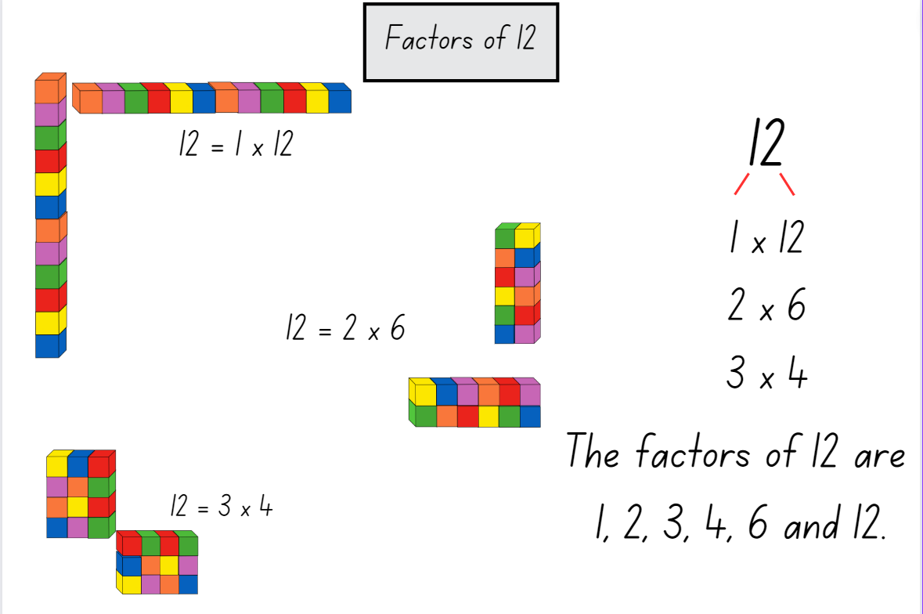
- Revise the definition of a factor from Daily number sense. Model the creation of a simple factor tree (see Figure 1).
- Identify that factors are found in pairs. Model the ‘Yes or No strategy’ of starting at one to identify the factor pair. Then proceed sequentially through 2, 3, 4, 5 and so on to identify all factors of a number.
- Give each pair of students a number in the range 10–24. Ask them to form as many unique rectangles as they can using that number of cubes. Vary the number range to suit the learning needs of your class, selecting some prime and square numbers.
- Students form the rectangles, first with cubes and then draw regions on grid paper.
- Ask questions to draw student attention to the factors of a number in a systematic way, such as arranging the first factor from lowest to highest (see Figure 1). For example:
- How many rectangles have you found for your number?
- How do you know you have found them all?
- Did you use a system to check? What was it?
- Why do some numbers have more rectangles than others?
- What patterns can you see in your factor tree?
- Why do we use rectangles to show factors?
- Students stick or draw rectangles onto a poster labelled for their number. Students label each rectangle with a multiplication sentence and create the relevant factor tree.
- As a class, group students that have exactly one rectangle (2 factors) and those that have more than one rectangle. Ask:
- What strategies did you use to ensure you did not miss any factors?
- Which number has the most rectangles?
- Are there any numbers that form only one rectangle?
- What patterns do you see with the ‘one rectangle’ numbers?
- What do you notice about the factors for 16? (Remind students that this is a square number.)
This table details opportunities for differentiation.
Too hard? | Too easy?
Students cannot determine factors for a given number.  - Students focus on creating arrays using concrete materials to represent a given number and identify the associated fact families.  - Give students multiplication fact families on cards, such as Resource 2 – fact families. Students create an array using concrete materials to match the cards. Students create an array using concrete materials to match the cards. | Students can determine factors for a given whole number.  - Students investigate a range of questions related to factors and prime numbers. Examples include which number under 100 has the most factors and how many prime numbers are there under 100?  - Students use calculators to find factors of 3- and 4-digit numbers.  - Write a procedure for how to find all factors of a number.  Students can determine whether a number is prime, composite or neither (0 or 1).  - Students explore the number of factors in number series, such as 1, 4, 16, 64, 256. Students identify the pattern and the next 2 items. See Finding patterns with factors, for more information.  - Provide students with a copy of Resource 3 – prime climb from Prime climb. Students answer the questions and share with the class.  - Enrich student learning by investigating the history of prime numbers and their uses. For example, ask students why 0 and 1 are not considered prime.

Discuss and connect the mathematics – 20 minutes
- Share the definitions of ‘prime’ and ‘composite’ numbers:
Prime number: a positive integer which has exactly 2 distinct factors, itself and one. Modelled as an array, it has only one row. Zero is not an integer and therefore is neither prime nor composite.
Composite number: a non-zero natural number that has a factor other than one and itself. For example, all even numbers besides 2 are composite numbers. Some odd numbers are composite (for example, 21) but not all are composite (for example, 11).
- Ask the class to help you sort all the numbers 1–20 into 3 headings: prime, composite or neither on the whiteboard. Ask students about how to classify zero, one and 2 using the prompts below.
The table below outlines stimulus prompts to generate conversation about the topic, along with anticipated responses from students.
Prompts | Anticipated student responses
- Do one and zero fit the definition of prime or composite?  - What is special about the number 2? | - No, the one and zero do not fit the definition of prime or composite.  - The number 2 is special because it is the smallest prime number.  - The number 2 is special because it is the only even prime number.
This table details opportunities for assessment.
Assessment opportunities | Links
What to look for:  - Can students use the terms ‘factors’ and ‘product’ to describe the result of multiplying 2 or more numbers? [MAO-WM-01, MA3-MR-01]  - Can students reason about structure to model different ways to show a whole number as a product? [MAO-WM-01, MA3-MR-01]  - Can students determine factors for a given number? [MAO-WM-01, MA3-MR-01]  - Can students determine whether a number is prime, composite or neither (0 or 1)? [MAO-WM-01, MA3-MR-01] | Links to National Numeracy Learning Progressions (NNLP):  - MuS6, MuS7.

Lesson 2
Core concept: known number facts and strategies support multiplicative understanding.

Daily number sense – factorising – 15 minutes
The table below contains a suggested learning intention and success criteria. These are best co-constructed with students.
Daily number sense learning intention | Daily number sense success criteria
Students are learning to:  - select and apply appropriate strategies to solve multiplication problems. | Students can:  - factorise numbers to aid mental multiplication.
Note: for this activity, the number 12 is used as an example as consolidation from the previous core lesson. Any other number with multiple factors can be selected to best suit the learning needs of your students.
- Revise the learning, definition and poster about factors from Lesson 1.
Factor: a number which divides another number without a remainder. For example, one, 2, 3 and 6 are factors of 6 but 4 and 5 are not.
- Discuss the factor pairs that make 12. Revise the commutative property of multiplication.
- Ask students if they can think of 3 numbers that can be multiplied together to make 12, such as 2 × 2 × 3.
- Students record their ideas on individual whiteboards and share their thinking.
- Display Resource 4 – the product is 12 and compare with student responses. Ask:
- What do you notice?
- What do you wonder?
- Display Resource 5 – looking at 12 and use the prompt box in the table below to discuss students’ observations.
Prompts | Anticipated student responses
- Do you notice or wonder anything else with the cards displayed this way?  - Is there another way the cards could be arranged?  - What property of multiplication do you notice? | - The cards create a visual pattern.  - The cards could be arranged so that they all start with the same factor, for example, in columns.  - The commutative property of multiplication means that cards can show the same numbers in a different order, but the outcome is the same. For example, 1 × 1 × 12 = 1 × 12 × 1.  - The associative property of multiplication means that you can group the factors on a card in different ways to find the total and the result will be the same. For example, in 2 × 6 × 1 = 12, either the 2 × 6 or the 6 × 1 could be multiplied first, then multiplied by the other factor and the total will still equal 12.
- Students use their whiteboards to draw and discuss another way that the cards could be arranged. For example, they arrange the cards so that the rows all start with the same factor.
- Display the statement 6 × 12. Ask students to record 3 numbers that can be multiplied to make same product, such as 6 × 3 × 4.
This table details an opportunity for assessment.
Assessment opportunity | Links
What to look for:  - Can students factorise numbers to aid mental multiplication? [MAO-WM-01, MA3-MR-01] | Links to National Numeracy Learning Progressions (NNLP):  - MuS6, MuS7.

Core lesson – multiplying numbers – 40 minutes
The table below contains a suggested learning intention and success criteria. These are best co-constructed with students.
Core concept learning intention | Core concept success criteria
Students are learning to:  - use partitioning and place value to multiply 2-, 3- and 4-digit numbers by one-digit numbers | Students can:  - use mental strategies to multiply one-digit numbers by 10, 100, 1000 and their multiples  - estimate the product of 2 numbers (one-digit by 2- or 3-digit numbers) using multiples of 10 or 100  - determine factors for a given whole number.
This activity is an adaptation of ‘Multiplying and Dividing Numbers by 10, 100...’, from Building Engagement for Middle Years Mathematics: Learning sequences for mixed-ability classrooms by Sullivan.
- Display Resource 6 – two boxes. Explain that the answer is 800 MAB blocks. Ask students to think what might be in the box to reach the answer of 800.
- Display Resource 7 – two hundreds. Confirm that in each box there is a hundred block. Ask students to check the answer.
- Explain that the answer can be written as 8 hundreds and expressed as the equation 2 × 100 × 4 = 800. Identify that 2 and 100 are factors of 200. Ask what the best order to multiply these numbers is.
- Pose other units that could be in the box, such as 1000, 10 000, 100 000. Ask what the answer would be then.
- Explain that dividing numbers into factors so that we can multiply them separately is called ‘factorising’. Share the definition.
Factorise: to express a number as a product. For example, 15 is factorised when expressed as a product, such as 15 = 3 × 5.
- Display Resource 8 – question prompts. Students show on individual whiteboards how they might factorise each of the examples. Encourage students to rename numbers to help, such as renaming 1500 as 15 hundreds or 15 × 100.
- Ask students to turn and talk to discuss:
- Does factorising make questions like this easier to solve? Why or why not?
- Where can it help?
- Where might it not help?
- Present Resource 9 – applying facts. Ask:
- Can you factorise one or more of the numbers to make them easier to calculate?
- What is similar about these questions? What is different?
- Did factorising make the questions easier to solve? How?
Note: guide students to realise that the answer will start with ‘40’ something because of the base fact 5 × 8. Encourage students to estimate whether the product would be in the hundreds, thousands or tens of thousands.
- Students choose a multiplication fact that they are confident with. Create a similar series of questions, using the previous task as a reference. Numbers used should extend into at least to 4-digit numbers.
- Students trade questions with a partner and solve.
- Students trade questions back and compare the way the other has factorised.
- Present the following problem to the class: ‘You are thinking of some numbers. One of them has a 3 in it. When you multiply the numbers, the answer is 600.’ Ask what the numbers might be. Encourage students to give as many answers as they can.
This table details opportunities for differentiation.
Too hard? | Too easy?
Students cannot determine factors for a given number or use mental strategies to multiply one-digit numbers by 10, 100, 1000 and their multiples.  - Use MAB materials to model even multiples of 10 and 100 and write an equation, such as 600 = 6 × 100. Split the model into 2 parts. Rewrite the equation, such as 600 = 2 × 3 × 100.  - Students use calculators to investigate and record patterns when multiplying by 10, 100 or 1000. | Students can use mental strategies to multiply one-digit numbers by 10, 100, 1000 and their multiples.  - Challenge students to create a list of division questions using 8 × 5 = 40, such as 40 ÷ 5; 400 ÷ 8; 400 ÷ 50; 4000 ÷ 5.  - Students use calculators to investigate and record the effect of multiplying or dividing decimals by 10, 100 or 1000.  - Students write some problem stories about planting The Deca Tree in different situations, such as 100 deca trees in a park or a million in a forest.

Discuss and connect the mathematics – 10 minutes
- Ask students to turn and talk and discuss the following questions:
- What patterns have you noticed when multiplying by 10, 100 and 1000? (Identify that the digits remain the same but the place value changes).
- Is it possible to factorise both numbers, such as 60 × 50? When might that be helpful?
- What advice would you give someone who has trouble multiplying large numbers with lots of zeroes?
Note: it is a common misconception that multiplying by 10 can be done by simply ‘adding a zero’ and multiplying by 100 can be done by ‘adding 2 zeros’. This should be avoided as it detracts from a deeper understanding of place value, multiplicative thinking and the link between them.

Consolidation and meaningful practice – 15 minutes
- Share Resource 10 – factorising gameboard. Students play according to the instructions.
This table details opportunities for differentiation.
Too hard? | Too easy?
Students cannot use mental strategies to multiply one-digit numbers by 10, 100, 1000 and their multiples.  - Students roll a single dice and multiply by multiples of 10 before placing a counter.  - Students roll 2 single-digit numbers and multiply before placing a counter. Students use a calculator to check their partner’s answer.  - Students create their own gameboard using multiples of 10 using Resource 11 – blank gameboard. | Students can use mental strategies to multiply one-digit numbers by 10, 100, 1000 and their multiples.  - Students use a 20-sided die or two 10-sided dice to create 2-digit numbers before placing a counter.  - Students create their own gameboard using multiples of 100 such as 1500 or 2100 on Resource 11 – blank gameboard.  - Students choose a number and multiply by the previous number their partner used.
This table details opportunities for assessment.
Assessment opportunities | Links
What to look for:  - Can students determine factors for a given number? [MAO-WM-01, MA3-MR-01]  - Can students use mental strategies to multiply one-digit numbers by 10, 100, 1000 and their multiples? [MAO-WM-01, MA3-MR-01] | Links to National Numeracy Learning Progressions (NNLP):  - MuS6, MuS7.  Links to suggested Interview for Student Reasoning (IfSR) tasks:  - IfSR-MT: 3A.1, 3A.2, 3A.3.

Lesson 3
Core concept: flexible methods of computation in multiplication and division involve composing and decomposing numbers.

Daily number sense – number talk – 10 minutes
The table below contains suggested learning intentions and success criteria. These are best co-constructed with students.
Daily number sense learning intentions | Daily number sense success criteria
Students are learning to:  - select and apply appropriate strategies to solve multiplication and division problems.  - apply the order of operations. | Students can:  - use the distributive property to solve problems by multiplying the hundreds, then the tens and then the ones.  - recognise the need to agree on the order in which to perform operations
Note: the multiplication equations provided below are an example and should be adapted to suit the cohort of students. Grouping symbols, such as parentheses, are not needed to solve the partitioned multiplication equation as the order of operations rules apply. However, the use of grouping symbols can be helpful to organise thinking.
- Model using the distributive property to solve the following multiplication equations using a standard partition. For example:
- 96 × 5 = (90 × 5) + (6 × 5) = 450 + 30 = 480
- 713 × 6 = (700 × 6) + (10 × 6) + (3 × 6) = 4200 + 60 + 18 = 4278
- Discuss the function of the parentheses, explaining that they are not formally needed in this equation. Discuss the order of operations.
- Display multiplication equations that use the distributive property as a scaffold.
- Pose additional questions, such as:
- 37 × 5 = (30 × 5) + (7 × 5) = 150 + 35 = 185
- 537 × 2 = (500 × 2) + (30 × 2) + (7 × 2) = 1000 + 60 + 14 = 1074
- 968 × 4 = (900 × 4) + (60 × 4) + (8 × 4) = 3600 + 240 + 32 = 3872
- Students turn and talk as they solve the problems, recording their ideas on individual-whiteboards.
- Display Resource 12 – find the total.
- Students use individual whiteboards to use the distributive property to find the sum of all the numbers. If needed, prompt students to add the numbers in the top row together and multiply the answer by 4 (see Figure 2).
Figure 2 – the distributive property
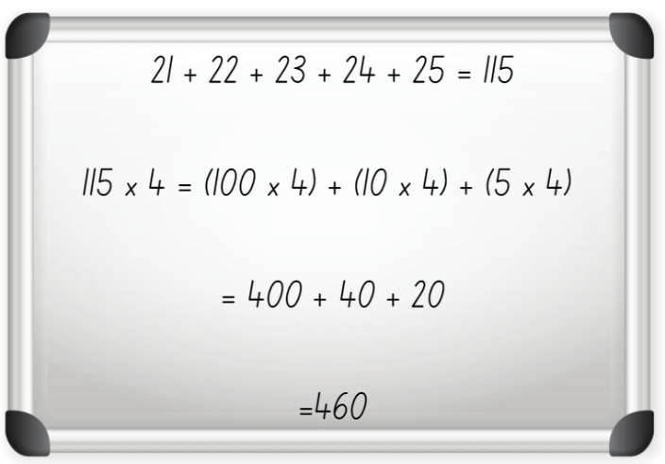
- Students share their strategies.
This table details opportunities for assessment.
Assessment opportunities | Links
What to look for:  - Can students use the distributive property to solve problems by multiplying the hundreds, then the tens and then the ones? [MAO-WM-01, MA3-MR-01, MA3-MR-02]  - Can students recognise the need to agree on the order in which to perform operations? [MAO-WM-01, MA3-MR-02] | Links to National Numeracy Learning Progressions (NNLP):  - MuS7.  Links to suggested Interview for Student Reasoning (IfSR) tasks:  - IfSR-MT: 3A.1, 3A.2, 3A.3.

Core lesson – multiple strategies for multiplication– 40 minutes
The table below contains a suggested learning intention and success criteria. These are best co-constructed with students.
Core concept learning intention | Core concept success criteria
Students are learning to:  - select and apply appropriate strategies to solve multiplication and division problems. | Students can:  - use informal written strategies, such as the area model, to solve multiplication  - use the distributive property with the area model to partition numbers in representing multiplication problems  - partition numbers in non-standard forms  - use estimation to check the reasonableness of answers to multiplication and division calculations.
- Display Resource 13 – student strategies and read out the speech bubbles. Ask:
- Can you show what Murray’s strategy looks like?
- Can you show what Heide’s strategy looks like?
- What might you use to help you? Can you think of a strategy that might help?
- Who is correct?
- Focus on Brett’s statement that he found the answer a different way. Ask:
- What might Brett’s strategy be?
- Can you show what his strategy looks like?
- What might someone else’s strategy be if they joined in the conversation?
- Capture student ideas on an anchor chart (see Figure 3). Annotate student ideas with number sentences as a method of sharing mathematical thinking.
- Explain that all these ideas are valid methods and students need to think of numbers and strategies flexibly.
Figure 3 – possible student strategies
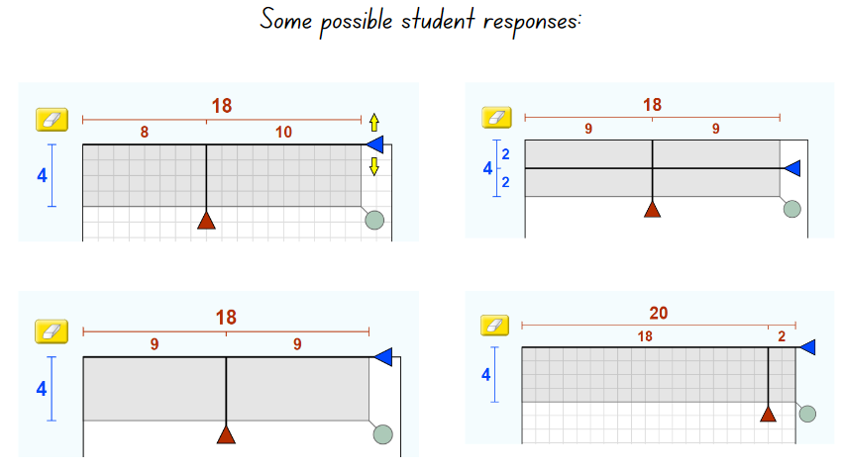
Image created using PhET Interactive Simulations, University of Colorado Boulder, https://phet.colorado.edu.
Note: explore the area model digital tool to represent different numbers in preparation for Lesson 4.
- Introduce the multiplication sentence 24 × 5. Ask students to discuss whether 200 is a reasonable answer to this, giving reasons why or why not.
- Explain to students that they will create a series of responses to the question 24 × 5 using Resource 14 – student strategies 2. Ask:
- How might Heide solve this question?
- How might Murray solve this question?
- How might Brett solve this question?
- How can we represent this?
Note: the question is designed to encourage students to represent the same equation in multiple ways, for example, a standard equation; multiply by 10 then halve, 12 × 5 × 2; 5 × 25 − 5.
This table details opportunities for differentiation.
Too hard? | Too easy?
Students cannot use informal written strategies, such as the area model, to solve multiplication.  - Support students to construct an array of 5 × 8 with concrete materials and model how to partition the array.  - Students colour a region or area on grid paper and find different ways to partition.  - Use the area model digital tool to explore different numbers. | Students can use informal written strategies such as the area model to solve multiplication.  - Provide students with a 2-digit multiplication question such as 24 × 15. Ask if students can link this back to the original question.  - Use the area model digital tool to explore larger numbers on a 100 × 100 grid.

Discuss and connect the mathematics – 15 minutes
- Share responses to the 24 × 5 task.
- Collect student ideas and collate on an anchor chart. Review the names of the strategies used and label on the anchor chart.
- Discuss which strategy they think is the most effective for this question. Prompt student to explain why or why not.
This table details opportunities for assessment.
Assessment opportunities | Links
What to look for:  - Can students use informal written strategies such as the area model to solve multiplication? [MAO-WM-01, MA3-MR-01]  - Can students use the distributive property with the area model to partition numbers in multiplication problems? [MAO-WM-01, MA3-MR-01, MA3-MR-02]  - Can students partition numbers in non-standard forms? [MAO-WM-01, MA3-MR-01]  - Can students annotate their strategy using words or numbers? [MAO-WM-01, MA3-MR-01]  - Can students generate more than one strategy for solving multiplication problems? [MAO-WM-01, MA3-MR-01] | Links to National Numeracy Learning Progressions (NNLP):  - MuS6, MuS7.  Links to suggested Interview for Student Reasoning (IfSR) tasks:  - IfSR-MT: 3A.1, 3A.2, 3A.3.

Lesson 4
Core concept: the area model can support multiplicative thinking.

Daily number sense – 10 minutes
- From a class need surfaced through formative assessment data, identify a short, focused activity that targets students’ knowledge, understanding and skills. Example activities may be drawn from the following resources:
- Mathematics K-6 resources
- Universal Resources Hub.

Core lesson – area model – 40 minutes
The table below contains a suggested learning intention and success criteria. These are best co-constructed with students.
Core concept learning intention | Core concept success criteria
Students are learning to:  - use the area model to partition numbers in multiplication problems. | Students can:  - partition 2-, 3- and 4-digit numbers  - represent a multiplication equation using the area model  - use parentheses in an equation to record thinking.
- Display Resource 15 – area model. Ask students:
- What do you see, think and wonder?
- How could this help us calculate multiplication problems?
- Record responses on a whiteboard to refer to during lesson.
- Explain to students that this is called the area model. In this example, 47 has been partitioned into 4 tens and 7 ones.
- Pose the problem 5 × 18. Ask students what this would look like using MAB materials or drawn on grid paper.
- In pairs, students use MAB materials, grid paper or a digital manipulative such as the Number Pieces by The Math Learning Center to construct this multiplication statement (see Figure 4).
Figure 4 – constructed area model using MAB materials
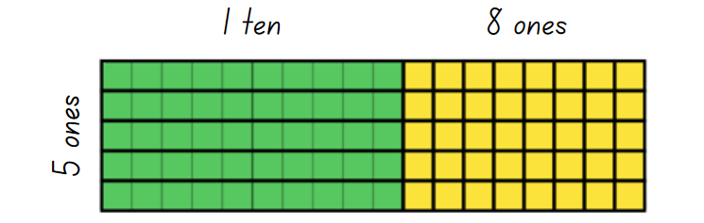
- Compare student examples.
- Demonstrate how to draw the multiplication statement as an area model using 2 examples (see Figure 5). Draw attention to Figure 5 as being simplified but equivalent to the image in Figure 4, without showing the individual units in the grid.
Figure 5 – constructed area model
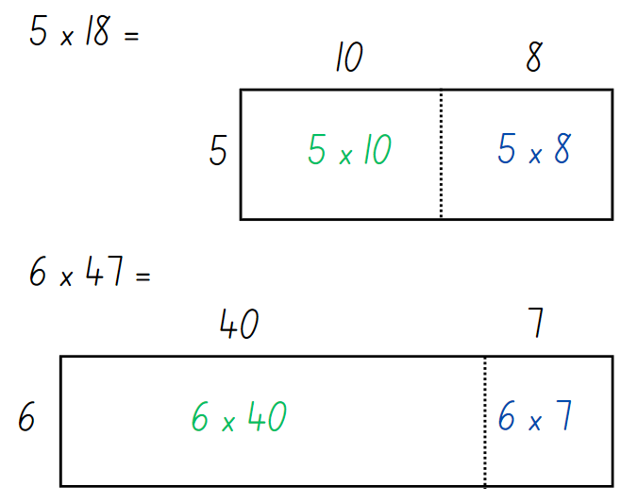
Note: when drawing the area model, it is important to consider proportionality and represent the relative sizes of the areas. In the examples in Figure 5 above, 10 and 8 are drawn as similar sizes. 40 is drawn as significantly larger than 7. Students should also maintain such proportions in their sketches.
- Compare the MAB example in Figure 4 with the area model in Figure 5. Ask students what they notice about the 2 ways of representing the multiplication.
- Provide writing materials and pose additional single multiplier questions for students to represent with the area model. For example, 3 × 85, 4 × 265 or 6 × 4532.
- Ask students to use the area model to represent these equations on a whiteboard.
- Ask students if they have seen brackets before and what they think their purpose is. Anticipated student responses include:
- Brackets appear in sentences and novels to add additional information.
- They are used to add important information about a topic.
- They are used when solving equations where the order of operations is important.
- In mathematics, brackets […] and braces {…} are used for other purposes.
- Ask students if they know how they could use parentheses to help organise their thinking when writing a partitioned multiplication equation.
- Demonstrate how to transfer the information in an area model to a partitioned multiplication equation (see Figure 6).
Figure 6 – area model and parentheses
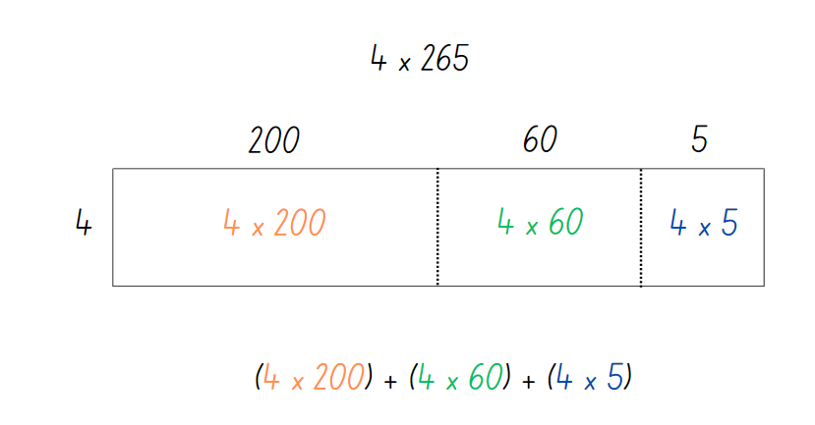
- Continue with solving the multiplication problem.
- Pose additional questions for students to represent using the area model and parentheses.
This table details opportunities for differentiation.
Too hard? | Too easy?
Students cannot partition 2- and 3-digit numbers or transfer this to an area model:  - Use concrete materials such as MAB materials to represent 2-digit numbers.  - Use the area model digital tool to explore different numbers on the 20 × 20 grid (see Figure 7). Use the calculation function to link the model to the number representations. | Students can partition 2-, 3- and 4-digit numbers and express this in an area model:  - Use two 2-digit numbers to form a multiplication equation and express it as an area model, using parentheses to model the distributive property.  - Use the area model digital tool to explore larger numbers on a 100 × 100 grid, using parentheses to model the distributive property.
Figure 7 – area model tool
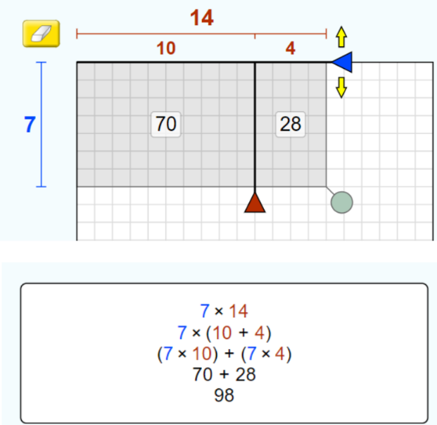
Image created using PhET Interactive Simulations, University of Colorado Boulder, https://phet.colorado.edu.

Discuss and connect the mathematics – 10 minutes
- Reflect on the activity by asking:
- When might the area model be useful for calculating multiplication problems?
- How can parentheses help us?
- Could we use the area model with different sized multiplication problems?
- What might that look like?
This table details opportunities for assessment.
Assessment opportunities | Links
What to look for:  - Can students partition 2-, 3- and 4-digit numbers into their place value components? [MAO-WM-01, MA3-MR-01]  - Can students use MAB materials or grid paper to form an area model? [MAO-WM-01, MA3-MR-01]  - Can students represent a multiplication equation using the area model? [MAO-WM-01, MA3-MR-01]  - Can students use parentheses in an equation to organise their thinking? [ MAO-WM-01, MA3-MR-01, MA3-MR-02] | Links to National Numeracy Learning Progressions (NNLP):  - NPV6, MuS6, MuS7.  Links to suggested Interview for Student Reasoning (IfSR) tasks:  - IfSR-MT: 3A.1, 3A.2, 3A.3.

Lesson 5
Core concept: mathematicians use algorithms with understanding to solve multiplicative problems.

Daily number sense – place value mystery – 15 minutes
Daily number sense activities for Lessons 5 to 7 ‘loop’ back to concepts and procedures covered in previous units to assist students to build an increasingly connected network of ideas. These concepts may differ from the core concepts being covered by the unit.
The table below contains a suggested learning intention and success criteria. These are best co-constructed with students.
Daily number sense learning intention | Daily number sense success criteria
Students are learning to:  - recognise and represent numbers in the millions. | Students can:  - read and represent numbers greater than 10 million.
This activity is an adaptation of ‘I am thinking of a number’ (p 43) from Open-Ended Maths Activities: Using ‘Good’ Questions to Enhance Learning Mathematics by Sullivan and Lilburn.
- Display and read Resource 16 – What am I? Explain that these are clues to a mystery number:
- Ask students what they think the number could be and to record their answer.
- Students share their answer with a partner and justify their thinking. Allow time for students to refine their answers.
- As a class, discuss student thinking. Ask questions, such as:
- What is your answer?
- Can you explain why your answer could be correct?
- Is your answer bigger or smaller than your partner’s?
- Can you think of another possible answer?
- Can you think of an incorrect answer and explain why?
- Students work in pairs to write their own clues to a mystery number. Some of these can be shared for the class to solve.
This table details an opportunity for assessment.
Assessment opportunity | Links
What to look for:  - Can students read and represent numbers greater than 10 million? [MAO-WM-01, MA3-RN-01] | Links to National Numeracy Learning Progressions (NNLP):  - NPV6, NPV7.

Core lesson – linking the area model to the algorithm – 40 minutes
The table below contains suggested learning intentions and success criteria. These are best co-constructed with students.
Core concept learning intentions | Core concept success criteria
Students are learning to:  - select and apply appropriate strategies to solve multiplication and division problems  - construct and complete equations involving multiplicative relations. | Students can:  - estimate the product of 2 numbers (one-digit by 2- or 3-digit numbers) using multiples of 10 or 100 and explain their thinking  - partition a 3-digit number and represent it as an area model  - represent the area model as an algorithm.
Note: this lesson can be used as an assessment opportunity to check that students know how to represent the multiplication equation as an area model, transfer it to an algorithm in expanded form and make reasonable estimations. While this lesson demonstrates one-digit by 3-digit multiplication; 2 by 2-digit multiplication is covered in later units.
- Present the statement 5 × 684.
- Ask: ‘Would 4000 be a reasonable estimate for this equation?’ Students turn and talk to share why or why not.
- Display Resource 17 – two estimations.
- Ask students which scenario is a reasonable estimate and why.
- Explain that reasonable estimations are an important tool in reviewing calculations using larger numbers. Estimation should be used both before and after calculations.
- Pose the problem 3 × 485.
- Students turn and talk to provide an estimate to the nearest 100 and share their thinking.
- Model the steps for representing 3 × 485 using the area model. Link the area model explicitly to the expanded algorithm (Figure 8).
- Explain that for the algorithm, the order of calculation is from the right column. Students may find it supportive to calculate the parts of the area model in the same order.
Figure 8 – area model to algorithm
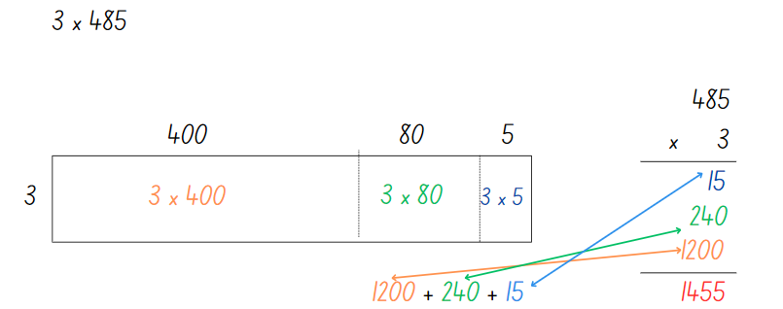
Note: when drawing the area model, it is important to consider proportionality and represent the relative sizes of the areas. In the example in Figure 8 above, the larger the value means the larger the area. Students should also maintain such proportions.
- Ask students:
- What connections can you make between the area model and the algorithm?
- How could you describe the connection to someone else?
- What differences do you notice?
- What are the benefits and limitations of each?
- Where might you make errors when using the area model to calculate your answer?
- What questions do you have?
- Was your estimate reasonable?
- Explain that students will work in pairs to match a card displaying a multiplication problem as an algorithm to a card with an area model.
- Distribute 2 sets of cards from Resource 18 – matching algorithms.
- Students find others who have their matching card.
- Return to the statement 5 × 684 from estimating above. In pairs, students use individual whiteboards to create an area model to find the solution to 5 × 684. They use this to complete the corresponding multiplication algorithm to check their answer.
- Compare the answer to the original estimate. Discuss the reasonableness of the estimate. Check for understanding with additional examples as necessary.
Note: some students may appear proficient with the algorithm but have only a procedural understanding of the calculations. Continue the link with the area model to develop their conceptual understanding.
- Ask students if they know the steps to completing the vertical multiplication algorithm. If necessary, remind students that they follow these steps for a 3-digit × one-digit problem:
- First, multiply the ones by the ones.
- Next, multiply the ones by the tens.
- Then, multiply the ones by the hundreds.
- Write each answer consecutively underneath the answer line.
- Finally, add up the calculated answers together and write them below another answer line.
- Make sure to line up the digits from the ones place in each new answer.
- Create an anchor chart with the steps on to display in the classroom.
- Ask students:
- What do you know about algorithms?
- Can you explain how they work?
- How are they organised?
This table details opportunities for differentiation.
Too hard? | Too easy?
Students cannot partition 3-digit numbers:  - Use MAB materials to support partitioning with 2-digit numbers (see Lesson 4).  - Use the area model digital tool to explore different numbers on the 20 × 20 grid, such as in Figure 8 above. Use the calculation function to link the model to the number representations. | Students can partition 3-digit numbers:  - Students explain their thinking by creating a video for students in another class with worked examples. For example, how to represent multiplication as an area model or explaining mathematical language such as ‘product’ or ‘factor’.  - Present students with an algorithm with a missing number, asking them to explain what the missing number is.  - Present students with a product. Ask students what the factors could be if they were a 3-digit number multiplied by a one-digit number. For example, the factors of the product 1215.  - Students experiment creating 2 by 2-digit multiplication equations and representing them as area models and expanded algorithms.

Consolidation and meaningful practice – 15 minutes
- Explain to students that they will play ‘Roll and Multiply’. Students:
- Roll a die to form numbers in a one-digit by 3-digit multiplication equation and record this on a whiteboard.
- Draw an area model using partitioning to split the 3-digit number into place value parts.
- Write an algorithm in expanded form next to the area model.
- Calculate the final answer in the algorithm.
- Check their calculation with a calculator.
- Variations include using place value dice to support students to partition and using coloured whiteboard markers to assist with translating numbers between the area model and the algorithm.
This table details opportunities for assessment.
Assessment opportunities | Links
What to look for:  - Can students estimate the product of 2 numbers (one-digit by 2- or 3-digit numbers) using multiples of 10 or 100 and explain their thinking? [MAO-WM-01, MA3-MR-01]  - Can students partition a 3-digit number and represent it as an area model? [MAO-WM-01, MA3-MR-01]  - Can students transfer the area model to an algorithm? [MAO-WM-01, MA3-MR-01] | Links to National Numeracy Learning Progressions (NNLP):  - MuS6, MuS7.  Links to suggested Interview for Student Reasoning (IfSR) tasks:  - IfSR-MT: 3A.1, 3A.2, 3A.3.

Lesson 6
Core concept: multiplication and division are inverse operations.

Daily number sense – larger numbers – 10 minutes
The table below contains a suggested learning intention and success criteria. These are best co-constructed with students.
Daily number sense learning intention | Daily number sense success criteria
Students are learning to:  - recognise, represent and round numbers in the millions. | Students can:  - read and write numbers in the millions using the place value grouping of ones, tens and hundreds  - round numbers to the nearest million.
This activity is an adaptation of ‘Write a number larger than …’ (p 38) from Open-Ended Maths Activities: Using ‘Good’ Questions to Enhance Learning Mathematics by Sullivan and Lilburn.
- Ask students to write numbers that are:
- larger than one million
- larger than 10 million
- larger than 100 million.
- Select students to share their answers. Review the correct mathematical language and place value conventions when reading large numbers.
- Select some other students to compare or order their large numbers.
- Ask questions such as:
- Can you prove that your answer is larger than one million, ten million or one hundred million?
- Can you round your answer to the nearest million?
- Can you provide another correct answer that is smaller or larger than your original answer?
This table details opportunities for assessment.
Assessment opportunities | Links
What to look for:  - Can students read and write numbers in the millions using the place value grouping of ones, tens and hundreds? [MAO-WM-01, MA3-RN-01]  - Can students round numbers to the nearest million? [MAO-WM-01, MA3-RN-01] | Links to National Numeracy Learning Progressions (NNLP):  - NPV6, NPV7.

Core lesson – connecting multiplication and division – 40 minutes
The table below contains a suggested learning intention and success criteria. These are best co-constructed with students.
Core concept learning intention | Core concept success criteria
Students are learning to:  - select and apply appropriate strategies to solve multiplication and division problems. | Students can:  - use knowledge of multiples to partition, as appropriate, and divide  - use known multiplication fact families to solve division problems  - select and apply appropriate strategies to divide a number with 3 or more digits by a one-digit divisor.
- Draw the image from Figure 9 on the whiteboard.
Figure 9 – fact family
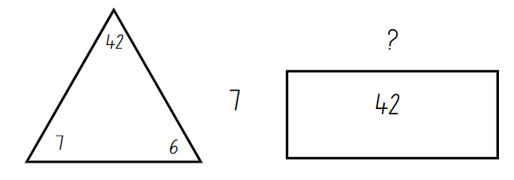
- Students turn and talk to answer:
- How do we know what number is missing from the rectangle?
- How are these 2 images similar?
- How are these 2 images different?
- What relationships can you see?
- Capture student thinking on a chart. Highlight how multiplication and division are related to one another.
- Draw the image from Figure 10 on the whiteboard. Pose the problem 39 divided by 3.
Figure 10 – division problem
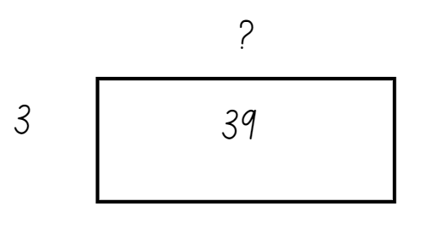
- Ask:
- Is it possible that the answer is close to 20? Why or why not?
- How might you work out the answer?
- What fact families do you think about to answer this question?
- Capture student responses by drawing corresponding fact family triangles and recording how students choose to partition 39 into multiples of 3. Responses may include 3 tens and 3 threes, 3 twelves and 3 ones, 3 elevens and 3 twos.
Note: before proceeding to the next activity, consider whether the question posed is a suitable progression for your students. The question is designed to promote flexible partitioning, such as the student ideas represented in Figure 11. Students may benefit from a question where tens and/or doubling are helpful partitions such as 120 divided by 6.
Figure 11 – anticipated student responses
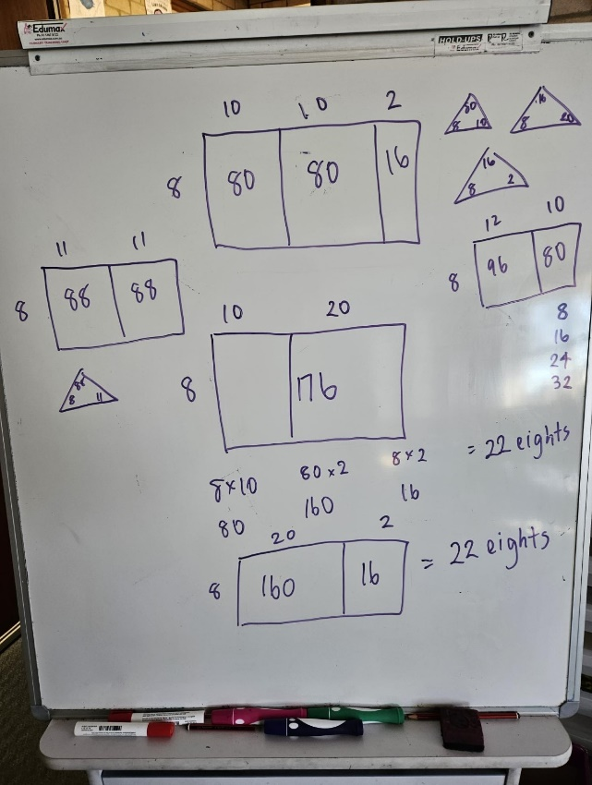
- Draw Figure 12 on the whiteboard and pose the problem 176 divided by 8.
Figure 12 – division problem 2
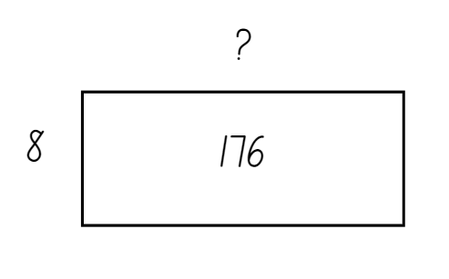
- Ask:
- How can we partition numbers using our knowledge of multiples?
- What other properties of multiplication or division will help you solve this problem?
Note: anticipated responses from students are on Figure 11 above. These examples include students who are still developing their thinking and reasoning for this concept.
- Display 3 division questions that promote flexible partitioning of numbers in non-standard forms, such as:
- 412 ÷ 4 = ?
- 726 ÷ 6 = ?
- 959 ÷ 7 = ?
- Provide students with a copy of Resource 19 – division template to show and explain their thinking.
This table details opportunities for differentiation.
Too hard? | Too easy?
Students cannot use knowledge of multiples to partition, as appropriate, and divide.  - Support students by providing them with fact families for 4. Use anchor charts from multiplying by 10 to support students in partitioning larger numbers.  - Provide students with questions where they can use multiples and fact families that they are familiar with. | Students can use knowledge of multiples to partition as appropriate and divide.  - Pose the question 176 ÷ ? = ? Students identify possible dimensions of the array and develop multiple solutions. Follow up with questions such as 726 ÷ ? = ?  - Students investigate what happens to possible partitions if they double both elements in an equation. For example, ask students if they can partition 726 ÷ 6 in the same way as 1452 ÷ 12. Encourage students to give reasons why or why not.

Discuss and connect the mathematics – 10 minutes
- Create an anchor chart to capture student ideas for one of the division questions. Record how students have partitioned with the use of multiples and the multiplication fact families they have used. Ask:
- Is there a best, or most efficient, way of partitioning numbers?
- What strategy could you suggest to another student if they were stuck with partitioning?
This table details opportunities for assessment.
Assessment opportunities | Links
What to look for:  - Can students use knowledge of multiples to partition, as appropriate, and divide? [MAO-WM-01, MA3-MR-01]  - Can students use known multiplication fact families to solve division problems? [MAO-WM-01, MA3-MR-01]  - Can students select and apply appropriate strategies to divide a number with 3 or more digits by a one-digit divisor? [MAO-WM-01, MA3-MR-01] | Links to National Numeracy Learning Progressions (NNLP):  - MuS6, MuS7.  Links to suggested Interview for Student Reasoning (IfSR) tasks:  - IfSR-MT: 2A.8  - IfSR-MT: 3A.1, 3A.2, 3A.3.

Lesson 7
Core concept: Euclidean division emphasises the relationship between multiplication and division.

Daily number sense – ordering numbers game – 10 minutes
The table below contains a suggested learning intention and success criteria. These are best co-constructed with students.
Daily number sense learning intention | Daily number sense success criteria
Students are learning to:  - order numbers in the millions. | Students can:  - arrange numbers in the millions in ascending and descending order.
- Divide the class into equal teams.
- Explain that students will be playing a game where they will each be given a number card from Resource 20 – number cards. Teams then need to arrange themselves in ascending order according to their number cards.
- Provide each student with a number card from Resource 20 – number cards and instruct them not to look at the number.
- Start the game.
- Students look at their number and teams arrange themselves in ascending order, displaying their number cards.
- When all teams have finished, check each team’s order by asking students to read out the numbers.
- Repeat using different cards.
- Variations could include:
- the first team to arrange themselves in the correct order scores a point
- teams arrange themselves in descending order
- students play in pairs and each pair is given cards to place in the correct order.
This table details opportunities for assessment.
Assessment opportunities | Links
What to look for:  - Can students arrange numbers in the millions in ascending and descending order? [MAO-WM-01, MA3-RN-01] | Links to National Numeracy Learning Progressions (NNLP):  - NPV6, NPV7.

Core lesson 1 – class remainders – 15 minutes
The table below contains a suggested learning intention and success criteria. These are best co-constructed with students.
Core concept learning intention | Core concept success criteria
Students are learning to:  - select and apply appropriate strategies to solve multiplication and division problems. | Students can:  - model division, including where the answer involves a remainder, using materials or diagrams  - record remainders to division problems in words  - use known multiplication fact families to solve division problems that may include a remainder.
- Display Resource 21 – array with remainders and ask students what they see, think and are wondering. Ask students how they might represent what is shown using a number sentence.
- Show students the equation 17 ÷ 5 = 3 remainder 2. Discuss the term remainder with the class.
Remainder: the part ‘left over’ when dividing a number into equal groups. The remainder forms part of the next group.
- Explain the activity ‘Class remainders’ to students.
- Start with the whole class together in a space where they can move.
- Explain that they will be divided into an array using a number rolled from a 9-sided die. For example, if there are 28 students and a 7 is rolled, it could make 28 ÷ 7 = 4 in a 4 by 7 array.
- Roll the 9-sided dice to determine how the class needs to be divided into an array.
- Record an equation and array to show how the class has been divided. If the class cannot be evenly divided, model how the equation can be written in different ways (30 ÷ 4 = 4 remainder 2).
- Repeat several times and record thinking on an anchor chart.
- Introduce the term ‘quotient’ as the result of dividing one number by another. Use the equations recorded in the ‘Class remainders’ activity to help students identify the quotient.
Quotient: the result of dividing one number by another.

Core lesson 2 – chipping away – 25 minutes
This activity is an adaption of Division – Chipping away at the whole number [PDF 487 KB] by Vingerhoets from Rob Vingerhoets Educational Consultancy.
- Explain to students that they will be learning to use multiplication fact families to solve division problems where the answer may include a remainder.
- Use the example of 237 balloons shared between 5 people. Ask:
- What is a good estimate for 237 balloons shared between 5 people?
- Why might it be helpful to make an estimate that involves a multiple of 10?
- Can you try and make an estimate that is a multiple of 10? (20 might be helpful.)
- Explain that larger division problems can be solved by chipping away at number.
Note: clarify that the meaning of the idiom is to chip away at something, meaning to make progress on a larger task one small piece at a time.
- Represent the 237 balloons in an area model (see Figure 13). Based on student suggestions, model the steps to ‘chip away’ using division (see Figure 13).
Figure 13 – chipping away at 237
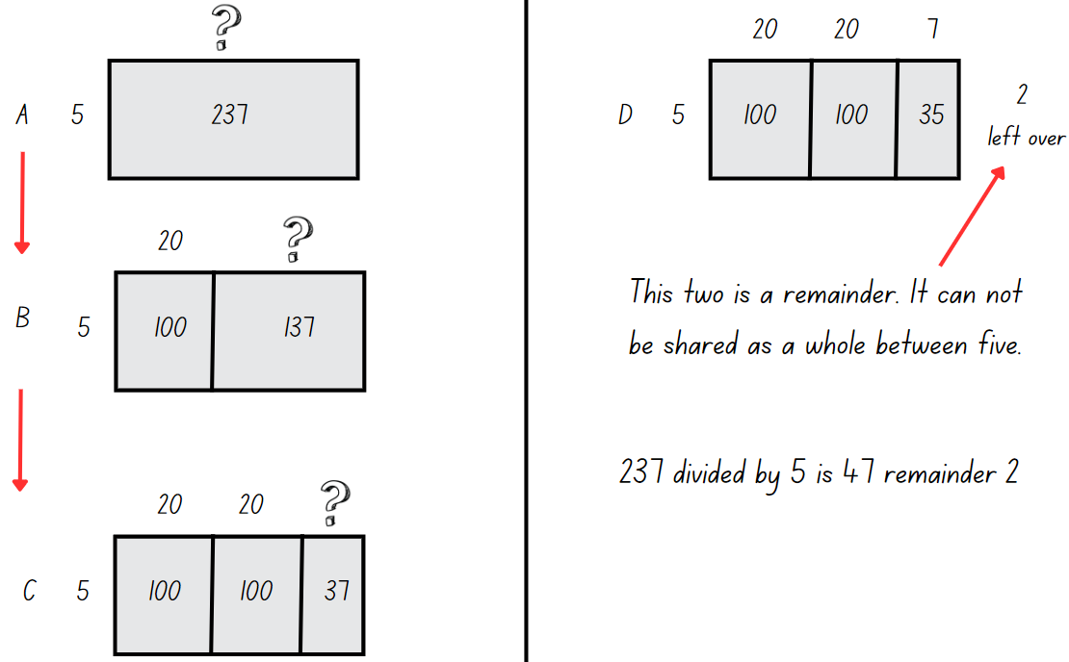
Note: the steps shown in Figure 13 above are only possible suggestions. Represent a second or third method based on student suggestions.
- Write the following problems on the board and ask students to identify multiplication fact families:
- 312 sheep split equally between 5 paddocks
- 132 chocolates shared equally into 8 boxes
- 241 students split equally between 7 buses.
- Students use the fact families and record their thinking strategies in student workbooks to solve the problems.
This table details opportunities for differentiation.
Too hard? | Too easy?
Students cannot model division, including where the answer involves a remainder, using materials or diagrams.  - Introduce the Remainders Game to students. Support students to create arrays and identify the remainders.  Support students to record their thinking as equations.  Use the Number Explorer to explore different division problems. | Students can use known multiplication fact families to solve division problems for which answers may include a remainder.  - Students create an instructional video on how multiplication fact families can be used to ‘chip away’ and solve division problems where the answer may include a remainder.

Discuss and connect the mathematics – 15 minutes
- Create an anchor chart to capture student ideas for one of the division questions. Record how students have used multiplication fact families and the equations that represent their strategy. Ask:
- Is there a best way of partitioning numbers?
- How did multiplication help you with division?
- What tips would you give other students if they were stuck?
- What other mathematical ideas or operations did you use when applying this strategy?
This table details opportunities for assessment.
Assessment opportunities | Links
- Can students model division, including where the answer involves a remainder, using materials or diagrams? [MAO-WM-01, MA3-MR-01]  - Can students record remainders in words to division problems? [MAO-WM-01, MA3-MR-01]  - Can students use known multiplication fact families to solve division problems for which answers may include a remainder? [MAO-WM-01, MA3-MR-01] | Links to National Numeracy Learning Progressions (NNLP):  - MuS6, MuS7.  Links to suggested Interview for Student Reasoning (IfSR) tasks:  - IfSR-MT: 2A.8.

Lesson 8
Core concept: worded problems can be solved using multiplicative thinking.

Daily number sense – 15 minutes
- From a class need surfaced through formative assessment data, identify a short, focused activity that targets students’ knowledge, understanding and skills. Example activities may be drawn from the following resources:
- Mathematics K-6 resources
- Universal Resources Hub.

Core lesson – using multiple strategies – 40 minutes
The table below contains a suggested learning intention and success criteria. These are best co-constructed with students.
Core concept learning intention | Core concept success criteria
Students are learning to:  - select and apply strategies to divide a number with 3 or more digits by a one-digit divisor. | Students can:  - use knowledge of multiples to partition as appropriate and divide  - apply and record appropriate strategies to solve multiplication and division word problems  - use and interpret remainders in solutions to division problems.
- Display Resource 22 – What’s the problem? Students turn and talk with a partner, discussing what the question could be to match the working out represented.
- Ask students to share their thinking, explaining how their question could match the working out in Resource 22 – What’s the problem?
- Ask students to discuss what strategies and ideas they have learned over the course of the unit. Anchor charts from previous lessons can be displayed to support student thinking.
- Students turn and talk with a partner and record their ideas before sharing these with the class. For example, strategies and ideas covered include multiplying by 10, 100, 1000, factorising, area models, partitioning, algorithms and ‘chipping away’ at a number using arrays.
- Present the word problem to students: ‘4 identical computers cost $896’. Ask how much one computer costs. Ask students whether they would estimate $200 or $300 as a reasonable answer.
- Students turn and talk with a partner to discuss how they would solve this problem. Share student responses and record the different strategies on the board.
- Ask students how they might use estimation or an inverse operation to check their answer.
- Using Resource 23 – problems to solve, present students with problems such as:
- How many 5-seater cars are required to take 247 people to the beach?
- How many days old will Sonya be on her twentieth birthday?
- There are 16 wallets on a table and each one has $200 inside. How much money is there altogether?
- 125 students need to be seated at tables that sit 4 or 5 to a table. How many of each table would be needed?
Note: explain that some problems will not be able to have a remainder. For example, 247 people shared between cars with 5 seats = 49 cars with a remainder of 2 people, but they cannot be left behind! Therefore, an extra car is needed. This makes a total of 50, even though the last car is not full.
- Students record their thinking in their student workbooks.
This table details opportunities for differentiation.
Too hard? | Too easy?
Students cannot apply and record appropriate strategies to solve multiplication and division word problems.  - Support students by providing questions suited to students’ ability, for example, smaller numbers.  - Guide students by suggesting strategies and why they might be effective.  - Encourage students to check their responses using estimation or inverse operations.  - Identify key words within the problems to clarify what the question is asking students to do. | Students can apply and record appropriate strategies to solve multiplication and division word problems.  - Extend students by providing questions suited to students’ ability, for example, larger numbers and open-ended problems.  - Students create, then solve problems that require them to use a particular strategy.  - Students give examples of inefficient strategies and provide reasons against their use.

Discuss and connect the mathematics – 10 minutes
- Ask students which strategy is the most efficient?
- As a class, discuss:
- Which strategy was the most efficient for a chosen problem? What makes you think that?
- Which strategy did you enjoy using?
- Why is it important to be able to use a variety of strategies when solving problems?
- Which strategy would you like to practise more?
This table details opportunities for assessment.
Assessment opportunities | Links
What to look for:  - Can students use knowledge of multiples to partition as appropriate and divide? [MAO-WM-01, MA3-MR-01]  - Can students apply and record appropriate strategies to solve multiplication and division word problems? [MAO-WM-01, MA3-MR-01]  - Can students use and interpret remainders in solutions to division problems? [MAO-WM-01, MA3-MR-01] | Links to National Numeracy Learning Progressions (NNLP):  - MuS6, MuS7, MuS8.  Links to suggested Interview for Student Reasoning (IfSR) tasks:  - IfSR-MT: 3A.6, 3A.7.

Resource 1 – What is inside?
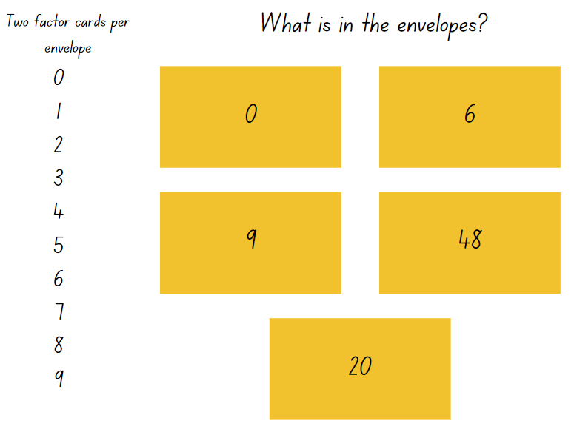

Resource 2 – fact families
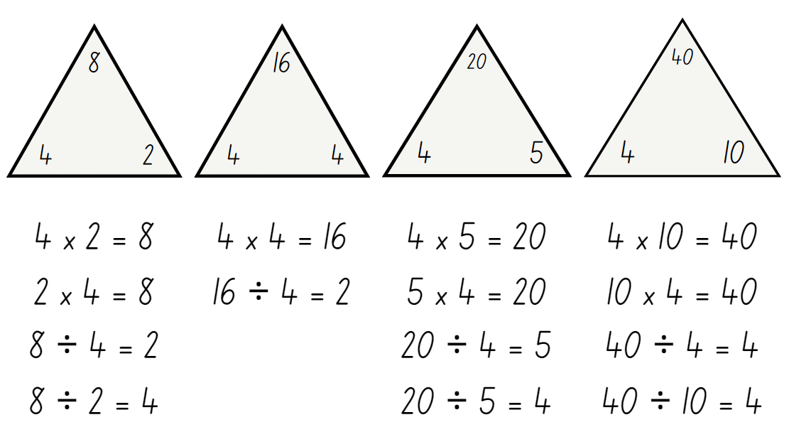

Resource 3 – prime climb
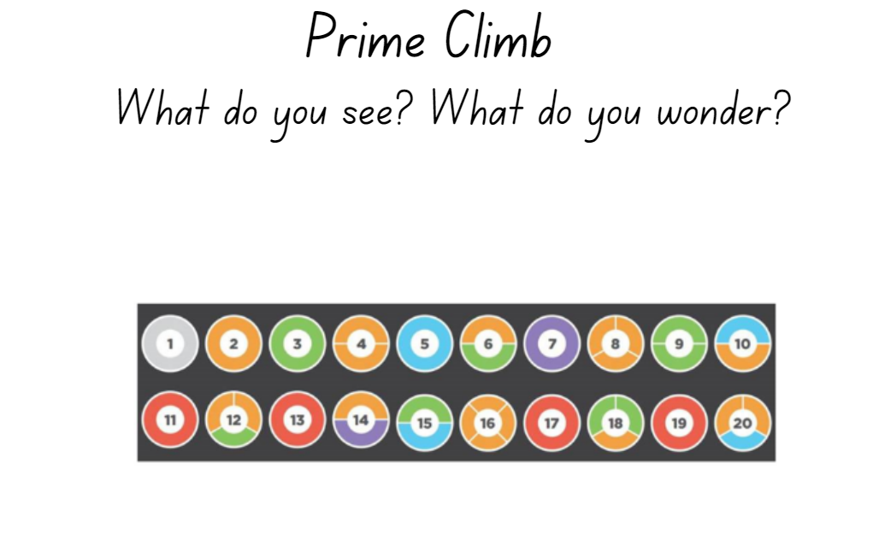
‘Prime Climb Color Chart’ by Math for Love used with permission from Dan Finkel.

Resource 4 – the product is 12
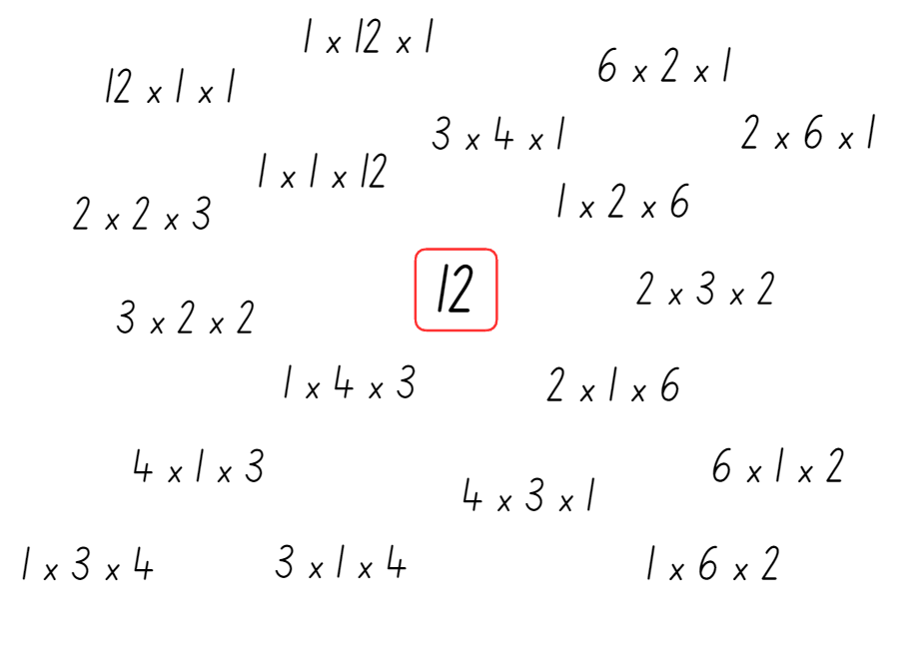

Resource 5 – looking at 12
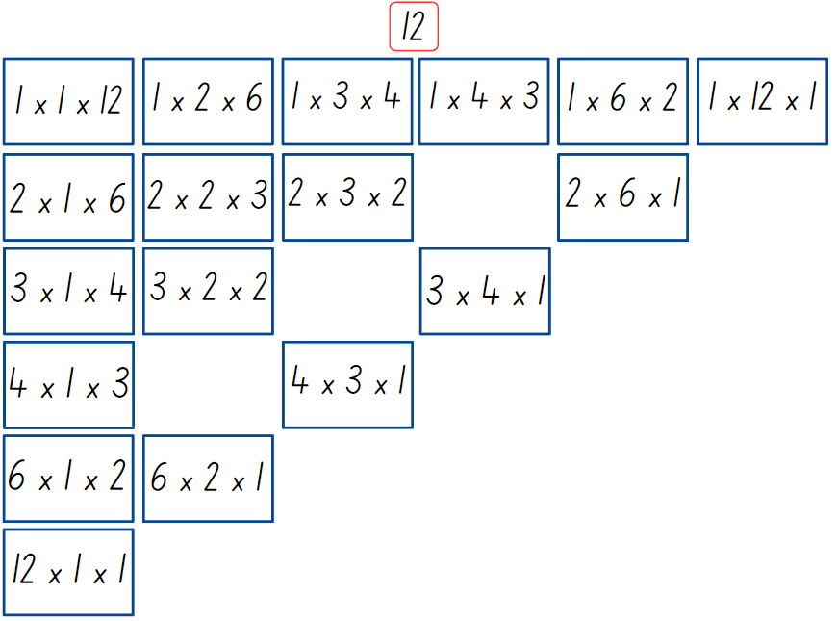

Resource 6 – two boxes

Resource 7 – two hundreds
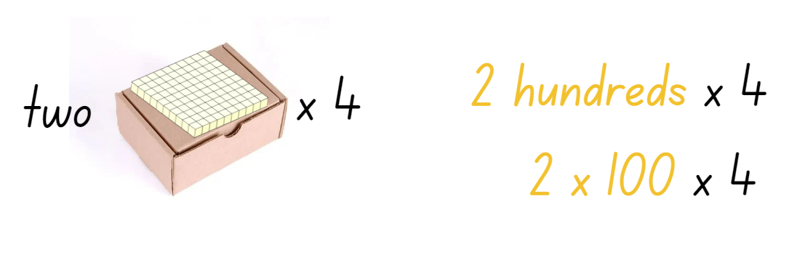

Resource 8 – question prompts
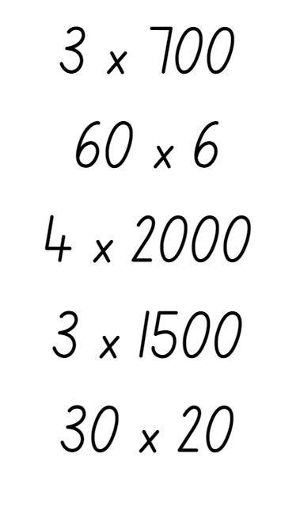

Resource 9 – applying facts
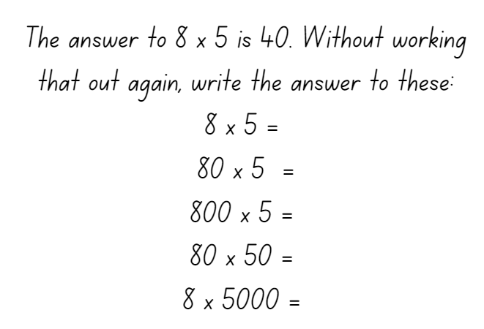

Resource 10 – factorising gameboard
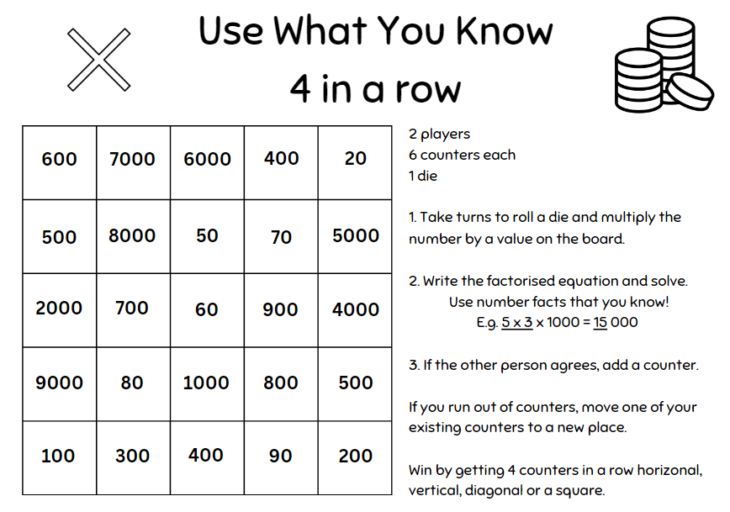

Resource 11 – blank gameboard
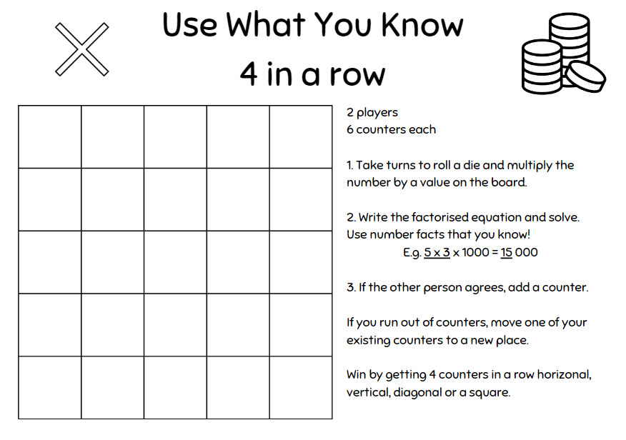

Resource 12 – find the total
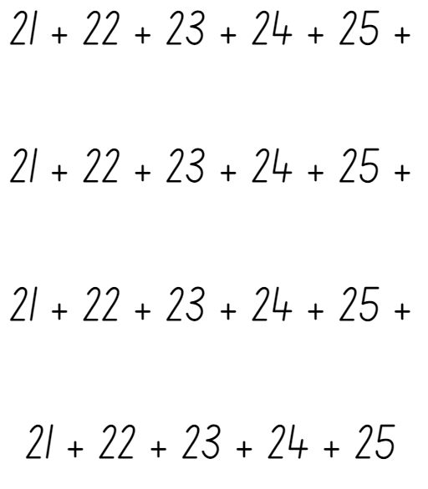

Resource 13 – student strategies
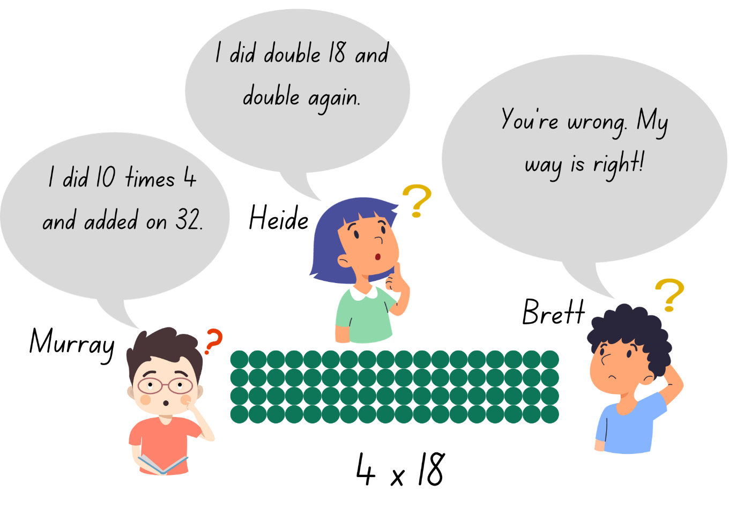

Resource 14 – student strategies 2
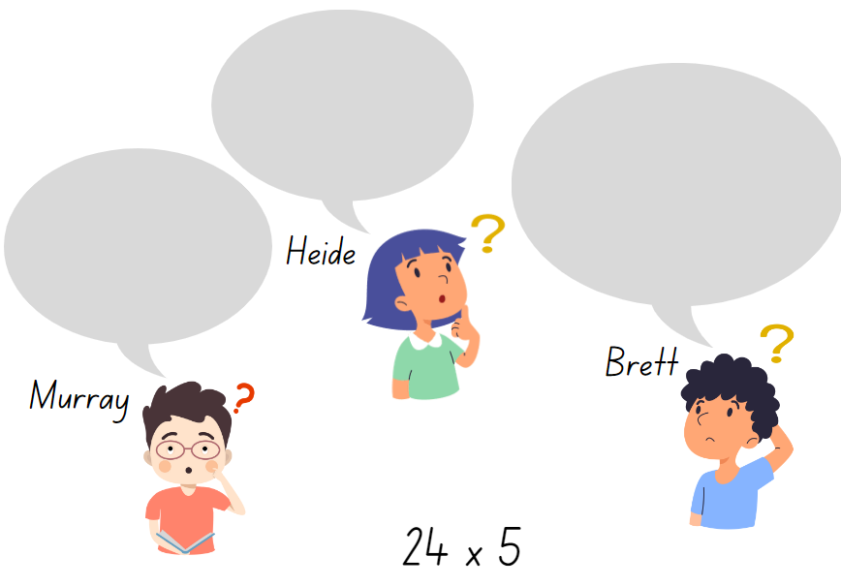

Resource 15 – area model
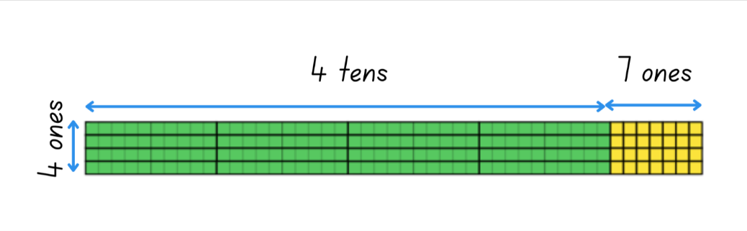

Resource 16 – What am I?
- I am larger than ten million.
- The number is a multiple of 5.
- The first 3 digits add to a number greater than 5.
- The tens of thousands digit is smaller than 4.
- The thousands digit is even.
- The hundreds digit is larger than the units digit.
- The tens digit is larger than the hundreds digit and is odd.

Resource 17 – two estimations
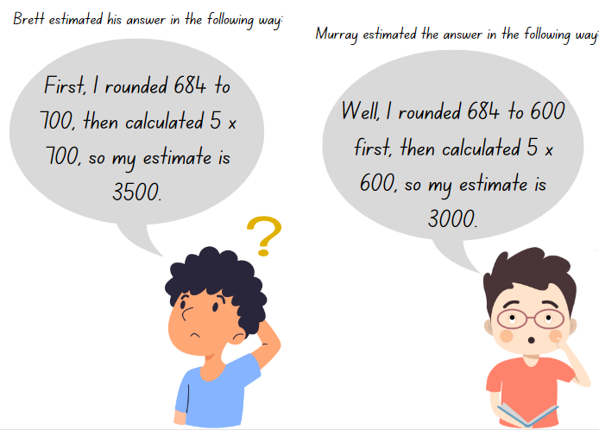

Resource 18 – matching algorithms
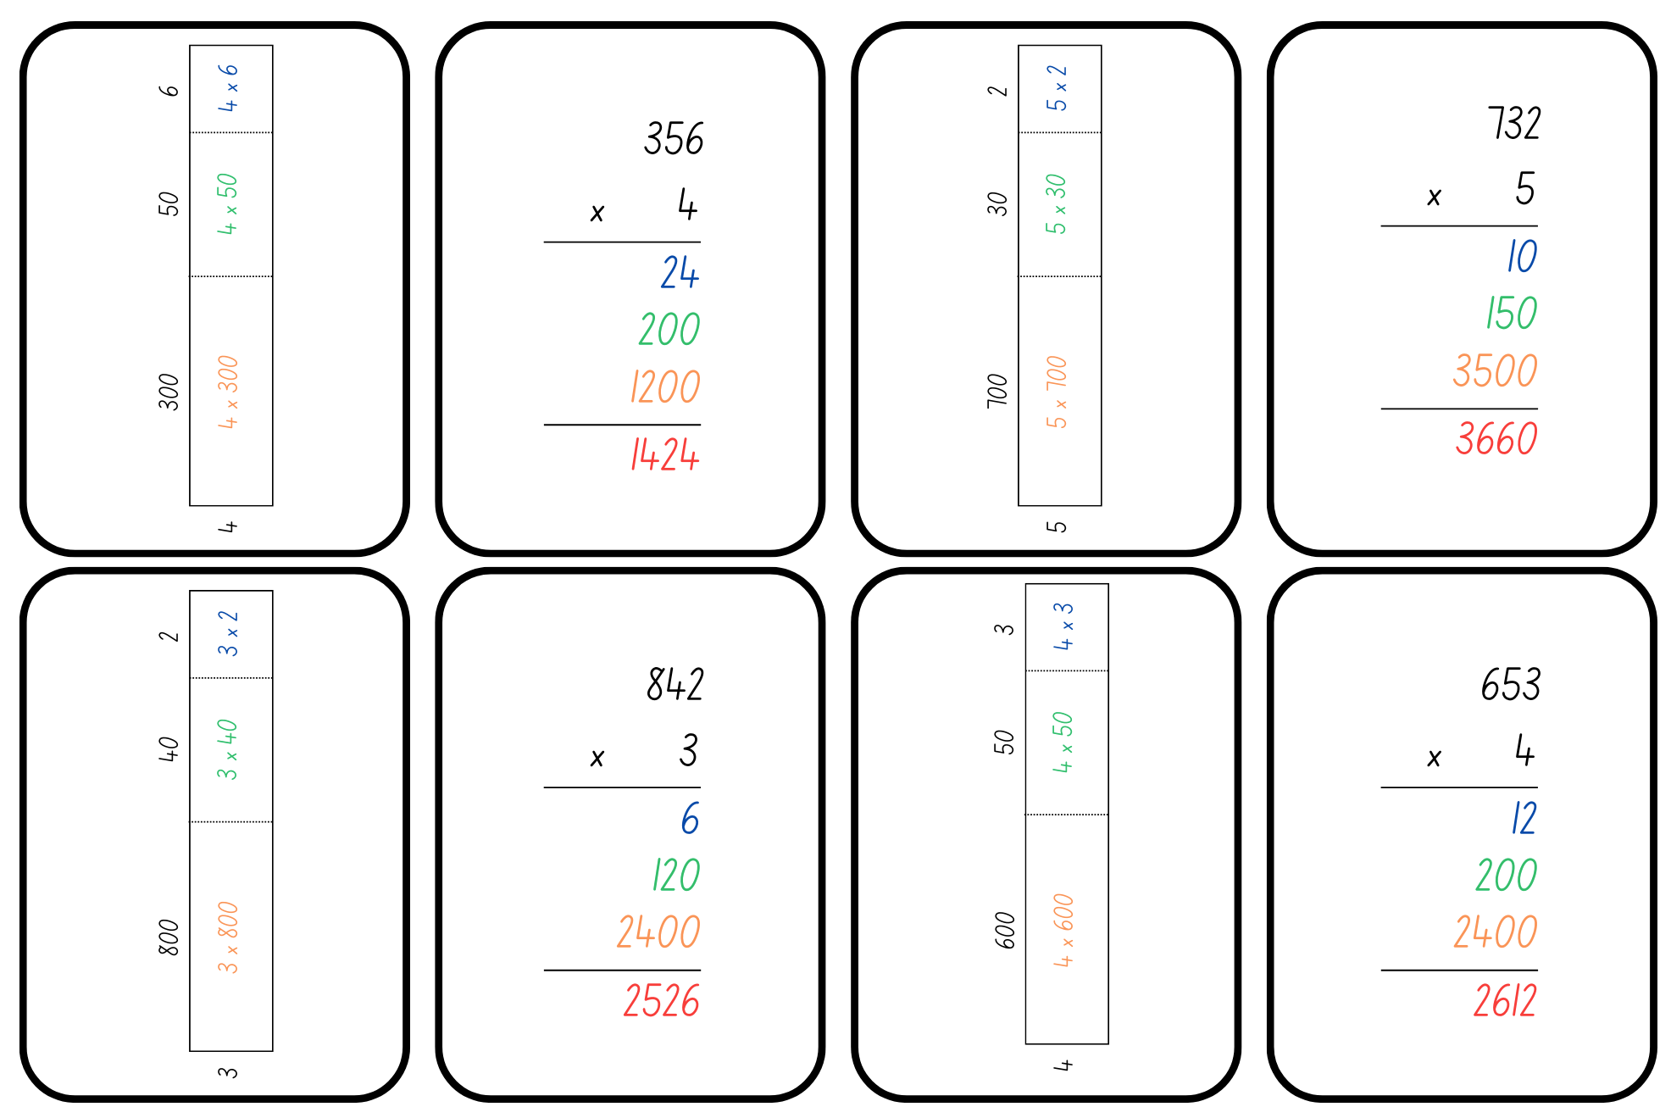

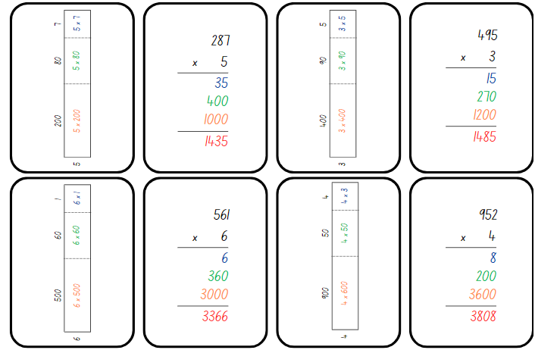

Resource 19 – division template
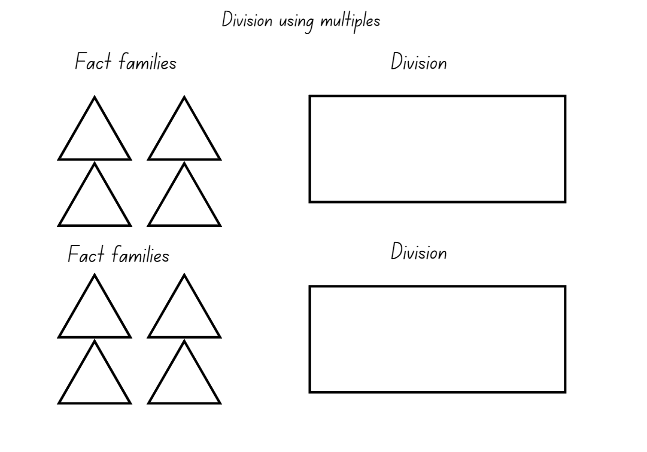

Resource 20 – number cards
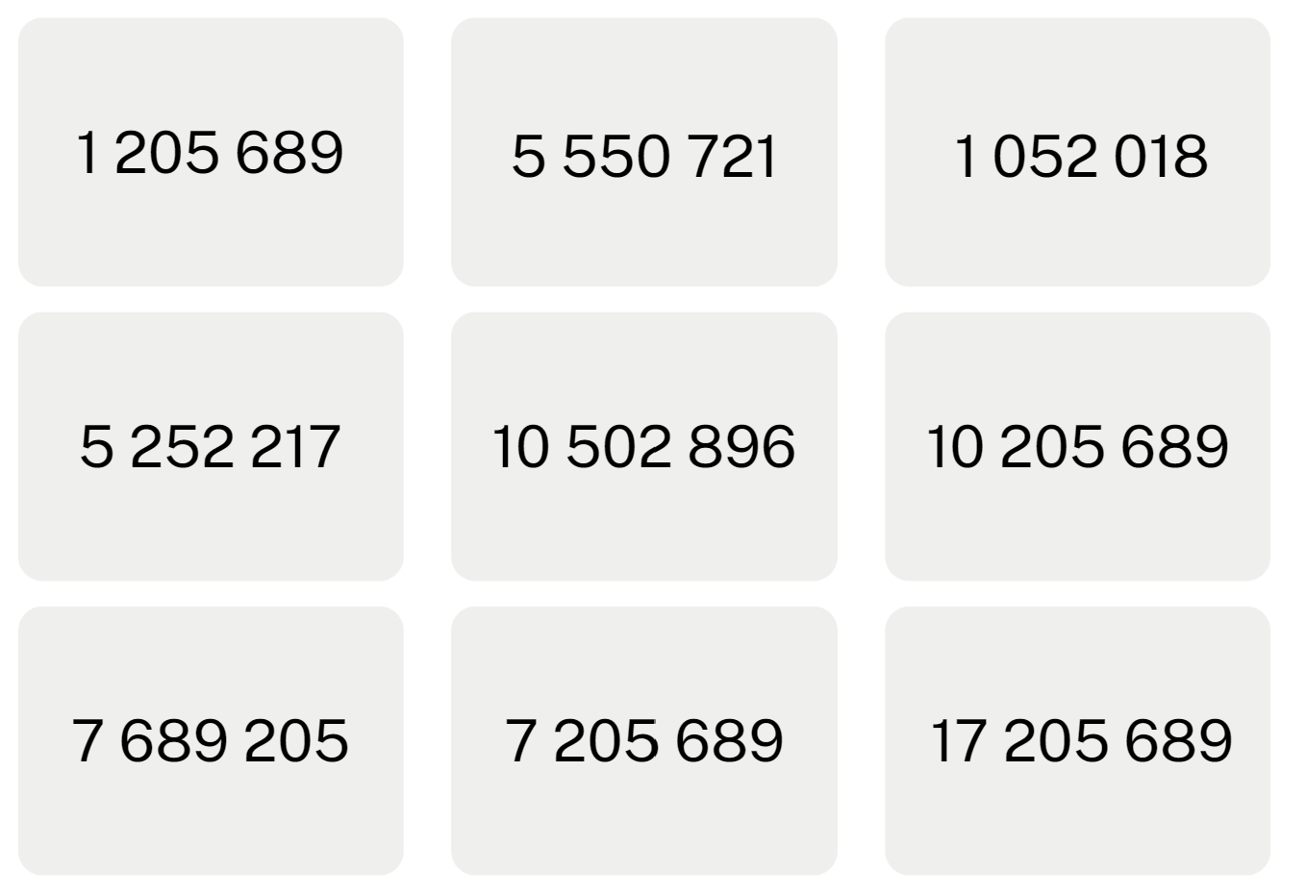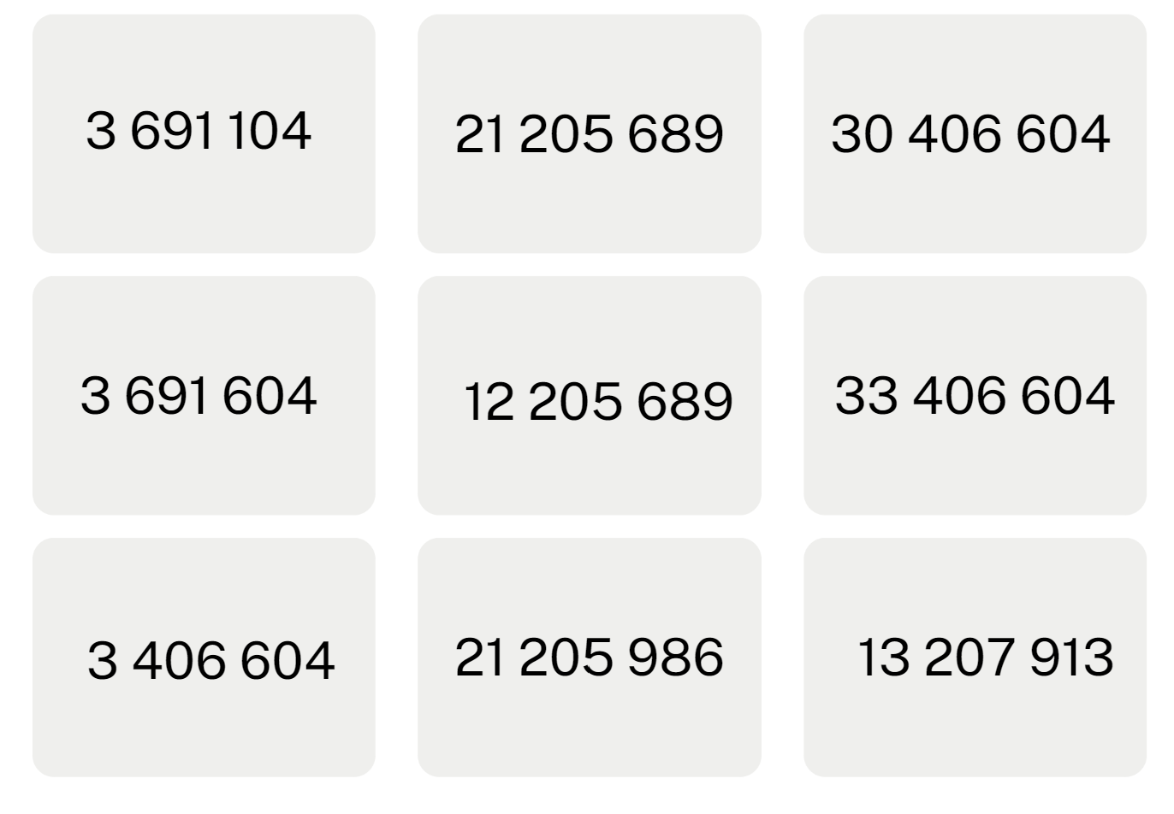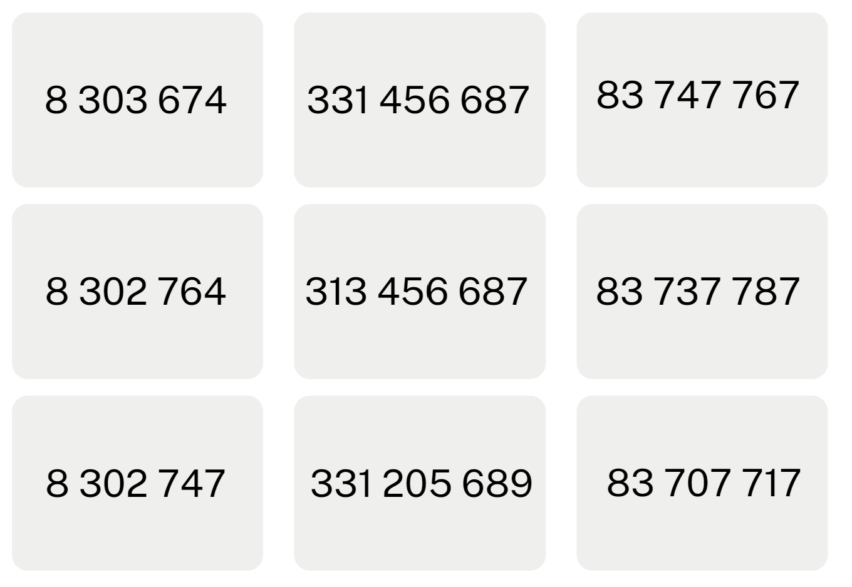
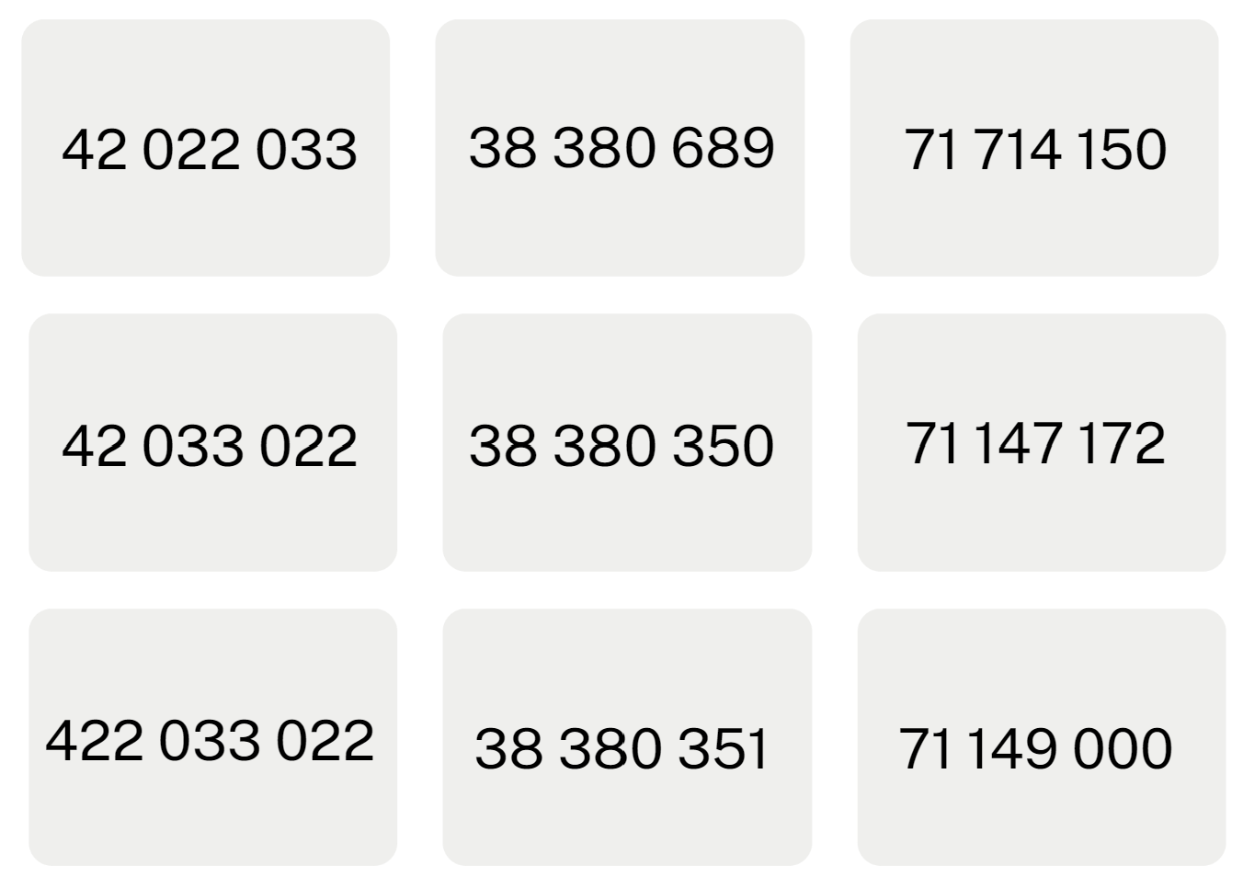

Resource 21 – array with remainders
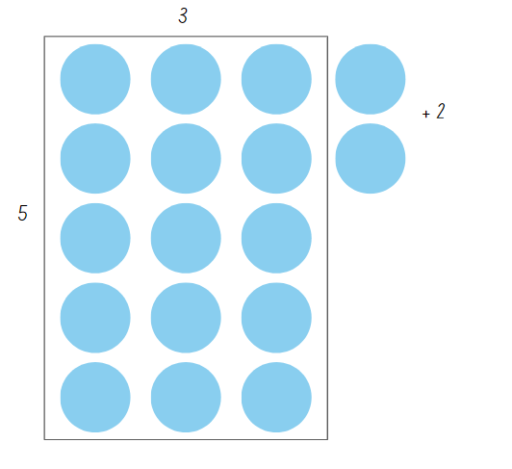

Resource 22 – What’s the problem?
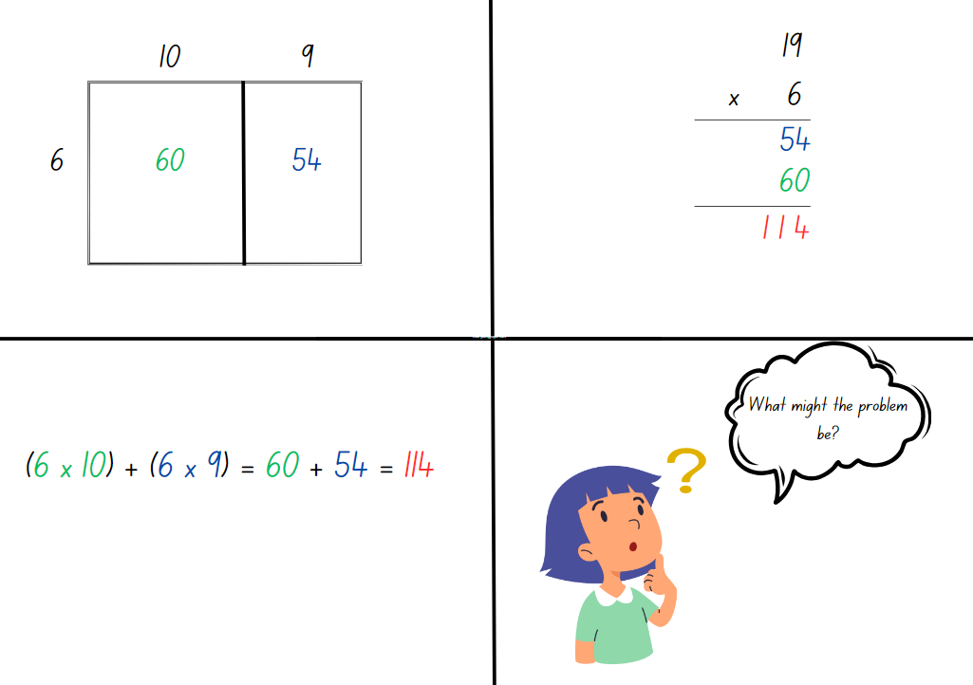

Resource 23 – problems to solve
- How many 5-seater cars are required to take 247 people to the beach?
- How many days old will Sonya be on her twentieth birthday?
- There are 16 wallets on a table and each one has $200 inside. How much money is there altogether?
- 125 students need to be seated at tables that sit 4 or 5 to a table. How many of each table would be needed?

Syllabus outcomes and content
The table below outlines the syllabus outcomes and range of relevant syllabus content covered in this unit. Content is linked to National Numeracy Learning Progression version (3).
Outcomes and content | 1 | 2 | 3 | 4 | 5 | 6 | 7 | 8
Represents numbers A: Whole numbers: Recognise, represent and order numbers in the millions
[MAO-WM-01, MA3-RN-01]
- Name millions using the place value grouping of ones, tens and hundreds |  |  |  |  | x | x | x
- Arrange numbers in the millions in ascending and descending order using place value |  |  |  |  |  |  | x
- Round numbers to a specified place value |  |  |  |  |  | x
Represents numbers A: Whole numbers: Apply place value to partition, regroup and rename numbers to 1 billion
[MAO-WM-01, MA3-RN-01]
- Regroup numbers in different forms (Reasons about quantity) |  |  |  |  | x | x
- Partition numbers to 1 billion in non-standard forms |  |  | x |  |  | x
Multiplicative relations A: Determine products and factors
[MAO-WM-01, MA3-MR-01]
- Use the term product to describe the result of multiplying 2 or more numbers | x | x | x |  | x
- Model different ways to show a whole number as a product (Reasons about structure) | x | x | x |  | x
- Determine factors for a given whole number | x | x |  |  | x
- Determine whether a number is prime, composite or neither (0 or 1) | x |  |  |  | x
Multiplicative relations A: Use partitioning and place value to multiply 2-, 3- and 4-digit numbers by one-digit numbers
[MAO-WM-01, MA3-MR-01, MA3-MR-02]
- Use mental strategies to multiply one-digit numbers by 10, 100, 1000 and their multiples |  | x |  |  | x
- Estimate the product of 2 numbers (one-digit by 2- or 3-digit numbers) using multiples of 10 or 100 |  | x
- Use informal written strategies such as the area model to solve multiplication and division problems |  | x | x | x | x | x |  | x
- Use the distributive property with the area model to partition numbers in representing multiplication problems |  | x | x | x | x |  |  | x
- Use the distributive property with partial products to solve problems by multiplying the hundreds, then the tens and then the ones |  | x | x |  | x |  |  | x
- Record the product of multiplying by a one-digit number using a formal algorithm |  | x | x |  | x |  |  | x
Multiplicative relations A: Select and apply mental and written strategies to multiply 2- and 3-digit numbers by 2-digit numbers
[MAO-WM-01, MA3-MR-01, MA3-MR-02]
- Factorise numbers to aid mental multiplication |  | x |  |  |  | x
- Use a multiplication algorithm with understanding (Reasons about relations) |  |  |  |  |  | x |  | x
- Solve multiplication word problems |  |  |  |  |  |  |  | x
Multiplicative relations A: Represent and solve division problems with whole number remainders
[MAO-WM-01, MA3-MR-01, MA3-MR-02]
- Model division, including where the answer involves a remainder, using materials or diagrams |  |  |  |  |  |  | x | x
- Record remainders in words to division problems |  |  |  |  |  |  | x | x
- Use known multiplication fact families to solve division problems for which answers may include a remainder |  |  |  |  |  | x | x | x
- Use the term quotient to describe the result of a division calculation |  |  |  |  |  |  | x
- Show the connection between division and multiplication involving the divisor and quotient |  |  |  |  |  |  | x
Multiplicative relations A: Select and apply strategies to divide a number with 3 or more digits by a one-digit divisor
[MAO-WM-01, MA3-MR-01, MA3-MR-02]
- Estimate the result of dividing by a one-digit divisor |  |  |  |  |  | x |  | x
- Use knowledge of multiples to partition as appropriate and divide |  |  |  |  |  | x |  | x
- Apply and record appropriate strategies to solve division word problems |  |  |  |  |  |  |  | x
- Use and interpret remainders in solutions to division problems |  |  |  |  |  |  |  | x
- Use digital technologies to divide whole numbers by one- and 2-digit divisors |  |  |  |  |  |  |  | x
Multiplicative relations A: Use estimation and rounding to check the reasonableness of answers to calculations
[MAO-WM-01, MA3-MR-01, MA3-MR-02]
- Use estimation to check the reasonableness of answers to multiplication and division calculations |  |  | x |  | x
Multiplicative relations B: Explore the use of brackets and the order of operations to write number sentences
[MAO-WM-01, MA3-MR-01, MA3-MR-02]
- Recognise the need to agree on the order in which to perform operations |  |  | x | x
- Use grouping symbols () in number sentences to indicate operations that must be performed first |  |  | x | x
Mathematics K–10 Syllabus © NSW Education Standards Authority (NESA) for and on behalf of the Crown in right of the State of New South Wales, 2022.

References
This document contains NSW Curriculum and syllabus content. The NSW Curriculum is developed by the NSW Education Standards Authority. This content is prepared by NESA for and on behalf of the Crown in right of the State of New South Wales. The material is protected by Crown copyright.
Please refer to the NESA Copyright Disclaimer for more information https://educationstandards.nsw.edu.au/wps/portal/nesa/mini-footer/copyright.
NESA holds the only official and up-to-date versions of the NSW Curriculum and syllabus documents. Please visit the NSW Education Standards Authority (NESA) website https://educationstandards.nsw.edu.au/ and the NSW Curriculum website https://curriculum.nsw.edu.au/.
Mathematics K–10 Syllabus © NSW Education Standards Authority (NESA) for and on behalf of the Crown in right of the State of New South Wales, 2022.
National Numeracy Learning Progression © Australian Curriculum, Assessment and Reporting Authority (ACARA) 2010 to present, unless otherwise indicated. This material was downloaded from the Australian Curriculum website (National Numeracy Learning Progression) (accessed 20 September 2023) and was not modified.
Askew M (2015) A Practical Guide to Transforming Primary Mathematics: Activities and tasks that really work, Routledge, United Kingdom.
Blair A (2023) 'Number of factors inquiry’, Number prompts: Factors and multiples, Inquiry Maths website, accessed 26 June 2023.
Math for Love (2017) ‘Prime Climb Color Chart’, Free Lesson Library, Math for Love website, accessed 23 October 2023.
McDaid M (2012–2020) Visnos Interactive Number Explorer, Visnos Mathematics website, accessed 23 October 2023.
New Zealand Ministry of Education (n.d.) ‘A Prime Search’, Resources, NZ Maths website, accessed 26 June 2023.
Parr A (17 April 2015) ‘Envelopes’, Established 1962 blog, accessed 20 October 2023.
Reasoning support Mathematics K–6 © NSW Education Standards Authority (NESA) for and on behalf of the Crown in right of the State of New South Wales, 2022.
Siemon D, Warren E, Beswick K, Faragher R, Miller J, Horne M, Jazby D, Breed M, Clark J and Brady K (2020) Teaching Mathematics: Foundations to Middle Years, 3rd edn, Oxford University Press Australia and New Zealand.
State of New South Wales (Department of Education) (2023) ‘Multiplicative strategies’, Numeracy, NSW Department of Education website, accessed 26 June 2023.
State of New South Wales (Department of Education) (2023) ‘Remainders game’, Mathematics K–6 resources, NSW Department of Education website, accessed 26 June 2023.
Sullivan P (2017) Challenging Mathematical Tasks: Unlocking the Potential of All Students, Oxford University Press Australia and New Zealand.
Sullivan P (2021) Building Engagement for Middle Years Mathematics: Learning sequences for mixed-ability classrooms, Oxford University Press Australia and New Zealand.
Sullivan P and Lilburn P (2017) Open-Ended Maths Activities: Using ‘Good’ Questions to Enhance Learning Mathematics, Revised edn, Oxford University Press Australia and New Zealand.
The Math Learning Center (2022) ‘Number Pieces’, Math Apps, The Math Learning Center website, accessed 26 June 2023.
University of Colorado Boulder (2002–2023) Area Model Algebra, PhET Interactive Simulations website, accessed 26 June 2023.
University of Cambridge (Faculty of Mathematics) (1997–2023) The Deca Tree, NRICH website, accessed 26 June 2023.
Van de Walle J, Karp K, Bay-Williams JM, Brass A, Bentley B, Ferguson S, Goff W, Livy S, Marshman M, Martin D, Pearn C, Prodromou T, Symons D and Wilkie K (2019) Primary and Middle Years Mathematics: Teaching Developmentally, 1st Australian edn, Pearson Education Australia, Melbourne.
Vingerhoets R (2009) Division – Chipping away at the whole number [PDF 487 KB] Rob Vingerhoets Educational Consultancy, accessed 26 June 2023.

© State of New South Wales (Department of Education), 2023
The copyright material published in this resource is subject to the Copyright Act 1968 (Cth) and is owned by the NSW Department of Education or, where indicated, by a party other than the NSW Department of Education (third-party material).
Copyright material available in this resource and owned by the NSW Department of Education is licensed under a Creative Commons Attribution 4.0 International (CC BY 4.0) license.
This license allows you to share and adapt the material for any purpose, even commercially.
Attribution should be given to © State of New South Wales (Department of Education), 2023.
Material in this resource not available under a Creative Commons license:
- the NSW Department of Education logo, other logos and trademark-protected material
- material owned by a third party that has been reproduced with permission. You will need to obtain permission from the third party to reuse its material.
Links to third-party material and websites
Please note that the provided (reading/viewing material/list/links/texts) are a suggestion only and implies no endorsement, by the New South Wales Department of Education, of any author, publisher, or book title. School principals and teachers are best placed to assess the suitability of resources that would complement the curriculum and reflect the needs and interests of their students.
If you use the links provided in this document to access a third-party's website, you acknowledge that the terms of use, including licence terms set out on the third-party's website apply to the use which may be made of the materials on that third-party website or where permitted by the Copyright Act 1968 (Cth). The department accepts no responsibility for content on third-party websites.

