Mathematics Stage 3 Year A – Unit 8

Contents

[Unit description and duration 6](#_Toc152777320)

[Syllabus outcomes 6](#_Toc152777321)

[Working mathematically 7](#_Toc152777322)

[Student prior learning 7](#_Toc152777323)

[Lesson overview and resources 11](#_Toc152777324)

[Lesson 1 17](#_Toc152777325)

[Daily number sense – language of fractions – 15 minutes 17](#_Toc152777326)

[Core lesson – locating a fly – 35 minutes 20](#_Toc152777327)

[Discuss and connect the mathematics – 10 minutes 27](#_Toc152777328)

[Lesson 2 30](#_Toc152777329)

[Daily number sense – How many wholes? – 15 minutes 30](#_Toc152777330)

[Core lesson – library ladders – 15 minutes 32](#_Toc152777331)

[Consolidation and meaningful practice – 20 minutes 35](#_Toc152777332)

[Lesson 3 39](#_Toc152777333)

[Daily number sense – number lines – 15 minutes 39](#_Toc152777334)

[Core lesson – navigating the plane – 30 minutes 41](#_Toc152777335)

[Consolidation and meaningful practice – 15 minutes 44](#_Toc152777336)

[Lesson 4 48](#_Toc152777337)

[Daily number sense – 10 minutes 48](#_Toc152777338)

[Core lesson – coordinate patterns – 20 minutes 48](#_Toc152777339)

[Consolidation and meaningful practice – 20 minutes 54](#_Toc152777340)

[Lesson 5 57](#_Toc152777341)

[Daily number sense – many millions – 10 minutes 57](#_Toc152777342)

[Core lesson – language of chance – 40 minutes 58](#_Toc152777343)

[Discuss and connect the mathematics – 10 minutes 64](#_Toc152777344)

[Lesson 6 67](#_Toc152777345)

[Daily number sense – guess the number – 10 minutes 67](#_Toc152777346)

[Core lesson– equally likely outcomes – 30 minutes 69](#_Toc152777347)

[Discuss and connect the mathematics – 15 minutes 74](#_Toc152777348)

[Lesson 7 78](#_Toc152777349)

[Daily number sense – place value system – 10 minutes 78](#_Toc152777350)

[Core lesson – fair but random – 30 minutes 79](#_Toc152777351)

[Consolidation and meaningful practice – 15 minutes 85](#_Toc152777352)

[Lesson 8 88](#_Toc152777353)

[Daily number sense – 10 minutes 88](#_Toc152777354)

[Core lesson – sample sizes – 30 minutes 88](#_Toc152777355)

[Consolidation and meaningful practice – 10 minutes 93](#_Toc152777356)

[Resource 1 – fraction words 96](#_Toc152777357)

[Resource 2 – fraction picture cards 97](#_Toc152777358)

[Resource 3 – position representations 98](#_Toc152777359)

[Resource 4 – shape guess lines 99](#_Toc152777360)

[Resource 5 – shape guess spaces 100](#_Toc152777361)

[Resource 6 – blank Cartesian plane 101](#_Toc152777362)

[Resource 7 – labelled plane cartoons 102](#_Toc152777363)

[Resource 8 – number line 103](#_Toc152777364)

[Resource 9 – fruit fractions 104](#_Toc152777365)

[Resource 10 – library ladder 105](#_Toc152777366)

[Resource 11 – blank library ladder 106](#_Toc152777367)

[Resource 12 – colour library ladder 107](#_Toc152777368)

[Resource 13 – finding fractions 108](#_Toc152777369)

[Resource 14 – Cartesian plane 109](#_Toc152777370)

[Resource 15 – carrot hunt 110](#_Toc152777371)

[Resource 16 – target cards 111](#_Toc152777372)

[Resource 17 – directional language cards 112](#_Toc152777373)

[Resource 18 – reflection consolidation 113](#_Toc152777374)

[Resource 19 – quadrant spinners 114](#_Toc152777375)

[Resource 20 – chance representations 115](#_Toc152777376)

[Resource 21 – colloquial terms 116](#_Toc152777377)

[Resource 22 – numerical phrases 117](#_Toc152777378)

[Resource 23 – cards and strips 118](#_Toc152777379)

[Resource 24 – random generators 119](#_Toc152777380)

[Resource 25 – sentence stems 120](#_Toc152777381)

[Resource 26 – equally likely cartoon 121](#_Toc152777382)

[Resource 27 – dot plot match 122](#_Toc152777383)

[Resource 28 – frequency thinking 123](#_Toc152777384)

[Resource 29 – chance bingo 124](#_Toc152777385)

[Resource 30 – bingo set up 125](#_Toc152777386)

[Resource 31 – creating spinners 126](#_Toc152777387)

[Syllabus outcomes and content 127](#_Toc152777388)

[References 133](#_Toc152777389)

[Further reading 134](#_Toc152777390)

# Unit description and duration

This unit develops the big idea that visual representations help us understand aspects of our world (chance and position).

In this 2-week unit students are provided opportunities to:

* compare different position systems, including Cartesian coordinates, to define precise points on a coordinate plane
* understand that probability can be represented numerically between zero to one
* present probability outcomes and create random generators.

## Syllabus outcomes

* **MAO-WM-01** develops understanding and fluency in mathematics through exploring and connecting mathematical concepts, choosing and applying mathematical techniques to solve problems, and communicating their thinking and reasoning coherently and clearly
* **MA3-RN-01 applies an understanding of place value and the role of zero to represent the properties of numbers**
* **MA3-RQF-01 compares and orders fractions with denominators of 2, 3, 4, 5, 6, 8 and 10**
* **MA3-GM-01 locates and describes points on a coordinate plane**
* **MA3-CHAN-01 conducts chance experiments and quantifies the probability**

## Working mathematically

In the Mathematics K–10 Syllabus, there is one overarching Working mathematically outcome (**MAO-WM-01**). The Working mathematically processes should be embedded within the concepts being taught. The Working mathematically processes are:

* communicating
* understanding and fluency
* reasoning
* problem solving.

[Mathematics K–10 Syllabus](https://curriculum.nsw.edu.au/learning-areas/mathematics/mathematics-k-10-2022/overview) © NSW Education Standards Authority (NESA) for and on behalf of the Crown in right of the State of New South Wales, 2022.

## Student prior learning

Before engaging in these teaching and learning activities, students would benefit from prior experience with:

* using directional language to interpret and locate positions on a grid map while describing routes between points
* predicting and describing possible outcomes from chance experiments
* using visualisation, language and multiple representations of position and chance concepts.

In NSW classrooms there is a diverse range of students, including Aboriginal and Torres Strait Islander students, students learning English as an additional language or dialect, high potential and gifted students and students with disability. Some students may identify with more than one of these groups or all of them. Refer to [Curriculum planning for every student – advice](https://education.nsw.gov.au/teaching-and-learning/curriculum/planning-programming-and-assessing-k-12/advice-on-curriculum-planning-for-every-student-k-12) for further information.

Teachers can support student learning and reasoning in this unit by connecting language, representations and visualisation for both position and chance (see Figure 1). This model of support is adapted from content provided by Adjunct Professor Marj Horne in ‘[Big ideas to start strong across K–6](https://education.nsw.gov.au/teaching-and-learning/curriculum/mathematics/professional-learning-mathematics-k-12/mathematics-k-6-professional-learning-catalogue/big-ideas-to-start-strong-across-k6)’ – Module 3 NSW DOE (2023).

Figure 1 – pedagogical support – position

A poster titled Stage 3 
position Everyone is a mathematician. Around a triangle are three statements: Visualisation, representation and language.
For visualisation there are 4 statements:
"Seeing in your mind", both statically and dynamically
Manipulating objects in your mind 
Imagine from someone else's perspective
Imagining what you can not see 

For language there are three statements:
Symbolic and non-verbal language (gestures)
Topic-specific language (formal/informal)
Language of reasoning 

For Representations there are two statements:
We can move between a range of representations to support understanding 
Examples/non-examples

Additional statements include:
By representing patterns within the coordinate plane, students are supported to visualise and describe the location of a point within a plane.

By representing transformations using shading, students can visualise and describe how shapes would look when reflected across an axis.

By using representations such as travelators, lifts and library ladders, students are supported to visualise horizontal and vertical movement across the plane and describe location using x and y coordinates.

By describing location using language alone, students develop an understanding that a coordinate system offers an easier way to visualise and describe precise location.

Figure 2 – pedagogical support – chance

A poster title Stage 3 Chance Everyone is a mathematician 
Around a central triangle are three headings: Visualisation, Language and Representation
For visualisation there are 4 statements:
"Seeing in your mind", both statically and dynamically
Manipulating objects in your mind 
Imagine from someone else's perspective
Imagining what you can not see 

For Language there are three points:
Symbolic and non-verbal language (gestures)
Topic-specific language (formal/informal)
Language of reasoning 

For Representation there are 2 points:
We can move between a range of representations to support understanding 
Examples/non-examples

There are 4 addition statements on the poster:
By visually representing random generators in a variety of ways, students can describe and visualise the same probability in different ways.

By using numerical representations and chance language on a number line, students can describe and visualise chance in different ways.

By representing chance using colour coded fraction strips, we support students to visualise and describe the probability of particular outcomes.

By exploring language, students develop an understanding that chance can be represented on a 0-1 scale and visualise what more or less likely looks like within that scale.

# Lesson overview and resources

The table below outlines the sequence and approximate timing of lessons, learning intentions and resources.

|  |  |  |
| --- | --- | --- |
| Lesson | Content | Duration and resources |
| [**Lesson 1**](#_Lesson_1)  **Daily number sense learning intention:**   * recognise the role of one as representing the whole | **Lesson core concept**: horizontal and vertical number lines intersect at zero.  **Core concept learning intention**:   * explore the Cartesian coordinate system | **Lesson duration**: 60 minutes   * [Resource 1 – fraction words](#_Resource_1:_Fraction) * [Resource 2 – fraction picture cards](#_Resource_2:_Fraction) * [Resource 3 – position representations](#_Resource_3:_Position) * [Resource 4 – shape guess lines](#_Resource_4:_Space) * [Resource 5 – shape guess spaces](#_Resource_5:_Shape) * [Resource 6 – blank Cartesian plane](#_Resource_6:_Blank) * [Resource 7 – labelled plane cartoons](#_Resource_7:_Labelled) * Counters * Writing materials |
| [**Lesson 2**](#_Lesson_2)  **Daily number sense learning intentions:**   * recognise the role of the number one as representing the whole * build up to the whole from a fractional part | **Lesson core concept**: number lines are used horizontally then vertically to plot data.  **Core concept learning intention**:   * explore the Cartesian coordinate system | **Lesson duration**: 50 minutes   * [Resource 3 – position representations](#_Resource_3:_Position) * [Resource 8 – number lines](#_Resource_8:_Number) * [Resource 9 – fruit fractions](#_Resource_9:_Lemon) * [Resource 10: – library ladder](#_Resource_10:_Library) * [Resource 11 – blank library ladder](#_Resource_11:_Blank) * [Resource 12 – colour library ladder](#_Resource_12:_Colour) * Counters * Craft sticks * Writing materials |
| [**Lesson 3**](#_Lesson_3)  **Daily number sense learning intentions:**   * compare and order unit fractions with denominators of 2, 3, 4, 5, 6, 8 and 10 * recognise the role of the number one as representing the whole | **Lesson core concept**: coordinates define the point on a number plane using real-world applications.  **Core concept learning intention**:   * use the 4 quadrants of the coordinate plane | **Lesson duration**: 60 minutes   * [Resource 3 – position representations](#_Resource_3:_Position) * [Resource 13 – finding fractions](#_Resource_13:_Finding) * [Resource 14 – Cartesian plane](#_Resource_14:_Labelled) * [Resource 15 – carrot hunt](#_Resource_15:_Carrot) * Writing materials |
| [**Lesson 4**](#_Lesson_4)  **Daily number sense learning intention:**   * teacher-identified task based on student needs | **Lesson core concept**: integer coordinates change when reflected.  **Core concept learning intention**:   * use the 4 quadrants of the coordinate plane | **Lesson duration**: 50 minutes   * [Resource 3 – position representations](#_Resource_3:_Position) * [Resource 14 – Cartesian plane](#_Resource_14:_Labelled) * [Resource 16 – target cards](#_Resource_16:_Target) * [Resource 17 – directional language cards](#_Resource_17:_Directional) * [Resource 18 – reflection consolidation](#_Resource_18:_Reflection) * [Resource 19 – quadrant spinners](#_Resource_19_–) * Colour highlighters * Writing materials |
| [**Lesson 5**](#_Lesson_5)  **Daily number sense learning intention:**   * apply place value to partition, regroup and rename numbers to 1 billion | **Lesson core concept**: probability can be represented on a scale from zero to one.  **Core concept learning intention**:   * list outcomes of chance experiments involving equally likely outcomes and represent probabilities | **Lesson duration**: 60 minutes   * [Resource 20 – chance representations](#_Resource_20:_Chance) * [Resource 21 – colloquial terms](#_Resource_21:_Colloquial) * [Resource 22 – numerical phrases](#_Resource_22:_Numerical) * [Resource 23 – cards and strips](#_Resource_x:_Cards) * Counters * Individual whiteboards * Writing materials |
| [**Lesson 6**](#_Lesson_6)  **Daily number sense learning intention:**   * apply place value to partition, regroup and rename numbers to 1 billion | **Lesson core concept**: outcomes in chance experiments can be equally likely.  **Core concept learning intentions**:   * list outcomes of chance experiments involving equally likely outcomes and represent probabilities * create random generators and describe probabilities using fractions | **Lesson duration**: 55 minutes   * [Resource 20 – chance representations](#_Resource_20:_Chance) * [Resource 24 – random generators](#_Resource_24:_Random) * [Resource 25 – sentence stems](#_Resource_25:_Sentence) * [Resource 26 – equally likely cartoon](#_Resource_26:_Equally) * Writing materials |
| [**Lesson 7**](#_Lesson_7)  **Daily number sense learning intention:**   * apply place value to partition, regroup and rename numbers to 1 billion | **Lesson core concept**: the frequency of outcomes has a value based on its occurrence.  **Core concept learning intention**:   * compare observed frequencies of outcomes with expected results | **Lesson duration**: 55 minutes   * [Resource 20 – chance representations](#_Resource_20:_Chance) * [Resource 27 – dot plot match](#_Resource_x:_Dot) * [Resource 28 – frequency thinking](#_Resource_28:_Frequency) * Bags of 4 differently coloured counters * Coins * Dice * Spinners * Writing materials |
| [**Lesson 8**](#_Lesson_8)  **Daily number sense learning intention:**   * teacher-identified task based on student needs | **Lesson core concept**: expected and observed probabilities align better in larger trials.  **Core concept learning intentions**:   * conduct chance experiments with both small and large numbers of trials * create random generators and describe probabilities using fractions | **Lesson duration**: 50 minutes   * [Resource 20 – chance representations](#_Resource_20:_Chance) * [Resource 29 – chance bingo](#_Resource_x:_Chance) * [Resource 30 – bingo set up](#_Resource_30:_Bingo) * [Resource 31 – creating spinners](#_Resource_31_–) * Different coloured counters * Paperclips * Writing materials |

# Lesson 1

**Core concept**: horizontal and vertical number lines intersect at zero.

## Daily number sense – language of fractions – 15 minutes

Daily number sense activities for Lessons 1 to 3 ‘activate’ prior number knowledge and support the learning of new content in the unit. These activities can also assist teachers to identify the starting points for learning by revealing the extent of students’ existing knowledge.

The table below contains a suggested learning intention and success criteria. These are best co-constructed with students.

|  |  |
| --- | --- |
| Daily number sense learning intention | Daily number sense success criteria |
| Students are learning to:   * recognise the role of 1 as representing the whole. | Students can:   * refer to the number 1 as the common whole. |

1. Display [Resource 1 – fraction words](#_Resource_1:_Fraction) and [Resource 2 – fraction picture cards](#_Resource_2:_Fraction).
2. Select an image. Ask students to identify the matching language card and to explain their reasoning. Discuss and label other fractional content from the image, such as complementary fraction parts to make one and benchmark percentages.

**Note:** there are 18 words and 15 images. Some of the images represent more than one language card.

1. Continue to share student responses.
2. Ask students if there are any word and picture matches that they disagree with. Discuss misconceptions as they arise.
3. Select images from [Resource 2 – fraction picture cards](#_Resource_2:_Fraction) that show an incomplete whole. Ask students to identify the complementary fraction part required to make a whole. For example, the circle needs one-eighth to make a whole. Use language such as seven-eighths and one-eighth make a whole.

**Complement principle:** the complement of a proper fraction is the fractional part required to form a whole.

1. Compare the 3 representations of fifths in [Resource 2](#_Resource_2:_Fraction) – fraction picture cards (see Figure 3). Discuss how the same fraction (such as a fifth) can be different if it does not come from a common whole. When comparing, ordering, adding or subtracting fractions, they must come from the same whole.

Figure 3 – different fifths

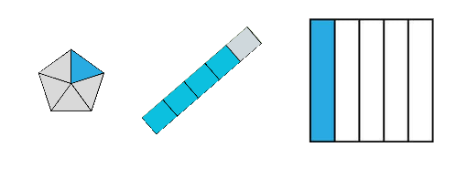

1. Explain that the language of fractions will be relevant to upcoming lessons in chance.

This table details opportunities for assessment.

|  |  |
| --- | --- |
| Assessment opportunities | Links |
| What to look for:   * Can students refer to the number 1 as the common whole? **[MAO-WM-01, MA3-RQF-01]** | Links to [National Numeracy Learning Progressions](https://www.australiancurriculum.edu.au/resources/national-literacy-and-numeracy-learning-progressions/version-3-of-national-literacy-and-numeracy-learning-progressions/) (NNLP):   * InF5.   Links to suggested [Interview for Student Reasoning](https://education.nsw.gov.au/teaching-and-learning/curriculum/literacy-and-numeracy/assessment-resources/ifsr/proportional-thinking) (IfSR) tasks:   * **IfSR-PT**: 1A.11, 1A.12. |

## Core lesson – locating a fly – 35 minutes

The table below contains a suggested learning intention and success criteria. These are best co-constructed with students.

|  |  |
| --- | --- |
| Core concept learning intentions | Core concept success criteria |
| Students are learning to:   * explore the Cartesian coordinate system. | Students can:   * recognise that the grid-map reference system gives the area of a location and the number plane identifies a specific point * identify that in the coordinate system the lines are numbered, not the spaces * identify the point of intersection of the 2 axes as the origin, having coordinates (0, 0). |

**Note:** the purpose of this lesson is to develop an understanding that the Cartesian plane represents two-dimensional space. It is represented by 2 infinite number lines that intersect at right angles at the origin (0, 0).

For each lesson on position in this unit, students can enhance their understanding of position by using multiple representations or tools, such as those in Figure 4. These representations and tools can be co-constructed with students on an anchor chart or provided as a resource, see [Resource 3 – position representations](#_Resource_3:_Position).

Figure 4 – position representations

A resource titled position representations, comprised of 6 images with related text.

Image 1 shows two number lines intersecting at right angles, labelled 2 number lines. The text asks:
What does the x and y axis remind you of? 
Why are they numbered this way? 
Where should we start when giving directions? 

Image 2 shows a child on a ladder and a travelator, labelled everyday references. The text asks:
How can real-world examples help me to think about their horizontal and vertical movement on the plane? 
Which movement comes first?  

Image 3 shows a geoboard, a ruler and a pair of hands, labelled manipulatives. The text asks:
How can tools be used to help me orientate myself within the plane? 
How can they help me to understand the movement that occurs within a transformation? 

Image 4 shows a grid with 4 rectangles of different colours and shades, labelled shading/colour. The text asks:
How can colour coding or shading help me to see patterns in movement and distance? 
How can colour coding help me to understand the order of movement and coordinates?

Image 5 shows an empty Venn diagram and an empty grid table, labelled tables/categories. The text asks:
What patterns do I notice? 
Can I sort coordinates using these patterns to help me understand movement or location within the plane?

Image 6 shows the 4 quadrants of the Cartesian plane, labelled Grid/Coordinate plane. The text asks: 
How do the grid lines help me to accurately pinpoint and describe a location?  
How does the plane help me to describe movement in any direction infinitely?

1. Provide half the students [Resource 4 – shape guess lines](#_Resource_4:_Shape) and the other half of the students [Resource 5 – shape guess spaces](#_Resource_5:_Shape).
2. Explain to students that you will call out a reference. Students will either need to:

* place a dot on the intersection if they are using [Resource 4 – shape guess lines](#_Resource_4:_Space)
* colour the box referred to if they are using [Resource 5 – shape guess spaces](#_Resource_5:_Shape).

1. Model how students can use their fingers or a ruler to help locate a particular location within the grid, paying attention to where they are using lines or spaces.
2. Call out the references D6, E5, E7 and F6 for students to mark (see Figure 5).

Figure 5 – student examples

Two images drawn on different labelled grids.
Image 1 is titled student diagram using the lines. It shows dots that form the corners of a square using coordinates D6, E5, E7 and F6. Below is the sentence: The dots form the corners of a square, which was the intended shape.

Image 2 is titled student diagram using the spaces. It shows 4 purple squares with Grid references D6, E5, E7 and F6. It is labelled as 'This does not clearly make a square shape'.

1. Ask students to describe what they can see.
2. Explain that you were thinking of the corners of a square, tilted on an angle. Ask if their shape was like that.
3. Show a student work sample of each to the class. Ask which was more accurate and why.
4. Draw attention to the idea that the coordinates system in which lines are numbered is more accurate than the grid reference system.
5. Ask for situations where it is important to be precise when describing location.
6. Explain that in this unit they will be learning about mathematics developed in the 17th Century by René Descartes. Legend has it that one day he was lazing in bed and noticed a fly on the ceiling. He wondered how best he could describe it so that someone could know where it was without seeing it for themselves.

**Note**: viewing [The Cartesian Plane (M251)](https://www.youtube.com/watch?v=q4dzIX6uDAo%200:21%20-%201:21)) (0:00–3:00) may support student understanding and engagement.

1. Provide each student with a copy of [Resource 6 – blank Cartesian plane](#_Resource_6:_Blank). Explain that students will use this to play a barrier game sitting back-to-back.
2. The purpose of the game is to guide their partner to a fly (see Figure 6).

Figure 6 – barrier game

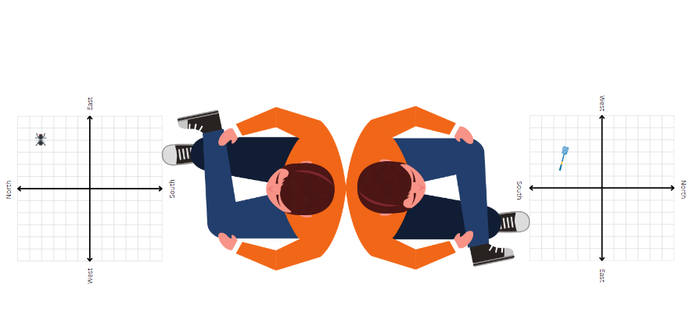

1. Ask students if they would use the grid boxes or lines to be most accurate. As an option, model placing the fly on the intersection of 2 lines.

**Note**: students do not need to start at the origin at this time; later lesson steps will draw students to the conclusion that it would have been better to start there. Stage 2 content about compass directions can be used for additional support.

1. In pairs, students sit back-to-back. Student A draws a fly (or places a counter) on their Cartesian plane. They then describe its location to Student B. Student B draws a fly swat (or places a counter) where they believe the fly is. Students check how close they were. Swap roles and repeat the activity.

The table below outlines stimulus prompts to generate conversation about the topic, along with anticipated responses from students.

|  |  |
| --- | --- |
| Prompts | Anticipated student responses |
| * What language did you use to help describe the position? | * Move 2 lines up and 4 lines over. * Move 2 lines north and 4 lines to the east. * Move 5 lines west and 3 lines south. |
| * Was your language effective? Why or why not? | * Using compass directions was helpful because my partner knew which direction I was going in. * It was not effective because I was not sure where my partner was starting from. |
| * Did you use a particular system to help you? | * We used the grid, but we did not label it. * We used the grid and labelled it with letter and numbers like a map. * We used the grid and labelled it with numbers on each axis. |
| * Did you have an agreed starting point? Why or why not? Where was it and why? | * We did not say a starting point. * We started at the top of the vertical line. * We started at the West sign. * We started in the middle where the lines meet. |

This table details opportunities for differentiation.

|  |  |
| --- | --- |
| Too hard? | Too easy? |
| Students cannot recognise that the grid-map reference system gives the area of a location, and the number plane identifies a specific point.   * Students use [Resource 5 – shape guess spaces](#_Resource_5:_Shape) to revise the use of grid references to locate an area. * Give students [Resource 8 – number line](#_Resource_8:_Number) to complete the fly activity, focusing on language such as forward 2 steps or 2 steps east/west. Repeat the activity with a vertical number line, focusing on steps north or south. | Students can recognise that the grid-map reference system gives the area of a location, and the number plane identifies a specific point.   * Students develop their own numbering systems for the Cartesian plane and justify why they are effective or ineffective (rather than using [Resource 7 – labelled plane cartoons](#_Resource_7:_Labelled)). * Students investigate the need for an infinite grid system. using [Google Earth](https://www.google.com.au/earth/) with gridlines (see Figure 7). Students explore how lines of latitude and longitude can represent a grid, however, when zooming in on a location, smaller grid lines are required to accurately pinpoint a location. |

Figure 7 – Google Earth grid

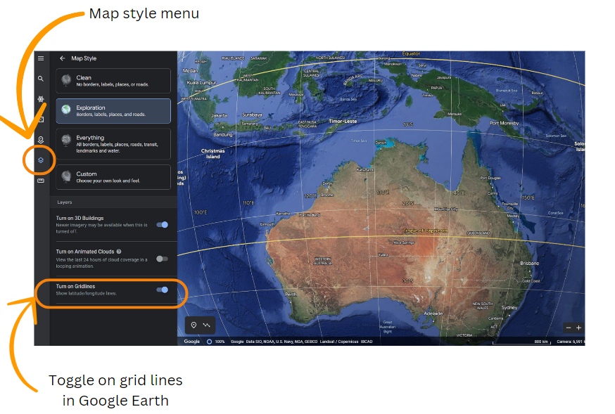

Map data © Google Data SIO, NOAA, U.S. Navy, NGA, GEBCO.

## Discuss and connect the mathematics – 10 minutes

1. Using this discussion, draw out the idea that the most effective system is when the lines are labelled or numbered.
2. Display [Resource 7 – labelled plane cartoons](#_Resource_7:_Labelled) and discuss which is the most effective labelling system using the questions in the table below. This table outlines stimulus prompts to generate conversation about the topic, along with anticipated responses from students.

|  |  |
| --- | --- |
| Prompts | Anticipated student responses |
| * Is it better to use letters or numbers? Why? | * If you use letters, you might run out of letters. * Using numbers means we can extend the plane easily. * Numbers give infinite possibilities in terms of size. |
| * Which labelling system will always work? | * The rooster’s system because you can increase it no matter how big you want your map or grid. |
| * What do the 2 lines remind you of? What do they represent? | * They are both number lines with negative and positive numbers. * It’s 2 number lines that meet at zero. * It is 2 number lines that intersect at right angles. |
| * Which system has a logical start point? Why is this useful? How is it labelled? | * The rooster has a starting point of (0, 0) so it is easy to see how far you travel from the starting point. * The other starting points are hard to remember, such as G7. |

1. Introduce the term origin to describe the starting point (0, 0), where the axes intersect at right angles.
2. Discuss the meaning of the word origin and how it is used in other contexts.

This table details opportunities for assessment.

|  |  |
| --- | --- |
| Assessment opportunities | Links |
| What to look for:   * Can students recognise that the grid-map reference system gives the area of a location and the number plane identifies a specific point? **[MAO-WM-01, MA3-GM-01]** * Can students identify that in the coordinate system the lines are numbered, not the spaces? **[MAO-WM-01, MA3-GM-01]** | Links to [National Numeracy Learning Progressions](https://www.australiancurriculum.edu.au/resources/national-literacy-and-numeracy-learning-progressions/version-3-of-national-literacy-and-numeracy-learning-progressions/) (NNLP):   * n/a. |

# Lesson 2

**Core concept**: number lines are used horizontally then vertically to plot data.

## Daily number sense – How many wholes? – 15 minutes

The table below contains suggested learning intentions and success criteria. These are best co-constructed with students.

|  |  |
| --- | --- |
| Daily number sense learning intention | Daily number sense success criteria |
| Students are learning to:   * recognise the role of the number one as representing the whole * build up to the whole from a fractional part. | Students can:   * justify the need for fractions to refer to the number 1 as the common whole * generate the whole quantity from non-unit fractional parts such as quarters. |

1. Remind students that when using fractions, the fractions need to refer to wholes of the same size. For example, you cannot add one half to one half if the size of the wholes you are comparing are different.
2. To add fractions, a common whole, one is needed (see Figure 8).

Figure 8 – a common whole

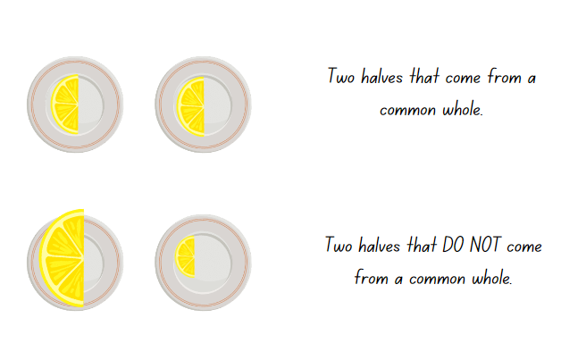

1. Display [Resource 9 – fruit fractions](#_Resource_9_–). Explain that these fractions represent parts of whole slices that are the same size. Someone has spilt some cola over the plates.
2. Ask student to [turn and talk](https://education.nsw.gov.au/teaching-and-learning/curriculum/literacy-and-numeracy/teaching-and-learning-resources/numeracy/talk-moves) to answer:

* What fraction pieces are visible? (Halves and quarters)
* How many whole slices do the visible pieces total? How did you work it out? (5 and a quarter)
* On how many plates is it unclear what fraction is on the plate? (10)
* What is the range of pieces that could be covered by the cola? (Quarter, half, three-quarters, whole, other fractions)

1. Explain that these kiwifruit slices are only cut into quarters, halves or three-quarters. There are no whole pieces or other fractions.
2. Ask students what the pieces covered by the cola might be if there were between 8 and 9 slices in total.
3. Ask students to draw the 10 missing plates with possible fractional pieces and to write number sentences to match.
4. Share different student responses.
5. Explain that the language of fractions will be relevant to upcoming lessons in chance.

This table details opportunities for assessment.

|  |  |
| --- | --- |
| Assessment opportunities | Links |
| What to look for:   * Can students justify the need for fractions to refer to the number 1 as the common whole? **[MAO-WM-01, MA3-RQF-01]** * Can students generate the whole quantity from non-unit fractional parts such as quarters? **[MAO-WM-01, MA3-RQF-01]** | Links to [National Numeracy Learning Progressions](https://www.australiancurriculum.edu.au/resources/national-literacy-and-numeracy-learning-progressions/version-3-of-national-literacy-and-numeracy-learning-progressions/) (NNLP):   * InF5, InF7.   Links to suggested [Interview for Student Reasoning](https://education.nsw.gov.au/teaching-and-learning/curriculum/literacy-and-numeracy/assessment-resources/ifsr/proportional-thinking) (IfSR) tasks:   * **IfSR-PT**: 1A.11, 1A.12. |

## Core lesson – library ladders – 15 minutes

The table below contains a suggested learning intention and success criteria. These are best co-constructed with students.

|  |  |
| --- | --- |
| Core concept learning intention | Core concept success criteria |
| Students are learning to:   * explore the Cartesian coordinate system. | Students can:   * plot and label points and given coordinates on the number plane in the first quadrant, describing the horizontal position first, followed by the vertical position * identify and record the coordinates of given points on the number plane in the first quadrant. |

**Note**: the purpose of this lesson is to understand that location on the Cartesian plane is described using the x-coordinate, followed by the y-coordinate. Students learn to relate the x-coordinate to the horizontal number line and the y-coordinate to the vertical number line.

1. Review [Resource 3 – position representations](#_Resource_3:_Position), linking the examples to content covered in [Lesson 1](#_Lesson_1).
2. Display [Resource 10 – library ladder](#_Resource_10:_Library). Give each student a copy to track the movement with their fingers as it is modelled.

The table below outlines stimulus prompts to generate conversation about the resource, along with anticipated responses from students.

|  |  |
| --- | --- |
| Prompts | Anticipated student responses |
| * What does this picture remind you of? | * A grid. |
| * What do the lines remind you of? | * The x and y axis. |
| * How do you describe a location on this grid? | * Using the x- and y- coordinates. For example (x, y). |
| * Which coordinate comes first and why? | * The x comes first because it always does.  **Note**: the (x, y) order is by convention. |
| * Where do you start from when using this system? | * At the intersection of the lines. * At the origin. * At (0, 0). |
| * How might you describe the location of the green book? | * (4,3) |
| * How do you know if you are correct? What does the x- and y-coordinate represent? | * I am not sure.  **Note**: use the following questions to illustrate that x represents the horizontal number line and y represents the vertical number line. |
| * What would you need to do if you wanted to get the green book from the origin? | * Move the ladder across so it is in line with the blue book, then climb up the ladder to get it. * Move the ladder across to the fourth line and climb up 3 lines to get the book, the book is located at (4, 3). |
| * How else could you describe moving the ladder across? | * Side to side. * Horizontal.   **Note**: draw connections to the idea of horizon. |
| * How else could you describe climbing up the ladder? | * Vertical |
| * What is the order when moving the ladder? How does it relate to the (x, y) coordinate system? | * You always describe the horizontal first and then the vertical. * You can think about moving the ladder before climbing. |

1. Model how to describe the location using (x, y) coordinate system with more examples.
2. Ask students to place a rectangle representing a book at the location (4, 2). Explicitly model moving the ladder across the x-axis first and before climbing up in line with the y-axis. Repeat as necessary.

## Consolidation and meaningful practice – 20 minutes

1. Provide pairs of students with a copy of [Resource 11 – blank library ladder](#_Resource_11:_Blank), a counter and a craft stick.
2. Instruct students to draw lines on their craft stick to represent a ladder (see Figure 9).

Figure 9 – craft-stick ladder

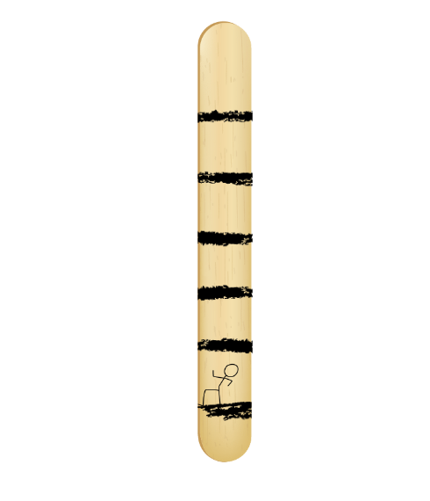

1. One student places a counter on a point to represent a library book.
2. Their partner uses the craft-stick ladder to help describe the location of the book by moving horizontally from the origin and then vertically on the ladder.
3. Students record the coordinates of the book, ensuring correct order of the coordinates (x, y).
4. Swap roles and repeat. Continue until students have recorded at least 10 coordinates.
5. Ask students:

* How did the ladder help you to think about the order of the coordinates when describing a point?
* If I were to describe a location as (4,1), what would the movement of the ladder look like? How could you describe that using mathematical vocabulary? For example, move 4 along the horizontal number line (x-axis) and one up parallel with the y-axis.
* What if I described a location as (0,6) or (5, 0)? **Note**: These coordinates remain at zero on one axis. For example, when tracking along the x-axis, the y-value does not change.
* If we did not have a ladder what other tools or representations can we use? For example, highlighter, finger or ruler.

This table details opportunities for differentiation.

|  |  |
| --- | --- |
| Too hard? | Too easy? |
| Students cannot identify and record the coordinates of given points on the number plane in the first quadrant.   * Give students [Resource 12 – colour library ladder](#_Resource_12:_Colour) to support the correct order of coordinates. * Give students [Resource 8 – number line](#_Resource_8:_Number), focusing on the horizontal number line and language. Repeat the activity with a vertical number line. | Students can identify and record the coordinates of given points on the number plane in the first quadrant.   * Using [Resource 10 – library ladder](#_Resource_10:_Library), students list locations for books on the plane that will create a specific letter. Swap with a partner to plot and check. * Students investigate patterns if the y-coordinate was always double the x-coordinate. For example, students explore what would happen if it were 3 times the x-coordinate. |

This table details opportunities for assessment.

|  |  |
| --- | --- |
| Assessment opportunities | Links |
| What to look for:   * Can students plot and label coordinates on the number plane describing the horizontal position first, followed by the vertical position? [**MAO-WM-01, MA3-GM-01]** * Can students identify and record coordinates on the number plane in the first quadrant? [**MAO-WM-01, MA3-GM-01]** | Links to [National Numeracy Learning Progressions](https://www.australiancurriculum.edu.au/resources/national-literacy-and-numeracy-learning-progressions/version-3-of-national-literacy-and-numeracy-learning-progressions/) (NNLP):   * n/a. |

# Lesson 3

**Core concept**: coordinates define the point on a number plane using real-world applications.

## Daily number sense – number lines – 15 minutes

The table below contains suggested learning intentions and success criteria. These are best co-constructed with students.

|  |  |
| --- | --- |
| Daily number sense learning intentions | Daily number sense success criteria |
| Students are learning to:   * compare and order unit fractions with denominators of 2, 3, 4, 5, 6, 8 and 10 * recognise the role of the number 1 as representing the whole. | Students can:   * compare and order fractions with denominators of 2, 3, 4, 5, 6, 8 and 10 by placing them on a number line * justify the need for fractions to refer to the number 1 as the common whole. |

1. Draw 3 different sized numbers lines, each showing zero and one. Mark half on each line, as shown in Figure 10.

Figure 10 – different wholes

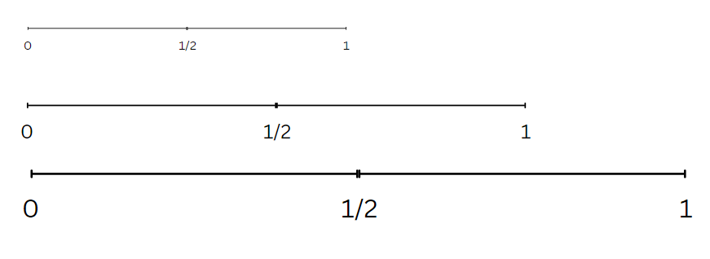

1. Ask students to [turn and talk](https://education.nsw.gov.au/teaching-and-learning/curriculum/literacy-and-numeracy/teaching-and-learning-resources/numeracy/talk-moves) to discuss why half is not marked in the same place on each line. Anticipated responses include:

* The lines are different lengths, so half is marked in the right spot for each line.
* As the lines are different lengths, half is not the same for the 3 lines.
* If you have 3 different sized objects like a ruler, a pencil and an eraser, half of those items would not be the same size.
* Half a cupcake would not be the same size as half a loaf of bread.

1. Remind students that to be compared, ordered, added or subtracted, fractions need to have a common (the same) whole.
2. Erase the first 3 number lines and draw a new number line from zero to one.
3. Display [Resource 13 – finding fractions](#_Resource_13:_Finding) and ask:

* How could you use a number line to order these fractions?
* What are the challenges of placing them all on the same number line?
* Which fractions might you place first? Explain your thinking.

1. In pairs or small groups, students draw and label a number line showing zero, one and the placement of each fraction.
2. Select 3 number lines to share with the class. Discuss similarities and differences. Ask students to justify any placements that differ to their peers.
3. Explain that comparing and ordering fractions will be relevant to upcoming lessons in chance.

This table details opportunities for assessment.

|  |  |
| --- | --- |
| Assessment opportunities | Links |
| What to look for:   * Can students compare and order fractions with denominators of 2, 3, 4, 5, 6, 8 and 10 by placing them on a number line? **[MAO-WM-01, MA3-RQF-01]** * Can students justify the need for fractions to refer to the number 1 as the common whole? **[MAO-WM-01, MA3-RQF-01]** | Links to [National Numeracy Learning Progressions](https://www.australiancurriculum.edu.au/resources/national-literacy-and-numeracy-learning-progressions/version-3-of-national-literacy-and-numeracy-learning-progressions/) (NNLP):   * InF5, InF6.   Links to suggested [Interview for Student Reasoning](https://education.nsw.gov.au/teaching-and-learning/curriculum/literacy-and-numeracy/assessment-resources/ifsr/proportional-thinking) (IfSR) tasks:   * **IfSR-PT**: 1A.11, 1A.12. |

## Core lesson – navigating the plane – 30 minutes

The table below contains suggested learning intentions and success criteria. These are best co-constructed with students.

|  |  |
| --- | --- |
| Core concept learning intentions | Core concept success criteria |
| Students are learning to:   * use the 4 quadrants of the coordinate plane. | Students can:   * plot and label points, given coordinates, in all 4 quadrants of the number plane * identify and record the coordinates of given points on the number plane in all 4 quadrants. |

**Note**: the purpose of this lesson is to support students in understanding that when identifying any location within all 4 quadrants of the Cartesian plane, it is important to think along the x-axis first to determine the x-coordinate before considering the y-coordinate. The use of travelators before lifts emphasises this idea in the context of the game played in this lesson.

1. Review [Resource 3 – position representations](#_Resource_3:_Position). Link the representations used to content covered in [Lesson 2](#_Lesson_2).
2. Show students [Resource 14 – Cartesian plane](#_Resource_14:_Labelled). Review the terms x-coordinate and y-coordinate and discuss that each axis on the Cartesian plane represents a number line.
3. Place a point in each quadrant of the Cartesian plane. Ask students:

* How would you label the point in each quadrant? (Students use their knowledge from previous lessons. Draw attention to the order of coordinates.)
* Have you ever used a lift or travelator? In which direction does each allow you to move?

1. Display [Resource 15 – carrot hunt](#_Resource_15:_Carrot). Identify the Origin Bunny, the lift and the travelator.
2. Explain that students will use the travelator and lift to help the Origin Bunny to get to the carrots and label each location.
3. Remind students that it is important to think of the horizontal number line first to help determine the x-coordinate.
4. Model how the travelator can be used, noting the change in the x-coordinate only (see Figure 11).

Figure 11 – carrot hunt example

An example of the carrot hunt game (Resource 15). On the Cartesian plane the travelator has been placed on the x-axis to +4. The elevator is shown moving to location 4, 5. On the data table origin is recorded:
Origin 0,0
Travelator 4,0
Lift 4,5
There is a box called Rabbit Holes asking the student to plot the following coordinates: (3,4), (-5, 3), (0, -3), (6, -4) and (-4, -5)

1. Use a similar process to model reading the vertical number line with the y-axis using the lift and noting the change in the y-coordinate.
2. Give pairs of students a copy of [Resource 15 – carrot hunt](#_Resource_15:_Carrot).
3. Student A uses the travelator to move the Origin Bunny from (0, 0) along the x-axis until it is in line with the carrot. Student A records the travelator movement. The y-coordinate should remain at zero.
4. Student B uses the lift to move the Origin Bunny upwards parallel with the y-axis to the carrot and records the location.
5. Students return Origin Bunny to (0, 0). Repeat the process for each carrot and complete the coordinate table.
6. Students then plot rabbit holes at the locations listed on [Resource 15 – carrot hunt](#_Resource_15:_Carrot).
7. Ask students:

* Was there a pattern in how the coordinates changed when using the travelator? (Only the x-coordinate changed).
* Why was it helpful to use your travelator first? (The x-coordinate is always stated first so it is helpful to move along the x-axis first).
* Was there a pattern in how the coordinates changed when using the lift? (Only the y-coordinate changed).

## Consolidation and meaningful practice – 15 minutes

This activity is an adaptation of ‘Snakes on a plane’ from reSolve: Maths by Inquiry.

1. Provide pairs of students [Resource 14 – Cartesian plane](#_Resource_14:_Labelled).
2. Explain to the students they will play a game where each player creates a snake on the Cartesian plane. The aim of the game is to capture the other player’s snake by intersecting with the head of their opponent’s snake (see Figure 12).

Figure 12 – snakes on a plane

A Cartesian plane a blue line and orange line drawn to represent the snakes of players in the game called snakes on a plane.
The blue line starts at -4,6. It travels through 10 points before intersecting the orange line at 4,-3.
The orange line starts at -4,-6. It travels through 9 points before intersecting with the blue line at 4,-3

1. Each player starts at a chosen position in a different quadrant, drawing a dot and labelling this coordinate.
2. Student A draws a line from their starting point to a new position within 3 units of the previous coordinate (lengthening the snake). They label the coordinate at their new position and Student B checks it.
3. Student B then has their turn.
4. Each student takes turns lengthening their snake and labelling the new coordinates.
5. The aim is for each student to ‘catch’ their partner’s snake by landing on their opponent's head position or their partner running out of moves as they cannot cross snakes.
6. As a class, discuss:

* What did you consider when labelling the coordinates?
* Did you notice a pattern in how the coordinates changed when moving your snake horizontally compared to vertically?
* What did you notice about the coordinates when you crossed into a new quadrant?
* Where any representations particularly useful in helping you to identify and label the coordinates? (For example, travelator and lift.)

**Note**: the following digital tools may support student understanding:

**Game 1**: <https://www.teacherled.com/iresources/coordinates/demonstratecoordinates/>

**Game 2**: <https://www.teacherled.com/iresources/coordinates/showthecoordinate/>

This table details opportunities for differentiation.

|  |  |
| --- | --- |
| Too hard? | Too easy? |
| Students cannot identify and record the coordinates of given points on the number plane in all 4 quadrants.   * In the carrot hunt, students only work in the first and second quadrant, focusing on moving along the x-axis first. * Students access instant feedback using digital game 2 instead of playing snakes on a plane. | Students can identify and record the coordinates of given points on the number plane in all 4 quadrants.   * Students plot carrot locations that involve decimals for example (1.7, 3.2) and justify the accuracy of its location. * Students play snakes on a plane in groups of 3 or using set criteria, for example, your snake must visit all 4 quadrants before catching another player. |

This table details opportunities for assessment.

|  |  |
| --- | --- |
| Assessment opportunities | Links |
| What to look for:   * Can students plot and label points, given coordinates, in all 4 quadrants of the number plane? **[MAO-WM-01, MA3-GM-01]** * Can students identify and record the coordinates of given points on the number plane in all 4 quadrants? **[MAO-WM-01, MA3-GM-01]** | Links to [National Numeracy Learning Progressions](https://www.australiancurriculum.edu.au/resources/national-literacy-and-numeracy-learning-progressions/version-3-of-national-literacy-and-numeracy-learning-progressions/) (NNLP):   * n/a. |

# Lesson 4

**Core concept**: integer coordinates change when reflected.

## Daily number sense – 10 minutes

1. From a class need surfaced through formative assessment data, identify a short, focused activity that targets students’ knowledge, understanding and skills. Example activities may be drawn from the following resources:

* [Mathematics K-6 resources](https://education.nsw.gov.au/teaching-and-learning/curriculum/mathematics/mathematics-curriculum-resources-k-12/mathematics-k-6-resources.main-education--category---catalogue---key-learning-area---mathematics---thinking-mathematically.nameAsc.1.grid)
* [Universal Resources Hub](https://resources.education.nsw.gov.au/home).

## Core lesson – coordinate patterns – 20 minutes

The table below contains suggested learning intentions and success criteria. These are best co-constructed with students.

|  |  |
| --- | --- |
| Core concept learning intentions | Core concept success criteria |
| Students are learning to:   * use the 4 quadrants of the coordinate plane. | Students can:   * plot and label points, given coordinates, in all 4 quadrants of the number plane * describe changes to coordinates when a point is translated or reflected across an axis. |

**Note**: the purpose of this lesson is to understand how patterns within the coordinate plane influence how locations are described in each quadrant. Students will use their understanding of these patterns to assist in locating positions across the Cartesian plane.

1. Review [Resource 3 – position representations](#_Resource_3:_Position). Link the representations to content from [Lesson 3.](#_Lesson_3)
2. Provide students with [Resource 14 – Cartesian plane](#_Resource_14:_Labelled), [Resource 16 – target cards](#_Resource_16:_Target) and [Resource 17 – directional language cards](#_Resource_17:_Directional). To make a larger plane, you may wish to use masking tape or draw a blank Cartesian plane.
3. Students work in small groups to place the target cards in the correct quadrant. Explain that the cards do not need to be placed in the exact location of the point shown.
4. Students then place a directional language card in each quadrant to describe direction of that quadrant from the origin (0, 0). The words forwards and backwards are adopted to represent movement along a number line.

**Note**: quadrants are labelled as shown in Figure 13. Quadrant labels are not explicitly stated in Stage 3 content but can be a useful label.

Figure 13 – labelled quadrants

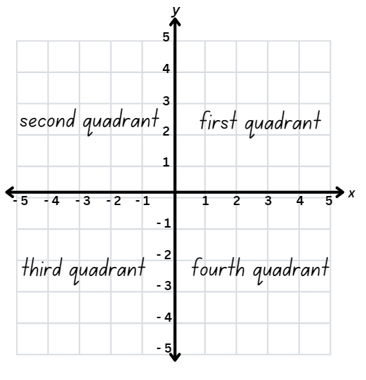

The table below outlines stimulus prompts to generate conversation about the topic, along with anticipated responses from students.

|  |  |
| --- | --- |
| Prompts | Anticipated student responses |
| * What patterns do you notice in the coordinates in each quadrant? | * In the first quadrant both x and y are positive. * In the second quadrant x is negative, and y is positive. * In the third quadrant both x and y are negative. * In the fourth quadrant x is positive, and y is negative. * The first and third quadrants are the opposite of each other * The second and fourth quadrants are the opposite of each other. * (0, 0) or the origin is the mirror point. |
| * How do these patterns relate to the origin? | * If both coordinates are positive, the location is in the first quadrant. * If both coordinates are negative, the location is in the third quadrant. * If x is positive and y is negative, the location is in in the fourth quadrant. * If x is negative and y is positive, the location is in in the second quadrant. * It is important to think about the x-coordinate first and then the y-coordinate. * It is important to think about reading the Cartesian plane horizontally, before vertically. |
| * What tools can you use to help you locate a point in any quadrant? | * I can slide my finger along the x-axis first then slide it up or down in line with the y-axis. * I can use a pencil or highlighter to trace along the x-axis and then up or down in line with the y-axis. * Slide a ruler along the x-axis perpendicular to the y-axis. Slide another ruler along the y-axis perpendicular to the x-axis to locate the point. |
| * If you are moving across the x-axis, which coordinates do you expect to see change? | * Only the x-coordinate will change. |
| * If you are moving up and down the y-axis, which coordinates do you expect to see change? | * Only the y-coordinate will change. |
| * What does it mean to reflect? What might it mean if you were asked to reflect a point across an axis? What would you expect to see? | * Reflection is like a mirror image. * The point will move to a different quadrant. * The point will be the same distance away from the middle (or the axis) on both sides. * If I reflect across the x-axis I am moving up or down so only the y-coordinate would change. * If I reflect across the y-axis, I am moving across so only the x-coordinate will change. |

1. Model how to locate and plot a point in the first quadrant.
2. Ask students to consider where this point might be located if it was reflected into the second quadrant.
3. Show students how a coloured pencil or highlighter can be used to mark the horizontal distance from the point to the y-axis. Then model how this distance can be extended into the second quadrant to assist in locating the reflected point (see Figure 14).

Figure 14 – reflected point

A Cartesian plane with the point 3,2 marked.
Pink highlighter is used to show how to reflect the dot over the y-axis to point -3,2.
Blue highlighter is used to show how to reflect the dot over the x-axis to point 3,-2.

1. Model how to label the reflected point emphasising how only the x-coordinate changed.
2. Model a similar process for reflecting the same point across the x-axis into the fourth quadrant. Use coloured pencils or highlighters and emphasise the change in y-coordinates.

## Consolidation and meaningful practice – 20 minutes

1. In pairs, use [Resource 18 – reflection consolidation](#_Resource_18:_Reflection) and [Resource 19 – quadrant spinners](#_Resource_19:_Quadrant).
2. Explain to students that they will use the dice or spinners to create an x- and y-coordinate. Students roll or spin twice, then plot the coordinate.
3. Student A reflects the point horizontally across the y-axis. Students use a coloured pencil or highlighter to help visualise the location of the reflected point.
4. Student B reflects the same point vertically across the x-axis, using a different coloured pencil or highlighter.
5. Students repeat this activity and swap roles.
6. As a class, discuss the following question:

* Did you notice a pattern in how the coordinates changed?
* Which coordinate changed when you reflected a point horizontally across the y-axis?
* Which coordinate changed when you reflected a point vertically across the x-axis?
* What does this tell us about the relationship between direction and coordinates within the Cartesian plane? (For example, 3 and –3 will be in opposite quadrants, if the x-coordinate changes you are reflecting across the y-axis).

This table details opportunities for differentiation.

|  |  |
| --- | --- |
| Too hard? | Too easy? |
| Students cannot describe changes to coordinates when a point is translated or reflected across an axis.   * When completing target activity, students focus on the first and second quadrants only. * In consolidating activity, students only reflect over the y-axis in the first and second quadrants to complete the task. | Students can describe changes to coordinates when a point is translated or reflected across an axis.   * Students play a game that requires them to visualise the quadrants of a point within the Cartesian plane such as [Show the coordinates](https://www.teacherled.com/iresources/coordinates/showthecoordinate/). * Students observe the pattern formed when reflecting across the x-and y-axis. Use this pattern to generalise about the reflection through the origin for each point they generate. |

This table details opportunities for assessment.

|  |  |
| --- | --- |
| Assessment opportunities | Links |
| What to look for:   * Can students plot and label points, given coordinates, in all 4 quadrants of the number plane? **[MAO-WM-01, MA3-GM-01]** * Can students describe changes to coordinates when a point is translated or reflected across an axis? **[MAO-WM-01, MA3-GM-01]** | Links to [National Numeracy Learning Progressions](https://www.australiancurriculum.edu.au/resources/national-literacy-and-numeracy-learning-progressions/version-3-of-national-literacy-and-numeracy-learning-progressions/) (NNLP):   * n/a. |

# Lesson 5

**Core concept**: probability can be represented on a scale from zero to one.

## Daily number sense – many millions – 10 minutes

Daily number sense activities for Lessons 5 to 7 ‘loop’ back to concepts and procedures covered in previous units to assist students to build an increasingly connected network of ideas. These concepts may differ from the core concepts being covered by the unit.

The table below contains a suggested learning intention and success criteria. These are best co-constructed with students.

|  |  |
| --- | --- |
| Daily number sense learning intention | Daily number sense success criteria |
| Students are learning to:   * apply place value to partition, regroup and rename numbers to 1 billion. | Students can:   * recognise 1000 thousands is one million and 1000 millions is 1 billion. |

1. Display or ask the following questions:

* How many hundred thousands are in one million?
* How many hundreds are there in 100 000?
* How many thousands in one million? How do you know?
* How can we rename 1000 millions?

1. Provide students individual whiteboards to record their responses.
2. Regroup as a class. Students share and explain their answers.

This table details opportunities for assessment.

|  |  |
| --- | --- |
| Assessment opportunities | Links |
| What to look for:   * Can students recognise 1000 thousands is 1 million and 1000 millions is 1 billion? **[MAO-WM-01, MA3-AR-01]** | Links to [National Numeracy Learning Progressions](https://www.australiancurriculum.edu.au/resources/national-literacy-and-numeracy-learning-progressions/version-3-of-national-literacy-and-numeracy-learning-progressions/) (NNLP):   * NPV10. |

## Core lesson – language of chance – 40 minutes

The table below contains suggested learning intentions and success criteria. These are best co-constructed with students.

|  |  |
| --- | --- |
| Core concept learning intentions | Core concept success criteria |
| Students are learning to:   * list outcomes of chance experiments involving equally likely outcomes and represent probabilities. | Students can:   * use the term probability to describe the numerical value that represents the likelihood of an outcome of a chance experiment * establish that the total of the probabilities of the outcomes of a chance experiment equals one * discuss the imprecise meaning of commonly used chance words including possible, likely and unlikely. |

**Note**: the purpose of this lesson is to explore how everyday chance language can lead to misconceptions and how assigning numerical values or phrases to a chance outcome can support a more precise understanding.

For each lesson on chance in this unit and Stage 3 – Unit 28, students can enhance their understanding by using various representations or tools, featured in Figure 15. These representations and tools can be collaboratively constructed with students or provided as a resource for them, see [Resource 20 – chance representations](#_Resource_20:_Chance).

Figure 15 – chance representations

A poster titled chance representations comprised of 6 images with related text.

Image 1 shows a number line from 0 to 1, called Linear scale. The text asks: How can a scale from 0 to 1 help me to describe chance? 
How can I think about partitioning this scale to represent equal and unequal chance? 

Image 2 shows a bag of counters, a die and a 4 part spinner, labelled random generators. The text asks:
How do different generators represent different possible outcomes?
How can they support our reasoning about chance? 
How can they support our language?

Image 3 shows 3 highlighters, labelled colour coding. The text asks:
How can colour coding help me visualise chance as parts of a whole? 
How can colour coding help me to understand if things are equally likely or unequally likely? 

Image 4 shows 2 different fraction strips, labelled fraction strips/wall. The text asks:
How do fraction strips help me to think about chance as a part of the total possibilities?
How can they help me to understand that the same chance can look different? 

Image 5 shows a half, 0.75 and 25%, labelled numerical representation. The text asks:
How does expressing chance as a fraction, decimal or percentage help us to build a shared understanding? 
How does it change the language we use when describing chance? 

Image 6 shows a dot plot graph, labelled dot plots. The text asks:
How can dot plots help me to visualise the outcomes of chance situations? 
How can they be used to compare expected frequency and observed frequency?  

1. Provide students with [Resource 21 – colloquial terms](#_Resource_x:_Colloquial).
2. In small groups, students sort the colloquial terms into 3 categories: impossible, possible, certain.
3. As a class, discuss the differences between the use of this language in everyday situations and how this may not support students in understanding these terms in the context of chance. For example, students may exaggerate that they **never** go outside for sport during school, when they do. Similarly, students may use **always** for situations that often happen, rather than situations with 100% certainty.
4. Provide students with [Resource 22 – numerical phrases](#_Resource_x:_Numerical).
5. In small groups, sort the numerical phrases into the same 3 categories (impossible, possible, certain), placing them below the colloquial terms.
6. As a class, compare the difference between colloquial terms and numerical phrases.
7. Discuss the idea that numerical phrases are more precise, less ambiguous, more universally understood and less subjective.

This activity is an adaptation of [In Between](https://nzmaths.co.nz/resource/between) at [NZ Maths](https://nzmaths.co.nz/) by New Zealand Ministry of Education.

1. Explain to students that they will play a card game:
2. Players turn over 2 cards from a pile of 10 cards numbered 1–10.
3. Players then turn over a third card.
4. If the number on that card is in between the 2 previously overturned numbers, the player wins a counter (see Figure 16).

Figure 16 – in between

A series of images to show the steps in the activity called in between.
On the left is an image showing a deck of cards, in front of which are the cards 4 and 9. The instruction is 'student A flips over the top 2 cards.'

Arrow pointing right is labelled 'Student A flips over a third card.'

Then two options are presented.
Option 1: Cards 4, 9 and 2 are displayed with the text: If the third card drawn is not between the others, the player does not get anything.

Option 2: The cards 4, 9 and 7 are presented with the text: If the third card drawn is between the others, the player takes a counter.

1. Provide an opportunity for students to play until one player has 5 counters.
2. Bring the class back together and display [Resource 23 – cards and strips](#_Resource_x:_Cards).
3. Model how to use the fraction strips to represent the chance of turning over an ‘in between card’ (the desired outcome) as a part of a whole (the total number of possibilities for the third card) (see Figure 17).

Figure 17 – fraction strips

Fraction strips

An image to show how fraction strips are used to support understanding in the activity called in between where the cards 4 and 9 have already been flipped over.

An 8 box strip numbered with numbers 1, 2, 3, 5, 6, 7, 8 and 10 is presented with the text: After flipping over 2 cards, the student records all the possible outcomes for their third flip.

An arrow points down to the same numbered strip but with the digits 5, 6, 7 and 8 shaded under which is the text: The student then shades outcomes that will result in a win. 

A second arrow is labelled Record the possible outcome as a part of a whole.

Next to that instruction is 4/8 written in fraction notation. Next to that is a statement to accompany the fraction: desired outcomes divided by total possible outcomes.

**Note**: as there are only 8 cards left in the deck after drawing 2, the total number of possibilities is represented as 8 on the fraction strip. Students use shading to represent the proportion of those cards that fall between the first 2 cards drawn.

1. Model for students how the shading on their strips can be written as a fraction.
2. In pairs, provide students with copies of [Resource 23 – cards and strips](#_Resource_23:_Cards) and 12 counters. Students shuffle the cards. Student A draws 2 cards, makes their fraction strip to assess the chance of winning, then draws a third card, taking a counter if they win. Student B repeats this process. The game continues until each student has had 6 turns. The player with the most counters wins.

This table details opportunities for differentiation.

|  |  |
| --- | --- |
| Too hard? | Too easy? |
| Students cannot use the term probability to describe the numerical value that represents the likelihood of an outcome of a chance experiment.   * Write the denominator for every fraction strip on [Resource 23](#_Resource_x:_Cards) – cards and strips. * Provide students with a number line labelled 1–10 where they can circle the first 2 numbers that they draw and count how many numbers are left in between. | Students can use the term probability to describe the numerical value that represents the likelihood of an outcome of a chance experiment.   * Consider how the fraction strip might change if playing with 12 or 20 cards. * Consider how the chance might change if the number had to be in between the 2 cards drawn first and must be even. |

## Discuss and connect the mathematics – 10 minutes

The table below outlines stimulus prompts to generate conversation about the topic, along with anticipated responses from students.

|  |  |
| --- | --- |
| Prompts | Anticipated student responses |
| * Were the fraction strips helpful in describing chance in numerical terms? | * Yes, it was easy to turn it into a fraction. * It was easy to see when the chance of winning was more likely or less likely. |
| * What did the shaded part of the fraction strip represent? | * The number of cards that would allow me to win. * The number of cards that are in between my numbers. |
| * When using the fraction strip, what did the whole fractions strip represent? | * The total number of cards left after drawing 2 cards. This is important because I must express the chance of getting a desired card as a proportion of the total number of cards left. |
| * Why was the fraction strip divided into 8 parts? Could there have been more or less parts? | * After drawing 2 cards there were 8 cards left; there are 8 total possibilities. * There had to be 8 parts as that represented the whole (number of options left). |
| * Sometimes people say things like, I have put in 110% effort. Do statements like this every apply in chance? Can you say that there is 110% chance of achieving something? | * No, because 100% is certain as it represents the total number of possibilities. I cannot achieve more than the total number of possibilities. |
| * If you were to put chance on a scale, what numbers would you use at the beginning of your scale and at the end? | * Scale of zero to one * Scale of 0% to 100% * Zero represents impossible and one represents certain. |
| * How did using the fraction strips help you to express chance as a fraction? | * I could describe the chance as the number of cards in between my first 2 cards (desired outcomes) over the total number of cards left. * It was easy to describe what I saw on the fraction strip. If my probability of winning was 4 in 8, then I could turn that into a fraction $\frac{4}{8}$. |

This table details opportunities for assessment.

|  |  |
| --- | --- |
| Assessment opportunities | Links |
| What to look for:   * Can students discuss the imprecise meaning of commonly used chance words including possible, likely and unlikely? **[MAO-WM-01, MA3-CHAN-01]** * Can students use the term probability to describe the numerical value that represents the likelihood of an outcome of a chance experiment? **[MAO-WM-01, MA3-CHAN-01]** | Links to [National Numeracy Learning Progressions](https://www.australiancurriculum.edu.au/resources/national-literacy-and-numeracy-learning-progressions/version-3-of-national-literacy-and-numeracy-learning-progressions/) (NNLP):   * UnC3, UnC4, UnC5 * InF5, InF6. |

# Lesson 6

**Core concept**: outcomes in chance experiments can be equally likely.

## Daily number sense – guess the number – 10 minutes

The table below contains a suggested learning intention and success criteria. These are best co-constructed with students.

|  |  |
| --- | --- |
| Daily number sense learning intention | Daily number sense success criteria |
| Students are learning to:   * apply place value to partition, regroup and rename numbers to 1 billion. | Students can:   * regroup numbers in different forms. |

This activity is an adaptation of [Mastermind](https://education.nsw.gov.au/teaching-and-learning/curriculum/mathematics/mathematics-curriculum-resources-k-12/mathematics-k-6-resources/mastermind) at [Mathematics K-6 resources](https://education.nsw.gov.au/teaching-and-learning/curriculum/mathematics/mathematics-curriculum-resources-k-12/mathematics-k-6-resources) by State of New South Wales (Department of Education).

1. In pairs, students write down a 7-digit number without showing the other player.
2. Players take it in turns to guess their opponent’s 7-digit number. Guessed numbers should be written down and named aloud using correct place value language.
3. After each guess, the player’s opponent tells them how many digits are correct, how many are in the correct place and how many are incorrect by using symbols underneath the number. Students use a tick for correct number and place, a circle for correct number but not the correct place and a cross for incorrect number.
4. If for example, the number is 7 246 384 and the guess is 3 257 689, there are 3 correct digits and there is one digit in the right place (see Figure 18).

Figure 18 – mastermind

Mastermind

Image of the number 3 257 689 with circles, ticks and crosses beneath the numbers.
The circles, ticks and crosses represent clues.
Circles mean the digit is in the number but not in that place.
Tick means the digit is correct.
Cross means that the digit does not feature in the number.

1. Players use this information to refine their guesses.
2. The player to correctly guess their opponent’s number in the fewest guesses is the winner.
3. The level of difficulty can be changed by using numbers with more or fewer digits and by using numbers with internal zeros.
4. After the game, ask students to rearrange the digits from their mystery number to form the largest number possible.
5. Then ask students to regroup the largest number in at least 3 different forms.
6. Share class responses and discuss the reasons students recorded the different forms.

**Note:** number expanders or place values houses can be used to assist students’ understanding of place value and renaming numbers into non-standard forms.

This table details opportunities for assessment.

|  |  |
| --- | --- |
| Assessment opportunities | Links |
| What to look for:   * Can students regroup numbers in different forms? **[MAO-WM-01, MA3-AR-01]** | Links to [National Numeracy Learning Progressions](https://www.australiancurriculum.edu.au/resources/national-literacy-and-numeracy-learning-progressions/version-3-of-national-literacy-and-numeracy-learning-progressions/) (NNLP):   * NPV6, NPV7. |

## Core lesson– equally likely outcomes – 30 minutes

The table below contains suggested learning intentions and success criteria. These are best co-constructed with students.

|  |  |
| --- | --- |
| Core concept learning intentions | Core concept success criteria |
| Students are learning to:   * list outcomes of chance experiments involving equally likely outcomes and represent probabilities * create random generators and describe probabilities using fractions. | Students can:   * recognise that outcomes are described as equally likely when any one outcome has the same chance of occurring as any other outcome * represent probabilities of outcomes of chance experiments using fractions * use knowledge of benchmark fractions, decimals and percentages to assign probabilities to the likelihood of an outcome. |

**Note**: the purpose of this lesson is to explore the idea that equally likely can have different numerical values, such as 1 in 2, 1 in 3 or 1 in 4, so long as every outcome has an equal chance of occurring.

1. Display [Resource 20 – chance representations](#_Resource_20:_Chance). Link the representations to learning in [Lesson 5](#_Lesson_5).
2. Display a zero to one scale.

The table below outlines prompts to generate conversation about the scale, along with anticipated responses from students.

|  |  |
| --- | --- |
| Prompts | Anticipated student responses |
| * Where would you write impossible and certain on this scale? | * Place impossible at zero because it cannot happen and certain at one because it will happen. |
| * Where would you place **equally likely** on this scale? Why? | * In the middle, at 0.5. * Because I have a 50/50 or half, half chance of either outcome, it is equally likely. * I am dividing the space equally, so it sits halfway between zero and one. * It is halfway between impossible (0) and certain (1). * If you break something equally you break it in half. |
| * What does it mean to be **equally likely**? | * Equal is like half. * There is a 50/50 chance. |

1. Explain to students that they will now explore the conjecture that equally likely is the same as 50/50.
2. Display and discuss [Resource 24 – random generators](#_Resource_x:_Random).
3. Provide students with 4 paper strips of equal size (approximately 3 cm by 20 cm).
4. Explain to students that they will use the paper strips to represent the possibility of getting any outcome using these generators.
5. Use the coin as an example and ask students how many possible outcomes there are when tossing a coin. List these outcomes on the board (heads/tails).
6. Ask students if there are 2 possible outcomes, how could they divide their strip to represent the total possible outcomes. For example, fold the strip equally in half.
7. Students fold one strip in half and draw a line down the centre. Label one half of the strip heads and the other half tails.
8. Discuss that because the strip has been divided into 2 equal parts it represents an equal chance of either outcome occurring. The whole strip represents certainty that both outcomes will occur.
9. Model different ways to describe the chance of getting heads or tail:

* For every 2 equal parts, one is heads. Therefore, I have a 1 in 2 chance of getting heads.
* There is a 1 in 2 chance of getting heads, I can represent this as half ($\frac{1}{2}$).
* There are 2 possible outcomes, represented by 2 equal parts. Therefore, there is an equal chance of each one occurring.
* There is the same chance that I will get heads compared to tails, so there is an equal chance.

**Note**: consider asking students for other ways to represent the chance of flipping heads or tails. Answers include 0.5 and 50%.

1. Students label each part of their fraction strip as half to represent the probability of it occurring as a fraction.
2. In small groups, students fold and colour code or label the remaining strips to represent the chance of each outcome occurring using the other random generators (see Figure 19).

Figure 19 – fraction strips

Fraction strips

A screenshot of a maths activity
At the top is an image of a paper strip with the text: Give students strips of paper approximately 3 cm by 20 cm that they will fold to partition.
Underneath are images of a coin, a  3 part spinner, a bag with 4 differently coloured counters and a standard dot die.
Next to each random generator the paper strip is drawn with the fractional representation of the chance of each outcome.
The coin strip is labelled half heads and half tails.
The spinner strip is labelled in thirds.
The bag/counter strip is labelled in quarters.
The dice strip is labelled in sixths.

1. Display [Resource 25 – sentence stems.](#_Resource_x:_Sentence) In pairs, students describe the chance of each outcome using the sentence stems.
2. Ask students to line up their fraction strips, similar to a fraction wall.
3. As a class, discuss the questions in the table below.

The table below outlines stimulus prompts to generate conversation about the topic, along with anticipated responses from students.

|  |  |
| --- | --- |
| Prompts | Anticipated student responses |
| * Do each of these strips represent an equal chance of each outcome? Are all outcomes equally likely? How do you know? | * Yes, because all the parts are the same size on each strip, all outcomes have an equal chance of occurring and are therefore equally likely. |
| * Looking at your fraction strips and considering where you placed equally likely on your zero to one scale, do you still think equally likely is in the middle? Is equally likely a 50/50 chance? | * It can be. On one of our strips equally likely was halfway. * It does not have to be because equally likely is about whether all outcomes have an equal chance of occurring. If there are more than 2 outcomes, then it will not be a 50/50 chance. * Equally likely can look different, depending on the number of possible outcomes |

## Discuss and connect the mathematics – 15 minutes

1. Display [Resource 26 – equally likely cartoon](#_Resource_x:_Equally). Use the prompts in the table below to generate conversation about the topic, along with anticipated responses from students.

|  |  |
| --- | --- |
| Prompts | Anticipated student responses |
| * Which cartoons represent equally likely outcomes? Why? | * The ones where there is an equal proportion of each colour within each strip. * The ones where all the colours occupy the same amount of space. * If the whole strip represents all the possibilities, then having equal parts means there is an equal chance of any possibility. |
| * Why can you represent bags of 8 and 12 marbles with fractions strips divided into 4 parts? | * There are only 4 colours to choose from so it is possible to group the marbles by colour. * There may be 2 or 3 marbles in a group, but it is still a 1 in 4 chance I will pick that colour. * On the fractions strips divided into more parts, there is still an equal proportion of all 4 colours. |
| * Do you notice any relationship between the fraction strips divided into 4 and the strips underneath them with more parts? | * It looks like the 4 parts have been divided again into half or thirds. |
| * Which diagrams show an unequal chance? Why? | * The rooster and rabbit show an unequal chance because all the sections are not shaded evenly. * There is not a 1 in 4 chance of picking a green or orange marble, but every other colour has a 1 in 4 chance. |
| * For the rooster, what is the chance of picking orange? * For the rabbit, what is the chance of picking orange? | * 1 in 8. * 1 in 12. |

This table details opportunities for differentiation.

|  |  |
| --- | --- |
| Too hard? | Too easy? |
| Students cannot recognise that outcomes are described as equally likely when any one outcome has the same chance of occurring as any other outcome.   * Give students strips that are subdivided into 2, 3, 4 and 6 parts so they can colour code or label them to represent equal chance. * Explicitly name the fractions [in Resource 26 – equally likely cartoon](#_Resource_x:_Equally) (see Figure 20) to support students in understanding that the orange and green each represent a 1 in 8 chance, whereas the other colours represent a 1 in 4 chance and therefore there is an unequal chance. | Students can recognise that outcomes are described as equally likely when any one outcome has the same chance of occurring as any other outcome.   * Students create their own generators to represent equal chance where there are 8 or 10 possible outcomes. * Students create their own cartoons by modifying the 3-part spinner on [Resource 24 – random generators](#_Resource_x:_Random) to represent both equal and unequal chance. |

Figure 20 – fraction model

Fraction model

An image of a bag containing 2 yellow counters, 2 blue counters, 2 purple counters, a green counter and an orange counter.
Next to the bag is a fraction strip shaded a quarter yellow, a quarter blue, a quarter purple, an eighth green and an eighth orange.

Under that fraction strip is a second strip where all parts are labelled in eighths.

For the second fraction strip there is an instruction: On the equally likely cartoon, label each fraction strip as shown

This table details opportunities for assessment.

|  |  |
| --- | --- |
| Assessment opportunities | Links |
| What to look for:   * Can students recognise that outcomes are described as equally likely when any one outcome has the same chance of occurring as any other outcome? **[MAO-WM-1, MA3-CHAN-01]** * Can students represent probabilities of outcomes of chance experiments using fractions? **[MAO-WM-1, MA3-CHAN-01]** | Links to [National Numeracy Learning Progressions](https://www.australiancurriculum.edu.au/resources/national-literacy-and-numeracy-learning-progressions/version-3-of-national-literacy-and-numeracy-learning-progressions/) (NNLP):   * UnC2, UnC3, UnC4, UnC5. |

# Lesson 7

**Core concept**: the frequency of outcomes has a value based on its occurrence.

## Daily number sense – place value system – 10 minutes

The table below contains a suggested learning intention and success criteria. These are best co-constructed with students.

|  |  |
| --- | --- |
| Daily number sense learning intention | Daily number sense success criteria |
| Students are learning to:   * apply place value to partition, regroup and rename numbers to 1 billion. | Students can:   * partition numbers to 1 billion in non-standard forms. |

This activity is an adaptation of [Mini Lessons: Maths – Our Place Value System](https://iview.abc.net.au/video/ED2003V012S00) by ABC iView.

1. Display the following words on the board: two, forty, hundred, seven, million, thousand, one and five.
2. Ask students in pairs to form the largest number possible using the words provided.
3. Select students to read their chosen number aloud listening for correct place value language.
4. Ask students to record and partition their number in various non-standard forms.
5. Regroup as a class and ask:

* Can you explain the different ways you partitioned the number you formed?
* Did you use any specific techniques or patterns for partitioning?

This table details opportunities for assessment.

|  |  |
| --- | --- |
| Assessment opportunities | Links |
| What to look for:   * Can students partition numbers to 1 billion in non-standard forms? **[MAO-WM-01, MA3-RN-01]** | Links to [National Numeracy Learning Progressions](https://www.australiancurriculum.edu.au/resources/national-literacy-and-numeracy-learning-progressions/version-3-of-national-literacy-and-numeracy-learning-progressions/) (NNLP):   * NPV6, NPV7. |

## Core lesson – fair but random – 30 minutes

The table below contains suggested learning intentions and success criteria. These are best co-constructed with students.

|  |  |
| --- | --- |
| Core concept learning intentions | Core concept success criteria |
| Students are learning to:   * compare observed frequencies of outcomes with expected results. | Students can:   * use the term frequency to describe the number of times a particular outcome occurs in a chance experiment * compare the expected frequencies of outcomes of chance experiments with observed frequencies * explain that randomness impacts expected outcomes in chance experiments. |

**Note**: the purpose of this lesson is to support students to calculate expected frequency based on theoretical probability, to record observed frequencies, and to note how randomness can contribute to discrepancies.

1. Display [Resource 20 – chance representations.](#_Resource_20:_Chance) Link the representations to learning in [Lesson 6.](#_Lesson_6)
2. Display [Resource 27 – dot plot match](#_Resource_x:_Dot). Explain that:

* each graph represents 12 trials (turns) using a particular generator
* the dots represent the number of times a particular outcome occurred. This is called the observed frequency.

1. Share the definition of frequency:

**Frequency:** the number of times that a particular value occurs in a data set. For example, when rolling a die 20 times, ‘the frequency of a 6’ means how many times the number 6 comes up.

1. In groups of 4, students [turn and talk](https://education.nsw.gov.au/teaching-and-learning/curriculum/literacy-and-numeracy/teaching-and-learning-resources/numeracy/talk-moves) to match dot plots to the random generators shown.
2. Select students to explain and justify their match using relevant vocabulary, including outcomes.

**Note**: students should be able to use the number of outcomes of each generator to match them to the number of outcomes shown on the dot plot. If required, ask students to list all possible outcomes on each generator.

1. As a class, discuss the questions below.

The table below outlines prompts to generate conversation about the topic, along with anticipated responses from students.

|  |  |
| --- | --- |
| Prompts | Anticipated student responses |
| * What did you think about to match a dot plot to a particular generator? | * I looked at the number of possible outcomes on the generator and looked for the same number of possible outcomes on the dot plot. |
| * What did you notice about the frequency of each outcome on the dot plots? | * Sometimes the columns had a lot of dots, and some had none at all. * The columns were not always even. * The dot plots with fewer outcomes had taller columns. * There are 12 dots in each dot plot. |
| * Does the data look the way you think it should? Why or why not? | * Yes, because there were 12 trials and there are 12 dots on each dot plot. * No, there should be at least a dot in every column as all outcomes are likely to occur. * No, because these are equally likely random generators, which means that the columns should all be the same height. |

1. Display [Resource 28 – frequency thinking](#_Resource_x:_Frequency).
2. Explain to students that expected frequency is calculated based on the number of total outcomes. For example, for a generator with 2 equally likely outcomes, the expected frequency will be 1 in 2 for each outcome.

**Note**: to find the expected frequency, you multiply the probability of that event taking place by the number of trials of the experiment. Expected frequency = probability of event × number of trials. For example, rolling an even number on a 6-sided dice in a trial of 500 is $\frac{1}{2}$ × 500 = 250.

1. Discuss the questions below about [Resource 28 – frequency thinking](#_Resource_x:_Frequency).

The table below outlines prompts to generate conversation about the topic, along with anticipated responses from students.

|  |  |
| --- | --- |
| Prompts | Anticipated student responses |
| * Do you notice any patterns in how each student calculated the expected frequency for the different number of trials? | * Yes, as the number of trials gets bigger, the expected frequency gets bigger. * The expected frequency is always half the number of trials. |
| * What if the random generator had more than 2 equally likely outcomes? How would this change their thinking? | * The expected frequency would no longer be half the number of trails. * If we used the spinner with 3 colours from [Resource 24 – random generators](#_Resource_x:_Random) and we did 6 trials, the expected frequency would be 2 blues. |
| * Is there a relationship between the number of trials and the number of total possible outcomes? | * As the number of possible outcomes increases the expected frequency decreases if we run the same number of trials. * The expected frequency decreases with more outcomes because if each outcome is equally likely we would expect to share the number of trials equally with each outcome. |
| * Is there a way you can calculate the expected frequency based on what we now know? | * For equal chance random generators, the expected frequency can be calculated by multiplying the probability of that event taking place by the number of trials of the experiment. |

1. Model how expected frequency can be represented using a dot plot graph (see Figure 21).

Figure 21 – expected frequency graphs

Expected frequency graphs 

An image of a coin is next to two dot plot graphs. 

Dot plot 1 shows expected outcomes a and b after 4 trials/coin tosses (there are two dots above a and two dots above b). It is labelled: Model how expected frequency for 4 trials of a coin flip can be represented on a dot plot.  

Dot plot 2 shows expected frequency outcomes for 12 trials/coin tosses (there are 6 dots above a and 6 dots above b). It is labelled: Model a dot plot of expected frequency for 12 trials of a coin flip. 

1. Break students into groups of 4. Students create a dot plot of expected frequency in 12 trials for each of the 4 generators.
2. As a class, discuss the strategies they used to create their expected frequency dot plots.
3. Compare the expected result dot plot with the dot plots used for the matching activity with [Resource 27 – dot plot match](#_Resource_x:_Dot).
4. Ask the students:

* What differences do you see between the expected frequency and the observed frequency in [Resource 27 – dot plot match](#_Resource_27:_Dot)? (The expected frequencies are all equal, but the dot plots are not.)
* Why do you think these differences occur? (Just because an outcome is expected, does not mean it will actually occur. I can roll a die 10 times and never roll a 6. The results are random.)

1. Introduce and discuss the idea of randomness.

**Note**: randomness means that just because an outcome is expected, does not mean it will occur. Randomness has a bigger effect in a small number of trials.

1. Explain to students that randomness, and the effect that the number of trials has on observed frequency, is further explored in [Lesson 8](#_Lesson_8).

## Consolidation and meaningful practice – 15 minutes

1. Provide students with a coin, a spinner, a die or a collection of 4 differently coloured counters in a bag or envelope.
2. In groups of 4, each student runs 12 trials with the random generators and creates their own observed frequency dot plot.
3. Students compare their trial of 12 with their peers’ trial, the given observed frequency of 12 trials and the expected frequency of 12 trials.
4. Discuss results as a class.

Use the questions in the table below to generate conversation about the topic, along with anticipated responses from students.

|  |  |
| --- | --- |
| Prompts | Anticipated student responses |
| * What differences do you see between the expected frequency and the observed frequency in [Resource 27 – dot plot match](#_Resource_x:_Dot)? | * The results were not the same. There were different frequencies observed in each column compared to the given ones. * Some of the results were the same, but others were different. |
| * Why do you think the observed frequency graphs were different? | * Because every time we run a set of trials, anything can happen. * There is luck/chance involved as to what will occur, so it will usually be different. * Because frequencies are random. |
| * If you compare the expected frequency graphs with the observed frequency graphs, how might you explain why they are different. | * The expected frequency graphs just show what might occur if there was no element of randomness. However, in a real-life situation it is never certain that these outcomes will actually occur. |

This table details opportunities for differentiation.

|  |  |
| --- | --- |
| Too hard? | Too easy? |
| Students cannot compare the expected frequencies of outcomes of chance experiments with observed frequencies.   * Students work with the coin or spinner where there are fewer outcomes. * Give students 12 counters that they can divide into equal groups to match the outcomes for their generator. Students then form equal columns to represent a dot plot for expected frequency. Provide a second set of 12 counters for students to track observed frequency. | Students can compare the expected frequencies of outcomes of chance experiments with observed frequencies.   * Students make their own equally likely random generator and create a dot plot for expected frequencies and possible observed frequencies without running trials. * Students amend one or more of the given generators to make one outcome twice as likely and create a dot plot for expected frequencies. |

This table details opportunities for assessment.

|  |  |
| --- | --- |
| Assessment opportunities | Links |
| What to look for:   * Can students compare the expected frequencies of outcomes of chance experiments with observed frequencies? **[MAO-WM-01, MA3-CHAN-01]** * Can students explain that randomness impacts expected outcomes in chance experiments? **[MAO-WM-01, MA3-CHAN-01]** | Links to [National Numeracy Learning Progressions](https://www.australiancurriculum.edu.au/resources/national-literacy-and-numeracy-learning-progressions/version-3-of-national-literacy-and-numeracy-learning-progressions/) (NNLP):   * UnC2, UnC3, UnC4, UnC5. |

# Lesson 8

**Core concept**: expected and observed probabilities align better in larger trials.

## Daily number sense – 10 minutes

1. From a class need surfaced through formative assessment data, identify a short, focused activity that targets students’ knowledge, understanding and skills. Example activities may be drawn from the following resources:

* [Mathematics K-6 resources](https://education.nsw.gov.au/teaching-and-learning/curriculum/mathematics/mathematics-curriculum-resources-k-12/mathematics-k-6-resources.main-education--category---catalogue---key-learning-area---mathematics---thinking-mathematically.nameAsc.1.grid)
* [Universal Resources Hub](https://resources.education.nsw.gov.au/home).

## Core lesson – sample sizes – 30 minutes

The table below contains suggested learning intentions and success criteria. These are best co-constructed with students.

|  |  |
| --- | --- |
| Core concept learning intentions | Core concept success criteria |
| Students are learning to:   * conduct chance experiments with both small and large numbers of trials * create random generators and describe probabilities using fractions. | Students can:   * assign expected probabilities to outcomes in chance experiments with random generators, including digital simulators, and compare the expected probabilities with the observed probabilities after both small and large numbers of trials * determine and discuss the differences between the expected probabilities and the observed probabilities after both small and large numbers of trials * create random generators to follow specified probabilities or proportions. |

**Note**: the purpose of this lesson is to develop an understanding that in larger sample sizes randomness has less of an effect and that expected and observed probability will be closer the more trials you conduct.

1. Display [Resource 20 – chance representations](#_Resource_20:_Chance). Link the representations to learning in [Lesson 7](#_Lesson_7).
2. Provide students with a copy of [Resource 29 – chance bingo](#_Resource_29:_Chance) and 4 blue, green and yellow counters.
3. Challenge students to design an equally likely spinner using blue, green and yellow that has a 1 in 3 chance of each.

**Note**: it is important that all students are using the same colours as, to represent the expected probability, students will combine their bingo boards to play a game later in the lesson.

1. Explain to students that each square of their bingo board represents one trial, so there will be 12 trials.
2. Students [turn and talk](https://education.nsw.gov.au/teaching-and-learning/curriculum/literacy-and-numeracy/teaching-and-learning-resources/numeracy/talk-moves) to determine:

* the expected frequency of each colour (4 each)
* methods of calculating the expected frequency (divide the number of trials by the number of outcomes).

1. Ask students to shade squares on their bingo board to represent a 1 in 3 chance of each colour. This can be done in multiple ways. However, the 3 rows are an opportunity to use the array structure to support student thinking.
2. Display [Resource 30 – bingo set up](#_Resource_x:_Creating). Explain that even though the boards look different, there is still a 1 in 3 chance of each colour.
3. Individually, students run 12 trials using their created spinner with a paperclip and pencil. Students mark an ‘X’ on a colour on their bingo board when the corresponding colour occurs on their spinner. If all spaces of that colour are filled with an ‘X’, students take a counter of the same colour and place it on the Counter trash bin (see Figure 22).

Figure 22 – game board example

An image titled chance bingo. 

On the left is a six-part spinner shaded green, blue and yellow in equal parts. 

In the middle is a 3 by 4 grid shaded green, blue and yellow in equal parts. All the blue boxes are marked with an x. All the green boxes are marked with an x. 2 yellow boxes are marked with an x. 

On the right is a bin labelled counter trash. In the bin is a blue and green counter.

1. As a class, discuss the differences between the expected frequency (as represented by the colours on the bingo board) and the observed frequencies (as represented by the ‘X’s’ on the bingo board). Ask students:

* Did a particular colour occur more times or fewer times than expected? How do you know? Why?
* Does your board look similar or different to other people on the table?
* What do the empty spaces on the board tell us? (That all the expected outcomes did not occur).
* If your spinner looks different to another person on your table but still represents a 1 in 3 chance, do you think that this caused the differences in your bingo boards?

**Note**: emphasise randomness as opposed to different representations on spinners of the same chance by reminding students that equally likely can look different as explored in [Lesson 6](#_Lesson_6).

1. Students cut out their bingo board and combine them in groups of 6 to form a 72 square bingo board.
2. Explain to students that they may now place their (previously trashed) counters anywhere on the larger group board where there is a space of the corresponding colour.
3. As a class, discuss the questions in the table below to generate conversation about the topic. This table includes anticipated responses from students.

|  |  |
| --- | --- |
| Prompts | Anticipated student responses |
| * Are there fewer empty spaces on the board now? | * Yes, because we were able to place our counters on anyone’s board and so there were more options to fill the empty spaces. |
| * What does this tell us about running a larger number of trials? | * I learned expected frequency and observed frequency have random variation. The more trials conducted, the less variation between results and expectations. |
| * Are the observed frequencies in this larger trial closer to the expected frequency? | * Yes, there are fewer empty spaces in the larger trial so what actually happened is closer to what we expected. |
| * Do you think that running more trials would get us even closer to the expected frequency? | * Yes, the more trials you run, the more the observed frequency will look like the expected frequency. |

1. Set up an online probability simulator, such as the [NCTM Adjustable spinner](https://www.nctm.org/adjustablespinner/), with a 1 in 3 chance.
2. As a class, simulate 3 separate trials: 12 spins, 72 spins and 1000 spins. After each trial, show students the experimental graph (by selecting the pie graph icon) so that students can visualise the experimental results compared to the theoretical results.
3. As a class, discuss:

* The variation in the experimental graph over the same number of trials. (**Note:** this emphasises the randomness that occurs in small sample sizes).
* The differences they see between the smaller and larger trials.
* Why this difference occurs.
* How the graph becomes closer to the expected probability as shown on the spinner when the number of trials increases.

## Consolidation and meaningful practice – 10 minutes

1. Give students [Resource 31 – creating spinners](#_Resource_31_–).
2. Students shade spinners to represent chance shown in multiple ways and bingo boards to represent expected frequencies over 12 trials.

This table details opportunities for differentiation.

|  |  |
| --- | --- |
| Too hard? | Too easy? |
| Students cannot determine and discuss the differences between the expected probabilities and the observed probabilities after both small and large numbers of trials.   * When playing bingo, students use a counter to represent the empty space in the individual and group trials. After the group trial, they combine their counters and then share them equally between the 6 people in the group. Students can then compare the number of counters they had in the individual trial. * Students create a spinner to represent half (in consolidation activity). Students then record the expected frequency of half in different ways on the table in [Resource 31 – creating spinners](#_Resource_31_–). | Students can determine and discuss the differences between the expected probabilities and the observed probabilities after both small and large numbers of trials.   * Students create their own spinners and bingo boards to represent a 1 in 2, 1 in 5 and 1 in 10 chance. Students consider the number of trials that might be suitable for a small, medium and large trial number. * Students use the bingo boards from their own spinners to press expected frequencies as a percentage, decimal and fraction. |

This table details opportunities for assessment.

|  |  |
| --- | --- |
| Assessment opportunities | Links |
| What to look for:   * Can students determine and discuss the differences between the expected probabilities and the observed probabilities after both small and large numbers of trials? **[MAO-WM-01, MA3-CHAN-01]** * Can students create random generators to follow specified probabilities or proportions? **[MAO-WM-01, MA3-CHAN-01]** | Links to [National Numeracy Learning Progressions](https://www.australiancurriculum.edu.au/resources/national-literacy-and-numeracy-learning-progressions/version-3-of-national-literacy-and-numeracy-learning-progressions/) (NNLP):   * UnC2, UnC3, UnC4, UnC5. |

# Resource 1 – fraction words

|  |  |  |
| --- | --- | --- |
| denominator | eight | equal parts |
| fifth | fraction | half |
| number line | quarter | sixth |
| tenth | whole | fraction bar |
| numerator | third | vinculum |
| whole number | is equal to | equivalent fraction |

# Resource 2 – fraction picture cards

Images to represent fractions: 

Image 1- fractional notation for 3/4 with the numerator circled and an arrow pointing to it.

Image 2- fractional notation for 50 / 100 with an arrow pointing to the denominator.  

Image 3 - a circle divided into eighths with 1/8 missing. 

Image 4 - an array of three-by-three squares. Each square is coloured in half. 

Image 5 - a rectangle divided into 5 smaller rectangles with one rectangle shaded blue to represent 1/5. 

Image 6 - fractional notation for 2/3 with an arrow pointing to the fraction bar or vinculum. 

Image 7 - a rectangle divided into fifths with 4/5 shaded blue and 1/5 shaded grey. Next to the rectangle is a pentagon with one fifth shaded blue and the remaining shaded grey. 

Image 8 - is a rectangle divided in a way to show 1/6 shaded blue. 

image 9 - a slice of lime with 4 equal segments over the top of which are drawn to intersecting lines to divide the lime slice into eighths. 

Image 10 - the numeral 5. 

Image 11 - an image to show all six faces of a dice. Faces one and two are circled to represent 1/3 of all the faces. 

Image 12 - a number line marked zero, 0.5 and one. 

Image 13 - an MAB long all shaded in grey to represent a whole, there are 10 sections.

Image 14 - the numeral 10% surrounded by 20 small wedges two of which are coloured light blue to show 10% of the wedges.

Image 15 - A four-by-four block of chocolate with four smaller squares shaded blue to represent 1/4. 

# Resource 3 – position representations

A resource titled position representations, comprised of 6 images with related text.

Image 1 shows two number lines intersecting at right angles, labelled '2 number lines'. The text asks:
What does the x and y axis remind you of? 
Why are they numbered this way? 
Where should we start when giving directions? 

Image 2 shows a child on a ladder and a travelator, labelled 'everyday references'. The text asks:
How can real-world examples help me to think about their horizontal and vertical movement on the plane? 
Which movement comes first?  

Image 3 shows a geoboard, a ruler and a pair of hands, labelled 'manipulatives'. The text asks:
How can tools be used to help me orientate myself within the plane? 
How can they help me to understand the movement that occurs within a transformation? 

Image 4 shows a grid with 4 rectangles of different colours and shades, labelled 'shading/colour'. The text asks:
How can colour coding or shading help me to see patterns in movement and distance? 
How can colour coding help me to understand the order of movement and coordinates?

Image 5 shows an empty Venn diagram and an empty grid table, labelled 'tables/categories'. The text asks:
What patterns do I notice? 
Can I sort coordinates using these patterns to help me understand movement or location within the plane?

Image 6 shows the 4 quadrants of the Cartesian plane, labelled Grid/Coordinate plane. The text asks: 
How do the grid lines help me to accurately pinpoint and describe a location?  
How does the plane help me to describe movement in any direction infinitely?

# Resource 4 – shape guess lines

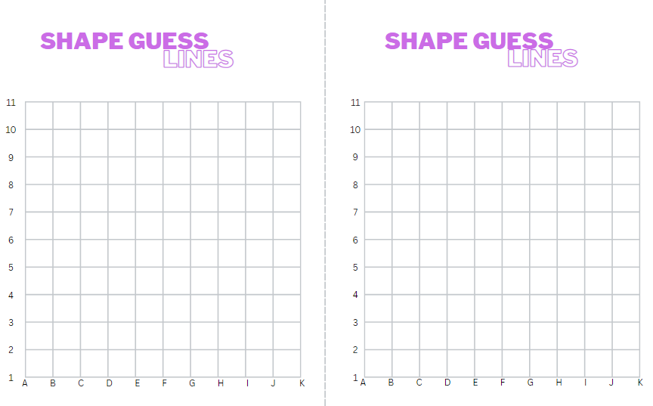

# Resource 5 – shape guess spaces

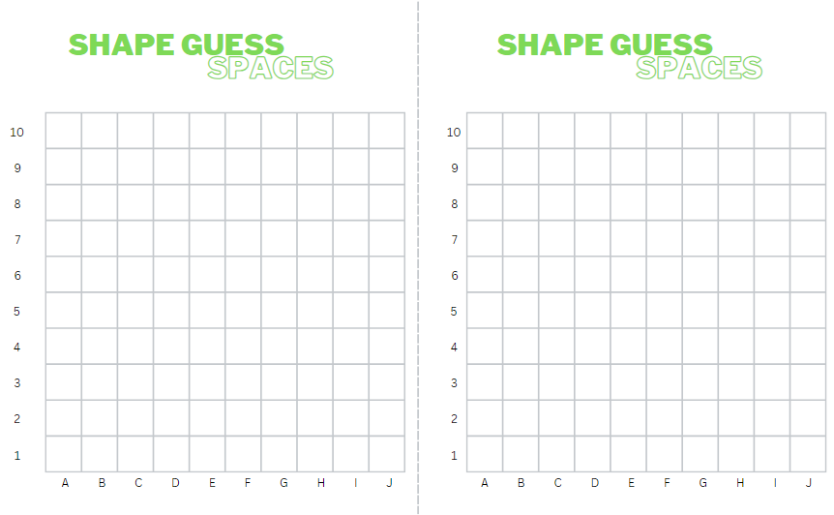

# Resource 6 – blank Cartesian plane

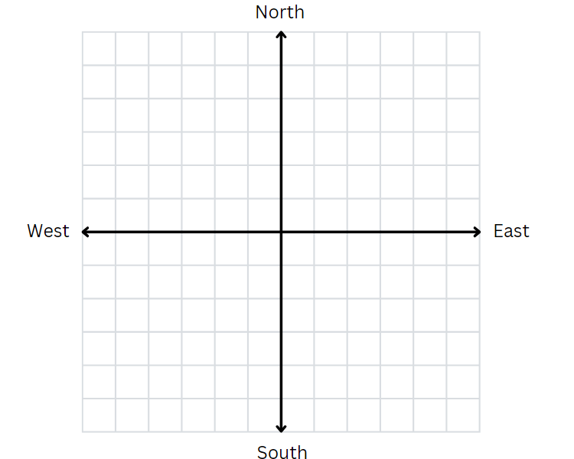

# Resource 7 – labelled plane cartoons

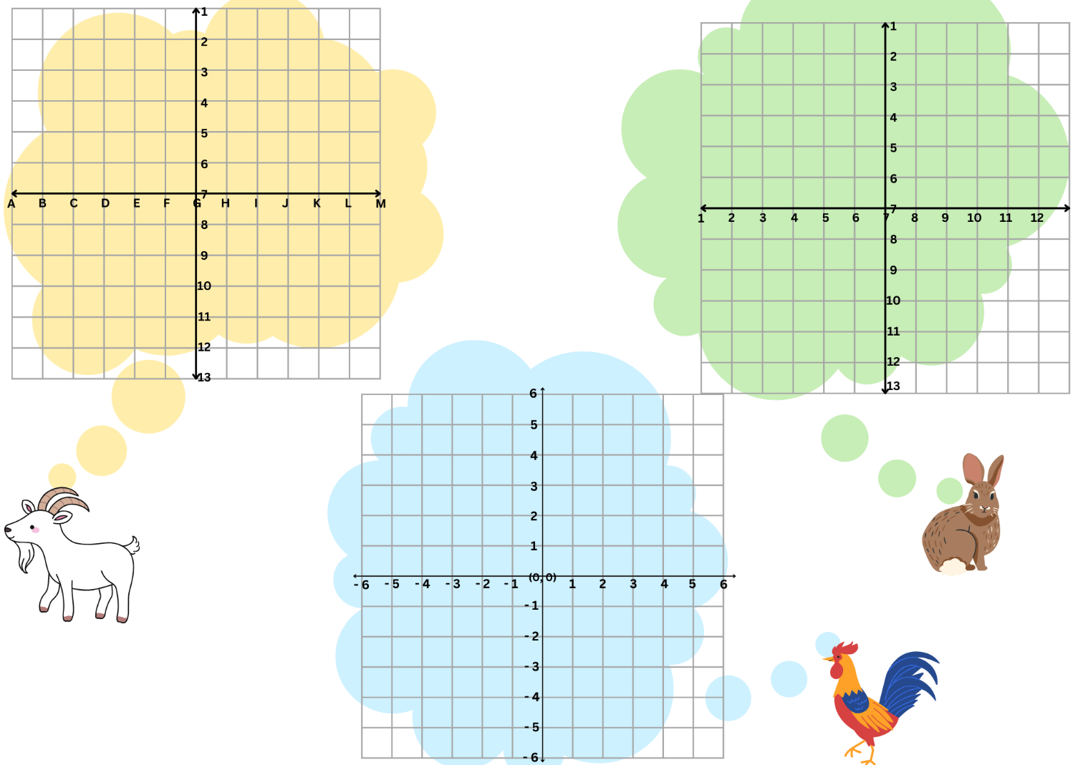

# Resource 8 – number line

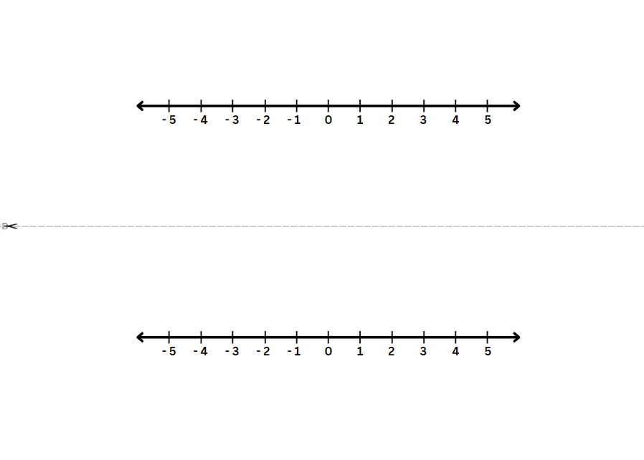

# Resource 9 – fruit fractions

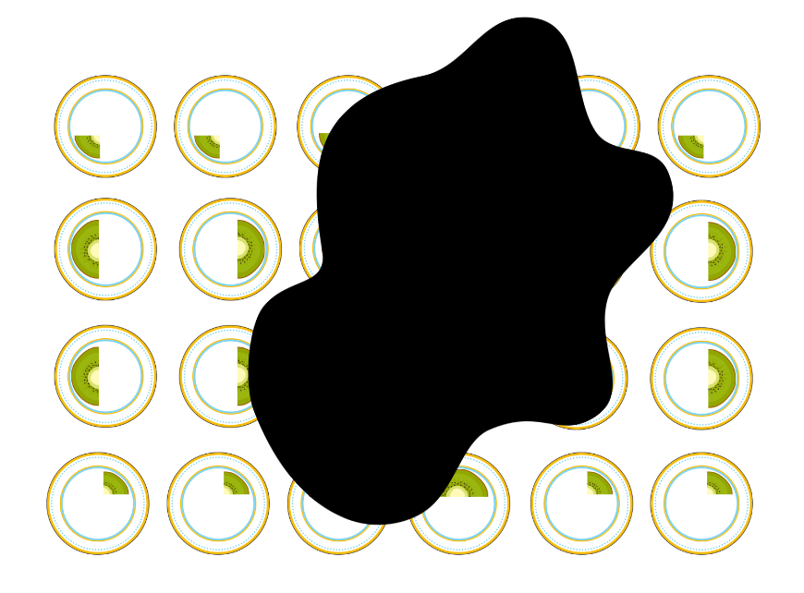

# Resource 10 – library ladder

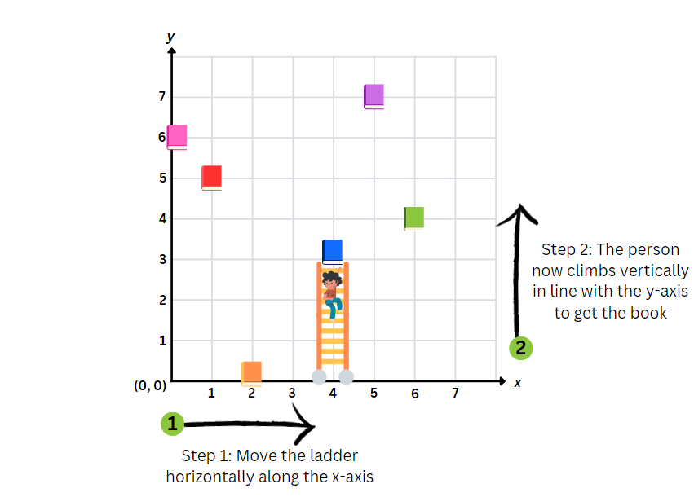

# Resource 11 – blank library ladder

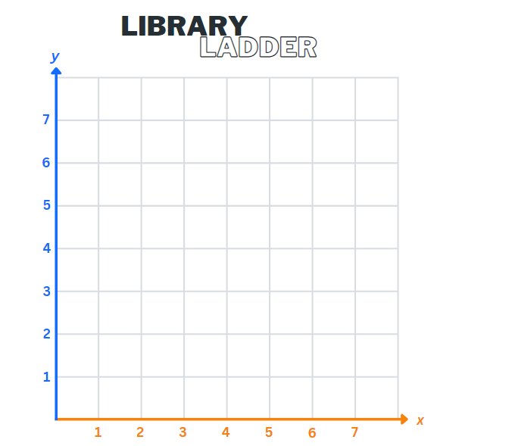

# Resource 12 – colour library ladder

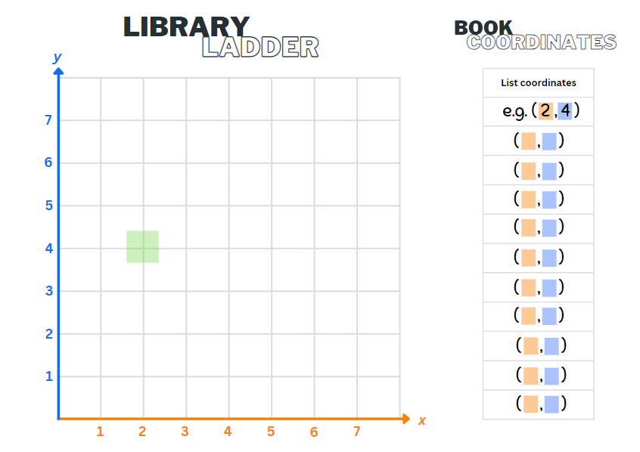

# Resource 13 – finding fractions

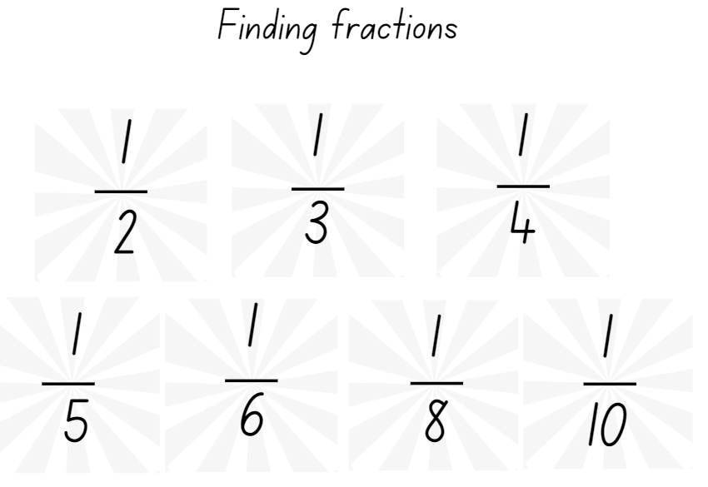

# Resource 14 – Cartesian plane

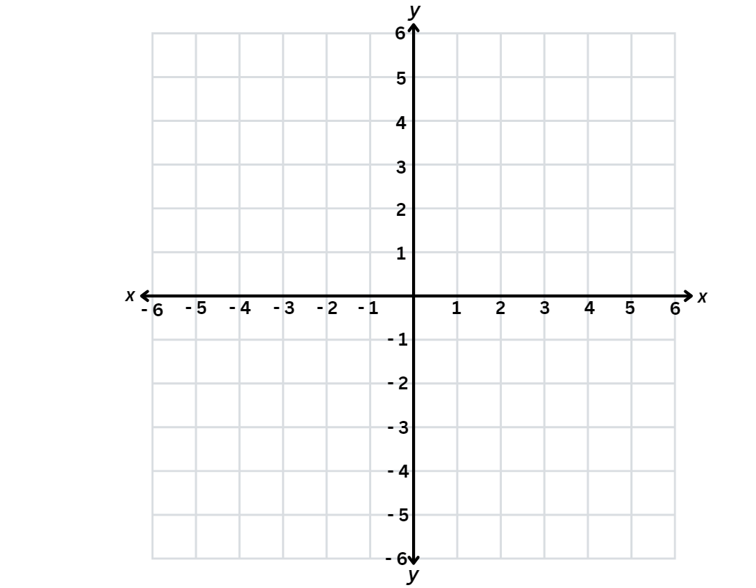

# Resource 15 – carrot hunt

A board for the game carrot hunt. Carrots are located at these coordinates: -4, 6; -2, 3; -4, -2; -3, -5; 2, 1; 4, 5; 2, -2; 4, -5. 
To the right of the board is a table titled carrot coordinates. The table has 3 columns with the headings origin, travelator and lift. To the right of the table is an image of a rabbit, a lift and a travelator. At the bottom of the page is a box titled rabbit holes. In that box are the instructions to plot the following coordinates: 3, 4; -5, 3; 0, -3; 6, -4; -4, -5. 

# Resource 16 – target cards

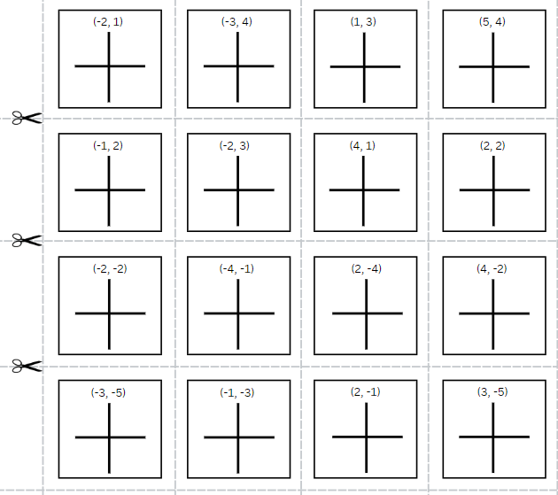

# Resource 17 – directional language cards

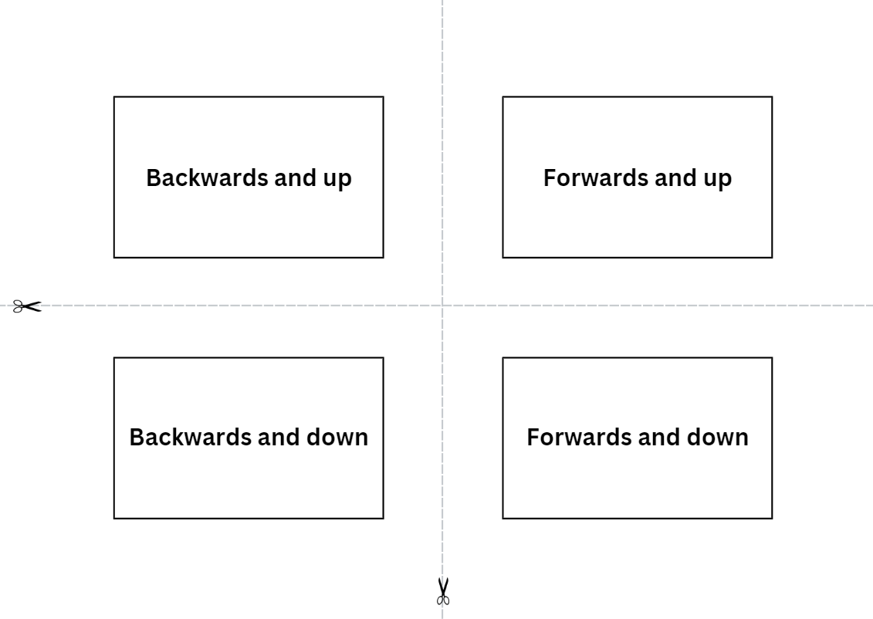

# Resource 18 – reflection consolidation

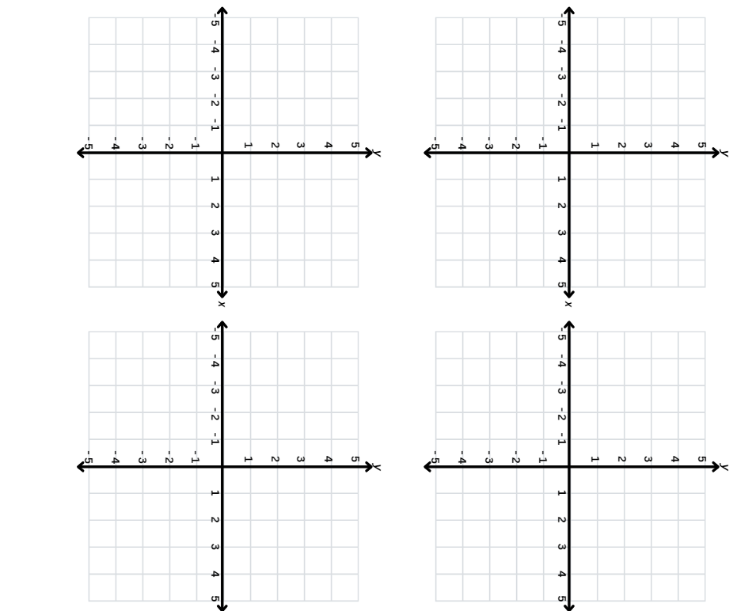

# Resource 19 – quadrant spinners

Two 6 part spinners.
Spinner 1 has the numbers 1 to 6.
Spinner 2 has 3 addition symbols and 3 subtraction symbols

# Resource 20 – chance representations

A poster titled chance representations comprised of 6 images with related text.

Image 1 shows a number line from 0 to 1, labelled 'Linear scale'. The text asks: How can a scale from 0 to 1 help me to describe chance? 
How can I think about partitioning this scale to represent equal and unequal chance? 

Image 2 shows a bag of counters, a die and a 4 part spinner, labelled 'random generators'. The text asks:
How do different generators represent different possible outcomes?
How can they support our reasoning about chance? 
How can they support our language?

Image 3 shows 3 highlighters, labelled 'colour coding'. The text asks:
How can colour coding help me visualise chance as parts of a whole? 
How can colour coding help me to understand if things are equally likely or unequally likely? 

Image 4 shows 2 different fraction strips, labelled fraction strips/wall. The text asks:
How do fraction strips help me to think about chance as a part of the total possibilities?
How can they help me to understand that the same chance can look different? 

Image 5 shows a half, 0.75 and 25%, labelled 'numerical representation'. The text asks:
How does expressing chance as a fraction, decimal or percentage help us to build a shared understanding? 
How does it change the language we use when describing chance? 

Image 6 shows a dot plot graph, labelled 'dot plots'. The text asks:
How can dot plots help me to visualise the outcomes of chance situations? 
How can they be used to compare expected frequency and observed frequency?

# Resource 21 – colloquial terms

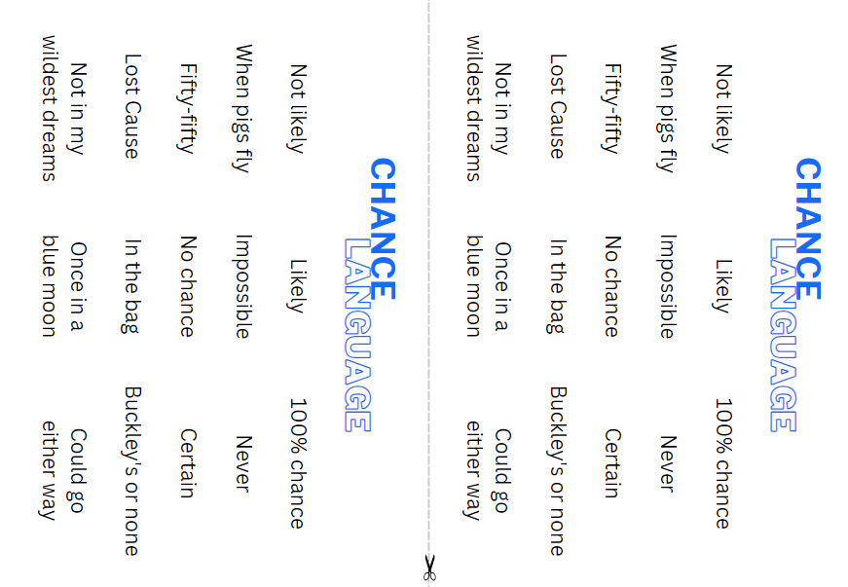

# Resource 22 – numerical phrases

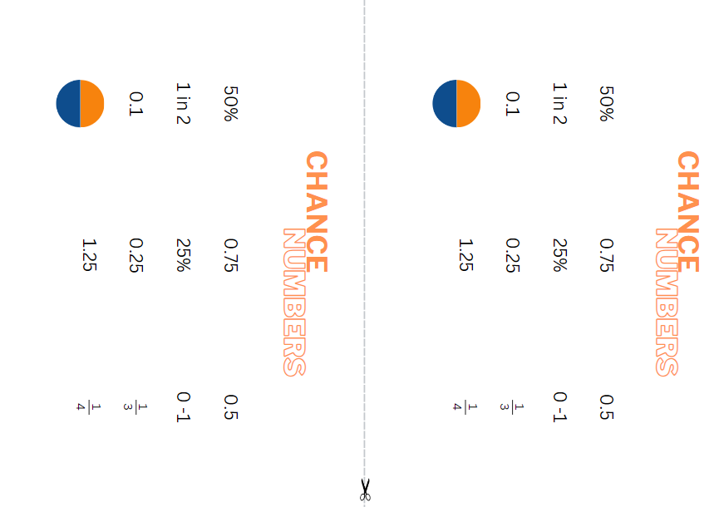

# Resource 23 – cards and strips

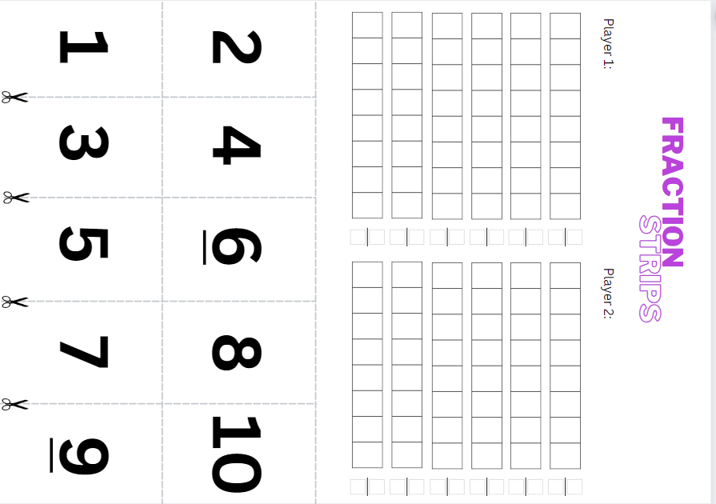

# Resource 24 – random generators

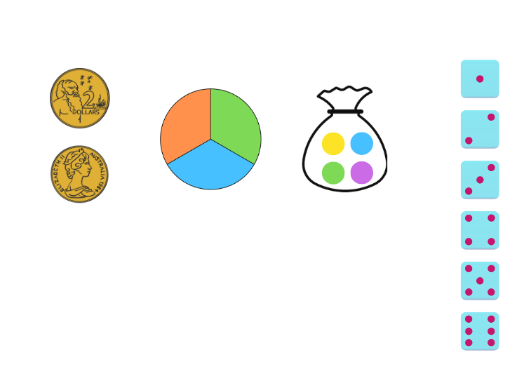

# Resource 25 – sentence stems

A resource showing CLOZE passages for students to complete.
For every ________ equal parts, one is ___________, therefore, I have a 1 in ________ chance of getting ___________. 

There is a ____ in ____ chance of getting ___________, I can represent this as ______. 

There are _____ possible outcomes, represented by __________ equal parts. Therefore, there is an equal chance of each one occurring. 

There is the same chance that I will get _______ compared to another possible outcome so there is an equal chance. 

# Resource 26 – equally likely cartoon

A resource labelled equally likely cartoon with 4 avatars: an owl, a rabbit, a rooster and a goat. Each avatar has a bag of counters and fraction strips that represent the proportion of different coloured counters in each bag. 

The owl has a bag with 2 yellow, 2 blue, 2 purple and 2 green counters. the fraction strips are drawn to show four quarters and eight eighths. The fraction strip colours match the colours of the counters in the bag. 

The rabbit has a bag with 3 yellow, 3 purple, 3 blue, 2 green and one orange counter. The fraction strip colours match the colours of the counters in the bag and are drawn to represent the fractional part of the collection. 

The rooster has a bag with 2 yellow, 2 blue, 2 purple, one green and one orange counter. The fraction strips are drawn to match the colours and fractional parts of the counters. 

The goat has a bag with 3 yellow, 3 purple, 3 blue and 3 green counters. The fractional strips are drawn to show 4 quarters and 12 twelfths. 

# Resource 27 – dot plot match

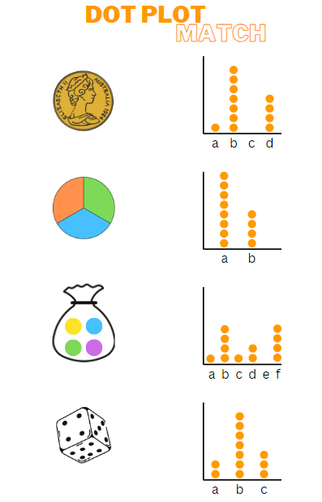

# Resource 28 – frequency thinking

A resource titled 'frequency thinking' with 3 student avatars. 

The first student is thinking: There is a 1 in 2 chance of getting heads or tails. That is the same as a 2 in 4 chance. So if I toss a coin 4 times, I should get heads 2 times and tails 2 times. The expected frequency for each outcome would be 2. There is a fraction strip to represent her thinking.  

The second student is thinking: It's also the same as a 3 in 6 chance so if I toss a coin 6 times, then I should get heads 3 times and tails 3 times. The expected frequency for each outcome would be 3. There is a different fraction strip to represent her thinking. 

The third student is thinking: Oh wow! It's the same as a 4 in 8 chance too. So if I toss a coin 8 times, then I should get heads 4 times and tails 4 times. The expected frequency for each outcome would be 4. There is a fraction strip to represent her thinking as well. 

# Resource 29 – chance bingo

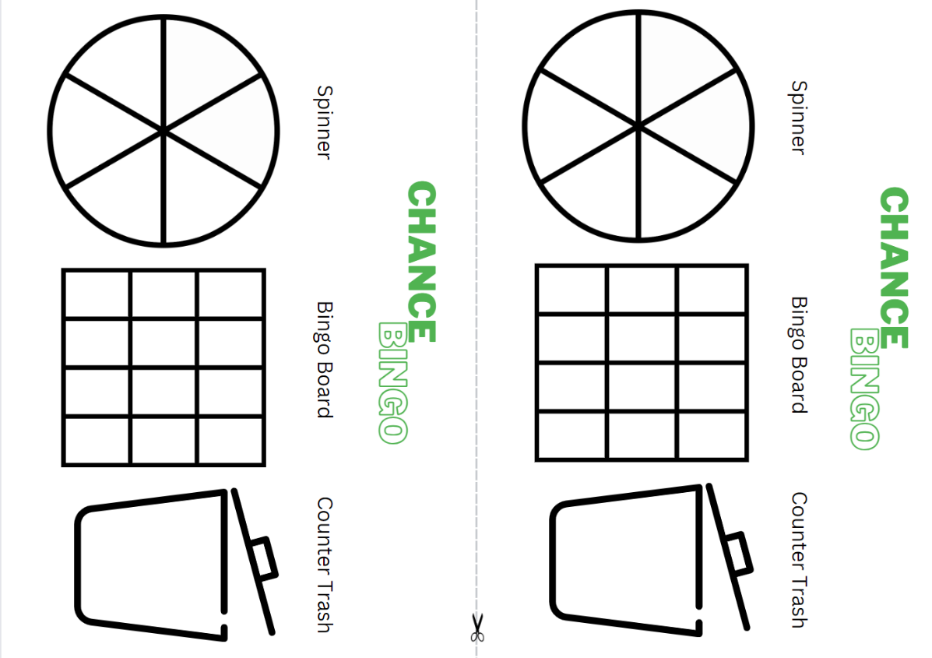

# Resource 30 – bingo set up

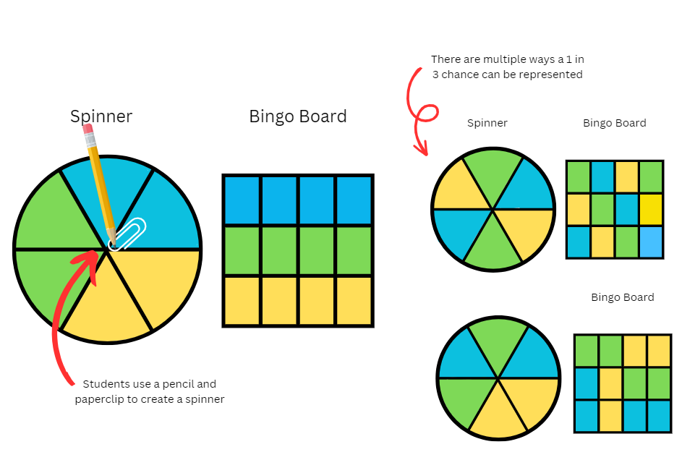

# Resource 31 – creating spinners

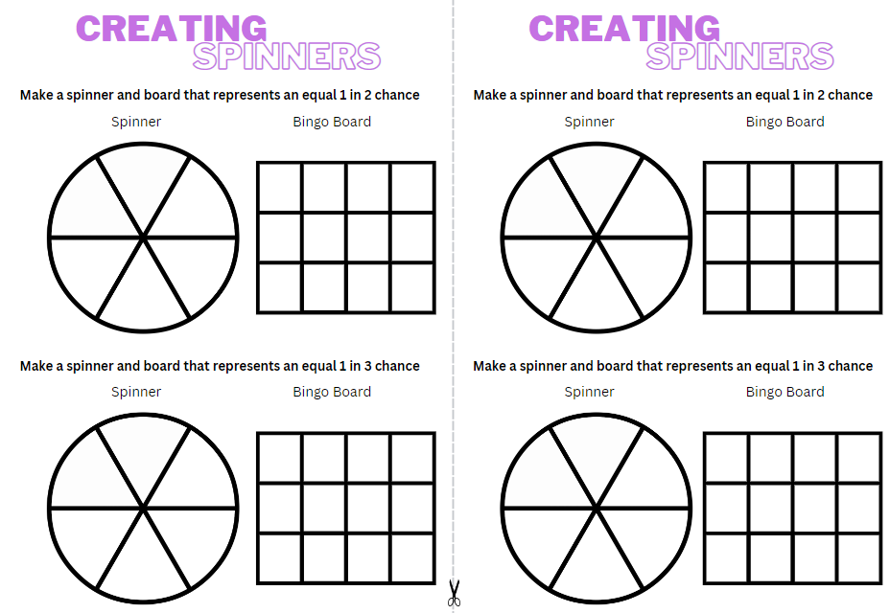

# Syllabus outcomes and content

The table below outlines the [syllabus outcomes](https://curriculum.nsw.edu.au/learning-areas/mathematics/mathematics-k-10-2022/overview) and range of relevant syllabus content covered in this unit. Content is linked to [National Numeracy Learning Progression](https://www.australiancurriculum.edu.au/resources/national-literacy-and-numeracy-learning-progressions/version-3-of-national-literacy-and-numeracy-learning-progressions/) version (3).

|  |  |  |  |  |  |  |  |  |
| --- | --- | --- | --- | --- | --- | --- | --- | --- |
| Outcomes and content | 1 | 2 | 3 | 4 | 5 | 6 | 7 | 8 |
| **Represents numbers A**: Whole numbers: Apply place value to partition, regroup and rename numbers to 1 billion  **MAO-WM-01, MA3-RN-01** |  |  |  |  |  |  |  |  |
| * Recognise 1000 thousands is 1 million and 1000 millions is 1 billion |  |  |  |  | x |  |  |  |
| * Regroup numbers in different forms (Reasons about quantity) |  |  |  |  |  | x | x |  |
| * Partition numbers to 1 billion in non-standard forms |  |  |  |  |  | x | x |  |
| **Representing quantity fractions A**: Recognise the role of the number 1 as representing the whole  **MAO-WM-01, MA3-RQF-01** |  |  |  |  |  |  |  |  |
| * Justify the need for fractions to refer to the number 1 as the common whole (Reasons about quantity) | x | x | x |  |  |  |  |  |
| **Representing quantity fractions A**: Compare and order common unit fractions  **MAO-WM-01, MA3-RQF-01** |  |  |  |  |  |  |  |  |
| * Compare and order unit fractions with denominators of 2, 3, 4, 5, 6, 8 and 10 by placing them on a number line |  |  | x |  |  |  |  |  |
| **Representing quantity fractions A**: Solve problems involving addition and subtraction of fractions with the same denominator  **MAO-WM-01, MA3-RQF-01** |  |  |  |  |  |  |  |  |
| * Represent the sum of fractions with the same denominator, recreating the whole, where the result may exceed one |  | x |  |  |  |  |  |  |
| **Representing quantity fractions B**: Compare common fractions with related denominators  **MAO-WM-01, MA3-RQF-01** |  |  |  |  |  |  |  |  |
| * Order common fractions with related denominators using diagrams and number lines |  |  | x |  |  |  |  |  |
| **Representing quantity fractions B**: Build up to the whole from a given fractional part  **MAO-WM-01, MA3-RQF-01** |  |  |  |  |  |  |  |  |
| * Generate the whole quantity from non-unit fractional parts such as quarters, eighths, thirds, sixths, fifths and tenths (Reversible reasoning) |  | x |  |  |  |  |  |  |
| **Geometric measure A:** Position: Explore the Cartesian coordinate system  **MAO-WM-01, MA3-GM-01** |  |  |  |  |  |  |  |  |
| * Recognise that the grid-map reference system gives the area of a location and the number plane identifies a specific point | x |  |  |  |  |  |  |  |
| * Identify that in the coordinate system the lines are numbered, not the spaces | x |  |  |  |  |  |  |  |
| * Identify the point of intersection of the 2 axes as the origin, having coordinates (0, 0) | x |  |  |  |  |  |  |  |
| * Plot and label points, given coordinates, on the number plane in the first quadrant, describing the horizontal position first, followed by the vertical position |  | x | x |  |  |  |  |  |
| * Identify and record the coordinates of given points on the number plane in the first quadrant |  | x | x |  |  |  |  |  |
| **Geometric measure B**: Position: Use the 4 quadrants of the coordinate plane  **MAO-WM-01, MA3-GM-01** |  |  |  |  |  |  |  |  |
| * Plot and label points, given coordinates, in all 4 quadrants of the number plane |  |  | x | x |  |  |  |  |
| * Identify and record the coordinates of given points on the number plane in all 4 quadrants |  |  | x | x |  |  |  |  |
| * Describe changes to coordinates when a point is translated or reflected across an axis |  |  |  | x |  |  |  |  |
| **Chance A:** List outcomes of chance experiments involving equally likely outcomes and represent probabilities  **MAO-WM-01, MA3-CHAN-01** |  |  |  |  |  |  |  |  |
| * Use the term probability to describe the numerical value that represents the likelihood of an outcome of a chance experiment |  |  |  |  | x |  |  |  |
| * Recognise that outcomes are described as equally likely when any one outcome has the same chance of occurring as any other outcome |  |  |  |  |  | x |  |  |
| * Represent probabilities of outcomes of chance experiments using fractions |  |  |  |  |  | x |  |  |
| * Establish that the total of the probabilities of the outcomes of a chance experiment equals one |  |  |  |  | x |  |  |  |
| * Discuss the imprecise meaning of commonly used chance words including possible, likely and unlikely |  |  |  |  | x |  |  |  |
| **Chance B**: Compare observed frequencies of outcomes with expected results  **MAO-WM-01, MA3-CHAN-01** |  |  |  |  |  |  |  |  |
| * Use the term frequency to describe the number of times a particular outcome occurs in a chance experiment |  |  |  |  |  |  | x |  |
| * Compare the expected frequencies of outcomes of chance experiments with observed frequencies, including where the outcomes are not equally likely |  |  |  |  |  |  | x |  |
| * Discuss the fairness of simple games involving chance and the idea of randomness |  |  |  |  |  |  | x |  |
| * Explain why observed frequencies of outcomes in chance experiments may differ from expected frequencies, and how this relates to randomness |  |  |  |  |  |  | x |  |
| **Chance B**: Create random generators and describe probabilities using fractions  **MAO-WM-01, MA3-CHAN-01** |  |  |  |  |  |  |  |  |
| * Create random generators to follow specified probabilities or proportions |  |  |  |  |  |  |  | x |
| * Use knowledge of benchmark fractions, decimals and percentages to assign probabilities to the likelihood of outcomes |  |  |  |  |  | x |  |  |
| **Chance B**: Conduct chance experiments with both small and large numbers of trials  **MAO-WM-01, MA3-CHAN-01** |  |  |  |  |  |  |  |  |
| * Assign expected probabilities to outcomes in chance experiments with random generators, including digital simulators, and compare the expected probabilities with the observed probabilities after both small and large numbers of trials |  |  |  |  |  |  |  | x |
| * Determine and discuss the differences between the expected probabilities and the observed probabilities after both small and large numbers of trials |  |  |  |  |  |  |  | x |

[Mathematics K–10 Syllabus](https://curriculum.nsw.edu.au/learning-areas/mathematics/mathematics-k-10-2022/overview) © NSW Education Standards Authority (NESA) for and on behalf of the Crown in right of the State of New South Wales, 2022.

# References

This resource contains NSW Curriculum and syllabus content. The NSW Curriculum is developed by the NSW Education Standards Authority. This content is prepared by NESA for and on behalf of the Crown in right of the State of New South Wales. The material is protected by Crown copyright.

Please refer to the NESA Copyright Disclaimer for more information <https://educationstandards.nsw.edu.au/wps/portal/nesa/mini-footer/copyright>.

NESA holds the only official and up-to-date versions of the NSW Curriculum and syllabus documents. Please visit the NSW Education Standards Authority (NESA) website <https://educationstandards.nsw.edu.au/> and the NSW Curriculum website [https://curriculum.nsw.edu.au](https://curriculum.nsw.edu.au/).

[Mathematics K–10 Syllabus](https://curriculum.nsw.edu.au/learning-areas/mathematics/mathematics-k-10-2022/overview) © NSW Education Standards Authority (NESA) for and on behalf of the Crown in right of the State of New South Wales, 2022.

[National Numeracy Learning Progression](https://www.australiancurriculum.edu.au/resources/national-literacy-and-numeracy-learning-progressions/version-3-of-national-literacy-and-numeracy-learning-progressions/) © Australian Curriculum, Assessment and Reporting Authority (ACARA) 2010 to present, unless otherwise indicated. This material was downloaded from the [Australian Curriculum](http://www.australiancurriculum.edu.au/) website (National Literacy Learning Progression) (accessed 25 September 2023) and was not modified.

Australian Government Department of Education and Australian Academy of Science (2022) ‘[Location: My Place In Space](https://resolve.edu.au/location-my-place-space)’, Teaching resources, reSolve: Maths by Inquiry website, accessed 25 September 2023.

Australian Government Department of Education and Australian Academy of Science (2020) ‘[Directed Number](https://www.resolve.edu.au/directed-number)’, Teaching resources, reSolve: Maths by Inquiry website, accessed 25 September 2023.

Australian Government Department of Education and Australian Academy of Science (n.d.) Snakes on a plane, Teaching resources, reSolve: Maths by Inquiry website (this resource is no longer available online).

Australian Broadcasting Corporation (2020) ‘[Mini Lessons: Maths – Series 1 Episode 12 Years 3-4: Our Place Value System’ [video]](https://iview.abc.net.au/show/mini-lessons-maths/series/1/video/ED2003V012S00), ABC iView website, accessed 25 September 2023.

National Council of Teachers of Mathematics (2023) [*Adjustable spinner*](https://www.nctm.org/adjustablespinner/), NCTM website, accessed 25 September 2023.

State of New South Wales (Department of Education) (2023) ‘[Mastermind](https://education.nsw.gov.au/teaching-and-learning/curriculum/mathematics/mathematics-curriculum-resources-k-12/mathematics-k-6-resources/mastermind)’, *Mathematics K-6 resources,* NSW Department of Education website, accessed 25 September 2023.

New Zealand Government (Ministry of Education) (2023) [*In Between*](https://nzmaths.co.nz/resource/between), NZmaths website, accessed 25 September 2023.

Riley S (n.d.) [*Demonstrate coordinates*](https://www.teacherled.com/iresources/coordinates/demonstratecoordinates/), Teacher Led website, accessed 25 September 2023.

Riley S (n.d.) [*Show the coordinate*](https://www.teacherled.com/iresources/coordinates/showthecoordinate/), Teacher Led website, accessed 25 September 2023.

## Further reading

Siemon D, Warren E, Beswick K, Faragher R, Miller J, Horne Marj, Jazby D, Breed M, Clark J, Brady K (2022) *Teaching Mathematics: Foundation to Middle Years*, 3rd edn, Oxford University Press, Australia and New Zealand.

Van de Walle J, Karp K, Bay-Williams JM, Brass A, Bentley B, Ferguson S, Goff W, Livy S, Marshman M, Martin D, Pearn C, Prodromou T, Symons D and Wilkie K (2019) Primary and Middle Years Mathematics: Teaching Developmentally, 1st Australian edn, Pearson Education Australia, Melbourne.

**© State of New South Wales (Department of Education), 2023**

The copyright material published in this resource is subject to the *Copyright Act 1968* (Cth) and is owned by the NSW Department of Education or, where indicated, by a party other than the NSW Department of Education (third-party material).

Copyright material available in this resource and owned by the NSW Department of Education is licensed under a [Creative Commons Attribution 4.0 International (CC BY 4.0) license](https://creativecommons.org/licenses/by/4.0/).

[](https://creativecommons.org/licenses/by/4.0/)

This license allows you to share and adapt the material for any purpose, even commercially.

Attribution should be given to © State of New South Wales (Department of Education), 2023.

Material in this resource not available under a Creative Commons license:

* the NSW Department of Education logo, other logos and trademark-protected material
* material owned by a third party that has been reproduced with permission. You will need to obtain permission from the third party to reuse its material.

**Links to third-party material and websites**

Please note that the provided (reading/viewing material/list/links/texts) are a suggestion only and implies no endorsement, by the New South Wales Department of Education, of any author, publisher, or book title. School principals and teachers are best placed to assess the suitability of resources that would complement the curriculum and reflect the needs and interests of their students.

If you use the links provided in this document to access a third-party's website, you acknowledge that the terms of use, including licence terms set out on the third-party's website apply to the use which may be made of the materials on that third-party website or where permitted by the *Copyright Act 1968* (Cth). The department accepts no responsibility for content on third-party websites.