Mathematics Stage 3 Year A – Unit 9

Contents

Unit description and duration 5

Syllabus outcomes 5

Working mathematically 6

Student prior learning 6

Lesson overview and resources 8

Lesson 1 14

Daily number sense – decimals on a number line – 10 minutes 14

Core lesson – naming and comparing three-dimensional objects – 40 minutes 16

Discuss and connect the mathematics – 10 minutes 19

Lesson 2 21

Daily number sense – What zeros matter? – 10 minutes 21

Core lesson – creating three-dimensional objects – 40 minutes 23

Consolidation and meaningful practice – 10 minutes 27

Lesson 3 29

Daily number sense – approximating decimals – 10 minutes 29

Core lesson – find and draw nets – 35 minutes 30

Consolidation and meaningful practice – 15 minutes 34

Lesson 4 36

Daily number sense – 10 minutes 36

Core lesson – making 3D objects by matching nets – 35 minutes 36

Consolidation and meaningful practice – 15 minutes 40

Lesson 5 42

Daily number sense – thousandths – 10 minutes 42

Core lesson – What’s my unit? – 35 minutes 44

Discuss and connect the mathematics – 15 minutes 47

Lesson 6 49

Daily number sense – decimals with MAB materials – 15 minutes 49

Core lesson – measuring water with decimals – 35 minutes 53

Discuss and connect the mathematics –10 minutes 57

Lesson 7 59

Daily number sense – measuring using decimal notation – 15 minutes 59

Core lesson – drinks for a disco – 35 minutes 61

Consolidation and meaningful practice – 10 minutes 64

Lesson 8 66

Daily number sense – 10 minutes 66

Core lesson – displacement – 40 minutes 66

Consolidation and meaningful practice – 10 minutes 69

Resource 1 – decimal cards 71

Resource 2 – Guess what? 72

Resource 3 – 3D bingo 73

Resource 4 – 3D bingo cards 75

Resource 5 – decimals with zeros 77

Resource 6 – sketch and label 78

Resource 7 – decimal flash cards 79

Resource 8 – square pyramid nets 80

Resource 9 – rectangular prism nets 81

Resource 10 – Venn diagram 82

Resource 11 – cut cube nets 83

Resource 12 – match my net 84

Resource 13 – What’s my unit? 85

Resource 14 – capacity cards 86

Resource 15 – equivalent capacity 88

Resource 16 – estimate and measure 89

Resource 17 – Which unit? 90

Resource 18 – capacity conversions 91

Resource 19 – equivalent capacities 92

Resource 20 – capacity problems 93

Resource 21 – capacity decimals bingo 94

Resource 22 – bingo clues 96

Syllabus outcomes and content 97

References 102

# Unit description and duration

This unit develops the big idea that what needs to be measured determines the unit of measurement.

In this 2-week unit students are provided opportunities to:

* name particular prisms and pyramids using properties of three-dimensional objects by making and exploring models, sketches and diagrams
* use decimal representations to record volume using formal units of litres and millilitres
* explore displacement to investigate volumes of irregular solids.

## Syllabus outcomes

* **MAO-WM-01** develops understanding and fluency in mathematics through exploring and connecting mathematical concepts, choosing and applying mathematical techniques to solve problems, and communicating their thinking and reasoning coherently and clearly
* **MA3-RN-01** applies an understanding of place value and the role of zero to represent the properties of numbers
* **MA3-RN-02** compares and orders decimals up to 3 decimal places
* **MA3-3DS-01** visualises, sketches and constructs three-dimensional objects, including prisms and pyramids, making connections to two-dimensional representations
* **MA3-3DS-02** selects and uses the appropriate unit to estimate, measure and calculate volumes and capacities

## Working mathematically

In the Mathematics K–10 Syllabus, there is one overarching Working mathematically outcome (**MAO-WM-01**). The Working mathematically processes should be embedded within the concepts being taught. The Working mathematically processes present in the Mathematics K–10 Syllabus are:

* communicating
* understanding and fluency
* reasoning
* problem solving.

[Mathematics K–10 Syllabus](https://curriculum.nsw.edu.au/learning-areas/mathematics/mathematics-k-10-2022/overview) © NSW Education Standards Authority (NESA) for and on behalf of the Crown in right of the State of New South Wales, 2022.

## Student prior learning

Before engaging in these teaching and learning activities, students would benefit from prior experience with:

* comparing and describing features of three-dimensional objects by making and exploring models, sketches and diagrams
* constructing and drawing models from given top, front and side views, using squared and isometric paper
* using formal units (litres and millilitres) to measure capacity and use scaled instruments to measure and compare capacities.

In NSW classrooms there is a diverse range of students, including Aboriginal and Torres Strait Islander students, students learning English as an additional language or dialect, high potential and gifted students and students with disability. Some students may identify with more than one of these groups or possibly all of them. Refer to [Curriculum planning for every student – advice](https://education.nsw.gov.au/teaching-and-learning/curriculum/planning-programming-and-assessing-k-12/advice-on-curriculum-planning-for-every-student-k-12) for further information.

# Lesson overview and resources

The table below outlines the sequence and approximate timing of lessons, learning intentions and resources.

|  |  |  |
| --- | --- | --- |
| Lesson | Content | Duration and resources |
| **Lesson 1**  **Daily number sense learning intention**:   * compare, order and represent decimals | **Lesson core concept**: objects can be described effectively by focusing on features.  **Core concept learning intention**:   * compare, describe and name prisms and pyramids | **Lesson duration**: 60 minutes   * Resource 1 – decimal cards * Resource 2 – Guess what? * Resource 3 – 3D bingo * Resource 4 – 3D bingo cards * [Guess What?](https://nrich.maths.org/14777) * Counters * Three-dimensional models * Writing materials |
| **Lesson 2**  **Daily number sense learning intention**:   * recognise that the place value system can be extended beyond hundredths * compare, order and represent decimals | **Lesson core concept**: objects can be constructed using different materials.  **Core concept learning intentions**:   * connect three-dimensional objects with two-dimensional representations by constructing prisms and pyramids * construct prisms and pyramids | **Lesson duration**: 60 minutes   * Resource 5 – decimals with zeros * Resource 6 – sketch and label * 6 paper or opaque plastic bags * Sticky putty * Straws * Three-dimensional models * Writing materials |
| **Lesson 3**  **Daily number sense learning intention**:   * compare, order and represent decimal | **Lesson core concept**: mathematicians examine diagrams to name and explore the features of an object.  **Core concept learning intentions**:   * compare, describe and name prisms and pyramids * connect three-dimensional objects with two-dimensional representations | **Lesson duration**: 60 minutes   * Resource 7 – decimal flash cards * Resource 8 – square pyramid nets * Resource 9 – rectangular prism nets * Website: [Cube nets](https://www.nctm.org/Classroom-Resources/Illuminations/Interactives/Cube-Nets/) * Cardboard * Scissors * Three-dimensional geometrical models |
| **Lesson 4**  **Daily number sense learning intention**:   * teacher-identified task based on student needs | **Lesson core concept**: mathematicians visualise diagrams to name and draw an object.  **Core concept learning intention**:   * connect three-dimensional objects with two-dimensional representations | **Lesson duration**: 60 minutes   * Resource 10 – Venn diagram * Resource 11 – cut cube net * Resource 12 – match my net * [Cut nets](https://nrich.maths.org/2315) * Glue * Individual whiteboards and markers * Scissors * Three-dimensional geometrical models |
| **Lesson 5**  **Daily number sense learning intention**:   * recognise that the place value system can be extended beyond hundredths. | **Lesson core concept**: the capacity of the object determines the most appropriate unit of measure.  **Core concept learning intentions**:   * choose appropriate units of measurement for capacity * connect decimal representations to the metric system | **Lesson duration**: 60 minutes   * Resource 13 – What’s my unit? * Resource 14 – capacity cards * Resource 15 – equivalent capacity * Resource 16 – estimate and measure * 0–9 spinners * Individual whiteboards and markers * Measuring jugs and cups * Teaspoons * Variety of containers * Water * Writing materials |
| **Lesson 6**  **Daily number sense learning intention**:   * recognise that the place value system can be extended beyond hundredths * compare, order and represent decimals | **Lesson core concept**: metric units of measurement relate to our base-10 place value system.  **Core concept learning intentions**:   * connect decimal representations to the metric system * recognise that the place value system can be extended beyond hundredths | **Lesson duration**: 60 minutes   * Resource 17 – Which unit? * Resource 18 – capacity conversions * Resource 19 – equivalent capacities * Resource 20 – capacity problems * Containers with a capacity of 1 L plus * MAB materials * Measuring jug and cup * Water * Writing materials |
| **Lesson 7**  **Daily number sense learning intention**:   * recognise that the place value system can be extended beyond hundredths * compare, order and represent decimals | **Lesson core concept**: metric units of measurement relate to our base-10 place value system.  **Core concept learning intentions**:   * connect decimal representations to the metric system * compare, order and represent decimals | **Lesson duration**: 60 minutes   * Resource 21 – capacity decimals bingo * Resource 22 – bingo clues * Counters * Rulers (that include millimetres) * Writing materials |
| **Lesson 8**  **Daily number sense learning intention**:   * teacher-identified task based on student needs | **Lesson core concept**: displacement occurs when exploring the volume of irregular solids.  **Core concept learning intention**:   * use displacement to investigate volumes of irregular solids | **Lesson duration**: 60 minutes   * Measuring jugs * Mr Archimedes’ Bath by Pamela Allen * Popsicle sticks * Solid irregular objects (3 per group) * Water * Whiteboard markers * Writing materials |

# Lesson 1

**Core concept**: objects can be described effectively by focusing on features.

## Daily number sense – decimals on a number line – 10 minutes

Daily number sense activities for Lessons 1 to 3 ‘activate’ prior number knowledge and support the learning of new content in the unit. These activities can also assist teachers to identify the starting points for learning by revealing the extent of students’ existing knowledge.

The table below contains a suggested learning intention and success criteria. These are best co-constructed with students.

|  |  |
| --- | --- |
| Daily number sense learning intention | Daily number sense success criteria |
| Students are learning to:   * compare, order and represent decimals. | Students can:   * compare and order numbers of up to 3 decimal places * place numbers of up to 3 decimal places on a number line. |

**Note**: pre-cut Resource 1 – decimal cards before the start of the lesson. To support place value conceptual understanding, 1.429 would be read as one **and** four hundred and twenty-nine thousandths. The language connects the decimal fraction with the whole number and makes a connection with common fractions.

1. Display a number line on the board with zero, one and 2 marked.
2. Give each student a card from Resource 1 – decimal cards.
3. Students say their number aloud and then decide where it should be placed on the number line (see Figure 1).

Figure 1 – decimal number line

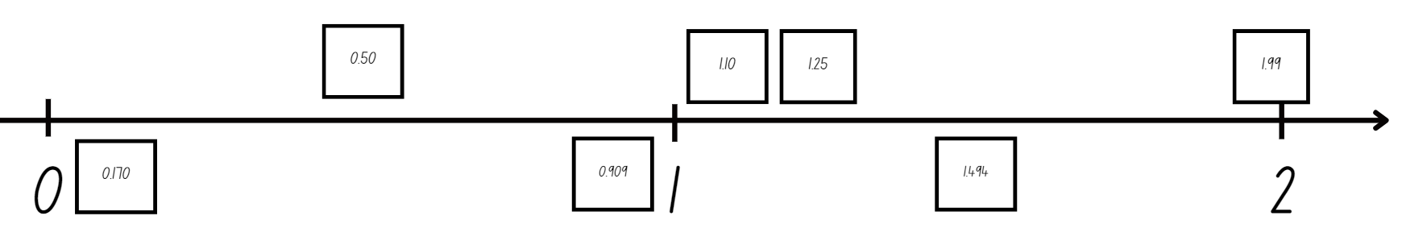

1. Students place their number on the number line and explain their reasoning for placing the number in that position.
2. Discuss the whole numbers or decimals on the number line already that could help decide where it goes.
3. Once students have placed numbers, ask:

* Are there any numbers that need to have their position adjusted? If yes, explain why.
* Which decimals are closest to the whole numbers?
* Are there any numbers you have seen represented in more than one way? For example, 0.50 and 0.5
* If I have a card with the number 2.25, where would I place it?

This table details opportunities for assessment.

|  |  |
| --- | --- |
| Assessment opportunities | Links |
| What to look for:   * Can students compare and order decimal numbers of up to 3 decimal places? **[MAO-WM-01, MA3-RN-02]** * Can students place decimal numbers of up to 3 decimal places on a number line? **[MAO-WM-01, MA3-RN-02]** | Links to [National Numeracy Learning Progressions](https://www.australiancurriculum.edu.au/resources/national-literacy-and-numeracy-learning-progressions/version-3-of-national-literacy-and-numeracy-learning-progressions/) (NNLP):   * NPV8.   Links to suggested [Interview for Student Reasoning](https://education.nsw.gov.au/teaching-and-learning/curriculum/literacy-and-numeracy/assessment-resources/ifsr) (IfSR) tasks:   * **Fir-PT**: 1A.5, 1A.7 * **IfSR-AT**: 4B.1 * **IfSR-NP**: 4D.6. |

## Core lesson – naming and comparing three-dimensional objects – 40 minutes

The table below contains a suggested learning intention and success criteria. These are best co-constructed with students.

|  |  |
| --- | --- |
| Core concept learning intention | Core concept success criteria |
| Students are learning to:   * compare, describe and name prisms and pyramids. | Students can:   * compare properties of prisms and pyramids * name prisms and pyramids according to the shape of their base. |

This activity is an adaptation of [Guess What?](https://nrich.maths.org/14777) from NRICH by the University of Cambridge.

1. Explain to students that they need to guess an object a partner has chosen by following these instructions:

* In pairs, each player chooses a random card from Resource 2 – Guess what?
* Students take turns asking their partner yes or no questions about properties of their three-dimensional object. Each answer should be used to get closer to guessing the object. For example, asking if it has 12 edges or 9 sides.

1. Ask students:

* What questions helped you to correctly guess your partner’s object?
* Why are they good questions?

1. Students repeat the process with a new object.
2. Display a variety of three-dimensional geometrical models, such as cubes, cylinders, cones, pyramids and prisms.
3. Each student writes a definition for a three-dimensional model on a sticky note. They place these next to each model.
4. As a class, discuss the student-generated definitions. For example, a square pyramid has a square base with 4 triangular faces that meet at an apex. It has 8 edges and 5 vertices. Ask students:

* What is similar and different about the models?
* What are the essential features needed to define each model? Support students to discuss bases of pyramids and prisms.
* Do any definitions describe more than one model? For example, all the pyramids have an apex, all the prisms have 2 bases.

**Note**: the Stage 3 teaching advice states the apex where the triangular faces meet on a pyramid is called a common vertex. This means that a square pyramid is described as having 5 vertices.

1. Write a class definition for each model and display.

**Note**: prisms have 2 bases that are the same shape and size. The bases of a prism may be squares, rectangles, triangles or other polygons. The base of a prism is the shape of the uniform cross-section, not necessarily the face on which it is resting. Pyramids differ from prisms as they have only one base and all the other faces are triangular.

This table details opportunities for differentiation.

|  |  |
| --- | --- |
| Too hard? | Too easy? |
| Students cannot compare, describe and/or name prisms and pyramids.   * Students match descriptions with three-dimensional geometrical models. * Support students to describe and name prisms and pyramids by discussing bases. | Students can compare, describe and name prisms and pyramids.   * Students create descriptions for hexagonal pyramids and pentagonal prisms. * Students list examples of real-life three-dimensional objects. |

## Discuss and connect the mathematics – 10 minutes

1. Give pairs of students counters and a bingo card from Resource 3 – 3D bingo.
2. Read Resource 4 – 3D bingo cards one by one to students.
3. Each time a card is read, students put a counter on the object that matches. Students can only put one counter down at a time even if a property matches more than one object. When a student covers all their objects, they call out 3D bingo.
4. After playing, discuss which properties could relate to multiple objects.

This table details opportunities for assessment.

|  |  |
| --- | --- |
| Assessment opportunities | Links |
| What to look for:   * Can students compare properties of prisms and pyramids? **[MAO-WM-01, MA3-3DS-01]** * Can students name prisms and pyramids according to the shape of their base? **[MAO-WM-01, MA3-3DS-01]** | Links to [National Numeracy Learning Progressions](https://www.australiancurriculum.edu.au/resources/national-literacy-and-numeracy-learning-progressions/version-3-of-national-literacy-and-numeracy-learning-progressions/) (NNLP):   * UnM5 * UGP3 * UGP5. |

# Lesson 2

**Core concept**: objects can be constructed using different materials.

## Daily number sense – What zeros matter? – 10 minutes

The table below contains suggested learning intentions and success criteria. These are best co-constructed with students.

|  |  |
| --- | --- |
| Daily number sense learning intentions | Daily number sense success criteria |
| Students are learning to:   * recognise that the place value system can be extended beyond hundredths * compare, order and represent decimals. | Students can:   * use place value to interpret zero digits in decimals * compare and order decimal numbers of up to 3 decimal places. |

**Note**: the Stage 3 teaching advice states that the role of zero as a place holder assists in understanding how we say and write decimals. Zero is written in the ones place in a decimal to reduce the risk of misreading the decimal as a whole number. The number 0.2 has the same value as 0.20 and the number 2 has the same value as 2.0. In measurement, zeros at the end of a decimal have a different meaning as they are used to record precision. A measurement recorded as 0.2 seconds is measured in tenths of a second. A measurement recorded as 0.20 seconds is measured in hundredths of a second.

1. Revise with students the role of zero as a placeholder to support saying and writing decimals. Revise how we must write a zero in the ones place if the decimal is smaller than 1.
2. Small groups of students cut up Resource 5 – decimals with zeros.
3. Students take turns to select a card, read the decimal aloud and sort the cards from smallest to largest, justifying decisions. Students decide which zeros matter. For example, the zeros in 0.025 are important, but the zero in 1.590 does not affect the place value if removed.

**Note**: when reading aloud, the normal convention is to ignore the end zeros. For example, 0.500 is interpreted as 0.5 and read as 5 tenths.

1. Move around the groups checking for misconceptions about the role of zero in decimals.
2. Once groups have ordered the cards, students compare their card order to one other group.
3. Ask the class:

* Were there any groups that had any cards in a different position? Why do you think that is?
* Did your group face any challenges while deciding on the order of cards?

This table details opportunities for assessment.

|  |  |
| --- | --- |
| Assessment opportunities | Links |
| What to look for:   * Can students use place value to interpret zero digits in decimals? **[MAO-WM-01, MA3-RN-02]** * Can students compare and order decimal numbers of up to 3 decimal places? **[MAO-WM-01, MA3-RN-02]** | Links to [National Numeracy Learning Progressions](https://www.australiancurriculum.edu.au/resources/national-literacy-and-numeracy-learning-progressions/version-3-of-national-literacy-and-numeracy-learning-progressions/) (NNLP):   * NPV7, NPV8.   Links to suggested [Interview for Student Reasoning](https://education.nsw.gov.au/teaching-and-learning/curriculum/literacy-and-numeracy/assessment-resources/ifsr) (IfSR) tasks:   * **IfSR-PT**: 1A.5, 1A.7 * **IfSR-AT**: 4B.1 * **IfSR-NP**: 4D.6. |

## Core lesson – creating three-dimensional objects – 40 minutes

The table below contains suggested learning intentions and success criteria. These are best co-constructed with students.

|  |  |
| --- | --- |
| Core concept learning intentions | Core concept success criteria |
| Students are learning to:   * connect three-dimensional objects with two-dimensional representations by constructing prisms and pyramids * construct prisms and pyramids. | Students can:   * visualise and sketch three-dimensional objects from different views, including top, front and side views * create skeletal models of prisms and pyramids * construct three-dimensional models of prisms and pyramids, given drawings of different views. |

**Note**: pre-prepare 6 bags containing a square pyramid, cube, cylinder, triangular prism, cone and triangular pyramid. The bags should not be see-through, so that students must rely on the features they can touch to identify the three-dimensional object.

1. Revise three-dimensional geometrical model definitions from Lesson 1.
2. Model feeling and visualising an unknown three-dimensional object inside a bag. Complete the first row of Resource 6 – sketch and label (see Figure 2).

Figure 2 – sketch and label table

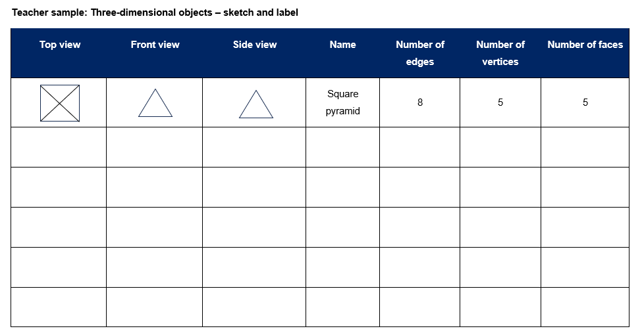

1. In small groups, students repeat the process with one of the pre-prepared bags.
2. Students [turn and talk](https://education.nsw.gov.au/teaching-and-learning/curriculum/literacy-and-numeracy/teaching-and-learning-resources/numeracy/talk-moves) to compare drawings and properties.
3. Rotate the bags and repeat the process until Resource 6 – sketch and label is completed.
4. Share results with the class.
5. Discuss which 2 models had the most similar features and which 2 models were the most different.
6. Provide small groups with straws and sticky putty. Explain that they will be told the number of straws and pieces of sticky putty needed to make a mystery three-dimensional skeleton. Students will work together to use the clues to identify and make the skeleton, as in Figure 3.

Figure 3 – examples of skeletal models

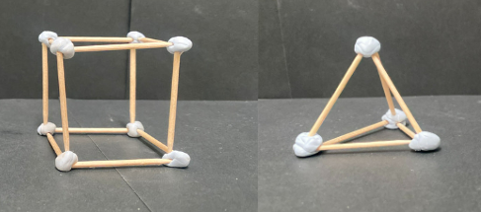

1. In small groups, students use the clues to see if they can name and make three-dimensional skeletons using:

* 12 straws and 8 pieces of sticky putty to join them? Answer: cube.
* 6 straws and 4 pieces of sticky putty? Answer: triangular pyramid (tetrahedron).
* 8 straws and 5 pieces of sticky putty? Answer: square pyramid.
* 9 straws and 6 pieces of sticky putty? Answer: triangular prism.

1. Students turn and talk to another group to prove how they know their models are correct.
2. As a class, group the models using the property of the base(s). Discuss how the pyramids have one base and the prisms have 2.

**Note**: the Stage 3 teaching advice states that another name for a triangular pyramid is a tetrahedron. If a triangular pyramid has all its triangular faces identical, it is called a regular tetrahedron.

This table details opportunities for differentiation.

|  |  |
| --- | --- |
| Too hard? | Too easy? |
| Students cannot sketch top, front and side views and/or create skeletal models of prisms and pyramids.   * Support students to draw prisms and pyramids from different views. * Support students to create skeletal models of prisms and pyramids. | Students can sketch top, front and side views and create skeletal models of prisms and pyramids.   * Students draw top, front and side views of their skeletal models. * Students create skeletal models of other three-dimensional objects. For example, hexagonal prism, pentagonal pyramid. |

## Consolidation and meaningful practice – 10 minutes

1. Revise properties of three-dimensional objects by giving descriptions. Students draw answers on individual whiteboards and justify thinking to a partner. Ask students:

* I have triangular faces and a square base. I have 5 vertices. What am I? Answer: square pyramid.
* I have 5 faces, only two of them are triangles. What am I? Answer: triangular prism.
* I have a curved boundary and 3 surfaces. What am I? Answer: cylinder.

This table details opportunities for assessment.

|  |  |
| --- | --- |
| Assessment opportunities | Links |
| What to look for:   * Can students visualise and sketch three-dimensional objects from different views, including top, front and side views?  **[MAO-WM-01, MA3-3DS-01]** * Can students create skeletal models of prisms and pyramids? **[MAO-WM-01, MA3-3DS-01]** * Can students construct three-dimensional models of prisms and pyramids, given drawings of different views?  **[MAO-WM-01, MA3-3DS-01]** | Links to [National Numeracy Learning Progressions](https://www.australiancurriculum.edu.au/resources/national-literacy-and-numeracy-learning-progressions/version-3-of-national-literacy-and-numeracy-learning-progressions/) (NNLP):   * UGP3 * UGP5. |

# Lesson 3

**Core concept**: mathematicians examine diagrams to name and explore the features of an object.

## Daily number sense – approximating decimals – 10 minutes

The table below contains a suggested learning intention and success criteria. These are best co-constructed with students.

|  |  |
| --- | --- |
| Daily number sense learning intention | Daily number sense success criteria |
| Students are learning to:   * compare, order and represent decimals. | Students can:   * approximate size of decimals. |

**Note**: pre-cut cards from Resource 7 – decimal flash cards prior to lesson.

1. Revise benchmark fractions as decimal numbers. For example, $\frac{1}{4}$ is 0.25, $\frac{1}{2}$ is 0.50 and $\frac{3}{4}$ is 0.75.
2. Explain to students that they will be approximating decimals to the nearest benchmark fraction. For example, 0.254 is approximated to 2 decimal places as 0.25 or $\frac{1}{4}$.

**Approximate**: an estimate of a number or an amount to a particular accuracy. For example, to 2 decimal places 1.254 is 1.25.

1. Display a decimal card from Resource 7 – decimal flash cards. Ask students what the closest benchmark is. For example, 0.254 is closest to $\frac{1}{4}$ or 0.25.
2. Give small groups of students Resource 7 – decimal flash cards. Students sort cards into 3 groups: close to one-quarter, one-half and three-quarters. Move around the room correcting any misconceptions about the place value of decimals.

This table details opportunities for assessment.

|  |  |
| --- | --- |
| Assessment opportunities | Links |
| What to look for:   * Can students approximate size of decimals?  **[MAO-WM-01, MA3-RN-02]** | Links to [National Numeracy Learning Progressions](https://www.australiancurriculum.edu.au/resources/national-literacy-and-numeracy-learning-progressions/version-3-of-national-literacy-and-numeracy-learning-progressions/) (NNLP):   * N/A.   Links to suggested [Interview for Student Reasoning](https://education.nsw.gov.au/teaching-and-learning/curriculum/literacy-and-numeracy/assessment-resources/ifsr) (IfSR) tasks:   * **IfSR-PT**: 1A.4 * **IfSR-NP**: 4D.5. |

## Core lesson – find and draw nets – 35 minutes

The table below contains suggested learning intentions and success criteria. These are best co-constructed with students.

|  |  |
| --- | --- |
| Core concept learning intentions | Core concept success criteria |
| Students are learning to:   * compare, describe and name prisms and pyramids * connect three-dimensional objects with two-dimensional representations. | Students can:   * compare properties of prisms and pyramids * name prisms and pyramids according to the shape of their base * visualise and sketch nets for given three-dimensional objects. |

**Note**:the teaching advice states that not all three-dimensional objects have nets. As spheres, cylinders and cones are not polyhedrons, their lack of edges means they do not have a net (Friedman 2018). There are 11 distinct nets of a cube and 2 nets of a regular tetrahedron.

1. Display Resource 8 – square pyramid nets. Ask students which net or nets could be folded to make a square pyramid. Discuss their answers and reasoning (see Figure 4).

Figure 4 – pyramid net answers

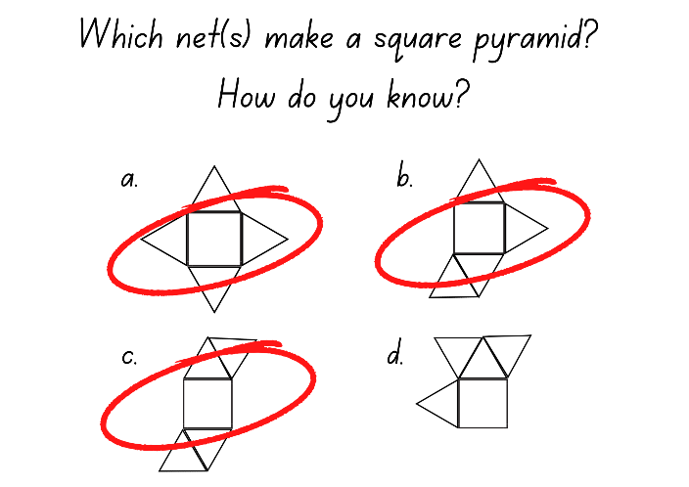

1. Repeat the process using Resource 9 – rectangular prism nets and Figure 5.

Figure 5 – prism net answers

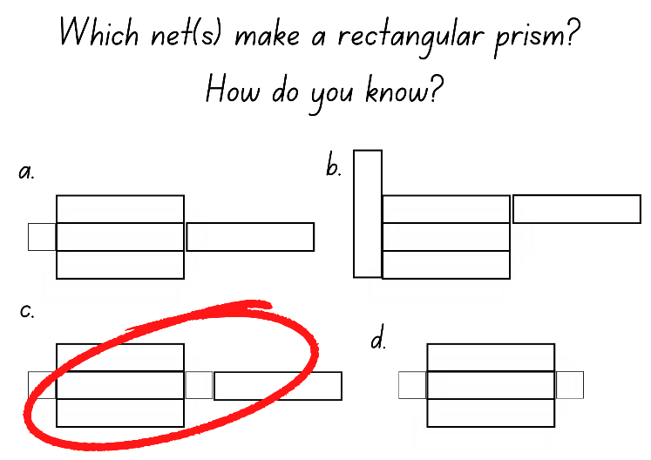

1. Show a triangular pyramid. Model drawing and constructing the net with card. Revise properties, for example, faces, edges and vertices.
2. Provide small groups of students with three-dimensional geometrical models and card.
3. Students draw the net of one solid and justify how it is correct to the group. If there is disagreement, a student may choose to adapt or redraw their net.
4. Students cut out their nets and make the geometrical model. Students may need to redraw their nets at this point.
5. Display the nets. Ask students:

* What did you notice?
* Is there only one way to make a net for each three-dimensional solid. Why or why not?
* What adjustments did you need to make for your net to be successful?

This table details opportunities for differentiation.

|  |  |
| --- | --- |
| Too hard? | Too easy? |
| Students cannot visualise and/or sketch nets for given three-dimensional objects.   * Provide students with further experience using bags hiding mystery three-dimensional objects from Lesson 2. * Use step by step instructions to support students to sketch nets of one three-dimensional object. * Give students pre-made nets to cut out and make. | Students can visualise and sketch nets for given three-dimensional objects.   * Students trial nets for other three-dimensional objects. * Students make nets for everyday objects in the classroom. |

## Consolidation and meaningful practice – 15 minutes

1. Draw one cube net as in Figure 6. Ask students if it will make a cube.

Figure 6 – cube net

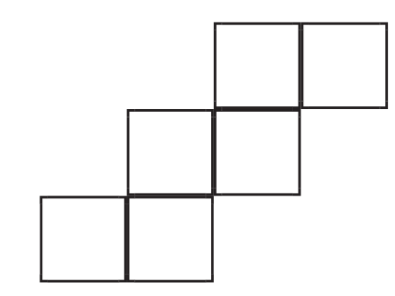

1. Show students the 24 cube nets on [Cube Nets](https://www.nctm.org/Classroom-Resources/Illuminations/Interactives/Cube-Nets/). Explain that some of these nets can be folded into a cube.
2. Students visualise which nets could create a cube. They turn and talk to discuss ideas.
3. With the class, use [Cube Nets](https://www.nctm.org/Classroom-Resources/Illuminations/Interactives/Cube-Nets/) to complete the interactive activity.

**Note**: there are 11 possible nets for a cube.

1. Ask the class:

* Which nets made a cube? How do you know?
* How did the net need to look to make a cube? How do you know?

This table details opportunities for assessment.

|  |  |
| --- | --- |
| Assessment opportunities | Links |
| What to look for:   * Can students compare properties of prisms and pyramids?  **[MAO-WM-01, MA3-3DS-01]** * Can students name prisms and pyramids according to the shape of their base? **[MAO-WM-01, MA3-3DS-01]** * Can students visualise and sketch nets for given three-dimensional objects? **[MAO-WM-01, MA3-3DS-01]** | Links to [National Numeracy Learning Progressions](https://www.australiancurriculum.edu.au/resources/national-literacy-and-numeracy-learning-progressions/version-3-of-national-literacy-and-numeracy-learning-progressions/) (NNLP):   * UnM5 * UGP3 * UGP5. |

# Lesson 4

**Core concept**: mathematicians visualise diagrams to name and draw an object.

## Daily number sense – 10 minutes

1. From a class need surfaced through formative assessment data, identify a short, focused activity that targets students’ knowledge, understanding and skills. Example activities may be drawn from the following resources:

* [Mathematics K–6 resources](https://education.nsw.gov.au/teaching-and-learning/curriculum/mathematics/mathematics-curriculum-resources-k-12/mathematics-k-6-resources.main-education--category---catalogue---key-learning-area---mathematics---thinking-mathematically.nameAsc.1.grid)
* [Universal Resources Hub](https://resources.education.nsw.gov.au/home).

## Core lesson – making 3D objects by matching nets – 35 minutes

The table below contains suggested learning intentions and success criteria. These are best co-constructed with students.

|  |  |
| --- | --- |
| Core concept learning intentions | Core concept success criteria |
| Students are learning to:   * connect three-dimensional objects with two-dimensional representations. | Students can:   * examine a diagram to determine whether it is or is not the net of a closed three-dimensional object * visualise and sketch nets for three-dimensional objects * visualise and name prisms and pyramids, given representations of their nets. |

This activity is an adaptation of ‘[Cut Nets](https://nrich.maths.org/2315)' from NRICH by the University of Cambridge.

1. Display a range of three-dimensional geometrical models. For example, a cube, triangular prism, rectangular prism and square pyramid.
2. Use Resource 10 – Venn diagram to model how to describe and record the similarities and differences between 2 models. For example, a rectangular prism and square pyramid (see Figure 7).

Figure 7 – Venn diagram ideas

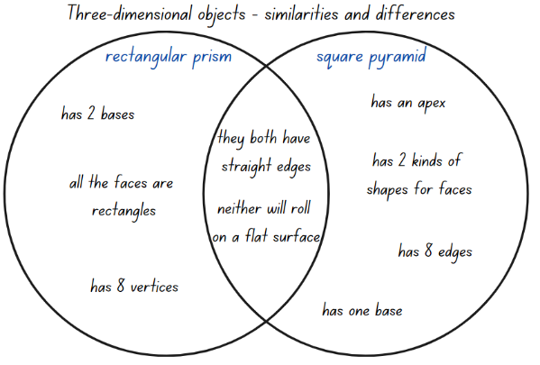

1. In small groups, students use Resource 10 – Venn diagram to repeat the process with a rectangular prism and a triangular pyramid.
2. Discuss responses as a class.
3. Display Resource 11 – cut cube net. Explain that the net of a cube has been cut into 2. These can be joined together and then folded into a cube.
4. Ask students how this net could be put back together. Make the net and discuss student answers. Support students to discuss multiple solutions.
5. Give small groups of students 2 copies of Resource 12 – match my net. Explain that each net has been cut into 2 pieces, like the net of the cube.
6. Students use one set of nets to join together and make geometrical models. Then they display these next to the other set of nets (see Figure 8).

Figure 8 – matching nets

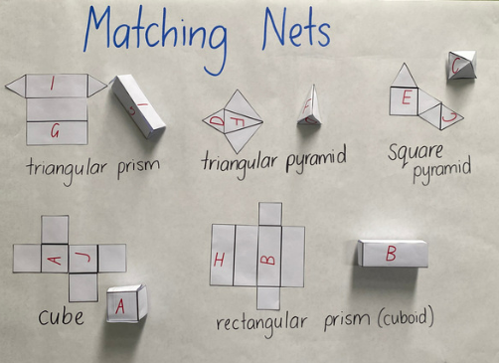

1. Discuss results with class. Ask students to explain the strategies used to put the cut nets together.

**Note**: please refer to [Cut Nets](https://nrich.maths.org/2315) at NRICH for further information on how to develop student responses.

This table details opportunities for differentiation.

|  |  |
| --- | --- |
| Too hard? | Too easy? |
| Students cannot visualise and/or make nets of three-dimensional objects.   * Support students to fold and unfold completed nets. * Allow students to trace unfolded nets. | Students can visualise and make nets of three-dimensional objects.   * Students create nets of other three-dimensional objects. * Students cut nets in 2 and swap with a student to solve. |

## Consolidation and meaningful practice – 15 minutes

1. Students draw half the net of a three-dimensional object on individual whiteboards.
2. Students swap their half net with a partner to solve.
3. Choose some students to share solutions with the class.

This table details opportunities for assessment.

|  |  |
| --- | --- |
| Assessment opportunities | Links |
| What to look for:   * Can students examine a diagram to determine whether it is or is not the net of a closed three-dimensional object?  **[MAO-WM-01, MA3-3DS-01]** * Can students visualise and sketch nets for given three-dimensional objects? **[MAO-WM-01, MA3-3DS-01]** * Can students visualise and name prisms and pyramids, given representations of their nets? **[MAO-WM-01, MA3-3DS-01]** | Links to [National Numeracy Learning Progressions](https://www.australiancurriculum.edu.au/resources/national-literacy-and-numeracy-learning-progressions/version-3-of-national-literacy-and-numeracy-learning-progressions/) (NNLP):   * UGP5 * UGP3. |

# Lesson 5

**Core concept**: the capacity of the object determines the most appropriate unit of measure.

## Daily number sense – thousandths – 10 minutes

Daily number sense activities for Lessons 5 to 7 ‘loop’ back to concepts and procedures covered in previous units to assist students to build an increasingly connected network of ideas. These concepts may differ from the core concepts being covered by the unit.

The table below contains a suggested learning intention and success criteria. These are best co-constructed with students.

|  |  |
| --- | --- |
| Daily number sense learning intention | Daily number sense success criteria |
| Students are learning to:   * recognise that the place value system can be extended beyond hundredths. | Students can:   * express thousandths as decimals * indicate the place value of digits in decimal numbers of up to 3 decimal places * use place value to partition decimals. |

1. Model spinning a 0–9 spinner 4 times to record as a whole number and tenths, hundredths and thousandths. Read aloud to show place value understanding in standard form. For example, 5.429 is 5 ones, 4 tenths, 2 hundredths and 9 thousandths. However, it is read as 5 and 429 thousandths (see Figure 9).

Figure 9 – teacher example

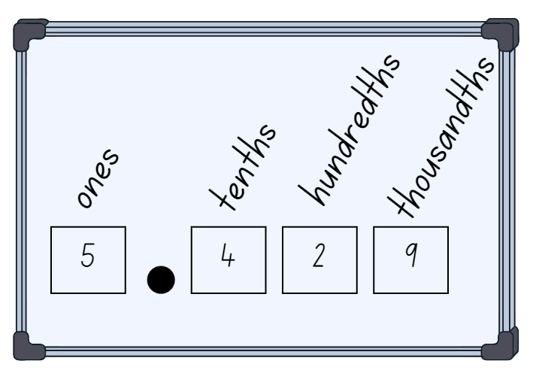

1. Give students a 0–9 spinner. Students spin the spinner 4 times and record on individual whiteboards the ones, tenths, hundredths and thousandths place as shown in Figure 9.
2. Once recorded, students identify and name the place value parts. For example, 6 ones, 3 tenths, 1 hundredth and 8 thousandths. Students circle the decimal parts and say that these will be named as thousandths. Then read the number as six and three hundred and eighteen thousandths.
3. Students repeat the process for a given time.
4. As a class, spin another number. Challenge students to consider non-standard place value partitioning:

* If you cannot have a whole number, how many thousandths would you have? For example, 7.264 could be recorded in a non-standard place value form as 7264 thousandths.
* If you cannot have tenths, how could you say this number? 7 wholes, 26 hundredths and 4 thousandths.

This table details opportunities for assessment.

|  |  |
| --- | --- |
| Assessment opportunities | Links |
| What to look for:   * Can students express thousandths as decimals?  **[MAO-WM-01, MA3-RN-02]** * Can students indicate the place value of digits in decimal numbers of up to 3 decimal places? **[MAO-WM-01, MA3-RN-02]** * Can students use place value to partition decimals?  **[MAO-WM-01, MA3-RN-02]** | Links to [National Numeracy Learning Progressions](https://www.australiancurriculum.edu.au/resources/national-literacy-and-numeracy-learning-progressions/version-3-of-national-literacy-and-numeracy-learning-progressions/) (NNLP):   * NPV7, NPV8.   Links to suggested [Interview for Student Reasoning](https://education.nsw.gov.au/teaching-and-learning/curriculum/literacy-and-numeracy/assessment-resources/ifsr) (IfSR) tasks:   * **IfSR-PT**: 1A.5 * **IfSR-NP**: 4D.2, 4D.6. |

## Core lesson – What’s my unit? – 35 minutes

The table below contains suggested learning intentions and success criteria. These are best co-constructed with students.

|  |  |
| --- | --- |
| Core concept learning intentions | Core concept success criteria |
| Students are learning to:   * choose appropriate units of measurement for capacity * connect decimal representations to the metric system. | Students can:   * select and use appropriate units to measure the capacities of a variety of containers * recognise the equivalence of whole-number and decimal representations of measurements of capacities. |

**Capacity (internal volume)**: capacity (internal volume) refers to the amount a container can hold and is measured in units such as millilitres (mL), litres (L) and kilolitres (kL).

**Volume**:the attribute of volume is the amount of space occupied by an object or substance and is usually measured in cubic units, for example cubic centimetres.

1. Revise with students that volume is the space taken up by a three-dimensional object. Capacity is the internal volume, which is how much a three-dimensional object can hold.
2. Share real-life examples of the difference between volume and capacity. For example, volume is used to measure a swimming pool to be sure it will fit in the backyard. Capacity describes how much water is needed to fill the swimming pool.

**Note**: capacity is only used in relation to containers and generally refers to fluid. The capacity of a closed container will be slightly less than its volume as capacity is based on the inside dimensions, while volume is determined by the outside dimensions of the container. It is recommended that the terms ‘capacity’ and ‘internal volume’ be used interchangeably.

1. Display Resource 13 – What’s my unit? Discuss the most appropriate formal unit to measure the capacity of each item.
2. In small groups, students order Resource 14 – capacity cards from smallest to largest.
3. Discuss the order with the class.
4. Display Resource 15 – equivalent capacity.
5. Select students to draw lines matching the equivalent amounts. For example, 500 mL is the same as half a litre or 0.5 L.
6. Ask students how they know these capacities are equivalent.
7. Model choosing a measuring instrument to estimate, measure and record the capacity of a container in Resource 16 – estimate and measure.
8. Give students containers with different capacities and a selection of formal and informal measuring instruments. For example, a measuring cup, jug, or teaspoon. Identify the capacity of each of the measuring instruments.
9. Students select a measuring instrument and use Resource 16 – estimate and measure to record estimates and measures for each container using water. Students may refine their estimates after measuring the first container.
10. Discuss with the class how accurate students’ estimates were. How do you know?

This table details opportunities for differentiation.

|  |  |
| --- | --- |
| Too hard? | Too easy? |
| Students cannot select and/or use appropriate units of measurement for capacity.   * Give students one instrument of measurement, for example, a measuring cup. Support students to measure using the given object with water. * Give students one more item to measure and an extra measuring instrument to begin making choices. | Students can select and use appropriate units of measurement for capacity.   * Students record measurements using litres and millilitres. * Students describe measurements using benchmarks. |

## Discuss and connect the mathematics – 15 minutes

1. Tell students that 3 friends went to the shops to buy drinks on a hot day. Baxter bought a 500 mL bottle, Lisa bought 300 mL bottle and Robbie bought a 250 mL bottle.
2. In pairs, students work out how many litres and millilitres were purchased and decide how to communicate their solution. For example, words, drawings and so on.
3. Ask students how they could you record the solutions in different ways? For example, 1050 mL is equivalent to 1.050 L.

This table details opportunities for assessment.

|  |  |
| --- | --- |
| Assessment opportunities | Links |
| What to look for:   * Can students select and use appropriate units to measure the capacities of a variety of containers? **[MAO-WM-01,** **MA3-3DS-02]** * Do students recognise the equivalence of whole-number and decimal representations of measurements of capacities?  **[MAO-WM-01,** **MA3-3DS-02]** | Links to [National Numeracy Learning Progressions](https://www.australiancurriculum.edu.au/resources/national-literacy-and-numeracy-learning-progressions/version-3-of-national-literacy-and-numeracy-learning-progressions/) (NNLP):   * UuM6. |

# Lesson 6

**Core concept**: metric units of measurement relate to our base-10 place value system.

## Daily number sense – decimals with MAB materials – 15 minutes

The table below contains a suggested learning intention and success criteria. These are best co-constructed with students.

|  |  |
| --- | --- |
| Daily number sense learning intention | Daily number sense success criteria |
| Students are learning to:   * recognise that the place value system can be extended beyond hundredths * compare, order and represent decimals. | Students can:   * indicate the place value of digits in decimal numbers of up to 3 decimal places * use place value to partition decimals * use place value to interpret zero digits in decimals. |

This activity is an adaptation of Identifies, represents and compares decimals from the [Universal Resources Hub](https://resources.education.nsw.gov.au/home).

1. Show students a collection of MAB materials and explain as per Figure 10:

* the block represents one whole
* the flat represents one tenth
* the long represents one hundredth
* the one represents one thousandth.

Figure 10 – MAB representing decimals

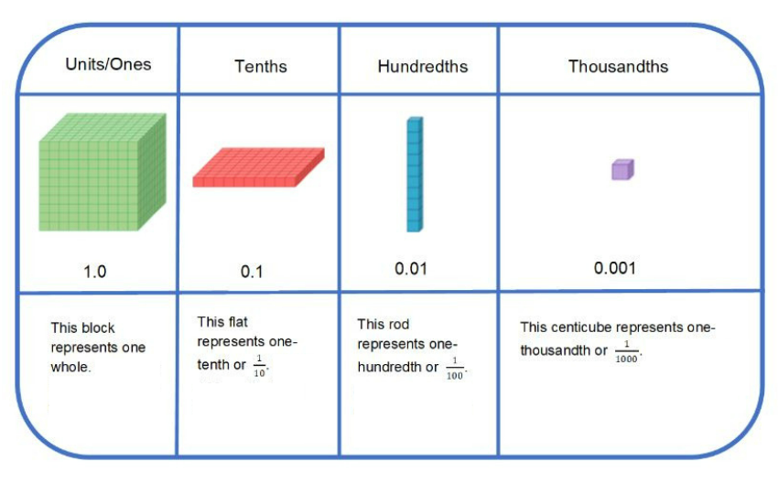

**Note**: students who have previously only used MAB materials for whole numbers may require support to adjust their thinking.

1. As a class, ask groups of students to read aloud a number and represent it using MAB materials:

* 1.594
* 2.637
* 0.186
* 3.045
* 2.108
* 1.770.

**Note**: to support place value conceptual understanding, 2.108 would be read as two and one hundred and eight thousandths. The language connects the decimal fraction with the whole number and makes a connection with common fractions.

1. Each group shares their representation. Ask students:

* How many whole numbers are there?
* How many tenths?
* How many hundredths?
* How many thousandth?
* What was the role of zero?

**Note**: the Stage 3 teaching advice states that the role of zero as a place holder assists in understanding how we say and write decimals. Zero is written in the ones place in a decimal to reduce the risk of misreading the decimal as a whole number.

This table details opportunities for assessment.

|  |  |
| --- | --- |
| Assessment opportunities | Links |
| What to look for:   * Can students indicate the place value of digits in decimal numbers of up to 3 decimal places? **[MAO-WM-01, MA3-RN-02]** * Can students use place value to partition decimals?  **[MAO-WM-01, MA3-RN-02]** * Can students use place value to interpret zero digits in decimals? **[MAO-WM-01, MA3-RN-02]** | Links to [National Numeracy Learning Progressions](https://www.australiancurriculum.edu.au/resources/national-literacy-and-numeracy-learning-progressions/version-3-of-national-literacy-and-numeracy-learning-progressions/) (NNLP):   * NPV7, NPV8.   Links to suggested [Interview for Student Reasoning](https://education.nsw.gov.au/teaching-and-learning/curriculum/literacy-and-numeracy/assessment-resources/ifsr) (IfSR) tasks:   * **IfSR-PT**: 1A.5 * **IfSR-NP**: 4D.2, 4D.6. |

## Core lesson – measuring water with decimals – 35 minutes

The table below contains suggested learning intentions and success criteria. These are best co-constructed with students.

|  |  |
| --- | --- |
| Core concept learning intentions | Core concept success criteria |
| Students are learning to:   * connect decimal representations to the metric system * recognise that the place value system can be extended beyond hundredths. | Students can:   * recognise the equivalence of whole-number and decimal representations of measurements of capacities * interpret and record decimal notation for capacities to 3 decimal places * indicate the place value of digits in decimal numbers of up to 3 decimal places. |

1. Revise benchmark equivalence with students. For example, one litre is the same as 1000 mL or 4 cups. Model using a measuring jug to show how 4 cups is the same as 1000 mL or one litre. Revise benchmark relationships of one cup and one-quarter, 2 cups and two-quarters or a half and 3 cups or three-quarters (see Figure 11).

Figure 11 – measuring benchmark equivalence

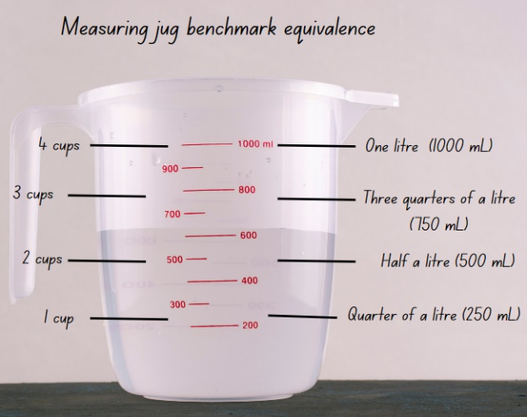

1. Revise formal units of measurement used to measure capacity. For example, litres and millilitres.
2. Display Resource 17 – Which unit? Ask students to explain their choice of measuring units to measure the capacity of each object (see Figure 12).

Figure 12 – Which unit? Answers

Answers to Which unit? What format would I use to measure this capacity? There are four images with their answers. 
Spoon: millilitres
Pool: litres
Milk jug: litres
Bottle: millilitres.


1. Display Resource 18 – capacity conversions. Discuss how to convert between millilitres and litres. Ask students to do simple mental conversions such as 2 L = 2000 mL and 7000 mL = 7 L.

**Note**: it is important that students understand the place value needed to convert between whole number (litres), and decimal representations (millilitres). For example, 1 mL = 0.001 L.

1. Model how to complete Resource 19 – equivalent capacities using decimal notation. See Figure 13. For example, 750 mL is the same as 0.750 L. Pour 5 cups into a container with a capacity of more than 1 L. At 4 cups, draw students' attention to 4 cups is the same as one litre or 1000 mL. Add the last cup and record the capacity as 1 L and 250 mL or 1250 mL. Ask students how this could be represented with decimal notation.

Figure 13 – teacher decimals recordings

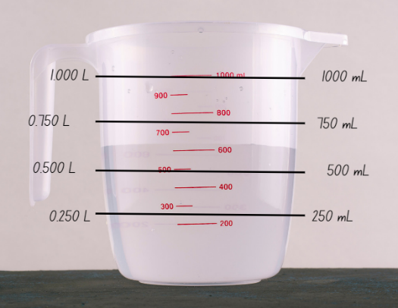

1. Model converting 1250 mL or 1 L and 250 mL to 1.250 L. Explain how the one here represents 1000 mL or one whole litre and the 250 after the decimal place represents 250 mL.

**Note**: some students may benefit from the use of a number slider to convert between millilitres and litres.

1. In small groups, students solve Resource 20 – capacity problems. Discuss answers with class, asking what strategies were most useful to help convert millilitres into litres?

This table details opportunities for differentiation.

|  |  |
| --- | --- |
| Too hard? | Too easy? |
| Students cannot recognise, interpret and/or record decimal notation to 3 decimal places for capacities.   * Support students further hands-on experience with exploring equivalent capacities. * Use MAB materials as in Lesson 6 Daily number sense with students to develop place value understanding of whole-number and decimal representations. | Students can recognise, interpret and record decimal notation to 3 decimal places for capacities.   * Students take one measurement and write it in standard and non-standard place value forms. * They compare their results with another student and discuss other ways to write it using non-standard place value forms. |

## Discuss and connect the mathematics –10 minutes

1. Revise place value to 3 decimal places and discuss what place the 7 represents in 3.758. Repeat for digits 3, 5, and 8.
2. Students answer the following questions on individual whiteboards:

* What is the place value of 7 in each of these numbers? 1.670, 0.700, 4.257 and 7.001.

This table details opportunities for assessment.

|  |  |
| --- | --- |
| Assessment opportunities | Links |
| What to look for:   * Can students recognise the equivalence of whole-number and decimal representations of measurements of capacities?  **[MAO-WM-01, MA3-3DS-02]** * Can students interpret and record decimal notation for capacities to 3 decimal places? **[MAO-WM-01, MA3-3DS-02]** * Can students indicate the place value of digits in decimal numbers of up to 3 decimal places? **[MAO-WM-01, MA3-RN-02]** | Links to [National Numeracy Learning Progressions](https://www.australiancurriculum.edu.au/resources/national-literacy-and-numeracy-learning-progressions/version-3-of-national-literacy-and-numeracy-learning-progressions/) (NNLP):   * NPV7, NPV8.   Links to suggested [Interview for Student Reasoning](https://education.nsw.gov.au/teaching-and-learning/curriculum/literacy-and-numeracy/assessment-resources/ifsr) (IfSR) tasks:   * **IfSR-PT**: 1A.5 * **IfSR-NP**: 4D.2, 4D.6. |

# Lesson 7

**Core concept**: metric units of measurement relate to our base-10 place value system.

## Daily number sense – measuring using decimal notation – 15 minutes

The table below contains a suggested learning intention and success criteria. These are best co-constructed with students.

|  |  |
| --- | --- |
| Daily number sense learning intention | Daily number sense success criteria |
| Students are learning to:   * recognise that the place value system can be extended beyond hundredths * compare, order and represent decimals. | Students can:   * express thousandths as decimals * interpret decimal notation for thousandths * compare and order decimal numbers of up to 3 decimal places. |

1. Show students the millimetre measurements on a ruler. Revise with students that there are 10 mm in one centimetre and 1000 millimetres in one metre. Explain that 1 mm is equal to 0.001 m, 10 mm is equal to 0.01 m (one centimetre) and 100 mm is equal to 0.1 m (10 centimetres).

**Note**: some students may benefit from the use of a number slider to convert between millimetres and metres.

1. Give students writing materials and a ruler. Students measure items around the room and record the millimetre measurement. Then they record the equivalent measurement in metres (see Figure 14).

Figure 14 – possible student recording

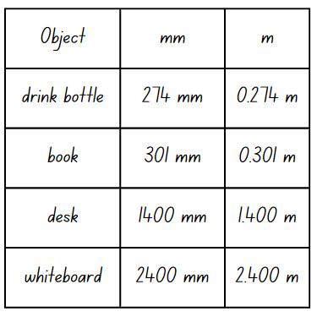

1. Once recording tables have been completed, students turn and talk. They discuss the items and their recorded measurements.
2. Ask students:

* What were the smallest and largest decimal notations you recorded? What were the items?
* Did anyone measure the same item as someone else and record a different measurement? If so, why do you think this may have happened?

1. Revise with students that because there are 1000 millimetres in one metre we read 0.301 m as 301 thousandths of a metre.

This table details opportunities for assessment.

|  |  |
| --- | --- |
| Assessment opportunities | Links |
| What to look for:   * Can students express thousandths as decimals?  **[MAO-WM-01, MA3-RN-02]** * Can students interpret decimal notation for thousandths?  **[MAO-WM-01, MA3-RN-02]** * Can students compare and order decimal numbers of up to 3 decimal places? **[MAO-WM-01, MA3-RN-02]** | Links to [National Numeracy Learning Progressions](https://www.australiancurriculum.edu.au/resources/national-literacy-and-numeracy-learning-progressions/version-3-of-national-literacy-and-numeracy-learning-progressions/) (NNLP):   * NPV7 * NPV8.   Links to suggested [Interview for Student Reasoning](https://education.nsw.gov.au/teaching-and-learning/curriculum/literacy-and-numeracy/assessment-resources/ifsr) (IfSR) tasks:   * **IfSR-PT**: 1A.5 * **IfSR-NP**: 4D.2, 4D.6. |

## Core lesson – drinks for a disco – 35 minutes

The table below contains suggested learning intentions and success criteria. These are best co-constructed with students.

|  |  |
| --- | --- |
| Core concept learning intentions | Core concept success criteria |
| Students are learning to:   * connect decimal representations to the metric system * compare, order and represent decimals. | Students can:   * recognise the equivalence of whole-number and decimal representations of measurements of capacities * interpret and record decimal notation for capacities to 3 decimal places * compare and order decimal numbers of up to 3 decimal places. |

1. Give pairs of students counters and a bingo card from Resource 21 – capacity decimals bingo.
2. Read Resource 22 – bingo clues one by one to students.
3. Students put a counter on the capacity that matches the clue. Students can only put one counter down at a time even if a clue matches more than one capacity. Students who can cover all their squares call out bingo.
4. After playing, discuss the clues and how they could relate to more than one capacity. Revise that the mathematical term for this is equivalence.
5. Explain to students that they will be organising the drinks for a Year 5 disco. There are 55 students in Year 5. Each student will have one 250 mL popper and one 600 mL water bottle. Ask students to solve and record these problems:

* How many litres of drink will be at the disco? Answer in decimal form.
* If 5 students do not come to the disco, how many litres are left over?
* If 10 students did not drink their popper, how many litres of juice are left over?

1. Discuss answers with class, asking what strategies they used to calculate the total amount of litres needed?
2. Model comparing and ordering 0.250 L, 2.25 L, 2.205 L from smallest to largest capacity.
3. Write the following capacities on the board for students to order from smallest to largest capacity.

* 3.300 L, 0.350 L, 2.35 L
* 2.000 L, 0.250 L, 0.750 L
* 0.7 L, 0.705 L, 0.75 L

1. Discuss orders with students, asking them to justify their thinking.

This table details opportunities for differentiation.

|  |  |
| --- | --- |
| Too hard? | Too easy? |
| Students cannot record and/or order capacity measurements to 3 decimal places.   * Use place value houses or a numeral card to help students develop place value understanding of whole-number and decimal representations. * Support students to order capacity measurements to one decimal place. | Students can record and order capacity measurements to 3 decimal places.   * Students create sets of capacity measurements to 3 decimal places. They swap with other students to order and discuss. |

## Consolidation and meaningful practice – 10 minutes

1. Show these problems to the class to solve:

* If everyone gets 100 mL of ice cream during a class party, how many tubs of 2 L ice cream will need to be bought?
* How much ice cream will be left over?

1. Discuss answers with class, asking:

* How could you buy the ice cream so there is no waste?
* What size tubs of ice cream could you buy? How do you know?

1. Ask students if they can think of other foods that are measured in litres and millimetres?

This table details opportunities for assessment.

|  |  |
| --- | --- |
| Assessment opportunities | Links |
| What to look for:   * Can students recognise the equivalence of whole-number and decimal representations of measurements of capacities?  **[MAO-WM-01, MA3-3DS-02]** * Can students interpret and record decimal notation for capacities to 3 decimal places? **[MAO-WM-01, MA3-3DS-02]** * Can students compare and order decimal numbers of up to 3 decimal places? **[MAO-WM-01, MA3-RN-02]** | Links to [National Numeracy Learning Progressions](https://www.australiancurriculum.edu.au/resources/national-literacy-and-numeracy-learning-progressions/version-3-of-national-literacy-and-numeracy-learning-progressions/) (NNLP):   * NPV9 * NPV8.   Links to suggested [Interview for Student Reasoning](https://education.nsw.gov.au/teaching-and-learning/curriculum/literacy-and-numeracy/assessment-resources/ifsr) (IfSR) tasks:   * **IfSR-PT**: 1A.5, 1A.7 * **IfSR-AT**: 4B.1 * **IfSR-NP**: 4B.2, 4D.6. |

# Lesson 8

**Core concept**: displacement occurs when exploring the volume of irregular solids.

## Daily number sense – 10 minutes

1. From a class need surfaced through formative assessment data, identify a short, focused activity that targets students’ knowledge, understanding and skills. Example activities may be drawn from the following resources:

* [Mathematics K–6 resources](https://education.nsw.gov.au/teaching-and-learning/curriculum/mathematics/mathematics-curriculum-resources-k-12/mathematics-k-6-resources.main-education--category---catalogue---key-learning-area---mathematics---thinking-mathematically.nameAsc.1.grid)
* [Universal Resources Hub](https://resources.education.nsw.gov.au/home).

## Core lesson – displacement – 40 minutes

The table below contains suggested learning intentions and success criteria. These are best co-constructed with students.

|  |  |
| --- | --- |
| Core concept learning intentions | Core concept success criteria |
| Students are learning to:   * use displacement to investigate volumes of irregular solids. | Students can:   * recognise that an object’s volume takes up space by observing the change in water level when an object is placed in a container of water * compare the volumes of 2 or more objects by marking the change in water level when each is submerged in a container. |

This activity is an adaptation of 'Calibrations' from [*Teaching measurement: Stage 2 and Stage 3* [PDF 686KB]](https://education.nsw.gov.au/content/dam/main-education/teaching-and-learning/curriculum/key-learning-areas/mathematics/media/documents/mathematics-s2-s3-teaching-measurement.pdf) by the State of New South Wales (Department of Education).

1. Revise litres and millilitres to measure and record capacities.
2. Read Mr Archimedes’ Bath. After reading, ask students to explain what they think the term displacement means.
3. Explain that displacement is the change in water level when an object is submerged.
4. Using a 1 L measuring jug, model and discuss how submerging an irregular object can be used to measure displacement in volume. See Figure 15.

Figure 15 – displaced object

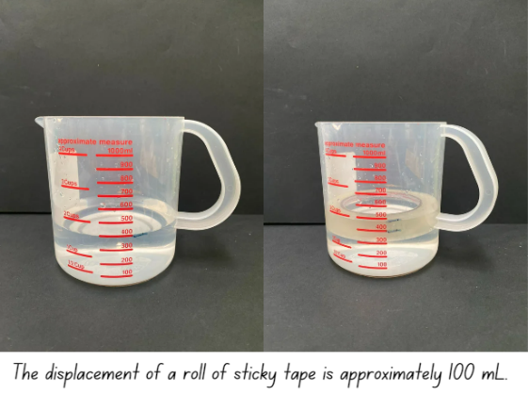

**Note**: objects will need to be fully submerged to measure displacement. A popsicle stick can be used to submerge the object.

1. Give small groups of students a measuring jug, whiteboard marker, popsicle stick and 3 solid irregular objects. For example, a glue stick, a hundreds block and a tennis ball.
2. Students submerge each object one at a time, marking, comparing and recording the changes in water level.
3. Students order the objects from smallest to largest volume, based on displacement tests.
4. Groups share findings with the class. For example, the glue stick has a smaller volume compared to the hundreds block, as the water level rose higher when the hundreds block was submerged.

This table details opportunities for differentiation.

|  |  |
| --- | --- |
| Too hard? | Too easy? |
| Students cannot recognise and/or compare the volume of objects using displacement.   * Model marking the level of water in a container before and after displacement. * Support students to record and compare displacement. | Students can recognise and compare the volume of objects using displacement.   * Students write displacement problems. For example, 2 glue sticks displaced 50 mL of water so how much water did each glue stick displace? * Students swap and solve problems. |

## Consolidation and meaningful practice – 10 minutes

1. Display these problems to students to solve:

* If Xiang submerges 5 glue sticks in a bucket and it displaces 500 mL of water. How much water does each glue stick displace?
* If 20 dice displaces 100 mL of water, how much water does each dice displace?

This table details opportunities for assessment.

|  |  |
| --- | --- |
| Assessment opportunities | Links |
| What to look for:   * Can students recognise that an object’s volume takes up space by observing the change in water level when an object is placed in a container of water? **[MAO-WM-01, MA3-3DS-02]** * Can students compare the volumes of 2 or more objects by marking the change in water level when each is submerged in a container? **[MAO-WM-01, MA3-3DS-02]** | Links to [National Numeracy Learning Progressions](https://www.australiancurriculum.edu.au/resources/national-literacy-and-numeracy-learning-progressions/version-3-of-national-literacy-and-numeracy-learning-progressions/) (NNLP):   * N/A. |

# Resource 1 – decimal cards

|  |  |  |  |  |  |  |
| --- | --- | --- | --- | --- | --- | --- |
| 1.50 | 1.20 | 1.99 | 1.10 | 0.80 | 0.10 | 1.40 |
| 1.80 | 1.25 | 0.20 | 1.494 | 0.75 | 1.90 | 0.025 |
| 1.60 | 0.125 | 0.50 | 0.20 | 1.55 | 0.90 | 1.429 |
| 0.70 | 0.089 | 1.70 | 0.02 | 0.170 | 1.804 | 1.125 |
| 1.075 | 0.25 | 0.60 | 0.909 | 0.375 | 1.30 | 1.75 |

# Resource 2 – Guess what?

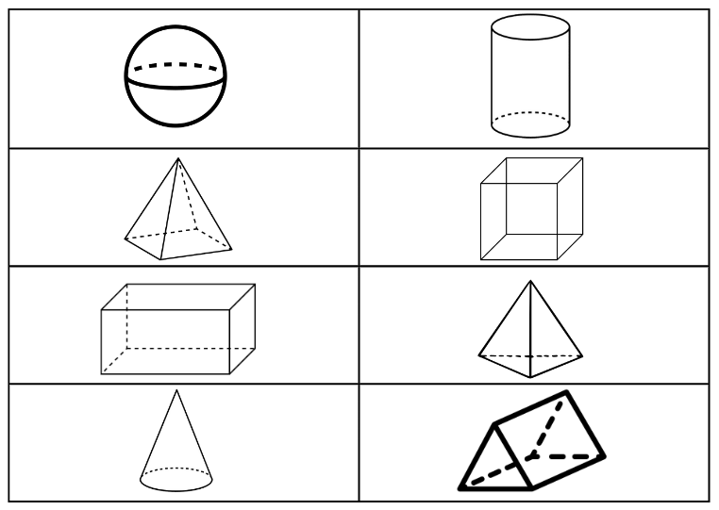

# Resource 3 – 3D bingo

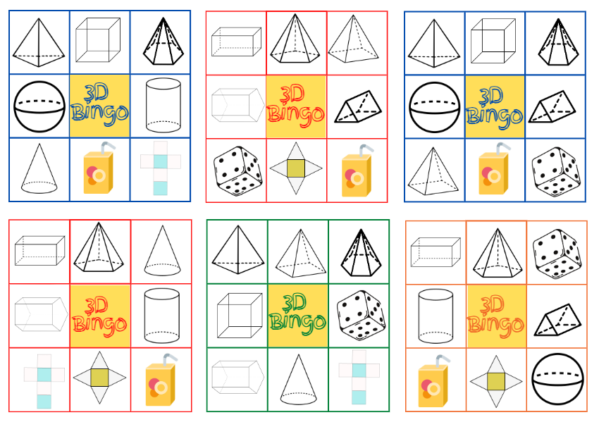

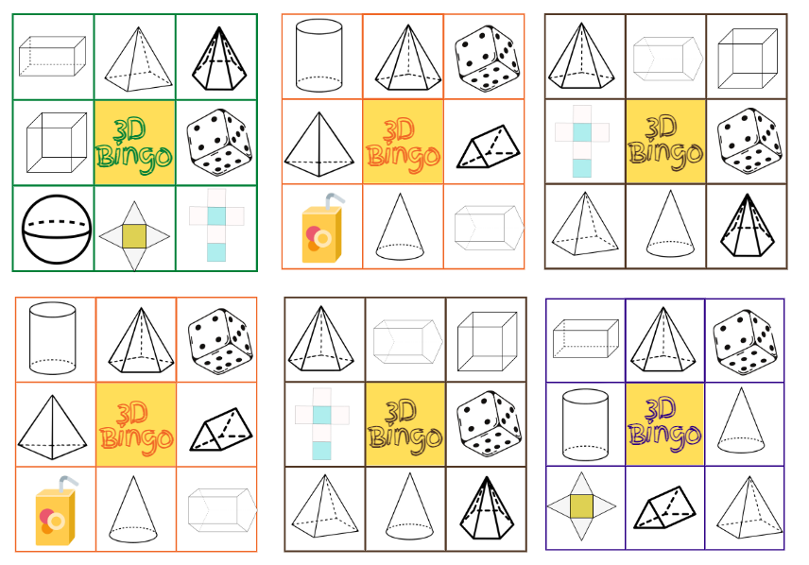

# Resource 4 – 3D bingo cards

|  |  |  |  |
| --- | --- | --- | --- |
| I have 2 triangular faces. | I have a hexagonal base. | I have rectangular faces. | I have 12 edges. |
| I have a curved surface. | I have 5 vertices. | I have 8 vertices. | I have 8 edges. |
| I have 6 vertices. | I have 0 vertices. | I have 10 vertices. | I have 0 faces. |

|  |  |  |  |
| --- | --- | --- | --- |
| I have 5 faces. | I have 6 faces. | I have one curved boundary. | I have 9 edges. |
| I have 2 curved surfaces. | I have equal faces. | I have an apex. | I have 15 edges. |
| I have 2 pentagonal bases. | I have 4 triangular faces. | I have one square face. | I have 10 edges. |

# Resource 5 – decimals with zeros

|  |  |  |  |  |
| --- | --- | --- | --- | --- |
| 0.150 | 0.390 | 0.602 | 0.209 | 0.375 |
| 0.005 | 0.750 | 0.500 | 0.025 | 0.904 |
| 0.050 | 0.250 | 0.505 | 0.001 | 0.650 |
| 0.710 | 0.470 | 0.800 | 0.010 | 0.075 |

# Resource 6 – sketch and label

|  |  |  |  |  |  |  |
| --- | --- | --- | --- | --- | --- | --- |
| Top view | Front view | Side view | Name | Number of edges | Number of vertices | Number of faces |
|  |  |  |  |  |  |  |
|  |  |  |  |  |  |  |
|  |  |  |  |  |  |  |
|  |  |  |  |  |  |  |
|  |  |  |  |  |  |  |
|  |  |  |  |  |  |  |

# Resource 7 – decimal flash cards

|  |  |  |  |  |
| --- | --- | --- | --- | --- |
| 0.254 | 0.189 | 0.790 | 0.551 | 0.722 |
| 0.265 | 0.519 | 0.570 | 0.524 | 0.730 |
| 0.583 | 0.270 | 0.758 | 0.492 | 0.749 |
| 0.703 | 0.761 | 0.537 | 0.281 | 0.767 |
| 0.598 | 0.293 | 0.784 | 0.549 | 0.670 |

# Resource 8 – square pyramid nets

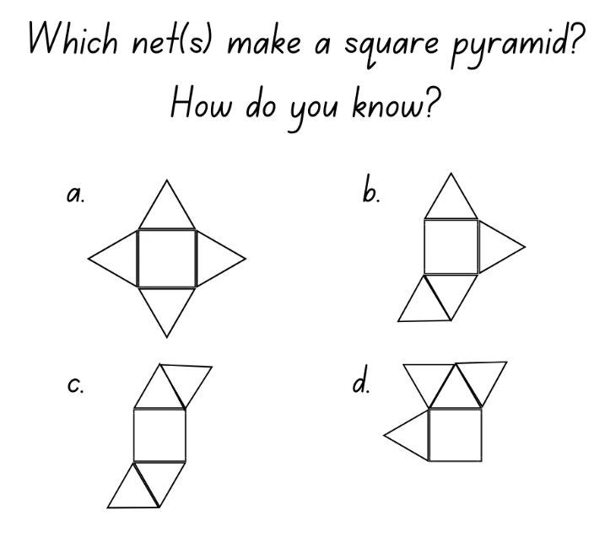

# Resource 9 – rectangular prism nets

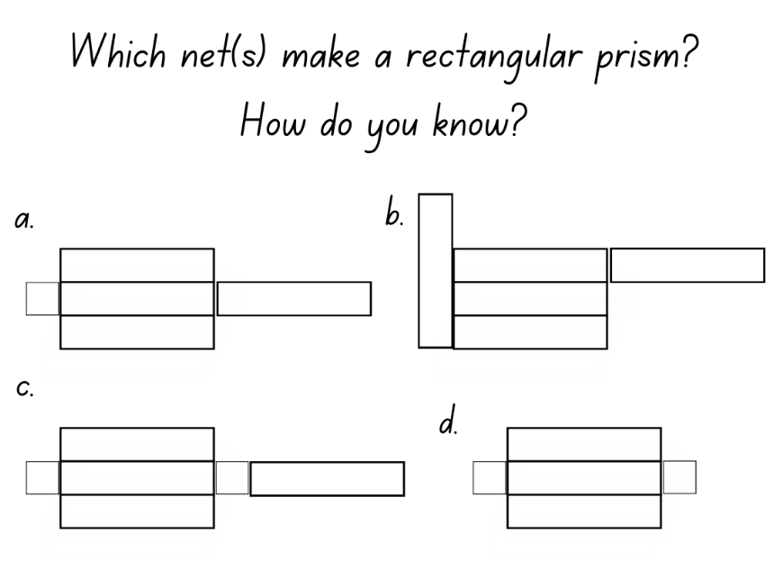

# Resource 10 – Venn diagram

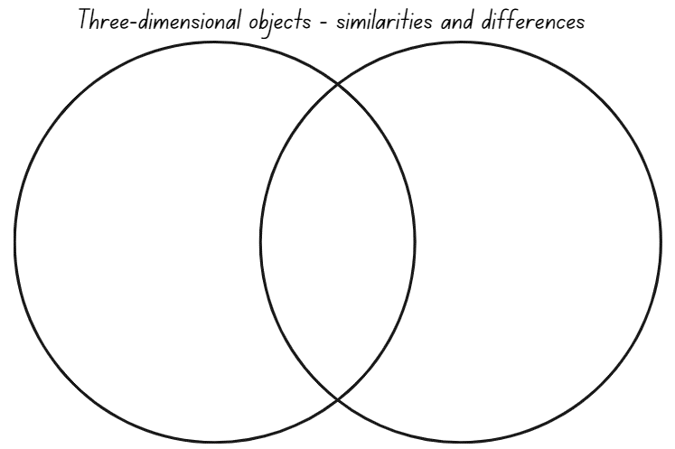

# Resource 11 – cut cube nets

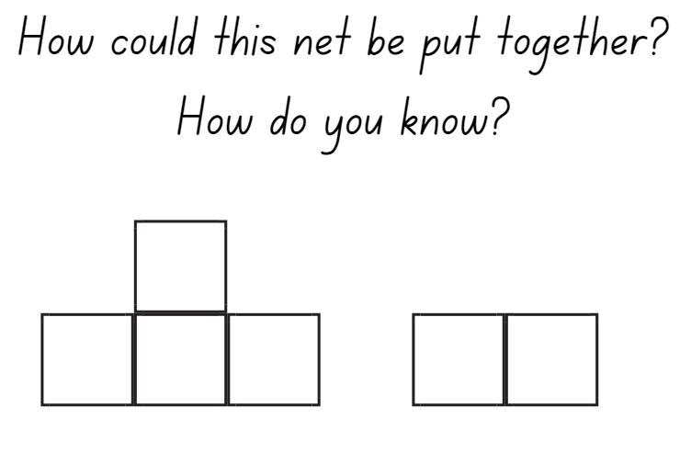

# Resource 12 – match my net

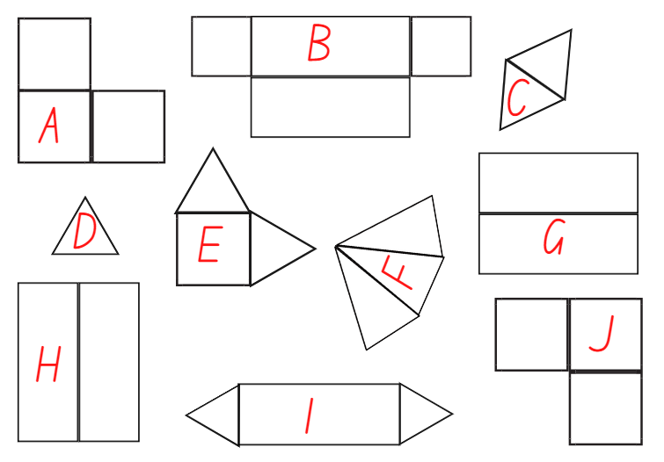

# Resource 13 – What’s my unit?

A set of cards with questions.

Each card has the same question: Which unit of measurement would I use to measure the capacity of this container?
How do you know?

The images on each card is different. The first card has a tomato sauce bottle, the second a tube of toothpaste, the third a juice box and the fourth a bottle of milk.

# Resource 14 – capacity cards

|  |  |  |  |  |  |  |  |  |
| --- | --- | --- | --- | --- | --- | --- | --- | --- |
| **100 mL** |  | **500 mL** |  | **1500 mL** |  | **10 mL** |  | **0.100 L** |
|  |  |  |  |  |  |  |  |  |
| **1000 mL** |  | **250 mL** |  | **1 L** |  | **2000 mL** |  | **1.000 L** |
|  |  |  |  |  |  |  |  |  |
| **700 mL** |  | **3 quarters of a litre** |  | **1.5 litres** |  | **Half a litre** |  | **0.750 L** |

|  |  |  |  |  |  |  |  |  |
| --- | --- | --- | --- | --- | --- | --- | --- | --- |
| **18 mL** |  | **3 litres** |  | **3 cups** |  | **750 mL** |  | **0.5 L** |
|  |  |  |  |  |  |  |  |  |
| **4 cups** |  | **1 cup** |  | **150 mL** |  | **2 cups** |  | **0.250 L** |
|  |  |  |  |  |  |  |  |  |
| **300 mL** |  | **700 mL** |  | **40 mL** |  | **1300 mL** |  | **1.3 L** |

# Resource 15 – equivalent capacity

**What is my equivalent measurement?**

|  |  |  |
| --- | --- | --- |
| **Half a litre** |  | **0.75 L** |
|  |  |  |
| **750 mL** |  | **Three quarters of a litre** |
|  |  |  |
| **Quarter of a litre** |  | **250 mL** |
|  |  |  |
| **0.25 mL** |  | **0.5 L** |
|  |  |  |
| **One litre** |  | **2 cups** |
|  |  |  |
| **500 mL** |  | **1000 mL** |

# Resource 16 – estimate and measure

|  |  |  |  |
| --- | --- | --- | --- |
| Container | Estimate | Revised estimate | Measure |
| **1** |  |  |  |
| **2** |  |  |  |
| **3** |  |  |  |

# Resource 17 – Which unit?

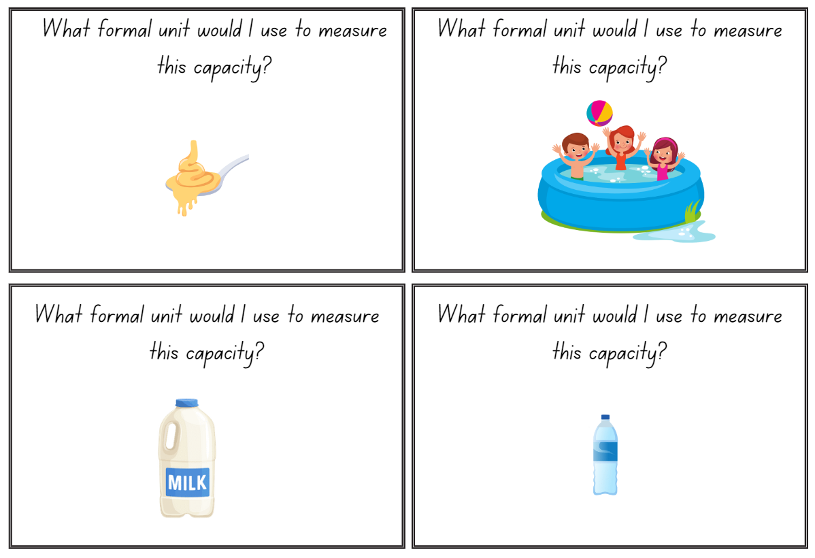

# Resource 18 – capacity conversions

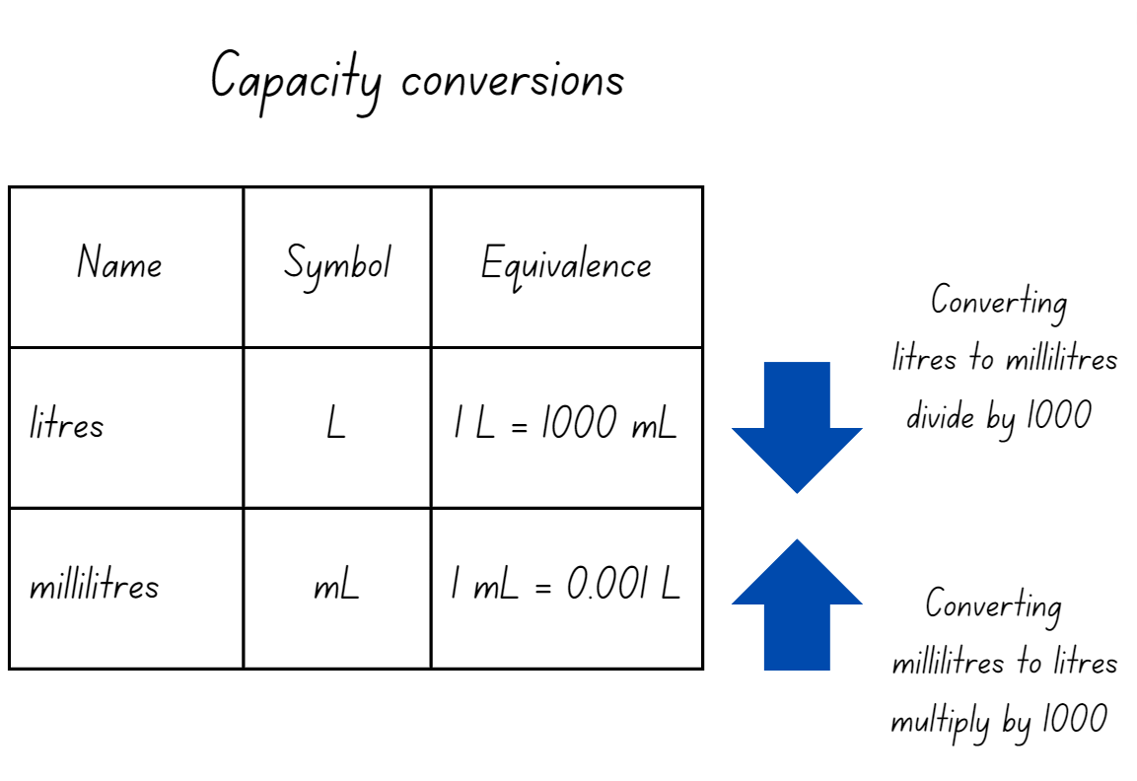

# Resource 19 – equivalent capacities

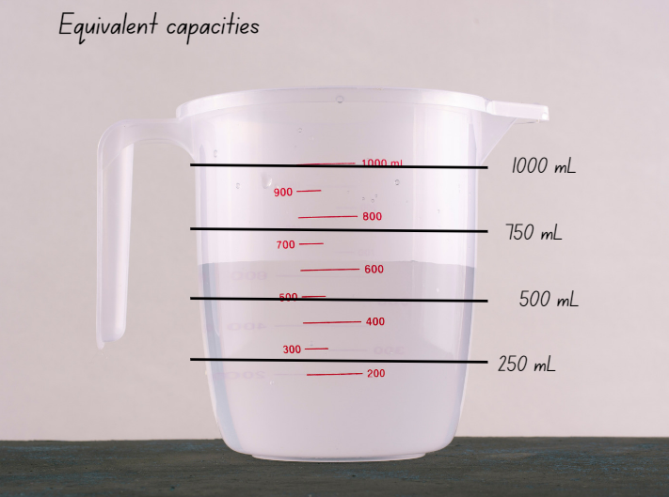

# Resource 20 – capacity problems

A set of capacity problems.

Problem 1: Linda is organising drinks for her friends. She needs one litre of soft drink 750 mL of orange
juice and 300 mL of milk. How many litres of drink does Linda need to organise? Answer using decimal notation.

Problem 2: Sarah goes to the shop and buys 6 bottles of 1.25 L soft drink. How many litres of soft drink 
did she buy? Answer using decimal notation.

Problem 3: Amy has a tap that is leaking 300 mL an hour. How much water has leaked after 6 hours?  Answer using decimal notation.

# Resource 21 – capacity decimals bingo

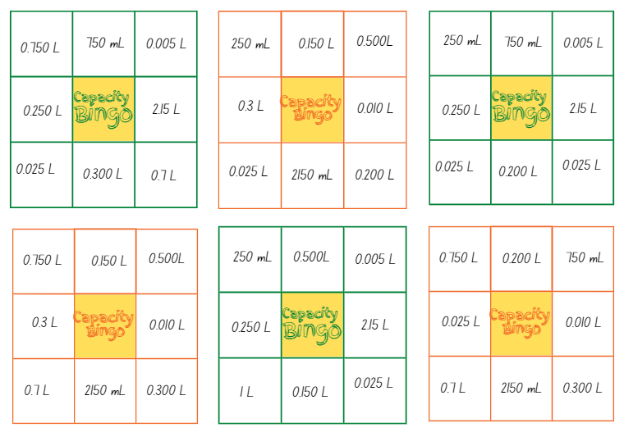

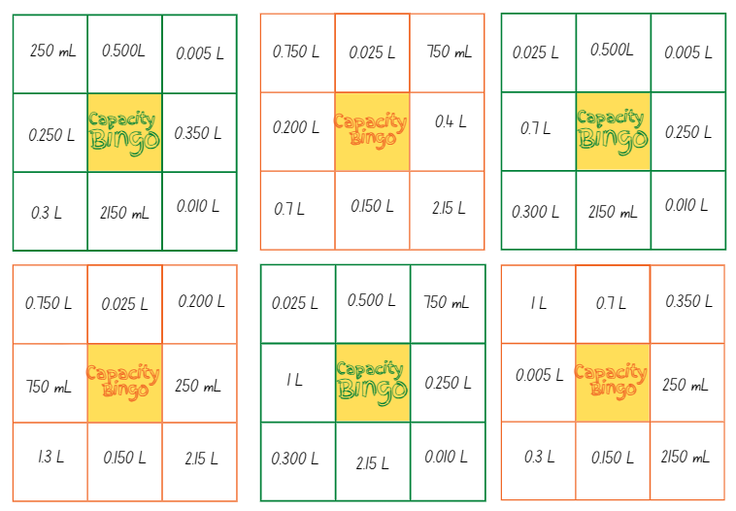

# Resource 22 – bingo clues

|  |  |  |
| --- | --- | --- |
| I am used to show 750 mL | I am used to show half a litre | I am used to show 100 mL |
| I am used to show 300 mL | I am used to show 25 mL | I am used to show 2 cups |
| I am used to show 2 L and 150 mL | I am used to show 10 mL | I am used to show 250 mL |
| I am used to show 5 mL | I am used to show 150 mL | I am used to show 700 mL |
| I am used to show 200 mL | I am used to show 1 L and 300 mL | I am used to show 4 cups |
| I am used to show 350 mL | I am used to show 3 cups | I am used to show 400 mL |
| I am used to show 750 mL | I am used to show half a litre | I am used to show 100 mL |

# Syllabus outcomes and content

The table below outlines the [syllabus outcomes](https://curriculum.nsw.edu.au/learning-areas/mathematics/mathematics-k-10-2022/overview) and range of relevant syllabus content covered in this unit. Content is linked to [National Numeracy Learning Progression](https://www.australiancurriculum.edu.au/resources/national-literacy-and-numeracy-learning-progressions/version-3-of-national-literacy-and-numeracy-learning-progressions/) version (3).

|  |  |  |  |  |  |  |  |  |
| --- | --- | --- | --- | --- | --- | --- | --- | --- |
| Outcomes and content | 1 | 2 | 3 | 4 | 5 | 6 | 7 | 8 |
| **Represents numbers A**: Decimals and percentages: Recognise that the place value system can be extended beyond hundredths  **[MAO-WM-01, MA3-RN-01, MA3-RN-02]** |  |  |  |  |  |  |  |  |
| * Express thousandths as decimals |  |  |  |  | x |  | x |  |
| * Interpret decimal notation for thousandths |  |  |  |  |  |  | x |  |
| * Indicate the place value of digits in decimal numbers of up to 3 decimal places |  |  |  |  | x | x |  |  |
| * Use place value to partition decimals |  | x |  |  | x | x |  |  |
| **Represents numbers A**: Decimals and percentages: Compare, order and represent decimals  **[MAO-WM-01, MA3-RN-01, MA3-RN-02]** |  |  |  |  |  |  |  |  |
| * Compare and order decimal numbers of up to 3 decimal places | x | x |  |  |  |  | x |  |
| * Interpret zero digit(s) at the end of a decimal |  |  |  |  |  | x |  |  |
| * Approximate the size of decimals |  |  | x |  |  |  |  |  |
| * Place decimal numbers of up to 3 decimal places on a number line | x |  |  |  |  |  |  |  |
| **Three-dimensional spatial structure A**: 3D objects: Compare, describe and name prisms and pyramids  **[MAO-WM-01, MA3-3DS-01]** |  |  |  |  |  |  |  |  |
| * Compare properties of prisms and pyramids | x |  | x |  |  |  |  |  |
| * Name prisms and pyramids according to the shape of their base | x |  | x |  |  |  |  |  |
| **Three-dimensional spatial structure A**: 3D objects: Connect three-dimensional objects with two-dimensional representations  **[MAO-WM-01, MA3-3DS-01]** |  |  |  |  |  |  |  |  |
| * Visualise and sketch three-dimensional objects from different views, including top, front and side views (Reasons about spatial orientation) |  | x |  |  |  |  |  |  |
| * Examine a diagram to determine whether it is or is not the net of a closed three-dimensional object |  |  |  | x |  |  |  |  |
| * Visualise and sketch nets for given three-dimensional objects |  |  | x | x |  |  |  |  |
| * Visualise and name prisms and pyramids, given representations of their nets (Reasons about spatial visualisation) |  |  |  | x |  |  |  |  |
| **Three-dimensional spatial structure A**: Volume: Choose appropriate units of measurement for capacity  **[MAO-WM-01, MA3-3DS-02]** |  |  |  |  |  |  |  |  |
| * Select and use appropriate units to measure the capacities of a variety of containers |  |  |  |  | x |  |  |  |
| **Three-dimensional spatial structure A**: Volume: Use displacement to investigate volumes of irregular solids  **[MAO-WM-01, MA3-3DS-02]** |  |  |  |  |  |  |  |  |
| * Recognise that an object’s volume takes up space by observing the change in water level when an object is placed in a container of water |  |  |  |  |  |  |  | x |
| * Compare the volumes of 2 or more objects by marking the change in water level when each is submerged in a container |  |  |  |  |  |  |  | x |
| **Three-dimensional spatial structure A**: Volume: Connect decimal representations to the metric system  **[MAO-WM-01, MA3-3DS-02]** |  |  |  |  |  |  |  |  |
| * Recognise the equivalence of whole-number and decimal representations of measurements of capacities |  |  |  |  | x | x | x |  |
| * Interpret decimal notation for capacities |  |  |  |  |  | x | x |  |
| * Record measurements to 3 decimal places |  |  |  |  |  | x | x |  |
| **Three-dimensional spatial structure B**: 3D objects: Construct prisms and pyramids  **[MAO-WM-01, MA3-3DS-01]** |  |  |  |  |  |  |  |  |
| * Create skeletal models of prisms and pyramids |  | x |  |  |  |  |  |  |
| * Construct three-dimensional models of prisms and pyramids, given drawings of different views |  | x |  |  |  |  |  |  |

[Mathematics K–10 Syllabus](https://curriculum.nsw.edu.au/learning-areas/mathematics/mathematics-k-10-2022/overview) © NSW Education Standards Authority (NESA) for and on behalf of the Crown in right of the State of New South Wales, 2022.

# References

This resource contains NSW Curriculum and syllabus content. The NSW Curriculum is developed by the NSW Education Standards Authority. This content is prepared by NESA for and on behalf of the Crown in right of the State of New South Wales. The material is protected by Crown copyright.

Please refer to the NESA Copyright Disclaimer for more information <https://educationstandards.nsw.edu.au/wps/portal/nesa/mini-footer/copyright>.

NESA holds the only official and up-to-date versions of the NSW Curriculum and syllabus documents. Please visit the NSW Education Standards Authority (NESA) website <https://educationstandards.nsw.edu.au/wps/portal/nesa/home> and the NSW Curriculum website <https://curriculum.nsw.edu.au>.

[Mathematics K–10 Syllabus](https://curriculum.nsw.edu.au/learning-areas/mathematics/mathematics-k-10-2022/overview) © NSW Education Standards Authority (NESA) for and on behalf of the Crown in right of the State of New South Wales, 2022.

[National Numeracy Learning Progression](https://www.australiancurriculum.edu.au/resources/national-literacy-and-numeracy-learning-progressions/version-3-of-national-literacy-and-numeracy-learning-progressions/) © Australian Curriculum, Assessment and Reporting Authority (ACARA) 2010 to present, unless otherwise indicated. This material was downloaded from the [Australian Curriculum](http://www.australiancurriculum.edu.au/) website (National Numeracy Learning Progression) (accessed 1 September 2023) and was not modified.

Allen P (2020) *Mr Archimedes’ Bath*, HarperCollins Children's Books, Australia.

Friedman M (2018) *A history of folding in mathematics: A mathematization of the margins*, Birkhäuser, Basel.

National Council of Teachers of Mathematics (n.d.) [*Cube Nets*](https://www.nctm.org/Classroom-Resources/Illuminations/Interactives/Cube-Nets/), NCTM website, accessed 20 December 2023.

State of New South Wales (Department of Education) (2017) ‘Calibrations’, in [*Teaching measurement: Stage 2 and Stage 3* [PDF 686KB]](https://education.nsw.gov.au/content/dam/main-education/teaching-and-learning/curriculum/key-learning-areas/mathematics/media/documents/mathematics-s2-s3-teaching-measurement.pdf), NSW Department of Education Learning and Teaching Directorate, accessed 19 December 2023.

State of New South Wales (Department of Education) (2023) [*Identifies, represents and compares decimals*](https://resources.education.nsw.gov.au/detail/NPV-44), Universal Resource Hub website, accessed 27 November 2023.

University of Cambridge (n.d.) [*Cut Nets?*](https://nrich.maths.org/2315),NRICH website, accessed 19 December 2023.

University of Cambridge (n.d.) [*Guess What?*](https://nrich.maths.org/14777), NRICH website, accessed 19 December 2023.

**© State of New South Wales (Department of Education), 2023**

The copyright material published in this resource is subject to the Copyright Act 1968 (Cth) and is owned by the NSW Department of Education or, where indicated, by a party other than the NSW Department of Education (third-party material).

Copyright material available in this resource and owned by the NSW Department of Education is licensed under a [Creative Commons Attribution 4.0 International (CC BY 4.0) license](https://creativecommons.org/licenses/by/4.0/).

[](https://creativecommons.org/licenses/by/4.0/)

This license allows you to share and adapt the material for any purpose, even commercially.

Attribution should be given to © State of New South Wales (Department of Education), 2023.

Material in this resource not available under a Creative Commons license:

* the NSW Department of Education logo, other logos and trademark-protected material
* material owned by a third party that has been reproduced with permission. You will need to obtain permission from the third party to reuse its material.

**Links to third-party material and websites**

Please note that the provided (reading/viewing material/list/links/texts) are a suggestion only and implies no endorsement, by the New South Wales Department of Education, of any author, publisher, or book title. School principals and teachers are best placed to assess the suitability of resources that would complement the curriculum and reflect the needs and interests of their students.

If you use the links provided in this document to access a third-party's website, you acknowledge that the terms of use, including licence terms set out on the third-party's website apply to the use which may be made of the materials on that third-party website or where permitted by the Copyright Act 1968 (Cth). The department accepts no responsibility for content on third-party websites.