Mathematics Stage 3 Year A – Unit 10

Contents
Unit description and duration 6
Syllabus outcomes 6
Working mathematically 7
Student prior learning 7
Lesson overview and resources 9
Lesson 1 14
Daily number sense – ordering fractions – 10 minutes 14
Core lesson part 1 – taking turns – 15 minutes 15
Core lesson part 2 – making turns – 25 minutes 18
Discuss and connect the mathematics – 10 minutes 19
Lesson 2 21
Daily number sense – rolling fractions – 10 minutes 21
Core lesson part 1 – a numberless protractor – 15 minutes 22
Core lesson part 2 – measuring with a protractor – 25 minutes 25
Discuss and connect the mathematics – 10 minutes 26
Lesson 3 28
Daily number sense – fractions and minutes – 10 minutes 28
Core lesson part 1 – using a protractor – 20 minutes 29
Core lesson part 2 – measuring angles – 20 minutes 31
Discuss and connect the mathematics – 10 minutes 32
Lesson 4 34
Daily number sense – 10 minutes 34
Core lesson part 1 – angles in art – 20 minutes 34
Core lesson part 2 – mountain bike geometry – 30 minutes 35
Discuss and connect the mathematics – 10 minutes 37
Lesson 5 39
Daily number sense – closest to zero – 10 minutes 39
Core lesson part 1 – time talk – 10 minutes 41
Core lesson part 2 – 24-hour time – 30 minutes 42
Discuss and connect the mathematics – 10 minutes 44
Lesson 6 46
Daily number sense – multistep problems – 10 minutes 46
Core lesson part 1 – 24-hour time – 10 minutes 47
Core lesson part 2 – 24-hour time tools – 20 minutes 49
Discuss and connect the mathematics – 20 minutes 50
Lesson 7 52
Daily number sense – which strategy? – 10 minutes 52
Core lesson part 1 – timetables – 15 minutes 53
Core lesson part 2 – television tonight – 25 minutes 55
Discuss and connect the mathematics – 10 minutes 56
Consolidation and meaningful practice – 10 minutes 57
Lesson 8 58
Daily number sense – 10 minutes 58
Core lesson part 1 – an astronaut’s day – 15 minutes 58
Core lesson part 2 – ISS mission control – 10 minutes 60
Core lesson part 3 – ISS group work – 25 minutes 60
Discuss and connect the mathematics – 10 minutes 61
Resource 1 – fractions 64
Resource 2 – angle categories 65
Resource 3 – angle identifiers 66
Resource 4 – angle instructions 1 67
Resource 5 – angle instructions 2 68
Resource 6 – a numberless protractor 69
Resource 7 – angle investigation 1 70
Resource 8 – angle investigation 2 71
Resource 9 – fraction line 72
Resource 10 – using a protractor 73
Resource 11 – angle hunt 74
Resource 12 – measuring angles 75
Resource 13 – angles in art 76
Resource 14 – mountain bike geometry 77
Resource 15 – angles in engineering 78
Resource 16 – time talk 1 79
Resource 17 – 12- and 24-hour time 80
Resource 18 – converting times 81
Resource 19 – time talk 2 82
Resource 20 – timeline 83
Resource 21 – time problems 84
Resource 22 – train timetable 86
Resource 23 – television tonight 87
Resource 24 – lemonade stand 88
Resource 25 – International Space Station 89
Resource 26 – 24-hour bar model 90
Resource 27 – ISS mission briefing 1 91
Resource 28 – ISS mission briefing 2 92
Resource 29: ISS mission briefing 3 93
Syllabus outcomes and content 94
References 98

Unit description and duration
This unit introduces the big idea that angles are the primary structural component of many shapes.
In this 2-week unit students are provided opportunities to:
- estimate and describe the size of angles using known angles as benchmarks
- estimate, measure and compare angles using degrees
- compare 12- and 24-hour time systems and convert between them.

Syllabus outcomes
- MAO-WM-01 develops understanding and fluency in mathematics through exploring and connecting mathematical concepts, choosing and applying mathematical techniques to solve problems, and communicating their thinking and reasoning coherently and clearly
- MA3-AR-01 selects and applies appropriate strategies to solve addition and subtraction problems
- MA3-RQF-01 compares and orders fractions with denominators of 2, 3, 4, 5, 6, 8 and 10
- MA3-RQF-02 determines $\frac{1}{2}$, $\frac{1}{4}$, $\frac{1}{5}$ and $\frac{1}{10}$ of measures and quantities
- MA3-GM-03 measures and constructs angles, and identifies the relationships between angles on a straight line and angles at a point
- MA3-NSM-02 measures and compares duration, using 12- and 24-hour time and am and pm notation

Working mathematically
In the Mathematics K–10 Syllabus, there is one overarching Working mathematically outcome (MAO-WM-01). The Working mathematically processes should be embedded within the concepts being taught. The Working mathematically processes present in the Mathematics K–10 Syllabus are:
- communicating
- understanding and fluency
- reasoning
- problem solving.
Mathematics K–10 Syllabus © NSW Education Standards Authority (NESA) for and on behalf of the Crown in right of the State of New South Wales, 2022.

Student prior learning
Before engaging in these teaching and learning activities, students would benefit from prior experience with:
- describing angles in comparison to quarter-turns as acute, right, obtuse, straight, reflex or a revolution
- recognising and describe angles as less than, equal to, about the same as or greater than a right angle
- representing and interpret digital time displays.
In NSW classrooms there is a diverse range of students, including Aboriginal students, students learning English as an additional language or dialect, high potential and gifted students and students with disability. Some students may identify with more than one of these groups or possibly all of them. Refer to Curriculum planning for every student – advice for further information.

Lesson overview and resources
The table below outlines the sequence and approximate timing of lessons, learning intentions and resources.
Lesson | Content | Duration and resources
Lesson 1  Daily number sense learning intention:  - compare and order common fractions. | Lesson core concept: angles are used as a measure of turn.  Core concept learning intention:  - estimate, measure and compare angles using degrees. | Lesson duration: 60 minutes  - Resource 1 – fractions  - Resource 2 – angle categories  - Resource 3 – angle identifiers  - Resource 4 – angle instructions 1  - Resource 5 – angle instructions 2  - Writing materials
Lesson 2  Daily number sense learning intention:  - compare and order common fractions. | Lesson core concept: angles are a measure of ‘opening’ between fixed arms.  Core concept learning intention:  - estimate, measure and compare angles using degrees. | Lesson duration: 60 minutes  - Resource 6: – a numberless protractor  - Resource 7 – angle investigation 1  - Resource 8 – angle investigation 2  - 10-sided dice  - Writing materials
Lesson 3  Daily number sense learning intention:  - compare and order common fractions. | Lesson core concept: angles can be estimated, measured and compared to organise our world.  Core concept learning intention:  - estimate, measure and compare angles using degrees. | Lesson duration: 60 minutes  - Resource 9 – fraction line  - Resource 10 – using a protractor  - Resource 11 – angle hunt  - Resource 12 – measuring angles  - Protractors  - Writing materials
Lesson 4  Daily number sense learning intention:  - teacher-identified task based on student needs. | Lesson core concept: angles can be measured to solve problems in our world.  Core concept learning intention:  - estimate, measure and compare angles using degrees. | Lesson duration: 70 minutes  - Resource 10 – using a protractor  - Resource 13 – angles in art  - Resource 14 – mountain bike geometry  - Resource 15 – angles in engineering  - Protractors  - Writing materials
Lesson 5  Daily number sense learning intention:  - apply efficient mental and written strategies to solve addition and subtraction problems. | Lesson core concept: 12- and 24-hour time systems are both used to measure the length of time.  Core concept learning intention:  - compare 12- and 24-hour time systems and convert between them. | Lesson duration: 60 minutes  - Resource 16: – time talk 1  - Resource 17 – 12- and 24-hour time  - Resource 18 – converting times  - 9-sided dice  - Writing materials
Lesson 6  Daily number sense learning intention:  - apply efficient mental strategies to solve addition and subtraction problems. | Lesson core concept: clocks are complex measuring tools.  Core concept learning intention:  - compare 12- and 24-hour time systems and convert between them. | Lesson duration: 60 minutes  - Resource 17 – 12- and 24-hour time  - Resource 19 – time talk 2  - Resource 20 – timeline  - Resource 21 – time problems  - Writing materials
Lesson 7  Daily number sense learning intention:  - apply efficient mental and written strategies to solve addition and subtraction problems. | Lesson core concept: timetables are an efficient way to communicate and organise lengths of time.  Core concept learning intention:  - compare 12-hour and 24-hour time systems and convert between them. | Lesson duration: 70 minutes  - Resource 17 – 12- and 24-hour time  - Resource 22 – train timetable  - Resource 23 – television tonight  - Resource 24 – lemonade stand  - Writing materials
Lesson 8  Daily number sense learning intention:  - teacher-identified task based on student needs. | Lesson core concept: quantities of time are often partitioned into common fractional lengths, such as halves and quarters.  Core concept learning intentions:  - solve problems involving addition and subtraction of fractions with the same denominator  - compare 12- and 24-hour time systems and convert between them. | Lesson duration: 70 minutes  - Resource 25 – International Space Station  - Resource 26 – 24-hour bar model  - Resource 27 – ISS mission briefing 1  - Resource 28 – ISS mission briefing 2  - Resource 29 – ISS mission briefing 3  - Writing materials

Lesson 1
Core concept: angles are used as a measure of turn.

Daily number sense – ordering fractions – 10 minutes
Daily number sense activities for Lessons 1 to 3 ‘activate’ prior number knowledge and support the learning of new content in the unit. These activities can also assist teachers to identify the starting points for learning by revealing the extent of students’ existing knowledge.
The table below contains a suggested learning intention and success criteria. These are best co-constructed with students.
Daily number sense learning intention | Daily number sense success criteria
Students are learning to:  - compare and order common fractions. | Students can:  - compare and order unit fractions with denominators of 2, 3, 4, 5, and 8 by placing them on a number line.
- Provide students with Resource 1 – fractions. Students place the fractions in the correct place on the number line.
- Students then add any other common fractions to the number line that they know. For example, $\frac{1}{6}$.
- Select students to share and explain the placement of the fractions.
This table details opportunities for assessment.
Assessment opportunities | Links
What to look for:  - Can students compare and order fractions with denominators of 2, 3, 4, 5, and 8 by placing them on a number line?  [MAO-WM-01, MA3-RQF-01] | Links to National Numeracy Learning Progressions (NNLP):  - InF6.

Core lesson part 1 – taking turns – 15 minutes
The table below contains a suggested learning intention and success criteria. These are best co-constructed with students.
Core concept learning intentions | Core concept success criteria
Students are learning to:  - estimate, measure and compare angles using degrees. | Students can:  - identify the arms and vertex of an angle where both arms are invisible, such as rotations  - explain how a protractor is formed and used to measure an angle  - estimate and describe the size of angles using known angles as benchmarks.
- Revise that an angle is the amount of turn between 2 straight arms. The arms are joined at a vertex.
- Ask students to stand up and all face the same direction.
- Explain that they will be making some turns.
- Give students the following instructions:
- make a half turn to the right
- make a quarter turn to the left, then another quarter turn to the left
- make a 3-quarter turn to the right
- make half of a quarter turn to the left.
- Ask students:
- What instruction will bring you all back to facing the front again?
- How could you describe the half of a quarter turn? (It is an acute angle, half a right angle, an eighth turn or a 45-degree angle).
- Can the amount of turn be described even if both arms are invisible?
- Display Resource 2 – angle categories and revise the angles and their names that students learnt about previously. Remind students that not all angles have arms that can be seen, sometimes they are invisible. For example, in this activity the amount of turn could be shown by comparing the starting and finishing position of each student.
- Explain that students can make a simple mathematical tool to help identify which category an angle belongs to. Provide students with a circle from Resource 3 – angle identifiers and say that they will be making an angle identifier.
- Support students to see that when:
- folded in half it creates a straight angle.
- folded in half again (quarters) it creates a right angle.
- folded in half again (eighths) it creates an acute angle.
- unfolded, the creases can be used to make the arms of different sized angles.
- Students shade and label segments of their angle identifier to represent each of the different sized angles. Students can add other information to it over the next few lessons.
- Demonstrate how the angle identifier can be used to test or compare the size of angles. For example, when it is folded up students can place it on the corner of a shape to compare its size to the angle they are testing.
- Explain that another way the angle identifier can be used is by unfolding it and laying the object on top. This allows students to compare the size of the object’s corner against the angles shaded on the angle identifier.

Core lesson part 2 – making turns – 25 minutes
- Display Resource 4 – angle instructions 1 and discuss the task.
- Ask students to turn and talk with a partner to describe the first instruction that Ethan’s friend would need. For example, walk forward 20 steps then turn to the left using an acute angle. Mark this step with a straight line on the map.
- Provide pairs of students with Resource 4 – angle instructions 1. Students work out each instruction needed to guide Ethan’s friend to his jacket in the park.
Note: tracing paper or baking paper can be overlaid on the map for students to trace their pathway. By removing the image underneath, students can then focus on identifying the angles in the lines they have drawn.
This table details opportunities for differentiation.
Too hard? | Too easy?
Students cannot identify the arms and vertex of an angle where both arms are invisible, such as for rotations.  - Place a small block or minifigure on the map to represent Ethan’s friend in the park. At each turn, students draw lines to show the amount of turn needed.  - Support students to use their angle identifier to determine the name type of angle at each turn.  Students cannot estimate and describe the size of angles using known angles as benchmarks.  - Refer to Resource 2 – angle categories and remind students of the types of angles and their names.  - Model how to estimate the size of a turn in comparison to the angle identifier. | Students can identify the arms and vertex of an angle where both arms are invisible, such as for rotations.  - Provide students with Resource 5 – angle instructions 2. They work out directions needed to get to the centre of the maze.  - Students create their own maze for another student to solve using angle instructions.  Students can estimate and describe the size of angles using known angles as benchmarks.  - Students draw shapes that have exactly 6 internal right angles and at least one angle that is smaller than a right angle.  - Students test another student’s shapes to see if they have 6 internal right angles and at least one acute angle.

Discuss and connect the mathematics – 10 minutes
- Regroup as a class and summarise the lesson together. Students share their findings from the angles task.
- Ask:
- What were some things you noticed when you were thinking about the directions for Ethan’s friend?
- Was there something that you found challenging about writing the instructions?
- How did you use your angle identifier to help you?
- Is there anything that you are still wondering?
This table details opportunities for assessment.
Assessment opportunities | Links
What to look for:  - Can students identify the arms and vertex of an angle where both arms are invisible, such as for rotations?  [MAO-WM-01, MA3-GM-03]  - Can students explain how a protractor is formed and used to measure an angle? [MAO-WM-01, MA3-GM-03]  - Can students estimate and describe the size of angles using known angles as benchmarks? [MAO-WM-01, MA3-GM-03] | Links to National Numeracy Learning Progressions (NNLP):  - UuM7, UuM8.

Lesson 2
Core concept: angles are a measure of ‘opening’ between fixed arms.

Daily number sense – rolling fractions – 10 minutes
The table below contains a suggested learning intention and success criteria. These are best co-constructed with students.
Daily number sense learning intention | Daily number sense success criteria
Students are learning to:  - compare and order common fractions. | Students can:  - compare and order fractions with denominators of 2, 3, 4, 5, 6, 8 and 10 by placing them on a number line.
- Provide students with a 10-sided die and an individual whiteboard. Students draw a number line from zero to one.
- Revise the meaning of the denominator, numerator and fraction line.
Numerator: the top number is the numerator, which identifies the number of parts. The line separating them is called the fraction bar; it is also sometimes referred to as the vinculum.
Denominator: the bottom number is called the denominator and it is the total number of equal parts the whole is broken into.
- Students roll the die and use the number rolled as the denominator with the numerator always being one. For example, if students roll a 5 the fractions will be $\frac{1}{5}$ . Students then place the fraction on the number line in the correct location.
- Select students to share and explain the placement of the fractions.
This table details opportunities for assessment.
Assessment opportunities | Links
What to look for:  - Can students compare and order fractions with denominators of 2, 3, 4, 5, 6, 8 and 10 by placing them on a number line?  [MAO-WM-01, MA3-RQF-01] | Links to National Numeracy Learning Progressions (NNLP):  - InF6.  Links to suggested Interview for Student Reasoning (IfSR) tasks:  - IfSR-PT: 1A.2.

Core lesson part 1 – a numberless protractor – 15 minutes
The table below contains a suggested learning intention and success criteria. These are best co-constructed with students.
Core concept learning intentions | Core concept success criteria
Students are learning to:  - estimate, measure and compare angles using degrees. | Students can:  - estimate and describe the size of angles using known angles as benchmarks  - record angle measurements using the symbol for degrees (°).
This activity is an adaptation of Empty protractor by Francome.
Note: Resource 6 – a numberless protractor can be reproduced on overhead transparent sheets and cut out. This can support students to measure and construct angles accurately. These can also be retained for future use. Paper can be used for copying but will limit students’ ability to view the angles while measuring.
- Display Resource 6 – a numberless protractor and ask students what they notice.
The table below outlines stimulus prompts to generate conversation about the topic, along with anticipated responses from students.
Prompts | Anticipated student responses
- What do you notice about the image? | - It is a circle.  - It looks like a ruler that is round.  - It shows a revolution angle of 360°.  - The lines/arms can be used to make angles of different sizes, including acute, right, obtuse, straight and reflex angles.
- What does each individual line represent? | - Each line is one degree.
- How many lines/degrees do you think there are altogether? How do you know? | - There are 360° altogether.  - There are 2 straight angles of 180° joined together.  - There are 4 right angles of 90° joined together.
- What is a mathematical tool like this called? | - It is called a protractor, or numberless protractor.
- What can this mathematical tool be used for? | - It can be used to measure the amount of turn in angles.  - It can be used to construct angles.
- Explain that:
- protractors are mathematical tools used to measure and construct angles
- some protractors are half a revolution, or circle, and some are a full revolution
- some protractors have numbers on them to help count the number of degrees in an angle
- although the lines look similar to the millimetre lines on a ruler, these lines represent degrees
- degrees are a unit for measuring an angle
- degrees are written as °
- degrees measure the amount of opening, or turn, in an angle between 2 arms.
Degree: a unit for measuring an angle. Angles are measured as a proportion of a full turn which is equivalent to 360 degrees, so that one degree is equal to $\frac{1}{360}$ of a full turn. Degrees are written as °.

Core lesson part 2 – measuring with a protractor – 25 minutes
- Show Resource 7 – angle investigation 1 and explain that students will use a numberless protractor to estimate, measure and record the size of the angles in the shapes.
- Demonstrate how to align the numberless protractor, by:
- finding an angle to measure
- placing the protractor on the angle (making sure to place the centre point of the protractor on the vertex of the angle)
- rotating the protractor so that the bottom line aligns with the bottom arm of the angle
- reading the protractor carefully and accurately, counting the angle lines from one arm to the other
- using the larger markings to count by multiples of 5° or 10° at a time.
- Students work with a partner to estimate, describe and record at least one angle measurement of shapes on Resource 7 – angle investigation 1. Remind students to use an arrow or other marking to show which angle they are referring to in each shape.
This table details opportunities for differentiation.
Too hard? | Too easy?
Students cannot estimate, describe and record angle measurements using the symbol for degrees (°).  - Choose one angle to start with and assist students to name it and estimate its size, using a right angle as a benchmark.  - Support students as they work through the steps of measuring and recording the size of each angle. | Students can estimate, describe and record angle measurements using the symbol for degrees (°).  - Provide students with Resource 8 – angle investigation 2. They estimate, describe and record the angles in the shapes. Both internal and external angles can be measured.  - Students create some irregular 2D shapes of their own for a partner to measure the internal and external angles.

Discuss and connect the mathematics – 10 minutes
- Regroup as a class and summarise the lesson together drawing out key mathematical ideas. Ask:
- Was there something that you found challenging about using the numberless protractors?
- Were there some strategies that you found helpful to use when measuring the angles?
- Were there any angles that had invisible arms that could be measured?
- Is there anything that you are still wondering?
This table details opportunities for assessment.
Assessment opportunities | Links
What to look for:  - Can students estimate and describe the size of angles using known angles as benchmarks? [MAO-WM-01, MA3-GM-03]  - Can students record angle measurements using the symbol for degrees (°)? [MAO-WM-01, MA3-GM-03] | Links to National Numeracy Learning Progressions (NNLP):  - UuM7, UuM8.

Lesson 3
Core concept: angles can be estimated, measured and compared to organise our world.

Daily number sense – fractions and minutes – 10 minutes
The table below contains a suggested learning intention and success criteria. These are best co-constructed with students.
Daily number sense learning intention | Daily number sense success criteria
Students are learning to:  - compare and order common fractions. | Students can:  - compare and order unit fractions with denominators of 2, 3, 4, 5, 6, 8 and 10 by placing them on a number line.
- Show students Resource 9 – fraction line. Ask students to think of a situation where one whole is equal to 60 of something.
Note: provide time for students to make the connection between one hour and 60 minutes, or prompt them if needed.
- Explain that on Resource 9 – fraction line, the whole can be interpreted as an hour or 60 minutes. Students need to place the fractions in the correct place on the number line and then record the equivalent minutes above the line (see Figure 1).
Figure 1 – fractions and minutes
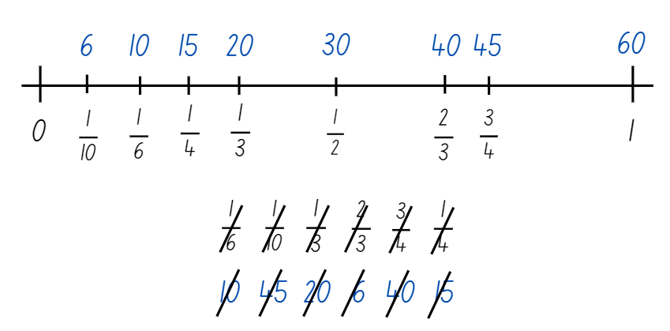
- Select students to share and explain their placement of the fractions and the equivalent minutes.
This table details opportunities for assessment.
Assessment opportunities | Links
What to look for:  - Can students compare and order unit fractions with denominators of 2, 3, 4, 5, 6, 8 and 10 by placing them on a number line?  [MAO-WM-01, MA3-RQF-01] | Links to National Numeracy Learning Progressions (NNLP):  - InF6.

Core lesson part 1 – using a protractor – 20 minutes
The table below contains suggested learning intentions and success criteria. These are best co-constructed with students.
Core concept learning intentions | Core concept success criteria
Students are learning to:  - estimate, measure and compare angles using degrees. | Students can:  - explain how a protractor is formed and used to measure an angle  - record angle measurements using the symbol for degrees (°).
- Revise the different categories of angles, using the interactive angle display to model. Ask:
- What are the 2 mathematical tools used for measuring angles so far?
- How are these similar?
- How are these different?
- What are perpendicular lines?
Perpendicular: 2 lines, rays, line segments, vectors, planes or other objects that intersect at a 90° angle (a right angle).
- Introduce protractors as another mathematical tool that can be used to measure the amount of turn in angles. Ensure that each student has a protractor to handle and measure with.
- Explain that this is a numbered protractor and that, similar to the numbers on a ruler, the markings are there to help count the number of angles. Ask:
- How is a numbered protractor different to the other mathematical tools we have used?
- Display Resource 10 – using a protractor and use it to discuss how to measure angles accurately.
- Use an enlarged copy of Resource 11 – angle hunt demonstrate to position the protractor to measure an angle accurately.

Core lesson part 2 – measuring angles – 20 minutes
- Display Resource 12 – measuring angles. Explain that students will be using protractors to accurately measure and record the size of angles that they find.
- Provide students with Resource 10 – using a protractor, Resource 12 – measuring angles and a protractor. In pairs, students work together to accurately find, measure and record the size of angles on the page.
This table details opportunities for differentiation.
Too hard? | Too easy?
Students cannot estimate, describe and record angle measurements using the symbol for degrees (°).  - Support students to identify the angle they are going to measure. It can be shaded in to make it clearer to see.  - Assist students with positioning the protractor, particularly with steps 3 and 4 in Resource 10 – using a protractor. Help them to start counting from zero, holding the protractor steady to ensure accuracy. | Students can estimate, describe and record angle measurements using the symbol for degrees (°).  - Students find the total of the angles for each set of joining lines.  - Students make a short video for other students to view, explaining how to use a protractor to measure angles.

Discuss and connect the mathematics – 10 minutes
- Regroup as a class and summarise the lesson together drawing out key mathematical ideas. Ask:
- What were some of the benefits of using numbered protractors for measuring angles?
- Was there something that you found challenging about using the numbered protractors?
- Were there some strategies that you found helpful to use when measuring the angles?
- Did you notice anything about some of the angles you measured?
- Is there anything that you are still wondering?
This table details opportunities for assessment.
Assessment opportunities | Links
What to look for:  - Can students estimate and describe the size of angles using known angles as benchmarks? [MAO-WM-01, MA3-GM-03]  - Can students record angle measurements using the symbol for degrees (°)? [MAO-WM-01, MA3-GM-03] | Links to National Numeracy Learning Progressions (NNLP):  - UuM7, UuM8.

Lesson 4
Core concept: angles can be measured to solve problems in our world.

Daily number sense – 10 minutes
- From a class need surfaced through formative assessment data, identify a short, focused activity that targets students’ knowledge, understanding and skills. Example activities may be drawn from the following resources:
- Mathematics K–6 resources
- Universal Resources Hub.

Core lesson part 1 – angles in art – 20 minutes
The table below contains a suggested learning intention and success criteria. These are best co-constructed with students.
Core concept learning intentions | Core concept success criteria
Students are learning to:  - estimate, measure and compare angles using degrees. | Students can:  - identify the arms and vertex of an angle where both arms are invisible, such as rotations  - estimate and describe the size of angles using known angles as benchmarks (reasons about mental rotation)  - record angle measurements using the symbol for degrees (°).
- Display Resource 10 – using a protractor and revise how to measure angles accurately using a protractor.
- Show Resource 13 – angles in art and ask students to identify examples of acute, right, obtuse, straight and reflex angles.
- Provide pairs of students with Resource 13 – angles in art, protractors and writing materials. Students work with their partner to find, measure and label examples of each type of angle.

Core lesson part 2 – mountain bike geometry – 30 minutes
- Explain that understanding angles and geometry is useful for solving many types of problems in the world.
- Introduce the problem that Rueben wants to buy a new downhill mountain bike. He has been saving for months and wants to get the best bike possible for his money.
- Rueben has been researching mountain bikes online and has found that bikes with certain geometric properties help riders to go faster in downhill races. The mountain bike store has 6 bikes with similar features for a similar price, so he wants to find the bike with the best geometry for racing.
- Display Resource 14 – mountain bike geometry and explain that there are 2 geometrical properties of downhill mountain bikes that he is looking for:
- An Effective Seat Angle (ESA) as close to 70° as possible. This helps the rider maximise speed by putting more power into their pedalling.
- A Head Angle (HA) of the smallest angle possible. This is important for racing downhill, as it puts the rider’s weight further back on the bike and means there is less risk of crashing over the handlebars.
- Explain to students that they will be working with partner to measure the ESA and HA of each bike, then make a recommendation about which bike Rueben should buy. When making a recommendation, students will also need to consider the best value for their money. Ask students to share their reasoning for their recommendation.
- Remind students that sometimes angles are invisible, that is, their arms aren’t always visible. Point out that the first bike on Resource 14 – mountain bike geometry has the ESA and HA already marked, but they will need to draw these on the other bikes.
- Using the example on the first bike on Resource 14 – mountain bike geometry, model how to draw a line along the bike’s seat post and the ground to show the ESA angle, then along the bike’s headtube and the ground to show the HA.
- Provide pairs of students with Resource 14 – mountain bike geometry. Using their protractors and writing materials, students measure, record and compare the bikes’ geometric properties to make their recommendation.
This table details opportunities for differentiation.
Too hard? | Too easy?
Students cannot identify the arms and vertex of an angle where both arms are invisible, such as for rotations.  - Model how to identify the ESA and HA in the next bike on Resource 14 – mountain bike geometry.  - Support students to identify and highlight the arms for the ESA and HA in the following bike.  Students cannot describe angle sizes using known benchmarks or measure angles using the symbol for degrees (°).  - After drawing the arms of the angles, ask students which type of angles they are likely to be.  - Support students to align their protractor accurately, then count the number of degrees in the angle starting from 0°. | Students can identify the arms and vertex of an angle where both arms are invisible, such as for rotations.  - Students use a digital device to find a profile image of a downhill mountain bike.  - Students measure the geometry of this bike and compare it with the bikes on Resource 14 – mountain bike geometry.  Students can describe angle sizes using known benchmarks or measure angles using the symbol for degrees (°).  - Provide students with Resource 15 – angles in engineering to find, categorise, measure and record the size of the angles in one of the structures.  - Ask students to reflect on which type of angle is most common, and why.

Discuss and connect the mathematics – 10 minutes
- Ask students to share their bike recommendations for Rueben with the class, as well as their reasoning for that choice.
- There are likely to be several different recommendations and this is an opportunity for students to justify their reasoning. Ask:
- After listening to the other groups, do you want to reconsider your recommendation? Why?
- Have you learnt something new about how angles can help solve problems in the world?
- Where else might angles be important in design and construction?
This table details opportunities for assessment.
Assessment opportunities | Links
What to look for:  - Can students identify the arms and vertex of an angle where both arms are invisible, such as for rotations?  [MAO-WM-01, MA3-GM-03]  - Can students estimate and describe the size of angles using known angles as benchmarks? [MAO-WM-01, MA3-GM-03]  - Can students record angle measurements using the symbol for degrees (°)? [MAO-WM-01, MA3-GM-03] | Links to National Numeracy Learning Progressions (NNLP):  - UuM7, UuM8.

Lesson 5
Core concept: 12- and 24-hour time systems are both used to measure the length of time.

Daily number sense – closest to zero – 10 minutes
Daily number sense activities for Lessons 5 to 7 ‘loop’ back to concepts and procedures covered in previous units to assist students to build an increasingly connected network of ideas. These concepts may differ from the core concepts being covered by the unit.
The table below contains a suggested learning intention and success criteria. These are best co-constructed with students.
Daily number sense learning intention | Daily number sense success criteria
Students are learning to:  - apply efficient mental and written strategies to solve addition and subtraction problems. | Students can:  - use place value to add or subtract 3 or more numbers with different numbers of digits.
This activity is an adaptation of ‘Dicey Operations in Line’ from NRICH by the University of Cambridge (Faculty of Mathematics).
- Provide pairs of students with 9-sided dice and whiteboards.
- Pairs decide whether they will be creating an addition or subtraction number sentence.
- Student one rolls the dice to make one 5-digit number, one 4-digit number and one 3-digit number. Students can create their multi-digit numbers from the numbers rolled. For example, if 6, 4 and 3 are rolled, students can choose to record 643, 346 or 463 and so on.
- Student one uses these numbers to form an addition or subtraction sentence and records it on their whiteboards (see Figure 2).
Figure 2 – subtraction number sentence
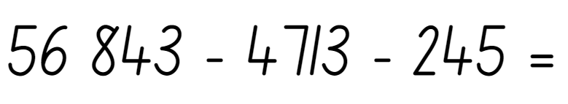
- Student 1 solves the number sentence using a mental or written strategy.
- Student 2 repeats the process.
- The winner is the student that gets closest to zero if a subtraction sentence is solved. The student with the highest sum is the winner if an addition sentence is solved.
- Students play multiple rounds.
This table details opportunities for assessment.
Assessment opportunities | Links
What to look for:  - Can students use place value to add or subtract 3 or more numbers with different numbers of digits?  [MAO-WM-01, MA3-AR-01] | Links to National Numeracy Learning Progressions (NNLP):  - AdS7, AdS8.  Links to suggested Interview for Student Reasoning (IfSR) tasks:  - IfSR-AT: 3A.5.

Core lesson part 1 – time talk – 10 minutes
The table below contains a suggested learning intention and success criteria. These are best co-constructed with students.
Core concept learning intentions | Core concept success criteria
Students are learning to:  - compare 12- and 24-hour time systems and convert between them. | Students can:  - recognise that 24-hour time is used to avoid confusion between am and pm  - read time using appropriate 24-hour time language.
- Start by observing that although time cannot be seen or touched, its length can be measured to organise things in the world.
- Display Resource 16 – time talk 1 and use the prompt box below to discuss the time shown.
The table below outlines stimulus prompts to generate conversation about the topic, along with anticipated responses from students.
Prompts | Anticipated student responses
- What is the time shown on the screen? | - It shows 11:59.
- Is it day or night? | - We do not know. It could be one minute before midnight or one minute before midday.
- Is this time closer to midday or midnight? What information do we need to answer this? | - We need to know if it is am or pm.
- Can the time be displayed in a different way to know if it’s day or night? | - The time can be displayed as a 24-hour time to show if it is day or night or have am/pm on the side.

Core lesson part 2 – 24-hour time – 30 minutes
Note: 24-hour time is written without the colon, for example, 3:45 pm is written as 1545 and read as ‘fifteen forty-five hours’.
- Introduce 24-hour time as a way of clearly communicating a particular time in the day or night. Explain that it is used to avoid confusion between am and pm. It is often used by emergency services, airlines, military forces and public transport services, as they need to be clear in communicating when things will be happening.
- Write the times 1:45 pm and 13:45 on the board. Display Resource 17 – 12- and 24-hour time and use the timeline and analog clock to explain that:
- On a 24-hour clock, time is measured from midnight (0000 hrs).
- The first 2 digits are the number of hours past midnight.
- The second 2 digits are the number of minutes past the hour.
- Numbers around the clock face shows how hours on an analogue clock face are converted into 24-hour time.
- The 24-hour times that are before midday are shown on the inside of the clock model above.
- The notation am is used to indicate before midday in 12-hour time.
- The 24-hour times that are after midday are shown on the outside of the clock model above.
- The notation pm is used to indicate after midday in 12-hour time.
- List some examples of times in the school day on the board, for example, lunch is at 1:10 pm. Ask students to turn and talk with a partner to convert the time to a 24-hour time.
- Provide students with a copy of Resource 18 – converting times. With a partner, they use the timeline and analog clock to convert the times from one format to another.
This table details opportunities for differentiation.
Too hard? | Too easy?
Students cannot recognise the difference between am and pm or read time using appropriate 24-hour time language.  - Draw students’ attention to the timeline on Resource 18 – converting times. Use this to write the first time, before comparing it to the equivalent hour above or below the timeline. The analog clock can also be used to convert between hours.  - Support students to see that the numbers representing the minutes remains the same. | Students can recognise the difference between am and pm or read time using appropriate 24-hour time language.  - Ask students to use the times they wrote on Resource 18 – converting times to see if they can find the time elapsed between each of them.  - Challenge students to complete 5 on the Clock. Using what they know about 24-hour time, students find how many times a 5 appears on a digital clock showing 24-hour time, over a whole day.

Discuss and connect the mathematics – 10 minutes
- As a class, view Resource 18 – converting times and discuss the students’ responses. Ask:
- What did you find challenging about converting between 12-hour and 24-hour time?
- What strategies or resources did you and your partner use?
- Did you notice any patterns that helped you?
- Is there anything that you are still wondering?
- Highlight to students that although they cannot see or touch time, they can measure its length. This helps to organise the world.
This table details opportunities for assessment.
Assessment opportunities | Links
What to look for:  - Can students recognise that 24-hour time is used to avoid confusion between am and pm? [MAO-WM-01, MA3-NSM-02]  - Can students read time using appropriate 24-hour time language? [MAO-WM-01, MA3-NSM-02] | Links to National Numeracy Learning Progressions (NNLP):  - MeT5.

Lesson 6
Core concept: clocks are complex measuring tools.

Daily number sense – multistep problems – 10 minutes
The table below contains a suggested learning intention and success criteria. These are best co-constructed with students.
Daily number sense learning intention | Daily number sense success criteria
Students are learning to:  - apply efficient mental strategies to solve addition and subtraction problems. | Students can:  - solve word problems, including multistep problems.
- Write the following problem on the board: Anwar has 375 stalks of corn and 598 cabbages. The crows destroy 153 of his crops. How many crops are left undestroyed in his garden?
- Ask students:
- Which parts of the problem are important pieces of information?
- What operations will be used in solving this problem? How do you know?
- What strategies would be efficient for solving this problem?
- Students turn and talk to discuss their strategies and the information required to solve the problem.
- Select a range of student responses to share with the class.
- Write another problem on the board and repeat the process. For example, Farmer Josie has 9638 kilograms of grain. She feeds 3725 kilograms to her pigs and 2948 kilograms to her cows. How much grain does she have left?
- Alternatively, pairs of students may wish to write their own multistep problems and solve them.
This table details opportunities for assessment.
Assessment opportunities | Links
What to look for:  - Can students solve word problems, including multistep problems? [MAO-WM-01, MA3-AR-01] | Links to National Numeracy Learning Progressions (NNLP):  - AdS8.

Core lesson part 1 – 24-hour time – 10 minutes
The table below contains suggested learning intentions and success criteria. These are best co-constructed with students.
Core concept learning intentions | Core concept success criteria
Students are learning to:  - compare 12-hour and 24-hour time systems and convert between them. | Students can:  - read time using appropriate 24-hour time language  - convert between 24-hour time and 12-hour time using am or pm notation.
- Display Resource 17 – 12- and 24-hour time and revise what students learnt about 12-hour and 24-hour time systems.
- Show Resource 19 – time talk 2 and use the prompt box to discuss the time shown.
The table below outlines stimulus prompts to generate conversation about the topic, along with anticipated responses from students.
Prompts | Anticipated student responses
- What is the time shown on the watch? | - 13:51
- Is it day or night? | - It is during the day.
- Is this time closer to midday or midnight? What information do we need to answer this? | - This time is closer to midday, as it is about 2 hours after midday.
- Can the time be displayed in a different way to know if it’s day or night? | - The time can be displayed on a 12-hour clock, but must show am/pm.
- Discuss where 24-hour times may be used. | - 24-hour times may be used by people working in the military, aviation, tourism, computing or hospitals.

Core lesson part 2 – 24-hour time tools – 20 minutes
- Show the activity Time tools to the class. Demonstrate how equivalent times can be represented on the 3 clocks.
- With a partner, students explore Time tools on a digital device. They record each of the times they create, both as a 12-hour and 24-hour time.
- After 10 minutes, ask students to stop playing the game. Provide them with a copy of Resource 20 – timeline. Students use the timeline to show where each of the times belong, both in 12-hour and 24-hour notation.
This table details opportunities for differentiation.
Too hard? | Too easy?
Students cannot read or convert between 12-hour time and 24-hour time using am or pm notation.  - Support students to use a copy of Resource 17 – 12- and 24-hour time to convert between 24-hour time and 12-hour times on the Time tools interactive display.  - Assist students to find the corresponding point for each time on their copy of Resource 20 – timeline. | Students can read or convert between 12-hour time and 24-hour time using am or pm notation.  - Students think of the times they do things in their day and add these to their timelines as both 24-hour time and 12-hour time.  - Using the timeline, students calculate how much time they spend on specific tasks each day.

Discuss and connect the mathematics – 20 minutes
- As a class, view Resource 20 – timeline and discuss the students’ responses. Ask:
- What strategies did you and your partner use to convert between 12-hour and 24-hour time?
- Did you find any new strategies to help you?
- Is there anything that you are still wondering?
- Show Resource 21 – time problems and discuss how to solve the first problem.
- Provide students with a copy of Resource 21 – time problems for them to work on solving the other problems.
- Students may wish to create their own time problems and ask a partner to solve them.
This table details opportunities for assessment.
Assessment opportunities | Links
What to look for:  - Can students read time using appropriate 24-hour time language? [MAO-WM-01, MA3-NSM-02]  - Can students convert between 24-hour time and 12-hour time using am or pm notation? [MAO-WM-01, MA3-NSM-02] | Links to National Numeracy Learning Progressions (NNLP):  - MeT5.

Lesson 7
Core concept: timetables are an efficient way to communicate and organise lengths of time.

Daily number sense – which strategy? – 10 minutes
The table below contains a suggested learning intention and success criteria. These are best co-constructed with students.
Daily number sense learning intention | Daily number sense success criteria
Students are learning to:  - apply efficient mental and written strategies to solve addition and subtraction problems. | Students can:  - apply known strategies such as levelling, addition for subtraction, using constant difference, and bridging.
- Write the following problem on the board: 3985 + 956 = ?
- Ask students:
- What strategy could you use solve this problem?
- What other strategies could be used to solve this problem?
- Which strategy is the most efficient?
- Students turn and talk to discuss their strategies.
- Select a range of student responses to share with the class. Highlight the use of strategies such as levelling (3985 + 956 → 3990 + 951 → 4000 + 941) and bridging (3985 + 956 = 3985 plus 5 plus 10 plus 941).
- Repeat the process with another problem, for example 8002 – 2998 = ?
- When discussing subtraction problems, highlight the use of addition for subtraction (8002 – 2998 add 2 is 3000 plus 5002) or using constant difference (8002 – 2998 → 8004 – 3000)
This table details opportunities for assessment.
Assessment opportunities | Links
What to look for:  - Can students apply known strategies such as levelling, addition for subtraction, using constant difference, and bridging?  [MAO-WM-01, MA3-AR-01] | Links to National Numeracy Learning Progressions (NNLP):  - AdS7, AdS8.  Links to suggested Interview for Student Reasoning (IfSR) tasks:  - IfSR-AT: 3A.4.

Core lesson part 1 – timetables – 15 minutes
The table below contains a suggested learning intention and success criteria. These are best co-constructed with students.
Core concept learning intentions | Core concept success criteria
Students are learning to:  - compare 12-hour and 24-hour time systems and convert between them. | Students can:  - convert between 24-hour time and 12-hour time using am or pm notation  - read, interpret and use timetables from real-life situations, involving 12-hour and 24-hour time.
- Revise the learning so far about 12-hour and 24-hour time systems using Resource 17 – 12- and 24-hour time.
- Ask students where they have seen timetables used as a way of organising and communicating time.
- Display Resource 22 – train timetable and ask students what they notice about the features of the timetable.
- Read the 2 problems that Sam has. Explain that students will work with a partner to answer the 2 questions.
- Explain that a blank number line can be used to find the difference between 2 amounts or times, using jumps.
- Model how to use small jumps of time to find the difference between 2 times. For example, to calculate the difference between 7:46 and 8:01, a 4 minute and 10 minute interval is used to jump to 8:00 and then a one minute interval is used to reach 8:01 (see Figure 3).
Figure 3 – time number line
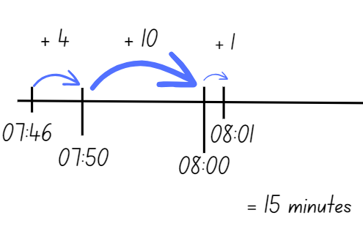
- Students work with their partner, using a number line in the second question to show how long his train journey would take.
- Discuss students’ responses and compare how they have used a number line to find a solution.

Core lesson part 2 – television tonight – 25 minutes
- Display Resource 23 – television tonight and explain that time systems help to understand television schedules.
- Ask students what they notice about this timetable, which is a television guide for 2 channels.
- Discuss the first question as a class, using an empty number line to mark the 2 times.
- Ask students to confirm which time should be written for each, recognising that the first time is when ‘Journey to space’ starts.
- With a partner, students find solutions to the problems, using jumps of time on the number lines to support their thinking.
This table details opportunities for differentiation.
Too hard? | Too easy?
Students cannot read, interpret and use timetables from real-life situations, involving 12-hour and 24-hour time.  - Support students to identify the beginning and ending time for each problem, then label these times on the number line.  - Assist students to find the difference between the 2 times, using jumps of time to find the total. | Students can read, interpret and use timetables from real-life situations, involving 12-hour and 24-hour time.  - Challenge students to find the times of each television program, then list them from shortest to longest.  - Explain that there is enough memory on the digital recorder to record 3 hours of programming that night. Students decide which combination of shows they would record to get as close to 3 hours as possible.

Discuss and connect the mathematics – 10 minutes
- As a class, ask students to share the solutions they developed with their partner, as well as their thinking when working on it. Ask:
- Which timetable did you find easier to understand? Why?
- What could be the consequence of not reading either timetable correctly?
- Were there any strategies or patterns that helped you and your partner?
- Is there anything else you noticed?
This table details opportunities for assessment.
Assessment opportunities | Links
What to look for:  - Can students convert between 24-hour time and 12-hour time using am or pm notation? [MAO-WM-01, MA3-NSM-02]  - Can students read, interpret and use timetables from real-life situations, involving 12- and 24-hour time?  [MAO-WM-01, MA3-NSM-02] | Links to National Numeracy Learning Progressions (NNLP):  - MeT5.

Consolidation and meaningful practice – 10 minutes
- Show Resource 24 – lemonade stand and read the problem as a class.
- Remind students that number lines and bar models can be used to show their thinking when solving problems.
- With a partner, students use a number line or bar model to solve the problem and show their thinking. Once they have found a solution, students try to show another way of solving the problem.
- Share some examples of students’ solutions with the class and discuss how they have shown their thinking.

Lesson 8
Core concept: quantities of time are often partitioned into common fractional lengths, such as halves and quarters.

Daily number sense – 10 minutes
- From a class need surfaced through formative assessment data, identify a short, focused activity that targets students’ knowledge, understanding and skills. Example activities may be drawn from the following resources:
- Mathematics K–6 resources
- Universal Resources Hub.

Core lesson part 1 – an astronaut’s day – 15 minutes
The table below contains suggested learning intentions and success criteria. These are best co-constructed with students.
Core concept learning intentions | Core concept success criteria
Students are learning to:  - solve problems involving addition and subtraction of fractions with the same denominator  - compare 12- and 24-hour time systems and convert between them. | Students can:  - solve word problems that involve fractions with the same denominator  - read, interpret and use timetables from real-life situations, involving 12- and 24-hour time.
This activity is an adaptation of ‘Time: Mission Control to ISS’ from reSolve: Maths by Inquiry by the Australian Government Department of Education.
- Display Resource 25 – International Space Station and ask what students already know about the International Space Station (ISS). Use the information provided to build their background knowledge.
- Explain that students will use what they know about time and fractions to design a daily schedule for 3 astronauts on the ISS.
- Introduce fractions as another way of measuring and compare the lengths of times. Present Resource 26 – 24-hour bar model and explain that a day can be represented as lengths on a bar model using fractions of time. For example, 24 hours can be partitioned using halves, quarters and eighths. Add these representations to Resource 26 – 24-hour bar model or draw these on the board.
- Ask students to think of other fractions that 24 hours can be partitioned with, for example $\frac{1}{6}$, $\frac{1}{12}$, $\frac{1}{24}$. Remind students that they need to have the total number of fraction parts to represent a complete, or one, day.
- Use Resource 27 – ISS mission briefing 1 to show students that there are many parts of a space mission that need to be planned each day, both from mission control on the ground and the astronauts in space.

Core lesson part 2 – ISS mission control – 10 minutes
- Show Resource 28 – ISS mission briefing 2 and tell students that they will be working in mission control, in groups of 2 or 3 to design the daily schedule for the 3 astronauts. Explain that there are a range of tasks the astronauts must complete each day. Some of these can be done at different times, while some tasks need to done by the 3 astronauts simultaneously.
- Provide students with a copy of Resource 29 – ISS mission briefing 3 and draw attention to the 3 fraction bars representing the 24 hours of a day. There is one for each of the astronauts to map their activities.
- Before working on the task, tell students that there is not one correct solution, but students should focus on meeting the criteria on Resource 29 – ISS mission briefing 3.
- Explain that, once students have decided on their daily schedule for the astronauts, they need to calculate the length of time spent on different tasks each day as a fraction.
- Ask students:
- How can times that are less than or more than an hour be represented on the fraction bars?
- How can the fraction bars be used to calculate the length of time spent on tasks as a fraction?

Core lesson part 3 – ISS group work – 25 minutes
- Students begin working on the task with their partner or small group, using their copy of Resource 29 – ISS mission briefing 3 to record their thinking. Remind students that they need to calculate the length of time spent on different tasks each day as a fraction.
This table details opportunities for differentiation.
Too hard? | Too easy?
Students cannot solve word problems that involve fractions with the same denominator or interpret and use timetables involving 12- and 24-hour time.  - Support students to focus on developing a daily schedule for just one astronaut.  - Assist students to identify and count the fraction parts of the day, recording each activity as a total of the whole day. | Students can solve word problems that involve fractions with the same denominator or interpret and use timetables involving 12- and 24-hour time.  - Tell students that there has been a collision with some space junk and one of the panels needs to be repaired. This will take at least 6 hours and must be a priority. Students must provide the astronauts with an updated schedule that allows all 3 of them to focus on the repairs, by prioritising critical tasks in their schedule for that day.

Discuss and connect the mathematics – 10 minutes
- Students share their solutions by swapping with another group, checking to see if the criteria was met in each daily schedule.
- Students compare the daily fraction summary from both groups. Use the prompt table to discuss the students’ learning.
The table below outlines stimulus prompts to generate conversation about the topic, along with anticipated responses from students.
Prompts | Anticipated student responses
- Were the fractions of time on each task in the daily schedules the same for both groups? Why do you think this was? | - The amount of time on each task was the same on the other group’s schedule, although the time when things happened were different. This was because the tasks took the same amount of time.  - Ours were different to the other group’s schedule, because although the main tasks were the same length, we used a little more time on one task.
- How were the daily schedules the same? | - They were the same in that the tasks took the same lengths of time.
- How were the daily schedules different? | - They were different because the tasks occurred at different time compared to another group.
- Is there one of the 2 schedules that you think would be more helpful for the crew? Why/why not? | - I liked how the other group had the astronauts exercising in the morning, because they said it would help them to focus on their experiments.
- What is something you noticed about solving problems with time during this lesson? | - I noticed that sometimes there can be more than one solution to a problem.  - I noticed that fractions help measure and compare the lengths of times.
- How did your knowledge of time and fractions help you with presenting your answers as fractions? | - I knew that one hour of time was the same as $\frac{1}{24}$ so 3 hours was the same as $\frac{3}{24}$ because I added $\frac{1}{24}$ + $\frac{1}{24}$ ₊ $\frac{1}{24}$
This table details opportunities for assessment.
Assessment opportunities | Links
What to look for:  - Can students solve word problems that involve fractions with the same denominator? [MAO-WM-01, MA3-RQF-02]  - Can students read, interpret and use timetables from real-life situations, involving 12- and 24-hour time?  [MAO-WM-01, MA3-NSM-02] | Links to National Numeracy Learning Progressions (NNLP):  - InF7, InF8, MeT5.

Resource 1 – fractions
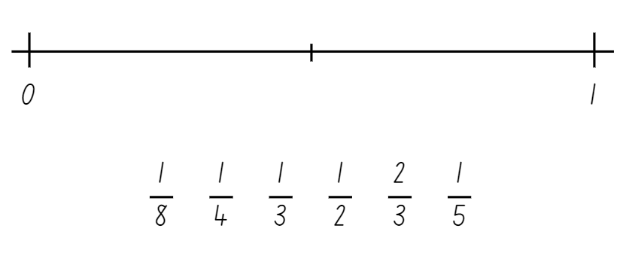

Resource 2 – angle categories
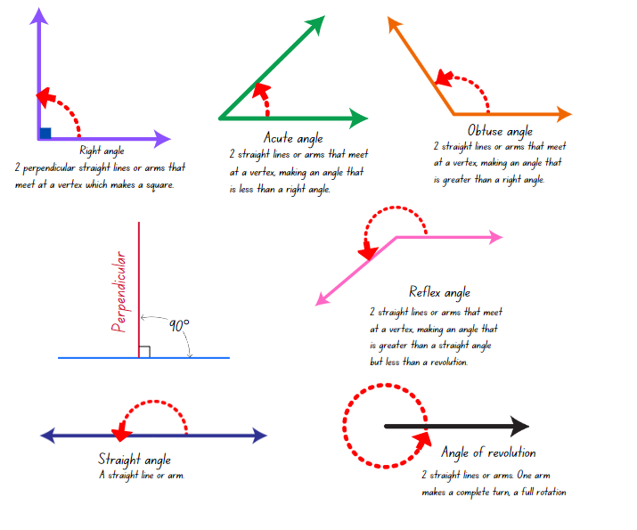

Resource 3 – angle identifiers

Resource 4 – angle instructions 1
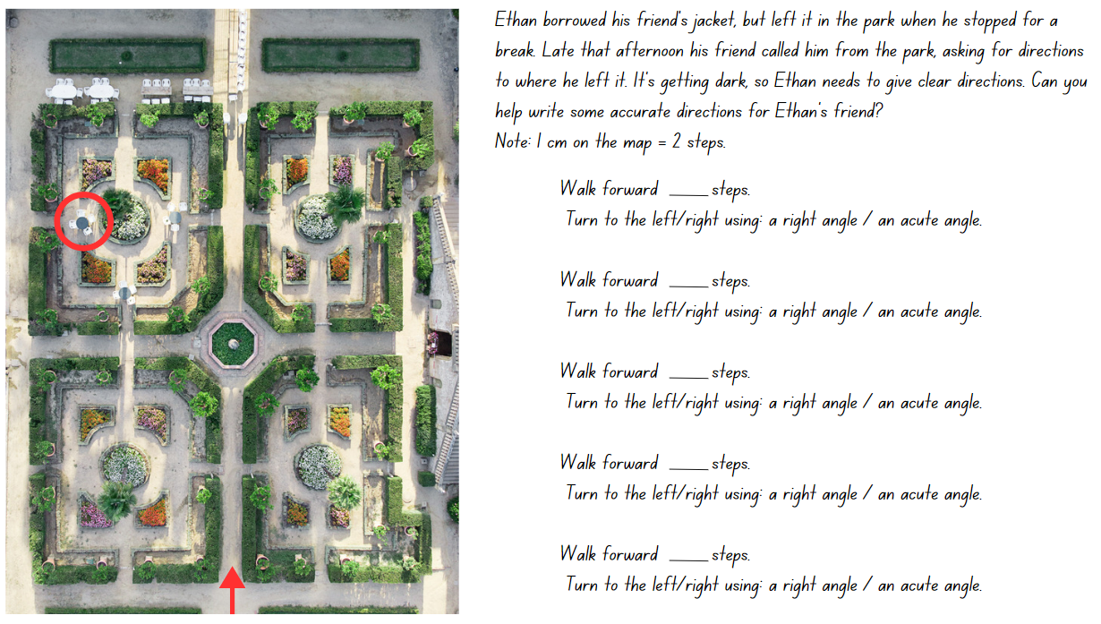

Resource 5 – angle instructions 2
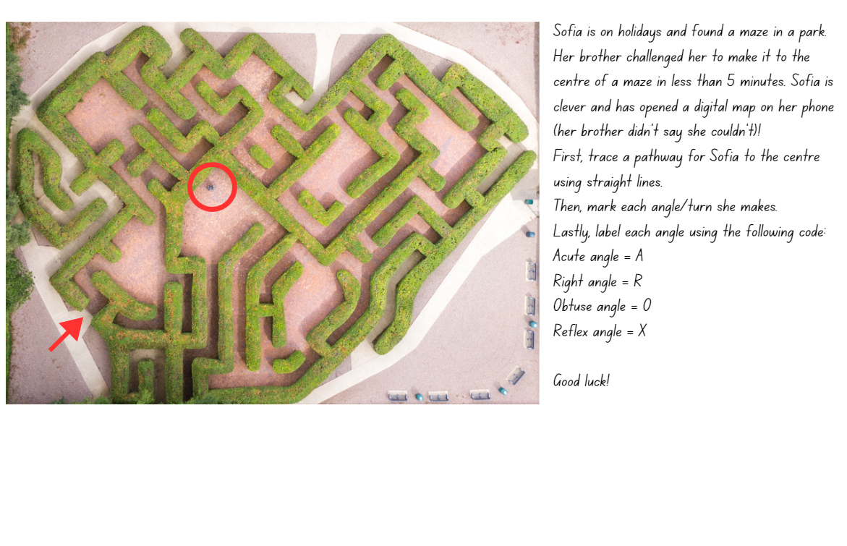

Resource 6 – a numberless protractor
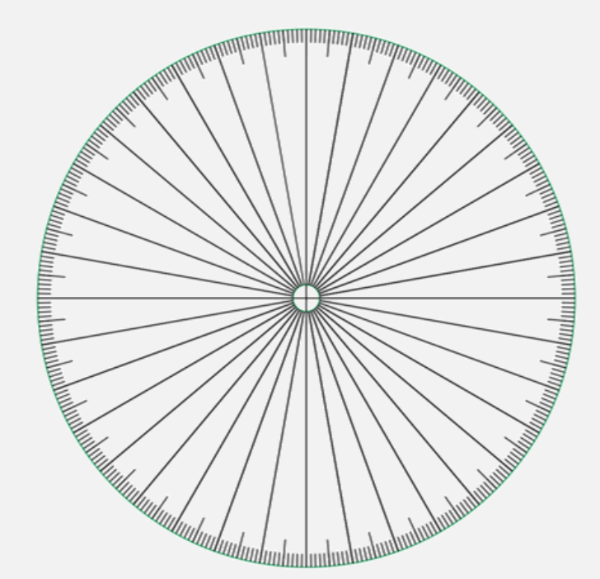
Source: ‘Empty protractor’ by Francome (2016).

Resource 7 – angle investigation 1
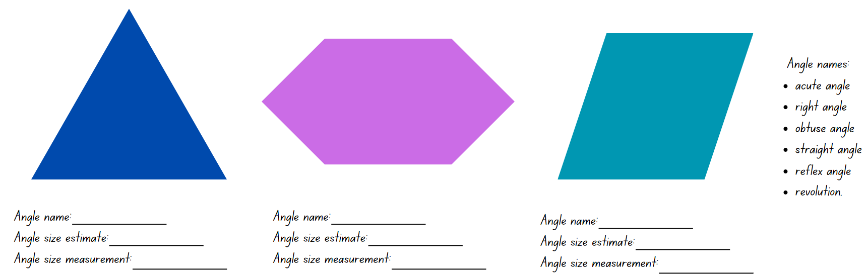

Resource 8 – angle investigation 2
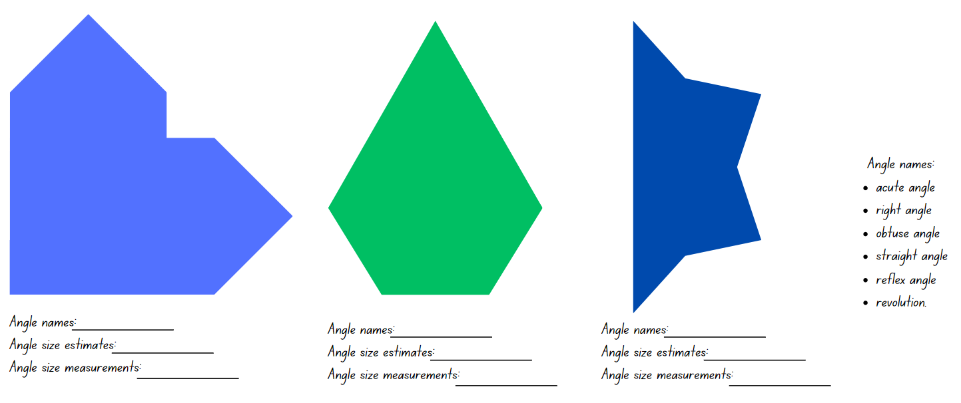

Resource 9 – fraction line
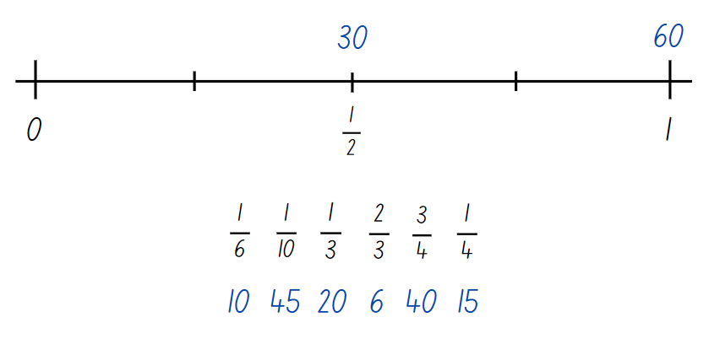

Resource 10 – using a protractor
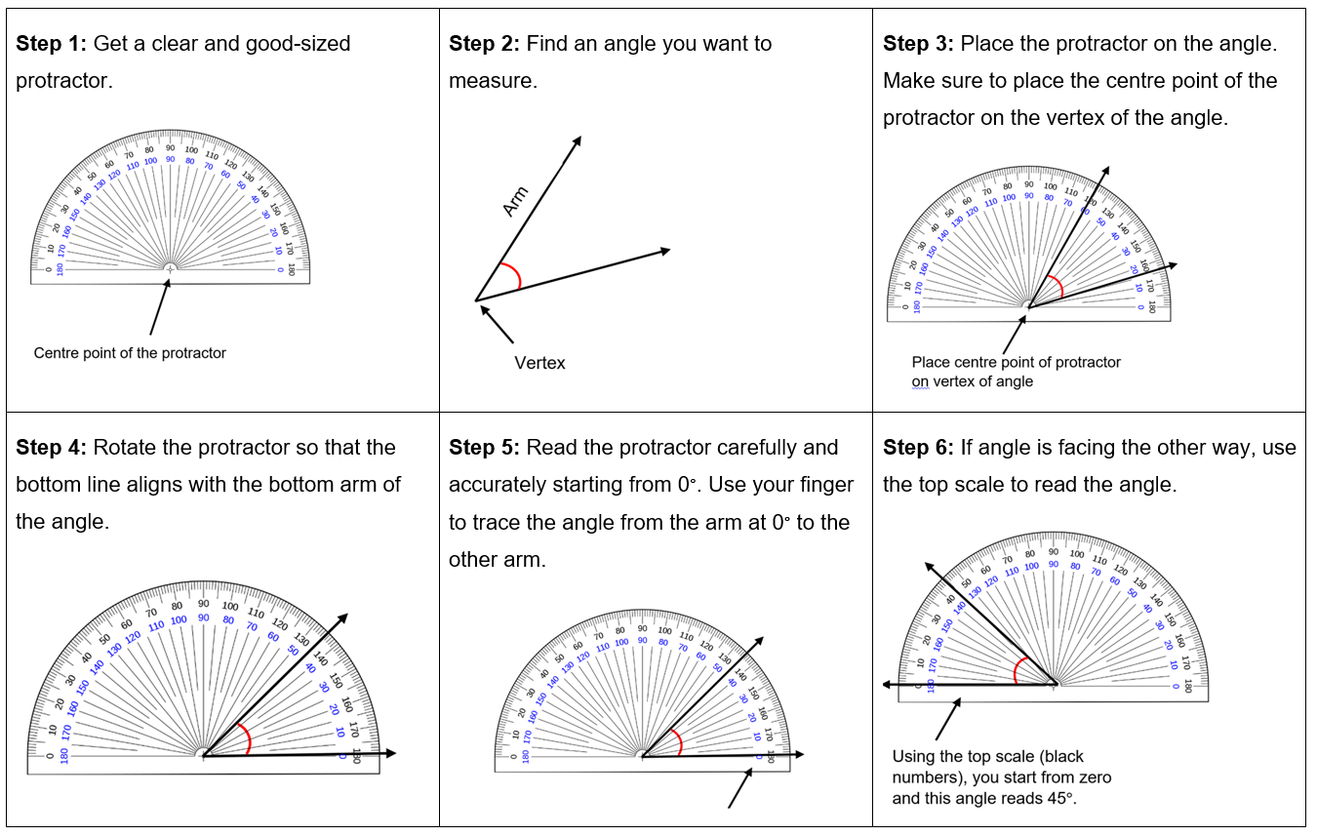

Resource 11 – angle hunt
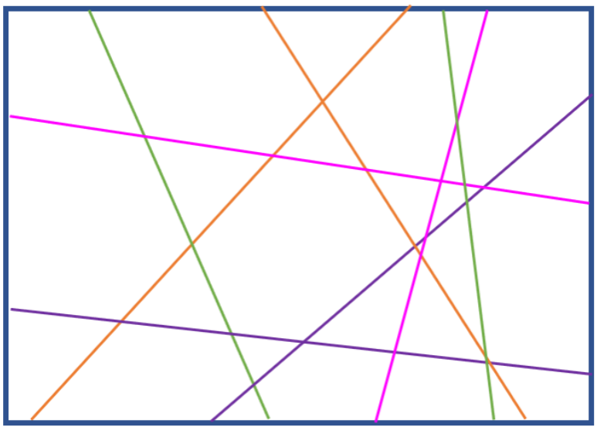

Resource 12 – measuring angles
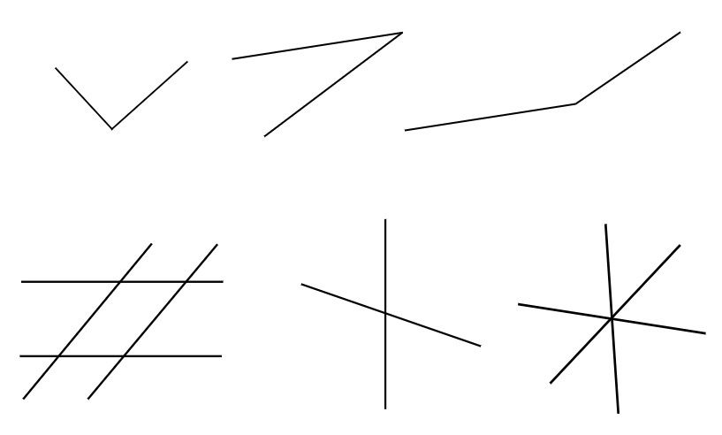

Resource 13 – angles in art

Resource 14 – mountain bike geometry
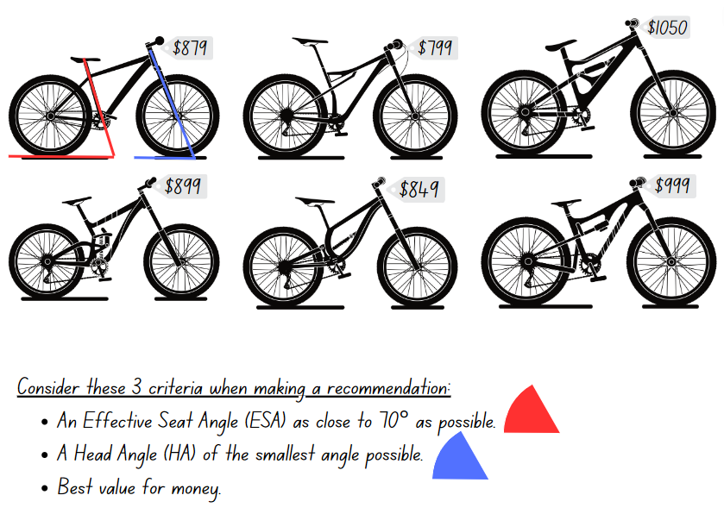

Resource 15 – angles in engineering

Resource 16 – time talk 1
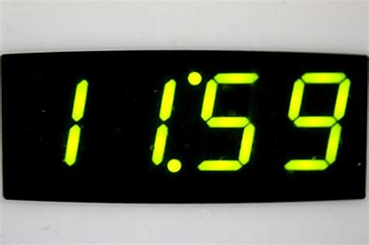
Source: http://www.photos-public-domain.com/wp-content/uploads/2011/11/digital-clock-reading-1159.jpg

Resource 17 – 12- and 24-hour time
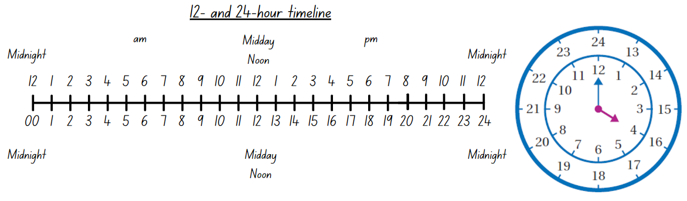

Resource 18 – converting times
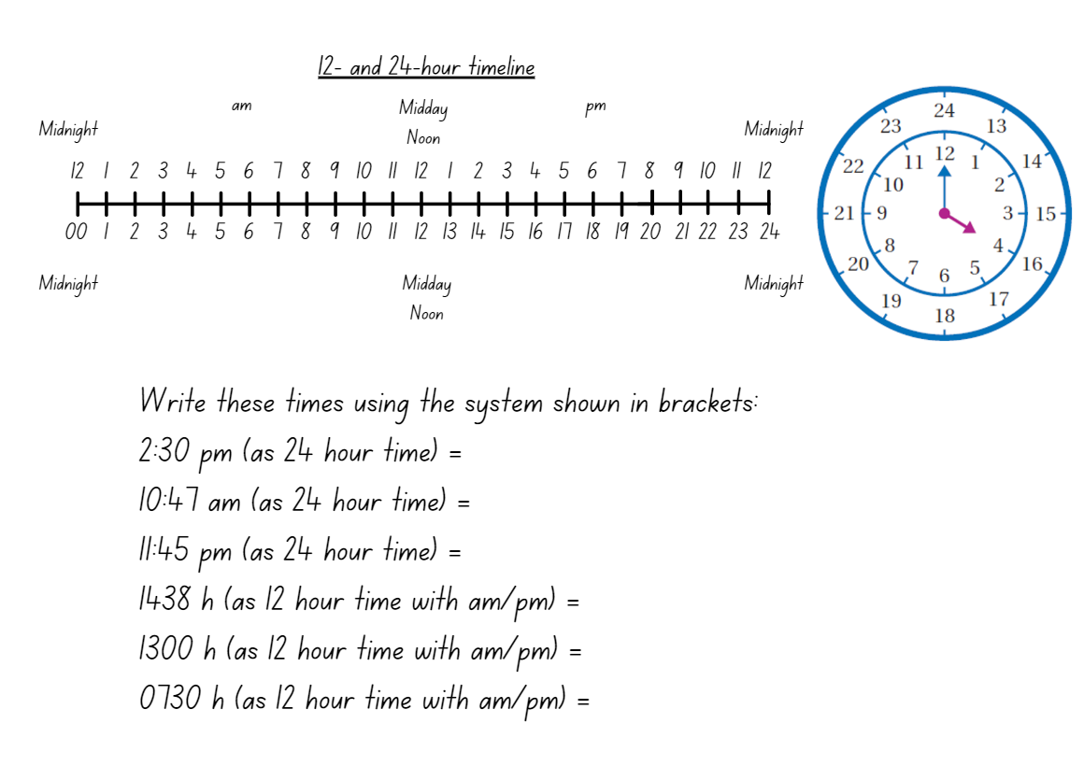

Resource 19 – time talk 2
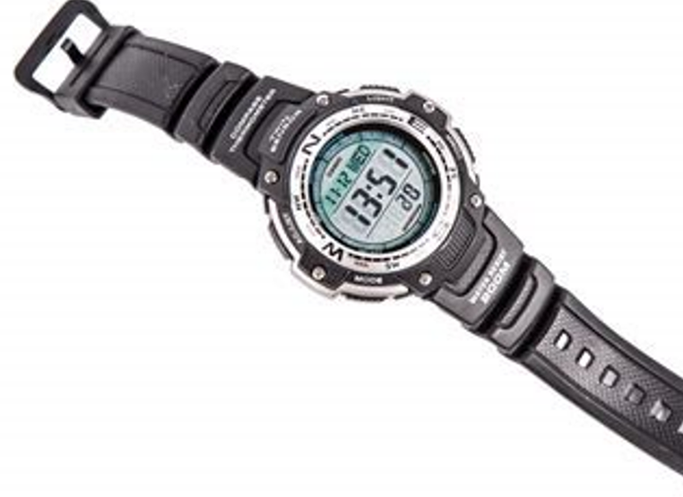
Source: https://www.publicdomainpictures.net/pictures/200000/velka/digital-wristwatch-1473924961J5c.jpg

Resource 20 – timeline
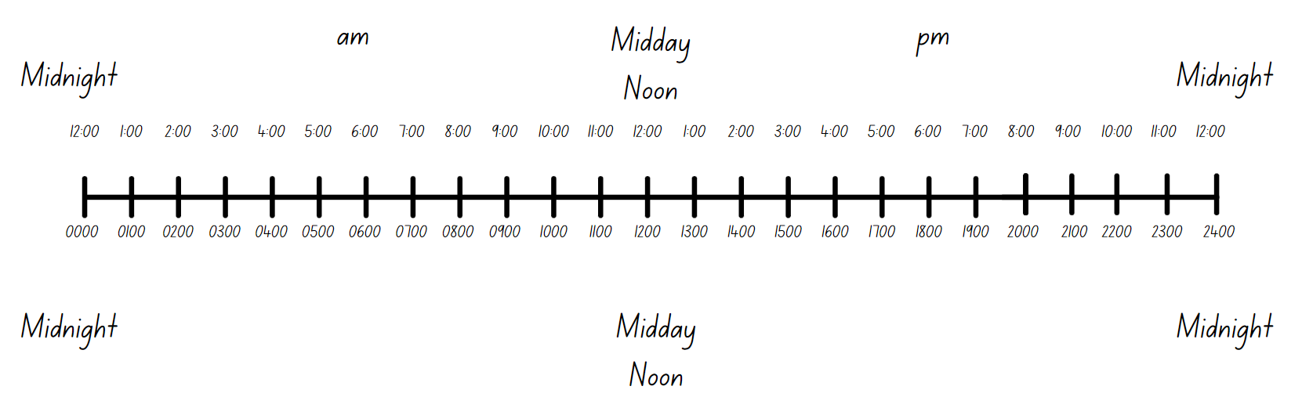

Resource 21 – time problems
Worded problem | Answer
Max had to set an alarm on his mobile phone for an appointment. He wanted to set the alarm for 4:30 pm. He had to set the time in 24-hour time. What time did he enter into his phone?
Adam works as a military officer. His boss told him to meet him at 1500 hours. Express this time as 12-hour time using correct notation.
John was looking at the train timetable and it said that the next train arrives at 1425. What is this in 12-hour time?
Adam’s flight departs at 1945, and he has to be at the airport 2 hours before to allow for check in time. What time does he need to be at the airport in 12-hour time?

Resource 22 – train timetable
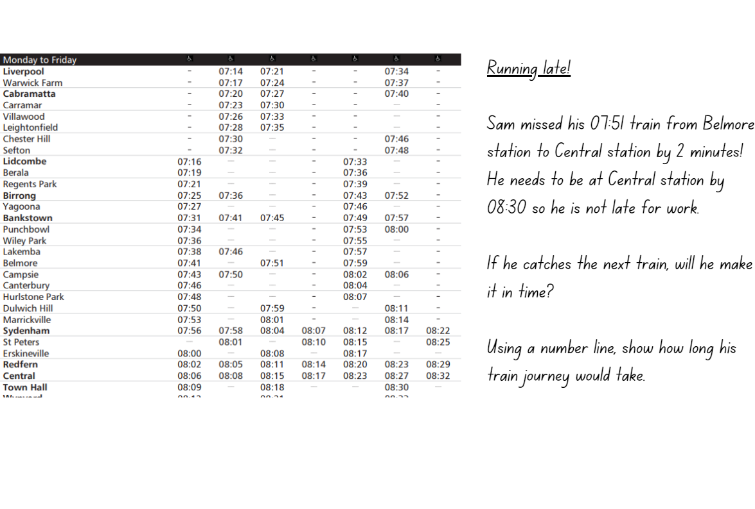

Resource 23 – television tonight
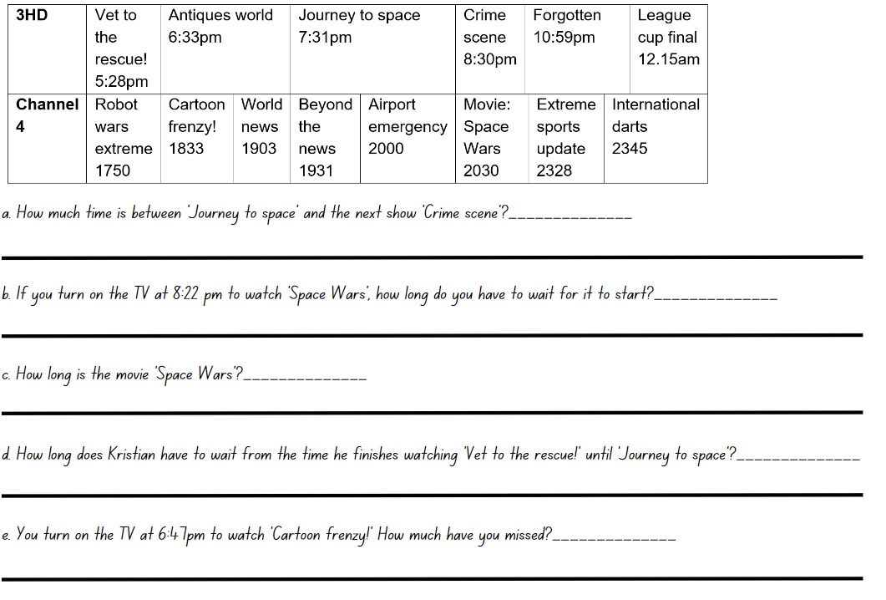

Resource 24 – lemonade stand
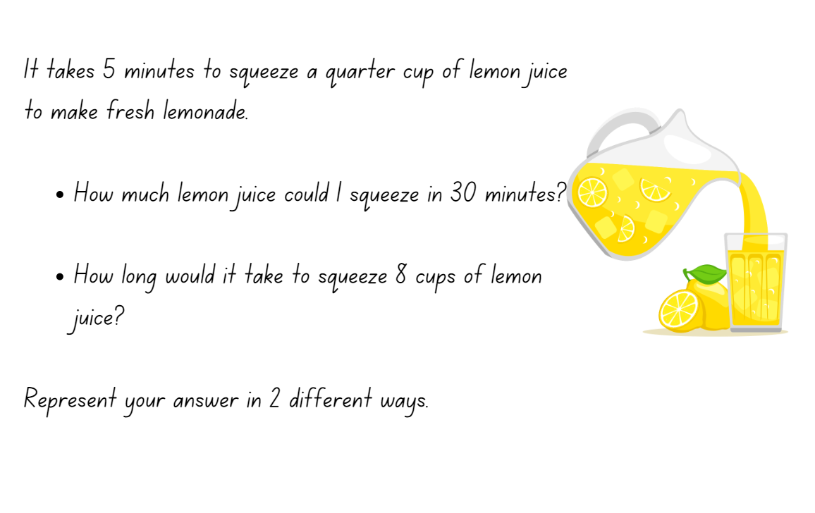

Resource 25 – International Space Station
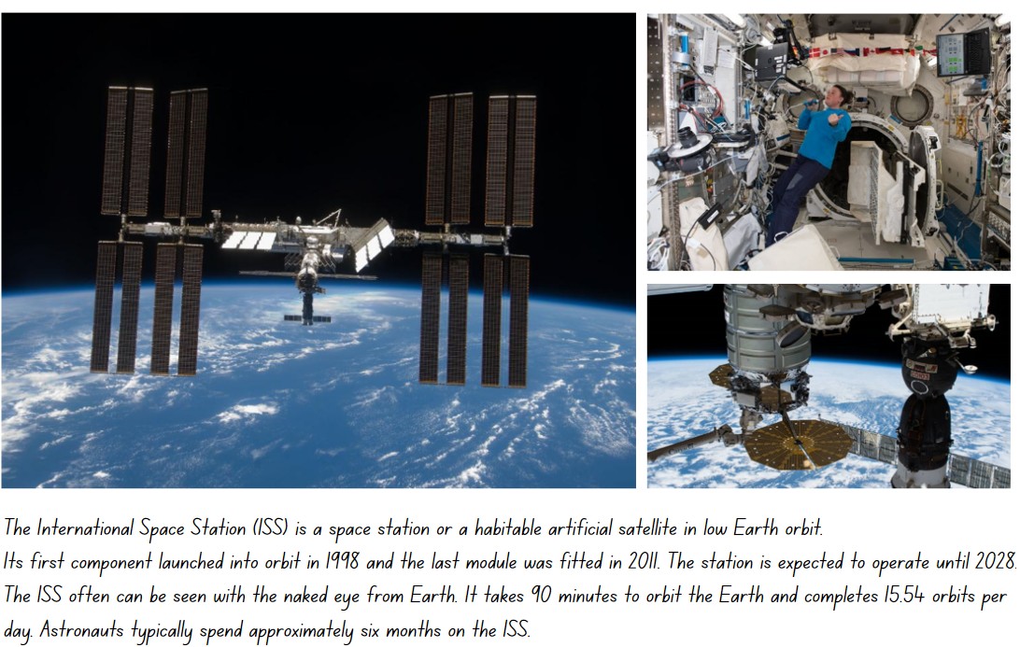

Resource 26 – 24-hour bar model

Resource 27 – ISS mission briefing 1
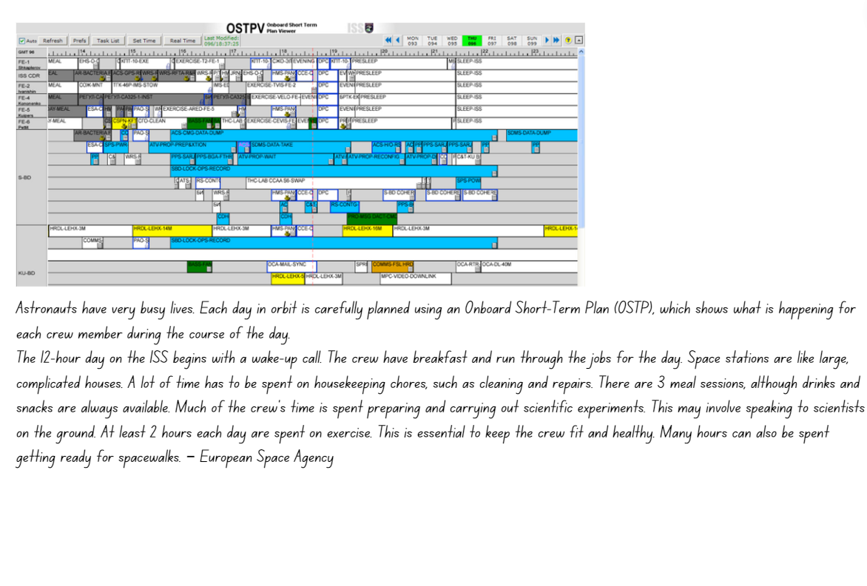

Resource 28 – ISS mission briefing 2
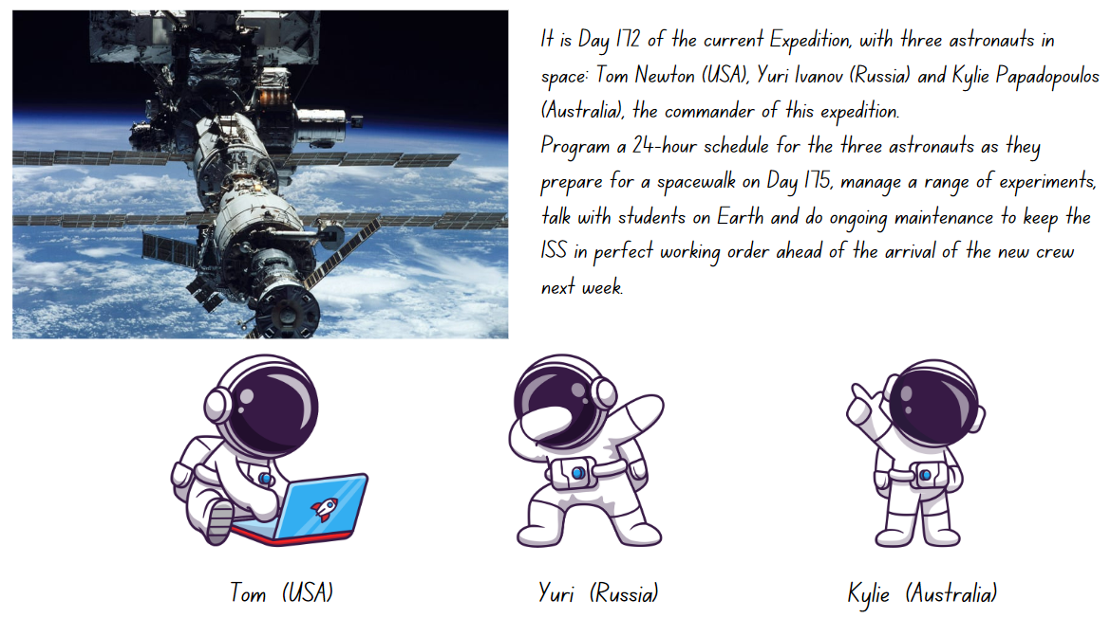

Resource 29: ISS mission briefing 3
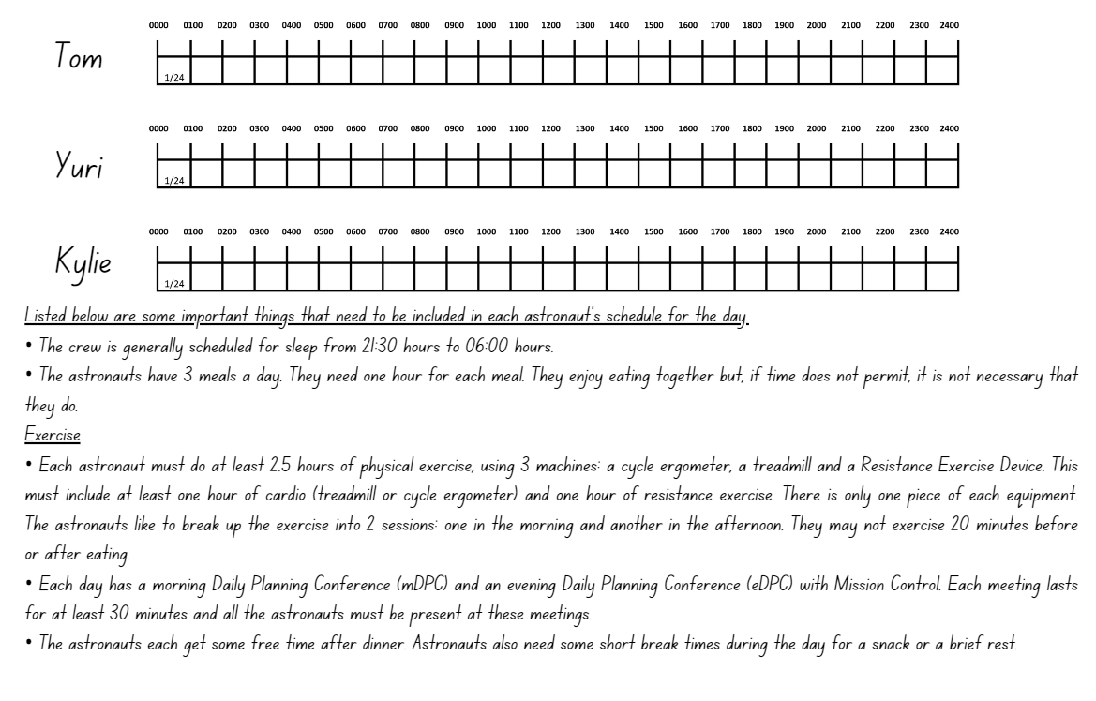

Syllabus outcomes and content
The table below outlines the syllabus outcomes and range of relevant syllabus content covered in this unit. Content is linked to National Numeracy Learning Progression version (3).
Outcomes and content | 1 | 2 | 3 | 4 | 5 | 6 | 7 | 8
Additive relations A: Apply efficient mental and written strategies to solve addition and subtraction problems
[MAO-WM-01, MA3-AR-01]
- Solve word problems, including multistep problems |  |  |  |  |  | x
- Apply known strategies such as levelling, addition for subtraction, using constant difference, and bridging (Reasons about relations) |  |  |  |  |  |  | x
- Use place value to add or subtract 3 or more numbers with different numbers of digits |  |  |  |  | x | x
- Identify efficient and inefficient multidigit subtraction strategies |  |  |  |  |  | x
Representing quantity fractions A: Compare and order common unit fractions
[MAO-WM-01, MA3-RQF-01]
- Compare unit fractions as numbers to the benchmark value ½ | x | x | x
- Compare and order unit fractions with denominators of 2, 3, 4, 5, 6, 8 and 10 by placing them on a number line | x | x | x
Representing quantity fractions A: Solve problems involving addition and subtraction of fractions with the same denominator
[MAO-WM-01, MA3-RQF-01, MA3-RQF-02]
- Represent the sum of fractions with the same denominator, recreating the whole, where the result may exceed one |  |  |  |  |  |  |  | x
- Solve word problems that involve fractions with the same denominator |  |  |  |  |  |  |  | x
Geometric measure A: Angles: Estimate, measure and compare angles using degrees
[MAO-WM-01, MA3-GM-03]
- Identify the arms and vertex of an angle where both arms are invisible, such as for rotations | x |  |  | x
- Explain how a protractor is formed and used to measure an angle | x |  | x | x
- Estimate and describe the size of angles using known angles as benchmarks (Reasons about mental rotation) | x | x |  | x
- Record angle measurements using the symbol for degrees (°) |  | x | x | x
- Measure angles of up to 360° using a protractor |  | x | x | x
Geometric measure A: Angles: Use a protractor to measure and identify types of angles
[MAO-WM-01, MA3-GM-03]
- Recognise that a right angle is 90°, a straight angle is 180° and an angle of revolution is 360° | x | x | x
- Identify and describe angle size in degrees for the classifications acute, obtuse and reflex | x | x | x | x
Non-spatial measure A: Time: Compare 12- and 24-hour time systems and convert between them
[MAO-WM-01, MA3-NSM-02]
- Recognise that 24-hour time is used to avoid confusion between am and pm |  |  |  |  | x | x | x
- Read time using appropriate 24-hour time language |  |  |  |  | x | x | x
- Convert between 24-hour time and 12-hour time using am or pm notation |  |  |  |  | x | x | x
- Read, interpret and use timetables from real-life situations, involving 12- and 24-hour time |  |  |  |  |  |  | x | x
Mathematics K–10 Syllabus © NSW Education Standards Authority (NESA) for and on behalf of the Crown in right of the State of New South Wales, 2022.

References
This resource contains NSW Curriculum and syllabus content. The NSW Curriculum is developed by the NSW Education Standards Authority. This content is prepared by NESA for and on behalf of the Crown in right of the State of New South Wales. The material is protected by Crown copyright.
Please refer to the NESA Copyright Disclaimer for more information https://educationstandards.nsw.edu.au/wps/portal/nesa/mini-footer/copyright.
NESA holds the only official and up-to-date versions of the NSW Curriculum and syllabus documents. Please visit the NSW Education Standards Authority (NESA) website https://educationstandards.nsw.edu.au/ and the NSW Curriculum website https://curriculum.nsw.edu.au.
Mathematics K–10 Syllabus © NSW Education Standards Authority (NESA) for and on behalf of the Crown in right of the State of New South Wales, 2022.
National Numeracy Learning Progression © Australian Curriculum, Assessment and Reporting Authority (ACARA) 2010 to present, unless otherwise indicated. This material was downloaded from the Australian Curriculum website (National Literacy Learning Progression) (accessed 4 August 2023) and was not modified.
Australian Government Department of Education (2020) ‘Time: Mission Control to ISS’, Teaching resources, reSolve: Maths by Inquiry website, accessed 3 August 2023.
Education Services Australia Ltd (2016) Time tools, Scootle website, accessed 4 August 2023.
Francome T (2016) Empty protractor [PDF 539 KB], Association of Teachers of Mathematics, accessed 4 August 2023.
MathsisFun.com (2021) Angles, Maths is Fun website, accessed 4 August 2023.
McMaster H and Mitchelmore M (2005) ‘The rewards and difficulties of Working Mathematically’ [conference presentation], AAMT Conference Proceedings, Sydney.
University of Cambridge (Faculty of Mathematics) (n.d.) 5 on the Clock, NRICH website, accessed 3 August 2023.
University of Cambridge (Faculty of Mathematics) (n.d.) Dicey Operations in Line, NRICH website, accessed 3 August 2023.

© State of New South Wales (Department of Education), 2023
The copyright material published in this resource is subject to the Copyright Act 1968 (Cth) and is owned by the NSW Department of Education or, where indicated, by a party other than the NSW Department of Education (third-party material).
Copyright material available in this resource and owned by the NSW Department of Education is licensed under a Creative Commons Attribution 4.0 International (CC BY 4.0) license.
This license allows you to share and adapt the material for any purpose, even commercially.
Attribution should be given to © State of New South Wales (Department of Education), 2023.
Material in this resource not available under a Creative Commons license:
- the NSW Department of Education logo, other logos and trademark-protected material
- material owned by a third party that has been reproduced with permission. You will need to obtain permission from the third party to reuse its material.
Links to third-party material and websites
Please note that the provided (reading/viewing material/list/links/texts) are a suggestion only and implies no endorsement, by the New South Wales Department of Education, of any author, publisher, or book title. School principals and teachers are best placed to assess the suitability of resources that would complement the curriculum and reflect the needs and interests of their students.
If you use the links provided in this document to access a third-party's website, you acknowledge that the terms of use, including licence terms set out on the third-party's website apply to the use which may be made of the materials on that third-party website or where permitted by the Copyright Act 1968 (Cth). The department accepts no responsibility for content on third-party websites.

