Mathematics Stage 3 – Unit 28
Visual representations help understand aspects of the world (chance and position)

Contents
Unit description and duration 6
Syllabus outcomes 6
Working mathematically 7
Student prior learning 7
Lesson overview and resources 11
Lesson 1 17
Daily number sense – number line search – 10 minutes 17
Core lesson – spaces v lines – 30 minutes 19
Consolidation and meaningful practice – 20 minutes 25
Lesson 2 28
Daily number sense – elevator challenge – 15 minutes 28
Core lesson – shapeshifters – 20 minutes 30
Consolidation and meaningful practice – 25 minutes 33
Lesson 3 37
Daily number sense – eyes closed subtraction – 10 minutes 37
Core lesson – Cartesian plane – 25 minutes 39
Consolidation and meaningful practice – 25 minutes 42
Lesson 4 45
Daily number sense – 10 minutes 45
Core lesson – mirror, mirror – 20 minutes 45
Consolidation and meaningful practice – 20 minutes 51
Lesson 5 53
Daily number sense – fun fractions – 10 minutes 53
Core lesson – numerically representing chance – 30 minutes 55
Consolidation and meaningful practice – 15 minutes 60
Lesson 6 64
Daily number sense – equivalent fractions – 15 minutes 64
Core lesson – equally likely – 30 minutes 66
Consolidation and meaningful practice – 15 minutes 70
Lesson 7 75
Daily number sense – everything about my fraction – 10 minutes 75
Core lesson – twice as likely – 30 minutes 77
Consolidation and meaningful practice – 15 minutes 81
Lesson 8 84
Daily number sense – 10 minutes 84
Core lesson – mystery bag – 40 minutes 84
Consolidation and meaningful practice – 10 minutes 90
Resource 1 – number lines 93
Resource 2 – position representations 94
Resource 3 – I spy grid 96
Resource 4 – I spy Cartesian plane 97
Resource 5 – ship shore 98
Resource 6 – ship shore grid 99
Resource 7 – labelling misconceptions 100
Resource 8 – move to shoot 101
Resource 9 – elevator floor cards 102
Resource 10 – hotel floors 103
Resource 11 – x- and y-coordinates 104
Resource 12 – shapeshifters 105
Resource 13 – shapeshifters 2 106
Resource 14 – blank Cartesian plane 107
Resource 15 – plotting shapes 108
Resource 16 – plotting points 109
Resource 17 – plotting shapes 2 110
Resource 18 – plotting points 2 111
Resource 19 – plotting points 3 112
Resource 20 – pentagon mirror 113
Resource 21 – mirror, mirror 114
Resource 22 – mirror, mirror 2 115
Resource 23 – reflecting stick figures 116
Resource 24 – reflect compound shapes 117
Resource 25 – chance representations 118
Resource 26 – spinner table 120
Resource 27 – spinner table 2 121
Resource 28 – rooster vs rabbit 122
Resource 29 – equally likely spinners 123
Resource 30 – fraction strips 1 124
Resource 31 – net and strips 125
Resource 32 – coloured fraction strips 126
Resource 33 – 4-part spinner 127
Resource 34 – 8-part spinner 128
Resource 35 – recording mystery bag 129
Resource 36 – class recording 130
Resource 37 – how accurate 131
Syllabus outcomes 132
References 136
Further reading 137

Unit description and duration
This unit develops the big idea that visual representations help understand aspects of our world (chance and position).
In this 2-week unit students are provided opportunities to:
- plot and translate shapes on a Cartesian plane
- explore and experiment with frequency and sample size containing equal and unequal chance
- present probability outcomes and create random generators.

Syllabus outcomes
- MAO-WM-01 develops understanding and fluency in mathematics through exploring and connecting mathematical concepts, choosing and applying mathematical techniques to solve problems, and communicating their thinking and reasoning coherently and clearly
- MA3-RN-01 applies an understanding of place value and the role of zero to represent the properties of number
- MA3-RQF-01 compares and orders fractions with denominators of 2, 3, 4, 5, 6, 8 and 10
- MA3-GM-01 locates and describes points on a coordinate plane
- MA3-2DS-01 investigates and classifies two-dimensional shapes, including triangles and quadrilaterals based on their properties
- MA3-CHAN-01 conducts chance experiments and quantifies the probability

Working mathematically
In the Mathematics K–10 Syllabus, there is one overarching Working mathematically outcome (MAO-WM-01). The Working mathematically processes should be embedded within the concepts being taught. The Working mathematically processes are:
- communicating
- understanding and fluency
- reasoning
- problem solving.
Mathematics K–10 Syllabus © NSW Education Standards Authority (NESA) for and on behalf of the Crown in right of the State of New South Wales, 2022.

Student prior learning
Before engaging in these teaching and learning activities, students would benefit from prior experience with:
- using directional language to interpret and locate positions on a grid map while describing routes
- predicting and describing possible outcomes from chance experiments
- using visualisation, language and multiple representations of position and chance concepts.
In NSW classrooms there is a diverse range of students, including Aboriginal and Torres Strait Islander students, students learning English as an additional language or dialect, high potential and gifted students and students with disability. Some students may identify with more than one of these groups or possibly all of them. Refer to Advice on curriculum planning for every student for further information.

Teachers can support student learning and reasoning in this unit by connecting language, representations and visualisation for both position and chance (see Figure 1 and Figure 2). This model of support is adapted from content provided by Adjunct Professor Marj Horne in Big ideas to start strong across K–6 – Module 3: We measure to learn about, navigate and describe the world around us (NSW DoE 2023).
Figure 1 – pedagogical support – chance
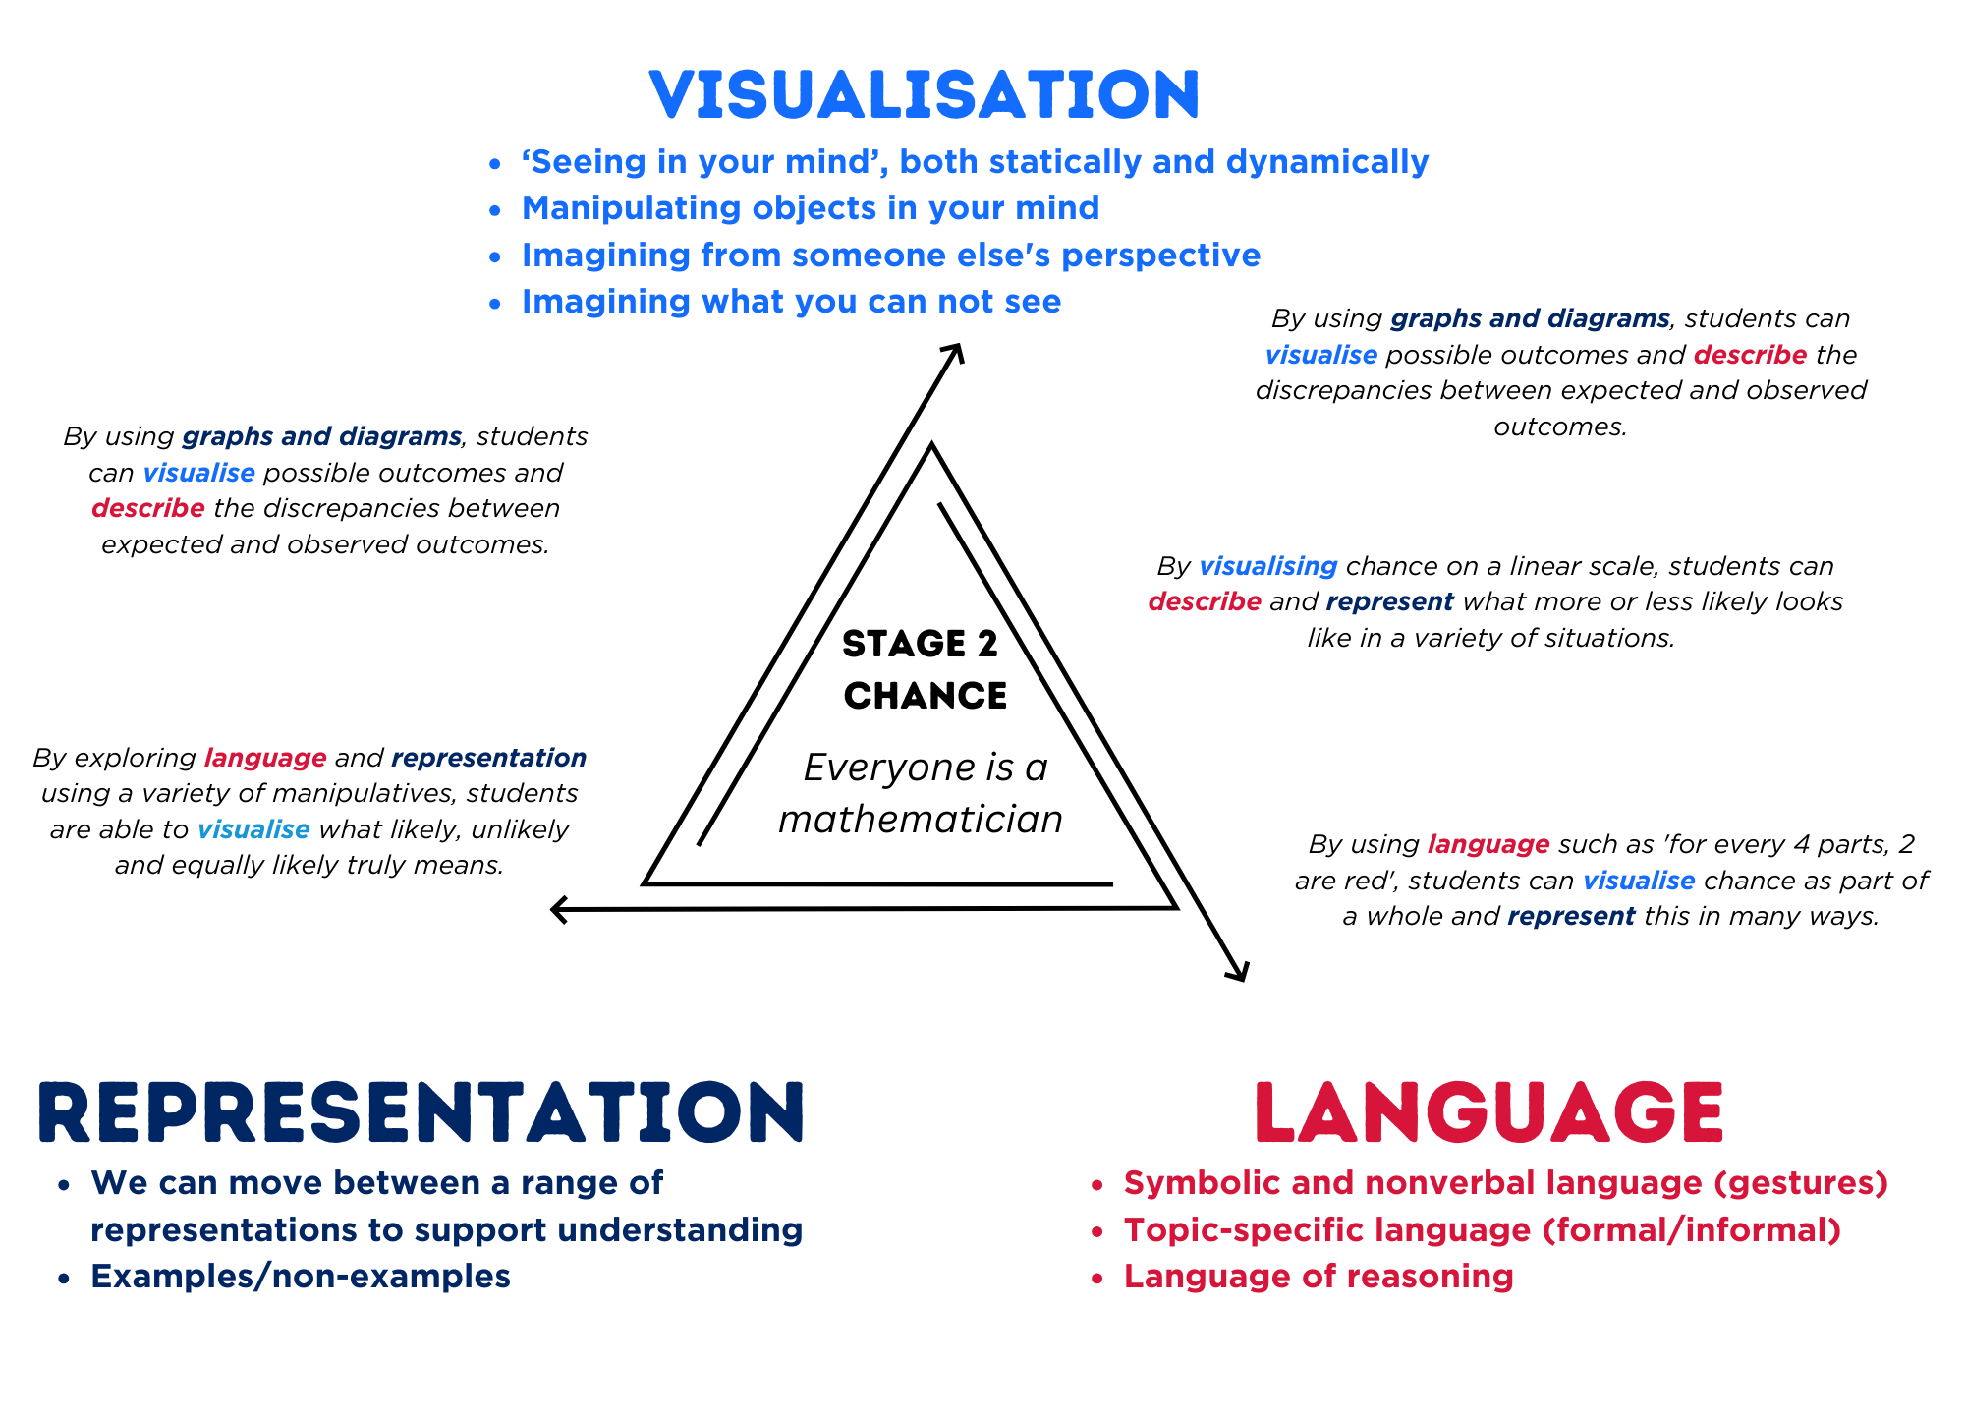
Figure 2 – pedagogical support – position
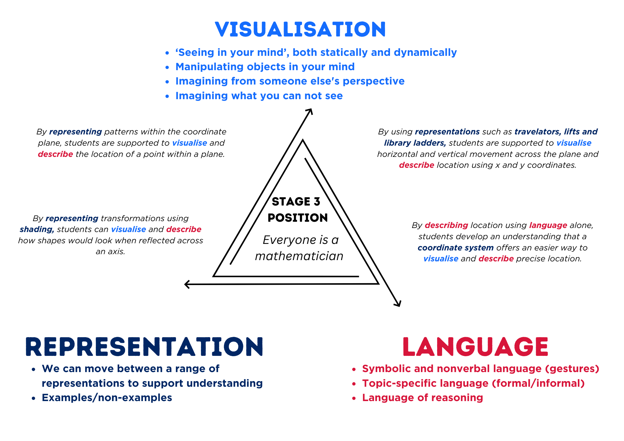

Lesson overview and resources
The table below outlines the sequence and approximate timing of lessons, learning intentions and resources.
Lesson | Content | Duration and resources
Lesson 1  Daily number sense learning intention:  - locate and represent integers on a number line | Lesson core concept: different mapping systems identify a grid area or a specific point.  Core concept learning intention:  - explore the Cartesian coordinate system | Lesson duration: 60 minutes  - Resource 1 – number lines  - Resource 2 – position representations  - Resource 3 – I spy grid  - Resource 4 – I spy Cartesian plane  - Resource 5 – ship shore  - Resource 6 – ship shore grid  - Resource 7 – labelling misconceptions  - Resource 8 – move to shoot  - Writing materials
Lesson 2  Daily number sense learning intention:  - locate and represent integers on a number line | Lesson core concept: coordinates define the point on a number plane.  Core concept learning intentions:  - explore the Cartesian coordinate system  - use the 4 quadrants of the coordinate plane | Lesson duration: 60 minutes  - Resource 9 – elevator floor cards  - Resource 10 – hotel floors  - Resource 11 – x- and y-coordinates  - Resource 12 – shapeshifters  - Resource 13 – shapeshifters 2  - Elastics  - Geoboards or digital geoboards  - Workbooks  - Writing materials
Lesson 3  Daily number sense learning intention:  - locate and represent integers on a number line. | Lesson core concept: coordinates define the point on a number plane.  Core concept learning intention:  - use the 4 quadrants of the coordinate plane | Lesson duration: 60 minutes  - Resource 14 – blank Cartesian plane  - Resource 15 – plotting shapes  - Resource 16 – plotting points  - Resource 17 – plotting shapes 2  - Resource 18 – plotting points 2  - Resource 19 – plotting points 3  - Writing materials
Lesson 4  Daily number sense learning intention:  - teacher-identified task based on student needs | Lesson core concept: coordinates change when a point is translated or reflected across an axis.  Core concept learning intentions:  - use the 4 quadrants of the coordinate plane  - dissect two-dimensional shapes and rearrange them using translations, reflections and rotations | Lesson duration: 50 minutes  - Resource 20 – pentagon mirror  - Resource 21 – mirror, mirror  - Resource 22 – mirror, mirror 2  - Resource 23 – reflecting stick figures  - Resource 24 – reflect compound shapes  - Coloured pencils or highlighters  - Writing materials
Lesson 5  Daily number sense learning intention:  - compare common fractions with related denominators | Lesson core concept: probability can be represented on a scale from zero to one.  Core concept learning intentions:  - list outcomes of chance experiments involving equally likely outcomes and represent probabilities  - create random generators and describe probabilities using fractions | Lesson duration: 55 minutes  - Resource 25 – chance representations  - Resource 26 – spinner table  - Resource 27 – spinner table 2  - Writing materials  - Whiteboards
Lesson 6  Daily number sense learning intention:  - compare common fractions with related denominators | Lesson core concept: probability can be represented as a fraction.  Core concept learning intentions:  - list outcomes of chance experiments involving equally likely outcomes and represent probabilities  - create random generators and describe probabilities using fractions | Lesson duration: 60 minutes  - Resource 28 – rooster vs. rabbit  - Resource 29 – equally likely spinners  - Resource 30 – fraction strips 1  - Resource 31 – net and strips  - Resource 32 – coloured fraction strips  - Coins  - Writing materials
Lesson 7  Daily number sense learning intention:  - compare common fractions with related denominators | Lesson core concept: the probability of an outcome occurring has a value.  Core concept learning intentions:  - list outcomes of chance experiments involving equally likely outcomes and represent probabilities  - create random generators and describe probabilities using fractions | Lesson duration: 55 minutes  - Resource 33 – four-part spinner  - Resource 34 – eight-part spinner  - Writing materials  - Whiteboard  - Counters
Lesson 8  Daily number sense learning intention:  - teacher-identified task based on student needs | Lesson core concept: expected and observed frequencies align better in larger trials.  Core concept learning intention:  - conduct chance experiments with both small and large numbers of trials | Lesson duration: 60 minutes  - Resource 35 – recording mystery bag  - Resource 36 – class recording  - Resource 37 – how accurate  - Writing materials  - Counters  - Paper bags

Lesson 1
Core concept: different mapping systems identify a grid area or a specific point.

Daily number sense – number line search – 10 minutes
Daily number sense activities for Lessons 1 to 3 ‘activate’ prior number knowledge and support the learning of new content in the unit. These activities can also assist teachers to identify the starting points for learning by revealing the extent of students’ existing knowledge.
The table below contains a suggested learning intention and success criteria. These are best co-constructed with students.
Daily number sense learning intention | Daily number sense success criteria
Students are learning to:  - locate and represent integers on a number line. | Students can:  - recognise the location of negative whole numbers in relation to zero and place them on a number line.
This activity is an adaptation of Finding numbers on a number line from Mathematics K–6 resources by State of New South Wales (Department of Education).
- Display Resource 1 – number lines. Direct student attention to Line ABC.
- Ask students what they notice about the number line and what numbers could be placed on the number line at point A, B and C and how they can prove it.
- Provide students with individual whiteboards to record their answers.
- Direct student attention to Line YZ.
- Ask students what numbers can be placed on the number line at point Y and Z and if can they find zero.
- Ask students to record their responses on individual whiteboards.
- Ask students:
- Where would you place -10 and -15 on the number line?
- What is half between Y and Z? Why?
- Can you give an example of when we use negative numbers in real life and what the negative numbers represent? (For example, temperature -5 degrees Celsius is 5 degrees below freezing point).
This table details opportunities for assessment.
Assessment opportunities | Links
What to look for:  - Can students recognise the location of negative whole numbers in relation to zero and place them on a number line? [MAO-WM-01, MA3-RN-01] | Links to National Numeracy Learning Progressions (NNLP):  - NPV9.

Core lesson – spaces v lines – 30 minutes
The table below contains suggested learning intentions and success criteria. These are best co-constructed with students.
Core concept learning intentions | Core concept success criteria
Students are learning to:  - explore the Cartesian coordinate system. | Students can:  - recognise that the grid-map reference system gives the area of a location and the number plane identifies a specific point  - identify that in the coordinate system the lines are numbered, not the spaces  - identify the point of intersection of the 2 axes as the origin, having coordinates (0, 0)  - plot and label points, given coordinates, on the number plane in the first quadrant, describing the horizontal position first, followed by the vertical position.
Note: the purpose of this lesson is to develop an understanding of the structure of the Cartesian plane as 2 intersecting number lines with an origin point at (0, 0). Points can be referenced by considering horizontal and then vertical movement within the plane.
For each lesson on position in this unit, students can enhance their understanding of position by using multiple representations or tools, such as those featured in Figure 3. These representations and tools can be co-constructed with students on an anchor chart or provided as a resource, see Resource 2 – position representations.
Figure 3 – position representations
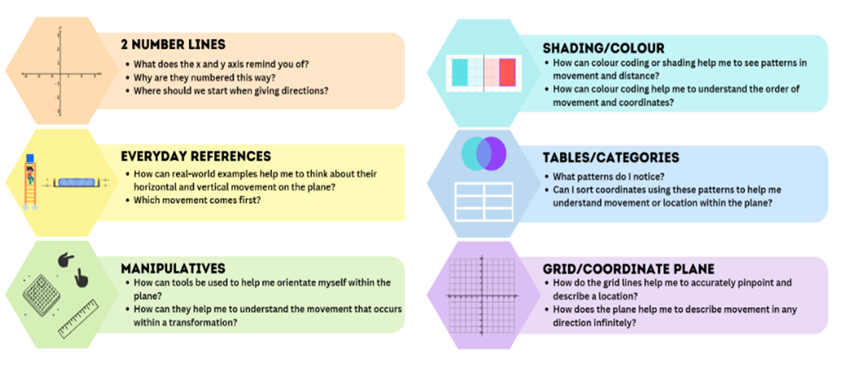
- Display Resource 3 – I spy grid. Ask students what they can see at different grid references such as at C1, D1 and so on.
- Record student answers in a table for each grid reference.
- Repeat the same activity using Resource 4 – I spy Cartesian plane and record student responses.
Note: the resources differ in the placement of the numbers and letters in line with the grid lines.
- Compare the observed data. Discuss the lines’ accuracy in pinpointing specific locations compared to the broader coverage of spaces where many objects may be located.
- Display Resource 5 – ship shore. Ask students to visualise standing on the island with the ship to their right and the shore to their left.
The table below outlines stimulus prompts to generate conversation about the topic, along with anticipated responses from students.
Prompts | Anticipated student responses
- How might you describe to your partner how to get to the yellow bird? | - Go diagonally into the sky.  - Travel in a north-east direction.
- Are these directions specific enough to ensure that your partner will reach the bird? | - No, because there are other things in the sky.
- What system could you use to help describe the location of the bird? | - I could use the grid reference system.
- What might this look like when using this map? | - I would need to layer the gird on top.
- Display Resource 6 – ship shore grid to represent layering a grid on top of the image.
- Display Resource 7 – labelling misconceptions. Use the table below to discuss the labelling systems.
Prompts | Anticipated student responses
- What happens if all the letters in the alphabet are used? | - You could use 2 letters.  - You could use a different system.  - You could use a letter and a number.
- What problem would you have if you want to add to the map and point A is already on the far left? | - There are no letters before A. You would need a different labelling system.
- Is it better to use letters or numbers? Why? | - It is better to use numbers because they go on forever.
- Which system will always work if you need to extend the map in any direction? | - Using the system where the zero is in the centre is best because you can never run out of numbers no matter which direction you travel.  Note: example B uses numbers, however, the quadrants do not mirror each other as zero is not at the centre.
- What do the 2 lines remind you of? What do they represent? | - 2 (infinite) number lines.
- How might you name these lines/axes? | - X (horizontal) and Y (vertical).
- How might these help you label a point on a plane? | - I can label it (x, y) or label it (y, x).  Note: emphasise the need for a consistent system of referencing and explain that (x, y) is always used.
- Provide each student a copy of Resource 6 – ship shore grid.
- Students label each axis using x- and y-coordinates.
- Model the location of the yellow bird. Explain that its position can be described using the number plane to pinpoint its location. Emphasise the need to reference the x-coordinate first, then the y-coordinate.
- Students share their labelled grids and ask a peer to locate and record various objects using a grid reference.
This table details opportunities for differentiation.
Too hard? | Too easy?
Students cannot explore the Cartesian coordinate system.  - Students describe locations moving left and right on a number line. Draw the connection that they are using lines, not the spaces.  - Students use a highlighting system that relates to a coloured coded x- and y-axis to support the order of the coordinates. | Students can explore the Cartesian coordinate system.  - Place Resource 6 – ship shore grid on a larger piece of paper. Extend the axes in each direction. Place additional images and label them using coordinates.  - Students write an assessment rubric for rating examples A, B and C from Resource 7 – labelling misconceptions. Students share their ratings with the class.

Consolidation and meaningful practice – 20 minutes
- Display Resource 8 – move to shoot. The aim of the game is to collect the most points.
- Place the spaceship at the corner marked zero of Resource 8 – move to shoot.
- Students play scissors, paper, rock.
- The winner of each round is allowed to take a shot. For example, move the spaceship 4 lines across and shoot up 5 lines. Students record this point (4, 5) and the points on the target (5).
- If there is more than one target on a line, students must take the closest target that has not already been taken.
- The spaceship returns to zero before the next round.
- Students record their scores in a table until all targets have been taken.
Note: it is important to draw students’ attention to the fact that the spaceship must move across horizontally before shooting up to hit the targets. This will encourage students to think about the x-coordinate first, then the y-coordinate.
- Provide pairs of students with a copy of Resource 8 – move to shoot. Allow time for students to play and record their scores.
- As a class, discuss:
- How would you describe the movement of your spaceship each time?
- How does this relate to the way you name coordinates for a point?
- If you did not have a spaceship, what else could you use to locate a point on the plane? (fingers, rulers, craft sticks)
This table details opportunities for assessment.
Assessment opportunities | Links
What to look for:  - Can students recognise that the grid-map reference system gives the area of a location and the number plane identifies a specific point? [MAO-WM-01, MA3-GM-01]  - Can students plot and label points, on the number plane in the first quadrant, describing the horizontal position first, followed by the vertical position? [MAO-WM-01, MA3-GM-01] | Links to National Numeracy Learning Progressions (NNLP):  - n/a.

Lesson 2
Core concept: coordinates define the point on a number plane.

Daily number sense – elevator challenge – 15 minutes
The table below contains a suggested learning intention and success criteria. These are best co-constructed with students.
Daily number sense learning intention | Daily number sense success criteria
Students are learning to:  - locate and represent integers on a number line. | Students can:  - recognise the location of negative whole numbers in relation to zero and place them on a number line  - interpret integers in everyday contexts.
The activity is an adaptation of Directed Number from reSolve by Australian Government Department of Education.
- Introduce the context of the elevator challenge: Joe and Joanna are employees at a hotel. The manager has given them each 4 errands to run on 4 different floors of the hotel. They need to share the elevator to get up and down to complete each task. The person who finishes all their jobs first will be ‘Employee of the Month’.
- Provide pairs of students with 12 cards from Resource 9 – elevator floor cards. Students take 4 cards each; these are the 4 errands. Place the remaining cards to the side.
- Provide each pair a die, Resource 10 – hotel floors and one counter. Place the counter at floor zero, the lobby. Students roll the die and the player with the highest number goes first.
- Player 1 rolls the die and moves the elevator (counter) the number of floors according to the number shown on the die, either up or down as they choose. Whoever holds the card matching the floor the elevator lands on can discard it; the errand is complete.
- Player 2 rolls the die and moves the elevator (counter) from the level where it is, up or down in either direction. Once again, when the elevator stops, the owner of the card for that level can discard it.
- Students continue rolling the dice, taking turns to move the elevator up or down.
- The winner is the first player to complete all their jobs. They can then be awarded the ‘Employee of the Month’.
- Students are not to go above floor 6, below -6 or ‘bounce’ the elevator off the top or bottom. This means if a student is on floor 5 and rolls a 3, they must go down. Each journey can be in one direction only. Players must move the total on the die.
This table details opportunities for assessment.
Assessment opportunities | Links
What to look for:  - Can students recognise the location of negative whole numbers in relation to zero and place them on a number line? [MAO-WM-01, MA3-RN-01]  - Can students interpret integers in everyday contexts? [MAO-WM-01, MA3-RN-01] | Links to National Numeracy Learning Progressions (NNLP):  - NPV9.

Core lesson – shapeshifters – 20 minutes
The table below contains suggested learning intentions and success criteria. These are best co-constructed with students.
Core concept learning intentions | Core concept success criteria
Students are learning to:  - explore the Cartesian coordinate system  - use the 4 quadrants of the coordinate plane. | Students can:  - identify the point of intersection of the 2 axes as the origin, having coordinates (0, 0)  - plot and label points, given coordinates, on the number plane in the first quadrant, describing the horizontal position first, followed by the vertical position  - describe changes to coordinates when a point is translated.
Note: the purpose of this lesson is to understand how horizontal movement within the plane corresponds to a shift in the x-coordinate and vertical movement leads to a shift in the y-coordinate.
- Write the following coordinates on the board: (2, 1), (4, 1), (2, 3), (4, 3).
- Provide pairs of students with Resource 11 – x- and y-coordinates. Students group the sets of coordinates according to similarities and differences.
Note: (2, 1) and (2, 3) share the same x-coordinate. (2, 1) and (4,1) share the same y-coordinate.
- Draw the first quadrant and revise how to plot (2, 1) onto the plane. Model the x-coordinate first, before the y-coordinate.
- Repeat with (4, 1) and draw a line connecting (2, 1) and (4, 1).
- Ask students:
- What connects these 2 points? (It is a horizontal line).
- Which coordinates have changed, and which remain the same? (The x-coordinates have changed, and y-coordinates have stayed the same).
- Add the point (2, 3) to the plane and connect it to (2, 1).
- Ask students:
- What did you notice? (It is a vertical line).
- Which coordinates have changed, and which remain the same? (The x-coordinates are the same and y-coordinates have changed).
- Repeat with (4, 1) and (4, 3) followed by (2, 3) and (4, 3).
- Ask the class:
- Is there a pattern between how the coordinates changed within the plane?
- Which coordinates change when you are moving horizontally across the plane?
- Which coordinates change when you are moving vertically up and down the plane?
- What shape is now plotted on the Cartesian plane? (A square).
- Draw a rhombus on the board.
- Ask students how they could change the coordinates of the square to make it a rhombus.
The table below outlines stimulus prompts to generate conversation about the topic, along with anticipated responses from students.
Prompts | Anticipated student responses
- Do all points of the square need to be changed or just some? | - No, just slide the top pair of coordinates over to the left/right.  - No, just slide the bottom pair of coordinates over to the left/right.
- If you change the x-coordinate in the top 2 pairs of coordinates, what type of change will you be making? Horizontal or vertical? | - Horizontal.  - Side to side.
- If you move horizontally, which coordinate will you expect to see change? By how much? | - The x-coordinate would change.  - It depends on how far you slide the point over.  - The x-coordinate because the shape is not being moved up or down.

Consolidation and meaningful practice – 25 minutes
- Provide each pair Resource 12 – shapeshifters and one of the tools below:
- a geoboard and some elastics
- Digital geoboard
- Cartesian plane template (first quadrant only).
- If using a geoboard, students put the geoboard on top of a sheet of paper that marks intervals along the x- and y-axis (see Figure 4).
Figure 4 – sample geoboard
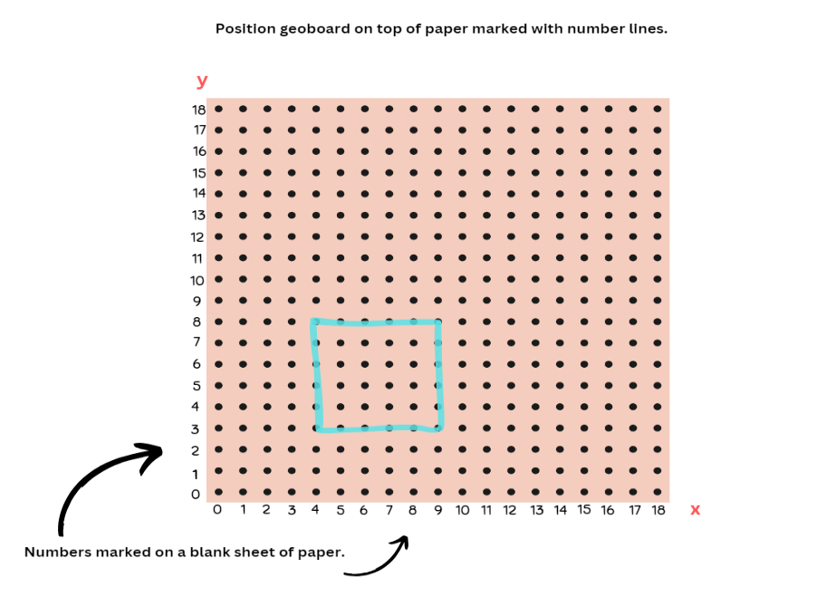
- Explain that students will be making the original shape on the plane followed by the new shape and see the change in coordinates.
- Students record the new points on Resource 12 – shapeshifters.
- Students also record whether a horizontal or vertical change was made, and whether the x- or y-coordinate was changed.
- Discuss the following questions at the completion of the shapes:
- What connection can you make between movement within the plane and changes in the x- and y-coordinates?
- How did your representation help you visualise the movement of x- and y-coordinates depending on which way the shape changed?
This table details opportunities for differentiation.
Too hard? | Too easy?
Students cannot explore the Cartesian coordinate system.  - Students focus on identifying and plotting single points in the first quadrant.  - Students identify, plot and connect a series of coordinates to form a simple shape. For example, a triangle. | Students can explore the Cartesian coordinate system.  - Students determine their own coordinates for each shape and amend accordingly when changing the shape.  - Students consider the effect of a point’s diagonal shift on the x- and y-coordinates as they complete the shapeshifters task with compound rectangles. See Resource 13 – shapeshifters 2.
This table details opportunities for assessment.
Assessment opportunities | Links
What to look for:  - Can students plot and label points in the first quadrant? [MAO-WM-01, MA3-GM-01]  - Can students describe changes to coordinates when a point is translated? [MAO-WM-01, MA3-GM-01] | Links to National Numeracy Learning Progressions (NNLP):  - n/a.

Lesson 3
Core concept: coordinates define the point on a number plane.

Daily number sense – eyes closed subtraction – 10 minutes
The table below contains a suggested learning intention and success criteria. These are best co-constructed with students.
Daily number sense learning intention | Daily number sense success criteria
Students are learning to:  - locate and represent integers on a number line. | Students can:  - recognise that negative whole numbers can result from subtraction.
The activity is an adaptation from Engaging Maths: 25 Favourite Lessons by Clark and Roche.
- Students place a calculator on a flat surface in front of them.
- Explain that they will be given 2 numbers to type and a target number. They will then be putting their finger on the equals key, closing their eyes and pushing equals. Students keep track of the number sequence in their head and only open their eyes when they are confident that the calculator is showing the target number.
- To start, ask students to type 25 + 7 and close their eyes and push the equals sign. When they think they have reached the targeted number of 60, they are to stop and check their answer. Students share their results.
- Repeat the task for the following equations:
- 32 – 5 = target number -3
- 40 – 6 = target number -14
- 16 – 8 = target number -16
- Regroup and ask students:
- How did you feel about completing calculations with your eyes closed and using mental calculations?
- What strategies did you use to keep track of the number sequence in your head?
- How did you know when to stop your calculation and open your eyes for negative number calculations?
- Did you need to adjust your mental strategies when dealing with negative numbers compared to positive numbers?
- What was challenging about this task? What do you think might be helpful?

This table details opportunities for assessment.
Assessment opportunities | Links
What to look for:  - Can students recognise that negative whole numbers can result from subtraction? [MAO-WM-01, MA3-RN-01] | Links to National Numeracy Learning Progressions (NNLP):  - NPV9.

Core lesson – Cartesian plane – 25 minutes
The table below contains a suggested learning intention and success criteria. These are best co-constructed with students.
Core concept learning intention | Core concept success criteria
Students are learning to:  - use the 4 quadrants of the coordinate plane | Students can:  - plot and label points, given coordinates, in all 4 quadrants of the number line  - identify and record the coordinates of given points on the number plane in all 4 quadrants.
Note: the purpose of this lesson is to explore how a location can be described using all 4 quadrants of the Cartesian plane and to generalise about patterns in the number system within each quadrant.
- Display and provide each student Resource 14 – blank Cartesian plane.
- As a class, discuss and ask students questions using the prompt table.
The table below outlines stimulus prompts to generate conversation about the topic, along with anticipated responses from students.
Prompts | Anticipated student responses
- What does this remind you of? | - 2 intersecting number lines.  - 2 perpendicular number lines.  - 2 number lines that meet at 90 degrees.
- Which quadrant is most familiar to you? | - The top right quadrant because it looks like how we draw graphs.  Note: draw students’ attention to the fact that this is the first quadrant. Explain that mathematicians label the quadrants in an anticlockwise direction.
- Where can you find zero on each number line? | - At the point where they meet.  - At the centre point.  Note: students should know this from the first lesson, but you may need to address any misconceptions about the placement of zero.
- If zero appears on the x-axis and the y-axis at the point the 2 lines meet, how do we label this point using the (x, y) labelling system? | - (0, 0) represents the origin.  Note: students can label the numbers in the first quadrant on their copy of the plane.
- Ask students to label the numbers in the first quadrant on their copy of the plane.
The table below outlines stimulus prompts to generate conversation about the topic, along with anticipated responses from students.
Prompts | Anticipated student responses
- How could you label the other half of the x-axis? What knowledge about number lines might assist us? | - Numbers get smaller as we move to the left and bigger as we move to the right.  - The number line extends past zero. Numbers less than zero are negative. They are to the left of zero on the number line.  - Numbers to the left of zero look like a reflection of the numbers to the right of zero but are expressed as negative number.
- How might we label the y-axis? | - See above responses.
- Ask students to label the remaining axis on the Cartesian plane.
- Plot 3 points on the existing Cartesian plane using the coordinates (4, 1), (4, 4) and (-1, 4). Do not show students the coordinates.
- Ask students to identify what the coordinates are for each point and label these accordingly.
- Revisit and emphasise that the horizontal coordinate is tracked first followed by the vertical.
- Discuss where the appropriate point would be if you were to turn these points into a rectangle.
- Plot, label and connect the fourth point.
- Ask students which quadrants the rectangle stretches across.
- In pairs, students take turns to plot 3 points of a rectangle on the Cartesian plane. Their partner identifies the coordinates for each point and labels them. Then plots, labels and connects the fourth point to make a rectangle. Students swap roles and repeat.

Consolidation and meaningful practice – 25 minutes
- Provide pairs of students with a copy of Resource 15 – plotting shapes and Resource 16 – plotting points.
- Explain that students have the choice to work on level 1, 2, or 3, which will determine the number of quadrants their shape will appear within. Explain they can change the orientation of the shape if needed.
- Using the Cartesian plane students plot and label the coordinates of each shape.
- When complete, discuss as a class:
- What did you consider when locating the missing points? (For example, x-coordinate before the y-coordinate).
- How do you know if you have plotted the point correctly?
- Do you notice any similarities in the way the coordinates are written in the first quadrant?
- What about the other quadrants? (All coordinates in the first quadrant are positive integers, in the third quadrant are all negative and the second and fourth quadrants will have a combination of positive and negative integers).
This table details opportunities for differentiation.
Too hard? | Too easy?
Students cannot use the 4 quadrants of the coordinate plane.  - Students finding missing set of coordinates where 3 points already plotted and labelled. See Resource 17 – plotting shapes 2.  - Students focus on level 1 questions in Resource 15 – plotting shapes. | Students can use the 4 quadrants of the coordinate plane.  - Students plot shapes with more points across more quadrants. See Resource 18 – plotting points 2.  - Students are given a plane with 2 predetermined points and are asked to plot a variety of shapes. See Resource 19 – plotting points 3. Students will need to consider the geometry of these shapes and how the vertices land on points on the plane.
This table details opportunities for assessment.
Assessment opportunities | Links
What to look for:  - Can students plot and label points on all 4 quadrants of a coordinate plane? [MAO-WM-01, MA3-GM-01]  - Can students identify and record the coordinates in all 4 quadrants of a coordinate plane? [MAO-WM-01, MA3-GM-01] | Links to National Numeracy Learning Progressions (NNLP):  - n/a.

Lesson 4
Core concept: coordinates change when a point is translated or reflected across an axis.

Daily number sense – 10 minutes
- From a class need surfaced through formative assessment data, identify a short, focused activity that targets students’ knowledge, understanding and skills. Example activities may be drawn from the following resources:
- Mathematics K–6 resources
- Universal Resources Hub.

Core lesson – mirror, mirror – 20 minutes
The table below contains suggested learning intentions and success criteria. These are best co-constructed with students.
Core concept learning intentions | Core concept success criteria
Students are learning to:  - use the 4 quadrants of the coordinate plane  - dissect two-dimensional shapes and rearrange them using translations, reflections and rotations. | Students can:  - plot and label points, given coordinates, in all 4 quadrants of the number plane  - identify and record the coordinates of given points on the number plane in all 4 quadrants  - describe changes to coordinates when a point is translated or reflected across an axis  - use the terms translate, reflect and rotate to describe transformations of two-dimensional shapes.
Note: the purpose of this lesson is to understand that both the x- and y-axis are mirror lines and notice how coordinates change when translated or reflected.
- Display and provide each student Resource 20 – pentagon mirror.
- Ask students to identify and label the 5 points of the pentagon on their copy.
The table below outlines stimulus prompts to generate conversation about the topic, along with anticipated responses from students.
Prompts | Anticipated student responses
- Can you name some transformations for this shape? | - Flip (reflect)  - Slide (translate)  - Turn (rotate)
- What might it look like if you reflect this shape into the second quadrant? Where would you expect the shape to be located and would it look the same? | - It would look like a mirror image.  - It would look the same.  - It would look like it was slid across the same distance on the other side of the y-axis.  - If the shape was flipped, it would still look the same.  Note: not all shapes will look the same if they are reflected across a particular axis. It will depend on how the shape is orientated in relation to the axis (see Figure 5).
- What might it look like if you reflect this shape into the fourth quadrant? Where would you expect the shape to be located and would it look the same? | - No, it would look like it is upside down.  - It would still be the same size.  - The x-axis is like a line of symmetry or a mirror line.
- If you are reflecting into the second quadrant, what type of movement are you making? Will the x- or y-coordinates change? | - Horizontal.  - Side to side.  - It is moving horizontally/across, I would only expect the x-coordinate to change.
- If you are reflecting into the second quadrant, how can you work out where the points will be located? What representations can help you? | - I need to plot one point at a time (see Figure 6).  - I could work out the distance of the point from the y-axis/mirror line and keep the same distance on the other side of the y-axis.  - I can use a coloured pen/pencil or highlight to help me work out these distances.
- Is this process the same if reflect into the fourth quadrant? | - Yes, but I will be using the x-axis as the mirror line.
Figure 5 – teacher reflections
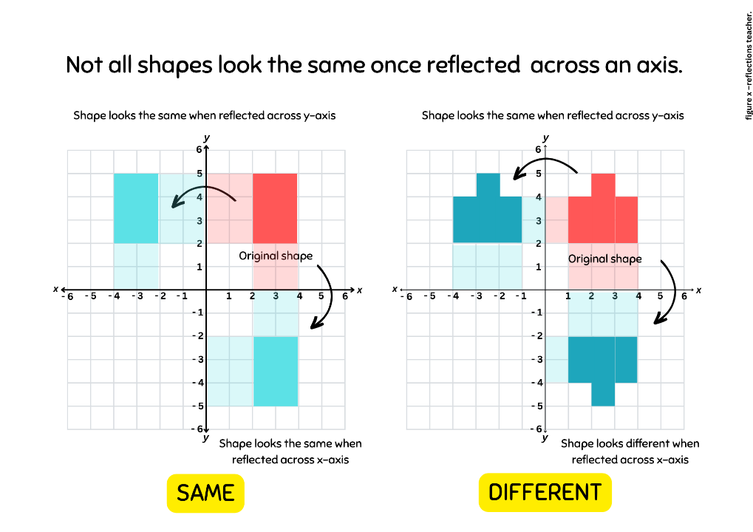

Figure 6 – reflected point
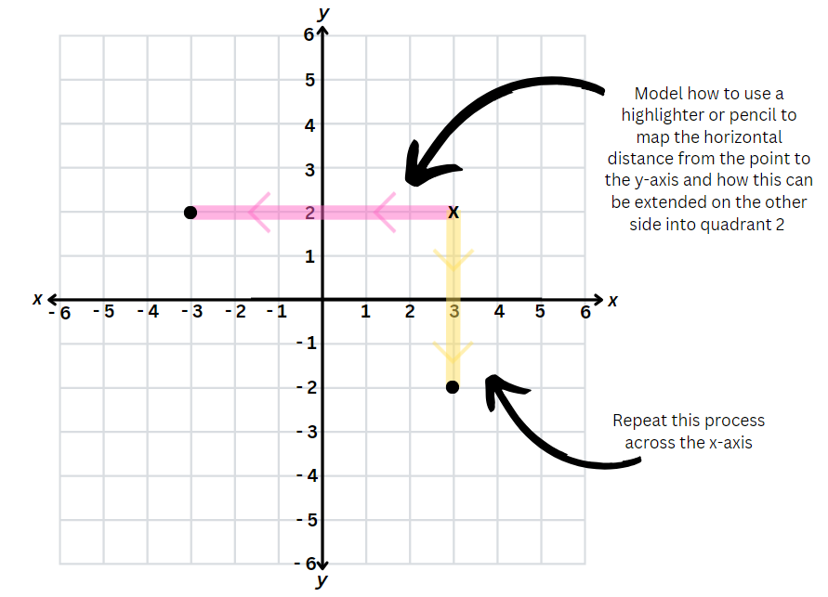
- Model how the pentagon can be reflected across the x- and y-axis using the questions above.
- Students can plot the reflections on Resource 20 – pentagon mirror. Encourage students to use different coloured pencils or highlighters for each point to help work out the distance from the x- or y-axis.

Consolidation and meaningful practice – 20 minutes
- Provide pairs of students with Resource 21 – mirror, mirror and a variety of coloured pencils or highlighters.
- In pairs, students label the original points of each shape.
- Students use coloured pencils or highlighters to support their reasoning as they reflect each shape across the x- and y-axis.
- Conclude the lesson and discuss:
- What did you notice about how the coordinates changed as you reflected across the x- or y- axis?
- How does this relate to the direction of the reflection? (For example, ‘I am reflecting it down along a vertical line so the x- coordinates change’.)
- How did using coloured pencils or highlighters help to ensure your shape looks similar and is in the right place?
This table details opportunities for differentiation.
Too hard? | Too easy?
Students cannot use the 4 quadrants of the coordinate plane.  - Students only reflect shapes that are aligned on the x- or y- axis reducing the number of points to be reflected. See Resource 22 – mirror, mirror 2.  - Provide students with shape manipulatives to physically simulate the flip across an axis. Students can use a coloured pencil or highlighter to shade the distance from the bottom or side of the shape to the mirror line. | Students can use the 4 quadrants of the coordinate plane.  - Students reflect a stick figure from the first quadrant into the remaining quadrants. See Resource 23 – reflecting stick figures.  - Students reflect compound shapes vertically and horizontally. See Resource 24 – reflect compound shapes.
This table details opportunities for assessment.
Assessment opportunities | Links
What to look for:  - Can students plot, label and record coordinates in all 4 quadrants? [MAO-WM-01, MA3-GM-01]  - Can students describe changes to coordinates when a point is reflected across an axis? [MAO-WM-01, MA3-GM-01]  - Can students use the terms translate, reflect and rotate to describe transformations of two-dimensional shapes? [MAO-WM-01, MA3-2DS-01] | Links to National Numeracy Learning Progressions (NNLP):  - UGP5, UGP6.

Lesson 5

Daily number sense – fun fractions – 10 minutes
Core concept: probability can be represented on a scale from zero to one.
Daily number sense activities for Lessons 5 to 7 ‘loop’ back to concepts and procedures covered in previous units to assist students to build an increasingly connected network of ideas. These concepts may differ from the core concepts being covered by the unit.
The table below contains a suggested learning intention and success criteria. These are best co-constructed with students.
Daily number sense learning intention | Daily number sense success criteria
Students are learning to:  - compare common fractions with related denominators. | Students can:  - order common fractions with related denominators using diagrams and number lines  - record equivalent fractions using diagrams, words and fraction notation.
This activity has been adapted from Open-Ended Maths Activities by Sullivan and Lilburn.
- Display the following problem: A friend of mine put these fractions into 2 groups. $\frac{2}{5}$, $\frac{3}{4}$, $\frac{6}{10}$, $\frac{1}{2}$ and $\frac{1}{10}$. What might the 2 groups be?
- Ask students to give reasons for their groups and to consider the following questions to support their explanation:
- What common characteristics or properties do you notice among these fractions?
- Can you simplify any of the fractions to make them easier to compare?
- Can you arrange the fractions in ascending or descending order to see if that helps in grouping?
- Do any of the fractions have the same numerator or denominator? Does that matter for grouping?
- What do you notice about the denominators of these fractions? Are there any common factors?
This table details opportunities for assessment.
Assessment opportunities | Links
What to look for:  - Can students order common fractions with related denominators using diagrams and number lines? [MAO-WM-01, MA3-RQF-01]  - Can students record equivalent fractions using diagrams, words and fraction notation? [MAO-WM-01, MA3-RQF-01] | Links to National Numeracy Learning Progressions (NNLP):  - InF6.

Core lesson – numerically representing chance – 30 minutes
The table below contains suggested learning intentions and success criteria. These are best co-constructed with students.
Core concept learning intentions | Core concept success criteria
Students are learning to:  - list outcomes of chance experiments involving equally likely outcomes and represent probabilities  - create random generators and describe probabilities using fractions. | Students can:  - use the term probability to describe the numerical value that represents the likelihood of an outcome of a chance experiment  - recognise that outcomes are described as equally likely when any one outcome has the same chance of occurring as any other chance outcome  - represent probabilities of outcomes of chance experiments using fraction  - use knowledge of benchmark fractions, decimals and percentages to assign probabilities to the likelihood of outcomes.
Note: the purpose of this lesson is to make the link between how both fractions and chance can be described as parts of a whole. Students will explore how chance may be described as the chance of a particular outcome occurring divided by the total possible outcomes and therefore it can be related to fractions.
For each lesson on chance in this unit, students can enhance their understanding by using various representations or tools, featured in Figure 7. These representations and tools can be collaboratively constructed with students or provided as a resource for them see Resource 25 – chance representations.
Figure 7 – chance representations
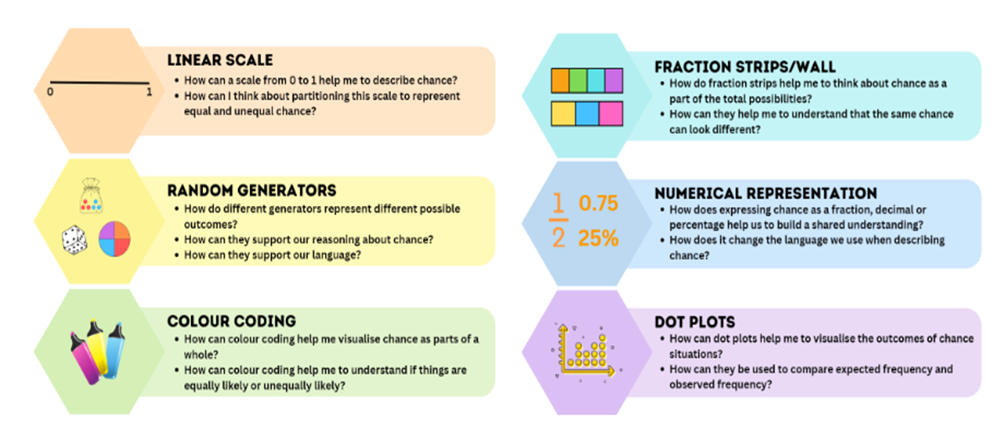
- Draw a circle on the board, divided into half (see Figure 8).
Figure 8 – Half representation
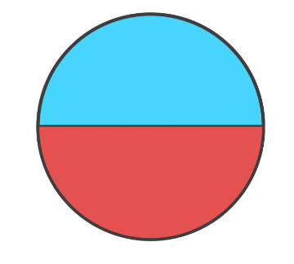
- Ask students how they would describe the red section. For example, red is half.
- Give each student a whiteboard and ask them to draw a number line from 0–1 representing the red section as a fraction on the number line.
- Ask students what other ways they could describe this representation, for example 50%, 0.5 or $\frac{1}{2}$.
Note: draw students’ attention to how a fraction can represent the number of particular outcomes divided by the total possible outcomes.
- Model the number line on the board with the numerical representations (see Figure 9).
Figure 9 – representing chance
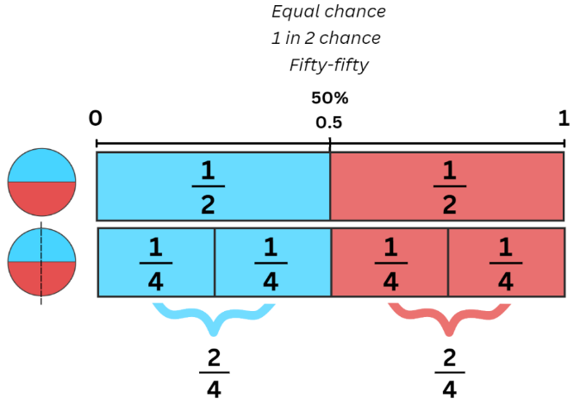
- Ask students to imagine the circle is now a spinner and ask what the chance is of landing on red. Anticipated student responses include 50:50, one out of 2, half. Add any additional language to the modelled number line, explicitly making the connection between the chance language and numerical representations.
- Model how to colour code the number line to reflect the spinner, noting that the midpoint separates the 2 colours (see Figure 9).
- Draw a vertical line through the circle you have drawn on the board to create 4 parts.
- Ask students what the chances are of landing on red if there are now 4 outcomes, where 2 are red and 2 are blue. (Still half).
- Discuss how the spinner would be represented on a new 0–1 number line positioned below the original for easy comparison.
- Ask students what language and numerical representations would we be including on the number line? (4 equal parts on the number line with 2 parts shaded red and 2 parts shaded blue, $\frac{2}{4}$ should be marked in line with $\frac{1}{2}$, for every 4 parts, 2 parts are blue and 2 parts are red, so it is equally likely to land on either.)
Note: focus on showing students how the fraction is formed, number of preferred outcomes divided by the total possible outcomes.
- Students represent the number line on their whiteboards. Emphasise that both spinners and number lines represent an equally likely chance for either outcome occurring.
The table below outlines stimulus prompts to generate conversation about the topic, along with anticipated responses from students.
Prompts | Anticipated student responses
- How can you make it less likely to land on red? | - Have more blue parts.  - Change a red section to blue.
- How can you represent this on our number line? | - By colour coding.  - By colour coding 3 parts blue and one part red.
- How can you describe this? | - One in 4 chances.  - $\frac{1}{4}$.  - For every 4 parts, one is red.  - For every 4 parts, 3 are blue.
- Model how to represent this on a number line with colour coding, numerical representation and chance language so that it is less likely to land on red.
- Students add this number line to their whiteboards.
- Using the 4-part spinner, repeat questions in the prompt box with a more likely chance of landing on red.
- Repeat activities and questions by manipulating the spinner so that it is:
- certain to land on red
- impossible to land on red.
Note: emphasise that impossible is the opposite of certain and how this relates to zero as the opposite of one.

Consolidation and meaningful practice – 15 minutes
- Give each student a copy of Resource 26 – spinner table.
- Explain that they will practice manipulating a spinner with benchmark fractions to given probabilities and represent this on a number line with numerical representations and chance language.
The table below outlines stimulus prompts to generate conversation about the topic, along with anticipated responses from students.
Prompts | Anticipated student responses
- What did you consider or think about when shading your spinners to represent equal chance? | - I thought about shading half the circle red and half the circle blue.  - I shaded half the segments red and the other half blue, but it did not have them beside each other.  - I split the total number of parts into 2.
- What did you consider or think about when representing equal chance for each spinner on the 0–1 scale? | - I looked at the total number of parts on my spinner and divided my number line into that many parts. Then, I shaded half of the parts blue and the other half red.  - I drew a line halfway and shaded one half red and the other half blue, but this could represent any spinner.  - I marked the appropriate number of parts on my scale and shared alternating spaces red and blue. However, this made it harder to see whether it was an equal chance.
- What did you consider or think about when representing unequal chance? For example, more or less likely. | - For a more likely chance of getting red, I had to make sure that more than half the parts were red than blue.  - For a less likely chance of getting red, I had to make sure that I had less than half the parts shaded red than blue.
This table details opportunities for differentiation.
Too hard? | Too easy?
Students cannot list outcomes of chance experiments involving equally likely outcomes and represent probabilities.  - Students can be provided with a scale that is already divided into the relevant parts, see Resource 27 – spinner table 2.  - Students complete the spinners with 6 parts only in Resource 27 – spinner table 2. | Students can list outcomes of chance experiments involving equally likely outcomes and represent probabilities.  - Students design one or more spinners where it is impossible to represent equal chance and represent this on a 0–1 scale to support their reasoning.  - Students assign decimals and percentages values to the probabilities on a 10-part spinner.
This table details opportunities for assessment.
Assessment opportunities | Links
What to look for:  - Can students use the terms probability to describe numerical values of chance outcomes, including equally likely probability? [MAO-WM-01, MA3-CHAN-01]  - Can students represent probabilities of outcomes of chance experiments using benchmark fractions? [MAO-WM-01, MA3-CHAN-01] | Links to National Numeracy Learning Progressions (NNLP):  - UnC3, UnC4, InF6, PrT3.

Lesson 6
Core concept: probability can be represented as a fraction.

Daily number sense – equivalent fractions – 15 minutes
The table below contains a suggested learning intention and success criteria. These are best co-constructed with students.
Daily number sense learning intention | Daily number sense success criteria
Students are learning to:  - compare common fractions with related denominators. | Students can:  - create equivalent fractions for half in quarters, eighths, sixths and tenths by re-dividing the whole, using diagrams and number lines.
This activity is an adaptation from Fractions: pikelets and lamingtons [PDF 4.08 MB] by State of New South Wales (Department of Education) and Professional Support and Curriculum Directorate.
- Write the following fractions on the board: $\frac{1}{2}$, $\frac{1}{4}$, $\frac{1}{8}$, $\frac{1}{6}$ and $\frac{1}{10}$.
- Explain that fractions represent parts of a whole.
- Provide small groups of students with 3 strips of paper, paper streamers or lengths of wool, each 60 cm long and of equal widths.
- Ask the students to make a representation of the displayed fractions.
- Explain that you want to see how many of these fractions can be made from one streamer.
- Once students have finished, ask the following questions:
- How did you know that those fractions (select fractions that students grouped to work together) would work?
- How do you know that it is one-eighth (or one-quarter or one-half)?
- Can you give an example of 2 fractions that are equivalent?
- Can you show on your strip why $\frac{1}{2}$ and $\frac{2}{4}$ are equivalent fractions?
- If you fold the quarter in half, you get two-eighths. Is two-eighths the same as one quarter?
- Can you have an equivalent fraction for $\frac{1}{3}$? Why or why not?
- How would you explain the concept of equivalent fractions to someone who has never learned about them before?
- If one of your strips of paper was torn, could you have displayed the fractions on 2 strips only?
This table details opportunities for assessment.
Assessment opportunities | Links
What to look for:  - Can students create equivalent fractions for half in quarters, eighths, sixths and tenths by re-dividing the whole, using diagrams and number lines? [MAO-WM-01, MA3-RQF-01] | Links to National Numeracy Learning Progressions (NNLP):  - InF5.

Core lesson – equally likely – 30 minutes
The table below contains suggested learning intentions and success criteria. These are best co-constructed with students.
Core concept learning intentions | Core concept success criteria
Students are learning to:  - list outcomes of chance experiments involving equally likely outcomes and represent probabilities  - create random generators and describe probabilities using fractions. | Students can:  - recognise that outcomes are described as equally likely when any one outcome has the same chance of occurring as any other outcome  - record the outcomes for chance experiments where the outcomes are not equally likely to occur and assign probabilities to the outcomes using fractions (denominators of 2, 3, 4, 5, 6, 8 and 10)  - use knowledge of benchmark fractions, decimals and percentages to assign probabilities to the likelihood of outcomes.
Note: the purpose of this lesson is to explore how equal chance can look different and to emphasise that chance can be described as the occurrence of a particular outcome divided by all possible outcomes.
- Provide each pair Resource 28 – rooster vs rabbit and a coin.
- Explain that to move forward one space on the gameboard, students must flip a head. If students flip a tail, they must stay still. Students take turns flipping the coin to see who gets furthest in 12 flips.
- Discuss what the 2 possible outcomes are – heads move forward, tails stay still. Highlight that they are equally likely to occur.
- Students take turns to flip the coin 6 times each.
- After the 12 flips, ask students:
- If both outcomes are equally likely on a coin, did you expect both animals to move the same distance forward?
- In 6 flips of a coin, how many spaces forward would you expect to move? (3).
- How many spaces did your animal move forward? Was it more or less than you expected?
- Did one animal get further than the other? Why do you think this happened?
Note: address randomness and explain to students that just because a particular outcome is expected to happen, does not guarantee its occurrence.
- Display Resource 29 – equally likely spinners.
- Give each student Resource 30 – fraction strips 1.
- Ask students how they might partition these fraction strips to represent each spinner.
- Students represent the first spinner (2 equal parts) on their fraction strip to show the probability of spinning each colour.
- Discuss that the first spinner has an equally likely chance of getting blue or purple and how this is represented on the fraction strip.
- Discuss that the second spinner has an unequal chance of landing on each colour based on the proportions coloured.
- Represent this second spinner on a fraction strip to show 2 portions coloured blue, one portion coloured purple and one portion coloured green.
- Discuss with students that in the first spinner, there were only 2 possible outcomes that were equally portioned (landing on blue or landing on purple). Compare it to the second spinner that shows there are 3 possible outcomes which are not equally portioned.
- Ask students:
- How could you play the rooster vs rabbit game using the first spinner? (For example, if they land on blue they move forward one space like heads, and if they land on purple they stay still).
- Is this a fair game?
- How could you use the second spinner to play the rooster vs rabbit game and continue to have 2 possible outcomes? (Moving forward and staying still).
- Is there a way that you can use this spinner to move forward or stay still?
Note: draw student attention to the relevant fraction strip that shows blue taking up half the strip with 2 colours filling the remaining half. Can students conclude that grouping outcomes together will make winning the game equally likely?
The table below outlines stimulus prompts to generate conversation about the topic, along with anticipated responses from students.
Prompts | Anticipated student responses
- If you are just looking at the spinners, do they both represent equal chance? | - Spinner 1 represents equal chance as blue and purple occupy the same amount of space. They represent the same proportion on the spinner.  - Spinner 2 does not represent equal chance because all the colours are not equally represented.
- Is it possible to use an unequal chance spinner and make the game fair? | - Yes, if you group some outcomes together to ensure that there is an equal chance of winning and losing.
- What did you consider when grouping outcomes using the spinner shown? | - I knew that blue represented half of the outcomes, so I needed to group purple and green together to make up the other half.

Consolidation and meaningful practice – 15 minutes
- Display Resource 31 – net and strips.
The table below outlines stimulus prompts to generate conversation about the topic, along with anticipated responses from students.
Prompts | Anticipated student responses
- If you use the die to play the rooster vs rabbit, rolling a one moves you forward. Is this game fair? Do you have an equal chance of moving forward to staying still? | - No, because there is a one in 6 chance of moving forward and 5 in 6 chances of staying still.  - No, there is more chance of staying still than moving forward.
- Is it an equal chance of rolling each number on the die? | - Yes, there is a one in 6 chance of rolling any number.
- How can you shade the dice strips to represent an equal chance of winning or losing? | - I might shade a half in one colour and the other half in another colour.  - I might shade 3 outcomes out of 6 in one colour and shade the remaining in another colour.  - I might need to group outcomes together.
- What could be some possible ways of grouping the possibilities on the dice? | - 1, 2, 3 vs 4, 5, 6.  - Odd vs even.  - 1, 5, 6 vs 2, 3, 4.
- What rules can you set for our rooster vs rabbit game to ensure that you have an equal chance of winning or losing? | - Roll a 1, 2, 3 to move forward and stay still if you roll a 4, 5, 6.  - Move forward if you land on an even number and stay still if you land on odd number.  - Move forward if you land on a 1, 5, 6 and stay still if you land on a 2, 3, 4.
- Colour code the different proportions on fraction strips that represent moving forward and staying still. Focus on how the coloured portions are in different spaces but still represent the same proportion of 3 out of 6, making the chance of winning equally likely.
- In pairs, students agree on a rule for the game to ensure an equal chance of winning and play rooster vs rabbit.
The table below outlines stimulus prompts to generate conversation about the topic, along with anticipated responses from students.
Prompts | Anticipated student responses
- Is ‘equally likely’ always represented by a half-half proportion? | - It can be represented by a half-half proportion such as in a win/lose situation. However, on a dice all outcomes are equally likely but in this case they each have a one in 6 chance.  - By grouping outcomes on the spinner, you also saw that a 2 in 4 chance can be grouped to look the same as a one in 2 chance. Therefore, it is equally likely. For every 4 possible outcomes, 2 allowed us to move forward and 2 made us stay still.  - In the dice example, 3 outcomes out of 6 are grouped so it looked the same as a one in 2 chance making it equally likely. So, for every 6 outcomes, 3 allowed you to move forward and 3 allowed you to stay still.
- How did representing chance using fraction strips support you to group outcomes? | - It was easy to see with the colour coding system whether there was an equal chance of moving forward or staying still.
This table details opportunities for differentiation.
Too hard? | Too easy?
Students cannot create random generators and describe probabilities using fractions.  - Students are given Resource 30 – fraction strips 1 to support partitioning appropriately.  - Students are provided with Resource 32 – coloured fraction strips it is already colour coded into equally likely portions. | Students can create random generators and describe probabilities using fractions.  - Students consider the possible make up of a bag of 8 marbles that can represent an equal chance of moving forward or staying still in the rabbit vs rooster game. Students should consider options using 2, 3, and 4 colours.  - Students amend the dice fractions strips and rules for the rooster vs. rabbit game to allow 3 equally likely options. For example, move forward one space, move forward 2 spaces, stay still.
This table details opportunities for assessment.
Assessment opportunities | Links
What to look for:  - Can students use the term probability to describe numerical values of chance outcomes, including equally likely probability? [MAO-WM-01, MA3-CHAN-01]  - Can students represent probabilities of outcomes of chance experiments using benchmark fractions? [MAO-WM-01, MA3-CHAN-01] | Links to National Numeracy Learning Progressions (NNLP):  - UnC4.

Lesson 7
Core concept: the probability of an outcome occurring has a value.

Daily number sense – everything about my fraction – 10 minutes
The table below contains a suggested learning intention and success criteria. These are best co-constructed with students.
Daily number sense learning intention | Daily number sense success criteria
Students are learning to:  - compare common fractions with related denominators. | Students can:  - record equivalent fractions using diagrams, words and fraction notation.
This activity is an adaptation from Mathematics Assessment for Learning Rich Tasks and Work Samples by Downton et al.
- Provide students an individual whiteboard and writing materials.
- Ask students to choose a fraction with a denominator of 2, 3, 4, 5, 6, 8, or 10.
- Students complete the following task:
- Represent your fraction on a number line
- Record 3 other fractions equivalent to your fraction
- Represent your fraction as part of a whole length
- Give a real-life example where your fraction might be useful
- Represent your fraction in a different form, for example, tape diagram, circle or collection.
- As a class create a fraction gallery where students can display their work and allows students to review each other's work.
This table details opportunities for assessment.
Assessment opportunities | Links
What to look for:  - Can students record equivalent fractions using diagrams, words and fraction notation? [MAO-WM-01, MA3-RQF-01] | Links to National Numeracy Learning Progressions (NNLP):  - InF5.

Core lesson – twice as likely – 30 minutes
The table below contains suggested learning intentions and success criteria. These are best co-constructed with students.
Core concept learning intentions | Core concept success criteria
Students are learning to:  - list outcomes of chance experiments involving equally likely outcomes and represent probabilities  - create random generators and describe probabilities using fractions. | Students can:  - represent probabilities of outcomes of chance experiments using fractions  - create random generators to follow specified probabilities or proportions.
Note: the purpose of this lesson is to explore how twice as likely can look different using different random generators and how quantities within random generators can be scaled to represent the same chance so long as the portion is kept the same.
- On the board, draw a 3-part spinner with a fraction strip, as shown in Figure 10.
Figure 10 – 3-part spinner
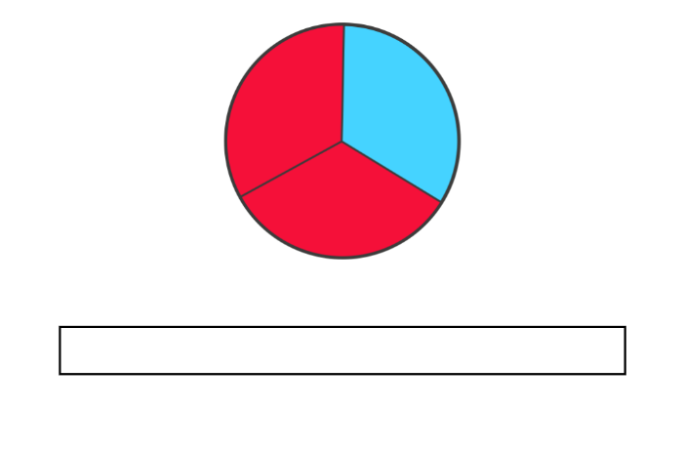
- Revisit skills of representing the spinner onto a fraction strip. Ask:
- How many equal parts does your spinner have?
- How many equal parts should your fraction strip include?
- How many parts of your fraction strip should you colour red?
- What colour will the remaining part be?
- Display both the spinner and fraction strip and discuss:
Prompts | Anticipated student responses
- What is the chance of landing on blue? | - 1 in 3.
- What is the chance of landing on red? How do you know? | - 2 in 3 because for every 3 parts, 2 parts are red.
- What is another way of describing the amount of red to blue on this spinner or fraction strip? | - There is double the chance of landing on red.  - Is it 2 times more likely to land on red than blue.  - It is twice as likely that I will land on red than blue.
- Display Resource 33 – 4-part spinner. Ask students:
- How might you shade the spinner if you want to make it twice as likely to get red as it is to get blue?
- How many colours would you need to use? (For example, 2 parts red, one part blue and one part yellow).
- What would this look like in a fraction strip?
- What language could you use to describe the chance of getting red? (For example, for every 4 sections, 2 are red and one is blue, therefore I am twice as likely to land on red as blue).
- In the 3-part spinner, it was also twice as likely to get red, how can it still be twice as likely to get red? (Red is taking up twice as much space than blue on both spinners).
- Give each student a variety of coloured counters, a whiteboard and a marker. Ensure that there are at least 6 of each colour.
- Students draw a mystery bag and a 6-part fraction strip on their whiteboard.
- In pairs, students place 6 counters in their bag ensuring that it is twice as likely to select a red counter than a blue counter. Challenge each student to create a different combination to their partner.
- Students represent this on a fraction strip. As a class, discuss:
- How many different colours did you use? (For example, students could have 2 red, one blue, one green, one yellow and one purple, or 4 red and 2 blue).
- How did you ensure that you have the chance of getting red twice as likely than another colour?
Note: this is a good opportunity to discuss why a particular bag of counters shows or does not show twice as likely. Discuss strategies to rectify any bags that do not reflect twice as likely.
- Does any other colour in the bag have an equal likelihood of being drawn as red?
- Is any colour more likely to be drawn than red?
- Does it matter if other colours are equally or more likely to be drawn than red?
- What particular proportion are we concerned with? (As long as there twice as many red counters than blue, the other combinations in the bag does not matter).
- Refer again to your drawing of the 3-part spinner. Model how to divide each part into half to create 6 equal parts.
- Ask students how the newly divided 6-part spinner could be represented on a fraction strip. For example, there will be 4 parts red and 2 parts blue.
- Ask students to predict what the fraction strip will look like if you divide each section of the spinner in half again. Anticipated student responses may include:
- There will be more parts
- There will be 12 parts
- Of the 12 parts, 8 parts will be red, and 4 parts will be blue.
- Ask students to draw the fraction strip for the newly divided 12-part spinner.
- Compare the fractions strips that show 3 parts, 6 parts and 12 parts by placing them beneath each other like a fraction wall.
- Discuss how in each fraction strip, red represents twice as many parts as blue showing a twice as likely chance. For example, some students may describe the fraction strip as for each part of blue, there are 2 parts that are red.

Consolidation and meaningful practice – 15 minutes
- Provide students with Resource 33 – 4-part spinner that was discussed in the core lesson.
- Ask students to divide each section in half to create 8 parts ensuring that red is still twice as likely as blue.
- Complete the fraction strip below the spinner, representing the new sections and the proportion of each colour in each.
- Students write the proportion represented by red and blue as a fraction for both fraction strips on Resource 33 – 4-part spinner.
- Ask students questions from the prompt table below.
The table below outlines stimulus prompts to generate conversation about the topic, along with anticipated responses from students.
Prompts | Anticipated student responses
- What relationship do you notice between the fractional representation of red using both fraction strips? | - In the second fraction strip there are more sections therefore the denominator is bigger. The numerator is also bigger.  - You divided the sections in half and it looks like we have multiplied both the numerator and denominator by 2.  - There is a proportional relationship between the numerator and denominator in both cases.
- How did using the fraction strips support you in expressing chance as a fraction? | - It is easy to determine the denominator as it is the total number of outcomes/parts.  - The numerator is the number of desired outcomes, in this case, red.
This table details opportunities for differentiation.
Too hard? | Too easy?
Students cannot create random generators to follow specified probabilities or proportions.  - Provide students with counters to represent each part on the spinner to support their understanding that there are twice as many red counters than blue. Students can use language such as ‘for every 2 red counters, one is blue, so red is twice as likely’.  - Provide students with a pre-shaded generator in the consolidation activity and ask them to represent it on a pre-divided fraction strip, see Resource 34 – 8-part spinner. | Students can create random generators to follow specified probabilities or proportions.  - Students use Resource 33 – 4-part spinner and subdivide parts as required to represent a spinner where it is 3 times more likely to land on red than blue.  - Students design another random generator where one particular outcome is 2 or 3 times more likely to occur than another outcome.
This table details opportunities for assessment.
Assessment opportunities | Links
What to look for:  - Can students represent probabilities of outcomes of chance experiments using fractions? [MAO-WM-01, MA3-CHAN-01]  - Can students create random generators to follow specified probabilities or proportions? [MAO-WM-01, MA3-CHAN-01] | Links to National Numeracy Learning Progressions (NNLP):  - UnC4.

Lesson 8
Core concept: expected and observed frequencies align better in larger trials.

Daily number sense – 10 minutes
- From a class need surfaced through formative assessment data, identify a short, focused activity that targets students’ knowledge, understanding and skills. Example activities may be drawn from the following resources:
- Mathematics K–6 resources
- Universal Resources Hub.

Core lesson – mystery bag – 40 minutes
The table below contains suggested learning intentions and success criteria. These are best co-constructed with students.
Core concept learning intentions | Core concept success criteria
Students are learning to:  - conduct chance experiments with both small and large numbers of trials  - compare observed frequencies of outcomes with expected results. | Students can:  - assign expected probabilities to outcomes in chance experiments with random generators, including digital simulators, and compare the expected probabilities with the observed probabilities after both small and large number of trials  - determine the likely make up of a large collection of objects, by sampling objects and returning them to the collection before the next sample (sample with replacement)  - compare the expected frequencies of outcomes of chance experiments with observed frequencies, including where the outcomes are not equally likely.
Note: the purpose of this lesson is to compare the expected and observed frequencies in small and large trials. Students use various trial sizes (small, medium and large) to deduce the composition of an unknown collection, recognising that larger trials enhance accurate predictions.
- Show a paper bag and tell the students that it contains 10 counters.
- Tell the students that there may be blue, yellow, red or green counters in the bag. Keep the colour proportions unknown to the students (5 blue, one yellow, 2 red, 2 green).
- Explain that students will be trying to determine the colours of the counters by running different numbers of trials.
The table below outlines stimulus prompts to generate conversation about the topic, along with anticipated responses from students.
Prompts | Anticipated student responses
- At this stage, do you have any idea which coloured counters are inside the bag? | - No.
- How can you start to think about what colours might be in the bag? | - By drawing some counters out.
- If you know that there are 10 counters in the bag, what number of draws/trials should you start with to make a reasonable prediction? | - I should start with 10 trials because there is a chance that I would draw out one of each counter.  - If I do less than 10 trials, I could not predict the make-up of the bag.
- Form 10 groups within the class.
- Provide each group with an identical mystery paper bag each and Resource 35 – recording mystery bag.
- Ask groups to remove one counter out of the paper bag (without looking) and record it on the first fraction strip on Resource 35 – recording mystery bag.
- Return the counter and remove a second counter (without looking). Repeat this process a total of 10 times.
- Each group transfers data on a fraction strip into the table on Resource 35 – recording mystery bag to show the frequency of removing each colour.
- Explain to students that frequency means how often a particular outcome occurs. Some groups may remove all 4 colours, while some may remove 3 or fewer colours.
- Using the observed frequencies in 10 trials, ask students to predict the colours and quantities of each counter that is in the mystery bag and record it in the tally table (see Figure 11).
Figure 11 – Recording example
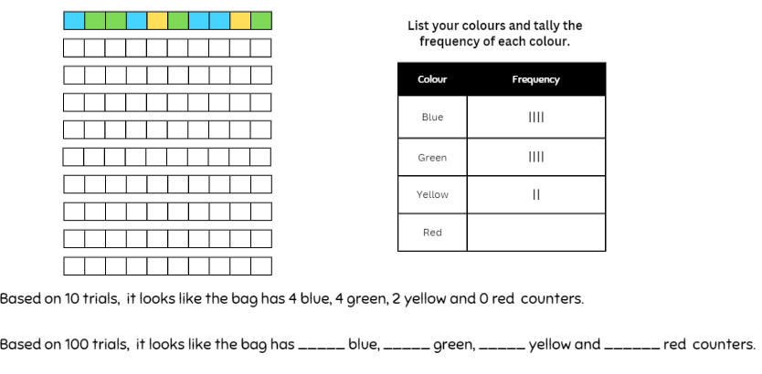
The table below outlines stimulus prompts to generate conversation about the topic, along with anticipated responses from students.
Prompts | Anticipated student responses
- Do you think your prediction is correct? Why or why not? | - No. There is a chance I picked the same counter twice.  - Yes, because I did 10 trials and there are 10 counters.
- Is your prediction similar or different to others? What does this tell us? | - No, they are different so maybe our predictions are not as accurate.  - I noticed that others got a colour that I did not get. If all the bags are the same, that tells me that I have not picked out every counter.
- Are 10 trials enough to make an accurate prediction? How can we make a more accurate prediction? | - No, I need to do more trials to make sure I have a better opportunity to draw all the different counters.
- How many trials do you think you need to make an accurate prediction? | - Answers may vary but explain to students that they might try 100 trials.
- Students return to their groups and repeat the process of removing counters to complete their remaining 9 fraction strips on Resource 35 – recording mystery bag.
- Students complete the tally chart on Resource 35 – recording mystery bag to keep track of the observed frequency of each colour as it is removed.
- Ask students to record the observed frequency of each outcome as a number in the ‘100 trials of mystery bag’.
- Ask students if they made their first prediction after 10 trials, how can they compare 100 trials to 10 trials.
Note: the total frequency of each colour will need to be divided by 10. Calculators can be provided if this process is challenging. This may result in decimals and it is important to discuss with students that these need to be rounded to reflect an actual quantity. For example, 0.4 cannot be rounded to 0 because it has been drawn and it is one. The total of the final predictions must add up to 10.
- Ask students to now make predictions of the contents of the mystery bag.
- Record these predictions beside the data table.
- Discuss with students:
The table below outlines stimulus prompts to generate conversation about the topic, along with anticipated responses from students.
Prompts | Anticipated student responses
- How has your prediction changed? | - I noticed colours that I did not pick in a trial of 10.  - Some colours appeared more, and some appeared less.
- Is your prediction now more accurate? If I continue doing more trials, will it be even more accurate? | - My prediction is more accurate because I now have colours that I did not draw in a trial of 10.  - I think that by selecting counters more times, I have a better idea of what might be in the bag.
- Explain to the class that they will now combine each group’s data and this will represent 1000 trials.
- Record the combined data in a table on the board and students can copy this onto the group’s relevant table on Resource 36 – class recording.
- Model how to scale the frequencies to make the data comparable with the trial of 10 (that is divide by 100).
- Using this data, students make predictions and record this beside the table.

Consolidation and meaningful practice – 10 minutes
- Reveal the contents of the mystery bag to the students.
- Ask students how they could represent the expected frequency of removing each colour from the bag on a fraction strip on Resource 37 – how accurate.
- Ask students to shade the fraction strips to represent observed frequency from trials of 10, 100 and 1000 on Resource 37 – how accurate.
- Students record the numerical representations for each colour on each fraction strip using Resource 37 – how accurate, for example, 2 out of 10 or $\frac{2}{10}.$
- As a class, discuss:
- What did you notice about the actual frequency in each set of trials compared to the expected probability?
- Which number of trials was closest to the expected probability?
- How did the fraction strips help you to compare the trials?
- Is it always better to conduct more trials in a chance experiment?
This table details opportunities for differentiation.
Too hard? | Too easy?
Students cannot conduct chance experiments with both small and large numbers of trials.  - Students who cannot divide by 10 or 100 provide a calculator.  - Students who find it challenging to represent probability as a fraction can be supported by writing 10 (number of trials) as the denominator in Resource 37 – how accurate. | Students can conduct chance experiments with both small and large numbers of trials.  - Students can consider a small, medium and large number of trials that would be appropriate for a mystery bag containing 8, 15 or 20 counters.  - Students reason about what the fraction strips for 10, 100, 1000 might look like in a sample where red was twice as likely to occur.

This table details opportunities for assessment.
Assessment opportunities | Links
What to look for:  - Can students record the outcomes for chance experiments where the outcomes are not equally likely to occur using fractions? [MAO-WM-01, MA3-CHAN-01]  - Can students determine the likely make up of a large collection of objects by sampling objects and returning them to the collection before the next sample? [MAO-WM-01, MA3-CHAN-01] | Links to National Numeracy Learning Progressions (NNLP):  - UnC2, UnC3, UnC5.

Resource 1 – number lines
Line ABC
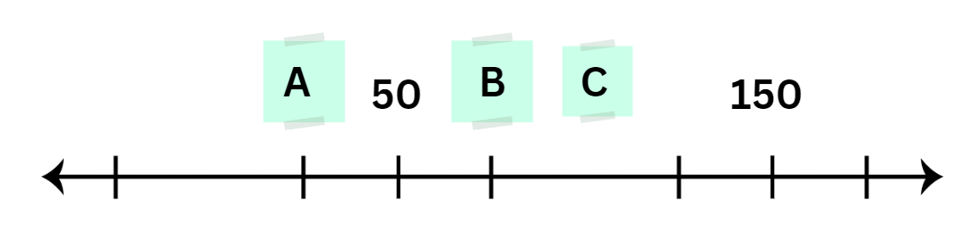
Line YZ
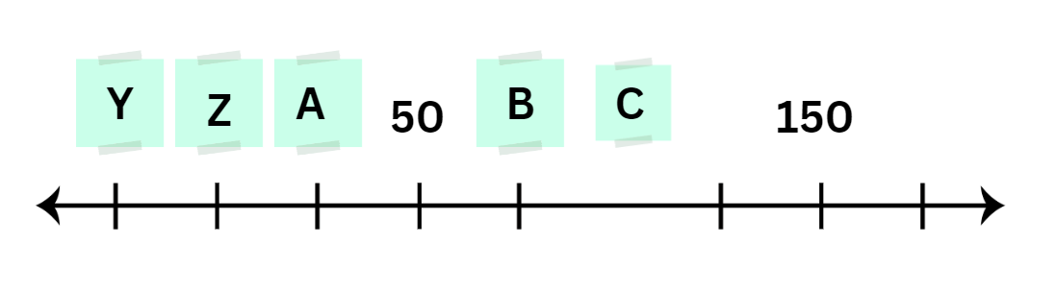

Resource 2 – position representations
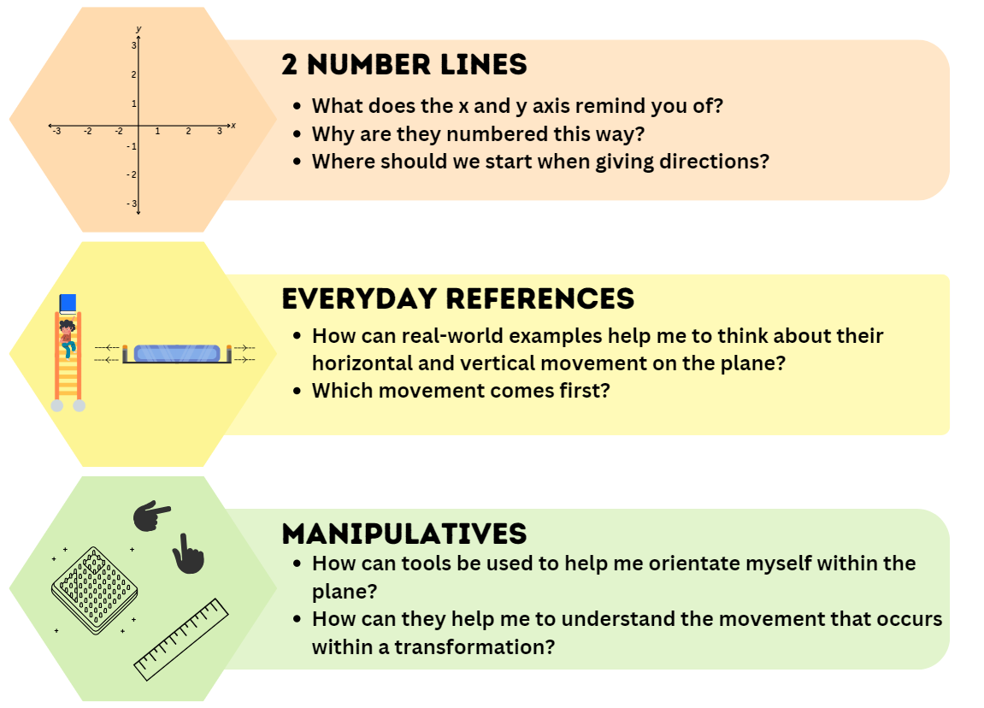
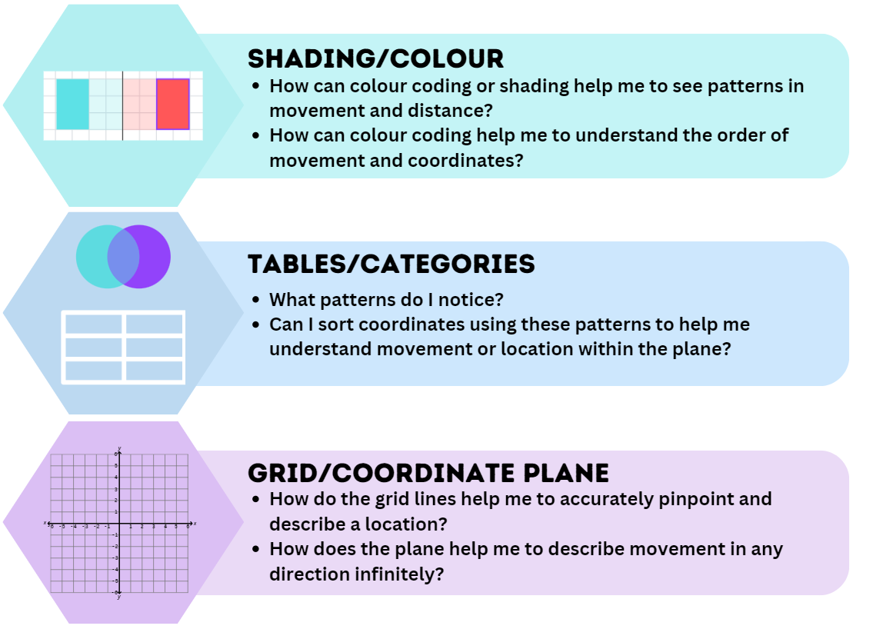

Resource 3 – I spy grid
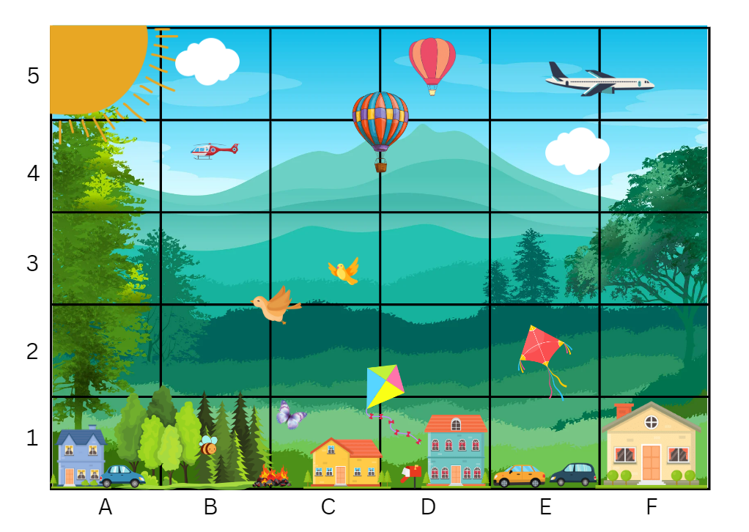

Resource 4 – I spy Cartesian plane
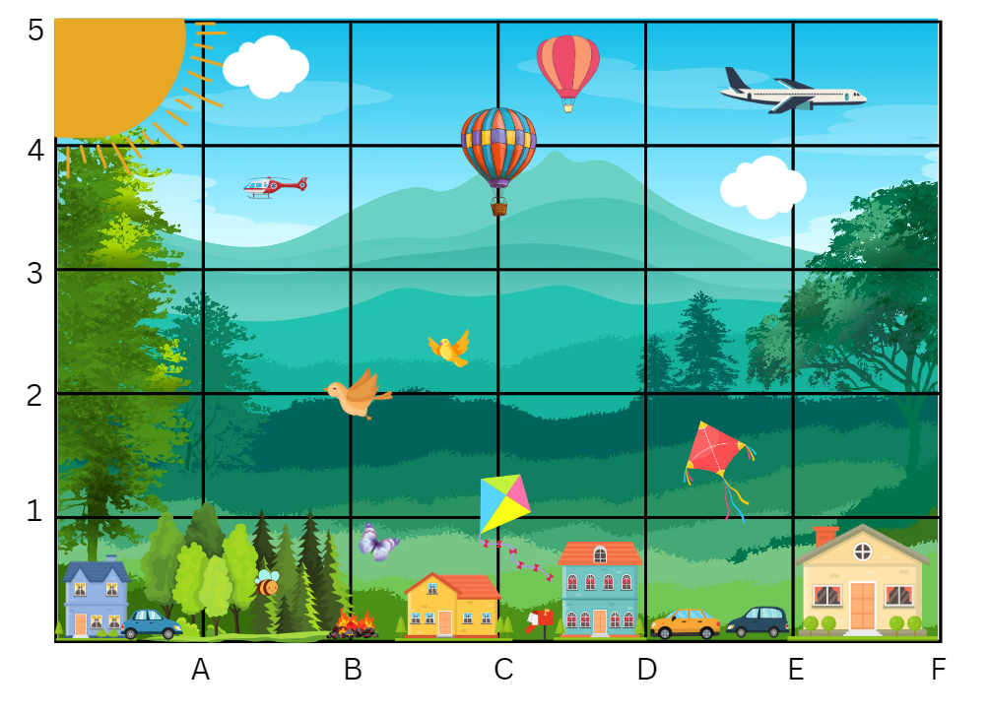

Resource 5 – ship shore
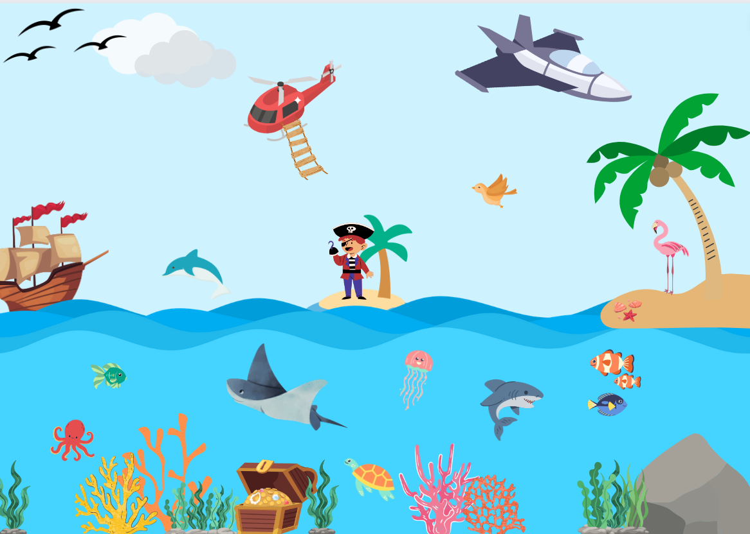

Resource 6 – ship shore grid
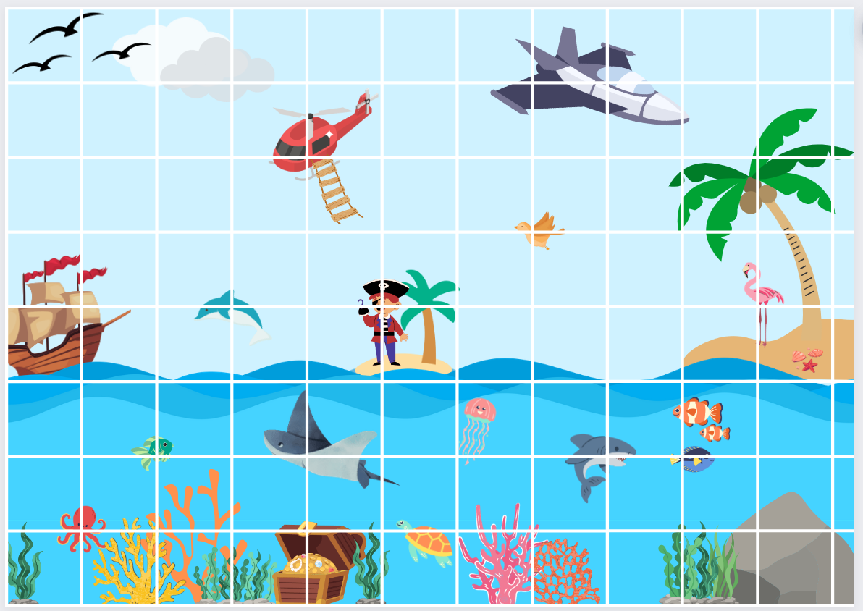

Resource 7 – labelling misconceptions
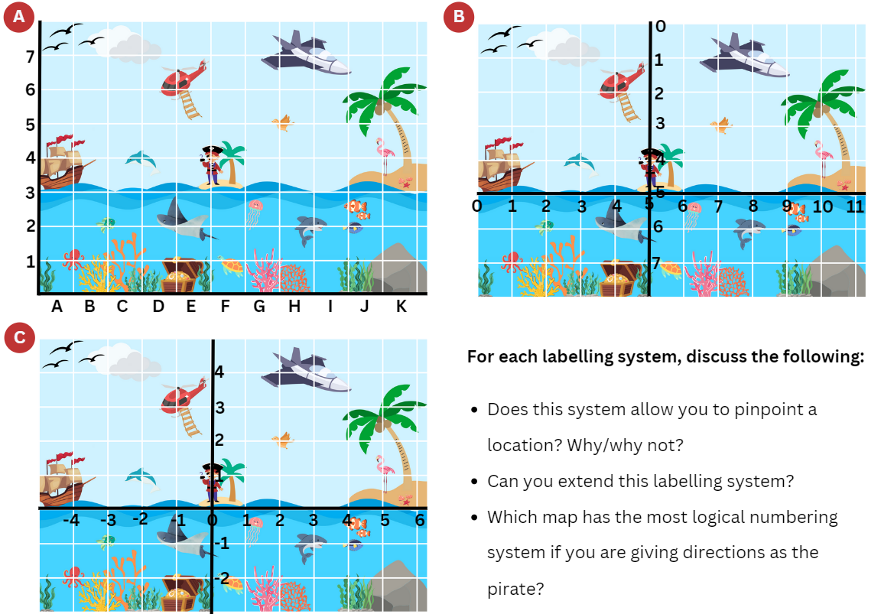

Resource 8 – move to shoot
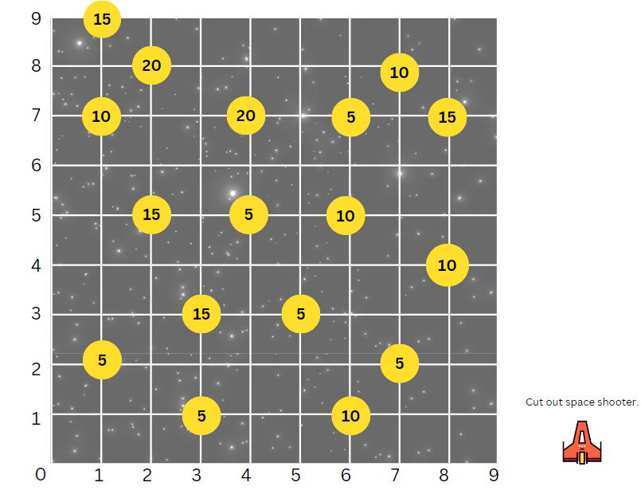

Resource 9 – elevator floor cards
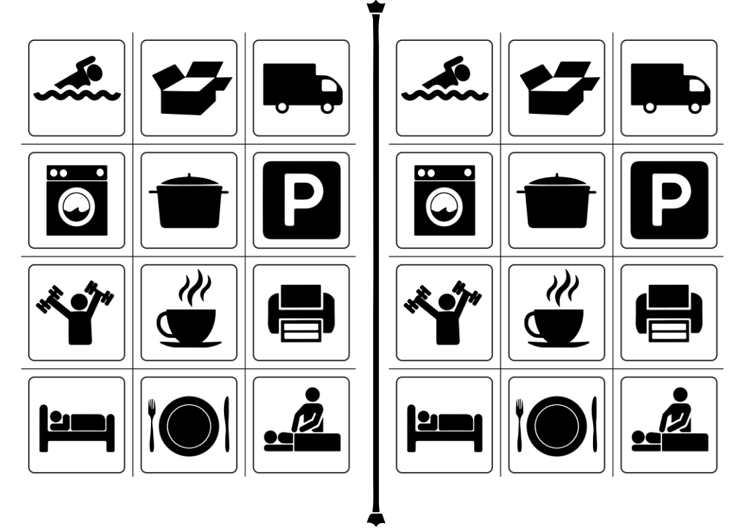
Elevator Cards by © Australian Government Department of Education 2023 is licensed under CC BY-NC-SA 4.0.

Resource 10 – hotel floors
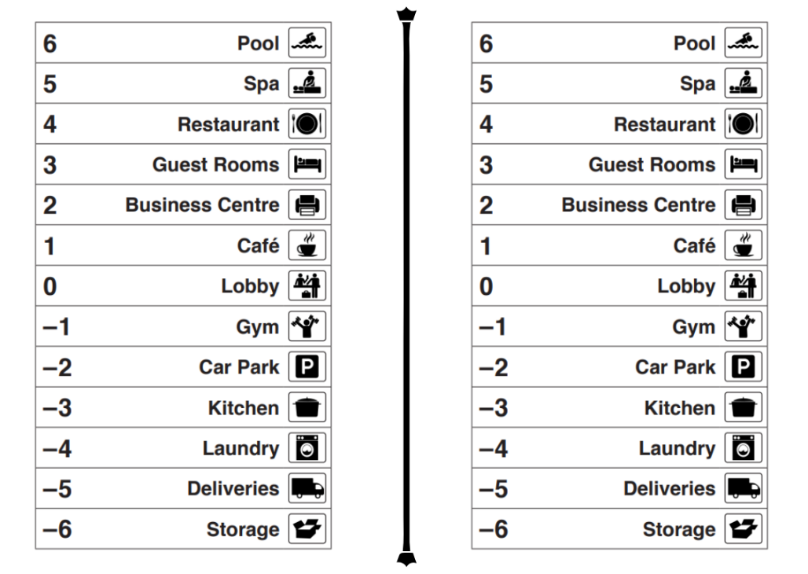
Hotel reSolve by © Australian Government Department of Education 2023 is licensed under CC BY-NC-SA 4.0.

Resource 11 – x- and y-coordinates
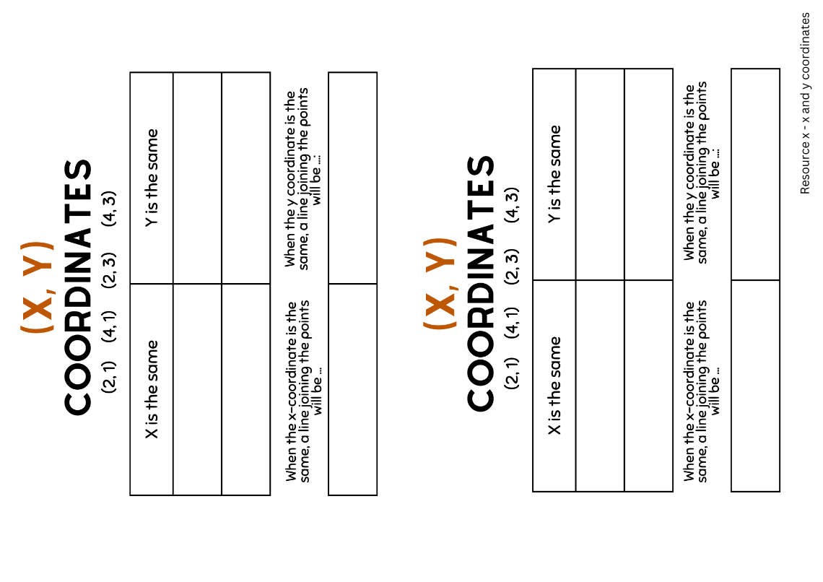

Resource 12 – shapeshifters
First shape | Second shape | Circle the change | Circle which coordinates changed
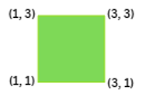 |  | Horizontal (left/right, side to side, across)  Vertical (up/down) | x-coordinate  y-coordinate
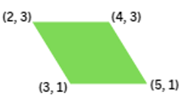 |  | Horizontal (left/right, side to side, across)  Vertical (up/down) | x-coordinate  y-coordinate
 |  | Horizontal (left/right, side to side, across)  Vertical (up/down) | x-coordinate  y-coordinate
 |  | Horizontal (left/right, side to side, across)  Vertical (up/down) | x-coordinate  y-coordinate
 |  | Horizontal (left/right, side to side, across)  Vertical (up/down) | x-coordinate  y-coordinate

Resource 13 – shapeshifters 2
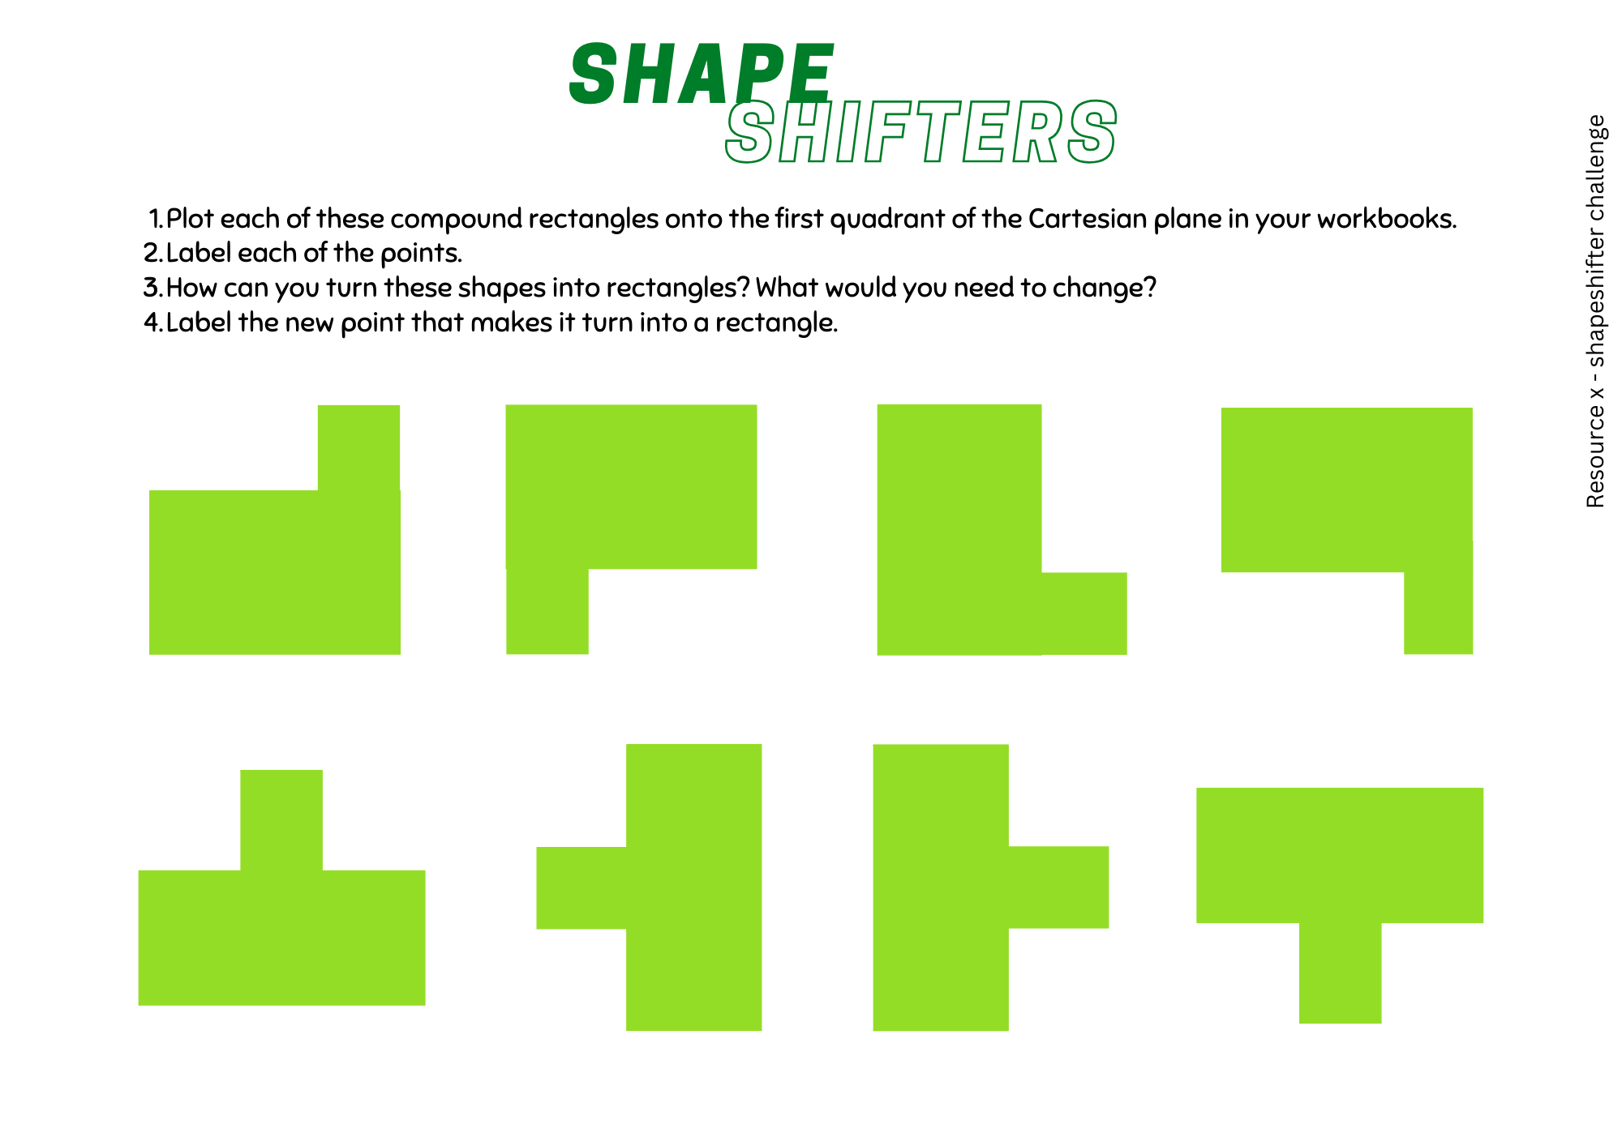

Resource 14 – blank Cartesian plane
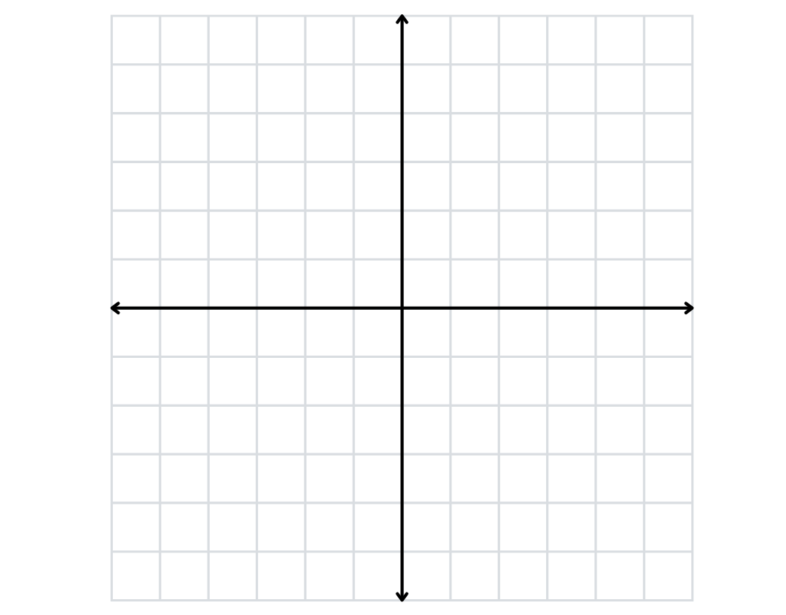

Resource 15 – plotting shapes
Level 1 – stretches across 2 quadrants | Level 2 – stretches across 3 quadrants | Level 3 – stretches across 4 quadrants
 |  | Does not have to be an isosceles
Level 1 points: (-1, 4), (1, 4), (1, 2), (__, __)  Level 2 points: (-1, 3), (1, 1), (-3, 1), (__, __)  Level 3 points: (4, 4), (-4, 4), (4, -4), (__, __) | Level 1 points: (2, 1), (5, 1), (1, -2) (__, __)  Level 2 points: (1, 1), (4, 1), (2, -2), (__, __)  Level 3 points: (6, 4), (3, - 3), (-2, 4), (__, __) | Level 1 points: (-1, 5), (1, 2), (__, __)  Level 2 points: (-2, 4), (-3, -2), (__, __)  Level 3 points: (-1, 5), (6, -2), (__, __)
Level 1 points: (-5, -4), (2, -4), (2, -2), (__, __)  Level 2 points: (-2, 2), (3, -3), (1, -5), (__, __)  Level 3 points: (1, -2), (4, 1), (-4, 3), (__, __) | Level 1 points: (1, 0), (3, 2), (4, -2), (2, -2), (__, __)  Level 2 points: (1, -1), (3, 1), (2, 3), (0, 3), (__, __)  Level 3 points: (0, 2), (2, 0), (1, -2), (-1, 2), (__, __) | Level 1 points: (1, -1), (3, -1), (5, -3), (3, -5), (1, -5), (__, __)  Level 2 points: (-3, 1), (-1, 1), (-1, -3), (-3, -3), (-5, -1), (__, __)  Level 3 points: (-6, 1), (-2, 5), (2, 5), (6, 1), (2, -3) (__, __)

Resource 16 – plotting points
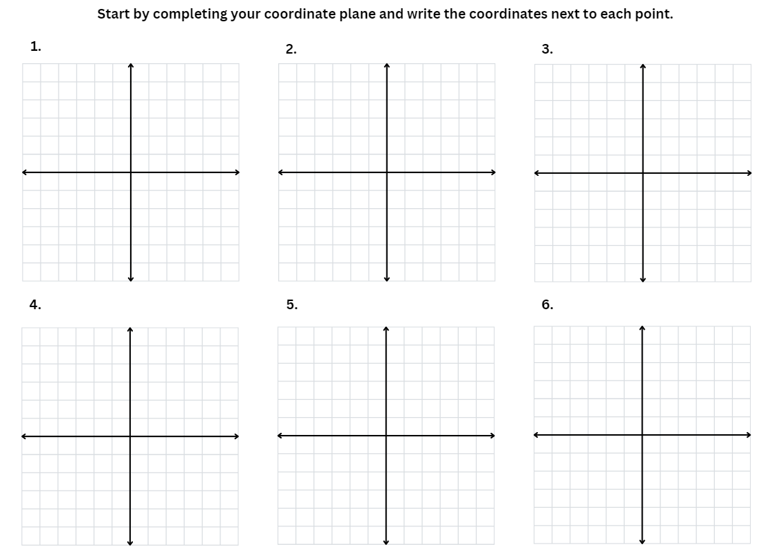

Resource 17 – plotting shapes 2
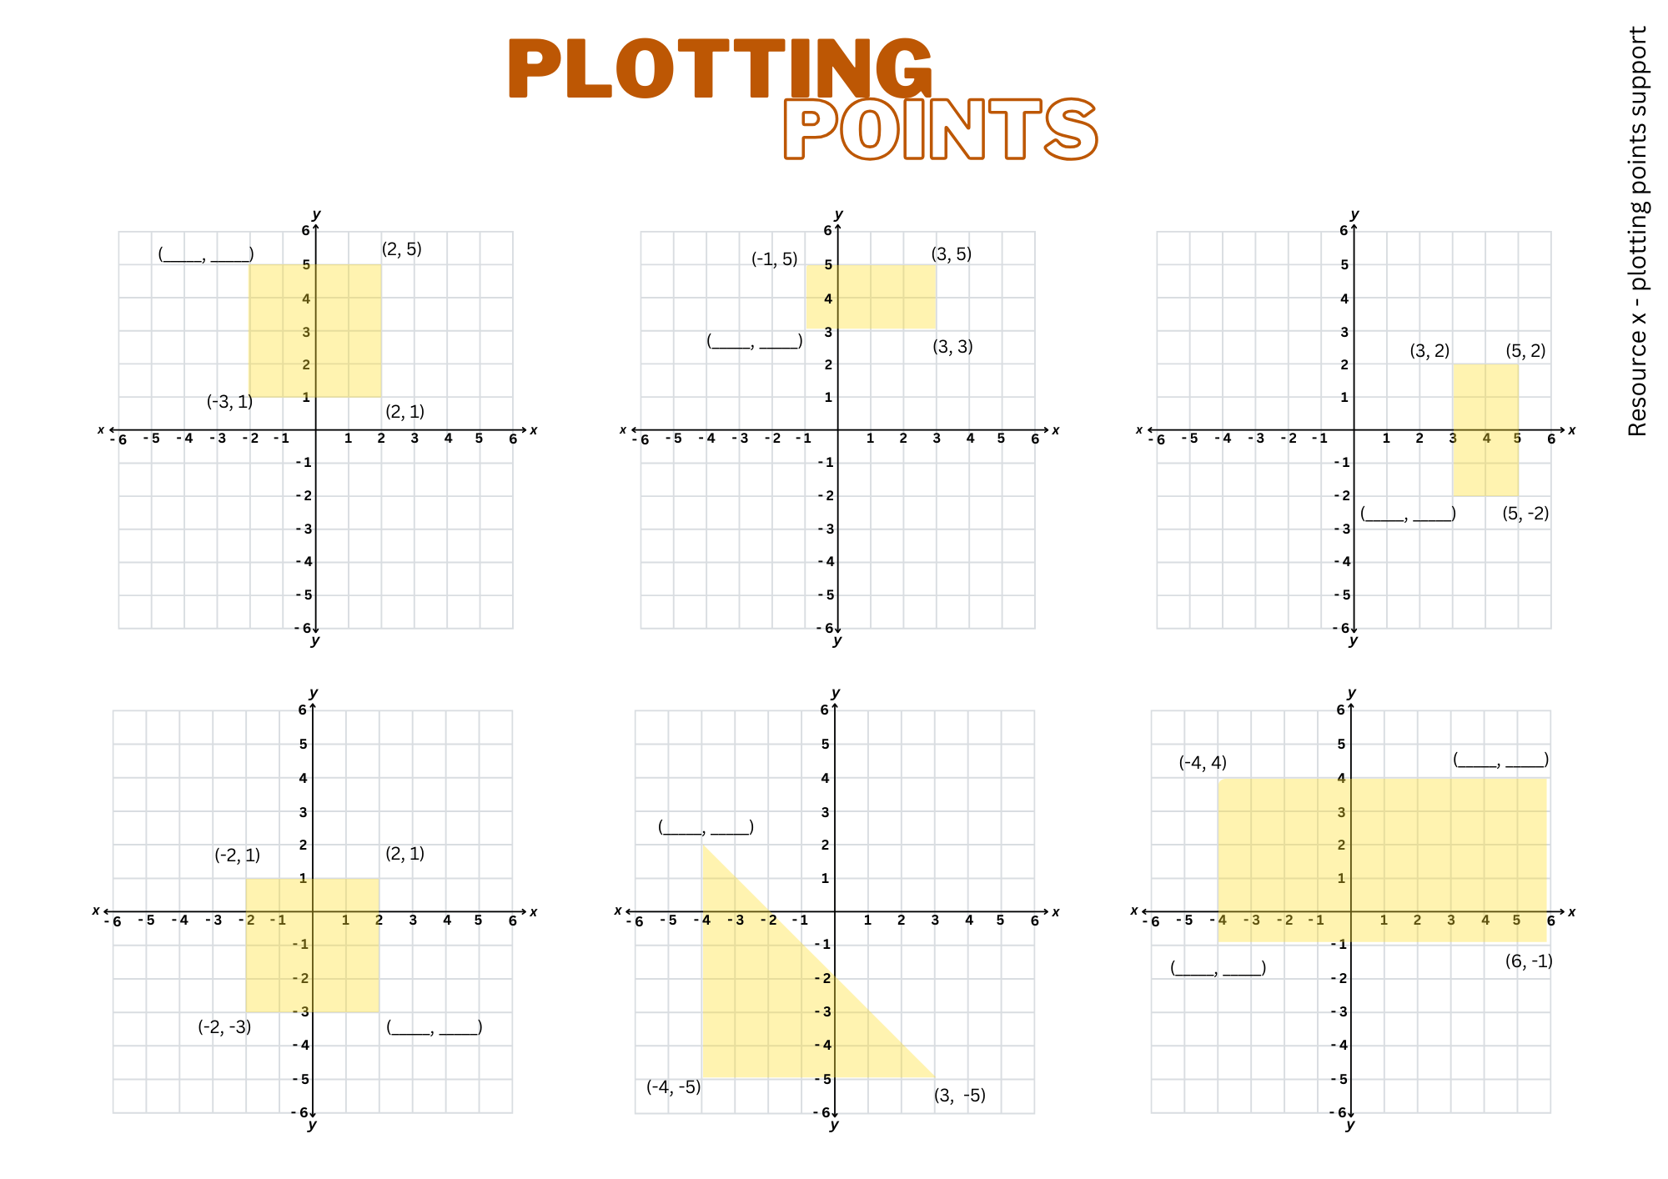

Resource 18 – plotting points 2
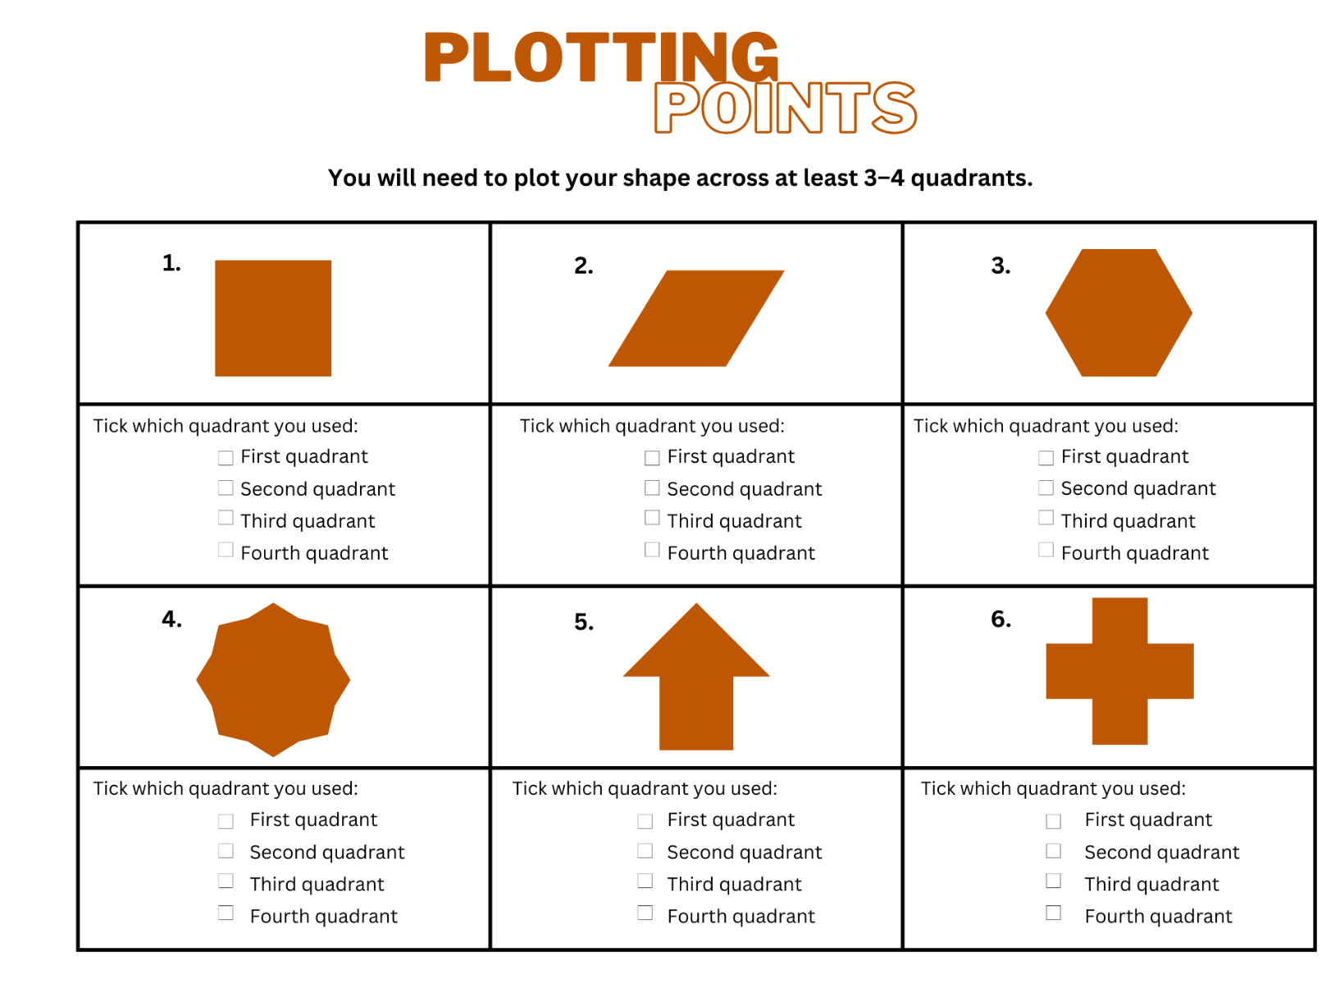

Resource 19 – plotting points 3
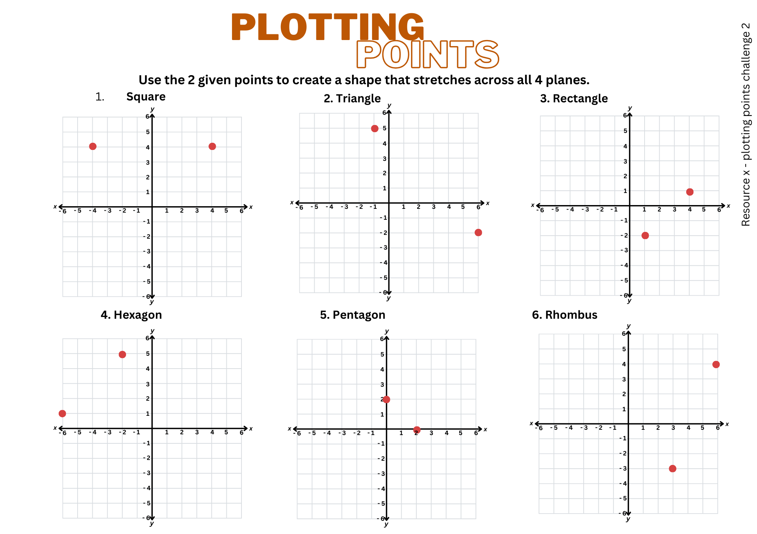

Resource 20 – pentagon mirror
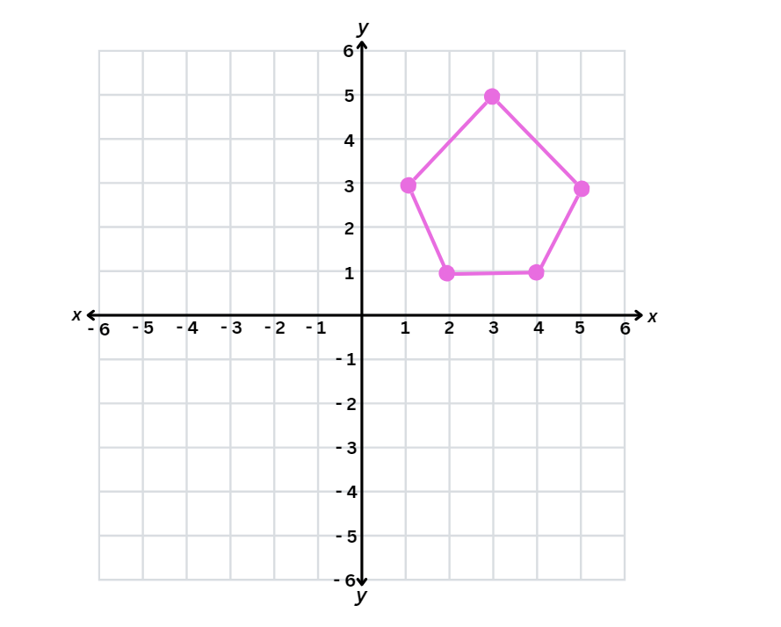

Resource 21 – mirror, mirror
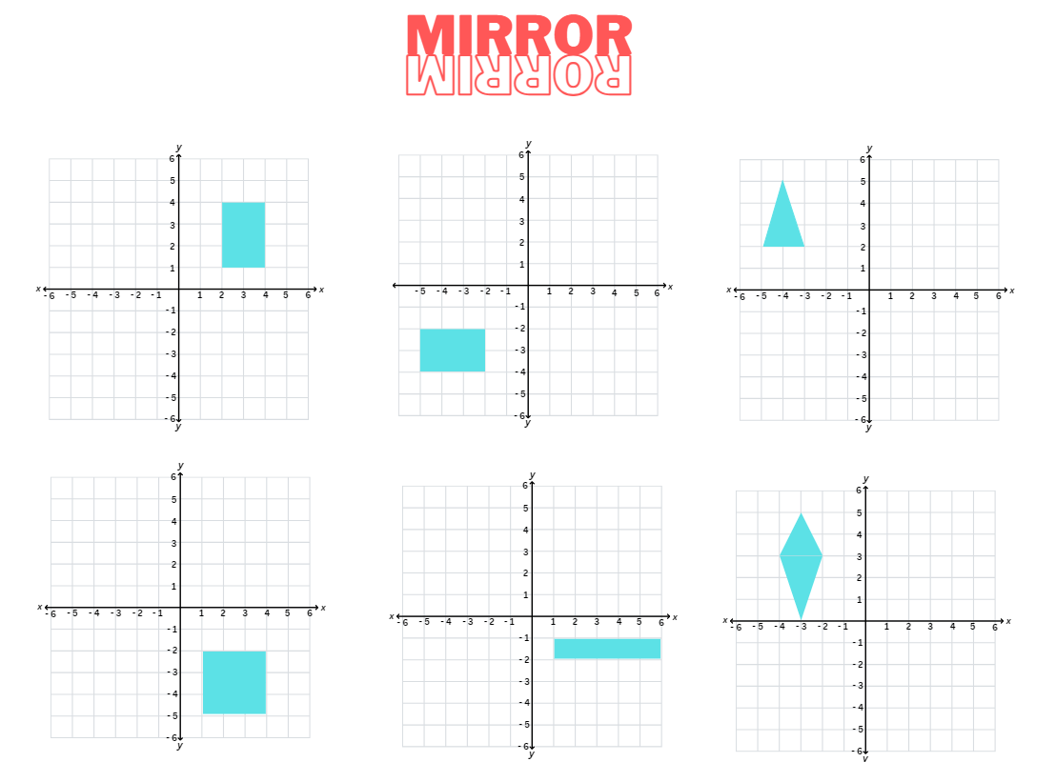

Resource 22 – mirror, mirror 2
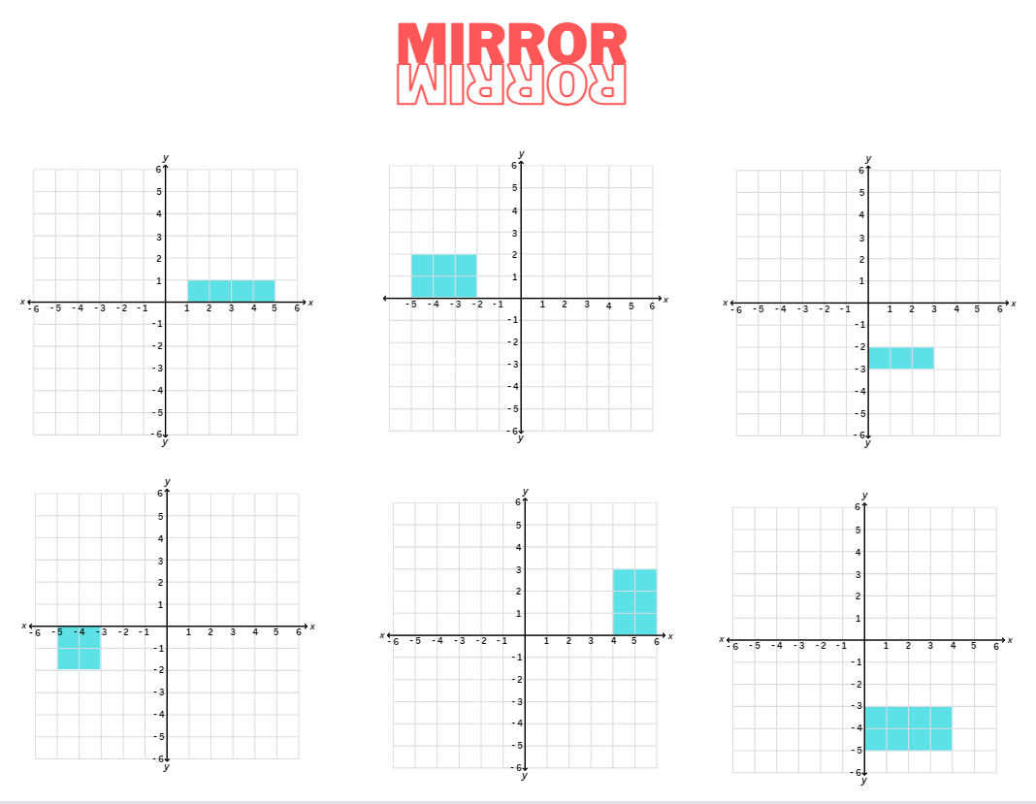

Resource 23 – reflecting stick figures
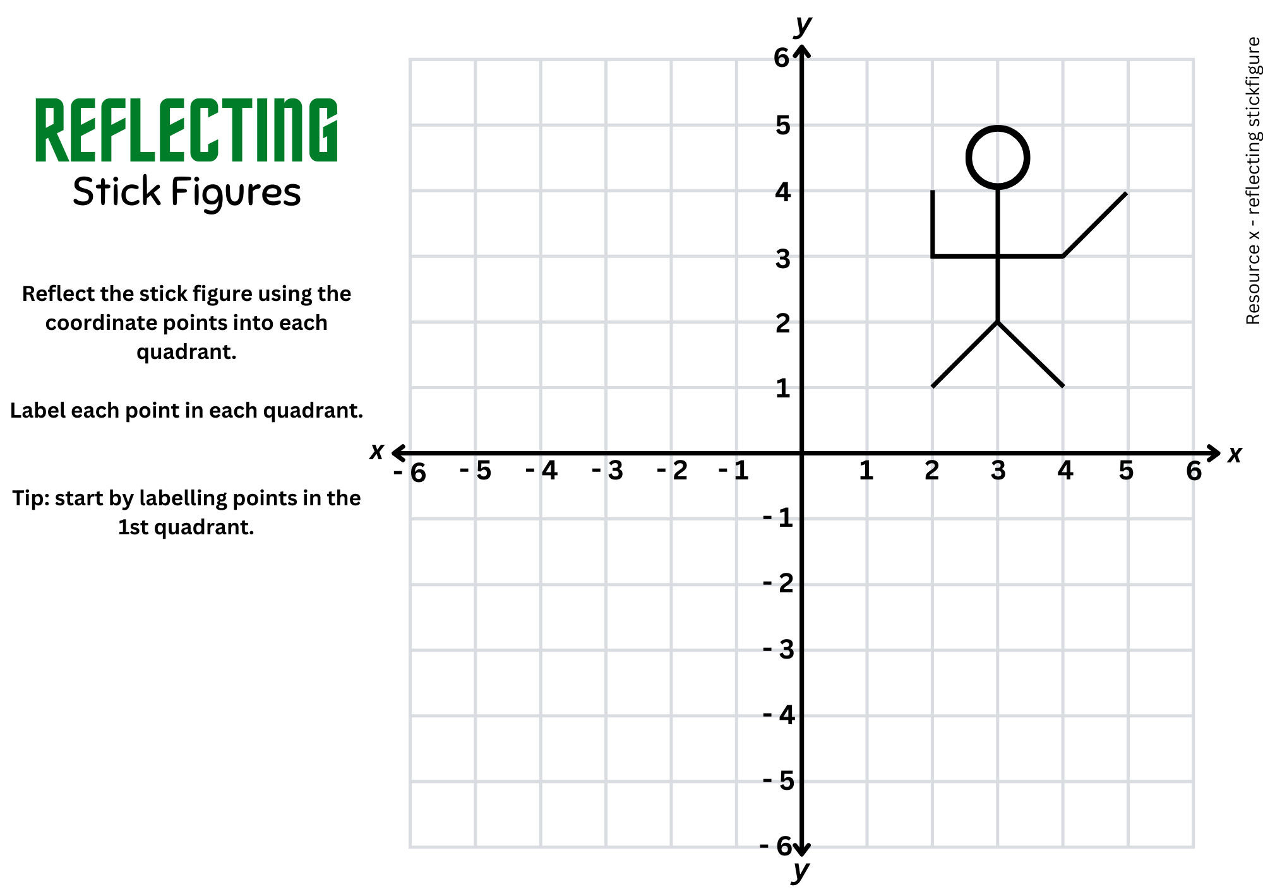

Resource 24 – reflect compound shapes
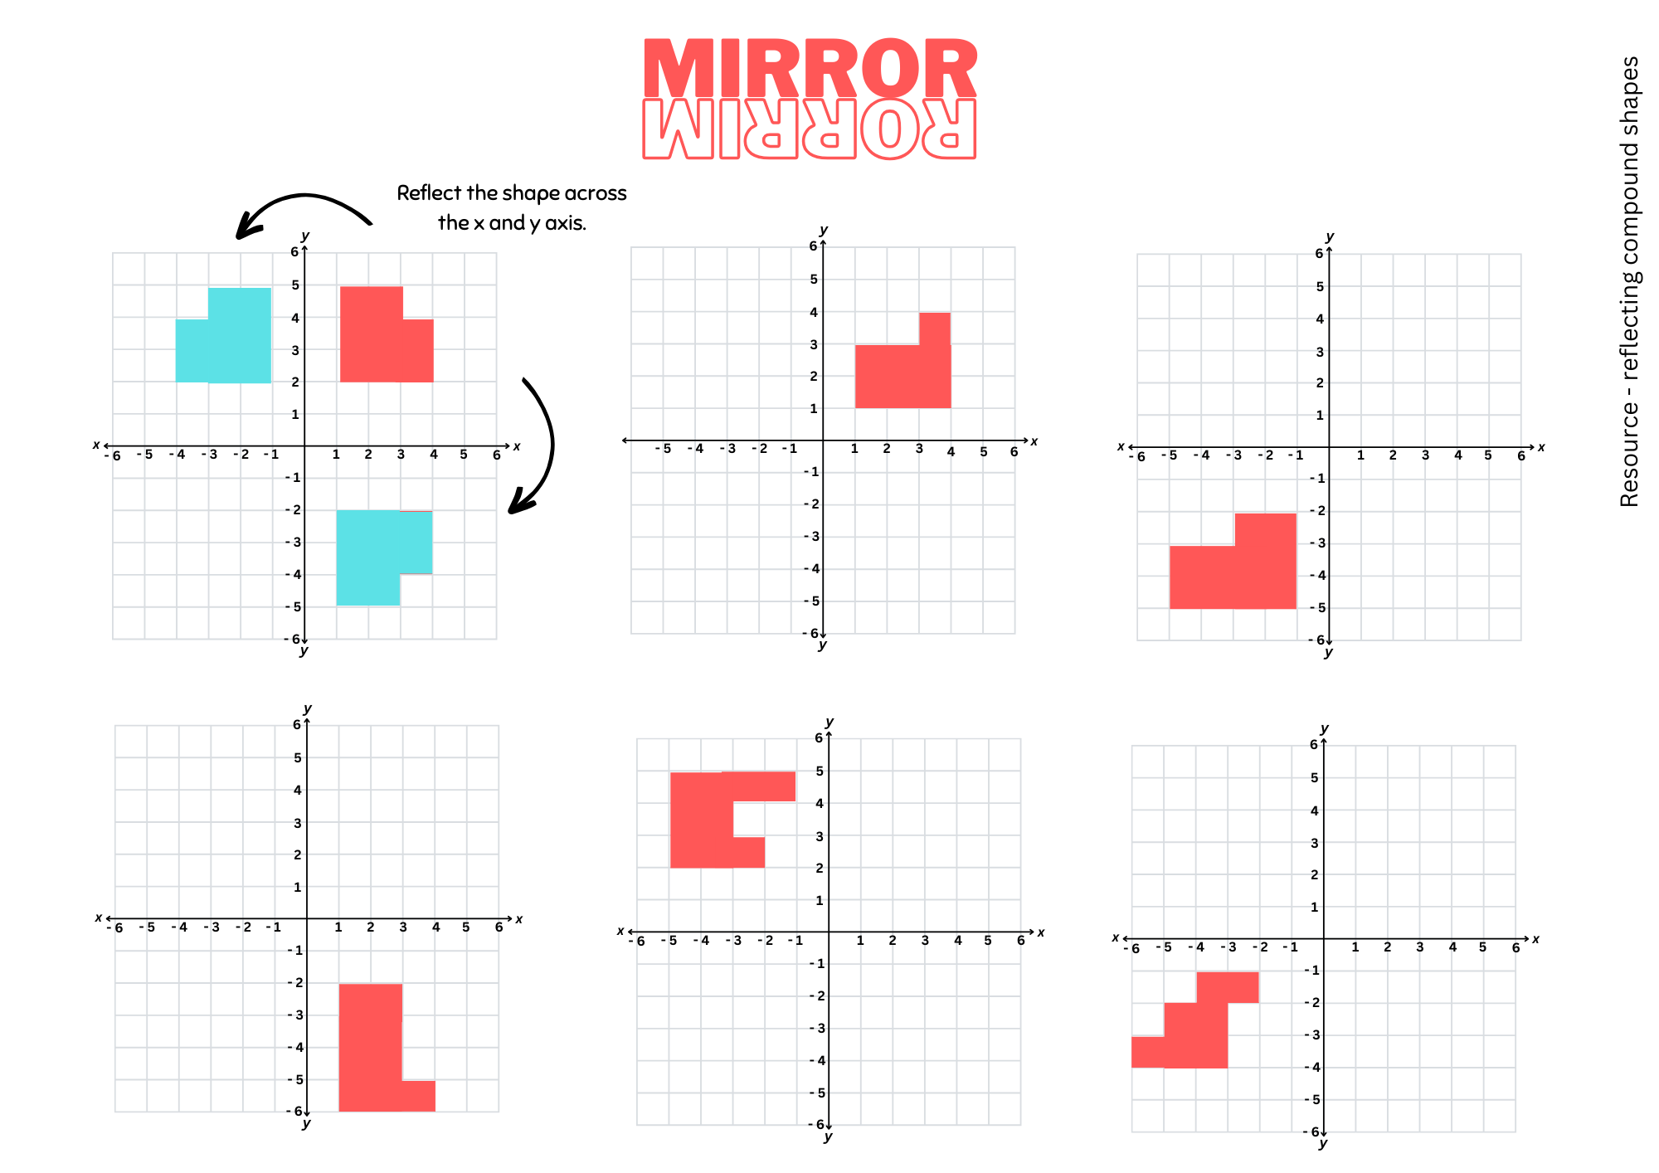

Resource 25 – chance representations
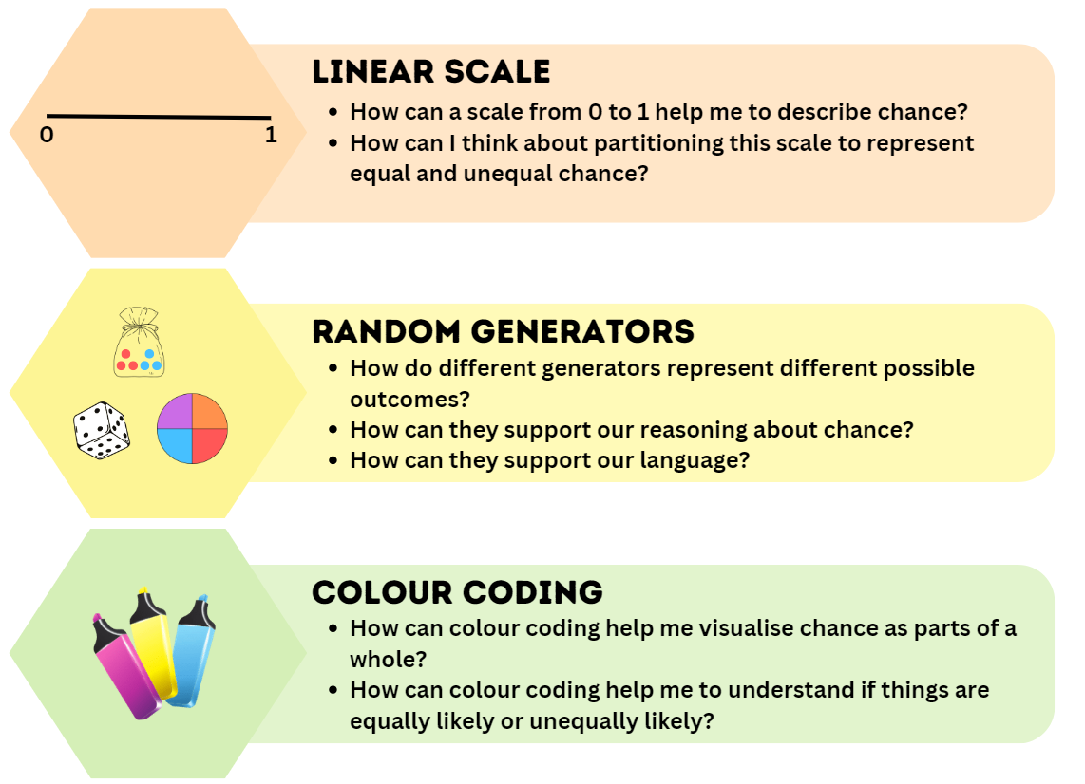
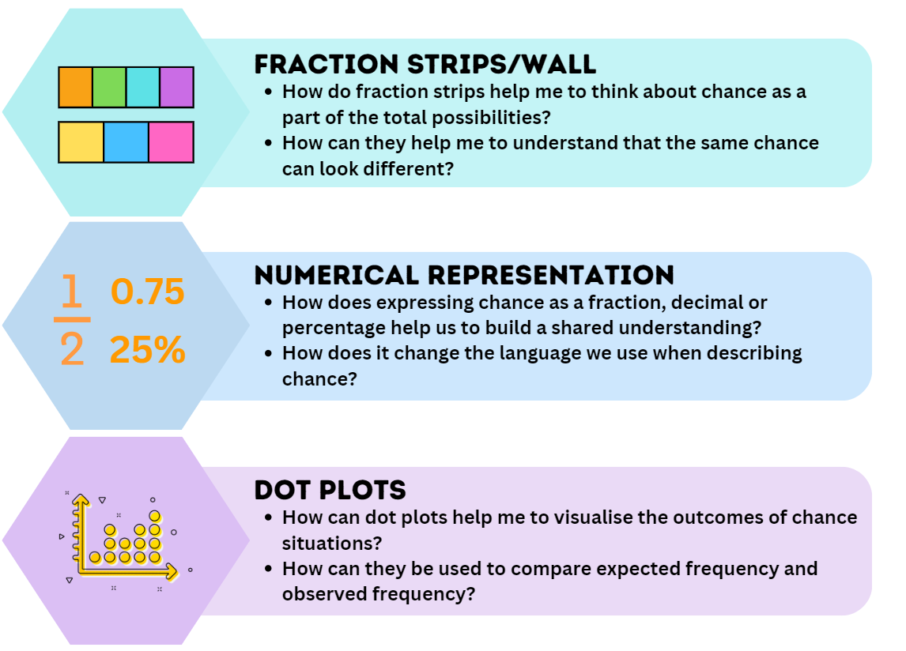

Resource 26 – spinner table
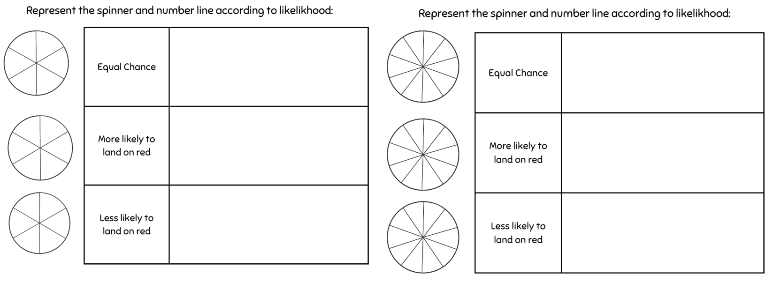

Resource 27 – spinner table 2
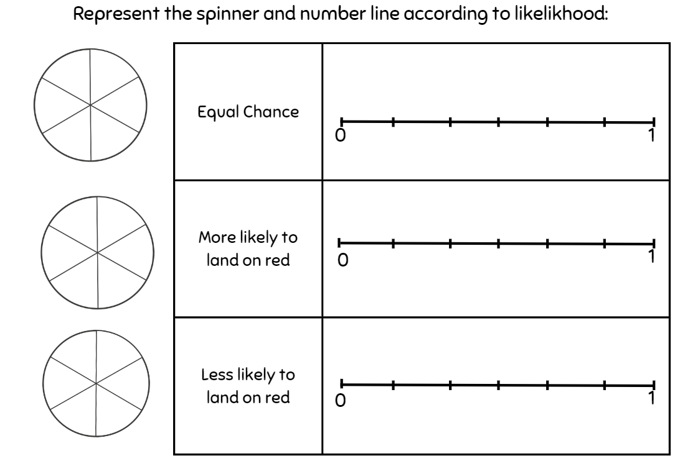

Resource 28 – rooster vs rabbit
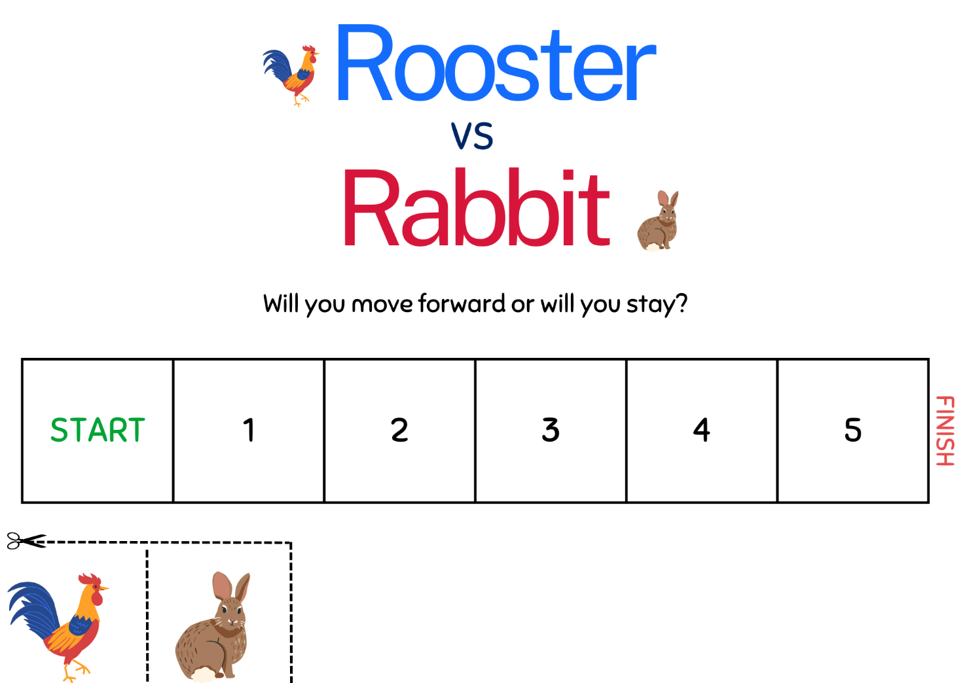

Resource 29 – equally likely spinners
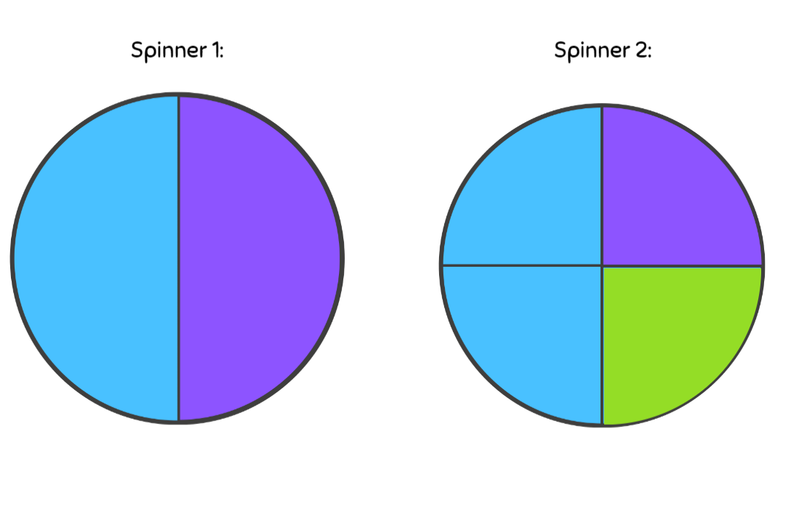

Resource 30 – fraction strips 1

Resource 31 – net and strips
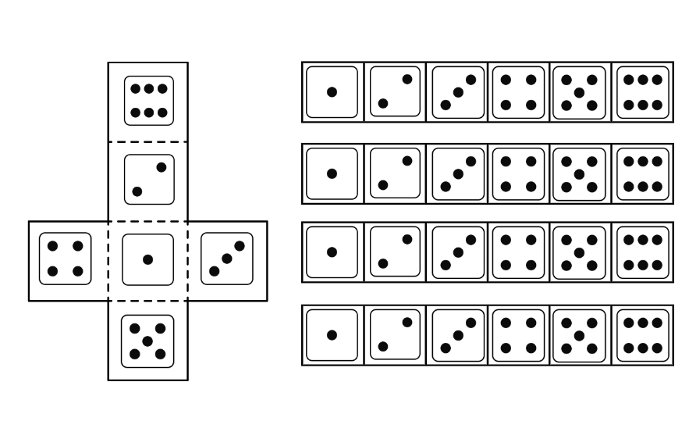

Resource 32 – coloured fraction strips
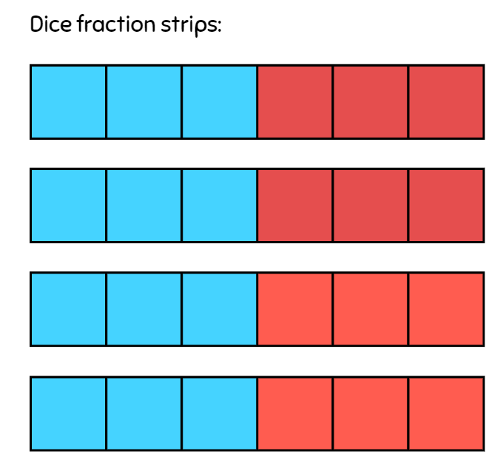

Resource 33 – 4-part spinner
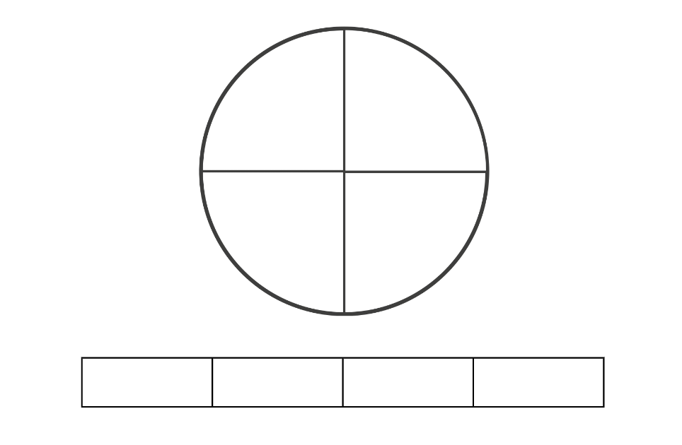

Resource 34 – 8-part spinner
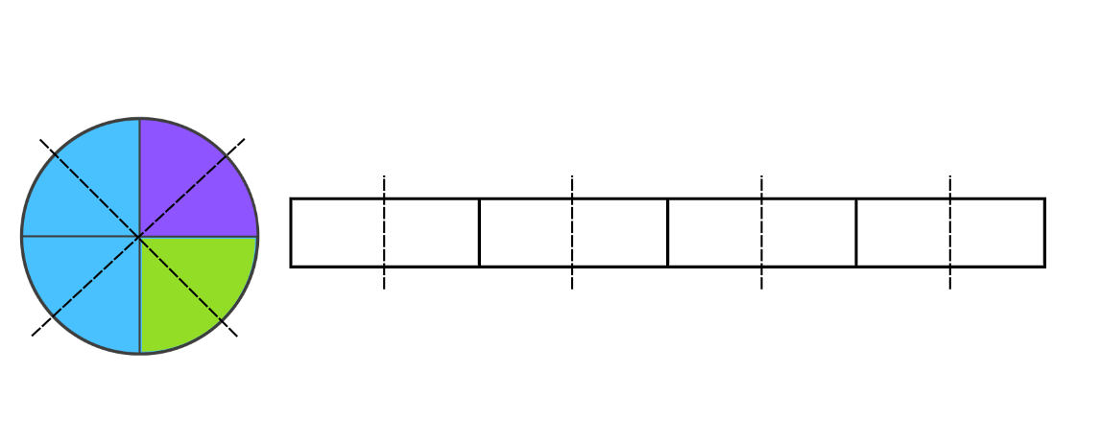

Resource 35 – recording mystery bag
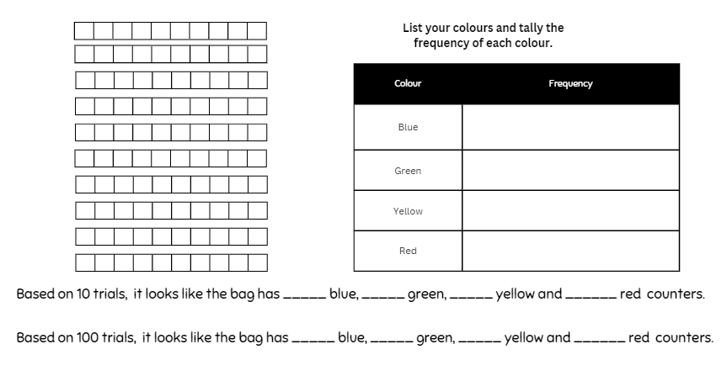

Resource 36 – class recording
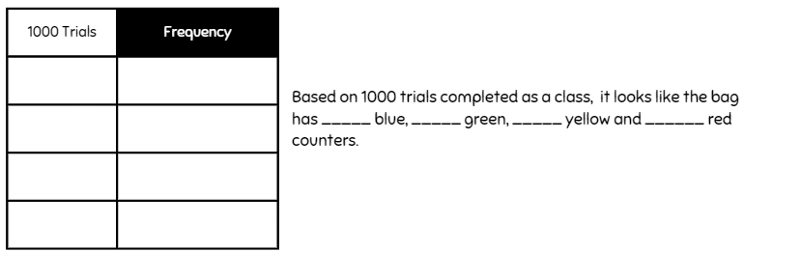

Resource 37 – how accurate
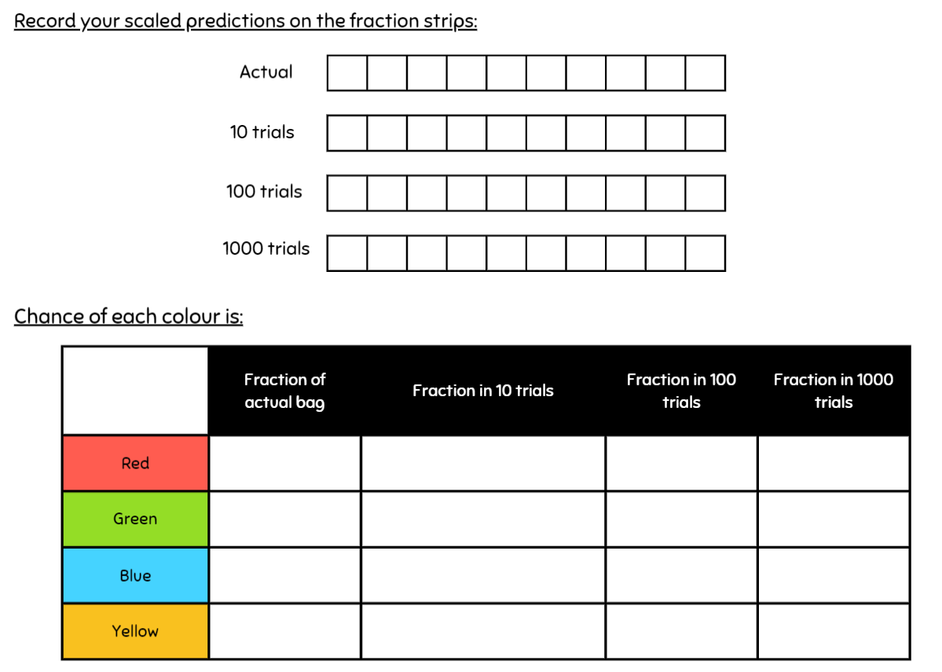

Syllabus outcomes
The table below outlines the syllabus outcomes and range of relevant syllabus content covered in this unit. Content is linked to National Numeracy Learning Progression version (3).
Outcomes and content | 1 | 2 | 3 | 4 | 5 | 6 | 7 | 8
Represents numbers B: Whole numbers: Locate and represent integers on a number line
MAO-WM-01, MA3-RN-01
- Recognise the location of negative whole numbers in relation to zero and place them on a number line | x | x | x
- Interpret integers in everyday contexts |  | x
- Recognise that negative whole numbers can result from subtraction (Reasons about quantity) |  |  | x
Representing quantity fractions B: Compare common fractions with related denominators
MAO-WM-01, MA3-RQF-01
- Order common fractions with related denominators using diagrams and number lines |  |  |  |  | x
- Create equivalent fractions for half in quarters, eighths, sixths and tenths by re-dividing the whole, using diagrams and number lines |  |  |  |  |  | x
- Record equivalent fractions using diagrams, words and fraction notation |  |  |  |  | x |  | x
Geometric measure A: Position: Explore the Cartesian coordinate system
MAO-WM-01, MA3-GM-01
- Recognise that the grid-map reference system gives the area of a location and the number plane identifies a specific point | x
- Identify that in the coordinate system the lines are numbered, not the spaces | x
- Identify the point of intersection of the 2 axes as the origin, having coordinates (0, 0) | x | x
- Plot and label points, given coordinates, on the number plane in the first quadrant, describing the horizontal position first, followed by the vertical position | x | x
Geometric measure B: Position: Use the 4 quadrants of the coordinate plane
MAO-WM-01, MA3-GM-01
- Plot and label points, given coordinates, in all 4 quadrants of the number plane |  |  | x | x
- Identify and record the coordinates of given points on the number plane in all 4 quadrants |  |  | x | x
- Describe changes to coordinates when a point is translated or reflected across an axis |  | x |  | x
Two-dimensional spatial structure B: 2D shapes: Dissect two-dimensional shapes and rearrange them using translations, reflections and rotations
MAO-WM-01, MA3-2DS-01
- Use the terms translate, reflect and rotate to describe transformations of two-dimensional shapes |  |  |  | x
Chance A: List outcomes of chance experiments involving equally likely outcomes and represent probabilities
- MAO-WM-01, MA3-CHAN-01
- Use the term probability to describe the numerical value that represents the likelihood of an outcome of a chance experiment |  |  |  |  | x
- Recognise that outcomes are described as equally likely when any one outcome has the same chance of occurring as any other outcome |  |  |  |  | x | x
- Represent probabilities of outcomes of chance experiments using fractions |  |  |  |  | x |  | x
Chance B: Conduct chance experiments with both small and large numbers of trials
- MAO-WM-01, MA3-CHAN-01
- Assign expected probabilities to outcomes in chance experiments with random generators, including digital simulators, and compare the expected probabilities with the observed probabilities after both small and large numbers of trials |  |  |  |  |  |  |  | x
- Determine and discuss the differences between the expected probabilities and the observed probabilities after both small and large numbers of trials |  |  |  |  |  |  |  | x
- Determine the likely make up of a large collection of objects, by sampling objects and returning them to the collection before the next sample (sampling with replacement) |  |  |  |  |  |  |  | x
Mathematics K–10 Syllabus © NSW Education Standards Authority (NESA) for and on behalf of the Crown in right of the State of New South Wales, 2022.

References
This resource contains NSW Curriculum and syllabus content. The NSW Curriculum is developed by the NSW Education Standards Authority. This content is prepared by NESA for and on behalf of the Crown in right of the State of New South Wales. The material is protected by Crown copyright.
Please refer to the NESA Copyright Disclaimer for more information https://educationstandards.nsw.edu.au/wps/portal/nesa/mini-footer/copyright.
NESA holds the only official and up-to-date versions of the NSW Curriculum and syllabus documents. Please visit the NSW Education Standards Authority (NESA) website https://educationstandards.nsw.edu.au/ and the NSW Curriculum website https://curriculum.nsw.edu.au.
Mathematics K–10 Syllabus © NSW Education Standards Authority (NESA) for and on behalf of the Crown in right of the State of New South Wales, 2022.
National Numeracy Learning Progression © Australian Curriculum, Assessment and Reporting Authority (ACARA) 2010 to present, unless otherwise indicated. This material was downloaded from the Australian Curriculum website (National Literacy Learning Progression) (accessed 26/09/23) and was not modified.
Australian Government Department of Education (2020) Directed Number, reSolve website, accessed 26 September 2023.
Clark D and Roche A (2014) Engaging Maths: 25 Favourite Lessons, Classic Press, Australia.
Downton A, Knight R, Clarke D and Lewis G (2015) Mathematics Assessment for Learning Rich Tasks and Work Samples, ACU National, Australia.
State of New South Wales (Department of Education) and Professional Support and Curriculum Directorate (2003) Fractions: pikelets and lamingtons [PDF 4.08 MB], NSW Department of Education and Training, accessed 26 September 2023.
State of New South Wales (Department of Education) (2023) ‘Finding numbers on a number line’ Mathematics K–6 resources, NSW Department of Education website, accessed 12 October 2023.
Sullivan P and Lilburn P (2017) Open-Ended Maths Activities, Oxford University Press, Australia and New Zealand.

Further reading
Van de Walle J, Karp K, Bay-Williams JM, Brass A, Bentley B, Ferguson S, Goff W, Livy S, Marshman M, Martin D, Pearn C, Prodromou T, Symons D and Wilkie K (2019) Primary and Middle Years Mathematics: Teaching Developmentally, 1st Australian edn, Pearson Education Australia, Melbourne.
Siemon D, Warren E, Beswick K, Faragher R, Miller J, Horne M, Jazby D, Breed M, Clark J and Brady K (2021) Teaching Mathematics: Foundations to Middle Years, 3rd edition, Oxford University Press Australia and New Zealand.

© State of New South Wales (Department of Education), 2023
The copyright material published in this resource is subject to the Copyright Act 1968 (Cth) and is owned by the NSW Department of Education or, where indicated, by a party other than the NSW Department of Education (third-party material).
Copyright material available in this resource and owned by the NSW Department of Education is licensed under a Creative Commons Attribution 4.0 International (CC BY 4.0) license.
This licence allows you to share and adapt the material for any purpose, even commercially.
Attribution should be given to © State of New South Wales (Department of Education), 2023.
Material in this resource not available under a Creative Commons licence:
- the NSW Department of Education logo, other logos and trademark-protected material
- material owned by a third party that has been reproduced with permission. You will need to obtain permission from the third party to reuse its material.
Links to third-party material and websites
Please note that the provided (reading/viewing material/list/links/texts) are a suggestion only and implies no endorsement, by the New South Wales Department of Education, of any author, publisher, or book title. School principals and teachers are best placed to assess the suitability of resources that would complement the curriculum and reflect the needs and interests of their students.
If you use the links provided in this document to access a third-party's website, you acknowledge that the terms of use, including licence terms set out on the third-party's website apply to the use which may be made of the materials on that third-party website or where permitted by the Copyright Act 1968 (Cth). The department accepts no responsibility for content on third-party websites.

