Mathematics Stage 3 Year B – Unit 29

Contents

Unit description and duration 5

Syllabus outcomes 5

Working mathematically 6

Student prior learning 6

Lesson overview and resources 8

Lesson 1 14

Daily number sense – matching game – 15 minutes 14

Core lesson – 3D properties – 35 minutes 16

Discuss and connect the mathematics – 10 minutes 19

Lesson 2 21

Daily number sense – Memory game – 10 minutes 21

Core lesson – net sketch – 30 minutes 22

Consolidation and meaningful practice – 20 minutes 26

Lesson 3 28

Daily number sense – metre ruler – 15 minutes 28

Core lesson – restaurant packaging part 1 – 40 minutes 31

Discuss and connect the mathematics – 10 minutes 33

Lesson 4 35

Daily number sense – 10 minutes 35

Core lesson – restaurant packaging part 2 – 50 minutes 35

Consolidation and meaningful practice – 10 minutes 39

Lesson 5 41

Daily number sense – fraction snap – 10 minutes 41

Core lesson – equivalent capacities – 40 minutes 42

Consolidation and meaningful practice – 15 minutes 46

Lesson 6 49

Daily number sense – dividing by dice – 10 minutes 49

Core lesson 1 – equivalence – 10 minutes 51

Core lesson2 – water, water, everywhere – 25 minutes 53

Discuss and connect the mathematics – 15 minutes 54

Lesson 7 56

Daily number sense – fair shares – 15 minutes 56

Core lesson – dripping taps – 40 minutes 59

Discuss and connect the mathematics – 15 minutes 61

Lesson 8 63

Daily number sense – 10 minutes 63

Core lesson – a thirsty crow – 35 minutes 63

Consolidation and meaningful practice – 15 minutes 67

Resource 1 – equivalency game cards 69

Resource 2 – Guess what? 70

Resource 3 – Net or not? 71

Resource 4 – cut nets 72

Resource 5 – 3D objects 73

Resource 6 – Snap set 1 74

Resource 7 – Snap set 2 75

Resource 8 – equivalence cards 76

Resource 9 – capacity recording table 78

Resource 10 – capacity problems 79

Resource 11 – equivalence match 81

Resource 12 – water usage facts 82

Resource 13 – number slide 83

Resource 14 – fair shares 84

Resource 15 – converting measurements 86

Syllabus outcomes and content 87

References 92

# Unit description and duration

This unit develops the big idea that what needs to be measured determines the unit of measurement.

In this 2-week unit students are provided opportunities to:

* compare the properties of prisms and pyramids by visualising, naming and sketching nets of three-dimensional objects
* compare volumes of 2 or more objects by observing the change in water level when objects are submerged in a container of water
* recognise the equivalence of whole-number and decimal representations by measuring, comparing and ordering measurements of capacities of up to 3 decimal places.

## Syllabus outcomes

* **MAO-WM-01** develops understanding and fluency in mathematics through exploring and connecting mathematical concepts, choosing and applying mathematical techniques to solve problems, and communicating their thinking and reasoning coherently and clearly
* **MA3-RN-02** compares and orders decimals up to 3 decimal places
* **MA3-RN-03** determines percentages of quantities, and finds equivalent fractions and decimals for benchmark percentage values
* **MA3-RQF-01** compares and orders fractions with denominators of 2, 3, 4, 5, 6, 8 and 10
* **MA3-3DS-01** visualises, sketches and constructs three-dimensional objects, including prisms and pyramids, making connections to two-dimensional representations
* **MA3-3DS-02** selects and uses the appropriate unit to estimate, measure and calculate volumes and capacities

## Working mathematically

In the Mathematics K–10 Syllabus, there is one overarching Working mathematically outcome (**MAO-WM-01**). The Working mathematically processes should be embedded within the concepts being taught. The Working mathematically processes present in the Mathematics K–10 Syllabus are:

* communicating
* understanding and fluency
* reasoning
* problem solving.

[Mathematics K–10 Syllabus](https://curriculum.nsw.edu.au/learning-areas/mathematics/mathematics-k-10-2022/overview) © NSW Education Standards Authority (NESA) for and on behalf of the Crown in right of the State of New South Wales, 2022.

## Student prior learning

Before engaging in these teaching and learning activities, students would benefit from prior experience with:

* naming prisms and pyramids using properties of three-dimensional objects by making and exploring models, sketches and diagrams
* using decimal representations to record volume using formal units of litres and millilitres
* exploring displacement to investigate volumes of irregular solids.

In NSW classrooms there is a diverse range of students, including Aboriginal and Torres Strait Islander students, students learning English as an additional language or dialect, high potential and gifted students and students with disability. Some students may identify with more than one of these groups or possibly all of them. Refer to [Curriculum planning for every student – advice](https://education.nsw.gov.au/teaching-and-learning/curriculum/planning-programming-and-assessing-k-12/advice-on-curriculum-planning-for-every-student-k-12) for further information.

# Lesson overview and resources

The table below outlines the sequence and approximate timing of lessons, learning intentions and resources.

|  |  |  |
| --- | --- | --- |
| Lesson | Content | Duration and resources |
| **Lesson 1**  **Daily number sense learning intention**:   * make connections between benchmark fractions, decimals and percentages | **Lesson core concept**: objects can be described effectively by focusing on properties.  **Core concept learning intention**:   * compare, describe and name prisms and pyramids | **Lesson duration**: 60 minutes   * Resource 1 – equivalency game cards * Resource 2 – Guess what? * Website: [Google Maps](https://www.google.com.au/maps) * Three-dimensional geometrical models * Writing materials |
| **Lesson 2**  **Daily number sense learning intention**:   * make connections between benchmark fractions, decimals and percentages | **Lesson core concept**: mathematicians examine diagrams to name and explore the properties of an object.  **Core concept learning intentions**:   * compare, describe and name prisms and pyramids * connect three-dimensional objects with two-dimensional representations | **Lesson duration**: 60 minutes   * Resource 1 – equivalency game cards * Resource 3 – Net or not? * Resource 4 – cut nets (on A3 paper) * Website: [Polypad](https://mathigon.org/polypad) * Individual whiteboards * Writing materials |
| **Lesson 3**  **Daily number sense learning intention**:   * make connections between benchmark fractions, decimals and percentages | **Lesson core concept**: mathematicians visualise diagrams to name and draw an object.  **Core concept learning intentions**:   * compare, describe and name prisms and pyramids * connect three-dimensional objects with two-dimensional representations | **Lesson duration**: 65 minutes   * Resource 5 – 3D objects * A3 paper * Individual whiteboards * Isometric grid paper * Metre rulers * Sticky tabs * Whiteboard markers * Writing materials |
| **Lesson 4**  **Daily number sense learning intention**:   * teacher-identified task based on student needs | **Lesson core concept**: compare, describe and name prisms and pyramids.  **Core concept learning intentions**:   * connect three-dimensional objects with two-dimensional representations * construct prisms and pyramids | **Lesson duration**: 70 minutes   * Isometric grid paper * Paper straws, pipe cleaners and/or toothpicks * Sticky tape, sticky putty and/or modelling clay * Thick poster cardboard * Writing materials |
| **Lesson 5**  **Daily number sense learning intention**:   * recognise that a fraction can represent a division | **Lesson core concept**: capacity is an internal measurement.  **Core concept learning intentions**:   * connect decimal representations to the metric system * choose appropriate units of measurement for capacity * compare, order and represent decimals | **Lesson duration**: 65 minutes   * Resource 6 – Snap set 1 * Resource 7 – Snap set 2 * Resource 8 – equivalence cards * Resource 9 – capacity recording table * Resource 10 – capacity problems * Different sized containers * Measuring jugs * Writing materials |
| **Lesson 6**  **Daily number sense learning intention**:   * recognise that a fraction can represent a division | **Lesson core concept**: the most appropriate unit of measure is determined by the object.  **Core concept learning intentions**:   * connect decimal representations to the metric system * recognise that the place value system can be extended beyond hundredths | **Lesson duration**: 60 minutes   * Resource 8 – equivalence cards * Resource 11 – equivalence match * Resource 12 – water usage facts * Resource 13 – number slide * 10-sided dice * Container to collect and measure water * Individual whiteboards * Number slides (if previously made) * Writing materials |
| **Lesson 7**  **Daily number sense learning intention**:   * recognise that a fraction can represent a division | **Lesson core concept**: our base-10 place value system helps to interpret and record capacities.  **Core concept learning intentions**:   * connect decimal representations to the metric system * compare, order and represent decimals * recognise that the place value system can be extended beyond hundredths | **Lesson duration**: 65 minutes   * Resource 14 – fair shares * Resource 15 – converting measurements * Individual whiteboards * Measuring containers * Writing materials |
| **Lesson 8**  **Daily number sense learning intention**:   * teacher-identified task based on student needs | **Lesson core concept**: displacement can be used to explore the volume of irregular solids.  **Core concept learning intention**:   * use displacement to investigate volumes of irregular solids | **Lesson duration**: 60 minutes   * ‘[The Crow and the Pitcher](https://read.gov/aesop/012.html)’ by Aesop * Dice * Glue stick, pair of scissors or modelling clay container * Marbles * Variety of narrow containers * Whiteboard markers * Writing materials |

# Lesson 1

**Core concept**: objects can be described effectively by focusing on properties.

## Daily number sense – matching game – 15 minutes

Daily number sense activities for Lessons 1 to 3 ‘activate’ prior number knowledge and support the learning of new content in the unit. These activities can also assist teachers to identify the starting points for learning by revealing the extent of students’ existing knowledge.

The table below contains a suggested learning intention and success criteria. These are best co-constructed with students.

|  |  |
| --- | --- |
| Daily number sense learning intention | Daily number sense success criteria |
| Students are learning to:   * make connections between benchmark fractions, decimals and percentages. | Students can:   * recall commonly used equivalent percentages, decimals and fractions including $\frac{1}{2}$, $\frac{1}{4}$ and $\frac{3}{4}$. |

1. Revise common equivalent percentages, decimals and fractions. For example, 50% = 0.5 = $\frac{50}{100}$ = $\frac{1}{2}$.
2. Explain to students that they will be sorting a set of cards to match equivalent percentages, decimals and fractions.
3. Give pairs or small groups of students Resource 1 – equivalency game cards and ask them to arrange the cards to represent equivalence.
4. Once students have sorted their cards, conduct a [gallery walk](https://app.education.nsw.gov.au/digital-learning-selector/LearningActivity/Card/555). Ask:

* Are there any cards that were sorted differently to your groups? Why do you think that is?
* Are there any cards you need to rearrange after conducting the [gallery walk](https://app.education.nsw.gov.au/digital-learning-selector/LearningActivity/Card/555)?
* Were there any groups of equivalency cards that were harder to sort? Why?

1. Ask students to read aloud a set of equivalency cards they sorted. For example, 10% is equal to 0.1 is equal to $\frac{10}{100}$ is equal to $\frac{1}{10}$.

**Note**: keep these sets of cards to use in Lesson 2. A memory game will be played in pairs. More sets of Resource 1 – equivalency game cards may need to be copied.

This table details an opportunity for assessment.

|  |  |
| --- | --- |
| Assessment opportunity | Links |
| What to look for:   * Can students recall commonly used equivalent percentages, decimals and fractions, including $\frac{1}{2}$, $\frac{1}{4}$ and $\frac{3}{4}$? [**MAO-WM-01, MA3-RN-03]** | Links to [National Numeracy Learning Progressions](https://www.australiancurriculum.edu.au/resources/national-literacy-and-numeracy-learning-progressions/version-3-of-national-literacy-and-numeracy-learning-progressions/) (NNLP):   * PrT2, UnM8. |

## Core lesson – 3D properties – 35 minutes

The table below contains a suggested learning intention and success criteria. These are best co-constructed with students.

|  |  |
| --- | --- |
| Core concept learning intention | Core concept success criteria |
| Students are learning to:   * compare, describe and name prisms and pyramids. | Students can:   * compare properties of prisms and pyramids * name prisms and pyramids according to the shape of their base. |

This activity is an adaptation of ['Guess What](https://nrich.maths.org/14777)?' from [NRICH](https://nrich.maths.org/frontpage) by the University of Cambridge.

1. Display three-dimensional geometrical models. For example, a cube, cuboid, triangular prism, square pyramid, triangular pyramid (tetrahedron), sphere, cylinder and cone.
2. Students record the names and properties of the models with a partner.
3. Create and display class definitions including the properties of each object, identifying and correcting misconceptions.

**Note**: prisms have 2 parallel bases and all joining faces are rectangles. Pyramids differ from prisms as they have only one base and all the other faces are triangular. The triangular faces meet at a common vertex (the apex). Spheres, cones and cylinders are not classified as prisms or pyramids as they have curved surfaces, not faces. For example, a cylinder has 2 flat surfaces and one curved surface.

1. Explain to students that they need to guess an object a partner has chosen by following these instructions:
2. In pairs, each player chooses a random card from Resource 2 – Guess what?
3. Students take turns asking their partner questions about properties of their three-dimensional object. Each answer should be used to get closer to guessing the object. For example, asking if it has 12 edges or 9 sides.
4. The first player to identify the object wins that round.
5. After playing the game, ask students which questions helped them make correct guesses and why. Students repeat the process.
6. In small groups, students create a set of clue cards. For example, ‘I have 8 edges. I have an apex. I have 4 triangle faces. I have a square face. I have 5 vertices. What am I?’ It is a square pyramid (see Figure 1).

Figure – clue card sample

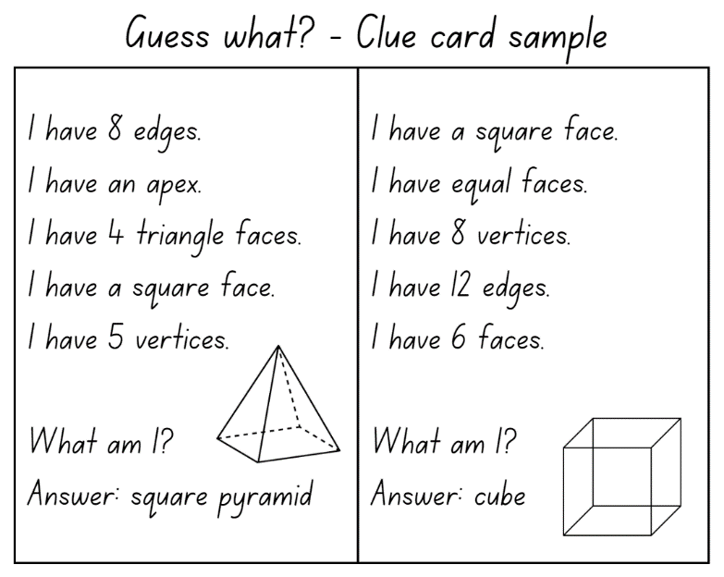

1. In pairs, students take turns playing the game.
2. After playing, ask students:

* What did you notice?
* Were any clue cards harder to guess then others? Why or why not?
* Do some objects have the same properties?

This table details opportunities for differentiation.

|  |  |
| --- | --- |
| Too hard? | Too easy? |
| Students cannot name prisms and pyramids from their properties.   * Give students three-dimensional objects to refer to when matching properties to the three-dimensional objects. * Provide students with a diagram of the three-dimensional object with some of the properties already labelled. | Students can name prisms and pyramids from their properties.   * Students identify the properties of other three-dimensional objects, including hemisphere and octagonal prisms. * Students investigate other interesting three-dimensional objects, including a dodecahedron and torus. |

## Discuss and connect the mathematics – 10 minutes

1. Use [Google Maps](https://www.google.com.au/maps) to display a bird's eye view of the school. Revise that three-dimensional objects have faces that are two-dimensional shapes. Ask students to name the two-dimensional shapes they can see from the top view. Identify possible objects they can make with them. Discuss:

* What are the most common two-dimensional shapes you can see?
* What are the least common two-dimensional shapes you can see?
* What properties do the objects have?

This table details opportunities for assessment.

|  |  |
| --- | --- |
| Assessment opportunities | Links |
| What to look for:   * Can students compare properties of prisms and pyramids**? [MAO-WM-01, MA3-3DS-0]** * Can students name prisms and pyramids according to the shape of their base? **[MAO-WM-01, MA3-3DS-01]** | Links to [National Numeracy Learning Progressions](https://www.australiancurriculum.edu.au/resources/national-literacy-and-numeracy-learning-progressions/version-3-of-national-literacy-and-numeracy-learning-progressions/) (NNLP):   * UnM5, UGP3, UGP5. |

# Lesson 2

**Core concept**: mathematicians examine diagrams to name and explore the properties of an object.

## Daily number sense – Memory game – 10 minutes

The table below contains a suggested learning intention and success criteria. These are best co-constructed with students.

|  |  |
| --- | --- |
| Daily number sense learning intention | Daily number sense success criteria |
| Students are learning to:   * make connections between benchmark fractions, decimals and percentages. | Students can:   * recall commonly used equivalent percentages, decimals and fractions including $\frac{1}{2}$, $\frac{1}{4}$ and $\frac{3}{4}$ |

**Note**: for this lesson, you will need the card sets from Lesson 1 and extra sets of cards, enough for pairs of students.

1. Revise common equivalent percentages, decimals and fractions. For example, 75% = 0.75 = $\frac{75}{100}$ = $\frac{3}{4}$.
2. Tell students they will be playing a memory game with a partner to try and make equivalent pairs. The partner who matches the most pairs is the winner.
3. Give pairs of students a set of cards from Resource 1 – equivalency game cards and ask students to shuffle the cards and place them face down.
4. Students take turns to flip over 2 cards at a time, trying to find a pair of equivalent cards. For example, $\frac{2}{2}$ is equivalent to 100% or $\frac{1}{5}$ is equivalent to 0.2. If a pair of cards match, the student keeps the cards. If a match isn’t made, the cards are turned face down again.
5. Students repeat the process until all cards have been matched.

This table details an opportunity for assessment.

|  |  |
| --- | --- |
| Assessment opportunity | Links |
| What to look for:   * Can students recall commonly used equivalent percentages, decimals and fractions including $\frac{1}{2}$, $\frac{1}{4}$ and $\frac{3}{4}$? **[MAO-WM-01, MA3-RN-03]** | Links to [National Numeracy Learning Progressions](https://www.australiancurriculum.edu.au/resources/national-literacy-and-numeracy-learning-progressions/version-3-of-national-literacy-and-numeracy-learning-progressions/) (NNLP):   * PrT2, UnM8. |

## Core lesson – net sketch – 30 minutes

The table below contains suggested learning intentions and success criteria. These are best co-constructed with students.

|  |  |
| --- | --- |
| Core concept learning intentions | Core concept success criteria |
| Students are learning to:   * compare, describe and name prisms and pyramids * connect three-dimensional objects with two-dimensional representations. | Students can:   * name and compare properties of prisms and pyramids, according to the shape of their base * examine a diagram to determine whether it is or is not the net of a closed three-dimensional object * visualise, name and sketch nets of prisms and pyramids, given representations of their nets. |

This activity is an adaptation of '[Cut Nets](https://nrich.maths.org/2315)' from [NRICH](https://nrich.maths.org/frontpage) by the University of Cambridge.

1. Revise what students know about representing three-dimensional objects as nets.

**Note**: not all three-dimensional objects have nets. For example, spheres, cylinders and cones do not have a net. As they are not polyhedrons, their lack of edges means they do not have a net.

1. Display Resource 3 – Net or not? Revise that a net must have flat faces, straight edges and be folded along the edges to make an enclosed object. Ask students whether each is a net or not, and why:

* A is not a net because its edges are not straight and it has a curved surface. Cylinders do not have nets.
* B is a net because it has straight edges, flat surfaces and it can be folded to make a triangular pyramid.
* C is a net because it has straight edges, flat surfaces and it can be folded to make a cube.

1. Display Resource 4 – cut nets.

**Note**: each group will need 2 copies of this resource printed on A3 paper.

1. Explain that the nets of 9 objects have been cut into 2 and they can be combined in several ways to make geometrical models.
2. Give small groups of students 2 copies of Resource 4 – cut nets. Groups create a display of matched nets and solids as shown in Figure 2.

Figure – matching nets student recording example

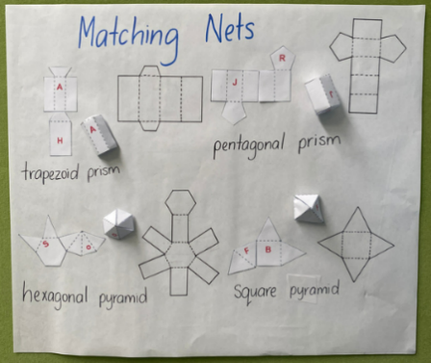

1. Discuss results with students as follows:

* What strategies did you use to put the cut nets together?
* How can you tell which are prisms and which are pyramids?
* Which 2 nets were the most similar and different?
* Was there more than one way to put 2 halves of some nets together?

This table details opportunities for differentiation.

|  |  |
| --- | --- |
| Too hard? | Too easy? |
| Students cannot visualise, name and/or sketch nets of prisms and pyramids, given representations of their nets.   * Provide students with three-dimensional geometrical models and labels for matching. * Give students 2 of the simpler cut nets to work with initially. For example, the cut nets of the square pyramid and pentagonal prism. | Students can visualise, name and sketch nets of prisms and pyramids, given representations of their nets.   * Students name and label properties of more complex three-dimensional geometrical models. * Students sketch the nets for these three-dimensional geometrical models. |

## Consolidation and meaningful practice – 20 minutes

**Note**: [Polypad](https://mathigon.org/polypad) is a digital resource for displaying, manipulating and transforming three-dimensional objects. Familiarisation prior to the lesson may be helpful.

1. Display [Polypad](https://mathigon.org/polypad) and model how a cube can unfold to a net.
2. Model making a new cube net, by moving the faces to different positions. Demonstrate how to use [Polypad](https://mathigon.org/polypad) to check this.
3. Refer to student displays of matched nets and solids (see Figure 3). Using individual whiteboards, students visualise and sketch different net solutions for each solid.
4. Students use [Polypad](https://mathigon.org/polypad) to recreate their nets digitally. They test them by folding them up to see if it creates the closed three-dimensional object, as intended.

Figure – matching nets and solids student example

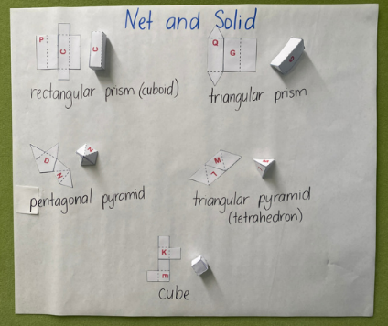

This table details opportunities for assessment.

|  |  |
| --- | --- |
| Assessment opportunities | Links |
| What to look for:   * Can students name and compare properties of prisms and pyramids? **[MAO-WM-01, MA3-3DS-01]** * Can students examine a diagram to determine whether it is or is not the net of a closed three-dimensional object? **[MAO-WM-01, MA3-3DS-0]** * Can students visualise, name and sketch nets of prisms and pyramids, given representations of their nets? **[MAO-WM-01, MA3-3DS-01]** | Links to [National Numeracy Learning Progressions](https://www.australiancurriculum.edu.au/resources/national-literacy-and-numeracy-learning-progressions/version-3-of-national-literacy-and-numeracy-learning-progressions/) (NNLP):   * UnM5, UGP3, UGP5. |

# Lesson 3

**Core concept**: mathematicians visualise diagrams to name and draw an object.

## Daily number sense – metre ruler – 15 minutes

The table below contains a suggested learning intention and success criteria. These are best co-constructed with students.

|  |  |
| --- | --- |
| Daily number sense learning intention | Daily number sense success criteria |
| Students are learning to:   * make connections between benchmark fractions, decimals and percentages. | Students can:   * represent common percentages of quantities and lengths as fractions and decimals. |

This lesson is an adaptation of ‘[Metre Ruler](https://fuse.education.vic.gov.au/mcc/CurriculumItem?code=VCMNA217)’ from [Maths Curriculum Companion](https://fuse.education.vic.gov.au/MCC) by State of Victoria (Department of Education and Training).

1. Revise common equivalent percentages, decimals and fractions. For example, 25% = 0.25 = $\frac{25}{100}$ = $\frac{1}{4}$.
2. Explain to students that we can describe lengths as percentages, decimals and fractions of a whole length. For example, 25 cm can be represented as 0.25 m, $\frac{25}{100}$, 25% of 100 cm and $\frac{1}{4}$ of one metre.
3. Show students a one metre ruler. Remind students that percent means ‘out of 100’. Explain that the full length of the ruler would equal 100%.
4. Cover part of the metre ruler with a piece of paper (see Figure 4).

Figure – covered metre ruler

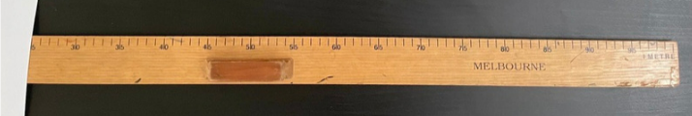

1. Ask:

* What percentage of the ruler has been covered? (Answer: 25%.)
* What percentage of the ruler is not covered? (Answer: 75%.)
* What could you say about the covered and uncovered parts of the ruler? (Answer: Together they are equal to 100%.)

1. Give small groups of students a metre ruler, sticky tabs and an individual whiteboard. Ask students to mark on the one metre ruler: 10%, 20%, 25%, 50%, 75% and 100% of 100 cm.
2. Students record the marked percentages as measurements, fractions and decimals (see Figure 5).

Figure – student recording example

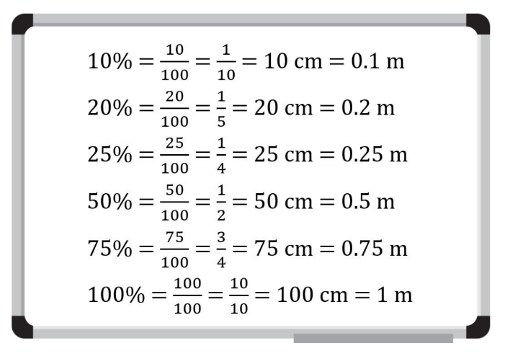

1. Tell students you have a glass filled with 100 mL of water. Ask students what 10%, 20%, 25%, 50%, 75% and 100% of 100 mL would be? Ask: ‘How could I record these measurements as fractions and decimals?’
2. Record student responses and discuss and compare with the recordings made by students for 100 cm.

This table details an opportunity for assessment.

|  |  |
| --- | --- |
| Assessment opportunity | Links |
| What to look for:   * Can students represent common percentages of quantities and lengths as fractions and decimals? **[MAO-WM-01, MA3-RN-03]** | Links to [National Numeracy Learning Progressions](https://www.australiancurriculum.edu.au/resources/national-literacy-and-numeracy-learning-progressions/version-3-of-national-literacy-and-numeracy-learning-progressions/) (NNLP):   * InF7, PrT2. |

## Core lesson – restaurant packaging part 1 – 40 minutes

The table below contains suggested learning intentions and success criteria. These are best co-constructed with students.

|  |  |
| --- | --- |
| Core concept learning intentions | Core concept success criteria |
| Students are learning to:   * compare, describe and name prisms and pyramids * connect three-dimensional objects with two-dimensional representations. | Students can:   * name prisms and pyramids according to the shape of their base * compare properties of prisms and pyramids * visualise and sketch three-dimensional objects from different views, including top, front and side views. |

This activity is an adaptation of ‘[Designing food packaging](https://resources.education.nsw.gov.au/detail/TSM-19)’ from the [Universal Resources Hub](https://resources.education.nsw.gov.au/home) by State of New South Wales (Department of Education)..

1. Give students Resource 5 – 3D objects. Students find examples of prisms and pyramids in the classroom.
2. Explain to students that they will be designing new packaging for a restaurant. The owners want to move away from using plastic takeaway containers.
3. Discuss why food packaging needs to be well constructed. Ask students if they think all packaging should be:

* made from cardboard? Why or why not?
* all the same size? Why or Why not?
* easily opened? Why or why not?

1. Brainstorm different types of takeaway foods and discuss the packaging currently used for those foods. For example, a pizza box.
2. In pairs, students draw a sketch of one kind of takeaway food and estimate the space it takes up.
3. Students transfer the sketch of their takeaway container onto isometric grid paper (see Figure 6).

Figure – packaging made with triangular and rectangular prisms

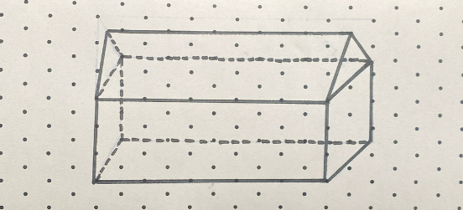

This table details opportunities for differentiation.

|  |  |
| --- | --- |
| Too hard? | Too easy? |
| Students cannot visualise and/or sketch their three-dimensional objects.   * Provide student with packaging examples to sketch. * Support students to sketch three-dimensional objects. | Students can visualise and sketch their three-dimensional objects.   * Students design a container that will separate 3 kinds of foods. * Students draw their design from different views. |

## Discuss and connect the mathematics – 10 minutes

1. Students label their design identifying the three-dimensional objects that have been used and their properties (see Figure 7).

Figure – labelling packaging

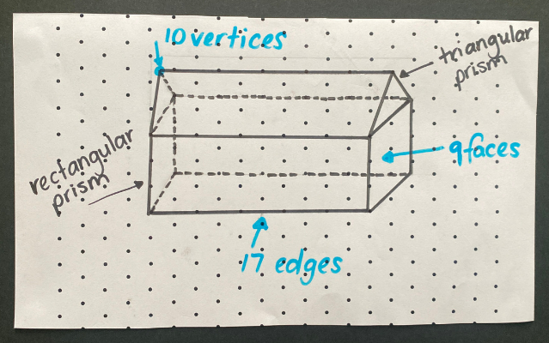

1. Pairs of students share their designs, describing the three-dimensional objects they used and why.

This table details opportunities for assessment.

|  |  |
| --- | --- |
| Assessment opportunities | Links |
| What to look for:   * Can students name prisms and pyramids according to the shape of their base? **[MAO-WM-01, MA3-3DS-01]** * Can students compare properties of prisms and pyramids? **[MAO-WM-01, MA3-3DS-01]** * Can students visualise and sketch three-dimensional objects from different views, including top, front and side views? **[MAO-WM-01, MA3-3DS-01]** | Links to [National Numeracy Learning Progressions](https://www.australiancurriculum.edu.au/resources/national-literacy-and-numeracy-learning-progressions/version-3-of-national-literacy-and-numeracy-learning-progressions/) (NNLP):   * UGP3, UGP5. |

# Lesson 4

**Core concept**: compare, describe and name prisms and pyramids.

## Daily number sense – 10 minutes

1. From a class need surfaced through formative assessment data, identify a short, focused activity that targets students’ knowledge, understanding and skills. Example activities may be drawn from the following resources:

* [Mathematics K–6 resources](https://education.nsw.gov.au/teaching-and-learning/curriculum/mathematics/mathematics-curriculum-resources-k-12/mathematics-k-6-resources.main-education--category---catalogue---key-learning-area---mathematics---thinking-mathematically.nameAsc.1.grid)
* [Universal Resources Hub](https://resources.education.nsw.gov.au/home).

## Core lesson – restaurant packaging part 2 – 50 minutes

The table below contains suggested learning intentions and success criteria. These are best co-constructed with students.

|  |  |
| --- | --- |
| Core concept learning intentions | Core concept success criteria |
| Students are learning to:   * connect three-dimensional objects with two-dimensional representations * construct prisms and pyramids. | Students can:   * construct skeletal and three-dimensional models of prisms and pyramids * visualise and sketch nets for given three-dimensional objects * visualise and sketch three-dimensional objects from different views, including top, front and side views * construct three-dimensional models of prisms and pyramids, given drawings of different views. |

This activity is an adaption of ‘[Designing food packaging](https://resources.education.nsw.gov.au/detail/TSM-19)’ from [Universal Resources Hub](https://resources.education.nsw.gov.au/home) by State of New South Wales (Department of Education).

1. Provide pairs of students with a range of resources, for example, paper straws, pipe cleaners, toothpicks, sticky tape, sticky putty or modelling clay.

**Note**: students remain in the pairs they worked in for Lesson 3.

1. Explain that companies need to test product designs before manufacturing them. Tell students that they will be working with their partners to create a skeletal model of their takeaway packaging design from Lesson 3. Then they will sketch a net of their package on isometric grid paper. This will help them to see if their design would be a workable solution.
2. Students create a skeletal model of their takeaway packaging design from Lesson 3 (see Figure 8).

Figure – skeletal model

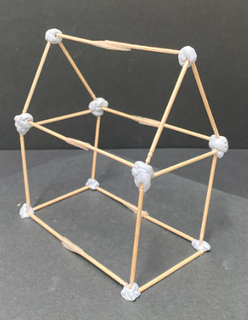

1. Students then sketch a net of their package on isometric grid paper (see Figure 9).

Figure – net and mini model

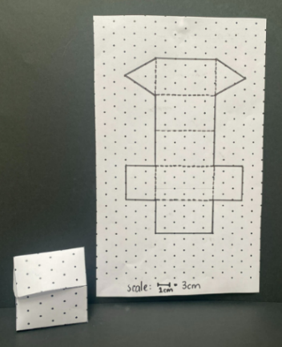

1. Students draw and make nets to scale on thick poster cardboard. Then they cut these out to assemble their package.
2. Choose some pairs of students to share their designs with the class. Ask students:

* Are you happy with your packaging? For example, the size. Why or why not?
* What difficulties did you experience when creating your packaging?
* Do you need to make any modifications for your packaging to be more efficient?

This table details opportunities for differentiation.

|  |  |
| --- | --- |
| Too hard? | Too easy? |
| Students cannot create skeletal and/or three-dimensional models of prisms and pyramids.   * Model building half of the skeletal model. Students complete the model. * Provide cardboard nets as examples for students to fold to construct a package. Support them to design and assemble their own net. | Students can create skeletal and three-dimensional models of prisms and pyramids.   * Students experiment with constructing more complex skeletal models. * Students draw nets of more their complex three-dimensional objects and recreate it as a model. |

## Consolidation and meaningful practice – 10 minutes

1. Students draw their packages from the front, side and top views (see Figure 10).

Figure – package views

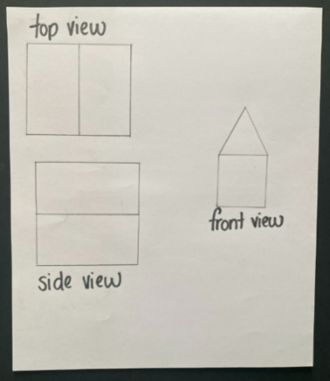

This table details opportunities for assessment.

|  |  |
| --- | --- |
| Assessment opportunities | Links |
| What to look for:   * Can students construct skeletal and three-dimensional models of prisms and pyramids? **[MAO-WM-01, MA3-3DS-01]** * Can students visualise and sketch nets for given three-dimensional objects? **[MAO-WM-01, MA3-3DS-01]** * Can students visualise and sketch three-dimensional objects from different views, including top, front and side views? **[MAO-WM-01, MA3-3DS-01]** * Can students construct three-dimensional models of prisms and pyramids, given drawings of different views? **[MAO-WM-01, MA3-3DS-01]** | Links to [National Numeracy Learning Progressions](https://www.australiancurriculum.edu.au/resources/national-literacy-and-numeracy-learning-progressions/version-3-of-national-literacy-and-numeracy-learning-progressions/) (NNLP):   * UGP3. |

# Lesson 5

**Core concept**: capacity is an internal measurement.

## Daily number sense – fraction snap – 10 minutes

Daily number sense activities for Lessons 5 to 7 ‘loop’ back to concepts and procedures covered in previous units to assist students to build an increasingly connected network of ideas. These concepts may differ from the core concepts being covered by the unit.

The table below contains a suggested learning intention and success criteria. These are best co-constructed with students.

|  |  |
| --- | --- |
| Daily number sense learning intention | Daily number sense success criteria |
| Students are learning to:   * recognise that a fraction can represent a division. | Students can:   * identify how the relationship between the number being divided and the divisor is represented in a fraction. |

1. Revise that fractions represent a division. For example, 4 shared between 9 is equal to $\frac{4}{9}$, so 4 divided by 9 = $\frac{4}{9}$.
2. Explain to students that they will be playing a game of Snap with a partner, where they will need to pair the fraction with its matching representation. For example, $\frac{5}{8}$ matches with 5 divided by 8 and $\frac{1}{6}$ matches with 1 shared between 6.
3. Give pairs of students Resource 6 – Snap set 1 and Resource 7 – Snap set 2. Explain that each student turns their pile of cards face down in front of them. Students turn the top card from their pile over at the same time. If the 2 cards turned over match, the player who says ‘Snap!’ first and reads aloud the matching set of cards, keeps them. If the cards don’t match, they are returned to the bottom of the pile.
4. Once students have turned over all cards in the set, they shuffle the cards and play again. Play continues for a set time and the player who gets the most matches by the end of the game wins.

This table details an opportunity for assessment.

|  |  |
| --- | --- |
| Assessment opportunity | Links |
| What to look for:   * Can students identify how the relationship between the number being divided and the divisor is represented in a fraction**? [MAO-WM-01, MA3-RQF-01]** | Links to [National Numeracy Learning Progressions](https://www.australiancurriculum.edu.au/resources/national-literacy-and-numeracy-learning-progressions/version-3-of-national-literacy-and-numeracy-learning-progressions/) (NNLP):   * InF6. |

## Core lesson – equivalent capacities – 40 minutes

The table below contains suggested learning intentions and success criteria. These are best co-constructed with students.

|  |  |
| --- | --- |
| Core concept learning intentions | Core concept success criteria |
| Students are learning to:   * connect decimal representations to the metric system * choose appropriate units of measurement for capacity * compare, order and represent decimals. | Students can:   * recognise the equivalence of whole number and decimal representations of measurements of capacities * interpret decimal notation for capacities * select and use appropriate units to measure the capacities of a variety of containers * compare and order decimal numbers of up to 3 decimal places. |

**Note**: capacity is only used in relation to containers and generally refers to measurement of fluids (liquids and gases). The capacity of a closed container will be slightly less than its volume – capacity is based on the inside dimensions, while volume is determined by the outside dimensions of the container. It is recommended that the terms ‘capacity’ and ‘internal volume’ be used interchangeably.

1. Revise the difference between volume and capacity. Volume is the space taken up by a three-dimensional object. Capacity is the internal volume, or how much a three-dimensional object can hold. Capacity is measured in units such as millilitres (mL) and litres (L).

**Capacity (internal volume)** refers to the amount a container can hold and is measured in units such as millilitres (mL) and litres (L).

1. Brainstorm different ways that capacity is measured. For example, with a jug, bottle or container.
2. Discuss the units of measurement for capacity can be converted to show equivalence. For example, 1000 mL = 1 L (see Figure 11).

Figure – equivalent capacities

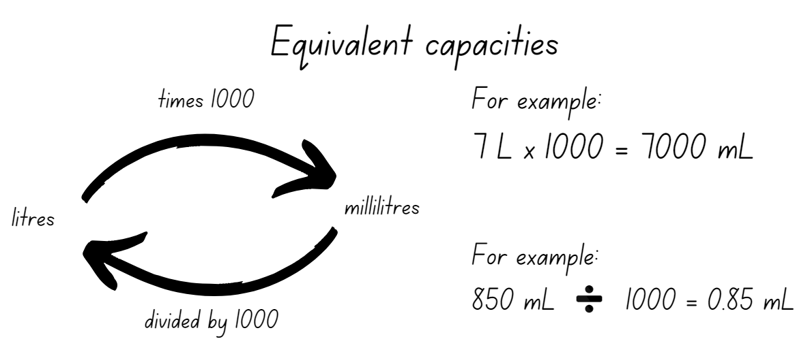

1. In small groups, give students Resource 8 – equivalence cards to match and order.
2. Show students 3 containers of different capacities. Model estimating and measuring the capacity of each container in millilitres. Revise with students that 250 mL is equivalent to one cup. Model converting millilitres to litres and record (see Figure 12).

Figure – capacity recording table

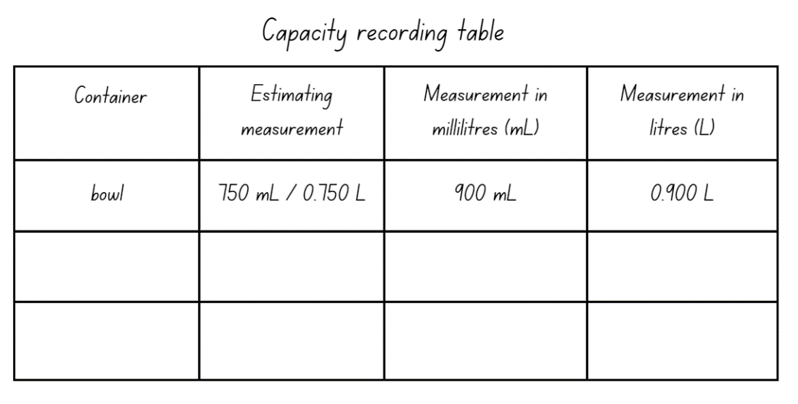

1. Provide small groups of students with Resource 9 – capacity recording table, a measuring jug and a variety of different sized containers. Ensure that some are smaller and some larger than a litre.
2. Students estimate, measure and record the capacity of these containers in millilitres. Then they convert to litres to 3 decimal places.
3. Groups share results, discussing strategies used to record capacities and convert between millilitres and litres. Support students to recognise whole-number and part-number measurements.

This table details opportunities for differentiation.

|  |  |
| --- | --- |
| Too hard? | Too easy? |
| Students cannot recognise and/or record the equivalence of whole-number and decimal representations of measurements.   * Support students to measure equivalent capacities using different measuring instruments. For example, pouring 250 mL into one cup and pouring one cup into a litre. * Provide support to students to record these capacities using whole-number and decimal representations. | Students can recognise and record the equivalence of whole-number and decimal representations of measurements.   * Students solve problems involving decimal representations of capacity. For example, Amy buys 3 drinks: one litre of water, a 375 mL can of soft drink and a 600 mL carton of milk. How many litres did Amy buy? * Students write their own capacity problems for other students to solve. |

## Consolidation and meaningful practice – 15 minutes

1. Display Resource 10 – capacity problems for students to solve.
2. For Question 1, the answer is 400 mL or 0.4 L. Revise with students why the zeros are removed.
3. For Question 2, answers may include:

* Fill the 9 L container and pour it into the 5 L container, leaving 4 litres in the 9 L container. Fill the 3 L container. Combine the 3 litres with the 4 litres left in the 9 L container to make exactly 7 litres of water.
* Fill the 5 L container and pour it into the 3 L container, leaving 2 litres in the 5 L container. Put the 2 litres in the 9 L container. Fill the 5 L container again and add this to the 9 L container, making exactly 7 litres.

1. For Question 3, the values of the 7 are:

* 700 mL
* 70 mL
* 7 mL
* 7 L.

1. For Question 4, the numbers in ascending order are 0.375 L, 1.750 L, 2.557 L, 7.550 L.
2. Discuss the answers with the class.

This table details opportunities for assessment.

|  |  |
| --- | --- |
| Assessment opportunities | Links |
| What to look for:   * Can students recognise the equivalence of whole-number and decimal representations of measurements of capacities? **[MAO-WM-01, MA3-3DS-02]** * Can students interpret decimal notation for capacities? **[MAO-WM-01, MA3-3DS-02]** * Can students select and use appropriate units to measure the capacities of a variety of containers? **[MAO-WM-01, MA3-3DS-02]** * Can students compare and order decimal numbers of up to 3 decimal places? **[MAO-WM-01, MA3-RN-02]** | Links to [National Numeracy Learning Progressions](https://www.australiancurriculum.edu.au/resources/national-literacy-and-numeracy-learning-progressions/version-3-of-national-literacy-and-numeracy-learning-progressions/) (NNLP):   * NPV8, NPV9, UuM6. |

# Lesson 6

**Core concept**: the most appropriate unit of measure is determined by the object.

## Daily number sense – dividing by dice – 10 minutes

The table below contains a suggested learning intention and success criteria. These are best co-constructed with students.

|  |  |
| --- | --- |
| Daily number sense learning intention | Daily number sense success criteria |
| Students are learning to:   * recognise that a fraction can represent a division. | Students can:   * identify how the relationship between the number being divided and the divisor is represented in a fraction. |

1. Revise that fractions represent division. For example, 5 divided by 10 = $\frac{5}{10}$. Remind students that the fraction $\frac{5}{10}$ can also be represented in different ways and still be equivalent. For example, $\frac{5}{10}$ is equal to $\frac{1}{2}$, $\frac{2}{4}$, $\frac{3}{6}$, $\frac{4}{8}$.
2. Tell students that they will be making and recording fractions and equivalent fractions. For example, $\frac{6}{8}$ = $\frac{3}{4}$. 6 ÷ 8 = $\frac{6}{8}$ and 3 ÷ 4 = $\frac{3}{4}$.
3. Explain to students they will being using two 10-sided dice to make their fractions. The larger number rolled will be the denominator and the smaller number rolled will be the numerator. For example, ‘I rolled a 4 and a 10, so 4 is the numerator and 10 is the denominator. The fraction is $\frac{4}{10}$.’

**Note:** tell students that some fractions, for example $\frac{1}{7}$, will have less possible equivalent fractions without going beyond a denominator of 10. Students can either record the fraction and roll the dice again or try to think of an equivalent fraction that would have a denominator that is greater than 10.

1. Give students two 10-sided dice and an individual whiteboard each. Students roll the dice, make a fraction and record the fractions and division number sentences (see Figure 13).

Figure – possible student recording

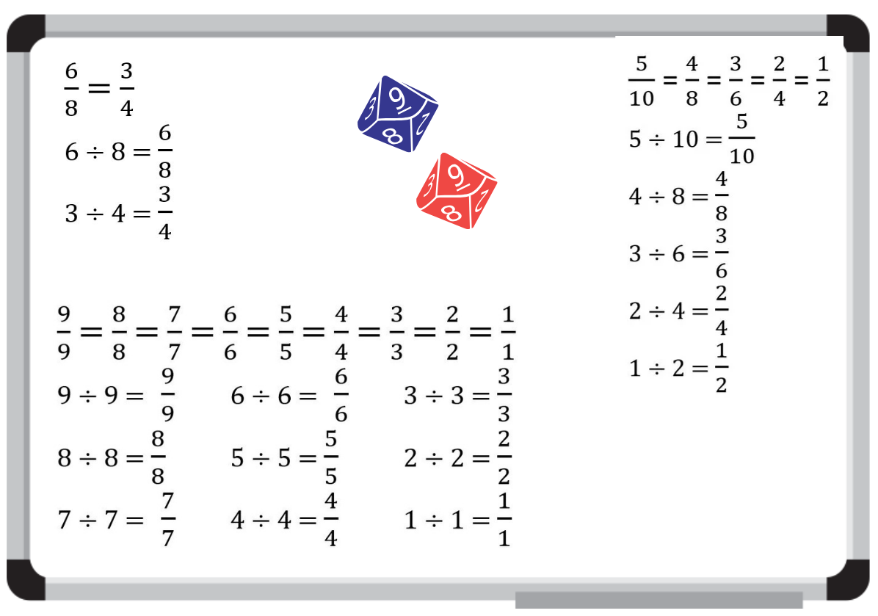

1. Students [turn and talk](https://education.nsw.gov.au/teaching-and-learning/curriculum/literacy-and-numeracy/teaching-and-learning-resources/numeracy/talk-moves) to share the recordings they made. Ask:

* Which fraction did you roll that had the least number of equivalent fractions?
* Which fraction did you roll that had the most number of equivalent fractions?
* Did you roll a fraction with the same numerator and denominator? What did you notice?

This table details an opportunity for assessment.

|  |  |
| --- | --- |
| Assessment opportunity | Links |
| What to look for:   * Can students identify how the relationship between the number being divided and the divisor is represented in a fraction? **[MAO-WM-01, MA3-RQF-01]** | Links to [National Numeracy Learning Progressions](https://www.australiancurriculum.edu.au/resources/national-literacy-and-numeracy-learning-progressions/version-3-of-national-literacy-and-numeracy-learning-progressions/) (NNLP):   * InF6. |

## Core lesson 1 – equivalence – 10 minutes

The table below contains suggested learning intentions and success criteria. These are best co-constructed with students.

|  |  |
| --- | --- |
| Core concept learning intentions | Core concept success criteria |
| Students are learning to:   * connect decimal representations to the metric system * recognise that the place value system can be extended beyond hundredths. | Students can:   * recognise the equivalence of whole-number and decimal representations of measurements of capacities * interpret decimal notation for capacities and record measurements to 3 decimal places * indicate the place value of digits in decimal numbers of up to 3 decimal places. |

1. Discuss equivalence and model converting between mL and L confirming place values of each number.
2. Display Resource 11 – equivalence match.
3. As a class, select students to draw a line matching the equivalent amounts. For example, 1500 mL is the same as one and a half litres and 1.5 L.
4. As a class, discuss the answers, asking students to justify how they know these capacities are equivalent.
5. Using Resource 8 – equivalence cards, in small groups, students play a game of ‘Equivalence snap’. Explain the rules of the game:

* Each student turns their pile of cards face down in front of them.
* Students turn the top card from their pile over at the same time.
* If the 2 cards turned over match, the player who says ‘Snap!’ first and reads aloud the matching set of cards, keeps them. If the cards don’t match, they are returned to the bottom of the pile.

## Core lesson2 – water, water, everywhere – 25 minutes

1. Explain to students they will be calculating how much water they use in one day.
2. Ask students to create a list of activities they do each day that require water.
3. Students estimate what their daily total water usage might be.
4. Provide students with a container to collect and measure how much water they use when they wash their hands.
5. Display Resource 12 – water usage facts.
6. Students calculate how much water they use in a day, recording measurements to 3 decimal places. They compare their result to the original estimate.
7. Discuss results with students, asking:

* How did you calculate your daily water usage?
* How accurate were your estimates? Why or why not?

1. Ask students what they could change in their daily routines to use less water? For example, showering for 2 minutes less, brushing teeth with the tap off, using the half flush when flushing the toilet.
2. Students decide on 3 water saving strategies and calculate how much water they could save each day.
3. Students [turn and talk](https://education.nsw.gov.au/teaching-and-learning/curriculum/literacy-and-numeracy/teaching-and-learning-resources/numeracy/talk-moves), explaining how they will save water tomorrow. For example, ‘Tomorrow I am going to save 11.5 L of water by showering for half a minute less.’

This table details opportunities for differentiation.

|  |  |
| --- | --- |
| Too hard? | Too easy? |
| Students cannot record capacity and/or calculate equivalent measurements to 3 decimal places.   * Model decimal representation to support students finding their daily water usage. * Give students Resource 11 – equivalence match cut into cards and support them to match them. | Students can record and calculate equivalent measurements to 3 decimal places.   * Students calculate their average weekly, monthly and annual water usage. * In a group of 3 or 4, students work out their combined average daily water usage. |

## Discuss and connect the mathematics – 15 minutes

1. Students will need a number slide made from Resource 13 – number slide, a pencil and an eraser.
2. Ask students to record the number 300 with a pencil, paying attention to the place value columns.
3. Explain that students will slide the long strip to show the number 10 times as big as 300 mL. Students make 3000 on their number slide.
4. Erase the number 300. Repeat the process for 20 mL, 500 mL and 125 mL.
5. Using the number slide, ask students to show the number 100 times less than 3000 mL. Students find 30 on their number slide.
6. Repeat the process for 5000 mL, 700 mL and 2300 mL.

This table details opportunities for assessment.

|  |  |
| --- | --- |
| Assessment opportunities | Links |
| What to look for:   * Can students recognise the equivalence of whole-number and decimal representations of measurements of capacities? **[MAO-WM-01, MA3-3DS-02]** * Can students interpret decimal notation for capacities and record measurements to 3 decimal places? **[MAO-WM-01, MA3-3DS-02]** * Can students indicate the place value of digits in decimal numbers of up to 3 decimal places? **[MAO-WM-01, MA3-RN-02]** | Links to [National Numeracy Learning Progressions](https://www.australiancurriculum.edu.au/resources/national-literacy-and-numeracy-learning-progressions/version-3-of-national-literacy-and-numeracy-learning-progressions/) (NNLP):   * NPV7, NPV8, NPV9.   Links to suggested [Interview for Student Reasoning](https://education.nsw.gov.au/teaching-and-learning/curriculum/literacy-and-numeracy/assessment-resources/ifsr) (IfSR) tasks:   * **IfSR-PT**: 4D.2, 4D.6. * **IfSR-NP**: 1A.5. |

# Lesson 7

**Core concept**: our base-10 place value system helps to interpret and record capacities.

## Daily number sense – fair shares – 15 minutes

The table below contains a suggested learning intention and success criteria. These are best co-constructed with students.

|  |  |
| --- | --- |
| Daily number sense learning intention | Daily number sense success criteria |
| Students are learning to:   * recognise that a fraction can represent a division. | Students can:   * identify how the relationship between the number being divided and the divisor is represented in a fraction. |

This activity is an adaptation of ‘Equal Sharing’ from Challenging Mathematical Tasks: Unlocking the Potential of all Students by Sullivan.

1. Display Resource 14 – fair shares and ask students:

* How could 6 cakes be shared equally between 8 friends?
* Is there more than one way the cakes could be shared equally?
* How could our knowledge of equivalent fractions help us find more than one possibility?

1. Give students time to solve the problem on individual whiteboards, encouraging them to find more than one answer. Ask students to [turn and talk](https://education.nsw.gov.au/teaching-and-learning/curriculum/literacy-and-numeracy/teaching-and-learning-resources/numeracy/talk-moves) and share their thinking.
2. Possible student responses could be:

* Divide each of the cakes into eighths and give each friend 6 of the eighths. Each friend gets six-eighths.
* Students realise that one-quarter is equivalent to two-eighths. Divide each of the cakes into quarters and give each friend 3 of the quarters. Each friend gets three-quarters.

1. Display the remaining problems on Resource 14 – fair shares and ask students to record their answers on their whiteboard, including equivalent fractions where appropriate.

The table below outlines stimulus prompts to generate conversation about the topic, along with anticipated responses from students.

|  |  |
| --- | --- |
| Prompts | Anticipated student responses |
| * 8 cakes shared between 10 friends | * If I have 10 friends, I know I need to make 10 parts. * I cut each of the cakes into 10 parts and then share them out equally. I gave each friend eight-tenths. Each friend gets $\frac{8}{10}$. |
| * 4 cakes shared between 6 friends | * If I have 6 friends, I know I need to make 6 parts. * I divided each of the cakes into sixths and gave each friend four-sixths. Each friend gets $\frac{4}{6}$. * I divided each of the cakes into thirds and gave each friend two-thirds. Each friend gets $\frac{2}{3}$. |
| * 2 cakes shared between 4 friends. | * If I have 4 friends, I know I need to make 4 parts. * I divided each of the cakes into quarters and gave each friend two-quarters. Each friend gets $\frac{2}{4}$. * I worked out that 2 quarters are in each half, so I divided each of the cakes in half and gave each friend one-half. Each friend gets $\frac{1}{2}$ or $\frac{2}{4}$. |

1. Ask students to share their thinking asking if their knowledge of equivalent fractions helped find multiple possibilities.

This table details opportunities for assessment.

|  |  |
| --- | --- |
| Assessment opportunities | Links |
| What to look for:   * Can students identify how the relationship between the number being divided and the divisor is represented in a fraction? **[MAO-WM-01, MA3-RQF-01]** | Links to [National Numeracy Learning Progressions](https://www.australiancurriculum.edu.au/resources/national-literacy-and-numeracy-learning-progressions/version-3-of-national-literacy-and-numeracy-learning-progressions/) (NNLP):   * InF6. |

## Core lesson – dripping taps – 40 minutes

The table below contains suggested learning intentions and success criteria. These are best co-constructed with students.

|  |  |
| --- | --- |
| Core concept learning intentions | Core concept success criteria |
| Students are learning to:   * connect decimal representations to the metric system * compare, order and represent decimals * recognise that the place value system can be extended beyond hundredths. | Students can:   * recognise the equivalence of whole-number and decimal representations of measurements of capacities * compare, order and record decimal measurements of up to 3 decimal places * indicate the place value of digits in decimal numbers of up to 3 decimal places. |

1. Incorporate daily review of recent concepts with students completing Resource 15 – converting measurements.
2. Explain to students that they are going to investigate the water wastage caused by a dripping tap.
3. In small groups, students estimate the water wastage caused by a dripping tap in 24 hours. They record their estimate in L and mL.
4. Students collect, measure and record, in L and mL, the water from a dripping tap over 5 minutes. They turn on a tap just enough to create a regular drip and collect these in a measuring container. Students turn off the tap after 5 minutes.
5. Ask students to use this measurement to calculate how much water would be wasted in 24 hours. For example, the water collected from a dripping tap in 5 minutes is 150 mL or 0.150 L. Multiply this by 12 to find out how much water would be wasted in one hour. Multiply this answer by 24 to find out how much water would be wasted in one day. The water wastage would be 0.150 L × 3 × 24 = 10.800 L.
6. Discuss the results with the class, asking:

* What did you notice?
* How accurate was your estimate? Why or why not?

**Note**: this lesson may be extended into an investigation of dripping taps around the school.

This table details opportunities for differentiation.

|  |  |
| --- | --- |
| Too hard? | Too easy? |
| Students cannot convert between millilitres and litres, litres and millilitres and/or record measurements to 3 decimal places.   * Support students to develop understanding of place value to 3 decimal places using a number slide. * Support students understanding of equivalence by relating common measurements to benchmark values. | Students can convert between millilitres and litres, litres and millilitres and record measurements to 3 decimal places.   * Students convert between millilitres and litres, litres and millilitres with large volumes of their choice. * Students research large capacities. For example, the local dam capacity. |

## Discuss and connect the mathematics – 15 minutes

1. Students will need a number slide made from Resource 13 – number slide, a pencil and an eraser.
2. In pairs, students use the number slide to find the numbers 10 times, 100 times and 1000 times as big as 4 mL, 73 mL and 625 mL.
3. Students find the numbers 10 times, 100 times and 1000 times smaller than 9 mL, 33 mL and 8075 mL.
4. After 10 minutes, students write their new decimal numbers in ascending order.

This table details opportunities for assessment.

|  |  |
| --- | --- |
| Assessment opportunities | Links |
| What to look for:   * Can students recognise the equivalence of whole-number and decimal representations of measurements of capacities? **[MAO-WM-01, MA3-3DS-02]** * **Can students compare, order and record decimal measurements of up to 3 decimal places? [MAO-WM-01, MA3-RN-02, MA3-3DS-02]** * Can students indicate the place value of digits in decimal numbers of up to 3 decimal places? **[MAO-WM-01, MA3-RN-02]** | Links to [National Numeracy Learning Progressions](https://www.australiancurriculum.edu.au/resources/national-literacy-and-numeracy-learning-progressions/version-3-of-national-literacy-and-numeracy-learning-progressions/) (NNLP):   * NPV7, NPV8, NPV9.   Links to suggested [Interview for Student Reasoning](https://education.nsw.gov.au/teaching-and-learning/curriculum/literacy-and-numeracy/assessment-resources/ifsr) (IfSR) tasks:   * **IfSR-PT**: 1A.5, 1A.7. * **IfSR-AT**: 4B.1. * **IfSR-NP**: 4D.2, 4D.6. |

# Lesson 8

**Core concept**: displacement can be used to explore the volume of irregular solids.

## Daily number sense – 10 minutes

1. From a class need surfaced through formative assessment data, identify a short, focused activity that targets students’ knowledge, understanding and skills. Example activities may be drawn from the following resources:

* [Mathematics K–6 resources](https://education.nsw.gov.au/teaching-and-learning/curriculum/mathematics/mathematics-curriculum-resources-k-12/mathematics-k-6-resources.main-education--category---catalogue---key-learning-area---mathematics---thinking-mathematically.nameAsc.1.grid)
* [Universal Resources Hub](https://resources.education.nsw.gov.au/home).

## Core lesson – a thirsty crow – 35 minutes

The table below contains a suggested learning intention and success criteria. These are best co-constructed with students.

|  |  |
| --- | --- |
| Core concept learning intention | Core concept success criteria |
| Students are learning to:   * use displacement to investigate volumes of irregular solids. | Students can:   * recognise that an object’s volume takes up space by observing the change in water level when an object is placed in a container of water * compare the volumes of 2 or more objects by marking the change in water level when each is submerged in a container. |

**Note**: fables such as those written by the ancient Greek author, Aesop, have been used by teachers throughout history to illustrate concepts for students. ‘[The Crow and the Pitcher](https://read.gov/aesop/012.html)’ is a fable that sees the displacement of objects used to solve a problem.

1. Share Aesop’s fable ‘The Crow and the Pitcher’ with the class.
2. Discuss what displacement means. Explain that it is the change in water level when an object is submerged into it. Displacement is a useful strategy to measure the volume of irregular objects.
3. Model measuring the internal capacity of an irregular object using displacement. For example, a glue stick, pair of scissors or modelling clay container.
4. Explain to students that they will be using displacement to calculate how many marbles would be needed to increase the water in a container, so that a bird could drink from it. The bird can only drink water from a container if it is completely full.
5. Show students a narrow container that is half full of water. Mark the halfway point with a whiteboard marker. Explain that you are going add marbles until the water reaches the top of the container. Each marble will displace some water. Have students estimate how many marbles will be needed to displace enough water so that the water level is at the top of the container instead of halfway (see Figure 14).

Figure – narrow container

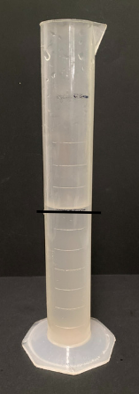

1. Model dropping in marbles one a time and mark the new level each time with a whiteboard marker. After dropping in 3 marbles, ask students if they would like to refine their estimates.
2. Continue the demonstration, keeping a tally of the number of marbles used to displace enough water so the water level is at the top of the container.
3. Give small groups of students narrow containers which are different to the demonstration container, marbles and a whiteboard marker.
4. Students pour water into a narrow container until it is half full. They mark this level.
5. The groups of students estimate how many marbles it will take to displace the water to the top of the container.
6. Students begin by dropping marbles in the container one at a time, measuring the water level each time and recording the results. After they have dropped in 3 marbles, they consider whether to refine their estimate.
7. Discuss with the class how many marbles were needed. Ask how close they were to their original estimates.
8. Students repeat the process with a different object such as dice. Discuss the students’ findings as a class.

The table below outlines stimulus prompts to generate conversation about the topic, along with anticipated responses from students.

|  |  |
| --- | --- |
| Prompts | Anticipated student responses |
| * Did using a different object change your estimate and/or measurement? | * Yes, using a different object changed our estimate and measurement. The new object had a different size to the marbles. * No, using a different object did not change our estimate and measurement. The new object had a similar size to the marbles. |
| * How could you calculate the volume of an object using only 2 or 3 marbles, dice or other objects? How do you know? | * Once we know how much 3 objects displace, we could calculate how many times this would fit in the container until it is full. |

This table details opportunities for differentiation.

|  |  |
| --- | --- |
| Too hard? | Too easy? |
| Students cannot recognise and/or compare the volume of objects using displacement.   * Support students to use displacement to find the volume of objects using different containers. * Support students to compare the volume of 2 objects using displacement. | Students can recognise and compare the volume of objects using displacement.   * Ask students to find the difference in volume between 2 objects. For example, marbles and dice. * Students calculate the volume of an object using displacement with a limited number of objects. For example, 30 marbles displace 50 mL, so 60 marbles would displace 100 mL. |

## Consolidation and meaningful practice – 15 minutes

1. Pose the problem: What is the volume of a marble?
2. Students calculate how many marbles it takes to displace 100 mL in a measuring jug.
3. Then students calculate the volume of one marble. For example, one marble is equivalent to approximately 1.666 mL.

This table details opportunities for assessment.

|  |  |
| --- | --- |
| Assessment opportunities | Links |
| What to look for:   * Can students recognise that an object’s volume takes up space by observing the change in water level when an object is placed in a container of water? **[MAO-WM-01, MA3-3DS-02]** * Can students compare the volumes of 2 or more objects by marking the change in water level when each is submerged in a container? **[MAO-WM-01, MA3-3DS-02]** | Links to [National Numeracy Learning Progressions](https://www.australiancurriculum.edu.au/resources/national-literacy-and-numeracy-learning-progressions/version-3-of-national-literacy-and-numeracy-learning-progressions/) (NNLP):   * N/A. |

# Resource 1 – equivalency game cards

|  |  |  |  |  |  |
| --- | --- | --- | --- | --- | --- |
| $$\frac{50}{100}$$ | 50% | 75% | 10% | 100% | $$\frac{25}{100}$$ |
| $$\frac{1}{4}$$ | $$\frac{20}{100}$$ | $$\frac{1}{5}$$ | 0.2 | 1.0 | $$\frac{1}{2}$$ |
| $$\frac{3}{4}$$ | 25% | $$\frac{1}{10}$$ | $$\frac{2}{2}$$ | $$\frac{10}{100}$$ | 0.5 |
| $$\frac{75}{100}$$ | 0.75 | 20% | 0.1 | 0.25 | $$\frac{100}{100}$$ |

# Resource 2 – Guess what?

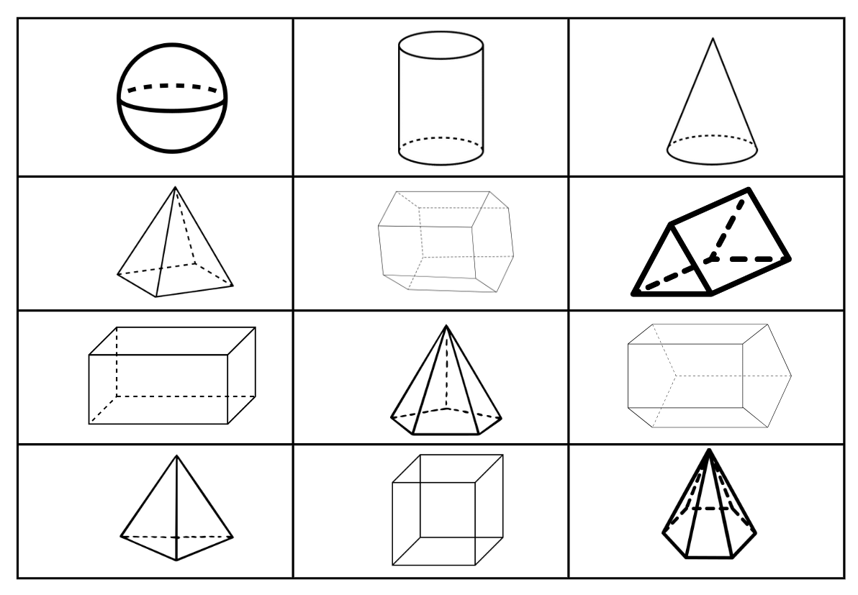

# Resource 3 – Net or not?

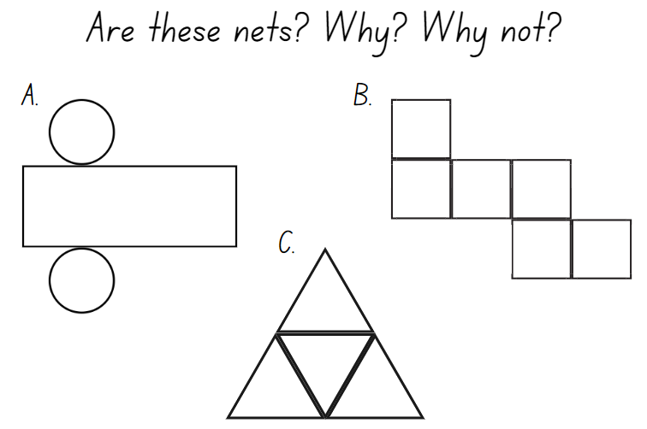

# Resource 4 – cut nets

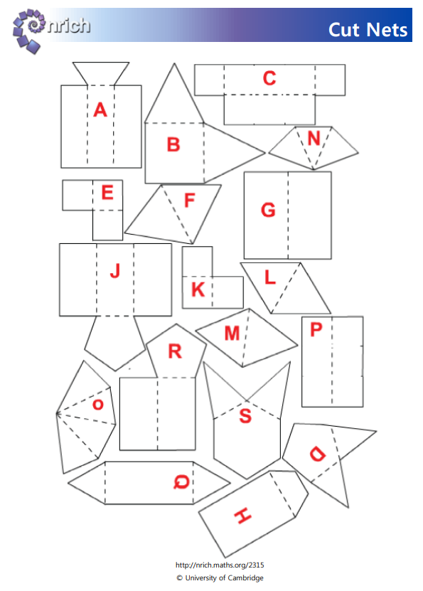

# Resource 5 – 3D objects

**3D objects in the world**

|  |  |
| --- | --- |
| 3D object name | Real-world examples |
| cube |  |
| rectangular prism (cuboid) |  |
| triangular prism |  |
| trapezoid prism |  |
| square pyramid |  |
| triangular pyramid (tetrahedron) |  |

# Resource 6 – Snap set 1

|  |  |  |  |
| --- | --- | --- | --- |
| 3 divided by 4 | 1 divided by 10 | 2 shared  between 5 | 2 shared  between 3 |
| 4 divided by 9 | 9 divided by 10 | 1 shared  between 4 | 5 shared  between 7 |
| 6 shared  between 7 | 7 divided by 9 | 1 shared  between 6 | 3 divided by 8 |
| 4 divided by 6 | 5 divided by 8 | 1 shared  between 2 | 3 shared  between 5 |

# Resource 7 – Snap set 2

|  |  |  |  |
| --- | --- | --- | --- |
| $$\frac{3}{4}$$ | $$\frac{2}{5}$$ | $$\frac{4}{6}$$ | $$\frac{6}{7}$$ |
| $$\frac{7}{9}$$ | $$\frac{5}{8}$$ | $$\frac{1}{10}$$ | $$\frac{1}{2}$$ |
| $$\frac{2}{3}$$ | $$\frac{1}{4}$$ | $$\frac{3}{8}$$ | $$\frac{4}{9}$$ |
| $$\frac{9}{10}$$ | $$\frac{5}{7}$$ | $$\frac{3}{5}$$ | $$\frac{1}{6}$$ |

# Resource 8 – equivalence cards

|  |  |  |  |  |  |  |  |  |
| --- | --- | --- | --- | --- | --- | --- | --- | --- |
| **1 cup** |  | **4 cups** |  | **350 mL** |  | **0.125 L** |  | **1 litre** |
|  |  |  |  |  |  |  |  |  |
| **2 cups** |  | **125 mL** |  | **1 L** |  | **0.125 L** |  | **500 mL** |
|  |  |  |  |  |  |  |  |  |
| $\frac{1}{4}$**cup** |  | **1000 mL** |  | **1500 mL** |  | **0.350 L** |  | **250 mL** |

|  |  |  |  |  |  |  |  |  |
| --- | --- | --- | --- | --- | --- | --- | --- | --- |
| **8750 mL** |  | **2450 mL** |  | **5 cups** |  | **1.250 L** |  | **1.500 L** |
|  |  |  |  |  |  |  |  |  |
| **1055 mL** |  | **1900 mL** |  | **75 mL** |  | **1.900 L** |  | **0.075 L** |
|  |  |  |  |  |  |  |  |  |
| **5 mL** |  | **0.005 L** |  | **8.750 L** |  | **1.055 L** |  | **2.450 L** |

# Resource 9 – capacity recording table

|  |  |  |  |
| --- | --- | --- | --- |
| Container | Estimate of measurement | Measurement in millilitres (mL) | Measurement in litres (L) |
|  |  |  |  |
|  |  |  |  |
|  |  |  |  |
|  |  |  |  |
|  |  |  |  |

# Resource 10 – capacity problems

1. I have 2 litres of water. I need to divide it into 5 small jugs equally.

|  |  |
| --- | --- |
| How much water in millilitres (mL) will be in each of the 5 jugs? |  |
| How much water in litres (L) will be in each of the 5 jugs? |  |

1. I have 3 containers. They hold 3, 5 and 9 litres. Use the space below to work out how I could use these containers to measure exactly 7 litres of water?

|  |
| --- |
|  |

1. Name the value of the 7 in:

|  |  |
| --- | --- |
| 1.750 L |  |
| 0.375 L |  |
| 2.557 L |  |
| 7.550 L |  |
| 1. Write these numbers in ascending order. |  |

# Resource 11 – equivalence match

**What is my equivalent measurement?**

|  |  |  |
| --- | --- | --- |
| **0.375 L** |  | **0.750 L** |
|  |  |  |
| **750 mL** |  | **375 mL** |
|  |  |  |
| **Quarter of a cup** |  | **0.125 L** |
|  |  |  |
| **0.250 L** |  | **0.500 L** |
|  |  |  |
| **1 litre** |  | **1 cup** |
|  |  |  |
| **500 mL** |  | **1000 mL** |

# Resource 12 – water usage facts

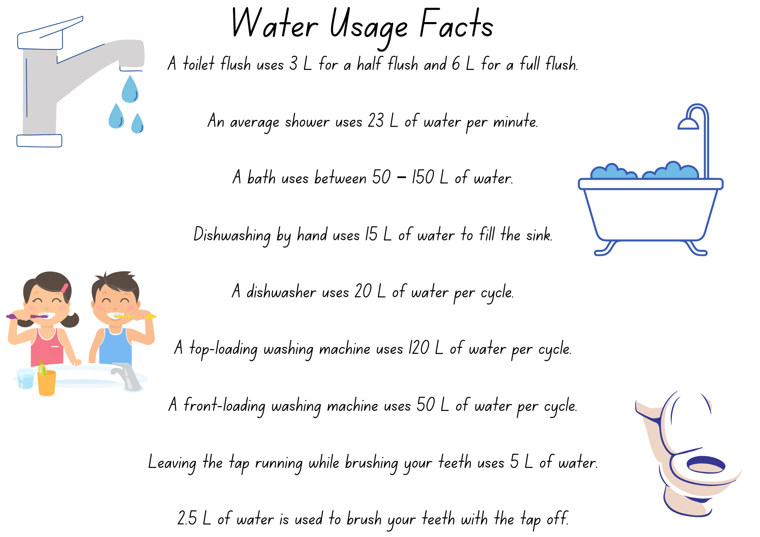

# Resource 13 – number slide

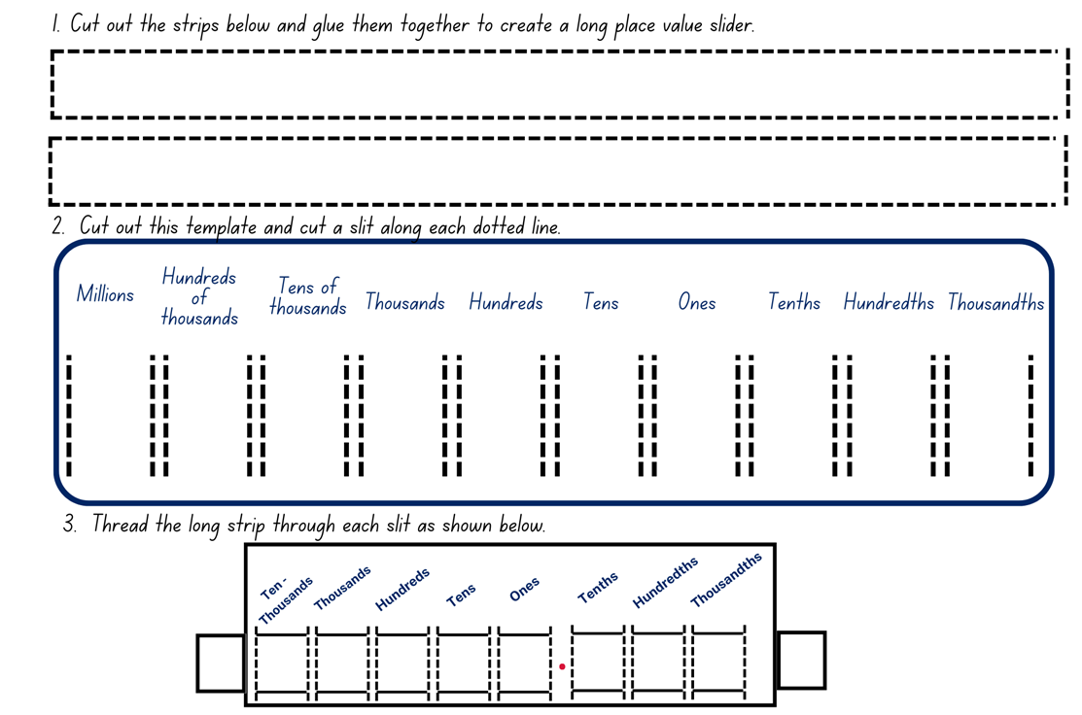

# Resource 14 – fair shares

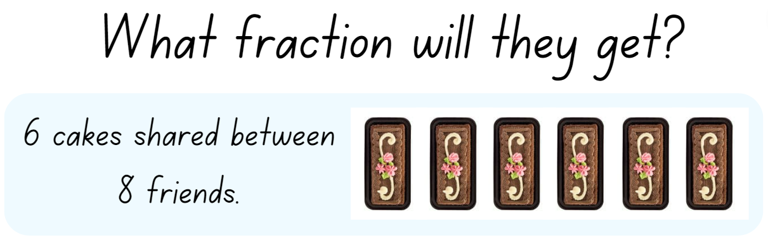

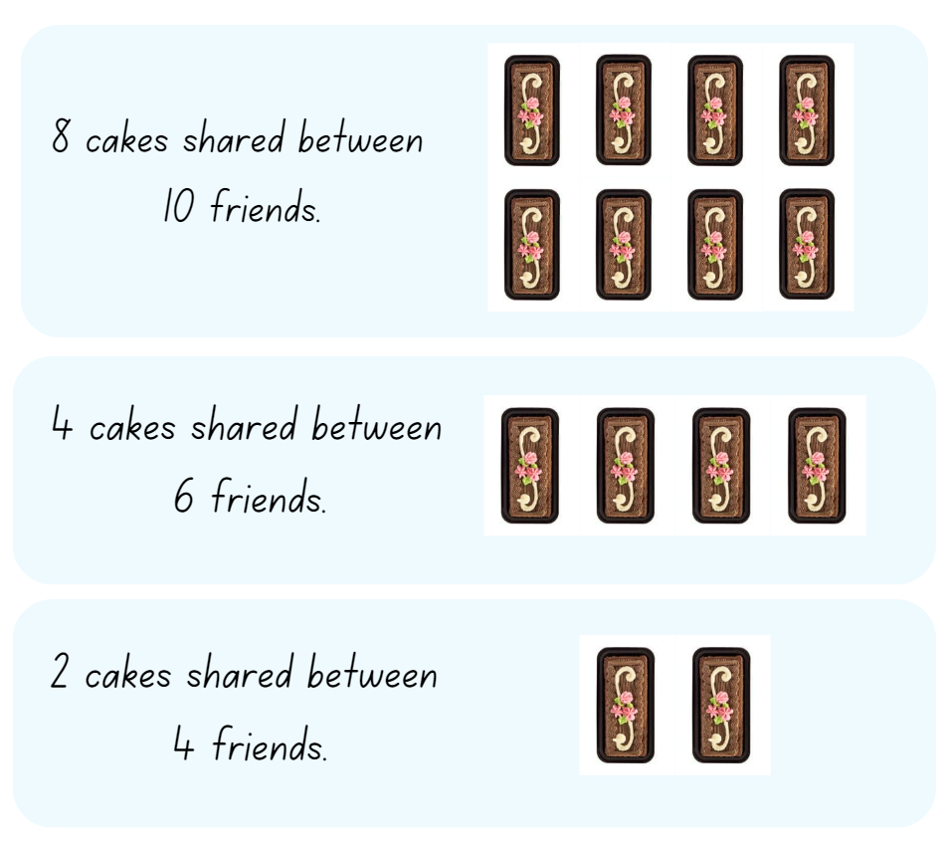

# Resource 15 – converting measurements

Sarah's measuring jug is only labelled in litres and Linda's is only labelled in millilitres. Complete the tables below to convert litres into millilitres and millilitres into litres:

|  |  |  |  |
| --- | --- | --- | --- |
| Litres (L) – Sarah’s jug | Millilitres (mL) | Millilitres (mL) – Linda’s jug | Litres (L) |
| 1.500 |  | 750 |  |
| 3.750 |  | 15 |  |
| 2.225 |  | 2300 |  |
| 0.250 |  | 1500 |  |
| 0.075 |  | 4 |  |

Order these capacities from smallest to largest capacity: 1.500 L, 3.750 L, 2.225 L, 0.250 L 0.075 L.

|  |
| --- |
|  |

# Syllabus outcomes and content

The table below outlines the [syllabus outcomes](https://curriculum.nsw.edu.au/learning-areas/mathematics/mathematics-k-10-2022/overview) and range of relevant syllabus content covered in this unit. Content is linked to [National Numeracy Learning Progression](https://www.australiancurriculum.edu.au/resources/national-literacy-and-numeracy-learning-progressions/version-3-of-national-literacy-and-numeracy-learning-progressions/) version (3).

|  |  |  |  |  |  |  |  |  |
| --- | --- | --- | --- | --- | --- | --- | --- | --- |
| Outcomes and content | 1 | 2 | 3 | 4 | 5 | 6 | 7 | 8 |
| **Represents numbers A**: Decimals and percentages: Recognise that the place value system can be extended beyond hundredths  **MAO-WM-01, MA3-RN-02** |  |  |  |  |  |  |  |  |
| * Indicate the place value of digits in decimal numbers of up to 3 decimal places |  |  |  |  |  | x | x |  |
| **Represents numbers A**: Decimals and percentages: Compare, order and represent decimals  **MAO-WM-01, MA3-RN-02** |  |  |  |  |  |  |  |  |
| * Compare and order decimal numbers of up to 3 decimal places |  |  |  |  | x |  | x |  |
| **Represents numbers B**: Decimals and percentages: Make connections between benchmark fractions, decimals and percentages  **MAO-WM-01, MA3-RN-03** |  |  |  |  |  |  |  |  |
| * Recall commonly used equivalent percentages, decimals and fractions including $\frac{1}{2}$, $\frac{1}{4}$ and $\frac{3}{4}$ | x | x |  |  |  |  |  |  |
| * Represent common percentages of quantities and lengths as fractions and decimals |  |  | x |  |  |  |  |  |
| **Representing quantity fractions B**: Recognise that a fraction can represent a division  **MAO-WM-01, MA3-RQF-01** |  |  |  |  |  |  |  |  |
| * Identify how the relationship between the number being divided and the divisor is represented in a fraction |  |  |  |  | x | x | x |  |
| **Three-dimensional spatial structure A**: 3D objects: Compare, describe and name prisms and pyramids  **MAO-WM-01, MA3-3DS-01** |  |  |  |  |  |  |  |  |
| * Compare properties of prisms and pyramids | x | x | x |  |  |  |  |  |
| * Name prisms and pyramids according to the shape of their base | x | x | x |  |  |  |  |  |
| **Three-dimensional spatial structure A**: 3D objects: Connect three-dimensional objects with two-dimensional representations  **MAO-WM-01, MA3-3DS-01** |  |  |  |  |  |  |  |  |
| * Visualise and sketch three-dimensional objects from different views, including top, front and side views (Reasons about spatial orientation) |  | x | x | x |  |  |  |  |
| * Examine a diagram to determine whether it is or is not the net of a closed 3-dimensional object |  | x |  |  |  |  |  |  |
| * Visualise and sketch nets for given three-dimensional objects |  | x |  | x |  |  |  |  |
| * Visualise and name prisms and pyramids, given representations of their nets (Reasons about spatial visualisation) |  | x |  |  |  |  |  |  |
| **Three-dimensional spatial structure A**: Volume: Choose appropriate units of measurement for capacity  **MAO-WM-01, MA3-3DS-02** |  |  |  |  |  |  |  |  |
| * Select and use appropriate units to measure the capacities of a variety of containers |  |  |  |  | x |  |  |  |
| **Three-dimensional spatial structure A**: Volume: Use displacement to investigate volumes of irregular solids  **MAO-WM-01, MA3-3DS-02** |  |  |  |  |  |  |  |  |
| * Recognise that an object’s volume takes up space by observing the change in water level when an object is placed in a container of water |  |  |  |  |  |  |  | x |
| * Compare the volumes of 2 or more objects by marking the change in water level when each is submerged in a container |  |  |  |  |  |  |  | x |
| **Three-dimensional spatial structure A**: Volume: Connect decimal representations to the metric system  **MAO-WM-01, MA3-3DS-02** |  |  |  |  |  |  |  |  |
| * Recognise the equivalence of whole-number and decimal representations of measurements of capacities |  |  |  |  | x | x | x |  |
| * Interpret decimal notation for capacities |  |  |  |  | x | x |  |  |
| * Record measurements to 3 decimal places |  |  |  |  |  | x | x |  |
| **Three-dimensional spatial structure B**: 3D objects: Construct prisms and pyramids  **MAO-WM-01, MA3-3DS-01** |  |  |  |  |  |  |  |  |
| * Create skeletal models of prisms and pyramids |  |  |  | x |  |  |  |  |
| * Construct three-dimensional models of prisms and pyramids, given drawings of different views |  |  |  | x |  |  |  |  |

[Mathematics K–10 Syllabus](https://curriculum.nsw.edu.au/learning-areas/mathematics/mathematics-k-10-2022/overview) © NSW Education Standards Authority (NESA) for and on behalf of the Crown in right of the State of New South Wales, 2022.

# References

This resource contains NSW Curriculum and syllabus content. The NSW Curriculum is developed by the NSW Education Standards Authority. This content is prepared by NESA for and on behalf of the Crown in right of the State of New South Wales. The material is protected by Crown copyright.

Please refer to the NESA Copyright Disclaimer for more information <https://educationstandards.nsw.edu.au/wps/portal/nesa/mini-footer/copyright>.

NESA holds the only official and up-to-date versions of the NSW Curriculum and syllabus documents. Please visit the NSW Education Standards Authority (NESA) website <https://educationstandards.nsw.edu.au/wps/portal/nesa/home> and the NSW Curriculum website [https://curriculum.nsw.edu.au](https://curriculum.nsw.edu.au/).

[Mathematics K–10 Syllabus](https://curriculum.nsw.edu.au/learning-areas/mathematics/mathematics-k-10-2022/overview) © NSW Education Standards Authority (NESA) for and on behalf of the Crown in right of the State of New South Wales, 2022.

[National Numeracy Learning Progression](https://www.australiancurriculum.edu.au/resources/national-literacy-and-numeracy-learning-progressions/version-3-of-national-literacy-and-numeracy-learning-progressions/) © Australian Curriculum, Assessment and Reporting Authority (ACARA) 2010 to present, unless otherwise indicated. This material was downloaded from the [Australian Curriculum](http://www.australiancurriculum.edu.au/) website (National Numeracy Learning Progression) (accessed 5 September 2023) and was not modified.

Aesop (1919) ‘[The Crow and the Pitcher](https://read.gov/aesop/012.html)’, The Aesop for Children: with Pictures by Milo Winter (Winter M illus), Rand, McNally and Co, adapted by the Library of Congress, accessed 20 December 2023.

Amplify Education, Inc (2023) [*Polypad*,](https://mathigon.org/polypad) Mathigon website, accessed 23 August 2023.

Google (2023) [*Google Maps*](https://www.google.com.au/maps) [website], accessed 23 August 2023.

State of New South Wales (Department of Education) (2023) ‘[Designing food packaging](https://resources.education.nsw.gov.au/detail/TSM-19)’, Measurement and geometric reasoning, Universal Resources Hub website, accessed 23 August 2023.

State of Victoria (Department of Education and Training) (2020) ‘[Metre Ruler](https://fuse.education.vic.gov.au/mcc/CurriculumItem?code=VCMNA217)’, Fractions and decimals, Maths Curriculum Companion website, accessed 14 September 2023.

Sullivan P (2017) Challenging Mathematical Tasks: Unlocking the Potential of all Students, Oxford University Press, Victoria.

University of Cambridge (n.d.) [*Cut Nets*](https://nrich.maths.org/2315), NRICH website, accessed 23 August 2023.

University of Cambridge (n.d.) [*Guess What?*](https://nrich.maths.org/14777), NRICH website, accessed 23 August 2023.

.

**© State of New South Wales (Department of Education), 2023**

The copyright material published in this resource is subject to the Copyright Act 1968 (Cth) and is owned by the NSW Department of Education or, where indicated, by a party other than the NSW Department of Education (third-party material).

Copyright material available in this resource and owned by the NSW Department of Education is licensed under a [Creative Commons Attribution 4.0 International (CC BY 4.0) license](https://creativecommons.org/licenses/by/4.0/).

[](https://creativecommons.org/licenses/by/4.0/)

This license allows you to share and adapt the material for any purpose, even commercially.

Attribution should be given to © State of New South Wales (Department of Education), 2023.

Material in this resource not available under a Creative Commons license:

* the NSW Department of Education logo, other logos and trademark-protected material
* material owned by a third party that has been reproduced with permission. You will need to obtain permission from the third party to reuse its material.

**Links to third-party material and websites**

Please note that the provided (reading/viewing material/list/links/texts) are a suggestion only and implies no endorsement, by the New South Wales Department of Education, of any author, publisher, or book title. School principals and teachers are best placed to assess the suitability of resources that would complement the curriculum and reflect the needs and interests of their students.

If you use the links provided in this document to access a third-party's website, you acknowledge that the terms of use, including licence terms set out on the third-party's website apply to the use which may be made of the materials on that third-party website or where permitted by the Copyright Act 1968 (Cth). The department accepts no responsibility for content on third-party websites.