Mathematics Stage 4 (Year 7) assessment task notification
Portfolio
Contents
Task description 4
Portfolio development 5
Work samples 5
Reflections 5
Final portfolio 5
Reflection template 6
Submission details 8
Integers 8
Fractions 8
Decimals and percentages 8
Indices 8
Algebra 8
What is the teacher looking for? 9
Marking guidelines 10
Teacher notes 13
Work samples 13
Reflections 13
Final portfolio 13
Understanding the assessment task 14
Using this assessment task as summative and formative assessment 14
Sample student marking sheet 15
Sample student portfolios 16
Mary 16
Fractions (MA4-FRC-C-01) 16
Sione 21
Algebra (MA4-ALG-C-01) 21
Sample grading annotations 25
Mary – fractions 25
Sione – algebra 25
References 26

Task description
Type of task: portfolio
Core outcomes being assessed:
- compares, orders and calculates with integers to solve problems MA4-INT-C-01
- represents and operates with fractions, decimals and percentages to solve problems MA4-FRC-C-01
- operates with primes and roots, positive-integer and zero indices involving numerical bases and establishes the relevant index laws MA4-IND-C-01
- generalises number properties to operate with algebraic expressions including expansion and factorisation MA4-ALG-C-01
Mathematics K–10 Syllabus © NSW Education Standards Authority (NESA) for and on behalf of the Crown in right of the State of New South Wales, 2022.
You are to collect work samples as evidence of your learning throughout lessons, reflecting on what you have learned and how your understanding has changed.

Portfolio development

Work samples
Throughout lessons, you need to collect work samples that represent what you know and understand and what you are able to do.

Reflections
You need to complete reflections on each selected work sample that you decide to include in your final portfolio. These reflections can be completed using the template on pages 4–5.

Final portfolio
You can collect and reflect on as many work samples as you wish, but will need to select 2 work samples to submit for each topic by the due date.
When selecting your work samples, you should consider the marking guidelines provided.

Reflection template
Reflection – [title of work sample]
Use the tables below to document your reflection of the task.
Write an ‘I can’ statement about what you can do now that you have completed this task | Date

Explain how you completed the task, giving examples

Describe what you found challenging in the task and anything you found helpful in overcoming those challenges

Describe what you learned from the task, such as something you know now that you didn’t know before

Submission details
Students should submit the following:

Integers
☐ 2 work samples
☐ 2 reflections

Fractions
☐ 2 work samples
☐ 2 reflections

Decimals and percentages
☐ 2 work samples
☐ 2 reflections

Indices
☐ 2 work samples
☐ 2 reflections

Algebra
☐ 2 work samples
☐ 2 reflections

What is the teacher looking for?
This outline uses the criteria points from the marking guidelines to list the skills and knowledge that your teacher will be looking for in your chosen work samples and reflections.
In your work samples, the teacher is looking to see how well you:
- solve a range of problems correctly
- show your working
- use representations where they are relevant
- choose efficient strategies.
In your reflections, the teacher is looking to see how well you:
- show an understanding of the topic
- use examples from your work samples when explaining your learning
- explain why calculations work the way they do
- show an understanding of what is represented by a question
- use representations of problems where they are relevant
- use mathematical language to communicate your thinking, reasoning and justifications.

Marking guidelines
The assessment marking guidelines in Table 1 are general and can be used to assess student performance in the outcomes MA4-INT-C-01, MA4-FRC-C-01, MA4-IND-C-01 and MA4-ALG-C-01. Teachers are encouraged to review student work with these guidelines in mind before using Table 1 to make a determination on the level to which each outcome has been demonstrated.
Note: MA4-FRC-C-01 has been split into 2 separate topics to be assessed. The first topic, ‘Fractions’ focuses mostly on the concept of fractions and operations with them. The second topic, ‘Decimals and percentages’ focuses mostly on these representations of numbers and their relationship to fractions. This distinction is important when considering which lessons and work samples students would draw from as evidence of their learning for each topic. This choice has been made to reflect the balance of lessons and opportunities for work samples in the NSW Department of Education sample lessons (bit.ly/departmentresources).
Table 1 – assessment marking guidelines
Working towards developing | Developing | Developed | Well developed | Highly developed
Student attempts to solve problems in selected work samples.  Uses very limited mathematical language to reflect upon their work samples. | Student accurately solves multiple problems in selected work samples.  Describes mostly procedural aspects of the relevant mathematics.  Uses limited mathematical language to reflect upon their work samples. | Student accurately solves some of the problems involving up to 3 steps in selected work samples.  Identifies connections with underlying concepts when reflecting on work samples.  Includes and demonstrates some understanding of accurate representations of the relevant concepts.  Uses some appropriate mathematical language associated with relevant mathematical concepts to reflect upon their work samples. | Student accurately solves most problems of up to 3 steps and some problems of more than 3 steps in selected work samples.  Identifies and explains connections with underlying concepts when reflecting on work samples.  Provides some examples of accurate representations of the relevant concepts in work samples, demonstrating some understanding of the connections between multiple representations in reflections.  Effectively uses appropriate mathematical language associated with relevant mathematical concepts to reflect upon their work samples and the relationship to some underlying concepts. | Student consistently and accurately solves problems involving multiple steps in selected work samples.  Identifies and explains connections with underlying concepts when reflecting on work samples, citing relevant examples.  Provides examples of accurate representations of the relevant concepts in work samples, demonstrating an extensive understanding of the connections between multiple representations and their usefulness in reflections.  Consistently and effectively uses precise mathematical language associated with relevant mathematical concepts to reflect upon their work samples and expertly explains the relationship to underlying concepts.

Teacher notes
Teachers are encouraged to keep student work for their portfolio in well-organised folders in the classroom or staffroom, where students can add to them progressively throughout the units of learning.

Work samples
It is largely impossible for students to know what their best work will be before it has been produced. Therefore, students should be regularly encouraged to include work samples in their portfolios that they believe reflect their best work. This could be as frequent as each lesson, as students can then make choices about which samples to include and which to remove at the end of a unit.
Students will need guidance as to which lessons relate to which outcome and how to categorise their work samples based on the outcomes being assessed. In this sample assessment task, this includes distinguishing between those lessons and work samples that demonstrate skills in fractions alone and those that focus more on the relationship between fractions, decimals and percentages.

Reflections
Teachers are encouraged to regularly provide time for students to complete reflections of their selected work. A possible frequency for this activity could be to allocate a single, 30-minute session each week. During this time, students should be encouraged to make decisions about which samples could be chosen for a particular outcome and to complete a reflection for a single chosen work sample.

Final portfolio
Teachers are encouraged to provide time for students to review their overall work in their portfolio and make decisions about the work that best displays their skills and understanding in the related outcome. A possible frequency for this activity could be to allocate part of a lesson at the end of each unit or the conclusion of work related to a specific outcome. During this time, students should be encouraged to consider the marking guidelines and how the work they have selected, including their reflections, represents the highest levels shown.

Understanding the assessment task
In addition to providing the ‘What the teacher is looking for’ section, teachers should consider measures they can take to help students understand how to select work samples and complete reflections. Teachers could provide students with the sample student portfolio work on the following page and have them act as the teacher, determining the grade that has been demonstrated. In future years, actual student work from previous use of this portfolio assessment task can be anonymised and given to new groups of students to help them consider what to include in their own portfolio.

Using this assessment task as summative and formative assessment
This assessment task can be used to assign each student a grade from A–E based on their demonstrated ability as shown in the annotated sample student portfolios. Teachers could use the sample student marking sheet on the follow page, both to determine grades demonstrated in the student portfolios against syllabus outcomes, as well as to provide overall feedback to students.

Sample student marking sheet
Table 2 – assessment marking recording sheet
Topic (outcome) | Working towards developing | Developing | Developed | Well developed | Highly developed
Integers
(MA4-INT-C-01)
Fractions
(MA4-FRC-C-01)
Decimals and percentages
(MA4-FRC-C-01)
Indices
(MA4-IND-C-01)
Algebra
(MA4-ALG-C-01)
Comments:

Sample student portfolios

Mary

Fractions (MA4-FRC-C-01)

Your turn problems
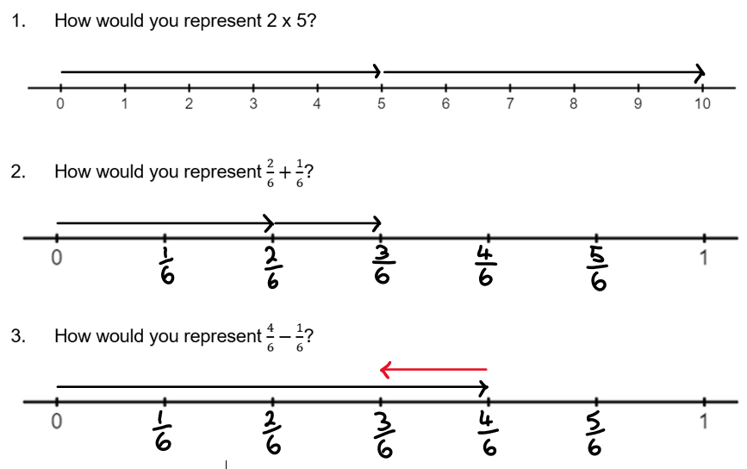

Independent practice
Represent each expression on the number line provided.
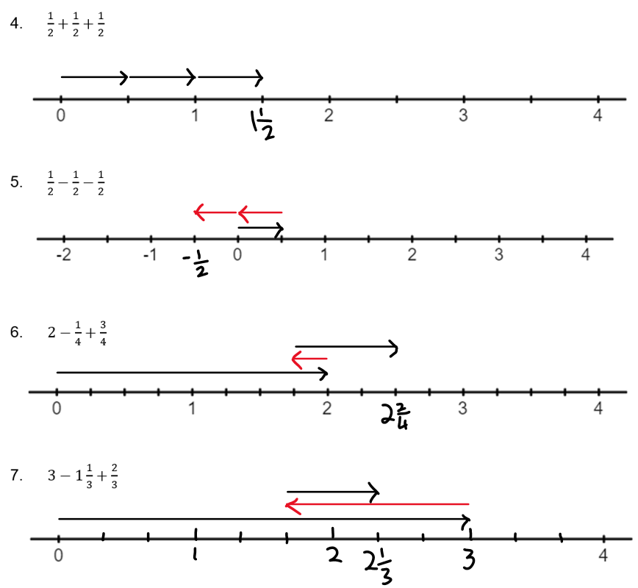

Reflection – addition with vectors problems
Write an ‘I can’ statement about what you can do now that you have completed this task | Date
I can represent fraction additions on a number line. | 25/10/2023

Explain how you completed the task, giving examples
I drew vectors, which are arrows, starting from 0 and going the distance of the first fraction. I added vectors to show more fractions and went to the left when a fraction was subtracted. In Question 3, which is $\frac{4}{6}-\frac{1}{6}$, I took 4 steps to the right, and then one to the left. This is because each step is one-sixth.

Describe what you found challenging in the task and anything you found helpful in overcoming those challenges
The hardest part was interpreting the scale, or sometimes even creating it, and then also working out what to do with whole numbers. Converting whole numbers to fractions with the same denominator as the other fractions in the question was sometimes a bit hard.

Describe what you learned from the task, such as something you know now that you didn’t know before
Fractions with the same denominator can be added because you just count how many steps you take. If they have different denominators, the fractions are a different size and can’t be counted in the same way.

Fractions of quantities – Part 2
- Write a statement about how you estimate a fraction of a quantity for each fraction listed in the table.
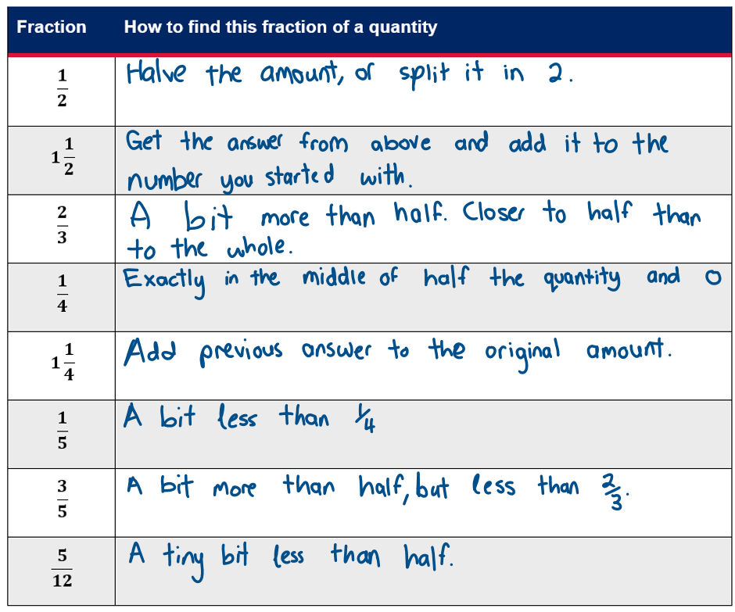
- Circle the fractions used in Part 1 that are less than 1 in the space below.
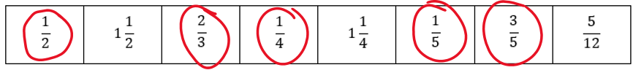
- What do you notice about the fractions that are less than 1, when you multiply them with a quantity?

Reflection – estimations
Write an ‘I can’ statement about what you can do now that you have completed this task | Date
I can estimate fractions of quantities. | 25/10/2023

Explain how you completed the task, giving examples
I used easy things like 0, 1, $\frac{1}{2}$ and $\frac{1}{4}$ to estimate fractions that are near these. I used the denominators to determine how close the fraction was to these known fractions. For example, $\frac{5}{12}$ is just $\frac{1}{12}$ less than one-half, whereas $\frac{1}{3}$ is $\frac{1}{6}$ less than half. So, when I find $\frac{5}{12}$ of 84 grams, I know that half of 84 grams is 42 grams, and that $\frac{5}{12}$ will be pretty close, maybe 35–40 grams. But $\frac{1}{3}$ is probably more like 25–30 grams, because it is further from half than $\frac{5}{12}$.

Describe what you found challenging in the task and anything you found helpful in overcoming those challenges
I found it hard to describe how to estimate. Sometimes fractions are close to one another, like $\frac{3}{5}$ is a bit larger than half, and so is $\frac{2}{3}$, but they aren’t the same. It’s hard to make the estimates different because they are both just a bit bigger than half. To overcome this, I tried to say which is bigger because then if I was estimating both of them, I’d make sure the larger one ends up bigger.

Describe what you learned from the task, such as something you know now that you didn’t know before
I found that if a fraction is more than 1, when we multiply by a quantity, the amount gets larger. If the fraction is less than 1, multiplying by a quantity gets smaller. This is because multiplying by 1 just gives us the starting quantity.

Sione

Algebra (MA4-ALG-C-01)

Grid algebra
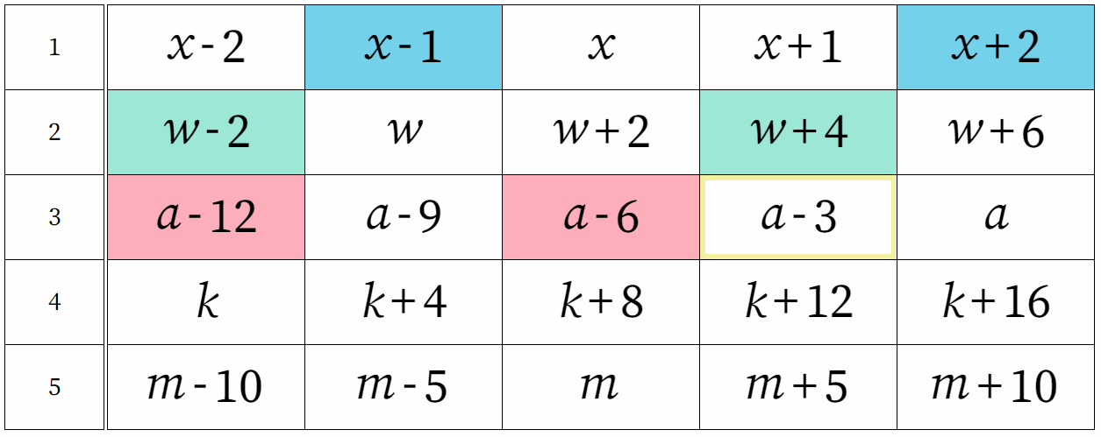
Image created using Grid Algebra.

Reflection – grid algebra
Write an ‘I can’ statement about what you can do now that you have completed this task | Date
I can complete a grid using algebra with both plus and minus. | 25/10/2023

Explain how you completed the task, giving examples
The grid started with just the letters $x$, $w$ and $a$. I had to drag the letters to the cells left and right of them to show what an expression would look like in a new cell. So $a$ is in row ‘3’ and that means it goes up by 3 each time. Moving $a$ 2 spots to the left means we take 3 away twice and get $a-6$. We then had to choose numbers for the variables, so for example, if I chose $a=10$, then $a-6$ would be $10-6=4$.

Describe what you found challenging in the task and anything you found helpful in overcoming those challenges
When dragging the cells across, if I clicked on the wrong cell, it would give me a long expression. For example, if I clicked on $a$ and then dragged it to the left, it became $a-3$. If I then clicked on $a-3$ and dragged it to the left, I know it is $a-6$, but it became $a-3-3$. To fix this, I always clicked on the pronumeral, $a$, $w$ and $x$ and dragged from there.

Describe what you learned from the task, such as something you know now that you didn’t know before
I can substitute any number for a pronumeral and get an answer.

Algebra pyramids
In the algebra pyramids below, 2 terms beside one another are multiplied to make the term above. Use the algebraic terms in the pyramids to fill in the blanks. The first one is an example to help you.
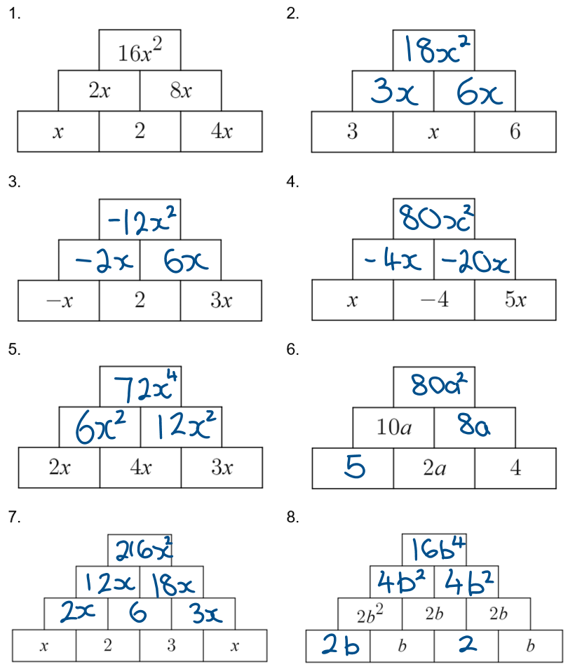

Reflection – algebra pyramids
Write an ‘I can’ statement about what you can do now that you have completed this task | Date
I can multiply algebraic terms. | 25/10/2023

Explain how you completed the task, giving examples
I took 2 terms that are listed beside one another and multiplied them to get the answer in the cell above. When multiplying, I multiplied the numbers together first, then combined the pronumerals. For example, in Question 7, at the top of the pyramid, I multiplied $12x$ by $18x$ by first multiplying $12$ by $18$ to get $216$, then I multiplied $x$ by $x$ to get $x^{2}$.

Describe what you found challenging in the task and anything you found helpful in overcoming those challenges
There were a couple of occasions where I had to work backwards and go down the pyramid. To do this, I had to think about what I multiply to get an answer. For example, in Question 8, I had to multiply something by $b$ to get $2b^{2}$ and I realised that what was missing was a $2$ and another $b$, so the answer I was looking for was $2b$.

Describe what you learned from the task, such as something you know now that you didn’t know before
When multiplying algebraic terms, multiply the numbers first and then combine the letters.

Sample grading annotations
The annotations below are examples of how the student work samples and reflections on pages 14–23 could be interpreted. They refer to the descriptions in the marking guidelines on pages 8–10.

Mary – fractions
The student is demonstrating an extensive knowledge of the content and is performing at an A-grade level in the outcome MA4-FRC-C-01. The student has consistently and accurately solved all problems in their work samples, including those involving multiple steps, such as Question 7 in their first work sample. They compare fractions based on their overall size and the effect of adding, subtracting and multiplying with them. The student has used vectors to represent fractions and accurately explained the relationship between this representation and concepts related to fractions, such as the role that each of the numerator and denominator play in the size of the number. They consistently use precise language to describe the features of fractions and the effects and results of operating with them, including terms such as ‘numerator’, ‘denominator’ and ‘vector’.

Sione – algebra
The student is demonstrating a sound knowledge of the content and is performing at a C-grade level in the outcome MA4-ALG-C-01. The student has solved most problems accurately, however, they have made some errors in their second work sample that they have not identified or fixed (Questions 5 and 8). They have also selected work samples that do not require more than 3 steps at any time. The student identifies the concept of pronumerals being used to represent unknown quantities. They do not acknowledge or explain any further concepts related to algebra, such as the need to use expressions to represent quantities in the grid in their first work sample owing to the unknown quantity, $a$. The student has used only abstract representations. They have demonstrated a sound understanding of what is represented. The student uses mostly appropriate mathematical language, including ‘pronumeral’, ‘variable’ and ‘term’. They do occasionally use more informal language, such as ‘letter’.

References
This resource contains NSW Curriculum and syllabus content. The NSW Curriculum is developed by the NSW Education Standards Authority. This content is prepared by NESA for and on behalf of the Crown in right of the State of New South Wales. The material is protected by Crown copyright.
Please refer to the NESA Copyright Disclaimer for more information https://educationstandards.nsw.edu.au/wps/portal/nesa/mini-footer/copyright.
NESA holds the only official and up-to-date versions of the NSW Curriculum and syllabus documents. Please visit the NSW Education Standards Authority (NESA) website https://educationstandards.nsw.edu.au/ and the NSW Curriculum website https://curriculum.nsw.edu.au.
Mathematics K–10 Syllabus © NSW Education Standards Authority (NESA) for and on behalf of the Crown in right of the State of New South Wales, 2022.

© State of New South Wales (Department of Education), 2023
The copyright material published in this resource is subject to the Copyright Act 1968 (Cth) and is owned by the NSW Department of Education or, where indicated, by a party other than the NSW Department of Education (third-party material).
Copyright material available in this resource and owned by the NSW Department of Education is licensed under a Creative Commons Attribution 4.0 International (CC BY 4.0) license.
This license allows you to share and adapt the material for any purpose, even commercially.
Attribution should be given to © State of New South Wales (Department of Education), 2023.
Material in this resource not available under a Creative Commons license:
- the NSW Department of Education logo, other logos and trademark-protected material
- material owned by a third party that has been reproduced with permission. You will need to obtain permission from the third party to reuse its material.
Links to third-party material and websites
Please note that the provided (reading/viewing material/list/links/texts) are a suggestion only and implies no endorsement, by the New South Wales Department of Education, of any author, publisher, or book title. School principals and teachers are best placed to assess the suitability of resources that would complement the curriculum and reflect the needs and interests of their students.
If you use the links provided in this document to access a third-party's website, you acknowledge that the terms of use, including licence terms set out on the third-party's website apply to the use which may be made of the materials on that third-party website or where permitted by the Copyright Act 1968 (Cth). The department accepts no responsibility for content on third-party websites.

