Uncovering shape secrets
Students use the concept of perimeter to delve into solving equations involving 2 steps using bar models.

Visible learning

Learning intention
- To be able to solve equations.

Success criteria
- I can explain the difference between an expression and an equation.
- I can solve equations involving 2 steps.
- I can represent the perimeter of a shape as an equation.

Syllabus outcomes
A student:
- develops understanding and fluency in mathematics through exploring and connecting mathematical concepts, choosing and applying mathematical techniques to solve problems, and communicating their thinking and reasoning coherently and clearly MAO-WM-01
- applies knowledge of the perimeter of plane shapes and the circumference of circles to solve problems MA4-LEN-C-01
- solves linear equations of up to 2 steps and quadratic equations of the form $ax^{2}=c$
MA4-EQU-C-01
Mathematics K–10 Syllabus © NSW Education Standards Authority (NESA) for and on behalf of the Crown in right of the State of New South Wales, 2022.

Activity structure
Please use the associated PowerPoint Uncovering shape secrets to display images in this lesson.

Launch
- Assign students into visibly random groups of 3 (bit.ly/visiblegroups) and have them move to a vertical non-permanent surface (bit.ly/VNPSstrategy).
- Inform students that we will be looking at a rectangle where the length is 3 centimetres longer than the width.
- Display slide 2 from the PowerPoint Uncovering shape secrets. This shows the rectangle from Figure 1, where students are prompted to find the missing value $w$, the width of the rectangle, if we know the perimeter is 66 units.
Figure 1 – a rectangle with a length that is 3 centimetres longer than its width
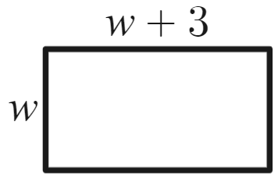
Image created using Desmos and is licensed under the Desmos Terms of Service.
The aim of this activity is not for students to find the correct answer but to explore strategies on how to approach it.
- Ask students assessing and advancing questions to further student thinking.
Assessing questions draw out students’ thinking about a problem and what methods they have tried so far.
Advancing questions are intended to help move students’ thinking forward toward the lesson goals. We want to draw their attention to something they may not have noticed or considered yet.
Question suggestions are included below. Students can be prompted using these assessing and advancing questions to help guide their thinking.
Table 1 – assessing and advancing questions
Assessing questions | Advancing questions
Can you explain the question to me? | Can you put some values in for w to see what the solution is?
What have you tried? | How could you verify your solution?
What does $w+3$ represent? | How do you find the perimeter of a shape?
- In a class discussion, ask students what they found easy and difficult about this problem.
- State to students that they were attempting to solve an equation. Explain the importance of being able to solve equations.
It is important to be able to solve equations as it is one of the most prevalent problem-solving skills we have and appears, not always obviously, in real life. It is important to be able to effectively communicate solution strategies in mathematics, and giving students a way to communicate mathematically allows students to reason and show understanding of problems.

Explore
- Display slide 3 from the PowerPoint Uncovering shape secrets. This slide shows Kyran’s approach to solving the problem using guess and refine.
- Explain to students that Kyran was evaluating an expression to try and find his solution.
- Ask students to continue his method to get closer to the solution.
- Display slide 4 from the PowerPoint Uncovering shape secrets. This slide shows Alex’s approach to solving the problem using the simplified equation formed from the perimeter of the rectangle.
- In a Think-Pair-Share (bit.ly/thinkpairsharestrategy), students should discuss the following:
- Where did Alex get the perimeter expression from?
- What would Alex’s next step be to find the answer?
- What are the advantages and disadvantages of Kyran and Alex’s approaches?
- State to students that we will be exploring Alex’s approach, which was the simplified equation. Before we can work with this, we need to establish what an equation is.
- Display slide 5 from the PowerPoint Uncovering shape secrets. This slide shows examples of expressions and equations side by side.
- In a Think-Pair-Share, ask students what they think is the difference between an expression and an equation.
An expression is 2 or more numbers or variables connected by operations. Expressions do not include an equal sign.
An equation is a statement that includes the ‘=’ symbol. Equations are used to show the equality of 2 expressions.
- Acknowledge to students that the situation in the Launch activity became an equation when we were told the total perimeter was 66. This gave us a need to include the ‘=’ symbol.
- Display Figure 2, available on slide 6 of the PowerPoint Uncovering shape secrets, showing bars representing the lengths on each of the sides of the rectangle.
Figure 2 – rectangle with bars shown on edges
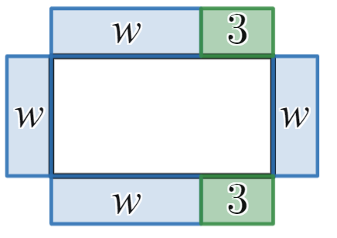
Image created using Desmos and is licensed under the Desmos Terms of Service.
Students were introduced to bar models to solve one-step equations in Lesson 3 – I see triangles of Unit 6 – triangles and quadrilaterals.
- Display Figure 3, available on slide 7 of the PowerPoint Uncovering shape secrets, showing a bar model representation of the equation for the original rectangle.
Figure 3 – bar model representing an equation
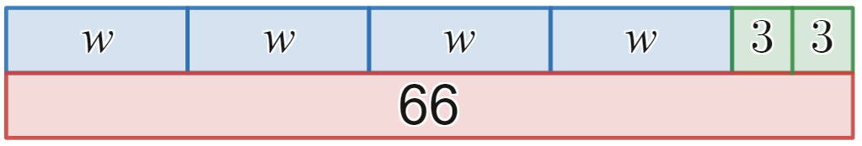
Image created using Desmos and is licensed under the Desmos Terms of Service.
- In a Think-Pair-Share, ask students the following questions:
- What are the similarities and differences between the 3 representations?
- What parts of each representation do you think are connected?
- What do the bars represent?
- Does the length of the unknown matter?
- What is used to represent the equal sign?
- Display slide 8 of the PowerPoint Uncovering shape secrets, showing 3 different versions of the bar model representation of the equation for the original rectangle. Ask students to identify similarities and differences between the 3 models.
- Distribute Appendix A ‘Match them up’ to each pair of students. Ask students to match the algebraic equations with their bar model representation.
- In a class discussion, ask students to explain how the diagrams relate to the equations and if they would change them in any way.
To help with solving equations, students may suggest putting the bars labelled with x together, or students could suggest moving things around, so the pronumerals and numbers are together.

Bar models
This lesson can be modified to use Algebra tiles in place of bar models. An example of solving equations with Algebra tiles on Polypad (https://mathigon.org/polypad) can be seen in the video ‘Solving a 2-step equation with Polypad’ (https://bit.ly/EquationPolypad).
- Using the bar models from slide 8 of the PowerPoint Uncovering shape secrets, students are to try to find the solution using the bar model.
For students who have already found the answer to the Launch problem, given them a similar equation to solve.
- Show slide 9 from the PowerPoint Uncovering shape secrets. This slide shows students an equation being solved using bar models. Ask students what they notice/wonder.
- Initiate a Pose-Pause-Pounce-Bounce question strategy (PDF 557KB) (bit.ly/posepausepouncebounce), to share student’s understanding of solving equations using bar models.
- By working in different visibly random groups of 3 on vertical non-permanent surfaces, students are to return to Appendix A ‘Match it up’ and solve the equations using the bar models.
These solutions will be used again so ensure students have adequate space to solve all equations or document their solutions elsewhere before erasing.
- Walk around the room and look at student work. Join groups together that have produced different solutions to the same problem and state ‘At least one of you is incorrect.’ Leave the groups to debate and justify the correct answer.
- Ask students to discuss in their groups, what is common about the order of the steps students used to solve the bar models, and to think why they may have done that.
Students could make the connection that this is the reverse of the order of operations. Using prompting questions such as, ‘Is there another mathematical concept we have learnt where you must go in a specific order?’ could help students make the connection.
- Conduct a class discussion to share thoughts on the order to solve equations and why.
- Ask students how they could tell if they have the right solution.
The purpose of this question is for students to realise that by substituting their answer into the variables, the equation should still be true.
- Students are to return to their boards and check their solutions.

Summarise
- Introduce the term inverse operation: The operation that reverses the effect of another operation. Use examples from their work to clarify its meaning.
- Use slides 10–17 from the PowerPoint Uncovering shape secrets for the explicit teaching of solving equations with 2 steps.
The explicit teaching technique used in the PowerPoint is ‘Your turn’. The first slide is a worked example which should be displayed for the students before using the following steps.
- Reveal the question to students and its solution.
- Students read in silence.
- Students individually explain to themselves what is happening in each step.
- Students hold a thumbs up to the teacher when they have finished reading and have some sort of understanding.
- Think-Pair-Share. Students explain the solution to their partner.
- In pairs, students then answer the self-explanation questions.
- Finally, randomly select students to share their answers with the whole class.
- Have students return to their problems on their vertical non-permanent surfaces and see if they can change their bar models from Appendix A into algebraic representations to communicate their thinking.
- As a class, ask groups to discuss how they connected to the algebraic representation. Challenge them to use the terminology inverse and variable when explaining their answer.
- Individually, students are to attempt the Open Middle problem ‘Two-step equations 3’ (https://www.openmiddle.com/two-step-equations-3/) to find the largest and smallest possible solutions using the numbers 1 to 9 to fill the boxes.
- By selecting random students, discuss the solution students found and the strategies they used to get to the solution they found.

Apply

Puzzling perimeters
This activity uses the concepts of simplifying expressions and solving equations for the perimeter of varying shapes.
- Issue each student a copy of Appendix B ‘Puzzling perimeters’.
- By working in visibly random groups of 3 on vertical non-permanent surfaces, ask students to solve the problems in any order.
- Invite a student from each group to share their solution to a problem, explaining their method and justifying their answer.

Worded problems
In this activity, students are to translate and solve worded problems involving the perimeter of quadrilaterals and triangles.
- Issue each student a copy of Appendix C ‘Worded problems’.
- By working in visibly random groups of 3 on vertical non-permanent surfaces, ask students to solve the problems in any order.
- Invite a student from each group to share their solution to a problem, explaining their method and justifying their answer.

Perimeter challenge
Activity adapted from the NRICH activity ‘Perimeter challenge’ (https://nrich.maths.org/11119). Sample solutions to this problem can be found on the site.
- In new visibly random groups of 3 at non-permanent surfaces Distribute Appendix D ‘Perimeter challenge’. The sheet displays the following diagram.
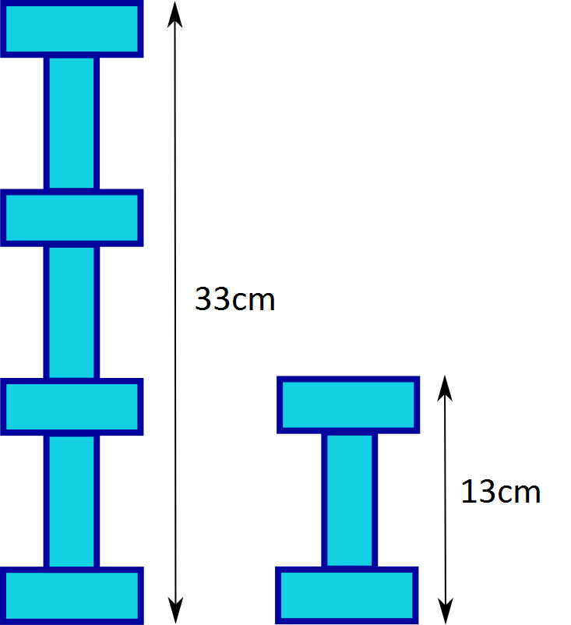
- State that all the rectangles are identical and ask students to find the dimensions.
- Walk around the room and circle student work that shows different approaches to solving the equations. Join groups together that have produced different solutions to the same problem and state ‘At least one of you is incorrect.’ Leave the students to debate which answer is correct and to justify their reasoning.
- Initiate the sharing of solutions by highlighting at least one thing done well in the approach of each group in the class.
When sharing student solutions, it is best to start with the most basic solution and then increase in complexity. You do not need to highlight the entire solution, rather mathematical strategies that work towards a solution.

Assessment and differentiation

Suggested opportunities for differentiation
Launch
- Students may benefit from first simplifying algebraic expressions to check student understanding of like terms.
Explore
- If students find it difficult to add numbers mentally, they can be allowed to use a calculator.
- Visual representations, like bar models, are used to assist students with their understanding of solving equations.
Summarise
- Open middle problems enable students to use the guess and refine method to approach problems, that allows an access point for all students. For those still not confident, have them focus on one type of equation at a time.
Apply
- To enable students who are not confident in simplifying using like terms, give the equations to students to match to each shape in Appendix B.
- Ask students to draw diagrams for Appendix C and then compare as a whole class before solving the problems.
- Asks students to make their own worded problem in Appendix C.

Suggested opportunities for assessment
Explore
- Check student understanding of substitution by monitoring responses from students to Kyran’s approach.
- Monitor responses in class discussions to check for student understanding of solving equations using bar models.
Summarise
- Monitor student responses in the ‘Your turn’ section to check for understanding.
- Students will demonstrate their working mathematically skills in discussions and justifications when completing the open middle problem.
- Create an exit ticket where students need to choose 2 equations they have solved from the open middle problem that best show their progress.
Apply
- Appendix B could be collected and used as summative assessment for this unit of learning.

Appendix A

Match them up
$$2x+5=17$$ | $$2x-5=17$$
$$17=2x+5$$ | $$17-2x=5$$
$$2x+5=57$$ | 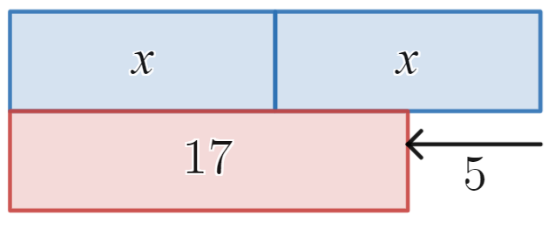
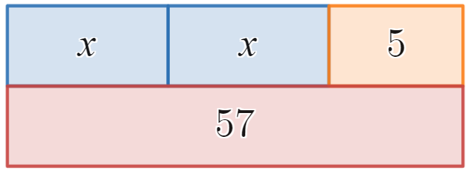 | 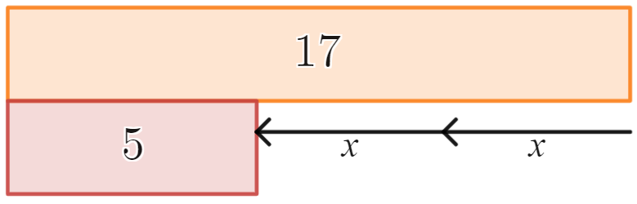
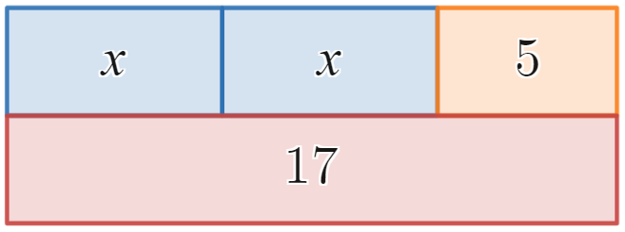 | 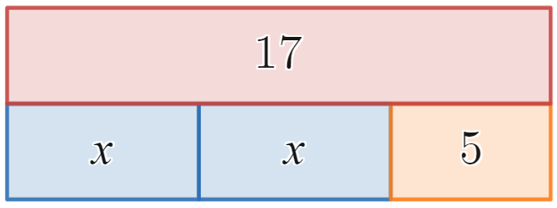
Images created using Desmos and is licensed under the Desmos Terms of Service.

Appendix B

Puzzling perimeters
- Find the value of $k$ if the perimeter of the rectangle is equal to 55 units.
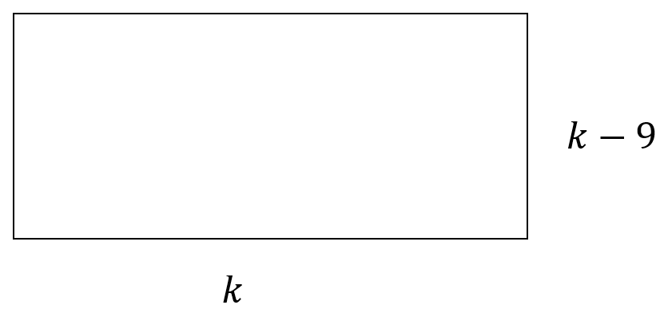
- Find the value of $m$ if the perimeter of the rectangle is equal to 64 units.
- Find the value of $d$ if the perimeter of the triangle is equal to 22 units.
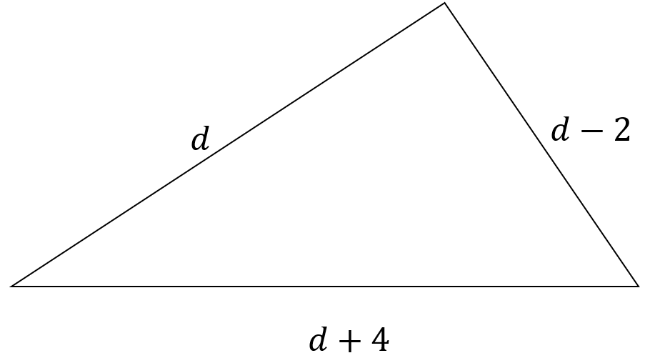
- Find the value of $t$ if the perimeter of the pentagon is equal to 37 units.
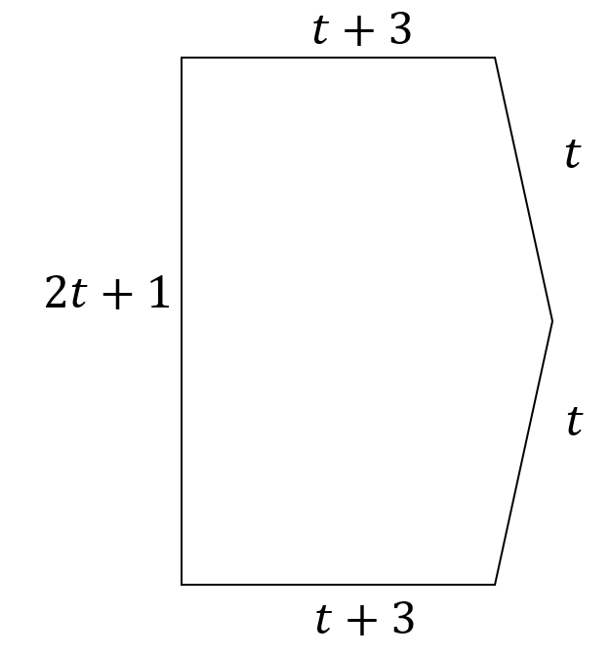
- Find the value of $n$ if the perimeter of the pentagon is equal to 471 units.
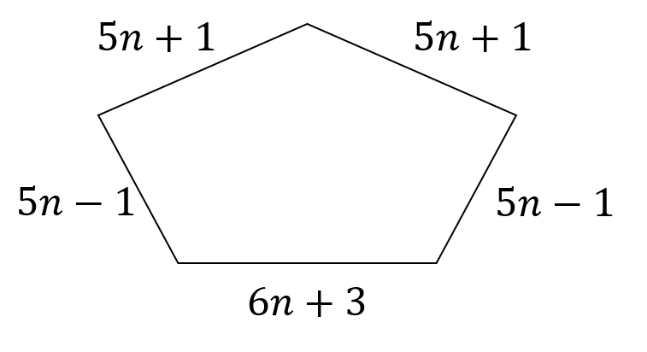
- Find the value of $w$ if the perimeter of the shape is equal to 288 units.
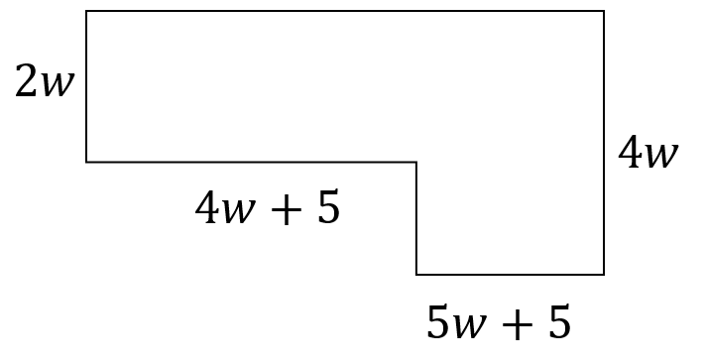

Appendix C

Worded problems
- A square and equilateral triangle have the same perimeter. If the length of one side of the triangle is 4 units, find the side length of the square.
- The length of a rectangle is 3 times as long as its width. Find the length and width of the rectangle if the perimeter is 56 units.
- A kite has a perimeter of 2688mm. Its longer sides are 10% longer than the shorter sides. Find the length in millimetres of one of the shorter sides.
- The lengths of adjacent sides of a parallelogram are consecutive numbers. If the perimeter is 42 units find the length of the longest side of the parallelogram. Hint: you may need to ask your teacher what the words adjacent and consecutive mean.
- The length of a rectangle is 2 cm less than 7 times its width. The perimeter is 60 cm. What are the dimensions of the rectangle?
- The first side of a triangle is 8 cm shorter than the second side. The third side is 4 times larger than the second side. The perimeter is 52 cm. What are the lengths of the triangle?

Appendix D

Perimeter challenge
Given all the rectangles are identical, find the dimensions of a rectangle.

Sample solutions

Appendix A – match them up
Equation | Bar model | Solution
$$2x+5=17$$ |  | $$x=6$$
$$17=2x+5$$ |  | $$x=6$$
$$2x-5=17$$ |  | $$x=11$$
$$2x+5=57$$ |  | $$x=26$$
$$17-2x=5$$ |  | $$x=6$$
Images created using Desmos and is licensed under the Desmos Terms of Service.

Appendix B – puzzling perimeters
- $4k-18=55$
$$4k=73$$$k=18.25$ units
- $80-2m=64$$$-2m=-16 \\ m=8$$
- $3d+2=22$$$3d=20$$$d=6\frac{2}{3}$ units
- $6t+7=37$
$$6t=30$$$t=5$ units
- $26n+3=471$
$$26n=468$$$n=18$ units
- $26w+20=288$
$$26w=268$$$w=10\frac{4}{13}$ units

Appendix C – worded problems
- Side lengths of the square are 3 units.
- Width = 7 units
Length = 21 units
- $4.2x=2688x=640$mm
- $4x+2=42$
$$4x=40 \\ x=10$$Longer side is 11 units.
- $16x-4=60$$$16x=64$$$x=4$cm
- $6x-8=52$$$6x=60$$$x=10$cm
First side = $x-8=2 \text{cm}$
Second side = $x=10 \text{cm}$
Third side = $4x=40 \text{cm}$

References
This resource contains NSW Curriculum and syllabus content. The NSW Curriculum is developed by the NSW Education Standards Authority. This content is prepared by NESA for and on behalf of the Crown in right of the State of New South Wales. The material is protected by Crown copyright.
Please refer to the NESA Copyright Disclaimer for more information https://educationstandards.nsw.edu.au/wps/portal/nesa/mini-footer/copyright.
NESA holds the only official and up-to-date versions of the NSW Curriculum and syllabus documents. Please visit the NSW Education Standards Authority (NESA) website https://educationstandards.nsw.edu.au and the NSW Curriculum website https://curriculum.nsw.edu.au.
Mathematics K–10 Syllabus © NSW Education Standards Authority (NESA) for and on behalf of the Crown in right of the State of New South Wales, 2022.

© State of New South Wales (Department of Education), 2024
The copyright material published in this resource is subject to the Copyright Act 1968 (Cth) and is owned by the NSW Department of Education or, where indicated, by a party other than the NSW Department of Education (third-party material).
Copyright material available in this resource and owned by the NSW Department of Education is licensed under a Creative Commons Attribution 4.0 International (CC BY 4.0) license.
This license allows you to share and adapt the material for any purpose, even commercially.
Attribution should be given to © State of New South Wales (Department of Education), 2024.
Material in this resource not available under a Creative Commons license:
- the NSW Department of Education logo, other logos and trademark-protected material
- material owned by a third party that has been reproduced with permission. You will need to obtain permission from the third party to reuse its material.
Links to third-party material and websites
Please note that the provided (reading/viewing material/list/links/texts) are a suggestion only and implies no endorsement, by the New South Wales Department of Education, of any author, publisher, or book title. School principals and teachers are best placed to assess the suitability of resources that would complement the curriculum and reflect the needs and interests of their students.
If you use the links provided in this document to access a third-party's website, you acknowledge that the terms of use, including licence terms set out on the third-party's website apply to the use which may be made of the materials on that third-party website or where permitted by the Copyright Act 1968 (Cth). The department accepts no responsibility for content on third-party websites.

