Which way is up?
Students will use their understanding of how to find the area of a rectangle to develop a formula and use it to solve problems. Students will consider the language we use when describing the dimensions of a rectangle.

Visible learning

Learning intention
- To develop the formula for the area of a rectangle.

Success criteria
- I can explain how the formula for the area of a rectangle is obtained.
- I can use various terms to describe the dimensions of a rectangle.
- I can correctly substitute values into the formula for the area of a rectangle.
- I can solve equations involving the area of a rectangle.

Syllabus outcomes
A student:
- develops understanding and fluency in mathematics through exploring and connecting mathematical concepts, choosing and applying mathematical techniques to solve problems, and communicating their thinking and reasoning coherently and clearly
MAO-WM-01
- applies knowledge of area and composite area involving triangles, quadrilaterals and circles to solve problems MA4-ARE-C-01
Mathematics K–10 Syllabus © NSW Education Standards Authority (NESA) for and on behalf of the Crown in right of the State of New South Wales, 2022.

Activity structure
The PowerPoint Which way is up accompanies this lesson.

Launch

Blockout
This activity is an extension of the activity Blockout included in Unit 5 Multiplicative thinking in Lesson 3 ‘Area models and divisibility tests’ which was modified from the ‘Maths for love’ website (bit.ly/MFLBlockout). In this lesson, students will use a larger grid and 10-sided dice.

Equipment
- Two 10-sided dice per group of students. Virtual dice are available on Polypad (mathigon.org/polypad)
- Different coloured highlighter pens per group of students
- One copy of Appendix A ‘Blockout gameboard’ per group

Method
- Players are to choose colours, then take turns rolling the dice and shading in a rectangle. If a player rolls a 4 and a 7, they can shade in 28 squares, either a 4 by 7 rectangle, or 2 by 14. They cannot shade a 1 by 28 rectangle as the grid is not large enough. The example, shown in Figure 1 below, is available on slide 2 of the Which way is up PowerPoint.
Figure 1 – a roll of 4 and 7
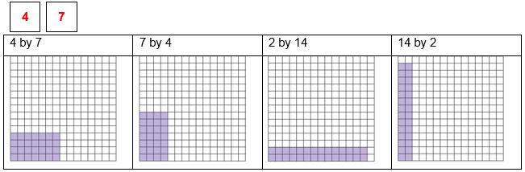
- Players can place their rectangle anywhere in the grid on the gameboard.
- No player can shade a square that is already shaded.
- If a player cannot take their turn, they must pass. An example of a player that cannot take their turn is shown below in Figure 2, also available on slide 3 of the Which way is up PowerPoint.
Figure 2 – a roll that cannot be played
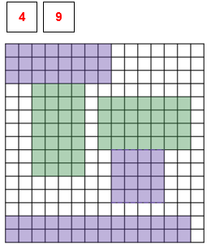
- If each player passes twice in a row, the game ends.
- At the end of the game, players count the number of squares shaded in their colour. The winner is the player with the highest number of squares shaded.
Alternatively, students can play collaboratively, where the aim is to fill as many squares as possible as a team.

Explore
- Enlarge Appendix B Finding Areas onto A3 paper and slip into a plastic pocket, before placing them on walls around the room.
- By working in visibly random groups of 3 (bit.ly/visiblegroups) at the A3 plastic sheets (bit.ly/VNPSstrategy), students will find the area of each rectangle and record their strategy for finding each area.
The rectangles increase in length, with the base dimension consistent at 5 units. The difficulty of the situation increases as the rectangles increase in size, the grid is removed and then dimensions begin to include decimals. The aim is for this to necessitate students moving away from counting squares to more efficient methods.
- Use the Pose-Pause-Pounce-Bounce question strategy (PDF 557 KB) (bit.ly/posepausepouncebounce) to share the strategies that groups used to find the area.
- As students share their strategies, make a list on the board of the terms they use to describe the dimensions of a rectangle.
- Discuss the different terms used and brainstorm as a class, other words that are sometimes used to describe the dimensions of a rectangle. Add these new terms to the list on the board.
Teachers should add, if necessary, the following 5 terms: length, width, breadth, height and base.
Note that a discussion may be useful regarding the word ‘breadth’. The word breadth is derived from the word ‘broad’. To measure how broad something is, we measure the breadth.
- Display Figure 3 for students, which is also available on slide 6 of the Which way is up PowerPoint.
Figure 3 – labelling sides of a rectangle
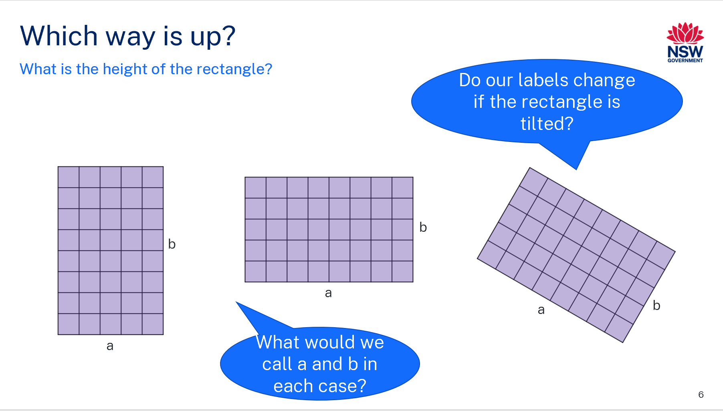
- Out of the terms that the class brainstormed (and using others if they can now think of more), instruct students to consider in a Think-Pair-Share (bit.ly/thinkpairsharestrategy) which terms we would use to describe sides a and b in each rectangle.
Pairs should consider the following questions:
- Is the length always the longest side?
- If a rectangle is tilted at ${45}^{o}$, which side is the length?
- As the rectangle is tilted more, do the labels ‘length’ and ‘breadth’, for example, change?
Students could be giving reasons which include that the length is always the longest side, the width and breadth are always the same side, the height is always vertical, or the base is always horizontal.
Students should recognise that the dimensions of the rectangle may be called different things and that both of the dimensions may be called the same thing.
Fun fact: the length is always measured along the grain of a piece of timber, even if it is not the longest side.
- Have students verbalise a rule for finding the area of a rectangle using correct terminology.
Students should be able to recognise that although they may use different language, the process is still the same.

Summarise
The formula $A=lb$ is used in the syllabus.
- Display slide 7 of the Which way is up PowerPoint.
- Discuss with the class:
- Could the formula be written as $A=bl$?
- What does $lb$ mean?
- How could we write the formula for the area of a square?
- Use slides 8–11 from the Which way is up PowerPoint for explicit teaching of the formula for the area of a rectangle.
The explicit teaching technique used in the PowerPoint is ‘Your turn’. The first slide is a worked example which should be displayed for the students before using the following steps.
- Reveal the question to students and its solution.
- Students read in silence.
- Students individually explain to themselves what is happening in each step.
- Students hold a thumbs up to the teacher when they have finished reading and have some sort of understanding.
- Think-Pair-Share. Students explain the solution to their partner.
- In pairs, students then answer the self-explanation questions.
- Finally, randomly select students to share their answers with the whole class.
- Have students individually complete Appendix C, ‘Does the rule work?’

Apply
- During this section, students will work in visibly random groups of 3 (bit.ly/visiblegroups) on vertical non-permanent surfaces (bit.ly/VNPSstrategy) answering questions from Appendix D ‘Area maze’.
- Provide groups with a copy of one question at a time. Allow them to compare and justify answers with other groups and to ‘steal’ questions from other groups when they have finished a question.
Students can be asked ‘Would you bet $100 on your answer?’ to assist them to justify how they know their answer is correct.
Groups with differing answers can also be placed together and asked to explain and justify their reasoning to each other.
More area mazes can be found on the Transum website (bit.ly/areamazes).

Assessment and differentiation

Suggested opportunities for differentiation
Launch
- To enable students to participate, use a smaller grid and 6-sided dice.
- To challenge students, use the larger grid and 10-sided dice which includes a 0 or a 12-sided die with a 10-sided die.
Explore
- There are many strategies students could use to find the area of the rectangles. Teachers could support students by encouraging them to continue to utilise a grid drawn over the top of rectangles.
- There are many correct terms that can be used to describe the dimensions of a rectangle, so all students should feel they can participate in the discussion.
Summarise
- Students requiring support can continue to utilise a grid drawn over the top of rectangles to find the area.
- Students can continue to use their own strategies or terminology for finding the area of a rectangle.
- Bar models will help to support students when working backwards from the area to find the length of a side.
Apply
- To support students, add numbered circles to show students what values need to be calculated before they can find the required value in the area maze.
- Extend students by encouraging them to write equations which could be used to solve the area mazes.
- To challenge students, guide them to the Transum website, where they can find more challenging area mazes.
- Challenge students to make their own area maze and consider the least amount of information needed to solve it.

Suggested opportunities for assessment
Launch
- Monitor that students know how to construct a rectangle with specific dimensions.
Explore
- Monitor responses in class and group discussions to check for student understanding that the labels of the dimensions are interchangeable.
- Check that students are able to formulate an appropriate rule to find the area of a rectangle.
Summarise
- Collect Appendix C to check for understanding.
Apply
- Monitor discussions and levels of participation of students whilst working in groups at the VNPS. Provide support where necessary.

Appendix A

Blockout gameboard

Appendix B

Finding areas
Find the area of each rectangle, explaining the strategy you used to find the area.
Rectangle | Area | Strategy used to find area
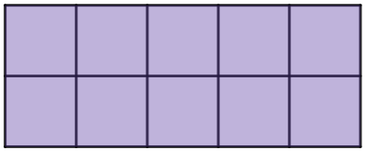

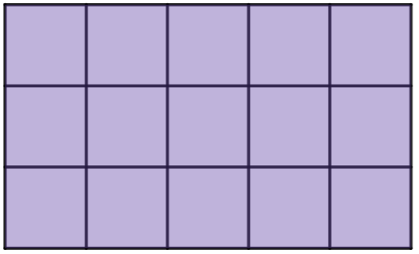

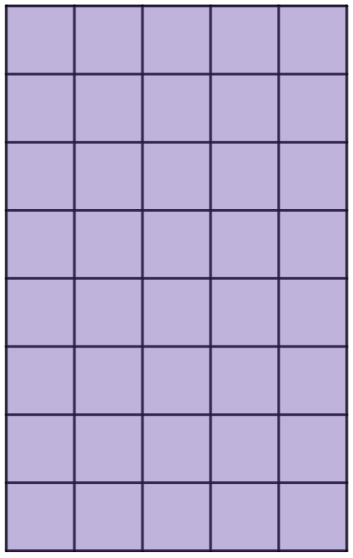

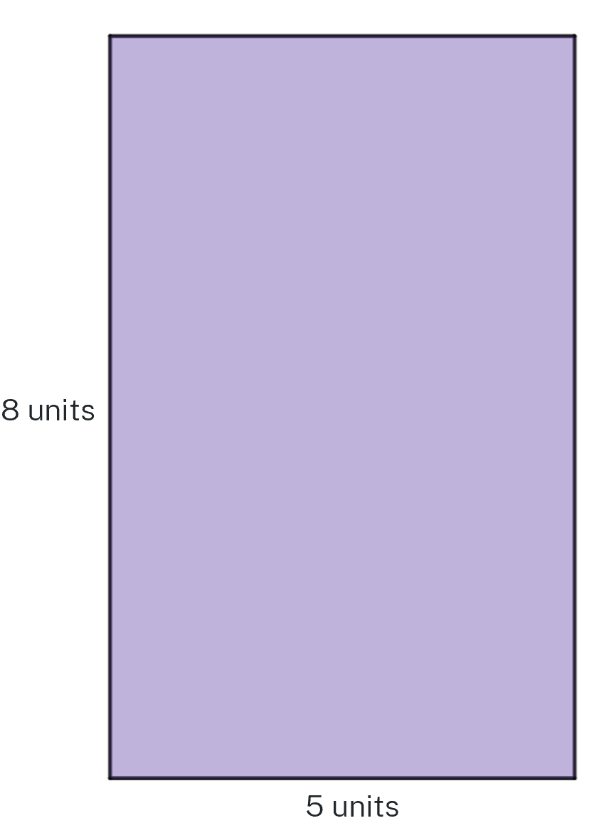
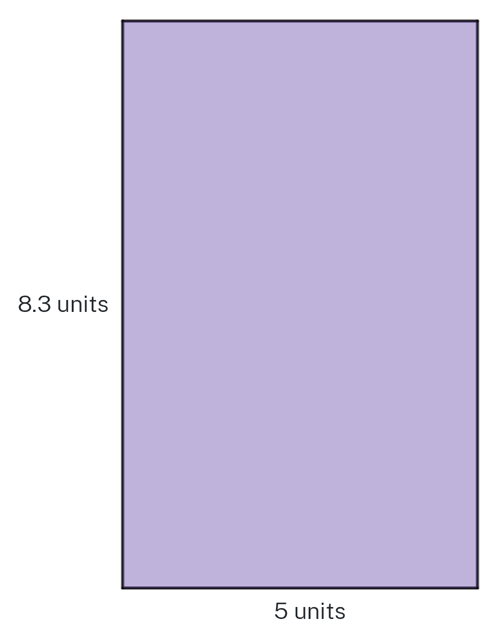

Appendix C

Does the rule work?
Write your rule for finding the area of a rectangle at the top of the writing space. Then, use your rule to find the area of each rectangle.

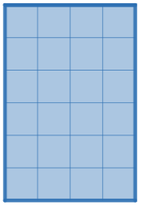

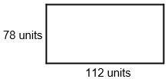

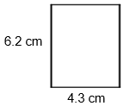

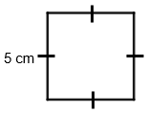
- A rectangular driveway is being re-surfaced. The contractor needs to calculate the area of the driveway to order materials. The driveway is 3.1 metres by 5.2 metres. What is the area of the driveway?

Appendix D

Area maze
Find the value of the question marks in the following diagrams.
All the shapes are rectangles but are not drawn to scale.
Your working should only contain whole numbers.
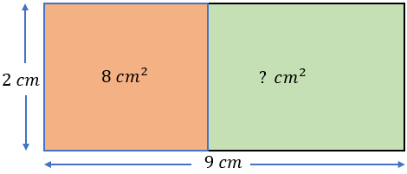
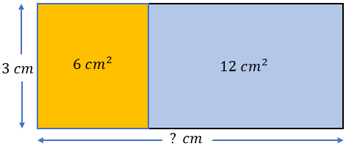
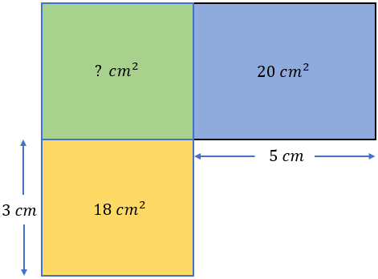
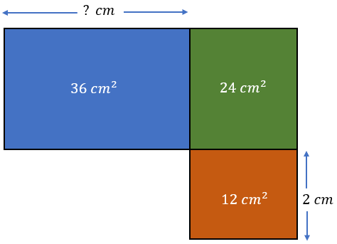
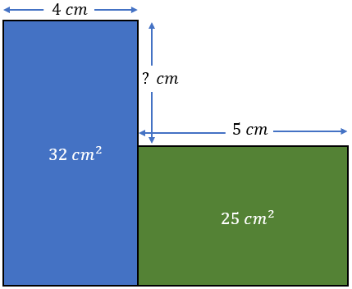
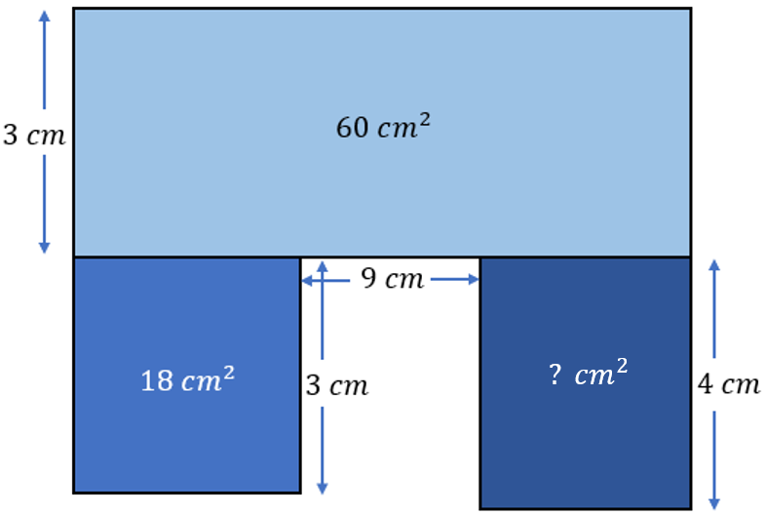
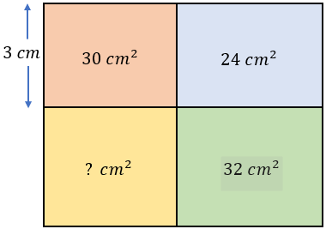
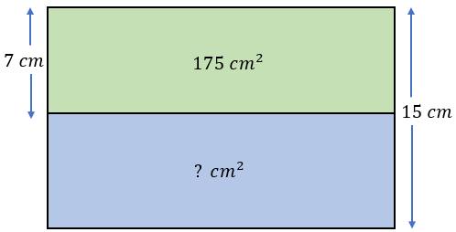
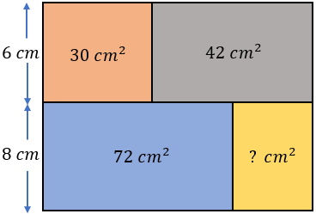
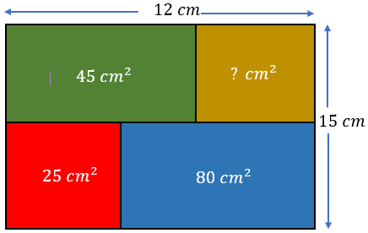
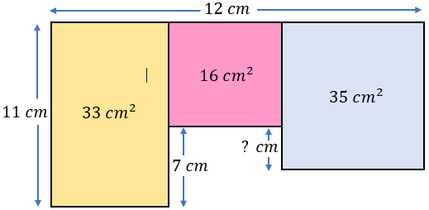
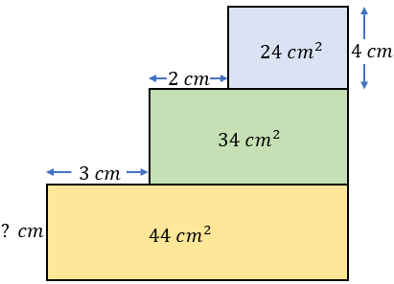
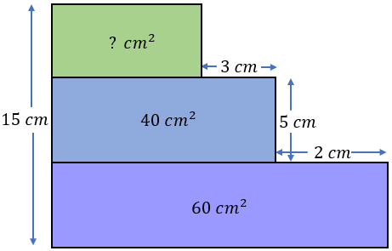
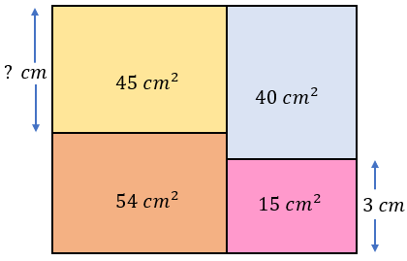
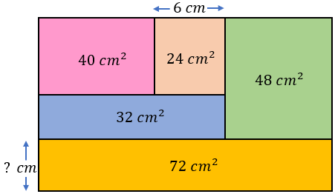

Sample solutions

Appendix C – Does the rule work?
- $24 squares$
- $132 {units}^{2}$
- $8736 {units}^{2}$
- $26.66 {cm}^{2}$
- $25 {cm}^{2}$
- $16.12 m^{2}$

Appendix D – area maze
- 10
- 6
- 24
- 9
- 3
- 20
- 40
- 200
- 24
- 30
- 3
- 4
- 20
- 5
- 3

References
This resource contains NSW Curriculum and syllabus content. The NSW Curriculum is developed by the NSW Education Standards Authority. This content is prepared by NESA for and on behalf of the Crown in right of the State of New South Wales. The material is protected by Crown copyright.
Please refer to the NESA Copyright Disclaimer for more information https://educationstandards.nsw.edu.au/wps/portal/nesa/mini-footer/copyright.
NESA holds the only official and up-to-date versions of the NSW Curriculum and syllabus documents. Please visit the NSW Education Standards Authority (NESA) website https://educationstandards.nsw.edu.au and the NSW Curriculum website https://curriculum.nsw.edu.au.
Mathematics K–10 Syllabus © NSW Education Standards Authority (NESA) for and on behalf of the Crown in right of the State of New South Wales, 2022.

© State of New South Wales (Department of Education), 2024
The copyright material published in this resource is subject to the Copyright Act 1968 (Cth) and is owned by the NSW Department of Education or, where indicated, by a party other than the NSW Department of Education (third-party material).
Copyright material available in this resource and owned by the NSW Department of Education is licensed under a Creative Commons Attribution 4.0 International (CC BY 4.0) license.
This license allows you to share and adapt the material for any purpose, even commercially.
Attribution should be given to © State of New South Wales (Department of Education), 2024.
Material in this resource not available under a Creative Commons license:
- the NSW Department of Education logo, other logos and trademark-protected material
- material owned by a third party that has been reproduced with permission. You will need to obtain permission from the third party to reuse its material.
Links to third-party material and websites
Please note that the provided (reading/viewing material/list/links/texts) are a suggestion only and implies no endorsement, by the New South Wales Department of Education, of any author, publisher, or book title. School principals and teachers are best placed to assess the suitability of resources that would complement the curriculum and reflect the needs and interests of their students.
If you use the links provided in this document to access a third-party's website, you acknowledge that the terms of use, including licence terms set out on the third-party's website apply to the use which may be made of the materials on that third-party website or where permitted by the Copyright Act 1968 (Cth). The department accepts no responsibility for content on third-party websites.

