A slant on solar energy
Students practise fitting rectangular and parallelogram-shaped solar panels onto various roof shapes and learn about the area of a parallelogram by considering the amount of solar energy absorbed.

Visible learning

Learning intentions
- To understand the relationship between the area of a parallelogram and related rectangles.
- To be able to calculate the area of a parallelogram.

Success criteria
- I can explain how the area of a parallelogram relates to rectangles.
- I can identify the base and height of a parallelogram.
- I can use the formula for the area of a parallelogram to solve problems.

Syllabus outcomes
A student:
- develops understanding and fluency in mathematics through exploring and connecting mathematical concepts, choosing and applying mathematical techniques to solve problems, and communicating their thinking and reasoning coherently and clearly MAO-WM-01
- applies knowledge of area and composite area involving triangles, quadrilaterals and circles to solve problems MA4-ARE-C-01
Mathematics K–10 Syllabus © NSW Education Standards Authority (NESA) for and on behalf of the Crown in right of the State of New South Wales, 2022.

Activity structure
Please use the A slant on solar energy PowerPoint to display the images from this lesson.

Launch
- Pose the question below to students.
How much do you think your family pays for electricity?
Students in Year 7 likely have very little experience with their family electricity bill and so will be speculating on the cost. Teachers should extend the question to consider how often it is paid and what impacts the cost.
- Pose the new question below to students.
How much do you want to pay for electricity in your home?
The answer we want from students is we want to get electricity for free.
- Display Figure 1 on the teacher screen, also available on slide 3 of the A slant on solar energy PowerPoint.
Figure 1 – solar panels on a residential roof
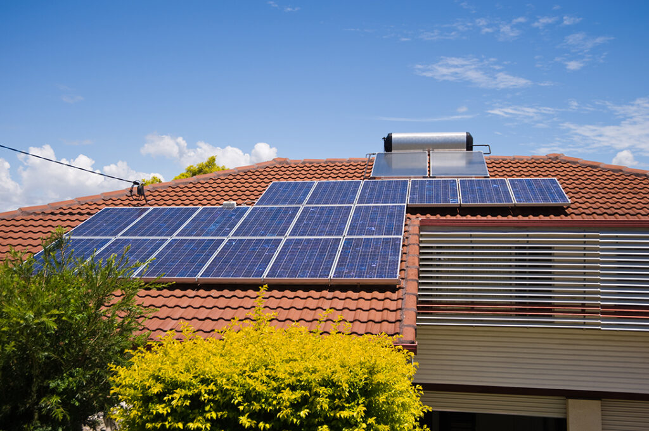
Solar panels by Unknown Author is licensed under CC BY 4.0.
- Explain to students that solar panels on our roof allow us to absorb energy from the sun into our own homes, so that we don’t have to pay for as much electricity from power companies.
- Display Figure 2, also available on slide 4 of the A slant on solar energy PowerPoint.
Figure 2 – rectangular solar panel
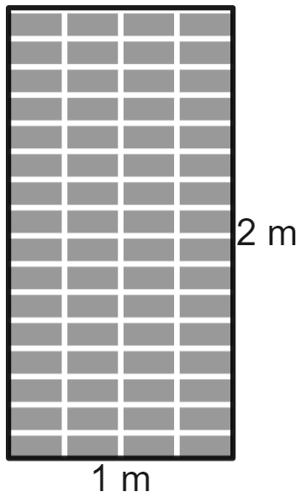
Image created using Desmos and is licensed under the Desmos Terms of Service.
- Explain to students that in one day, the solar panels we will be investigating can absorb up to 0.9 kWh of energy per square metre. This is approximately enough energy to run your refrigerator for 2 hours or your television for 15 hours.
- Challenge students, in pairs, to determine how much energy the solar panel in Figure 2 can absorb in one day.
- Conclude with the class that because the area of this rectangular solar panel is $1 m×2 m=2{ m}^{2}$, the panel can absorb up to $2×0.9=1.8 kWh$ of energy in one day.
- Inform students that an average household uses approximately 27 kWh per day. Have students engage in a Think-Pair-Share (bit.ly/thinkpairsharestrategy) to determine how many solar panels an average household would need to absorb all of their electricity from the sun and have an electricity bill of $0.
Students should identify that it takes 15 solar panels, each absorbing 1.8 kWh per day, to absorb a total of 27 kWh in a day for the household.

Explore
- Display the Desmos graph ‘Solar panels: Rectangles’ (bit.ly/DesmosSPRect) on the teacher screen and acknowledge that the roof is divided into 3 distinct sections. Clarify to students that these sections are slanted back into the picture, so solar panels can rest on them, facing the sky.
- Inform students that they will be dragging the rectangular solar panels that have been left on the lawn onto the roof, remembering the rules below, which are also displayed in the graph.
- Solar panels cannot overlap.
- Solar panels cannot hang off the roof, they need to fit completely on the roof.
- Solar panels cannot cross sections of the roof.
- Try to fit as many solar panels on the roof as you can.
- Send pairs of students on digital devices to the Desmos graph (bit.ly/DesmosSPRect) to complete this task, reminding them that their task is to find how many solar panels will fit on the roof.
If digital devices are not available, students can be handed printed copies of Appendix A ‘Placing solar panels on a roof’ and instructed to shade the grid to indicate solar panels.
Challenge students who find the dragging or shading of solar panels tedious to use methods to approximate additional rows.
The total number of rectangular solar panels that should fit on the roof is 38. Slightly less is reasonable if students were concerned about overlapping panels.
- Collect responses from students of the total number of solar panels that they have been able to fit on the roof.
- Display either a piece of student work, or Figure 3 on the teacher screen. Figure 3 is also available on slide 6 of the A slant on solar energy PowerPoint.
Figure 3 – house with rectangular solar panels
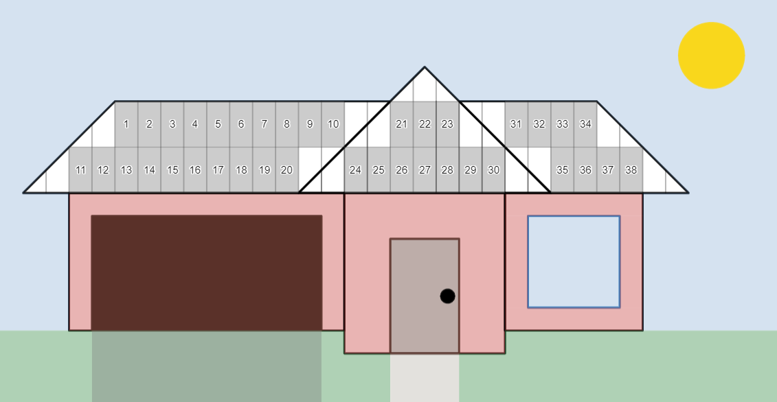
Image created using Desmos and is licensed under the Desmos Terms of Service.
- Lead a discussion with students about the amount of space on the roof that has been covered with solar panels.
- Challenge students to compare the number of solar panels displayed here and the number we calculated we would need to have an electricity bill of $0.
- Use a Pose-Pause-Pounce-Bounce question strategy (PDF 557 KB) (bit.ly/posepausepouncebounce) to ask students what it means if we have more solar panels than we need to get all of our household’s electricity.
Important answers to consider include:
- we might be able to use more electricity
- if there are lots of cloudy days, we might still get enough energy
- we can sell the energy to the electricity company and make money on our electricity bill.
- Acknowledge the space on the roof that has not been used. Have students engage in a Think-Pair-Share to answer the following questions.
- How many extra solar panels do you think could fit if we put all of this space together?
- What shapes do you see on the roof before we put any solar panels on it?
- What shape of solar panel would be perfect for this roof?
- Inform students that to maximise roof space, solar panels could be made in a parallelogram shape.
- Send students to the Desmos graph ‘Solar panels: Parallelograms’ (bit.ly/DesmosSPPara) and instruct them to repeat the task by now placing rectangular and parallelogram shaped solar panels on the roof.
If not using digital devices, the second page of Appendix A can be used with students again shading solar panels.
Students should fit approximately 46 solar panels in this scenario, depending how they approach placing them onto the roof.
- Lead a brief discussion with students that when using the parallelogram solar panels, we cover more of the roof. Teachers can display Figure 4 or Figure 5, also available on slides 7 and 8 of the A slant on solar energy PowerPoint if this is beneficial.
Students may have explored the parallelogram shapes to cover the triangular section of the roof. During the class discussion, teachers should give opportunities for students to share if they felt any of the 3 panel shapes (2 parallelograms and rectangles) covered more of this section and justify their perspective.
Figure 4 – house with rectangular and parallelogram shaped solar panels
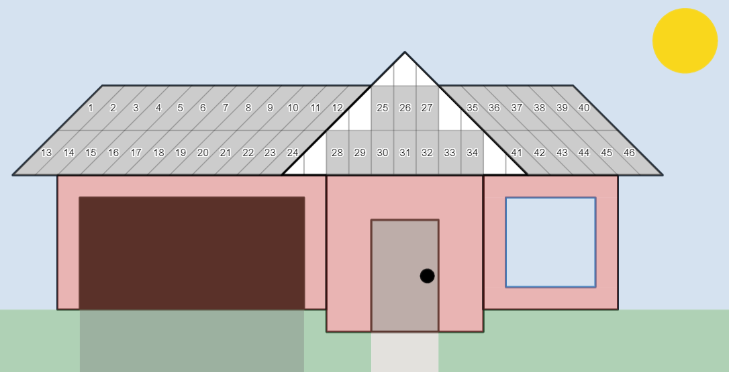
Image created using Desmos and is licensed under the Desmos Terms of Service.
Figure 5 – comparison of using rectangular panels only versus also using parallelogram shaped panels
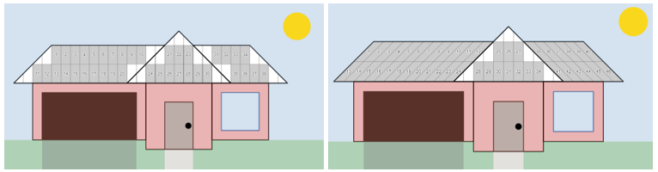
Image created using Desmos and is licensed under the Desmos Terms of Service.
- Pose the following problem to students:
We know that 46 panels is more than 38 panels, but do we know if parallelogram panels absorb the same amount of energy as rectangular panels?
Students may need to be reminded that the energy absorption of the rectangular solar panels was based on the area of the panel. Hence conclude with students that we need to compare the area of the rectangle and the parallelogram panels.
- Hand pairs of students copies of Appendix B, ‘Rectangles versus parallelograms’. Challenge students to answer the questions on the worksheet about the relationships between the rectangular and parallelogram shaped panels and develop a strategy to find the area of a parallelogram.
- Lead a class discussion where students can share their approach to finding the area of a parallelogram, prompting justifications to support their approach.

Summarise
- Explain to students that we will be writing a formula for the area of a parallelogram.
- Display the Desmos graph ‘Parallelogram animation’ (bit.ly/DesmosParaAnim) on the teacher screen.
- Press the ‘Play’ button and press pause after the pronumerals $b$ and $h$ appear on the screen, representing the base length and perpendicular height respectively. This will occur after ‘Play’ is greater than 1.
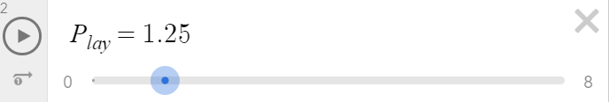
- Instruct students to engage in a Think-Pair-Share about what they believe the formula should be based on their work in Appendix B. Instruct students to explain and justify their reasoning.
- Press the Play button again to show why the formula for the area of a parallelogram is $A=bh$, where $b$ is the base length and $h$ is the perpendicular height.
- Display Figure 6, which is also available on slide 10.
Figure 6 – solar panel dimensions
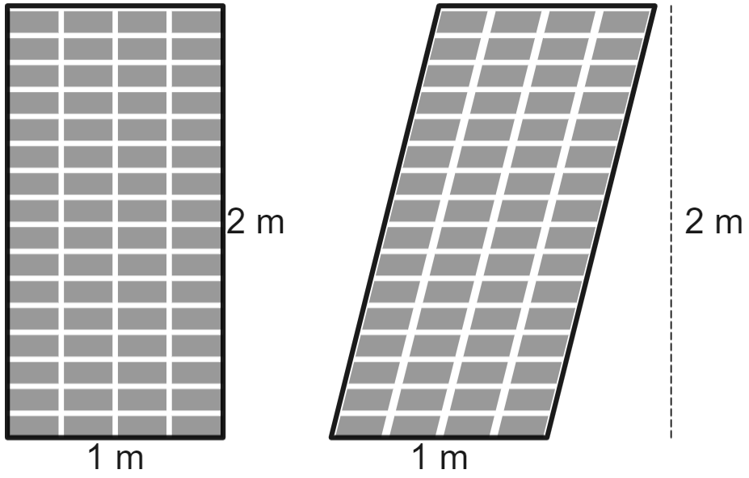
Image created using Desmos and is licensed under the Desmos Terms of Service.
- Acknowledging that the area of the 2 shapes is the same, have students work in pairs to determine:
- How much additional area is covered when the parallelogram solar panels are available?
- How much additional energy can be absorbed in an average day with the additional solar panels?
- If the electricity company will buy extra energy from you for 10c per kWh, how much extra money could you make with parallelogram solar panels?
An extra 8 panels, each with an area of $2 m^{2}$ will give an extra $16 m^{2}$ of coverage. This is then $0.9×16=14.4 kWh$ of additional energy per day, which is an extra $14.4×10=144$ cents, or $\$1.44$ per day. Students might find it interesting to consider how much this is per month or year.
- By working in visibly random groups of 3 (bit.ly/visiblegroups) on vertical non-permanent surfaces (bit.ly/VNPSstrategy), have students complete Appendix C ‘Parallelogram problems’.

Apply
- Give pairs of students a digital device with internet access. Have students go to the ‘Google Earth’ website (earth.google.com) and type in their school’s name. Students will need to zoom in to see the roof of the school buildings.
Teachers may wish to direct students to particular buildings that have a parallelogram shape. Alternatively, students could be sent to search for other local buildings or their own home.
- Instruct students to look at the shapes they see on the roof of the building. Have students write a list of the shapes that can be identified.
- Instruct students to draw a rough sketch of the roof of the building, clearly showing the various shapes.
- Students are to use the measuring tool at the top of the Google Earth screen to measure the dimensions of the shapes on their roof and calculate the total area.
- Based on the idea that solar panels can absorb 0.9 kWh of energy in a typical day, have students determine the amount that can be absorbed if the entire roof of the chosen building were to be covered in solar panels.

Assessment and differentiation

Suggested opportunities for differentiation
Launch
- The numbers chosen in the Launch activity are a balance between realistic values and ensuring calculations are reasonable for all students. If students experience difficulty working with decimals, the solar panels could be stated to absorb 1 kWh per square metre. It is important to not simply state the absorption rate of the entire panel, as the learning episode relies on the solar panels operating based on the area of the panel.
Explore
- Challenge students to explore the situation in greater detail by providing rates. For example, for every kWh absorbed by solar panels and not used in the house, the electricity company will pay you 16 cents. How much money can you make per day from the 46 solar panels we fit on this house, remembering you will use 27 kWh per day in your household?
Summarise
- Students who experience difficulty with the concept of area can be shown how to draw shapes of an approximately correct-sized solar panel for the shape in question 3 of Appendix C.

Suggested opportunities for assessment
Launch
- Student responses in the Think-Pair-Share activity can be observed and recorded during the sharing component to identify the approaches students are taking to division with decimals.
Summarise
- Appendix C can be submitted to demonstrate students’ ability to use dimensions found in a diagram to find and use the area of a parallelogram.
Apply
- Teachers can review the sketches and calculations from students to determine their ability to take information from a map in Google Maps, select appropriate dimensions to measure and use them to find the area of shapes. This is particularly applicable if the students are using the map of a known place, such as the school.

Appendix A

Placing solar panels on a roof

Rectangular solar panels
The house in the image below has a roof that is divided into 3 parts. The grid on the roof shows where solar panels could be placed. One solar panel has been placed, by shading a full rectangle.
Solar panels cannot be placed across any lines and must fit entirely on the roof.
Shade all the full rectangles that are on the roof and count how many rectangular solar panels we can fit on this roof.
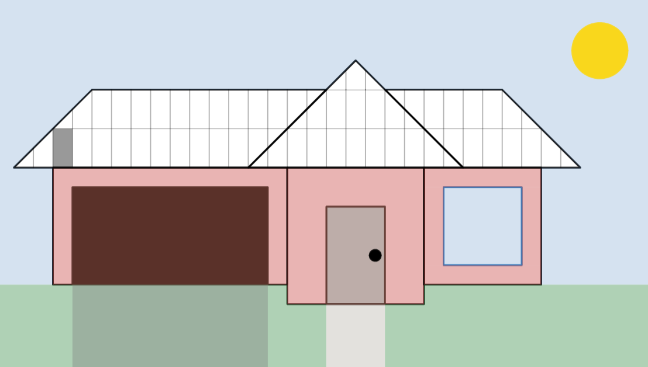
Image created using Desmos and is licensed under the Desmos Terms of Service.

Parallelogram and rectangular solar panels
The roof of the same house has now been shown with a grid that has rectangles and parallelograms. A single parallelogram solar panel has again been shaded.
Solar panels still cannot be placed across any lines and must fit entirely on the roof.
Shade all the full rectangles and parallelograms that are on the roof and count how many total solar panels we can fit on this roof.
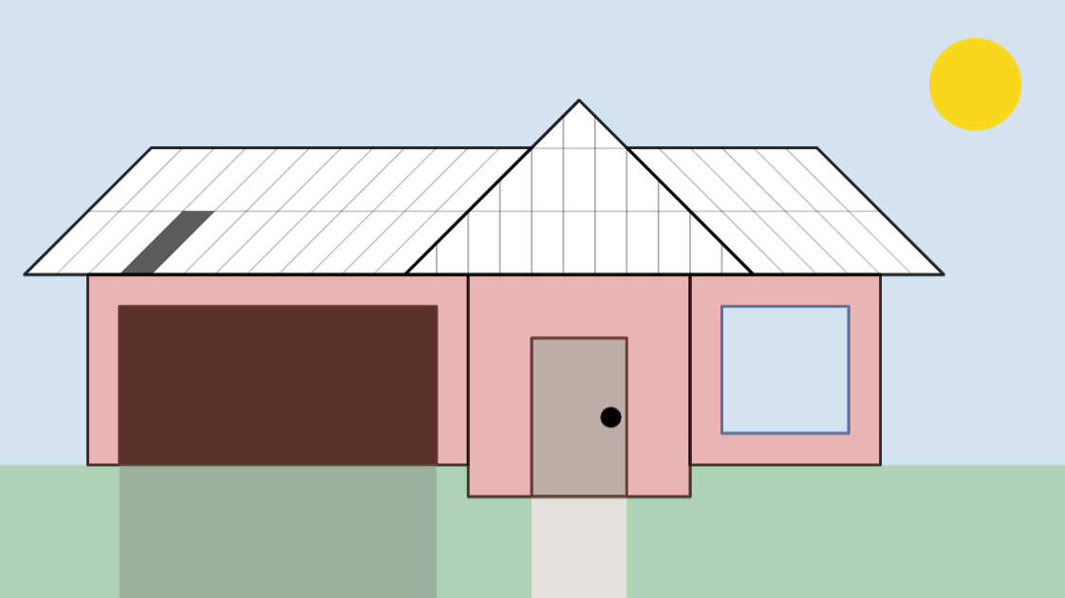
Image created using Desmos and is licensed under the Desmos Terms of Service.

Appendix B

Rectangles versus parallelograms
Below is a rectangle and a parallelogram, similar to the solar panel shapes placed on rooftops.
- What do you notice is the same about the 2 shapes?
- What do you notice is different?
- How do their areas compare? How do you know?
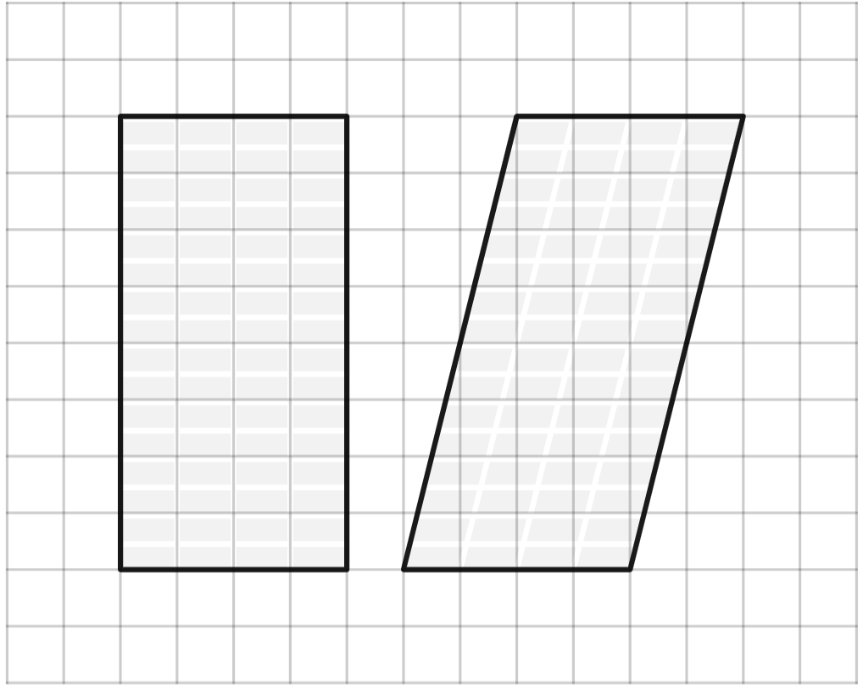

Find the area of each of the shapes below using a strategy of your choice.
Shape | Area
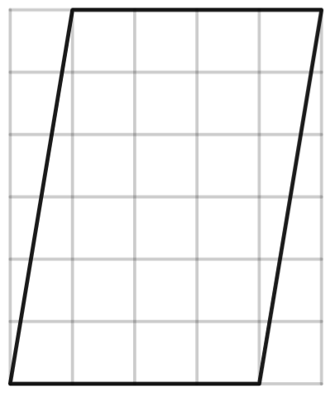
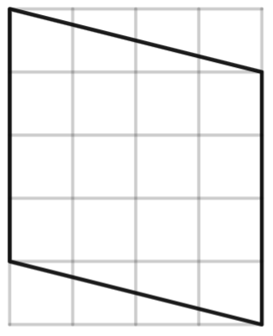
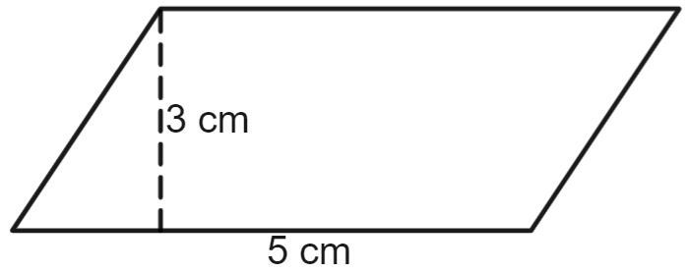

Appendix C

Parallelogram problems
- Find the area of the parallelogram below.
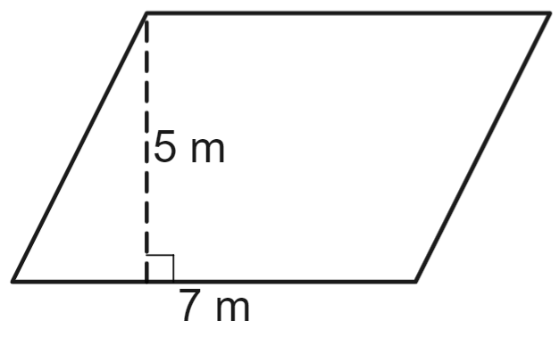
- Use a ruler to find the area of the parallelogram below.
- The image below shows a rooftop with dimensions. By calculating the total area of the rooftop, determine the number of solar panels with area $2 m^{2}$ we could fit on the roof.
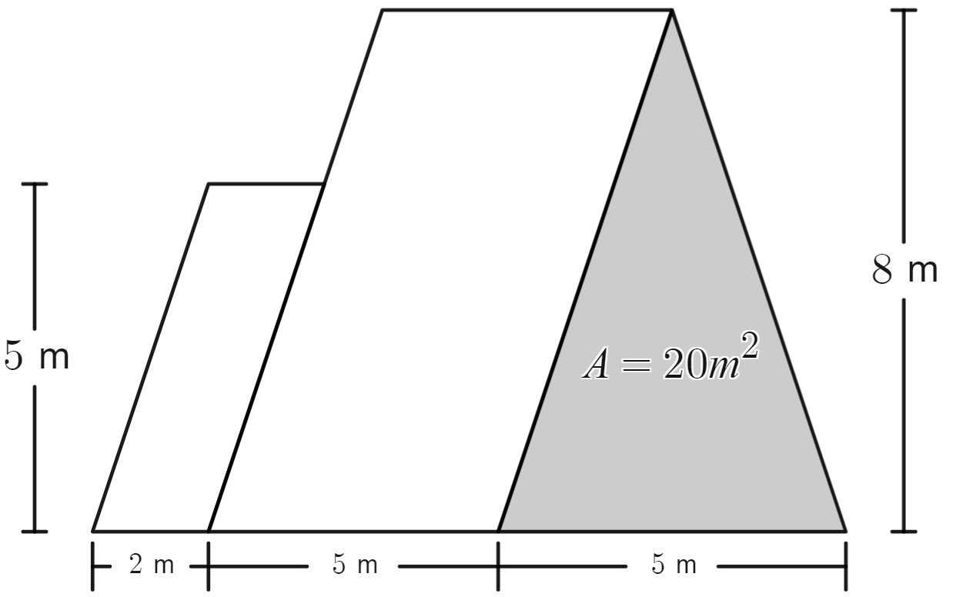

Sample solutions

Appendix A – placing solar panels on a roof

Rectangular solar panels
We can fit 38 solar panels on the roof if we include only rectangular shaped panels.
Image created using Desmos and is licensed under the Desmos Terms of Service.

Parallelogram and rectangular solar panels
We can fit 46 solar panels on the roof if we include both rectangular and parallelogram shaped panels.
Image created using Desmos and is licensed under the Desmos Terms of Service.

Appendix B – rectangles versus parallelograms
Below is a rectangle and a parallelogram, similar to the solar panel shapes placed on rooftops.
- What do you notice is the same about the 2 shapes? The height of both is 8 squares, the base of both is 4 squares.
- What do you notice is different? The parallelogram is the same as the rectangle, except it is slanted, so its angles are not right angles.
- How do their areas compare? How do you know? Counting the squares in the shape, the rectangle has 32 squares (4 by 8), and the parallelogram has 24 full squares. The parallelogram also has 16-part squares which can be placed together to make 8 additional squares, so both shapes have 32 squares of area.
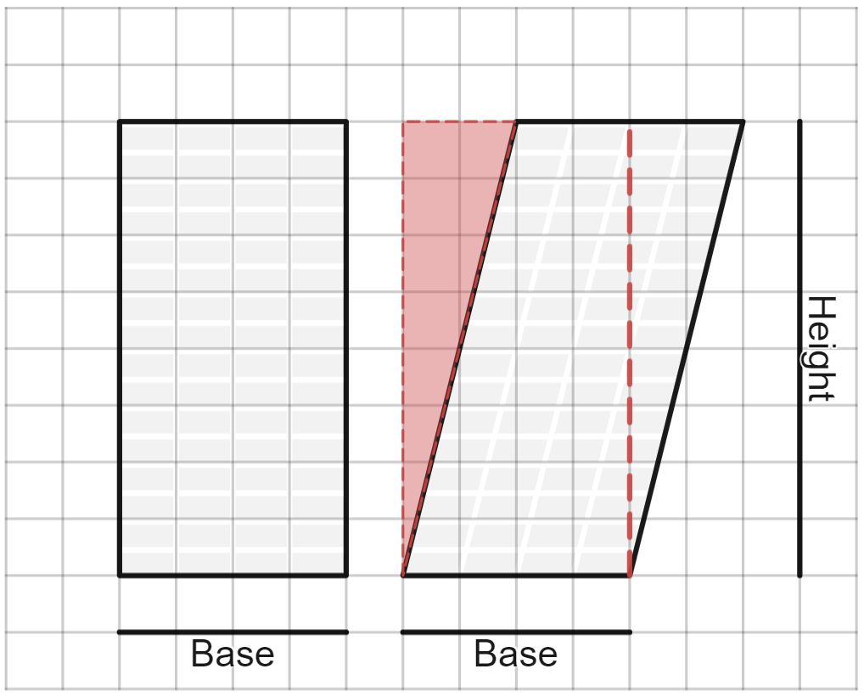
Image created using Desmos and is licensed under the Desmos Terms of Service.

Find the area of each of the shapes below using a strategy of your choice.
Shape | Area
 | $$A=4×6 \\ =24 u^{2}$$
 | $$A=4×4 \\ =16 u^{2}$$
 | $$A=5×3 \\ =15 cm^{2}$$

Appendix C – parallelogram problems
- Find the area of the parallelogram below.
$$A=5×7=35 m^{2}$$
- Use a ruler to find the area of the parallelogram below.
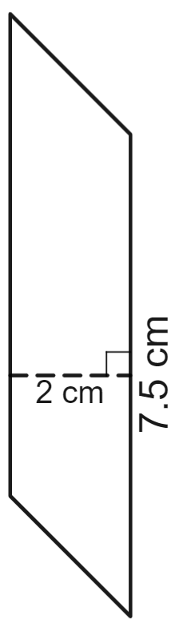
$$A=2×7.5=15 cm^{2}$$
Dimensions are based on measurements made in the Word document. Actual dimensions will depend on printing.
- The image below shows a rooftop with dimensions. By calculating the total area of the rooftop, determine the number of solar panels with area $2 m^{2}$ we could fit on the roof.
$$A_{1}=2×5=10 m^{2}$$
$$A_{2}=5×8=40 m^{2}$$
$$A_{3}=20 m^{2}$$
$$A_{total}=10+40+20=70 m^{2}$$
This means we can fit a total of $70÷2=35$ solar panels of size $2 m^{2}$. This is assuming that they all fit perfectly in the space on the roof.

References
This resource contains NSW Curriculum and syllabus content. The NSW Curriculum is developed by the NSW Education Standards Authority. This content is prepared by NESA for and on behalf of the Crown in right of the State of New South Wales. The material is protected by Crown copyright.
Please refer to the NESA Copyright Disclaimer for more information https://educationstandards.nsw.edu.au/wps/portal/nesa/mini-footer/copyright.
NESA holds the only official and up-to-date versions of the NSW Curriculum and syllabus documents. Please visit the NSW Education Standards Authority (NESA) website https://educationstandards.nsw.edu.au and the NSW Curriculum website https://curriculum.nsw.edu.au.
Mathematics K–10 Syllabus © NSW Education Standards Authority (NESA) for and on behalf of the Crown in right of the State of New South Wales, 2022.

© State of New South Wales (Department of Education), 2024
The copyright material published in this resource is subject to the Copyright Act 1968 (Cth) and is owned by the NSW Department of Education or, where indicated, by a party other than the NSW Department of Education (third-party material).
Copyright material available in this resource and owned by the NSW Department of Education is licensed under a Creative Commons Attribution 4.0 International (CC BY 4.0) license.
This license allows you to share and adapt the material for any purpose, even commercially.
Attribution should be given to © State of New South Wales (Department of Education), 2024.
Material in this resource not available under a Creative Commons license:
- the NSW Department of Education logo, other logos and trademark-protected material
- material owned by a third party that has been reproduced with permission. You will need to obtain permission from the third party to reuse its material.
Links to third-party material and websites
Please note that the provided (reading/viewing material/list/links/texts) are a suggestion only and implies no endorsement, by the New South Wales Department of Education, of any author, publisher, or book title. School principals and teachers are best placed to assess the suitability of resources that would complement the curriculum and reflect the needs and interests of their students.
If you use the links provided in this document to access a third-party's website, you acknowledge that the terms of use, including licence terms set out on the third-party's website apply to the use which may be made of the materials on that third-party website or where permitted by the Copyright Act 1968 (Cth). The department accepts no responsibility for content on third-party websites.

