Too clever by half
Students will develop the formula for the area of a triangle and use the formula to solve problems.

Visible learning

Learning intention
- To establish the formula for the area of a triangle.

Success criteria
- I can explain why the area of a triangle is half the area of a parallelogram.
- I can identify the base and height of a triangle.
- I can find the area of a triangle.
- I can substitute values into the formula for the area of a triangle.

Syllabus outcomes
A student:
- develops understanding and fluency in mathematics through exploring and connecting mathematical concepts, choosing and applying mathematical techniques to solve problems, and communicating their thinking and reasoning coherently and clearly
MAO-WM-01
- applies knowledge of area and composite area involving triangles, quadrilaterals and circles to solve problems MA4-ARE-C-01
Mathematics K–10 Syllabus © NSW Education Standards Authority (NESA) for and on behalf of the Crown in right of the State of New South Wales, 2022.

Activity structure
Please use the associated PowerPoint Too clever by half in this lesson.

Warm up
The aim of this activity is for students to revisit their multiplicative thinking skills, specifically the use of the commutative property, in anticipation to using the formula for the area of a triangle.
- Display slide 3 of the Too clever by half PowerPoint, which contains a ‘Two truths and a lie’ prompt (bit.ly/Two_Truths_One_Lie).
- Ask students to engage in a Think-Pair-Share (bit.ly/thinkpairsharestrategy), to identify which of the statements are true and which is a lie.
- Display slide 4 of the Too clever by half PowerPoint, which contains another ‘Two truths and a lie’ prompt. Once again, ask students to engage In a Think-Pair-Share to identify which of the statements are true and which is a lie.
- Use a Pose-Pause-Pounce-Bounce questioning strategy (PDF 557 KB) (bit.ly/posepausepouncebounce), to share student answers and reasoning.
Students should conclude that the order in which we complete the multiplications does not affect the answer.

Launch
- Display Figure 1 which can be found on slide 6 of the Too clever by half PowerPoint.
- Ask students to engage in a Think-Pair-Share to identify which triangle they believe has the biggest area and why.
Figure 1 – which triangle has the bigger area?
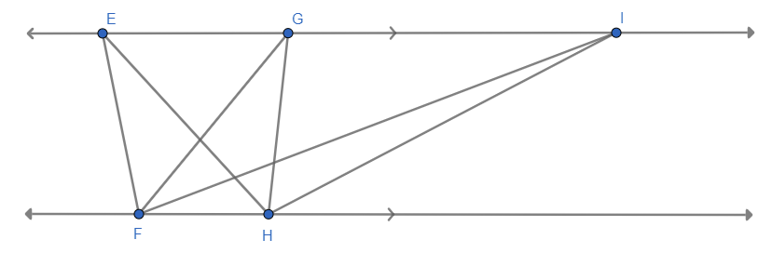
- Use the Pose-Pause-Pounce-Bounce questioning strategy for students to share their answers and their thinking. Do not confirm at this point if students are correct.
- Explain to students that for us to solve this problem, we need to find out how to calculate the area of a triangle.

Explore

Equipment
For each pair of students:
- Appendix A ‘Triangles’
- Appendix B ‘Triangles into parallelograms’
- scissors
- blank paper
- ruler.

Method
- Distribute a copy of Appendix A to pairs of students.
- In a Think-Pair-Share students are to discuss what they notice and wonder about the triangles on the page.
- Use the Pose-Pause-Pounce-Bounce questioning strategy for students to share their thoughts.
Points that students should notice include:
- There are 3 pairs of identical triangles.
- Each of the triangles are labelled with letters to indicate which are the matching sides, in each pair.
- There is a pair of acute-angled triangles, a pair of obtuse-angled triangles and a pair of right-angled triangles.
- Ask students to cut out the triangles.
- Distribute blank paper to each pair of students.
- Continuing in a Think-Pair-Share, ask the students to explore what happens when they rotate the triangles and place them next to each other. Students should trace the shapes they produce onto their blank paper.
- Use the following questions to promote student thinking:
- When you place the 2 identical triangles together, what do you notice about the shapes they make?
- When matching the sides with the same letters, what type of shape do they create?
Students should, at a minimum, be able to identify that the shape created is a quadrilateral:
- When students are manipulating the pair of right-angled triangles, they will likely identify that the type of quadrilateral created is a rectangle.
- When manipulating the acute-angled or obtuse-angled triangles, students may need assistance to identify that they can create a parallelogram. Each of the triangles are labelled with letters to indicate which are the matching sides, in each pair.
- Remind students that a rectangle is a type of parallelogram.
- Continuing in their pair, students need to discuss how they would find the area of the quadrilaterals they have made.
The discussion should focus on encouraging students to recall, from Unit 7 Learning episode 11 – a slant on solar energy, that the area of a parallelogram is found by multiplying the base length by the perpendicular height and that using the formula $A=bh$ can be useful.
- Ask students to use a ruler to measure the base length and the perpendicular height and to find the area of the parallelograms they have drawn.
- In a Think-Pair-Share, ask the students how they might use the information about the area of the parallelogram to find the area of the triangles they used to create the parallelogram.
Students should be able to recognise that if 2 identical triangles were used to create the parallelogram, that the area of one of the triangles is half of the area of the parallelogram.
- Use the Geogebra applet ‘Area of a Triangle interactive (cf parallelogram)’ (https://bit.ly/AreaOfTriangle) to demonstrate that any triangle can be duplicated and manipulated to form a parallelogram.
- Ask students to identify what is the same about the triangle and the parallelogram.
Students should identify that they have the same base length and height.
- Students are to complete Appendix B ‘Triangles into parallelograms’. They need to turn each triangle into a parallelogram before recording the base and height of the parallelogram and then calculating the area of both the parallelogram and the triangle.

Summarise
- Use slides 8 to 15 from the Too clever by half PowerPoint for explicit teaching of the formula for the area of a triangle.
The explicit teaching technique used in the PowerPoint is ‘Your turn’. The first slide is a worked example which should be displayed for the students before using the following steps.
- Reveal the question to students and its solution.
- Students read in silence.
- Students individually explain to themselves what is happening in each step.
- Students hold a thumbs up to the teacher when they have finished reading and have some sort of understanding.
- Think-Pair-Share. Students explain the solution to their partner.
- In pairs, students then answer the self-explanation questions.
- Finally, randomly select students to share their answers with the whole class.
- Students are to individually complete Appendix C ‘Triangle practice’ to practise using the formula for area of a triangle.

Apply
There are 3 tasks outlined below that students could complete to consolidate their knowledge of finding the area of a triangle. Teachers can choose which tasks and as many tasks as necessary for their students.

Investigating further
- Display slide 16 of the Too clever by half PowerPoint and relate this back to our Launch.
- Ask the question: ’Which of these 2 triangles do you now think has the greater area?’. Ask the class to vote by holding up 1, 2 or 3 fingers in front of their chest.
- The straight triangle.
- The leaning triangle.
- Both the same.
Students may have some insight through completing the questions in Appendix B.
- Working as a pair, ask students to calculate the area of both triangles to test their answer.
- Challenge students to discuss how they could draw at least 2 other triangles with the same area as those on the screen.
- Lead a class discussion to identify the area of the triangles and for students to share how they could create other triangles with the same area.
- Display slide 17 of the Too clever by half PowerPoint.
- Conclude with students that any triangles with the same base and height will have the same area, regardless of their shape.
- Display slide 18 of the Too clever by half PowerPoint. Discuss with students what effect moving the top point of the triangle up would have on the area.
- Assign students to visibly random groups of 3 (bit.ly/visiblegroups) on vertical non-permanent surfaces (bit.ly/VNPSstrategy).
- Issue each group an investigation from Appendix D ‘Triangle investigation’. There are 8 different investigations.
- Lead a class discussion to conclude that the area will increase as the height of the triangle increases. Encourage students to further generalise these findings: For instance, if the height doubles, the area will double.

Triangle Venn
Students complete the ‘Area of a triangle’ Venn diagram task from https://mathsvenns.com/area-of-a-triangle/.
They need to draw a triangle in each region of the Venn diagram that satisfies the given conditions.
For example, in section A they must draw a triangle that has an area less than 30. If section F, they must draw a triangle that has a base of 5 but an area that is less than 30.

Tricky triangles
Working in visibly random groups of 3 (bit.ly/visiblegroups) on vertical non-permanent surfaces (bit.ly/VNPSstrategy), ask students to solve the problem in Appendix E ‘Tricky triangles’.

Assessment and differentiation

Suggested opportunities for differentiation
Warm up
- If students are ready, teachers could choose to just display Slide 4 of the Too clever by half PowerPoint.
Launch
- A ‘Which one doesn’t belong’ activity allows all students to engage at an appropriate level. An important element of the activity is that students need to communicate their reasoning, justifying why their selection does not belong.
Explore
- Students may find it useful to use a grid to draw an outline of their parallelogram.
Summarise
- Students can turn the triangle into a parallelogram to calculate the area if they need to. They could also count squares if that is their level of readiness.
- If necessary, revisit the warm-up activity to ensure students are correctly multiplying the values after substituting.
- Encourage students to continue drawing bar models to assist them in working backwards to find the height or base. For students who are ready, encourage them to demonstrate the correct algebraic working alongside their bar model.
Apply
- Some students may need hints to identify a useful strategy to solve the Tricky triangles problem. Identifying triangles and rectangles will assist students.
- Students could be challenged to create their own triangle Venn.

Suggested opportunities for assessment
Explore
- Monitor student recognition that a triangle is half of a parallelogram.
- Appendix B could be collected to check for understanding.
Summarise
- Monitor student use of the formula for the area of a triangle.
- Check that students are substituting values into the formula for the area of a triangle.
- Appendix C could be collected to check for understanding.
Apply
- Appendices D and/or E as well as the triangle Venn could be collected to check for understanding.

Appendix A

Triangles
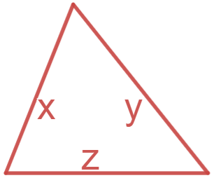
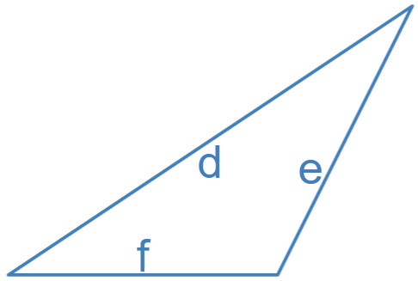
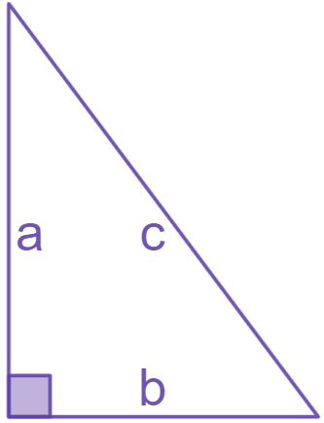

Appendix B

Triangles into parallelograms
Turn each of the triangles into a parallelogram.
Mark the base length and height of each parallelogram on your diagram and then calculate the area of both the parallelogram and triangle.
Triangle | Area of parallelogram | Area of triangle
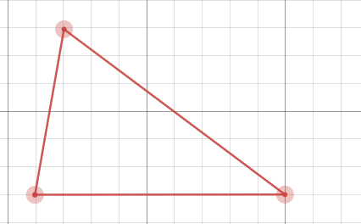
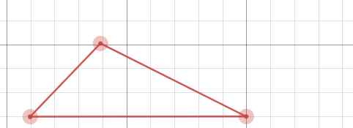
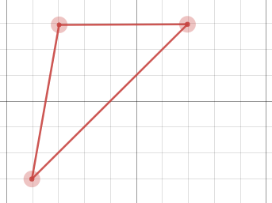
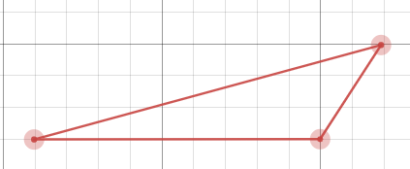
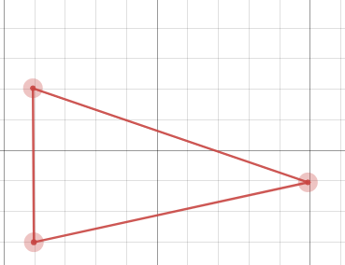

Appendix C

Triangle practice
Triangle | Base | Height | Area
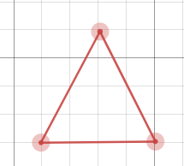
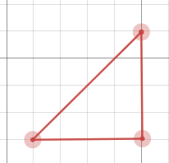
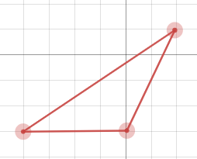
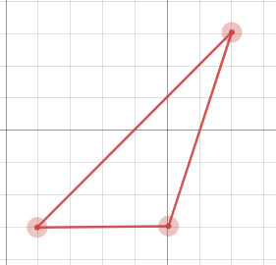
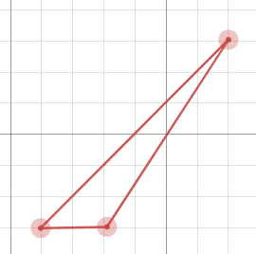
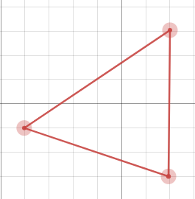
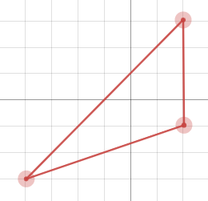
 | $$8 mm$$ |  | $$12 {mm}^{2}$$
 | $$8 mm$$ |  | $$24 {mm}^{2}$$
 |  | $$2 mm$$ | $$8 {mm}^{2}$$

Appendix D

Triangle investigation
Group 1
Investigate what happens to the area of the triangle as the top of the triangle moves up.
Use the diagrams and complete the table below.
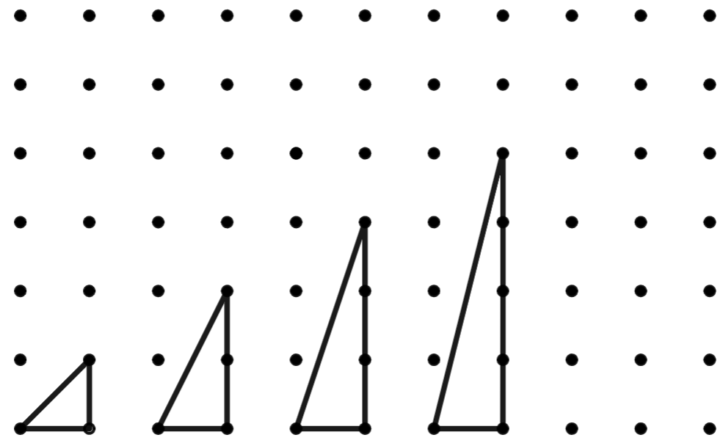
Base | Height | Area

Group 2
Investigate what happens to the area of the triangle as the top of the triangle moves up.
Use the diagrams and complete the table below.
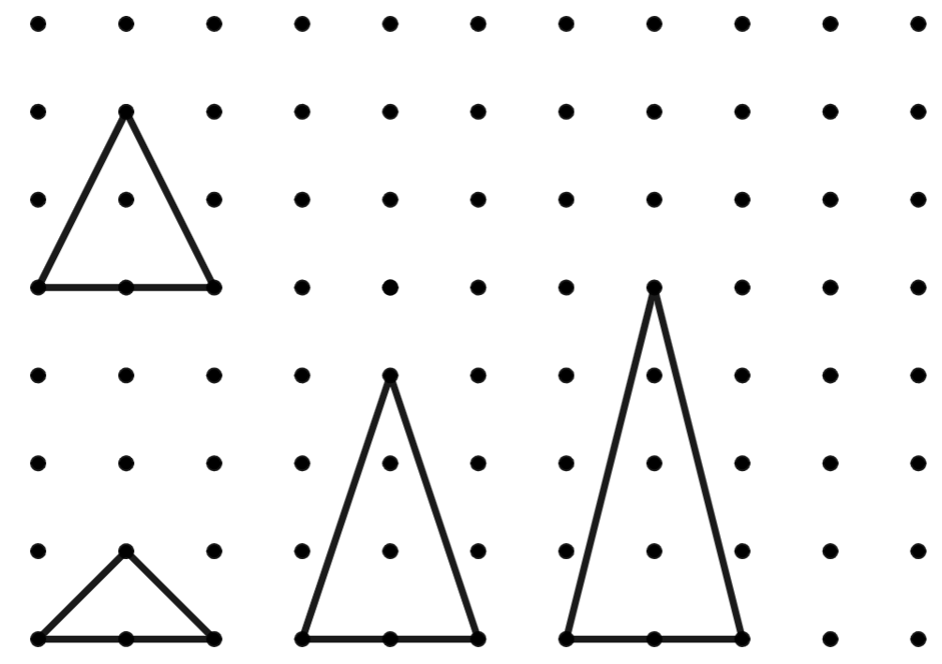
Base | Height | Area

Group 3
Investigate what happens to the area of the triangle as the top of the triangle moves up.
Use the diagrams and complete the table below.
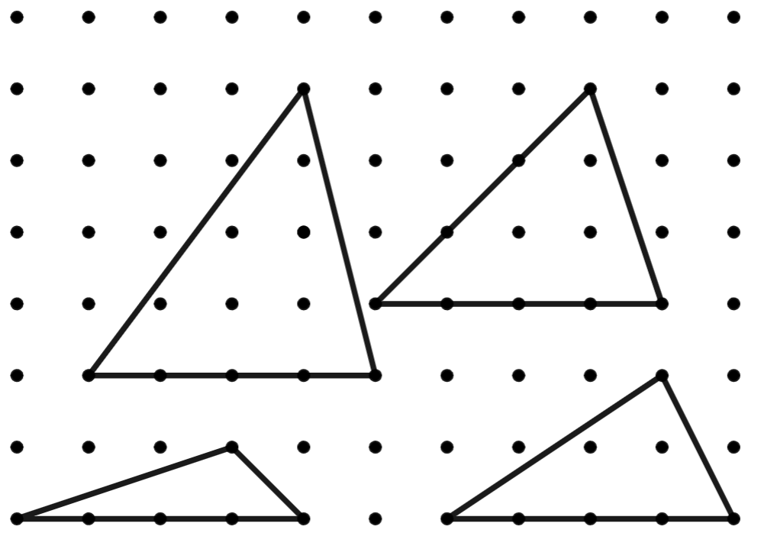
Base | Height | Area

Group 4
Investigate what happens to the area of the triangle as the top of the triangle moves up.
Use the diagrams and complete the table below.
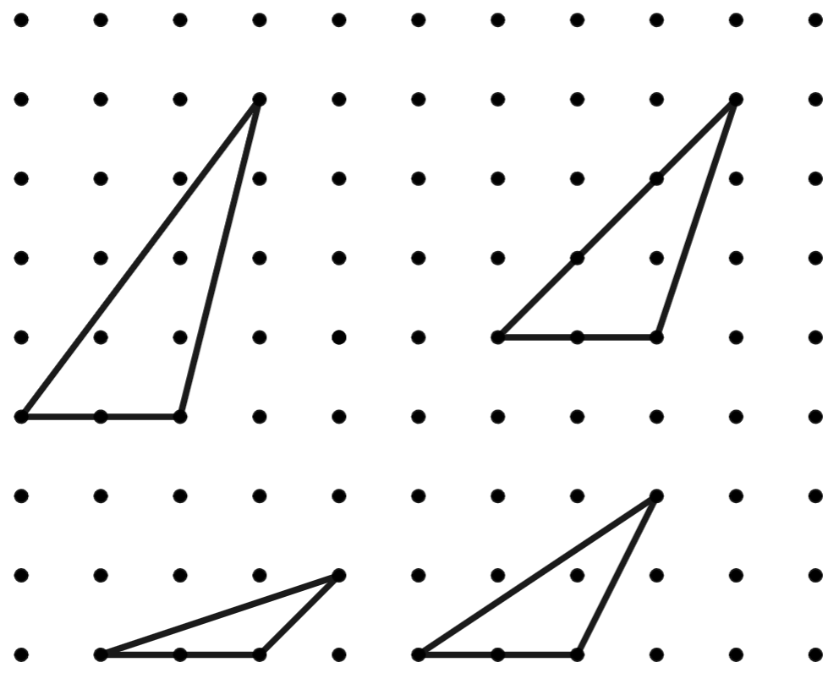
Base | Height | Area

Group 5
Investigate what happens to the area of the triangle as the top of the triangle moves up.
Use the diagrams and complete the table below.
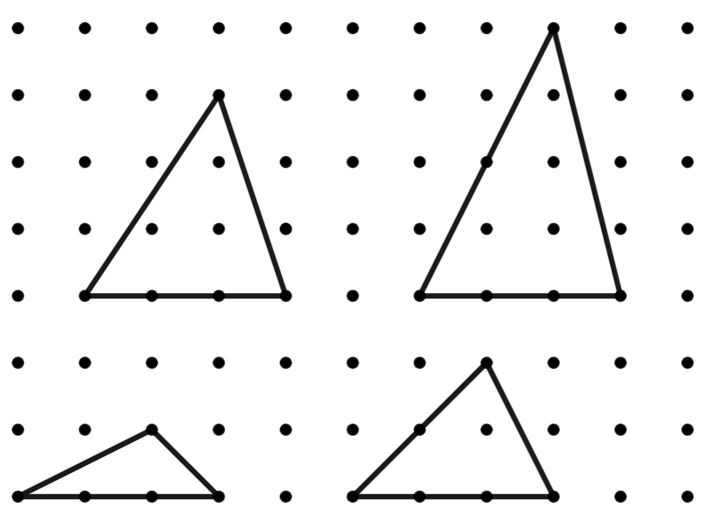
Base | Height | Area

Group 6
Investigate what happens to the area of the triangle as the top of the triangle moves up.
Use the diagrams and complete the table below.
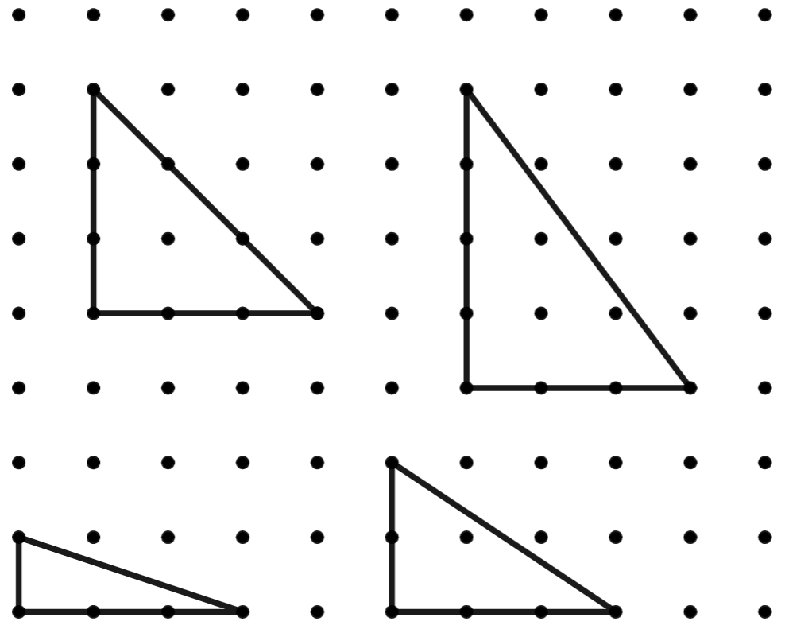
Base | Height | Area

Group 7
Investigate what happens to the area of the triangle as the top of the triangle moves up.
Use the diagrams and complete the table below.
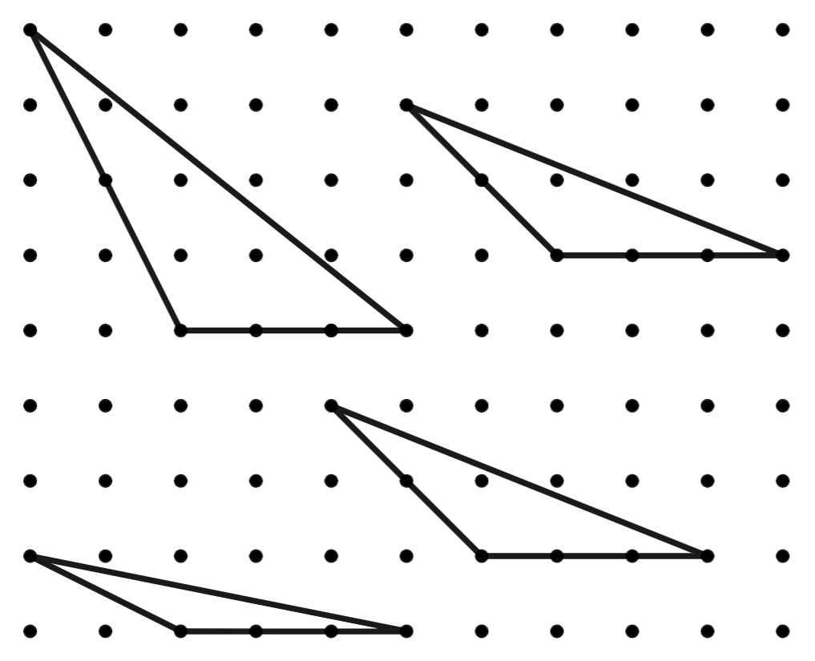
Base | Height | Area

Group 8
Investigate what happens to the area of the triangle as the top of the triangle moves up.
Use the diagrams and complete the table below.
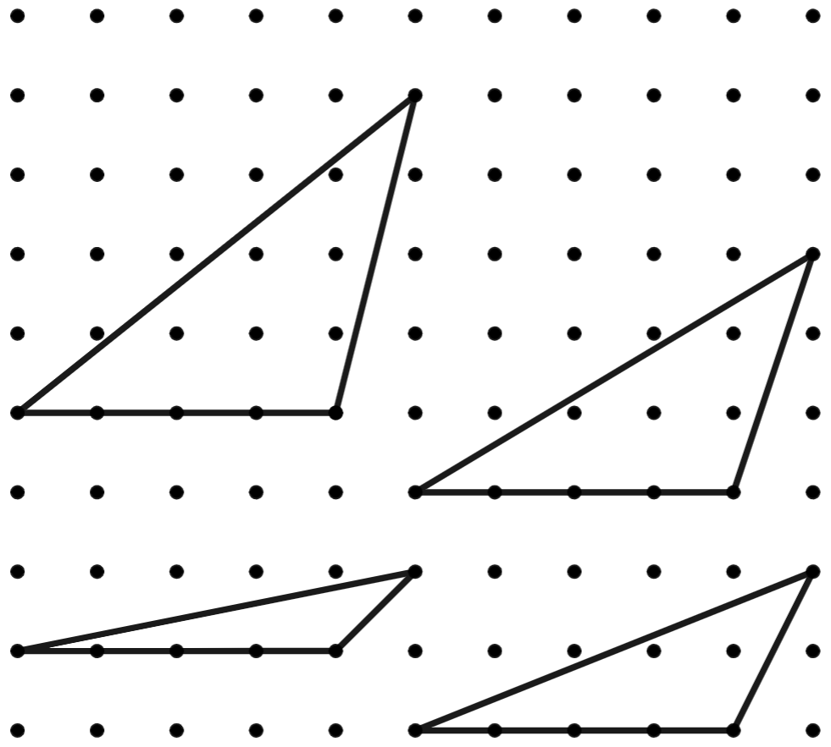
Base | Height | Area

Appendix E

Tricky triangles
The figure shows 3 squares of sides $3 cm$, $8 cm$ and $6 cm$.
- Find the total area of A and B.
- Find the area of the shaded part.
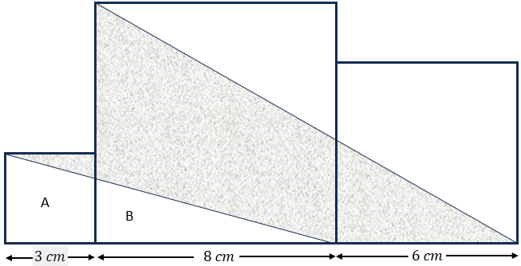

Sample solutions

Appendix A – triangles
Measurements are approximate.
Possible solution 1: acute angled triangle rotated with side y matching.
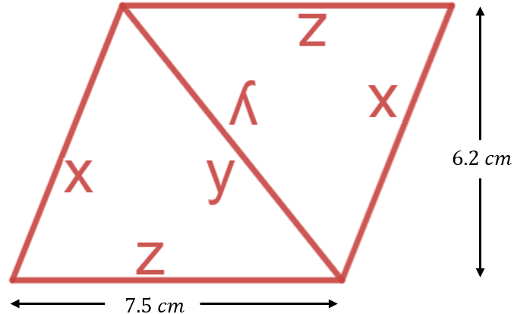 | $$Area of parallelogram:$$  $$A=7.5×6.2$$  $$=46.5 {cm}^{2}$$  $$Area of triangle=\frac{1}{2}×46.5$$  $=23.25 {cm}^{2}$
Possible solution 2: obtuse angled triangle rotated with side e matching.
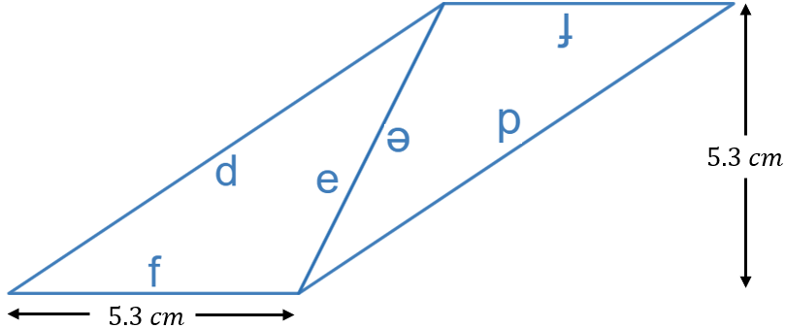 | $$Area of parallelogram:$$  $$A=5.3×5.3$$  $$=28.09 {cm}^{2}$$  $$Area of triangle=\frac{1}{2}×28.09$$  $$=14.045 {cm}^{2}$$
Possible solution 3: right-angled triangle rotated with side c matching.
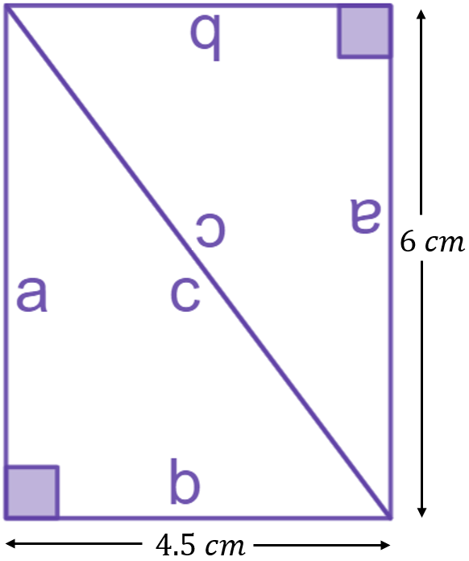 | $$Area of rectangle:$$  $$A=4.5×6$$  $$=27 {cm}^{2}$$  $$Area of triangle=\frac{1}{2}×27$$  $$=13.5 {cm}^{2}$$

Appendix B – triangles into parallelograms
Triangle | Area of parallelogram | Area of triangle
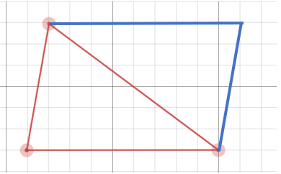 | $$9 × 6 = 54 {units}^{2}$$ | $$\frac{1}{2}×54=27 {units}^{2}$$
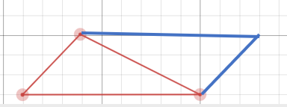 | $$9 × 3 = 27 {units}^{2}$$ | $$\frac{1}{2}×27=13.5 {units}^{2}$$
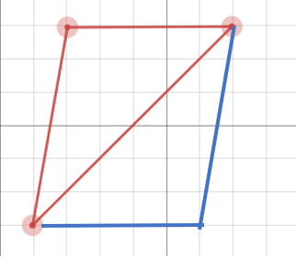 | $$5 × 6 = 30 {units}^{2}$$ | $$\frac{1}{2}×30=15 {units}^{2}$$
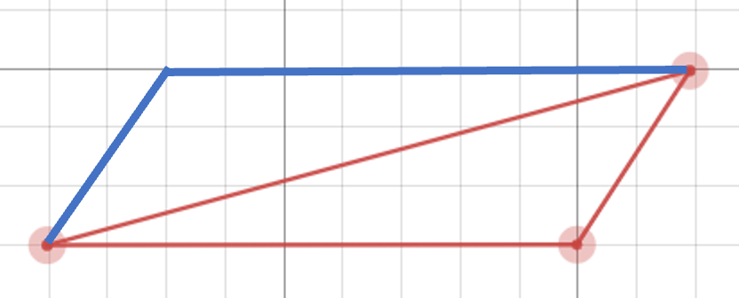 | $$9 × 3 = 27 {units}^{2}$$ | $$\frac{1}{2}×27=13.5 {units}^{2}$$
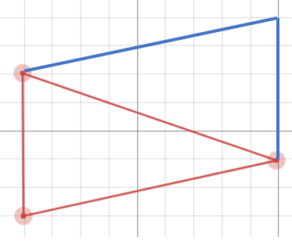 | $$5 × 9= 45 {units}^{2}$$ | $$\frac{1}{2}×45=22.5 {units}^{2}$$

Appendix C – triangle practice
Triangle | Base | Height | Area
 | 4 | 4 | $$8 {units}^{2}$$
 | 4 | 4 | $$8 {units}^{2}$$
 | 4 | 4 | $$8 {units}^{2}$$
 | 4 | 6 | $$12 {units}^{2}$$
 | 2 | 6 | $$6 {units}^{2}$$
 | 6 | 6 | $$18 {units}^{2}$$
 | 4 | 6 | $$12 {units}^{2}$$
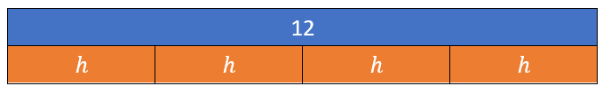 | $$8 mm$$  $$\frac{1}{2} \text{base = }4 mm$$ | $$3 mm$$ | $$12 {mm}^{2}$$
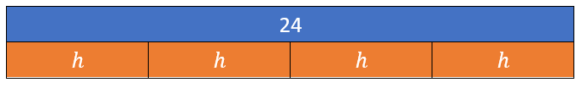 | $$8 mm$$  $$\frac{1}{2} \text{base = }4 mm$$ | $$6 mm$$ | $$24 {mm}^{2}$$
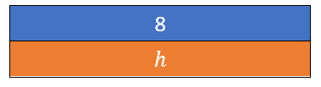 | $$8 mm$$ | $$2 mm$$  $$\frac{1}{2} \text{height = 1} mm$$ | $$8 {mm}^{2}$$

Appendix E – tricky triangles
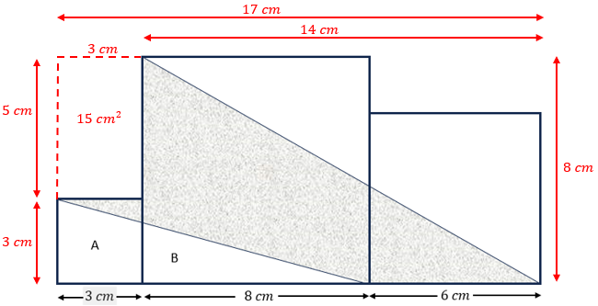
- $Area \left(A+B\right)=\frac{1}{2}×11×3$
$$=16.5 cm^{2}$$
- $Shaded area=area of large rectangle-area \left(A+B\right)-area small rectangle-area top right triangle$
$$=17×8-16.5-15-\frac{1}{2}×14×8$$
$=48.5 {cm}^{2}$

References
This resource contains NSW Curriculum and syllabus content. The NSW Curriculum is developed by the NSW Education Standards Authority. This content is prepared by NESA for and on behalf of the Crown in right of the State of New South Wales. The material is protected by Crown copyright.
Please refer to the NESA Copyright Disclaimer for more information https://educationstandards.nsw.edu.au/wps/portal/nesa/mini-footer/copyright.
NESA holds the only official and up-to-date versions of the NSW Curriculum and syllabus documents. Please visit the NSW Education Standards Authority (NESA) website https://educationstandards.nsw.edu.au and the NSW Curriculum website https://curriculum.nsw.edu.au.
Mathematics K–10 Syllabus © NSW Education Standards Authority (NESA) for and on behalf of the Crown in right of the State of New South Wales, 2022.

© State of New South Wales (Department of Education), 2024
The copyright material published in this resource is subject to the Copyright Act 1968 (Cth) and is owned by the NSW Department of Education or, where indicated, by a party other than the NSW Department of Education (third-party material).
Copyright material available in this resource and owned by the NSW Department of Education is licensed under a Creative Commons Attribution 4.0 International (CC BY 4.0) license.
This license allows you to share and adapt the material for any purpose, even commercially.
Attribution should be given to © State of New South Wales (Department of Education), 2024.
Material in this resource not available under a Creative Commons license:
- the NSW Department of Education logo, other logos and trademark-protected material
- material owned by a third party that has been reproduced with permission. You will need to obtain permission from the third party to reuse its material.
Links to third-party material and websites
Please note that the provided (reading/viewing material/list/links/texts) are a suggestion only and implies no endorsement, by the New South Wales Department of Education, of any author, publisher, or book title. School principals and teachers are best placed to assess the suitability of resources that would complement the curriculum and reflect the needs and interests of their students.
If you use the links provided in this document to access a third-party's website, you acknowledge that the terms of use, including licence terms set out on the third-party's website apply to the use which may be made of the materials on that third-party website or where permitted by the Copyright Act 1968 (Cth). The department accepts no responsibility for content on third-party websites.

