Inverse variation
Students explore inverse variation through an experiment; collecting and graphing data to describe the shape and characteristics of inverse variation. Students are explicitly taught how to construct equations and solve problems involving inverse variation.
Students will need at least one digital device per pair to interact with Desmos during this lesson.

Visible learning
This lesson incorporates Path content and assumes students are confident with related Core content.

Learning intention
In this lesson, the learning intention and success criteria are introduced within Summarise rather than at the beginning of the lesson.
- To understand what makes 2 variables inversely proportional.

Success criteria
- I can identify problems that involve inverse variation.
- I can construct an equation for 2 variables that are inversely proportional.
- I can explain why a problem does or does not represent inverse variation.

Syllabus outcomes
A student:
- develops understanding and fluency in mathematics through exploring and connecting mathematical concepts, choosing and applying mathematical techniques to solve problems, and communicating their thinking and reasoning coherently and clearly MAO-WM-01
- develops understanding and fluency in mathematics through exploring and connecting mathematical concepts, choosing and applying mathematical techniques to solve problems, and communicating their thinking and reasoning coherently and clearly MA5-RAT-P-02
Mathematics K–10 Syllabus © NSW Education Standards Authority (NESA) for and on behalf of the Crown in right of the State of New South Wales, 2022.

Activity structure

Launch
- Show students the video ‘Blowing up a BIG balloon, and Let it Go’ (3:27–3:35) (bit.ly/blowingupabigballoon) (7:07).
- Construct a notice and wonder (bit.ly/noticewonderstrategy) list with students on the board.
- Explain the following to students:
Today, we will be conducting an experiment where we will be blowing up balloons to different sizes and measuring the time taken to reach the ground.

Explore
- Ask students to construct a hypothesis for the experiment. For example, the larger the balloon the longer it will take to land. Have students refine their hypotheses using a Think-Pair-Share strategy (bit.ly/thinkpairsharestrategy).
- Assign students to visibly random groups of 3 (bit.ly/visiblegroups).
- Provide the equipment for the experiment and print and distribute one copy of Appendix A ‘Balloon experiment’ to each group or display the instructions below.

Equipment
- Balloon (one per group of 3)
- Stopwatch (one per group of 3)
- Measuring tape (one per group of 3)
- Digital device (one per group of 3)

Method
- Inflate the balloon and hold the end pinched closed with your fingers.
- Measure and record the length of the balloon. Use a measuring tape to measure from the neck of the balloon to the point at the top of the balloon.
- Let the balloon go, starting the stopwatch as soon as you release the balloon.
- Record the time taken for the balloon to land on the ground.
- Repeat with the balloon inflated to different sizes.
- Plot the data points on a graph, using spreadsheet software.
- Write a conclusion for the experiment, reflecting on your hypothesis and what you can infer from the data collected.
Students should observe that as the size of the balloon increases, the time it takes to land decreases, demonstrating inverse proportion. Emphasise the comparison between direct variation and inverse variation.

Summarise

Direct or inverse variation
- Share the learning intention and success criteria with students. By referring to the experiment students completed, define inverse variation as: ‘When one quantity decreases, the other quantity increases and vice versa.’
- Print and distribute Appendix B ‘Direct or inverse variation’ to each student.
- Model filling in the first row with the prompt ‘Earnings are directly proportional to the number of hours worked.’
- ‘D’ or ‘I’ refer to direct or inverse variation. This example is directly proportional.
- The equation for direct variation is $y=kx$. And the equation for inverse variation is $y=\frac{k}{x}$.
- Students’ explanations could be a graph, table of values or written explanation. If students have introduced pronumerals, they should explain what they represent.
- Students in each group discuss their answers with a partner. Encourage students to explain and justify any solutions that are the same or different between group members.
- Use a Pose-Pause-Pounce-Bounce (PDF 200 KB) (bit.ly/pausepouncebounce) strategy to fill in the table with student responses, facilitating discussion along the way.
Students are likely to use lower case $e$ as a pronumeral in the first 2 examples. Remind students that $e$ has a value and as such, cannot be used as a pronumeral. If wanting to use the letter ‘e’, capital ‘E’ should be used instead.

Inverse variation worksheet
- Use slides 2–9 from the Inverse variation PowerPoint for explicit teaching of solving problems with inverse variation.
The explicit teaching technique used in the associated PowerPoint is ‘Your turn’. The first slide is a worked example which should be displayed for the students and then use the following steps.
- Reveal the question to students and its solution.
- Students read in silence.
- Students individually think and explain to themselves what is happening in each step.
- Students hold a thumbs up to the teacher when they have finished reading and have some sort of understanding.
- Think-Pair-Share. Students explain the solution to their partner.
- In pairs, students then answer the self-explanation questions.
- Finally, randomly select students to share their answers with the whole class.
- Print and distribute Appendix C ‘Inverse variation worksheet’ and a digital device to pairs.
- Explain how students are to interact with the task:
- For each question, pairs fill in each column of the table. (You might like to model the first question for the class.)
- There is one ‘catch question’ which will not work using the same process as the other questions. When students think they have discovered the catch question, they should attempt to solve the problem using an alternate method, filling in the table and explaining why that question is different in the space provided.
- Students should use a graphing calculator such as Desmos (desmos.com/calculator) to graph the equations they construct, then sketch the graph, labelling important features in the space provided.
- Students write notes to their future forgetful selves (bit.ly/notesstrategy) on how to solve inverse variation problems.

Apply
- Provide the equipment for the experiment and print and distribute one copy of Appendix D ‘Shadows experiment’ to each group or display the instructions below.
- Students follow the steps as laid out in Appendix D.

Equipment
- Torch or lamp (one per group of 3)
- Objects to measure
- Card or paper
- Scissors (one per group of 3)
- Ruler (one per group of 3)

Method
- Place an object in front of a wall.
- Darken the room and shine the flashlight on the object. Measure and record the distance between the flashlight and the object as well as the length of the shadow.
- Move the flashlight closer to the object and measure that distance and the length of the shadow again.
- Repeat this process, recording shadow length for a variety of flashlight distances.
- Discuss and plot the data points on a graph.
Students may choose to measure and record lengths however they like. So long as they are consistent, their method will not affect the result.
Students will observe that as the flashlight gets closer to the object (decreasing distance), the shadow gets longer (increasing length), demonstrating inverse proportion.

Assessment and differentiation

Suggested opportunities for differentiation
Launch
- Challenge students to justify which variable is dependent and which is independent.
Summarise
Appendix B ‘Direct or inverse variation’
- If students are not ready to complete Appendix B independently, they could be provided with only the first 2 columns ‘Prompt’ and ‘D’ or ‘I’. Students then verbally explain their reasoning.
- In some cases, the constant of proportionality can be found. Students should be challenged to find $k$ wherever possible.
- Students’ explanations can be written, a table of values, a graph or any other form of reasoning. Prompt students to show variety and depth in their explanations.
Appendix C ‘Inverse variation worksheet’
- There are many ways to structure a solution to an inverse variation problem. Encourage students to use a structure that makes sense to them.
- If students are not ready to complete Appendix C independently, the activity could be structured as a faded example, in which some cells are already completed.
Apply
- Students choose to cut out a shape that they know how to find the area of. Challenge students to determine if measuring the area of the shadow also demonstrates inverse variation.
- Challenge students to write similarity statements for their shape when recording measurements.

Suggested opportunities for assessment
Explore
- Assess students’ explanations for reasoning and justification skills. Look for students’ capacity to move between visual and abstract representations.
Summarise
- Monitor student progress and collect Appendix C ‘Inverse variation worksheet’ from students to assess their ability to represent and solve inverse variation problems.
- For Appendix C’s catch question, challenge students to create a representation to explain why it is not an example of direct variation.

Appendix A

Balloon experiment

Equipment
- Balloon (one per group of 3)
- Stopwatch (one per group of 3)
- Measuring tape (one per group of 3)
- Digital device (one per group of 3)

Method
- Inflate the balloon and hold the end pinched closed with your fingers.
- Measure and record the length of the balloon. Use a measuring tape to measure from the neck of the balloon to the point at the top of the balloon.
- Let the balloon go, starting the stopwatch as soon as you release the balloon.
- Record the time taken for the balloon to land on the ground.
- Repeat with the balloon inflated to different sizes.
- Plot the data points on a graph, using a spreadsheet software.
- Write a conclusion for the experiment, reflecting on your hypothesis and what you can infer from the data collected.

Appendix B

Direct or inverse variation
Prompt | D or I | Equation | Explanation
Earnings are directly proportional to the number of hours worked.
It costs $6 for 12 eggs and $10 for 20 eggs.
The number of workers hired to build a house and the time required to build the house.
The variation relating the time it takes an ice cube to melt in water and the temperature of the water.
The variation relating the distance between 2 locations on a map and the actual distance between the 2 locations.
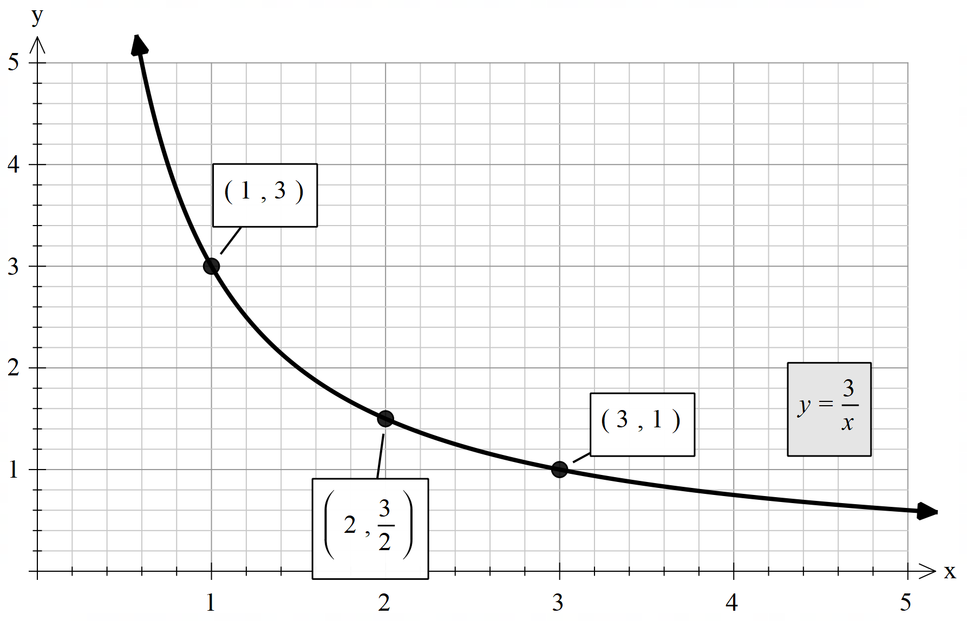
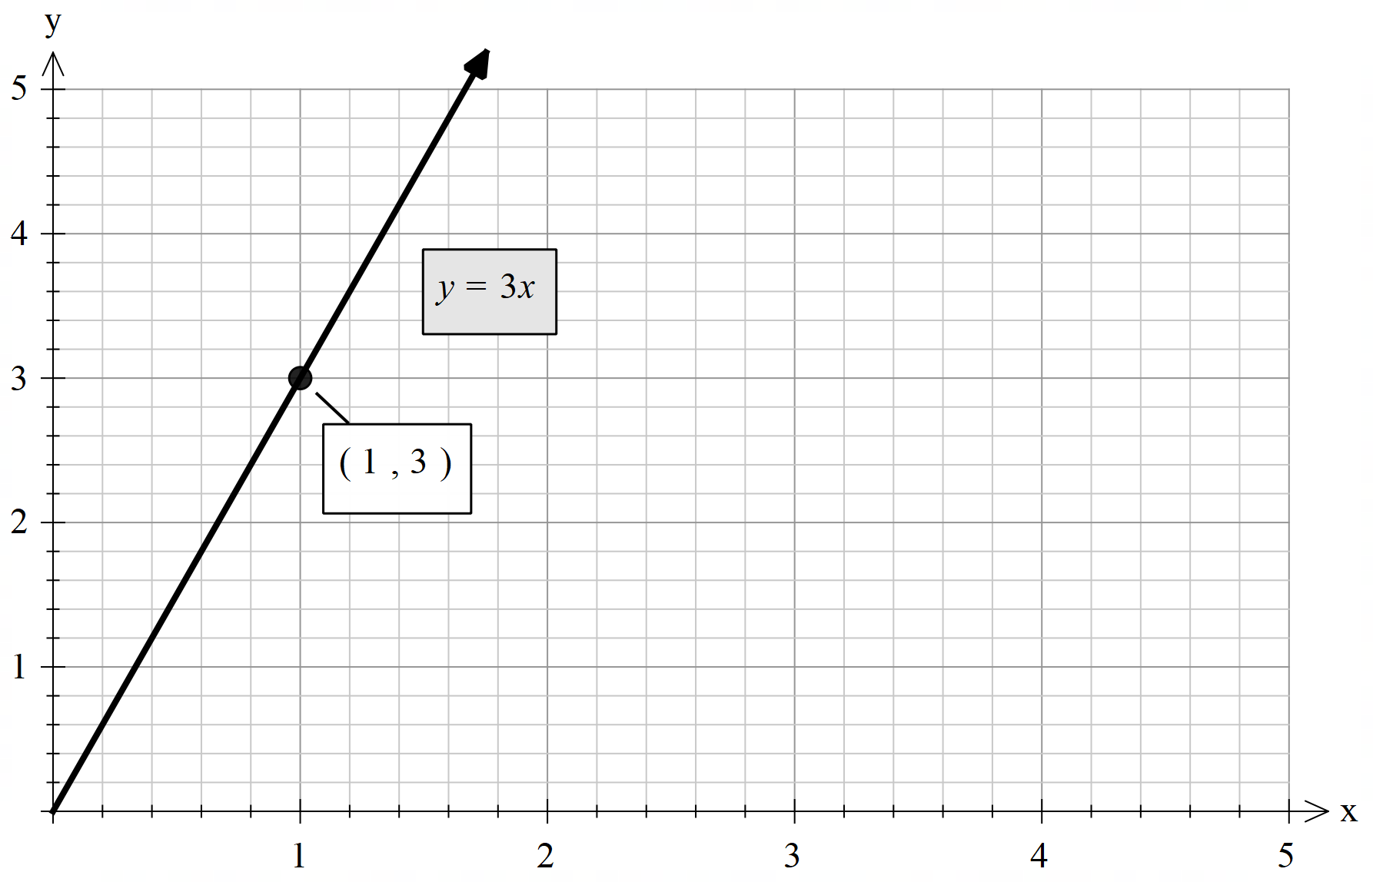
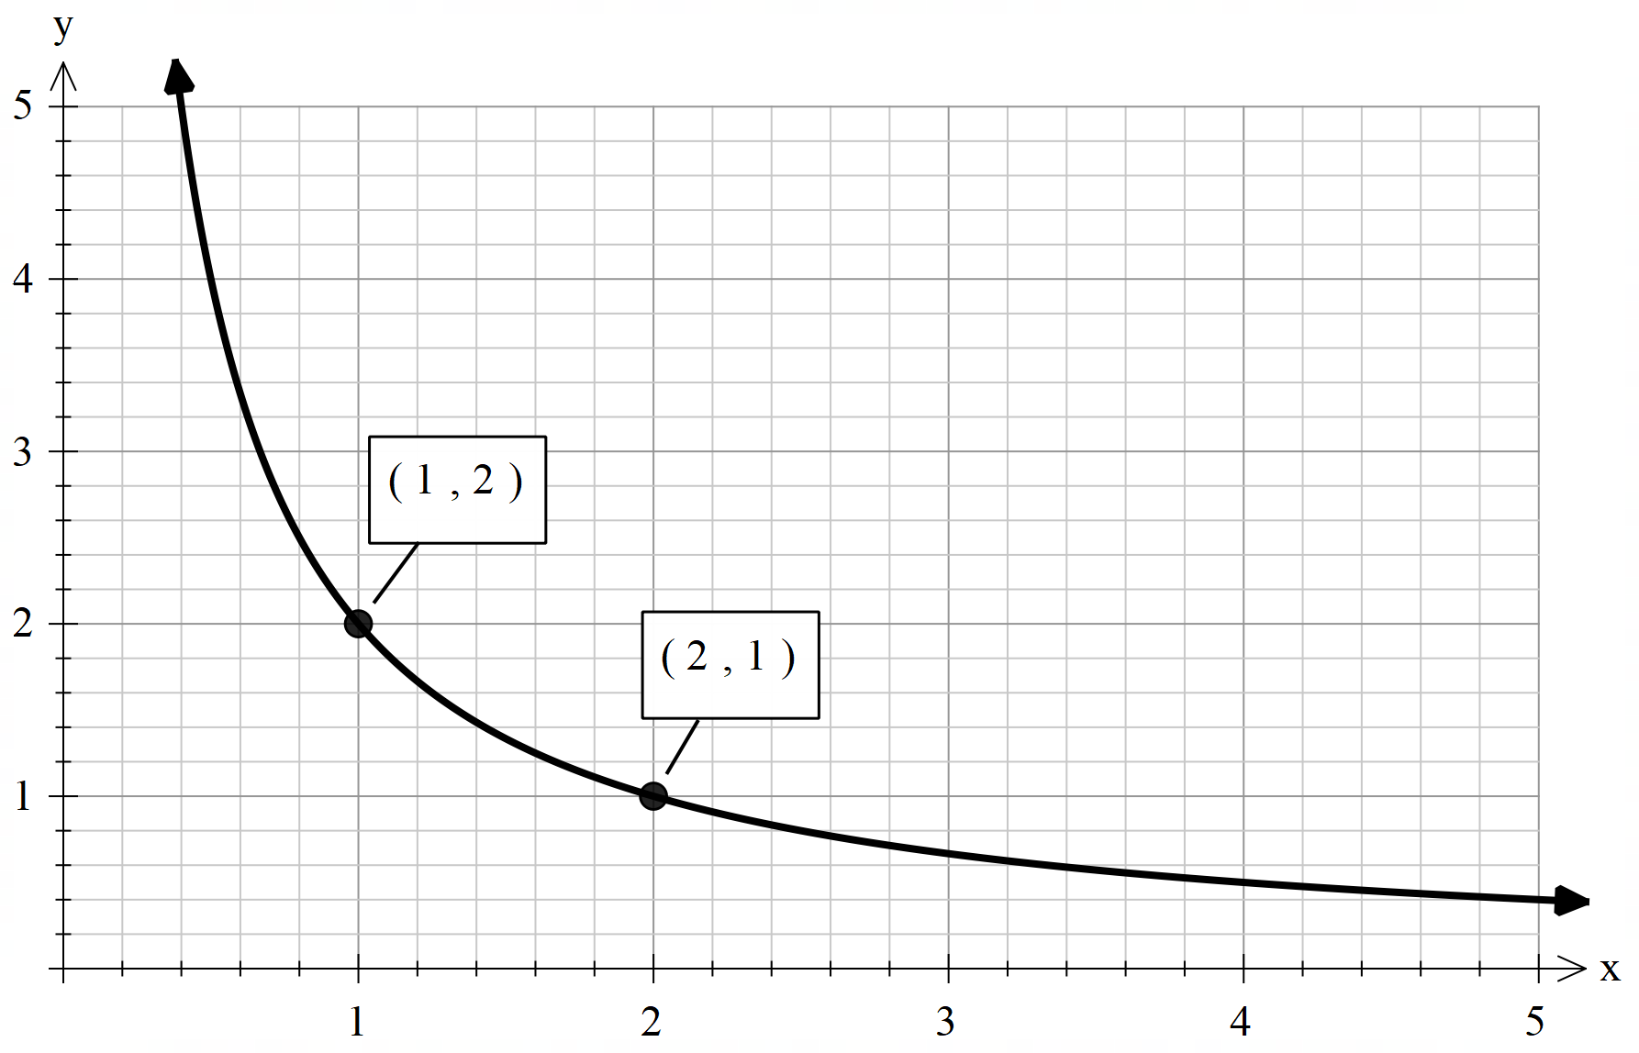
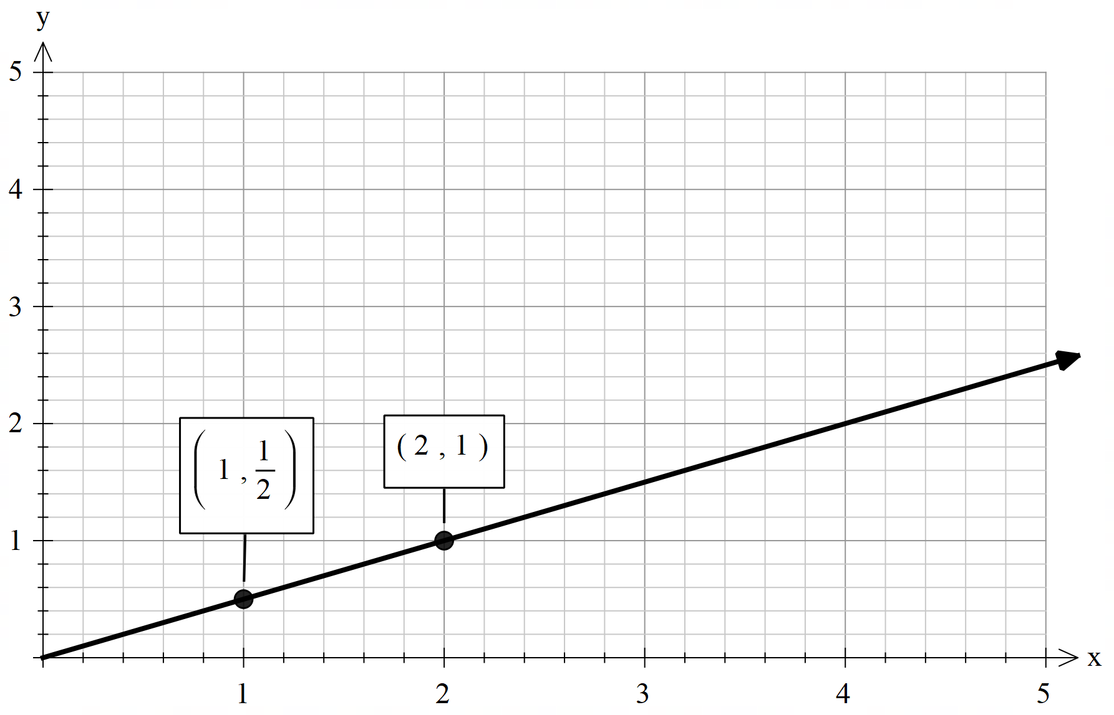
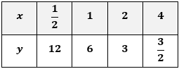
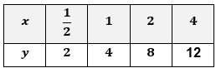
 |  | $$y=30x$$
 |  | $$y=\frac{30}{x}$$

Appendix C

Inverse variation worksheet
- $y∝\frac{1}{x}$. When $x=10, y=10$. Find $y$ when $x=5$.
- $y∝\frac{1}{x}$. When $x=20, y=10$. Find $y$ when $x=5$.
- $y∝\frac{1}{x}$. When $x=20, y=10$. Find $x$ when $y=5$.
- $y$ is inversely proportional to $x$. When $x=20$, $y=100$. Find $y$ when $x=5.$
- $y$ is inversely proportional to $x$. When $x=20$, $y=100$. Find $x$ when $y=5$.
- The distance travelled by plane varies inversely with the speed of the plane. If a plane travels 100 km in 20 minutes, how far will it travel in 5 minutes?
- The time taken to complete a job varies inversely with the number of workers. If 20 workers can complete a job in 100 hours, how long will it take for 10 workers to complete the same job?
Item | Construct an equation | Find the constant of variation | Find the value required | Verify graphically
a.
b.
c.
d.
e.
f.
g.

Catch question:
It is a catch question because:

Appendix D

Shadows experiment

Equipment
- Torch or lamp (one per group)
- Objects to measure
- Card or paper
- Scissors (one per group)
- Ruler (one per group)

Method
- Place an object in front of a wall.
- Darken the room and shine the flashlight on the object. Measure and record the distance between the flashlight and the object as well as the length of the shadow.
- Move the flashlight closer to the object and measure that distance and the length of the shadow again.
- Repeat this process, recording shadow length for a variety of flashlight distances.
- Discuss and plot the data points on a graph.

Sample solutions

Appendix B – direct or inverse variation
Prompt | D or I | Equation | Explanation
Earnings are directly proportional to the number of hours worked. | D | $$E=kh$$ | $E$ represents earnings, $h$ represents number of hours worked. This is direct variation because you earn money per hour.
It costs $6 for 12 eggs and $10 for 20 eggs. | D | $$C=kE$$  $$6=12k$$  $$k=\frac{1}{2}$$  $$C=\frac{1}{2}E$$ | $C$ represents costs in dollars, $E$ represents number of eggs being purchased. This is direct variation because you pay $0.50 per egg.
The number of workers hired to build a house and the time required to build the house. | I | $$t=\frac{k}{w}$$ | $t$ represents time required to build the house, $w$ represents number of workers hired. This is an inverse variation because if you had more workers then the time taken would be less.
The variation relating the time it takes an ice cube to melt in water and the temperature of the water. | I | $$t=\frac{k}{T}$$ | $t$ represents time, $T$ represents temperature. This is inverse because as the temperature increases the time to melt in water will be faster.
The variation relating the distance between 2 locations on a map and the actual distance between the 2 locations. | D | $$A=kd$$ | $A$ represents the actual distance between 2 locations, $d$ represents the distance on the map.
 | I | $$y=\frac{3}{x}$$ | As $x$increases, $y$ approaches 0.
 | D | $$y=3x$$ | As $x$increases, $y$ approaches increases by a gradient of 3.
 | I | $$y=\frac{2}{x}$$ | As $x$increases, $y$ approaches 0.
 | D | $$y=\frac{1}{2}x$$ | As $x$increases, $y$ approaches increases by a gradient of $\frac{1}{2}$.
 | I | $$y=\frac{6}{x}$$ | As $x$increases, $y$ approaches 0.
 | D | $$y=4x$$ | As $x$increases, $y$ approaches increases by a gradient of 4.
The hairdresser charges $30 per haircut. | D | $$y=30x$$ | $y$ represents the total amount of money made by the hairdresser, $x$ represents the number of haircuts done by the hairdresser.
The variation relating the number of chocolates Bob gets with the number of people in their class. | I | $$y=\frac{30}{x}$$ | $y$ represents the number of chocolates Bob gets, $x$ represents the number of people in their class. This is an inverse variation because more people to share with means less chocolates for Bob.

Appendix C – inverse variation worksheet
- $y∝\frac{1}{x}$. When $x=10, y=10$. Find $y$ when $x=5$.
- $y∝\frac{1}{x}$. When $x=20, y=10$. Find $y$ when $x=5$.
- $y∝\frac{1}{x}$. When $x=20, y=10$. Find $x$ when $y=5$.
- $y$ is inversely proportional to $x$. When $x=20$, $y=100$. Find $y$ when $x=5.$
- $y$ is inversely proportional to $x$. When $x=20$, $y=100$. Find $x$ when $y=5$.
- The distance travelled by plane varies inversely with the speed of the plane. If a plane travels 100 km in 20 minutes, how far will it travel in 5 minutes?
- The time taken to complete a job varies inversely with the number of workers. If 20 workers can complete a job in 100 hours, how long will it take for 10 workers to complete the same job?

Item | Construct an equation | Find the constant of variation | Find the value required | Verify graphically
a. | $$y=\frac{k}{x}$$ | $$10=\frac{k}{10}$$  $$k=100$$  $$y=\frac{100}{x}$$ | $$y=\frac{100}{5}$$  $$y=20$$ | 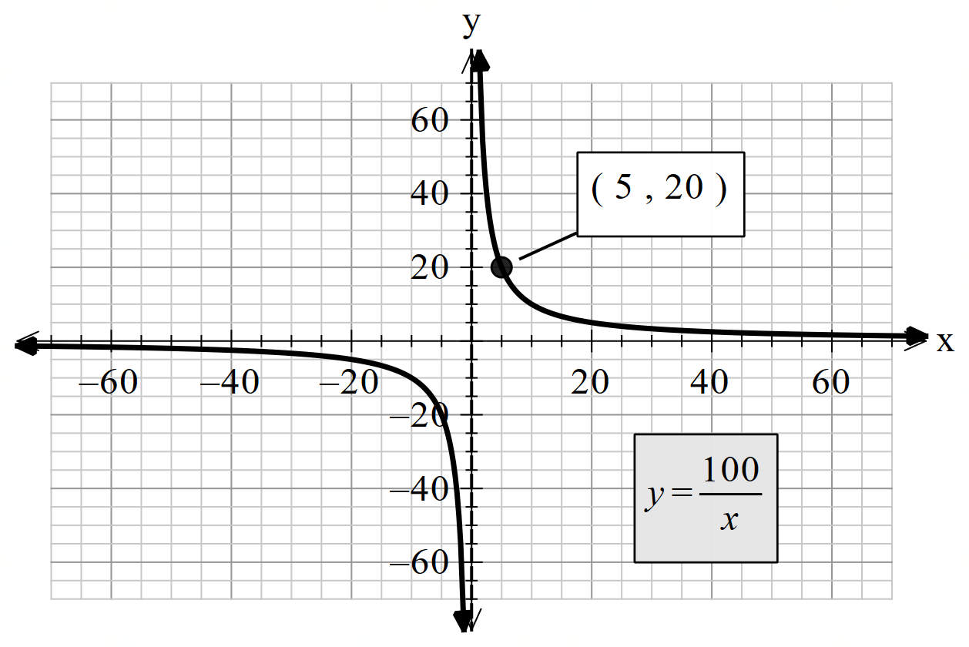
b. | $$y=\frac{k}{x}$$ | $$10=\frac{k}{20}$$  $$k=200$$  $$y=\frac{200}{x}$$ | $$y=\frac{200}{5}$$  $$y=40$$ | 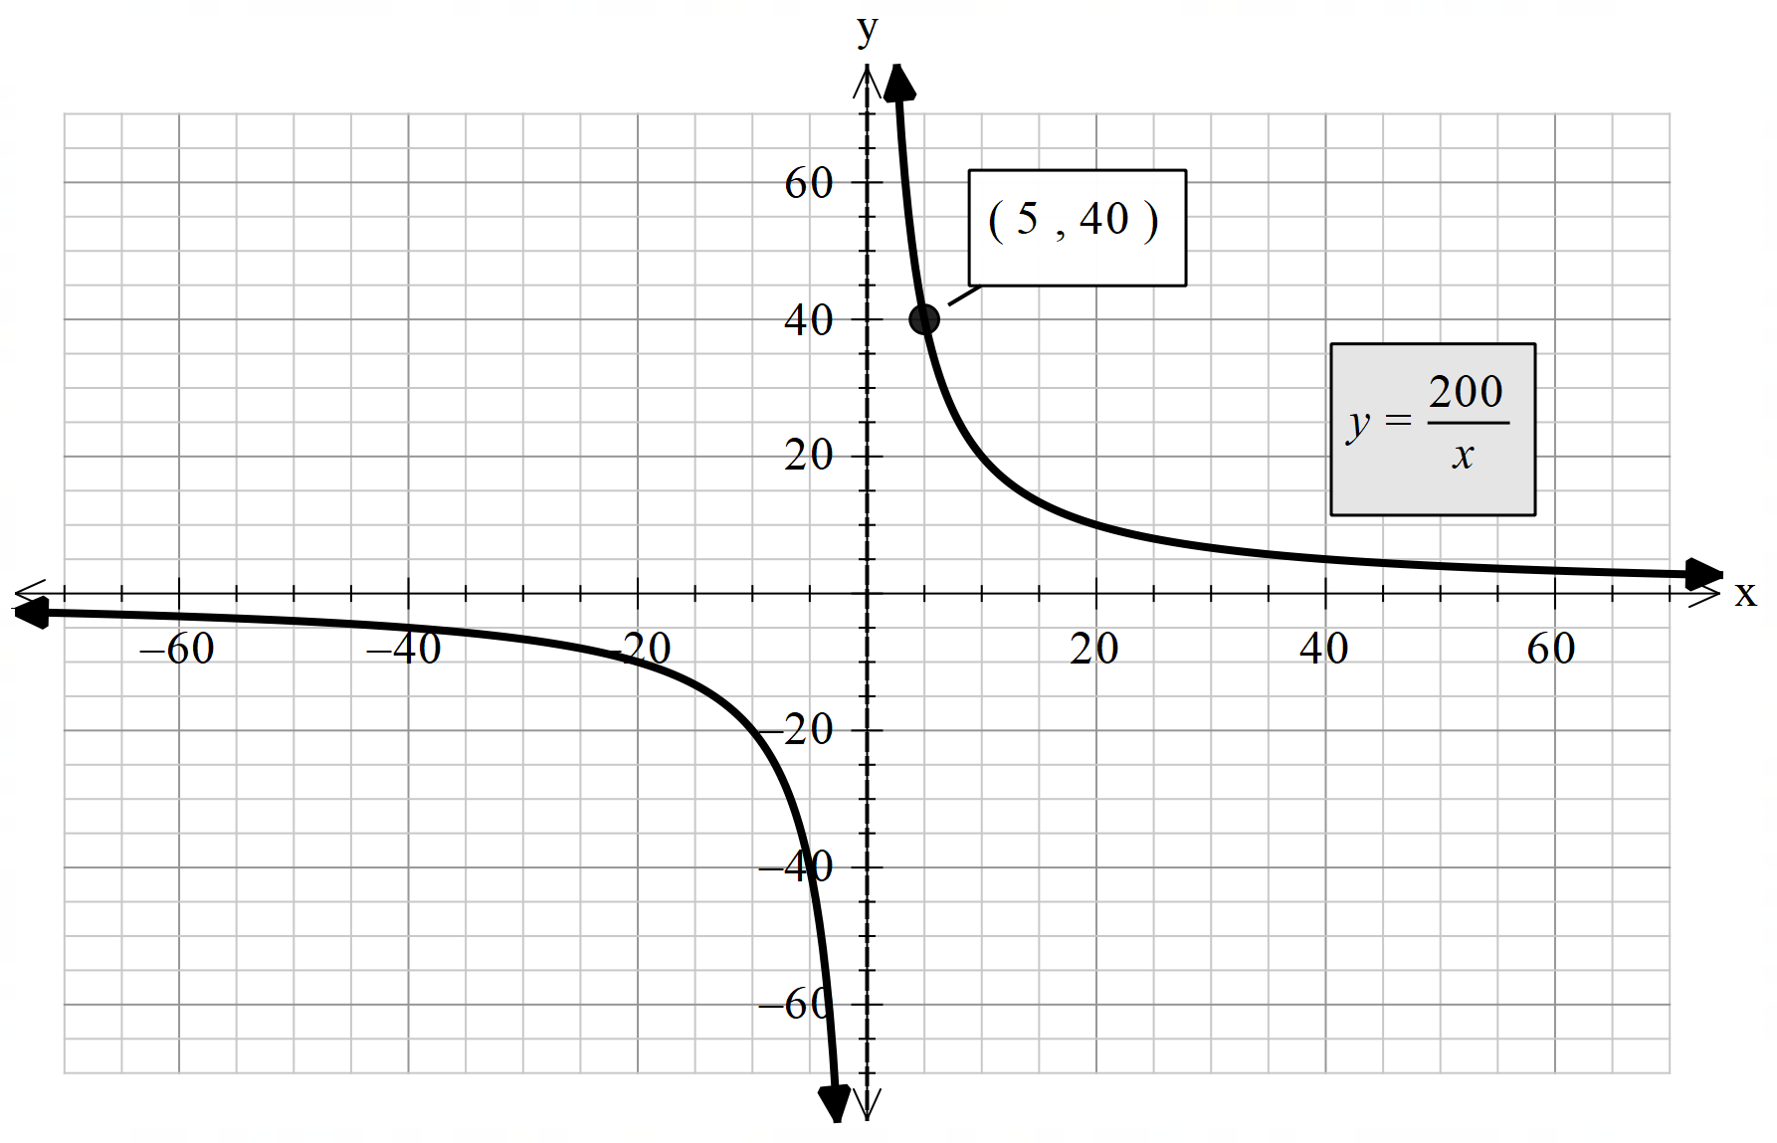
c. | $$y=\frac{k}{x}$$ | $$10=\frac{k}{20}$$  $$k=200$$  $$y=\frac{200}{x}$$ | $$5=\frac{200}{x}$$  $$x=\frac{200}{5}$$  $$x=40$$ | 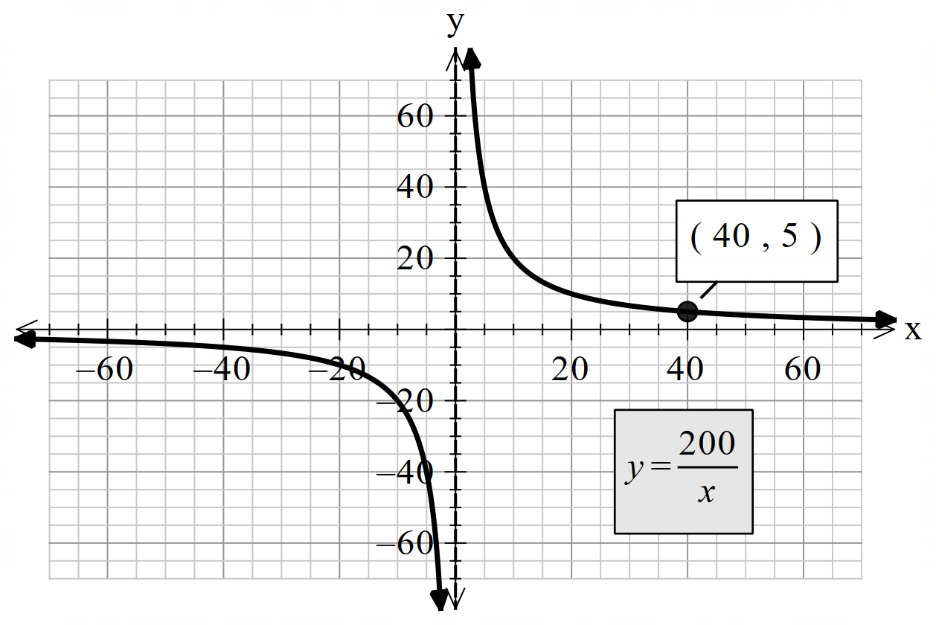
d. | $$y=\frac{k}{x}$$ | $$100=\frac{k}{20}$$  $$k=2000$$  $$y=\frac{2000}{x}$$ | $$y=\frac{2000}{5}$$  $$y=400$$ | 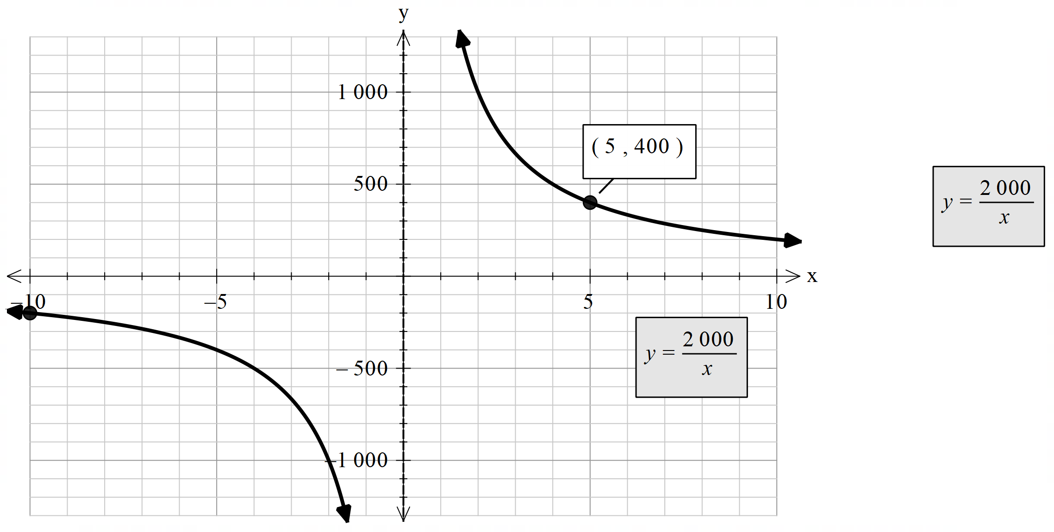  Students may need to restrict the domain to clearly see their graph.
e. | $$y=\frac{k}{x}$$ | $$100=\frac{k}{20}$$  $$k=2000$$  $$y=\frac{2000}{x}$$ | $$5=\frac{2000}{x}$$  $$x=\frac{2000}{5}$$  $$x=400$$ | 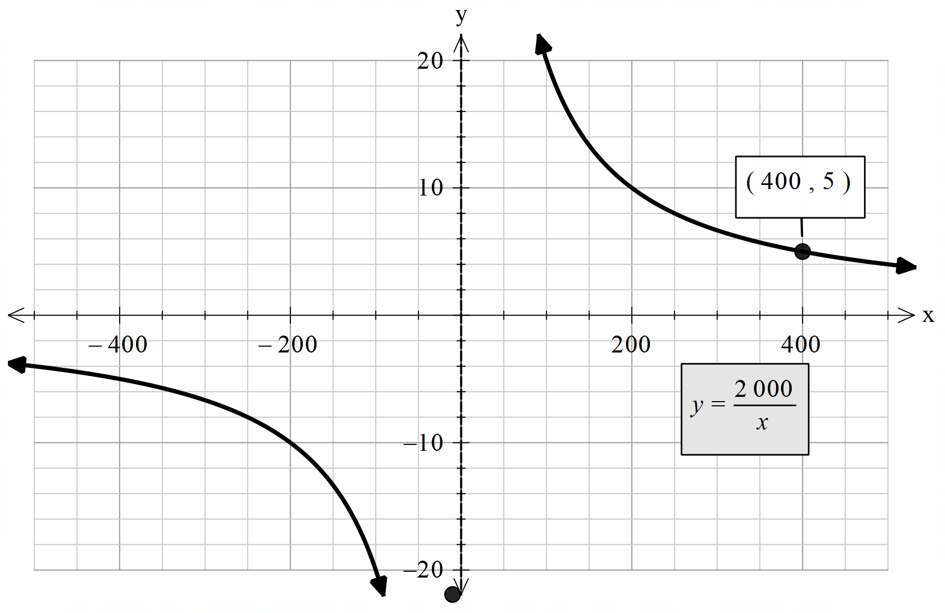  Students may need to restrict the range to clearly see their graph.
f. | Catch question.  Distance is directly proportional to speed, not inversely proportional.  Can be solved as a direct variation problem.  $$d=kv$$ | $$100=20k$$  $$k=\frac{100}{20}$$  $$k=5$$  $$d=5v$$ | $$d=5×5$$  $$d=25 km$$ | 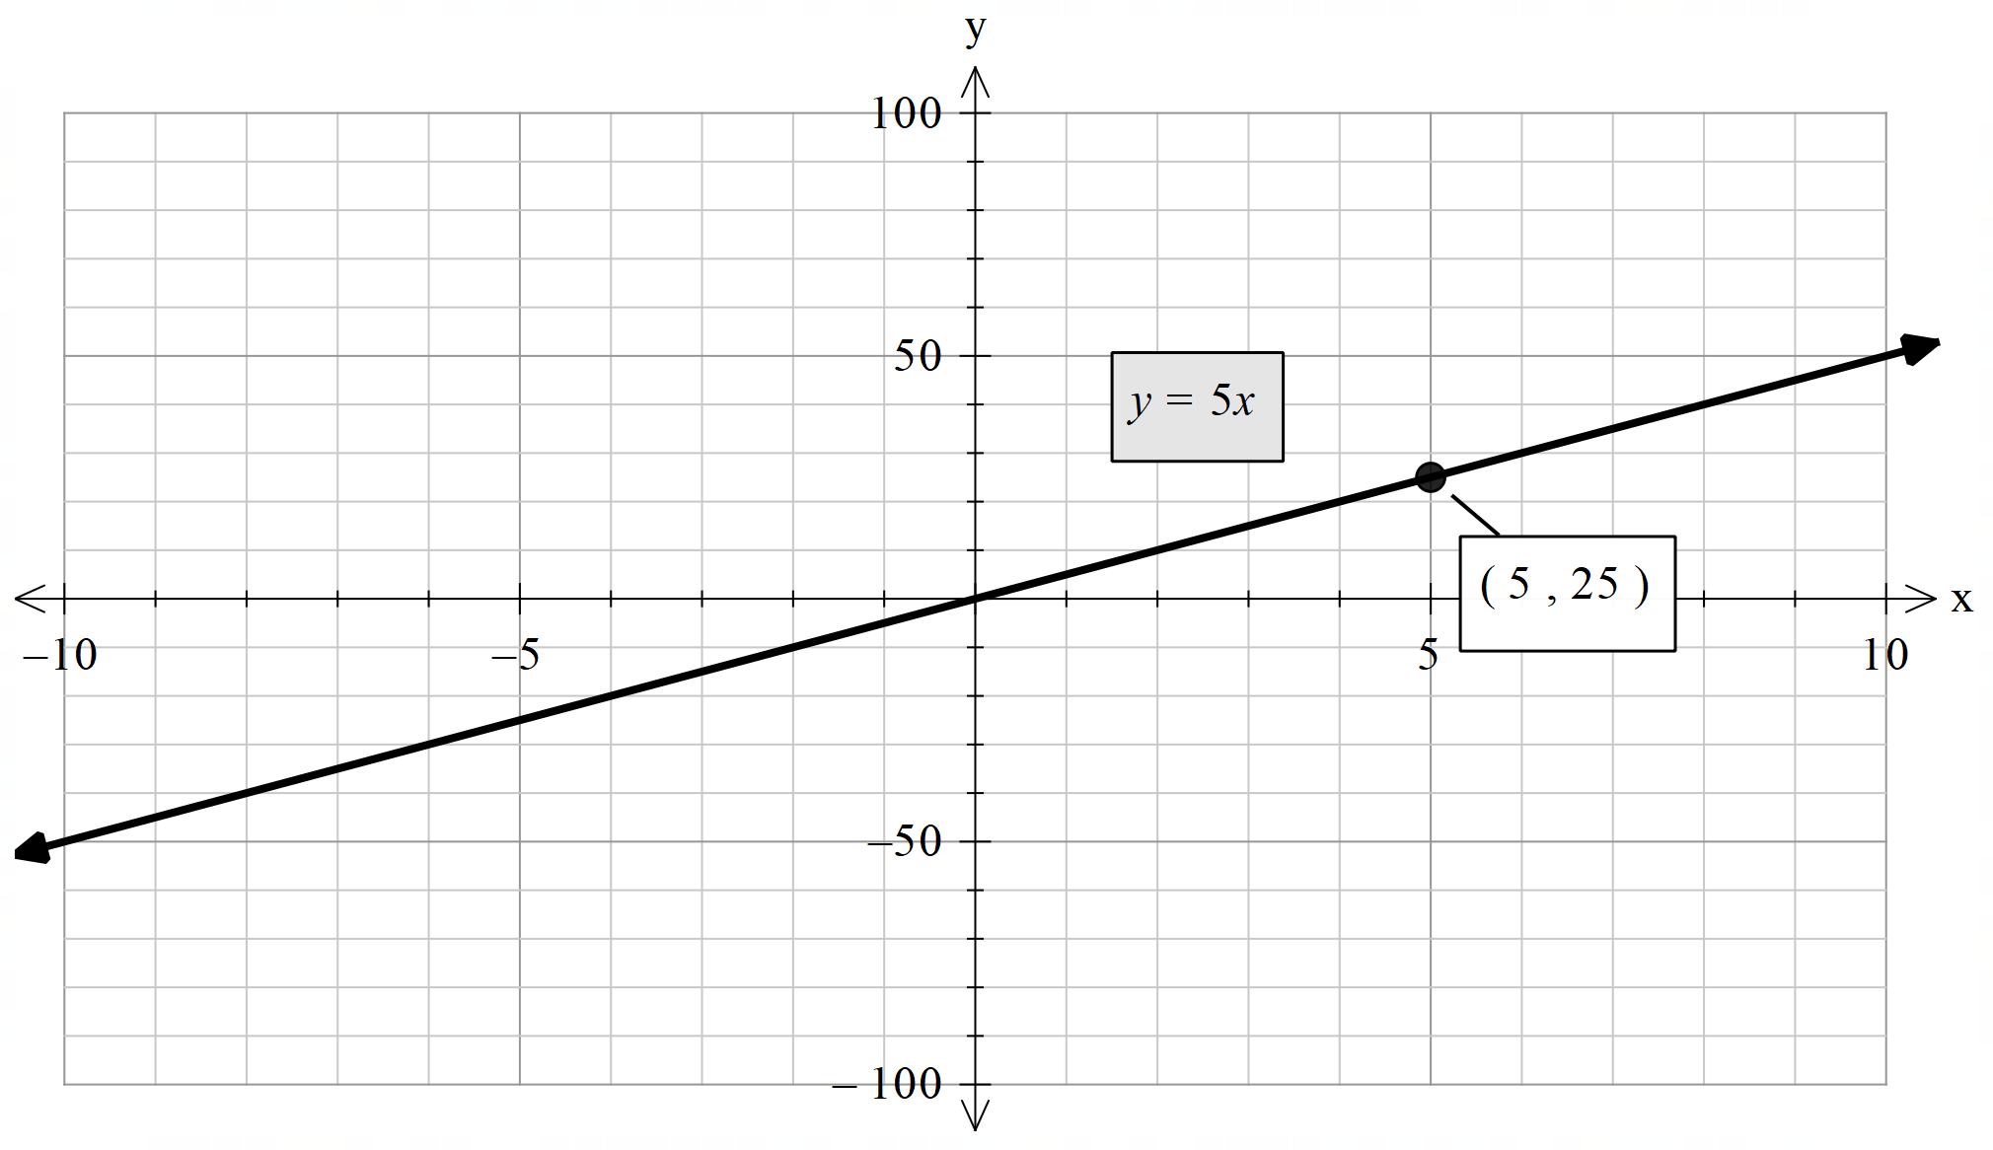
g. | $$t=\frac{k}{w}$$  Where $t=$ time and $w=$ number of workers. | $$100=\frac{k}{20}$$  $$k=2000$$  $$t=\frac{2000}{w}$$ | $$t=\frac{2000}{10}$$  $t=200$ hours | 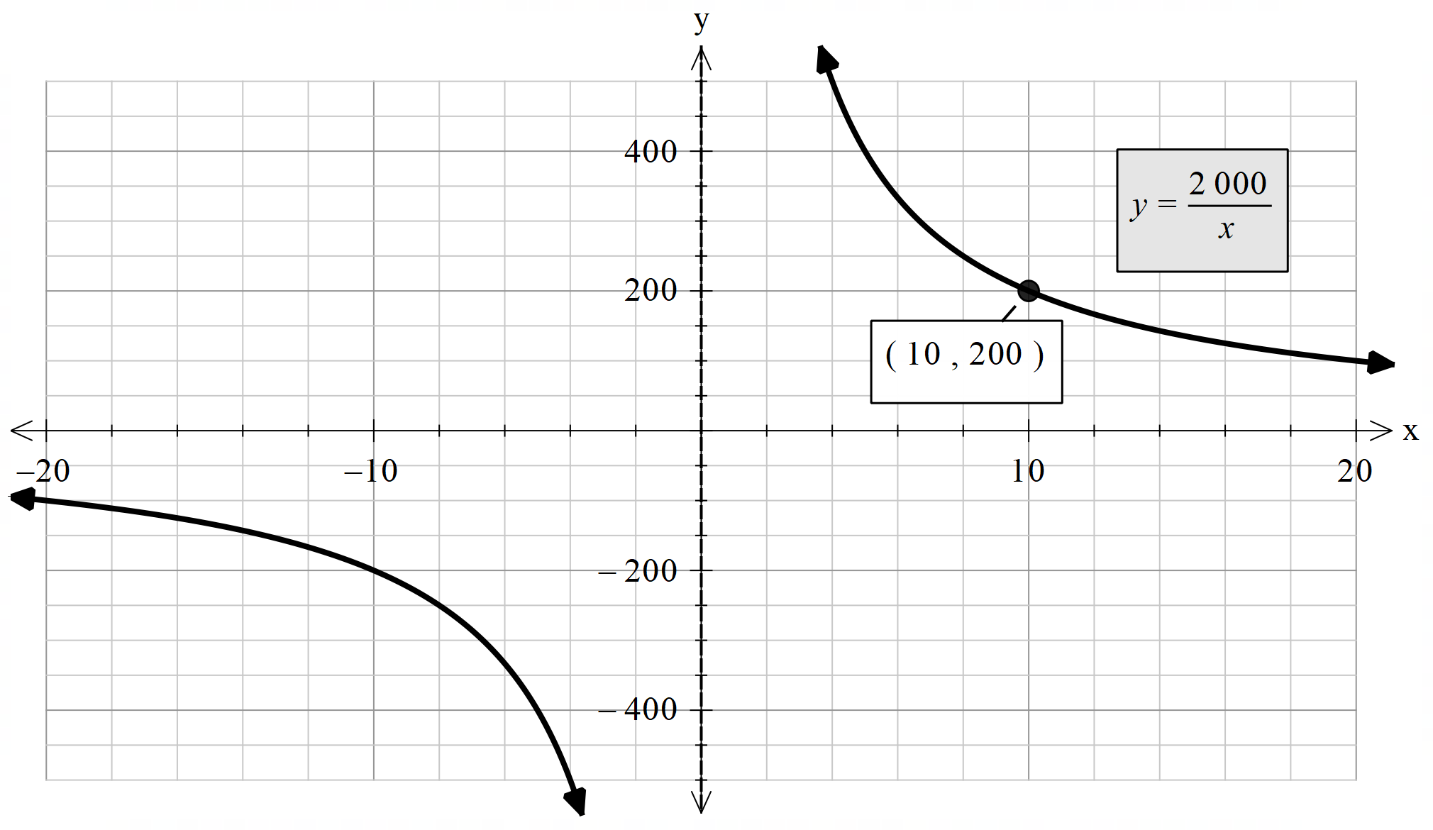

Catch question: | f
It is a catch question because: | f is an example of direct variation not inverse variation.

References
This resource contains NSW Curriculum and syllabus content. The NSW Curriculum is developed by the NSW Education Standards Authority. This content is prepared by NESA for and on behalf of the Crown in right of the State of New South Wales. The material is protected by Crown copyright.
Please refer to the NESA Copyright Disclaimer for more information https://educationstandards.nsw.edu.au/wps/portal/nesa/mini-footer/copyright.
NESA holds the only official and up-to-date versions of the NSW Curriculum and syllabus documents. Please visit the NSW Education Standards Authority (NESA) website https://educationstandards.nsw.edu.au/ and the NSW Curriculum website https://curriculum.nsw.edu.au.
Mathematics K–10 Syllabus © NSW Education Standards Authority (NESA) for and on behalf of the Crown in right of the State of New South Wales, 2022.
© State of New South Wales (Department of Education), 2024
The copyright material published in this resource is subject to the Copyright Act 1968 (Cth) and is owned by the NSW Department of Education or, where indicated, by a party other than the NSW Department of Education (third-party material).
Copyright material available in this resource and owned by the NSW Department of Education is licensed under a Creative Commons Attribution 4.0 International (CC BY 4.0) license.
This license allows you to share and adapt the material for any purpose, even commercially.
Attribution should be given to © State of New South Wales (Department of Education), 2024.
Material in this resource not available under a Creative Commons license:
- the NSW Department of Education logo, other logos and trademark-protected material
- material owned by a third party that has been reproduced with permission. You will need to obtain permission from the third party to reuse its material.
Links to third-party material and websites
Please note that the provided (reading/viewing material/list/links/texts) are a suggestion only and implies no endorsement, by the New South Wales Department of Education, of any author, publisher, or book title. School principals and teachers are best placed to assess the suitability of resources that would complement the curriculum and reflect the needs and interests of their students.
If you use the links provided in this document to access a third-party's website, you acknowledge that the terms of use, including licence terms set out on the third-party's website apply to the use which may be made of the materials on that third-party website or where permitted by the Copyright Act 1968 (Cth). The department accepts no responsibility for content on third-party websites.

