Monty Hall
Students explore the Monty Hall problem to discover that sometimes probabilities do not work out how people expect. Students create a simulation to demonstrate how probability can help us make predictions.
Students have the option to use at least one digital device per pair in the apply section.

Visible learning

Learning intentions
- To use a probability simulation to predict future events.
- To challenge common misconceptions relating to chance experiments.

Success criteria
- I can design and conduct a probability simulation.
- I can display my simulation results using tables and graphs.
- I can apply reasoning to evaluate the results of a probability simulation.

Syllabus outcomes
A student:
- develops understanding and fluency in mathematics through exploring and connecting mathematical concepts, choosing and applying mathematical techniques to solve problems, and communicating their thinking and reasoning coherently and clearly MAO-WM-01
- solves problems involving probabilities in multistage chance experiments and simulations MA5-PRO-C-01
Mathematics K–10 Syllabus © NSW Education Standards Authority (NESA) for and on behalf of the Crown in right of the State of New South Wales, 2022.

Activity structure
Please use the associated PowerPoint Monty Hall to display images in this lesson.

Launch
- Display Monty Hall Problem Simulator (montyhall.io) as students enter the classroom.
- Select Rules to display the rules for the game, as shown below.
Rules of play
The goal of this game is to choose the winning door from 3 available doors. Behind the winning door is a new car, and behind the other 2 doors are goats.
First, the player must choose one of the 3 doors.
Next, the game show host will reveal a goat from behind one of the other 2 doors (the host always knows where the car is and will never reveal it).
Lastly, the player can either open the door they chose first, or they can switch to the other closed door. If the door they open reveals a new car, the player wins!
- Randomly select students to choose a door number, then after a goat is revealed decide if they want to stay or switch.
- Repeat with as many students as is reasonable.
You could choose to bring in lollies as prizes for students who win the car.
- In a Think-Pair-Share (bit.ly/thinkpairsharestrategy), students are to discuss:
- Does swapping or staying change your chances of winning?
- Complete this conjecture: ‘If I choose door 1, then a goat is revealed behind door 3, I should…’
Students may not be familiar with the term conjecture. A conjecture is a mathematical statement that appears to be true but has not been proven yet.
- Explain this problem is one of the most well-known maths problems in the world. It is called the Monty Hall problem, named after the host of the TV game show ‘Let’s make a deal’ (1963). Explain that the mathematics behind the Monty Hall problem has caused a lot of debate ever since and in this lesson, students will be using probability to help them choose which door they should select.

Explore
- Students are to design and use their own simulations to test their conjecture. Groups could use a deck of cards, drawings on the back of paper, coloured counters under cups, a spreadsheet or any other means to create their simulations.
Teachers will need to have paper, cards, cups and coloured counters available for students to use during the lesson.
- Assign visibly random groups of 3 (bit.ly/visiblegroups) and provide each group with their chosen resources and a vertical non-permanent surface (bit.ly/VNPSstrategy) to work at.
- Groups conduct as many trials as they think they need to consolidate their conjecture.
- Ask students assessing and advancing questions to further student thinking.
Assessing questions draw out students’ thinking about a problem and what methods they have tried so far.
Advancing questions are intended to help move students’ thinking forward toward the lesson goals. We want to draw their attention to something they may not have noticed or considered yet.

Question suggestions are included below:
Table 1 – examples of assessing and advancing questions
Assessing questions | Advancing questions
How are you displaying or recording your data? | Is your simulation a fair representation of the problem? Why or why not?
How many trials have you done so far? | How confident are you in your conjecture?  Would you bet $100 on it?
Which do you think is the better decision, to stay or switch? Why do you say that. | What if we changed the number of doors? Would that change your answer?
- Once students have their data, ask students to recall different ways in which probability data can be displayed. Discuss as a class which representation would be best for this data.
If students need guidance, the teacher could recommend a 2-way table with columns ‘Stay and Swap’ and rows ‘Win and Loss’, keeping in mind 2-way tables are Path content that will be explored later in the unit.
- Have groups display their data on their vertical whiteboards leaving room for a graph underneath.
- Explain to students that as part of supporting their conjecture, graphs are often drawn to represent the data visually. Allow groups time to create a graph and present it under their data on the vertical whiteboards.
The graph could be a column graph with horizontal axis as stay or switch and the vertical axis of number of wins. Other options include but are not limited to a sector graph, a dot plot or an infographic.
- Conduct a gallery walk (bit.ly/DLSgallerywalk) for students to view the trials created by their peers and the results of each trial. Have students focus on similarities and differences between the different groups’ data.
- Randomly select students to share what was similar or different in the results they observed during the gallery walk.

Summarise
- Provide students some more information on the history of the Monty Hall problem and why it is so well known:
It wasn't until September of 1990 that this problem really became popular. Marilyn vos Savant was known from 1986 to 1989 for having the highest IQ in the world, according to the Guinness Book of World Records. In the September 9 1990, issue of Parade magazine, vos Savant argued that the contestant should switch doors, because in switching, the contestant has moved from a 1/3 chance of winning the car to a 2/3 chance of winning the car. Her answer sparked a national debate regarding this problem. Experienced mathematicians wrote letters to vos Savant arguing against her initial answer, and these letters invited a second column from vos Savant, causing more of a stir and leading to a front-page article in The New York Times.
- Print and distribute a copy of Appendix A ‘Monty Hall sample space’ to pairs of students. Pairs are to recreate vos Savant’s reasoning by completing the table of outcomes and finding the probabilities listed underneath.
- Share the following information with the students.
Despite vos Savant’s logic and the numerous simulations like students have created today, the majority of people show a strong tendency to stay with their initial choice (Burns and Wieth 2004). Research shows that staying percentages range between 79% and 87% (Granberg 1999). Even when people were asked to complete repeated trials of the Monty Hall problem, staying percentages remained relatively high (Granberg and Dorr 1998).
- In a Think-Pair-Share, students discuss:
- Why do you think people tend to stay with their initial choice?
- Are you convinced that you should always switch? Why or why not?
- If you were trying to convince someone that they have better odds by switching, how would you convince them?

Apply
- Display the Advanced Monty Hall interactive activity (bit.ly/advancedmontyhall).
- Model selecting a door, revealing a pig behind another door, and deciding whether to stay or switch, as before.
- Add additional doors by selecting the right arrow above the doors. Model that as more doors are added, pigs are revealed to be behind all but one door, then as before, students decide whether to stay or switch.
- With one digital device between each pair, direct students to the Advanced Monty Hall interactive activity (bit.ly/advancedmontyhall).
- Pairs should play a few rounds with each number of doors, then they can run simulations under the ‘Multiple runs’ heading.
- Use a questioning strategy such as Pose-Pause-Pounce-Bounce question strategy (PDF 557KB) (bit.ly/posepausepouncebounce) to have students share their thoughts on the following prompts:
- How did you expect the probability of winning to change as you introduced more doors?
- What do you suppose would happen if you continued to add doors?
- Could there be a number of doors when switching would win 100% of the time?
- Finalise by concluding that the reasoning behind switching becomes more evident when doors are added.
- Lead students through the explanation for 100 doors using the explanation below. Figures 1–3 can be displayed using the associated PowerPoint Monty Hall on slides 2–4.
Figure 1 – 100 doors
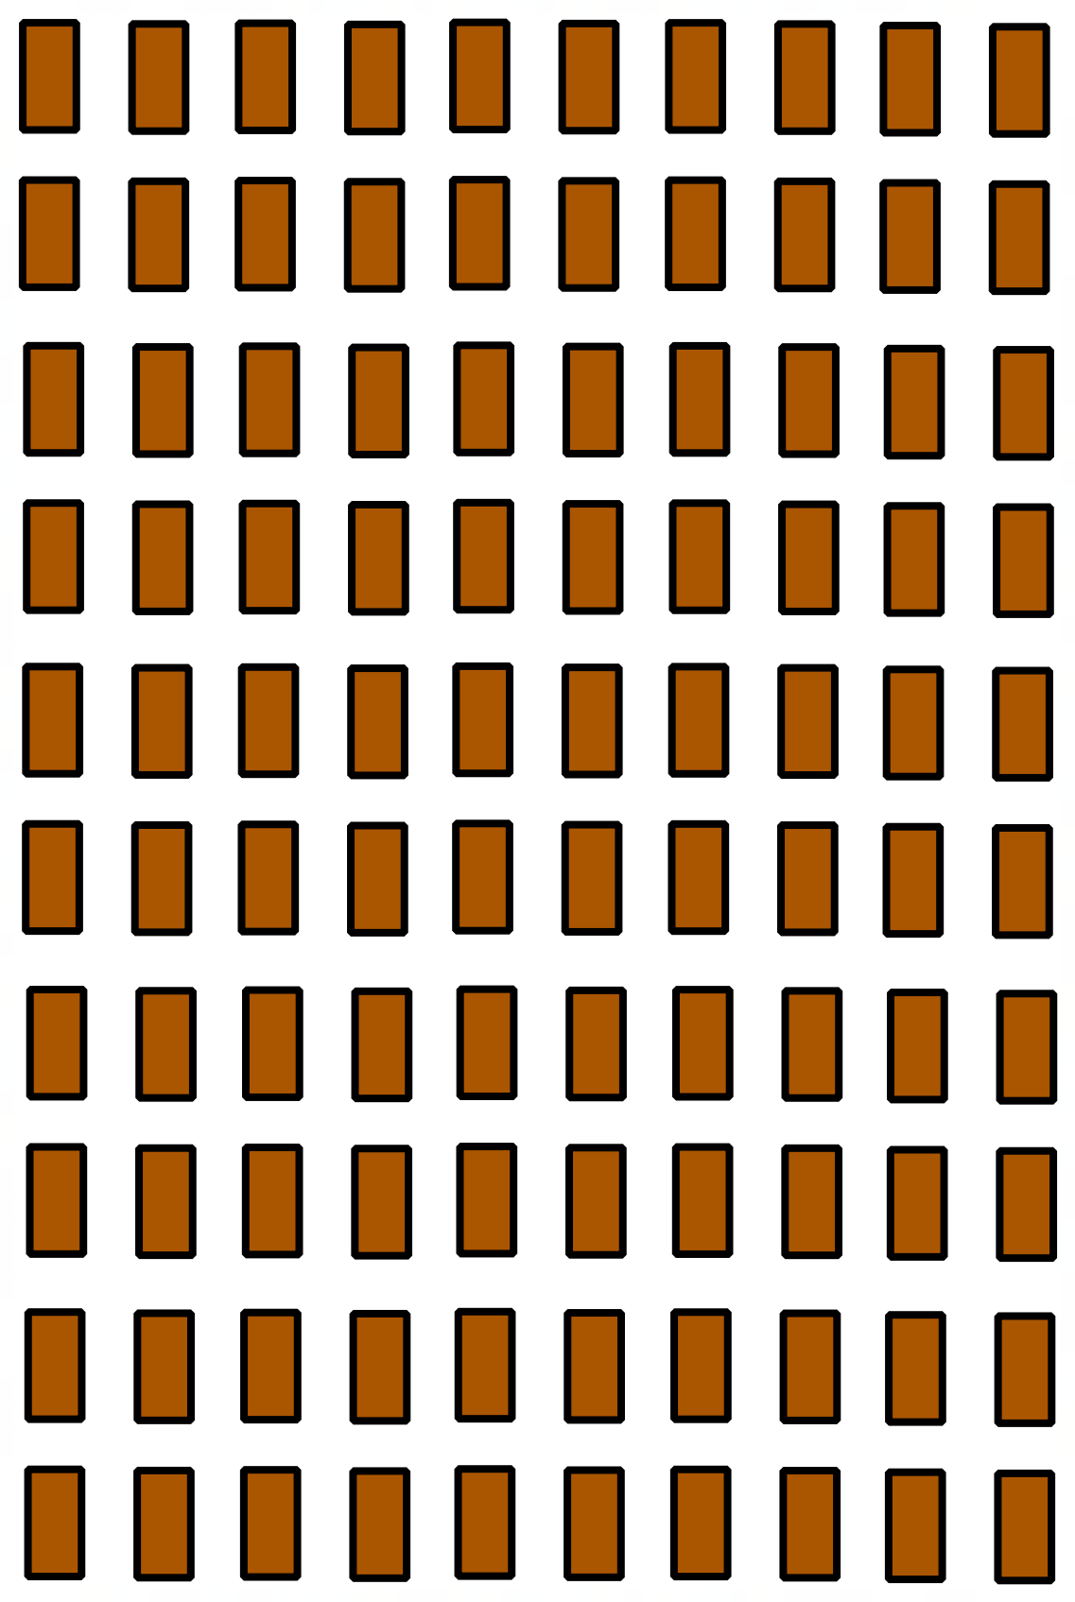
If you chose this door. What is the probability you chose the prize?
Figure 2 – one door selected
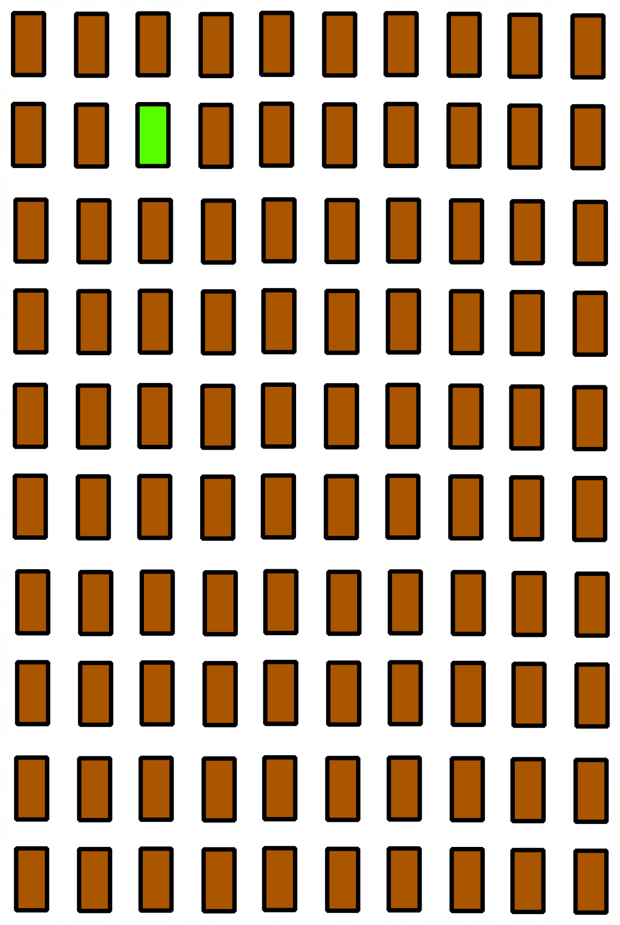
Monty reveals 98 doors that he is certain do not conceal the prize. This leaves 2 remaining doors, the one you initially chose and one that remained after Monty excluded the rest.
Figure 3 – two doors remain
Now when given the choice, would you stay or switch?

Assessment and differentiation

Suggested opportunities for differentiation
Explore
- Students could create a computer simulation to model the problem.
- Students could be introduced to 2-way tables and how to create them, keeping in mind this is Path content.
- Students could be challenged to create a tree diagram to model the problem.
- Visual representations are used to assist students with their understanding when comparing data. Students might need to be reminded of which graphs are available to them and when it is best to use each.
Summarise
- Students could find different research papers on the Monty Hall problem or the history behind the problem.
Apply
- Students could be introduced to the Bayer Theorem and use it to calculate the probabilities for different door numbers.

Suggested opportunities for assessment
Explore
- Monitor responses in group discussions to check for student understanding of simulations and why they are used.
- When placed in groups of 3, students provide and receive peer feedback on their understanding.
Summarise
- A Think-Pair-Share provides students with the opportunity to reflect on their understanding.

Appendix A

Monty Hall sample space
Complete the table below, listing all possible combinations.
Your pick | Prize door | Stay | Switch
Door 1 | Door 1 | Win | Lose
By referring to your table:
- Find the probability that you win if you stay.

- Find the probability that you win if you switch.

Sample solutions

Appendix A – Monty Hall sample space
Complete the table below, listing all possible combinations.
Your pick | Prize door | Stay | Switch
Door 1 | Door 1 | Win | Lose
Door 1 | Door 2 | Lose | Win
Door 1 | Door 3 | Lose | Win
Door 2 | Door 1 | Lose | Win
Door 2 | Door 2 | Win | Lose
Door 2 | Door 3 | Lose | Win
Door 3 | Door 1 | Lose | Win
Door 3 | Door 2 | Lose | Win
Door 3 | Door 3 | Win | Lose
By referring to your table:
- Find the probability that you win if you stay.
$$P\left(Win if you stay\right)=\frac{3}{9}$$
- Find the probability that you win if you switch.
$$P\left(Win if you switch\right)=\frac{6}{9}$$

References
This resource contains NSW Curriculum and syllabus content. The NSW Curriculum is developed by the NSW Education Standards Authority. This content is prepared by NESA for and on behalf of the Crown in right of the State of New South Wales. The material is protected by Crown copyright.
Please refer to the NESA Copyright Disclaimer for more information https://educationstandards.nsw.edu.au/wps/portal/nesa/mini-footer/copyright.
NESA holds the only official and up-to-date versions of the NSW Curriculum and syllabus documents. Please visit the NSW Education Standards Authority (NESA) website https://educationstandards.nsw.edu.au/ and the NSW Curriculum website https://curriculum.nsw.edu.au/.
Mathematics K–10 Syllabus © NSW Education Standards Authority (NESA) for and on behalf of the Crown in right of the State of New South Wales, 2022.
Johnson B (2009) The Monty Hall problem [PDF 400 KB], University of Nebraska-Lincoln, accessed 29 February 2024.

© State of New South Wales (Department of Education), 2024
The copyright material published in this resource is subject to the Copyright Act 1968 (Cth) and is owned by the NSW Department of Education or, where indicated, by a party other than the NSW Department of Education (third-party material).
Copyright material available in this resource and owned by the NSW Department of Education is licensed under a Creative Commons Attribution 4.0 International (CC BY 4.0) license.
This license allows you to share and adapt the material for any purpose, even commercially.
Attribution should be given to © State of New South Wales (Department of Education), 2024.
Material in this resource not available under a Creative Commons license:
- the NSW Department of Education logo, other logos and trademark-protected material
- material owned by a third party that has been reproduced with permission. You will need to obtain permission from the third party to reuse its material.
Links to third-party material and websites
Please note that the provided (reading/viewing material/list/links/texts) are a suggestion only and implies no endorsement, by the New South Wales Department of Education, of any author, publisher, or book title. School principals and teachers are best placed to assess the suitability of resources that would complement the curriculum and reflect the needs and interests of their students.
If you use the links provided in this document to access a third-party's website, you acknowledge that the terms of use, including licence terms set out on the third-party's website apply to the use which may be made of the materials on that third-party website or where permitted by the Copyright Act 1968 (Cth). The department accepts no responsibility for content on third-party websites.

