Health and movement science Stage 6 (Year 11)
Collaborative investigation logbook – student guide
Contents
Overview 2
Purpose 3
How will my logbook be used by my teacher? 4
Sample reflection words 5
‘I can’ or ‘I have’ statements 7
Additional information 9
Support and alignment 9
References 11
This resource has been developed to assist teachers in NSW Department of Education schools to create learning that is contextualised to their classroom. It can be used as a basis for the teacher’s own program, assessment, or scope and sequence, or be used as an example of how the new curriculum could be implemented. The resource has suggested timeframes that may need to be adjusted by the teacher to meet the needs of their students.

Overview
A logbook is a tool used to record and monitor collaboration in a group context. You will use a logbook to reflect on your learning and record observations throughout a health and movement science collaborative investigation.
Figure 1 – collaborative investigation 10-step process
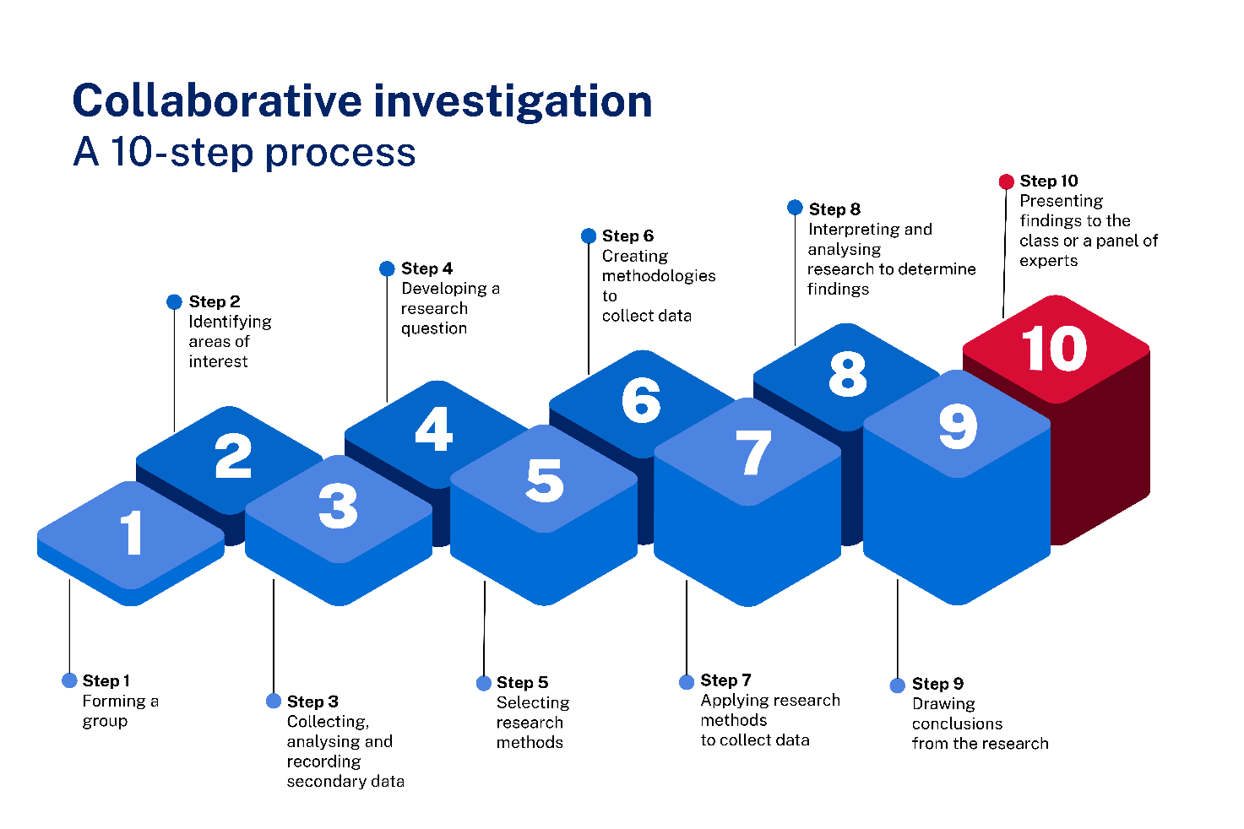
By the end of the collaborative investigation, your logbook should be filled with reflective writing, evaluation, ideas and opinions. These could include:
- responses and reflections on draft work in relation to your role or the group’s progress, such as research, plans and/or analysis
- images, diagrams or verbal responses in written or digital format, or other ways, to communicate creatively about aspects of the collaboration and group work
- reflections and evaluations of group cohesion, decision making, risks, challenges and solutions throughout the process.

Purpose
Learning is an active process which involves talking to people, sharing ideas, clarifying thoughts and building your own knowledge. Throughout health and movement science years 11–12, you will be assessed on your ability to collaborate and demonstrate the collaboration outcome (HM-11-05).
Your logbook is a working record of your reflections, evaluations, ideas and opinions. It is also a way for you to let your teacher know how you are developing the skills needed to positively interact with others and work together to develop your understanding of the health and movement science concepts.
Your teacher may give you structured questions or ask you to use the sample statements to reflect and answer at certain points in the collaborative investigation. For example, prior to starting the investigation, at 2 points during the investigation and at the end of the investigation. This gives teachers multiple points of evidence to collect and respond to, so that groups and individuals can work most effectively. These reflections will be done as part of your logbook. Additional reflections and contributions are important. The best way to use your logbook is to contribute to it in the last 10 minutes of the lesson or for homework on the same day.
Recording in your logbook regularly is important because it is a chance to reflect on your learning and create a record of your engagement in the collaborative investigation. Using your logbook allows you to:
- develop your skills in speculating, critiquing, analysing, interpreting and constructing possible meanings for your own and others’ health, physical activity levels and performance
- record and reflect on your experiences to positively interact with others and work collaboratively to reach agreements and decisions
- record and reflect on your ability to manage your own learning and to become flexible, critical thinkers, problem-solvers and decision-makers
- record and reflect on your experiences to negotiate plans and tasks, distribute leadership, and create and maintain a positive group environment
- record and reflect how you can work with others and maintain the academic integrity of your own work
- offer constructive feedback and critical analysis of your own work and the work of others
- keep track of the development of your collaborative investigation
- celebrate your achievements in the collaborative investigation product and process
- share your feelings and experiences as you progress in the collaborative investigation.

How will my logbook be used by my teacher?
Your logbook will help your teacher to:
- get to know how you learn and work with others
- gain insight into your contributions to the collaborative investigation product and process
- get another perspective on your collaborative process
- assess strategies and actions that may not always be visible in lessons
- identify your strengths and areas for improvement in your writing and work with others
- learn from your honest evaluation of the learning experiences and make adjustments
- celebrate your strengths – even those you may not see yourself.

Sample reflection words
Select from the words provided to record reflections of your involvement in the group, performance of a role or contribution towards the collaborative investigation. Provide examples in your reflection of your application of the selected words in terms of your actions.
Sample words
accepting | entertaining | patient
adventurous | fair | perceptive
amusing | flexible | persistent
anxious | friendly | playful
appreciative | funny | polite
approachable | generous | practical
articulate | gentle | proactive
aware | hard-working | punctual
brave | helpful | realistic
bright | honest | reasonable
broad-minded | idealistic | reliable
calm | independent | resourceful
careful | intelligent | respectful
caring | interested | self-disciplined
cheerful | inventive | sensible
cheerful | joyful | sensitive
compassionate | kind | stable
cool-headed | logical | strong
courageous | loving | supportive
creative | loyal | sympathetic
dedicated | motivated | tactful
deep | neat | thoughtful
definite | objective | trustworthy
dependable | open-minded | unaffected
determined | optimistic | understanding
easy-going | organised | warm-hearted
encouraging | outgoing | well-behaved
energetic | outspoken | witty

‘I can’ or ‘I have’ statements
Select from the statements provided to record reflections on your involvement in the group, performance of a role or contribution towards the collaborative investigation. Provide examples in your reflection of your application of the selected statements in terms of your actions in the group and investigation.
Sample statements
Use the sentence stem ‘I can …’ at the start of a task.
Use the sentence stem ‘I have …’ to reflect during or at the end of a task.
I can/I have…
- taken responsibility when leadership is needed
- spoken up even if I am scared
- learnt from my mistakes
- used what I have been taught
- apologised when I did the wrong thing
- drawn on preparation that I did
- stuck at it
- kept going even if I was stuck
- turned up even if I didn’t feel like it
- tried a different strategy if the first one didn’t work
- controlled my nerves
- worked out how to manage my time
- planned for my own safety and wellbeing
- done the right thing even when my friends didn’t
- kept my promises
- shown friendship even if no one else did
- handled being ordinary, I don’t have to be the best
- stayed positive even if people around me are getting upset
- handled being different, it is okay to be who I am
- controlled myself even when I felt angry
- got over it even if someone wronged me
- owned up even when I didn’t want to take the blame
- stuck with my plan even if other people were being distracting
- smiled and been friendly even when I was nervous
- thought through how my actions might have affected other people
- gone out of my way to help even if I didn’t know if it would be accepted
- stuck at it even when I wasn’t sure if I would make it
- taken on a new challenge even if I wasn’t sure how I would manage it
- asked for help when I needed it
- explained what I needed
- spoken up when I knew something is wrong
- identified when change was needed.

Additional information
The information below can be used to support teachers when using this teaching resource for health and movement science.

Support and alignment
Resource evaluation and support: all curriculum resources are prepared through a rigorous process. Resources are periodically reviewed as part of our ongoing evaluation plan to ensure currency, relevance and effectiveness. For additional support or advice, contact the PDHPE Curriculum team by emailing PDHPEcurriculum@det.nsw.edu.au.
Alignment to system priorities and/or needs: School Excellence Policy, School Success Model
Alignment to the School Excellence Framework: this resource supports the School Excellence Framework elements of curriculum (curriculum provision) and effective classroom practice (lesson planning, explicit teaching).
Alignment to Australian Professional Teaching Standards: this resource supports teachers to address Australian Professional Teaching Standards 3.2.2, 3.3.2.
Consulted with: Curriculum and Reform and subject matter experts
NSW syllabus: Health and Movement Science 11–12 Syllabus
Syllabus outcomes: HM-11-05
Author: PDHPE Curriculum Team
Publisher: State of NSW, Department of Education
Resource: Assessment tool
Related resources: further resources to support health and movement science Stage 6 can be found on the Planning, programming and assessing PDHPE 11–12 curriculum webpage and the HSC hub.
Professional learning: relevant professional learning is available through the PDHPE statewide staffroom.
Universal Design for Learning: Curriculum planning for every student in every classroom. Support the diverse learning needs of students using inclusive teaching and learning strategies.
Creation date: 4 December 2023
Rights: © State of New South Wales, Department of Education.

References
This resource contains NSW Curriculum and syllabus content. The NSW Curriculum is developed by the NSW Education Standards Authority. This content is prepared by NESA for and on behalf of the Crown in right of the State of New South Wales. The material is protected by Crown copyright.
Please refer to the NESA Copyright Disclaimer for more information https://educationstandards.nsw.edu.au/wps/portal/nesa/mini-footer/copyright.
NESA holds the only official and up-to-date versions of the NSW Curriculum and syllabus documents. Please visit the NSW Education Standards Authority (NESA) website https://educationstandards.nsw.edu.au/ and the NSW Curriculum website https://curriculum.nsw.edu.au.
Health and Movement Science 11–12 Syllabus © NSW Education Standards Authority (NESA) for and on behalf of the Crown in right of the State of New South Wales, 2023.

© State of New South Wales (Department of Education), 2023
The copyright material published in this resource is subject to the Copyright Act 1968 (Cth) and is owned by the NSW Department of Education or, where indicated, by a party other than the NSW Department of Education (third-party material).
Copyright material available in this resource and owned by the NSW Department of Education is licensed under a Creative Commons Attribution 4.0 International (CC BY 4.0) license.
This license allows you to share and adapt the material for any purpose, even commercially.
Attribution should be given to © State of New South Wales (Department of Education), 2023.
Material in this resource not available under a Creative Commons license:
- the NSW Department of Education logo, other logos and trademark-protected material
- material owned by a third party that has been reproduced with permission. You will need to obtain permission from the third party to reuse its material.
Links to third-party material and websites
Please note that the provided (reading/viewing material/list/links/texts) are a suggestion only and implies no endorsement, by the New South Wales Department of Education, of any author, publisher, or book title. School principals and teachers are best placed to assess the suitability of resources that would complement the curriculum and reflect the needs and interests of their students.
If you use the links provided in this document to access a third-party's website, you acknowledge that the terms of use, including licence terms set out on the third-party's website apply to the use which may be made of the materials on that third-party website or where permitted by the Copyright Act 1968 (Cth). The department accepts no responsibility for content on third-party websites.

