Health and movement science Stage 6 (Year 11)
Collaborative investigation logbook – teacher guide

Contents
Overview 2
Using the framework and logbook to assess student collaboration 3
How can a logbook be used by a teacher? 5
Element 1 – group dynamic 6
Element 2 – mutual regulation 11
Element 3 – shared understanding 15
Sample reflection words 20
‘I can’ or ‘I have’ statements 22
Additional information 24
Support and alignment 24
References 26
This resource has been developed to assist teachers in NSW Department of Education schools to create learning that is contextualised to their classroom. It can be used as a basis for the teacher’s own program, assessment, or scope and sequence, or be used as an example of how the new curriculum could be implemented. The resource has suggested timeframes that may need to be adjusted by the teacher to meet the needs of their students.

Overview
A logbook is a tool used to record and monitor collaboration in a group context. Students can use a logbook to reflect on their learning and record observations throughout a health and movement science collaborative investigation.
Figure 1 – collaborative investigation 10-step process
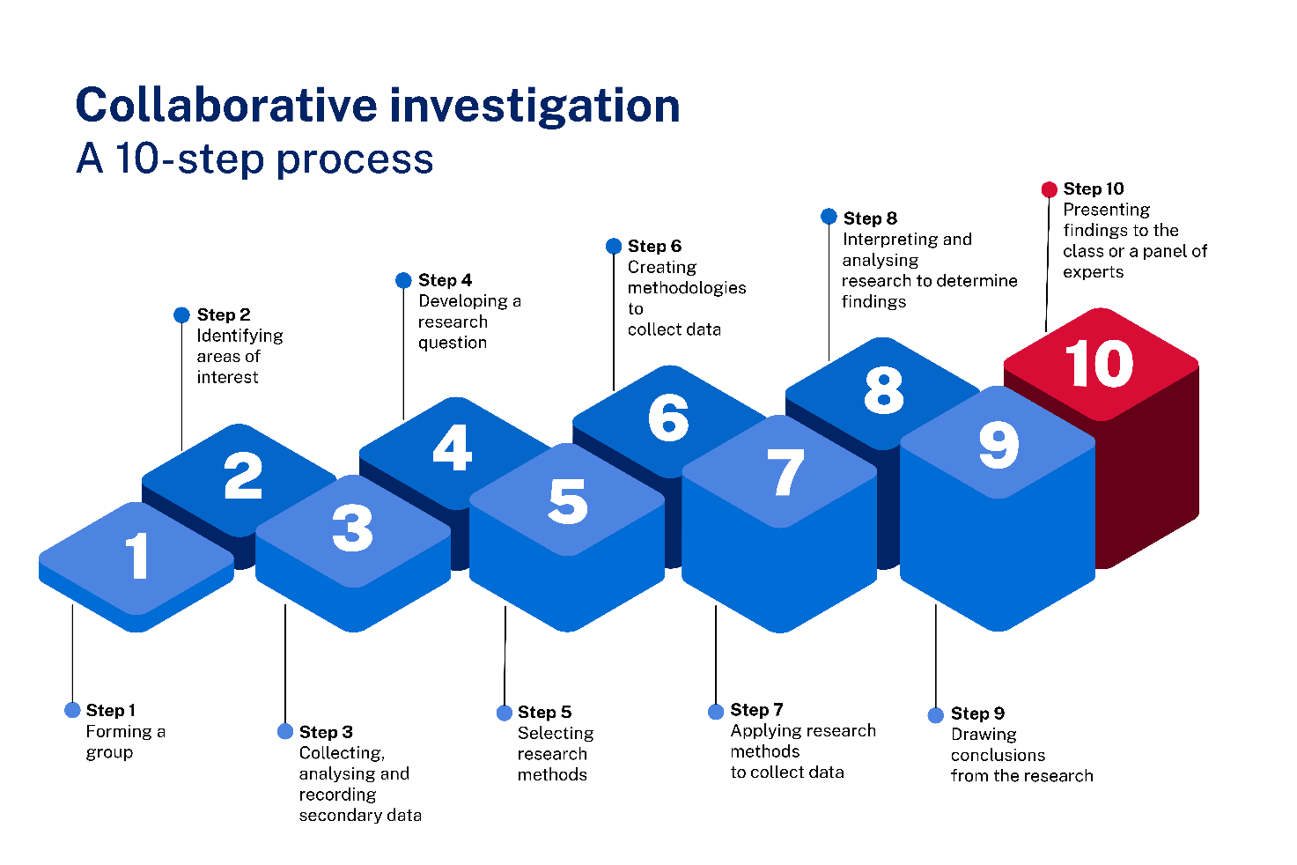
By the end of the collaborative investigation, a student logbook should be filled with reflective writing, evaluation, ideas and opinions. These could include:
- responses and reflections on draft work in relation to their role or the group’s progress, such as research, plans and/or analysis
- images, diagrams or verbal responses in written or digital format, or other ways, to communicate creatively about aspects of the collaboration and group work
- reflections and evaluations of group cohesion, decision making, risks, challenges and solutions throughout the process.

Using the framework and logbook to assess student collaboration
The following collaboration framework [DOCX 2.96 MB] has been developed by the NSW Department of Education’s PDHPE Curriculum team to support teachers to assess outcome
HM-11-05 as part of health and movement science.
The framework splits collaboration into 3 elements which are interrelated and link closely to the components of outcome HM-11-05.
- Element 1 is based around group dynamic.
- Element 2 is based around mutual regulation.
- Element 3 is based around shared understanding.
For each element, a range of strategies have been identified. These strategies can be applied by students as part of effective collaboration. Strategies are listed in order of complexity within the sub-elements with accompanying evidence of learning.
These strategies are a guide. Teachers can determine their own strategies or evidence of learning for assessment.
Figure 2 – the 3 elements of the collaboration framework
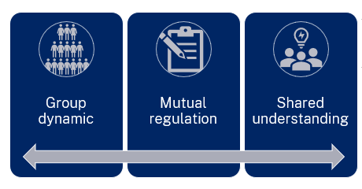
To use the framework to teach or assess collaboration (outcome HM-11-05), teachers should select a minimum of one strategy from each element. This strategy could be assessed 3 or 4 times across a task through checkpoints to give observable measures and valid evidence of achievement or progress.
Sample questions, sentences starters and words have been provided to encourage reflection and assessment. These have been provided across the 3 identified elements of collaboration which align to the Stage 6 Health and Movement Science Syllabus outcome:
- Collaboration: demonstrates strategies to positively interact with others to develop an understanding of health and movement concepts HM-11-05
Health and Movement Science 11–12 Syllabus © NSW Education Standards Authority (NESA) for and on behalf of the Crown in right of the State of New South Wales, 2023.
To use the logbook, select a number of questions for students which align to the strategies selected. Alternatively, provide the sample words and statements to promote self and peer assessment or reflection. Teachers may also choose to use a combination of questions and statements at different points in the investigation based on student need.
Not all strategies within each element are required to be assessed or identified. Use your discretion based on student prior experience, evidence required and time available to determine the most suitable strategies to be assessed at different points.
Provide a context for reflection and allow students to use the questions, statements or words to respond at different points. For example, prior to starting a collaborative investigation or task, at 2 points during the investigation or task, and at the end of the investigation or task. This gives teachers multiple points of evidence to collect and respond to.
More information about collaboration in health and movement science and the establishment of the 3 identified elements can be found in the Collaboration in the Health and Movement Science classroom document [DOCX 4.03 MB].
A logbook allows students to:
- develop skills in speculating, critiquing, analysing, interpreting and constructing possible meanings for their own and others’ health, physical activity levels and performance
- record and reflect on experiences to positively interact with others and work collaboratively to reach agreements and decisions
- record and reflect on their ability to manage their own learning and to become flexible, critical thinkers, problem-solvers and decision-makers
- record and reflect on experiences to negotiate plans and tasks, distribute leadership, create and maintain a positive group environment
- record and reflect how they can work with others and maintain the academic integrity of their own work
- offer constructive feedback and critical analysis of their own work and the work of others
- keep track of the development of their collaborative investigation
- celebrate their achievements in the collaborative investigation product and process
- share their feelings and experiences as they progress in the collaborative investigation.

How can a logbook be used by a teacher?
A logbook will help teachers to:
- get to know how students learn and work with others
- gain insight into student contributions to the collaborative investigation product and process
- offer another perspective on the group’s collaborative process
- assess strategies and actions that may not always be visible in lessons
- identify student strengths and areas for improvement in writing and work with others
- promote learning from honest evaluation of the experiences and make adjustments
- celebrate student strengths – even those they may not see themselves.

Element 1 – group dynamic
This element focuses on the effective interactions within the group. Group members become oriented with each other by recognising personal motivations, strengths, weaknesses, boundaries and communication needs. Working together and group cohesion can support individual members to feel respected and valued, leading to efficient and effective performance throughout an investigation.
Table 1 – group dynamic strategies and evidence of learning
Strategy | Evidence of learning | Sample reflection questions for the logbook
- Communicate needs and how they can be met  - Identify and apply own strengths to participate in the group  - Assess own ability and contributions back to the group | - Shares information about own ability and needs  - Identifies and applies own strengths to contribute to the group  - Participates in the group with confidence  - Demonstrates adaptability and flexibility to promote group cohesion and task completion | - What strengths or skills did you bring to this group?  - How did you make sure that group members were aware of your strengths and skills?  - Describe a situation where you were able to apply one of your strengths to contribute to the group. What was the outcome? How did it make you feel?  - Describe a situation where you had to compromise to promote group cohesion and task completion. How did you feel about your decision? What might you do differently in the future?
- Assess the ability, needs and strengths of others for group success | - Recognises contributions of others verbally and non-verbally  - Discovers others’ abilities  - Recognises the needs and strengths of others  - Supports others to apply their abilities and strengths to work towards group goals  - Assesses the type of interaction needed and makes adjustments  - Encourages and supports others to communicate and contribute to discussions | - How did you find out what the strengths and skills of your group members were?  - How did you demonstrate trust and openness towards the other members and their ideas?  - How did the group make sure that members felt supported, encouraged and appreciated for their work?
- Initiate communication with others suitable to the purpose of the task  - Actively listen to understand others  - Modify communication style where necessary  - Tailor explanations to different group members  - Provide constructive feedback on other’s participation and communication in the group | - Expresses ideas with confidence and clarity  - Asks questions for clarification  - Responds to requests or questions verbally and non-verbally  - Acts on messages received appropriately  - Listens attentively  - Uses verbal and non-verbal communication to validate or show understanding of messages received  - Adapts tone when contributing towards discussion (online or offline)  - Participates in the group respective to their role  - Communicates respectfully during monitoring and resolution of group work  - Evaluates how others are communicating and participating in the group  - Offers feedback to maintain or improve a member’s contribution and participation in the group | - Did you participate willingly in discussion? If not, why not?  - What impacted how willingly you were involved in discussion?  - Did you give honest opinions? What impacted your honesty and willingness to share that opinion?  - Did others appear to understand your ideas? If not, why not?  - What do you focus on when others speak? How could you improve your listening skills?  - What did you do if another person’s ideas were unclear?  - How did you respond to others’ ideas? How did they respond to yours? What could be improved?  - How did the group ensure that all voices were heard irrespective of a member’s role?  - Give an example of where a difference of perspective or opinion occurred in the group.  - What role did you take in discussing differences of opinion within the group? How did your actions support the group’s progress and cohesiveness?
- Establish clear boundaries and expectations  - Discuss difference of opinion or perspective  - Come to an agreement where opinions differ, or conflict arises  - Negotiate the most effective approach to completing the task for the greater good of the group | - Establishes group and individual processes or ways of working together  - Contributes to the development of group expectations and boundaries  - Identifies differences of opinion or perspectives  - Shows respect for the differing opinion or perspectives of others  - Incorporates and addresses differences of opinion and perspectives into discussion  - Works towards compromise where conflict or disagreement occurs  - Addresses and manages conflict in the group to maintain a productive group dynamic | - What were your group’s ground rules and goals? What changes to these rules and goals were needed to improve the functioning of your group?  - How was everyone encouraged to stay accountable to the tasks they had been assigned?  - How were decisions made in your group? Who was involved and in which ways?  - Explain what was effective about the processes used by the group? How could your decision-making processes be improved?  - To what extent did your group monitor and reflect on their goals, progress and achievements? How would more (or less) discussion about goals help or hinder your group’s functioning?  - What happened if a group member was unhappy or uncomfortable with a decision made by the group? How did this impact the cohesion of the group and/or progress towards group goals?  - What conflicts have arisen within your group? How (if at all) have the conflicts been resolved? What role did you play in resolving these conflicts? What could you (or others) do to improve your group’s ability to deal productively with conflict?

Element 2 – mutual regulation
This element encompasses self and social management, acknowledging that for collaboration to be effective, all individuals in a group need to contribute to team knowledge, value the contributions of others, perform tasks assigned to roles and work within the group boundaries and meet expectations. Accountability to self and others is a key feature of this element.
Table 2 – mutual regulation strategies and evidence of learning
Strategy | Evidence of learning | Sample reflection questions for the logbook
- Evaluate own strengths and weaknesses in relation to the group  - Share responsibility for the tasks to reach a common goal  - Match responsibilities with expertise where possible | - Recognises limits of own personal knowledge or skills  - Contributes to development of role descriptions, including allocation of tasks to roles  - Nominates or adopts roles suitable to strengths and expertise  - Discusses the allocation of roles within the group  - Applies knowledge of strengths and abilities of self and others to role allocations  - Encourages or supports others to adopt roles based on their expertise | - Who has emerged as a leader in your group? Explain your answer with examples.  - Which other roles do you see group members playing?  - Which role(s) do you play?  - Which role do you prefer and why?  - How much do you feel you can rely on your group members to complete the required task(s)? Explain your answer.
- Make quality and relevant contributions  - Persist with tasks when challenged  - Monitor own and others’ contributions to the group and overall progress | - Makes contributions that support or progress the investigation towards the group goal or a deeper understanding of the investigation focus  - Identifies what has and has not been contributed to progress the investigation  - Adapts behaviour for task completion  - Provides constructive updates on own progress  - Monitors and evaluates the work and contributions of self and others through self and peer assessment  - Assesses the extent to which individual roles and responsibilities enhance group cohesion and the achievement of personal and group objectives  - Acknowledges own and others’ successes and areas for improvement in relation to the investigation process and outcomes | - In what ways have your contributions supported the investigation towards the group goal?  - In what ways have all group members contributed to the investigation?  - What processes did your group have in place to log contributions and progress towards the common goal?  - To what extent has group member contribution impacted group cohesion?  - To what extent has group member contribution impacted progress towards the common goal?  - How was everyone encouraged to stay accountable to the tasks they had been assigned? Was this effective?  - What types of feedback did your group use? Which type do you prefer? Why?  - How did members of your group respond to feedback?  - Describe a situation where you had to adapt your behaviour to complete a task. How did you feel about your decision? What might you do differently in the future?
- Take personal responsibility  - Perform responsibilities assigned by the collective group  - Set goals based on individual responsibility and group progress | - Meets deadlines and works within the group boundaries and expectations  - Demonstrates that they are prepared for group tasks  - Performs the actions of an assigned role  - Creates and works towards individual short-term and long-term goals to complete required tasks for each role  - Contributes to the development, monitoring and achievement of group goals | - On a scale of 1 to 5 (5 being the highest), rate how well you performed the required actions of your assigned role in the group. Explain your rating.  - How much did you feel you could rely on your group members to complete the required task(s)?  - What motivated you to stay accountable to the tasks you had been assigned? Do you think this would be the same or different in another group performing the same task? Explain your answer.  - Do you think this would be the same or different in the same group performing a different task? Explain your answer.
- Discuss individual and group responsibilities at different steps of the investigation  - Share roles between group members  - Adapt roles or group composition if necessary | - Identifies tasks and sub tasks at different points of investigation  - Contributes constructively to discussions about roles and responsibilities, including task allocation and change of roles at different points of the investigation  - Understands and communicates who does what, how, why and when in line with the group goals and investigation process | - How were group roles identified?  - How were group roles shared within the group? What processes were used to make this equitable and transparent?  - What is your role in the group? How do you know this? What are your responsibilities throughout the task to support the group as you all work towards a task?
- Access assistance or feedback where required | - Asks group or teacher for clarification on role, task progress or responsibilities  - Seeks feedback to improve performance or progress a task  - Accepts and adopts useful feedback for task understanding or completion | - To what extent did you and others provide feedback? How could you and your group members improve the way you give and receive feedback?

Element 3 – shared understanding
This element focuses on the active engagement of all members to contribute to the collective knowledge and understanding of the group and their progress towards a common goal. Specifically, the actions of group members to develop an understanding of health and movement concepts applicable to the goals of the collaborative investigation.
Table 3 – shared understanding strategies and evidence of learning
Strategy | Evidence of learning | Sample reflection questions for the logbook
- Pool resources and information, including:  - tangible resources such as equipment, space, technology  - primary and secondary knowledge and understanding, skills, expertise | - Shares information and resources with others  - Contributes relevant points and ideas throughout a discussion or group task  - Asks for perspectives and input from group members  - Discusses the investigation and data to facilitate deeper analysis and understanding  - Challenges or critiques different perspectives or ways of working to advance the work or draw conclusions | - What do you believe is the best way to share resources and information with others in your group? How will a strategy be decided upon?  - Did you share information and resources with others? How was this done? What could be done better?  - Did you participate willingly in the discussion to facilitate deeper analysis and understanding? How? What was the outcome? If not, why not? What was the outcome?  - How did you ensure that all group members had input and provided their perspective? Why is this important for collaborative investigation?
- Acknowledge others’ perspectives  - Comprehend others’ understanding  - Enhance own understanding as a result of the perspectives, understanding or contributions of others | - Identifies differences of opinion or perspectives in relation to the investigation process, research, findings or conclusions  - Asks relevant questions to deepen individual and group understanding of the content, findings or investigation processes  - Considers perspectives, opinions and contributions from others in relation to group goals  - Discusses different opinions and perspectives to enhance their own learning  - Makes links and connections between ideas to include the contribution of others  - Critiques perspectives, opinions and contributions from others to enhance the learning in the group | - What did you do if another person’s ideas were unclear?  - How did you respond to others’ ideas? How did they respond to yours? What could be improved? Were ideas acknowledged, negotiated and used?  - How was your attitude towards your group members demonstrated in how you functioned within the group? Consider this in a situation where you agreed, and in a situation where you disagreed. How was group learning enhanced?
- Identify and evaluate different options and pathways towards the common goal | - Suggests improvements in methods used for investigations or communication of findings  - Offers solutions and either an explanation of how or why it works or the benefit or consequences of the solution for the group or the task  - Recognises the most suitable solution for the resolution of the task  - Demonstrates flexibility in how they work for the benefit of the group or progress in the investigation | - Provide an example of when you were able to suggest an improvement for the good of the task. How did you propose it? What were the reactions of others? How did that make you feel?  - Provide an example of when a group member was able to suggest an improvement for the good of the task. How did this change your thinking? How did it improve the task? How did this make you feel?  - Provide an example of how you or another group member adapted your behaviour or demonstrated flexibility to assist the group to move forward. Why was this done?
- Support others to understand the task or perform their role | - Directs the conversation or seeks clarification about the task or discussion  - Provides constructive feedback  - Shares ideas and solutions in ways that help group progress | - In what ways did you contribute to discussion of the stages of the investigation and/or group findings?  - At any point of the investigation, did you or another group member need to clarify the tasks or group progress? How was this done? What was the response of the group?  - How did you respond to the ideas of other group members? How did other group members respond to your ideas? What could be improved?  - How was feedback offered in your group? Did you like receiving feedback? Why or why not? Did you like providing feedback? Why or why not? What made feedback usable and constructive?

Sample reflection words
Select from the words provided to record reflections of your involvement in the group, performance of a role or contribution towards the collaborative investigation. Provide examples in your reflection of your application of the selected words in terms of your actions.
Sample words
accepting | entertaining | patient
adventurous | fair | perceptive
amusing | flexible | persistent
anxious | friendly | playful
appreciative | funny | polite
approachable | generous | practical
articulate | gentle | proactive
aware | hard-working | punctual
brave | helpful | realistic
bright | honest | reasonable
broad-minded | idealistic | reliable
calm | independent | resourceful
careful | intelligent | respectful
caring | interested | self-disciplined
cheerful | inventive | sensible
cheerful | joyful | sensitive
compassionate | kind | stable
cool-headed | logical | strong
courageous | loving | supportive
creative | loyal | sympathetic
dedicated | motivated | tactful
deep | neat | thoughtful
definite | objective | trustworthy
dependable | open-minded | unaffected
determined | optimistic | understanding
easy-going | organised | warm-hearted
encouraging | outgoing | well-behaved
energetic | outspoken | witty

‘I can’ or ‘I have’ statements
Select from the statements provided to record reflections on your involvement in the group, performance of a role or contribution towards the collaborative investigation. Provide examples in your reflection of your application of the selected statements in terms of your actions in the group and investigation.
Sample statements
Use the sentence stem ‘I can …’ when students are using the statements at the start of a task.
Use the sentence stem ‘I have …’ when students are using the statements to reflect during or at the end of a task.
I can/I have…
- taken responsibility when leadership is needed
- spoken up even if I am scared
- learnt from my mistakes
- used what I have been taught
- apologised when I did the wrong thing
- drawn on preparation that I did
- stuck at it
- kept going even if I was stuck
- turned up even if I didn’t feel like it
- tried a different strategy if the first one didn’t work
- controlled my nerves
- worked out how to manage my time
- planned for my own safety and wellbeing
- done the right thing even when my friends didn’t
- kept my promises
- shown friendship even if no one else did
- handled being ordinary, I don’t have to be the best
- stayed positive even if people around me are getting upset
- handled being different, it is okay to be who I am
- controlled myself even when I felt angry
- got over it even if someone wronged me
- owned up even when I didn’t want to take the blame
- stuck with my plan even if other people were being distracting
- smiled and been friendly even when I was nervous
- thought through how my actions might have affected other people
- gone out of my way to help even if I didn’t know if it would be accepted
- stuck at it even when I wasn’t sure if I would make it
- taken on a new challenge even if I wasn’t sure how I would manage it
- asked for help when I needed it
- explained what I needed
- spoken up when I knew something is wrong
- identified when change was needed.

Additional information
The information below can be used to support teachers when using this teaching resource for health and movement science.

Support and alignment
Resource evaluation and support: all curriculum resources are prepared through a rigorous process. Resources are periodically reviewed as part of our ongoing evaluation plan to ensure currency, relevance and effectiveness. For additional support or advice, contact the PDHPE Curriculum team by emailing PDHPEcurriculum@det.nsw.edu.au.
Alignment to system priorities and/or needs: School Excellence Policy, School Success Model
Alignment to the School Excellence Framework: this resource supports the School Excellence Framework elements of curriculum (curriculum provision) and effective classroom practice (lesson planning, explicit teaching).
Alignment to Australian Professional Teaching Standards: this resource supports teachers to address Australian Professional Teaching Standards 3.2.2, 3.3.2.
Consulted with: Curriculum and Reform and subject matter experts
NSW syllabus: Health and Movement Science 11–12 Syllabus
Syllabus outcomes: HM-11-05
Author: PDHPE Curriculum Team
Publisher: State of NSW, Department of Education
Resource: Assessment tool
Related resources: further resources to support health and movement science Stage 6 can be found on the Planning, programming and assessing PDHPE 11–12 curriculum webpage and the HSC hub.
Professional learning: relevant professional learning is available through the PDHPE statewide staffroom.
Universal Design for Learning: Curriculum planning for every student in every classroom. Support the diverse learning needs of students using inclusive teaching and learning strategies.
Creation date: 4 December 2023
Rights: © State of New South Wales, Department of Education.

References
This resource contains NSW Curriculum and syllabus content. The NSW Curriculum is developed by the NSW Education Standards Authority. This content is prepared by NESA for and on behalf of the Crown in right of the State of New South Wales. The material is protected by Crown copyright.
Please refer to the NESA Copyright Disclaimer for more information https://educationstandards.nsw.edu.au/wps/portal/nesa/mini-footer/copyright.
NESA holds the only official and up-to-date versions of the NSW Curriculum and syllabus documents. Please visit the NSW Education Standards Authority (NESA) website https://educationstandards.nsw.edu.au/ and the NSW Curriculum website https://curriculum.nsw.edu.au.
Health and Movement Science 11–12 Syllabus © NSW Education Standards Authority (NESA) for and on behalf of the Crown in right of the State of New South Wales, 2023.

© State of New South Wales (Department of Education), 2023
The copyright material published in this resource is subject to the Copyright Act 1968 (Cth) and is owned by the NSW Department of Education or, where indicated, by a party other than the NSW Department of Education (third-party material).
Copyright material available in this resource and owned by the NSW Department of Education is licensed under a Creative Commons Attribution 4.0 International (CC BY 4.0) license.
This license allows you to share and adapt the material for any purpose, even commercially.
Attribution should be given to © State of New South Wales (Department of Education), 2023.
Material in this resource not available under a Creative Commons license:
- the NSW Department of Education logo, other logos and trademark-protected material
- material owned by a third party that has been reproduced with permission. You will need to obtain permission from the third party to reuse its material.
Links to third-party material and websites
Please note that the provided (reading/viewing material/list/links/texts) are a suggestion only and implies no endorsement, by the New South Wales Department of Education, of any author, publisher, or book title. School principals and teachers are best placed to assess the suitability of resources that would complement the curriculum and reflect the needs and interests of their students.
If you use the links provided in this document to access a third-party's website, you acknowledge that the terms of use, including licence terms set out on the third-party's website apply to the use which may be made of the materials on that third-party website or where permitted by the Copyright Act 1968 (Cth). The department accepts no responsibility for content on third-party websites.

