# Inventory of current behaviour interventions

## The PBL continuum

Understanding the interventions currently in place within each tier of the PBL continuum is essential for effective resource allocation and ensuring that support is directed where it is most needed. This awareness fosters continuity of support, preventing overlaps or gaps in services, and enables educators to make data-driven decisions about interventions that align with the school’s behavioural expectations and goals.

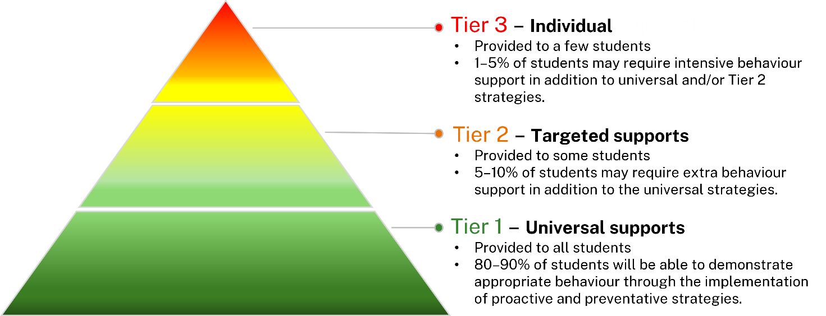

## Inventory of interventions across the PBL continuum of support

List the current interventions in place at your school across each tier of the PBL continuum in the corresponding rows below. This information will help assess current practices and identify areas for improvement in the school’s approach to supporting student behaviour. Each school will provide this information in their School Behaviour Support and Management Plan (SBSMP) where they describe interventions used across the care continuum.

|  |  |
| --- | --- |
| PBL continuum of support | List of interventions |
| Tier 1: Universal supports |  |
| Tier 2: Targeted supports |  |
| Tier 3: Individual supports |  |