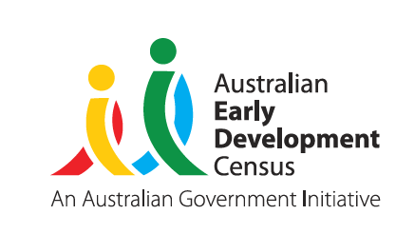
Our Children
Our Communities
Our Future


Value of the AEDC for education leaders: An overview of the way the AEDC supports data driven planning
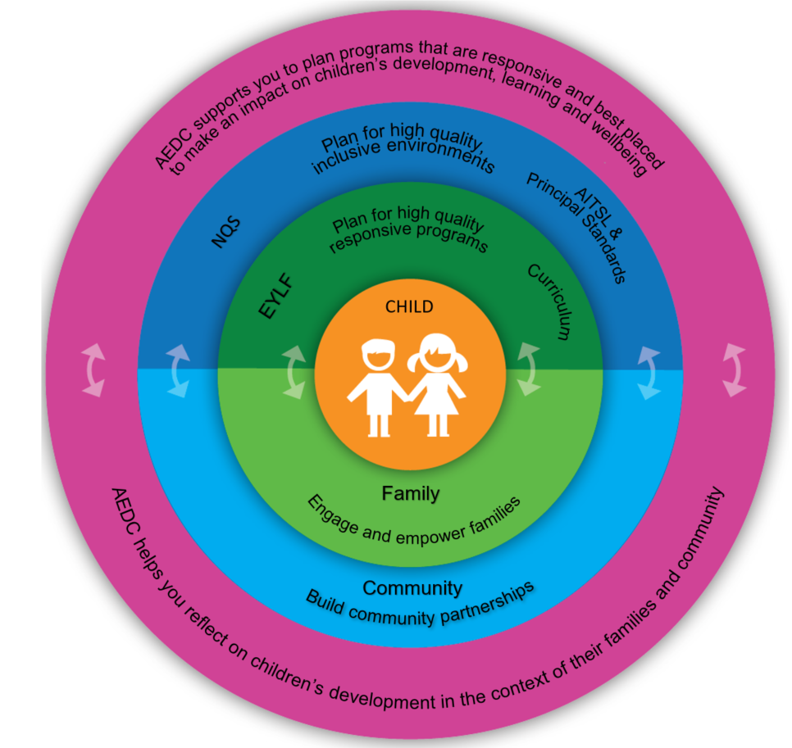
Knowing how children are developing at five years of age can help identify community strengths, challenges and opportunities.
Reflecting on the local context ensures education and care planning is responsive and inclusive of children’s experiences

© Western Australian Department of Education 2018

Assess your context


Understanding the community
enables education leaders to effectively plan for children’s learning and development
Get to know the community
- Download and review your AEDC school and community profile
- Document what you know about families from your experience (enrolment interviews, conversations with parents, knowledge of the area)
- Listen to leaders and Elders share their vision for children in community
- Investigate population data sources (consider the Social Health Atlas and the ABS website)
- Speak to local service providers about the issues they are seeing for children and families

Consider the equity of access
to learning and development opportunities available in the school and community
- Take time to drill down and find out what is getting in the way of or supporting children’s wellbeing, development and learning
- Use the AEDC data to consider the barriers to learning that children face
- Consider how your site’s practices either support or create additional challenges for children

Building strategic connections in your community
can support you to be responsive to the needs of children and families
- Use the AEDC to establish a common ground and create a set of shared goals for the community
- Consider partnerships that enable approaches that are responsive to culture, place, and people
Reflect on your community and the data
- How can other data you collect (e.g. home background, conversations with parents) be used alongside AEDC data to help understand your community and their needs?
- Who do you already work alongside to shape the outcomes of children in your community?
© Western Australian Department of Education 2018

Plan your actions

Demonstrate your knowledge
and approach in your planning
- Document the issues identified through interrogation of community data to demonstrate a clear understanding of the strengths and challenges – align the information gathered to responses and intended outcomes
- Use the AEDC to support your planning for the National Quality Standards (NQS), the Early Years Learning Framework (EYLF), the NSW Curriculum and AITSL standards

Working in partnership to support children
to transition between home, ECEC, and school can help give all children the best possible start
- Adapting to changes in their care and education settings can present challenges for children and can disrupt their development, especially when transitions are not mindful of children’s strengths, needs, and contexts
- Reflect on the continuity of care and learning that children experience in transitioning to your site
- Consider the information you share with your transition partners and how you can work together to support children’s transitions

Clearly documenting your plan
can support you to be responsive to the needs of children and families
- Work together with your partners to create an action plan that outlines the role and commitment of each partner, activity milestones, and intended outcomes. These plans can also support funding applications
- Consider how you will record what will happen, who will make it happen, when it will happen by, and how you will know it worked

Reflect on your planning and vision for children’s
holistic development
at your site
- To what extent is your site’s vision
evident in planning documents?
- How do you ensure that your work
is purposefully linked to your site’s vision?
- How will you work with other
staff members, educators and stakeholders to achieve your goals?
- What continuity of care and learning do children experience in transitioning to your centre or school?
- How do you measure and report on progress toward these goals

© Western Australian Department of Education 2018

Act – implement and evaluate

Programs can be evaluated in a number of ways
- Decide what success looks like to you and your working group to ensure that your vision is aligned with your goals and you are able to determine if your program is effective
- Consider what might impact the success of your initiative or what challenges you might face and address these in your plan

Evaluating your program ensures you are reaching the right people
- Once your program or initiative is up and running it is important to continue to evaluate its success and consider any changes in your community
- The AEDC can be a good indicator of what is happening in your community and can help your program stay on track and in tune with children’s needs
Reflect on your plan and how you will measure success
- What can you expect to see given the size of your response?
- What data are you collecting to measure the success of your initiative?
- How will you identify and respond to the community’s changing needs?

Find out more at www.aedc.gov.au and https://education.nsw.gov.au/student-wellbeing/whole-school-approach/aedc
© Department of Education Western Australia 2017 (see: https://www.education.wa.edu.au/copyright and https://www.education.wa.edu.au/disclaimer for full details).
Developed in partnership between the Western Australian Department of Education, the Association of Independent Schools Western Australia, Catholic Education of Western Australia, the New South Wales Department of Education and the South Australian Department for Education and Child Development.
The partners acknowledge the assistance and expertise of the Telethon Kids Institute in the development of the resources.
For more information about the Australian Early Development Census, please visit the AEDC web site: www.aedc.gov.au
© Western Australian Department of Education 2018

