Psychology – Option 6: Psychology and gender

Contents
Focus 2
Outcomes 2
Teacher note 3
Learning sequence 1 4
Understanding key terms 4
Exploring social stereotypes 6
Myths and stereotypes from the past and how they influence current stereotypes 7
Learning sequence 2 10
Reasons for gender differences 11
Physiological theories of psychology and gender 12
Socio-cultural theories of psychology and gender 14
Learning sequence 3 16
Case study: Hypothesis and conclusions 16
Biological approach vs social development theory 17
Interpreting theoretical responses 17
Reliability 18
Assessment for learning 19
Psychological experiment report task 19
References 22
Further reading 24

Focus
In this elective option, students will explore gender differences. Physical and psychological similarities and differences in men and women and the influence of socialisation and gender roles are examined. Students compare and contrast biological and social psychological explanations of gender differences to identify the strengths and limitations of each approach.

Outcomes
A student:
- PSY5-1 explains how the field of psychology provides scientific explanations for the mind and behaviour through research, theories, and approaches.
- PSY5-2 identifies and explains the main approaches to the study of the nature of human behaviour and the strengths and weaknesses of those approaches.
- PSY5-6 recognises the applications and influence of psychology in popular culture and its importance to social factors.
- PSY5-7 examines suitable research methods including procedures and critical analysis when completing action based learning.
- PSY5-8 communicates psychological information and ideas using appropriate written, oral, and visual forms.
Outcomes and other elements of syllabus references in this document are from the Psychology course document © NSW Department of Education, 2021 for and on behalf of the Crown in the State of New South Wales.

Teacher note
Some of the content in this module may be considered controversial in some school communities. If delivering this optional module as part of the study of Psychology in Stage 5, it is recommended to study these concepts towards the end of the stage, within a 200-hour pattern of study. Using this recommendation will allow more opportunity for students to develop a foundational understanding of psychology and bring a mature approach when working with the concepts of the module. If uncertain about using this optional module, discuss this with school leaders.
This option clarifies the significant differences between sex as a biological tool of classification and gender as a social construct. It explores current and historical thinking that has contributed towards gender theory and allows students to explore how social thinking influences psychological thinking about gender over time. In this resource, students are guided to understand key terminology and current established stereotypes related to both males and females and their perceived gender identity. They will explore how historical psychology has contributed towards these perceptions. They will then consider some opposing views and theories and use a scientific inquiry mindset to consider the limitations and strengths of different psychological theories related to how gender constructs have been established and how they are maintained.
Adjustments may need to be made to meet the needs of every learner. Learning adjustments enable students with disability and additional learning and support needs to access syllabus outcomes and content on the same basis as their peers. Teachers can use a range of adjustments to ensure a personalised approach to student learning. In addition, the Universal Design for Learning planning tool can be used to support the diverse learning needs of students using inclusive teaching and learning strategies. Under the department’s Inclusive Education Policy for students with disability and the Disability Standards for Education (2005), all staff must implement reasonable adjustments for students with disability, in consultation with parents/carers, to support students with disability to access the curriculum.
To meet the needs, interests, and abilities of students in the cohort, activities may be adapted or adjusted for the local context. When selecting alternate stimuli or issues for study, it is important to ensure compliance with the Controversial Issues in Schools Policy.

Learning sequence 1
Students:
- explain the difference between sex and gender
- examine historical and contemporary gender myths and stereotypes.
Note: This learning sequence will provide essential terminology to discuss the concepts of Option 6: Psychology and gender. Some key guiding questions will be introduced throughout this learning sequence. These include questions like, ‘What is the difference between the terms “sex” and “gender”?’, ‘What key differences exist between men and women?’ and ‘To what extent are the differences between men and women due to physiology/psycho-social development?’
Students will consider their existing assumptions about gender; and challenge these assumptions by exploring examples of gendered behaviour across different cultures.
It is important to revisit the term ‘theory’ throughout this sequence and guide students with appropriate discussion protocols. Ten Tips for Facilitating Classroom Discussions on Sensitive Topics [PDF 670.04KB] may be useful to guide the establishment of a safe classroom environment.
The foundational concepts in this learning sequence will allow students to build a critical understanding of different theories related to psychology and gender. It is important to consider the context of the students and community for this learning sequence. Preface the learning sequence with classroom protocols about respectful discussions and clarify that the content presented is scientific theory, rather than fact. It could be necessary and beneficial to provide notification to parents prior to dealing with concepts like sex and gender.

Understanding key terms
Use Table 1 to define key terminology used in gender psychology. Complete the first 2 examples together with a partner and co-construct a definition. Next to each definition, provide details or examples for each key term, for example, how it is used in a sentence, or how this is reflected in our current context.
Table 1 – Key words for psychology and gender
Key words | Definition | Detail or example
sex | (Add definition) | (Add example)
gender | (Add definition) | (Add example)
gender identity | (Add definition) | (Add example)
gender-role behaviour | (Add definition) | (Add example)
male | (Add definition) | (Add example)
female | (Add definition) | (Add example)
masculinity | (Add definition) | (Add example)
femininity | (Add definition) | (Add example)
Construct a PEEL paragraph in response to the question, ‘In what ways do the definitions suggest sex is different to gender?’
Note: The activity above could be an exit ticket for the lesson.
A graphic organiser with guided questions may assist in writing the PEEL paragraph above. See Table 2 for a suggested graphic organiser.
Table 2 – Graphic organiser for a PEEL paragraph
Questions | My response
What are the key differences between the definitions of sex and gender? | The definitions of sex and gender differ in many ways. An example of this is…
What is an example of a key difference between sex and gender? | There are many key differences between sex and gender, for example, a man…
What are the key terms related to sex and gender? | Important terminology when exploring the difference between sex and gender is…
Why is it important to consider the difference between sex and gender? | Understanding the difference between sex and gender is important because…

Exploring social stereotypes
Consider the following occupations:
- artist
- astronaut
- athlete
- author
- civil rights leader
- explorer
- health pioneer or scientist
- leader of a nation
- musician
- religious leader.
Use Think-Pair-Share to respond to the question, ‘Which gender do we normally associate with each of the occupations?’
As a class, discuss how you have categorised each profession. Practise writing some notes about the personality traits we associate with each job and why you may think of these as male or female traits.
Define the key terms ‘adheres to’ and ‘challenges’.
Access the YouTube clips in Table 3 and record information about the people speaking. Identify any stereotypes/expectations associated with the biological sex of each of the speakers. Complete the table, indicating how each speaker either adheres to or challenges gender expectations. Discuss your findings as a class.
Table 3 – Adheres to and challenges gender expectations
Video examples | Adheres to gender expectations | Challenges gender expectations
Q's View Ep. 2: Dextina Booker (6:49) | (Add observations) | (Add observations)
Q's View Ep. 1: Cody Coleman (8:56) | (Add observations) | (Add observations)
Q's View from MIT Ep. 3: Frankie Peña (10:49) | (Add observations) | (Add observations)
Note: When facilitating the class discussion, promote deeper thinking about social expectations by using questions like ‘what makes you say that?’ The ‘What makes you say that?’ thinking routine may be useful in building students’ skills in justification.

Myths and stereotypes from the past and how they influence current stereotypes
Use the Figure 1 phrenology chart and the following guided questions as a discussion starter:
- Discuss the position of the different qualities.
- Do there appear to be any patterns?
- Does the diagram cover all important psychological qualities?
- Which of the qualities do you think are most important?
- Would you choose to represent the most important qualities larger or smaller than they appear in the chart?
- Define the role and purpose of psychological research.
- Identify the characteristics of quality psychological research.
Figure 1 – Phrenology chart
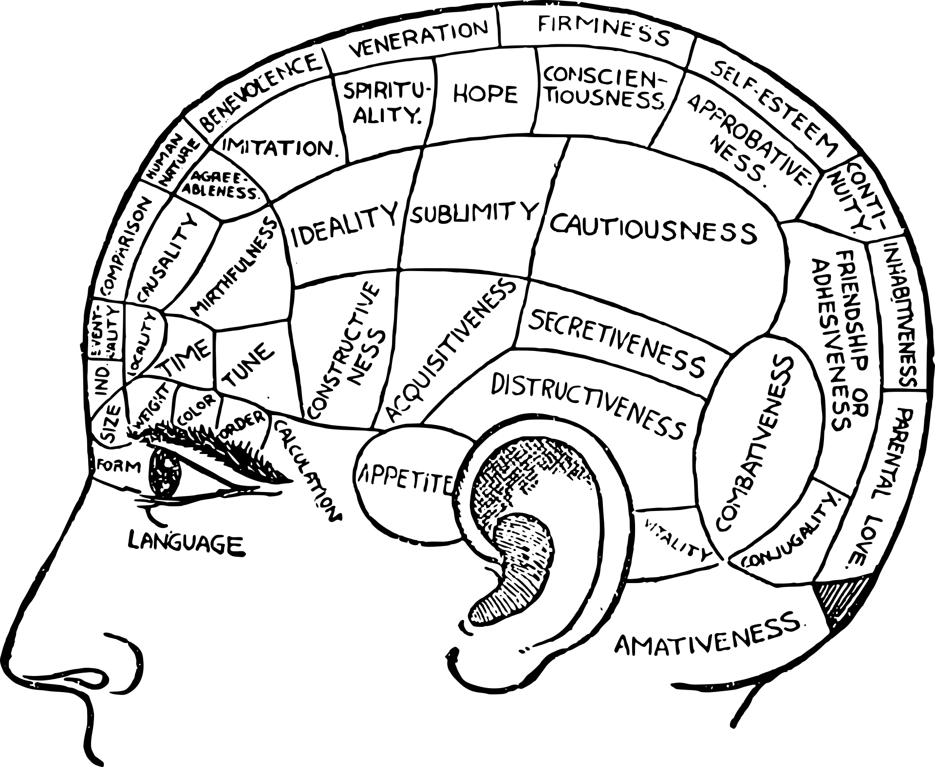
“Brain chart” by OpenClipart-Vectors is licensed in accordance with the Pixabay License.
Note: Briefly explain that the learning intention for the lesson is to understand how beliefs regarding psychology and gender change over time. Introduce the key term ‘phrenology’.
Access Is phrenology the weirdest pseudoscience of them all? (4:08). As a class, discuss the video to ensure you have a firm understanding of the concept. Predict how this pseudoscience could have resulted in misinformed perceptions about gender.
Read Phrenology – Time for a Feminist Perspective!. As a class, discuss how some of the contemporary stereotypes and myths associated with women have been carried from this period in the 19th century to our current context.
Construct a response to the following question: Why is it important that we question and update psychological beliefs about sex and gender? Consider using a range of options to present your response, such as video, audio, and multimodal presentation.
Plenary reflection activity:
Students list 3 things they have learned in this lesson, found interesting about the lesson and/or understand better about the discipline of psychology.
Follow up with a teacher-led discussion of the 3 things students listed. Use the cold calling method to ensure all students are ready to answer.
Synthesise student comments and collaborate as a class to agree on 3 key points of learning for the lesson.

Learning sequence 2
Students:
- explain the nature of male and female differences, including:
- the role of hormones
- nurturance
- aggression and activity level
- intelligences.
- identify and describe the areas of mental ability in which males and females show differences
- recognise and discuss gender differences in communication.
Note: In this learning sequence, students will expand on the key terminology they have already encountered. This will form the basis to explore the concept of nature vs nurture. This concept will be used to discuss the theoretical perspective that gendered behaviour could be attributable to environmental factors, including popular beliefs and culture.
Students will also learn about arguments related to physiology and how they influence the theory that biological sexes exhibit different behaviours and a propensity for specific skills and intelligences.
The divergent viewpoints explored here will allow students to continue to understand that psychological theories of gender are under constant construction. They will also begin to understand the use of examples and evidence in building an argument for psychological theory.
Many of the activities in this and other sequences may be supported by research tests, such as the CRAAP test.
Remind students that information in this lesson sequence is not presented as fact and revisit protocols for respectful conversations in the classroom. A silent debate or a paper debate could be an effective way to mitigate any controversial or sensitive issues that could arise when delivering this sequence. Informing parents of potentially controversial topics prior to delivery and finding alternatives when necessary would be useful for this learning sequence. When informing parents and guiding respectful and on-topic discussions, some topics in this learning sequence to consider are: male and female intelligence, hormonal influence on actions, animal behaviour compared to human behaviour, and social influence.

Reasons for gender differences
Introduce students to key terms for this learning sequence, as shown in Table 4. Complete the first 2 examples together with a partner and co-construct a definition. Next to each definition, provide details or examples for each key term, for example, how it is used in a sentence, or how this is reflected in our current context.
Table 4 – Key terms for gender difference, physiology, and environment
Key words | Definition | Detail or example
bias | (Add definition) | (Add example)
cortices | (Add definition) | (Add example)
physiology | (Add definition) | (Add example)
hormones | (Add definition) | (Add example)
hypothesis | (Add definition) | (Add example)
credibility | (Add definition) | (Add example)
Brainstorm stereotypical behaviours and personality traits associated with each sex. These traits may be physical traits or gender traits, such as things we typically associate with the feminine and masculine psychology.
Access the BBC article Do men and women really have different personalities? Use the questions listed below to guide your understanding and ensure that you comprehend key ideas.
Note: Explicitly model answering the first question using scanning techniques to find information within the text to support responses.
- Why does the article suggest that the question of psychological differences between the genders is complicated and controversial?
- What were the criticisms of the design process for the studies about gender differences carried out in 2001 and 2008?
- What did the study of 3-year-old twins suggest about the difference between boys’ and girls’ behaviour and temperament?
- Why are some scholars uncomfortable with a biological account of human behaviour?
- In 2011, what did Yanna Weisburg and her colleagues conclude about gender differences between men and women?

Physiological theories of psychology and gender
Introduce the key term physiological. Start with an overarching look at brain physiology before moving into specific hormones.
Ask the question, ‘What physiological things happen that make men/women better at certain things?’ Provide a list of stereotypical things that men and women and better at. This list can include spatial awareness, emotional intelligence, and reading body language. Get students to predict which sex are better at each and to justify responses.
Access Are Boys Smarter Than Girls? (4:40). Guide students on gathering evidence for the key similarities and differences between brain physiology outlined in the video.
Use Figure 2 to create brainstorm reference sheets outlining physical differences between the male and female brain.
Figure 2 – Human brain
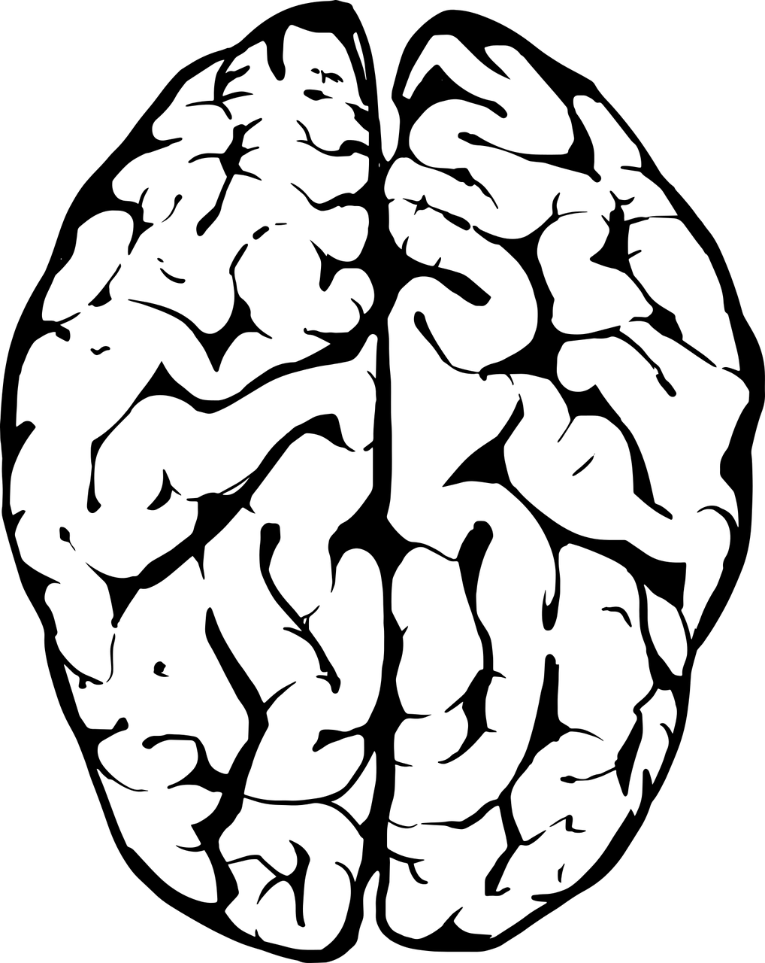
“Brain Human Anatomy” by StarGlade is licensed in accordance with the Pixabay License.
Access Women Are Smarter Than Men? (1:46) and add any additional information to initial brainstorms. Compare and contrast the similarities and differences between the ideas presented in ‘Are boys smarter than girls?’ and ‘Women are smarter than men?’
Access Hormones and Behaviour. In groups, create a summary of one hormone and the behaviours associated with it. The information gathered can be presented to the class at the conclusion of the activity.
Focus on oestrogen as a hormone that may influence gendered behaviour. Use extracts from the article Hormones linked to reasoning ability to guide your responses to the following questions:
- When was the article written?
- What skills does the article suggest are associated with oestrogen?
- What are the limitations/flaws with the study?
- Are the ideas explored in the article an accurate representation of current perceptions of gendered behaviour associated with females?
Make predictions on the role that testosterone plays in gender identity using your knowledge of existing perceptions.
Access The Rise of Culture and the Fall of Testosterone. Create a summary using key details learnt about testosterone. Create links to stereotypical gender behaviours associated with males. Use extracts from Is that man a bonobo or a chimp? to further support how the concept of animal behaviour observations links to human behaviour observations. As a class, discuss the role of psychological observations of animals in the understanding of human psychological theories. Consider the question, ‘Is this reliable information’?
Create a fact sheet about hormones and behaviour. You may choose to do this using online means, like Canva. You may also consider using other options for presentation, such as video, audio, or multimodal presentation. The fact sheet may focus on the hormones oestrogen and testosterone, but you can choose additional hormones as well. If you are researching beyond class material provided, you should provide a bibliography.

Socio-cultural theories of psychology and gender
As a class, create shared definitions of the key terms ‘nature’ and ‘nurture’.
Access and engage with Nature vs Nurture | Genetics | Biology | FuseSchool (3:47) and complete the Venn diagram activity outlined in the video. The linked video Epigenetics Nature vs nurture (4:55) can be used to extend the understanding of this concept.
Access the article What is conformity? Identify how this article talks about notions of nature vs nurture, as covered in the previous activity. Focus on how this concept could explain and influence stereotypical gender traits being presented across the sexes.
Note: An additional resource for this activity is the Crash Course video Social Influence: Crash Course Psychology #38 (10:07).
Conduct a class debate on which theory is best used to explain gender differences and assumptions. Split the room into 2 groups. One half of the room will represent the physiology theory and the other half will represent the socio-cultural theory. Provide time for each group to prepare arguments for their theory.
Explicitly state that each argument should be supported with clear evidence from the research that has been conducted as a class. Examples should also be relevant and appropriate.
Complete the sequence with a writing activity using the Visible Thinking Routine, I used to think… Now I think…
Plenary reflection activity:
Students list 3 things they have learned in this lesson, found interesting about the lesson and/or understand better about the discipline of psychology.
Follow up with a teacher-led discussion of the 3 things students listed. Use the cold calling method to ensure all students are ready to answer.
Synthesise student comments and collaborate as a class to agree on 3 key points of learning for the lesson.

Learning sequence 3
Students:
- examine historical and contemporary gender myths and stereotypes
- explain the nature of male and female differences, including:
- the role of hormones
- nurturance
- aggression and activity level
- intelligences.
- recognise and discuss gender differences in communication
- identify the implications of biological and social psychological explanations of atypical gender behaviour.
Note: Remind students that information in this lesson sequence is not presented as fact and revisit protocols for respectful conversations in the classroom. Informing parents of potentially controversial topics prior to delivery and finding alternatives, when necessary, would be useful for this learning sequence. Be vigilant of classroom discussions when discussing driving abilities of males and females. Ensure students understand this example is being used to develop their understanding of 2 different theories, rather than to come to a decision about driving abilities.

Case study: Hypothesis and conclusions
Access and engage with Women vs men: Who are the better drivers? Use the guided questions listed below to discuss key elements of psychology experiment design. Recall your prior understanding of experiment design from science:
- What is the hypothesis being tested?
- What data is being used?
- What conclusions were drawn?
- How reliable are the conclusions drawn by the evidence?
Access the article, You don’t have a male or female brain – the more brains scientists study, the weaker the evidence for sex differences and compare/contrast against the previous article, ‘Women vs men who are the better drivers?’. Reflect on the following questions:
- What is the hypothesis being tested?
- What data is being used?
- What conclusions were drawn?
- How reliable are the conclusions drawn by the evidence?
Create a hypothesis about whether physiological or socio-cultural factors are responsible for the results in each of the studies above.

Biological approach vs social development theory
Start by comprehending the overview on Biological approach. Consider the following question to challenge your thinking: ‘How does the biological approach account for people who possesses gendered behaviours not associated with their sex?’
Come up with your own questions to challenge the theory using the Question Formulation Technique (QFT).
Access Bandura and Social Learning Theory (3:22).
- Use exit ticket questions after watching the video.
- Predict how this theory can help support what we have been exploring about gender.
- Explore the similarities and differences between the 2 different approaches. A Venn diagram could be a useful way to facilitate this.

Interpreting theoretical responses
Use information from the case studies about male and female drivers (biological approach versus social development theory) to explore the following questions:
- What stereotypical gendered qualities do we need to consider in the theoretical understanding of driving ability?
- What would the biological response say about men and women’s driving ability?
- What would social development theory say about men and women’s driving ability?

Reliability
Define the key terms reliability and validity. Use the first 50 seconds of Reliability VS Validity (5:45) to test the concepts raised in the case studies about male and female drivers and collaborate to form a common definition of each term as a class.
Plenary reflection activity:
Use the questions in Take Note to get students to reflect on the lesson content.
Have a class discussion and share responses to each of the questions. Frame student responses and create a bank of interesting ideas the students can access.
Synthesise student comments and collaborate as a class to agree on 3 key points of learning for the lesson about the discipline of psychology.

Assessment for learning
Prior to this task, access Simple and choice reaction time tasks. Read the introduction and the breakdown of the tasks prior to students completing them and compare their results.

Psychological experiment report task
Experiment question: Does gender self-perception influence responses in reaction time tests?

Introduction
Students write their introductions when examining the concepts during learning sequences 2 and 3.
Hypothesis
Discuss as a class after writing the introduction. This will allow students to get a better understanding of the experiment question they are responding to and to develop ideas for the discussion writing component of the task.
Method
Two sets of data were collected. The first set of data required students selected at random to be asked, ‘Do you believe or would others say that you are good at the following tasks and skills?’ The tasks and skills are listed in the header of the results table. Each of the tasks and skills are typically seen as being the strengths of different sexes. These tasks and skills are therefore associated with stereotypical gender identity.
Additionally, data was collected from the same group using the simple and choice reaction time tasks, relying on the Deary-Liewald paradigm. This test was administered in an online environment under supervised conditions. Participants were not told about the connection between the 2 different activities.

Results
Table 5 – Student responses to stereotypical gender quality questions
Name | Sex | Caring for others | Public speaking | Spatial problem solving | Discussing ideas | Discovering how things work
Rebecca | F | Y | N | N | Y | N
Shaun | M | Y | N | Y | Y | Y
Carlie | F | N | Y | N | N | Y
Marcus | M | N | N | Y | N | N
Ron | M | Y | Y | Y | Y | Y
Elliot | M | N | Y | N | Y | Y
August | F | N | N | Y | N | Y
Shyla | F | Y | N | N | Y | Y
Van | M | Y | N | N | Y | N
Aaron | M | Y | Y | Y | N | N
Holly | F | Y | N | Y | Y | N
Ryder | M | N | N | Y | N | Y
Kim | F | Y | Y | N | N | Y
Table 6 – Student results for simple and choice response speed tests
Name | Sex | Response speed simple | Response speed choice
Rebecca | F | 401MS | 558MS
Shaun | M | 316MS | 564MS
Carlie | F | 306MS | 477MS
Marcus | M | 414MS | 521MS
Ron | M | 299MS | 483MS
Elliot | M | 365MS | 498MS
August | F | 400MS | 606MS
Shyla | F | 513MS | 585MS
Van | M | 217MS | 422MS
Aaron | M | 348MS | 499MS
Holly | F | 232MS | 421MS
Ryder | M | 613MS | 819MS
Kim | F | 385MS | 536MS

Discussion
Students complete the following questions to scaffold the discussion of the experimental findings and assist students and guide their discussion:
- Findings (what does the data say?)
- Interpretation (what does the data show?)
- Validity and reliability (how effective was the experiment design? Can the results be trusted?)

Conclusion
Explain how the data supports or refutes the hypothesis.
Note: An option for this task is to work through the flaws in the experiment design process. There are elements of bias in the data gathering, and correlations that are explored in the discussion may not equal causation. Students could demonstrate their understanding by redesigning the experiment.

References
Links to third-party material and websites
Please note that the provided (reading/viewing material/list/links/texts) are a suggestion only and implies no endorsement, by the New South Wales Department of Education, of any author, publisher, or book title. School principals and teachers are best placed to assess the suitability of resources that would complement the curriculum and reflect the needs and interests of their students.
If you use the links provided in this document to access a third-party's website, you acknowledge that the terms of use, including licence terms set out on the third-party's website apply to the use which may be made of the materials on that third-party website or where permitted by the Copyright Act 1968 (Cth). The department accepts no responsibility for content on third-party websites.
All material © State of New South Wales (Department of Education), 2021 unless otherwise indicated. All other material used by permission or under licence.
ABC News (17 July 2012) ‘Women Are Smarter Than Men?’ [video], ABC News, YouTube, accessed 1 August 2022.
Choe E (11 March 2015) ‘Q's View Ep. 1: Cody Coleman’, Q's View, YouTube, accessed 1 August 2022.
Choe E (2 June 2015) ‘Q’s View Ep. 2: Dextina Booker’, MITK12Videos, YouTube, accessed 1 August 2022.
Choe E (10 June 2015) ‘Q's View from MIT Ep. 3: Frankie Peña’, MITK12Videos, YouTube, accessed 1 August 2022.
Corby S (9 February 2016) ‘Women vs men: Who are the better drivers?’, WhichCar?, accessed 1 August 2022.
Crash Course (2022) ‘Social Influence: Crash Course Psychology #38’ [video], Crash Course Psychology, Crash Course website, accessed 1 August 2022.
Duberti G (18 September 2019) ‘Phrenology – Time for a Feminist Perspective! by Gaia Duberti’, Anatomical Museum, University of Edinburgh blog, accessed 1 August 2022.
Duke University Office of News and Communication (14 August 2015) ‘The Rise of Culture and the Fall of Testosterone’, The Leakey Foundation, accessed 1 August 2022.
Eliot L (22 April 2021) ‘You don’t have a male or female brain – the more brains scientists study, the weaker the evidence for sex differences’, The Conversation, accessed 1 August 2022.
Farnsworth B (6 July 2021) ‘What is Experimental Psychology?’, iMotions blog, accessed 1 August 2022
FuseSchool – Global Education (27 August 2019) ‘Nature vs Nurture | Genetics | Biology | FuseSchool’ [video], FuseSchool – Global Education, YouTube, accessed 1 August 2022.
Hozack N (8 March 2015) 'Reliability VS Validity’ [video], Prof. Nikki Hozack, YouTube, accessed 1 August 2022.
iResearch.net (2022), ‘Hormones and Behaviour’, Social Psychology, psychology.iresearchnet.com, accessed 1 August 2022.
Jarrett C (13 October 2016) ‘Do men and women really have different personalities?’, BBC Future, accessed 1 August 2022.
McLeod SA (5 February 2015) ‘Biological Approach’, Simply Psychology, accessed 1 August 2022.
McLeod SA (14 January 2016) ‘What is Conformity?’, Simply Psychology, accessed 1 August 2022
Moffit M and Brown G (24 February 2017) ‘Are Boys Smarter Than Girls?’ [video], AsapSCIENCE, accessed 1 August 2022.
Moore AL and Deshaies M (2012) Ten Tips for Facilitating Classroom Discussions on Sensitive Topics [PDF 670.04KB], Twin Cities Public Television, Inc, accessed 1 August 2022.
Ozynska D and Hartrick A (16 March 2021),‘'Is phrenology the weirdest pseudoscience of them all? [video]', BBC Reel, BBC website, accessed 1 August 2022.
President and Fellows of Harvard College and Harvard Graduate School of Education (2015) ‘I Used to Think… Now I Think…’, Thinking Routine, Project Zero website, accessed 1 August 2022.
President and Fellows of Harvard College and Harvard Graduate School of Education (2022) ‘Take Note’, Thinking Routine, Project Zero website, accessed 1 August 2022.
President and Fellows of Harvard College and Harvard Graduate School of Education (2022) ‘What Makes You Say That?’, Thinking Routine, Project Zero website, accessed 1 August 2022.
Sherrington T (7 February 2021) ‘Cold Calling: The #1 strategy for inclusive classrooms – remote and in person.’, teacherhead, accessed 1 August 2022.
Stoet G (2021) ‘Simple and choice reaction time tasks’, Lessons, PsyToolkit website, accessed 1 August 2022.
The Curious Classroom (31 August 2013) ‘Bandura and Social Learning Theory’ [video], The Curious Classroom, YouTube, accessed 1 August 2022.
The Washington Post (22 November 1988) ‘Hormones Linked to Reasoning Ability’, The Washington Post, accessed 1 August 2022.
Trist og traurig (29 January 2016) ‘Epigenetics: Nature vs nurture’, Det medisinske fakultet – Universitetet i Oslo, YouTube, accessed 1 August 2022.
University of Western Australia (2022) ‘The CRAAP Test’, Evaluating Information and Fake News, University of Western Australia Library website, accessed 1 August 2022.
Zielinski S (30 June 2010) ‘Is That Man a Bonobo or a Chimp?’, Smithsonian Magazine, accessed 1 August 2022.

Further reading
Dowthwaite L (21 November 2018) ‘Men and women experience happiness differently – here’s why’, The Conversation, accessed 1 August 2022.
Facing History and Ourselves (2022) ‘Big Paper: Building a Silent Conversation’, Teaching Strategies, Facing History and Ourselves website, accessed 1 August 2022.
Janick E (7 January 2014) ‘The Shape of Your Head and the Shape of Your Mind’, The Atlantic, accessed 1 August 2022.
Rippon G (March 2019) ‘When bigger isn’t always better: how history got the female brain wrong – The Gendered Brain’, Penguin Books UK Features, accessed 1 August 2022.
Rubin J (2017) ‘Gender’, Psychology, Julian Rubin website, accessed 1 August 2022.

