English – K-2 multi-age – Year A – Unit 1
Contents
Unit overview and instructions for use 3
Teacher notes 4
Outcomes and content – Component A 5
Outcomes and content – Component B 9
Week 1 13
Component A teaching and learning 13
Component B teaching and learning 14
Lesson 1: Our Island 16
Lesson 2: Nouns and noun groups 18
Lesson 3: Animal environments 20
Lesson 4: Context 23
Lesson 5: Our school context 25
Week 2 28
Component A teaching and learning 28
Component B teaching and learning 29
Lesson 6: Under the Southern Cross 30
Lesson 7: Comparing context 32
Lesson 8: Planning 33
Lesson 9: Composing 34
Lesson 10: Publishing 36
Resource 1: Animal cards 38
Resource 2: Animal features 40
Resource 3: Sentence frame 41
Resource 4: Map of Australia 42
Resource 5: Our Island example 43
References 44

Unit overview and instructions for use
This two-week unit is comprised of Component A and Component B. Connecting learning across both components is encouraged.
Teaching and learning | Component A | Component B
Suggested duration | 60 minutes | 45 minutes
Explicit teaching focus areas | - Phonological awareness (Early Stage 1)  - Print conventions (Early Stage 1)  - Phonic knowledge  - Reading fluency  - Reading comprehension  - Spelling  - Handwriting | - Oral language and communication  - Vocabulary  - Reading comprehension  - Creating written texts  - Understanding and responding to literature
To prepare for teaching and learning: | - Refer to Outcomes and content – Component A, K-2 – Instructional sequence – grapheme–phoneme correspondences [PDF 825 KB], and the teaching advice documents (hyperlinked in Component A teaching and learning table).  - Based on student needs identified through ongoing assessment data, plan and document how you will sequence teaching and learning in whole class and targeted teaching groups across the two-week cycle. | - Familiarise yourself with Outcomes and content – Component B, Textual concepts information and videos, English Textual Concepts and Learning Processes (2016), and the teaching and learning sequence.  - Based on student needs identified through ongoing assessment data, determine how you will support students in whole class and targeted teaching groups across the two-week cycle as required.
English K–10 Syllabus © 2022 NSW Education Standards Authority (NESA) for and on behalf of the Crown in right of the State of New South Wales.

Teacher notes
- Context is defined as ‘a culturally or socially situated circumstance that may give rise to a particular register’ (NESA Glossary). To understand context, we look beyond the text to ‘consider the world in which it was produced and the worlds of its reception’.– English Textual Concepts and Learning Processes (2016)
- Understanding of context can be supported through watching the department’s video: Understanding context video (5:24).
- While ‘context’ is the mentor concept for the conceptual component of this unit, the supporting concept of ‘representation’ can be explored using the mentor text, Our Island by Children of Gununa, Alison Lester, and Elizabeth Honey.
- For information on nouns, verbs and prepositions refer to the NESA Glossary.
- A noun group is a group of words relating to, or building on, a noun. Noun groups usually consist of a pointer (the, a, an, this, that, these, those, my, your, his, her, its, our, mum’s, Mr Smith’s) plus one or more adjectives or adverbs. They are an important language resource for building descriptions.
- This unit could enhance student learning towards achievement of outcomes from the creative arts syllabus regarding visual arts.
- Consider student prior knowledge of nouns, verbs and prepositions (Stage 1).
- Reflect on student learning and engagement in activities and record differentiation and adjustments within the unit to inform future teaching and learning. One way of doing this could be to add comments to the digital file.
- Content points are linked to the National Literacy Learning Progression version (3).
Levels and indicators sourced from National Literacy Learning Progression © Australian Curriculum, Assessment and Reporting Authority (ACARA), (accessed 5 September 2022 and was not modified. See references for more information.

Outcomes and content – Component A
The table below outlines the focus outcomes and content. Content is linked to the National Literacy Learning Progression version (3).
Early Stage 1 Focus area and outcome | Stage 1 Focus area and outcome
Phonological awareness  ENE-PHOAW-01 – identifies, blends, segments and manipulates phonological units in spoken words as a strategy for reading and creating texts  - repeat words and phrases  - complete familiar spoken phrases in texts, including chants, rhymes, songs and poems (PhA1)  - segment a spoken sentence of 3 to 5 words into separate spoken words (PhA2) | N/A
Print conventions  ENE-PRINT-01 – tracks written text from left to right and from top to bottom of the page and identifies visual and spatial features of print  - understand that print contains a message  - identify pictures in texts (PKW2)  - identify words in a variety of situations in school, the classroom and the environment (PKW1, UnT1)  - recognise symbols, icons and personally significant words in everyday situations and in texts (UnT2)  - show awareness of appropriate orientation of the text being read (UnT2)  - locate the front and back of a book and top and bottom of page (UnT2) | N/A
N/A | Phonic knowledge  EN1-PHOKW-01 – uses initial and extended phonics, including vowel digraphs, trigraphs to decode and encode words when reading and creating texts  - blend and decode one-syllable words with taught extended vowel graphs and digraphs, including graphemes for r-controlled vowels and diphthongs, and apply this when reading texts (PKW6, PKW7)  - segment and encode one-syllable words with taught vowel graphs, digraphs and trigraphs and apply this when creating texts
N/A | Reading fluency  EN1-REFLU-01 – sustains reading unseen texts with automaticity and prosody and self-corrects errors  - apply grapheme–phoneme correspondence to read words with automaticity (FlY1)  - self-correct when fluency and/or meaning is interrupted  - use sentence punctuation to enhance reading in a conversational manner (FlY3, FlY4)
Reading comprehension  ENE-RECOM-01 – comprehends independently read texts using background knowledge, word knowledge and understanding of how sentences connect  - use background knowledge when identifying connections between a text, own life, other texts and/or the world (UnT4)  - recall key characters, events and/or information in text (UnT5) | Reading comprehension  EN1-RECOM-01 – comprehends independently read texts that require sustained reading by activating background and word knowledge, connecting and understanding sentences and whole text, and monitoring for meaning  - use known vocabulary to build a mental model of the content of the text  - make text-to-self, text-to-text or text-to-world connections when reading (UnT6)
Spelling  ENE-SPELL-01 – applies phonological, orthographic and morphological generalisations and strategies to spell taught familiar and high-frequency words when creating texts  - spell their own name (SpG1) | Spelling  EN1-SPELL-01 – applies phonological, orthographic and morphological generalisations and strategies when spelling words in a range of writing contexts  - segment single-syllable words into phonemes as a strategy for spelling (SpG4)  - spell high-frequency base words with taught vowel graphs, digraphs, split digraphs, trigraphs and quadgraphs (SpG6)
Handwriting  ENE-HANDW-01 – produces all lower-case and upper-case letters to create texts  - use writing implements with a stable and relaxed pencil grip (HwK2) | Handwriting  EN1-HANDW-01 – uses a legible, fluent and automatic handwriting style, and digital technology, including word-processing applications, when creating texts  - form all letters with consistent size and slope in NSW Foundation Style from memory (HwK5)

Outcomes and content – Component B
The table below outlines the focus outcomes and content. Content is linked to the National Literacy Learning Progression version (3).
Early Stage 1 Focus area and outcome | Stage 1 Focus area and outcome
Oral language and communication  ENE-OLC-01 – communicates effectively by using interpersonal conventions and language with familiar peers and adults  - orientate self to the speaker (LiS1)  - contribute to group conversations (InT3)  - use oral language to make requests and express needs  - understand there are many languages that are used by family, peers and community | Oral language and communication  EN1-OLC-01 – communicates effectively by using interpersonal conventions and language to extend and elaborate ideas for social and learning interactions  - listen to or engage with texts for enjoyment and recognise that their own experience can shape their ideas and opinions of texts  - initiate, listen and/or respond in partner and group conversations (LiS4, LiS6)
Vocabulary  ENE-VOCAB-01 – understands and effectively uses Tier 1 words and Tier 2 words in familiar contexts  - use vocabulary that is personal | N/A
Reading comprehension  ENE-RECOM-01 – comprehends independently read texts using background knowledge, word knowledge and understanding of how sentences connect  - use background knowledge when identifying connections between a text, own life, other texts and/or the world (UnT4)  - recall key characters, events and/or information in text (UnT5) | Reading comprehension  EN1-RECOM-01 – comprehends independently read texts that require sustained reading by activating background and word knowledge, connecting and understanding sentences and whole text, and monitoring for meaning  - use known vocabulary to build a mental model of the content of the text  - make text-to-self, text-to-text or text-to-world connections when reading (UnT6)
Creating written texts  ENE-CWT-01 – creates written texts that include at least 2 related ideas and correct simple sentences  - use personal vocabulary, words on display and in mentor texts when constructing sentences  - use drawing, images or mind maps to support planning and writing (CrT4) | Creating written texts  EN1-CWT-01 – plans, creates and revises texts written for different purposes, including paragraphs, using knowledge of vocabulary, text features and sentence structure  - write texts that describe, explain, give an opinion, recount an event, tell a story (CrT7)  - use visual elements to expand meaning in own texts  - use noun groups to build descriptions of people and things (CrT6)  - use contextually precise prepositional phrases when creating texts (GrA4)  - use a variety of planning strategies and tools for creating texts  - use a combination of simple and compound sentences to engage the reader when creating texts (Year 2)
Understanding and responding to literature  ENE-UARL-01 – understands and responds to literature read to them  - identify aspects of their own world represented in texts (UnT4)  - create imaginative and/or informative texts relating to their own experience, the world and/or other texts (CrT3) | Understanding and responding to literature  EN1-UARL-01 – understands and responds to literature by creating texts using similar structures, intentional language choices and features appropriate to audience and purpose  - identify representations of groups and cultures in a range of texts  - create and re-create texts in a range of modes and media using understanding of context (CrT5)

Week 1

Component A teaching and learning
The table below can be used to plan and document lessons that address Component A outcomes and content. Both the detailed example [DOC 529KB] of a two-week teaching and learning cycle and brief example [DOC 66KB] may support you in your planning.
Focus Areas | Lesson 1 | Lesson 2 | Lesson 3 | Lesson 4 | Lesson 5
Phonological awareness (Early Stage 1) and Phonic knowledge
15 minutes
Spelling and Handwriting
15 minutes
Print conventions (Early Stage 1), Reading comprehension and Reading fluency
30 minutes

Component B teaching and learning
The following teaching and learning sequence has been designed to address Component B outcomes and content. Adapt the sequence as required to best meet the needs of your students.

Learning intention and success criteria
Learning intentions and success criteria are best co-constructed with students. The table below contains suggested learning intentions and success criteria.
Element | Early Stage 1 | Stage 1
Learning intentions | Students are learning to make connections with texts and identify how aspects of their own world have been represented in texts. | Students are learning to make connections with texts and understand how an author’s context and personal experiences help them create texts.
Success criteria | Students can:  - make connections with a text and their own world  - contribute to group discussions  - demonstrate active listening skills  - respond to texts by relating to their own experience and context  - identify an enjoyable activity at school. | Students can:  - respond to texts by making connections to their own experience and context  - use noun groups to build descriptions of people and things  - identify and use prepositional phrases  - create texts with an understanding of context.

Resources
- Children of Gununa, Lester A and Honey E (2016) Our Island, Picture Puffin, Australia. ISBN: 9780143505938
- Resource 1: Animal cards
- Resource 2: Animal features
- Resource 3: Sentence frame
- Resource 4: Map of Australia
- Resource 5: Our Island example
- T-chart
- Art materials such as crayons and food dye
- Recycled materials, blocks
- Mini whiteboards
- Photos of school locations
- Soft ball or beanbag

Lesson 1: Our Island
The following teaching and learning activities support multi-age settings.

Whole
- Display the text Our Island by Children of Gununa, Alison Lester and Elizabeth Honey. Highlight the word ‘island’ and ask students what they know about the topic. Ask students if they have a connection to the word or to share any personal experiences. On mini whiteboards, students make connections to the topic by drawing images and writing associated words related to the topic island. Discuss students’ connections and personal experiences. Create a concept map of ideas.
- Before reading the text Our Island, establish class expectations for modelled reading. Locate the front and back of a book and top and bottom of a page. Explain that, when reading a new text, it is important to pause and clarify meaning to support comprehension. Read Our Island. Ask students to put their hands on their head when they hear an unfamiliar word or phrase. Pause reading and create a list of new vocabulary from the text. Discuss the meaning of new or unknown words and encourage students to ask questions to clarify their understanding. Using the Think-Pair-Share strategy, students discuss if the text represents their own culture, setting, or experiences.
- Ask students to recall the animals from the text. Display Resource 1: Animal cards. Students turn and talk to discuss animals from the text they are familiar with and share personal experiences. For example, ‘At the aquarium, I saw a shark swimming in a tank.’

Part
The table below details the differentiated teaching and learning activities for each stage.
Early Stage 1 (pairs/independent) | Stage 1 (teacher guided)
- In pairs, students select an animal from Resource 1: Animal cards and discuss how the animal was represented in the text.  - Students draw or create a scene, using recycled materials, from the story using their selected animal and describe their scene to a partner | - Revise the terms noun and verb. Explain that the authors use interesting words to begin sentences in the text. Re-read the beginning of some sentences from the text and write them on large paper. For example, ‘Turtles glide’, ‘An old man crane watches’ and ‘One dog howls’.  - Encourage students to recognise that many of the nouns are the names of animals and they are followed by a verb describing what the animal is doing. Students circle the nouns and underline the verbs. Create a list of nouns and verbs from the text.

Whole
- Explain that students will retell parts of the story focusing on one animal. In pairs, provide students with one animal from Resource 1: Animal cards. Students discuss what the animal is, where it lives and what it was doing in the story. Encourage students to retell the story in their own words and create actions to perform what their animal was doing.
Stage 1 Assessment task 1 – Observations from this lesson allow students to demonstrate achievement towards the following syllabus outcomes and content points:
EN1-OLC-01 – communicates effectively by using interpersonal conventions and language to extend and elaborate ideas for social and learning interactions
- listen to or engage with texts for enjoyment and recognise that their own experience can shape their ideas and opinions of texts
- initiate, listen and/or respond in partner and group conversations.
EN1-RECOM-01 – comprehends independently read texts that require sustained reading by activating background and word knowledge, connecting and understanding sentences and whole text, and monitoring for meaning
- use known vocabulary to build a mental model of the content of the text
- make text-to-self, text-to-text or text-to-world connections when reading.

Lesson 2: Nouns and noun groups
The following teaching and learning activities support multi-age settings.

Whole
- Re-read the text Our Island.
- Students stand up and spread out around the room. Display an animal from Resource 1: Animal cards. Explain that Early Stage 1 students will say a feature or body part of the animal and Stage 1 students will say an adjective to describe the animal as they pass around a soft ball or beanbag. Continue until all ideas have been exhausted. Repeat the activity for different animals from the text.
- Display Resource 1: Animal cards and Resource 2: Animal features. Model matching one animal to its feature and say a sentence about the animal. For example, ‘The turtle has a shell’ or ‘The shark has teeth’.

Part
The table below details the differentiated teaching and learning activities for each stage.
Early Stage 1 (pairs/small groups) | Stage 1 (teacher guided)
- Provide students with Resource 1: Animal cards and Resource 2: Animal features. Students match the cards together and say a sentence about the animal. For example, ‘The pelican has a large throat’.  Too easy? Students draw and label features of an animal from the text. | - Explain that noun groups are a group of words that build on a noun and include a pointer such as his, her, the, our and one or more adjectives or adverbs. Authors use them to build descriptions of people and things. Create a list of noun groups from the text. For example, ‘the turquoise sea’, ‘the clear salt water’, ‘the red and white cliffs’ and ‘the shimmering salt pans’.  - Draw an animal from the text or display an enlarged copy from Resource 1: Animal cards. Model labelling the image using noun groups. For example, sharp beak, strong wings and long skinny legs. Provide each student with an image of the animal they performed in Lesson 1. Students label their image using noun groups.  - Introduce Resource 3: Sentence frame. Model writing a sentence from the text and discuss the subject-verb-object structures in sentences. For example, ‘Sea rats (subject) hide (verb) in the red and white cliffs (object).’ Revise sentence punctuation and explain that a sentence starts with a capital letter and ends with a punctuation marker such as a full stop.

Part
The table below details the differentiated teaching and learning activities for each stage.
Early Stage 1 (teacher guided) | Stage 1 (independent)
- Revise class expectations and model active listening skills. For example, looking at the person speaking.  - Students share their sentences from activity 4 using active listening skills. | - Using their labelled image from activity 3, students write sentences about their animal using Resource 3: Sentence frame. For example, ‘Brolgas eat insects with their sharp beak.’ Encourage students to use correct punctuation in their sentences.
Early Stage 1 Assessment task 1 – Observations from this lesson allow students to demonstrate achievement towards the following syllabus outcome and content points:
ENE-OLC-01 – communicates effectively by using interpersonal conventions and language with familiar peers and adults
- orientate self to the speaker
- contribute to group conversations.

Lesson 3: Animal environments
The following teaching and learning activities support multi-age settings.

Whole
- Play a game such as I spy and give clues using prepositions. For example, I spy something that is next to the door. Encourage students to give their response using a question. For example, Is your object the tissue box?
Note: A preposition is a word that begins an adverbial phrase or an adjectival phrase to indicate a circumstance such as time, place, manner or causality. For example, in, on, after, before, by, under, over, of. A prepositional phrase consists of a preposition followed by a noun or pronoun. For example, in the phrase ‘the teddy has landed under the table’, ‘under the table’ is the prepositional phrase.

Part
The table below details the differentiated teaching and learning activities for each stage.
Early Stage 1 (independent/pairs/) | Stage 1 (teacher guided/independent)
- Provide students with building materials such as blocks or recycled materials. Students create an environment for an animal’s home from the text Our Island.  - In pairs, students describe their created environment and their partner shares something they like about it. | - Explain that prepositional phrases include a preposition followed by a noun group or phrase. Discuss that prepositional phrases provide details about where or when and may be called time phrases or place phrases. Read the sentence, ‘Our island lies beneath a big blue sky, surrounded by the turquoise sea.’ Deconstruct the where prepositional phrase by circling the preposition ‘beneath’ and underline the noun group ‘a big blue sky’.  - Read sentences from Our Island and identify where and when prepositional phrases. For example, along the beach, across the ocean, at midday, late at night. Create a T-chart with the headings ‘Where’ and ‘When’ and record prepositional phrases from the text.  - Display the sentence ‘Brolgas eat insects with their sharp beak.’ from Lesson 2. Model adding a prepositional phrase to the sentence to indicate where or when. For example, ‘Brolgas eat insects with their sharp beak near the mudflats or early in the morning.’ Underline the prepositional phrase in the sentence.  - Students add where and when prepositional phrases to their sentences from the previous lesson to describe animal environments.  Too hard? Co-construct sentences using where and when prepositional phrases from the T-chart.  Too easy? Create sentences about a new animal using where and when prepositional phrases.

Lesson 4: Context
The following teaching and learning activities support multi-age settings.

Whole
- Introduce the concept of context. Explain that where someone lives, what they have done, and what they know affects what they can speak and write about.
- Reread the text Our Island. Ask students how their context compares to the context of Our Island, and what the similarities and differences are.
- Display an enlarged copy of Resource 4: Map of Australia. As a class, locate Mornington Island and students’ local area on the map. Explain that the traditional language of Mornington Island is Lardil. Explore Lardil language by using the identified words in the back of the text. Discuss languages students use at home and at school. Explain that there are different cultures and languages used in Australia. Discuss how students’ experiences, culture and context have shaped the story.
- Model drawing 4 pictures associated with the context of Our Island. Refer to Resource 5: Our Island example. Ask students to close their eyes and think of 4 images related to their context. Students share responses. Model drawing 4 pictures related to the local context. Use think alouds to highlight similarities and differences between the 2 contexts.

Part
The table below details the differentiated teaching and learning activities for each stage.
Early Stage 1 (independent/teacher guided/pairs) | Stage 1 (independent/pairs)
- Students draw one picture associated with the text and one picture about their own local context. Students describe their picture using personal vocabulary.  - Model making connections between the text and the local context.  - Students share similarities and differences comparing the 2 contexts. | - Students draw 4 pictures associated with the text and 4 pictures about their own local context.  - In pairs, students share similarities and differences. Students write sentences comparing the 2 contexts.
Early Stage 1 Assessment task 2 – Observations from this lesson allow students to demonstrate achievement towards the following syllabus outcomes and content points:
ENE-OLC-01 – communicates effectively by using interpersonal conventions and language with familiar peers and adults
- understand there are many languages that are used by family, peers and community.
ENE-VOCAB-01 – understands and effectively uses Tier 1 and Tier 2 words in familiar contexts
- use vocabulary that is personal.
ENE-RECOM-01 – comprehends independently read texts using background knowledge, word knowledge and understanding of how sentences connect
- use background knowledge when identifying connections between a text, own life, other texts and/or the world.
ENE-UARL-01 – understands and responds to literature read to them
- identify aspects of their own world represented in texts.
Stage 1 Assessment task 2 – Observations from this lesson allow students to demonstrate achievement towards the following syllabus outcome and content point:
EN1-UARL-01 – understands and responds to literature by creating texts using similar structures, intentional language choices and features appropriate to audience and purpose
- identify representations of groups and cultures in a range of texts.

Lesson 5: Our school context
The following teaching and learning activities support multi-age settings.

Whole
- Explain that students will co-construct a class text about their school context. Display photos of various school locations, for example, library, canteen, playground, classroom, office. Model labelling images and create a class word wall.

Part
The table below details the differentiated teaching and learning activities for each stage.
Early Stage 1 (teacher guided/small groups/independent) | Stage 1 (small groups/independent)
- Display photos of different school locations. Ask students what they like to do in each location. Create a class word wall of activities students like to do. For example, read, play, eat or learn.  - Students draw themselves in one location around the school doing an activity that they enjoy.  - Provide students with sentence starters. For example, ‘In the playground, I like to __’ or 'In the library, I like to __.’ Students select a word from the word wall and write it at the end of their sentence.  Too hard? Scribe sentences for students.  Too easy? Students write their own sentences about their image. | - In small groups, students label the photo of their location. For example, long blue slide, excited children or play safely.  - Students create sentences using noun groups and prepositional phrases about their location to contribute to the class text. For example, ‘In the playground students play safely during lunch. There are excited children having fun on the long blue slide.’ As a class, share sentences from each group.

Whole
- Display images from the text Our Island. Discuss how the students at Mornington Island State School used crayons and food dye to illustrate the book.
- Read the created text as a whole class.
Stage 1 Assessment task 3 – Observations and work samples from this lesson allow students to demonstrate achievement towards the following syllabus outcome and content points:
EN1-CWT-01 – plans, creates and revises texts written for different purposes, including paragraphs, using knowledge of vocabulary, text features and sentence structure
- use visual elements to expand meaning in own texts
- use contextually precise prepositional phrases when creating texts.

Week 2

Component A teaching and learning
The table below can be used to plan and document lessons that address Component A outcomes and content. Both the detailed example [DOC 529KB] of a two-week teaching and learning cycle and brief example [DOC 66KB] may support you in your planning.
Focus Areas | Lesson 6 | Lesson 7 | Lesson 8 | Lesson 9 | Lesson 10
Phonological awareness (Early Stage 1) and Phonic knowledge
15 minutes
Spelling and Handwriting
15 minutes
Print conventions (Early Stage 1), Reading comprehension and Reading fluency
30 minutes

Component B teaching and learning
The following teaching and learning sequence has been designed to address Component B outcomes and content. Adapt the sequence as required to best meet the needs of your students.

Learning intention and success criteria
Learning intentions and success criteria are best co-constructed with students. The table below contains suggested learning intentions and success criteria.
Element | Early Stage 1 | Stage 1
Learning intentions | Students are learning to make connections with texts and identify how aspects of their own world have been represented in texts. | Students are learning to make connections with texts and understand how an author’s context and personal experiences help them create texts.
Success criteria | Students can:  - recall information from the text Under the Southern Cross  - use drawing, images or mind maps to support planning  - use personal vocabulary, words on display and in mentor texts when constructing sentences  - create an artwork to represent a special place. | Students can:  - understand and recognise ways that context is represented in texts  - create texts using their understanding of context  - use planning strategies to create texts  - use noun groups to build descriptions of places  - use visual elements to expand meaning in own texts.

Resources
- Lessac F (2020) Under the Southern Cross, Walker Books Australia. ISBN: 9781760651718
- Map of Australia from Lesson 4
- Venn diagram
- Enlarged images of 2 places from the text
- Enlarged copies of a Venn diagram for Early Stage 1 students
- Art materials such as crayons and watercolour paints

Lesson 6: Under the Southern Cross
The following teaching and learning activities support multi-age settings.

Whole
- Display the text Under the Southern Cross by Frané Lessac. Look at the images on the front cover and make predictions about where the story takes place. Ask students to share what they know about the Southern Cross. Explain that the Southern Cross is a star constellation that can be seen from anywhere in Australia. Discuss if students’ predictions were correct about where the story takes place.
- Explain that Under the Southern Cross is an informative text that explores different areas of Australia at night. Read the text, focusing on the sentences at the top of each page. Display the map of Australia from Lesson 4. As the text introduces a new place, locate it on the map and draw an image to represent the activity described in that place. For example, ‘a penguin for Phillip Island and a football for Melbourne’. Discuss the repetition of the phrase ‘under the southern cross’ and find the image on each page. Create a class graph or tally the number of students who have visited places from the text.

Part
The table below details the differentiated teaching and learning activities for each stage.
Early Stage 1 (teacher guided/independent) | Stage 1 (pairs/independent)
- Students recall places from the text and discuss their features.  - Students draw their favourite place from the text and share why they chose it.  Too easy? Students label their drawing with features that make it unique and special. | - Using the Think-Pair-Share strategy, students discuss their favourite place from the text. Encourage students to provide reasons using personal experiences or examples from the text.  - Students identify a place that they would like to visit from the text and create a poster. Include information and illustrations about what makes that place a unique and special part of Australia to visit.

Lesson 7: Comparing context
The following teaching and learning activities support multi-age settings.

Whole
- Re-read the text Under the Southern Cross.
- Display enlarged images of 2 places from the text. For example, ‘In Brisbane’ and ‘On the Daintree River’. Read the information on the selected pages including the smaller informative paragraphs. Discuss the similarities and differences between the 2 places and record ideas on a Venn diagram.

Part
The table below details the differentiated teaching and learning activities for each stage.
Early Stage 1 (independent) | Stage 1 (teacher guided/independent)
- Provide students with an A3 copy of a Venn diagram. Students draw special features to compare and contrast the 2 places.  Too easy? Students write words or phrases to compare and contrast the 2 places. | - Re-read parts of the text focusing on the sentences at the top of each page. Write the sentence ‘Near Boulia, a light follows people.’ Display the sentence from the text, ‘Near Boulia, a mysterious light bounces and bobs and chases scared travellers down the road.’ Discuss the differences between the sentences and how authors use adjectives, verbs, noun groups and prepositional phrases to create interesting and engaging texts.  - Students write sentences to compare the 2 places. For example, ‘There are tall high-rise buildings in Brisbane and dangerous crocodiles in the Daintree River.’  Too hard? Draw a picture of 2 places and label the features.  Too easy? Students circle the prepositions and underline the noun groups in their sentences, then work to strengthen these.

Lesson 8: Planning
The following teaching and learning activities support multi-age settings.

Whole
- Explain that students will create a new page for the text, Under the Southern Cross. They will use the text’s structure to write about another place that should be included. This could be a special place in their local context, or a favourite holiday spot.
- Explain that planning is an important part of creating texts. Model using a concept map to identify a location important to you that is under the Southern Cross. Extend the map to show why it is special, for example, the animals found there, activities you can do there, the landscape. Include noun groups and prepositional phrases as appropriate. Explain that Frané Lessac included distinctive features of each place that make them a unique and special part of Australia.
- Students independently plan their ideas using a concept map. Encourage students to identify a place that is important to them and what is special about that place. In pairs, students then share their work.
Early Stage 1 Assessment task 3 – Observations and work samples from this lesson allow students to demonstrate achievement towards the following syllabus outcome and content point:
ENE-CWT-01 – creates written texts that include at least 2 related ideas and correct simple sentences
- use drawing, images or mind maps to support planning and writing.
Stage 1 Assessment task 4 – Observations and work samples from this lesson allow students to demonstrate achievement towards the following syllabus outcome and content point:
EN1-CWT-01 – plans, creates and revises texts written for different purposes, including paragraphs, using knowledge of vocabulary, text features and sentence structure
- use a variety of planning strategies and tools for creating texts.

Lesson 9: Composing
The following teaching and learning activities support multi-age settings.

Whole
- Re-read a page from the text Under the Southern Cross and ask students to identify the structure of the text. For example, each page begins with a preposition to introduce a new place, describes why the place is special using interesting words, and ends with the phrase ‘under the Southern Cross’.
- Revise the purpose for writing, to create a new page for the text Under the Southern Cross.

Part
The table below details the differentiated teaching and learning activities for each stage.
Early Stage 1 (independent) | Stage 1 (independent)
- Students draw their special place. Encourage students to include distinctive features or activities.  - Students share a sentence describing their drawing.  - Scribe sentences to display on artworks in Lesson 10.  Too easy? Students label their drawing with words or phrases.  - Optional: Students record themselves saying their sentence or use voice to text technology. | - Using their planning page and the structure of the mentor text, students write about their chosen place. Encourage students to use noun groups to build descriptions of people, places and things. Include compound sentences for Year 2.  - Students provide peer feedback and edit their work.
Early Stage 1 Assessment task 4 – Observations and work samples from this lesson allow students to demonstrate achievement towards the following syllabus outcomes and content points:
ENE-CWT-01 – creates written texts that include at least 2 related ideas and correct simple sentences
- use personal vocabulary, words on display and in mentor texts when constructing sentences.
ENE-UARL-01 – understands and responds to literature read to them
- create imaginative and/or informative texts relating to their own experience, the world and/or other texts.
Stage 1 Assessment task 5 – Observations and work samples from this lesson allow students to demonstrate achievement towards the following syllabus outcomes and content points:
EN1-CWT-01 – plans, creates and revises texts written for different purposes, including paragraphs, using knowledge of vocabulary, text features and sentence structure
- write texts that describe, explain, give an opinion, recount an event, tell a story
- use noun groups to build descriptions of people and things
- use a combination of simple and compound sentences to engage the reader when creating texts (Year 2).
EN1-UARL-01 – understands and responds to literature by creating texts using similar structures, intentional language choices and features appropriate to audience and purpose
- create and re-create texts in a range of modes and media using understanding of context.

Lesson 10: Publishing
The following teaching and learning activities support multi-age settings.

Whole
- Examine pictures from the text Under the Southern Cross. Explain that Frané Lessac has used gouache, a water-based paint to illustrate the images. Discuss the different colours used in the night sky and identify the Southern Cross in each picture. Ask students what colours are emphasised on each page and why they think Frané Lessac chose to use those colours.
- Students replicate this style of artwork using crayons and watercolour paints to illustrate their special place from Lesson 9. Develop class expectations when sharing equipment and model making requests and expressing needs. For example, asking to use another student’s crayon using please and thank you. Encourage students to make requests and express needs when sharing classroom materials.
- Students share their work in small groups or participate in a gallery walk.
Early Stage 1 Assessment task 5 – Observations from this lesson allow students to demonstrate achievement towards the following syllabus outcome and content point:
ENE-OLC-01 – communicates effectively by using interpersonal conventions and language with familiar peers and adults
- use oral language to make requests and express needs.

Resource 1: Animal cards
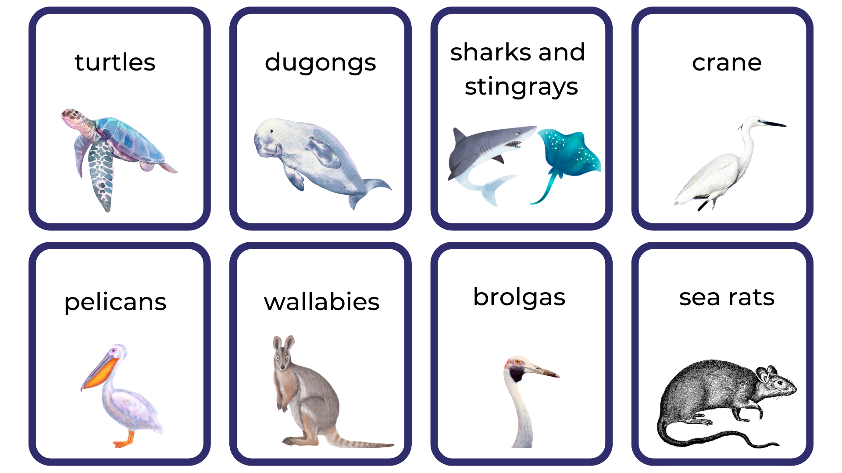
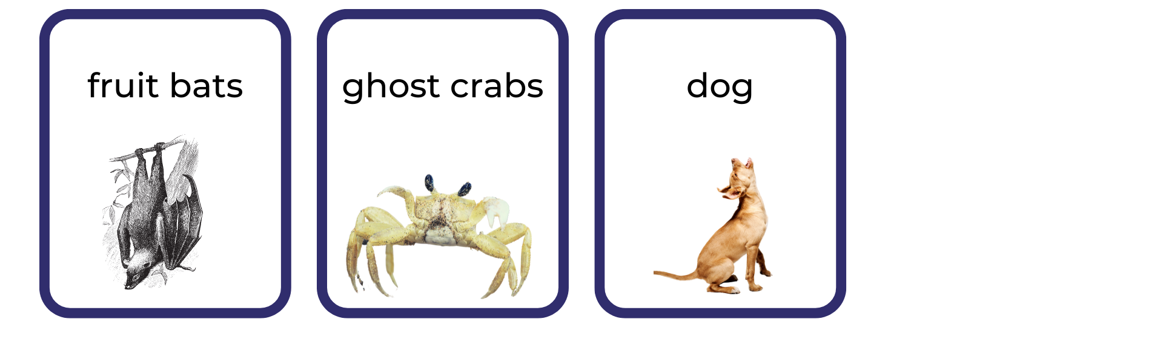
Images sourced from Canva and used in accordance with the Canva Content License Agreement.

Resource 2: Animal features
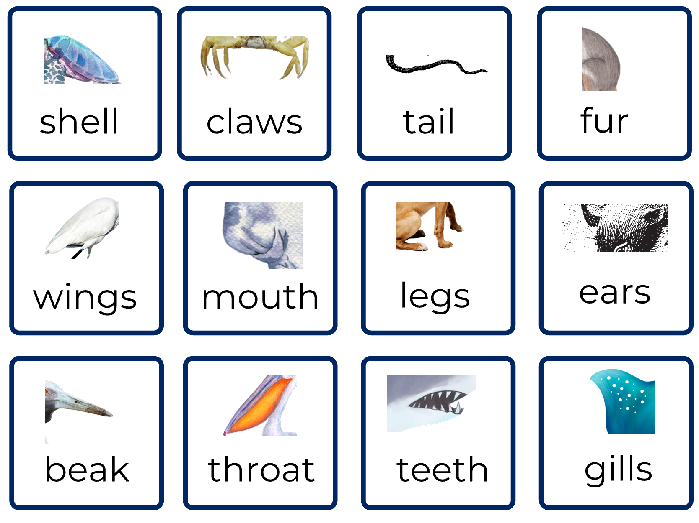
Images sourced from Canva and used in accordance with the Canva Content License Agreement.

Resource 3: Sentence frame
The naming part  (the ‘who’ or ‘what’)  subject/noun/noun group | The happening part  (what the naming part is doing)  verb/verb group (includes preposition) | The naming part  (the ‘what’)  object/noun/noun group
Turtles | glide through | the clear salt water.
An old man crane | watches for | fish in the shallows.
Use the sentence frame to create your own sentences.
The naming part  (the ‘who’ or ‘what’)  subject/noun/noun group | The happening part  (what the naming part is doing)  verb/verb group (includes preposition) | The naming part  (the ‘what’)  object/noun/noun group

Resource 4: Map of Australia
Images sourced from Canva and used in accordance with the Canva Content License Agreement.

Resource 5: Our Island example
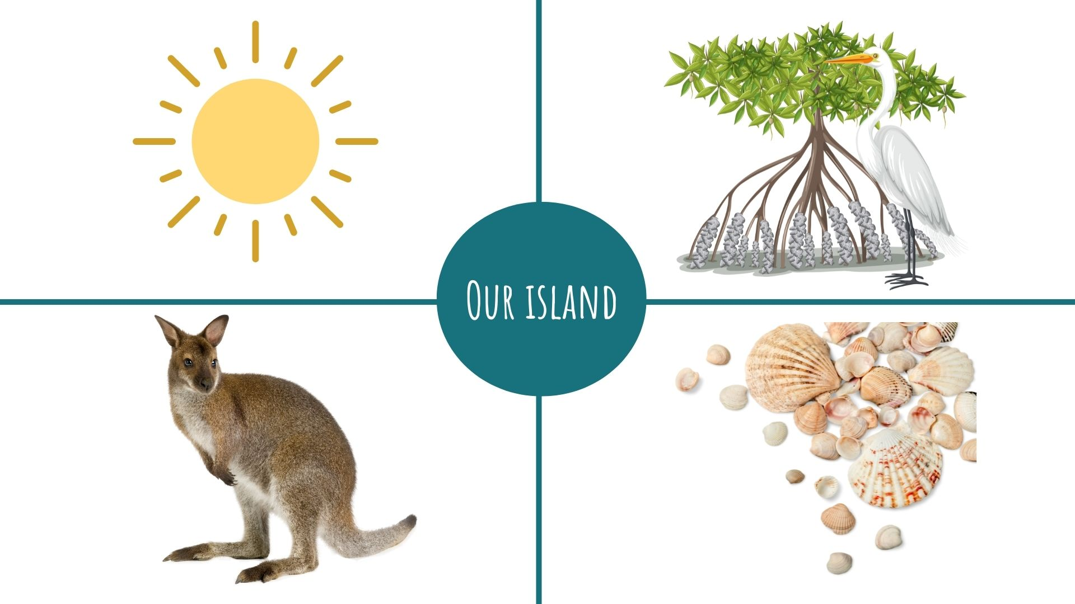
Images sourced from Canva and used in accordance with the Canva Content License Agreement.

References
Links to third-party material and websites
Please note that the provided (reading/viewing material/list/links/texts) are a suggestion only and implies no endorsement, by the New South Wales Department of Education, of any author, publisher, or book title. School principals and teachers are best placed to assess the suitability of resources that would complement the curriculum and reflect the needs and interests of their students.
If you use the links provided in this document to access a third-party's website, you acknowledge that the terms of use, including licence terms set out on the third-party's website apply to the use which may be made of the materials on that third-party website or where permitted by the Copyright Act 1968 (Cth). The department accepts no responsibility for content on third-party websites.
Except as otherwise noted, all material is © State of New South Wales (Department of Education), 2021 and licensed under the Creative Commons Attribution 4.0 International License. All other material (third-party material) is used with permission or under licence. Where the copyright owner of third-party material has not licensed their material under a Creative Commons or similar licence, you should contact them directly for permission to reuse their material.
English K–10 Syllabus © 2022 NSW Education Standards Authority (NESA) for and on behalf of the Crown in right of the State of New South Wales.
© 2021 NSW Education Standards Authority. This document contains NSW Curriculum and syllabus content. The NSW Curriculum is developed by the NSW Education Standards Authority. This content is prepared by NESA for and on behalf of the Crown in right of the State of New South Wales. The material is protected by Crown copyright.
Please refer to the NESA Copyright Disclaimer for more information.
NESA holds the only official and up-to-date versions of the NSW Curriculum and syllabus documents. Please visit the NSW Education Standards Authority (NESA) website and the NSW Curriculum website.
National Literacy Learning Progression © Australian Curriculum, Assessment and Reporting Authority (ACARA) 2010 to present, unless otherwise indicated. This material was downloaded from the Australian Curriculum website (National Literacy Learning Progression) (accessed 5 September 2022) and was not modified. The material is licensed under CC BY 4.0. Version updates are tracked in the ‘Curriculum version history’ section on the About the Australian Curriculum page of the Australian Curriculum website.
ACARA does not endorse any product that uses the Australian Curriculum or make any representations as to the quality of such products. Any product that uses material published on this website should not be taken to be affiliated with ACARA or have the sponsorship or approval of ACARA. It is up to each person to make their own assessment of the product, taking into account matters including, but not limited to, the version number and the degree to which the materials align with the content descriptions and achievement standards (where relevant). Where there is a claim of alignment, it is important to check that the materials align with the content descriptions and achievement standards (endorsed by all education Ministers), not the elaborations (examples provided by ACARA).
Children of Gununa, Lester A and Honey E (2016) Our Island, Picture Puffin, Australia.
ETA (English Teachers Association) and NSW Department of Education (2016) Context, English Textual Concepts website, accessed 25 July 2022.
ETA (English Teachers Association) and NSW Department of Education (2016) The Textual Concepts and Processes resource, English Textual Concepts website, accessed 2 September 2022.
Lessac F (2020) Under the Southern Cross, Walker Books Australia.

