English – K-2 multi-age – Year A – Unit 15
Contents
Unit overview and instructions for use 4
Teacher notes 5
Outcomes and content – Component A 7
Outcomes and content – Component B 11
Week 1 15
Component A teaching and learning 15
Component B teaching and learning 16
Lesson 1: Giraffes Can’t Dance 18
Lesson 2: Rhyme, noun groups, and verbs 21
Lesson 3: Exploring word play using alliteration 24
Lesson 4: Comparing factual and fictional texts 27
Lesson 5: Writing a character description using multiple sources 29
Week 2 35
Component A teaching and learning 35
Component B teaching and learning 36
Lesson 6: Leroy the Lionhearted 37
Lesson 7: Researching lions 41
Lesson 8: Additional research and planning 43
Lesson 9: Composing a fact file about lions 44
Lesson 10: Publishing a fact file about lions 46
Resource 1: Rhyme and rhythm 48
Resource 2: Story retell 49
Resource 3: Animal cards 50
Resource 4: Giraffe informative text 51
Resource 5: Giraffe diagram 53
Resource 6: Venn diagram example 54
Resource 7: Leroy the Lionhearted 55
Resource 8: T-chart 57
Resource 9: Y-chart 58
Resource 10: Lion fact file 59
References 60

Unit overview and instructions for use
This two-week unit is comprised of Component A and Component B. Connecting learning across both components is encouraged.
Teaching and learning | Component A | Component B
Suggested duration | 60 minutes | 45 minutes
Explicit teaching focus areas | - Phonological awareness (Early Stage 1)  - Print conventions (Early Stage 1)  - Phonic knowledge  - Reading fluency  - Reading comprehension  - Spelling  - Handwriting | - Oral language and communication  - Vocabulary  - Reading comprehension  - Creating written texts  - Understanding and responding to literature
To prepare for teaching and learning: | - Refer to Outcomes and content – Component A, K-2 – Instructional sequence – grapheme–phoneme correspondences [PDF 825 KB], and the teaching advice documents (hyperlinked in Component A teaching and learning table).  - Based on student needs identified through ongoing assessment data, plan and document how you will sequence teaching and learning in whole class and targeted teaching groups across the two-week cycle. | - Familiarise yourself with Outcomes and content – Component B, Textual concepts information and videos, English Textual Concepts and Learning Processes (2016), and the teaching and learning sequence.  - Based on student needs identified through ongoing assessment data, determine how you will support students in whole class and targeted teaching groups across the two-week cycle as required.
English K–10 Syllabus © 2022 NSW Education Standards Authority (NESA) for and on behalf of the Crown in right of the State of New South Wales.

Teacher notes
- Character is a construct of verbal and visual statements about a fictional identity. Analysis of characters contribute to our own personal judgements about self, morals, and values. – English Textual Concepts and Learning Processes (2016).
- Understanding of character can be supported through watching the department’s video: Character (2:31).
- For information on figurative language, Tier 1, 2 and 3 words, rhyme, sentences, nouns, verbs, adjectives, word play, subject–verb agreement, adverbs, possessive apostrophes, pronouns, and paragraphs refer to the NESA Glossary.
- A noun group is a group of words relating to, or building on, a noun. Noun groups usually consist of a pointer (the, a, an, this, that, these, those, my, your, his, her, its, our, mum’s, Mr Smith’s) plus one or more adjectives or adverbs. They are an important language resource for building descriptions.
- Reflect on student learning and engagement in activities and record differentiation and adjustments within the unit to inform future teaching and learning. One way of doing this could be to add comments to the digital file.
- Content are points are linked to the National Literacy Learning Progression version (3).
Levels and indicators sourced from National Literacy Learning Progression © Australian Curriculum, Assessment and Reporting Authority (ACARA), (accessed 13 February 2023) and was not modified. See references for more information.

Outcomes and content – Component A
The table below outlines the focus outcomes and content. Content is linked to the National Literacy Learning Progression version (3).
Early Stage 1 Focus area and outcome | Stage 1 Focus area and outcome
Phonological awareness  ENE-PHOAW-01 – identifies, blends, segments and manipulates phonological units in spoken words as a strategy for reading and creating texts  - complete familiar spoken phrases in texts, including chants, rhymes, songs and poems (PhA1)  - blend aloud all phonemes when asked to substitute a medial vowel phoneme | N/A
Print conventions  ENE-PRINT-01 – tracks written text from left to right and from top to bottom of the page and identifies visual and spatial features of print | N/A
Phonic knowledge  ENE-PHOKW-01 – uses single-letter grapheme–phoneme correspondences and common digraphs to decode and encode words when reading and creating texts  - decode words containing split digraphs and vowel digraphs (PKW5)  - experiment with encoding high-frequency words containing split digraphs and vowel digraphs | Phonic knowledge  EN1-PHOKW-01 – uses initial and extended phonics, including vowel digraphs, trigraphs to decode and encode words when reading and creating texts  - blend and decode one-syllable words with taught extended vowel graphs and digraphs, including graphemes for r-controlled vowels and diphthongs, and apply this when reading texts (PKW6, PKW7)  - segment and encode one-syllable words with taught vowel graphs, digraphs and trigraphs and apply this when creating texts (SpG8)  - decode words with trigraphs and quadgraphs and apply this when reading texts  - decode words with less common consonant digraphs and apply this when reading texts
Reading fluency  ENE-REFLU-01 – reads decodable texts aloud with automaticity  - know that fluent reading involves recognising and reading words accurately and automatically  - know that pace and expression vary when reading, according to the audience and purpose | Reading fluency  EN1-REFLU-01 – sustains reading unseen texts with automaticity and prosody and self-corrects errors  - adjust phrasing, intonation, volume or rate to maintain fluency when reading aloud (FIY4)  - vary pace when reading according to the audience and purpose (FIY4)
Reading comprehension  ENE-RECOM-01 – comprehends independently read texts using background knowledge, word knowledge and understanding of how sentences connect  - identify words that represent who, what, when, where and why in texts  - re-read to check if an error was made  - self-correct error using phonic knowledge (UnT5)  - ask a question or make a statement to clarify meaning (UnT3, UnT4) | Reading comprehension  EN1-RECOM-01 – comprehends independently read texts that require sustained reading by activating background and word knowledge, connecting and understanding sentences and whole text, and monitoring for meaning  - understand vocabulary that signals humorous word play in texts  - combine multiple sources of information within a text to make meaning
Spelling  ENE-SPELL-01 – applies phonological, orthographic and morphological generalisations and strategies to spell taught familiar and high-frequency words when creating texts  - experiment with some vowel digraphs and split digraphs to spell taught high-frequency words and/or personally significant words  - spell high-frequency compound words and homophones comprising taught graphemes | Spelling  EN1-SPELL-01 – applies phonological, orthographic and morphological generalisations and strategies when spelling words in a range of writing contexts  - explain that the consonant trigraphs, –tch and –dge, can end a base word immediately following a short vowel and apply this when spelling  - spell taught high-frequency contractions (SpG6)  - use extended phonic code for taught consonant phoneme  - use spelling conventions when adding tense-marking suffixes (SpG9)  - spell nouns ending in the suffix –er to indicate a person (SpG9)  - use common prefixes such as un–, re– and dis–
Handwriting  ENE-HANDW-01 – produces all lower-case and upper-case letters to create texts  - apply taught handwriting skills when creating texts | Handwriting  EN1-HANDW-01 – uses a legible, fluent and automatic handwriting style, and digital technology, including word-processing applications, when creating texts  - position all letters correctly on the line with appropriate spacing between words (HwK5)  - use taught software functions to create texts in a range of modes for different contexts, audiences and purposes.

Outcomes and content – Component B
The table below outlines the focus outcomes and content. Content is linked to the National Literacy Learning Progression version (3).
Early Stage 1 Focus area and outcome | Stage 1 Focus area and outcome
Oral language and communication  ENE-OLC-01 – communicates effectively by using interpersonal conventions and language with familiar peers and adults  - understand how pronouns can be linked to nouns to support meaning  - start a conversation with a peer and/or adult, staying on topic (InT3)  - use oral language to reason when speaking  - use oral language to persuade, negotiate, give opinions or discuss ideas (InT4)  - use a combination of sentences to elaborate and connect ideas (SpK3)  - retell favourite stories, poems, songs and rhymes with some parts as exact repetition and some in their own words (SpK2) | Oral language and communication  EN1-OLC-01 – communicates effectively by using interpersonal conventions and language to extend and elaborate ideas for social and learning interactions.  - respond to information by asking relevant questions to extend their own and others' knowledge (LiS4, LiS6)  - link or compare ideas when interacting
Vocabulary  ENE-VOCAB-01 – understands and effectively uses Tier 1 and Tier 2 words in familiar contexts  - experiment with and create word play and poems | Vocabulary  EN1-VOCAB-01 – understands and effectively uses Tier 1, taught Tier 2 and Tier 3 vocabulary to extend and elaborate ideas  - identify, understand and use word play and rhyme in a range of texts
Reading comprehension  ENE-RECOM-01 – comprehends independently read texts using background knowledge, word knowledge and understanding of how sentences connect  - identify words that represent who, what, when, where and why in texts  - ask a question or make a statement to clarify meaning (UnT3, UnT4) | Reading comprehension  EN1-RECOM-01 – comprehends independently read texts that require sustained reading by activating background and word knowledge, connecting and understanding sentences and whole text, and monitoring for meaning  - understand vocabulary that signals humorous word play in texts  - combine multiple sources of information within a text to make meaning
Creating written texts  ENE-CWT-01 – creates written texts that include at least 2 related ideas and correct simple sentences  - sequence ideas in a text (GrA4)  - identify and use verbs in simple sentences, including in own writing (GrA2)  - identify and use nouns in simple sentences, including in own writing (GrA3)  - identify and use time connectives to sequence information and events (GrA4)  - understand that punctuation is a feature of written language and how it impacts meaning  - understand they can improve their writing based on feedback from teachers | Creating written texts  EN1-CWT-01 – plans, creates and revises texts written for different purposes, including paragraphs, using knowledge of vocabulary, text features and sentence structure  - group sentences into paragraphs commencing with a topic sentence, followed by other sentences with related ideas (CrT7)  - use noun/pronoun-referencing across a text (CrT7)  - use subject–verb agreement across a text (GrA5)  - use noun groups to build descriptions of people and things (CrT6)  - use adverbs to modify the meaning of verbs and adjectives (GrA3)  - use possessive apostrophes in own writing (PuN4)  - use creative word play to affect the reader  - use different modes and media to enhance the presentation of texts they have created (CrT5, CrT6)
Understanding and responding to literature  ENE-UARL-01 – understands and responds to literature read to them  - reason using background knowledge as to why a character has acted in a certain way (UnT4)  - identify and discuss language used to describe characters in narratives. | Understanding and responding to literature  EN1-UARL-01 – understands and responds to literature by creating texts using similar structures, intentional language choices and features appropriate to audience and purpose  - identify how characters are constructed through different modes and media and through a combination of modes  - compare and contrast characters in text  - identify how a character reflects their own or other lived experiences.

Week 1

Component A teaching and learning
The table below can be used to plan and document lessons that address Component A outcomes and content. Both the detailed example [DOC 529KB] of a two-week teaching and learning cycle and brief example [DOC 66KB] may support you in your planning.
Focus Areas | Lesson 1 | Lesson 2 | Lesson 3 | Lesson 4 | Lesson 5
Phonological awareness (Early Stage 1) and Phonic knowledge
15 minutes
Spelling and Handwriting
15 minutes
Print conventions (Early Stage 1), Reading comprehension and Reading fluency
30 minutes

Component B teaching and learning
The following teaching and learning sequence has been designed to address Component B outcomes and content. Adapt the sequence as required to best meet the needs of your students.

Learning intention and success criteria
Learning intentions and success criteria are best co-constructed with students. The table below contains suggested learning intentions and success criteria.
Element | Early Stage 1 | Stage 1
Learning intentions | Students are learning to understand and explain how characters change in texts. | Students are learning to identify how authors construct characters in texts.
Success criteria | Students can:  - identify who, what, when, where and why in a text  - identify and use nouns and verbs in sentences  - identify and use word play in own texts  - retell familiar stories using time connectives  - use nouns, verbs, and pronouns to build character descriptions  - identify similarities and differences between fiction and non-fiction texts. | Students can:  - identify how characters change throughout a text  - identify and use rhyme in own texts  - identify and use word play in own texts  - use noun groups to build descriptions of characters  - use subject–verb agreement, possessive apostrophes, and personal pronouns  - identify similarities and differences between fiction and non-fiction texts.

Resources
- Andreae G (2019) Giraffes Can’t Dance (Parker-Rees G, illus.) Hachette Children’s Books, Great Britain. ISBN: 9781408354414
- Resource 1: Rhyme and rhythm
- Resource 2: Story retell (enlarged copy)
- Resource 3: Animal cards
- Resource 4: Giraffe informative text
- Resource 5: Giraffe diagram
- Resource 6: Venn diagram example
- 2 different coloured markers
- 2 hula hoops
- Copies of a Venn diagram (one between 2 students)
- Cut up colour copies of pages from Giraffes Can’t Dance and colour copies of Resource 4: Giraffe informative text
- Enlarged image of the character Gerald from Giraffes Can’t Dance
- Mini whiteboards.
- Sticky notes
- Tapping sticks (if available)

Lesson 1: Giraffes Can’t Dance
The following teaching and learning activities support multi-age settings.

Whole
- Introduce the text Giraffes Can’t Dance. Guide students to make predictions about what type of text it is, using the front and back covers, title, and illustrations. Discuss narrative elements and who the main character of the story may be. Revise the concept of character and how authors use descriptive and figurative language to help the audience build a deeper understanding of a character’s actions and emotions. Explain that a character can be a fictional person or idea, but they must always have an identity.
- Read Giraffes Can’t Dance. Ask students to put their hands on their head when they hear an unfamiliar word or phrase. Write words or phrases on a sticky note to refer to in activity 3. As a class, identify the best way to clarify meaning, for example, re-read parts of the text, read ahead or use visual cues. Encourage students to ask questions to clarify meaning of new words.
- Explain that good authors carefully consider their language choices. Revise the 3 tiers of vocabulary, then read through the new vocabulary identified on the sticky notes and clarify meaning. For example, bandy, daft, entranced. Encourage students to make inferences about how the character was feeling by drawing attention to specific moments and illustrations in the text. For example, ‘Oh, I feel like such a clot.’ Search for synonyms for the word ‘clot’ and use clues from the text to identify how Gerald was feeling.
- Display the enlarged image of Gerald and discuss his physical and personal character traits. For example, tall, long neck, nervous, brave, flexible. On one side of the image, record his physical traits in blue and on the other record his personal traits in green. This image will be used in Lesson 4, Lesson 5, and Lesson 6.
- Divide the class into 2 groups. Ask one group to think about Gerald at the beginning of the story and the second group to think about him at the end. Prompt both groups to think about how Gerald might be feeling and why he felt that way. For example, ‘Gerald felt sad at the beginning of the story because he thought he wasn’t good at dancing’, ‘Gerald was brave because he danced in front of the other animals at the end of the story’.
- Students form 2 circles, an inner circle and outer circle, facing each other. Students in the outer circle will think about Gerald at the beginning of the story and the students in the inner circle are Gerald at the end of the story. Explain that each student will share one idea with their partner about how Gerald felt and why. After both students have shared, the outer circle will take one step to the right to form a new partnership. Encourage students to share a new idea as they move around the circle.

Part
The table below details the differentiated teaching and learning activities for each stage.
Early Stage 1 (teacher guided/independent) | Stage 1 (pairs/independent)
- Display a page from Giraffes Can’t Dance and the words who, what, when, where and why.  - Ask students to identify key words within the text that tell, who, what, when, where and why and record ideas on a graphic organiser.  - Students write sentences about the text. Encourage students to include information about who, what, when, where and why.  Too hard? Students draw a picture of what happened in the story, labelling it with words or phrases.  Too easy? Students write sentences that compare how Gerald felt at the beginning to the end of the story. | - Students draw 2 pictures of Gerald, one at the beginning and one at the end. In pairs, students discuss how Gerald changed throughout the text.  - Students write sentences about how Gerald felt at the beginning compared to how he felt at the end. For example, ‘At the beginning of the story, Gerald thought he was useless because he couldn’t dance like the other animals. After creating his own music and listening to the cricket’s violin, Gerald felt confident and excited that he was dancing and surprised the other animals’.
Early Stage 1 Assessment task 1 – Observations and work samples from this lesson allow students to demonstrate achievement towards the following syllabus outcomes and content points:
ENE-OLC-01 – communicates effectively by using interpersonal conventions and language with familiar peers and adults
- start a conversation with a peer and/or adult, staying on topic
- use oral language to persuade, negotiate, give opinions or discuss ideas
- use a combination of sentences to elaborate and connect ideas.
ENE-RECOM-01 – comprehends independently read texts using background knowledge, word knowledge and understanding of how sentences connect
- identify words that represent who, what, when, where and why in texts
- ask a question or make a statement to clarify meaning.
Stage 1 Assessment task 1 – Observations from this lesson allow students to demonstrate achievement towards the following syllabus outcomes and content points:
EN1-OLC-01 – communicates effectively by using interpersonal conventions and language to extend and elaborate ideas for social and learning interactions
- respond to information by asking relevant questions to extend their own and others' knowledge
- link or compare ideas when interacting.
EN1-RECOM-01 – comprehends independently read texts that require sustained reading by activating background and word knowledge, connecting and understanding sentences and whole text, and monitoring for meaning
- combine multiple sources of information within a text to make meaning.

Lesson 2: Rhyme, noun groups, and verbs
The following teaching and learning activities support multi-age settings.

Whole
- Re-read the first 2 pages of the text, Giraffes Can’t Dance. Ask students what they noticed about the language Giles Andreae used in the text. Highlight the use of rhyme throughout the text. Explain that rhyme is the repetition of similar speech sounds in the final syllable of words.
- Provide students with tapping sticks. If tapping sticks are unavailable students can clap their hands to form the sound. Explain that the author has used syllables to create rhyme and rhythm. Using Resource 1: Rhyme and rhythm, identify and compare the syllable structure of 2 different paragraphs. Re-read the text while students clap along to the syllable structure on each page. Explain that the author has used the literary techniques of rhyme and rhythm to give the text a musical pattern and to make it more enjoyable for the reader.
- On mini whiteboards, students create a list of rhyming words from the text. Create a T-chart with the headings ‘sounds the same and spelt the same’ and ‘same sound but different spelling’. As a class, sort the words according to the spelling of the rime. For example, under the heading ‘sounds the same and spelt the same’ write trees/knees, ground/round and then under the heading ‘sounds the same but different spelling’ write, ‘rolled/bold’, ‘laughed/daft’. Compare and discuss the type of rhyming words used in the text.
- Create a list of the other animals from the text and list these under the heading ‘nouns’. This list will be referred to in Lesson 3. Ask students to think of describing words about the animals and create a list under the heading ‘adjectives’. Ask students to think of action words to suit the animals and create a list under the heading ‘verbs’.

Part
The table below details the differentiated teaching and learning activities for each stage.
Early Stage 1 (pairs/independent) | Stage 1 (teacher guided)
- Students choose a noun and a verb from the list created in activity 4. In pairs, students take turns performing actions and verbalising a sentence about the animal. For example, ‘I am an elephant swinging my trunk’. Repeat for multiple animals.  - Students choose one animal from the text and draw a picture then label the drawing with adjectives and verbs. | - Explain that noun groups are a group of words that build on a noun. Authors use noun groups to create character descriptions. They include a pointer such as his, her, the, our, plus one or more adjective or adverb and a noun.  - Display the sentence, ‘The big grey rhino was dancing in the sun.’ Using 2 different coloured pens, circle the pointer ‘The’, and underline the remainder of the noun group ‘big grey rhino’.  - Display a picture of a chimp or another animal from the text. Model writing noun groups on the left side of the image. For example, small chimp, silly chimp, wise chimp.  - Select a verb from the list created in activity 4 and model using it in a phrase to describe the animal’s action on the right side of the image. For example, climbs up trees, swings on branches.  - Co-construct a sentence using a noun group and a verb to describe an action. For example, The silly chimp swings on branches. This sentence will be used in Lesson 3.

Part
The table below details the differentiated teaching and learning activities for each stage.
Early Stage 1 (teacher guided) | Stage 1 (independent)
- Model writing a sentence about one of the animals using adjectives and verbs. For example, ‘The silly chimp swings’. Circle the noun ‘chimp’ and underline the verb ‘swings’.  - Using their plan created in activity 6, students write their own sentences about an animal from the text. Students circle nouns and underline verbs in their sentences. | - Students choose a different animal from the text and draw a picture, listing noun groups and verbs to describe an action around the outside of the picture.  - Students write their own sentences using nouns groups and verbs.

Lesson 3: Exploring word play using alliteration
The following teaching and learning activities support multi-age settings.

Whole
- Display an enlarged copy of Resource 2: Story retell. Discuss the use of time connectives ‘first’, ‘then’, and ‘after’. Explain that time connectives help sequence a story in order. Ask students to close their eyes and think about what happened in the story Giraffes Can’t Dance. Model drawing 3 key events from the story in the boxes from Resource 2: Story retell. In pairs, students retell the story to their partner using the picture prompts. Encourage students to use exact phrases or rhyme from the text.
- Revise the literary techniques of rhyme and rhythm and why the author, Giles Andreae, used them in Giraffes Can’t Dance. Introduce the term ‘alliteration’ and explain that this is a different literary technique used by authors to create emotions and rhythm. Explain that alliteration is when words written together begin with the same letter or sound, and this creates rhyme and rhythm. Identify examples in the text, for example, ‘warthogs waltzing’, ‘rhinos rock'n’roll’, ‘chimps cha-cha’ and ‘cricket coughed’.
- Display the list of animals that was created in Lesson 2. In pairs, students choose an animal and brainstorm adjectives that begin with the same sound. List these on the board. For example, crazy cricket, zippy zebra, big, bossy baboon. Explain that when 2 or more adjectives are listed, they must be separated by a comma.
- Explain that students will create a text including two- or three-word alliteration. Display the image of the chimp from the previous lesson and the sentence, ‘The silly chimp swings on branches.’ Model changing words in the sentence to include alliteration and repetition. For example, The cheeky chimp swings from branch to branch. Explain that the repetition of the ‘ch’ sound creates alliteration and rhythm within the sentence. Model adding time connectives to the sentence. For example, ‘First the cheeky chimp swings from branch to branch then falls from the tall tree’.

Part
The table below details the differentiated teaching and learning activities for each stage.
Early Stage 1 (small groups/independent) | Stage 1 (teacher guided/independent)
- Provide students with Resource 3: Animal cards. In small groups, students brainstorm adjectives that begin with the same sound. For example, heavy hippo, beautiful butterfly, sneaky snake, or delicate dolphin.  - Students write sentences about their animals including alliteration and time connectives.  Too hard? Students label a picture of an animal including two-word alliteration.  Too easy? Students experiment with creating three-word alliteration and rhyme. | - Students review their sentences from Lesson 2 and use their ideas to create a text about their animal including two- or three-word alliteration.  Too hard? Students create noun groups including two-word alliteration for different animals in the text.  Too easy? Students experiment using rhyme and rhythm in their text about an animal.
Early Stage 1 Assessment task 2 – Observations and work samples from this lesson allow students to demonstrate achievement towards the following syllabus outcomes and content points:
ENE-OLC-01 – communicates effectively by using interpersonal conventions and language with familiar peers and adults
- retell favourite stories, poems, songs and rhymes with some parts as exact repetition and some in their own words.
ENE-VOCAB-01 – understands and effectively uses Tier 1 and Tier 2 words in familiar contexts
- experiment with and create word play and poems.
ENE-CWT-01 – creates written texts that include at least 2 related ideas and correct simple sentences
- identify and use time connectives to sequence information and events.
Stage 1 Assessment task 2 – Observations and work samples from this lesson allow students to demonstrate achievement towards the following syllabus outcome and content point:
EN1-CWT-01 – plans, creates and revises texts written for different purposes, including paragraphs, using knowledge of vocabulary, text features and sentence structure
- use creative word play to affect the reader.

Lesson 4: Comparing factual and fictional texts
The following teaching and learning activities support multi-age settings.

Whole
- Present the factual text, Resource 4: Giraffe informative text. Ask students to predict what type of text it is. Display the image of Gerald from Giraffes Can’t Dance from Lesson 1 and place it next to Resource 5: Giraffe diagram. Discuss the differences between a drawing and a diagram and explain that the purpose of a diagram is to inform. Identify and list the key elements of a diagram. For example, diagrams are easy to read and include factual words or phrases, arrows or lines and no punctuation. The list of key elements will be used in Lesson 10.
- Display an enlarged Venn diagram with the titles ‘Giraffes Can’t Dance’ and ‘Giraffe informative text’. Explain that students will compare and contrast the 2 texts. Ask students if they can see any similarities. For example, both texts have the word giraffe in the title. Model writing information on a sticky note and placing it in the middle of the Venn diagram. Ask students if they see any differences between the texts. For example, one text has a drawing of a giraffe and the other uses photos. Model writing ‘photos’ on a sticky note and placing it under the heading ‘Giraffe informative text’. Model writing ‘drawings’ and placing it under the heading ‘Giraffes Can’t Dance.’ Refer to Resource 6: Venn diagram example and add a few more ideas.
- Display and ask the following questions:
- Is the book fiction or non-fiction? How do you know?
- What is the purpose of the text Giraffes Can’t Dance?
- What is the purpose of the giraffe informative text?
- Did the texts have more similarities or differences? Were you surprised with the results?
- Explain that the author, Giles Andreae, created the character Gerald using information about giraffes. Discuss the importance of authors having background knowledge of a topic before creating characters. Compare the language from Giraffes Can’t Dance and Resource 4: Giraffe informative text. Highlight the informative language about giraffes that is similar in both texts. For example, long neck, hooves, eats shoots off trees.

Part
The table below details the differentiated teaching and learning activities for each stage.
Early Stage 1 (teacher guided) | Stage 1 (pairs)
- Compare Giraffes Can’t Dance to Resource 4: Giraffe informative text and Resource 5: Giraffe diagram. Discuss the audience and purpose – one is a narrative and its purpose is to entertain, while the others are factual and the purpose is to inform.  - Students sit in a circle. Place 2 hula hoops on the ground with the headings ‘Fact’ and ‘Fiction’. Display cut up coloured copies of images from Giraffes Can’t Dance and the giraffe informative text resources around the hoops.  - Students select an image and place it in the correct hoop, providing a reason for their choice.  Too easy? Students write a reason to justify their choice. | - In pairs, students complete their own Venn diagram identifying similarities and differences between Giraffes Can’t Dance and Resource 4: Giraffe informative text.  Too easy? Provide a range other informative texts for students to compare, for example, a website or poster.

Whole
- Students share similarities and differences they found between imaginative and informative texts.

Lesson 5: Writing a character description using multiple sources
The following teaching and learning activities support multi-age settings.

Whole
- Revise personal pronouns. Explore ways that nouns can be represented through pronouns, for example, he, she, they. Locate examples of personal pronouns used in Giraffes Can’t Dance.
- Revise possessive apostrophes and their purpose, which is to demonstrate a noun’s ownership of an object or quality. Brainstorm and list examples of ownership from the text, for example, Gerald’s long neck, Africa’s Jungle Dance, cricket’s cough, the lion’s tango.
- Explain that students will create a character description of Gerald. Early Stage 1 will use nouns, verbs and pronouns and Stage 1 will use correct subject–verb agreement, noun groups and creative word play such as alliteration, rhythm, and rhyme. Students may describe Gerald’s appearance, personality, emotions or experiences.
- Display the image of Gerald from Giraffes Can’t Dance from Lesson 1. Discuss his identity and character traits.
- Encourage students to include information from Giraffes Can’t Dance, Resource 4: Giraffe informative text and Resource 5: Giraffe diagram. Co-construct writing criteria to be used by students as they write their own character description.

Part
The table below details the differentiated teaching and learning activities for each stage.
Early Stage 1 (independent) | Stage 1 (teacher guided)
- Students draw an image of Gerald and brainstorm ideas around the outside to describe his appearance and personality.  Too hard? Brainstorm ideas in pairs or small groups.  Too easy? Students include facts learnt about giraffes around their drawing of Gerald. | - Revise subject–verb agreement as when a writer or speaker selects the correct verb for the noun or noun group to which it is referring. Identify examples of subject–verb agreement throughout the text, highlighting the use of single subject and single verbs. For example, ‘Gerald was very good at standing still’, ‘Gerald felt so sad, he crept off’.  - Display the enlarged image of Gerald from Giraffes Can’t Dance from Lesson 1. Using mini whiteboards, students select physical and personal characteristics to write a series of sentences using a subject–verb agreement. For example, ‘Gerald was brave to dance’, ‘Gerald is very flexible’, ‘Gerald was shuffling and swaying’.  - Model writing a character description about Gerald. For example, ‘Gerald the giraffe lived in a giant jungle. He was very tall and had long thin legs. Gerald was a bit clumsy and shy. He wished he could prance and dance and wanted to be accepted by the animals. The cricket’s music helped him move and shuffle his hooves. Gerald danced up a storm and he felt confident to perform’.  - Using different coloured markers, ask students to identify examples of noun groups, alliteration, rhyme, personal pronouns, and possessive apostrophes. Discuss how information about giraffes has been used to create the character, Gerald.

Part
The table below details the differentiated teaching and learning activities for each stage.
Early Stage 1 (teacher guided/independent) | Stage 1 (independent/pairs)
- Revise nouns, verbs, and pronouns.  - Display the following character description example of Gerald: ‘Gerald the giraffe lived in a giant jungle. He was very tall and had long thin legs. Gerald was a bit clumsy and shy. He wished he could prance and dance and wanted to be accepted by the animals. The cricket’s music helped him move and shuffle his hooves. Gerald danced up a storm and felt confident to perform’.  - Using 2 different coloured markers, students circle the nouns, underline the verbs and identify the pronouns used in the example.  - Students write a character description about Gerald from Giraffes Can’t Dance, describing his appearance and personality. Students circle nouns and underline verbs in their sentences.  Too hard? Co-construct a character description about Gerald using nouns, verbs and pronouns.  Too easy? Students use alliteration in their character description. | - Students draw an image of Gerald and brainstorm ideas around the outside. Using the writing criteria and their plan, students write a character description.  - Students provide peer feedback using the writing criteria. Allow time for students to apply feedback to their writing.  Too hard? Students list words or phrases about Gerald around an image, then co-construct a character description.  Too easy? Students create a poem about Gerald using noun groups, alliteration, rhyme and rhythm.

Whole
- Students identify and explain how they included information about giraffes and characteristics of Gerald from Giraffes Can’t Dance in their character description.
Early Stage 1 Assessment task 3 – Observations and work samples from this lesson allow students to demonstrate achievement towards the following syllabus outcomes and content points:
ENE-OLC-01 – communicates effectively by using interpersonal conventions and language with familiar peers and adults
- understand how pronouns can be linked to nouns to support meaning.
ENE-CWT-01 – creates written texts that include at least 2 related ideas and correct simple sentences
- identify and use verbs in simple sentences, including in own writing
- identify and use nouns in simple sentences, including in own writing.
ENE-UARL-01 – understands and responds to literature read to them
- identify and discuss language used to describe characters in narratives.
Stage 1 Assessment task 3 – Observations and work samples from this lesson allow students to demonstrate achievement towards the following syllabus outcomes and content points:
EN1-VOCAB-01 – understands and effectively uses Tier 1, taught Tier 2 and Tier 3 vocabulary to extend and elaborate ideas
- respond to information by asking relevant questions to extend their own and others' knowledge
- identify, understand and use word play and rhyme in a range of texts.
EN1-CWT-01 – plans, creates and revises texts written for different purposes, including paragraphs, using knowledge of vocabulary, text features and sentence structure
- use noun/pronoun-referencing across a text
- use subject–verb agreement across a text
- use noun groups to build descriptions of people and things
- use possessive apostrophes in own writing
- use creative word play to affect the reader.
EN1-UARL-01 – understands and responds to literature by creating texts using similar structures, intentional language choices and features appropriate to audience and purpose
- identify how a character reflects their own or other lived experiences.

Week 2

Component A teaching and learning
The table below can be used to plan and document lessons that address Component A outcomes and content. Both the detailed example [DOC 529KB] of a two-week teaching and learning cycle and brief example [DOC 66KB] may support you in your planning.
Focus Areas | Lesson 6 | Lesson 7 | Lesson 8 | Lesson 9 | Lesson 10
Phonological awareness (Early Stage 1) and Phonic knowledge
15 minutes
Spelling and Handwriting
15 minutes
Print conventions (Early Stage 1), Reading comprehension and Reading fluency
30 minutes

Component B teaching and learning
The following teaching and learning sequence has been designed to address Component B outcomes and content. Adapt the sequence as required to best meet the needs of your students.

Learning intention and success criteria
Learning intentions and success criteria are best co-constructed with students. The table below contains suggested learning intentions and success criteria.
Element | Early Stage 1 | Stage 1
Learning intentions | Students are learning to use knowledge of the world around them to create texts. | Students are learning to use multiple sources of information to create texts.
Success criteria | Students can:  - compare and describe characters from different texts  - use multiple sources of information to conduct research  - use facts to create informative sentences  - create a labelled diagram. | Students can:  - compare and contrast characters from texts  - use adverbs to describe a character  - use multiple sources of information to conduct research  - use facts to create detailed, informative sentences  - group sentences into paragraphs  - create a detailed labelled diagram.

Resources
- Andreae G (2019) Giraffes Can’t Dance (Parker-Rees G, illus.) Hachette Children’s Books, Great Britain. ISBN: 9781408354414
- Resource 7: Leroy the Lionhearted
- Resource 8: T-chart (enlarged copy and individual copies for Early Stage 1 students)
- Resource 9: Y-chart
- Resource 10: Lion fact file (enlarged copy and individual copies for each student)
- National Geographic Kids – Lion
- Britannica Kids – lion or Taronga Conservation Society Australia – Lion
- One large photograph of a lion
- Sticky notes.

Lesson 6: Leroy the Lionhearted
The following teaching and learning activities support multi-age settings.

Whole
- Introduce Resource 7: Leroy the Lionhearted, guiding students to make predictions about what type of text it is, including its purpose and audience. Read the text and discuss the literary techniques used. Highlight the use of rhyming words. For example, coronation/celebration, king/sing, ready/steady, gave/brave.
- As a class, identify new language and create a list of topic words about lions from the text. For example, fangs, mane, pride. Explain that students will be researching lions in Lesson 7. Discuss the use of word play and identify phrases the author has used to create humour and emotion. For example, ‘roared up a storm’, ‘sang out with pride’, ‘liony voice’ and ‘royal performance’.
- Discuss the character Leroy and how he felt at the beginning compared to the end of the story. Display the image of Gerald from Giraffes Can’t Dance from Lesson 1 and discuss similarities and differences between the characters. For example, ‘Leroy performed in a ballroom, Gerald performed bravely in the jungle, both characters were nervous about their performance’. Using the Think-Pair-Share strategy, students explain how the characters are similar or different.

Part
The table below details the differentiated teaching and learning activities for each stage.
Early Stage 1 (teacher guided) | Stage 1 (independent/pairs)
- Display an enlarged copy of Resource 8: T-chart with the titles ‘Leroy’ and ‘Gerald’. Discuss character traits that describe Leroy and Gerald focusing on their personality, emotions, and actions from the texts.  - Model writing a word or phrase that describes each character under the headings. For example, giraffe, lion, nervous, confident. Students take turns with the teacher to add words or phrases to the enlarged T-chart. | - Provide students with a copy of Resource 9: Y-chart. Students write character traits in each section about Gerald, Leroy and themselves. Students compare and contrast the characters in the story to their own experiences.  - Students share their responses with a peer.  Too hard? Students complete a T-chart comparing Leroy and Gerald.  Too easy? Students write sentences to compare and contrast the characters in the story to their own identity or experiences.

Part
The table below details the differentiated teaching and learning activities for each stage.
Early Stage 1 (independent) | Stage 1 (teacher guided/independent)
- Provide students with their own copy of Resource 8: T-chart to complete.  Too hard? Students draw pictures of the 2 characters performing actions and write key words to describe what they are doing.  Too easy? Students write sentences using nouns and verbs to describe the characters. | - Revise adverbs as a word that tells something about a verb, adjective or another verb to indicate manner (how), place (where) or time (when). Explain that adverbs commonly end in -ly.  - Brainstorm and list adverbs that describe the characters’ actions and personality traits. For example, Leroy: awoke happily, arrived nervously, bravely sang; Gerald: simply froze, boldly danced, bowed gracefully. Highlight how each adverb contains a base word (free morpheme) that is built on by the suffix (bound morpheme) -ly.  - Students write adverbs to describe Gerald, Leroy and themselves on their Y-chart.

Whole
- Compare and contrast the characters in the 2 texts, discussing how both Gerald and Leroy have been represented. For example, Gerald’s story is written as a narrative, whereas Leroy’s story is written as a poem. Explore how these different modes of storytelling impact how the audience understands a character’s traits and personal development. Ask students what other forms of media can be used for storytelling, for example, movies, songs, wordless books, websites.
Early Stage 1 Assessment task 4 – Observations from this lesson allow students to demonstrate achievement towards the following syllabus outcomes and content points:
ENE-OLC-01 – communicates effectively by using interpersonal conventions and language with familiar peers and adults
- use oral language to reason when speaking
- use oral language to persuade, negotiate, give opinions or discuss ideas.
ENE-UARL-01 – understands and responds to literature read to them
- reason using background knowledge as to why a character has acted in a certain way.
Stage 1 Assessment task 4 – Observations and work samples from this lesson allow students to demonstrate achievement towards the following syllabus outcomes and content points:
EN1-RECOM-01 – comprehends independently read texts that require sustained reading by activating background and word knowledge, connecting and understanding sentences and whole text, and monitoring for meaning
- understand vocabulary that signals humorous word play in texts.
EN1-CWT-01 – plans, creates and revises texts written for different purposes, including paragraphs, using knowledge of vocabulary, text features and sentence structure
- use adverbs to modify the meaning of verbs and adjectives.
EN1-UARL-01 – understands and responds to literature by creating texts using similar structures, intentional language choices and features appropriate to audience and purpose
- identify how characters are constructed through different modes and media and through a combination of modes
- compare and contrast characters in text.

Lesson 7: Researching lions
The following teaching and learning activities support multi-age settings.

Whole
- Explain that the author of Leroy the Lionhearted used information about lions to create the character in the text.
- Display a photograph of a lion. Ask:
- What type of animal is a lion?
- Where do they live?
- What do they eat?
- Do lions have any special features or characteristics?
- Explain that students will be creating an informative text about lions. Ask students if they learnt enough information about lions from Resource 7: Leroy the Lionhearted. Discuss reasons why or why not.
- Discuss the purpose of an informative text. Revise the topic words about lions identified in Lesson 6 and explain that students will be conducting research to help them create their own text.
- View National Geographic Kids – Lion and use the ‘think aloud’ strategy to describe how informative texts are read. Ask students to identify similarities and differences between digital texts and printed texts. Discuss key content from the page and navigate through it following the navigation pathway. Explain that National Geographic is a trusted source and that the website’s ‘Site last updated’ information, located at the bottom of the page, indicates that the information is recent.
- Read through the information and watch the videos on the website, pausing to discuss key facts about lions.
- Display an enlarged copy of Resource 10: Lion fact file. Read through the headings and discuss new vocabulary. For example, appearance, diet. Model writing one fact about lions under each heading. For example, Lions are mammals, live in Africa, carnivores. Explain that students will write words or phrases rather than full sentences.
- Provide students with their own copy of Resource 10: Lion fact file. Students write at least one fact about lions under the headings using information sourced from the website. Students will add more information to their fact file in Lesson 8.
Too hard? Students verbalise facts about lions. Co-construct phrases and record them on an enlarged copy of the fact file.
Too easy? Students write detailed sentences using the facts from the website, rewriting information in their own words.

Lesson 8: Additional research and planning
The following teaching and learning activities support multi-age settings.

Whole
- Revise information learnt about lions from the previous lesson. Students participate in a gallery walk to see what information their peers recorded about lions. Encourage students to identify one new fact that they could include in their own fact file.
- Explain that students will be using a different source of information to conduct more research about lions. Open Britannica Kids – lion or Taronga Conservation Society Australia – Lion and prompt students to consider the audience of the text. Read through the website, watch the videos or discuss the ‘Fast facts’.
- Students discuss new information they learnt about lions. Display the enlarged copy of Resource 10: Lion fact file, model re-reading existing information and writing new facts.
- Using their own copy of Resource 10: Lion fact file, students re-read their information and write additional facts they have learnt from the website or videos.
- Model writing sentences using facts about lions. For example, ‘Lions hunt other animals for their meat. They eat zebras and water buffalos’. Discuss the use of pronouns and punctuation to form accurate sentences.
- Co-construct differentiated writing criteria to be used in Lesson 9.

Lesson 9: Composing a fact file about lions
The following teaching and learning activities support multi-age settings.

Whole
- Re-read the modelled sentences about lions from Lesson 8. Students identify and circle the pronouns used. Explain that students will be using their information about lions to create a well-sequenced informative text.

Part
The table below details the differentiated teaching and learning activities for each stage.
Early Stage 1 (independent) | Stage 1 (teacher guided)
- Students write informative sentences about lions using information from their Resource 10: Lion fact file. Encourage students to use nouns, verbs and pronouns.  Too hard? Students work in small groups to write simple facts about lions.  Too easy? Students include topic specific vocabulary in their sentences. | - Ask students to share what they know about paragraphs. Explain that paragraphs are a sequence of sentences, grouped together and focused on a specific theme.  - Model writing an exemplar paragraph using information from one of the subheadings from Resource 10: Lion fact file. For example, ‘Lions are carnivores and hunt their prey. They usually eat large animals like zebras and water buffalos. The lionesses do most of the hunting and provide for their pride’. Discuss the importance of grouping similar ideas together and using pronouns.

Part
The table below details the differentiated teaching and learning activities for each stage.
Early Stage 1 (teacher guided/pairs) | Stage 1 (independent/pairs)
- Using the modelled sentences from Lesson 8, model applying feedback using the writing criteria.  - Students re-read their informative sentences identifying their use of nouns, verbs, pronouns and punctuation.  - In pairs, students provide feedback using the writing criteria. They then apply this feedback to improve their writing. | - Students complete their informative text, writing paragraphs using information from Resource 10: Lion fact file.  Too hard? Co-construct sentences for each subheading about lions.  Too easy? Students include scientific names and topic specific vocabulary in their text.  - Using the writing criteria, students provide peer feedback to edit their writing.
Early Stage 1 Assessment task 5 – Collecting work samples from this lesson allows students to demonstrate achievement towards the following syllabus outcome and content point:
ENE-CWT-01 – creates written texts that include at least 2 related ideas and correct simple sentences
- understand they can improve their writing based on feedback from teachers.

Lesson 10: Publishing a fact file about lions
The following teaching and learning activities support multi-age settings.

Whole
- Students publish their writing from Lesson 9.
- Display Resource 5: Giraffe diagram and revise the key elements of a labelled diagram from Lesson 4. Co-construct success criteria for creating a labelled diagram. For example:
- factual words or phrases
- arrows or lines
- no punctuation
- clear and easy to read.
- Students use the success criteria to create a labelled diagram of a lion. They could do this digitally, by labelling their own drawing, or labelling a printed image.
- Optional: Students create a multimodal text using visuals, written and/or spoken text together to create meaning. Suggested examples that students can use to publish their work include:
- recording a slide show with narration using PowerPoint
- creating a short video using stop motion animation
- designing a poster.
Too hard? Co-construct words or phrases about lions.
Too easy? Students include scientific names and topic specific vocabulary in their text.
Early Stage 1 Assessment task 6 – Collecting work samples from this lesson allows students to demonstrate achievement towards the following syllabus outcome and content points:
ENE-CWT-01 – creates written texts that include at least 2 related ideas and correct simple sentences
- sequence ideas in a text
- understand that punctuation is a feature of written language and how it impacts meaning.
Stage 1 Assessment task 5 – Collecting work samples from this lesson allows students to demonstrate achievement towards the following syllabus outcome and content points:
EN1-CWT-01 – plans, creates and revises texts written for different purposes, including paragraphs, using knowledge of vocabulary, text features and sentence structure
- group sentences into paragraphs commencing with a topic sentence, followed by other sentences with related ideas
- use different modes and media to enhance the presentation of texts they have created.

Resource 1: Rhyme and rhythm
Example 1 | Example 2
Now every year in Africa  They hold the Jungle Dance,  Where every single animal  Turns up to sing and prance.  Note: Line 1 and 3 have 8 syllables, Line 2 and 4 have 6 syllables | With that, the cricket smiled  And picked up his violin.  Then Gerald felt his body  Do the most amazing thing.  Note: Line 1 has 6 syllables and the rest have 7 syllables

Resource 2: Story retell
First | Then | After

Resource 3: Animal cards
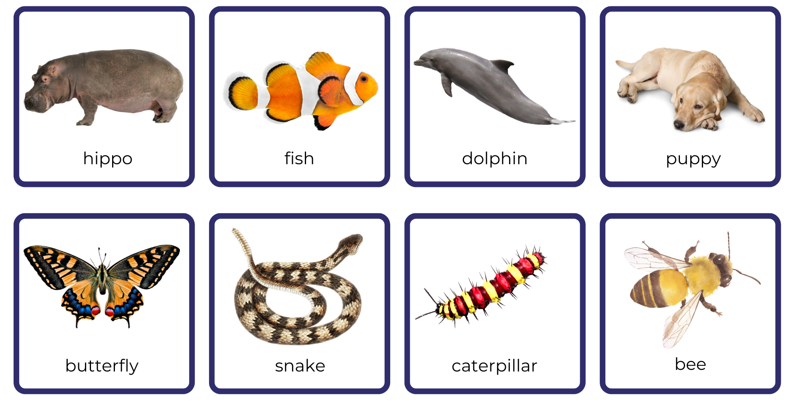
Images sourced from Canva and used in accordance with the Canva Content License Agreement.

Resource 4: Giraffe informative text
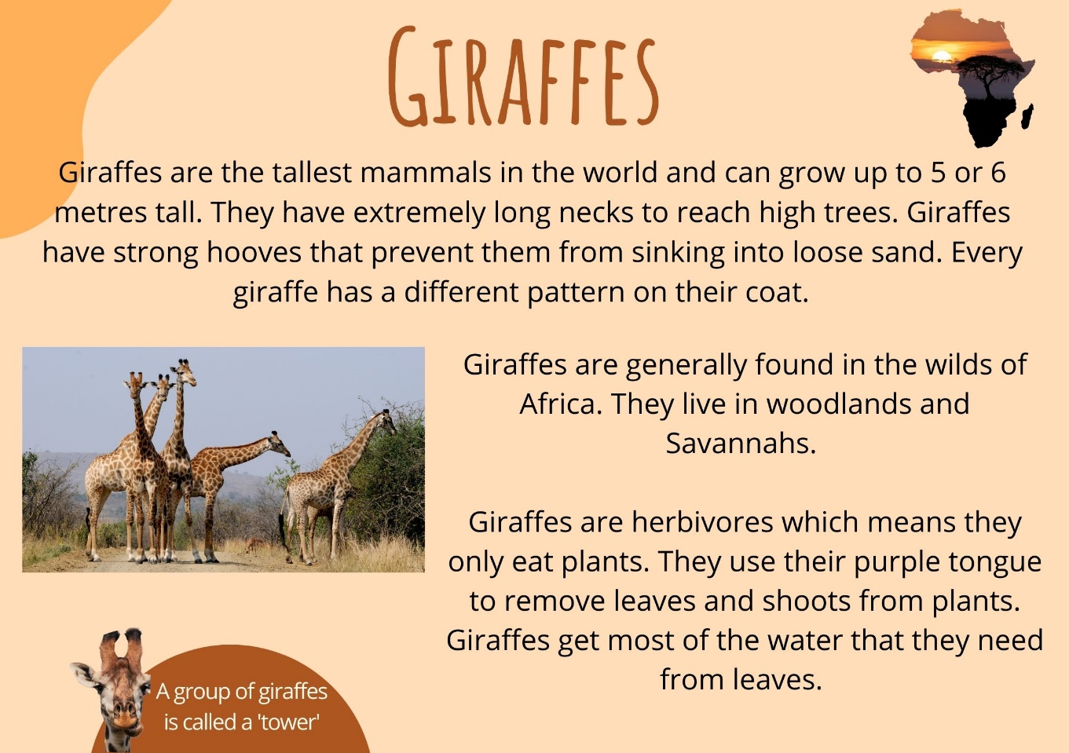
Images sourced from Canva and used in accordance with the Canva Content License Agreement.

Giraffe informative text transcript
Giraffes are the tallest mammals in the world and can grow up to 5 or 6 metres tall. They have extremely long necks to reach high trees. Giraffes have strong hooves that prevent them from sinking into loose sand. Every giraffe has a different pattern on their coat.
Giraffes are generally found in the wilds of Africa. They live in woodlands and Savannahs.
Giraffes are herbivores which means they only eat plants. They use their purple tongue to remove leaves and shoots from plants. Giraffes get most of the water that they need from leaves. A group of giraffes is called a 'tower'.

Resource 5: Giraffe diagram
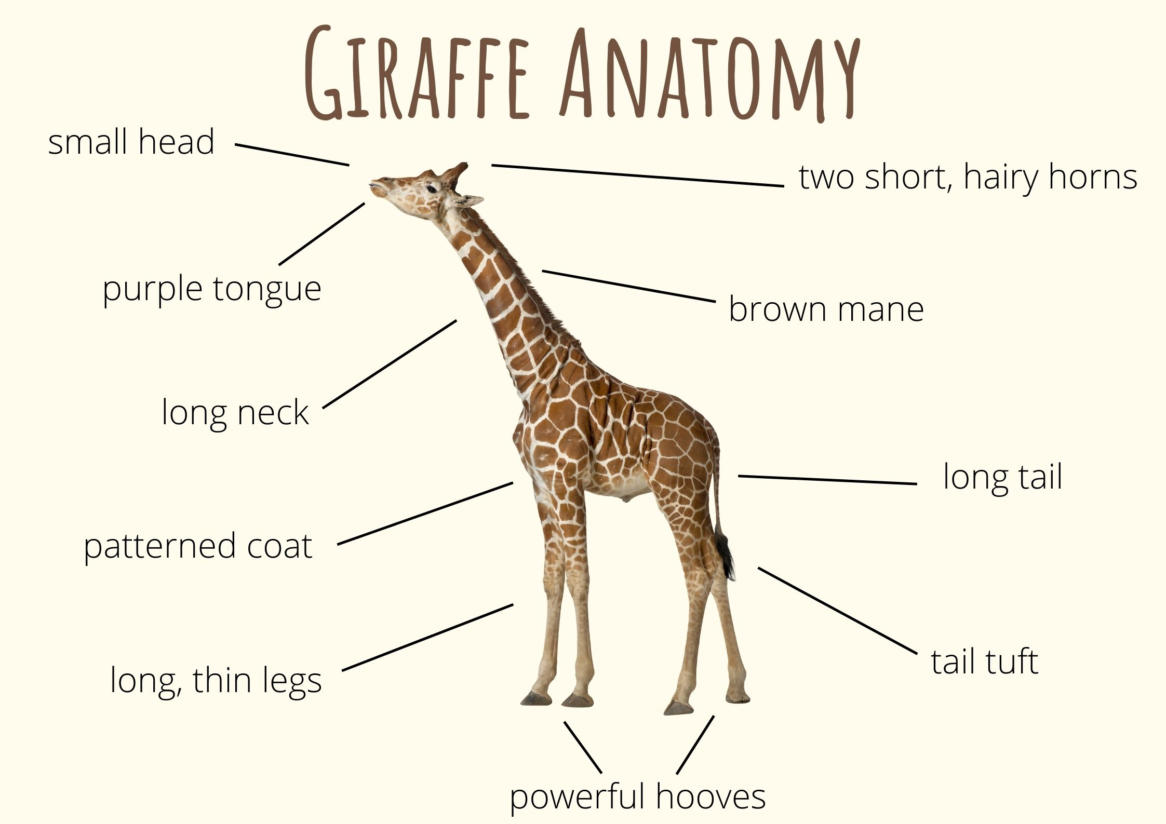
Images sourced from Canva and used in accordance with the Canva Content License Agreement.

Resource 6: Venn diagram example
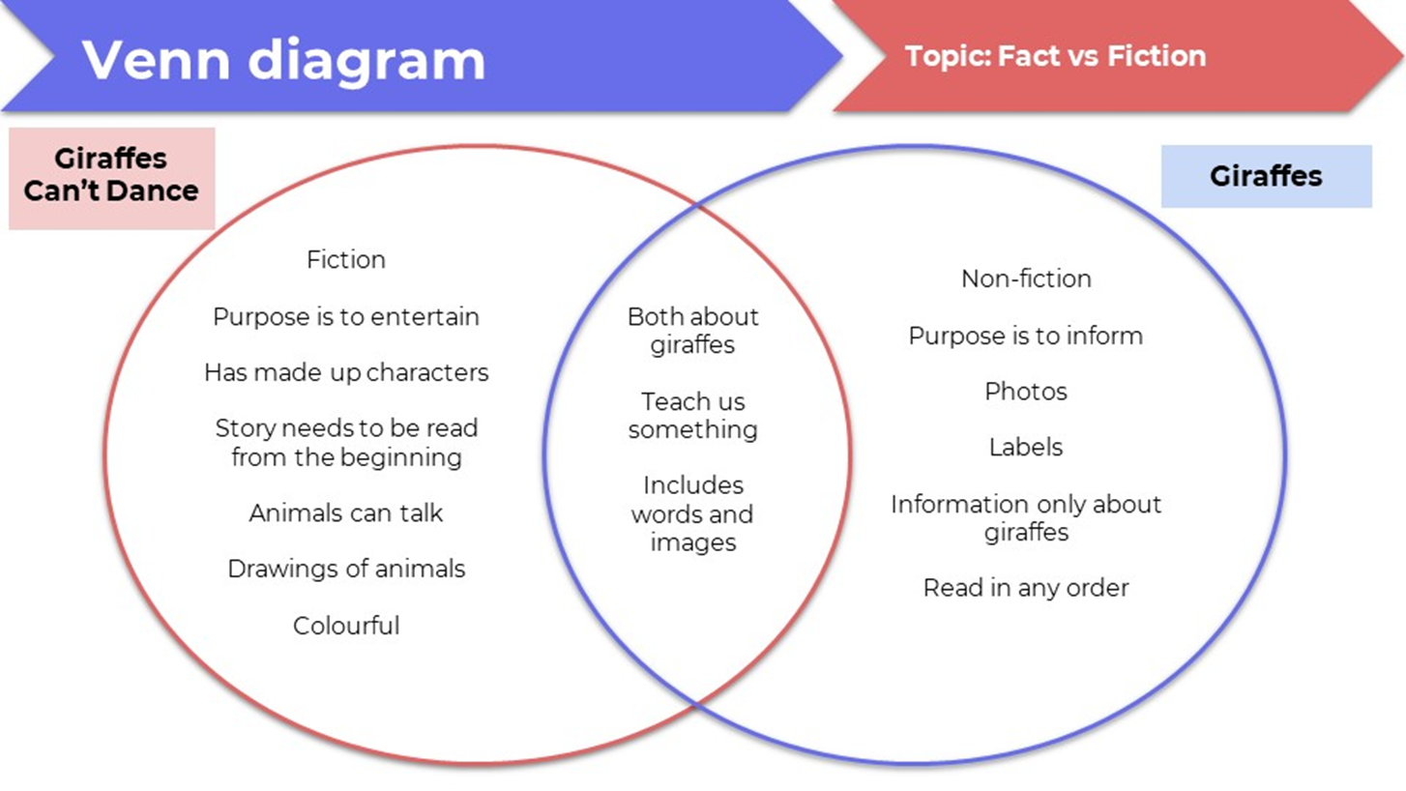

Resource 7: Leroy the Lionhearted
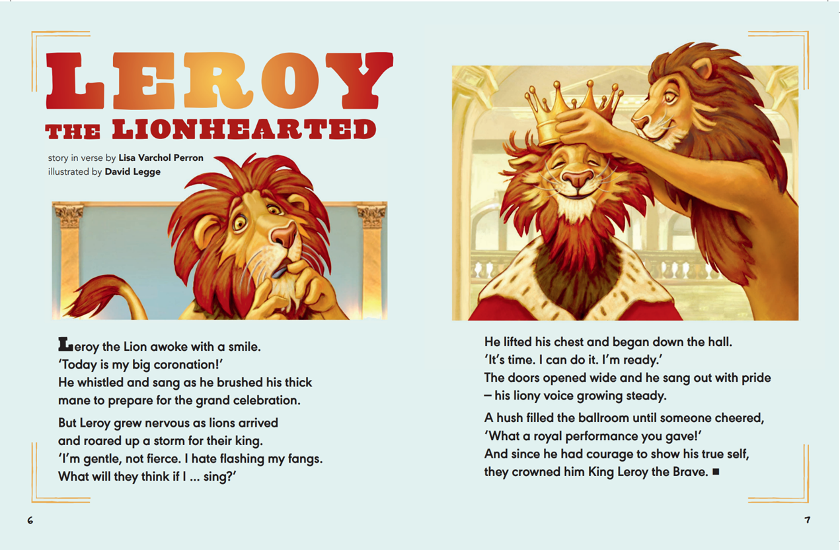
Varchol Perron L (2022) ‘Leroy the Lionhearted’ (Legge D, illus.), The School Magazine: Launchpad (Pilot Magazine).

Leroy the Lionhearted transcript
Leroy the Lion awoke with a smile.
‘Today is my big coronation!’
He whistled and sang as he brushed his thick mane
to prepare for the grand celebration.
But Leroy grew nervous as lions arrived
and roared up a storm for their king.
‘I’m gentle, not fierce. I hate flashing my fangs.
What will they think if I … sing?’
He lifted his chest and began down the hall.
‘It’s time, I can do it, I’m ready.’
The doors opened wide and he sang out with pride
– his liony voice growing steady.
A hush filled the ballroom until someone cheered,
‘What a royal performance you gave!’
And since he had courage to show his true self,
they crowned him King Leroy the Brave.

Resource 8: T-chart
Leroy | Gerald

Resource 9: Y-chart
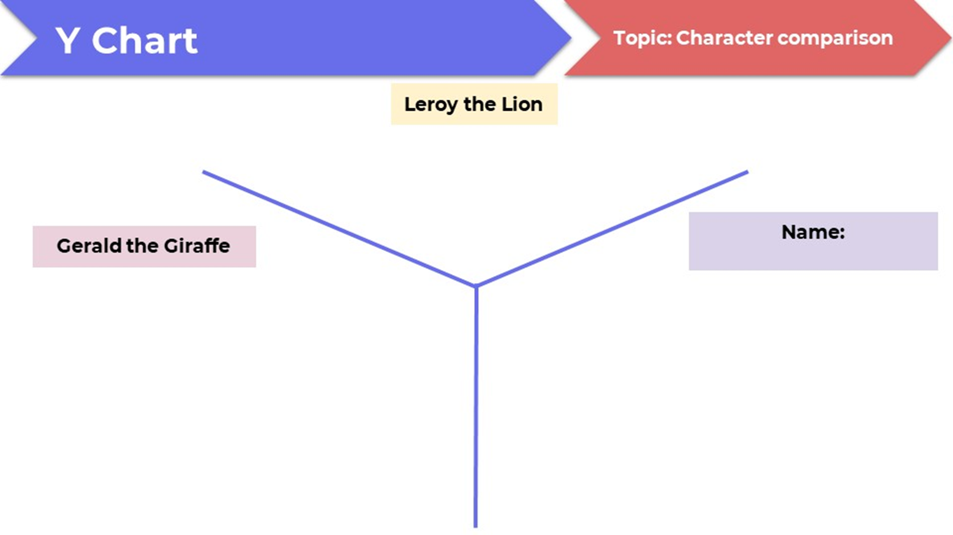

Resource 10: Lion fact file
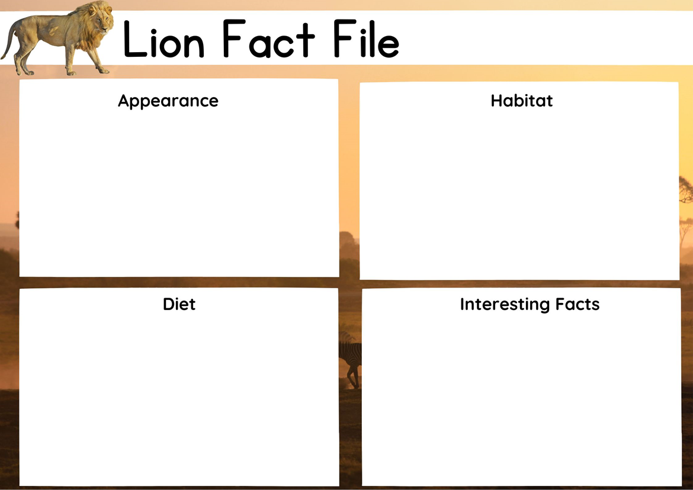
Images sourced from Canva and used in accordance with the Canva Content License Agreement.

References
Links to third-party material and websites
Please note that the provided (reading/viewing material/list/links/texts) are a suggestion only and implies no endorsement, by the New South Wales Department of Education, of any author, publisher, or book title. School principals and teachers are best placed to assess the suitability of resources that would complement the curriculum and reflect the needs and interests of their students.
If you use the links provided in this document to access a third-party's website, you acknowledge that the terms of use, including licence terms set out on the third-party's website apply to the use which may be made of the materials on that third-party website or where permitted by the Copyright Act 1968 (Cth). The department accepts no responsibility for content on third-party websites.
Except as otherwise noted, all material is © State of New South Wales (Department of Education), 2023 and licensed under the Creative Commons Attribution 4.0 International License. All other material (third-party material) is used with permission or under licence. Where the copyright owner of third-party material has not licensed their material under a Creative Commons or similar licence, you should contact them directly for permission to reuse their material.
English K–10 Syllabus © 2022 NSW Education Standards Authority (NESA) for and on behalf of the Crown in right of the State of New South Wales.
© 2022 NSW Education Standards Authority. This document contains NSW Curriculum and syllabus content. The NSW Curriculum is developed by the NSW Education Standards Authority. This content is prepared by NESA for and on behalf of the Crown in right of the State of New South Wales. The material is protected by Crown copyright.
Please refer to the NESA Copyright Disclaimer for more information.
NESA holds the only official and up-to-date versions of the NSW Curriculum and syllabus documents. Please visit the NSW Education Standards Authority (NESA) website and the NSW Curriculum website.
National Literacy Learning Progression © Australian Curriculum, Assessment and Reporting Authority (ACARA) 2010 to present, unless otherwise indicated. This material was downloaded from the Australian Curriculum website (National Literacy Learning Progression) (accessed 13 February 2023) and was not modified. The material is licensed under CC BY 4.0. Version updates are tracked in the ‘Curriculum version history’ section on the 'About the Australian Curriculum' page of the Australian Curriculum website.
ACARA does not endorse any product that uses the Australian Curriculum or make any representations as to the quality of such products. Any product that uses material published on this website should not be taken to be affiliated with ACARA or have the sponsorship or approval of ACARA. It is up to each person to make their own assessment of the product, taking into account matters including, but not limited to, the version number and the degree to which the materials align with the content descriptions and achievement standards (where relevant). Where there is a claim of alignment, it is important to check that the materials align with the content descriptions and achievement standards (endorsed by all education Ministers), not the elaborations (examples provided by ACARA).
Andreae G (2019) Giraffes Can’t Dance (Parker-Rees G, illus.) Hachette Children’s Books, Great Britain.
Britannica Kids (2022) ‘Lion’, Mammals, Britannica Kids website, accessed 13 February 2023.
ETA (English Teachers Association) and NSW Department of Education (2016) Character, English Textual Concepts website, accessed 13 February 2023.
ETA (English Teachers Association) and NSW Department of Education (2016) The Textual Concepts and Processes resource, English Textual Concepts website, accessed 13 February 2023.
National Geographic Kids (2022) ‘Lion’, Mammals, National Geographic Kids website, accessed 13 February 2023.
Taronga Conservation Society Australia (2022) ‘Lion’, Animals, Taronga Conservation Society Australia website, accessed 13 February 2023.
Varchol Perron L (2022) ‘Leroy the Lionhearted’ (Legge D, illus.), The School Magazine: Launchpad (Pilot Magazine)

