English – K-2 multi-age – Year B – Unit 3
Contents
Unit overview and instructions for use 3
Teacher notes 4
Outcomes and content – Component A 5
Outcomes and content – Component B 9
Week 1 13
Component A teaching and learning 13
Component B teaching and learning 14
Lesson 1: Introduction to A is for Australian Animals 15
Lesson 2: Creating factual animal statements 18
Lesson 3: Including prepositions to add details 22
Lesson 4: Describing and displaying animal features 27
Lesson 5: Who am I? 30
Week 2 34
Component A teaching and learning 34
Component B teaching and learning 35
Lesson 6: Crocodiles and conjunctions 36
Lesson 7: Describing and drawing quokkas 40
Lesson 8: Planning a multimodal text 42
Lesson 9: Composing and editing 45
Lesson 10: Publishing the magazine 47
Resource 1: Singular and plural nouns 48
Resource 2: Sentence frame (Early Stage 1) 49
Resource 3: Sentences (Stage 1) 50
Resource 4: Preposition T-chart (Stage 1) 51
Resource 5: Diagram checklist (Stage 1) 52
Resource 6: Speech bubble (Early Stage 1) 53
Resource 7: Crocodile craft prompt 54
Resource 8: FANBOYS 55
Resource 9: Quokkas: The Happiest Animals! 56
Resource 10: Planning templates 58
References 60

Unit overview and instructions for use
This two-week unit is comprised of Component A and Component B. Connecting learning across both components is encouraged.
Teaching and learning | Component A | Component B
Suggested duration | 60 minutes | 45 minutes
Explicit teaching focus areas | - Phonological awareness (Early Stage 1)  - Print conventions (Early Stage 1)  - Phonic knowledge  - Reading fluency  - Reading comprehension  - Spelling  - Handwriting | - Oral language and communication  - Vocabulary  - Reading comprehension  - Creating written texts  - Understanding and responding to literature
To prepare for teaching and learning: | - Refer to Outcomes and content – Component A, K-2 – Instructional sequence – grapheme–phoneme correspondences [PDF 825 KB], and the teaching advice documents (hyperlinked in Component A teaching and learning table).  - Based on student needs identified through ongoing assessment data, plan and document how you will sequence teaching and learning in whole class and targeted teaching groups across the two-week cycle. | - Familiarise yourself with Outcomes and content – Component B, Textual concepts information and videos, English Textual Concepts and Learning Processes (2016), and the teaching and learning sequence.  - Based on student needs identified through ongoing assessment data, determine how you will support students in whole class and targeted teaching groups across the two-week cycle as required.
English K–10 Syllabus © 2022 NSW Education Standards Authority (NESA) for and on behalf of the Crown in right of the State of New South Wales.

Teacher notes
- Perspective is defined as a lens through which we learn to see the world; it shapes what we see and the way we see it – English Textual Concepts and Learning Processes (2016).
- Understanding of perspective can be supported through watching the department’s video: Perspective (3:37)
- For information on verbs, singular and plural nouns, tense, simple sentences, prepositional phrases, nouns, noun groups, compound sentences, and conjunctions refer to the NESA Glossary.
- This unit could enhance student learning towards achievement of outcomes from the HSIE Syllabus and Creative Arts Syllabus regarding environmental impact and visual arts respectively.
- Reflect on student learning and engagement in activities and record differentiation and adjustments within the unit to inform future teaching and learning. One way of doing this could be to add comments to the digital file.
- Content points are linked to the National Literacy Learning Progression version (3).
Levels and indicators sourced from National Literacy Learning Progression © Australian Curriculum, Assessment and Reporting Authority (ACARA), (accessed 15 September 2022) and was not modified. See references for more information.

Outcomes and content – Component A
The table below outlines the focus outcomes and content. Content is linked to the National Literacy Learning Progression version (3).
Early Stage 1 Focus area and outcome | Stage 1 Focus area and outcome
Phonological awareness  ENE-PHOAW-01 – identifies, blends, segments and manipulates phonological units in spoken words as a strategy for reading and creating texts  - orally blend and segment syllables in words comprising up to 3 syllables (PhA2)  - orally blend up to 4 phonemes together to make a one-syllable spoken word (PhA4)  - orally segment one-syllable words comprised of up to 4 phonemes into separate phonemes (PhA4) | N/A
Print conventions  ENE-PRINT-01 – tracks written text from left to right and from top to bottom of the page and identifies visual and spatial features of print  - understand that written Standard Australian English uses letters to represent sounds  - know the difference between a letter and a word (PKW1)  - identify and name lower- and upper-case letters (PKW4)  - turn pages one at a time (UnT3)  - consistently read left page before right page (UnT4) | N/A
Phonic knowledge  ENE-PHOKW-01 – uses single-letter grapheme–phoneme correspondences and common digraphs to decode and encode words when reading and creating texts  - match a single-letter grapheme with a phoneme  - say the most common phoneme for single-letter graphemes (graphs) (PKW3)  - blend single-letter grapheme–phoneme correspondences to decode VC and CVC words, and apply this knowledge when reading, including decodable texts (PKW3, PKW4)  - segment and encode single-letter VC and CVC words, and apply this knowledge when writing words and creating texts (PKW4) | Phonic knowledge  EN1-PHOKW-01 – uses initial and extended phonics, including vowel digraphs, trigraphs to decode and encode words when reading and creating texts  - segment and encode one-syllable high-frequency base words with split digraphs and apply this when creating texts (SpG6)  - blend and decode one-syllable words with taught extended vowel graphs and digraphs, including graphemes for r-controlled vowels and diphthongs, and apply this when reading texts (PKW6, PKW7)  - segment and encode one-syllable words with taught vowel graphs, digraphs and trigraphs and apply this when creating texts
Reading fluency  ENE-REFLU-01 – reads decodable texts aloud with automaticity  - read texts with taught grapheme–phoneme correspondences and taught high-frequency words with automaticity | Reading fluency  EN1-REFLU-01 – sustains reading unseen texts with automaticity and prosody and self-corrects errors  - apply grapheme–phoneme correspondence to read words with automaticity (FlY1)  - vary pace when reading according to the audience and purpose (FlY4)
Reading comprehension  ENE-RECOM-01 – comprehends independently read texts using background knowledge, word knowledge and understanding of how sentences connect  - recall key characters, events and/or information in text (UnT5) | Reading comprehension  EN1-RECOM-01 – comprehends independently read texts that require sustained reading by activating background and word knowledge, connecting and understanding sentences and whole text, and monitoring for meaning  - make text-to-self, text-to-text or text-to-world connections when reading (UnT6)  - recount relevant ideas from texts in the form of a written, visual or oral summary (UnT6)
Spelling  ENE-SPELL-01 – applies phonological, orthographic and morphological generalisations and strategies to spell taught familiar and high-frequency words when creating texts  - combine phonological, phonic, orthographic and morphemic knowledge to spell taught high-frequency irregular words comprising up to 3 phonemes (SpG5)  - segment single-syllable words into phonemes as a strategy for spelling (SpG4)  - spell their own name (SpG1) | Spelling  EN1-SPELL-01 – applies phonological, orthographic and morphological generalisations and strategies when spelling words in a range of writing contexts  - segment single-syllable words into phonemes as a strategy for spelling (SpG4)  - spell high-frequency base words with taught vowel graphs, digraphs, split digraphs, trigraphs and quadgraphs (SpG6)  - use spelling conventions when adding plural-marking suffixes (SpG9)
Handwriting  ENE-HANDW-01 – produces all lower-case and upper-case letters to create texts  - use a stable posture when handwriting or drawing by sitting comfortably with feet flat on the floor, the writing arm resting on a table, with the opposite hand resting on the paper, and shoulders relaxed | Handwriting  EN1-HANDW-01 – uses a legible, fluent and automatic handwriting style, and digital technology, including word-processing applications, when creating texts  - position all letters correctly on the line with appropriate spacing between words (HwK5)

Outcomes and content – Component B
The table below outlines the focus outcomes and content. Content is linked to the National Literacy Learning Progression version (3).
Early Stage 1 Focus area and outcome | Stage 1 Focus area and outcome
Oral language and communication  ENE-OLC-01 – communicates effectively by using interpersonal conventions and language with familiar peers and adults  - respond to spoken questions  - contribute to group conversations (InT3)  - use imaginative, verbal language in structured and unstructured activities | Oral language and communication  EN1-OLC-01 – communicates effectively by using interpersonal conventions and language to extend and elaborate ideas for social and learning interactions  - follow extended instructions that contain connectives and conjunctions (LiS5)
Vocabulary  ENE-VOCAB-01 – understands and effectively uses Tier 1 words and Tier 2 words in familiar contexts  - recognise and understand taught Tier 1 and Tier 2 words (PKW3, SpK3)  - identify, name and describe a range of objects, characters, animals, people, and places when given visual and/or auditory prompts | Vocabulary  EN1-VOCAB-01 – understands and effectively uses Tier 1, taught Tier 2 and Tier 3 vocabulary to extend and elaborate ideas  - use vocabulary to express cause and effect (SpK3)
Reading comprehension  ENE-RECOM-01 – comprehends independently read texts using background knowledge, word knowledge and understanding of how sentences connect  - identify words that represent who, what, when, where and why in texts  - understand how adjectives describe a noun and verbs identify actions in a sentence  - use background knowledge when identifying connections between a text, own life, other texts and/or the world (UnT4)  - use visual cues in multimodal texts to interpret meaning (UnT5)  - recall key characters, events and/or information in text (UnT5) | Reading comprehension  EN1-RECOM-01 – comprehends independently read texts that require sustained reading by activating background and word knowledge, connecting and understanding sentences and whole text, and monitoring for meaning  - use known vocabulary to build a mental model of the content of the text  - combine multiple sources of information within a text to make meaning  - identify how creative visual features are used to expand meaning  - make text-to-self, text-to-text or text-to-world connections when reading (UnT6)  - use knowledge of text structure, type of text, author, and forms of writing to predict and confirm meaning (UnT6)
Creating written texts  ENE-CWT-01 – creates written texts that include at least 2 related ideas and correct simple sentences  - know that a simple sentence makes sense by itself and is a complete thought represented by a subject and a verb (GrA2)  - use personal vocabulary, words on display and in mentor texts when constructing sentences  - use drawing, images or mind maps to support planning and writing (CrT4) | Creating written texts  EN1-CWT-01 – plans, creates and revises texts written for different purposes, including paragraphs, using knowledge of vocabulary, text features and sentence structure  - write texts that describe, explain, give any opinion, recount an event, tell a story (CrT7)  - select and use a range of conjunctions to create cohesive texts (GrA5)  - use appropriate tense across a text (GrA4)  - write compound sentences using coordinating conjunctions (GrA4, CrT5)  - recognise compound sentences in own writing, knowing that each clause has meaning by itself (CrT5, CrT7)  - use action, saying, relating and sensing verbs to add detail and precision to writing (GrA2, GrA5)  - use noun groups to build descriptions of people and things (CrT6)  - use contextually precise prepositional phrases when creating texts (GrA4)  - use a variety of planning strategies and tools for creating texts
Understanding and responding to literature  ENE-UARL-01 – understands and responds to literature read to them  - identify aspects of their own world represented in texts  - create imaginary and/or informative texts that relate to their own experience, the world and/or other texts | Understanding and responding to literature  EN1-UARL-01 – understands and responds to literature by creating texts using similar structures, intentional language choices and features appropriate to audience and purpose  - express personal responses to the real and imagined world that are represented in texts  - identify how language and form of a text vary according to purpose, audience and mode

Week 1

Component A teaching and learning
The table below can be used to plan and document lessons that address Component A outcomes and content. Both the detailed example [DOC 529KB] of a two-week teaching and learning cycle and brief example [DOC 66KB] may support you in your planning.
Focus Areas | Lesson 1 | Lesson 2 | Lesson 3 | Lesson 4 | Lesson 5
Phonological awareness (Early Stage 1) and Phonic knowledge
15 minutes
Spelling and Handwriting
15 minutes
Print conventions (Early Stage 1), Reading comprehension and Reading fluency
30 minutes

Component B teaching and learning
The following teaching and learning sequence has been designed to address Component B outcomes and content. Adapt the sequence as required to best meet the needs of your students.

Learning intention and success criteria
Learning intentions and success criteria are best co-constructed with students. The table below contains suggested learning intentions and success criteria.
Element | Early Stage 1 | Stage 1
Learning intentions | Students are learning to use informative texts to develop knowledge about animals. | Students are learning to use informative texts to write detailed descriptions about animals.
Success criteria | Students can:  - identify and match letters of the alphabet  - write sentences with a subject, verb, object structure  - make text-to-self connections  - name and label common nouns of an animal  - write simple sentences to describe animal features. | Students can:  - use singular and plural nouns correctly  - understand that relating verbs are used to inform present tense  - use prepositional phrases to add precision to writing  - use noun groups to add detail to writing  - write a series of statements to describe animal features.

Resources
- Lessac F (2017) A is for Australian Animals, Walker Books Australia. ISBN13: 9781925381009
- Resource 1: Singular and plural nouns
- Resource 2: Sentence frame (EARLY STAGE 1) (enlarged copy)
- Resource 2: Sentence frame (EARLY STAGE 1)
- Resource 3: Sentences (Stage 1)
- Resource 4: Preposition T-chart (Stage 1) (enlarged copy)
- Resource 4: Preposition T-chart (Stage 1) (one per Stage 1 student)
- Resource 5: Diagram checklist (Stage 1)
- Video: Alphabet Song / Rap – Aboriginal Style by Gregg Dreise (1:29)
- A selection of factual texts on Australian animals for general exploration
- Animal image printed on A3 paper (Early Stage 1) and blank A3 paper (Stage 1)
- Magnetic letters
- Mini whiteboards
- Sticky notes

Lesson 1: Introduction to A is for Australian Animals
The following teaching and learning activities support multi-age settings.

Whole
- Introduce A is for Australian Animals. Display the front cover and read the description ‘a factastic tour’. Students discuss what they think factastic means. Note that factastic is an imagined word created by blending 2 real words together – fact and fantastic. This is known as a portmanteau word and is an example of the author using wordplay.
- Display the back cover and discuss the questions.
- Students Think-Pair-Share to make text predictions.
- Explain to students that A is for Australian Animals is an informative text. Highlight the textual features of informative texts, for example, the layout, placement of images alongside information, headings, and specific language choice. Revise that a factual text does not need to be read in a sequential order and that there is no set reading path.
- Preview A is for Australian Animals with a book walk.
Note: A book walk is a preview of the text before reading. It allows students to build a mental model of the content.
- Read:
- page A – Australia: define verbs and note examples on page A, sliding, dancing, slithering, and hopping. Students mime the actions
- two additional pages: note the text layout and mime the verbs
- page Z – Zebra Finch: read the large print and the small print that refers to zebra finches singing.
- Clarify unknown words and add these to a class word wall.

Part
The table below details the differentiated teaching and learning activities for each stage.
Early Stage 1 (independent) | Stage 1 (teacher guided/small groups)
- Consolidate the alphabet and increase student engagement by listening to Alphabet Song / Rap (1:29).  - Students use virtual or physical magnetic letters to write the letters learnt within the term so far on mini whiteboards, for example, s, a, t, p, i, n.  - Students refer to an alphabet chart and make letters in capitals and lowercase using concrete resources, for example:  - sand trays  - pebbles  - playdough  - craft sticks or pompoms.  - Students draw an animal of their choice from the text and write its name.  Too hard? Students draw an animal from the text and write the initial grapheme of its name.  Too easy? Students draw and name multiple animals from the text. | - Explicitly teach plurals as more than one of a person or thing. Display and discuss Resource 1: Singular and plural nouns.  - Model writing the names of different animals from the text, changing them from a singular to a plural form. For example, one quokka – two quokkas.  - Explain common plural marking suffixes of -s and -ies. Provide examples of animals from the text:  - add -s (kangaroos, magpies)  - remove the ‘y’ and add -ies (bilbies, wallabies)  - word remains unchanged (jellyfish)  - a new word is created (platypi, mice).  - In small groups, students are allocated a series of letters from the alphabet, for example, A to E, F to J, K to O.  - Using paper which will be combined to make a book, students draw and write an example of a singular noun animal (kangaroo) from the text and then draw multiple versions of the animal with its plural form written (kangaroos).  Too easy? Students research and write the collective noun for their animal groups.  - Students combine their responses to create a class alphabet book of singular and plural animals.

Lesson 2: Creating factual animal statements
The following teaching and learning activities support multi-age settings.

Whole
- Recall the animals from the text by playing a game of ‘Would you rather?’ For example:
- Would you rather be a flying fox or a jellyfish?
- Would you rather be a death adder or a crocodile?
- Students respond by miming the action of the animal. Give students the opportunity to provide reasoning for their response using compound and complex sentences. For example, I would rather be a crocodile because I would prefer to live in water rather than in a log.
- Revise that A is for Australian Animals is an informative text that states facts to provide the audience with details about Australian animals. Compare facts with opinions. For example, koalas are cute and cuddly (opinion), koalas have sharp claws to climb trees (fact).
- Select a well-known animal from the text, for example, koalas. Model generating ideas for simple sentences that describe the koala for its physical features, unique skills, or habitat. For example, Koalas climb trees; Koalas sleep most of the day.

Part
The table below details the differentiated teaching and learning activities for each stage.
Early Stage 1 (small groups/pairs) | Stage 1 (teacher guided)
- In small groups or pairs, students select animals from the text to orally describe their features or where they live. For example, Koalas eat leaves; Possums live in trees; Crocodiles have big teeth.  - Provide students with access to a range of other informative texts about Australian animals to explore and discuss.  Too easy? Students orally share statements about animals using adjectives for further detail. | - Revise verbs including examples of action, saying, relating and sensing verbs.  - Open A is for Australian Animals to any double page and work with students to identify examples of the different types of verbs. Highlight that mostly action and relating verbs are used. Write these on an anchor chart.  - Identify the tense of selected verbs from the anchor chart. Explicitly teach that present tense verbs are used in informative texts because the information being provided remains the same regardless of time. Select and read a sentence, changing the tense to show the impact of past/present/future tense. For example, Koalas climbed trees; Koalas climb trees; Koalas will climb trees.  - Explain that relating verbs, for example, is, are, be, have, and has, are used in statement sentences, and often orient the structure to present tense. For example, Koalas have claws to climb trees.  - Students Think-Pair-Share their own statement sentences about animals from the text using relating verbs.

Part
The table below details the differentiated teaching and learning activities for each stage.
Early Stage 1 (teacher guided/pairs) | Stage 1 (independent)
- Explicitly teach the concept of a sentence. Explain that a sentence is a group of words that make a complete message.  - Model using an enlarged copy of Resource 2: Sentence frame to identify the subject, verb, and object within a simple sentence. Provide example statements about animals from the text, for example, Koalas (subject) climb (verb) trees (object). Remind students about sentence boundary conventions including a capital letter, spaces between words and full stop in their sentence.  - Students Think-Pair-Share their own ideas for simple statement sentences about known animals from the text.  - Scribe sentences for students, or in pairs, students complete Resource 2: Sentence frame, with an illustration to accompany it.  Too hard? Complete the sentence frame as a group and work through several examples together.  Too easy? Students write several subject-verb-object sentences about their selected Australian animal. | - Using Resource 3: Sentences, students select a verb, subject, or additional information that would best fit in the blank component in each statement about Australian animals.  - Students write their own factual sentences in present tense.  Too hard? Students work in pairs to complete the activity.  Too easy? Students generate their own sentences with blank components and swap with a peer to complete.
Early Stage 1 Assessment task 1 – Observations and work samples from this lesson allow students to demonstrate achievement towards the following syllabus outcomes and content points:
ENE-VOCAB-01 – understands and effectively uses Tier 1 and Tier 2 words in familiar contexts
- recognise and understand taught Tier 1 and Tier 2 words.
ENE-RECOM-01 – comprehends independently read texts using background knowledge, word knowledge and understanding of how sentences connect
- understand how adjectives describe a noun and verbs identify actions in a sentence.
ENE-CWT-01 – creates written texts that include at least 2 related ideas and correct simple sentences
- know that a simple sentence makes sense by itself and is a complete thought represented by a subject and a verb
- use personal vocabulary, words on display and in mentor texts when constructing sentences.
Stage 1 Assessment task 1 – Observations and work samples from this lesson allow students to demonstrate achievement towards the following syllabus outcome and content points:
EN1-CWT-01 – plans, creates and revises texts written for different purposes, including paragraphs, using knowledge of vocabulary, text features and sentence structure
- write texts that describe, explain, give any opinion, recount an event, tell a story
- use appropriate tense across a text
- use action, saying, relating and sensing verbs to add detail and precision to writing.

Lesson 3: Including prepositions to add details
The following teaching and learning activities support multi-age settings.

Whole
- Revisit the text A is for Australian Animals, selecting several pages to read through, pausing to discuss key information presented. Allow students to share a piece of information they recall from each page read.

Part
The table below details the differentiated teaching and learning activities for each stage.
Early Stage 1 (small groups/pairs) | Stage 1 (teacher guided)
- In pairs or small groups, students select an animal from the text A is for Australian Animals. One at a time, students act like their chosen animal using actions.  - Members of the group attempt to guess which animal their peer is representing and provide reasons as to which clues helped them reach their decision. | - Explicitly teach students about prepositional phrases.  - Using the text, A is for Australian Animals, model stating facts about an animal’s habitat using a prepositional phrase. For example, Koalas sleep high up in trees; Crocodiles can hide under shallow water.  - Locate and discuss prepositional phrases in the text which add to the description of the animal’s appearance and those which add to the description of its habitat.  - Using an enlarged copy of Resource 4: Preposition T-chart, model writing examples of prepositional phrases under the headings ‘Prepositional phrases to describe appearance’ and ‘Prepositional phrases to describe the setting/habitat’.  - Brainstorm and list several examples with students. Note that examples may be paraphrased from the text.  - Examples of prepositional phrases describing the animal’s appearance:  - Cockatoos have a striking crest on top of its head.  - An echidna has sharp spines covering its back.  - The male platypus has poisonous spurs on its hind legs.  - Examples of prepositional phrases about setting/habitat:  - The hopping mouse lives in the harsh desert.  - Sugar gliders can glide through the air between forest trees.

Part
The table below details the differentiated teaching and learning activities for each stage.
Early Stage 1 (teacher guided) | Stage 1 (independent)
- Ask students if they have seen or interacted with any of the animals from the text before. Provide students with the opportunity to share their personal stories and experiences. Discuss if any of the stories are similar and why.  - Highlight that students can make connections with texts, the world, and their own experiences.  - Using blank paper, students draw their personal story about an animal they have seen or interacted with before. Encourage students to include detail in their illustration.  - Students share their illustration with a partner.  - Scribe simple sentences to describe students’ illustrations. Reinforce sentence conventions including that a sentence is a complete idea, boundary punctuation, contains a subject and a verb, and spaces between words.  Too hard? Work with students to scaffold a scene for an animal encounter. For example, going to the zoo, the aquarium, or the beach. | - Students complete Resource 4: Preposition T-chart to write sentences containing prepositional phrases. Students can include examples from the text as well as their own sentence. Encourage students to identify details from illustrations as well as from the written text.  - Students use a coloured pencil to underline the prepositional phrase in their sentences.  - Students create detailed illustrations to expand meaning.  Too hard? Select one animal and write a simple sentence using a preposition.  Too easy? Students write compound sentences using information from the text.
Early Stage 1 Assessment task 2 – Observations and work samples from this lesson allow students to demonstrate achievement towards the following syllabus outcomes and content points:
ENE-OLC-01 – communicates effectively by using interpersonal conventions and language with familiar peers and adults
- use imaginative, verbal language in structured and unstructured activities.
ENE-RECOM-01 – comprehends independently read texts using background knowledge, word knowledge and understanding of how sentences connect
- use background knowledge when identifying connections between a text, own life, other texts and/or the world
- recall key characters, events and/or information in text.
ENE-UARL-01 – understands and responds to literature read to them
- identify aspects of their own world represented in texts.
Stage 1 Assessment task 2 – Observations and work samples from this lesson allow students to demonstrate achievement towards the following syllabus outcomes and content points:
EN1-RECOM-01 – comprehends independently read texts that require sustained reading by activating background and word knowledge, connecting and understanding sentences and whole text, and monitoring for meaning
- combine multiple sources of information within a text to make meaning
- identify how creative visual features are used to expand meaning.
EN1-CWT-01 – plans, creates and revises texts written for different purposes, including paragraphs, using knowledge of vocabulary, text features and sentence structure
- use contextually precise prepositional phrases when creating texts
- use a variety of planning strategies and tools for creating texts.

Lesson 4: Describing and displaying animal features
The following teaching and learning activities support multi-age settings.

Whole
- Display a model of a diagram and discuss the visual features, including layout. Explain that diagrams are often a feature of factual texts.
- Discuss how diagrams provide detailed information that is specific or unique to a particular animal or group of animals. Highlight that diagrams often support information that is provided as written text.

Part
The table below details the differentiated teaching and learning activities for each stage.
Early Stage 1 (teacher guided) | Stage 1 (independent)
- Explicitly teach students that nouns are words that name things such as people, places, and objects.  - Write common human body parts on sticky notes. Select a student to become a living diagram. Students select a sticky note and place it on the student where the body part is. For example, arm, leg, hair, face, fingers, feet.  - Students share examples of nouns/features that animals have. Write these on an anchor chart. | - Students select an animal from the text A is for Australian Animals and draw a detailed illustration of it on A3 paper. Highlight the importance of identifying the unique or distinctive features of their selected animal. Students will need to ensure there is space left around their illustration as they will be creating labels to turn their illustration into a diagram in activity 12.

Part
The table below details the differentiated teaching and learning activities for each stage.
Early Stage 1 (pairs/independent) | Stage 1 (teacher guided/independent)
- Provide students with an A3 image of an animal from the text to create a labelled diagram.  - Students label the features of the animal using simple nouns, for example, head, ears, snout, fur, eyes, claws, whiskers.  Too hard? Students work in small groups to complete the task.  Too easy? Students label their diagram and write simple sentences using the nouns. For example, A koala has grey fur. | - Explicitly teach students about noun groups.  - Explain that factual texts provide detailed information. Authors use both diagrams and descriptions containing noun groups to ensure that facts are clear and detailed.  - Locate noun groups in the text that describe an animal. For example, Bilby: rabbit-like ears; Lyrebird: magnificent tail; Jumping Spiders: eight eyes; Koalas: two thumbs on front paw; Numbat: long, sticky tongue.  - Using their animal illustration from activity 6, students create a diagram by labelling the animal’s features using noun groups. Students use Resource 5: Diagram checklist to ensure their work is clear and accurate.  Too easy? Write descriptive sentences using noun groups to extend the information presented in their diagram.

Whole
- Students share their diagrams with small groups or as part of a gallery walk. Students can reflect on and self-assess their work using the diagram checklist.
Early Stage 1 Assessment task 3 – Observations and work samples from this lesson allow students to demonstrate achievement towards the following syllabus outcome and content point:
ENE-VOCAB-01 – understands and effectively uses Tier 1 words and Tier 2 words in familiar contexts
- identify, name and describe a range of objects, characters, animals, people, and places when given visual and/or auditory prompts.
Stage 1 Assessment task 3 – Observations and work samples from this lesson allow students to demonstrate achievement towards the following syllabus outcome and content points:
EN1-CWT-01 – plans, creates and revises texts written for different purposes, including paragraphs, using knowledge of vocabulary, text features and sentence structure
- write texts that describe, explain, give any opinion, recount an event, tell a story (CrT7)
- use noun groups to build descriptions of people and things.

Lesson 5: Who am I?
The following teaching and learning activities support multi-age settings.

Whole
- Re-read the following pages in the text A is for Australian Animals:
- page I – Irukandji Jellyfish
- page J – Jumping Spider.
- Clarify the meaning of unknown words, for example, venomous and tentacles. Add new vocabulary to the class word wall.
- Students share and discuss information about the Irukandji jellyfish and the jumping spider. Model recording shared facts about both animals in the form of simple statements.
- Using their knowledge of Australian animals, students will create a ‘Who am I?’ quiz for their peers. Who am I? quizzes are made up of 3 or more clues, expressed as statements. For example (oblong turtle):
- I do not have any teeth.
- I have a long snake-like neck.
- My relatives have lived on earth since the dinosaurs.
- I can swim in water or walk on land.
- My shell at birth is the size of a ten-cent coin.

Part
The table below details the differentiated teaching and learning activities for each stage.
Early Stage 1 (small groups/pairs/independent) | Stage 1 (teacher guided/pairs)
- In small groups, students are provided with a picture of one of the animals from the text.  - Students practise saying 3 oral statements about the animal to be presented to peers in the ‘Who am I?’ activity.  Too hard? Students record themselves saying the facts or use voice-to-text technology.  Too easy? Students work in pairs or independently to write statements about a chosen animal. | - Explain that student statements should include at least one relating verb.  - Revise that relating verbs expressed in the present tense are needed to construct the statements for the quiz. For example, has, is, can, have, are.  - Highlight the use of noun groups and/or prepositional phrases in statements.  - In pairs, students are allocated an animal from the text and write a list of facts/statements using relating verbs to be used in the ‘Who am I?’ activity.  Too hard? Students record themselves saying the facts or use voice-to-text technology.  Too easy? Students work independently to create a list of statements about an animal not listed in the text.

Whole
- Students participate in the ‘Who am I?’ activity by joining with another small group to present their facts. Students attempt to guess which Australian animal has been described.
Optional: Display student animal statements along with their labelled diagrams from Lesson 4.
Early Stage 1 Assessment task 4 – Observations and work samples from this lesson allow students to demonstrate achievement towards the following syllabus outcomes and content points:
ENE-OLC-01 – communicates effectively by using interpersonal conventions and language with familiar peers and adults
- respond to spoken questions
- contribute to group conversations.
ENE-RECOM-01 – comprehends independently read texts using background knowledge, word knowledge and understanding of how sentences connect
- identify words that represent who, what, when, where and why in texts.
ENE-CWT-01 – creates written texts that include at least 2 related ideas and correct simple sentences
- know that a simple sentence makes sense by itself and is a complete thought represented by a subject and a verb.
ENE-UARL-01 – understands and responds to literature read to them
- create imaginary and/or informative texts that relate to their own experience, the world and/or other texts.
Stage 1 Assessment task 4 – Observations and work samples from this lesson allow students to demonstrate achievement towards the following syllabus outcomes and content points:
EN1-OLC-01 – communicates effectively by using interpersonal conventions and language to extend and elaborate ideas for social and learning interactions
- follow extended instructions that contain connectives and conjunctions.
EN1-RECOM-01 – comprehends independently read texts that require sustained reading by activating background and word knowledge, connecting and understanding sentences and whole text, and monitoring for meaning
- use known vocabulary to build a mental model of the content of the text
- make text-to-self, text-to-text or text-to-world connections when reading
- use knowledge of text structure, type of text, author, and forms of writing to predict and confirm meaning.
EN1-CWT-01 – plans, creates and revises texts written for different purposes, including paragraphs, using knowledge of vocabulary, text features and sentence structure
- write texts that describe, explain, give any opinion, recount an event, tell a story
- use action, saying, relating and sensing verbs to add detail and precision to writing.
EN1-UARL-01 – understands and responds to literature by creating texts using similar structures, intentional language choices and features appropriate to audience and purpose
- express personal responses to the real and imagined worlds that are represented in texts.

Week 2

Component A teaching and learning
The table below can be used to plan and document lessons that address Component A outcomes and content. Both the detailed example [DOC 529KB] of a two-week teaching and learning cycle and brief example [DOC 66KB] may support you in your planning.
Focus Areas | Lesson 6 | Lesson 7 | Lesson 8 | Lesson 9 | Lesson 10
Phonological awareness (Early Stage 1) and Phonic knowledge
15 minutes
Spelling and Handwriting
15 minutes
Print conventions (Early Stage 1), Reading comprehension and Reading fluency
30 minutes

Component B teaching and learning
The following teaching and learning sequence has been designed to address Component B outcomes and content. Adapt the sequence as required to best meet the needs of your students.

Learning intention and success criteria
Learning intentions and success criteria are best co-constructed with students. The table below contains suggested learning intentions and success criteria.
Element | Early Stage 1 | Stage 1
Learning intentions | Students are learning to adapt texts for a different purpose and audience. | Students are learning to create texts about familiar topics for a different audience.
Success criteria | Students can:  - use words on display when creating sentences  - contribute to group conversations to support writing  - write simple sentences using a subject, noun, object structure  - draw or select images to support multimodal texts. | Students can:  - write compound sentences using coordinating conjunctions  - follow detailed instructions  - combine multiple sources of information to plan writing  - use noun groups and prepositional phrases to enhance meaning in own texts  - source or create images to support multimodal texts.

Resources
- Lessac F (2017) A is for Australian Animals, Walker Books Australia. ISBN: 9781925381009
- Resource 6: Speech bubble
- Resource 7: Crocodile craft prompt
- Resource 8: FANBOYS
- Resource 9: Quokkas: The Happiest Animals!
- Resource 10: Planning templates
- Video: Be Crocwise (0:52)
- Video: How to draw a Quokka (10:44)
- Video: Quokka at Rottnest Island, Australia (1:55)
- National Geographic Kids online article: Mixed-up Marsupials? [PDF 2.46MB]
- Art and craft supplies for all Early Stage 1 students

Lesson 6: Crocodiles and conjunctions
The following teaching and learning activities support multi-age settings.

Whole
- Read page C – Cockatoo and Crocodile from the text A is for Australian Animals. Discuss the key information specific to the crocodile.
- Watch the video Be Crocwise (0:52) on the Queensland Government website and discuss the information presented.
- Use a Y-chart to write ideas about crocodiles based on the text, video and student prior knowledge. Ask:
- What did you already know?
- What did you see in the visuals?
- What did you read or hear?

Part
The table below details the differentiated teaching and learning activities for each stage.
Early Stage 1 (teacher guided/independent) | Stage 1 (small groups/pairs)
- Refer to the class Y-chart from activity 3 and support students to identify other pieces of interesting information.  - Write the following simple sentence and sentence starter on the board, ‘I am a crocodile. I have________.’  - Brainstorm different facts that could be used to finish the sentence. Write student responses on an anchor chart.  - Using Resource 6: Speech bubble, students write a simple fact to complete the sentence starter referring to the anchor chart for ideas. For example, I am a crocodile. I have... teeth, claws, jaw, scales.  Too hard? Scribe student writing on the speech bubble.  Too easy? Students use an adjective to enhance their noun, for example, sharp teeth, razor claws, strong jaw, brown scales.  - Students will attach their speech bubble to a crocodile craft activity.  - Display Resource 7: Crocodile craft prompt and model making the crocodile. Discuss physical features using descriptive language.  - Provide paper and scissors for cutting the teeth shape and a stapler or glue to attach the speech bubble to the crocodile's mouth. | - Students create a ‘Be Crocwise’ poster about staying safe around crocodiles.  - Students refer to the information presented in the video, text, Y-chart, and their own personal knowledge.  Too easy? Students research additional information about keeping safe around crocodiles and add this to their poster.

Part
The table below details the differentiated teaching and learning activities for each stage.
Early Stage 1 (independent) | Stage 1 (teacher guided/pairs)
- Students create the crocodile jaw craft using egg cartons.  - Students read their speech bubble to a peer and role play real or imagined crocodile behaviour. | - Display and discuss Resource 8: FANBOYS.  - Model writing a compound sentence, for example, ‘You will need to leave the water quickly, but don’t splash too much.’ Underline the conjunction in the sentence and the 2 independent clauses. Highlight that the 2 clauses make sense on their own.  - In pairs, students orally share the beginning of a compound sentence about crocodiles. For example:  - Crocodiles weigh a lot, and...  - Crocodiles move much faster than you think, so...  - Crocodiles look like they can’t jump, but…  - The partner listens and responds with a possible ending to the sentence.  - Students write compound sentences using coordinating conjunctions to show cause and effect on their posters. For example:  - You can’t see crocodiles in the water, but they may be hiding.  - Crocodiles float under water, so it is hard to see how big they are.  Too hard? Students write one compound sentence on their poster or use voice-to-text technology to assist in their writing.
Early Stage 1 Assessment task 5 – Observations and work samples from this lesson allow students to demonstrate achievement towards the following syllabus outcomes and content points:
EN1-VOCAB-01 – understands and effectively uses Tier 1, taught Tier 2 and Tier 3 vocabulary to extend and elaborate ideas
- use vocabulary to express cause and effect.
EN1-CWT-01 – plans, creates and revises texts written for different purposes, including paragraphs, using knowledge of vocabulary, text features and sentence structure
- select and use a range of conjunctions to create cohesive texts
- write compound sentences using coordinating conjunctions
- recognise compound sentences in own writing, knowing that each clause has meaning by itself.

Lesson 7: Describing and drawing quokkas
The following teaching and learning activities support multi-age settings.

Whole
- Re-read page Q – Quokkas from A is for Australian Animals.
- Read Resource 9: Quokkas – The Happiest Animals! Brainstorm and list key vocabulary for student reference. Look up images of quokkas on the internet to improve student understanding.
- Discuss strategies for following oral instructions. For example:
- look at the person who is giving the instructions
- look at their hand movements and gestures
- listen for words that provide exact details
- know that when connectives or conjunctions (linking words) are used, more information is going to be given or a particular sequence is required. For example: first, next, then, after that, now, because, but.
- Explain that students will draw a picture of a quokka. Watch How to draw a Quokka (10:44) pausing the video to allow students time to draw. Once completed, students label their illustration using key vocabulary listed in activity 2.
- Explain that students will write an article about quokkas for a kid’s magazine to be kept in the classroom. Display and discuss the National Geographic Kids online article Mixed-up Marsupials? [PDF 2.46MB]
- View Quokka at Rottnest Island, Australia (1:55) without sound. Ask:
- How can the quokka be described? – colour of eyes, the nose, ears, fur; shape of tail, and paws; colour and overall size and shape.
- What is the quokka eating?
- How do we know they are enjoying it?
- How do quokkas move?

Part
The table below details the differentiated teaching and learning activities for each stage.
Early Stage 1 (teacher guided/independent) | Stage 1 (independent)
- Using the information presented and discussed as a group, model writing simple sentences about quokkas.  - Students write their own simple sentence about quokkas or copy words from a model.  Too hard? Work with students to assist in writing a sentence or a word. | - Students write 3 additional facts in the form of compound sentences on their quokka illustration using the information discussed, video and online article.

Whole
- Students share their sentences in small groups.

Lesson 8: Planning a multimodal text
The following teaching and learning activities support multi-age settings.

Whole
- Brainstorm ideas for a title for the class magazine. Students discuss and select a title.
- Reintroduce the task and explain that students will be creating a multimodal text as their final version of the magazine article about quokkas. Students will use elements including images, sentences with subject, verb, object structure (Early Stage 1) or compound sentences with prepositional phrases and noun groups (Stage 1).
Note: Multimodal texts are texts that combine 2 or more communication modes. For example, printed words and images, or spoken words and sound effects.
- Recap prior learning and facts discussed about quokkas. Discuss the purpose of informative texts and the appropriate structure needed. Display the National Geographic Kids online article, Mixed-up Marsupials? [PDF 2.46MB] for further reference.
- Model using Resource 10: Planning templates to generate ideas about quokkas under each heading. Discuss what images or drawings would best support each sentence.
- Co-construct success criteria for the multimodal text. See the table below as an example.
Early Stage 1 success criteria | Stage 1 success criteria
- use the information learnt about quokkas to support idea generation  - write simple facts about quokkas  - write sentences with subject, verb, object structure  - use personal vocabulary and words on display when writing sentences  - select or draw images to expand meaning. | - use the information learnt about quokkas to support idea generation  - write facts about the appearance, diet, and habitat of quokkas  - write compound sentences using coordinating conjunctions  - use noun groups to add detail to writing  - use prepositional phrases to add precision to writing  - select or draw images to expand meaning.
- Students work in pairs to complete Resource 10: Planning templates.
Early Stage 1 Assessment task 6 – Observations and work samples from this lesson allow students to demonstrate achievement towards the following syllabus outcomes and content points:
ENE-RECOM-01 – comprehends independently read texts using background knowledge, word knowledge and understanding of how sentences connect
- use visual cues in multimodal texts to interpret meaning.
ENE-CWT-01 – creates written texts that include at least 2 related ideas and correct simple sentences
- use drawing, images or mind maps to support planning and writing.
Stage 1 Assessment task 5 – Observations and work samples from this lesson allow students to demonstrate achievement towards the following syllabus outcomes and content points:
EN1-RECOM-01 – comprehends independently read texts that require sustained reading by activating background and word knowledge, connecting and understanding sentences and whole text, and monitoring for meaning
- combine multiple sources of information within a text to make meaning
EN1-UARL-01 – understands and responds to literature by creating texts using similar structures, intentional language choices and features appropriate to audience and purpose
- identify how language and form of a text vary according to purpose, audience and mode.

Lesson 9: Composing and editing
The following teaching and learning activities support multi-age settings.

Whole
- Revisit the co-constructed success criteria from Lesson 8. Ask students to describe the features of a successful multimodal text that presents facts about quokkas.
- Reintroduce the task and explain that students will be creating a multimodal text as their final version of the magazine article about quokkas.
- Model using the completed planning templates from Lesson 8 to construct sentences that provide information about quokkas suitable for Early Stage 1 and Stage 1 students. Ask students if the modelled example meets the success criteria.

Part
The table below details the differentiated teaching and learning activities for each stage.
Early Stage 1 (teacher guided/independent) | Stage 1 (pairs/independently)
- Teacher supports students to write 1 or 2 simple sentences using a subject-verb-object structure about quokkas. Sentences may include facts about a quokka's appearance, features, diet, or habitat.  - Students use their planning template to attempt to write sentences (or words) about quokkas.  - Encourage students to share their ideas with a peer about what drawings or illustrations would best suit their writing.  Too hard? Scribe sentences for students or record students saying their sentences.  Too easy? Students write compound sentences using taught Tier 2 vocabulary. | - In pairs or independently, students write both simple and compound sentences using the information written in their planning template.  - Encourage students to share their ideas with a peer about what drawings or illustrations would best suit each sentence.  Too hard? Students write at least one compound sentence using a coordinating conjunction.  Too easy? Students write compound sentences using cause and effect language to describe quokkas.

Whole
- Students draw or source one image of a quokka that will be used on the front cover of the class magazine. Teacher to collate all the images and enter the agreed magazine title into a software program of their choosing. The cover and student pages can be printed and bound.
- Students use the success criteria to provide peer to peer feedback.
- Provide time for students to apply feedback to edit and improve their writing.

Lesson 10: Publishing the magazine
The following teaching and learning activities support multi-age settings.

Whole
- Students finalise and publish their multimodal magazine article. Teacher to print student work and bind to create a magazine. Attach the front cover to the class text. Suggested multimodal software examples include:
- Book Creator app for iPad
- Microsoft Word
- Microsoft PowerPoint
- Google Slides in Google Workspace
- Seesaw or Flipgrid.
- Read through the class magazine together. Encourage students to read their page aloud to the class.

Resource 1: Singular and plural nouns
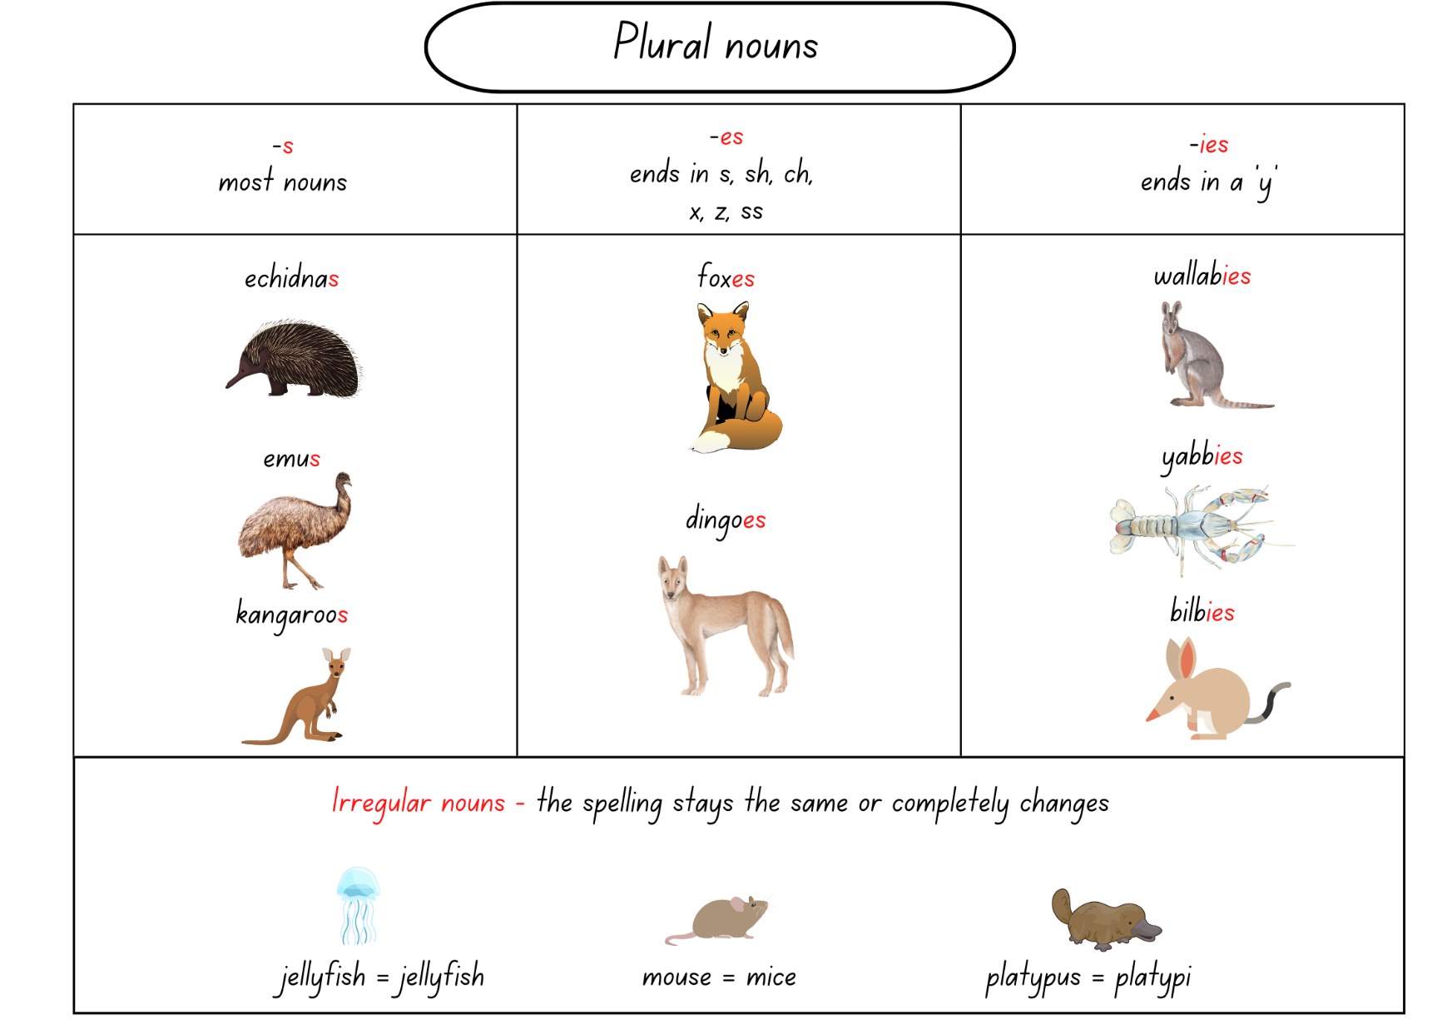
Images sourced from Canva and used in accordance with the Canva Content License Agreement.

Resource 2: Sentence frame (Early Stage 1)
Example:
subject | verb | object
Koalas | climb | trees.

subject | verb | object

Resource 3: Sentences (Stage 1)
Select an appropriate subject, verb, or additional information to fill in the blanks of the sentences.
The ____________________ is the largest of all living reptiles.
Platypi ____________________ webbed feet which are perfect for swimming.
The bilby is a desert living marsupial with _________________________________.
A _______________ has sharp _______________ which help it to _______________ tall trees.
Write your own sentences:
_______________________________________________________________________________________________________________________________________________________________________________________________________________________________________________________________________________________________________________________________________________________________________________________________________________________________________________________________________________________________________________________________________________________

Resource 4: Preposition T-chart (Stage 1)
Prepositional phrases to describe  appearance | Prepositional phrases to describe  the setting or habitat

Resource 5: Diagram checklist (Stage 1)
- Title: The animal's name at the top in larger-sized font.
- Accurate drawing of the animal with specific feature clearly identified.
- Labels written near the body part in a straight line.
- Arrow or straight line connecting the body part to the label.
- Descriptive noun groups in labels.
- Accurate and informative language.
- Title: The animal's name at the top in larger-sized font.
- Accurate drawing of the animal with specific feature clearly identified.
- Labels written near the body part in a straight line.
- Arrow or straight line connecting the body part to the label.
- Descriptive noun groups in labels.
- Accurate and informative language.

Resource 6: Speech bubble (Early Stage 1)
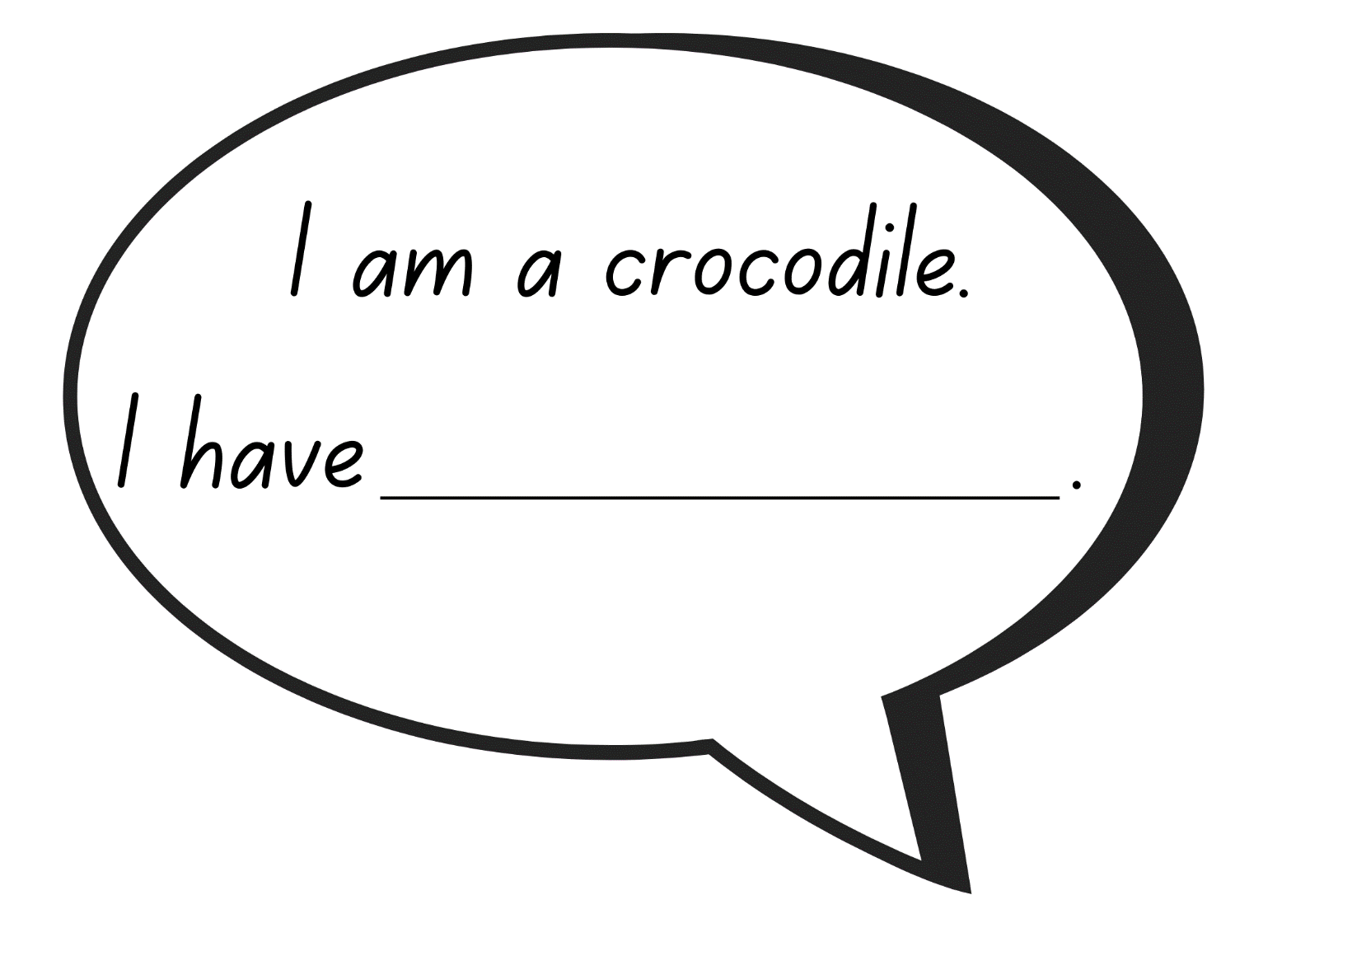
Images sourced from Canva and used in accordance with the Canva Content License Agreement.

Resource 7: Crocodile craft prompt
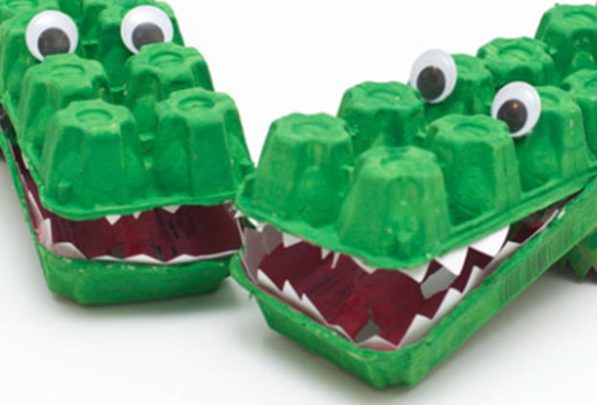
"Egg Carton Alligator" by The Laurie Berkner Band

Resource 8: FANBOYS
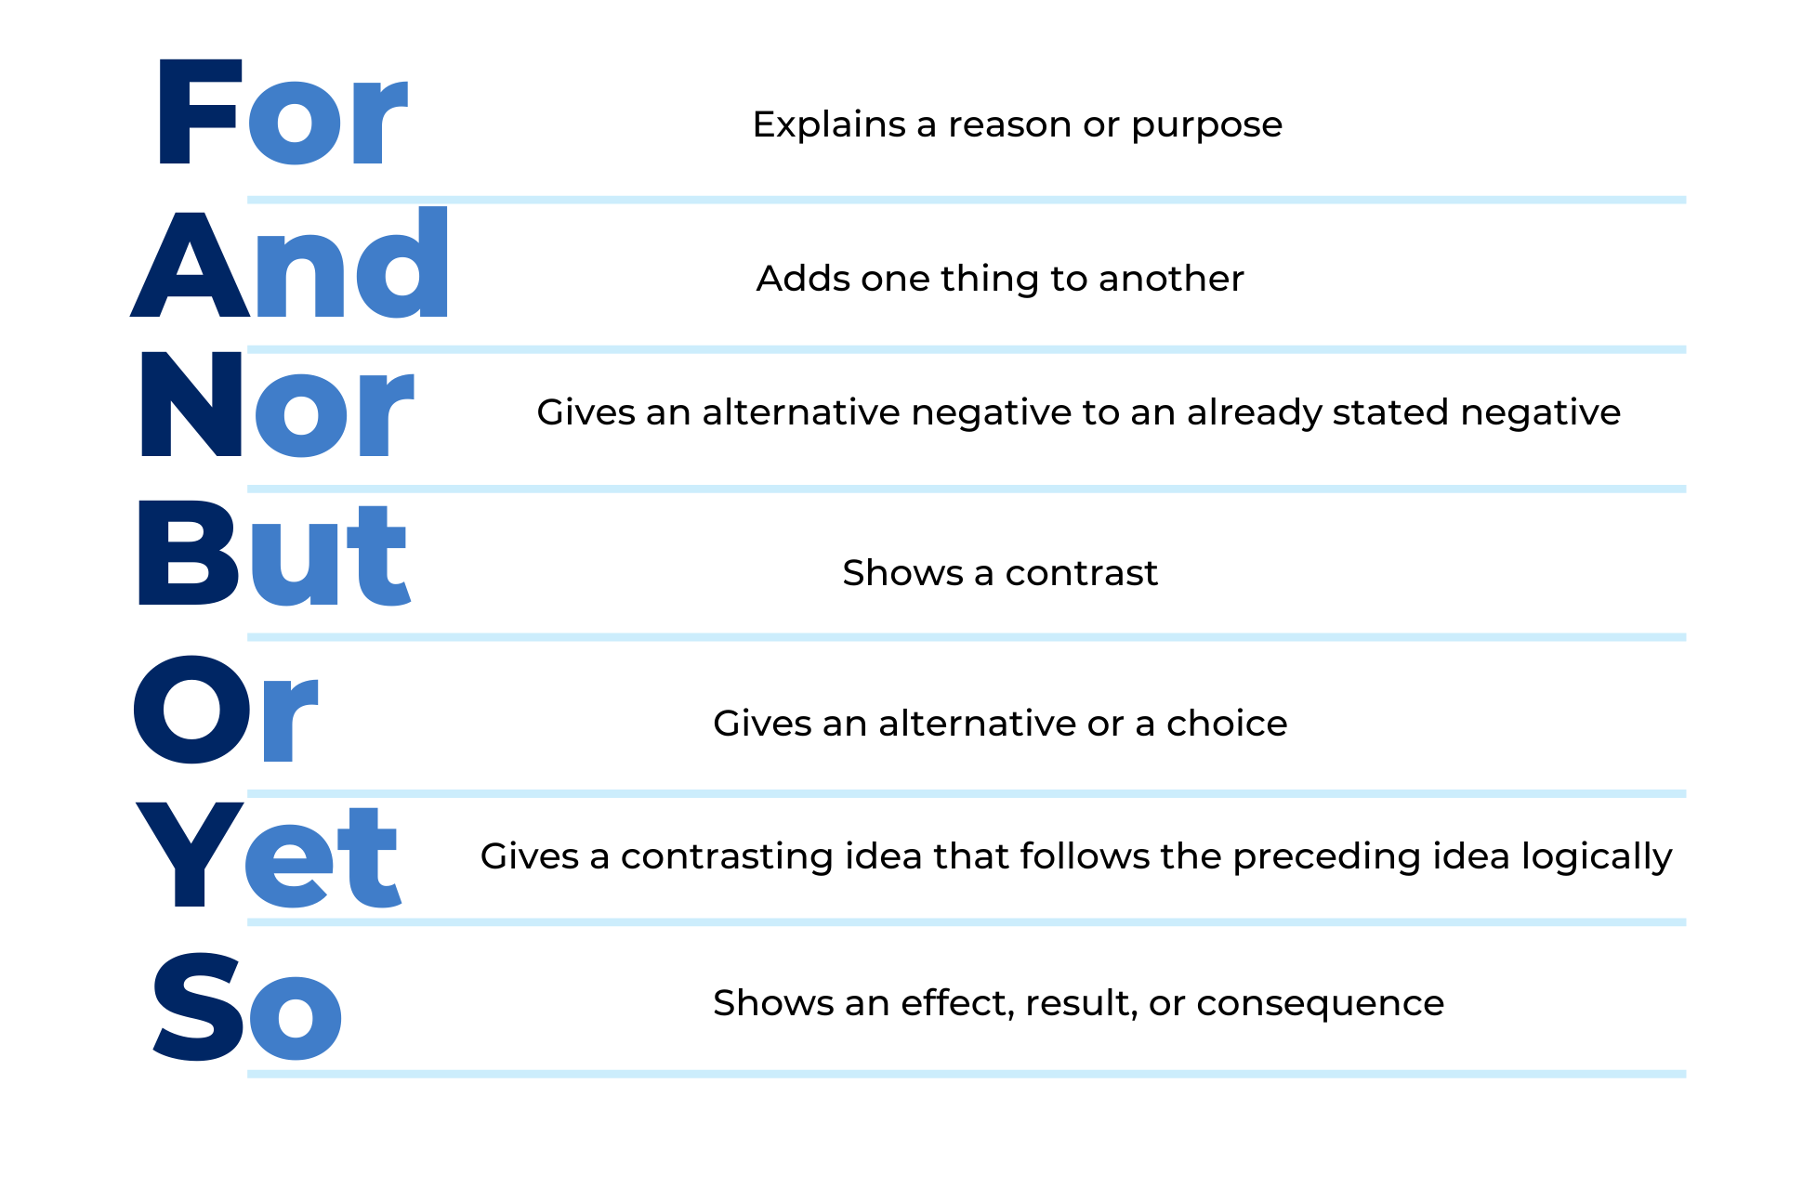

Resource 9: Quokkas: The Happiest Animals!
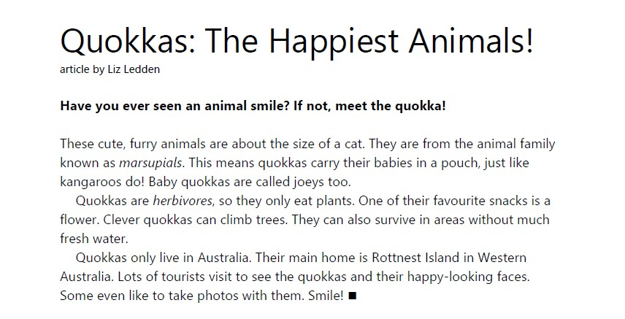
Ledden L (2022) ‘Quokkas: The Happiest Animals!’, The School Magazine: Launchpad (Pilot Magazine).
Transcript:
Quokkas: The Happiest Animals!
Article by Liz Ledden
Have you ever seen an animal smile? If not, meet the quokka!
These cute, furry animals are about the size of a cat. They are from the animal family known as marsupials. This means quokkas carry their babies in a pouch, just like kangaroos do! Baby quokkas are called joeys too.
Quokkas are herbivores, so they only eat plants. One of their favourite snacks is a flower. Clever quokkas can climb trees. They can also survive in areas without much fresh water.
Quokkas only live in Australia. Their main home is Rottnest Island in Western Australia. Lots of tourists visit to see the quokkas and their happy-looking faces. Some even like to take photos with them. Smile!

Resource 10: Planning templates
Early Stage 1 template
Sentences: Appearance, diet, or habitat of quokkas | Images or drawings

Stage 1 template
Appearance | Diet | Habitat | Images or drawings

References
Links to third-party material and websites
Please note that the provided (reading/viewing material/list/links/texts) are a suggestion only and implies no endorsement, by the New South Wales Department of Education, of any author, publisher, or book title. School principals and teachers are best placed to assess the suitability of resources that would complement the curriculum and reflect the needs and interests of their students.
If you use the links provided in this document to access a third-party's website, you acknowledge that the terms of use, including licence terms set out on the third-party's website apply to the use which may be made of the materials on that third-party website or where permitted by the Copyright Act 1968 (Cth). The department accepts no responsibility for content on third-party websites.
Except as otherwise noted, all material is © State of New South Wales (Department of Education), 2021 and licensed under the Creative Commons Attribution 4.0 International License. All other material (third-party material) is used with permission or under licence. Where the copyright owner of third-party material has not licensed their material under a Creative Commons or similar licence, you should contact them directly for permission to reuse their material.
English K–10 Syllabus © 2022 NSW Education Standards Authority (NESA) for and on behalf of the Crown in right of the State of New South Wales.
Creative Arts K–6 Syllabus © 2006 NSW Education Standards Authority (NESA) for and on behalf of the Crown in right of the State of New South Wales.
© 2021 NSW Education Standards Authority. This document contains NSW Curriculum and syllabus content. The NSW Curriculum is developed by the NSW Education Standards Authority. This content is prepared by NESA for and on behalf of the Crown in right of the State of New South Wales. The material is protected by Crown copyright.
Please refer to the NESA Copyright Disclaimer for more information.
NESA holds the only official and up-to-date versions of the NSW Curriculum and syllabus documents. Please visit the NSW Education Standards Authority (NESA) website and the NSW Curriculum website.
National Literacy Learning Progression © Australian Curriculum, Assessment and Reporting Authority (ACARA) 2010 to present, unless otherwise indicated. This material was downloaded from the Australian Curriculum website (National Literacy Learning Progression) (accessed 15 September 2022) and was not modified. The material is licensed under CC BY 4.0. Version updates are tracked in the ‘Curriculum version history’ section on the 'About the Australian Curriculum' page of the Australian Curriculum website.
ACARA does not endorse any product that uses the Australian Curriculum or make any representations as to the quality of such products. Any product that uses material published on this website should not be taken to be affiliated with ACARA or have the sponsorship or approval of ACARA. It is up to each person to make their own assessment of the product, taking into account matters including, but not limited to, the version number and the degree to which the materials align with the content descriptions and achievement standards (where relevant). Where there is a claim of alignment, it is important to check that the materials align with the content descriptions and achievement standards (endorsed by all education Ministers), not the elaborations (examples provided by ACARA).
Arty Smarty Party Creations (25 January 2021) 'How to draw a Quokka' [video], Arty Smarty Party Creations, YouTube, accessed 15 September 2022.
Dreise G (14 March 2021) ‘'Alphabet Song / Rap – Aboriginal Style by Gregg Dreise' [video], Gregg Dreise, YouTube, accessed 15 September 2022.
ETA (English Teachers Association) and NSW Department of Education (2016) The Textual Concepts and Processes resource, English Textual Concepts website, accessed 15 September 2022.
ETA (English Teachers Association) and NSW Department of Education (2016) Perspective, English Textual Concepts website, accessed 15 September 2022.
Ledden L (2022) ‘Quokkas: The Happiest Animals!’, The School Magazine: Launchpad (Pilot Magazine).
Lessac F (2017) A is for Australian Animals, Walker Books Australia.
LimeWave (25 April 2009) 'Quokka at Rottnest Island, Australia' [video], LimeWave, YouTube, accessed 15 September 2022.
Seesaw Learning, Inc (2021) Seesaw [website], accessed 15 September 2022.
Shaw A (2018, 2019) Mixed-up Marsupials? [PDF 2.46MB], National Geographic Kids, accessed 15 September 2022.
The State of Queensland (Department of Environment and Science) (13 August 2021) 'Be Crocwise' [video], Department of Environment and Science, Queensland Government website, accessed 15 September 2022.

