English – K-2 multi-age – Year B – Unit 8
Contents
Unit overview and instructions for use 3
Teacher notes 4
Outcomes and content – Component A 5
Outcomes and content – Component B 8
Week 1 13
Component A teaching and learning 13
Component B teaching and learning 14
Lesson 1: Introducing Florette 15
Lesson 2: Proper nouns, pronouns and articles 20
Lesson 3: Prepositional phrases 23
Lesson 4: Making connections and planning for writing 25
Lesson 5: Recounting events using simple and compound sentences 28
Week 2 32
Component A teaching and learning 32
Component B teaching and learning 33
Lesson 6: Descriptive language 34
Lesson 7: Planning a narrative 37
Lesson 8: Writing a narrative 40
Lesson 9: Peer feedback, edit, and publish 42
Lesson 10: Published narrative 45
Resource 1: Florette 47
Resource 2: The Secret Sky Garden (Early Stage 1) 48
Resource 3: The Secret Sky Garden (Stage 1) 49
Resource 4: Simple sentences (Early Stage 1) 50
Resource 5: Sentence frame (Early Stage 1) 51
Resource 6: FANBOYS mnemonic (Stage 1) 52
Resource 7: Compound sentences (Stage 1) 53
Resource 8: Narrative plan 54
Resource 9: Writing checklist (Early Stage 1) 55
Resource 10: Writing checklist (Stage 1) 56
References 57
Further reading 59

Unit overview and instructions for use
This two-week unit is comprised of Component A and Component B. Connecting learning across both components is encouraged.
Teaching and learning | Component A | Component B
Suggested duration | 60 minutes | 45 minutes
Explicit teaching focus areas | - Phonological awareness (Early Stage 1)  - Print conventions (Early Stage 1)  - Phonic knowledge  - Reading fluency  - Reading comprehension  - Spelling  - Handwriting | - Oral language and communication  - Vocabulary  - Reading comprehension  - Creating written texts  - Understanding and responding to literature
To prepare for teaching and learning: | - Refer to Outcomes and content – Component A, K-2 – Instructional sequence – grapheme–phoneme correspondences [PDF 825 KB], and the teaching advice documents (hyperlinked in Component A teaching and learning table).  - Based on student needs identified through ongoing assessment data, plan and document how you will sequence teaching and learning in whole class and targeted teaching groups across the two-week cycle. | - Familiarise yourself with Outcomes and content – Component B, Textual concepts information and videos, English Textual Concepts and Learning Processes (2016), and the teaching and learning sequence.  - Based on student needs identified through ongoing assessment data, determine how you will support students in whole class and targeted teaching groups across the two-week cycle as required.
English K–10 Syllabus © 2022 NSW Education Standards Authority (NESA) for and on behalf of the Crown in right of the State of New South Wales.

Teacher notes
- Narrative can refer to a story itself or to the conventions by which we communicate and understand it. Students understand that through narrative they enter and create other worlds. It is a way of sharing and learning about life experiences. – English Textual Concepts and Learning Processes (2016).
- Understanding of narrative can be supported through watching the department’s video: Narrative (3:51).
- For information on simple sentences, compound sentences, coordinating conjunctions refer to the NESA Glossary.
- Reflect on student learning and engagement in activities and record differentiation and adjustments within the unit to inform future teaching and learning. One way of doing this could be to add comments to the digital file.
- Content points are linked to the National Literacy Learning Progression version (3).
Levels and indicators sourced from National Literacy Learning Progression © Australian Curriculum, Assessment and Reporting Authority (ACARA), (accessed 15 November 2022) and was not modified. See references for more information.

Outcomes and content – Component A
The table below outlines the focus outcomes and content. Content is linked to the National Literacy Learning Progression version (3).
Early Stage 1 Focus area and outcome | Stage 1 Focus area and outcome
Phonological awareness  ENE-PHOAW-01 – identifies, blends, segments and manipulates phonological units in spoken words as a strategy for reading and creating texts  - blend onset and rime to say a one-syllable word (PhA2)  - provide a word when given a starting phoneme (PhA2)  - identify the first, middle and final phonemes in a one-syllable word (PhA4) | N/A
Print conventions  ENE-PRINT-01 – tracks written text from left to right and from top to bottom of the page and identifies visual and spatial features of print  - as needed | N/A
Phonic knowledge  ENE-PHOKW-01 – uses single-letter grapheme–phoneme correspondences and common digraphs to decode and encode words when reading and creating texts  - decode and blend words containing consonant digraphs and apply this when reading texts, including decodable texts (PKW5)  - segment and encode CVC words containing consonant digraphs (PKW4, PKW5) | Phonic knowledge  EN1-PHOKW-01 – uses initial and extended phonics, including vowel digraphs, trigraphs to decode and encode words when reading and creating texts  - blend and decode one-syllable words with taught extended vowel graphs and digraphs, including graphemes for r-controlled vowels and diphthongs, and apply this when reading texts (PKW6, PKW7)  - decode words with less common consonant digraphs and apply this when reading texts  - decode words with trigraphs and quadgraphs and apply this when reading texts  - decode 2-syllable base words with common double consonants when reading texts (PKW7)
Reading fluency  ENE-REFLU-01 – reads decodable texts aloud with automaticity  - know that fluent reading involves recognising and reading words accurately and automatically  - read phrases comprising 2 or 3 words aloud, in a rhythmic manner (FlY2, FlY3) | Reading fluency  EN1-REFLU-01 – sustains reading unseen texts with automaticity and prosody and self-corrects errors  - self-correct when fluency and/or meaning is interrupted
Reading comprehension  ENE-RECOM-01 – comprehends independently read texts using background knowledge, word knowledge and understanding of how sentences connect  - recall the sequence of events/information in texts (UnT5) | Reading comprehension  EN1-RECOM-01 – comprehends independently read texts that require sustained reading by activating background and word knowledge, connecting and understanding sentences and whole text, and monitoring for meaning  - use known morphemes and known vocabulary in the text to work out or refine the meaning of unknown words (UnT4)  - register a break in comprehension when reading (UnT5)  - recount relevant ideas from texts in the form of a written, visual or oral summary (UnT6)
Spelling  ENE-SPELL-01 – applies phonological, orthographic and morphological generalisations and strategies to spell taught familiar and high-frequency words when creating texts  - combine phonological, phonic, orthographic and morphemic knowledge to spell taught high-frequency irregular words comprising up to 3 phonemes (SpG5)  - know that the digraphs zz, ss, ll, ff and ck do not usually start a word in Standard Australian English | Spelling  EN1-SPELL-01 – applies phonological, orthographic and morphological generalisations and strategies when spelling words in a range of writing contexts  - spell high-frequency base words with taught vowel graphs, digraphs, split digraphs, trigraphs and quadgraphs (SpG6)  - use extended phonic code for taught consonant phonemes
Handwriting  ENE-HANDW-01 – produces all lower-case and upper-case letters to create texts  - apply appropriate pressure when handwriting to produce legible writing (HwK2) | Handwriting  EN1-HANDW-01 – uses a legible, fluent and automatic handwriting style, and digital technology, including word-processing applications, when creating texts  - recognise and use keys to show more complex punctuation or symbols (HwK5)

Outcomes and content – Component B
The table below outlines the focus outcomes and content. Content is linked to the National Literacy Learning Progression version (3).
Early Stage 1 Focus area and outcome | Stage 1 Focus area and outcome
Oral language and communication  ENE-OLC-01 – communicates effectively by using interpersonal conventions and language with familiar peers and adults  - understand how the most common inflected word forms affect the meanings of words  - use regular past tense verbs when speaking  - use irregular past tense verbs when speaking  - recall details of events or stories using who, what, when, where, why and how (SpK2) | Oral language and communication  EN1-OLC-01 – communicates effectively by using interpersonal conventions and language to extend and elaborate ideas for social and learning interactions  - use tense correctly to discuss past, present and future events  - recount narratives with key components (SpK3)
Vocabulary  ENE-VOCAB-01 – understands and effectively uses Tier 1 words and Tier 2 words in familiar contexts  - N/A | Vocabulary  EN1-VOCAB-01 – understands and effectively uses Tier 1, taught Tier 2 and Tier 3 vocabulary to extend and elaborate ideas  - N/A
Reading comprehension  ENE-RECOM-01 – comprehends independently read texts using background knowledge, word knowledge and understanding of how sentences connect  - use known vocabulary to build a mental model of the content of the text  - understand how adjectives describe a noun and verbs identify actions in a sentence  - understand that informative and imaginative texts have different structures, features and forms (UnT5)  - predict purpose, type of text or topic from title, illustration, image and/or form (UnT4)  - use background knowledge when identifying connections between a text, own life, other texts and/or the world (UnT4)  - recall the sequence of events/information in texts (UnT5) | Reading comprehension  EN1-RECOM-01 – comprehends independently read texts that require sustained reading by activating background and word knowledge, connecting and understanding sentences and whole text, and monitoring for meaning  - identify pronouns linked to nouns within and across sentences and/or paragraphs  - make text-to-self, text-to-text or text-to-world connections when reading (UnT6)  - recount relevant ideas from texts in the form of a written, visual or oral summary (UnT6)
Creating written texts  ENE-CWT-01 – creates written texts that include at least 2 related ideas and correct simple sentences  - include recognisable structural features for text purpose (CrT5)  - write a simple sentence with correct subject–verb–object structure to convey an idea (GrA2, GrA3, CrT4)  - use personal pronouns in own writing (CrT7)  - use prepositional phrases to indicate time or place (GrA2)  - use capital letters when writing proper nouns (PuN3, CrT5)  - identify different purposes for writing (CrT4) | Creating written texts  EN1-CWT-01 – plans, creates and revises texts written for different purposes, including paragraphs, using knowledge of vocabulary, text features and sentence structure  - select and use a range of conjunctions to create cohesive texts (GrA5)  - use noun/pronoun-referencing across a text (CrT7)  - use a combination of simple and compound sentences to engage the reader when creating written texts (CrT6, GrA4)  - use noun groups to build descriptions of people and things (CrT6)  - use contextually precise prepositional phrases when creating texts (GrA4)  - accurately use articles and pronouns in own writing (GrA3)  - understand that their own texts can be improved by incorporating feedback and editing  - use knowledge of similarities and differences between imaginative, informative and persuasive texts when planning for writing
Understanding and responding to literature  ENE-UARL-01 – understands and responds to literature read to them  - understand that narrative can be real or imagined  - identify, discuss and compare the beginning, middle and end in a range of narratives  - experiment with using parts and/or features of a narrative, innovating from a mentor text | Understanding and responding to literature  EN1-UARL-01 – understands and responds to literature by creating texts using similar structures, intentional language choices and features appropriate to audience and purpose  - identify the sequence of events that make up a narrative in own and others’ texts (UnT6)  - create and re-create narratives using understanding of narrative features (CrT5)  - identify figurative language and wordplay in texts

Week 1

Component A teaching and learning
The table below can be used to plan and document lessons that address Component A outcomes and content. Both the detailed example [DOC 529KB] of a two-week teaching and learning cycle and brief example [DOC 66KB] may support you in your planning.
Focus Areas | Lesson 1 | Lesson 2 | Lesson 3 | Lesson 4 | Lesson 5
Phonological awareness (Early Stage 1) and Phonic knowledge
15 minutes
Spelling and Handwriting
15 minutes
Print conventions (Early Stage 1), Reading comprehension and Reading fluency
30 minutes

Component B teaching and learning
The following teaching and learning sequence has been designed to address Component B outcomes and content. Adapt the sequence as required to best meet the needs of your students.

Learning intention and success criteria
Learning intentions and success criteria are best co-constructed with students. The table below contains suggested learning intentions and success criteria.
Element | Early Stage 1 | Stage 1
Learning intentions | Students are learning to understand narrative features and recount key events, identifying beginning, middle, and end. | Students are learning to understand narrative features and characters, and sequence key events.
Success criteria | Students can:  - orally recall events in a story  - speak using past tense correctly  - use proper nouns, pronouns, and capital letters in their own writing  - use prepositional phrases  - write simple sentences. | Students can:  - recount the key events of a story using past tense  - use proper nouns, pronouns, and articles in their own writing  - use prepositional phrases  - write compound sentences using coordinating conjunctions.

Resources
- Walker A (2017) Florette, Viking Australia. ISBN: 9780670079414
- Sarah L (2019) The Secret Sky Garden (Lumbers F, illus.), Simon & Schuster Children’s Books, Great Britain. ISBN: 9781471119262
- Resource 1: Florette
- Resource 2: The Secret Sky Garden (Early Stage 1)
- Resource 3: The Secret Sky Garden (Stage 1)
- Resource 4: Simple sentences (Early Stage 1)
- Resource 5: Sentence frame (Early Stage 1)
- Resource 6: FANBOYS mnemonic (Stage 1)
- Resource 7: Compound sentences (Stage 1)
- Individual whiteboards
- Sticky notes
- Writing materials

Lesson 1: Introducing Florette
The following teaching and learning activities support multi-age settings.

Whole
- Display the front cover of Florette. Explain that this text is a narrative. Discuss the author’s purpose (to persuade, inform or entertain). Explain that narratives are texts that entertain and that they can be real or imagined.
- Review the concept of narrative and revisit key terminology. For Stage 1 students, this includes character, setting, orientation, series of events and conclusion. For Early Stage 1 students, reinforce that narratives have a beginning, middle, and end.
- Open the text to display the front and back cover illustration. Note that it is one illustration that spans both covers. Refer to the book’s title.
- Ask students:
- What does the word ‘florette’ make you think of?
- What do you think ‘florette’ means?
- Who or what do you think the title Florette could be talking about?
- Explain that a florette is either a small flower or one of the small flowers in a group of flowers on the head of a plant, such as broccoli.
- Remind students that all narratives have characters. Refer to the cover and predict who the main character might be. Students share predictions about the character from the cover illustrations. Ask questions such as, what might the character be thinking or feeling?
- Explain that narratives also have settings. Use a think aloud to draw student attention to the illustrations of the setting on the cover. Consider:
- the stark whiteness of the concrete
- the dense greenery behind a glass door or wall
- the size of the plant being held in the character's hand.
- Display the end pages and refer to the dense green illustrations.
- Ask students:
- What can you see?
- What extra information might this give you about the narrative?
- Students Think-Pair-Share their ideas about the story and make a prediction.
- Read Florette.
- After reading, compare student predictions with the story. Consider similarities and differences.
- Display Resource 1: Florette. Explain that students will recall key details of the text and draw their ideas.
- Model the use of Resource 1: Florette. Use the think aloud strategy to guide discussion and jointly construct drawn responses.
- Ask students:
- Who was in the story? Who was the main character?
- Where did the story take place? Where did Mae go throughout the story?
- What were the main events? What was Mae longing/wishing for?
- Why was Mae alone/lonely? Why did she take the ‘stalk of green’?
- How did Mae find the forest? How did the story end?
- Students independently complete Resource 1: Florette using drawing and/or writing to show key details in each section.
Too hard? Students draw key details on blank paper.
Too easy? Students label their drawn recount with key vocabulary from the text.
- Explain that students will use their drawn images to verbally recount the story to a peer. Discuss and model the use of past tense when recounting events.
- Revise the correct use of past tense verbs. Provide students with an action to complete, for example, jump. Students complete the action. Ask students to state what they did, using the past tense. For example, I jumped. Repeat the activity using different actions. Discuss how the action word changes when it is in present or past tense.
- Identify verbs in the text. Note that some are ‘regular’ verbs and the tense is changed by adding the suffix -ed. Other verbs are ‘irregular’ and the spelling is changed. For example, listen/listened, chase/chased, walk/walked, draw/drew, run/ran, hold/held.
- Model recounting the story using regular and irregular past tense verbs, referring to Resource 1: Florette.
- Students refer to completed Resource 1: Florette to verbally recount the story to a peer.
Too hard? Students verbally describe the pictures they have drawn.
Too easy? Students use key language from the text to recount the story in detail.
Early Stage 1 Assessment task 1 – Observations and work samples from this lesson allow students to demonstrate achievement towards the following syllabus outcomes and content points:
ENE-OLC-01 – communicates effectively by using interpersonal conventions and language with familiar peers and adults
- recall details of events or stories using who, what, when, where, why and how
- understand how the most common inflected word forms affect the meanings of words
- use regular past tense verbs when speaking
- use irregular past tense verbs when speaking.
ENE-RECOM-01 – comprehends independently read texts using background knowledge, word knowledge and understanding of how sentences connect
- predict purpose, type of text or topic from title, illustration, image and/or form
- recall the sequence of events/information in texts.
Stage 1 Assessment task 1 – Observations and work samples from this lesson 1 allow students to demonstrate achievement towards the following syllabus outcomes and content points:
EN1-OLC-01 – communicates effectively by using interpersonal conventions and language to extend and elaborate ideas for social and learning interactions
- use tense correctly to discuss past, present and future events
- recount narratives with key components.
EN1-RECOM-01 – comprehends independently read texts that require sustained reading by activating background and word knowledge, connecting and understanding sentences and whole text, and monitoring for meaning
- recount relevant ideas from texts in the form of a written, visual or oral summary.

Lesson 2: Proper nouns, pronouns and articles
The following teaching and learning activities support multi-age settings.

Whole
- Remind students that Florette is a narrative. Explain that narratives have characters.
- Ask students:
- Who is the main character in Florette?
- How does the author refer to the main character in the text? (Mae, she, her)
- Explain that characters can be referred to by their name (a proper noun) and their pronouns. Explain that a proper noun has a capital letter and that a pronoun is used in place of a noun.
- Re-read Florette. Identify and record proper nouns and pronouns. Note that Mae is the only named character in the text.
- Ask students:
- Why do you think the author only named Mae?
- How does this affect our response to the story?
- Display the page where Mae is sitting on the swing. Identify the proper nouns (Mae) and pronouns (she). Display the text: ‘Mae drew a daisy among the pebbles. She listened to the hum of the city, and the rustle of a tiny bird. An apple-tree bird! Mae ran, as the bird took flight.’
- Explain how the proper nouns and pronouns have been used in place of each other without affecting meaning. For example, she drew a daisy among the pebbles.
- Re-read the page slowly, having students clap when they hear a proper noun (Mae) and again when they hear a personal pronoun (her, she).
- Use a different stimulus image to model writing sentences. For example:
- Mae crouched down and carefully chose her favourite piece of chalk. She drew a beautiful butterfly while her dog watched.
- Mae is wearing blue overalls with a white T-shirt. Her hair is short and wavy. She has blue and white stripy socks and brown shoes.

Part
The table below details the differentiated teaching and learning activities for each stage.
Early Stage 1 (independent) | Stage 1 (teacher guided/independent)
- Provide students with a stimulus image from the text. Students use proper nouns and pronouns to write sentences that describe or explain what Mae is doing.  Too hard? Students draw the characters and label using proper nouns and pronouns.  - Students use 2 different coloured pencils or markers to underline the proper nouns and pronouns in their sentences. | - Explain that articles (a, an, the) are used before nouns or noun groups. Explicitly teach that when a noun begins with a vowel, the article ‘an’ must be used.  - Display the page from activity 6. Identify the articles in the text:  ‘Mae drew a daisy among the pebbles. She listened to the hum of the city, and the rustle of a tiny bird. An apple-tree bird! Mae ran, as the bird took flight.’  - Display a stimulus image from the text. Explain that students will use pronouns and articles to write sentences that describe and explain what Mae is doing.  - Model writing a short text using pronouns and articles based on the stimulus image. For example, ‘Mae drew a beautiful red butterfly on the pavement while her dog sat and watched. She longed to run and jump and play in the wavy grass.’ Ask students to identify pronouns and articles in the modelled text.  - Students construct their own short text that describes or explains what Mae is doing in the stimulus image.

Part
The table below details the differentiated teaching and learning activities for each stage.
Early Stage 1 (teacher guided/independent) | Stage 1 (independent)
- Discuss that in the text, the only proper noun used is Mae. Draw attention to how a capital letter is used for a name at the start, and in the middle of a sentence.  - Explain that proper nouns are used to name specific people and places and start with a capital letter. For example, a student’s name, name of a school, name of a town.  - On individual whiteboards, students record names of peers and underline the capital letter.  - Students check their use of a capital letter for the proper nouns in their writing from activity 11. | - Students use 2 different coloured pencils or markers to underline where they have used pronouns and articles in their text.  - Students share their writing with others.

Whole
- Discuss why authors use proper nouns, pronouns, and articles. Explain that these types of words help the text to flow and the audience to make meaning.

Lesson 3: Prepositional phrases
The following teaching and learning activities support multi-age settings.

Whole
- Explain that authors use prepositional phrases to show a circumstance such as time or place. In narratives, authors can use prepositional phrases to help the reader understand how the characters are positioned in and interact with the setting.
- Display the double page in Florette where Mae goes for a walk with her mother. Identify the prepositional phrases on the double page. For example, ‘she turned the corner and walked over the bridge’, ‘between the buildings’, ‘and under the lamp posts until she came to a park’.
- Re-read Florette. Record prepositional phrases on an anchor chart with the prepositions highlighted.
- Revisit the page where Mae turned the corner and walked over the bridge. Identify the prepositions used, and substitute with alternative prepositions to change the course that Mae took. For example, ‘along the lamp posts’, ‘around the corner’, ‘under the bridge’, ‘behind the chairs’, ‘around the buildings’.
- As a class, students find a space around the room or move to an area of the playground. Give instructions that include a prepositional phrase for students to follow. For example, go through the tunnel, climb over the bridge, slide down the slippery dip.
- In the chosen space, provide students with a point A and point B. Explain that students will use prepositional phrases to write a path that Mae could take from point to point.
- Students plan a path for Mae to take, then physically travel the path themselves. Students consider the prepositions and prepositional phrases that could be used to describe Mae’s path.
- Model writing a path Mae could have taken from point A to point B, using prepositional phrases. Underline the prepositional phrases and highlight the prepositions.
- Students Think-Pair-Share to recall the path that they will write about.
- Students write their path for Mae using prepositional phrases.
Too hard? Students draw their path/map from point A to point B and label their drawing with prepositional phrases.
Too easy? Students underline the prepositional phrases and indicate the circumstance.
- Students play ‘prepositional phrase charades’. Students select a prepositional phrase used to describe Mae’s path. The student acts out the action while the remaining students guess the prepositional phrase.

Lesson 4: Making connections and planning for writing
The following teaching and learning activities support multi-age settings.

Whole
- Display the front covers of Florette and The Secret Sky Garden. Note that both texts have one illustration that spans the front and back covers. Discuss similarities and differences between the 2 texts, drawing attention to visual elements, including the use of white space (concrete), main characters and settings.
- Explain that The Secret Sky Garden is also a narrative. Review the concept of narrative and revisit key terminology. For example, character, setting, beginning/orientation, middle/series of events, end/conclusion.
- Show the end pages of The Secret Sky Garden. Students discuss what they can see and share any predictions they have.
- Read The Secret Sky Garden. Students revisit their predictions and compare with the events in the story. Ask students to identify if this is an informative or persuasive text and provide reasoning.
- Remind students that Florette and The Secret Sky Garden are narratives and contain features such as characters, settings, and events. Support students to make text-to-text connections. Discuss the similarities and differences between the 2 texts and draw attention to the narrative features. For example, the main character’s feelings at the beginning of the story compared to their feelings at the end. Mae longed for a garden while Funni longed for a friend.
- Discuss the interplay between the visuals and vocabulary in the text.
- Ask students:
- Are there any words in the story that you did not understand?
- How did the images help build a mental model of what the text was about?
- Discuss and clarify unknown words, for example, tannoy, emperor, descending, Kestrel Warrior stunt kite.
- Explain that authors use rich vocabulary to create detailed descriptions of characters and events. This helps the audience to visualise and build a mental model of the text and makes it more interesting to read.
- Review The Secret Sky Garden discussing the narrative structure throughout the text, noting the beginning, middle and end. While reviewing, tag illustrations with sticky notes that represent key events throughout the text.
- Explain that students will draw what is happening (key events) from The Secret Sky Garden using a planning tool.
- Model drawing key events on an enlarged copy of Resource 2: The Secret Sky Garden (Early Stage 1) referring to the sticky notes from activity 9. Drawings could include ideas such as:
- Beginning – Funni liked to go to the old airport car park with her kite and recorder, but something was missing.
- Middle – Funni hatched a plan to grow a garden on the car park rooftop. Over time the garden grew.
- End – Zoo saw the garden from the plane and came to find it and became friends with Funni.

Part
The table below details the differentiated teaching and learning activities for each stage.
Early Stage 1 (independent) | Stage 1 (teacher guided)
- Students complete Resource 2: The Secret Sky Garden (Early Stage 1) by drawing the key events from The Secret Sky Garden. | - Refer back to the modelled resource in activity 11 and explain to students that they will be focusing on identifying more detail, including the orientation, series of events, and conclusion.  - Students draw key events from The Secret Sky Garden on sticky notes and collate ideas in order using Resource 3: The Secret Sky Garden (Stage 1).  Too easy? Students label drawings with key vocabulary from the text.  - Discuss the conclusion and how Funni’s problem was resolved.

Whole
- In pairs, students recount The Secret Sky Garden using Resource 2: The Secret Sky Garden (Early Stage 1) and Resource 3: The Secret Sky Garden (Stage 1).
- Explain that in Lesson 5, students will use their completed plan to compose a written recount of The Secret Sky Garden.
Early Stage 1 Assessment task 2 – Observations and work samples from this lesson allow students to demonstrate achievement towards the following syllabus outcomes and content points:
ENE-RECOM-01 – comprehends independently read texts using background knowledge, word knowledge and understanding of how sentences connect
- use background knowledge when identifying connections between a text, own life, other texts and/or the world
- use known vocabulary to build a mental model of the content of the text.
ENE-UARL-01 – understands and responds to literature read to them
- identify, discuss and compare the beginning, middle and end in a range of narratives.
Stage 1 Assessment task 2 – Observations and work samples from this lesson allow students to demonstrate achievement towards the following syllabus outcomes and content points:
EN1-RECOM-01 – comprehends independently read texts that require sustained reading by activating background and word knowledge, connecting and understanding sentences and whole text, and monitoring for meaning
- make text-to-self, text-to-text or text-to-world connections when reading.
EN1-UARL-01 – understands and responds to literature by creating texts using similar structures, intentional language choices and features appropriate to audience and purpose
- identify the sequence of events that make up a narrative in own and others’ texts.

Lesson 5: Recounting events using simple and compound sentences
The following teaching and learning activities support multi-age settings.

Whole
- Explain that students will compose a written recount of The Secret Sky Garden. Explain that recounts help develop readers’ understanding of texts. Review narrative structure.
- Re-read The Secret Sky Garden.
- Explain that students will use simple (Early Stage 1) and compound (Stage 1) sentences to recount the events in the story.
- Display a simple sentence from The Secret Sky Garden, ‘Funni liked the old airport carpark.’ Using 3 different coloured markers, underline or circle the subject (Funni), the verb (liked), and the object (the old airport carpark).
- Model how to use Resource 4: Simple sentences (Early Stage 1) by underlining or circling the subject, verb, and object using different coloured pencils or markers.

Part
The table below details the differentiated teaching and learning activities for each stage.
Early Stage 1 (independent) | Stage 1 (teacher guided/independent)
- Provide students with Resource 4: Simple sentences (Early Stage 1).  - Students underline or circle the subject, verb, and object in each sentence using different coloured pencils or markers.  - Students use Resource 5: Sentence frame (Early Stage 1) to write their own simple sentences about The Secret Sky Garden. | - Remind students that a compound sentence is a sentence with 2 or more independent clauses joined by a coordinating conjunction, for example, ‘Funni enjoyed gardening and they both liked flying kites’. Using 3 different coloured markers, underline the first independent clause (Funni enjoyed gardening), circle the coordinating conjunction (and), and underline the second independent clause (they both liked kites).  - Introduce coordinating conjunctions as words that link 2 independent clauses, or a word, or group of words. Display Resource 6: FANBOYS mnemonic (Stage 1).  - Provide students with Resource 7: Compound sentences (Stage 1).  - Using different coloured pencils or markers, students underline each independent clause and circle the coordinating conjunctions.  Too easy? Students use different coloured pencils or markers to underline or circle the subject, verb, and object in each independent clause.

Whole
- Explain that students will write a recount of The Secret Sky Garden using their plans from Lesson 4.
- Discuss how authors use a range of interesting vocabulary to enhance their writing.
- Review vocabulary used in The Secret Sky Garden. List vocabulary on an anchor chart with the headings ‘subject’, ‘verb’ and ‘object’. For example:
- Subject: Funni, Zoo, airport carpark
- Verb: lugged, swept, nuzzled, noticed, grinned, nodding, waving, watered, descending, darkens, criss-crossing
- Object: soil, planes, rooftops, Kestral Warrior stunt kite, flowers, garden.
- Explain that students will use vocabulary from the anchor chart to write simple and compound sentences about the text.
- Refer to a plan from Lesson 4 to model writing simple sentences about the beginning of the story. For example, ‘Funni cleaned up the airport carpark. She carefully planted lots of flowers.’
- Using different coloured markers, underline the subject, verb, and object in each sentence.

Part
The table below details the differentiated teaching and learning activities for each stage.
Early Stage 1 (independent) | Stage 1 (teacher guided/independent)
- Using their completed plans from Lesson 4, students write simple sentences to recount the beginning, middle, and end of the text.  Too hard? Students orally recount the events in the text.  Too easy? Students use compound sentences in their written recounts.  - Students underline or circle the subject, verb and object in their sentences using different coloured pencils or markers. | - Model writing compound sentences describing the beginning of the text. For example, ‘Funni went to the airport carpark and she played her recorder.’  - Using ideas planned in Lesson 4, students write using simple and compound sentences to recount events from the text.  Too hard? Students use simple sentences to recount the events in the text.  - Students underline the independent clauses and circle the coordinating conjunctions using different coloured pencils or markers.

Week 2

Component A teaching and learning
The table below can be used to plan and document lessons that address Component A outcomes and content. Both the detailed example [DOC 529KB] of a two-week teaching and learning cycle and brief example [DOC 66KB] may support you in your planning.
Focus Areas | Lesson 6 | Lesson 7 | Lesson 8 | Lesson 9 | Lesson 10
Phonological awareness (Early Stage 1) and Phonic knowledge
15 minutes
Spelling and Handwriting
15 minutes
Print conventions (Early Stage 1), Reading comprehension and Reading fluency
30 minutes

Component B teaching and learning
The following teaching and learning sequence has been designed to address Component B outcomes and content. Adapt the sequence as required to best meet the needs of your students.

Learning intention and success criteria
Learning intentions and success criteria are best co-constructed with students. The table below contains suggested learning intentions and success criteria.
Element | Early Stage 1 | Stage 1
Learning intentions | Students are learning to plan and write a short narrative that includes a beginning, middle, and end. | Students are learning to plan and sequence events logically when writing narratives.
Success criteria | Students can:  - use adjectives to describe nouns when writing  - plan a narrative including beginning, middle, and end  - provide feedback to help others improve their writing  - apply feedback to improve writing. | Students can:  - write descriptions using noun groups  - plan a narrative including an orientation, series of events, and conclusion  - provide and apply feedback referring to success criteria  - use feedback to edit and publish a narrative.

Resource
- Walker A (2017) Florette, Viking Australia. ISBN: 9780670079414
- Sarah L (2019) The Secret Sky Garden (Lumbers F, illus.), Simon & Schuster Children’s Books, Great Britain. ISBN: 9781471119262
- Resource 8: Narrative plan
- Resource 9: Writing checklist (Early Stage 1)
- Resource 10: Writing checklist (Stage 1)
- Photographs of school playground and local area
- Sticky notes
- Student copies of the page from The Secret Sky Garden where Funni is watering her flowers (Early Stage 1)
- Writing materials

Lesson 6: Descriptive language
The following teaching and learning activities support multi-age settings.

Whole
- Remind students that Florette and The Secret Sky Garden are narratives. Review the authors’ purpose (to entertain).
- Review nouns and adjectives. Discuss how authors help readers to visualise what is happening in the story through use of adjectives to describe nouns.
- Flick through Florette. Use the think aloud strategy to identify adjectives used throughout the text. For example, new, crowded, winding, leafy, cranky, wavy. Record adjectives on an anchor chart.
- Flick through The Secret Sky Garden. Ask students to identify adjectives used throughout the text. For example, old, blue, huge, squished, silver, warm. Record adjectives on the anchor chart.
- Copy and display the page from The Secret Sky Garden where Funni is watering her flowers, flying her kite, and playing the recorder. Discuss other adjectives that could be used to describe characters, settings, or events represented on the page. Add to anchor chart.

Part
The table below details the differentiated teaching and learning activities for each stage.
Early Stage 1 (small groups/pairs/independent) | Stage 1 (teacher guided)
- Provide students with a copy of the page used in activity 5.  - On sticky notes, students write other adjectives that could be used to describe the characters, settings, and events.  - Add sticky notes to the whole class anchor chart. | - Revise noun groups as groups of words that build on a noun and include a pointer such as ‘his’, ‘her’, ‘the’, ‘our’ and one or more adjectives or adverbs. Explain that authors use noun groups to build descriptions of people and things.  - Display examples of noun groups from The Secret Sky Garden, for example, ‘her Kestrel Warrior stunt kite’, ‘a tiny, red radio’, ‘a huge sack of soil’.  - Deconstruct the noun groups. Using 3 different coloured markers, underline or circle the articles, adjectives, and nouns.

Whole
- Display a stimulus image, such as an illustration from The Secret Sky Garden or Florette, a photograph of the school playground, or a photograph of the local area.
- As a class, create an anchor chart of nouns and adjectives that appear in the stimulus image.
- Model writing a description of the stimulus image using vocabulary from the anchor chart. Circle the nouns and underline the adjectives.

Part
The table below details the differentiated teaching and learning activities for each stage.
Early Stage 1 (pairs/independent) | Stage 1 (teacher guided/independent)
- Students use vocabulary from the anchor chart to write simple sentences that describe the stimulus image.  Too hard? Students verbally describe the stimulus image. | - Co-construct noun groups using adjectives and nouns recorded on sticky notes.  - Model writing descriptive sentences using noun groups. Refer to sticky notes and the anchor chart.  - Students write descriptions of the stimulus image using noun groups.  Too easy? Students describe a character or individual that might interact with the setting in the stimulus image.
Early Stage 1 Assessment task 3 – Observations and work samples from this lesson allow students to demonstrate achievement towards the following syllabus outcome and content point:
ENE-RECOM-01 – comprehends independently read texts using background knowledge, word knowledge and understanding of how sentences connect
- understand how adjectives describe a noun and verbs identify actions in a sentence.
Stage 1 Assessment task 3 – Observations and work samples from this lesson allow students to demonstrate achievement towards the following syllabus outcome and content point:
EN1-CWT-01 – plans, creates and revises texts written for different purposes, including paragraphs, using knowledge of vocabulary, text features and sentence structure
- use noun groups to build descriptions of people and things.

Lesson 7: Planning a narrative
The following teaching and learning activities support multi-age settings.

Whole
- Revisit Florette and The Secret Sky Garden and review the structural features of narratives, including the beginning/orientation, middle/series of events including problem, end/conclusion. Ask students what the purpose of a narrative is. Prompt students to identify and share ways in which informative and imaginative text structures and features are similar and different.
- Review the main characters from each text. Discuss what each character ‘longed’ for. For example, Mae was longing for a garden. Funni was longing for a friend.
- Explain that students will write a narrative about longing for something, using characters and a setting from one of the texts.
- Students use the Think-Pair-Share strategy to discuss criteria for writing an engaging narrative. Record student responses.
- Co-construct differentiated (Early Stage 1 and Stage 1) success criteria for narrative writing. Students will refer to this in Lesson 8 and Lesson 9. Consider: narrative structure, personal pronouns, capital letters, prepositional phrases, conjunctions, articles, vocabulary, simple and/or compound sentences.
- Brainstorm ideas for settings and problems or challenges for student narratives. Encourage creative, original ideas and record on an anchor chart.
- Model creating a narrative plan, using ideas from the anchor chart and Resource 8: Narrative plan. Write ideas onto sticky notes and place on the narrative plan. Review how ideas can be changed by replacing one sticky note with another or moving the sticky notes around to create a logical sequence. Keep this for Lesson 8.
- Distribute the narrative plans and sticky notes to the Stage 1 students. Explain that the narrative plan will be used in Lesson 8.

Part
The table below details the differentiated teaching and learning activities for each stage.
Early Stage 1 (teacher guided/pairs) | Stage 1 (independent)
- Using Funni and the setting from The Secret Sky Garden, jointly construct a plan for a narrative using the anchor chart and Resource 8: Narrative plan.  - Using Resource 8: Narrative plan, students draw to create a plan for their narrative. They also use Funni as the main character and the setting from The Secret Sky Garden.  - Model providing feedback based on the co-constructed success criteria and how to ask clarifying questions.  - In pairs, students share their plan with a partner. Students use the co-constructed success criteria and take turns to ask clarifying questions and provide feedback.  - Students apply feedback to their narrative plan.  Too hard? Demonstrate how to apply feedback to writing. | - Students create a plan for their narrative using the anchor chart, sticky notes and Resource 8: Narrative plan.  Too easy? Students create their own characters.  - Students share their plan with a partner. Students take turns to ask clarifying questions on the ideas and events within the narrative and provide feedback based on the co-constructed success criteria.  - Students apply feedback to their narrative plan.
Early Stage 1 Assessment task 4 – Observations and work samples from this lesson allow students to demonstrate achievement towards the following syllabus outcomes and content points:
ENE-CWT-01 – creates written texts that include at least 2 related ideas and correct simple sentences
- identify different purposes for writing.
ENE-RECOM-01 – comprehends independently read texts using background knowledge, word knowledge and understanding of how sentences connect
- understand that informative and imaginative texts have different structures, features and forms.
Stage 1 Assessment task 4 – Observations and work samples from this lesson allow students to demonstrate achievement towards the following syllabus outcome and content point:
EN1-CWT-01 – plans, creates and revises texts written for different purposes, including paragraphs, using knowledge of vocabulary, text features and sentence structure
- use knowledge of similarities and differences between imaginative, informative and persuasive texts when planning for writing.

Lesson 8: Writing a narrative
The following teaching and learning activities support multi-age settings.

Whole
- Display the page in Florette where ‘Mae was sick of those boxes...’ and the page in The Secret Sky Garden with the text ‘So she hatched a plan...’ to identify and revise the concepts in the co-constructed success criteria.
- Discuss why authors use language features such as prepositional phrases and adjectives when composing narratives. Display the modelled narrative plans and anchor chart from Lesson 7.
- Model writing the beginning/orientation of the narrative using ideas planned on Resource 8: Narrative plan, introducing the setting and main characters. Explicitly model how writing can be developed from drawings and planned ideas. Draw attention to the use of language features, for example, proper nouns, pronouns, and adjectives.
- Use an interactive writing strategy such as ‘Share the pen’ to complete the remainder of the narrative.

Part
The table below details the differentiated teaching and learning activities for each stage.
Early Stage 1 (teacher guided/ independent) | Stage 1 (independent)
- Students write the beginning of their narrative using their completed Resource 8: Narrative plan.  - Use a student’s plan to model writing sentences for the middle/series of events using their narrative plan.  - Students write the middle, in logical order, and the end using their plan.  Too hard? Facilitate use of text-to-speech technology or audio recording to produce the text. | - Students write the orientation, series of events (in logical order) and the conclusion of their narrative using their completed Resource 8: Narrative plan.  Too easy? Students edit their writing to include more complex vocabulary and punctuation, including character dialogue.

Whole
- Read the modelled/co-constructed narrative from the beginning, pausing and using think alouds to check for text cohesion and meaning. Refer to the co-constructed success criteria to model self-assessment and editing.
- Students re-read their narratives to ensure text cohesion. Students self-assess their writing and edit to enhance their work.

Lesson 9: Peer feedback, edit, and publish
The following teaching and learning activities support multi-age settings.

Whole
- Students finish writing their narrative from the previous lesson, if required.
- Discuss that reading and editing a narrative enhances writing. It provides feedback and allows changes to be made. Explain that students will provide peer feedback using Resource 9: Writing checklist (Early Stage 1) and Resource 10: Writing checklist (Stage 1). Display and discuss the checklists.
- Re-read the teacher modelled narrative from Lesson 8 and model recording feedback using Resource 10: Writing checklist (Stage 1) by circling the relevant emoji.
Early Stage 1 (teacher guided/pairs) | Stage 1 (pairs)
- In pairs, students read and review their narrative.  - Discuss the first criteria in Resource 9: Writing checklist (Early Stage 1), ‘capitals for proper nouns’. Model reviewing the teacher narrative and circle the appropriate face on the checklist.  - Students review their partner’s writing and complete the first criteria on the checklist.  Too hard? Simplify the checklist to suit student learning needs.  - Repeat Activity 5 and 6 for each criteria on the checklist. | - In pairs, students read and review their narrative, using Resource 10: Writing checklist (Stage 1). Peers circle the relevant emojis for their partner.  - Students swap roles and repeat.  - Students discuss their narrative with their partner using language from the checklist.

Whole
- Display a student work sample or the teacher narrative. Identify checklist criteria that could be improved. This will form the basis of the editing process.
- Model editing the work sample by referring to feedback from Resource 9: Writing checklist (Early Stage 1) or Resource 10: Writing checklist (Stage 1).
- Students edit their writing based on feedback from their checklists.
- Students publish and illustrate their narrative.
Too hard? Facilitate use of text-to-speech technology or audio recording to produce the text.
Early Stage 1 Assessment task 5 – Observations and work samples from this lesson allow students to demonstrate achievement towards the following syllabus outcomes and content points:
ENE-CWT-01 – creates written texts that include at least 2 related ideas and correct simple sentences
- write a simple sentence with correct subject–verb–object structure to convey an idea
- use prepositional phrases to indicate time or place
- use personal pronouns in own writing
- use capital letters when writing proper nouns.
ENE-UARL-01 – understands and responds to literature read to them
- experiment with using parts and/or features of a narrative, innovating from a mentor text.
Stage 1 Assessment task 5 – Observations and work samples from this lesson allow students to demonstrate achievement towards the following syllabus outcomes and content points:
EN1-CWT-01 – plans, creates and revises texts written for different purposes, including paragraphs, using knowledge of vocabulary, text features and sentence structure
- use noun/pronoun-referencing across a text
- select and use a range of conjunctions to create cohesive texts
- use a combination of simple and compound sentences to engage the reader when creating written texts
- use contextually precise prepositional phrases when creating texts
- accurately use articles and pronouns in own writing
- understand that their own texts can be improved by incorporating feedback and editing.
EN1-RECOM-01 – comprehends independently read texts that require sustained reading by activating background and word knowledge, connecting and understanding sentences and whole text, and monitoring for meaning
- identify pronouns linked to nouns within and across sentences and/or paragraphs.
EN1-UARL-01 – understands and responds to literature by creating texts using similar structures, intentional language choices and features appropriate to audience and purpose
- create and re-create narratives using understanding of narrative features.

Lesson 10: Published narrative
The following teaching and learning activities support multi-age settings.

Whole
- Provide time for students to finalise their published narrative.
- Arrange and display students’ published narratives around the classroom for a gallery walk.
- Outline the response requirements for completing the gallery walk – Stage 1 students work with an Early Stage 1 partner to attach 2 sticky note responses to published narratives, noting:
- their favourite part of the narrative
- two interesting words.
- Students move around the classroom providing responses for their peers.
- Students return to their narrative and review peer responses.

Resource 1: Florette
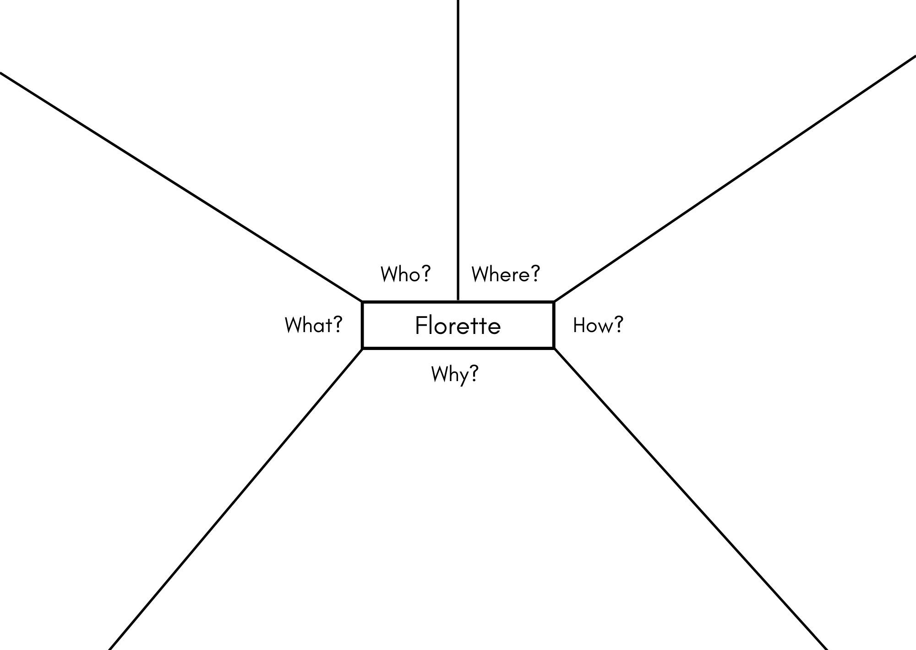

Resource 2: The Secret Sky Garden (Early Stage 1)
The Secret Sky Garden – Beginning, middle, end
Beginning
Middle
End

Resource 3: The Secret Sky Garden (Stage 1)
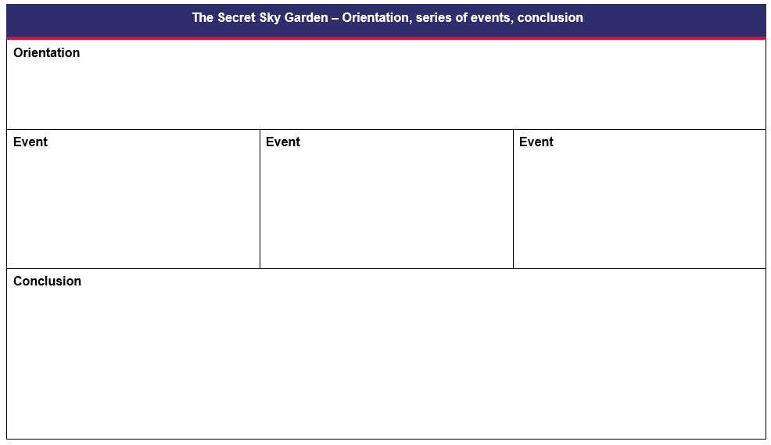

Resource 4: Simple sentences (Early Stage 1)
Funni flew her kite.
Zoo saw the garden.
Funni plays the recorder.
Zoo plays the harmonica.
Funni watered the flowers.
Zoo made a friend.

Resource 5: Sentence frame (Early Stage 1)
The naming part  (the ‘who’ or ‘what’)  subject | The happening part  (what the naming part is doing)  verb | The naming part  (the ‘what’)  object

Resource 6: FANBOYS mnemonic (Stage 1)
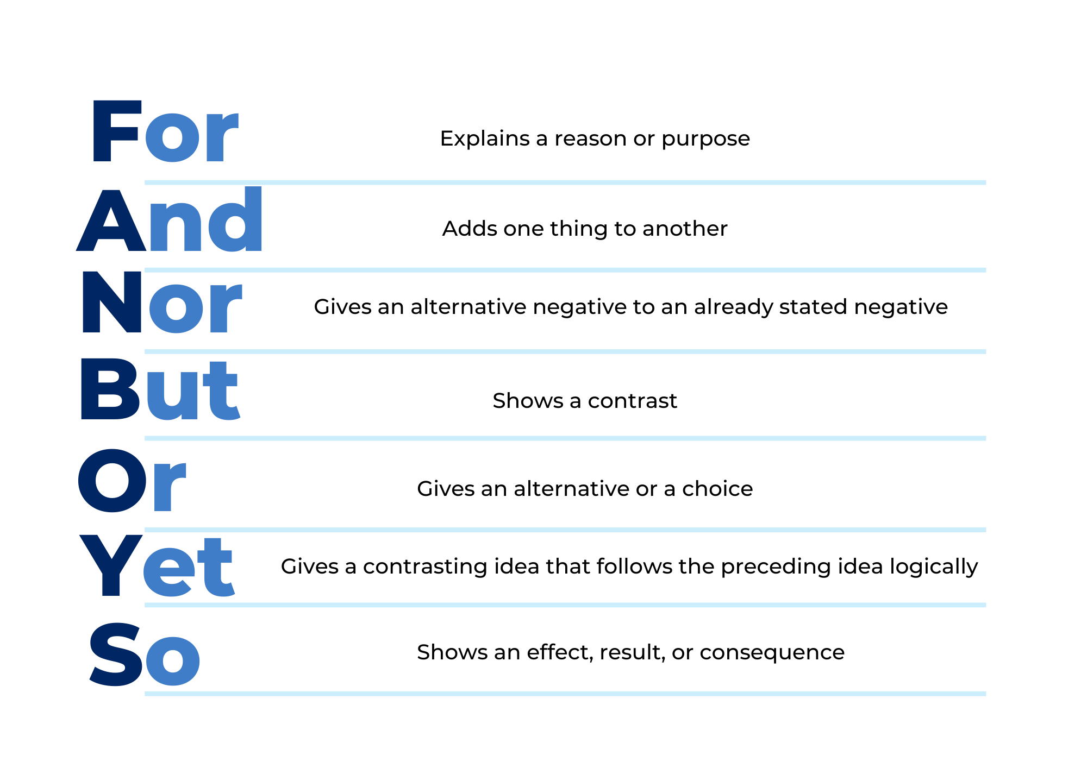

Resource 7: Compound sentences (Stage 1)
Funni plays recorder and Zoo plays a silver harmonica.
Funni liked the old airport carpark, but she longed for a friend.
Funni cleaned the carpet of litter, and she swept up squished cans.
Zoo noticed the sky garden from a plane, so he decided to find it.

Resource 8: Narrative plan
Narrative plan
Beginning/Orientation
Middle/Series of events – in order
End/Conclusion

Resource 9: Writing checklist (Early Stage 1)
Author’s name:
Peer feedback name:
Elements | Yes | Not sure | No
capitals for proper nouns | 🙂 | 🙄 | 😐
personal pronouns | 🙂 | 🙄 | 😐
prepositional phrases | 🙂 | 🙄 | 😐
beginning | 🙂 | 🙄 | 😐
middle | 🙂 | 🙄 | 😐
end | 🙂 | 🙄 | 😐
adjectives | 🙂 | 🙄 | 😐

Resource 10: Writing checklist (Stage 1)
Author’s name:
Peer feedback name:
Elements | Yes | Not sure | No
orientation | 🙂 | 🙄 | 😐
series of events | 🙂 | 🙄 | 😐
conclusion | 🙂 | 🙄 | 😐
simple and compound sentences | 🙂 | 🙄 | 😐
conjunctions | 🙂 | 🙄 | 😐
articles | 🙂 | 🙄 | 😐
personal pronouns | 🙂 | 🙄 | 😐
prepositional phrases | 🙂 | 🙄 | 😐
noun groups | 🙂 | 🙄 | 😐

References
Links to third-party material and websites
Please note that the provided (reading/viewing material/list/links/texts) are a suggestion only and implies no endorsement, by the New South Wales Department of Education, of any author, publisher, or book title. School principals and teachers are best placed to assess the suitability of resources that would complement the curriculum and reflect the needs and interests of their students.
If you use the links provided in this document to access a third-party's website, you acknowledge that the terms of use, including licence terms set out on the third-party's website apply to the use which may be made of the materials on that third-party website or where permitted by the Copyright Act 1968 (Cth). The department accepts no responsibility for content on third-party websites.
Except as otherwise noted, all material is © State of New South Wales (Department of Education), 2021 and licensed under the Creative Commons Attribution 4.0 International License. All other material (third-party material) is used with permission or under licence. Where the copyright owner of third-party material has not licensed their material under a Creative Commons or similar licence, you should contact them directly for permission to reuse their material.
English K–10 Syllabus © 2022 NSW Education Standards Authority (NESA) for and on behalf of the Crown in right of the State of New South Wales.
© 2021 NSW Education Standards Authority. This document contains NSW Curriculum and syllabus content. The NSW Curriculum is developed by the NSW Education Standards Authority. This content is prepared by NESA for and on behalf of the Crown in right of the State of New South Wales. The material is protected by Crown copyright.
Please refer to the NESA Copyright Disclaimer for more information.
NESA holds the only official and up-to-date versions of the NSW Curriculum and syllabus documents. Please visit the NSW Education Standards Authority (NESA) website and the NSW Curriculum website.
National Literacy Learning Progression © Australian Curriculum, Assessment and Reporting Authority (ACARA) 2010 to present, unless otherwise indicated. This material was downloaded from the Australian Curriculum website (National Literacy Learning Progression) (accessed 15 November 2022) and was not modified. The material is licensed under CC BY 4.0. Version updates are tracked in the ‘Curriculum version history’ section on the 'About the Australian Curriculum' page of the Australian Curriculum website.
ACARA does not endorse any product that uses the Australian Curriculum or make any representations as to the quality of such products. Any product that uses material published on this website should not be taken to be affiliated with ACARA or have the sponsorship or approval of ACARA. It is up to each person to make their own assessment of the product, taking into account matters including, but not limited to, the version number and the degree to which the materials align with the content descriptions and achievement standards (where relevant). Where there is a claim of alignment, it is important to check that the materials align with the content descriptions and achievement standards (endorsed by all education Ministers), not the elaborations (examples provided by ACARA).
ETA (English Teachers Association) and NSW Department of Education (2016) The Textual Concepts and Processes resource, English Textual Concepts website, accessed 15 November 2022.
ETA (English Teachers Association) and NSW Department of Education (2016) Narrative, English Textual Concepts website, accessed 15 November 2022.
Sarah L (2019) The Secret Sky Garden (Lumbers F, illus.), Simon & Schuster Children’s Books, Great Britain. ISBN: 9781471119262
Walker A (2017) Florette, Viking Australia. ISBN: 9780670079414

Further reading
Mackenzie N (22 October 2019) ‘Draw, Talk, Write (and Share)’, Noella’s Blog, accessed 15 November 2022.

