English – K-2 multi-age – Year B – Unit 14
Contents
Unit overview and instructions for use 3
Teacher notes 4
Outcomes and content – Component A 5
Outcomes and content – Component B 9
Week 1 13
Component A teaching and learning 13
Component B teaching and learning 14
Lesson 1: Narrative features and oral recount 16
Lesson 2: Language features in narratives 19
Lesson 3: Recounting with sentences and paragraphs 22
Lesson 4: Dust Buddies – Narrative through animation 27
Lesson 5: Identifying language features 29
Week 2 32
Component A teaching and learning 32
Component B teaching and learning 33
Lesson 6: Planning for writing 34
Lesson 7: Writing the beginning/orientation 37
Lesson 8: Writing the middle/series of events 39
Lesson 9: Writing the end/conclusion, feedback and editing 40
Lesson 10: Publish and share 44
Resource 1: Possum Magic narrative plan 45
Resource 2: Possum Magic language features 46
Resource 3: FANBOYS mnemonic 47
Resource 4: Compound sentences (Early Stage 1) 48
Resource 5: Subordinating conjunctions 49
Resource 6: Dust Buddies (Early Stage 1) 50
Resource 7: Dust Buddies (Stage 1) 51
Resource 8: Word mat 52
References 53

Unit overview and instructions for use
This two-week unit is comprised of Component A and Component B. Connecting learning across both components is encouraged.
Teaching and learning | Component A | Component B
Suggested duration | 60 minutes | 45 minutes
Explicit teaching focus areas | - Phonological awareness (Early Stage 1)  - Print conventions (Early Stage 1)  - Phonic knowledge  - Reading fluency  - Reading comprehension  - Spelling  - Handwriting | - Oral language and communication  - Vocabulary  - Reading comprehension  - Creating written texts  - Understanding and responding to literature
To prepare for teaching and learning: | - Refer to Outcomes and content – Component A, K-2 – Instructional sequence – grapheme–phoneme correspondences [PDF 825 KB], and the teaching advice documents (hyperlinked in Component A teaching and learning table).  - Based on student needs identified through ongoing assessment data, plan and document how you will sequence teaching and learning in whole class and targeted teaching groups across the two-week cycle. | - Familiarise yourself with Outcomes and content – Component B, Textual concepts information and videos, English Textual Concepts and Learning Processes (2016), and the teaching and learning sequence.  - Based on student needs identified through ongoing assessment data, determine how you will support students in whole class and targeted teaching groups across the two-week cycle as required.
English K–10 Syllabus © 2022 NSW Education Standards Authority (NESA) for and on behalf of the Crown in right of the State of New South Wales.

Teacher notes
- Narrative can refer to a story itself or to the conventions by which we communicate and understand it. Students understand that through narrative they enter and create other worlds. It is a way of sharing and learning about life experiences. – English Textual Concepts and Learning Processes (2016).
- Understanding of narrative can be supported through watching the department’s video: Narrative (3:51).
- While narrative is the mentor concept for the conceptual component of this unit, the supporting concept of imagery, symbol and connotation can be explored using the mentor text Possum Magic by Mem Fox and the supporting animation Dust Buddies.
- It is suggested that devices with recording capabilities, such as Flip or Apple iMovie, are used to showcase student narratives at the completion of the unit.
- Strategies from Effective Reading in the early years of school are used in this unit, particularly shared practice, word walls and rich text talk.
- For information on nouns, verbs, prepositional phrases, sentences and paragraphs refer to the NESA Glossary.
- This unit could enhance student learning towards achievement of science and technology outcomes, specifically using digital platforms to communicate.
- Reflect on student learning and engagement in activities and record differentiation and adjustments within the unit to inform future teaching and learning. One way of doing this could be to add comments to the digital file.
- Content points are linked to the National Literacy Learning Progression version (3).
Levels and indicators sourced from National Literacy Learning Progression © Australian Curriculum, Assessment and Reporting Authority (ACARA), (accessed 16 January 2023) and was not modified. See references for more information.

Outcomes and content – Component A
The table below outlines the focus outcomes and content. Content is linked to the National Literacy Learning Progression version (3).
Early Stage 1 Focus area and outcome | Stage 1 Focus area and outcome
Phonological awareness  ENE-PHOAW-01 – identifies, blends, segments and manipulates phonological units in spoken words as a strategy for reading and creating texts  - blend aloud all phonemes when asked to delete, add or substitute an initial phoneme (PhA5)  - blend aloud all phonemes when asked to substitute a medial vowel phoneme | N/A
Print conventions  ENE-PRINT-01 – tracks written text from left to right and from top to bottom of the page and identifies visual and spatial features of print  - as needed | N/A
Phonic knowledge  ENE-PHOKW-01 – uses single-letter grapheme–phoneme correspondences and common digraphs to decode and encode words when reading and creating texts  - decode words containing split digraphs and vowel digraphs (PKW5)  - experiment with encoding high-frequency words containing split digraphs and vowel digraphs | Phonic knowledge  EN1-PHOKW-01 – uses initial and extended phonics, including vowel digraphs, trigraphs to decode and encode words when reading and creating texts  - decode words with trigraphs and quadgraphs and apply this when reading texts
Reading fluency  ENE-REFLU-01 – reads decodable texts aloud with automaticity  - read texts with taught grapheme–phoneme correspondences and taught high-frequency words with automaticity  - know that pace and expression vary when reading, according to the audience and purpose | Reading fluency  EN1-REFLU-01 – sustains reading unseen texts with automaticity and prosody and self-corrects errors  - self-correct when fluency and/or meaning is interrupted  - adjust phrasing, intonation, volume or rate to maintain fluency when reading aloud (FlY4)
Reading comprehension  ENE-RECOM-01 – comprehends independently read texts using background knowledge, word knowledge and understanding of how sentences connect  - ask or pause to clarify meaning of unknown words (UnT3)  - self-correct error using phonic knowledge (UnT5)  - ask a question or make a statement to clarify meaning (UnT3, UnT4)  - recount the relevant ideas from the text (UnT5) | Reading comprehension  EN1-RECOM-01 – comprehends independently read texts that require sustained reading by activating background and word knowledge, connecting and understanding sentences and whole text, and monitoring for meaning  - draw on sources to seek clarification for unknown words  - know that a complex sentence includes a clause for expressing a main message and one or more clauses that elaborate on that message  - recognise how the position of a clause in a complex sentence influences the important idea for the reader  - monitor understanding to ensure meaning is sustained and expanded through the whole text (UnT6)
Spelling  ENE-SPELL-01 – applies phonological, orthographic and morphological generalisations and strategies to spell taught familiar and high-frequency words when creating texts  - combine phonological, phonic, orthographic and morphemic knowledge to spell taught high-frequency irregular words comprising up to 3 phonemes (SpG5)  - experiment with some vowel digraphs and split digraphs to spell taught high-frequency words and/or personally significant words | Spelling  EN1-SPELL-01 – applies phonological, orthographic and morphological generalisations and strategies when spelling words in a range of writing contexts  - segment multisyllabic words into syllables and phonemes as a strategy for spelling (SpG5)  - explain that the consonant trigraphs, -tch and -dge, can end a base word immediately following a short vowel and apply this when spelling  - use spelling conventions when adding tense-marking suffixes (SpG9)  - spell nouns ending in the suffix -er to indicate a person (SpG9)
Handwriting  ENE-HANDW-01 – produces all lower-case and upper-case letters to create texts  - apply taught handwriting skills when creating texts | Handwriting  EN1-HANDW-01 – uses a legible, fluent and automatic handwriting style, and digital technology, including word-processing applications, when creating texts  - type up to 5 familiar words per minute  - use taught software functions to create texts in a range of modes for different contexts, audiences and purposes

Outcomes and content – Component B
The table below outlines the focus outcomes and content. Content is linked to the National Literacy Learning Progression version (3).
Early Stage 1 Focus area and outcome | Stage 1 Focus area and outcome
Oral language and communication  ENE-OLC-01 – communicates effectively by using interpersonal conventions and language with familiar peers and adults  - recognise how nonverbal language can contribute to meaning in spoken communication (LiS3)  - use connectives such as and, but and because when speaking (SpK2)  - recall details of events or stories using who, what, when, where, why and how (SpK2) | Oral language and communication  EN1-OLC-01 – communicates effectively by using interpersonal conventions and language to extend and elaborate ideas for social and learning interactions  - understand that oral language can be used in combination with nonverbal communication  - recount narratives with key components (SpK3)
Vocabulary  ENE-VOCAB-01 – understands and effectively uses Tier 1 words and Tier 2 words in familiar contexts  - identify, name and describe a range of objects, characters, animals, people and places when given visual and/or auditory prompts (GrA1) | Vocabulary  EN1-VOCAB-01 – understands and effectively uses Tier 1, taught Tier 2 and Tier 3 vocabulary to extend and elaborate ideas  - understand and intentionally choose subject-specific vocabulary to enhance precision and for effect
Reading comprehension  ENE-RECOM-01 – comprehends independently read texts using background knowledge, word knowledge and understanding of how sentences connect  - identify conjunctions in a compound sentence, their meaning and purpose  - recount the relevant ideas from the text (UnT5) | Reading comprehension  EN1-RECOM-01 – comprehends independently read texts that require sustained reading by activating background and word knowledge, connecting and understanding sentences and whole text, and monitoring for meaning  - identify how creative visual features are used to expand meaning  - know that a complex sentence includes a clause for expressing a main message and one or more clauses that elaborate on that message  - use visual and/or auditory features in multimodal texts to build meaning (UnT5)  - recount relevant ideas from texts in the form of a written, visual or oral summary (UnT6)
Creating written texts  ENE-CWT-01 – creates written texts that include at least 2 related ideas and correct simple sentences  - create a text including at least 2 related ideas (CrT5)  - identify and use verbs in simple sentences, including in own writing (GrA2)  - identify and use nouns in simple sentences, including in own writing (GrA1)  - use prepositional phrases to indicate time or place (GrA2)  - identify and use time connectives to sequence information and events (GrA4)  - experiment with writing compound sentences and recognise that each clause makes meaning by itself (GrA4)  - understand they can improve their writing based on feedback from teachers  - edit their texts after receiving feedback | Creating written texts  EN1-CWT-01 – plans, creates and revises texts written for different purposes, including paragraphs, using knowledge of vocabulary, text features and sentence structure  - group sentences into paragraphs commencing with a topic sentence, followed by other sentences with related ideas (CrT7)  - use noun groups to build descriptions of people and things (CrT6)  - use action, saying, relating and sensing verbs to add detail and precision to writing (GrA2, GrA5)  - use contextually precise prepositional phrases when creating texts (GrA4)  - experiment with writing complex sentences which include a clause for the main message and dependent clause to elaborate or modify the message (GrA5)  - make intentional word choices to enhance precision of meaning and ideas in a text (CrT5)  - re-read and edit their own texts after receiving feedback
Understanding and responding to literature  ENE-UARL-01 – understands and responds to literature read to them  - identify narratives told through a range of modes and media  - experiment with using parts and/or features of a narrative, innovating from a mentor text  - identify how visual cues contribute to the meaning of a text | Understanding and responding to literature  EN1-UARL-01 – understands and responds to literature by creating texts using similar structures, intentional language choices and features appropriate to audience and purpose  - identify patterns in narratives that set up expectation and aid prediction of actions and attitudes  - identify and appreciate how key messages in narratives evoke feelings  - create and re-create narratives using understanding of narrative features (CrT5)

Week 1

Component A teaching and learning
The table below can be used to plan and document lessons that address Component A outcomes and content. Both the detailed example [DOC 529KB] of a two-week teaching and learning cycle and brief example [DOC 66KB] may support you in your planning.
Focus Areas | Lesson 1 | Lesson 2 | Lesson 3 | Lesson 4 | Lesson 5
Phonological awareness (Early Stage 1) and Phonic knowledge
15 minutes
Spelling and Handwriting
15 minutes
Print conventions (Early Stage 1), Reading comprehension and Reading fluency
30 minutes

Component B teaching and learning
The following teaching and learning sequence has been designed to address Component B outcomes and content. Adapt the sequence as required to best meet the needs of your students.

Learning intention and success criteria
Learning intentions and success criteria are best co-constructed with students. The table below contains suggested learning intentions and success criteria.
Element | Early Stage 1 | Stage 1
Learning intentions | Students are learning to recount narratives with a focus on structure and language features. | Students are learning to analyse and recount narratives with a focus on structure and language features.
Success criteria | Students can:  - identify narrative structure  - orally recount a narrative  - identify nouns, verbs, descriptive language and prepositional phrases in a text  - use simple and compound sentences  - identify narratives told though different modes and media. | Students can:  - identify narrative structure  - orally recount a narrative  - write using nouns, verbs, descriptive language and prepositional phrases  - use compound and complex sentences  - write well-constructed paragraphs  - identify language features in narratives told through different modes and media.

Resources
- Fox M (2018) Possum Magic (Vivas J, illus.) 35th anniversary edn, Omnibus Books (original work published in 1983). ISBN: 9781742763460
- Video: Dust Buddies (4:04)
- Video: Mem Fox Book Reading - Possum Magic, Whoever You Are, Ten Little Fingers and Ten Little Toes (from 0:00 to 5:32)
- Audio: Listen to Possum Magic – Mem Fox audio (5:18)
- Resource 1: Possum Magic narrative plan – one A3 copy for each pair and one enlarged teacher copy
- Resource 2: Possum Magic language features
- Resource 3: FANBOYS mnemonic
- Resource 4: Compound sentences (Early Stage 1)
- Resource 5: Subordinating conjunctions
- Resource 6: Dust Buddies (Early Stage 1) – one A3 copy for each Early Stage 1 student and one enlarged teacher copy
- Resource 7: Dust Buddies (Stage 1) – one A3 copy for each Stage 1 student and one enlarged teacher copy
- Resource 8: Word mat
- A3 paper/butchers’ paper for anchor charts – one for each group
- Markers
- Mini whiteboards or paper
- Sticky notes

Lesson 1: Narrative features and oral recount
The following teaching and learning activities support multi-age settings.

Whole
- Display the front cover of Possum Magic. Allow time for students to make observations. Ask:
- What can you see?
- What do you think the characters are doing?
- What do you know about possums?
- What type of text could this be? How do you know?
- Read Possum Magic, stopping to discuss meaning when required. Ask students to identify the key message in the text and how it makes them feel.
- Explain and discuss that Possum Magic is a narrative and the purpose of a narrative is to entertain. Explain that narratives can be real or imagined.
Note: The narrative structure terminology used for Early Stage 1 is beginning, middle and end. Stage 1 uses the term ‘series of events’ – including an orientation, problem and conclusion.
- Review the features of narratives, including the characters, setting, beginning/orientation, middle/series of events including problem, and end/conclusion. Identify these features in Possum Magic. Draw attention to the Australiana theme.
- Discuss other features of quality narratives. For example, descriptive language and dialogue. Identify these features in the text.
- Display enlarged Resource 1: Possum Magic narrative plan. Explain how the narrative features are represented in each section.
- Model completing Resource 1: Possum Magic narrative plan. Write one idea on a sticky note and place it in the relevant section. For example, write ‘Grandma Poss’ and place in the ‘who/characters’ section. Repeat for other sections.
- Students work in pairs to complete Resource 1: Possum Magic narrative plan using sticky notes. Keep this for Lesson 3.
- Display the teacher modelled Resource 1: Possum Magic narrative plan. Ask students to share their work and add new ideas to the teacher model. Note that students may have different answers for some sections of the resource.
- Students review their resource and move sticky notes to relevant sections, if required.
- Model orally recounting Possum Magic using the completed enlarged Resource 1: Possum Magic narrative plan. Highlight the use of connectives to link ideas, for example, and, but and because.
- Student pairs join another pair. Students orally share their recounts using connectives, by referring to their completed Resource 1: Possum Magic narrative plan.
- As a class, ask what connectives were used in their oral recounts and discuss how connectives link ideas. Revise key features of narratives.
Early Stage 1 Assessment task 1 – Observations and work samples from this lesson allow students to demonstrate achievement towards the following syllabus outcomes and content points:
ENE-OLC-01 – communicates effectively by using interpersonal conventions and language with familiar peers and adults
- use connectives such as and, but and because when speaking
- recall details of events or stories using who, what, when, where, why and how.
ENE-VOCAB-01 – understands and effectively uses Tier 1 words and Tier 2 words in familiar contexts
- identify, name and describe a range of objects, characters, animals, people and places when given visual and/or auditory prompts.
ENE-RECOM-01 – comprehends independently read texts using background knowledge, word knowledge and understanding of how sentences connect
- recount the relevant ideas from the text.
Stage 1 Assessment task 1 – Observations and work samples from this lesson allow students to demonstrate achievement towards the following syllabus outcomes and content points:
EN1-OLC-01 – communicates effectively by using interpersonal conventions and language to extend and elaborate ideas for social and learning interactions
- recount narratives with key components.
EN1-RECOM-01 – comprehends independently read texts that require sustained reading by activating background and word knowledge, connecting and understanding sentences and whole text, and monitoring for meaning
- recount relevant ideas from texts in the form of a written, visual or oral summary.
EN1-UARL-01 – understands and responds to literature by creating texts using similar structures, intentional language choices and features appropriate to audience and purpose
- identify and appreciate how key messages in narratives evoke feelings.

Lesson 2: Language features in narratives
The following teaching and learning activities support multi-age settings.

Whole
- Display and read the first page of Possum Magic, ‘Once upon a time...’. Discuss how the author’s word choices provide more description. For example, ‘not very long ago, deep in the Australian bush’ provides more detail than, ‘they lived in the bush’.
- Discuss and review some language features that authors use when writing narratives, including:
- nouns
- verbs
- descriptive language
- prepositional phrases.
- Display individual anchor charts for each language feature. These will be referred to and extended on throughout the unit.
- Establish student understanding of the language features and make connections to prior learning. Discuss how each feature is used in a narrative. For example:
- nouns – name characters and settings
- verbs – describe the action
- descriptive language – helps the audience visualise
- prepositional phrases – move characters through the setting.
- Re-read Possum Magic.
- Refer to the first page of Possum Magic. Revise what a noun is. Identify the nouns on the page and add them to the noun anchor chart. Repeat for verbs, descriptive language, and prepositional phrases.
- Explain that in small groups, students will search for language features in Possum Magic and add to the anchor charts.
- Provide each group with markers and one language feature anchor chart. Identify the language feature for each group. Provide students with one of the following: excerpts of the text, the whole text, the audio Possum Magic – Mem Fox (5:18) or video Mem Fox Book Reading - Possum Magic, Whoever You Are, Ten Little Fingers and Ten Little Toes (from 0:00 to 5:32). Note that for larger class sizes, multiple anchor charts could be created for each language feature.
- Students review the text excerpt and add to their language feature anchor chart.
- As a class, collate and display the anchor charts. Allow each group to share ideas from their language feature search. Ask students to identify the language features in a sentence and provide feedback. Add shared sentences to the bottom of the anchor charts for students to refer to. Identify and underline the language feature focus in each sentence.

Part
The table below details the differentiated teaching and learning activities for each stage.
Early Stage 1 (independent) | Stage 1 (teacher guided/independent)
- Students write sentences about the text using words from the language feature anchor charts. For example, ‘Hush (noun) ate (verb) a vegemite sandwich.’  Too hard? Students draw and label their illustration using words from the anchor charts.  Too easy? Students include more than 2 language features in sentences. | - Display Resource 2: Possum Magic language features. Read the passage. Explain that students are going to identify the language features in the passage.  - Model identifying the language features. Refer to the anchor charts to assist.  - Students complete Resource 2: Possum Magic language features.  Too hard? Students work in mixed ability groups to complete the resource.  Too easy? Students write their own sentences about the text and label the language features used.  - Discuss the answers to Resource 2: Possum Magic language features.

Whole
- Play charades. Mime using words from the language feature anchor charts. Students select a word from the anchor charts and act it out for their peers to guess.
- Discuss how the words support the audience to understand the narrative. For example, the verb ‘slide’ provides detail about how Hush moved.

Lesson 3: Recounting with sentences and paragraphs
The following teaching and learning activities support multi-age settings.

Whole
- Explain that students will use their completed Resource 1: Possum Magic narrative plan from Lesson 1 to write a recount of Possum Magic.
- Revise narrative features, for example, characters, setting and structure then re-read Possum Magic.
- Students Think-Pair-Share what they know about sentence structure. Discuss how authors use compound and complex sentences to add detail and extend their ideas.
- Revise simple and compound sentence structures. Explain that a simple sentence is an independent clause and represents a complete thought.
- Explicitly teach use of coordinating conjunctions to join simple sentences to form a compound sentence. Display Resource 3: FANBOYS mnemonic. Discuss the meaning and purpose of each conjunction.
- Display compound sentences from the text, for example, ‘She looked into this book and she looked into that.’ Underline each independent clause and circle the coordinating conjunction.
- Display the teacher modelled Resource 1: Possum Magic narrative plan.
- Model orally retelling and writing a recount of the first event in Possum Magic using compound sentences, for example, ‘Grandma Poss made Hush invisible and Hush had lots of adventures.’ Underline each independent clause and circle the coordinating conjunction.
- Co-construct a compound sentence for the next event, for example, ‘Hush felt sad so Grandma Poss promised to make her visible.’ Underline each independent clause and circle the coordinating conjunction.

Part
The table below details the differentiated teaching and learning activities for each stage.
Early Stage 1 (pairs/independent) | Stage 1 (teacher guided/independent)
- Provide students with Resource 4: Compound sentences (Early Stage 1).  - Students cut out the coordinating conjunctions and paste into the appropriate gaps to create compound sentences. Provide additional support as required to read the sentences.  Too hard? Students work in pairs to complete the resource. | - Explicitly teach that a complex sentence is formed by adding one or more dependent (subordinate) clauses to a main (independent) clause using subordinating conjunctions. An independent clause expresses the main message and the dependent clause elaborates on that message.  - Display and discuss Resource 5: Subordinating conjunctions, providing explanation and examples of when different conjunctions could be used.  Note: A subordinating conjunction is a word that links a dependent clause to an independent clause, for example, when, because, although, unless.  - Identify complex sentences in the text. For example, ‘Because she couldn’t be seen she could slide down snakes.’ Identify the independent clause (main message) ‘she could slide down snakes’, the subordinating conjunction ‘because’, and dependent clause (elaboration on main message) ‘because she couldn’t be seen.’  - Refer to the modelled compound sentence in activity 9 and Resource 1: Possum Magic narrative plan. Model writing the next event using complex sentences. For example, ‘While Hush was sleeping, Grandma Poss looked through all her magic books.’  - Revise paragraphs as a group of sentences, starting with a topic sentence followed by sentences with related ideas. Explain that a new event is a new idea and therefore a new paragraph.  - Co-construct another sentence about the same event to create a paragraph. For example, ‘While Hush was sleeping, Grandma Poss looked through all her magic books (topic sentence). Grandma Poss searched for hours but she could not find what she was looking for (related idea).’

Whole
- Explain that when writing recounts of narratives, ideas must be sequenced and related.
- Review the beginning of the teacher modelled recount from activity 8 and activity 9. Explain that each event is a separate idea. Discuss how they are related to each other.

Part
The table below details the differentiated teaching and learning activities for each stage.
Early Stage 1 (teacher guided) | Stage 1 (independent)
- Explain that students will write compound sentences to recount of the end of Possum Magic using the teacher modelled Resource 1: Possum Magic narrative plan.  - Students write a recount of the end of Possum Magic.  Too hard? Students draw a recount and label with key words.  Too easy? Students write a recount of the entire text.  - Students identify compound sentences in their writing by independent clause and circling coordinating conjunctions. | - Students refer to completed Resource 1: Possum Magic narrative plan and use a variety of sentence structures to write a recount of Possum Magic, organising their events/ideas in paragraphs and using engaging language features.  - Students identify complex sentences in their writing by underlining independent clauses/main idea and highlighting subordinating conjunctions and dependent clauses/elaboration.
Early Stage 1 Assessment task 2 – Observations and work samples from this lesson allow students to demonstrate achievement towards the following syllabus outcomes and content points:
ENE-RECOM-01 – comprehends independently read texts using background knowledge, word knowledge and understanding of how sentences connect
- identify conjunctions in a compound sentence, their meaning and purpose.
ENE-CWT-01 – creates written texts that include at least 2 related ideas and correct simple sentences
- create a text including at least 2 related ideas
- experiment with writing compound sentences and recognise that each clause makes meaning by itself.
Stage 1 Assessment task 2 – Observations and work samples from this lesson allow students to demonstrate achievement towards the following syllabus outcomes and content points:
EN1-RECOM-01 – comprehends independently read texts that require sustained reading by activating background and word knowledge, connecting and understanding sentences and whole text, and monitoring for meaning
- know that a complex sentence includes a clause for expressing a main message and one or more clauses that elaborate on that message.
EN1-CWT-01 – plans, creates and revises texts written for different purposes, including paragraphs, using knowledge of vocabulary, text features and sentence structure
- group sentences into paragraphs commencing with a topic sentence, followed by other sentences with related ideas
- experiment with writing complex sentences which include a clause for the main message and dependent clause to elaborate or modify the message.

Lesson 4: Dust Buddies – Narrative through animation
The following teaching and learning activities support multi-age settings.

Whole
- Revise narrative purpose and features, for example, characters, setting and structure.
- Introduce Dust Buddies as a narrative.
- View Dust Buddies (4:04) up to 1:15. Ask students to identify how the narrative is told (wordless animation – images, sounds and music).
- Display the words ‘first’, ‘next’, ‘then’ and ‘last’. Explain that these are time connectives that can be used to sequence events or information. Brainstorm other time connectives, for example, before, finally, later, after, following that. Record and display.
- In pairs, students use time connectives to orally recount events in Dust Buddies and predict what will happen next.
- Discuss how patterns in narratives establish audience expectations and aid predictions, for example, the audience expects a happy ending because that is the predictable narrative pattern.
- Finish viewing Dust Buddies. Ask students to identify the key message in the text and how it makes them feel.
- Compare student predictions with the actual ending.
- Revise that Dust Buddies is a narrative told through visual and auditory features, without words. Discuss how the audience understood what the characters were thinking and feeling. Draw attention to specific visual and auditory features. Explore how non-verbal communication contributes to meaning. Discuss facial expressions and sound effects.
- Re-watch Dust Buddies then model the use of Resource 6: Dust Buddies (Early Stage 1) or Resource 7: Dust Buddies (Stage 1) to draw a recount of the story. Keep the modelled resources to refer to from Lesson 5 onwards.
- Students complete an A3 copy of Resource 6 or Resource 7.
- Model using Resource 6 or 7 to orally retell the story using time connectives from activity 4.
- In pairs or small groups, students refer to their completed Resource 6 or Resource 7 orally retell Dust Buddies.
Early Stage 1 Assessment task 3 – Observations and work samples from this lesson allow students to demonstrate achievement towards the following syllabus outcomes and content points:
ENE-OLC-01 – communicates effectively by using interpersonal conventions and language with familiar peers and adults
- recognise how nonverbal language can contribute to meaning in spoken communication.
ENE-RECOM-01 – comprehends independently read texts using background knowledge, word knowledge and understanding of how sentences connect
- recount the relevant ideas from the text.
ENE-UARL-01 – understands and responds to literature read to them
- identify narratives told through a range of modes and media
- identify how visual cues contribute to the meaning of a text.
Stage 1 Assessment task 3 – Observations and work samples from this lesson allow students to demonstrate achievement towards the following syllabus outcomes and content points:
EN1-OLC-01 – communicates effectively by using interpersonal conventions and language to extend and elaborate ideas for social and learning interactions
- understand that oral language can be used in combination with nonverbal communication.
EN1-RECOM-01 – comprehends independently read texts that require sustained reading by activating background and word knowledge, connecting and understanding sentences and whole text, and monitoring for meaning
- identify how creative visual features are used to expand meaning
- use visual and/or auditory features in multimodal texts to build meaning
- recount relevant ideas from texts in the form of a written, visual or oral summary.
EN1-UARL-01 – understands and responds to literature by creating texts using similar structures, intentional language choices and features appropriate to audience and purpose
- identify patterns in narratives that set up expectation and aid prediction of actions and attitudes
- identify and appreciate how key messages in narratives evoke feelings.

Lesson 5: Identifying language features
The following teaching and learning activities support multi-age settings.

Whole
- Refer to Possum Magic. Remind students how authors use intentional word choices to add detail and extend ideas in writing.
- Explain that students will plan, write, and publish a narrative for Dust Buddies.
- Refer to Dust Buddies. Remind students how the visual and auditory features support the audience to understand what the characters are thinking and feeling.
- Explain that students will view Dust Buddies and consider words that could be used in a narrative text based on the animation. Use shared practice to demonstrate adding to the language feature anchor charts started in Lesson 2.
- View Dust Buddies (4:04). Pause at 1:15 (beginning/orientation). While viewing, student groups record ideas for key language on mini-whiteboards, sticky notes or paper.
- Add some group ideas to the anchor charts for each language feature. For example:
- nouns – crackers, crumbs, paper clip
- verbs – shuffling, squealed, alerted
- descriptive language – fluffy, velvety, tiny
- prepositional phrases – under the table, behind the leg, over the carpet.
- Continue viewing Dust Buddies. Students record ideas. Pause at the following times and repeat activities 5 and 6.
- 2:36 (middle/event)
- 3:13 (middle/event)
- 3:35 (middle/event)
- 3:49 (end/conclusion)
- Review the completed anchor charts. These will be used to support writing from Lesson 6 onwards.
- Display Resource 8: Word mat and model completing by selecting an interesting word from one of the anchor charts.
- Provide students with a copy Resource 8: Word mat to complete by selecting an interesting or new word from one of the anchor charts.

Week 2

Component A teaching and learning
The table below can be used to plan and document lessons that address Component A outcomes and content. Both the detailed example [DOC 529KB] of a two-week teaching and learning cycle and brief example [DOC 66KB] may support you in your planning.
Focus Areas | Lesson 6 | Lesson 7 | Lesson 8 | Lesson 9 | Lesson 10
Phonological awareness (Early Stage 1) and Phonic knowledge
15 minutes
Spelling and Handwriting
15 minutes
Print conventions (Early Stage 1), Reading comprehension and Reading fluency
30 minutes

Component B teaching and learning
The following teaching and learning sequence has been designed to address Component B outcomes and content. Adapt the sequence as required to best meet the needs of your students.

Learning intention and success criteria
Learning intentions and success criteria are best co-constructed with students. The table below contains suggested learning intentions and success criteria.
Element | Early Stage 1 | Stage 1
Learning intentions | Students are learning to write engaging narratives using a range of sentence structures. | Students are learning to write engaging narratives, organising the series of events in paragraphs and using a range of sentence structures.
Success criteria | Students can:  - plan writing using language features  - write a planned narrative, including a beginning, middle and end  - edit writing based on feedback and the success criteria  - publish and share a narrative. | Students can:  - plan writing using language features  - use noun groups to enhance descriptions  - write the orientation, series of events and conclusion for a planned narrative  - provide peer feedback based on the success criteria  - edit writing based on feedback and the success criteria  - publish and share a narrative.

Resources
- Fox M (2018) Possum Magic (Vivas J, illus.), 35th anniversary edn, Omnibus Books (original work published in 1983). ISBN: 9781742763460
- Video: Dust Buddies (4:04)
- Student devices with recording capabilities such as Flip or Apple iMovie
- Resource 6: Dust Buddies (Early Stage 1)
- Resource 7: Dust Buddies (Stage 1)

Lesson 6: Planning for writing
The following teaching and learning activities support multi-age settings.

Whole
- Revisit the anchor charts from Lesson 5. Engage students in a brief review of the 4 language features.
- Explain that students will re-watch Dust Buddies. Remind students that it is a narrative told through a wordless animation.
- Prompt students to focus on visual and auditory features. Direct thinking to:
- characters and objects (nouns)
- what actions they do (verbs)
- where characters and objects are (prepositional phrases)
- details of characters and events (descriptive language).
- Re-watch Dust Buddies.
- Remind students that they will plan, write, and publish a narrative for Dust Buddies.
- Explain that students will use vocabulary on the anchor charts from Lesson 5 to intentionally choose words for each section of their narrative.
- Display teacher modelled Resource 6: Dust Buddies (Early Stage 1) and Resource 7: Dust Buddies (Stage 1) from Lesson 4.
- Refer to the beginning/orientation section of the resources. Use vocabulary from the anchor charts to orally describe the drawn ideas.
- Use the ‘think aloud’ strategy to model intentionally choosing words from each of the anchor charts to write around drawn ideas on Resource 6 or Resource 7. For example, a drawing of a dust buddy under the table could include:
- nouns – dust, friend, cracker, paper clip
- verbs – giggle, scamper, hide, beckon
- prepositional phrases – under the table, behind the leg, across the carpet
- describing words – grey, miniscule, fluffy, velvety.
- Continue with the beginning/orientation section, ensuring each of the language features has been referred to.
- Explain that students will use the anchor charts and write around drawn ideas on Resource 6 or Resource 7.

Part
The table below details the differentiated teaching and learning activities for each stage.
Early Stage 1 (independent) | Stage 1 (teacher guided/independent)
- Students select vocabulary from each of the anchor charts and write words around drawn ideas in Resource 6: Dust Buddies (Early Stage 1).  Too hard? Students choose fewer words from a reduced number of anchor charts. | - Explicitly teach that a noun group is a group of words relating to or building on a noun. Explain that students will be creating noun groups.  - Use think alouds to select a noun from the anchor chart and a word from the descriptive language anchor chart then model writing a noun group. For example, ‘The tiny, velvety dust buddy’. Add to the teacher modelled Resource 7: Dust Buddies (Stage 1).  - In pairs, students orally create noun groups, referring to the noun and descriptive language anchor charts.  - Explain that students will use noun groups to describe their drawings and write on Resource 7.  - Students select vocabulary from each of the anchor charts and write words and noun groups around drawn ideas in their own copy of Resource 7: Dust Buddies (Stage 1).

Whole
- In mixed ability and stage groups students share their writing with a peer referring to their completed Resource 6: Dust Buddies (Early Stage 1) or Resource 7: Dust Buddies (Stage 1).

Lesson 7: Writing the beginning/orientation
The following teaching and learning activities support multi-age settings.

Whole
- Revisit that Possum Magic and Dust Buddies are narratives. Remind students they will write a narrative to accompany Dust Buddies.
- Discuss the features of entertaining and exciting narratives. For example:
- purpose – to entertain
- structure – beginning/orientation, middle/series of events, end/conclusion
- language features – nouns, verbs, descriptive language, prepositional phrases
- text features – compound and complex sentences, related ideas, paragraphs.
- Co-construct differentiated success criteria for Dust Buddies narrative recreation. For example, an entertaining and engaging narrative includes:
- related ideas (Early Stage 1) and paragraphs with a topic sentence followed by related sentences (Stage 1)
- accurate compound sentences (Early Stage 1/Stage 1) and complex sentences (Stage 1)
- verbs
- nouns (Early Stage 1) and noun groups (Stage 1)
- descriptive language
- prepositional phrases
- time connectives (Early Stage 1).
- Explain that students will write the beginning/orientation of their narrative.
- Explicitly teach that the beginning/orientation of a narrative includes who (characters), where (setting) and what (situation).
- Model writing the beginning/orientation referring to the teacher modelled Resource 6 or Resource 7. Use the ‘think aloud’ strategy to select language features from the resource and anchor charts. For example, ‘There they lay, out in the open. Cracker crumbs scattered across the floor. A small, grey, fluffy arm reached out from under the table and stretched longingly for the closest crumb. A shiny paper clip appeared. It skewered the crumb and dragged it behind the table leg. A dust buddy emerged from the shadows, happy to have scored a tasty morsel. All of a sudden, another dust buddy appeared and knocked the crumb away.’
- Identify and discuss effective use of the success criteria in the teacher modelled beginning/orientation. Draw attention to differences for Early Stage 1 and Stage 1 students, for example, Stage 1 students use paragraphs and complex sentences, Early Stage 1 students write related ideas.
- Students write the beginning/orientation of their Dust Buddies narrative. Remind students to refer to their completed Resource 6: Dust Buddies (Early Stage 1) or Resource 7: Dust Buddies (Stage 1) and the success criteria. Explain that students will continue to write their narrative in Lesson 8 and Lesson 9.
Too hard? Facilitate use of text-to-speech technology or audio recording to produce the text.
- Students share their beginning/orientation.

Lesson 8: Writing the middle/series of events
The following teaching and learning activities support multi-age settings.

Whole
- Explain that students will write the middle/series of events in this lesson.
- Revise that ideas and events can be sequenced using time connectives. Display time connectives, for example, before, first, then, after.
- Display teacher modelled Resource 6: Dust Buddies (Early Stage 1) or Resource 7: Dust Buddies (Stage 1). Model adding time connectives to the middle/series of events section such as: before, finally, later, after, following that.
- Students add time connectives to their own copy of Resource 6 or Resource 7.
- Display and review the co-constructed success criteria from Lesson 7.
- Display and reread the teacher modelled beginning/orientation.
- Model writing middle/series of events, first paragraph using the think aloud strategy to select planned language features from the resource and anchor charts. For example, ‘In the distance the family of dust buddies feasted on the cracker crumbs. One lonely dust buddy remained hidden behind the tall table leg, too afraid to venture into the open. As the door swung open, the lonely dust buddy tried desperately to warn his family of the impending danger. The vacuum cleaner slammed down on the floor, but it was too late. Wielded by the fearsome maid, the vacuum cleaner sucked up the dust buddies, leaving no trace.’
- Identify and discuss effective use of the success criteria in the teacher modelled middle/series of events.
- Remind students that ideas must be related and sequenced (Early Stage 1) and/or grouped into paragraphs (Stage 1).
- Students write middle/series of events, referring to their completed Resource 6: Dust Buddies (Early Stage 1) or Resource 7: Dust Buddies (Stage 1) and the co-constructed success criteria.
Too hard? Facilitate use of text-to-speech technology or audio recording to produce the text.
- Students share their middle/series of events.

Lesson 9: Writing the end/conclusion, feedback and editing

Whole
- Explain that students will write the end/conclusion in this lesson.
- Display and review the co-constructed success criteria.
- Display and reread the teacher modelled beginning/orientation and middle/series of events.
- Model writing end/conclusion. Refer to Resource 6: Dust Buddies (Early Stage 1) or Resource 7: Dust Buddies (Stage 1). Use the think aloud strategy to select planned language features from the resource and anchor charts. For example, ‘The dust buddies stood proudly atop the vacuum cleaner and stared the maid in the eye. She glared back with a fierce expression on her face and strode towards them, feather duster in hand. The dust buddies did not hesitate. They flicked the machine on, and the vacuum cleaner charged forward. They circled the maid, wrapping the cord tightly around her spindly legs. The maid fell to the ground and was swiftly sucked into the fathomless depths of the vacuum cleaner.’
- Identify and discuss effective use of the success criteria when editing in the teacher modelled end/conclusion.
- Students write end/conclusion, referring to their completed Resource 6: Dust Buddies (Early Stage 1) or Resource 7: Dust Buddies (Stage 1) and co-constructed success criteria.
Too hard? Facilitate use of text-to-speech technology or audio recording to produce the text.
- Explain that good writers improve their writing by re-reading and editing. Display the co-constructed success criteria and explain that the success criteria can be used to edit and improve writing.
- Display and reread the teacher modelled narrative from Lessons 7, Lesson 8 and Lesson 9.
- Review the teacher narrative against the first success criteria. Make edits and adjustments to improve the narrative.
- Students reread and check their writing against the first success criteria. Provide time for students to edit their work. For example, the narrative should have related ideas (Early Stage 1) and/or paragraphs (Stage 1). Draw attention to examples in the teacher modelled narrative. Edit if required.
- Repeat activities 9 and 10 for all success criteria.

Part
The table below details the differentiated teaching and learning activities for each stage.
Early Stage 1 (teacher guided/ independent) | Stage 1 (independent)
- Ask students to share their narrative. Use the success criteria to provide feedback to students.  - Students apply relevant feedback to their narrative.  - Students begin publishing their narrative. | - Students swap their narrative with a partner to read.  - Students review their partner’s writing, working through the success criteria one at a time.  - Students provide partner feedback on each criterion.  - Students apply relevant partner feedback to edit their writing.  - Students begin publishing their narrative.
Early Stage 1 Assessment task 4 – Observations and work samples from this lesson allow students to demonstrate achievement towards the following syllabus outcomes and content points:
ENE-VOCAB-01 – understands and effectively uses Tier 1 words and Tier 2 words in familiar contexts
- identify, name and describe a range of objects, characters, animals, people and places when given visual and/or auditory prompts.
ENE-CWT-01 – creates written texts that include at least 2 related ideas and correct simple sentences
- create a text including at least 2 related ideas
- identify and use verbs in simple sentences, including in own writing
- identify and use nouns in simple sentences, including in own writing
- use prepositional phrases to indicate time or place
- identify and use time connectives to sequence information and events
- understand they can improve their writing based on feedback from teachers
- edit their texts after receiving feedback.
ENE-UARL-01 – understands and responds to literature read to them
- experiment with using parts and/or features of a narrative, innovating from a mentor text.
Stage 1 Assessment task 4 – Observations and work samples from this lesson allow students to demonstrate achievement towards the following syllabus outcomes and content points:
EN1-VOCAB-01 – understands and effectively uses Tier 1, taught Tier 2 and Tier 3 vocabulary to extend and elaborate ideas
- understand and intentionally choose subject-specific vocabulary to enhance precision and for effect.
EN1-CWT-01 – plans, creates and revises texts written for different purposes, including paragraphs, using knowledge of vocabulary, text features and sentence structure
- group sentences into paragraphs commencing with a topic sentence, followed by other sentences with related ideas
- use noun groups to build descriptions of people and things
- use action, saying, relating and sensing verbs to add detail and precision to writing
- use contextually precise prepositional phrases when creating texts
- make intentional word choices to enhance precision of meaning and ideas in a text
- re-read and edit their own texts after receiving feedback.
EN1-UARL-01 – understands and responds to literature by creating texts using similar structures, intentional language choices and features appropriate to audience and purpose
- create and re-create narratives using understanding of narrative features.

Lesson 10: Publish and share
The following teaching and learning activities support multi-age settings.

Whole
- Students finish publishing their narrative from Lesson 9.
- Students record a video, reading their narrative aloud to share with peers. Use a digital platform such as Flip or Apple iMovie.
- Ask students to reflect on their learning and identify their achievements.

Resource 1: Possum Magic narrative plan
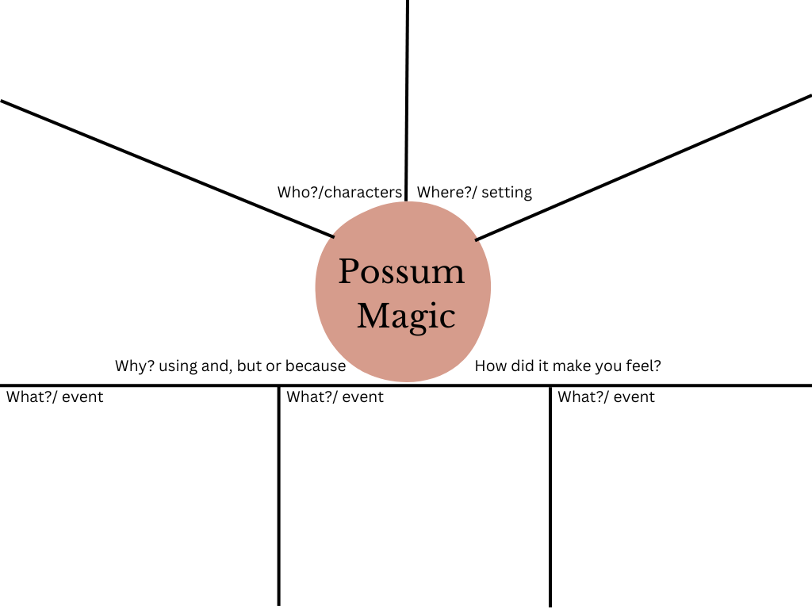

Resource 2: Possum Magic language features
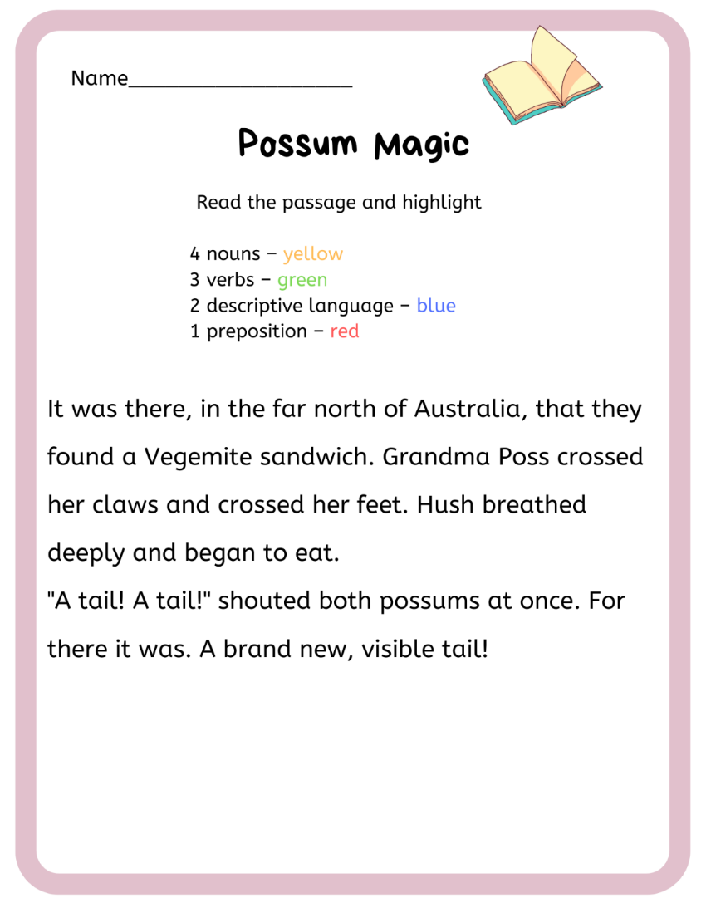
“Book Single Page Turn” by Canva Original Stickers sourced from Canva and used in accordance with the Canva Content License Agreement.
This passage is an excerpt from Fox M (2018) Possum Magic (Vivas J, illus.) 35th anniversary edn, Omnibus Books (original work published in 1983).

Resource 3: FANBOYS mnemonic
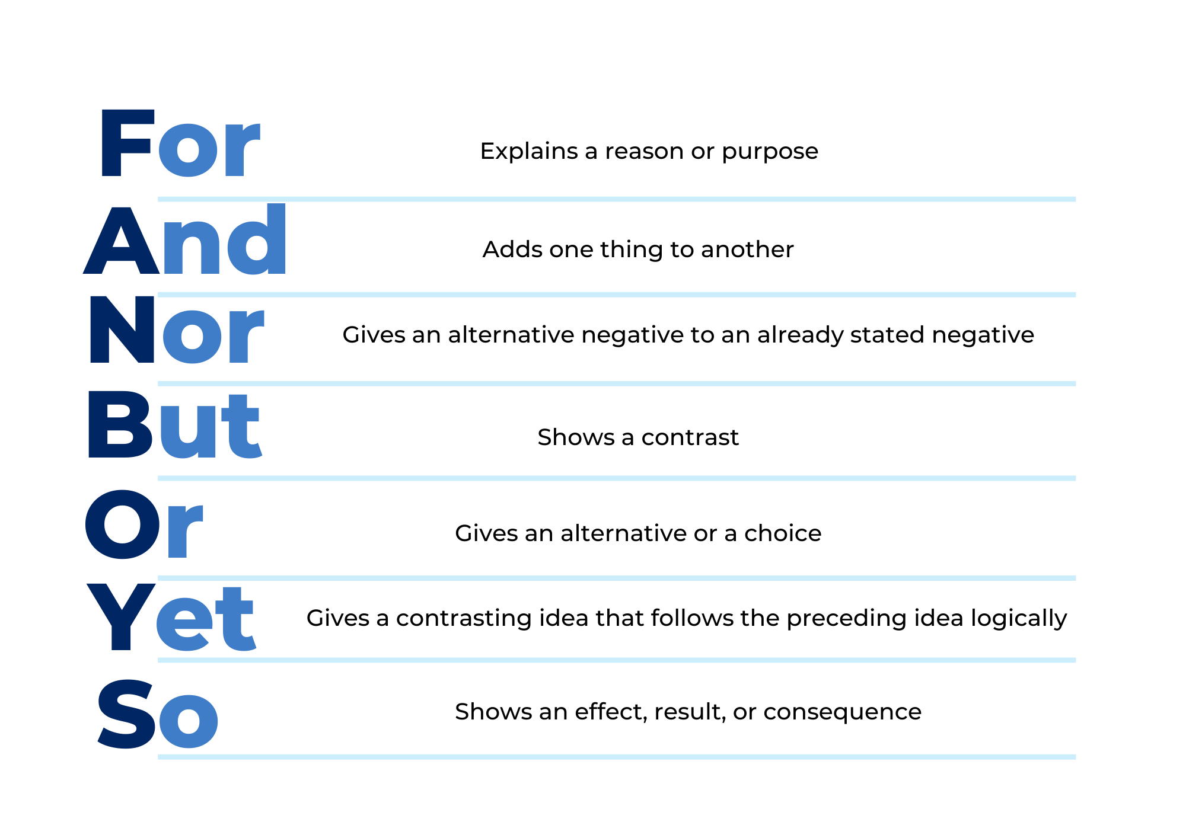

Resource 4: Compound sentences (Early Stage 1)
- Grandma Poss made Hush invisible _________ she was safe from snakes.
- Hush had lots of adventures ________ she felt sad.
- Hush couldn't remember what she looked like ________ she asked Grandma Poss to make her visible.
- Grandma Poss looked for the right magic _________ she couldn’t find it.
- Grandma Poss and Hush left the bush _________ they travelled all over Australia.
so | but | so | but | and

Resource 5: Subordinating conjunctions
after | before | so long as | when
although | if | though | whenever
as | once | unless | where
because | since | until | while

Resource 6: Dust Buddies (Early Stage 1)
Dust Buddies – Beginning, middle, end
Beginning
Middle
End

Resource 7: Dust Buddies (Stage 1)
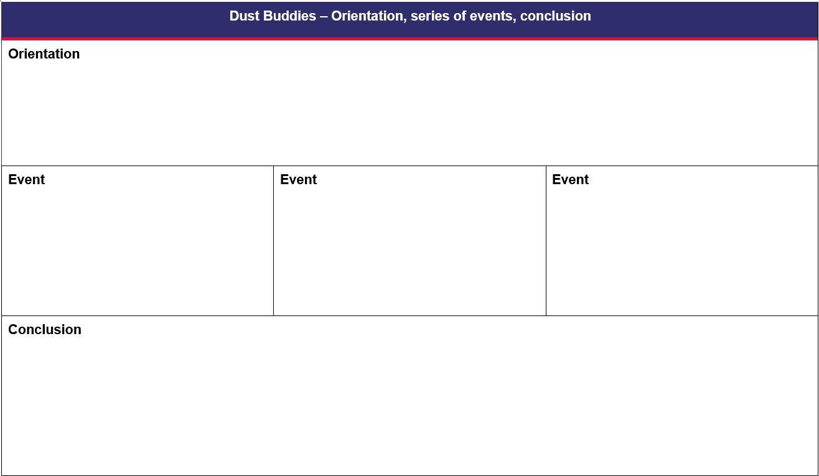

Resource 8: Word mat

References
Links to third-party material and websites
Please note that the provided (reading/viewing material/list/links/texts) are a suggestion only and implies no endorsement, by the New South Wales Department of Education, of any author, publisher, or book title. School principals and teachers are best placed to assess the suitability of resources that would complement the curriculum and reflect the needs and interests of their students.
If you use the links provided in this document to access a third-party's website, you acknowledge that the terms of use, including licence terms set out on the third-party's website apply to the use which may be made of the materials on that third-party website or where permitted by the Copyright Act 1968 (Cth). The department accepts no responsibility for content on third-party websites.
Except as otherwise noted, all material is © State of New South Wales (Department of Education), 2023 and licensed under the Creative Commons Attribution 4.0 International License. All other material (third-party material) is used with permission or under licence. Where the copyright owner of third-party material has not licensed their material under a Creative Commons or similar licence, you should contact them directly for permission to reuse their material.
English K–10 Syllabus © 2022 NSW Education Standards Authority (NESA) for and on behalf of the Crown in right of the State of New South Wales.
© 2022 NSW Education Standards Authority. This document contains NSW Curriculum and syllabus content. The NSW Curriculum is developed by the NSW Education Standards Authority. This content is prepared by NESA for and on behalf of the Crown in right of the State of New South Wales. The material is protected by Crown copyright.
Please refer to the NESA Copyright Disclaimer for more information.
NESA holds the only official and up-to-date versions of the NSW Curriculum and syllabus documents. Please visit the NSW Education Standards Authority (NESA) website and the NSW Curriculum website.
National Literacy Learning Progression © Australian Curriculum, Assessment and Reporting Authority (ACARA) 2010 to present, unless otherwise indicated. This material was downloaded from the Australian Curriculum website (National Literacy Learning Progression) (accessed 16 January 2023) and was not modified. The material is licensed under CC BY 4.0. Version updates are tracked in the ‘Curriculum version history’ section on the 'About the Australian Curriculum' page of the Australian Curriculum website.
ACARA does not endorse any product that uses the Australian Curriculum or make any representations as to the quality of such products. Any product that uses material published on this website should not be taken to be affiliated with ACARA or have the sponsorship or approval of ACARA. It is up to each person to make their own assessment of the product, taking into account matters including, but not limited to, the version number and the degree to which the materials align with the content descriptions and achievement standards (where relevant). Where there is a claim of alignment, it is important to check that the materials align with the content descriptions and achievement standards (endorsed by all education Ministers), not the elaborations (examples provided by ACARA).
ETA (English Teachers Association) and NSW Department of Education (2016) The Textual Concepts and Processes resource, English Textual Concepts website, accessed 16 January 2023.
Fox M (14 September 2021) 'Mem Fox Book Reading - Possum Magic, Whoever You Are, Ten Little Fingers and Ten Little Toes' [video], Mem Fox, YouTube, accessed 16 January 2023.
Fox M (2018) Possum Magic (Vivas J, illus.), 35th anniversary edn, Omnibus Books (original work published in 1983).
Fox M (2023) Listen to Possum Magic, Mem Fox website, accessed 16 January 2023.
Tomashek B and Wade S (21 July 2016) ‘Dust Buddies’ [video], Ringling Computer Animation, Vimeo, accessed 16 January 2023.

