English – Stage 1 – Unit 18
Contents
Unit overview and instructions for use 3
Teacher notes 4
Outcomes and content – Component A 5
Outcomes and content – Component B 7
Week 1 10
Component A teaching and learning 10
Component B teaching and learning 11
Lesson 1: Introducing the text 12
Lesson 2: The Imagineer 14
Lesson 3: Vocabulary 17
Lesson 4: The Most Magnificent Thing 19
Lesson 5: I am an imagineer 20
Week 2 22
Component A teaching and learning 22
Component B teaching and learning 23
Lesson 6: Planning a narrative 24
Lesson 7: Orientation 25
Lesson 8: Series of events and conclusion 27
Lesson 9: Editing 29
Lesson 10: Presenting 29
Resource 1: Matching invention names 30
Resource 2: Tiered vocabulary 32
Resource 3: Narrative planning 33
Resource 4: Narrative planning modified 34
References 35

Unit overview and instructions for use
This two-week unit is comprised of Component A and Component B. Connecting learning across both components is encouraged.
Teaching and learning | Component A | Component B
Suggested duration | 60 minutes | 45 minutes
Explicit teaching focus areas | - Phonic knowledge  - Reading fluency  - Reading comprehension  - Spelling  - Handwriting | - Oral language and communication  - Vocabulary  - Reading comprehension  - Creating written texts  - Understanding and responding to literature
To prepare for teaching and learning: | - Refer to Outcomes and content – Component A, K-2 – Instructional sequence – grapheme–phoneme correspondences [PDF 825 KB], and the teaching advice documents (hyperlinked in Component A teaching and learning table).  - Based on student needs identified through ongoing assessment data, plan and document how you will sequence teaching and learning in whole class and targeted teaching groups across the two-week cycle. | - Familiarise yourself with Outcomes and content – Component B, Textual concepts information and videos, English Textual Concepts and Learning Processes (2016), and the teaching and learning sequence.  - Based on student needs identified through ongoing assessment data, determine how you will support students in whole class and targeted teaching groups across the two-week cycle as required.
English Syllabus K–10 © 2022 NSW Education Standards Authority (NESA) for and on behalf of the Crown in right of the State of New South Wales.

Teacher notes
- Context refers to factors that impinge on meaning. To understand context, we need to look beyond the text and consider the world in which it was produced and the worlds of its reception. – English Textual Concepts and Learning Processes (2016).
- Understanding of context can be supported through watching the department’s video: Context (5:23).
- For information on context, adjectives, action verbs, nouns, tiered words, and narrative refer to the NESA glossary.
- This unit could enhance student learning towards achievement of outcomes from the Science and Technology syllabus.
- Reflect on student learning and engagement in activities and record differentiation and adjustments within the unit to inform future teaching and learning. One way of doing this could be to add comments to the digital file.
- Content points are linked to the National Literacy Learning Progression version (3).
Levels and indicators sourced from National Literacy Learning Progression © Australian Curriculum, Assessment and Reporting Authority (ACARA), (accessed 26 September 2022) and was not modified. See references for more information.

Outcomes and content – Component A
The table below outlines the focus outcomes and content. Content is linked to the National Literacy Learning Progression version (3).
Focus area and outcome | Content points and National Literacy Learning Progression
Phonic knowledge  EN1-PHOKW-01 – uses initial and extended phonics, including vowel digraphs, trigraphs to decode and encode words when reading and creating texts | - blend and decode one-syllable words with taught extended vowel graphs and digraphs, including graphemes for r-controlled vowels and diphthongs, and apply this when reading texts (PKW6, PKW7)  - decode words with less common consonant digraphs and apply this when reading texts  - decode words with trigraphs and quadgraphs and apply this when reading texts
Reading fluency  EN1-REFLU-01 – sustains reading unseen texts with automaticity and prosody and self-corrects errors | - self-correct when fluency and/or meaning is interrupted  - vary pace when reading according to the audience and purpose
Reading comprehension  EN1-RECOM-01 – comprehends independently read texts that require sustained reading by activating background and word knowledge, connecting and understanding sentences and whole text, and monitoring for meaning | - monitor understanding to ensure meaning is sustained and expanded through the whole text (UnT6)
Spelling  EN1-SPELL-01 – applies phonological, orthographic and morphological generalisations and strategies when spelling words in a range of writing contexts | - segment single-syllable words into phonemes as a strategy for spelling (SpG4)  - use extended phonic code for taught consonant phonemes  - spell nouns ending in the suffix –er to indicate a person (SpG9)  - use the comparative and superlative suffixes –er and –est (SpG9)
Handwriting  EN1-HANDW-01 – uses a legible, fluent and automatic handwriting style, and digital technology, including word-processing applications, when creating texts | - form all letters with consistent size and slope in NSW Foundation Style from memory (HwK5)  - use taught software functions to create texts in a range of modes for different contexts, audiences and purposes

Outcomes and content – Component B
The table below outlines the focus outcomes and content. Content is linked to the National Literacy Learning Progression version (3).
Focus area and outcome | Content points and National Literacy Learning Progression
Oral language and communication  EN1-OLC-01 – communicates effectively by using interpersonal conventions and language to extend and elaborate ideas for social and learning interactions | - respond to information by asking relevant questions to extend their own and others' knowledge (LiS4, LiS6)  - interact to evaluate ideas and refine meaning (InT4, InT5)
Vocabulary  EN1-VOCAB-01 – understands and effectively uses Tier 1, taught Tier 2 and Tier 3 vocabulary to extend and elaborate ideas | - understand and intentionally choose subject-specific vocabulary to enhance precision and for effect  - understand and use words that have different meanings in different contexts
Reading comprehension  EN1-RECOM-01 – comprehends independently read texts that require sustained reading by activating background and word knowledge, connecting and understanding sentences and whole text, and monitoring for meaning | - use known vocabulary to build a mental model of the content of the text  - draw on sources to seek clarification for unknown words  - use navigation pathways, including hyperlinks, to extract essential information to support reading fluency and enhance meaning when reading digital texts  - re-read words, phrases or sentences to check and clarify precise meaning  - use visual and/or auditory features in multimodal texts to build meaning (UnT5)  - use information read in texts to enhance learning across key learning areas  - confirm meaning by sequencing and explaining events and information
Creating written texts  EN1-CWT-01 – plans, creates and revises texts written for different purposes, including paragraphs, using knowledge of vocabulary, text features and sentence structure | - write texts that describe, explain, give an opinion, recount an event, tell a story (CrT7)  - use visual elements to expand meaning in own texts  - use action, saying, relating and sensing verbs to add detail and precision to writing (GrA2, GrA5)  - use knowledge of similarities and differences between imaginative, informative and persuasive texts when planning for writing  - use modifying and qualifying words and words to indicate quantity
Understanding and responding to literature  EN1-UARL-01 – understands and responds to literature by creating texts using similar structures, intentional language choices and features appropriate to audience and purpose | - identify how the language and form of a text vary according to purpose, audience and mode (UnT5)  - create and re-create texts in a range of modes and media using understanding of context (CrT5)

Week 1

Component A teaching and learning
The table below can be used to plan and document lessons that address Component A outcomes and content. Both the detailed example [DOC 529KB] of a two-week teaching and learning cycle and brief example [DOC 66KB] may support you in your planning.
Focus Areas | Lesson 1 | Lesson 2 | Lesson 3 | Lesson 4 | Lesson 5
Phonic knowledge
15 minutes
Spelling and Handwriting
15 minutes
Reading comprehension and Reading fluency
30 minutes

Component B teaching and learning
The following teaching and learning sequence has been designed to address Component B outcomes and content. Adapt the sequence as required to best meet the needs of your students.

Learning intention and success criteria
Learning intentions and success criteria are best co-constructed with students.

Learning intention
Students are learning to understand context by identifying connections between texts and themselves.

Success criteria
Students can:
- understand the context of a character
- use various texts to access information
- understand the purpose of subject-specific vocabulary
- compare and contrast characters
- ask relevant questions to deepen understanding
- plan and create an invention to solve a problem.

Resources
- Cheng C (2022) The Imagineer (Masciullo L, illus.), National Library of Australia. ISBN13: 9781922507341
- Spires A (2013) The Most Magnificent Thing, Kids Can Press. ISBN13: 9781554537044
- Resource 1: Matching invention names
- Resource 2: Tiered vocabulary
- Inventions by Kids
- Venn diagram
- A3 colour copy of Penny’s final invention bifold page – one for each group
- Cardboard boxes for each student
- Craft and recyclable items for creating an invention. For example, straws, lids, bottle tops, empty cylinder rolls, craft sticks, buttons, newspapers, masking tape, scissors, glue
- Online and/or hardcopies of dictionaries
- Sticky notes

Lesson 1: Introducing the text
- Introduce the text The Imagineer. Guide students to make predictions about the book using the front cover, title, and blurb.
- Read the text. Support students to make text-to-self connections and to understand the context of the text. For example:
- What was something interesting you noticed?
- What steps does Penny take to create her invention?
- In what ways are Penny and Grandpa similar?
- Where have you seen old objects like Grandpa’s before?
- Which one of Penny’s inventions did you like best? Why?
- Sometimes Penny’s inventions did not work the first time. What is something that did not work the first time for you? How did you feel?
- Have you tried to invent anything before?
- Create an anchor chart titled ‘Wonderful Words’ including the headings: adjectives, action verbs, and nouns. Use the text to record vocabulary, discussing each word as it is written to clarify meaning.
- Explain that modifying and qualifying words add detail to a sentence. Some modifying and qualifying words show quantity. For example, several, few, more, a lot.
- Support students to identify sentences or phrases, in the text, that include modifying and qualifying words that indicate quantity. For example, ‘work out the first time’, ‘visit for the very first time’, ‘what many of the bits and pieces were used for’.
- Display ‘work out the first time’ and ‘visit for the very first time’. Discuss how the author intentionally chose the word ‘very’ to add detail and emphasise time.
- Record words from the text that indicate quantity. Brainstorm and record additional words, for example, many, some, a lot, most, few.
- Co-construct sentences about Penny’s inventions using modifying and qualifying words from activity 7. For example, Penny made many inventions for Grandpa, but they did not always work the first time.
- Students write sentences about Penny’s inventions, using words from activity 7.
Too hard? Co-construct sentences about Penny’s inventions.
Stage 1 Assessment task 1 – Observations and work samples from this lesson allow students to demonstrate achievement towards the following syllabus outcome and content points:
EN1-CWT-01 – plans, creates and revises texts written for different purposes, including paragraphs, using knowledge of vocabulary, text features and sentence structure
- confirm meaning by sequencing and explaining events and information
- use modifying and qualifying words and words to indicate quantity.

Lesson 2: The Imagineer
- Access the website Inventions by Kids from The Works Museum. Use a think aloud when navigating the website, tools, and hyperlinked images on the webpage. Use vocabulary such as website title, heading, search bar, scroll bar, links, image, caption, text, navigation menu and background.
- Discuss the audience and purpose of the website. Ask:
- Who was the website created for?
- How do you know?
- What is the purpose of the website?
- Select an invention on the webpage to read about and discuss how the young inventor came up with their idea. Ask students what they think would have been hard or easy for the inventor.
- Re-read The Imagineer. Ask:
- What makes Penny an inventor?
- What were some things she found easy or hard?
- Discuss Penny’s growth mindset characteristics and how she started again if her creations did not work the first time.
Note: In a growth mindset, people believe that their most basic abilities can be developed through dedication and hard work – brains and talent are just the starting point. This view creates a love of learning and a resilience that is essential for great accomplishment. (Dweck 2008)
- In groups, students match the invention to its name by completing Resource 1: Matching invention names.
- Review as a class and discuss the inventions, what they were used for and how they have changed over time.
- In groups, students view an A3 copy of Penny’s final invention. Display and discuss questions to consider when working in groups. For example:
- What do you see?
- What do you think?
- What do you wonder?
- What real-life inventions can you see that we just learnt about?
- Can you see any other inventions that you know of?
- Hand out sticky notes to each group. Students write responses to the questions on the sticky notes and place them on the A3 picture.
- Invite groups to share responses. Ask:
- Why did Penny create this?
- What purpose does the invention have?
- How does it help Grandpa?
- Model writing a sentence to explain what Grandpa can do with Penny’s invention. For example, ‘Grandpa can use the umbrella to protect himself from the sun and the rain.’
- Students write sentences that explain what Grandpa can do with Penny’s invention.
Too hard? Co-construct sentences with students.
Too easy? Students write a detailed paragraph about how Grandpa can use Penny’s invention.
- As a class, reflect on what else Penny could add to her invention and how the additions could help Grandpa.
Stage 1 Assessment task 2 – Observations from this lesson allow students to demonstrate achievement towards the following syllabus outcomes and content points:
EN1-RECOM-01 – comprehends independently read texts that require sustained reading by activating background and word knowledge, connecting and understanding sentences and whole text, and monitoring for meaning
- use navigation pathways, including hyperlinks to extract essential information to support reading fluency and enhance meaning when reading digital texts
- use visual and/or auditory features in multimodal texts to build meaning
- use information read in texts to enhance learning across key learning areas.
EN1-UARL-01 – understands and responds to literature by creating texts using similar structures, intentional language choices and features appropriate to audience and purpose
- identify how the language and form of a text vary according to purpose, audience and mode.

Lesson 3: Vocabulary
- Display the enlarged copy of Resource 2: Tiered vocabulary. Explain the difference between Tier 2 and Tier 3 words. Tier 3 words are rarely used and only in highly specific situations, while Tier 2 words are commonly used when writing to add power and precision.
- Re-read The Imagineer, stopping to add new or unfamiliar vocabulary to Resource 2.
- Choose a Tier 3 word and ask students what strategies could be used to clarify its meaning. Access an online or hardcopy dictionary to look up the meaning and discuss what contexts the word could be used in.
- Ask students if they can identify any words that could be used in different contexts. For example, communicator, visualiser, bellows.
- Without showing the students, refer to the page with Penny’s submarine. Ask students to create a mental model of the submarine as it is described and then draw it. Provide descriptions without using subject-specific (Tier 3) vocabulary. For example, draw a box with a tail and 2 holes.
- In pairs, students compare their drawings and discuss what was easy and what was difficult about the task.
- Show students the picture of Penny’s submarine. Ask students to state subject-specific vocabulary that would allow them to create a stronger mental image and add further details to their drawing. For example, periscope, porthole, propeller. List the vocabulary on the board for students to refer to.
- Students redraw and label a submarine using the subject-specific vocabulary. In pairs, students take turns to describe their submarine without showing their partner their drawing. Each student now draws the submarine described by their partner.
- Students compare their 2 drawings. Discuss how the subject-specific language added precision and detail, and how the students’ drawings changed based on the 2 different descriptions.
Stage 1 Assessment task 3 – Observations and work samples from this lesson allow students to demonstrate achievement towards the following syllabus outcomes and content points:
EN1-RECOM-01 – comprehends independently read texts that require sustained reading by activating background and word knowledge, connecting and understanding sentences and whole text, and monitoring for meaning
- use known vocabulary to build a mental model of the content of the text
- draw on sources to seek clarification for unknown words.
EN1-VOCAB-01 – understands and effectively uses Tier 1, taught Tier 2 and Tier 3 vocabulary to extend and elaborate ideas
- understand and intentionally choose subject-specific vocabulary to enhance precision and for effect
- understand and use words that have different meanings in different contexts.

Lesson 4: The Most Magnificent Thing
- Introduce the text The Most Magnificent Thing. As a class, make predictions about the book using the front cover, title, and blurb. Ask:
- Where could the girl be going?
- Why does she have so many objects in her wagon?
- What could be magnificent?
- Read the text The Most Magnificent Thing.
- Create a large Venn diagram to compare and contrast The Imagineer and The Most Magnificent Thing. Discuss the similarities and differences between the 2 texts.
- Brainstorm the growth mindset similarities between the 2 main characters in the texts. Discuss what the characters did when faced with challenges. For example, the girl in The Most Magnificent Thing goes for a walk and sees things from a different perspective.
- Students divide a page in half. On one side of the page, students list personal challenges they have faced and on the other side they write things that helped them to learn and grow. For example, riding a bike – using positive self-talk.
- In small groups, students share their work and discuss how they overcame their personal challenges.
- Model writing about a challenge using a student work sample. For example, ‘When I learnt to ride my bike, I fell off a lot. It made me upset. I tried hard every day and never gave up because I was determined. Now I can go on bike rides with my family when we are on holidays.’
- Students write about one of the personal challenges they have faced, how it made them feel, and how they overcame it.
Too hard? Provide students with sentence stems to support writing.
Too easy? Students also write about what would have happened if they hadn’t displayed a growth mindset.

Lesson 5: I am an imagineer
- Look at the double-page spread from The Imagineer where Penny made her spaceship and submarine. Discuss the purpose for her 2 inventions, focusing on vocabulary. Add new vocabulary to Resource 2: Tiered vocabulary. For example, interstellar communicator and aquasonic visualiser. Ask:
- What problem was Penny trying to solve?
- Why would she want to solve that problem?
- What materials do you think Penny used to create her inventions?
- What problems might Penny have with her spaceship?
- Explain that students will become an ‘imagineer’ and will write about an adventure like the one Penny went on. They will need to consider the setting and series of events during the adventure.
- Brainstorm settings for adventures. For example, living in an underwater world, flying, trekking through the jungle, travelling through time. As a class, choose one setting and discuss a problem that could be faced during the adventure.
- Ask students to think about what inventions could solve the problem. For example, travelling to the moon and an asteroid hit the spaceship. The invention is a safety capsule with propellers that ejects from the spaceship.
- Students Think-Pair-Share about a setting, problem, and invention that would help them overcome the problem.
- Students write about their chosen setting and a problem that could be faced.
- Students ‘sketch, plan and scribble’ an invention to solve the problem. This will be used in Lesson 6.
Too hard? Students orally describe the setting and problem to clarify the plan for their invention. Co-construct sentences with students.
Too easy? Students label their pictures using Tier 3 vocabulary.
- In pairs, students share their writing, sketches, and ideas. Ask students relevant questions, for example:
- Where will your narrative take place?
- What will you be doing?
- What is your problem?
- How will you solve it?
- Students name their invention.
- Provide students with a range of materials to build their inventions and remind them to use a growth mindset as they create.

Week 2

Component A teaching and learning
The table below can be used to plan and document lessons that address Component A outcomes and content. Both the detailed example [DOC 529KB] of a two-week teaching and learning cycle and brief example [DOC 66KB] may support you in your planning.
Focus Areas | Lesson 6 | Lesson 7 | Lesson 8 | Lesson 9 | Lesson 10
Phonic knowledge
15 minutes
Spelling and Handwriting
15 minutes
Reading comprehension and Reading fluency
30 minutes

Component B teaching and learning
The following teaching and learning sequence has been designed to address Component B outcomes and content. Adapt the sequence as required to best meet the needs of your students.

Learning intention and success criteria
Learning intentions and success criteria are best co-constructed with students.

Learning intention
Students are learning to respond to literature by creating their own imaginary text using intentional language choices.

Success criteria
Students can:
- plan for an imaginative text
- add visual elements to expand meaning
- use action verbs to add precision to writing
- sequence events to write an imaginative text
- give and apply feedback to edit writing
- create a presentation to demonstrate understanding of context.

Resources
- Cheng C (2022) The Imagineer (Masciullo L, illus.), National Library of Australia. ISBN13: 9781922507341
- Spires A (2013) The Most Magnificent Thing, Kids Can Press. ISBN13: 9781554537044
- Resource 3: Narrative planning (enlarged copy and one for each student)
- Resource 4: Narrative planning modified

Lesson 6: Planning a narrative
- Review The Most Magnificent Thing. Highlight how the girl’s inventions went wrong and what she did about it. Ask:
- What inventions have you created?
- Did anything go wrong?
- How did you feel about it?
- What did you do?
- Explain that students are going to be using their invention and sketches from Lesson 5 as inspiration for their own narrative.
- Explain that, in the narrative, one of the events needs to include their invention failing. For example, a spaceship fails to launch. Discuss how the problem could be resolved. For example, the spaceship has an extra engine added.
- In pairs, students discuss their invention and a problem that might occur with it. Each student asks relevant questions to clarify their understanding of their partner’s invention. Students work together to find solutions to the problem.
- Model writing a narrative plan using an enlarged copy of Resource 3: Narrative planning. Ensure that a main character is identified and that an invention failing is part of the series of events. Ask students to suggest ideas for the conclusion.
- Students use Resource 3: Narrative planning to plan their writing.
Too hard? Students use Resource 4: Narrative planning modified to draw-talk-share their ideas. Co-construct sentences to add detail to planning.
- Students share their plan with a partner and make edits based on feedback.
Stage 1 Assessment task 4 – Observations and work samples from this lesson allow students to demonstrate achievement towards the following syllabus outcomes and content points:
EN1-OLC-01 – communicates effectively by using interpersonal conventions and language to extend and elaborate ideas for social and learning interactions
- respond to information by asking relevant questions to extend their own and others’ knowledge
- interact to evaluate ideas and refine meaning.
EN1-CWT-01 – plans, creates and revises texts written for different purposes, including paragraphs, using knowledge of vocabulary, text features and sentence structure
- use knowledge of similarities and differences between imaginative, informative and persuasive texts when planning for writing.

Lesson 7: Orientation
- Review previous learning on a narrative structure. Explain that students are to identify the orientation, series of events and conclusion in the text, The Most Magnificent Thing, as it is read.
- Re-read The Most Magnificent Thing pausing to discuss the different parts of the text. This could be discussed as a class or by completing Resource 3: Narrative planning.
- Students reflect on their plan from Lesson 6 and add any further relevant details.
- Use the modelled Resource 3: Narrative planning from Lesson 6 to begin writing an orientation for a narrative to introduce the main character. Use one of the author’s story starters from the mentor texts. For example, Billy was an imagineer. He created things to help him explore space.
- Students use their plan to begin writing their own orientation to introduce their main character.
- Continue to co-construct the orientation of the narrative using the ‘Wonderful Words’ chart to ensure interesting action verbs are used. For example, ‘Late one evening Billy finally finished his supersonic alien tracker and was ready to depart. As he blasted off into space, he watched in wonder as his house got smaller and smaller. His heart was racing as he dodged asteroids across the vast galaxy.’
- Students complete their orientation using their plan and the ‘Wonderful Words’ chart. Remind students to re-read and edit after each sentence is written.
Too hard? Provide sentence stems for students to complete an orientation.
- Model drawing pictures that enhance and build the meaning of the orientation.
- Students build upon the meaning of their writing by drawing detailed pictures showing the character and the setting.

Lesson 8: Series of events and conclusion
- Open The Most Magnificent Thing and read the page beginning with ‘When she is finished’ where the girl realises her invention ‘isn’t magnificent or good at all’. Ask students what is wrong with the girl’s invention. Prompt students to explain if they think the fault is with its purpose, design or looks.
- Read the next 2 pages. Ask:
- How has the illustrator shown that the girl is experiencing a problem? (facial expressions, actions, body language)
- How does the text show us that the girl is trying to fix the problem?
- What are the action verbs used by the author?
- Can you see a pattern in the text? (3 action verbs in a sentence)
- Draw a picture that shows an invention failing. Talk as you draw to explain where the failure is. For example, ‘I am drawing parts of the spaceship that seem to wobble and rattle and beep’.
- As a class, brainstorm some action verbs to describe what is happening as the invention is failing. For example, wobble, rattle, beep, clink, leak, flash, clunk, beep, stall, rattle, bang, smash, froze, stop, blare, broke, split.
- Using the modelled narrative plan, co-construct the series of events including the problem. For example, ‘As the spaceship failed to launch it wobbled and rattled and beeped.’
- Using their own plans, students continue writing their narrative detailing the series of events including the problem. Students illustrate their work to build meaning.
- Model or co-construct writing a conclusion for the narrative in 2 sentences. The first sentence should have a growth mindset statement. For example, ‘I know I can make this magnificent’. The second sentence should explain how the problem was fixed. For example, ‘I just need to hammer, glue and tinker to add an extra engine so that my spaceship will launch.’
- Students use their narrative plan to write the conclusion. Remind students to re-read and edit their work.
- Students add illustrations to build meaning.
Stage 1 Assessment task 5 – Observations from this lesson allow students to demonstrate achievement towards the following syllabus outcomes and content points:
EN1-RECOM-01 – comprehends independently read texts that require sustained reading by activating background and word knowledge, connecting and understanding sentences and whole text, and monitoring for meaning
- use information read in texts to enhance learning across key learning areas.
EN1-CWT-01 – plans, creates and revises texts written for different purposes, including paragraphs, using knowledge of vocabulary, text features and sentence structure
- write texts that describe, explain, give an opinion, recount an event, tell a story
- use visual elements to expand meaning in own texts
- use action, saying, relating and sensing verbs to add detail and precision to writing.
EN1-UARL-01 – understands and responds to literature by creating texts using similar structures, intentional language choices and features appropriate to audience and purpose
- create and re-create texts in a range of modes and media using understanding of context.

Lesson 9: Editing
- Develop success criteria for the narrative using the co-constructed text from Lesson 7 and Lesson 8. Ensure action verbs, narrative structure and illustrations are included. Explain that narratives need a title and add this to the success criteria.
- Students add a title to their narrative.
- Students share their narrative with a partner and use the success criteria to provide feedback using Two stars and a wish.
- Allow time for students to make any necessary edits, referring to the peer feedback and success criteria.
- Explain to students that they will publish their work, either as a multimodal text (text and illustrations) or a multimodal presentation. This could include a drama using spoken words and sound effects, or a recording with images/video.

Lesson 10: Presenting
- Students create/rehearse their multimodal text/presentation.
- Students share their multimodal text/presentation with a partner, the class, or a wider audience.

Resource 1: Matching invention names
Match the invention to its name.
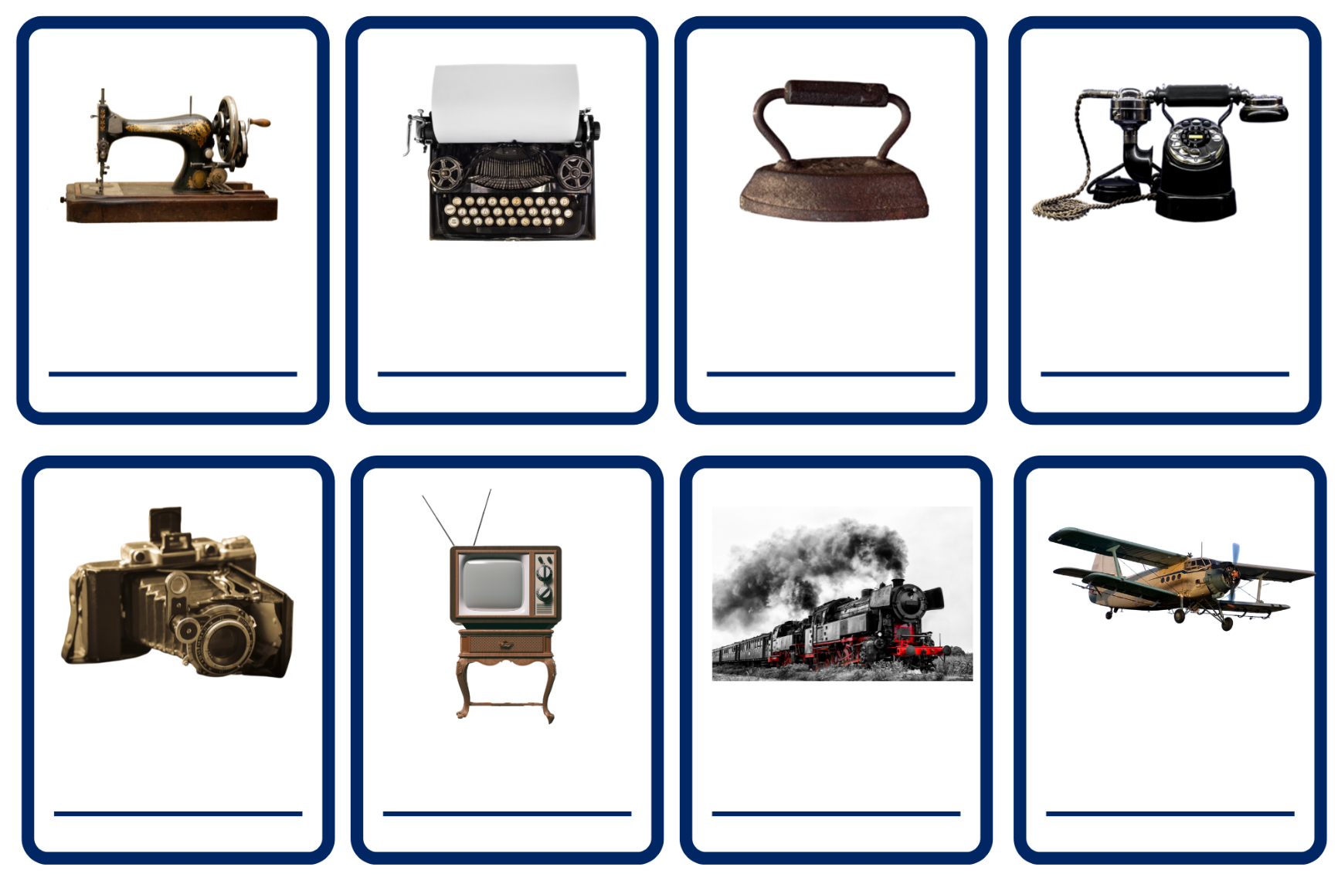
Images sourced from Canva and used in accordance with the Canva Content License Agreement.
telephone | iron | sewing machine | typewriter
television | steam train | aeroplane | camera

Resource 2: Tiered vocabulary
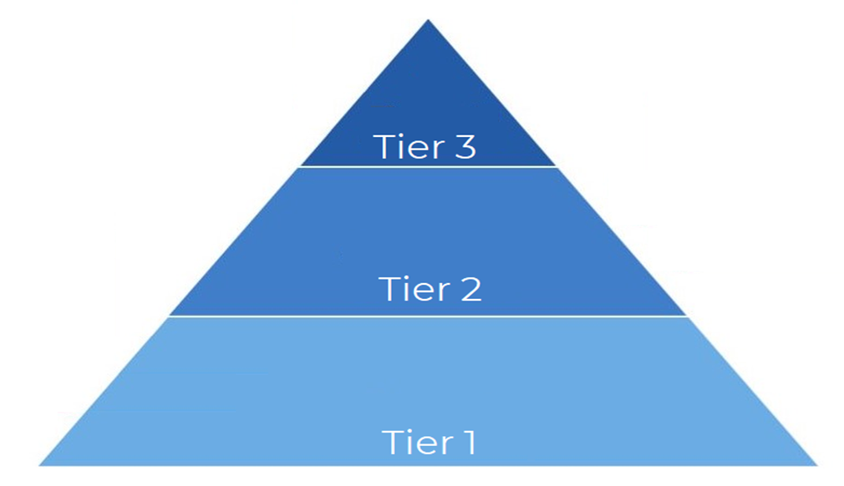

Resource 3: Narrative planning
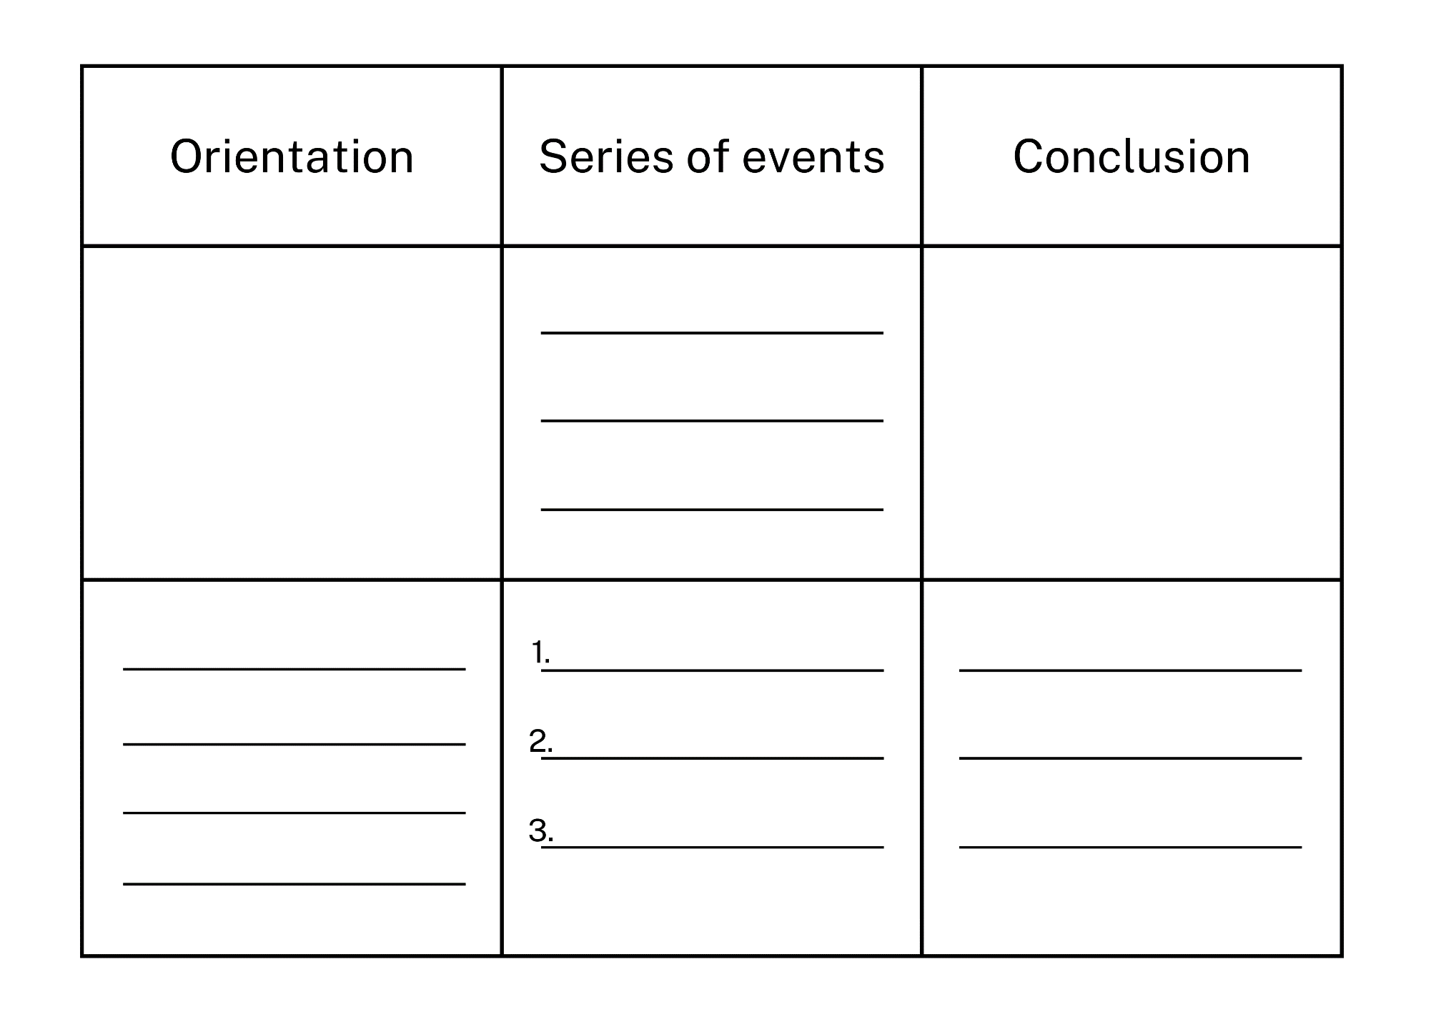

Resource 4: Narrative planning modified
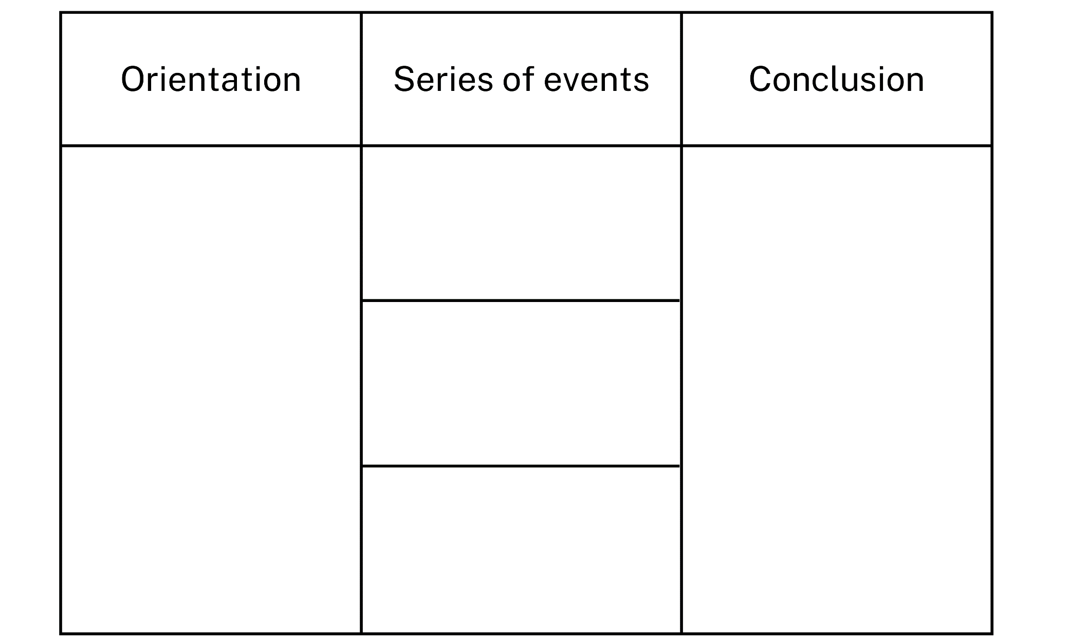

References
Links to third-party material and websites
Please note that the provided (reading/viewing material/list/links/texts) are a suggestion only and implies no endorsement, by the New South Wales Department of Education, of any author, publisher, or book title. School principals and teachers are best placed to assess the suitability of resources that would complement the curriculum and reflect the needs and interests of their students.
If you use the links provided in this document to access a third-party's website, you acknowledge that the terms of use, including licence terms set out on the third-party's website apply to the use which may be made of the materials on that third-party website or where permitted by the Copyright Act 1968 (Cth). The department accepts no responsibility for content on third-party websites.
Except as otherwise noted, all material is © State of New South Wales (Department of Education), 2023 and licensed under the Creative Commons Attribution 4.0 International License. All other material (third-party material) is used with permission or under licence. Where the copyright owner of third-party material has not licensed their material under a Creative Commons or similar licence, you should contact them directly for permission to reuse their material.
English K–10 Syllabus © 2022 NSW Education Standards Authority (NESA) for and on behalf of the Crown in right of the State of New South Wales.
Science and Technology K–6 Syllabus © 2017 NSW Education Standards Authority (NESA) for and on behalf of the Crown in right of the State of New South Wales.
© 2022 NSW Education Standards Authority. This document contains NSW Curriculum and syllabus content. The NSW Curriculum is developed by the NSW Education Standards Authority. This content is prepared by NESA for and on behalf of the Crown in right of the State of New South Wales. The material is protected by Crown copyright.
Please refer to the NESA Copyright Disclaimer for more information.
NESA holds the only official and up-to-date versions of the NSW Curriculum and syllabus documents. Please visit the NSW Education Standards Authority (NESA) website and the NSW Curriculum website.
National Literacy Learning Progression © Australian Curriculum, Assessment and Reporting Authority (ACARA) 2010 to present, unless otherwise indicated. This material was downloaded from the Australian Curriculum website (National Literacy Learning Progression) (accessed 26 September 2022) and was not modified. The material is licensed under CC BY 4.0. Version updates are tracked in the ‘Curriculum version history’ section on the 'About the Australian Curriculum' page of the Australian Curriculum website.
ACARA does not endorse any product that uses the Australian Curriculum or make any representations as to the quality of such products. Any product that uses material published on this website should not be taken to be affiliated with ACARA or have the sponsorship or approval of ACARA. It is up to each person to make their own assessment of the product, taking into account matters including, but not limited to, the version number and the degree to which the materials align with the content descriptions and achievement standards (where relevant). Where there is a claim of alignment, it is important to check that the materials align with the content descriptions and achievement standards (endorsed by all education Ministers), not the elaborations (examples provided by ACARA).
ETA (English Teachers Association) and NSW Department of Education (2016) The Textual Concepts and Processes resource, English Textual Concepts website, accessed 26 September 2022.
Cheng C (2022) The Imagineer (Masciullo L, illus.), National Library of Australia.
Dweck C (2008) Mindset: The New Psychology of Success, Random House, New York.
Spires A (2013) The Most Magnificent Thing, Kids Can Press, Canada.
The Works Museum (1 September 2019) ‘Inventions by Kids’, The Works Museum blog, accessed 26 September 2022.

